Supplementary Material

Role of orbitofrontal sulcogyral pattern on lifetime cannabis use and depressive symptoms

Yann Chyeª, Nadia Solowij^{b}, Eleni P Ganella^{c,d,e}, Chao Suoª, Murat Yücelª, Albert Batalla^{f,g}, Janna Cousijn^{h}, Anna E Goudriaan^{i,j}, Rocio Martin-Santos^{g}, Sarah Whittle^{c}, Cali F Bartholomeusz^{c,d,e}*, Valentina Lorenzetti^{a,c,k}*

ª Brain and Mental Health Laboratory, Monash Institute of Cognitive and Clinical Neurosciences, School of Psychological Sciences, Monash University, Melbourne, Australia
^{b} School of Psychology and Illawarra Health and Medical Research Institute, University of Wollongong, Wollongong, Australia
^{c} Melbourne Neuropsychiatry Centre, Department of Psychiatry, University of Melbourne, Melbourne, Australia
^{d} Orygen, The National Centre of Excellence in Youth Mental Health, Victoria, Australia
^{e} Orygen, Centre for Youth Mental Health, The University of Melbourne, Victoria, Australia
^{f} Department of Psychiatry, Donders Institute for Brain, Cognition and Behaviour, Radboud University Medical Centre, Nijmegen, The Netherlands
^{g} Department of Psychiatry and Psychology, Hospital Clinic, IDIBAPS, CIBERSAM and Institute of Neuroscience, University of Barcelona, Barcelona, Spain
^{h} Department of Developmental Psychology, University of Amsterdam, Amsterdam, The Netherlands
^{i} Department of Psychiatry, Amsterdam Institute for Addiction Research, Academic Medical Centre, University of Amsterdam, Amsterdam, The Netherlands
^{j} Arkin Mental Health Care, Amsterdam, The Netherlands
^{k} School of Psychological Sciences, Institute of Psychology, Health and Society, The University of Liverpool, Liverpool, UK
*Joint last author

Corresponding author:
Valentina Lorenzetti, vlor@liv.ac.uk, +44 0151 794 5657; Address: Whelan Building, Brownlow Hill, The University of Liverpool, Liverpool L69 7ZX, UK
Supplementary Table 1 Scanner Information by Imaging Site
 | Amsterdam | Barcelona | Wollongong | Melbourne
Manufacturer and Model | Phillips Intera | GE Signa Excite | Phillips Intera | Siemens Trio
Field Strength (Tesla, T) | 3 | 1.5 | 3 | 3
Number of Channels | 8 | 8 | 8 | 32
Repetition Time, TR (ms) | 9600 | 11.8 | 6.4 | 1900
Echo Time, TE (ms) | 4.6 | 3.2 | 2.9 | 2.15
Sequence | Turbo field echo | 3D inversion recovery prepared fast spoiled gradient | 3D spoiled gradient-recalled echo | 3D MP-RAGE

Supplementary Table 2 Overview of Demographic, IQ, Substance Use Levels, and Orbitofrontal Cortex (OFC) Pattern Distribution of Healthy Controls (HC) and Cannabis (CB) Users by Imaging Site (Mean (SD))
 | HC ^{c} |  |  |  |  | CB ^{c}
 | Amsterdam  N = 43 | Barcelona  N = 30 | Wollongong  N = 18 |  | Melbourne  N = 37 | Amsterdam  N = 33 |  | Barcelona  N = 30 | Wollongong  N = 16 | Melbourne  N = 67
Age | 21.98 (2.46) | 22.57 (3.36) | 35.00 (10.08) |  | 29.95 (11.29) | 21.32 (2.39) |  | 21.03 (2.34) | 38.99 (9.24) | 32.67 (11.07)
Gender (% M / F) | 62.79 / 37.21 | 100.00 / 0.00 | 88.89 / 11.11 |  | 48.65 / 51.35 | 66.67 / 33.33 |  | 100.00 / 0.00 | 93.75 / 6.25 | 46.27 / 53.73
IQ ª | 104.86 (7.25) | 109.26 (10.47)¹ | 113.45 (8.07) |  | 112.32 (12.72) | 104.18 (5.44) |  | 103.58 (10.71) | 109.37 (6.16) | 101.83 (12.96)²
Depressive Symptoms ^{b} | -0.26 (0.71)³ | -0.75 (0.26)⁴ | -0.25 (0.58) |  | -0.41 (0.73) | 0.23 (0.80)⁵ |  | -0.50 (0.91) | 0.78 (0.98) | 0.49 (1.35)
Alcohol (StDr/mth) ^{c} | 21.44 (26.76) | 12.43 (10.52)⁶ | 28.12 (21.79)⁷ |  | 19.79 (26.72) | 23.64 (23.85) |  | 21.14 (15.38)¹ | 40.29 (26.37)⁷ | 22.89 (28.06)²
Tobacco (Cig/mth) ^{c} | 41.73 (106.41) | 24.22 (103.97)⁸ | 25.35 (100.20) |  | 22.46 (77.77) | 211.99 (218.91) |  | 168.41 (152.35)¹ | 482.86 (274.73) | 266.12 (233.14)²
Cannabis Use
Onset Regular Use (years) | - | - | - |  | - | 18.85 (2.26) |  | 18.12 (2.05)⁹ | 20.14 (5.25) | 16.72 (3.27)
Current Use (cones/month) | - | - | - |  | - | 158.51 (115.95) |  | 224.13 (138.20)⁴ | 634.13 (545.45) | 404.97 (308.94)
Lifetime Use (cones) | - | - | - |  | - | 4,738.64 (4,275.06) |  | 15,611.28 (12,577.01)¹ | 177,772.50 (205,672.08) | 74,579.21 (75,833.71)¹⁰
Right OFC ^{c} sulcogyral pattern, n (%)
Type I | 17 (40) | 20 (67) | 7 (39) | 19 (51) |  |  | 17 (52) | 14 (47) | 7 (44) | 31 (46)
Type II | 11 (26) | 4 (13) | 4 (22) | 2 (5) |  |  | 7 (21) | 8 (27) | 4 (25) | 12 (18)
Type III | 15 (35) | 6 (20) | 7 (39) | 16 (43) |  |  | 9 (27) | 8 (27) | 5 (31) | 24 (36)
Left OFC sulcogyral pattern, n (%)
Type I | 23 (54) | 14 (47) | 9 (50) | 18 (49) |  |  | 13 (39) | 18 (60) | 8 (50) | 31 (46)
Type II | 8 (19) | 7 (23) | 3 (19) | 7 (19) |  |  | 8 (24) | 4 (13) | 3 (19) | 12 (18)
Type III | 12 (28) | 9 (30) | 6 (33) | 12 (32) |  |  | 12 (36) | 8 (27) | 5 (31) | 24 (36)
ª Estimated IQ measured with the Dutch version of the National Adult Reading Test (DART) (Schmand et al., 1991) (Amsterdam), the vocabulary subscale of the Wechsler Adult Intelligence Scale – Third Edition (WAIS-III) (Barcelona) (Wechsler, 1997); the National Adult Reading Test (NART) (Wollongong) (Nelson, 1982); and the Wechsler Abbreviated Scale of Intelligence (WASI) (Wechsler, 1999) (Melbourne).
^{b} Depressive symptoms measured with the Beck Depression Inventory (BDI) (Beck et al., 1961) (Amsterdam, Barcelona, Melbourne) and Hamilton Depression Rating Scale (HAMD) (Hamilton, 1960) (Wollongong); and subsequently standardized to a z-score based on reported population means (Crawford et al., 2011; Zimmerman et al., 2004).
^{c} StDr/mth = standard drinks per month; Cig/mth = cigarettes smoked per month; OFC = orbitofrontal cortex; HC = healthy control; CB = cannabis
¹n = 29, ²n = 64, ³n = 41, ⁴n = 27, ⁵n = 31, ⁶n = 28, ⁷n = 15, ⁸n = 27, ⁹n = 25, ¹⁰n = 66

Supplementary Table 3 Comparison of Differences in Orbitofrontal Cortex (OFC) Pattern Distribution in Healthy Controls (HC) or Cannabis (CB) Users by Imaging Site
Variable of Interest | Comparison | HC ª  N = 128 |  | CB ª  N = 146
 |  | χ2 | p | χ2 | P
Right OFC ª sulcogyral pattern | Within continent – Amst vs. Barc ª | 5.22 | .07 | 0.27 | .87
 | Within continent – Woll vs. Melb | 3.59 | .17 | 0.43 | .81
 | Across continents – Europe vs. Australia | 3.41 | .18 | 1.16 | .56
 | Across sites – Amst vs. Barc vs. Woll vs. Melb | 11.34 | .08 | 1.86 | .93
Left OFC sulcogyral pattern | Within continent – Amst vs. Barc | 0.38 | .83 | 2.80 | .25
 | Within continent – Woll vs. Melb | 0.04 | .98 | 0.12 | .94
 | Across continents – Europe vs. Australia | 0.27 | .88 | 0.16 | .92
 | Across sites – Amst vs. Barc vs. Woll vs. Melb | 0.70 | .99 | 3.13 | .79
ª OFC = orbitofrontal cortex; Amst = Amsterdam, Barc = Barcelona, Woll = Wollongong, Melb = Melbourne; HC = healthy control; CB = cannabis

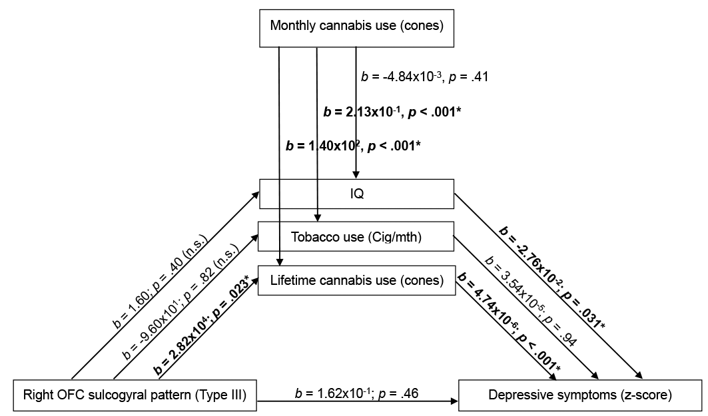
Supplementary Fig. 1 Cumulative lifetime cannabis (CB) use, IQ, and tobacco use as mediator between right orbitofrontal cortex (OFC) pattern type (categorical, Type III vs. non-Type III) and depressive symptoms in CB users; relative indirect effect of lifetime CB use, b = 0.13, 95% CI = [0.02, 0.31].

References
Beck, A.T., Ward, C.H., Mendelson, M.M., Mock, J.J., Erbaugh, J., 1961. An inventory for measuring depression. Arch. Gen. Psychiatry 4, 561–571.
Crawford, J., Cayley, C., Lovibond, P.F., Wilson, P.H., Hartley, C., 2011. Percentile norms and accompanying interval estimates from an Australian general adult population sample for self-report mood scales (BAI, BDI, CRSD, CES-D, DASS, DASS-21, STAI-X, STAI-Y, SRDS, and SRAS). Aust. Psychol. 46, 3–14.
Hamilton, M., 1960. Hamilton Depression Rating Scale (HDRS). J. Neurol. Neurosurg. Psychiatry 23, 56–62. doi:10.1007/978-3-642-70486-4_14
Nelson, H.E., 1982. National Adult Reading Test. NFER-Nelson, Windsor, UK.
Schmand, B., Bakker, D., Saan, R., Louman, J., 1991. The Dutch Reading Test for Adults: a measure of premorbid intelligence level. Tijdschr. Gerontol. Geriatr. 22, 15–19.
Wechsler, D., 1999. Wechsler Abbreviated Scale of Intelligence (WASI) Manual. Psychological Corporation, San Antonio, TX.
Wechsler, D., 1997. WAIS-III administration and scoring manual. The Psychological Corporation, San Antonio, TX.
Zimmerman, M., Chelminski, I., Posternak, M., 2004. A review of studies of the Hamilton Depression Rating Scale in healthy controls. J. Nerv. Ment. Dis. 192, 595–601.

