Outdoor thermal comfort in a hot urban climate: analysing the impact of creating wind passageways in Al-Moski, Egypt using ENVI-met

Yara Ayyad and Steve Sharples
School of Architecture, University of Liverpool, Liverpool L69 7ZN, United Kingdom

Abstract: Outdoor thermal comfort for pedestrians is difficult to achieve in high density, high population cities in hot climates, such as Cairo in Egypt. This study focussed on the outdoor thermal comfort of urban spaces in the Al-Moski district of Cairo and tested the effectiveness of creating new wind passageways at pedestrian level by selectively removing some of the buildings that encompass the Al-Moski area. The computational fluid dynamics (CFD) modelling software ENVI-met was used to create part of the existing Al-Moski urban form. Then, by extracting data from the CFD modelling, such as air temperature, wind speed, relative humidity and mean radiant temperature, the study was able to calculate the human thermal comfort index physiological equivalent temperature (PET). The urban form of Al-Moski was then changed in a systematic way by removing specific buildings in the ENVI-met model. The choice of building to remove was based on prevailing wind directions to see if accelerated flows at ground level through the newly created passageways could improve PET values. In addition, the benefit of adding areas of trees was also examined. The outcome of the analysis showed how a change in conditions, whether in the geometrical formation of the urban space or the addition of vegetation, could significantly affect the resulting PET values.

Keywords: wind passageways, outdoor thermal comfort, ENVI-met, simulation, PET.

Introduction
Design driven by sustainability considerations is now adopted in many development projects, especially in architecture and urban planning, where one focus has been on increasing human thermal comfort. Though new projects have the potential to provide environmental friendly solutions, the existing building stock has the biggest impact on the environment. For example, it is estimated that 87% of current buildings in the UK will still exist by 2050, with a low rate of renewal of 1% annually (The Construction Products Association, 2009). With that being the case, retrofitting old buildings and managing existing urban spaces would have much bigger impacts on the environment and carbon emissions than new build.
The focus in this paper is derived from the need to improve the human comfort in the outdoor urban environment at pedestrian level by providing better urban spaces through modification of the local microclimate, especially in commercial areas of cities. The human body interacts with the environmental conditions around it, whether for indoor or outdoor conditions. The degree of comfort depends on the different factors that the built environment creates for its occupants, such as air temperature, wind speed and relative humidity. For that reason, choosing the appropriate approach is somewhat difficult due to the complex nature of the urban spaces, where the climate zone plays a very important role, as well as urban geometry, where the formation of the buildings can influence the climatic factors greatly.
Considering the above, this study investigated the possibility of improving outdoor thermal comfort in an urban commercial setting in Cairo, Egypt, by creating wind passages and adding vegetation. A comparative analysis between several proposed solutions was carried out by using ENVI-met, a three-dimensional CFD software that models and analyses the interaction between a selected location’s microclimate and the local environmental conditions (ENVI-met, 2016). The model provided the study with the needed parameters, such as air temperature, wind speed, relative humidity and mean radiant temperature (MRT), to calculate the biometeorological comfort parameter the Physiological Equivalent Temperature (PET), which is the parameter used in the comparative analysis of different urban layouts.

Background

Context of study area
Egypt is in North Africa and covers a land area of 1,001,450 km². Egypt’s capital is Cairo, with a population of 7.772 million. Cairo was chosen as the location for this study because it is a megacity with a hot arid climate. The aim was to identify an area in the city and to investigate, through ENVI-met CFD computer modelling, the impact that removing/demolishing existing buildings might have on thermal comfort by altering pedestrian-level wind flows to create new wind passageways. The Al-Moski district of Cairo was chosen as it contains a range of urban layouts with the potential for wind flow enhancement. The Al-Moski district of Cairo was founded by Izz El-Deen Mosk, in the reign of An-Nasir Salah ad-Din Yusuf ibn Ayyub founder of Ayyubid dynasty around 1160-1193. The district is famous for the old markets that combine different commercial products. The buildings in this area are influenced by the French architecture in the era of Ismail Basha, which along the years has been reoccupied and reused for multiple purposes (Al-Tarabili, 2003).
The area of Al-Moski chosen for the ENVI-met analysis is a commercial site in a hot arid zone with a very close, nearly random formation of buildings. Cairo lies in the warm desert climate zone, with dry summers and moderate winters (Peel, et al., 2007). The area has harsh winds twice a year, in spring and autumn, when sand and other impurities shroud the city for several weeks. Temperatures vary with the seasons, with values as high as 42°C in summer (June- August) with average mean temperature of 28°C, and temperatures as low as 6°C in winter (December- February). The average wind speed value in Egypt is around 3.5 m/s from the North to Northeast. However, the area experiences Al-Khamasin winds, which can reach 26 m/s in March and April, as well as in August and October.

Thermal comfort
Thermal comfort indices are based on energy balance models of the human body, and one of the most widely used models is Fanger’s equation (Fanger, 1970), which was used to predict the indoor thermal comfort for air-conditioned spaces. The model was then adjusted by Jendritzky and Nübler (1981) to fit outdoor conditions. However, the model lacked realistic values of the thermal conditions of the individual’s body, due the fundamental design of climate based equations not including all the human physiological conditions (Höppe, 1999). In 1984 Höppe introduced the Munich Energy-balance Model for Individuals “MEMI” that would consider human sweat rate, clothing surface temperature and core temperature. The MEMI is based on the heat balance equation following Büttner’s work in the 1960s (Höppe, 1999).
Physiological equivalent temperature (PET) is a thermal comfort index introduced by Höppe and Mayer in 1987 which was based on MEMI (Höppe, 1999). Höppe (1999) defined PET as “the physiological equivalent temperature at any given place (outdoors or indoors) and is equivalent to the air temperature at which, in a typical indoor setting, the heat balance of the human body (work metabolism 80 W of light activity, added to basic metabolism; heat resistance of clothing 0.9 clo) is maintained with core and skin temperatures equal to those under the conditions being assessed.” The typical indoor conditions that are referenced in the PET calculations are (Matzarakis et al,1999): 20°C air temperature, which is also equal to mean radiant temperature; 50% relative humidity and 0.1 m/s wind speed. In order to be able to calculate the PET, certain steps are needed (Höppe 1999):
- Setting the meteorological parameters to be used in MEMI to determine the individual’s thermal conditions.
- Calculating the air temperature value through solving the energy balance equation with an individual’s thermal parameters extracted from MEMI.
PET was the index of external thermal comfort adopted in this study and it can be calculated by ENVI-met. Table 1 shows how the PET thermal scale related to thermal perception and physiological stress.

PET | Thermal perception | Grade of physiological stress
<4 | Very cold | Extreme cold stress
4 to 8 | Cold | Strong cold stress
8 to 13 | Cool | Moderate cold stress
13 to 18 | Slightly cool | Slight cold stress
18 to 23 | Comfortable | No thermal stress
23 to 29 | Slightly warm | Slight heat stress
29 to 35 | Warm | Moderate heat stress
32 to 41 | Hot | Strong heat stress
>41 | Very hot | Extreme heat stress

Method
Table 1: PET thermal scale
Al-Moski is a commercial area with relatively high buildings ranging between 6m and 15m in height. The buildings are randomly placed with no inner streets and only pedestrian passageways, which greatly reduce the potential for natural ventilation in buildings. Figure 1 shows the existing urban layout as modelled in ENVI-met. Six receptors were positioned around the site (Figure 2), and these were the points were PET values were examined. Space constraints in this paper mean that not all the results from the six receptors can be presented. Considering Al-Moski’s traditional nature, initial adjustments were proposed (Proposal 1) to eliminate three buildings, as seen in Figure 3, to create wind passages that would help in flushing out stale air and consequently raising the comfort level. Proposal 1 was put into simulation to see the effect of the minor adjustments, and the Receptors data were extracted for further comparison. Proposal 2 is a more invasive approach, eliminating more buildings to ensure more wind interaction inside the plot. And since the elimination process created more space, small scale vegetation areas were introduced in Proposal 2 to test out the effect the vegetation had in changing pedestrian human comfort levels (see Figure 4).
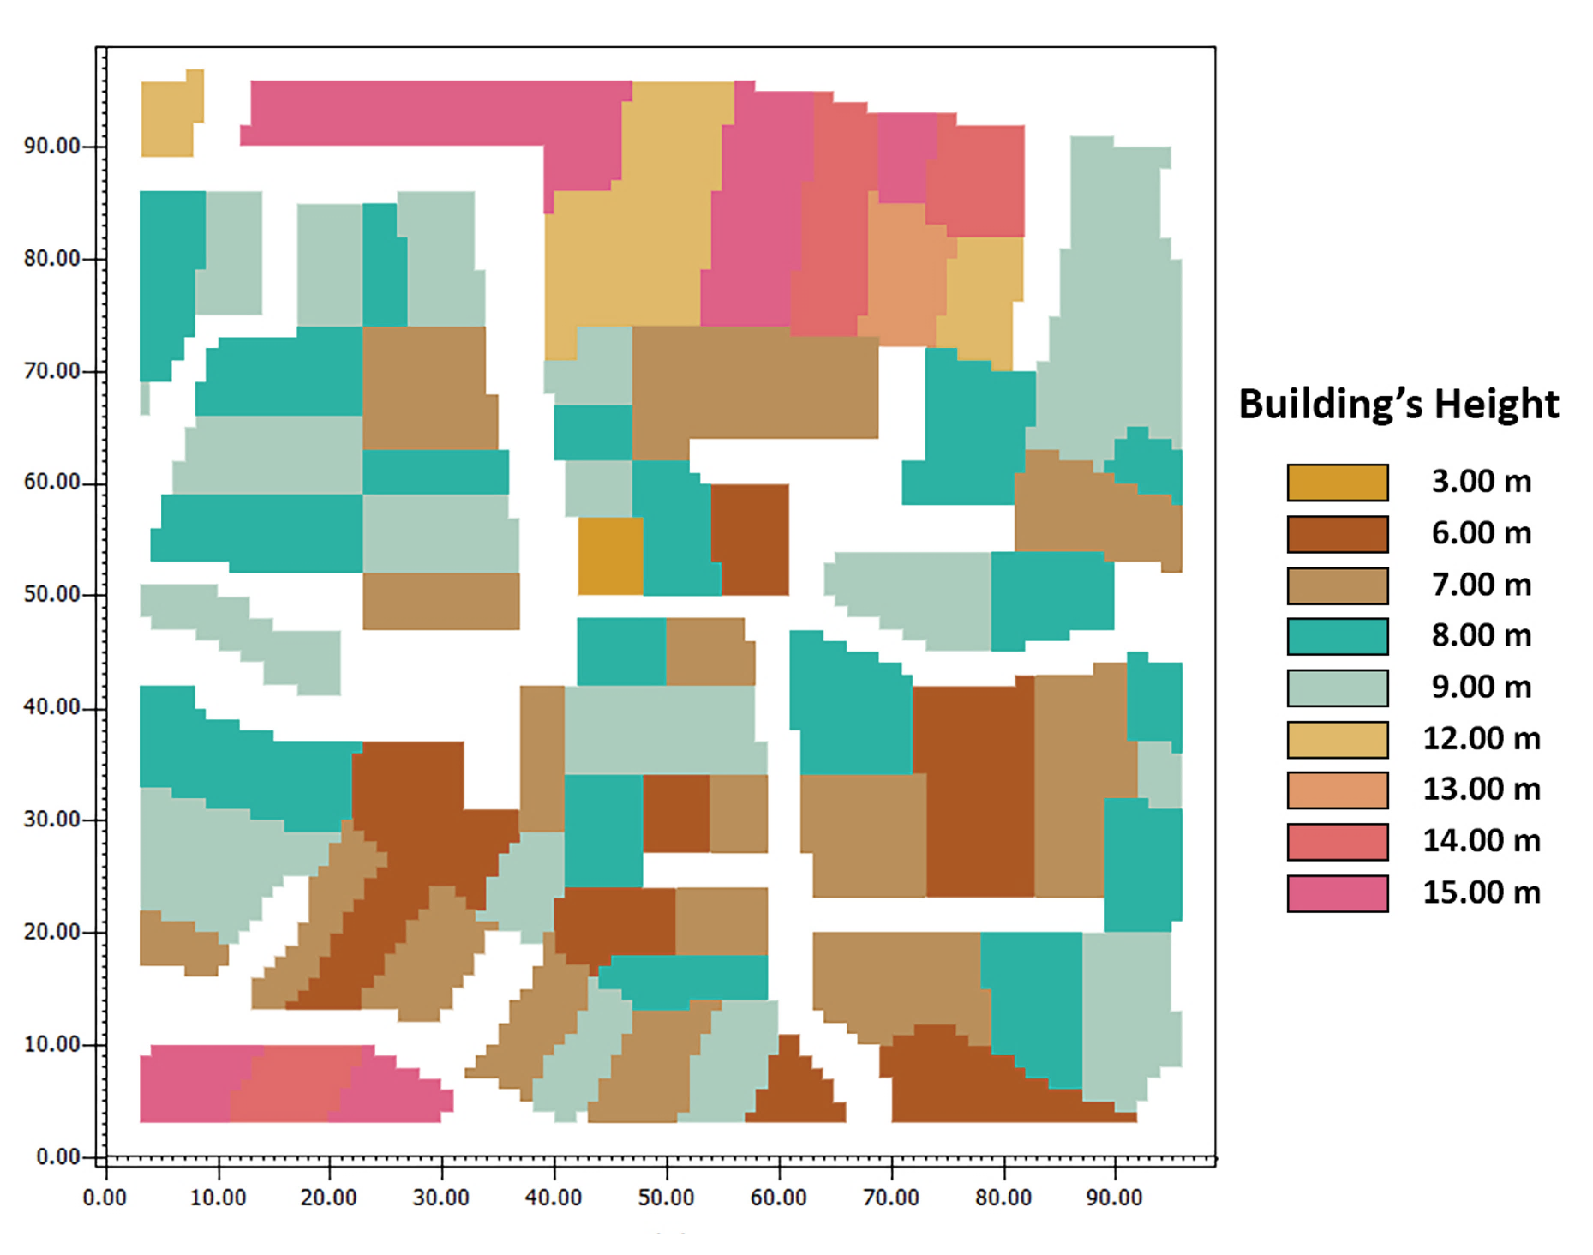
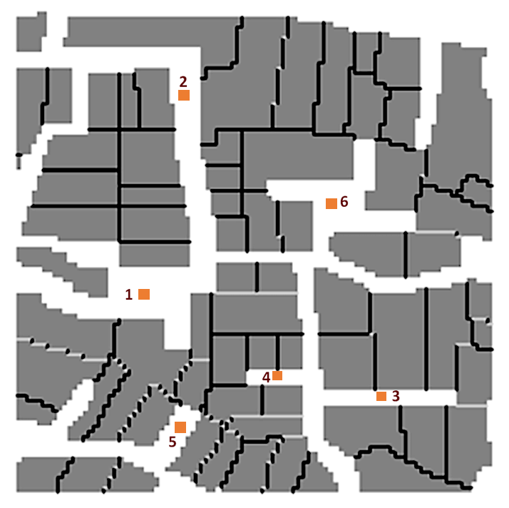
Figure 1. Building’s height.
Figure 2. Existing Plot.
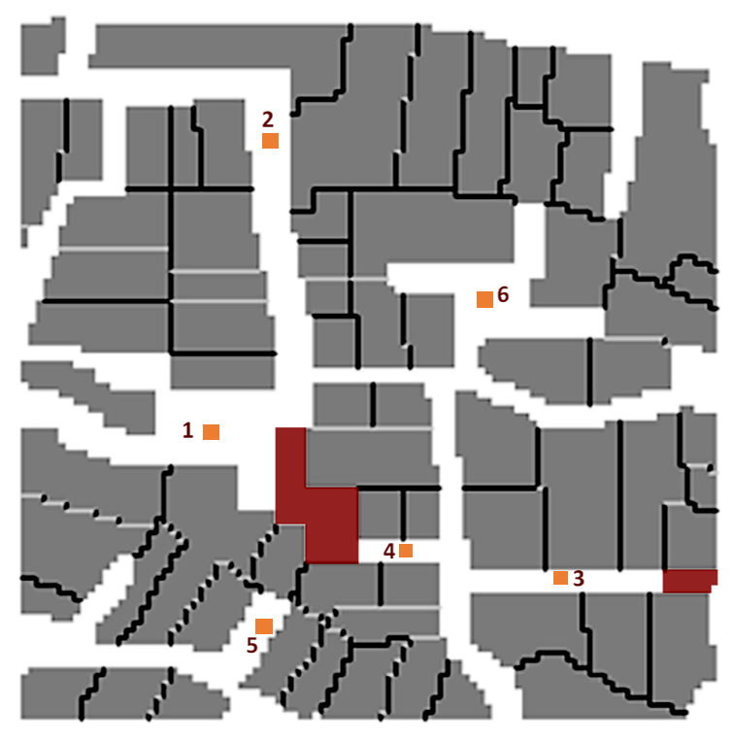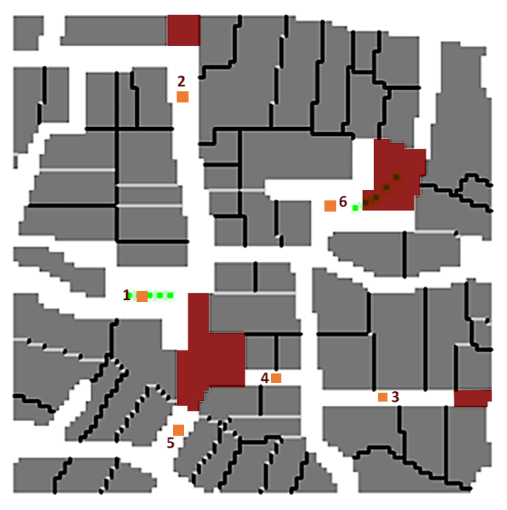
Figure 4. Proposal 2.
Figure 3. Proposal 1.

Results and discussion
The PET levels for the existing area in summer time rise drastically when the sun irradiates the receptors, as shown in Figure 5. Differences in PET between the receptors are due to the different heights of the buildings surrounding each receptor, which will block the sun at different times of the day. The PET values patterns are, to some extent, similar for all the receptors except for receptor 2, which had lower PET levels. This can be explained by examining the initial climatic values (air temperature, wind speed, relative humidity and mean radiant temperature) for all the receptors. Although the difference in wind values is noticeable, the main reason for the low PET values for receptor 2 is the difference in received solar radiation. While the other receptors received solar radiation for more than five hours a day, receptor 2 only received two hours a day.
The PET levels for the existing area in winter, as shown in Figure 5, rise significantly for only in two receptors, 6 and 2. Due to the change of seasons the winter sun cannot reach all the receptors, resulting in PET levels ranging from cool to comfortable, excluding the two hours where receptors 2 and 6 receive direct solar radiation.
Very Cold
Cold
Cool
Slightly cool
Comfortable
Slightly warm
Warm
Hot
Very hot
Receptors
Figure 5. PET values for the existing plot – summer and winter.

Receptor 1
Receptor 1 was in a relatively large square and the PET values in summer time exceeded the comfort levels, especially at noon. In Proposal 1 some buildings east of the receptor were removed to enhance the wind conditions, and no other major changes were made. In Proposal 2 the initial adjustments were kept, and a part of a building was removed to open a wind passage that was located north to the receptor. In addition to demolishing the building, a set of small sized trees were introduced to this receptor location since the space was wide enough for pedestrians’ movement and landscape additions.
The wind speed values in the existing conditions were very low. With the adjustments to the existing site, a slight change in wind speed values can be noticed. However, the change was not more than 0.05 m/s for both Proposals 1 and 2. The improvement in PET values in Proposal 2, as shown in Figure 5, is due to the addition of vegetation, which introduced shading and cooler surfaces. The vegetation helped in reducing the mean radiant temperature T_{mrt}, thereby changing the PET levels. Although the T_{mrt} values were less than for the existing plot and Proposal 1, the air temperature remained the same with a maximum change in values of 0.35 ^{ᴼ}C.
The demolishing of certain buildings in Proposal 1 and 2 allowed the winter sun to reach receptor 1’s location, which did not occur for the existing conditions. Other than that, no major changes in the PET values for Receptor 1 in winter were observed (see Figure 6).

Very Cold
Cold
Cool
Slightly cool
Comfortable
Slightly warm
Warm
Hot
Very hot
Receptors
Figure 6. PET values for Receptor 1.

Receptor 2
Receptor 2 was located at the end of a long street. The PET values for receptor 2 in summer time were very similar in the three scenarios. PET values behaved the same and peaked at noon when the sun was at its highest, resulting in hot values on the PET scale. For Proposal 1 there were no changes near the receptor and therefore the PET values graph is almost the same as for the existing site’s PET values graph. However, in Proposal 2 a part of an existing building close to receptor 2 was removed to open a wind passage, and create a direct path through this commercial area that would link the two sides of the plot. Since there were no adjustments to the buildings close to receptor 2 in Proposal 1 the data extracted from the simulation did not change compared to the existing values. However, a significant change in wind speed of 1.9 m/s could be noticed in Proposal 2, due to the demolishing of the building to the north of receptor 2. However, there is not a large difference in the PET values, as seen in Figure 7. The increased values of wind speed helped in changing the air temperature, where it worked in two intervals throughout the day. It reduced the air temperature at night by flushing the hot air, and increased the air temperature by day by forcing hot air in.
PET levels did not change greater, especially when solar radiation was present, due to the greater effect that solar radiation has in the PET calculation, where it contributes more than the wind speed variable. Since the solar radiation levels were relatively high in the three scenarios, the PET levels did not show a noticeable improvement with the increased wind speed. However, during night time the PET levels in Proposal 2 weare less than the other two scenarios as seen in Figure 7, due to the lack of solar exposure and increased wind speed.
As for the case of winter, the PET levels in Proposal 2 were lower than Proposal 1 (Figure 7), due to improved wind speed values. In this case the winter sun exposure impact on the PET levels was lower than summer time, which is why the wind speed effected the PET levels in winter and did not affect the PET levels in summer.

Very Cold
Cold
Cool
Slightly cool
Comfortable
Slightly warm
Warm
Hot
Very hot
Receptors
Figure 7. PET values for receptor 2.

Receptor 4
Receptor 4 was in a small enclosed path. The PET values for receptor 4 in summer time were the highest compared to the other receptors - they exceeded the comfort levels, especially at noon, as shown in Figure 8. In Proposal 1 buildings to the west of the receptor were removed to enhance the wind conditions, and no other major changes were made. In Proposal 2 the initial adjustments were kept, and the building to the southwest of the receptor was removed to open a wind passage that was located near to receptor 5. The wind values in the three cases were very low, ranging from 0.02 to 0.18 m/s; even with the demolition of the adjacent buildings that were blocking the wind flow, the values did not improve to a significant degree. The PET levels in Figure 7 show that the values in the three cases behaved in two intervals; the first interval was when there was not much solar radiation, which started at 17:00 and ended at 09:00. The PET levels in this interval were seemingly the same for all three cases, since the wind speed did not increase enough to influence PET values. The second interval started at 9:00 and ended at 17:00 when the solar radiation was present. Here it can be noticed that the PET levels for the existing plot have lower values than for Proposals 1 and 2, due to the demolishing of the buildings near the receptor that caused more solar radiation to reach that area. Figure 9 shows the shadows of the buildings at 15:00 for the three different cases, where receptor 4 is only shaded in the existing plot but not for Proposals 1 and 2.

Very Cold
Cold
Cool
Slightly cool
Comfortable
Slightly warm
Warm
Hot
Very hot
Receptors
Figure 8: PET values for receptor 4.

Existing Plot Proposal 1 Proposal 2
Figure 9. Shadows casts at 15:00.

As for the case of winter time, the PET levels in Proposal 1 and 2 were slightly lower than for the existing plot at 10:00 to 00:00, as seen in Figure 8, and relatively the same for the rest of the hours. This behaviour can be linked to the wind speed patterns, where Proposal 1 and 2 wind speed values are higher than for the existing plot at 10:00 to 00:00, and the rest of the hours have smaller differences in values resulting in almost similar PET values. Wind speed was still considerably low but in this case at winter, the receptor is overshadowed by the surrounding building all day.

Conclusion
Choosing to demolish existing buildings to enhance an area’s pedestrian microclimate is not a trivial consideration, and there could be conflicts between enhanced environmental sustainability, social sustainability and heritage issues. This paper has assessed the potential benefits of altering urban form as a mechanism for improving outdoor human comfort. From studying the results it is clear that PET values are influenced heavily by the climatic parameter mean radiant temperature Tmrt, and so creating shading, such as with vegetation, can significantly lower the values of Tmrt. However, there are certain conditions when the effect of the Tmrt has less impact on PET values - for instance, when the sun’s position means a particular receptor is strongly irradiated. The findings from this study highlight that increasing local wind speeds at a site (by removing building obstructions) to try and lower a high PET value might not be effective if the removal means that the site is exposed to higher levels of solar radiation. Such findings can help in deciding the elements of future urban developments such as building geometry, street grids and shading devices.

References
Al-Tarabili, A. (2003). Ahya'a Al-qahera Al-mahrosa [The Guarded neighbourhood of Cairo]. 1st ed. Cairo: Al-Dar al-masriah al-lubnaniah, pp.70-99.
ENVI-met, 2016. ENVI-met 4. A holistic Microclimate Modelling System. [Online] Available at: http://www.model.envi-met.com/hg2e/doku.php?id=root:start [Accessed 24 June 2016].
Fanger, P.O., 1970. Thermal Comfort: Analysis and Applications in Environmental Engineering, Danish Technical Press, Copenhagen.
Höppe, P., 1999. The physiological equivalent temperature – a universal index for the biometeorological assessment of the thermal environment. Biometeorol, Volume 43, p. 71–75.
Jendritzky, G. & Nübler, W., 1981. A model analysing the urban thermal environment in physiologically significant terms. Archives for Meteorology, Geophysics and Bioclimatology, Series B, 29, 313-326
Matzarakis, A., Mayer, H. & Iziomon, M. G., 1999. Applications of a universal thermal index: physiological equivalent temperature. s.l.:Int J Biometeorol.
Peel, M. C., Finlayson, B. L. & McMahon, T. A., 2007. Updated world map of the Koppen-Geiger climate classification. Hydrology and Earth System Sciences, Volume 11, p. 1633–1644.
The Construction Products Association, 2009. Memorandum submitted by the Construction Products Association. [Online] Available at:
http://www.publications.parliament.uk/pa/cm200809/cmselect/cmenvaud/202/202we06.htm. [Accessed 24 March 2017].

