Assessing Cooling Energy Load and Dehumidification in Housing Built to Passivhaus Standard in Jakarta, Indonesia

Roy Candra Sigalingging1, David Chow1 and Steve Sharples1

1 School of Architecture, University of Liverpool, Liverpool, United Kingdom

**Abstract:** A preference for low-density housing by Indonesian people has contributed greatly to uncontrollable urban sprawl around the peripheries of Indonesia’s major cities. The cooling of low-density housing to maintain thermal comfort is energy intensive, with approximately 30–50% of conditioned air lost through ventilation and air infiltration. As Indonesia is in a hot and humid climatic region, the air’s moisture level is high, and ventilation during hot weather can introduce more moisture in to buildings. Thus, the removal of excess internal humidity is essential for human comfort. The German Passivhaus building standard is effective in preserving stable interior temperatures, but its air-tight envelope might hinder the removal of excess moisture in tropical climates. The dynamic thermal simulation software DesignBuilder was used to model a typical Jakarta terraced dwelling to investigate the effects on indoor temperature and humidity on comfort and energy use from applying the Passivhaus standard. The aim was to find the optimum setting for minimising cooling and dehumidification energy in air-conditioning systems. The research examined the type of active dehumidification system that might be most suitable to work with a Passivhaus in tropical conditions to position the house’s internal environment within the thermal comfort zone.

**Keywords**: Passivhaus, Hot and humid climate, Dehumidification, tropical climate, Low energy building

# Introduction

In hot and humid climates the application of simple cooling measures can be effective in reducing the cooling load of buildings. Reductions of up to 43% in cooling load can be achieved using a combination of well-established technologies such as glazing, shading, insulation, and natural ventilation (Omer 2008). Properly designed ventilation in a house will provide enough fresh air to keep the occupants healthy, to remove odours and to dilute indoor pollutants. However, ventilation during hot weather introduces more moisture in to a house, and that tends to raise rather than lower the indoor relative humidity. Approximately 30–50% of the energy used for cooling is also lost through ventilation and air infiltration (Omer 2008). It is crucial to find cooling strategies that, whenever possible, are energy efficient for houses experiencing hot and humid climatic conditions.

One radical alternative solution is to apply one of the world's most proactive energy reduction approaches to tropical housing - that is, the Passivhaus standard from German. “*A Passive House is a building in which thermal comfort can be guaranteed solely by heating or cooling of the supply air which is required for sufficient indoor air quality without using additional recirculated air*” (McLeod, Hopfe, and Kwan 2013). The Passivhaus standard ensures indoor air quality, durability, and thermal comfort in the building. To achieve certification as a Passivhaus a project must demonstrate compliance, with the annual heating/cooling demand requirement being less than or equal to 15 kWh/m2/year and primary energy use not exceeding 120 kWh/m2/year (Brew 2011). With extreme air tightness and high thermal resistance R-values in Passivhaus construction, the application of the Passivhaus standard must properly consider moisture balances and the attendant latent loads on the building in a hot humid climate. A failure to do so can lead to discomfort or moisture-related problems, such as mould (Walker and Sherman 2007).

Different types of heat exchangers have been widely used in air conditioning systems for coolness recovery. The cooling strategy used by the Austrian Embassy that was built as a Passivhaus office in Jakarta was the Concrete Core Temperature Control or CCTC (Oettl 2014). A chiller covered the base load for the cooling supply, and provides gentle radiant cooling instead of a cold breeze from split units. In Louisiana, southern USA, where cooling and dehumidifying are as much of a challenge as heating, Energy Recovery Ventilators (ERV) are being used. Unlike straight heat exchangers, ERV also transfers water vapour, which prevents the air from drying out in winter months, and removes outdoor humidity during summer months (MacDonald, 2010). However, in a hot and humid climate, the incoming outdoor air can only possibly be cooled by the outgoing exhaust air in an air-conditioned house (Holladay 2010). While not a dehumidifier, ERV systems transfer moisture from incoming humid air to the stale indoor air that is being vented to the outside, and retain the internal humid air that produced by equipment and building user.

The objective of this study was to determine energy-saving modifications through the application of Passivhaus principles to Jakarta urban houses. The target houses chosen for analysis were row (terrace) houses, which form the majority of the existing urban housing stock (Badan Pusat Statistic 2016). This study analysed the effects of air conditioning (AC) and dehumidifiers on thermal comfort and cooling load through numerical simulation using the DesignBuilder program.

# Housing in Jakarta Metropolitan Region

To support the exponential growth of urbanization, the surrounding areas of Jakarta have become the extension of satellite cities for Jakarta. The Jakarta Metropolitan Region covers an area of approximately 7500 km2, including Jakarta City and its surrounding areas of Bogor, Depok, Tangerang and Bekasi (Firman 2004). The current development for housing products in the Jakarta Metropolitan Region is expanding horizontally to surrounding areas around Jakarta and is reaching parts of the neighboring provinces (Rahadi et al. 2015). Table 1 shows the proportions of dwellings with different floor areas in the Jakarta Metropolitan Region. From the total 100% of households in every province/ regency in the Jakarta Metropolitan Region (Figure 1), the most prevalent housing floor areas lie between 50m2 to 69m2 floor area, except for Jakarta, where the biggest percentage is for housing under 20m2. Low dwelling floor areas in Jakarta are because the calculations include the apartment room and slum areas, where the houses/unit’s floor area are below 20m2.

# Research methodology

The performance of a dwelling in Jakarta built to the Passivhaus standard in the hot humid climate was examined in this research, with the focus on the energy used to achieve thermal comfort and the needs for dehumidification. A model of the dwelling was created using DesignBuilder, which comprised a core 3-D modeler and ten modules which work together to provide in-depth analysis for any building to provide high quality, comfortable buildings that also comply with building regulations, optimize on-going energy costs and reduce environmental impact (DesignBuilder 2017).

Table 1. Percentage Floor Area of Dwelling Units built in the Jakarta Metropolitan Region.

|  |  |  |  |  |  |  |  |  |  |  |  |
| --- | --- | --- | --- | --- | --- | --- | --- | --- | --- | --- | --- |
| Province/ Regency/ Municipality | Percentage Floor Area of Dwelling Unit (%) | | | | | | | | | | |
| <20m2 | 20-29 m2 | 30-39 m2 | 40-49 m2 | 50-69 m2 | 70-99 m2 | 100-149 m2 | 150-199 m2 | 200-299 m2 | >300 m2 | Total |
| DKI Jakarta Province | 27 | 12 | 13 | 7 | 11 | 10 | 9 | 4 | 4 | 3 | 100 |
| Bogor Regency | 7 | 11 | 16 | 15 | 23 | 17 | 8 | 2 | 1 | 0 | 100 |
| Bogor | 9 | 11 | 12 | 11 | 19 | 17 | 12 | 4 | 3 | 2 | 100 |
| Depok | 7 | 9 | 14 | 8 | 18 | 20 | 15 | 5 | 3 | 1 | 100 |
| Tangerang Regency | 11 | 11 | 13 | 14 | 27 | 16 | 5 | 1 | 1 | 0 | 100 |
| Tangerang | 19 | 12 | 12 | 6 | 17 | 17 | 11 | 3 | 2 | 1 | 100 |
| Tangerang Selatan | 6 | 9 | 14 | 8 | 20 | 18 | 15 | 5 | 4 | 2 | 100 |
| Bekasi Regency | 9 | 13 | 12 | 14 | 29 | 15 | 6 | 1 | 1 | 0 | 100 |
| Bekasi | 9 | 11 | 13 | 7 | 18 | 19 | 14 | 5 | 3 | 1 | 100 |
| Source: 2010 Population Census Data - Statistics Indonesia | | | | | | | | | | | | |
|  | | | | | | | | | | | | |

|  |
| --- |
|  |

Figure 1. Household by region and floor area of dwelling unit

The empirical validation of the model designed by the DesignBuilder software was determined by comparing the simulation results with some field experiment data from buildings in the same climate with selected project locations. It should be clarified here that modeling refers to the task of making a logic machine that represents the material properties of the building and physics processes in it, whereas simulation refers to numerical experimentation with the model to investigate its response to changing conditions inside and outside the building. To study the Passivhaus performance, a row house from a field experiment was chosen to be modelled in this simulation study. The selected row house represents the typical housing built in the Jakarta Metropolitan region. The building configuration (materials, cooling systems, lights and appliances) of the house were replicated and modelled in DesignBuilder, with a presupposed occupancy schedule. A Jakarta weather file was acquired through the climate-modelling software Meteonorm (Meteonorm 2017).

# Validation of the DesignBuilder software

A study by Hooi et al. (2014) in Johor Bahru, Malaysia, that investigated the effectiveness of night ventilation for residential buildings, was chosen to validate the DesignBuilder software. Johor Bahru has a hot and humid climate which is similar to that of Jakarta. The study was conducted to study better thermal comfort for occupants in Malaysian terraced houses through field experiments. The field experiment examined the effects of night ventilation techniques on the indoor thermal environment for Malaysian terraced houses, focusing not only on the daytime thermal conditions but also on the night-time thermal conditions. The model of this Malaysian terrace house was constructed using the DesignBuilder software, and simulated the same situation as for the field experiment. This DesignBuilder validation experiment imitated the night ventilation condition that was used in the field experiment study.

Measured indoor air temperatures, relative humidity and the corresponding outdoor climatic conditions for modelled building in DesignBuilder software were compared with the field measurements. Figure 2(a) shows that there is a 2°C air temperature differences at the first day of simulation, but the difference reduces during the week. From the middle of the week, the air temperature between field measurements and software simulation indicates similar results. Figure 2(b) shows that the simulation results having the same trend as the field measurements.

(a) (b) 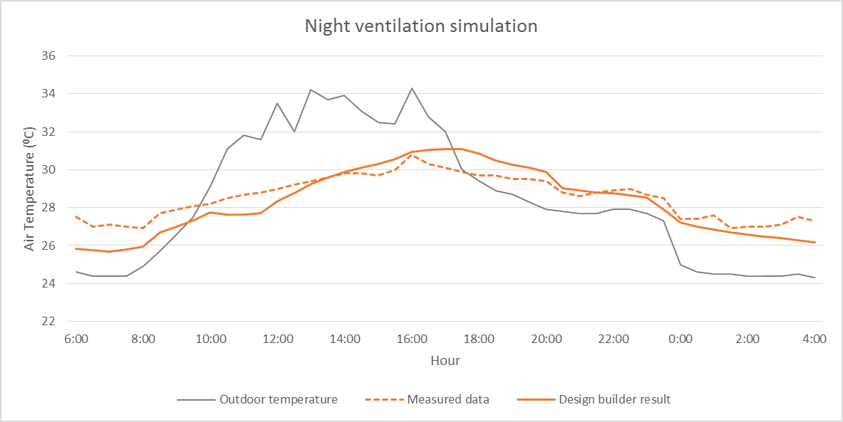

Figure 2. Night ventilation air temperature comparison in (a) one week and (b) one day

(a) (b) 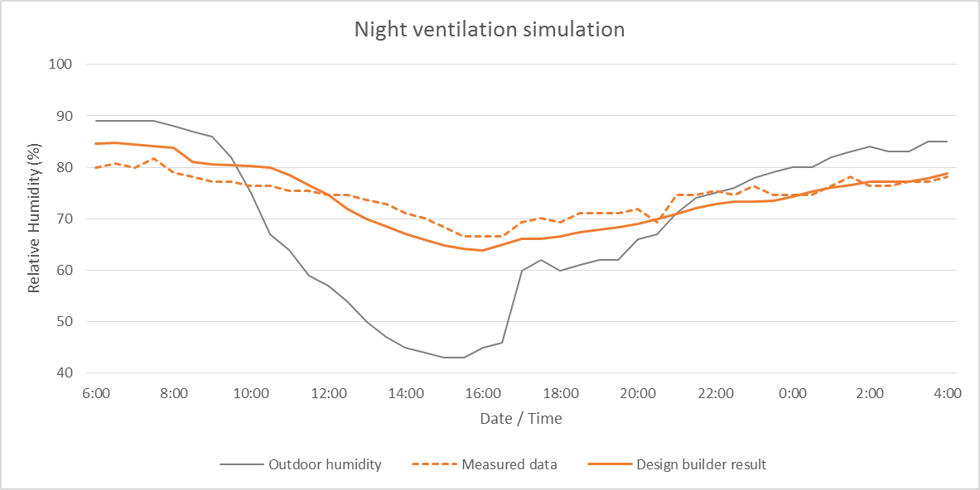

Figure 3. Night ventilation relative humidity comparison in (a) one week and (b) one day

The different results for the first day of the week in the simulation are possibly due to some differences in the climate data used in the software simulation compared to actual local meteorological station data for the selected simulation date. Another possible reason is the circumstances of the measurements on site - all house windows were open for 24 hours a day before the experimental period. The relative humidity of the house also indicates the same situation with the air temperature. Figure 3(a) shows that with ±5% differences, the graph indicates the same trend between simulation results and field measurement. Figure 3(b) indicates that the relative humidity shows the same shape between measured and simulation results.

With this experiment, the terrace house in the hot humid climate modelled in DesignBuilder produced relatively similar results compared with the field measurement data.

(a) (b)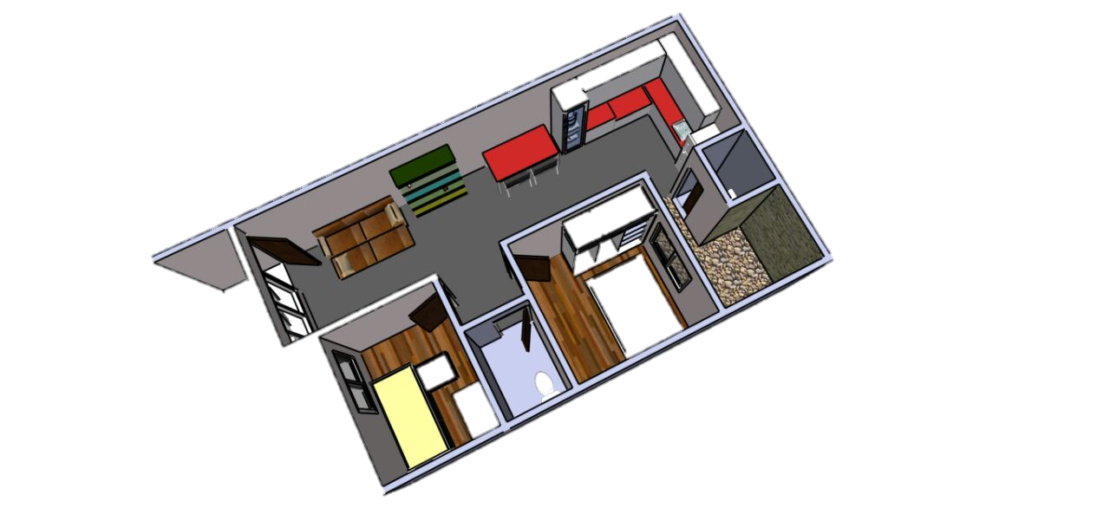

(c)

Figure 4. The case study row house (a) exterior view, (b) building model, and (c) floor plans.

# Description and modelling of case study row house

A selected row house representing the typical housing built in Jakarta Metropolitan region was modelled in this simulation study (Figure 4). The whole house was modelled in three dimensions using DesignBuilder. The house measured 6 m by 10 m with a total floor area of 55 m2, with a floor-to-ceiling height of 2.85 m. The building was oriented towards north, which meant that the external façade of the children’s bedroom faced north. The entire house was not insulated, being constructed from a single layer of brick, with single glazing windows. The building elements used to build the model in DesignBuilder can be seen in Table 2 (base model) and Table 3 (Passivhaus model).

The row house modelled in DesignBuilder was analysed to study the effect of air conditioning and dehumidification. A modelled house was developed using the existing building elements. Through DesignBuilder simulation, the performance of the building with natural ventilation was compared with the performance of the building when an air conditioner (AC) or dehumidifier was used. When applied in the simulation, the AC or dehumidifier were in the living room, master bedroom, and children’s bedroom. The analysis then continued by studying the building performance when the Passivhaus concepts were applied to the building. The same AC location was still used on this Passivhaus building. Table 3 indicates the changes on the building material to follow the Passivhaus concept.

Table 2. Building elements.

|  |  |
| --- | --- |
| **Building Element** | **Constructional layers** |
| External and internal walls | 25 mm thick cement plaster + 100 mm thick clay brick + 25 mm thick cement plaster |
| Party wall | 25 mm thick cement plaster + 200 mm thick clay brick + 25 mm thick cement plaster |
| Floor | 8 mm thick ceramic tile + 22 mm thick cement screed + 100 mm thick concrete slab + soil layer |
| Window | 6 mm thick single layer glass |
| Ceiling | 6 mm thick gypsum board |
| Pitched roof | 20 mm thick roof tile + 25 mm thick timber batten |
| Flat roof | 22 mm thick cement screed + 100 mm thick concrete slab + 20 mm thick cement plaster |

Table 3. Passivhaus building elements.

|  |  |
| --- | --- |
| **Building Element** | **Constructional layers** |
| External and internal walls | 25 mm thick cement plaster + 100 mm thick clay brick + 100 mm XPS Extruded Polystyrene + 25 mm thick cement plaster |
| Party wall | 25 mm thick cement plaster + 200 mm thick clay brick + 100 mm XPS Extruded Polystyrene + 25 mm thick cement plaster |
| Floor | 8 mm thick ceramic tile + 22 mm thick cement screed + 100 mm thick concrete slab + Urea Formaldehyde Foam + soil layer |
| Window | 6 mm thick double layer glass |
| Ceiling | 6 mm thick gypsum board |
| Pitched roof | 20 mm thick roof tile + 25 mm thick timber batten + 100 mm MW Glass Wool (rolls) |
| Flat roof | 22 mm thick cement screed + 100 mm thick concrete slab + 20 mm thick cement plaster + 100 mm XPS Extruded Polystyrene |

# Simulation Result and discussion

The air temperature comparison graph (Figure 5) indicates that, by introducing AC, the temperatures in the living room and master bedroom were lowered by around 3⁰C compared to using natural ventilation in the dwelling, making the air temperature always below 260C for this selected period. Air temperatures in the Passivhaus building show a flat line with the temperature stable at around 26⁰C. Based on the DesignBuilder calculations, the annual cooling energy used in the building was 4093 kWh for the house with AC, 3631 kWh for the house with the dehumidifier, and 517 kWh for the house built to the Passivhaus standard.

Even with a fluctuating relative humidity between 50 – 70%, the relative humidity in the building using AC was still lower by 10% compared to the Passivhaus building. Using a dehumidifier in the building lowered the air temperature by only 0.5⁰C, but maintained the room’s relative humidity always below 60% (Figure 6).

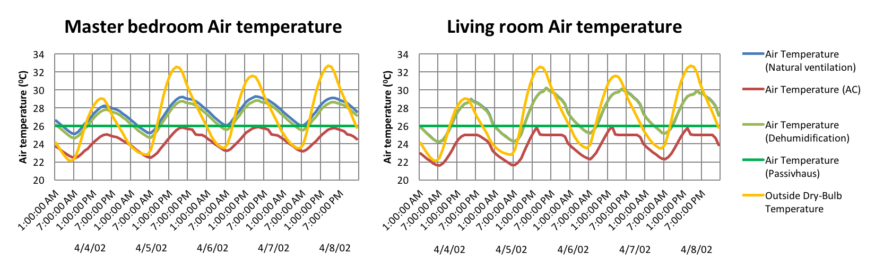

Figure 5. Hourly air temperatures in master bedroom and living room for natural ventilation, AC, dehumidification and Passivhaus approaches.

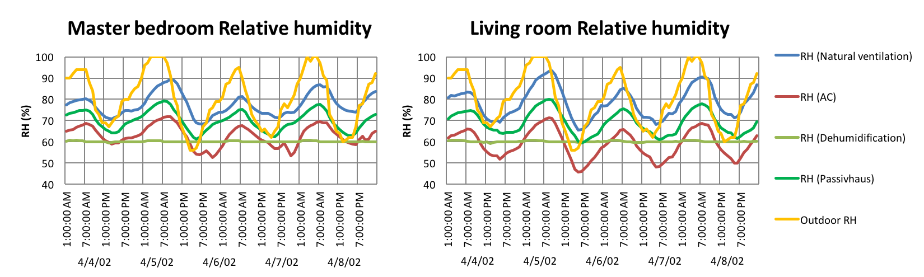

Figure 6. Hourly relative humidity in master bedroom and living room for natural ventilation, AC, dehumidification and Passivhaus approaches.

# Conclusion

The modelled house needed a means of active dehumidification to achieve optimal control over the comfort zone. In a hot humid climate, it makes more sense to install an ERV than a HRV. The main reason is that the additional transfer of moisture introduced by the ERV will not increase the internal humidity. While HRVs and ERVs both cause increased energy use, the energy attributable to the ERV’s operation is less.

With a similar process, air-conditioning can act as a dehumidifier. Lowering indoor air temperature will reduce the moisture capacity of the indoor air and decrease relative humidity. However, as expected, lowering the cooling set point increased energy use. Using a dehumidifier enabled the maintenance of a stable relative humidity, but required considerable energy. The Passivhaus application in the housing produced a high relative humidity but created very stable room temperatures. With a small energy demand below 10 kWh/m2 annually, the additional energy for the dehumidifier means it can still be used to lower the dwelling’s relative humidity whilst still meeting the Passivhaus standard.

# References

Badan Pusat Statistic. 2016. “2010 Population Census - Household by Region and Floor Area of Dwelling Unit | Indonesia.” http://sp2010.bps.go.id/index.php/site/tabel?tid=333&wid=0.

Brew, James Scott. 2011. “Achieving Passivhaus Standard in North America: Lessons Learned.” *ASHRAE Transactions* 117 (2). ASHRAE: 51–58.

http://liverpool.idm.oclc.org/login?url=http://search.ebscohost.com/login.aspx?direct=true&db=a9h&AN=67217555&site=eds-live&scope=site.

DesignBuilder. 2017. “DesignBuilder Software Ltd - Home.” https://www.designbuilder.co.uk/.

Firman, Tommy. 2004. “New Town Development in Jakarta Metropolitan Region: A Perspective of Spatial Segregation.” *Habitat International* 28 (3): 349–68. doi:10.1016/S0197-3975(03)00037-7.

Holladay, Martin. 2010. “HRV or ERV? | GreenBuildingAdvisor.com .”

http://www.greenbuildingadvisor.com/blogs/dept/musings/hrv-or-erv.

Hooi, Doris, Susumu Sugiyama, Satoshi Yasufuku, and Tetsu Kubota. 2014. “Numerical Simulation of Passive Cooling Strategies for Urban Terraced Houses in Hot-Humid Climate of Malaysia.” *PLEA 2014 - 30th INTERNATIONAL PLEA CONFERENCE*, no. December: 1–8.

MacDonald, Christine. 2010. “Just Add Body Heat: The New Passive Houses Are so Energy Efficient, They Make Heating and Cooling Practically Irrelevant.” *2010*.

McLeod, Robert S, Christina J Hopfe, and Alan Kwan. 2013. “An Investigation into Future Performance and Overheating Risks in Passivhaus Dwellings.” *Building and Environment* 70. Elsevier Ltd: 189–209. doi:10.1016/j.buildenv.2013.08.024.

Meteonorm. 2017 http://www.meteonorm.com/

Oettl, Fritz. 2014. “Regional Workshop and Training on Energy Efficiency in Buildings - Praia, Cabo Verde | ECREEE.” http://www.ecreee.org/event/regional-workshop-and-training-energy-efficiency-buildings-praia-cabo-verde.

Omer, Abdeen Mustafa. 2008. “Renewable Building Energy Systems and Passive Human Comfort Solutions.” *Renewable and Sustainable Energy Reviews* 12. Elsevier Ltd: 1562–87. doi:10.1016/j.rser.2006.07.010.

Rahadi, Raden Aswin, Sudarso Kaderi Wiryono, Deddy Priatmodjo Koesrindartoto, and Indra Budiman Syamwil. 2015. “Factors Influencing the Price of Housing in Indonesia.” *International Journal of Housing Markets and Analysis* 8 (2): 169–88. doi:10.1108/IJHMA-04-2014-0008.

Walker, Iain S, and Max H Sherman. 2007. “Humidity Implications for Meeting Residential Ventilation Requirements.” *Berkeley, CA: Lawrence Berkeley National Laboratory, LBNL-62182*.