Impact of building envelope construction on thermal comfort: a parametric analysis of modern, low income housing in south-west Nigeria for current and future climates

Stephanie Ogunrin¹ and Steve Sharples¹

¹ School of Architecture, University of Liverpool, United Kingdom stephanieogunrin@hotmail.com
¹ School of Architecture, University of Liverpool, United Kingdom steve.sharples@liverpool.ac.uk

Abstract: Studies have shown that the biggest climate impacts will take place in the tropical countries of Africa. This paper examines how different building construction choices influence the thermal performance of contemporary low-income housing in the south-west Nigeria region for present and future climates. Climate-resilient and responsive dwellings need to be developed that can adapt to changing tropical climates whilst being socio-economically suited to their geographical context. This study examines the evidence of climate change in south-west Nigeria and how the region’s contemporary low-income housing currently performs from energy and thermal comfort perspectives. Then, the study uses dynamic thermal modelling and current and future climate data sets to test, parametrically, how changes to the dwelling’s envelope can be made to reduce climate change impact and improve occupant thermal wellbeing. As such, the typical south-west Nigerian family house type was modelled and parametrically optimised. The findings showed that some modifications to the walls, roofs and floors can help improve thermal comfort in present and future south-west Nigerian climates. The study concludes that improvements to thermal comfort and climate change resilience are realistically achievable by small modifications to a dwelling’s envelope.

Key words: Vernacular housing, climate-resilience, building envelope performance, parametric optimisation
Introduction
Climate change is a phenomenon associated with industrialisation, urbanisation and the accompanying increase in greenhouse gas (GHG) emissions from the burning of fossil fuels (Thiele, 2013; Johnson et al, 2015). Despite these factors being associated primarily with the developed world, the Intergovernmental Panel on Climate Change (IPCC) identified the continent of Africa as being at risk from the impacts of climate change, with the threat of higher land temperatures, changes in precipitation and stresses on water availability (Niang et al, 2014). Nigeria will experience most of these predicted impacts and so strategies must be developed that make Nigeria more resilient to climate change. Ijeoma (2012) identified resilient housing as a key component of this strategy. Climate responsive architecture addresses climate change by trying to use passive measures to work with the prevailing climate and to reduce the need for fossil fuel energy. Climate-responsive design produces spaces, whether individual or communal, that adapt to contextual climates to create optimal living settings. In this study, a typical house in south-west Nigeria was investigated to exam its thermal performance under the existing climate. Dynamic simulations of the house allowed thermal comfort conditions to be assessed, and by generating future climate scenarios for the same region it was also possible to estimate future comfort conditions in the house. Finally, some passive design alterations to the house were made and then the impacts of these changes on thermal comfort for current and future climates were investigated.
Nigeria and Climate Change
Nigeria is a west-African country, and is the most populous country in Africa (CIA, 2015). It is also Africa’s largest economy, presenting a platform for advancement in all sectors. Presently, it seems that there is still much room for investigations into climate change in Nigeria. AMCEN (2011) stated that Nigeria is the fourth highest emitter of carbon dioxide globally. Therefore, the country is important in discussions that consider the roles that African countries must play towards combating climate change. According to the CIA (2015), Nigeria is a party to the Climate Change-Kyoto Protocol, which was “…an international agreement linked to the United Nations Framework Convention on Climate Change, which commits its parties by setting internationally binding emission reduction targets” UNFCC (2014).
National awareness about climate change is being encouraged in Nigeria, and regions of the country are being incentivised about taking steps towards mitigating climate change. From reports of present and predicted floods in southern Nigeria, it is apparent that the country’s coastal regions are at risk (AMCEN, 2011). Other predictions state that the increased flooding will be accompanied by droughts in rural areas, which may trigger rural-urban migration. Consequently, there will be rapid urbanisation, which implies higher levels of poverty, inadequate infrastructure and housing. South-western Nigeria’s climate change can be addressed partly from the platform of architecture, by promoting the use of green and climate-responsive housing solutions in the region (AMCEN, 2011).
South-western Nigeria’s geography, climate and housing
South-western Nigeria lies along the country’s western coastline, bordered by the Atlantic Ocean (see Figure 1). The region comprises of six states, namely: Oyo, Ogun, Lagos, Osun, Ekiti and Ondo. The population of the region has been estimated at 32.5 million people and they account for about 21% of Nigeria’s total population (AOAV, 2014). The Yoruba have dwelt in large urban communities in Nigeria’s south-western regions for thousands of years (Laitin, 1986). The south-western Nigerian topography features mainly lowlands. The climate of the region is equatorial and tropical rainforests abound. There is a rainy season, which is caused by the wet south-west winds blowing from the Atlantic. This generally lasts from March till November. The dry season lasts from November till March and is caused by the Harmattan winds, which blow from the northern deserts (My Destination, 2014).

South-western Nigerian housing and climate change
Against the background of oil flares and waste sites it may seem that housing is a relatively negligible contributor to climate change in the region (AMCEN, 2011). However, national plans towards climate change mitigation emphasise that development takes in to consideration climate-responsive and climate–sensitive growth. When south-western Nigerian housing is studied, definite relationships between housing practices and the climate context can be established. Presently, typical modern and affordable housing available in south-western Nigeria possess a hip and gable roof, while featuring the use of glass sliding or louvered windows, reinforced concrete slabs and columns and metal roofing sheets. In many such dwellings, the installation of electric appliances, such as air conditioning units or electric fans, and fluorescent tubes among others, are very necessary due to the climatic context (Olaniyan et al, 2013). As this borrowed architecture is climatically unsuitable, occupants resort to using electrically powered mechanical ventilation when indoor air temperatures are high. As such, petrol generators, which release carbon dioxide, are commonly used in the region. Thiele (2013) points out that burning fossil fuels, such as petrol, for energy will accelerate climate change. Accordingly, a large amount of qualitative research has shown that the degree of climate-responsiveness of modern south-western Nigerian housing is relatively low. Presently, there are efforts at understanding the climate responsiveness of housing design in this region objectively, and this study represents one such effort.

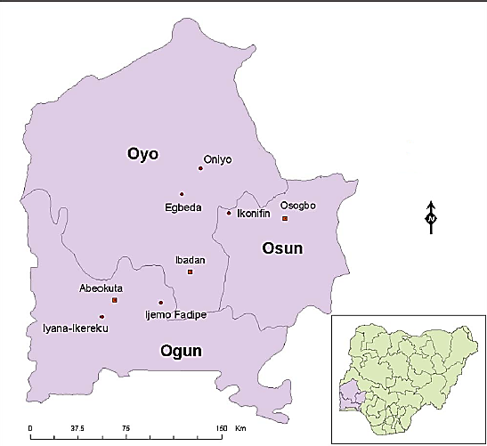

Figure 1. South-west Nigeria (source: http://www.seedbuzz.com/knowledge-center/article/seed-supply-system-for-vegetable-production-at-smallholder-farms-in-southwe).
Methodology
Thermal comfort and parametric optimisation
This study primarily aimed to examine quantitatively thermal comfort and building envelope climate-responsiveness and performance in a typical south-western Nigerian family house. Thermal comfort predictions, derived from the computer modelling software DesignBuilder, were analysed and compared against different building envelope designs (set by tropical design standards). Hence, this study employed the parametric optimisation concept which involves searching for the best possible solution to a problem under the constraints of certain parameters (Lee, Han & Lee, 2016). This study focused on the relationship between air temperature and the building envelope under different climate scenarios, created by a unique specification of building envelope parameters without altering the general model. The operative temperature was considered for thermal comfort, especially as studies have revealed that humidity is generally a minor factor in determining thermal comfort (Mallick, 1996). In addition, the effects on the internal thermal environment due to climate change in south-western Nigeria were also investigated. The ASHRAE 55 adaptive thermal comfort standard served as the bench mark for this analysis. This standard stipulates that for optimum thermal comfort conditions the operative air temperature should be between 23⁰C and 29⁰C.
Geographical context and climate of study
Climatic data were generated by the software Meteonorm (Meteonorm 2015) for the south-western Nigerian city of Ibadan, which is built on seven hills and is approximately 150 km from the Atlantic Ocean. It is geographically located between latitude 7⁰ 20' and 7⁰40'N. The month of March - the warmest month - was chosen for the analysis. Meteonorm was used to generate both current and future weather data files for Ibadan up to the year 2050. Figure 2 shows the annual average temperature, indicating the magnitude of the predicted increase due to climate change.

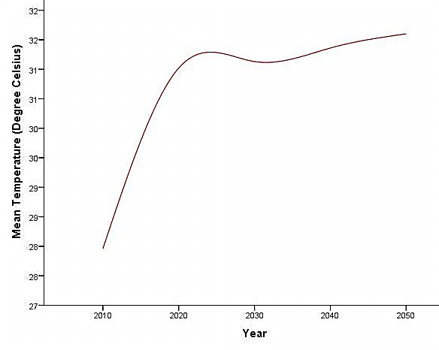
Figure 2. Ibadan’s average annual mean air temperature now and up to 2050 (source: Meteonorm).
House and materials
A typical lower middle-class contemporary low-cost house was modelled using DesignBuilder (see Figure 3). The house had a total floor plan area of 36m² with a lounge (15m²), dining area (11m²), kitchen (11m²), bathroom (10m²) and two bedrooms (each 16m²), and would typically accommodate 4 to 6 people. The base case model consisted of the basic envelope, with external walls made of 230mm cement/plaster mortar blocks; a floor of 126mm reinforced concrete slab with screed; and a pitched, uninsulated roof with a metal covering. No HVAC systems were used. Meteonorm climatic files were exported in an .epw format to DesignBuilder and indoor air temperature values were derived from the simulation analyses. Simulations based on the climatic contexts on a day during the hottest month of the year (March) were produced.
Based on weather data generated by Meteonorm, future weather conditions for south-western Nigeria over the next 35 years were generated to compare thermal comfort parameters now and in the future. The results of the simulation analyses show a rise in outside dry bulb temperature levels (see Figure 2). The building envelope performance was optimised for present (1991-2010 Meteonorm dataset) and future (2050 Meteonorm data set) climates. The month of March, the warmest month, was chosen for analysis. The validity of the DesignBuilder weather data values were checked against field measurements of external temperatures made by Adunola (2014) in Ibadan (Figure 4), and the agreement was satisfactory.

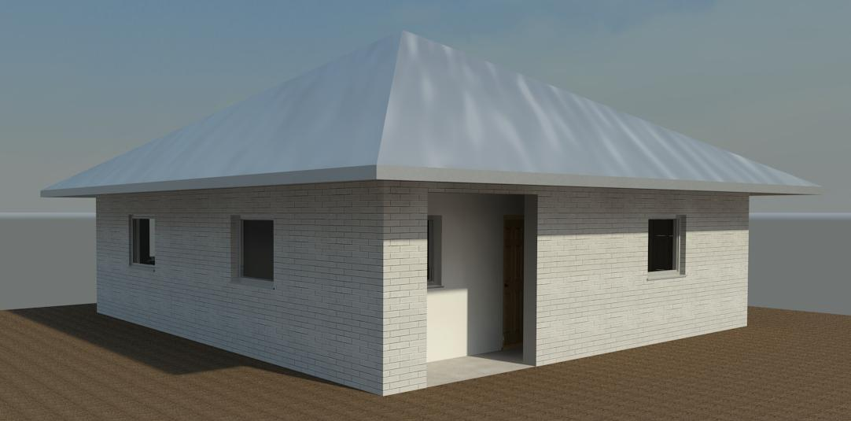
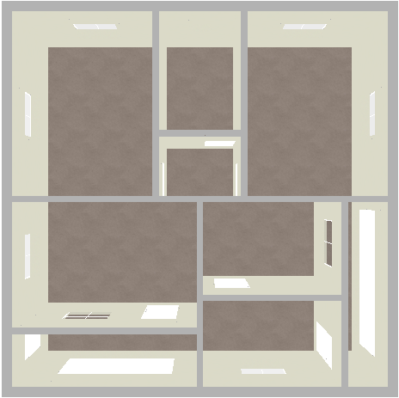
Dining area
Bedroom
Kitchen
Bath
room
Bedroom
Lounge

Figure 3. Base case model – floor plan and 3D model.

Figure 4. Validation of external temperature data for March (source: author’s data analysis; Adunola, 2014).
Results
A parametric analysis for the walls, floor and roof constructions was undertaken for the hottest month of March. This study considered that thermal comfort had been established when the operative temperature (average of indoor air and mean radiant temperature) was within the comfort zone (23⁰C - 29⁰C). For walls, Figure 5 shows that for the current SW Nigerian climate, hollow heavyweight concrete walls performed better than natural adobe or stone walls. However, operative temperatures with heavyweight concrete walls were still outside of the comfort zone (the shaded area in Figures 5 to 8).
Two composite floor types were assessed: reinforced concrete slab and concrete slab with timber joists. The reinforced concrete floor promoted temperatures closest to the comfort zone (see Figure 6). Here, during the hottest periods of the day (12.00 noon to 17.00) temperatures were still outside the thermal comfort range.

Figure 5. Hourly mean indoor operative temperature for different wall materials in March.

Figure 6. Hourly mean indoor operative temperature for different floor materials in March.

Two roofs were examined to optimise the roof performance. These were the hardwood-framed pitched roof and hardwood-framed flat-roof. With the hardwood-framed pitched roof, all the diurnal temperature ranges fell within the comfort range (see Figure 7). Finally, comparisons between the basic dwelling model for present and future climates revealed that the operative temperatures were outside of the thermal comfort range in both instances. However, the optimised building envelope delivered thermal comfort in present and future climates (see Figure 8 (a) and (b)).
Discussion
The best-performing heavyweight hollow concrete block wall contradicts the claims of many studies that promote adobe walls for humid tropical climates (Tessema et al, 2013; Osasona, 2007). Optimisation of the floors also validated concrete as a suitable material for the climate as opposed to the timber material promoted by some studies (Atkinson 1950). For the roofs, a pitched roof undoubtedly performed best, as has been found by previous research (Jiboye & Ogunshakin, 2010). The interesting observation was the fact the concrete walls performed

Figure 7. Hourly mean indoor operative temperature for different roofs in March.
better than adobe walls. Similarly, concrete represented a better option compared to timber, another indigenous building material. Therefore, there seems to be a limit to how much indigenous construction can be integrated effectively with modern construction.

Figure 8. Comparison between optimised and unoptimized versions of SW Nigerian modern house model for present (top graph) and 2050 (bottom graph) climates.

Conclusions and recommendations
Based on the results, it can be concluded that optimising a dwelling’s envelope is a promising way of improving indoor thermal comfort for the present south-west Nigerian climate. Furthermore, the optimisation analyses indicate the ability of the building envelope to adapt to future climates. However, this study has only explored the relationship between temperature and the building envelope within the south-western Nigerian climate presently and in the future. Therefore, there is a need for more investigations into the effects of building envelope optimisation on other indoor environmental parameters, such as natural ventilation and air quality, in present and future climates.

References
ADUNOLA, A. O. (2014) Evaluation of urban residential thermal comfort in relation to indoor and outdoor air temperatures in Ibadan, Nigeria. Buildings and Environment [Online] 75, pp.190-205 DOI: http://dx.doi.org/10.1016/j.buildenv.2014.02.007 [Accessed: 24/5/16]
AMCEN. (2011) Addressing Climate Change Challenges in Africa; A Practical Guide Towards Sustainable Development. [Online] Available from: http://www.unep.org/roa/amcen/docs/publications/guidebook_CLimateChange.pdf [Accessed: 7/11/16]
AOAV. (2014) The Violent Road: Nigeria’s South West. [Online] Available from: http://aoav.org.uk/2013/the-violent-road-nigeria-south-west/ [Accessed: 21/7/14]
ATKINSON, G. A. (1950) African Housing. African Affairs 49(196) pp.228-237
CIA. (2015) The World Factbook – Nigeria. [Online] Available from: https://www.cia.gov/library/publications/the-world-factbook/geos/ni.html [Accessed 30/9/15]
IJEOMA, S (2012) Nigeria & climate change adaptation, International Society of Sustainability Professionals Insight, May, p 1-6.
JIBOYE, A. D. & OGUNSHAKIN, L. (2010) The Place of the Family House in Contemporary Oyo Town, Nigeria. Journal of Sustainable Development 3(2), pp.117-128.
JOHNSON, C., TOLY, N. & SCHROEDER H. (eds.) (2015) The Urban Climate Challenge: Rethinking the Role Of Cities in the Global Climate Regime. New York: Taylor and Francis.
LAITIN, D.D. (1986) Hegemony and Culture: Politics and religious Change among the Yoruba. Chicago: University of Chicago Press.
LEE, K. S., HAN, K. J. & LEE, J. W. (2016) Feasibility Study on Parametric Optimisation of Daylighting in Building Shading Design. Sustainability 8.
MALLICK, F. H. (1996) Thermal Comfort and building design in the tropical climates. Energy and Buildings 23, pp.161-167.
METEONORM (2015) http://meteonorm.com/en/ [Accessed: 14/9/15]
MY DESTINATION. (2014) “Global Home: Nigeria: South West Region Guide. http://www.mydestination.com/nigeria/regionalinfo/6182976/south-west-region [Accessed: 21/7/14]
NIANG, I., RUPPEL, O.C., ABDRABO, M.A., ESSEL, A., LENNARD, C., PADGHAM, J., and URQUHART, P. (2014): “Africa. In: Climate Change 2014: Impacts, Adaptation, and Vulnerability. Part B: Regional Aspects”. Fifth Assessment Report of the IPCC [Barros, V.R., et al (eds.)]. Cambridge University Press, pp. 1199-1265.
OLANIYAN, S. A., AYINLA, A.K. & ODETOYE, A.S. (2013) Building Envelope vis-à-vis indoor thermal discomfort in Tropical Design: How Vulnerable are the Constituent Elements? International Journal of Science, Environment and Technology 2(5), pp. 1370-1379
OSASONA, C.O. (2007) From Traditional Residential Architecture to the Vernacular. http://www.obafemio.com/uploads/5/1/4/2/5142021/nigerianarchitechture.pdf
[Accessed: 9/7/15].
TESSEMA, F., TAIPALE, K. & BETHGE, J. (2009) Sustainable Buildings and Construction in Africa. Germany: Federal Ministry for the Environment, Nature Conservation and Nuclear Safety (BMU) Press.
THIELE, L. P. (2013) Sustainability. Cambridge: Polity Press.
UNFCCC. (2014) Kyoto Protocol. [Online] Available from: http://unfccc.int/kyoto_protocol/items/2830.php [Accessed: 9/7/16]

