Quantifying the Behaviour of Modern and Traditional Construction Systems on the Basis of Thermal Comfort

Seyed Masoud Sajjadian¹, Stephen Sharples²

¹Southampton Solent University, Southampton, United Kingdom
²School of Architecture, University of Liverpool, Liverpool, United Kingdom

Abstract: Thermal comfort is crucial to ascertain the energy consumption in buildings and is a key factor for decision-making in the design of sustainable building envelopes. This paper presents a methodology to assess the performance of construction systems quantitatively on the basis of overall yearly thermal comfort. A framework is proposed to deal with the risk from climate change temperature increases in the UK. A dynamic thermal model with five of the most commonly used construction systems for dwellings was chosen for simulation in London, UK, for current, short term, medium term and long-term climate scenarios using the software Designbuilder. The research investigated the effect of thermal mass and insulation thickness on the behaviour of widely used construction systems based on annual thermal comfort. The study reveals that high level of thermal mass and insulation thickness do not necessarily provide maximum comfort hours in high performance construction systems for future climates.
Keywords: Climate Change, Thermal Mass, Insulation, Thermal Simulation

Introduction
Buildings that can respond to future climate change are less likely to be obsolete, and so future thinking in the early design stages of a building is an essential principle of sustainable development. One of the key parameters to decide energy consumption in buildings and, consequently, to determine possible future optimization is the thermal comfort of occupants. The potential impacts of changes in the UK climate on the built environment have become widely recognized, with possibly the most important feature of these changes being the impact of higher air temperature on building thermal performance. Tabatabaei, et al. (2015) considered the importance of alleviating climate change consequences by passive design features to offset temperature rises. The study also recognized that thermally lightweight homes could cause levels of discomfort by creating higher room temperatures. The research work emphasized that masonry houses, with inherent thermal mass, can result in less energy consumption over their lifetime compared to a similarly designed lightweight timber frame house. A study by Orme et al. (2007) indicated that in lightweight well-insulated houses an outdoor temperature of 29°C might cause overheating, with air temperatures of more than 39°C inside the building. The aim of this study is to quantify the thermal response of some wall construction types to climate change risk. Five of the most commonly used wall construction systems for dwellings were chosen, and all met the German Passivhaus (PH) standard requirements – a standard that can reduce building carbon emissions by up to 80% in the UK (AECB, 2017).

Methodology
Five common construction systems, including traditional and modern methods of construction (MMC), were selected and configured to achieve a U-Value of 0.1 W/m²K. These constructions were used to investigate the effect of thermal mass and insulation thickness on comfort levels using the dynamic thermal simulation software DesignBuilder (DB) that employs EnergyPlus as its calculation engine. The admittance factor, i.e. building fabric response to a swing in temperature (CIBSE, 2006) was taken as a thermal mass performance indicator. The selected construction systems meant low, medium and high thermal mass performances were considered. Current and future weather data for London were used to evaluate the behaviour of the construction systems. Future climate data for three timelines (2020, 2050 and 2080) in London were generated by the ‘CCWeatherGen’ morphing procedure (SERG, 2016). CCWeatherGen morphs Chartered Institution of Building Service Engineers (CIBSE) TRY (Test Reference Year) files in to future EPW files based on projections from the UK Climate Impacts Programme (UKCIP). EPW is the weather file format used by DB.

Climate change
Lisq (2006) emphasized that “the possible impacts of climate change on the building stock being built over the next few decades must be addressed today”. Figure 1 illustrates the psychrometric charts for London in 2011 and 2080, with the comfort zones shown. These charts demonstrate likely temperature increases as well as likely thermal discomfort.
Figure 1. Psychrometric charts for London 2011(left) and London 2080 (right), showing comfort zones

London’s temperatures are expected to increase by around 5°C between 2011 and 2080, with levels of thermal discomfort also rising. Consequently, temperature increases may increase occupant vulnerability to overheating. Reducing this vulnerability will require improvements in both building energy performance and occupant thermal comfort. This paper examines the impact different construction choices can have in tackling the potential risk of overheating in future dwellings.

Wall construction types for UK housing
This research considered five commonly used UK wall construction systems. The selection criteria were:

- Recent utilization in the UK housing industry
- Method appropriate for UK housing
- The potential of achieving the Passivhaus standard (set at 0.10 W/m²K U-Value)

The building model used for the simulations was a simple, single storey single zone room measuring 8m x 8m x 3.2m high with a centrally located south-facing triple glazed window 2m x 3m wide. The infiltration rate was set at 0.25 air change per hour (AC/H). Mechanical ventilation was considered and U-Values of 0.1 W/m²K for the roof and floor and 0.8 W/m²K for a triple glazed window were assumed. The wall constructions examined are shown in Table 1.

Thermal comfort
Several studies have proposed a temperature range of 18-26°C as likely to be within the human comfort zone (Gupta & Gregg, 2012). ASHRAE 55-2004 identified thermal comfort as a subjective response and defined it as the ‘state of mind that expresses satisfaction with existing environment’ (ASHRAE, 2004). Therefore, it seems that a precise value cannot be assigned to thermal comfort. ‘State of mind’ largely depends on residents’ perceptions and expectations. ASHRAE-55 is based on a the static heat balance approach, which includes four environmental variables (dry bulb air temperature, mean radiant temperature, relative humidity and air velocity) and two human variables (activity and clothing level). For simplification and quantification purposes, this paper used this standard as a reasonable way to assess the thermal comfort/overheating results.

Results and discussion
DesignBuilder was used to analyse the thermal performance of the wall systems. The generated London weather data used a high emission scenario from the year 2011 until 2080. Predicted levels of total annual discomfort hours are shown in Figure 2 and given in Table 2.

Figure 2. Total annual discomfort hours in London for four climate periods

Table 1. Wall construction systems used for the simulations

Construction Systems | Details
Brick and Block BB | From Out to in: 110mm Brick Outer Leaf, 300mm Phenolic Insulation, 100mm Aerated Concrete Block, 10mm Lightweight Plaster  Decrement factor (0-1): 0.23; Time Constant (Hrs): 7.7  Admittance ($W$/$m^{2}K$): 5.3; U-Value ($W$/$m^{2}K$): 0.1  Thickness (mm): 520
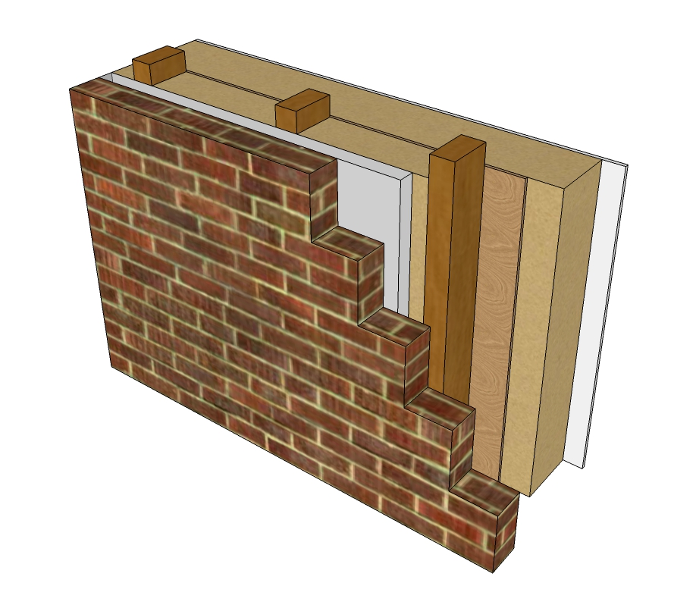  Timber Frame TF | From Out to in: 110mm Brick Outer Leaf, 50mm Air Gap, 140mm Rockwool, 10 mm Plywood, 200mm Rockwool, 12.5mm Plasterboard  Decrement factor (0-1): 0.2; Time Constant (Hrs): 3  Admittance ($W$/$m^{2}K$): 1.54; U-Value ($W$/$m^{2}K$): 0.1  Thickness (mm): 522.5
Insulating Concrete Formwork ICF | From out to in: 5mm Rendering, 120mm Extruded Polystyrene (EPS), 100mm Extruded Polystyrene (EPS), 160mm Heavyweight concrete, 100mm Extruded Polystyrene (EPS), 12.5mm Plasterboard  Decrement factor (0-1): 0.47; Time Constant (Hrs): 5  Admittance ($W$/$m^{2}K$): 2.96; U-Value ($W$/$m^{2}K$): 0.1  Thickness (mm): 497.5
Structural Insulated Panel SIP | From out to in: 5mm Rendering, 15mm Softwood board, 200mm Extruded Polyurethane (PUR), 15mm Softwood board, 50mm Air Gap, 12.5mm Plasterboard  Decrement factor (0-1): 0.81; Time Constant (Hrs): 2.4  Admittance ($W$/$m^{2}K$): 1.16; U-Value ($W$/$m^{2}K$): 0.1  Thickness (mm): 297.5
Steel Frame SF | From out to in: 5mm Rendering, 200mm Extruded Polystyrene (EPS), 10mm Plywood, 90mm Rockwool, 12.5mm Plasterboard  Decrement factor (0-1): 0.36; Time Constant (Hrs): 4.9  Admittance ($W$/$m^{2}K$): 1.39 ; U-Value ($W$/$m^{2}K$): 0.1  Thickness (mm): 317.5

Table 2. Total discomfort hours by year and wall type
Year/Wall | BB | ICF | SF | TF | SIP
2011 | 2284 | 2289 | 2284 | 2260 | 2284
2020 | 2500 | 2504 | 2502 | 2493 | 2498
2030 | 2552 | 2552 | 2551 | 2540 | 2545
2050 | 2648 | 2647 | 2645 | 2623 | 2638

Thermal mass effect
For all periods in London the results from the simulations showed a slight advantage for timber frame (TF) compared to the other wall constructions. Table 1 shows that brick and block (BB) had the highest admittance factor, which demonstrates a high level of thermal mass. However, maximum discomfort hours for most of the times was observed for BB. The behaviour of the steel frame (SF) and insulating concrete formwork (ICF) are almost the same as BB. However, as the climate warms so the performance of the structural insulated panel (SIP) reduced compared to the other systems. The systems all had the same U-Value, and so the thermal mass does not seem to provide a benefit in terms of reducing annual discomfort hours.

Insulation effect
The study reduced the amount of insulation thickness in each construction (i.e. increased the U-Value) to observe the impact of insulation thickness on the overall performance. Figures 3 to 6 demonstrate the results of this insulation reduction for each construction system.

Figure 3. Comparison of insulation thickness effect in BB construction, London

Figure 3 suggests that for the brick and block BB wall, reducing the insulation thickness (from that which gave a 0.1 U-Value) to 200mm and 100 mm (U-Values of 0.13 and 0.2 respectively) does not give significant differences in annual discomfort hours. For the ICF wall (Figure 4), the maximum insulation thickness (320mm) for the 0.1 U-Value provides a small comfort advantage for current weather data compared to the 200mm (0.15 U-Value) and 100mm (0.28 U-Value) insulation thicknesses. However, this benefit narrows and then disappears during the following decades.

Figure 4. Comparison of insulation thickness effect in ICF construction, London

The TF wall (Figure 5) demonstrates a similar trend to the ICF wall, with an initial small comfort benefit for London 2011 weather data as the insulation thicknesses are reduced (U-Values of 0.15 and 0.24 W/m² K for 200 and 100 mm thicknesses respectively). However, as with the ICF wall, the benefit is soon lost.

Figure 5. Comparison of insulation thickness effect in TF construction, London

For the SF and SIP systems (Figures 6 and 7), a 100mm decrease in insulation (0.1 and 0.14 U-Values respectively) has a negible effect on total discomfort hours for any period.

Figure 6. Comparison of insulation thickness effect in SF construction, London

Figure 7. Comparison of insulation thickness effect in SIP construction, London

In general, it seems that any changes in insulation thickness that increases U-Values up to about 0.3 W/m²K will not impact on total annual discomfort hours. It should be mentioned that reducing insulation thickness is likely to decrease the overheating risk and increase the overcooling risk for UK summers and winters respectively. However, this study has considered only the total annual hours of discomfort, adding together both cold and hot discomfort hours to find the annual total.

This point is illustrated in Figure 8. The y-axis shows the number of hours during a year that a certain temperature was experienced in the room for the ICF wall with two insulation thicknesses. So, the ICF room with 100mm insulation experienced 100 hours at 11°C temperature while the 300mm ICF wall had nearly zero hours at 11°C. Even though the overall discomfort hours over a year are close for both ICF constructions, the distributions of the hours in each temperature band are not similar.

Figure 8. Hours at each temperature band interval for an ICF wall with 100 and 300mm of insulation

Conclusion
This study has examined the effects of construction type, thermal mass and thermal insulation on annual thermal discomfort hours for different climate periods in London. The results for a simple house form suggest that the annual discomfort hours are relatively insensitive to the type of building system used. The number of discomfort hours increase in a warming future, but with little difference in total discomfort hours between the differently constructed spaces. Timber frame shows a slightly better performance compared to the others, but no one ‘‘correct’’ construction can be recommended to decision-makers. This finding agrees with a comfort study by the Three Regions Climate Change Group (TRCCG, 2008) of 1960s houses and flats in London, East and Southeast of England. The Group concluded that ventilation strategies, solar control and cooler floors were more effective approaches to improving comfort in UK housing compared to increasing insulation levels.

It appears that a preferred building materials/details can be chosen without worrying that it might be a risky choice for future discomfort. However, there is the caveat that looking at total annual values of discomfort hours can obscure the balance between the ‘hot’ and ‘cold’ discomfort hours. More research is needed to disaggregate the hourly types of discomfort as the energy used to meet a heating demand per °C can be provided much more efficiently and economically than the energy needed to meet the same per °C cooling demand.

References
AECB. (2017, February 27). CarbonLite. Retrieved from http://www.carbonlite.org.uk/carbonlite/passivhaus.ph
ASHRAE. (2004). Thermal Environment Conditions for Human Occupancy. Atlanta: American Society of Heating, Refrigerating and Air-conditioning Engineers organization.
CIBSE. (2006). Guide A: Environmental Design. London: Chartered Institution of Building Services Engineers.
Gupta, R., & Gregg, M. (2012). Using UK climate change projections to adapt existing English homes for a warming climate. Building and Environment, 8-17.
Humphreys MA. (1976). Comfortable indoor temperatures related to the outdoor air temperature. Building Services Engineer, 44, 5-27.
Lisq, K. (2006). Integrated approach to risk management of future climate change impacts. Building research and information, 1-10.
MacLaren, F., Dennis, L., & Mourshed, M. (2012). Public opinions on alternative lower carbon wall construction techniques for UK housing. Habitat International, 3-5.
Orme, M., Palmer, J., & Irving, S. (2003). Control of overheating in well-insulated housing. In: Building sustainability: value and profit. Retrieved Mar 7, 2012, from http://www.cibse.org/pdfs/7borme.pdf
SERG (2016). Sustainable Energy Research Group, University of Southampton), CCWeatherGen: Climate Change Weather File Generator for the UK. Retrieved from http://www.serg.soton.ac.uk/ccweathergen Retrieved Mar 1, 2017
Tabatabei Sameni, S., Gaterell, M., Montazami, A., & Ahmed, A. (2015). Overheating investigation in UK social housing flats built to the Passivhaus standard. Building and Environment, 222-235.
TRCCG (2008) Your home in a changing climate: retrofitting existing homes for climate change impacts. ARUP, London.

