Valuing life: Exploring the history of Quality-Adjusted Life-Years (QALY)
« Previous / Next »
#nav-above
By remedianetwork / May 3, 2017 / Money / Leave a comment
.entry-meta
.post_title
By Eleanor MacKillop
An analysis of the development of QALYs, a central concept in a number of countries’ health decision-making, and the complex political context in which it was formulated, can illuminate contemporary debates about whether QALYs are the best available tools for health care decision-making, and whether they adequately address equity issues, especially around rare diseases and issues of racism and ageism. We need to understand how QALYs have become taken-for-granted metrics by academics, policy-makers and the medical profession, and how economics was mobilized politically to support this concept. To construct this complex history and discuss how and why QALYs emerged in the late 1960s, I examine the origins of the idea, the role of key individuals in its development whom I call ‘policy entrepreneurs’, and the wider context, particularly the growing influence of the economics ‘discourse’ in British society in the post-war period.[1]
The concept of the QALY
The Quality-Adjusted Life-Years (QALY) is an economics concept which assesses the combined impact of a medical intervention on mortality and morbidity in order to evaluate whether such a treatment is cost-effective. Rooted in decision-making theory, the QALY moves beyond consideration of mere survival rates from treated conditions. The status of health is weighted and ranked: perfect health being ranked at 1, while death is given 0. Health interventions are thus measured in terms of QALYs gained, with one extra year of healthy life being equal to 1 QALY. Thus, QALYs allow a comparison of the cost-effectiveness of different medical treatments given at different stages of a person’s life and at different points in a disease trajectory. For example, if a patient has kidney disease, QALYs will help to guide clinical decision making about whether a kidney transplant is more cost-effective than hemodialysis. More controversially, QALYs also allow evaluation of which patients would benefit most from the same treatment (the age of the patient and the particular type of a disease they have, as well as their baseline risk factor). QALYs therefore attempt to place a value on life, something that ethicists like Professor John Harris contend is too abstract and un-costable to be monetized.
Quality-Adjusted Life-Years (QALYs) are now a central factor which influences decision-making in many health systems across the world. For Britain, such decisions are the responsibility of the National Institute for Health and Care Excellence (NICE). Similar systems include the Health Intervention and Technology Assessment Program (HITAP) in Thailand, and the Priceless SA (Priority Cost Effective Lessons for Systems Strengthening) in South Africa. In Britain, the development and use of the QALY from the 1980s by policy makers is linked to the rising costs of running a national healthcare system with growing population morbidity, and can be seen as an indirect form of healthcare rationing.
The post-war context: spiraling costs
From the late 1960s, Britain faced a series of economic shocks and industrial unrest. The cost of healthcare was also growing, with new, technological innovations such as new transplants and renal dialysis. For instance, although heart transplants were only just beginning in the early 1980s, the cost of 60 transplants per year was estimated to have risen from £1.2 million to £2.3 million per year from 1983-84 to 1995-96 (Buxton et al., 1985). Figure 1 below highlights how, between 1960 and 1982, healthcare costs increased from 3.9% to 5.9% of Gross Domestic Product (GDP), with two significant increases taking place around the mid-1970s and early 1980s. Due in part to health innovations such as new drugs and treatments, people in the UK were living longer, and therefore spending more years living in retirement and with potentially greater occurrence of ill health due to longer life.[2] There were also rising expectations about what good health meant, and people wanted easier access to high quality healthcare.
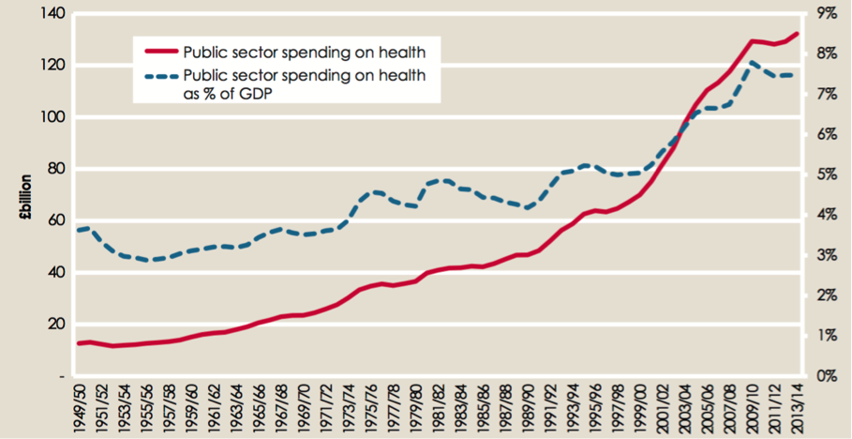
Figure 1: Public spending on health in the UK as a percentage of GDP (Source: Health Foundation, 2015)
An economist interviewed for this project who worked in the Department of Health and Social Security (DHSS) in the 1970s stated that the cost of innovations such as heart transplants “horrified” the Department.[3] There is evidence of these concerns in the archived DHSS files, with one handwritten note from 1970 stating that “the more people we keep alive, the more it will cost the service.”[4] More generally, according to the DHSS economists I interviewed, there was a feeling amongst the employees of the DHSS that rationing in the NHS was inevitable. Indeed, the creation of the service in 1948 had led to a near monopoly where, unlike systems of social or private insurance in continental Europe and the US, health demand could not be limited by the market. Rationing, which until then had been limited to waiting lists, would have to be imposed or implemented by the government.
What were the debates around quality of life?
For the complex American context of policy-making, the policy theorist John Kingdon has compared the process of policy formation to a ‘primeval soup’ in which ideas ‘float around’ (1993). QALYs developed from a number of ideas circulating in different policy communities and networks. For instance, philosophers discussed the question of cost of life from as early as the 1920s in relation to issues of the right to live and eugenism. From the 1940-50s, measuring “Quality of Life” (QoL) had already become a central concern of research for the medical community with the Nottingham Health Profile and the Karnofsky index.
From the late 1960s, Rachel Rosser, Professor of Psychiatry at University College London/Middlesex University, with her husband Victor Watts, an operational researcher working with Ministries such as the Home Office and the DHSS, developed ‘sanative output’ measures to evaluate whether a hospital stay had improved a patient’s health, and to what extent, when compared with their full state of health previously. (see Figure 2 below).
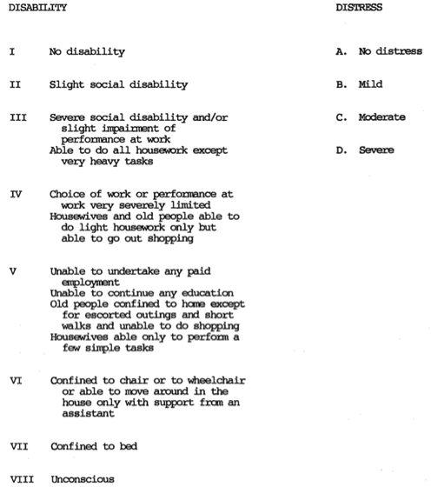
Figure 2: Classification of illness states (Source: Rosser and Watts, 1972)
Rosser’s own methods were continuously developed and tweaked by her, moving from evaluating health states, notably distress and disability, based on legal awards for personal injuries and industrial accidents and diseases, to collecting qualitative data from interviews with patients and health professionals and survey questionnaires to refine these health states scales in the 1970s. Moreover, this research was not having a significant impact on the actions of clinicians, social scientists or policy-makers within and beyond the DH.
The 1980s political context and growth of the discourse of economics
From its creation in 1948, the NHS was treasured by the British public, particularly its public funding and (almost) free access to care.[5] Nigel Lawson, Chancellor of the Exchequer (1983-1989), noted that ‘the NHS was the closest thing that the English have to a national religion’. Any proposal to introduce payments in the NHS or change its financing would be politically risky, as Margaret Thatcher’s later cautious attitude towards the NHS bore out. This question of the cost of the NHS had emerged very soon after the creation of the NHS, with for instance the Guillebaud Committee being commissioned by government to examine this particular question as early as 1953. Over the following decades, discussions in government, academia and society had grown over what could and could not be afforded, the successive Thatcher victories highlighting the grip of the idea of cutting costs and living within our means. Economics, as a set of values and concepts, had grown in prominence, with Harold Wilson’s first government actively facilitating the importance of economists and their role in political and social decision-making. When Labour was elected in 1964, only 25 full-time economists were employed by Whitehall. Five years later, just under 200 were employed, albeit on short-term contracts. This number doubled between 1970 and 1977. And yet, health was a latecomer to this trend, with the first two economists to work specifically on health being hired in 1970, although the famous special adviser and economically trained Brian Abel-Smith had been working on health issues in the Ministry of Health since the 1960s.
Policy entrepreneurs
The MSA approach was to give a role to specific actors and institutions as policy entrepreneurs or “surfers waiting for the right wave” (Kingdon 1984). These entrepreneurs played a key role in policy-making by bringing together, or coupling, the three streams, seizing the opportunity of a particular problem grabbing the nation, and coupling it with a policy solution that had gained ground over the years in the policy stream. For example, they gathered the support of different think tanks, academics and government departments.
Professor Alan Williams (Source: University of York website)
Alan Williams, Professor of Health Economics at the University of York from the late 1960s, enjoyed a wide-ranging academic career as well as having policy impact, perfectly fitting Kingdon’s description of a ‘policy entrepreneur.’ Academic and civil service colleagues referred to Williams in interviews as a “shrewd operator,” a “philosopher of health” and “the grandfather of health economics.” Williams played a pivotal role in bringing together different ideas, contexts and values, and seizing opportunities in the crisis of growing costs of healthcare and restricted budgets to advance his particular solution: QALYs.
Although QALYs were largely formulated by Rachel Rosser, it was Williams who made the concept more palatable, softening it up to make it easy to understand by a non-specialist audience.[6] He changed the maximum value of 497 for perfect health, for example, a figure which did not correspond to anything obvious. What Williams proposed was the integration of measures of quality of life with those of life expectancy to “capture the essence of a person’s healthiness”, thus moving to the now commonly used 0 to 1 scale (Williams, 2005). During his secondment to the Treasury between 1966 and 1968, Williams developed an in-depth knowledge of Whitehall and its workings, and according to a DH civil servant, this experience made “a huge difference in the style of interaction and [its] effectiveness” that Williams developed. He knew who he could ask for research funding in developing QALYs, although another government economist who was involved in the development of QALYs admitted what “we weren’t there inviting [Williams and Rosser] to meetings or doing anything.” When government began to look for ways to promote NHS efficiency and cost reduction, Williams and his economist colleagues, such as Tony Culyer, Alan Maynard, Bob Lavers or Martin Buxton, were able to frame policy solutions in a way that resonated with the government’s agenda.
Why history matters
Recent projects such as the Arts and Humanities Research Council (AHRC) and Institute for Government’s project have sought to examine how policy has been made in the past. This post highlights the complex political and non-necessary history of the QALY, where other options (such as more recently Disability-Adjusted Life-Years (DALYs)) were excluded. Therefore, in understanding past and present policies, it is necessary to examine their multiple origins, the economic, social and political contexts at the time, as well as the protagonists at play. The Wellcome Trust-funded project I am currently collaborating on at the University of Liverpool demonstrates how the history of policy-making – notably by bringing together policy-makers and other actors to discuss past healthcare reforms – can help these protagonists reflect on their roles and actions, as well as provide insight into current policy-making.

Eleanor MacKillop is a Research Associate at the Institute of Psychology, Health and Society at the University of Liverpool (UK). Her research interests include public policy-making, knowledge transfer, organizational change and austerity/crisis. She has recently published an article in Critical Policy Studies examining how English local government has been mobilizing to deal with the government’s austerity agenda. You can follow her on Twitter at @esmackillop.

[1] Here, I understand discourse in its wider poststructuralist sense as a set of ideas, values, actors and other signifiers mobilised by a political project in gaining hegemony (Laclau, 1996)
[2] When in 1948, the average life expectancy was 65 for males and 70 for females, in 1980, it had risen to 71 for males and 77 for females (ONS, 2017)
[3] Interview DH1
[4] TNA/BN13.197
[5] By the 1980s, the original principle of health being free to all at the point of use and based on need had already been eroded, for instance with the introduction of fees for dental and ophthalmological services.
[6] There is debate over who first coined the term ‘QALY’ although the literature would suggest Klarman et al. (1968) first articulated the idea of QALYs with Bush et al. (1972), first coining the term QALY.

