TITLE PAGE
Title: Use of Internet Search Data to Monitor Rotavirus Vaccine Impact in the United States, United Kingdom and Mexico
Authors: Minesh P. Shah^{1,2}, Benjamin Lopman¹, Jacqueline Tate¹, John Harris³, Marcelino Esparza-Aguilar⁴, Edgar Sanchez-Uribe⁵, Vesta Richardson⁵, Claudia A. Steiner⁶, Umesh Parashar¹
- Division of Viral Diseases, National Center for Immunizations and Respiratory Diseases, Centers for Disease Control and Prevention, Atlanta, United States
- Epidemic Intelligence Service, Office of Public Health Scientific Services, Centers for Disease Control and Prevention, Atlanta, United States
- National Institute for Health Research, Health Protection Research Unit GI Infections, University of Liverpool, Liverpool, England
- National Center for Child and Adolescent Health, Ministry of Health, Faculty of Medicine, National Autonomous University of Mexico, Mexico City, Mexico
- Ministry of Health, State of Morelos, Cuernavaca, Mexico
- Center for Delivery, Organization and Markets, Agency for Healthcare Research and Quality, Rockville, United States
Keywords: Rotavirus, Vaccine Effectiveness, Google, Surveillance, Digital Epidemiology
Running Title: Internet Searches and Rotavirus Vaccines
Correspondence: Minesh Shah, MD, MPH
Centers for Disease Control and Prevention
1600 Clifton Road NE, M/S A-34
Atlanta, GA 30329
Email: mpshah@cdc.gov
Phone: (404) 718-1122
Fax: (404) 471-8605

Disclaimer: The findings and conclusions of this report are those of the authors and do not necessarily represent the official position of the Centers for Disease Control and Prevention (CDC) or the Agency for Healthcare Research and Quality (AHRQ).

40-Word Summary: Rotavirus internet searches, as measured by Google Trends, correlated well with laboratory-confirmed rotavirus disease and acute gastroenteritis hospitalizations in the United States, United Kingdom and Mexico. Internet searches declined after introduction of national rotavirus vaccination programs, mirroring rotavirus disease activity.

ABSTRACT
Background: Prior studies have shown strong correlation between internet search and public health surveillance data. Less is known about how search data responds to public health interventions, such as vaccination, and the consistency of responses in different countries. We aim to study the correlation between rotavirus internet searches and disease activity in the United States (US), United Kingdom (UK) and Mexico, before and after rotavirus vaccine introductions.
Methods: We compared time series of internet searches for “rotavirus” from Google Trends with rotavirus laboratory reports from US and UK, and with acute gastroenteritis hospitalizations from US and Mexico. Using time and location parameters, Google quantifies an Internet Query Share (IQS) to measure relative search volume for specific terms. We analyzed correlation between IQS and laboratory and hospitalization data before and after national vaccine introductions.
Results: There was strong positive correlation between rotavirus IQS and laboratory reports for the US (R²=0.79) and UK (R²=0.60), and between rotavirus IQS and acute gastroenteritis hospitalizations for the US (R²=0.87) and Mexico (R²=0.69), p<.0001 for all correlations. Correlations were stronger in the pre-vaccine period compared to the post-vaccine period. Mean rotavirus IQS decreased after vaccine introduction by 40% (95% CI: 25-55%) in the US and by 70% (95% CI: 55-86%) in Mexico. In the UK, there was a loss of seasonal variation after vaccine introduction.
Conclusions: Rotavirus internet search data trends mirrored national rotavirus laboratory trends in the US and UK, and gastroenteritis hospitalization data in the US and Mexico, with lower correlations following rotavirus vaccine introductions.
MANUSCRIPT
Background
Internet access is rapidly expanding in countries across all income levels. The World Bank estimates internet use at 87.4, 91.6, and 44.4 users per 100 people in the United States (US), United Kingdom (UK), and Mexico, respectively [1]. Many internet users use search engines to identify health information; aggregated search data to monitor disease activity has shown both promise and limitations [2-8]. An example limitation is that users may search disease terms for reasons other than current illness, and these non-illness searches may be amplified by transient media coverage, thereby weakening the association between searches and real disease activity.
Rotavirus is the most common cause of severe diarrhea in children worldwide [9]. In countries with national rotavirus vaccination programs, disease burden has been dramatically reduced following vaccine implementation [10]. Google internet searches for rotavirus strongly correlated with rotavirus disease activity in the US and UK from 2004 to 2010 [11]. However, that time period preceded vaccine introduction in the UK and only included two full US post-vaccine rotavirus seasons with reasonable vaccine uptake, limiting conclusions about the value of search data to monitor vaccine impact. Furthermore, that study did not include any middle-income countries, where both internet search behavior and disease surveillance systems may differ compared to high-income countries.
We aimed to assess how well Google internet searches capture rotavirus disease trends as a complement to other approaches to monitoring the impact of rotavirus vaccination programs, especially during a period of rapid change following vaccine implementation in countries of different income levels and vaccination introduction dates and vaccine coverage. We compared internet search data with rotavirus laboratory detection and acute gastroenteritis hospitalization in the United States, United Kingdom and Mexico, which implemented national rotavirus vaccination in 2006, 2013, and 2007, respectively.

Methods
We conducted a time series analysis of internet search, laboratory surveillance data for rotavirus, and hospitalization surveillance data for acute gastroenteritis using multiple data sources detailed below from the US, UK and Mexico. We measured the correlation between internet search and laboratory or hospitalization data before and after implementation of national rotavirus vaccination programs. Our hypothesis was that disease activity was the main driver of search activity, but we also considered the impact of alternative drivers for rotavirus internet searches, specifically rotavirus vaccine-related news events and norovirus illnesses, which causes a similar clinical syndrome.
Internet Search Data
Internet search volume was estimated using Google Trends Internet Query Score (www.google.com/trends), which has been used in other studies of disease monitoring [6]. Google Trends summarizes the relative amount of Google web searches for a given search term in a specified time and location. Each data point is normalized to the total searches within the time and location range it represents, and the resulting values are scaled to range from 0 to 100. Monthly Internet Query Scores (IQS) for “rotavirus” and “rotavirus vaccine” were downloaded on November 13, 2015 for the US, UK and Mexico for the time period of January 1, 2004 – September 30, 2015.
Laboratory Data
National laboratory surveillance data for rotavirus cases and norovirus outbreaks were available for the US and for England and Wales (approximating disease patterns for the UK). US rotavirus laboratory data from January 2004 to September 2015 was sourced from 371 laboratories reporting rotavirus tests to the National Respiratory and Enteric Virus Surveillance System (NREVSS). A variety of clinical, state and county laboratories participate in NREVSS, and laboratory participation varies over time. For this reason, we used the proportion of stool samples that tested positive for rotavirus per month as an indicator of rotavirus activity. US norovirus outbreak laboratory data was sourced from CaliciNet, a national surveillance network of federal, state, and local public health laboratories. Launched in 2009, CaliciNet collects genetic sequence data on laboratory-confirmed norovirus outbreaks (2 or more norovirus-positive samples) reported to 29 state and local health departments across the United States.
Rotavirus and norovirus laboratory data for England and Wales from January 2004 to September 2015 were sourced from LabBase2 (which later became the Second Generation Surveillance System (SGSS) in December 2014), a well-established laboratory reporting system which routinely collects data from laboratories around the UK on positive specimens for many organisms [12]. Using data from this surveillance network, Public Health England publishes weekly rotavirus and norovirus surveillance reports. Since reporting is thought to be relatively consistent over time but negative results are not reported, we used the number of rotavirus-positive test results for analysis.
Hospitalization Data
National hospitalization data for acute gastroenteritis (AGE) of all etiologies were available for the US and Mexico. All-cause AGE trends have been used previously to assess rotavirus vaccine impact on hospitalizations given the high proportion of this syndrome associated with rotavirus and the lack of standardization in testing and coding for rotavirus across hospital sites [13-15]. AGE hospitalizations in the US were sourced from the State Inpatient Databases (SID) of the Healthcare Cost and Utilization Project maintained by the Agency of Healthcare Research and Quality, which captures hospitalizations in acute care community hospitals [16]. We restricted analyses to the 31 states that continuously reported data to SID from January 2004 to December 2013, the most current year for which data were available at the time of this analysis, and representing 76% of the US population under 5 years. HCUP SID data were accessed through an active collaboration between HCUP and CDC. All-cause AGE hospitalizations, including bacterial, parasitic, viral and undetermined etiologies, were identified using ICD-9-CM codes. Per capita rates were calculated by dividing the monthly number of hospitalizations by the number of children younger than 5 years residing in the participating states, using the same methodology as previously described [15].
AGE hospitalizations in Mexico were sourced from the National System for Health Informatics, an electronic database for Mexico’s Ministry of Health hospitals, from January 2005 (the first year of reliable Mexico IQS data) to December 2014. As the catchment populations of the study hospitals were not known, rates of hospitalization for diarrhea per 10,000 hospitalizations from all causes were calculated, using the same methodology as in a prior study of rotavirus vaccine impact in Mexico [17].
Pre- and Post-vaccine Comparisons
We evaluated differences in internet searches, rotavirus laboratory reports and AGE hospitalizations before and after vaccine introduction using unpaired samples t-tests. The boundaries for pre-vaccine and post-vaccine time periods were defined by the months of rotavirus vaccine introduction into national health systems in the United Kingdom (July 2013) and Mexico (May 2007), and by the month of rotavirus vaccine recommendation by the American Academy of Pediatrics in the United States (January 2007). The month of vaccine introduction was excluded from each analysis.
Correlation
We calculated the coefficient of determination (R²) to evaluate how closely laboratory and hospitalization data fit IQS data for all years, and stratified for pre- and post-vaccine time periods for all three countries. We also calculated the R² from multivariable linear regression models to assess the influence of rotavirus vaccine-related searches and norovirus activity (by including “rotavirus vaccine” IQS and norovirus laboratory data, respectively, as explanatory variables) in the United States and United Kingdom models.
Seasonal Variation
In all three countries, vaccine introduction has changed the seasonality of rotavirus infections [17-20]. To assess if seasonality in rotavirus IQS has also been affected, we compared the ratio of peak IQS (i.e., the month with the highest IQS in each season) to the median IQS in each season. A similar peak to average ratio has been used previously as an indicator of seasonal intensity of rotavirus disease, with higher ratios reflecting greater deviation from average, and thus greater seasonal variation [21].

Results
We found strong positive correlations between rotavirus IQS and laboratory data for the US (R²=0.78) and UK (R²=0.52) (Figure 1 and Table 1). Similarly, we found strong positive correlations between rotavirus IQS and AGE hospitalization data for the US (R²=0.86) and Mexico (R²=0.69) (Figure 2 and Table 1). In all analyses, correlations were stronger in the pre-vaccine period (R²=0.83, 0.61, 0.88 and 0.74, respectively) compared to the post-vaccine period (R²=0.68, 0.28, 0.88, and 0.42, respectively) (Table 1).
In the US and UK, months with high norovirus disease activity experienced high rotavirus IQS values despite low rotavirus laboratory detection (Figure 3). Correlation improved with the additions of rotavirus vaccine IQS and norovirus disease activity in both the US and UK (Table 1).
The US mean monthly rotavirus IQS decreased from 36.4 to 25.3 after vaccine introduction, a 30.5% (95% CI, 12.9-48.1%; p=0.0008) reduction (Table 2). Similarly, rotavirus IQS decreased from 32.7 to 10.7 in Mexico after vaccine introduction, a 67.4% (95% CI, 52-83%; p<.0001) reduction. Rotavirus IQS increased in the UK after vaccine introduction, but this increase was not statistically significant (7.3%; 95% CI, 10.1% decrease – 24.7% increase; p=0.41).
Seasonal variation in rotavirus IQS decreased markedly after vaccine introduction in all three countries, with lower peak:median IQS ratios in post-vaccine seasons compared to pre-vaccine seasons (Figure 4). In the UK, the median IQS increased after vaccine introduction, compared to a decrease in median IQS in the United States and Mexico.

Conclusions
Rotavirus internet searches, as measured by Google Trends IQS values, correlated well with laboratory-confirmed rotavirus disease in the US and UK, and with AGE hospitalizations in the US and Mexico. Consistent with decreased rotavirus disease activity after the introduction of national vaccination programs, there were declines in IQS values during peak rotavirus seasons in all three countries.
In each country, there was a lower correlation between rotavirus IQS values and disease activity after vaccine introduction. This finding is most likely explained by internet searches for rotavirus motivated by reasons other than illness, such as queries related to vaccination that are not likely to be seasonal resulting in relatively elevated IQS values in months of low disease activity. Additional alternative motives for internet searches include rotavirus vaccine-related news events and norovirus outbreaks; adding these inputs improves the post-vaccine correlation to approximate pre-vaccine correlation in the US and UK.
In the US, the correlation between rotavirus IQS was stronger with AGE hospitalizations than with rotavirus laboratory detection. The stronger correlation with hospitalizations may be due to higher specificity for rotavirus disease with laboratory testing than with AGE hospitalizations and rotavirus IQS. The difference in specificity is evidenced by more similar variability in monthly values for rotavirus IQS and AGE hospitalizations than with laboratory detection. The amplitude (ratio of maximum:minimum values) for rotavirus IQS was 9, for AGE hospitalizations was 8 (911:115 per 100,000), while for rotavirus test-positive proportion was 45 (0.45:0.01). The trends in activity were similar for all three variables, but the higher variability for the more specific measure of laboratory testing contributes to the lower correlation with the less specific measure of internet searches.
There are several outlier IQS monthly values that were likely attributable to news items related to rotavirus vaccines and not disease. On March 22, 2010, there were media reports that the US Food and Drug Administration (FDA) suspended use of Rotarix after researchers found porcine circovirus genetic material in vaccines [22]. On November 12, 2012, the UK announced that rotavirus vaccine would be added into its national program the following summer. Those months (March 2010 for US, November 2012 for UK) had extremely high rotavirus IQS scores despite low level of disease activity, and thus negatively impacted the correlation results.
Post-vaccine correlation between rotavirus IQS and rotavirus disease was lowest in the UK (0.28) and Mexico (0.42). In the UK, rotavirus IQS did not decline following vaccine introduction, despite a decline in rotavirus laboratory detection. This divergence is in part driven by searches for rotavirus vaccine, as indicated by improved correlation when rotavirus vaccine IQS was added to the model. We also suspect that many vaccine-motivated rotavirus searches did not specify vaccine in the search term. While overall searches for rotavirus did not decline, the seasonal intensity of IQS diminished considerably, consistent with a loss of seasonality in laboratory rotavirus detection after vaccine introduction.
In Mexico, the low post-vaccine correlation between rotavirus IQS and AGE hospitalizations might be due to alternative etiologies of AGE hospitalization (i.e. bacterial enteritis), more commonly seen in low & middle-income countries than high-income countries [23]. This explanation is supported by the observation that annual peaks in AGE hospitalizations in Mexico changed from the fall-winter seasons pre-vaccine, when rotavirus is predominant, to the spring-summer seasons post-vaccine, when rotavirus is rare [17, 20]. Models for AGE hospitalization that included IQS for bacterial pathogens shigella and salmonella (data not shown) had weak individual correlations and did not improve upon models with rotavirus IQS alone. Conversely, post-vaccine correlation between US rotavirus IQS and AGE hospitalization remained strong (0.88) as non-rotavirus etiologies of hospitalized AGE are less common [15, 24, 25].
Our study has several limitations related to how time series data may not reflect disease activity. Changes in lab testing practices could affect the rotavirus and norovirus laboratory data from the US and UK. Changes in non-rotavirus gastroenteritis disease could affect hospitalization data. Google Trends data could be affected by changes in who has internet access over time, the type of information available on the internet, and the type of information that people search for during the study time period. Another limitation is generalizability to other countries, which may have differences in internet access by socio-economic strata, internet search behavior and rotavirus testing practices.
In conclusion, our study suggests that internet searches can approximate rotavirus disease activity, though should be contextualized by considering competing search motivations. Internet searches can complement, but not replace, other surveillance approaches to monitoring the impact of rotavirus vaccination programs. Our findings are made more robust by showing similar results across three different countries using both laboratory and epidemiologic measures of disease activity, and similar changes after the introduction of rotavirus vaccination programs. Furthermore, divergence in internet search and disease activity can retrospectively be adjusted for in models that consider variables that prompt similar searches, but media events that garner public attention can limit the use of these approaches in real-time. Continued growth in internet access world-wide adds promise to the role of big data sources, including internet search, social media, and commercial activity, as a complement to traditional disease surveillance, especially given its low cost, timeliness, and ease of use.

Funding
This work received no external funding.
Acknowledgements
Thank you to the state partners that provide the SID data to the HCUP.

References
1. The World Bank, World Development Indicators 2015. http://data.worldbank.org/data-catalog/world-development-indicators. Accessed December 17, 2015.
2. Brownstein, J.S., C.C. Freifeld, and L.C. Madoff, Digital Disease Detection — Harnessing the Web for Public Health Surveillance. New England Journal of Medicine, 2009. 360(21): p. 2153-2157.
3. Carneiro, H.A. and E. Mylonakis, Google trends: a web-based tool for real-time surveillance of disease outbreaks. Clin Infect Dis, 2009. 49(10): p. 1557-64.
4. Ginsberg, J., et al., Detecting influenza epidemics using search engine query data. Nature, 2009. 457(7232): p. 1012-1014.
5. Salathé, M., et al., Digital Epidemiology. PLoS Comput Biol, 2012. 8(7): p. e1002616.
6. Nuti, S.V., et al., The Use of Google Trends in Health Care Research: A Systematic Review. PLoS ONE, 2014. 9(10): p. e109583.
7. Milinovich, G.J., et al., Internet-based surveillance systems for monitoring emerging infectious diseases. The Lancet Infectious Diseases, 2014. 14(2): p. 160-168.
8. Lazer, D., et al., Big data. The parable of Google Flu: traps in big data analysis. Science, 2014. 343(6176): p. 1203-5.
9. Parashar, U.D., et al., Global illness and deaths caused by rotavirus disease in children. Emerg Infect Dis, 2003. 9(5): p. 565-72.
10. Tate, J.E. and U.D. Parashar, Rotavirus vaccines in routine use. Clin Infect Dis, 2014. 59(9): p. 1291-301.
11. Desai, R., et al., Use of Internet search data to monitor impact of rotavirus vaccination in the United States. Clin Infect Dis, 2012. 54(9): p. e115-8.
12. Wall, P.G., et al., Food poisoning: notifications, laboratory reports, and outbreaks--where do the statistics come from and what do they mean? Commun Dis Rep CDR Rev, 1996. 6(7): p. R93-100.
13. Cortes, J.E., et al., Rotavirus vaccine and health care utilization for diarrhea in U.S. children. N Engl J Med, 2011. 365(12): p. 1108-17.
14. Curns, A.T., et al., Reduction in acute gastroenteritis hospitalizations among US children after introduction of rotavirus vaccine: analysis of hospital discharge data from 18 US states. J Infect Dis, 2010. 201(11): p. 1617-24.
15. Leshem, E., et al., Acute gastroenteritis hospitalizations among US children following implementation of the rotavirus vaccine. Jama, 2015. 313(22): p. 2282-4.
16. HCUP State Inpatient Databases (SID). Healthcare Cost and Utilization Project (HCUP). 2004-2013. Agency for Healthcare Research and Quality, Rockville, MD. www.hcup-us.ahrq.gov/sidoverview.jsp
17. Esparza-Aguilar, M., et al., Diarrhoea-related hospitalizations in children before and after implementation of monovalent rotavirus vaccination in Mexico. Bulletin of the World Health Organization, 2014. 92(2): p. 117-125.
18. Tate, J.E., et al., Decline and change in seasonality of US rotavirus activity after the introduction of rotavirus vaccine. Pediatrics, 2009. 124(2): p. 465-71.
19. Atchison, C., B. Lopman, and W.J. Edmunds, Modelling the seasonality of rotavirus disease and the impact of vaccination in England and Wales. Vaccine, 2010. 28(18): p. 3118-26.
20. Velazquez, F.R., et al., Diarrhea morbidity and mortality in Mexican children: impact of rotavirus disease. Pediatr Infect Dis J, 2004. 23(10 Suppl): p. S149-55.
21. Patel, M.M., et al., Global seasonality of rotavirus disease. Pediatr Infect Dis J, 2013. 32(4): p. e134-47.
22. Victoria, J.G., et al., Viral nucleic acids in live-attenuated vaccines: detection of minority variants and an adventitious virus. J Virol, 2010. 84(12): p. 6033-40.
23. Kotloff, K.L., et al., Burden and aetiology of diarrhoeal disease in infants and young children in developing countries (the Global Enteric Multicenter Study, GEMS): a prospective, case-control study. The Lancet. 382(9888): p. 209-222.
24. Glass, R.I., et al., The epidemiology of rotavirus diarrhea in the United States: surveillance and estimates of disease burden. J Infect Dis, 1996. 174 Suppl 1: p. S5-11.
25. Fischer, T.K., et al., Hospitalizations and deaths from diarrhea and rotavirus among children <5 years of age in the United States, 1993-2003. J Infect Dis, 2007. 195(8): p. 1117-25.

FIGURES AND TABLES
Figure 1. Rotavirus Internet Query Share (IQS) compared to rotavirus laboratory detection in the United States (A) and United Kingdom (B). United Kingdom data is from England and Wales only
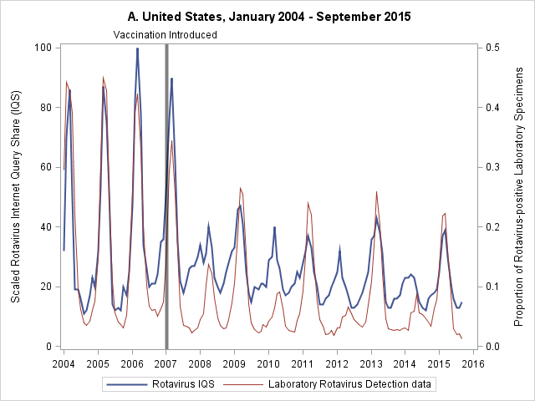
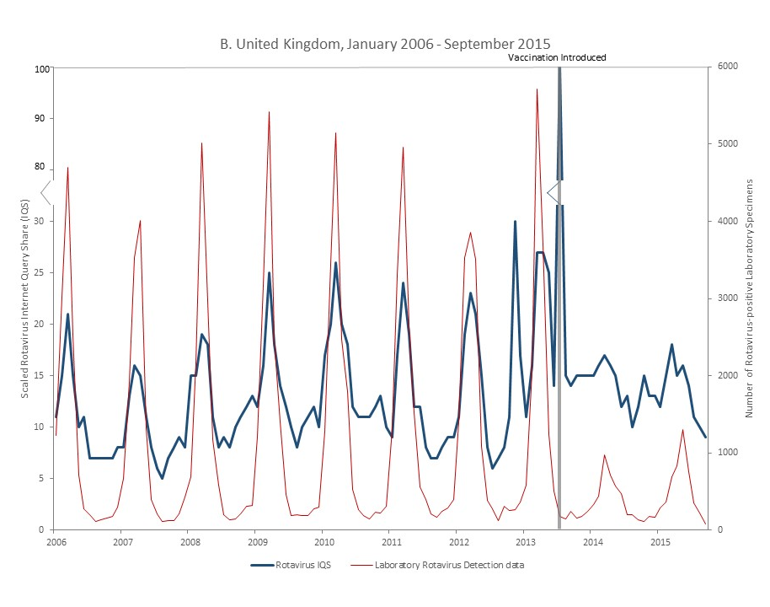
Figure 2. Rotavirus Internet Query Share (IQS) compared to under 5 acute gastroenteritis (AGE) hospitalization rates in the United States (A) and Mexico (B). US AGE rates are for the 31 states that consistently reported to State Inpatient Database from 2004-2013.
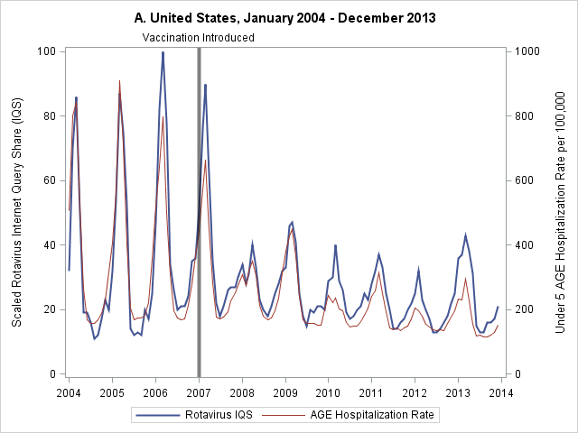
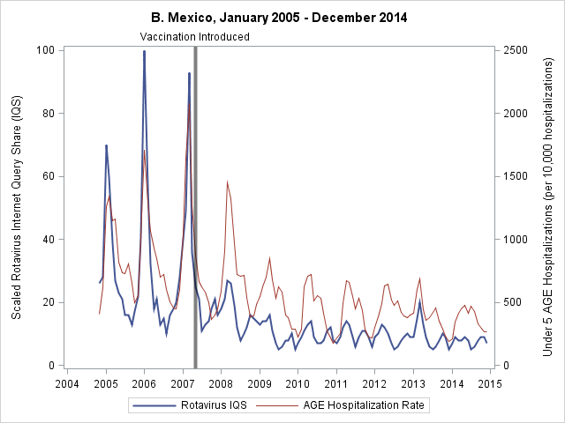
Figure 3. Impact of laboratory-confirmed norovirus outbreaks in the United States (A) and United Kingdom (B) on rotavirus Internet Query Share (IQS), all available data.
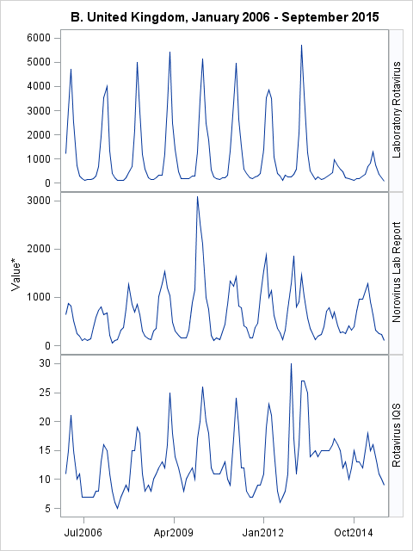
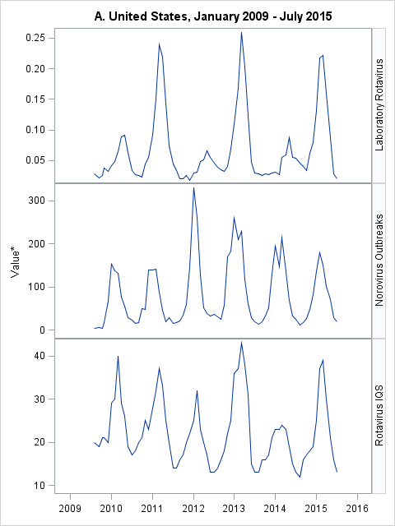
*Y-axis values are: Norovirus outbreaks (US) or laboratory reports (UK), Rotavirus Internet Query Share, and Proportion (US) or Number (UK) of Rotavirus-positive laboratory tests. Shaded bars show seasons where peaks in Norovirus Outbreaks match Rotavirus IQS trend despite low Rotavirus Laboratory activity. UK data is from England and Wales only and excludes July 2013 (vaccine introduction).

Figure 4. Seasonal Variation in Rotavirus Internet Query Share (IQS) in the United States (A), United Kingdom (B) and Mexico (C). Seasons are from July of first year to June of second year. Months of rotavirus vaccine introduction are excluded.
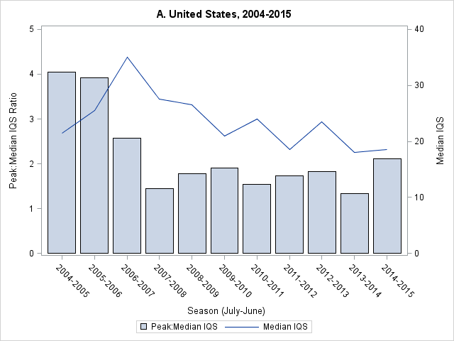
Vaccination Introduced
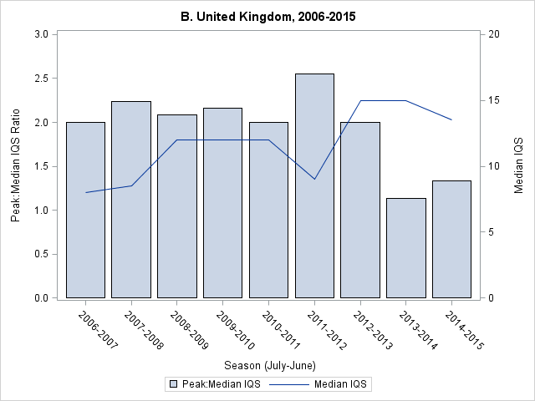
Vaccination Introduced

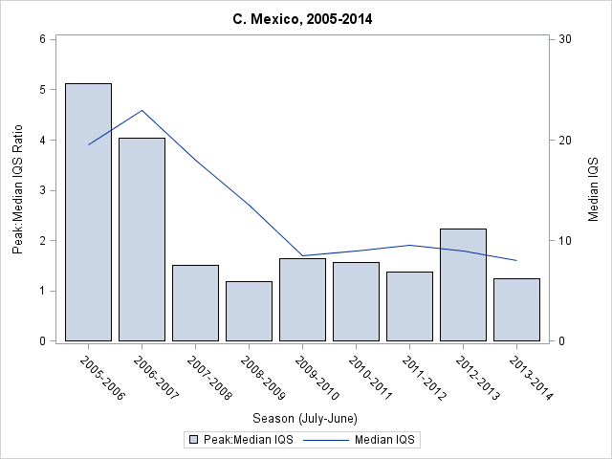
Vaccination Introduced

Table 1. Summary of correlation models between rotavirus Internet Query Share (IQS) and rotavirus laboratory detection or under 5 acute gastroenteritis (AGE) hospitalization rates before and after national rotavirus vaccination programs, United States, United Kingdom and Mexico.
 |  | Rotavirus IQS
Country | Input Variable(s) | All Seasons |  |  | Pre-Vaccine |  |  | Post-Vaccine
 |  | R² | p-value | R² |  | p-value | R² |  | p-value
United States | Rotavirus Laboratory Detection | 0.78 | <.0001 | 0.83 |  | <.0001 | 0.68 |  | <.0001
United Kingdom | Rotavirus Laboratory Detection | 0.52 | <.0001 | 0.61 |  | <.0001 | 0.28 |  | 0.005
United States | Under 5 AGE Hospitalization Rate | 0.86 | <.0001 | 0.88 |  | <.0001 | 0.88 |  | <.0001
Mexico | Under 5 AGE Hospitalization Rate | 0.69 | <.0001 | 0.74 |  | <.0001 | 0.42 |  | <.0001
United States | Rotavirus Laboratory Detection+  Rotavirus Vaccine IQS | 0.82 | <.0001 | 0.93 |  | <.0001 | 0.70 |  | <.0001
 |  |  | 0.0042 |  |  | 0.0021 |  |  | 0.0136
United Kingdom | Rotavirus Laboratory Detection +  Rotavirus Vaccine IQS | 0.64 | <.0001 | 0.67 |  | <.0001 | 0.49 |  | 0.0006
 |  |  | <.0001 |  |  | 0.0008 |  |  | 0.006
United States | Rotavirus Laboratory Detection +  Rotavirus Vaccine IQS +  Norovirus Outbreaks | N/A |  | N/A |  |  | 0.81 |  | <.0001
 |  |  |  |  |  |  |  |  | 0.0009
 |  |  |  |  |  |  |  |  | <.0001
United Kingdom | Rotavirus Laboratory Detection +  Rotavirus Vaccine IQS +  Norovirus Laboratory Reports | 0.66 | <.0001 | 0.68 |  | <.0001 | 0.59 |  | 0.002
 |  |  | <.0001 |  |  | 0.002 |  |  | 0.003
 |  |  | 0.08 |  |  | 0.35 |  |  | 0.03

Time periods are US All Seasons: Jan 2004 – Sep 2015, US Pre-Vaccine: Jan 2004 – Dec 2006, US Post-Vaccine: Feb 2007 – Sep 2015, UK All Seasons: Jan 2006 – Sep 2015, UK Pre-Vaccine: Jan 2006 – Jun 2013, UK Post-Vaccine: Aug 2013 – Sep 2015, Mexico All Seasons: Nov 2004 – Dec 2014, Mexico Pre-Vaccine: Nov 2004 – Apr 2007, Mexico Post-Vaccine: Jun 2007 – Dec 2014. US AGE Hospitalization data is Jan 2004 – Dec 2013. UK laboratory data is from England and Wales only. Months of national rotavirus vaccine introduction are excluded.

Table 2. Rotavirus Internet Query Share (IQS), rotavirus laboratory detection, and under 5 acute gastroenteritis (AGE) hospitalization rates, before and after national rotavirus vaccination programs, United States, United Kingdom and Mexico.
Country | Input Variable(s) | All Seasons |  | Pre-Vaccine |  | Post-Vaccine
 |  | Mean | 95% CI | Mean | 95% CI | Mean | 95% CI | Percent Decrease Post-Vaccine (95% CI) | p-value
United States | Rotavirus IQS | 28.2 | 25.3-31.1 | 36.4 | 27.7-45.2 | 25.3 | 22.9-27.7 | 30.5% (12.9-48.1%) | 0.0008
 | Percentage of Rotavirus-positive lab specimens | 10.4 | 8.6-12.1 | 17.6 | 12.5-22.6 | 7.9 | 6.5-9.3 | 55.1% (34.1-76.1%) | <.0001
 | Under 5 AGE  hospitalization rate  (per 100,000 children) | 261.4 | 231.5-291.2 | 364.7 | 287.5-441.8 | 216.6 | 194.8-238.3 | 40.6% (24.3-56.9%) | <.0001
United Kingdom | Rotavirus IQS | 13.2 | 12.2-14.1 | 12.9 | 11.8-14.1 | 13.9 | 13-14.8 | -7.3% (-24.7 – 10.1%) | 0.41
 | Number of Rotavirus-positive lab specimens | 1,097.6 | 840.1-1,355.0 | 1,300.6 | 981.5-1,619.7 | 395 | 270.3-519.6 | 69.6% (23.7 - 115.5%) | 0.0033
Mexico | Rotavirus IQS | 16.2 | 13.5-19.0 | 32.8 | 24.3-41.4 | 10.7 | 9.7-11.7 | 67.4% (52-83%) | <.0001
 | Under 5 AGE  hospitalization rate  (per 10,000 hospitalizations) | 593.9 | 533.7-654.1 | 921.5 | 767.4-1,075.6 | 485.9 | 440.9-530.9 | 47.3% (34.7-59.8%) | <.0001

Time periods are US All Seasons: Jan 2004 – Sep 2015, US Pre-Vaccine: Jan 2004 – Dec 2006, US Post-Vaccine: Feb 2007 – Sep 2015, UK All Seasons: Jan 2006 – Sep 2015, UK Pre-Vaccine: Jan 2006 – Jun 2013, UK Post-Vaccine: Aug 2013 – Sep 2015, Mexico All Seasons: Nov 2004 – Dec 2014, Mexico Pre-Vaccine: Nov 2004 – Apr 2007, Mexico Post-Vaccine: Jun 2007 – Dec 2014. US AGE Hospitalization data is Jan 2004 – Dec 2013. UK laboratory data is from England and Wales only. Months of national rotavirus vaccine introduction are excluded.

