Polycentric development practice in Master Planning: The case of China

Abstract
Towards the end of 20th century, polycentricity was introduced into China as a planning concept. Subsequently a number of super/mega city regions began to adopt polycentric development spatial planning strategies, which are designed to facilitate more sustainable and balanced development. This paper seeks to identify the main differences in application of polycentricity between China and the West, and explore the major emerging thematic strands of polycentric development practice, as illustrated through an evaluation of master planning in eight super/mega city regions across China. In particularly the paper highlights the divergent interpretations of polycentricity in master plan-making practice and shows how plans have been adjusted to help deliver the idea of polycentric development. Although the concept of polycentricity is relatively new in China, it has already become a normative approach used to determine future spatial structures. Whilst is there an absence of an articulated rationality to ‘decide’ whether this is (or should be) an ‘ideal’ model, already it has gone beyond Western approaches of initially using polycentricity as an interpretative tool to describe urban realities.

Key words
polycentricity, urban planning, master planning, super/mega city regions, sustainable development

Introduction
The central idea of polycentricity can be traced back to Geddes in early 20th century, or even Howard in late 19th century. But the term polycentricity was not used. Nevertheless since the early 1990s, the urban space in Europe, North America and Japan have all increasingly shown polycentric development trends (Yang and Cai, 2008), suggesting that urban spatial structures were entering a new stage of development. Researchers in Western countries have been using multiple methods to study the morphology and composition of polycentric development across a variety of spatial scales. Nevertheless the concept has been clouded in ambiguity depending on methodological tradition and geographical context (Meeteren et al 2016). In literature the concept has increasingly been invoked in recognition of the existence of multiple centres in one area (Kloosterman and Musterd (2001) and when articulated in a policy context often has the normative objective of seeking balanced development within cities and/or regions (Hall and Pain, 2006).
Polycentricity, as a means of describing the urban landscape in advanced western economies, has been applied at range of different scales. At a city/city regional scale, examples included Atlanta (Fuji and Hartshorn, 1995; Harshorn and Muller, 1989), Cleveland (Bogart and Ferry, 1999), San Francisco (Cervero and Wu, 1997), Houston (Craig and Ng, 2001), California (Modarres, 2011), Barcelona (Garcial-Lopez, Miquel-Angel etc. 2010), Rome and Milan (Paolo, 2013), and Rotterdam (Musterd and Zelm, 2001) ; at a country scale Belgium (Riguelle et al 2007; Hanssens et al 2013); at a transnational scale perhaps the most famous is the European Spatial Development Perspective (ESDP) (CEC1999). From a planning policy perspective at least, polycentricity can therefore refer to at least three spatial scales: 1) an intra-urban or ‘micro’ agglomeration scale; 2) an inter-urban or the territorial or ‘meso’ scale and 3) an inter-regional or the pan-European ‘macro’ level (Davoudi, 2003; Sykes 2005).
Towards the end of 20th century, the concept of polycentricity was introduced to China, although critical research was still in its infancy, and influential theories on polycentricity have not yet been constructed which are bespoke to the country context (Wang etc. 2012). The few studies on polycentricity in China have mainly focused on reviews and introducing the idea of polycentricity based on Western interpretations (Qin and Li, 2012; Li, 2012; Shi, 1999; Shen, Zhang and Chen, 2005), the way cities and city regions exhibit patterns of polycentricity (Wei and Zhao, 2006; Li and Zhao, 2011; Wang and Sun, 2011, Mu and Yeh, 2016, Li and Phelps 2016; Zhoa et al 2017) and the governance of polycentric city regions (Zhang etc. 2008, Zhang, 2016, Huang and Hay;2016). Nevertheless a number of metropolitan areas have adopted polycentric spatial planning development strategies which are intended to guide future development (Luo and Zhu, 2008). However, after more than ten years of an application of the ideas polycentricity into planning policy, there is little research available which evaluates whether this concept has successfully been applied from a policy perspective. Instead much of the research evaluates the patterns associated with connections and linkages within and between particular cities or metropolitan regions (e.g. the urban structure of Shanghai (Sun, Shi and Ning, 2010); co-production of knowledge linkages in the Yangtze River delta (Li and Phelps 2016) or intercity connections and migration patterns within city regions (Mu and Yeh, 2016) and ascribes these to polycentricity. In an attempt to overcome this limitation, this paper attempts to critically evaluate the application of polycentric policy development practice in China through the lens of master planning. Hence the paper is focused on exploring the emergence of planning practice and identifying any challenges arising from this application in practice.
The paper starts by providing an overview of polycentricity more generally and its introduction into China in particular, before evaluating the way the concept has been applied in practice overtime in selected super-mega city regions at a variety of scales, before focusing in particularly on Guangzhou and Nanjing. The analysis is based on a review of formal planning documents over time. This then highlights similarities and differences in the way that polycentricty has been interpreted and applied between the west and China.

A conceptual framework for evaluating polycentric practice in master planning in China.

2.1 Conceptualising Polycentricity in Practice
Before evaluating polycentric application through the lens of master planning, the defining characteristics of polycentricity needs to be identified. There is an increasing literature that has been exploring the linkages which exist within and between nodes at a variety of spatial scales. This is often reflected in an academic discourse which explores these ideas through patterns of networked connectivity (see for example, from a Chinese perspective, Li and Phelps, 20160, Mu and Yeh, 2016 and Zhao et al 2017). This stems from what Shaw and Sykes (2004) describe as an emerging academic but contested discourse about what polycentricity means. Is it merely a pattern that can be observed which reflects growing interconnectivity between different places at different scales, and is emerging largely as a function of increasing global competitiveness? From such a perspective an interesting question emerges as how do such trends become embedded in policy making discourses? From a European perspective, for example, polycentric policy making during the early part of the 20th century was largely top down, applied at a variety of scales and interpreted differently in different places for different purposes. In some cases it was an analytical tool, in some cases a rhetoric device for re-imaging places and the interconnectivities that existed at different scales, or a policy tool to foster collaboration and balanced development often used as a fig leaf to cover the spatially discriminating effects of none spatial policies (Jenson and Richardson, 2000, Kunzmann 2000, Shaw and Sykes 2003, 2004).
Nevertheless from a policy perspective is often associated with two theoretically distinct aspirations: functional balance and spatial integration (Burger et al., 2011, Burger and Meijers, 2012; Vasanen, 2013; Lambregts 2009; Burger 2011). These two perspectives when combined have become the new objective of ‘functional polycentric’ development, which, if applied at a regional scale, can deliver an ‘integrated polycentric region’. A defining feature of polycentricity therefore can be regarded as similar sized independent centers with horizontal functional linkages replacing the classical urban hierarchy. The spatial relationship of the centers should be defined by their horizontal connections and functional interdependences at a variety of spatial scales (Qian and Wong, 2012).
Hence the basic nature of polycentricity, from a policy perspective, should embody two major principles: a settlement system and a spatial structure. In other words urban form should be considered as a network system consisting of urban centers and rural towns, or functional interdependent centers/towns all of which are horizontally and functionally interconnected at different spatial scales.
In this paper we particularly focus on the way the policy makers, through the development of selected master plans, have applied polycentricity ideas and principles. For the city-regional level, polycentricity application can be regarded as a form promoting an interconnected multi-nodal structure, with functionally interdependent centers balanced across city regions. For the metropolitan level, polycentricity application often refers to a polycentric or multi-centered spatial structure. For the central city level, sub-centers within an urban development framework often with horizontal connections becomes a polycentric model. Based on the two major concepts of polycentricity (outlined above) and the defining criteria for each level of application, we will evaluate the application of polycentricity in selected super/mega city regions to see how exactly the concept was applied in plan making at each spatial scale and whether it complies with the basic nature of polycentricity in practice.

2.2 Urban and rural planning system and planning levels in City Master Plans of China
The current urban and rural planning system in China was introduced in 2008 through the Urban and Rural Planning Act (2008). This replaced the former Urban Planning Act which existed from 1990. Up to 2008 urban planning frameworks were very focused exclusively on the development trajectories of the cities themselves. In theory the 2008 system created a more integrated and holistic planning approach exploring not just urban form but also the connectivities, both real and potential between settlements to create a more integrated network covering rural and urban areas (see Figure 1).

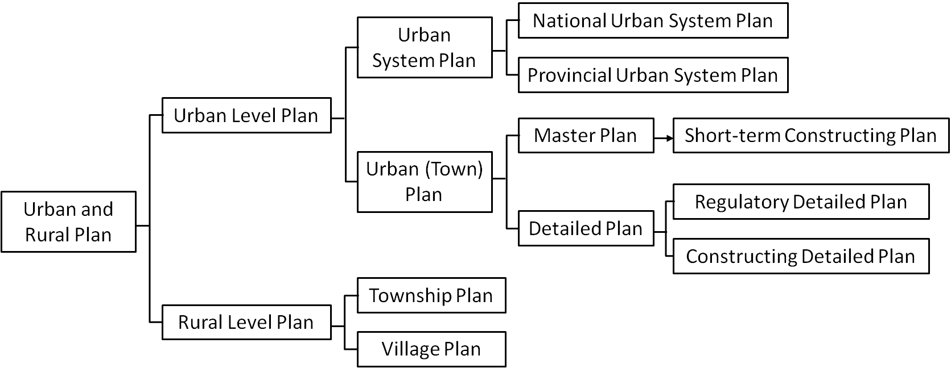
Fig. 1 Urban and rural planning system currently practiced in China
Sources: Urban and Rural Planning Act (2008); Qian and Wong, 2012.

Based on the urban and rural planning system outlined in Figure 1 a city region’s urban (town) system planning and county’s urban (town) system planning were not legally binding but were designed to create a framework to guide urban master plans and rural level plans. Hence under the new urban and rural planning system urban master planning is being extended from the central city to cover the entire city administrative area (Qian and Wong, 2012), with urban master planning being understood as an integrative planning tool considering both rural and urban needs together. Therefore, in most cases in China, a City Master Plan (chengshi zongti guihua) generally includes two (but may include three) levels of planning. The term city region (shi yu) is used here for the highest level of planning and focuses on the concept of functional regions often comprising a core or main city and its surrounding counties. The spatial scale for city regional level urban (town) system planning is the whole administrative area, which includes all the urban districts, administrative counties and county-level cities. In some cases, middle-level planning, sometimes called metropolitan planning can be included in master planning activities of some cities. This usually focuses upon a metropolitan area (shi qu/dushiqu) and planning policy covers the central city, its urban-rural fringe and some rural areas. Nevertheless the most important plan is focused on the central city (zhongxinchengqu). Normally it covers the continuous built-up of the central city and regulates the major future development of this area (see table 1).
Table 1 Spatial scope of different levels of City Master Plans in China
Planning level | Spatial scope
City region(shi yu) | Entire city administrative area
Metropolitan area  (shi qu/dushiqu) | Central city, its urban-rural fringe and some rural areas
Central city (zhongxinchengqu) | The continuous built-up of the central city

2.3 Tracing the origins of polycentricity practice in China
After the founding of modern China, in 1949, urban construction was mostly focused on the central part of city (Shi, 1999). This resulted in an increasingly monocentric urban structure characterised by a concentration of city functions and high population densities in the core cities. Further expansion of these urban agglomerations quickly meant that the drawbacks of monocentric model become increasingly evident. In an attempt to overcome the diseconomies of scale associated which such development trends, Shanghai and Beijing in particular, drew inspiration from the development experiences of large Western cities. A number of new development zones, high-tech industrial parks, township industrial parks and various other forms of development were rapidly promoted in suburban areas, with the expressed purpose of decanting the ever expanding population and industries from central areas. For example, from the beginning of the 1950s, Shanghai established six suburban industrial areas, including Wusong, Wujiaochang, Yangpu, Caohejing, Changqiao and Gaoqiao, and seven outer suburban satellite towns, Jiading, Anting, Songjiang, Minhang, Wujing, Jinshanwei and Baoshan. Beijing followed suite establishing satellite towns such as Yanshan, Tongzhou, Huangcun and Changping (Shi, 1999).
The early creation of these industrial parks and satellite towns certainly played a role in relocating expanding industries and population from the central cities. However, since they were largely single functional industrial areas or suburban residential areas, the development of much of the necessary key infrastructure and public services failed to keep pace with the speed of development. This often made these satellite places extremely unattractive to new residents. Furthermore, many the early successes in terms of growth rates was dependent on foreign investments which, combined with a slowing down in economic growth and acute resource bottlenecks has, today, exacerbated these problems outline above in Chinese development zones. Hence development of single functional industrial areas or residential areas is recognised as being challenging and there are urgent calls for planned interventions to ensure a restructuring and strategic adjustments to these places (Yuan and Wang, 2010; Che, 2012).
Shanghai’s City Master Plan (1999-2020) covering the functional region, for example, proposed an urban spatial structure of ‘multi-axis, multi-levels, multi-cores’, which would be made up of the central city, new towns, central towns and market towns. ‘Multi-cores’ at different spatial scales can be regarded as the first representation of a polycentric spatial structure, and indeed, the first application of polycentricity to master planning in China. Following Shanghai, other large cities or metropolitan areas, also proposed strategies and policies designed to build a more polycentric spatial structure. Hangzhou’s City Master Plan (2001-2020) put forward an open spatial structure of ‘one core-two circles, three axes-two corridors, and one ring- multi-centres’. Beijing City Master Plan (2004-2020) also argued for a more integrate spatial structure comprising ‘two axes - two belts - multi-centres’. A regional spatial layout of ‘an axis-two belts-three zones’ was proposed in the Tianjin City Master Plan (2005-2020) and Guangzhou, in its City Master Plan for 2001 to 2020, presented the idea of transforming its urban spatial structure from a mono-centric to a polycentric form along the Pearl River. In consideration of the increasing adoption of polycentricity concept in master planning, next the paper provides a broad overview of polycentricity application in selected super/mega city regions before moving on to a more detailed analysis of specific examples.

An Overview of polycentricity application in Chinese master planning

3.1 Selection of Chinese super/mega city regions in terms of polycentricity application
Reflecting the enormous changes that have taken place in the scale and rate of urbanisation in China since 1990, on November 20th 2014, the State Council of China issued a new ‘Notification on the adjustment of city size classifications criteria.’ This then replaced what had been a fourfold classification, which had been used since the 1990 Chinese City Planning Act. Using resident population in urban districts as the statistical standard, it classified all cities into five groups:-
- a small city has a resident population in urban districts of under 0.5 million ;
- a medium-sized city has a resident population in urban districts of between 0.5 million and 1 million ;
- a large city has a resident population in urban districts of between 1 million and 5 million ;
- a mega city has a resident population in urban districts of between 5 million and 10 million ; and,
- a super city has a resident population in urban districts of over 10 million.

Based on this classification, and the sixth national census which took place in 2010, there were 16 super/mega cities on the Chinese mainland. The population data from National Economic and Social Development Statistics Bulletins and Statistical Yearbooks of these 16 cities show that 7 of them are super cities and 9 are mega cities, with Shanghai, Beijing, Chongqing and Tianjin having populations exceeding 15 million (see Table 2). It is these super and mega cities which are the focus of the discussion in this paper.

Table 2 The sixteen super/mega cities and their resident population by the end of 2015
 | Super/Mega cities | Province | Resident population in urban district (10,000)
1 | Shanghai | Shanghai | 2415.27
2 | Beijing | Beijing | 2170.50
3 | Chongqing | Chongqing | 1838.41
4 | Tianjin | Tianjin | 1546.95
5 | Guangzhou | Guangdong | 1350.11
6 | Shenzhen | Guangdong | 1137.89
7 | Wuhan | Hubei | 1060.77
8 | Chengdu | Sichuan | 829.10
9 | Dongguan | Guangdong | 825.41
10 | Nanjing | Jiangsu | 823.59
11 | Foshan | Guangdong | 743.06
12 | Hangzhou | Zhejiang | 679.06
13 | Xi’an | Shanxi | 635.68
14 | Ha’erbin | Heilongjiang | 548.70
15 | Shantou | Guangdong | 547.64
16 | Shenyang | Liaoning | 529.90
Sources: 2016 Statistical Yearbooks of Shanghai, Chongqing, Guangzhou, Xi’an and Shantou, Statistical Bureaus of Shanghai, Chongqing, Guangzhou, Xi’an and Shantou; 2015 National Economic and Social Development Statistics Bulletins of Beijing, Tianjin, Shenzhen, Wuhan, Nanjing, Chengdu (here use registered population), Dongguan, Foshan, Hangzhou, Harbin and Shenyang, Statistical Bureaus of Beijing, Tianjin, Shenzhen, Wuhan, Nanjing, Chengdu, Dongguan, Foshan, Hangzhou, Harbin and Shenyang.

For over thirty years Chinese municipal governments have been expected to make legally binding spatial plans, the City Master Plan (chengshi zongti guihua) to provide a strategic overview of their urban development framework (Zhang, 2000). By focusing on these super/mega city regions, all the master plans that have been prepared since 1995 have been examined to see whether polycentricity has been invoked to describe both the existing, and future, urban structure. This initial evaluation is intended to act as a basic overview before exploring more specific examples in a little more detail. By 2010, all the 16 super/mega cities had prepared a shi yu master plan and, in at least half the cities the original master plan had been replaced by a more recent and updated version (see Table 3).

When determining whether the ideas of polycentricity were being invoked various terms were looked for as an indicator. These included not only the exact term polycentricity (duozhongxin) but also different variations of polycentricity terminology, including multi-cores (duohe), multi-centres (duoxin), multi-clusters (duozutuan), clustered spatial layout (zutuanshi), multi-spots (duodian), etc. The above are all variations of an application of the polycentricity concept in the Chinese context reflecting different stages of polycentric development practice in China’s master plans. Although the terms have been applied, at this stage it remains uncertain as to how they have been elaborated in master planning at different scales.
In terms of the application of polycentricity in master plans four broad types of practice emerged:
- those city regions that had applied polycentric principles to both rounds of Master Plans;
- those city regions that had applied polycentricity principles in their latest iteration of Master Plans, and had been adopted before 2005;
- those city regions that applied polycentricity principles in their latest round of Master Plans, but were adopted after 2005; and
- those city regions which had never applied polycentricity to any of their Master Plans.
The focus of the rest of this paper is to explore in more detail how and why such a categorisation was evident based on a more detailed evaluation of a smaller number of case study examples of policy in practice. It is not the purpose to evaluate the effectiveness of the policy, but rather to understand the ways in which polycentric ideas were being applied to plan making processes. Therefore, super/mega cities which fall into the first (Chongqing, Guangzhou, Wuhan and Nanjing) and second type (Shanghai, Beijing, Tianjin and Hangzhou) becomes the focus of the remainder of this paper (see Figure 2).

Table 3 Application of polycentricity in Master Plans of sixteen super/mega city regions
 | Super/Mega cities | Belonging provinces | Planning period of earlier Master Plans (after 1995) | Planning period of current Master Plans
1 | Shanghai | Shanghai | —— | 1999-2020(applied)
2 | Beijing | Beijing | —— | 2004-2020(applied)
3 | Chongqing | Chongqing | 1996-2020(applied) | 2007-2020(applied)
4 | Tianjin | Tianjin | —— | 2005-2020(applied)
5 | Guangzhou | Guangdong | 2001-2010(applied) | 2011-2020(applied)
6 | Shenzhen | Guangdong | 1996-2010 | 2010-2020(applied)
7 | Wuhan | Hubei | 1996-2020(applied) | 2010-2020(applied)
8 | Chengdu | Sichuan | 2004-2020 | 2011-2020(applied)
9 | Dongguan | Guangdong | 1996-2010 | 2000-2015
10 | Nanjing | Jiangsu | 2001-2010(applied) | 2011-2020(applied)
11 | Foshan | Guangdong | —— | 2012-2020(applied)
12 | Hangzhou | Zhejiang | —— | 2001-2020(applied)
13 | Xi’an | Shanxi | 1995-2010 | 2008-2020(applied)
14 | Ha’erbin | Heilongjiang | 1996-2010 | 2011-2020
15 | Shantou | Guangdong | —— | 2002-2020
16 | Shenyang | Liaoning | 1996-2010 | 2011-2020(applied)
Sources: City Master Plans of sixteen super/mega cities, collected from Urban Planning Bureaus or their official websites.

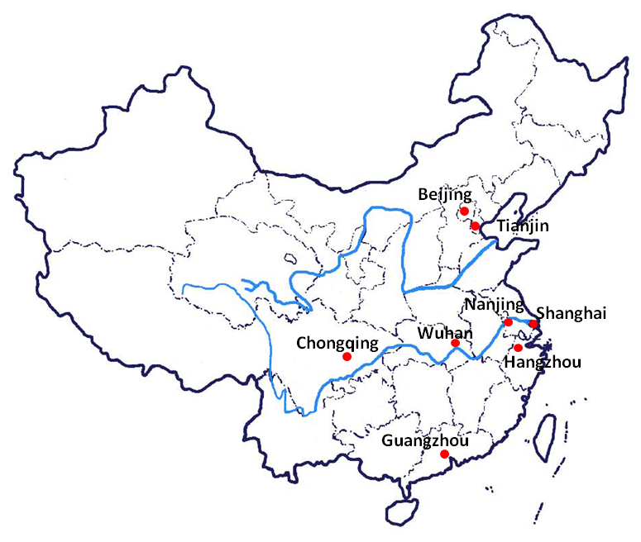
Fig. 2 Locations of 8 selected super/mega cities in China

Each of these super/mega cities and regions is enormous (Table 4). All have very big populations ranging from 24 million in Shanghai to 6.7 million in Hangzhou. The areas that these super regions cover are vast and incorporate at least 11 lower tier administrative districts or counties.
Table 4 Basic information for eight selected super/mega city regions
Super/mega city regions | Region type | Resident population in urban district (10,000) (2015) | Overall area  (km²) | GDP(2015)  (billion yuan) | Administrative  divisions
Shanghai | Municipalities | 2415.27 | 6,219 | 2496.50 | 16 districts
Beijing | Municipalities | 2170.50 | 16,411 | 2296.86 | 16 districts
Chongqing | Municipalities | 1838.41 | 82,400 | 1571.97 | 26districts, 12counties
Tianjin | Municipalities | 1546.95 | 11,920 | 1653.82 | 16 districts
Guangzhou | Provincial capital | 1350.11 | 7,434 | 1810.04 | 11 districts
Wuhan | Provincial capital | 1060.77 | 8,494 | 1090.56 | 13 districts
Nanjing | Provincial capital | 823.59 | 6582 | 972.08 | 11 districts
Hangzhou | Provincial capital | 679.06 | 16,596 | 1005.36 | 9 districts, 2 county-level cities, 2 counties
Sources: 2015 National Economic and Social Development Statistics Bulletins of Shanghai, Beijing, Chongqing, Tianjin, Guangzhou, Wuhan, Nanjing and Hangzhou, Statistical Bureaus of Shanghai, Beijing, Chongqing, Tianjin, Guangzhou, Wuhan, Nanjing and Hangzhou.

3.2 Spatial scales of polycentricity application in City Master Plans
In the range of master planning activities within these super/mega cities polycentric development strategies have been applied at all three levels. Table 5 illustrates the different levels at which polycentric development strategies have been applied in the various rounds of master planning activities in the eight super/mega cities.
Table 5 Different levels of polycentricity application in earlier and latest rounds of Master Plans of 8 super/mega cities
Super/mega city regions |  | Application levels
 |  | City region(shi yu) | Metropolitan area (shi qu) | Central city (zhongxinchengqu)
Shanghai |  | √ |  | √
Beijing |  | √
Chongqing | 1996-2020 |  | √
 | 2007-2020 |  | √
Guangzhou | 2001-2010 | √ | √ | √
 | 2011-2020 | √ |  | √
Tianjin |  | √
Wuhan | 1996-2020 |  |  | √
 | 2010-2020 |  | √
Nanjing | 2001-2010 | √ | √
 | 2011-2020 | √ | √ | √
Hangzhou |  | √ | √ | √
Sources: Shanghai City Master Plan (1999-2020), Beijing City Master Plan (2004-2020), Chongqing City Master Plan (1996-2020), Chongqing City Master Plan (2007-2020), Guangzhou City Master Plan (2001-2010), Guangzhou City Master Plan (2011-2020),Tianjin City Master Plan (2005-2020), Wuhan City Master Plan (1996-2020),Wuhan City Master Plan (2010-2020), Nanjing City Master Plan (2001-2010), Nanjing City Master Plan (2011-2020), Hangzhou City Master Plan (2001-2020).

It can be seen from Table 5 that there are some differences in terms of the scale at which polycentric ideas are being applied within these mega city regions. In some cases, Guangzhou, Nanjing and Hangzhou, it has been applied at all three spatial scales. Only in Beijing and Tianjin, has it been applied at one spatial scale, and then only at the city regional scale. From a temporal perspective the picture in terms of whether polycentricity is becoming a more prominent policy narrative is a little mixed, but only in Guangzhou has the policy principle become less prominent, and then only at the intermediate or metropolitan scale. In the next sections we look at the way that polycentricity as an idea has been articulated at the three spatial scales or levels outlined above.

3.3 At city regional level
The evaluation in Table 6 highlights how polycentricity has been applied at city regional level in latest round of master plans in Shanghai, Beijing, Tianjin and Hangzhou, and both rounds of master plans for Guangzhou and Nanjing, with the broad approaches being similar. A more detailed analysis of each of the master plans shows that application of polycentricity is based on three distinct but interconnected aspects, the spatial structure, settlement system and settlements exhibiting an internal polycentric structure. Details of these characteristics are illustrated in table 6.

Table 6 The application of polycentricity at city regional level
Super/mega city regions |  | City regional level
 |  | Spatial structure | Settlement system | Settlements exhibiting an internal polycentric structure
Shanghai |  | Multi-axes, multi-levels, multi-cores | Central city, new towns(including counties), central towns, general towns | Multi-levelled urban areas/towns
Beijing |  | Two axes - two belts - multi-centres | Central city, new towns, general towns | Multi-centres within city region
Guang zhou | 2001-2010 | A multi-levelled, constellation-styled spatial structure, with the central urban area as core centre and balanced distributed urban areas/towns at each level | Central urban area, central district areas, central towns, general towns | Multi-levelled urban areas/towns
 | 2011-2020 | Polycentric, clustered and networked structure | Central urban area, sub-centres, satellite towns, small towns | Sub-centres within city region
Tianjin |  | One axis-two belts-three zones | Centre and sub-centre, new towns, central towns, general towns | New towns
Nan jing | 2001-2010 | ‘Cross-shaped’ pattern | Central city, new urban district, new towns, central towns, general towns | New towns
 | 2011-2020 | Two belts-one axis | Central city, new towns, lower tier new towns (xinshizhen) | New towns
Hangzhou |  | One core-two circles, three axes-two corridors, one ring- multi-centres | Central city, central towns in counties or city regions, central towns or urban clusters, general towns | Multi-levelled urban areas/towns
Sources: Shanghai City Master Plan (1999-2020), Beijing City Master Plan (2004-2020), Guangzhou City Master Plan (2001-2010), Guangzhou City Master Plan (2011-2020), Tianjin City Master Plan (2005-2020), Nanjing City Master Plan (2001-2010), Nanjing City Master Plan (2011-2020), Hangzhou City Master Plan (2001-2020).

The application at this level, in relation to, either the existing, or prospective spatial structure, includes four inter-connected elements. A ‘Point’ usually refers to the core of the whole region and other centres/towns within each level. A ‘Line’ refers to the axes, belts or corridors which connect different centres/towns and is also designed promote the wider regional development and outward expansion of the region as a whole, not just the core city. ‘Zones’ refers to the key areas of influence which surround the core and centres, with the former dependant on the later. Such an approach is also used to emphasize, at the same time, integrated urban-rural development.
The ‘Settlement system’ usually describes the hierarchy of urban centres and rural towns within the city regional scale. Whilst such terms as are not really explicitly used, the functional interdependency in some cases especially between new towns and the rest of the settlement hierarchy suggest the application of polycentricity at the city regional scale remains valid both within the core city and also between the core city and other satellite centres within the wider city region.
As for polycentric models, multi-levelled urban areas/towns were all included within a polycentric spatial structure, including general towns which were dependent on, or attached to central towns/new towns in most cases. This was evident in 1999 Shanghai Master Plan, 2001 Guangzhou Master Plan and 2001 Hangzhou Master Plan, This clearly went against the basic nature of polycentricity, as functional interdependent centers/towns are supposed to serve as polycentric models. Another specific case was Beijing. Beijing planned multi-centers¹ as a polycentric model within the 2004 Master Plan for the city region, although the planned connectivity of these centers was expected to extend well beyond the city region. These were intended to be functional centres, expected to provide services to the whole nation, provide spaces for global co-operation and respond to global risks, thereby promoting the centrality and competitiveness of the city as a whole. However, many these urban functional centres surround the city core were not balanced or evenly distributed across the city region as a whole. Therefore, we argue that the scale in applying polycentricity (multi-centres) in Beijing, can only, in reality be regarded as being focused on the central city scale, not as stated in its master plan to cover the whole city region. Its polycentric development strategies primarily aimed to promote central city’s competitiveness, not balanced development of the whole city region.

3.4 At metropolitan level
Moving down in scale and focusing at the metropolitan scale, polycentric development practice within master planning can be examined from two aspects. Firstly the overall spatial development strategies of respective metropolitan area and secondly the spatial layouts of cities/towns. The latter are the main components within the spatial structures. Table 7 shows where polycentric development practices at metropolitan level have occurred. The evidence is drawn from both rounds of master plans. It was really only applied the earliest round of master planning in Guangzhou, and was not explicitly considered during the second phase of Master planning. In Chongqing and Nanjing, polycentricity as a concept has been applied in both rounds of master planning, but was really only applied to the spatial structure. In both Wuhan and Hangzhou during the most recent round of master planning polycentricity has been used to create a network of balanced growth and emphasising the connectivity between centres, sometimes emphasising the role of growth corridors along transport routes (e.g Nanjing) but equally placing a strong emphasis on managing and maintaining the natural environment as the context for growth (Guangzhou, Nanjing and Hangzhou) .
Table 7. The application of polycentricity at metropolitan level
Super/mega city regions |  | Metropolitan level
 |  | Spatial structure | Spatial layout of cities/towns
Chongqing | 1996-2020 | Polycentric and clustering spatial structure | Be divided into main urban area (3 districts and 12 clusters) and periphery clusters
 | 2007-2020 | Polycentric and clustering spatial structure | Two parts: main urban area (middle, northern, southern, western and eastern districts) and suburban area
Guangzhou | 2001-2010 | Polycentric, clustering and networking spatial structure based on the natural patterns of mountains, rivers/lakes, cities, fields and sea, and mainly develop along the Pearl River | ——
Wuhan | 2010-2020 | Multi-axes, multi-centred open spatial structure with main city as urban core | Axial extension and clustered organization
Nanjing | 2001-2010 | A polycentric and open spatial structure with the Yangtze River as the main axis and the main city as the urban core | Central city, new urban districts, new towns
 | 2011-2020 | With the main city as urban core, radial transport corridors as development axes, ecological space as the green wedge, a polycentric open spatial structure with axial clusters developing along the river | One belt- five axes
Hangzhou | 2001-2020 | One major core- three sub-centres, two centres two axes, six clusters and six ecological belts | ——
Sources: Chongqing City Master Plan (1996-2020), Chongqing City Master Plan (2007-2020), Guangzhou City Master Plan (2001-2010), Wuhan City Master Plan (2010-2020), Nanjing City Master Plan (2001-2010), Nanjing City Master Plan (2011-2020), Hangzhou City Master Plan (2001-2020).

3.5 At central city level
Focusing in still further, at the core urban agglomeration within the metropolitan or city regional scale several core cities, Shanghai, Guangzhou, Wuhan, Nanjing and Hangzhou have also applied polycentricity in their master planning to highlight the importance of the internal structure of the city (see table 8). Paralleling the practices at metropolitan level, two particular aspects can be highlighted. One is strategic recognition of the spatial layouts of these central cities, often highlighting the importance of sub-centres. This is then translated into something more specific and concrete in the urban development framework, where the core areas and sub-centres are often explicitly identified, as well as the actual and envisioned relationships and connections between urban core and sub-centres.
Table 8 Application of polycentricity at central city level
Super/mega city regions |  | Central city level
 |  | Spatial structure | Urban development framework
Shanghai |  | Multi-centered and open | CBD and main public activity centres (one city level centre and four city level sub-centres)
Guangzhou | 2001-2010 | Multi-clustered and semi-networking | Three developing areas with several clusters in each of them: urban central area, east-wing urban developing area, north-wing urban developing area.
 | 2011-2020 | Polycentric and networking spatial structure with new central axis as the urban core | Zhujiang New Town- Yuan village area, Pazhou area, Bai’ertan area, Baiyun New Town, southern area of the central axis, etc.
Wuhan | 1996-2020 | Polycentric and clustering spatial structure following balanced development strategy | Two core areas (Wuchang and Hankou), ten central districts and 10 comprehensive clusters
Nanjing | 2011-2020 | One major core- three sub-centres | Major city and three sub-cities (Dongshan, Xianlin and Jiangbei)
Hangzhou |  | One major core- three sub-centres | Major city and three sub-cities (Jiangnan city, Linping city and Xiasha city)
Sources: Shanghai City Master Plan (1999-2020), Guangzhou City Master Plan (2001-2010), Guangzhou City Master Plan (2011-2020), Wuhan City Master Plan (1996-2020), Nanjing City Master Plan (2011-2020), Hangzhou City Master Plan (2001-2020).

Major planning adjustments in polycentric development practice in Guangzhou and Nanjing
Of the eight selected super/mega cities, Chongqing, Guangzhou, Wuhan and Nanjing have all applied polycentricity to both rounds of their latest master plans, although only Guangzhou and Nanjing have explicitly applied polycentricity narratives and strategic thinking at city regional level. Hence because of this polycentric development practices at the city regional scale in Guangzhou and Nanjing are selected as particular cases to discuss these ideas further. By comparing the spatial structures, settlement systems and polycentric models of Guangzhou and Nanjing city regions over time, changes in the way polycentricity has been conceptualised can be examined (see figure 3).

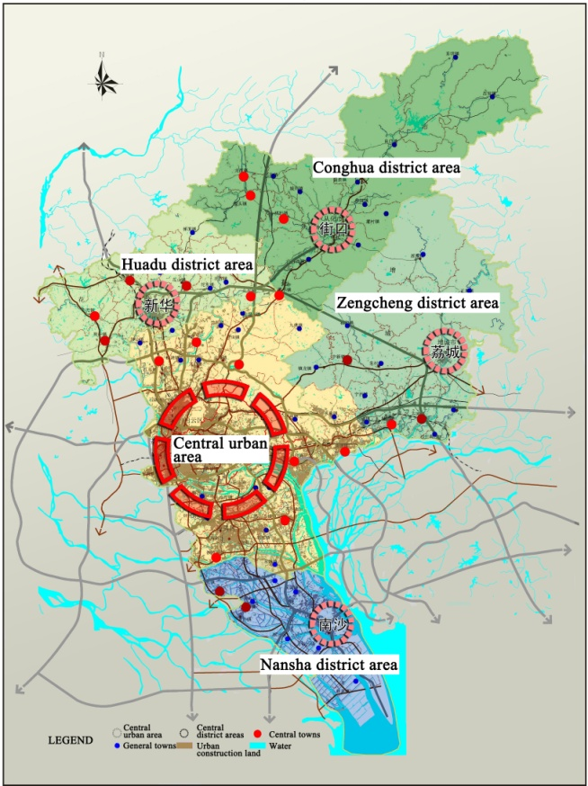 | 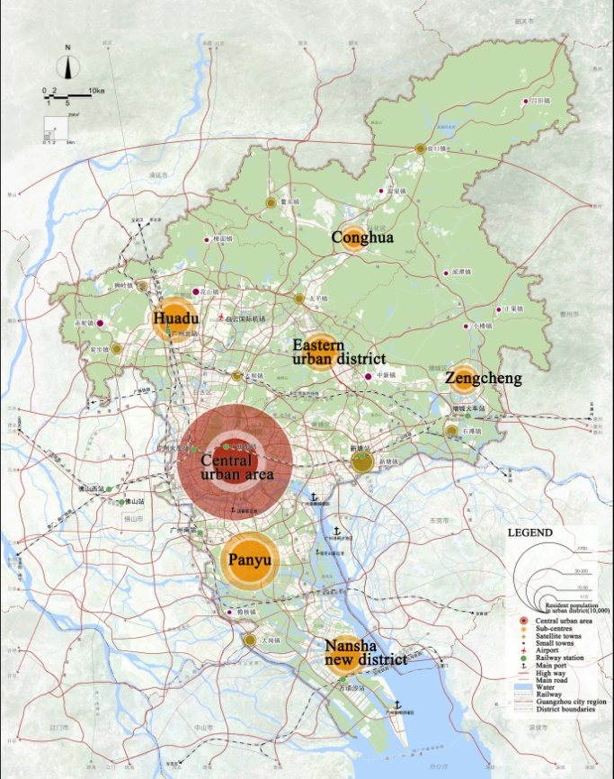
2001 Guangzhou City Master Plan | 2011 Guangzhou City Master Plan
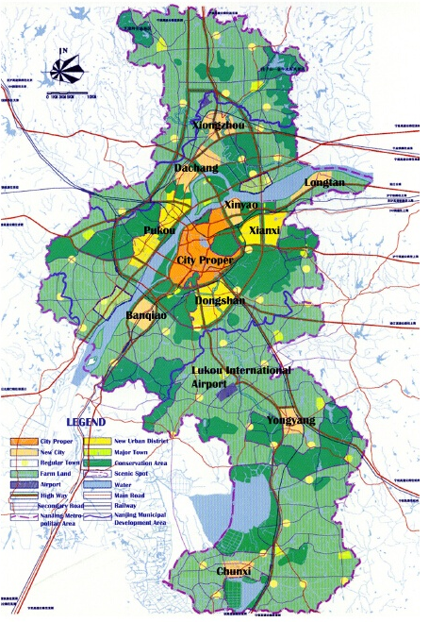 | 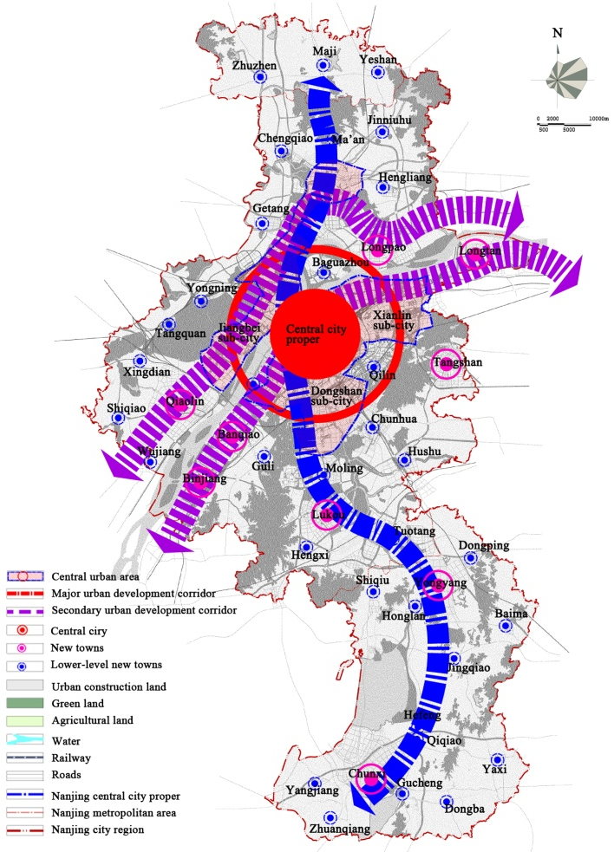
2001 Nanjing City Master Plan | 2011 Nanjing City Master Plan
Fig. 3 Spatial structures/urban (town) systems of Guangzhou and Nanjing city regions in Master Planning
Sources: Guangzhou Municipal Planning Bureau; Zhu, 2013; Nanjing Municipal Planning Bureau. Revised by authors.

4.1 Guangzhou
Guangzhou applied polycentric development strategies in both of its city master plans in 2001 and 2011. In a document called an ‘Outline of Guangzhou City Overall Strategic and Concept Plan’ published in 2000, a break with Guangzhou’s previous monocentric spatial structure was made. This clearly stated spatial development strategies of ‘southward expansion, northward optimization, eastward extension, westward combination’ (Guangzhou Municipal Government, 2000). At the same time there was some administrative reorganisation with Panyu and Huadu cities losing some of their independent status by becoming districts. Subsequently the 2001 city master plan re-iterated this eight-word spatial development strategy advocating a polycentric, clustered and networked spatial structure. It should be acknowledged that at this stage the polycentric spatial structure largely referred to the metropolitan area of Guangzhou (rather than the city region of Guangzhou) which included within the central cluster, Panyu and Huadu but excluded two county-level cities, Zengcheng and Conghua. Meanwhile, a multi-levelled, constellation-styled spatial structure was planned at the city regional level. This envisioned establishing 13 central towns as major growth centres primarily aimed at promoting urban-rural integration and more balanced development across the whole of the Guangzhou city region. However, functional interdependent centres were not highlighted and promoted as polycentric models in 2001 master plan.
Later, in 2007, a ‘central adjustment’ strategy was proposed at Guangzhou’s 10th Party Congress. This added to the original eight-word development strategy by promoting ongoing transformative development, away from market segmentation to regional integration across the whole of the Pearl River Delta region. In 2010, Guangzhou’s new spatial vision, ‘one metropolitan area, two new towns, three peripheral urban areas’, was proposed as part of Guangzhou’s Strategic Planning and Master Planning Framework. This ten-word strategy based on the so-called ‘Integration Principles’ was adopted as part of the city master plan in 2011. Hence, from 2011 onwards the Guangzhou Master Plan has adopted a polycentric, clustered and networked spatial structure covering the whole region, focused around six sub-centres and nine satellite towns which collectively can help to form a polycentric city region.
It is also worth noting that sitting alongside the idea outward sub regional expansion and more balanced development within the whole city region, with planned improvements to each of the key sub centres and satellite towns, was an explicit recognition of the need for investment and renewal of Guangzhou’s central city. Hence despite the rhetoric of balanced integrated development, the leading role of the central city is still pre-eminent. Table 9 illustrates both the continuities and differences in applying the concept of polycentricity in both rounds of Guangzhou City Master Plans.
Table 9 The application of polycentricity in both rounds of Guangzhou City Master Plans
 | The earlier round of Master Planning  (2001-2010) | Latest round of Master Planning  (2011-2020)
Spatial development strategy | Southward expansion, northward optimization, eastward extension, westward combination | Southward expansion, northward optimization, eastward extension, westward combination, central adjustment
Spatial structure | A multi-levelled, constellation-styled spatial structure, with the central urban area as core centre and balanced distributed urban areas/towns at each level | Polycentric, clustered and networking structure
Settlement system | Central urban area, central district areas, central towns, general towns | Central urban area, sub-centres, satellite towns, small towns
Polycentric model | Multi-levelled urban areas/towns | Six sub-centres: Panyu, Nansha new district, Eastern urban district, Huadu, Zengcheng and Conghua
Sources: Guangzhou City Master Plan (2001-2010), Guangzhou City Master Plan (2011-2020).

4.2. Nanjing
In Nanjing’s case, there have been two significant adjustments to the administrative territory covered by the Nanjing municipal government. In 2000 the municipal government consisted of 10 districts and 5 counties. In 2007 the area for master planning comprised 11 districts and 2 counties, and finally in 2014, further re-organisation saw a simplification of the administrative structure and 11 districts were created. These changes and extension to Nanjing’s municipal area provided new opportunities for urban spatial expansion and the promotion of more sustainable urban development. The 2011 Nanjing City Master Plan created a three tiered settlement system with nine new towns. This replaced the former five level settlement hierarchy and accompanying seven new towns. This clearer and simpler settlement system, it is hoped will better promote planning implementation and policy delivery. Banqiao, Longtan, Yongyang and Chunxi continue to be four identified new towns in both the 2001 and 2011 master plans, while Dachang, Xinyao and Xiongzhou have been replaced by Tangshan, Lukou, Binjiang and Qiaolin in the more recent plan. The reasons for the continuities with Banqiao, Longtan,Yongyang and Chunxi continuing to be chosen as new towns was because they had already become functionally interdependent centres with horizontal connections, and/or have the internal potential and external environment for this to realistically realised in the future. These four towns lie on the primary north south corridor (Yongyang and Chuxi) or the east west corridor (Longton and Banqiao). In both cases, these four new towns can be considered a certain degree of success in contributing to polycentric spatial structures. Most of the other five new towns envisaged as contributing further to a polycentric structure are located along these axes.
When further exploring the main characteristics of the chosen new towns, two similarities become apparent in Nanjing. One is their origin. They are largely based on the original district (county) governments-based towns. The other is their functions. Future developments rely on expanding functions from the central city, new industries and the major construction urban infrastructure, hence the focus on corridor development. Furthermore, in some cases, these new towns do not just look to bolseter the city regional economy, but also aim to promote regional development across administrative boundaries. For example, in the 2011 Nanjing city master plan, Yongyang is planned to be a comprehensive new town not just within the Nanjing city region, but also within Ningbo-Hangzhou urban agglomeration. Furthermore Chunxi is also expected to be a comprehensive new town providing services to the border regions of Jiangsu and Anhui Provinces. Table 10 illustrates both the continuities and differences in the way the concept of polycentricity has been applied in both rounds of Nanjing City’s Master Plans.
Table 10 The application of polycentricity in both rounds of Nanjing City Master Plans
 | Former round of UCP (2001-2010) | Latest round of UCP (2011-2020)
Settlement system | central city, new urban district, new towns, central towns, general towns | central city, new towns, lower tier new towns (xinshizhen)
Polycentric model | 7 new towns: Dachang, Xinyao, Banqiao, Longtan, Xiongzhou, Yongyang, Chunxi | 9 new towns: Longtan, Tangshan, Lukou, Banqiao, Binjiang, Qiaolin, Longpao, Yongyang, Chunxi
Sources: Nanjing City Master Plan (2001-2010), Nanjing City Master Plan (2011-2020).

5. Discussion and conclusion
This paper provides a broad overview of the application of polycentric development strategies in China’s master planning processes. First, a conceptual framework for urban and rural planning system in China was set up, and the background and origin for polycentricity practice were elaborated. Secondly, 8 super/mega city regions which have applied polycentric development strategies at various spatial scales were selected from the 16 super/mega city regions in China and examined to explore the way that polycentric concepts have been applied at three spatial scales, city regional, metropolitan and central city level. Finally, Guangzhou and Nanjing, two city regions that applied polycentric thinking in latest two rounds master planning were examined. At each stage major changes in the polycentric application processes and models were emphasized.
Although the concept of polycentricity has only officially been adopted in master planning since 1999, when it first appeared in the Shanghai City Master Plan, it has gained widespread popularity becoming both a normative approach and strategic guidance to determine future spatial structures. Polycentric development strategies have been articulated in a number of super/mega city regions’ master plans at a variety of different spatial scales right across China. The advocacy argument for applying polycentric thinking is to begin to resolve the ever increasing problems associated with unprecedented urban expansion and urbanization processes. However in practice any critical analysis as to whether applying polycentricity as an ‘ideal’ model is still rare in China. The same is true with regards to empirical findings which seek to describe and interpret new Chinese urban realities through the lens of polycentric development (Li and Zhao, 2011). This lack of critical analysis and more of an application of a simply descriptive interpretation of polycentricity can be regarded as one of the major differences in the conceptual evolution and adoption between China and Europe. It is an idea that seems to have been applied or invoked without critical reflection.
Other differences can be illustrated from evaluations of polycentricity application in planning documents, and have been highlighted through our interpretations of the nature of polycentricity within a Chinese context. Inevitably, as an ‘imported’ concept, the polycentric development practice in China has its own characteristics which, sometimes goes against the basic nature of polycentricity. In some cases (e.g. Shanghai, Guangzhou and Hangzhou) a multi-levelled structuring of urban areas/towns are all regarded as polycentric models. There is lack of nuanced understanding with regards to the basic nature of polycentric models: functional interdependence and horizontal connectivity. On the other hand, major changes in the settlement system at city regional scale, largely a function of unprecedented urbanisation trends is in line with the spirit of polycentricity. Although settlement systems are still set up based on a separated classical urban (town) system hierarchical planning framework, within the emerging polycentric development structure narratives, they are now designated to deliver a more networked system including urban centres and rural towns.
Compared to Western countries, extensive developments and constructions in suburbs or outer suburbs have not resulted in any decline in central areas of Chinese super/mega cities. Indeed central areas still maintain their original vitality and primacy at the city, metropolitan and city regional scales. This is because polycentric development strategies in China still place a great emphasis on development of core central cities. At all three spatial scales (city region, metropolitan area and central city), polycentricity indeed aims to promote more sustainable and balanced development, however, this balance is still more rhetoric when compared with the Western concept.
Based on the above findings, some issues and challenges can be identified regarding the application of polycentricity in Chinese master planning. Firstly, there is a need to rethink the rationale and the timing of the introduction of the application of polycentricity in master planning in China. Instead of using the concept of polycentricity as a universal applicable approach the different development stages and potentials of particular cities, metropolitan areas and city regions need to be considered more carefully to see whether the urban systems really need accommodate this concept. Instead of being a kind of simplified policy narrative, polycentricity should be interpreted more in terms of the need for and potentials of developing still further horizontal and vertical linkages within and between urban centers. Secondly, with regard to the delivery and promotion of polycentric development strategies it undoubtedly requires both implementation efforts from central and local levels of governance. There is thus a need to clarify the roles and importance of central and local stakeholders to avoid the presumption that key tasks will inadvertently be left to either scale. This might include developing planning and policy guidance, under a polycentric development framework, in order to promote co-operation between different actors (at different levels) who are responsible for, or involved in, the integration of policy-making and implementation and delivery.

Notes
- Multi-centers include the core area of Zhongguan Village High-tech Park, Olympic central area, the Central Business District (CBD), Technology Innovation Centre behind Haidian Mountains, Shunyi modern manufacturing base, Tongzhou comprehensive service centre, Yizhuang high-tech industries development centre and Shijingshan comprehensive service centre, etc.

References
Bogart, W. T. and Ferry, W. C. (1999) 'Employment Centres in Greater Cleveland: Evidence of Evolution in a Formerly Monocentric City', Urban Studies (Routledge), 36 (12), pp.2099-110.
Burger, M.J. (2011) 'Structure and Cooptition in Urban Networks', (Ph.D. thesis, Erasmus University Rotterdam).
Burger, M. J., de Goei, B., van, d. L. and Huisman, F. J. M. (2011) 'Heterogeneous development of metropolitan spatial structure: Evidence from commuting patterns in English and Welsh city-regions, 1981-2001', Cities, 28 (2), pp.160-70.
Burger, M. and Meijers, E. (2012) 'Form follows function? linking morphological and functional polycentricity', Urban Studies., 49 (5), pp.1127-49.
CEC (1999), European Spatial Development Perspective: Towards a Balanced and Sustainable Development
of the Territory of the European Union. Luxembourg: Office for Official Publications of the European
Communities.
Cervero, R. and Wu, K. -. (1997) 'Polycentrism, commuting, and residential location in the San Francisco Bay area', Environ.Plann.A, 29 (5), pp.865-86.
Che, X. (2012) 'Innovation-driven transformation of development zones in Shanghai', Urban Planning Forum, (7), pp.203-206.
Craig, S. G. and Ng, P. T. (2001) 'Using quantile smoothing splines to identify employment subcenters in a multicentric urban area', J.Urban Econ., 49 (1), pp.100-20.
Davoudi, S. (2003) European Briefing: Polycentricity in European spatial planning: from an analytical tool to a normative agenda', European Planning Studies, 11 (8), pp.979-99.
Fuji T, Hartshorn T. (1995) 'The changing metropolitan structure of Atlanta, Georgia: location of functions and regional structure in a multinucleared urban area', Urban Geography, 16, pp. 680-707.
Garcia-López, M. -. and Muñiz, I. (2010) 'Employment decentralisation: Polycentricity or scatteration? the case of Barcelona', Urban Stud., 47 (14), pp.3035-56.
Guangzhou Municipal Government (2000) 2000 Outline of Guangzhou City Overall Strategic and Concept Plan (Guangzhou: Guangzhou Municipal Government).
Hall, P.. and Pain, K. (2006) The polycentric metropolis : learning from mega-city regions in Europe / written and edited by Peter Hall and Kathy Pain. London: Earthscan, 2006.
Hanssens, H., Derudder, B., Witlox, F. and van Aelst, S. (2013) 'Assessing the Functional Polycentricity of the Mega-City-Region of Central Belgium Based on Advanced Producer Service Transaction Links', Reg.Stud.
Harshorn T A, Muller P O. (1989) 'Suburban downtowns and the transformation of metropolitan Atlanta’s business landscape', Urban Geography, 10 (4), pp. 375-395.
Huang, X. and Hay, I. (2016) Polycentric city regions in the state scalar politics of land development: the case of China, Land Use Policy, 59, pp168-175.
Kloosterman, R. C. and Musterd, S. (2001) 'The polycentric urban region: Towards a research agenda', Urban Studies, 38 (4), pp.623-33.
Lambregts, B. (2009) 'The Polycentric Metropolis Unpacked: Concepts, Trends and Policy in the Randstad, Holland', (Ph.D. thesis, University of Amsterdam).
Li, F., Zhao, M. (2011) 'A discussion on housing development in multi-center cities: phenomenon and planning implications of Chongqing', Urban Planning Forum, (3), pp.8-19.
Li,Q. (2012) ' Overview on European Polycentric mega-city region research', Urban Problems, 11, pp.82-86.
Li, Y. and Phelps, N. (2016) Megalopolis unbounded: Knowledge collaboration and functional polycentricity within and beyond the Yangtze Delta Region in China 2014, Urban Studies, pp1-17.
Luo, Z., Zhu, Z. (2008)'Understanding Polycentricity by Configuration, Function and Governance', Urban Planning International, 23(3), pp.85-88.
Modarres, A. (2011) 'Polycentricity, Commuting Pattern, Urban Form: The Case of Southern California', International Journal of Urban and Regional Research, 35 (6), pp.1193-211.
Mu, Y and Yeh, A. (2016) Measuring Polycentricity of Mega City Regions in China, The international Archives of the Photogrammetry Remote Survey and Spatial information Sciences, Vol XLI-B6, 2016 XXIII ESPRS Congress, 12-16 July, Prague, Czech Republic.
Musterd, S. and van Zelm, I. (2001) 'Polycentricity, Households and the Identity of Places', Urban Studies (Routledge), 38 (4), pp.679-96.
Paolo Veneri. (2013) 'The identification of sub-centres in two Italian metropolitan areas: A functional approach', Cities, 31, pp. 177–185.
Qian, H. and Wong, C., (2012) 'Master Planning under Urban-Rural Integration: The Case of Nanjing, China', Urban Policy and Research, 30(4) , pp.403-421.
Qin,C., Li, H. (2012) 'Progress of studies on polycentric urban region in Western countries', Human Geography, (1), pp.6-10.
Riguelle, F., Thomas, I. and Verhetsel, A. (2007) 'Measuring urban polycentrism: A European case study and its implications', Journal of Economic Geography, 7 (2), pp.193-215.
Shaw, D and Sykes, O (2003) Investigating the Application of ESDP to regional planning in the UK, Town Planning Review, 74(1), pp31-50.
Shaw, D. and Sykes, O. (2004) The concept of polycentricity in European Spatial Planning: Reflections on its interpretation and application in the practice of spatial planning, International Planning Studies, 9(4) 283-306.
Shen, H., Zhang, J., Chen, M. (2005) 'Polycentric reorganization of urban space in Chinese large cities', Urban Problems, (4), pp.25-30.
Shi, Y. (1999) 'From a single center city to a multi-center city—Spatial organization pattern of metropolitan development in China', Urban Planning Forum, (3), pp.36-39.
Sun, B., Shi, W., Ning, Y. (2010)'An empirical study on the polycentric urban structure of Shanghai and strategies in future', Urban Planning Forum, (1), pp.58-63.
Sykes, O. (2005) 'Polycentricity—an idea that’s here to stay? ', Town and country planning, 74, pp. 250-253.
Van der Knaap. G.A. and Wall, R.S. (2003) 'Linking scales and urban network development', In: Van Dijk, H.(ed.) The European Metropolis 1920-2000. Rotterdam: ESHCC.
Vasanen, A. (2013) 'Spatial Integration and Functional Balance in Polycentric Urban Systems: A Multi-Scalar Approach', Tijdschrift voor Economische en Sociale Geografie (Journal of Economic & Social Geography), 104 (4), pp.410.
Wang, X., Sun, B. (2011) 'The economic performance of the polycentric spatial structure of mega-cities: based on the models of urban economics', Urban Planning Forum, (6), pp.20-27.
Wang, Y., Sun, B., Qiao, S., Zhou, H. (2012) 'Polycentric spatial strategy of mega-cities in China: The case of Shanghai', Urban Planning Forum, (2), pp.17-23.
Wei, Y., Zhao, M. (2006) 'Spatial structure and performance of metropolis: interpretation and application of polycentric structure', City Planning Review, 30(4) , pp.9-16.
Yang, Z., Cai, J. (2008) 'Implications of the concept and experiences on polycentric spatial planning in developed regions to China', Urban Planning International, 23(4), pp.71-77.
Yuan, X., Wang, X. (2010) 'Edge city and its implications on the re-development of development zones: A case study of Ningbo Economic-technological Development Zone', Urban Planning Forum, (6), pp.95-101.
Zhang, J., Luo,X., Yin, J. (2008) 'Polycentric Mega-city Regions and Multi-level Governance of the Yangtze River Delta', Urban Planning International, (1), pp.65-69.
Zhang, T. (2000) 'Land market forces and government's role in sprawl: The case of China', Cities, 17(2), pp.123-135.
Zhang, X (2016) Emerging Polycentric Patterns in Governing Transitional China, in Foo, C.T. (eds.) Diversity of Managerial Perspectives from Inside China, pp.47-65, Singapore, Springer Sciences and Business Media.
Zhao, M., Derudder, B., and Huang, J. (2017) Examining the transition process within the Pearl River Delta polycentric mega-city through the lense of corporate networks, Cities, Part a Feb. 2017, pp147-155.
Zhu, Q. (2013) 'Master plan, plan adjustment and urban development reality under China’s market transition: A case study of Nanjing', Cities, 30, pp.77-88.

Table captions:
Table 1 Spatial scope of different levels of City Master Plans in China
Table 2 The sixteen super/mega cities and their resident population by the end of 2015
Table 3 Application of polycentricity in Master Plans of sixteen super/mega city regions
Table 4 Basic information for eight selected super/mega city regions
Table 5 Different levels of polycentricity application in earlier and latest rounds of Master Plans of 8 super/mega cities
Table 6 The application of polycentricity at city regional level
Table 7 The application of polycentricity at metropolitan level
Table 8 Application of polycentricity at central city level
Table 9 The application of polycentricity in both rounds of Guangzhou City Master Plans
Table 10 The application of polycentricity in both rounds of Nanjing City Master Plans

Figure captions:
Figure 1 Urban and rural planning system currently practiced in China
Figure 2 Locations of eight selected super/mega cities in China
Figure 3 Spatial structures/urban (town) systems of Guangzhou and Nanjing city regions in Master Planning
Figure 3(a) 2001 Guangzhou City Master Plan
Figure 3(b) 2011 Guangzhou City Master Plan
Figure 3(c) 2001 Nanjing City Master Plan
Figure 3(d) 2011 Nanjing City Master Plan

