Online supplement

Novel blood pressure locus and gene discovery using GWAS and expression datasets from blood and the kidney

Running title: Novel blood pressure locus and gene discovery

Louise V. Wain¹, Ahmad Vaez^{2,3}, Rick Jansen⁴, Roby Joehanes^{5,6}, Peter J. van der Most², A. Mesut Erzurumluoglu¹, Paul O'Reilly⁷, Claudia P. Cabrera^{8,9}, Helen R. Warren^{8,9}, Lynda M. Rose¹⁰, Germaine C. Verwoert¹¹, Jouke-Jan Hottenga¹², Rona J. Strawbridge^{13,14}, Tonu Esko^{15,16,17}, Dan E. Arking¹⁸, Shih-Jen Hwang^{19,20}, Xiuqing Guo²¹, Zoltan Kutalik^{22,23}, Stella Trompet^{24,25}, Nick Shrine¹, Alexander Teumer^{26,27}, Janina S. Ried²⁸, Joshua C. Bis²⁹, Albert V. Smith^{30,31}, Najaf Amin³², Ilja M. Nolte², Leo-Pekka Lyytikäinen^{33,34}, Anubha Mahajan³⁵, Nicholas J. Wareham³⁶, Edith Hofer^{37,38}, Peter K. Joshi³⁹, Kati Kristiansson⁴⁰, Michela Traglia⁴¹, Aki S. Havulinna⁴⁰, Anuj Goel^{42,35}, Mike A. Nalls^{43,44}, Siim Sõber⁴⁵, Dragana Vuckovic^{46,47}, Jian'an Luan³⁶, Fabiola Del Greco M.⁴⁸, Kristin L. Ayers⁴⁹, Jaume Marrugat⁵⁰, Daniela Ruggiero⁵¹, Lorna M. Lopez^{52,53,54}, Teemu Niiranen⁴⁰, Stefan Enroth⁵⁵, Anne U. Jackson⁵⁶, Christopher P. Nelson^{57,58}, Jennifer E. Huffman⁵⁹, Weihua Zhang^{60,61}, Jonathan Marten⁶², Ilaria Gandin⁴⁷, Sarah E Harris^{52,63}, Tatijana Zemunik⁶⁴, Yingchang Lu⁶⁵, Evangelos Evangelou^{60,66}, Nabi Shah^{67,68}, Martin H. de Borst⁶⁹, Massimo Mangino^{70,71}, Bram P. Prins⁷², Archie Campbell^{73,74}, Ruifang Li-Gao⁷⁵, Ganesh Chauhan^{76,77}, Christopher Oldmeadow⁷⁸, Gonçalo Abecasis⁷⁹, Maryam Abedi⁸⁰, Caterina M. Barbieri⁴¹, Michael R. Barnes^{8,9}, Chiara Batini¹, John Beilby^{81,82,83}, BIOS Consortium⁸⁴, Tineka Blake¹, Michael Boehnke⁵⁶, Erwin P. Bottinger⁶⁵, Peter S. Braund^{57,58}, Morris Brown^{8,9}, Marco Brumat⁴⁷, Harry Campbell³⁹, John C. Chambers^{60,61,85}, Massimiliano Cocca⁴⁷, Francis Collins⁸⁶, John Connell⁸⁷, Heather J. Cordell⁸⁸, Jeffrey J. Damman⁸⁹, Gail Davies^{52,90}, Eco J. de Geus¹², Renée de Mutsert⁷⁵, Joris Deelen⁹¹, Yusuf Demirkale⁹², Alex S.F. Doney⁶⁷, Marcus Dörr^{93,27}, Martin Farrall^{42,35}, Teresa Ferreira³⁵, Mattias Frånberg^{13,14,94}, He Gao⁶⁰, Vilmantas Giedraitis⁹⁵, Christian Gieger⁹⁶, Franco Giulianini¹⁰, Alan J. Gow^{52,97}, Anders Hamsten^{13,14}, Tamara B. Harris⁹⁸, Albert Hofman^{11,99}, Elizabeth G. Holliday⁷⁸, Jennie Hui^{81,82,100,83}, Marjo-Riitta Jarvelin^{101,102,103,104}, Åsa Johansson⁵⁵, Andrew D. Johnson^{6,105}, Pekka Jousilahti⁴⁰, Antti Jula⁴⁰, Mika Kähönen^{106,107}, Sekar Kathiresan^{108,109,110}, Kay-Tee Khaw¹¹¹, Ivana Kolcic¹¹², Seppo Koskinen⁴⁰, Claudia Langenberg³⁶, Marty Larson⁶, Lenore J. Launer⁹⁸, Benjamin Lehne⁶⁰, David C.M. Liewald^{52,90}, Lifelines Cohort Study¹¹³, Li Lin¹¹⁴, Lars Lind¹¹⁵, François Mach¹¹⁴, Chrysovalanto Mamasoula¹¹⁶, Cristina Menni⁷⁰, Borbala Mifsud⁸, Yuri Milaneschi¹¹⁷, Anna Morgan⁴⁷, Andrew D. Morris¹¹⁸, Alanna C. Morrison¹¹⁹, Peter J. Munson⁹², Priyanka Nandakumar¹⁸, Quang Tri Nguyen⁹², Teresa Nutile⁵¹, Albertine J. Oldehinkel¹²⁰, Ben A. Oostra³², Elin Org¹⁵, Sandosh Padmanabhan^{121,74}, Aarno Palotie¹²², Guillaume Paré¹²³, Alison Pattie⁹⁰, Brenda W.J.H. Penninx¹¹⁷, Neil Poulter¹²⁴, Peter P. Pramstaller^{48,125,126}, Olli T. Raitakari^{127,128}, Meixia Ren^{8,129}, Kenneth Rice¹³⁰, Paul M. Ridker^{10,131}, Harriëtte Riese¹²⁰, Samuli Ripatti¹²², Antonietta Robino¹³², Jerome I. Rotter¹³³, Igor Rudan³⁹, Yasaman Saba¹³⁴, Aude Saint Pierre^{48,135}, Cinzia F. Sala⁴¹, Antti-Pekka Sarin¹²², Reinhold Schmidt³⁷, Rodney Scott^{78,136,137}, Marc A. Seelen⁶⁹, Denis C. Shields¹³⁸, David Siscovick¹³⁹, Rossella Sorice^{51,140}, Alice Stanton¹⁴¹, David J. Stott¹⁴², Johan Sundström¹¹⁵, Morris Swertz¹⁴³, Kent D. Taylor^{144,145}, Simon Thom¹⁴⁶, Ioanna Tzoulaki⁶⁰, Christophe Tzourio^{76,77,147}, André G. Uitterlinden^{11,148}, Understanding Society Scientific group⁸⁴, Uwe Völker^{149,27}, Peter Vollenweider¹⁵⁰, Sarah Wild³⁹, Gonneke Willemsen¹², Alan F. Wright⁶², Jie Yao²¹, Sébastien Thériault¹²³, David Conen¹⁵¹, Attia John^{78,136,137}, Peter Sever¹⁵², Stéphanie Debette^{76,77,153}, Dennis O. Mook-Kanamori^{75,154}, Eleftheria Zeggini⁷², Tim D. Spector⁷⁰, Pim van der Harst¹⁵⁵, Colin N.A. Palmer⁶⁷, Anne-Claire Vergnaud⁶⁰, Ruth J.F. Loos^{36,156,157}, Ozren Polasek¹¹², John M. Starr^{52,158}, Giorgia Girotto^{47,46}, Caroline Hayward^{159,74}, Jaspal S. Kooner^{160,61,85}, Cecila M. Lindgren^{17,35}, Veronique Vitart⁵⁹, Nilesh J. Samani^{57,58}, Jaakko Tuomilehto^{161,162,163,164}, Ulf Gyllensten⁵⁵, Paul Knekt⁴⁰, Ian J. Deary^{52,90}, Marina Ciullo^{51,140}, Roberto Elosua⁵⁰, Bernard D. Keavney¹⁶⁵, Andrew A. Hicks⁴⁸, Robert A. Scott³⁶, Paolo Gasparini^{46,47}, Maris Laan^{45,166}, YongMei Liu¹⁶⁷, Hugh Watkins^{42,35}, Catharina A. Hartman¹²⁰, Veikko Salomaa⁴⁰, Daniela Toniolo⁴¹, Markus Perola^{40,122,168}, James F. Wilson^{39,62}, Helena Schmidt^{134,169}, Jing Hua Zhao³⁶, Terho Lehtimäki^{33,34}, Cornelia M. van Duijn³², Vilmundur Gudnason^{30,31}, Bruce M. Psaty^{29,170,171,172}, Annette Peters²⁸, Rainer Rettig¹⁷³, Alan James^{174,175}, J Wouter Jukema²⁴, David P. Strachan¹⁷⁶, Walter Palmas¹⁷⁷, Andres Metspalu¹⁵, Erik Ingelsson^{178,179}, Dorret I. Boomsma¹², Oscar H. Franco¹¹, Murielle Bochud²², Christopher Newton-Cheh^{180,108,110,17}, Patricia B. Munroe^{8,9}, Paul Elliott¹⁰⁴, Daniel I. Chasman^{10,131}, Aravinda Chakravarti¹⁸, Joanne Knight¹⁸¹, Andrew P. Morris^{182,35}, Daniel Levy^{183,20}, Martin D. Tobin¹, Harold Snieder^{2*}, Mark J. Caulfield^{8,9*}, Georg B. Ehret^{18,114*}
*: contributing equally

Corresponding authors: Georg B. Ehret (georg@rhone.ch), tel. +41 22 3727200, fax +41 22 -372 72 29, Louise V. Wain (louisewain@le.ac.uk), tel. +44 116 229 7252, fax +44 116 229 7250
AFFILIATIONS
1. Department of Health Sciences, University of Leicester, Leicester LE1 7RH, UK
2. Department of Epidemiology, University of Groningen, University Medical Center Groningen, Hanzeplein 1, 9713 GZ Groningen, The Netherlands
3. Research Institute for Primordial Prevention of Non-communicable Disease, Isfahan University of Medical Sciences, Isfahan, Iran
4. Department of Psychiatry, VU University Medical Center, Neuroscience Campus Amsterdam, Amsterdam, The Netherlands
5. Hebrew SeniorLife, Harvard Medical School, 1200 Centre Street Room #609, Boston, MA 02131, USA
6. National Heart, Lung and Blood Institute's Framingham Heart Study, Framingham, MA 01702, USA
7. Institute of Psychiatry, Psychology and Neuroscience, King's College London, London SE5 8AF, UK
8. Clinical Pharmacology, William Harvey Research Institute, Barts and The London School of Medicine and Dentistry, Queen Mary University of London, London, EC1M 6BQ, UK
9. NIHR Barts Cardiovascular Biomedical Research Unit, Barts and The London School of Medicine and Dentistry, Queen Mary University of London, London, EC1M 6BQ, UK
10. Division of Preventive Medicine, Brigham and Women's Hospital, Boston MA 02215, USA
11. Department of Epidemiology, Erasmus MC, Rotterdam, 3000CA, The Netherlands
12. Department of Biological Psychology, Vrije Universiteit, Amsterdam, EMGO+ institute, VU University medical center, Amsterdam, The Netherlands
13. Cardiovascular Medicine Unit, Department of Medicine Solna, Karolinska Institutet, Stockholm, 17176, Sweden
14. Centre for Molecular Medicine, Karolinska Universitetsjukhuset, Solna, 171 76, Sweden
15. Estonian Genome Center, University of Tartu, Tartu, 51010, Estonia
16. Divisions of Endocrinology/Children's Hospital, Boston, MA 02115, USA
17. Broad Institute of Harvard and MIT, Cambridge, MA 02139 USA
18. Center for Complex Disease Genomics, McKusick-Nathans Institute of Genetic Medicine, Johns Hopkins University School of Medicine, Baltimore, MD 21205, USA
19. The Population Science Branch, Division of Intramural Research, National Heart Lung and Blood Institute national Institute of Health, Bethesda, MD 20892, USA
20. The Framingham Heart Study, Framingham MA 01702, USA
21. The Institute for Translational Genomics and Population Sciences, Department of Pediatrics, LABioMed at Harbor-UCLA Medical Center, 1124 W. Carson Street, Torrance, CA 90502, USA
22. Institute of Social and Preventive Medicine, Lausanne University Hospital, Route de la Corniche 10, 1010 Lausanne, Switzerland
23. Swiss Institute of Bioinformatics, Lausanne, Switzerland
24. Department of Cardiology, Leiden University Medical Center, Leiden, 2300RC, The Netherlands
25. Department of Gerontology and Geriatrics, Leiden University Medical Center, Leiden, 2300RC, The Netherlands
26. Institute for Community Medicine, University Medicine Greifswald, Greifswald, 17475, Germany
27. DZHK (German Centre for Cardiovascular Research), partner site Greifswald, Greifswald, 17475, Germany
28. Institute of Epidemiology II, Helmholtz Zentrum München, Neuherberg 85764, Germany
29. Cardiovascular Health Research Unit, Department of Medicine, University of Washington, Seattle, WA 98101, USA
30. Icelandic Heart Assoication, Kopavogur, Iceland
31. Faculty of Medicine, University of Iceland, Reykjavik, Iceland
32. Genetic Epidemiology Unit, Department of Epidemiology, Erasmus MC, Rotterdam, 3000CA, The Netherlands
33. Department of Clinical Chemistry, Fimlab Laboratories, Tampere 33520, Finland
34. Department of Clinical Chemistry, Faculty of Medicine and Life Sciences, University of Tampere, Tampere 33014, Finland
35. Wellcome Trust Centre for Human Genetics, University of Oxford, Roosevelt Drive, Oxford OX3 7BN, UK
36. MRC Epidemiology Unit, University of Cambridge School of Clinical Medicine, Institute of Metabolic Science, Cambridge Biomedical Campus, Cambridge, CB2 0QQ, UK
37. Clinical Division of Neurogeriatrics, Department of Neurology, Medical University Graz, Auenbruggerplatz 22, 8036 Graz, Austria
38. Institute of Medical Informatics, Statistics and Documentation, Medical University Graz, Auenbruggerplatz 2, 8036 Graz, Austria
39. Centre for Global Health Research, Usher Institute of Population Health Sciences and Informatics, University of Edinburgh EH89AG, Scotland, UK
40. Department of Health, National Institute for Health and Welfare (THL), Helsinki, Finland
41. Division of Genetics and Cell Biology, San Raffaele Scientific Institute, 20132 Milano, Italy
42. Division of Cardiovascular Medicine, Radcliffe Department of Medicine, University of Oxford, Oxford, OX3 9DU, UK
43. Laboratory of Neurogenetics, National Institute on Aging, NIH, Bethesda, 20892, USA
44. Data Tecnica International, Glen Echo, MD, USA
45. Human Molecular Genetics Research Group, Institute of Molecular and Cell Biology, University of Tartu, Riia St.23, 51010 Tartu, Estonia
46. Medical Genetics, IRCCS-Burlo Garofolo Children Hospital, Via dell’Istria 65, Trieste, Italy
47. Department of Medical, Surgical and Health Sciences, University of Trieste, Strada di Fiume 447, Trieste, 34100, Italy
48. Institute for Biomedicine, Eurac Research, Affiliated Institute of the University of Lübeck, Bolzano, Italy
49. Department of Genetics and Genomic Sciences, Icahn School of Medicine at Mount Sinai, New York, NY, USA
50. Cardiovascular Epidemiology and Genetics, IMIM. Dr Aiguader 88, Barcelona, 08003, Spain
51. Institute of Genetics and Biophysics A. Buzzati-Traverso, CNR, via P. Castellino 111, 80131 Napoli, Italy
52. Centre for Cognitive Ageing and Cognitive Epidemiology, University of Edinburgh, 7 George Square, Edinburgh EH8 9JZ, UK
53. Department of Psychiatry, Royal College of Surgeons in Ireland, Education and Research Centre, Beaumont Hospital, Dublin, Ireland
54. University College Dublin, UCD Conway Institute, Centre for Proteome Research, UCD, Belfield, Dublin, Ireland
55. Department of Immunology, Genetics and Pathology, Uppsala Universitet, Science for Life Laboratory, Husargatan 3, Uppsala, SE-75108, Sweden
56. Department of Biostatistics and Center for Statistical Genetics, University of Michigan, Ann Arbor, MI 48109, USA
57. Department of Cardiovascular Sciences, University of Leicester, Leicester LE3 9QP, UK
58. NIHR Leicester Cardiovascular Biomedical Research Unit, Glenfield Hospital, Leicester LE3 9QP, UK
59. MRC Human Genetics Unit, IGMM, University of Edinburgh, Western General Hospital, Edinburgh, EH4 2XU Scotland, UK
60. Department of Epidemiology and Biostatistics, School of Public Health, Imperial College London, London W2 1PG, United Kingdom
61. Department of Cardiology, Ealing Hospital, London North West Healthcare NHS Trust, Uxbridge Rd, Southall UB1 3HW, UK
62. MRC Human Genetics Unit, Institute of Genetics and Molecular Medicine, University of Edinburgh, Western General Hospital, Crewe Road, Edinburgh, EH4 2XU, UK
63. Medical Genetics Section, University of Edinburgh Centre for Genomic and Experimental Medicine and MRC Institute of Genetics and Molecular Medicine, Western General Hospital, Crewe Road, Edinburgh EH4 2XU, UK
64. Department of Medical Biology, Faculty of Medicine, University of Split, Croatia
65. The Charles Bronfman Institute for Personalized Medicine, Icachn School of Medicine at Mount Sinai, New York, NY 10029, USA
66. Department of Hygiene and Epidemiology, University of Ioannina Medical School, Ioannina, 45110, Greece
67. Medical Research Institute, University of Dundee, Ninewells Hospital and Medical School, Dundee, DD1 9SY, Scotland, UK
68. Department of Pharmacy, COMSATS Institute of Information Technology, Abbottabad, 22060, Pakistan
69. Department of Internal Medicine, Division of Nephrology, University of Groningen, University Medical Center Groningen, PO Box 30001, 9700 RB Groningen, The Netherlands
70. Department of Twin Research and Genetic Epidemiology, King’s College London, Lambeth Palace Rd, London, SE1 7EH, UK
71. National Institute for Health Research Biomedical Research Centre, London SE1 9RT, UK
72. Department of Human Genetics, Wellcome Trust Sanger Institute, CB10 1HH, United Kingdom
73. Medical Genetics Section, Centre for Genomic and Experimental Medicine, Institute of Genetics and Molecular Medicine, University of Edinburgh, Edinburgh EH4 2XU, UK
74. Generation Scotland, Centre for Genomic and Experimental Medicine, University of Edinburgh, Edinburgh, EH4 2XU, UK
75. Department of Clinical Epidemiology, Leiden University Medical Center, Leiden, The Netherlands
76. INSERM U 1219, Bordeaux Population Health center, Bordeaux, France
77. Bordeaux University, Bordeaux, France
78. Hunter Medical Research Institute, New Lambton, NSW 2305, Australia
79. Center for Statistical Genetics, Dept. of Biostatistics, SPH II, 1420 Washington Heights, Ann Arbor, MI 48109-2029, USA
80. Department of Genetics and Molecular Biology, Isfahan University of Medical Sciences, Isfahan, Iran
81. Busselton Population Medical Research Institute, Western Australia
82. PathWest Laboratory Medicine of Western Australia, NEDLANDS, Western Australia
83. School of Pathology and Laboratory Medicine, The University of Western Australia, NEDLANDS, Western Australia
84. For a complete list of contributing authors, please see Supporting Information.
85. Imperial College Healthcare NHS Trust, London, UK
86. Medical Genomics and Metabolic Genetics Branch, National Human Genome Research Institute, NIH, Bethesda, MD 20892, USA
87. University of Dundee, Ninewells Hospital & Medical School, Dundee, DD1 9SY, UK
88. Institute of Genetic Medicine, Newcastle University, Newcastle upon Tyne, UK
89. Department of Pathology, Amsterdam Medical Center, Meibergdreef 9, 1105 AZ, Amsterdam, The Netherlands
90. Department of Psychology, University of Edinburgh, 7 George Square, Edinburgh, EH8 9JZ, UK
91. Department of Molecular Epidemiology, Leiden University Medical Center, Leiden, 2300RC, The Netherlands
92. Center for Information Technology, NIH, USA
93. Department of Internal Medicine B, University Medicine Greifswald, Greifswald, 17475, Germany
94. Department of Numerical Analysis and Computer Science, Stockholm University, Lindstedtsvägen 3, Stockholm, 100 44, Sweden
95. Department of Public Health and Caring Sciences, Geriatrics, Uppsala 752 37, Sweden
96. Helmholtz Zentrum Muenchen, Deutsches Forschungszentrum fuer Gesundheit und Umwelt (GmbH), Ingolstaedter Landstr. 1, 85764 Neuherberg, München, Germany
97. Department of Psychology, School of Social Sciences, Heriot-Watt University, Edinburgh, EH14 4AS, UK
98. Intramural Research Program, Laboratory of Epidemiology, Demography, and Biometry, National Institute on Aging, USA
99. Department of Epidemiology, Harvard T.H. Chan School of Public Health, Boston, MA 02115, USA
100. School of Population and Global Health, The University of Western Australia, NEDLANDS, Western Australia
101. Center For Life-course Health Research, P.O. Box 5000, FI-90014 University of Oulu, Finland
102. Biocenter Oulu, P.O. Box 5000, Aapistie 5A, FI-90014 University of Oulu, Finland
103. Unit of Primary Care, Oulu University Hospital, Kajaanintie 50, P.O. Box 20, FI-90220 Oulu, 90029 OYS, Finland
104. MRC-PHE Centre for Environment and Health, Department of Epidemiology and Biostatistics, School of Public Health, Imperial College London, Norfolk Place, W2 1PG London, UK
105. National Heart, Lung and Blood Institute, Cardiovascular Epidemiology and Human Genomics Branch, Bethesda, MD 20814, USA
106. Department of Clinical Physiology, Tampere University Hospital, Tampere 33521, Finland
107. Department of Clinical Physiology, Faculty of Medicine and Life Sciences, University of Tampere, Tampere 33014, Finland
108. Cardiovascular Research Center, Massachusetts General Hospital, Boston, MA 02114, USA
109. Center for Human Genetics, Massachusetts General Hospital, 185 Cambridge Street, Boston, MA 02114, USA
110. Program in Medical and Population Genetics, Broad Institute, 7 Cambridge Center, Cambridge, MA 02142, USA
111. Department of Public Health and Primary Care, Institute of Public Health, University of Cambridge, Cambridge CB2 2SR, UK
112. Department of Public Health, Faculty of Medicine, University of Split, Croatia
113. See complete listing of contributors in the Supporting Information.
114. Cardiology, Department of Medicine, Geneva University Hospital, Rue Gabrielle-Perret-Gentil 4, 1211 Geneva 14, Switzerland
115. Department of Medical Sciences, Cardiovascular Epidemiology, Uppsala University, Uppsala 751 85, Sweden
116. Institute of Health and Society, Newcastle University, Newcastle upon Tyne, UK
117. Department of Psychiatry, EMGO Institute for Health and Care Research, VU University Medical Center, A.J. Ernststraat 1187, 1081 HL Amsterdam, The Netherlands
118. School of Molecular, Genetic and Population Health Sciences, University of Edinburgh, Medical School,Teviot Place, Edinburgh, EH8 9AG, Scotland, UK
119. Department of Epidemiology, Human Genetics and Environmental Sciences, School of Public Health, University of Texas Health Science Center at Houston, 1200 Pressler St., Suite 453E, Houston, TX 77030, USA
120. Interdisciplinary Center Psychopathology and Emotion Regulation (IPCE), University of Groningen, University Medical Center Groningen, Hanzeplein 1, PO Box 30001, 9700 RB Groningen, The Netherlands
121. British Heart Foundation Glasgow Cardiovascular Research Centre, Institute of Cardiovascular and Medical Sciences, College of Medical, Veterinary and Life Sciences, University of Glasgow, Glasgow G12 8TA, UK
122. Institute for Molecular Medicine Finland (FIMM), University of Helsinki, Helsinki, Finland
123. Department of Pathology and Molecular Medicine, McMaster University, 1280 Main St W, Hamilton, L8S 4L8, Canada
124. School of Public Health, Imperial College London, W2 1PG, UK
125. Department of Neurology, General Central Hospital, Bolzano, Italy
126. Department of Neurology, University of Lübeck, Lübeck, Germany
127. Department of Clinical Physiology and Nuclear Medicine, Turku University Hospital, Turku 20521, Finland
128. Research Centre of Applied and Preventive Cardiovascular Medicine, University of Turku, Turku 20014, Finland
129. Department of Cardiology, Fujian Provincial Hospital, Fujian Medical University, Fuzhou 350001, China
130. Department of Biostatistics University of Washington, Seattle, WA 98101, USA
131. Harvard Medical School, Boston MA, USA
132. Institute for Maternal and Child Health IRCCS Burlo Garofolo, Via dell'Istria 65, Trieste, 34200, Italy
133. The Institute for Translational Genomics and Population Sciences, Departments of Pediatrics and Medicine, LABioMed at Harbor-UCLA Medical Center, 1124 W. Carson Street, Torrance, CA 90502, USA
134. Institute of Molecular Biology and Biochemistry, Centre for Molecular Medicine, Medical University of Graz, Harrachgasse 21, 8010 Graz, Austria
135. INSERM U1078, Etablissement Français du Sang, 46 rue Félix Le Dantec, CS 51819, Brest Cedex 2 29218, France
136. Faculty of Health, University of Newcastle, Callaghan NSW 2308, Australia
137. John Hunter Hospital, New Lambton NSW 2305, Australia
138. School of Medicine, Conway Institute, University College Dublin, Ireland
139. The New York Academy of Medicine. 1216 5th Ave, New York, NY 10029, USA
140. IRCCS Neuromed, Pozzilli, Isernia, Italy
141. Molecular and Cellular Therapeutics, Royal College of Surgeons in Ireland, Dublin 2, Ireland
142. Institute of Cardiovascular and Medical Sciences, Faculty of Medicine, University of Glasgow, United Kingdom
143. Department of Genetics, University of Groningen, University Medical Center Groningen, PO Box 30001, 9700 RB Groningen, The Netherlands
144. Institute for Translational Genomics and Population Sciences. Los Angeles BioMedical Research Institute at Harbor-UCLA Medical Center, Torrance, CA, 90502, USA
145. Division of Genetic Outcomes, Department of Pediatrics, Harbor-UCLA Medical Center, Torrance, CA, 90502, USA
146. International Centre for Circulatory Health, Imperial College London, W2 1PG, UK
147. Department of Public Health, Bordeaux University Hospital, Bordeaux, France
148. Department of Internal Medicine, Erasmus MC, Rotterdam, 3000CA, The Netherlands
149. Interfaculty Institute for Genetics and Functional Genomics, University Medicine Greifswald, Greifswald, 17475, Germany
150. Department of Internal Medicine, Lausanne Universiyt Hospital, CHUV, 1011 Lausanne, Switzerland
151. Population Health Research Institute, McMaster University, Hamilton Ontario, Canada
152. National Heart and Lung Institute, Imperial College London, W2 1PG, UK
153. Department of Neurology, Bordeaux University Hospital, Bordeaux, France
154. Department of Public Health and Primary Care, Leiden University Medical Center, Leiden, The Netherlands
155. Department of Cardiology, University of Groningen, University Medical Center Groningen, PO Box 30001, 9700 RB Groningen, The Netherlands
156. The Charles Bronfman Institute for Personalized Medicine, The Icahn School of Medicine at Mount Sinai, New York, NY 10029, USA
157. Mindich Child health Development Institute, The Icahn School of Medicine at Mount Sinai, New York, NY 10029, USA
158. Alzheimer Scotland Dementia Research Centre, University of Edinburgh, 7 George Square, Edinburgh, EH8 9JZ, UK
159. Medical Research Council Human Genetics Unit, Institute of Genetics and Molecular Medicine, University of Edinburgh, Edinburgh EH4 2XU, UK
160. National Heart and Lung Institute, Imperial College London, Hammersmith Hospital Campus, Du Cane Road, London W12 0NN, UK
161. Diabetes Prevention Unit, National Institute for Health and Welfare, 00271 Helsinki, Finland
162. South Ostrobothnia Central Hospital, 60220 Seinäjoki, Finland
163. Red RECAVA Grupo RD06/0014/0015, Hospital Universitario La Paz, 28046 Madrid, Spain
164. Centre for Vascular Prevention, Danube-University Krems, 3500 Krems, Austria
165. Division of Cardiovascular Sciences, The University of Manchester, Manchester, UK and Central Manchester University Hospitals NHS Foundation Trust, Manchester, UK
166. Institute of Biomedicine and Translational Medicine, University of Tartu, Ravila Str. 19, 50412 Tartu, Estonia
167. Division of Public Health Sciences, Wake Forest School of Medicine, Winston-Salem, 27106, USA
168. University of Tartu, Tartu, Estonia
169. Department of Neurology, Medical University Graz, Auenbruggerplatz 22, 8036 Graz, Austria
170. Department of Epidemiology University of Washington, Seattle, WA 98101, USA
171. Department of Health Services, University of Washington, Seattle, WA 98101, USA
172. Group Health Research Institute, Group Health, Seattle, WA, 98101, USA
173. Institute of Physiology, University Medicine Greifswald, Karlsburg, 17495, Germany
174. Department of Pulmonary Physiology and Sleep, Sir Charles Gairdner Hospital, Hospital Avenue, Nedlands 6009,H57, Western Australia
175. School of Medicine and Pharmacology, University of Western Australia, Australia
176. Population Health Research Institute, St George's, University of London, London SW17 0RE, UK
177. Department of Medicine, Columbia University Medical Center, 622 West 168th Street, PH 9, East, 107, New York, NY 10032, USA
178. Department of Medical Sciences, Molecular Epidemiology and Science for Life Laboratory, Uppsala University, Uppsala 752 37, Sweden
179. Department of Medicine, Division of Cardiovascular Medicine, Stanford University School of Medicine, Stanford, CA 94305, USA
180. Center for Human Genetic Research, Massachusetts General Hospital, Boston, MA 02114, USA
181. Data Science Institute and Lancaster Medical School, Lancaster University, LA1 4YG, UK
182. Department of Biostatistics, University of Liverpool, Block F, Waterhouse Building, 1-5 Brownlow Street, Liverpool L69 3GL, UK
183. The population Science Branch, Division of Intramural Research, National Heart Lung and Blood Institute national Institute of Health, Bethesda MD 20892, USA

Corresponding authors: Louise V. Wain (louisewain@le.ac.uk) and Georg B. Ehret (georg@jhmi.edu)

Table of Contents
Studies contributing to discovery (Stage 1) of signals of association with systolic (SBP) and diastolic blood pressure (DBP), and Pulse Pressure (PP) 11
Studies contributing association results for variants selected for replication/follow-up (Stage 2) 11
Studies contributing eQTL data 11
SABRe 11
NESDA/NTR 11
BIOS 13
TransplantLines eQTL data (kidney) 14
Supplemental references 15
Supplementary Table legends 17
Supplementary Figures 20
Supplementary Figure 1 (Figure S1): Study design. 20
Supplementary Figure 2 (Figure S2): Manhattan and QQ plots 21
Supplementary Figure 3 (Figure S3): Region plots for 8 novel signals representing 7 novel regions of association for SBP (A), DBP (B) and PP (C). 24
A) SBP 24
B) DBP 27
Supplementary Figure 4 (Figure S4): Region plots for a novel signal at a previously reported region of association. 28
Supplementary Figure 5 (Figure S5): Enrichment of overlap of DNase1 site in Roadmap (a) and ENCODE (b) tissues and cell lines. 29
Competing financial interests 31
Consortium membership 32
BIOS Consortium 32
LifeLines Cohort Study 32
UKHLS 33

Studies contributing to discovery (Stage 1) of signals of association with systolic (SBP) and diastolic blood pressure (DBP), and Pulse Pressure (PP)
All studies contributing genome-wide association results for SBP, DBP and PP to the discovery meta-analysis undertook genome-wide imputation to the 1000 Genomes Project reference panel. Study details are given in Supplementary Table 1 (S1) (including study design, ethnicity and key references), Supplementary Table 2 (S2) (overall descriptive statistics of SBP, DBP, PP, hypertension, age, sex and BMI, and blood pressure measurement details), Supplementary Table 3 (S3) (quality control, association testing method and adjustments for ancestry and relatedness) and Supplementary Table 4 (S4) (genotyping and imputation details).

Studies contributing association results for variants selected for replication/follow-up (Stage 2)
Details of all studies contributing data for the 61 variants followed-up to stage 2 are given in Supplementary Table 5 (S5).

Studies contributing eQTL data

SABRe
The expression quantitative trait locus (eQTL) analysis was performed in 5,257 whole blood samples of Framingham Heart Study (FHS) Offspring and Generation 3 cohort participants having both genotypic and expression datasets. The genotypic data came from Affymetrix 500K and 50K MIPS platforms, imputed to the 1000-Genomes “Cosmopolitan” panel. Only 8,510,936 variants having minimum allele frequency (MAF) ≥ 0.01 and imputation R^2≥0.3 were chosen. The expression data came from Affymetrix Human Exon Array ST v1.0, processed using robust multi-chip average (RMA) algorithm under Affymetrix Power Tools (APT), yielding a total of 17,873 transcripts in log base 2 values. The association was performed on the expression values as the dependent variable, additive genetic dosage as an independent variable, adjusted for sex, age, imputed blood cell fractions, 20 factors of Bayesian confounding factors (PEER¹), and familial correlations. The full details of eQTL analysis can be found in Joehanes, et al. Integrated Genome-wide Analysis of Expression Quantitative Trait Loci Identifies Putative Disease-Related Genes and Pathways.
The linkage disequilibrium (LD) database for the FHS was computed from 8,481 genotypic samples from individuals of FHS cohorts (Original, Offspring, and Generation 3), using the squared Pearson correlation of the imputed additive genotypic dosage, as defined by Hill and Robertson 1968². All pairwise LDs of at least 0.1 were stored in the database and were used in this analysis.

NESDA/NTR
Subjects for eQTL analysis: The two parent projects that supplied data for the eQTL analysis are large-scale longitudinal studies: the Netherlands Study of Depression and Anxiety (NESDA)³ and the Netherlands Twin Registry (NTR)⁴. NESDA and NTR studies were approved by the Central Ethics Committee on Research Involving Human Subjects of the VU University Medical Center, Amsterdam (institutional review board [IRB] number IRB-2991 under Federal wide Assurance 3703; IRB/institute codes: NESDA 03-183 and NTR 03-180). All participants provided written informed consent. The sample used for eQTL analysis consisted of 4,896 subjects with European ancestry (1,880 unrelated subjects from NESDA, 559 MZ twin pairs, 102 siblings of MZ twins (one per MZ twin pair), 594 DZ twin pairs, 111 siblings of DZ twins (one per DZ twin pair), 51 parent-sibling trios and 344 unrelated subjects from NTR). The age of the participants ranged from 17 to 88 years (mean=38, SD=13); 65% of the sample was female.
Blood sampling, RNA extraction, and RNA expression measurement: Study protocols and biological sample collection methods were harmonized between NTR and NESDA. RNA processing and measurements have been described in detail previously^{5, 6}. Venous blood samples were drawn in the morning after an overnight fast. Heparinized whole blood samples were transferred within 20 minutes of sampling into PAXgene Blood RNA tubes (Qiagen, Valencia, California, USA) and stored at −20°C. Gene expression assays were conducted at the Rutgers University Cell and DNA Repository. Samples were hybridized to Affymetrix U219 arrays (Affymetrix, Santa Clara, CA) containing 530,467 probes summarized in 49,293 probe sets. Array hybridization, washing, staining, and scanning were carried out in an Affymetrix GeneTitan System per the manufacturer’s protocol. Gene expression data were required to pass standard Affymetrix QC metrics (Affymetrix expression console) before further analysis. We excluded from further analysis probes that did not map uniquely to the hg19 (Genome Reference Consortium Human Build 37) reference genome sequence, as well as probes targeting a messenger RNA (mRNA) molecule resulting from transcription of a DNA sequence containing a single nucleotide polymorphism (based on the dbSNP137 common database). After this filtering step, data for analysis remained for 423,201 probes, which could be summarized into 44,241 probe sets targeting 18,238 genes. Normalized probe set expression values were obtained using Robust Multi-array Average (RMA) normalization as implemented in the Affymetrix Power Tools software (APT, version 1.12.0, Affymetrix). Data for samples that displayed a low average Pearson correlation with the probe set expression values of other samples, and samples with incorrect sex-chromosome expression were removed, leaving 4,896 subjects for analysis.
Gene expression normalization: Inverse quantile normal transformation was applied for each expression probe set to obtain normal distributions. The transformed probeset data were then residualized by multiple linear regression with respect to the covariates sex, age, body mass index (kg/m²), blood hemoglobin level, smoking status, several technical covariates (plate, well, hour of blood sampling, lab, days between blood sampling and RNA extraction and average correlation with other samples) and the scores on three principal components (PCs) as estimated from the imputed SNP genotype data⁷ using the EIGENSOFT package. The residuals resulting from the linear regression analysis of the probe set intensity values onto the covariates listed above were subjected to a principal component analysis, with the aim to further filter out environmental variation from the data⁸. For each principal component a genome-wide association study was performed, and the first 50 principal components without genome-wide significant SNP associations were removed from the residualized probeset data before eQTL analysis.
DNA extraction and SNP genotyping and imputation: DNA was extracted from peripheral blood or buccal swabs as has described previously⁹. SNP genotype pre-imputation quality control, haplotype phasing and 1000 Genomes imputation were performed as described previously¹⁰. Imputed SNP genotypes were coded into reference allele dosage format, and filtered at MAF>0.01 and HW P>1E−04 resulting in 8,158,830 remaining SNPs for eQTL analysis.
eQTL analysis and FDR based on permutations accounting for relatedness: eQTL effects were detected with a linear model approach using MatrixeQTL¹¹ with expression level as dependent variable and SNP genotype values as independent variable. To account for relatedness of the NTR subjects, permutations were performed where in each permutation the relatedness was preserved (i.e, in each permutation the genotypes of the MZ twin pairs were assigned the expression of a random MZ twin pair, the genotypes of the DZ twin pairs were assigned the expression of a random DZ twin pair, the genotypes of the MZ twin pairs with sibling were assigned the expression of a random MZ twin pair with sibling, the genotypes of the parent-sibling trios were assigned the expression of a random parent-sibling trios and the genotypes of the unrelated subjects were assigned the expression of a random subject from the group of unrelated subjects). For each permutation the complete cis or trans eQTL analysis was repeated, and after each permutation the P-value threshold for rejecting at FDR<0.05 was computed. This can be done in 2 ways: 1) divide the total number of significant eQTLs in the permuted data by the total number of significant eQTLs in the unpermuted data (=false positives/true positives) or 2) divide the total number of probesets with a significant eQTL in the permuted data by the total number of probesets with a significant eQTLs in the unpermuted data. We used the the second method which is more conservative and was proposed by⁸ to account for large LD blocks with strong eQTL effects that inflate the FDR when using the first method. Similar as what was observed previously⁸ only 10 permutations were needed to have the P-value threshold corresponding to FDR<5% converging. Of note, the eQTL P-values reported in this manuscript are based on the complete sample with related subject and thus are too liberal: however the FDR takes into account the family structure and should be used to draw conclusions. The reported betas from the linear models can be correctly estimated from samples containing related subjects.
eQTL effects were defined as cis when probe set–SNP pairs were at distance < 1M base pairs (Mb), and as trans when the SNP and the probe set were separated by more than 1 Mb on the genome according to hg19. For each probe set that displayed a statistically significant association with at least one SNP in the cis region, we identified the most significantly associated SNP (top eQTL). Conditional eQTL analysis was carried out by first residualizing probeset expression using the corresponding top eQTL and then repeating the eQTL analysis using the residualized data.
For this analysis, of the 164 SNPs requested, 12 were not available in the NESDA/NTR dataset leaving 152 for further analysis.

BIOS
eQTL analyses performed by the BIOS consortium have been described previously¹². The method described in these papers are summarized below. Genotype data were harmonized towards the Genome of the Netherlands (GoNL)¹³ using Genotype Hamonizer and subsequently imputed per cohort using Impute2 using the GoNL reference panel (v5). We removed SNPs with an imputation info-score below 0.5, a HWE P-value smaller than 10⁻⁴, a call rate below 95% or a minor allele frequency smaller than 0.05. Total RNA from whole blood was deprived of globin using Ambions GLOBINclear kit and subsequently processed for sequencing using Illumina’s Truseq version 2 library preparation kit. Paired-end sequencing of 2x50bp was performed using Illumina’s Hiseq2000, pooling samples at 10 per lane, and aiming for >15M read pairs per sample. Finally, read sets per sample were generated using CASAVA, retaining only reads passing Illumina’s Chastity Filter for further processing. The quality of the raw reads was checked using FastQC. The adaptors identified by FastQC (v0.10.1) were clipped using cutadapt (v1.1) applying default settings (min overlap 3, min length). Sickle (v1.200) (https://github.com/najoshi/sickle)was used to trim low quality ends of the reads (min length 25, min quality 20). Read alignment was performed using STAR 2.3.0e. To avoid reference mapping bias all GoNL SNPs with MAF > 0.01 in the reference genome were masked. Read pairs with at most 8 mismatches, mapping to at most 5 positions were used. Mapping statistics from the BAM files were acquired through Samtools flagstat (v0.1.19-44428cd). The 5’ and 3’ coverage bias, duplication rate and insert sizes were assessed using Picard tools (v1.86). We estimated expression on the gene, exon, exon ratio and polyA ratio levels using Ensembl v.71 annotation (which corresponds to Gencode v.16). Overlapping exons (on either of the two strands) were merged into meta-exons and expression was quantified for the whole meta-exon. For that, custom scripts were developed which uses coverage per base from coverageBed and intersectBed from the Bedtools suite (v2.17.0) and R (v2.15.1). This resulted in base counts per exon or meta-exon. Expression data was first normalized using Trimmed Mean of M-values (TMM). Then expression values were log2 transformed, probe and sample means were centred to zero. To correct for batch effects, principal component analysis (PCA) was run on the sample correlation matrix and the first 25 PCs were removed. We saw that removing these PCs resulted in highest number of eQTLs detected. To ascertain that none of these 25 PCs are under genetic control, we ran separate QTL mapping on each principal component and ensured that there were no SNPs associated with them. After QC, data was available from 2,116 samples. Data was available for 123 of the 164 blood pressure associated SNPs. For each of the 123 SNPs, local (cis, genes < 1 MB from the SNP) effects were identified by computing Spearman rank correlations between SNPs and local gene expression. FDR was computed based on permutations¹². For each of the significant associations, the genes were selected, the strongest eQTLs were identified for these genes sites, and LD between these strongest eQTLs and the corresponding SNP identified in the GWAS were computed. LD was computed using the European 1000G reference set.

TransplantLines eQTL data (kidney)
We performed an expression quantitative trait locus (eQTL) analysis in order to identify regulatory variants associated with the ICBP SNPs, using a gene-expression database from kidney biopsy specimens. The TransplantLines eQTL cohort used for the kidney analysis is part of a donor cohort for which gene expression results have been described previously¹⁴. The dataset includes kidneys from living donors, donated after brain death and donated after cardiac death (non-heart-beating). Time of biopsy (that is, before transplantation (T1), before reperfusion (T2) and after reperfusion (T3)) was recorded as well. For some donors multiple biopsies from different time points were taken. In addition, for some donors biopsies from both kidneys were available.
Samples were genotyped on the Illumina CytoSNP 12 v2 array and imputed using the 1000Genomes Phase 1 ALL reference panel¹⁵ using Impute2¹⁶. Expression and genotype data were available for 236 kidney biopsies of 134 donors. Of the 164 SNPs identified by the ICBP consortium, two were not present in our dataset (chr 6: rs200999181; chr 9: rs9710247) and three were removed because of their proximity to the HLA region, leaving 159 SNPs available for eQTL analysis. In this study we only tested cis effects meaning that the probe was at a distance < 1Mb from the SNP on the genome according to GRCh37/hg19. Mixed model analyses were carried out in R¹⁷ to account for multiple samples from a donor (package lme3 version 1.1.12¹⁸). SNP, sex, age, donor type, time of biopsy, and the first three principal components from the genotype data were included in the model as fixed effects; and sample ID was included as a random effect. Residuals of gene expression values after adjusting for the first 50 expression principal components to filter out environmental variation⁸ were used as dependent variable. Probes with a false discovery rate <5% were considered statistically significant.

Supplemental references

1. Stegle O, Parts L, Durbin R, Winn J. A bayesian framework to account for complex non-genetic factors in gene expression levels greatly increases power in eqtl studies. PLoS Comput Biol. 2010;6:e1000770.
2. Hill WG, Robertson A. Linkage disequilibrium in finite populations. Theor Appl Genet. 1968;38:226-231.
3. Penninx BW, Beekman AT, Smit JH, et al. The netherlands study of depression and anxiety (nesda): Rationale, objectives and methods. Int J Methods Psychiatr Res. 2008;17:121-140.
4. Boomsma DI, de Geus EJ, Vink JM, Stubbe JH, Distel MA, Hottenga JJ, Posthuma D, van Beijsterveldt TC, Hudziak JJ, Bartels M, Willemsen G. Netherlands twin register: From twins to twin families. Twin Res Hum Genet. 2006;9:849-857.
5. Jansen R, Batista S, Brooks AI, et al. Sex differences in the human peripheral blood transcriptome. BMC Genomics. 2014;15:33.
6. Wright FA, Sullivan PF, Brooks AI, et al. Heritability and genomics of gene expression in peripheral blood. Nat Genet. 2014;46:430-437.
7. Abdellaoui A, Hottenga JJ, de Knijff P, et al. Population structure, migration, and diversifying selection in the netherlands. Eur J Hum Genet. 2013;21:1277-1285.
8. Fehrmann RS, Jansen RC, Veldink JH, et al. Trans-eqtls reveal that independent genetic variants associated with a complex phenotype converge on intermediate genes, with a major role for the hla. PLoS Genet. 2011;7:e1002197.
9. Boomsma DI, Willemsen G, Sullivan PF, Heutink P, Meijer P, Sondervan D, Kluft C, Smit G, Nolen WA, Zitman FG, Smit JH, Hoogendijk WJ, van Dyck R, de Geus EJ, Penninx BW. Genome-wide association of major depression: Description of samples for the gain major depressive disorder study: Ntr and nesda biobank projects. Eur J Hum Genet. 2008;16:335-342.
10. Nivard MG, Mbarek H, Hottenga JJ, Smit JH, Jansen R, Penninx BW, Middeldorp CM, Boomsma DI. Further confirmation of the association between anxiety and ctnnd2: Replication in humans. Genes Brain Behav. 2014;13:195-201.
11. Shabalin AA. Matrix eqtl: Ultra fast eqtl analysis via large matrix operations. Bioinformatics. 2012;28:1353-1358.
12. Zhernakova DV, Deelen P, Vermaat M, et al. Identification of context-dependent expression quantitative trait loci in whole blood. Nat Genet. 2017;49:139-145.
13. Boomsma DI, Wijmenga C, Slagboom EP, et al. The genome of the netherlands: Design, and project goals. Eur J Hum Genet. 2014;22:221-227.
14. Damman J, Bloks VW, Daha MR, van der Most PJ, Sanjabi B, van der Vlies P, Snieder H, Ploeg RJ, Krikke C, Leuvenink HG, Seelen MA. Hypoxia and complement-and-coagulation pathways in the deceased organ donor as the major target for intervention to improve renal allograft outcome. Transplantation. 2015;99:1293-1300.
15. Genomes Project C, Abecasis GR, Auton A, Brooks LD, DePristo MA, Durbin RM, Handsaker RE, Kang HM, Marth GT, McVean GA. An integrated map of genetic variation from 1,092 human genomes. Nature. 2012;491:56-65.
16. Howie BN, Donnelly P, Marchini J. A flexible and accurate genotype imputation method for the next generation of genome-wide association studies. PLoS Genet. 2009;5:e1000529.
17. R Development Core Team. R: A language and environment for statistical computing. .
18. Bates D, Maechler M, Bolker B, Walker S. Fitting linear mixed-effects models using lme4. Journal of Statistical Software. 2015;67:1-48.
19. Ehret GB, Ferreira T, Chasman DI, et al. The genetics of blood pressure regulation and its target organs from association studies in 342,415 individuals. Nat Genet. 2016;48:1171-1184.
20. Ehret GB, Munroe PB, Rice KM, et al. Genetic variants in novel pathways influence blood pressure and cardiovascular disease risk. Nature. 2011;478:103-109.
21. Franceschini N, Fox E, Zhang Z, et al. Genome-wide association analysis of blood-pressure traits in african-ancestry individuals reveals common associated genes in african and non-african populations. American journal of human genetics. 2013;93:545-554.
22. Ganesh SK, Chasman DI, Larson MG, et al. Effects of long-term averaging of quantitative blood pressure traits on the detection of genetic associations. American journal of human genetics. 2014;95:49-65.
23. Ganesh SK, Tragante V, Guo W, et al. Loci influencing blood pressure identified using a cardiovascular gene-centric array. Hum Mol Genet. 2013;22:1663-1678.
24. Johnson T, Gaunt TR, Newhouse SJ, et al. Blood pressure loci identified with a gene-centric array. The American Journal of Human Genetics. 2011;89:1-13.
25. Kato N, Loh M, Takeuchi F, et al. Trans-ancestry genome-wide association study identifies 12 genetic loci influencing blood pressure and implicates a role for DNA methylation. Nat Genet. 2015;47:1282-1293.
26. Kato N, Takeuchi F, Tabara Y, et al. Meta-analysis of genome-wide association studies identifies common variants associated with blood pressure variation in east asians. Nat Genet. 2011;43:531-538.
27. Liu C, Kraja AT, Smith JA, et al. Meta-analysis identifies common and rare variants influencing blood pressure and overlapping with metabolic trait loci. Nat Genet. 2016;48:1162-1170.
28. Padmanabhan S, Melander O, Johnson T, et al. Genome-wide association study of blood pressure extremes identifies variant near umod associated with hypertension. PLoS Genet. 2010;6:e1001177.
29. Simino J, Shi G, Bis JC, et al. Gene-age interactions in blood pressure regulation: A large-scale investigation with the charge, global bpgen, and icbp consortia. American journal of human genetics. 2014;95:24-38.
30. Surendran P, Drenos F, Young R, et al. Trans-ancestry meta-analyses identify rare and common variants associated with blood pressure and hypertension. Nat Genet. 2016;48:1151-1161.
31. Tragante V, Barnes MR, Ganesh SK, et al. Gene-centric meta-analysis in 87,736 individuals of european ancestry identifies multiple blood-pressure-related loci. American journal of human genetics. 2014;94:349-360.
32. Wain LV, Verwoert GC, O'Reilly PF, et al. Genome-wide association study identifies six new loci influencing pulse pressure and mean arterial pressure. Nat Genet. 2011;43:1005-1011.
33. Wang Y, O'Connell JR, McArdle PF, et al. From the cover: Whole-genome association study identifies stk39 as a hypertension susceptibility gene. Proc Natl Acad Sci U S A. 2009;106:226-231.
34. Zhu X, Feng T, Tayo BO, et al. Meta-analysis of correlated traits via summary statistics from gwass with an application in hypertension. American journal of human genetics. 2015;96:21-36.

Supplementary Table legends
Supplementary Table 1 (Table S1): Study design summary information for each of the studies contributing to Stage 1.
Details include study acronym, full study name, epidemiological study design, and total study sample size, information about ascertainment, ethnicity and origin and references (as PubMed ID [PMID]).
Supplementary Table 2 (Table S2): Summaries of blood pressure phenotypes and covariates for all studies contributing to Stage 1.
Mean, median, standard deviation (SD), minimum (min) and maximum (max) values for the blood pressure phenotypes being analysed (SBP, DBP and PP) and covariates (age, Body Mass Index [BMI]) in all stage 1 studies separately. Individuals were assigned as hypertension cases if they had SBP ≥140, or DBP ≥90, or used antihypertensive or blood pressure lowering medication. Method of blood pressure measurement is included.
Supplementary Table 3 (Table S3): Summaries of methods used to adjust for population stratification and kinship for all studies contributing to Stage 1.
PCA: Principal Components Analysis, PC: Principal Component. IBS: Identity By State.
Supplementary Table 4 (Table S4): Summary of genotyping and imputation strategy for all studies contributing to Stage 1.
HWE; Hardy-Weinberg Equilibrium P value threshold used for exclusion. MAF; Minor Allele Frequency.
Supplementary Table 5 (Table S5): Results for all 61 variants followed up in stage 2
Stage 2 results are shown separately for UK Biobank_CMC and all other replication studies separately and meta-analysed. The final column (Conclusion) includes an explanation as to why each signal was either classed as a novel signal or otherwise. Top_trait: trait for which the variant was found to be most strongly associated in Stage 1 and for which it was followed up in Stage 2. Se: standard error. gc: Genomic control correction applied. Neff: N effective (sum of the products of imputation quality and sample size for each contributing study). Results for rs1048238 and chr1:243458005:I were not available from UK Biobank_CMC and so proxy SNPs rs848309 and rs10926988 were selected as they had the next most significant P value, were in LD (r²> 0.6) with the original sentinel variants and were measured in UK Biobank_CMC.
Supplementary Table 6 (Table S6): Stage 2 study details.
Details include study acronym, full study name, epidemiological study design, and total study sample size, information about ascertainment, ethnicity and origin and references (as PubMed ID [PMID]). Mean, median, standard deviation (SD), minimum (min) and maximum (max) values for the blood pressure phenotypes being analysed (SBP, DBP and PP) and covariates (age, Body Mass Index [BMI]) in all stage 1 studies separately. Individuals were assigned as hypertension cases if they had SBP ≥140, or DBP ≥90, or used antihypertensive or blood pressure lowering medication. Method of blood pressure measurement is included. PCA: Principal Components Analysis, PC: Principal Component. IBS: Identity By State. HWE; Hardy-Weinberg Equilibrium P value threshold used for exclusion. MAF; Minor Allele Frequency. *For UK Biobank_CMC, an additional 52 individuals were included in the HTN analysis as they used antihypertensive or blood pressure lowering medication (but did not have full data for SBP, DBP or PP and so were not included in the SBP, DBP and PP analyses).
Supplementary Table 7 (Table S7): a) Stage 1 and Stage 2 results separately and combined for all 22 novel signals of association with blood pressure b) Stage 1 and Stage 2 results separately and combined for a further 14 signals of association with blood pressure that were initially confirmed as putatively novel signals in this study but were subsequently reported in Hoffman et al 2016 and Warren et al 2017.
Results are shown separately for Stage 1, for the UK Biobank_CMC component of Stage 2 and for the other replication studies component of Stage 2 (see Supplementary Figure 1 for list of other replication studies). Results are ordered by chromosome and position. Se: standard error. gc: Genomic control correction applied. Neff: N effective (sum of the products of imputation quality and sample size for each contributing study). Top_trait: trait for which the variant was found to be most strongly associated in Stage 1 and for which it was followed up in Stage 2.
Supplementary Table 8 (Table S8): Evidence for independence of secondary signals at previously reported loci
Summaries of conditional analyses establishing independence of novel secondary signals at previously reported loci. For each novel variant, association testing was repeated conditioning on the previously reported SNP. The conditional P value and the fold change in –log10 P value following conditioning are reported here. Linkage Disequilibrium (LD) r² and D’ are from 1000 Genomes Project Phase 1. Se: standard error. gc: Genomic control correction applied. Neff: N effective (sum of the products of imputation quality and sample size for each contributing study).
Supplementary Table 9 (Table S9): Stage 1 association results for all 8 signals for all 3 blood pressure traits (SBP, DBP and PP)
Results from Stage 1 and from a meta-analysis of Stage 1 and Stage 2 are shown for all 3 blood pressure traits for all 8 signals. Genome-wide significant (P < 5x10⁻⁸) signals are highlighted in green and results are ordered by chromosome and position. Se: standard error. gc: Genomic control correction applied. Neff: N effective (sum of the products of imputation quality and sample size for each contributing study).
Supplementary Table 10 (Table S10): Look-up of results in stage 1 for previously reported genome-wide significant signals of association with quantitative blood pressure traits.
Association results for SBP, DBP and PP from Stage 1 are shown for all previously reported signals of association. P values which are significant after Bonferroni adjustment for 141 tests are shown in green. Se: standard error. gc: Genomic control correction applied. Neff: N effective (sum of the products of imputation quality and sample size for each contributing study).¹⁹⁻³⁴
Supplementary Table 11 (Table S11): Genes with levels of expression associated with novel or previously reported signals of association with blood pressure.
Each row represents a correlation of SNP genotype and gene expression. The 4 whole-blood data sets (BIOS, SABRe, NESDA/NTR, GTEx whole blood) are presented first in columns 6 to 9 followed by the all-tissue results from GTEx and from kidney. The number of blood data sets for which an eQTL signal was significant (FDR<5%) is indicated in column 5.
Supplementary Table 12 (Table S12): Kidney eQTL results
Variants in the TransplantLines eQTL analysis (see Supplementary Note) with a FDR < 0.05. FDR: False Discovery Rate.
Supplementary Table 13 (Table S13): Complete GTEx results.
The complete lookup results for each ICBP sentinel SNP are presented. If a proxy SNP was used for the GTEx lookup, it is indicated in this table.
Supplementary Table 14 (Table S14): LD lookup of sentinel SNPs in 1000G.
Variants with r²>0.5 with novel and previously reported BP associated variants. LD: linkage disequilibrium, AF_EUR: Allele Frequency in 1000 Genomes Project EUR samples. Annotation also includes GWAScatalog results.
Supplementary Table 15 (Table S15): Gene-based pathway enrichment analysis of blood pressure genes
Summary of overrepresented known biological pathways for the 49 genes with evidence from 3 or 4 blood eQTL resources. FDR: False Discovery Rate.
Supplementary Table 16 (Table S16): Gene-based Gene Ontology enrichment analysis of blood pressure genes
Summary of overrepresented Gene Ontology (GO) for the 49 genes with evidence from 3 or 4 blood eQTL resources. FDR: False Discovery Rate. GO term categories (m= molecular function, b= biological process, c= cellular component) and levels (1 to 5, with highest level GO terms assigned to level 1) are indicated.
Supplementary Table 17 (Table S17): Network analysis
Results of GO term enrichment analysis following functional network construction. FDR: False Discovery Rate. An FDR cutoff of <0.01 was used.
Supplementary Table 18 (Table S18): Drug Target Analysis
Known drug-gene interactions and genes druggability prediction, investigating only expert curated data for the 48 genes with evidence from 3 or 4 blood eQTL resources and the non-synonymous SNPs in high LD (r2>0.50) with the sentinel BP associated SNPs (Supplementary Table 13 (S13)).

Supplementary Figures

Supplementary Figure 1 (Figure S1): Study design.

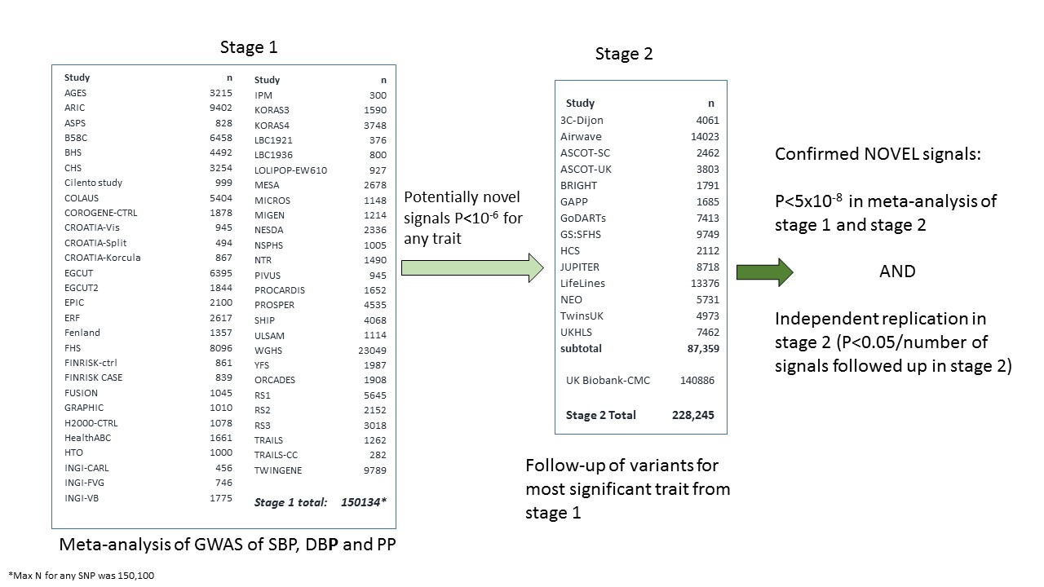
Overview of study design showing studies contributing to stage 1 (discovery) and studies contributing to stage 2 (replication/follow-up). Full study names are given in Supplementary Table 1 (S1) (Stage 1) and Supplementary Table 6 (S6) (Stage 2).

Supplementary Figure 2 (Figure S2): Manhattan and QQ plots

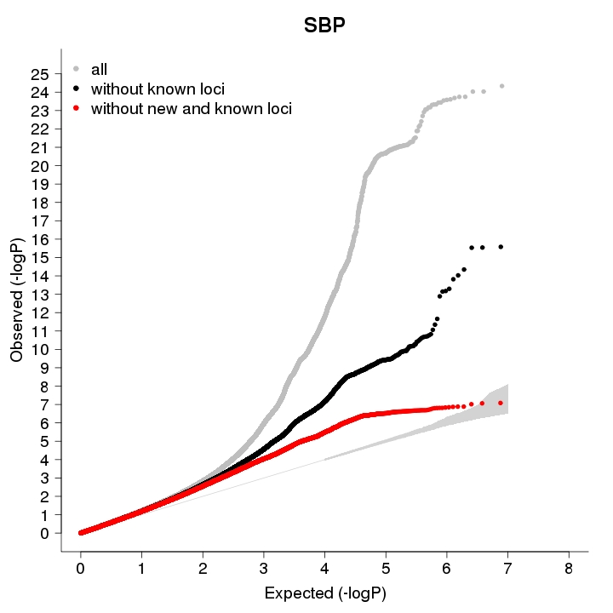
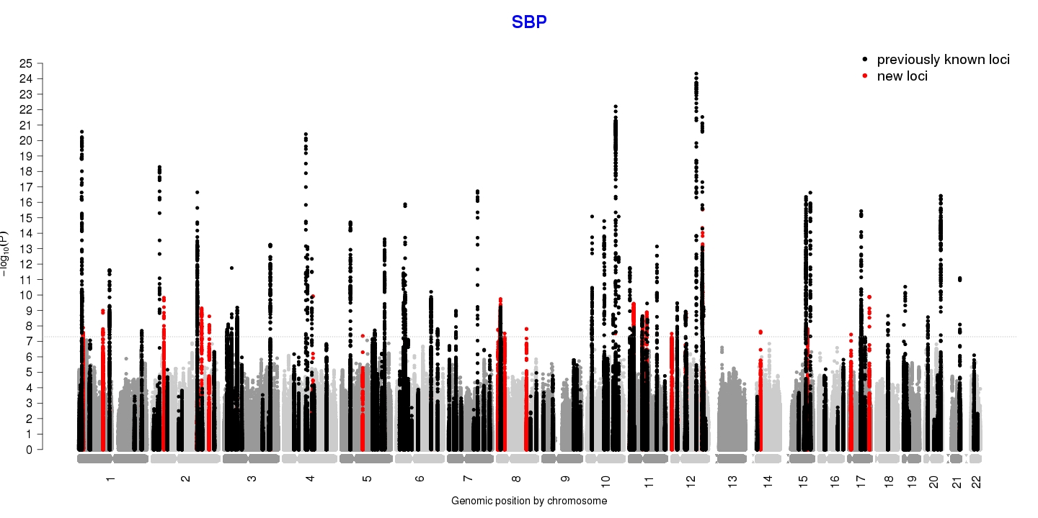

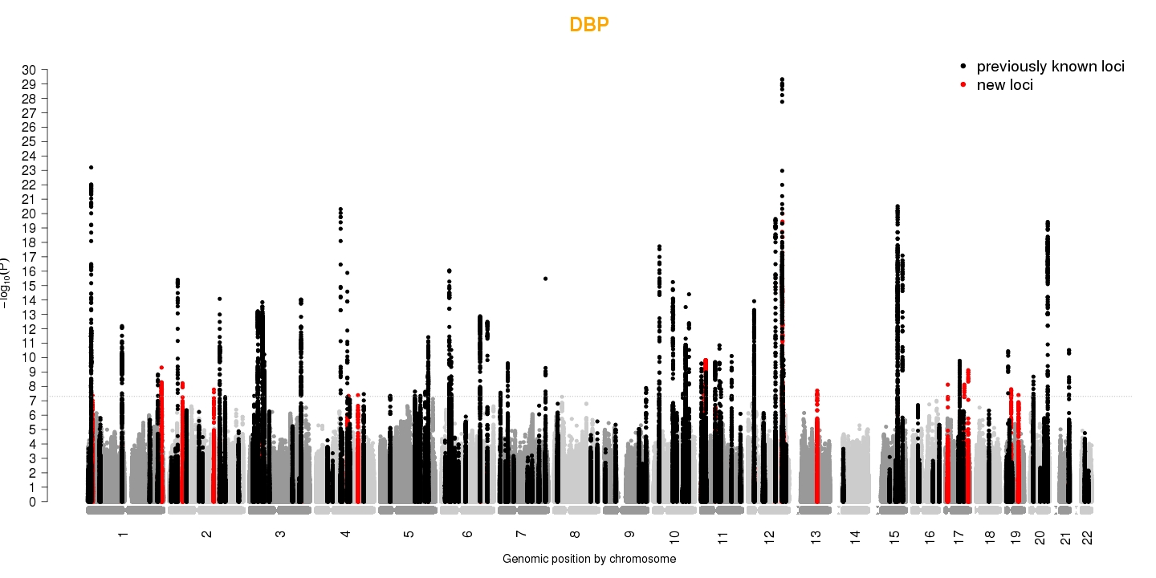
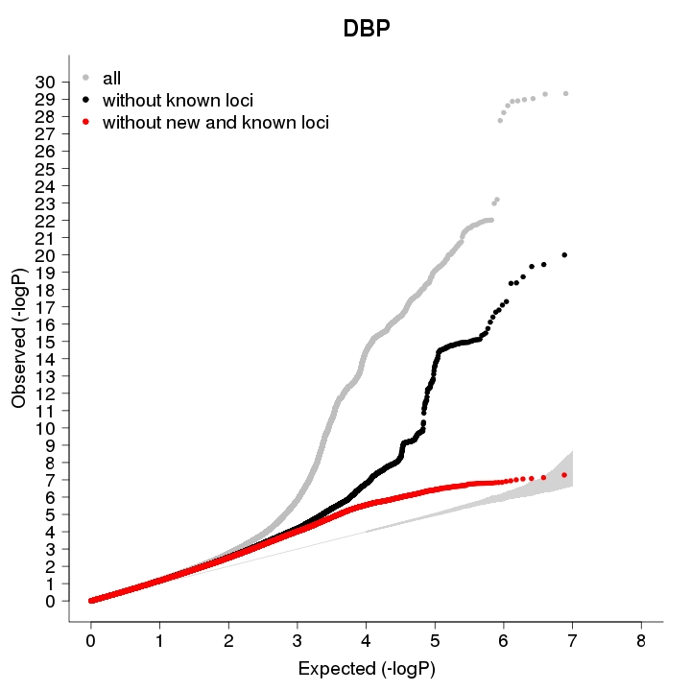

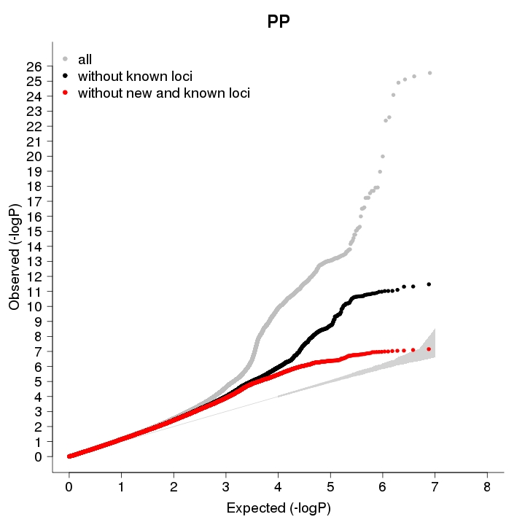

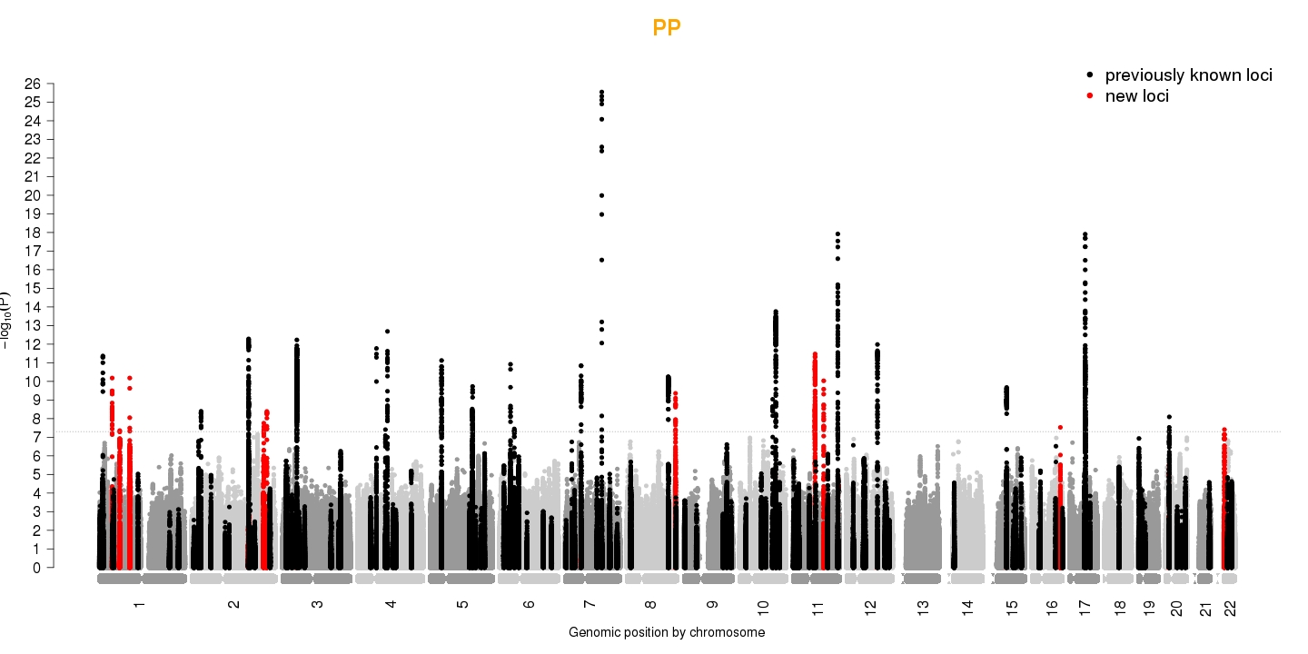
Known loci refers to signals published prior to this study. New includes signals that were initially identified as novel in this study but were subsequently reported in Warren et al 2017 and Hoffman et al 2016.

Supplementary Figure 3 (Figure S3): Region plots for 8 novel signals representing 7 novel regions of association for SBP (A), DBP (B) and PP (C).

A) SBP

B) DBP

Supplementary Figure 4 (Figure S4): Region plots for a novel signal at a previously reported region of association.
SBP: rs185819 (novel signal reported in this study)
The region plot for the previously reported signal is shown (left) alongside the region plot for the novel signal. Results for association of the novel signal after conditioning on the previously reported signal are shown in Supplementary Table 8 (S8).

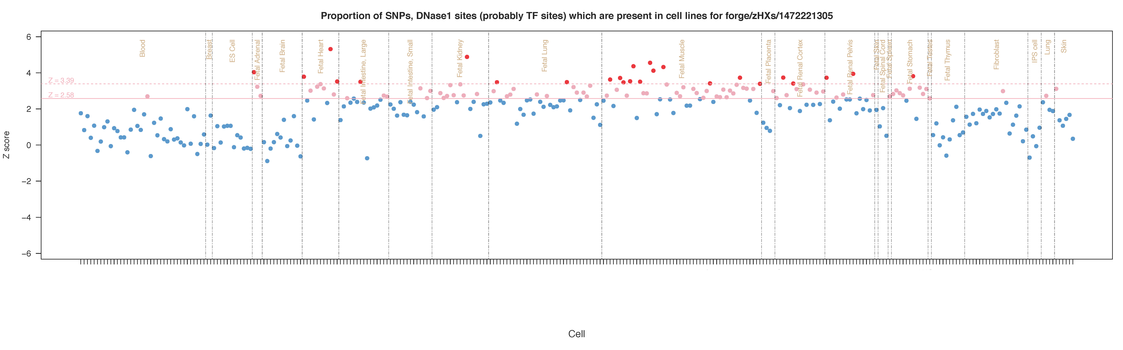
Supplementary Figure 5 (Figure S5): Enrichment of overlap of DNase1 site in Roadmap (a) and ENCODE (b) tissues and cell lines.
a)

b)

Competing financial interests
Mike A. Nalls’ participation is supported by a consulting contract between Data Tecnica International and the National Institute on Aging, NIH, Bethesda, MD, USA, as a possible conflict of interest Dr. Nalls also consults for Illumina Inc, the Michael J. Fox Foundation and University of California Healthcare among others.

Consortium membership

BIOS Consortium
(Biobank-based Integrative Omics Study)
Management Team Bastiaan T. Heijmans (chair)¹, Peter A.C. ’t Hoen², Joyce van Meurs³, Aaron Isaacs⁴, Rick Jansen⁵, Lude Franke⁶.
Cohort collection Dorret I. Boomsma⁷, René Pool⁷, Jenny van Dongen⁷, Jouke J. Hottenga⁷ (Netherlands Twin Register); Marleen MJ van Greevenbroek⁸, Coen D.A. Stehouwer⁸, Carla J.H. van der Kallen⁸, Casper G. Schalkwijk⁸ (Cohort study on Diabetes and Atherosclerosis Maastricht); Cisca Wijmenga⁶, Lude Franke⁶, Sasha Zhernakova⁶, Ettje F. Tigchelaar⁶ (LifeLines Deep); P. Eline Slagboom¹, Marian Beekman¹, Joris Deelen¹, Diana van Heemst⁹ (Leiden Longevity Study); Jan H. Veldink¹⁰, Leonard H. van den Berg¹⁰ (Prospective ALS Study Netherlands); Cornelia M. van Duijn⁴, Bert A. Hofman¹¹, Aaron Isaacs⁴, André G. Uitterlinden³ (Rotterdam Study).
Data Generation Joyce van Meurs (Chair)³, P. Mila Jhamai³, Michael Verbiest³, H. Eka D. Suchiman¹, Marijn Verkerk³, Ruud van der Breggen¹, Jeroen van Rooij³, Nico Lakenberg¹.
Data management and computational infrastructure Hailiang Mei (Chair)¹², Maarten van Iterson¹, Michiel van Galen², Jan Bot¹³, Dasha V. Zhernakova⁶, Rick Jansen⁵, Peter van ’t Hof¹², Patrick Deelen⁶, Irene Nooren¹³, Peter A.C. ’t Hoen², Bastiaan T. Heijmans¹, Matthijs Moed¹.
Data Analysis Group Lude Franke (Co-Chair)⁶, Martijn Vermaat², Dasha V. Zhernakova⁶, René Luijk¹, Marc Jan Bonder⁶, Maarten van Iterson¹, Patrick Deelen⁶, Freerk van Dijk¹⁴, Michiel van Galen², Wibowo Arindrarto¹², Szymon M. Kielbasa¹⁵, Morris A. Swertz¹⁴, Erik. W van Zwet¹⁵, Rick Jansen⁵, Peter-Bram ’t Hoen (Co-Chair)², Bastiaan T. Heijmans (Co-Chair)¹.
1. Molecular Epidemiology Section, Department of Medical Statistics and Bioinformatics, Leiden University Medical Center, Leiden, The Netherlands
2. Department of Human Genetics, Leiden University Medical Center, Leiden, The Netherlands
3. Department of Internal Medicine, ErasmusMC, Rotterdam, The Netherlands
4. Department of Genetic Epidemiology, ErasmusMC, Rotterdam, The Netherlands
5. Department of Psychiatry, VU University Medical Center, Neuroscience Campus Amsterdam, Amsterdam, The Netherlands
6. Department of Genetics, University of Groningen, University Medical Centre Groningen, Groningen, The Netherlands
7. Department of Biological Psychology, VU University Amsterdam, Neuroscience Campus Amsterdam, Amsterdam, The Netherlands
8. Department of Internal Medicine and School for Cardiovascular Diseases (CARIM), Maastricht University Medical Center, Maastricht, The Netherlands
9. Department of Gerontology and Geriatrics, Leiden University Medical Center, Leiden, The Netherlands
10. Department of Neurology, Brain Center Rudolf Magnus, University Medical Center Utrecht, Utrecht, The Netherlands
11. Department of Epidemiology, ErasmusMC, Rotterdam, The Netherlands
12. Sequence Analysis Support Core, Leiden University Medical Center, Leiden, The Netherlands
13. SURFsara, Amsterdam, the Netherlands
14. Genomics Coordination Center, University Medical Center Groningen, University of Groningen, Groningen, the Netherlands
15. Medical Statistics Section, Department of Medical Statistics and Bioinformatics, Leiden University Medical Center, Leiden, The Netherlands

LifeLines Cohort Study
Behrooz Z Alizadeh (Department of Epidemiology, University of Groningen, University Medical Center Groningen, The Netherlands), H Marike Boezen (Department of Epidemiology, University of Groningen, University Medical Center Groningen, The Netherlands), Lude Franke (Department of Genetics, University of Groningen, University Medical Center Groningen, The Netherlands), Pim van der Harst (Department of Cardiology, University of Groningen, University Medical Center Groningen, The Netherlands), Gerjan Navis (Department of Internal Medicine, Division of Nephrology, University of Groningen, University Medical Center Groningen, The Netherlands), Marianne Rots (Department of Medical Biology, University of Groningen, University Medical Center Groningen, The Netherlands), Harold Snieder (Department of Epidemiology, University of Groningen, University Medical Center Groningen, The Netherlands), Morris Swertz (Department of Genetics, University of Groningen, University Medical Center Groningen, The Netherlands), Bruce HR Wolffenbuttel (Department of Endocrinology, University of Groningen, University Medical Center Groningen, The Netherlands), Cisca Wijmenga (Department of Genetics, University of Groningen, University Medical Center Groningen, The Netherlands)

UKHLS
Michaela Benzeval(1), Jonathan Burton(1), Nicholas Buck(1), Annette Jäckle(1), Meena Kumari(1), Heather Laurie(1), Peter Lynn(1), Stephen Pudney(1), Birgitta Rabe(1), Dieter Wolke(2)
1) Institute for Social and Economic Research
2) University of Warwick

