A New Phase Current Reconstruction Scheme for Four-Phase SRM Drives Using Improved Converter Topology Without Voltage Penalty

Abstract—Accurate current detection is of crucial importance for the operation and fault diagnosis of motor drives. In this paper, a new phase current reconstruction scheme is proposed for four-phase switched reluctance motors (SRMs) by using one DC-link current sensor without voltage penalty. Firstly, an improved converter topology is proposed, which has less electronic components and more compact structure compared to the conventional asymmetrical half-bridge converter. Then, an advanced pulse injection technology is developed to obtain the phase currents. By using the proposed approach, the cost and volume of the motor drive are reduced and the reliability of the system is improved. Most importantly, the scheme proposes a promising solution to the voltage penalty problem caused by the other existing strategies, which significantly increases the sampling accuracy without restriction of the duty cycle of injected pulse. In order to verify the effectiveness of the proposed method, three classical control schemes including angular position control (APC), current chopping control (CCC), and voltage pulse-width modulation control (VPC) are all performed in the closed-loop system. The simulation and experiments based on a 150 W four-phase 8/6 SRM are carried out to validate the feasibility of this proposed scheme.

Index Terms—Phase current reconstruction, converter topology improvement, reduced electronic components, no voltage penalty, switched reluctance motors (SRMs).

Introduction
Over the recent decades, switched reluctance motors (SRMs) have been one promising candidate for industrial applications, such as household appliances [1], [2], electric vehicles (EVs) [3]-[5], electric aircraft [6], [7] and general industrial [8], [9]. Comparing to the other conventional DC and AC electrical machines, SRMs have a series of advantages: simple structures, excellent robustness, rare-earth-free features, low cost, high reliability and wide speed range [10]-[12], which contributes to the reliability under some harsh environments for a long time working.
However, the high torque ripple, vibration, and acoustic noise problems, caused by the inherent doubly salient structure and discrete nature of torque production, pose a challenge to further development of SRMs in industrial fields. Hence, many advanced schemes are developed to improve the motor performance. In order to realize lower torque ripple for SRMs, the following two methods are usually adopted: i) optimizations of the motor structure [13], [14]; ii) developments of the control strategies [15]-[18]. The accurate calculations, predictions and control strategies of the radial force have always been the main concerns to reduce the acoustic noise and vibration [19]-[21]. Meanwhile, in order to reduce the cost and improve the motor performance and reliability, the optimization design of the power converter [22], [23] and the research on sensorless technology [24], [25] also attract great attentions.
The information feedback mechanism of phase currents is of crucial importance, not only for the detection and improvement of motor performance but also for the fault diagnosis during the motor operation. Conventionally, the phase current is sampled directly by each current sensor placed in each phase winding, which increases the volume and cost of the drive system and reduces the running reliability of the machines. Therefore, advanced phase current detection schemes are presented, accordingly. In [26], a switching state phase shift (SSPS) scheme is utilized to sample the phase current with a DC-link current sensor in the permanent magnet synchronous motor (PMSM) servo drives, which is achieved by the space-vector pulse width modulation (SVPWM) modification with less impact on the output current ripples and switching losses. An AC motor current reconstruction scheme is developed in [27]. The method is applied in the SVM-based three phase direct matrix converter (DMC), where two phase currents are measured in the two intervals divided by the zero-vector application time, and then the third phase current is obtained by the constraint function of three phase currents. In [28], the line currents are mapped by the prestored space-vector-based lookup table according to the measured voltage source inverter (VSI) DC-link current. However, this scheme still has a limitation in the low modulation index region. In [29], a single current sensor operation method is developed with minimal hardware and software requirements, which is achieved by fixed sampling for three-phase AC system based on the tristate pulse-width modulation technique (TSPWM). However, higher phase current total harmonic distortion (THD) exists in this scheme due to the switching harmonics, which reduces the phase current sampling accuracy. A six-phase current reconstruction method is proposed in [30] for the dual traction inverters based on the phase-shift PWM procedure. The control strategy is complex due to the constraint of the maximum allowable modulation index and the minimum required sampling time. In [31], a hybrid switching pattern is presented in SVPWM scheme based on the three-level T-type converters. The modified switching signals are easily generated without significant computational complexity, whereas the cost and the volume of the drive system increase.
The study on phase current detection for SRMs also has attracted great attentions of researchers in recent years. In [32], the technology of multiphase current reconstruction with one current sensor is developed in SRMs for the first time. The switching signals are generated by the complicated logic function based on the additional hardware circuits, and the way to sample phase current is not put forward effectively. In [33], a double high-frequency pulses injection method is utilized to decompose the DC-link current into phase currents in the overlapped region. Although the presented control algorithm is easy to implement, the duty cycle and frequency of the injected double pulses must be extremely high to maintain the motor operation performance, which easily causes the inaccuracy of current sampling. In addition, in both [32] and [33], the voltage penalty is inevitable due to the forced change of operation modes when the current reconstruction techniques are executed, which easily leads to the distortion of phase currents. An advanced and promising phase current reconstruction scheme should satisfy the following requirements: i) little change of the traditional converter topology; ii) accurate phase current reconstruction; iii) no voltage penalty and current distortion; iv) feasibility for multifarious control strategies.
In this paper, in order to obtain the accurate phase currents with a single DC-link current sensor, a new phase current reconstruction scheme is proposed for four-phase SRMs based on an improved asymmetrical half-bridge converter topology, which significantly reduces the cost and volume of the motor drive and improve the reliability of the system due to less electronic components and more compact structure. Compared with the existing current reconstruction methods, the proposed scheme provides a promising solution to the voltage penalty and current distortion problems, which caused by the forced change of operation modes for SRMs. Meanwhile, the proposed phase current reconstruction technique is applicable to all three classical control strategies: angular position control (APC), current chopping control (CCC) and voltage pulse-width modulation control (VPC) [34]-[36]. In order to validate the feasibility and effectiveness of the proposed scheme, the simulation and experiments are carried out based on a 150 W four-phase 8/6 SRM.

Proposed Power Converter Topology and Phase Current Reconstruction Scheme
In order to implement the proposed phase current reconstruction scheme, an improved asymmetrical half-bridge converter topology is developed firstly, which has less electronic components and more compact structure. An advanced current sampling technology is then proposed to reconstruct the phase currents by one DC-link current sensor without voltage penalty.

Improved Converter Topology
The conventional SRM drive system is composed of an SRM, an asymmetrical half-bridge converter, a drive controller, a position sensor and a current sensor in each phase winding, as shown in Fig. 1. In the proposed SRM drive system, an improved power converter topology is employed, as shown in Fig. 2, where only current sensor is placed in the new bus line and i_{bus} is the DC-link current.
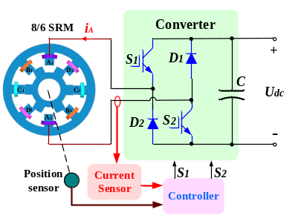
Fig. 1. Conventional four-phase 8/6-pole SRM Drive.
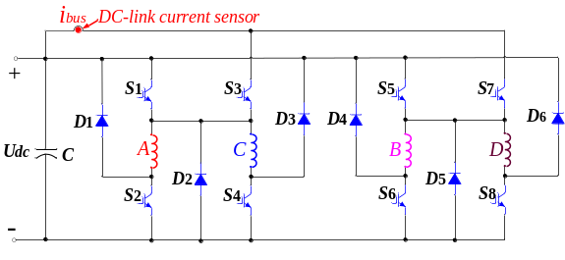
Fig. 2. Improved power converter for four-phase SRM.
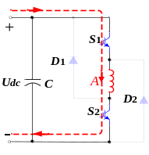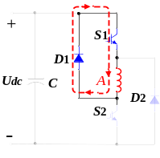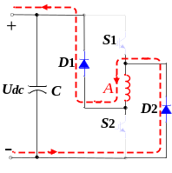
(a) (b) (c)
Fig. 3. Operation modes of the converter. (a) Excitation mode. (b) Freewheeling mode. (c) Demagnetization mode.
Considering that no more than two phase windings conduct simultaneously, phase-A and C will not conduct at the same time, which is similar to phase-B and D. Hence, phase-A and C (or phase-B and D) can share same electronic components by appropriate optimization to the conventional converter topology, which makes the converter simpler and reduces the cost. In the proposed converter, there are also three switching states. For example of phase-A, when switches S₁ and S₂ are both turned on, the bus voltage, i.e., U_{dc}, is applied to phase winding, which is the excitation mode, as shown in Fig. 3 (a). When S₁ is on and S₂ is off, the freewheeling mode is shown in Fig. 3 (b). When S₁ and S₂ are both turned off, the energy of the phase winding feeds back to the power supply through diodes D₁ and D₂, and the demagnetization mode is shown in Fig. 3 (c).

Analysis of the DC-Link Current and Phase Currents
In order to illustrate the current sampling strategy of the proposed topology, the constrained relationship between the DC-link current and phase currents should be firstly analyzed in details. Therefore, the simplified converter topology is presented in Fig. 4, which can reflect their connections more clearly before the phase current reconstruction strategy is applied. In the simplified topology, phase-A and C share the switch S₃ and the diode D₂, and phase-B and D share the switch S₇ and the diode D₅. The topology excludes the demagnetization current from the DC-link current by pulling out all the cathode ends of the upper diodes and connecting them to the upper DC-link, which is beneficial to achieve the following proposed phase current reconstruction scheme. Considering that only one phase or two phases are conducting simultaneously, the waveforms of the two adjacent phase currents present two states: overlap and non-overlap.
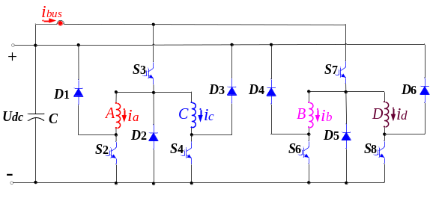
Fig. 4. Simplified power converter topology.
When there is no overlap between the two adjacent phase currents, the waveforms of DC-link current and phase currents in the APC control system are shown in Fig. 5, where the conduction region of each phase is no more than 15°. As previously stated, the demagnetization current will not influence DC-link current due to the optimization design of the proposed power converter. In this condition, each phase current can be directly obtained by sampling the DC-link current during the corresponding conduction region. It should be noted that the measured phase current will not include the demagnetization part, which is acceptable because the demagnetization current is not in the conduction region and uncontrolled.
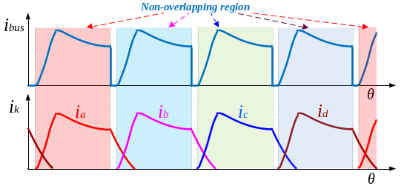
Fig. 5. Non-overlap state of two adjacent phase current.
When there is an overlapping region between the two adjacent phase currents, i.e., the conduction range of each phase is more than 15°, the DC-link current is the sum of the two phase currents, and every phase current can be separated into three parts, as shown in Fig.6. For each phase current, the middle part of the current waveform can be obtained directly from the DC-link current, while the first and third parts should be decomposed from the DC-link current by utilizing the proposed topology and phase current reconstruction technique.
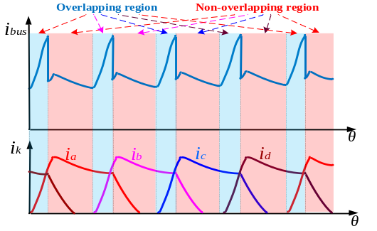
Fig. 6. Overlap state of two adjacent phase current.

New Phase Current Reconstruction Scheme
The phase current is easy to measure when there is no overlap between the two adjacent phases. The key point is the phase current detection under the overlapping state. In order to decompose the DC-link current into two separate phase currents in the overlapping region, only one phase current should flow through the DC-link current sensor while another phase current flow through the other circuit simultaneously. For example of phase-A and B, there are four states in the overlapping region: i) phase-A and B are both in the excitation modes; ii) phase-A is in the excitation mode and phase-B is in the freewheeling mode; iii) phase-A is in the freewheeling mode and phase-B is in the excitation mode; iv) phase-A and B are both in the freewheeling mode.

Working State under Excitation Modes of Phase-A and B
Fig.7 illustrates the current path when the proposed phase current reconstruction scheme is executed under the excitation modes of phase-A and B. The DC-link current is the sum of excitation current of phase-A i_{a} and excitation current of phase phase-B i_{b}, as shown in Fig.7 (a). By turning on the switch S₅ and turning off the switch S₇, the phase-B current is separated from the DC-link current, and only phase-A current flows through the DC-link current sensor, as shown in Fig.7 (b). Also, by turning on the switches S₁, S₇ and turning off the switches S₃, S₅, phase-A current is separated from the DC-link current, and phase-B current can be sampled at the moment, as shown in Fig.7 (c). In this working state, the DC-link current is expressed as
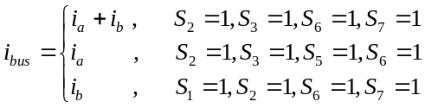 (1)
where S₁, S₂, S₃, S₅, S₆ and S₇ are the switching signals of corresponding switches, respectively.
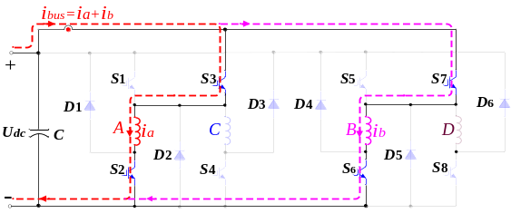
(a)
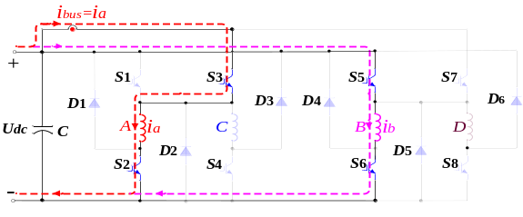
(b)
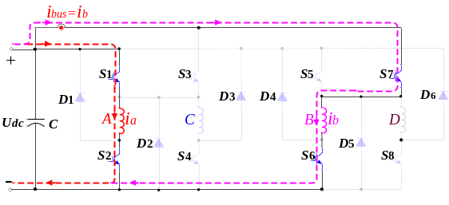
(c)
Fig.7 Working state under excitation modes of phase-A and B. (a) Normal operation. (b) Phase-A current detection. (c) Phase-B current detection.
The switching signals and sampling instants under this operational mode are presented in Fig. 8, where t_{a}__{sam} is the sampling instants for phase-A current, which is synchronized with the high level of S₅ and t_{b}__{sam} is the sampling instants for phase-B current, which is synchronized with the high level of S₁. In order to ensure the independence of each phase current sampling, a proper phase-shift between S₁ and S₅ is necessary. In the proposed scheme, the switching signal S₅ is delayed by 180° based on S₁. The switching signal S₃ is obtained by inverting the switching signal S₁ and S₇ is obtained by inverting S₅ in the overlapping region. In addition, the duty cycle of pulses S₁ and S₅ should be less than 50% to achieve the phase current reconstruction scheme mentioned above during the overlapping region.
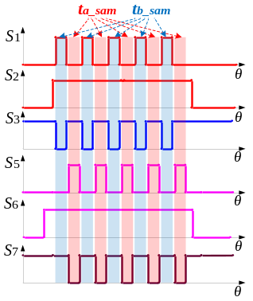
Fig. 8 Switching signals and sampling instants under excitation modes of phase-A and B.

Working State under Freewheeling Mode of Phase-A and Excitation Mode of Phase-B
The working state under the freewheeling mode of phase-A and excitation mode of phase-B is shown in Fig. 9. In Fig.9 (a), the DC-link current is the sum of the freewheeling current of phase-A and excitation current of phase phase-B. When S₅ is on and S₇ is off, phase-A and B currents are separated and phase-A current can be sampled by the DC-link sensor, as shown in Fig.9 (b). By turning on the switches S₁, S₇ and turning off the switches S₃, S₅, phase-A and B currents are also separated and the phase-B current can be sampled by the DC-link sensor, as shown in Fig.9 (c).
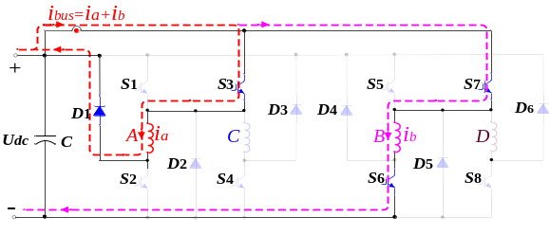
(a)
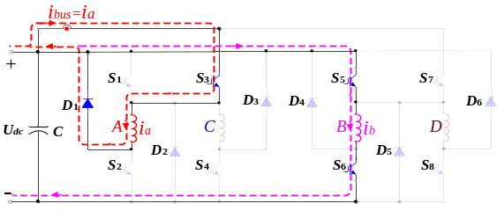
(b)
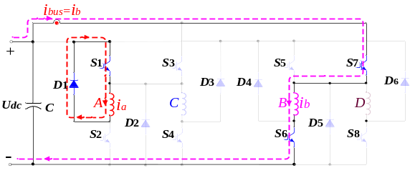
(c)
Fig.9 Working state under the freewheeling mode of phase-A and excitation mode of phase-B. (a) Normal operation. (b) Phase-A current detection. (c) Phase-B current detection.
Fig.10 shows the switching signals and sampling instants under this operational mode and the DC-link current can be expressed as
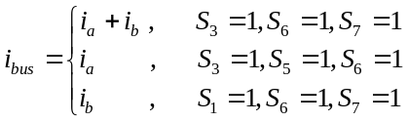 (2)
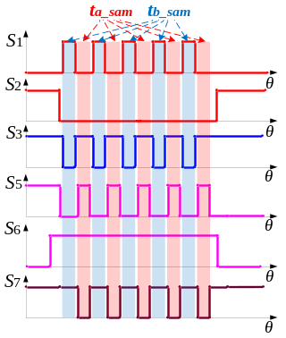
Fig. 10 Switching signals and sampling instants under the freewheeling mode of phase-A and excitation mode of phase-B.

Working State under Excitation Mode of Phase-A and Freewheeling Mode of Phase-B
The working state under excitation mode of phase-A and freewheeling mode of phase-B is similar to the condition under the freewheeling mode of phase-A and excitation mode of phase-B, hence the same will not be repeated here.

Working State under Freewheeling Modes of Phase-A and B
The working state under freewheeling modes of phase-A and B are presented in Fig. 11. The switching signals and sampling instants are shown in Fig.12, and the DC-link current is expressed as
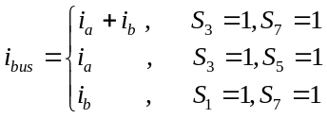 (3)
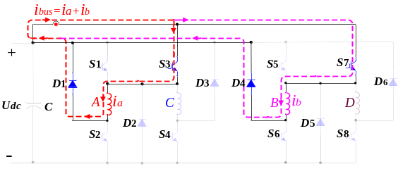
(a)
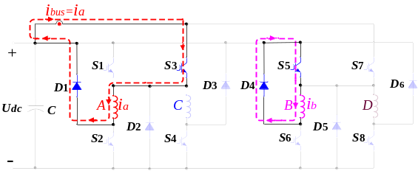
(b)
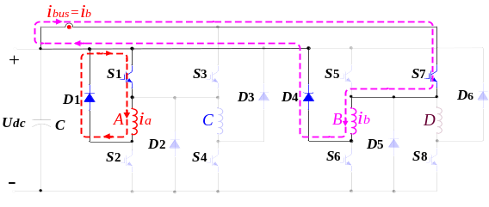
(c)
Fig.11 Working state under freewheeling modes of phase-A and B. (a) Normal operation. (b) Phase-A current detection. (c) Phase-B current detection.
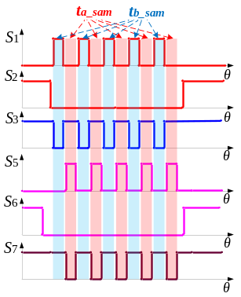
Fig. 12 Switching signals and sampling instants under freewheeling modes of phase-A and B.
According to the explanation above, the proposed phase current reconstruction scheme is implemented when the duty cycle of S₁ and S₅ is set to less than 50% in the overlapping region. Actually, even if the duty cycle of S₁ and S₅ is set to more than 50% in the overlapping region, the phase current reconstruction procedure can also be realized. The switching signal S₅ is still delayed by 180° based on S₁. The switching signal S₃ is still obtained by inverting the switching signal S₁ and S₇ is obtained by inverting S₅ in the overlapping region. In this condition, the duty cycle of S₃ and S₇ becomes less than 50% accordingly. Hence, the phase-A current is sampled by synchronizing with the high level of S₃ and phase-B current is sampled by synchronizing with the high level of S₇.
Compared to the scheme in [33], there are some advantages in the proposed phase current reconstruction scheme. First, the power converter topology is optimized to implement the proposed scheme, which has less electronic components and more compact structure. Second, the operation modes of the optimized converter are not changed by triggering switches appropriately when the proposed scheme is implemented. In order to decompose the DC-link current into two separate phase currents in the overlapping region, one phase current flows through the DC-link current sensor while another one flows through the other loop simultaneously. Although the phase current path is changed, the operation modes of the overlapped phases during reconstruction process are not changed by controlling the turn-on and turn-off states of switches appropriately. Hence, the voltage penalty and current distortion problems are completely avoided, and phase currents can be reconstructed more accurately without current distortions. Third, the duty cycle of the injected signals is not restrained compared to the 95% duty cycle that selected in [33], which ensures that there is sufficient time for the dc-link sensor to detect the current. Therefore, the proposed method ensures an accurate current sampling and reduces the control complexity.

Control Strategies
There are three conventional methods for SRM control, including APC, CCC and VPC [34]-[36]. Fig. 13 shows the control block diagram including the three methods. A PI controller is employed to regulate the motor speed for the closed-loop control. The control mode switch is used to select the control strategies according to different operational conditions. The rotor position is detected by a position sensor for conduction angle and speed calculations.
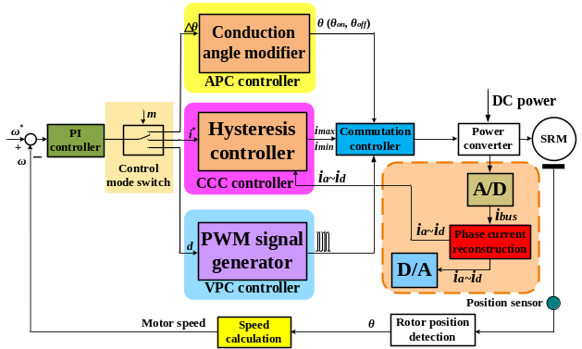
Fig. 13 Control block diagram for APC, CCC and VPC.

APC Strategy
In APC system, the turn-on and turn-off angles are adjustable according to the load and operational speed [34]. The current waveforms under non-overlap state are shown in Fig. 5 and the waveforms under overlap state are shown in Fig. 6. There is only one working mode during the overlapping region, i.e. excitation modes of the two adjacent phases. Hence, the phase current detection scheme is easily achieved (see Fig. 7), and the switching signals and sampling instants are shown in Fig. 8. Obviously, by using the proposed scheme, it is easy to decompose the DC-link current into independent phase currents as long as the appropriate frequency of the injected switching signals is adopted during the overlapping region. The sampled phase currents will be more accurate when this frequency is set to be higher as the motor speed increases.

CCC Strategy
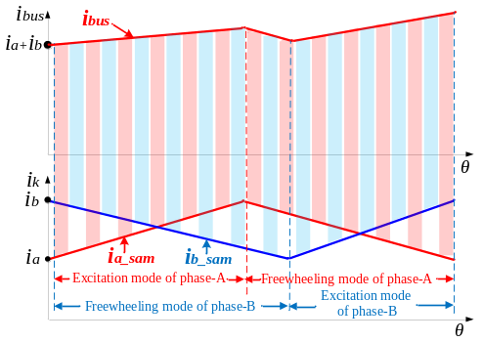
Fig. 14 Phase current sampling in the CCC system.
In CCC system, the phase current is regulated by a current hysteresis controller [35]. The four working modes mentioned above all exist during the overlapping region. In order to reconstruct each phase current from the DC-link current accurately, the sufficient sampling points must be guaranteed during the ascending and descending regions of every current sawtooth wave, as shown in Fig. 14.
The voltage equation for SRM drive is expressed as
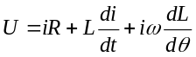 (4)
where U, i, R are the bus voltage, phase current and phase resistance, respectively; θ is the rotor position angle; L is the phase inductance and ω is the angular velocity.
When the phase winding is in the excitation mode, the phase current is in the ascending region of the sawtooth wave. Considering that the ascending duration is extremely short, the voltage equation can be rewritten as
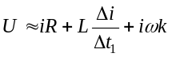 (5)
where △t₁ is the ascending time; △i is the hysteresis width and k is the slope factor of the phase inductance.
Hence, the ascending time can be obtained by
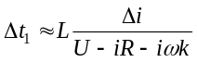 (6)
If the bus voltage, motor speed, the phase current reference and the hysteresis width are fixed, the maximum of the ascending time, i.e., △t_{max}_₁ can be determined by
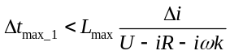 (7)
where L_{max} is the maximum of the phase inductance.
Similarly, the maximum of the descending time, i.e., △t_{max}_₂ can be determined by (8), (9) and (10).
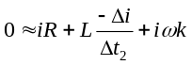 (8)
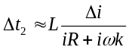 (9)
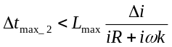 (10)
where △t₂ is the descending time.
Therefore, to reconstruct the phase current precisely in the CCC system, the frequency of the injected switching signals during the overlapping region should satisfy
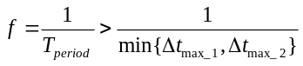 (11)
where f is the frequency of the injected switching signals in the overlapping region.

VPC Strategy
In VPC system, the average voltage applied to the phase winding is determined by the duty cycle of the voltage-PWM signal [36]. The concern to implement the proposed phase current reconstruction method is the constraint condition between the frequency of the injected switching signals and PWM signal. Hence, the frequency of the injected switching signal during the overlapping region should be higher than the frequency of voltage-PWM.
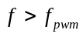 (12)
where f_{pwm} is the PWM frequency.

Simulation Verification
In order to validate the proposed phase current reconstruction scheme, a close-loop system based on a 150 W 8/6-pole SRM prototype is built in MATLAB/Simulink. The required torque and flux data in the simulation are obtained by the finite element analysis (FEA) using the ANSOFT software. The improved converter topology is used to drive the SRM system. The phase current reconstruction procedure during the overlapping region of phase-A and B is shown in Fig. 15, where S_{a2} and S_{b2} represent the conduction regions of phase-A and B, respectively; S_{a3} is the injected pulse in the phase-A and B overlapping region for phase-A current sampling and S_{b3} is the injected pulse in the phase A and B overlapping region for phase-B current sampling. In the simulation, the frequency of the injected switching signals is set to 10 KHz. As previously mentioned, the proposed phase current detection scheme can be realized with lower duty-cycle requirements for the injected pulse. The simulation is carried out under the duty cycle of 30% and 70%, respectively.
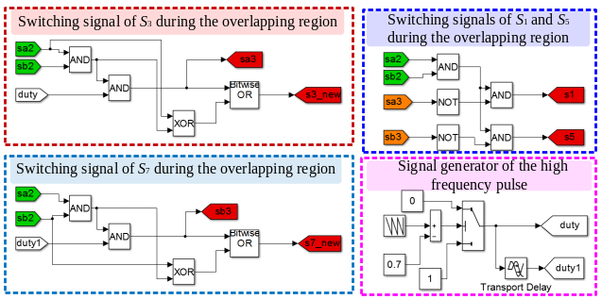
Fig. 15 Phase current reconstruction procedure during the overlapping region of phase-A and B.
Fig. 16 shows the waveforms of DC-link current, phase currents and relevant switching signals in the APC-based simulation system. The working mode without overlapping region is shown in Fig. 16 (a), where the speed reference is set to 600 r/min. The waveform of DC-link current tracks each phase current accurately without the demagnetization current. The phase current can be obtained directly by sampling the DC-link current under this condition. Hence, the switching signal S₁ is not used and the switching signal S₂ and S₃ are utilized to implementing the APC control strategy. The working mode with overlapping region is shown in Fig. 16 (b), where the speed reference is set to 800 r/min and the phase current reconstruction procedure is not executed. The DC-link current is the sum of the two adjacent phase currents. When the phase current reconstruction procedure is executed and the duty cycle of S₁ and S₅ is set to 30%, the waveform is shown in Fig. 16 (c). The DC-link current demonstrates three envelopes during the overlapping region, which represent the two overlapped phase currents and their sum, respectively. The phase currents can be reconstructed by sampling their envelopes, respectively. Fig. 16 (d) shows the waveforms when the duty cycle of S₁ and S₅ is set to 70%. Similarly, the DC-link current demonstrates three envelopes during the overlapping region, which represent the two overlapped phase currents and zero, respectively. The phase currents can also be reconstructed by sampling the envelopes, respectively. By applying the proposed strategy, the switches S₁ and S₅ conduct alternatively, which ensure the phase current is reconstructed without any voltage penalty.
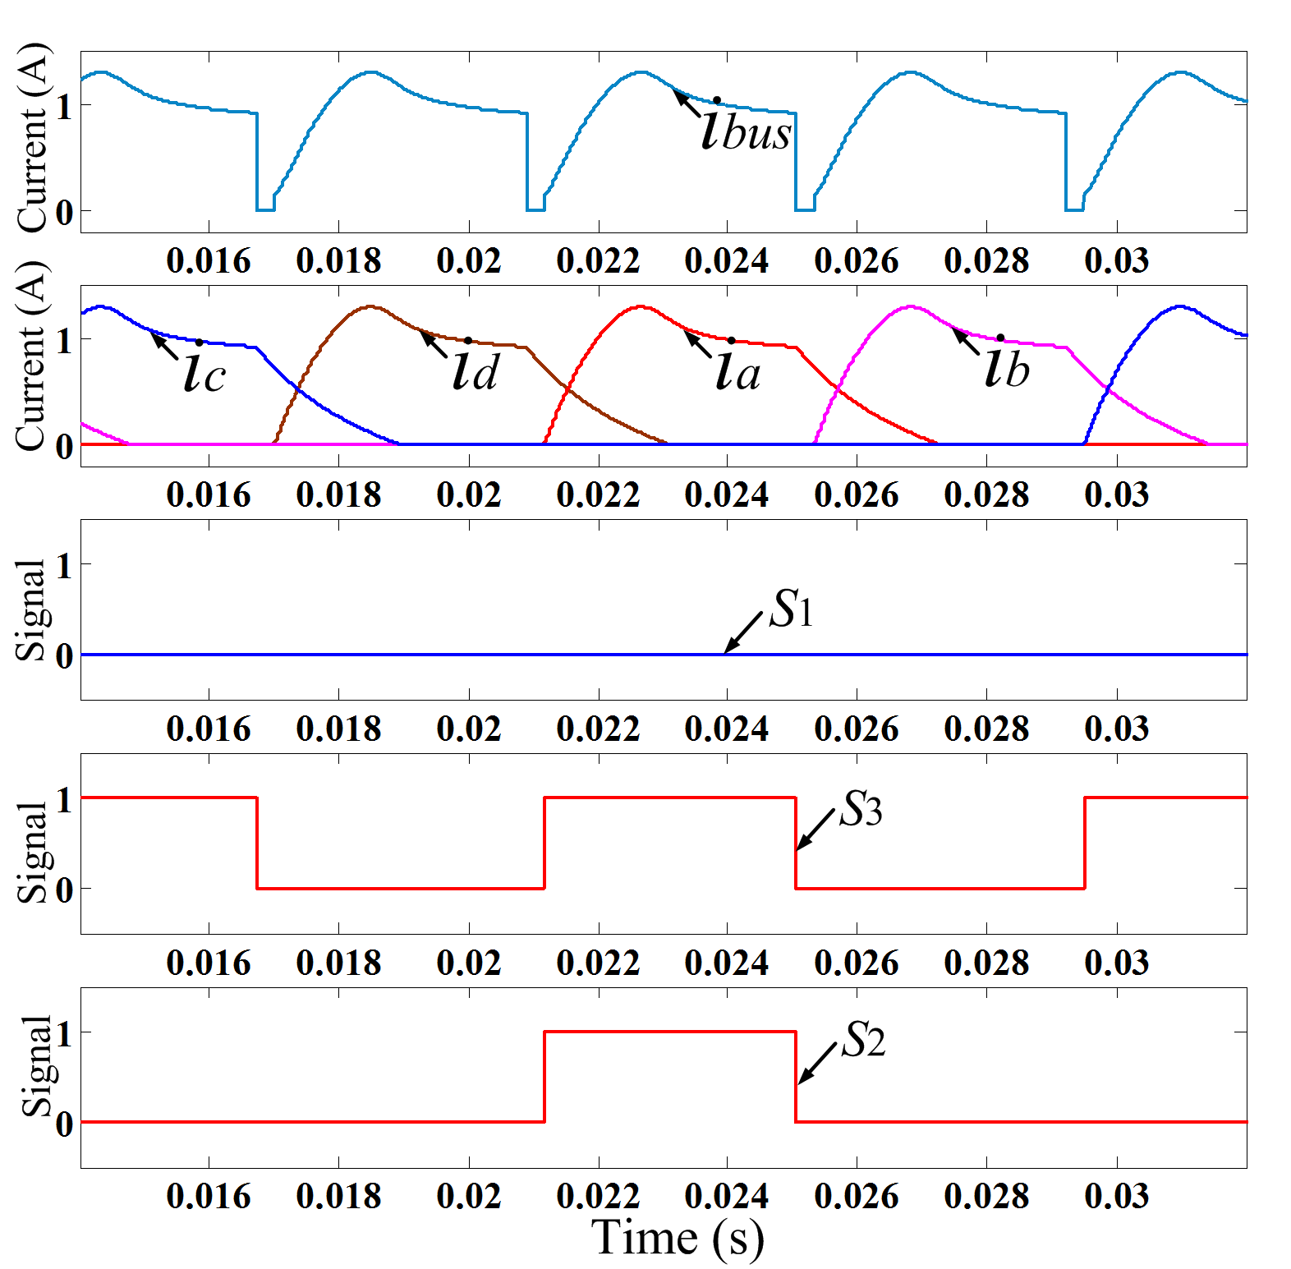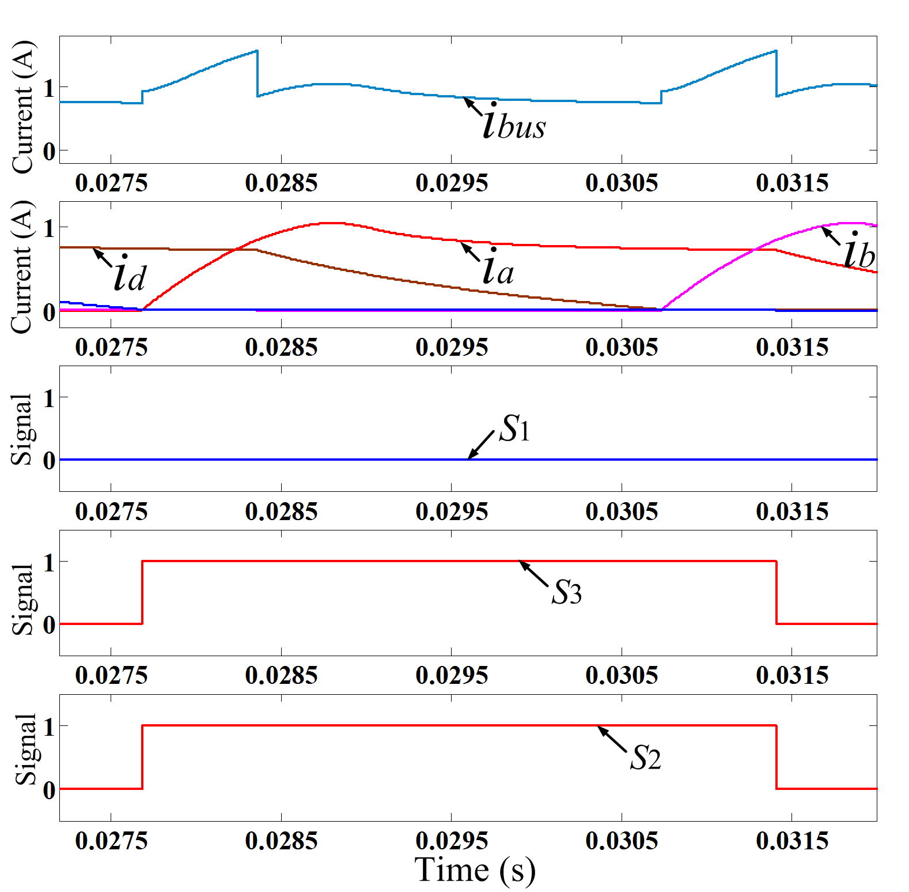
(a) (b)
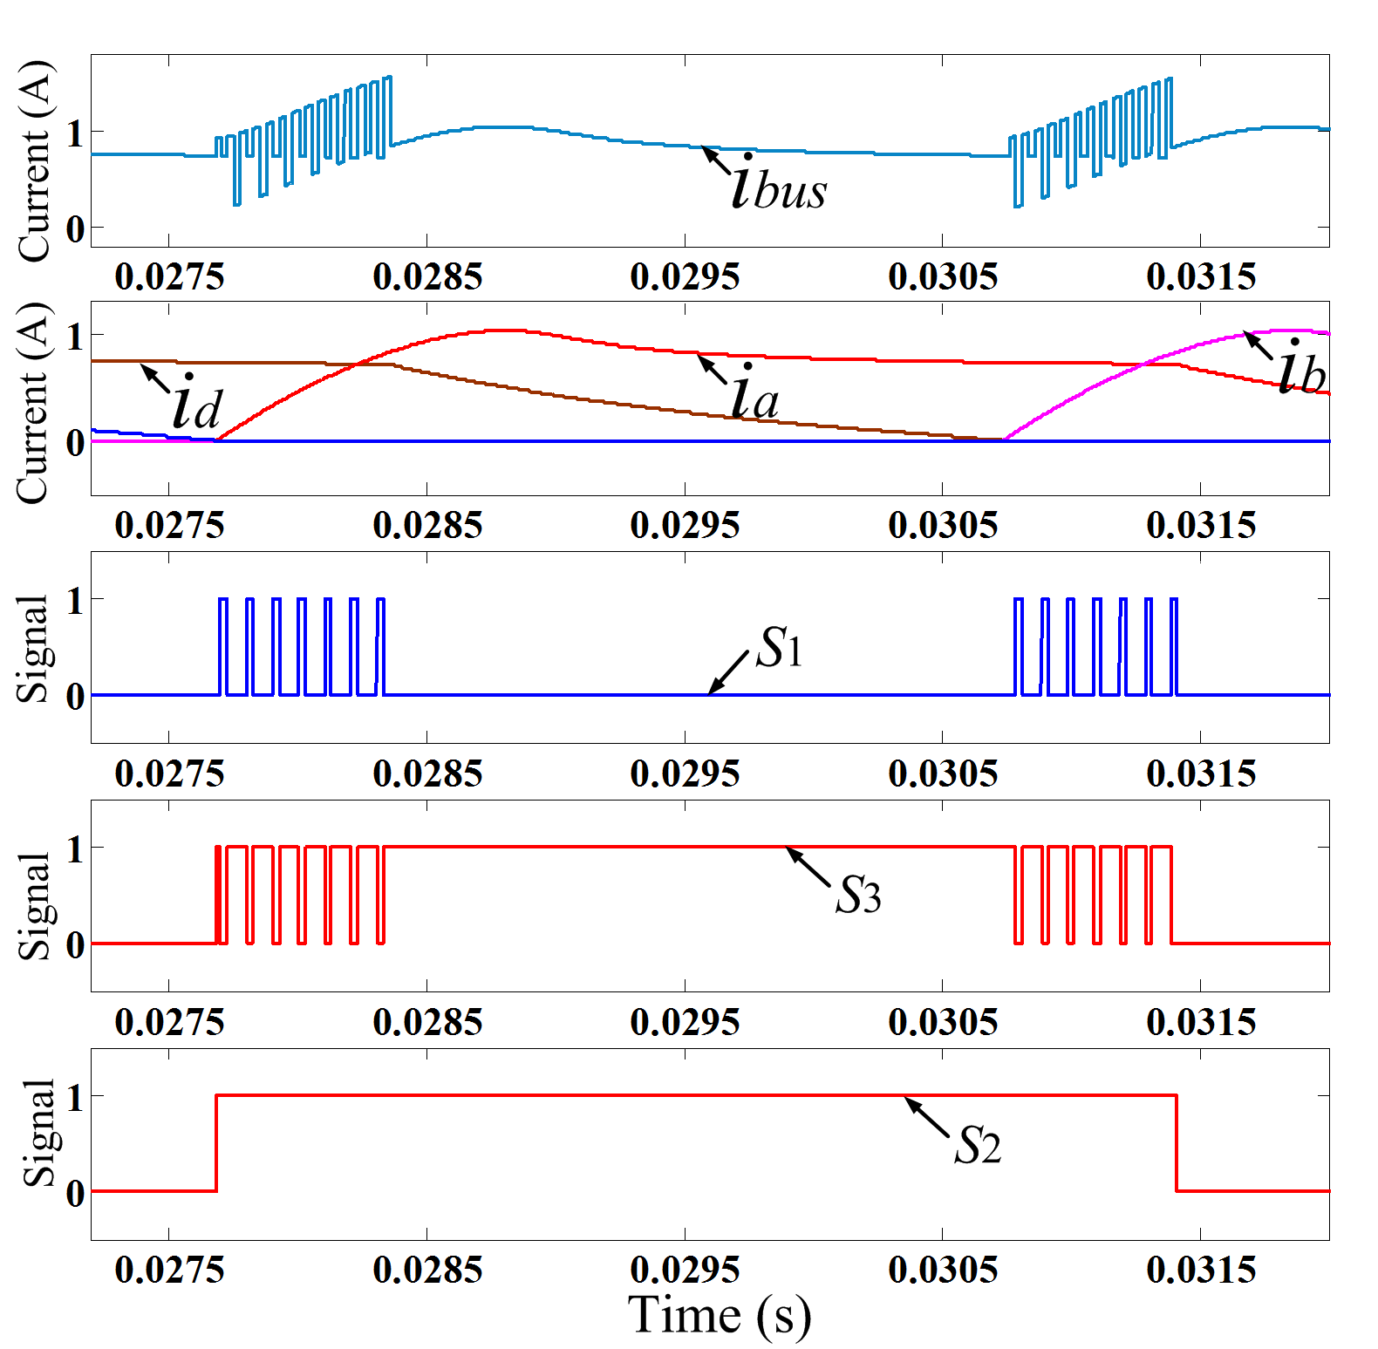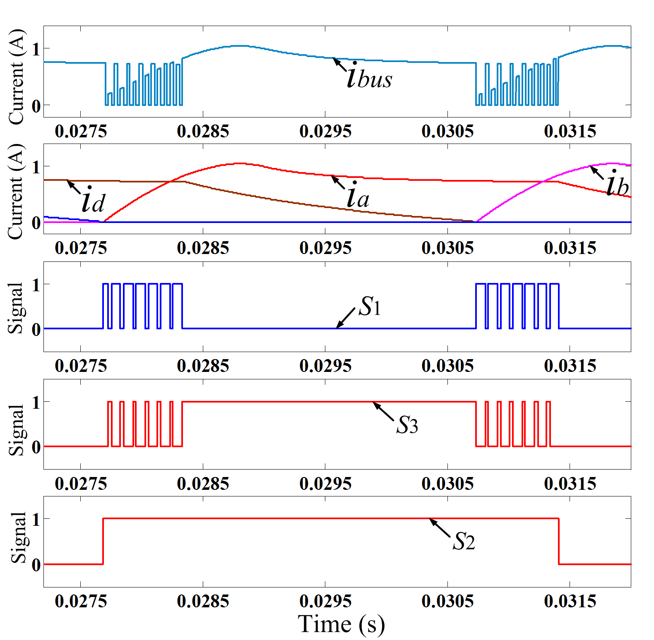
(c) (d)
Fig. 16 Phase current reconstruction scheme in APC-based simulation system. (a) Operation state without overlapping region. (b) Operation state with overlapping region. (c) Operation state under the duty cycle of 30%. (d) Operation state under the duty cycle of 70%.
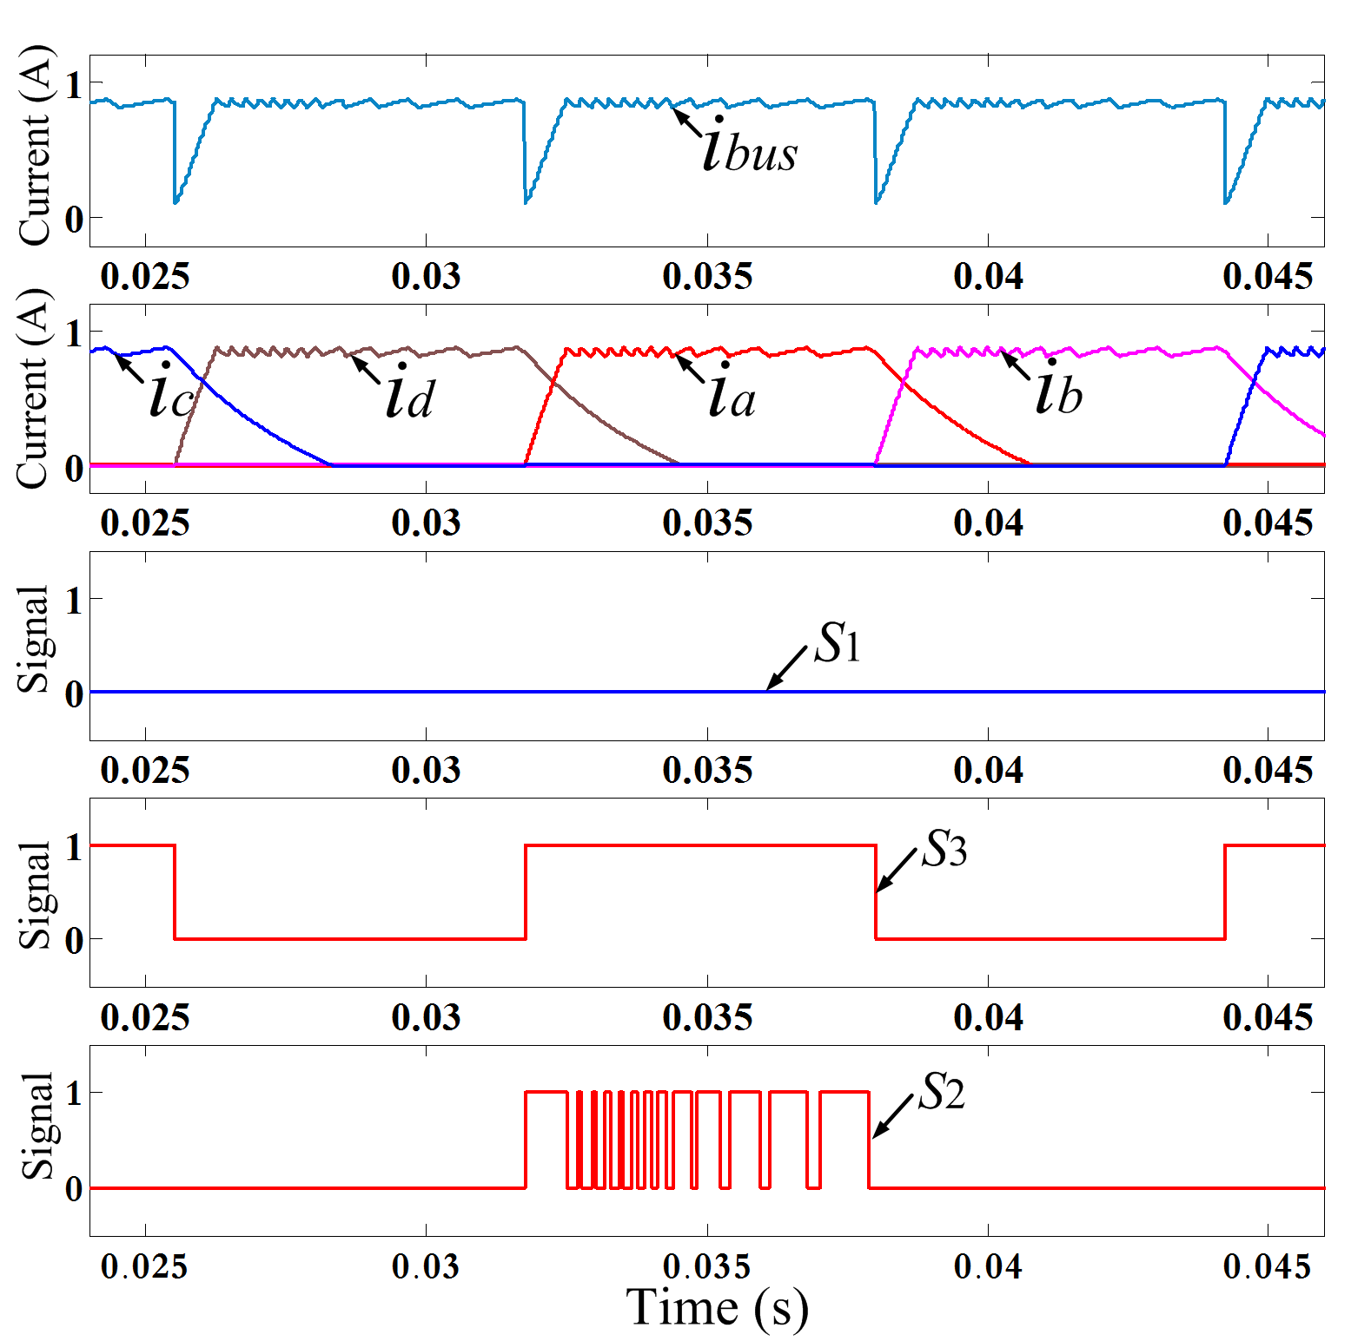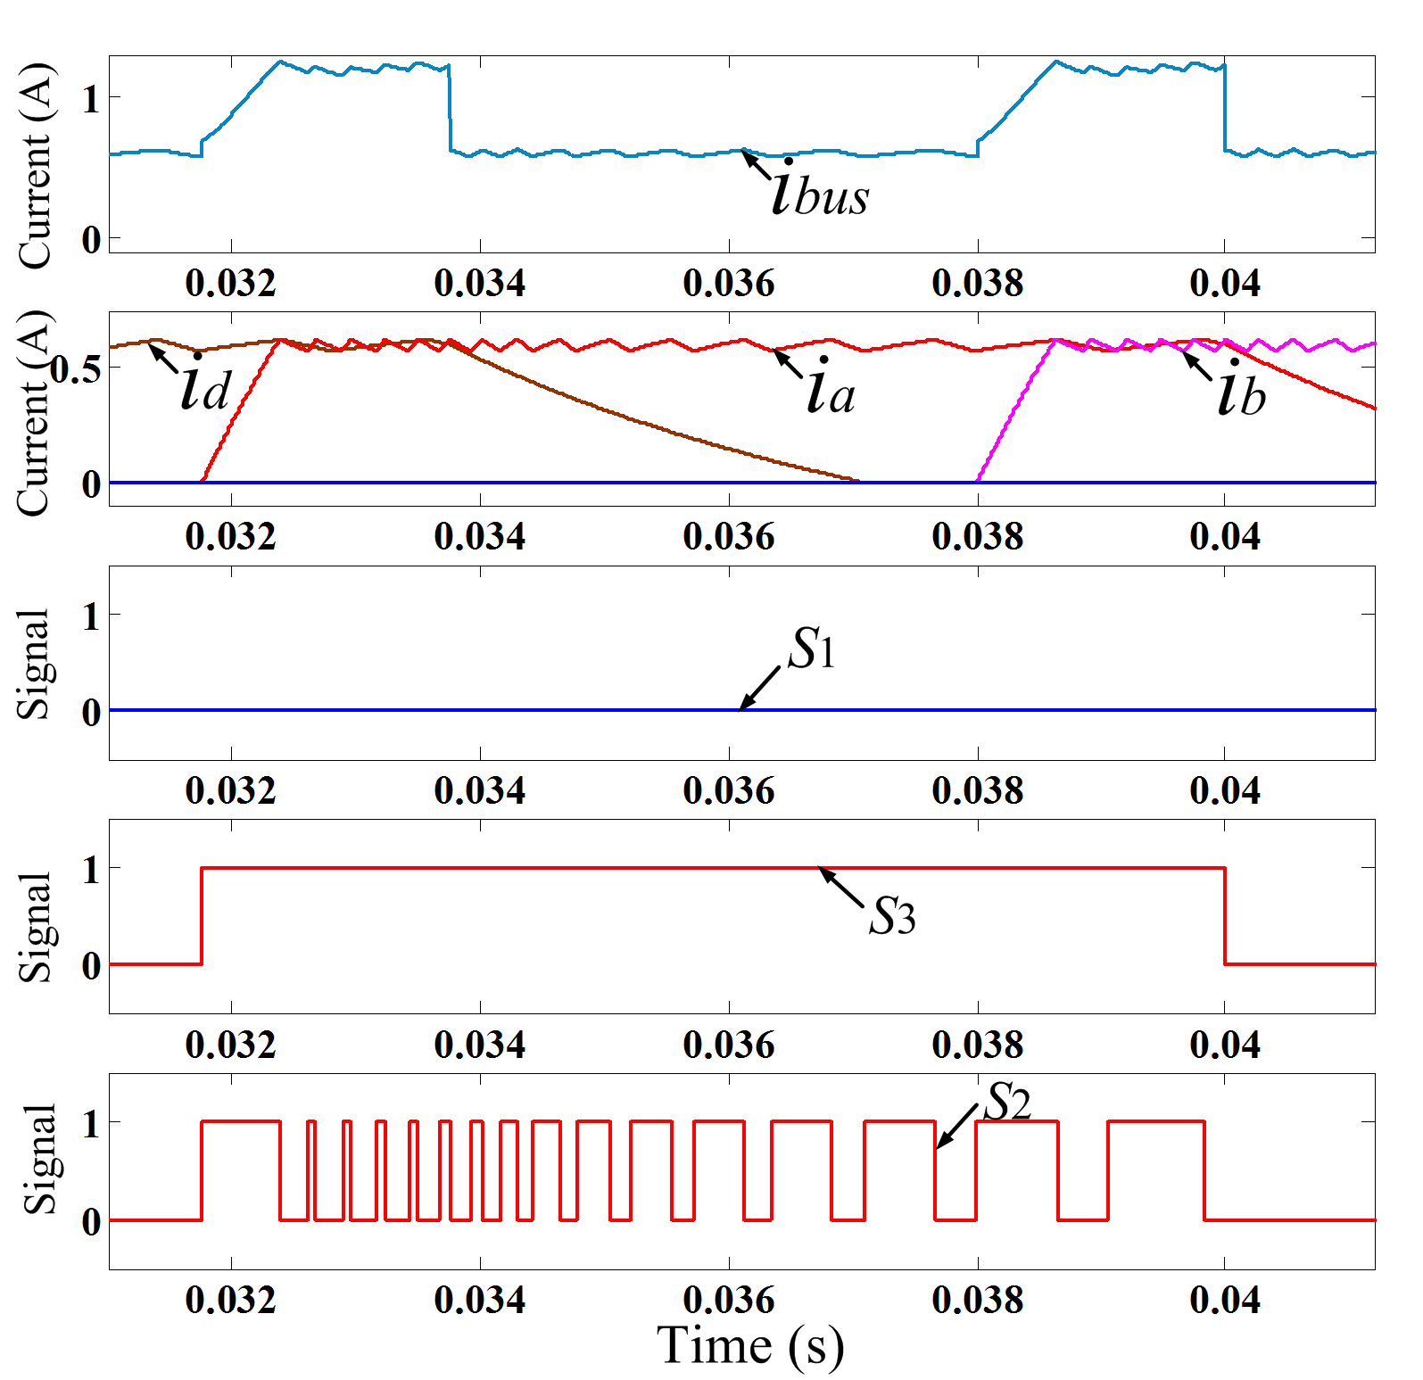
(a) (b)
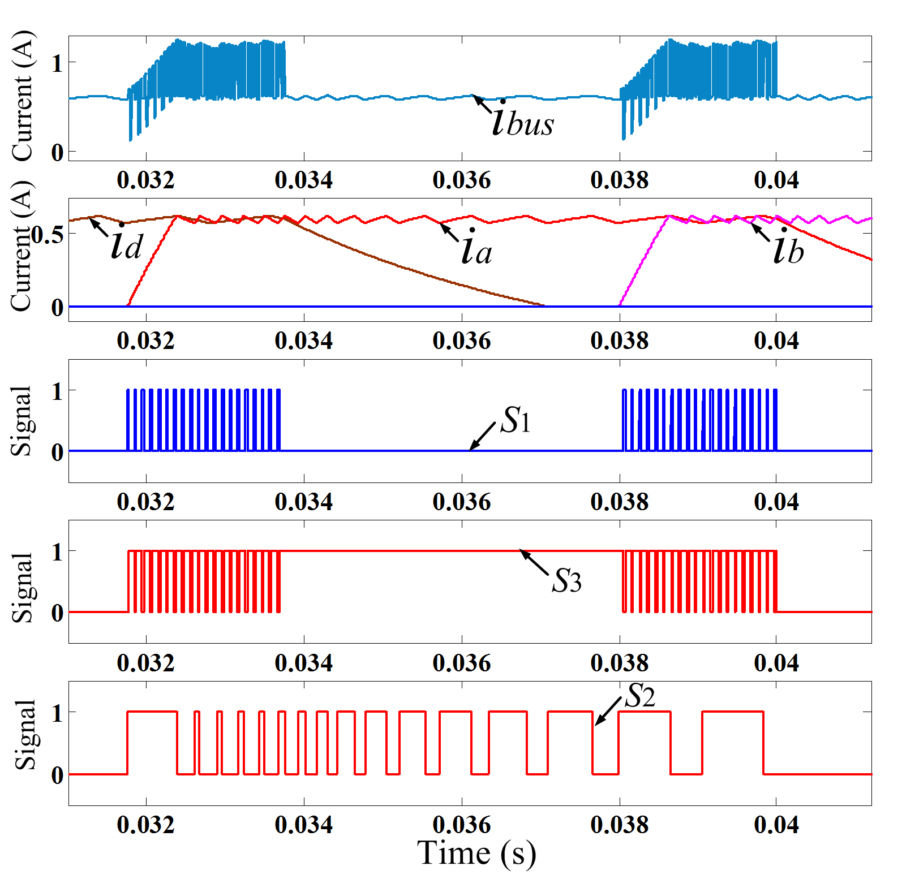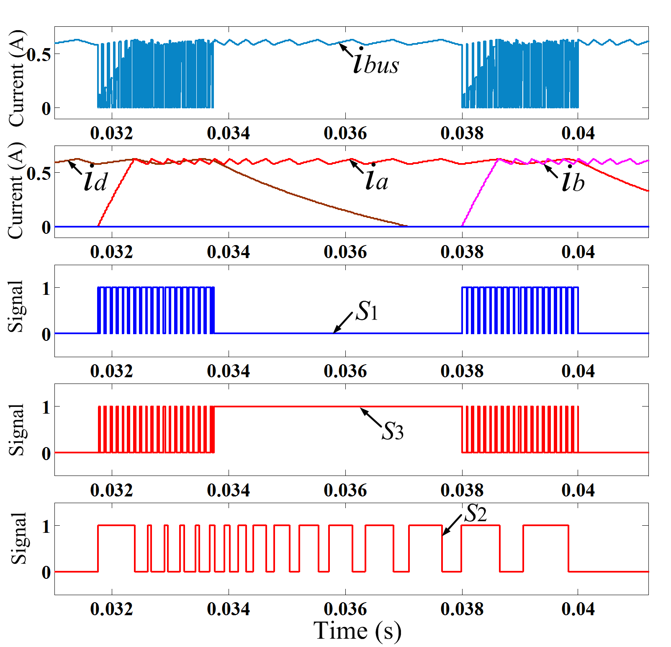
(c) (d)
Fig. 17 Phase current reconstruction scheme in the CCC-based simulation system. (a) Operation state without overlapping region. (b) Operation state with overlapping region. (c) Operation state under the duty cycle of 30%. (d) Operation state under the duty cycle of 70%.
Fig. 17 shows the relevant waveforms in the CCC-based simulation system, where the speed reference is set to 400 r/min. The motor is driven under the soft-chopping mode and the lower switch S₂ is in the chopping state according to the current hysteresis controller. The operation mode without overlapping region is shown in Fig. 17 (a), where the turn-on and turn-off angles are set to 0° and 15°, respectively. The upper switch S₁ is not used when there is no overlapping region. Fig. 17 (b) shows the operation mode with overlapping region when the phase current reconstruction procedure is not executed, where the turn-on and turn-off angles are set to 0° and 21°, respectively. Fig. 17(c) shows the waveforms when the duty-cycle of S₁ and S₅ is set to 30% and Fig. 17 (d) shows the waveforms when the duty-cycle of S₁ and S₅ is set to 70%. The phase currents can be reconstructed by sampling their envelopes during the overlapping region, respectively.
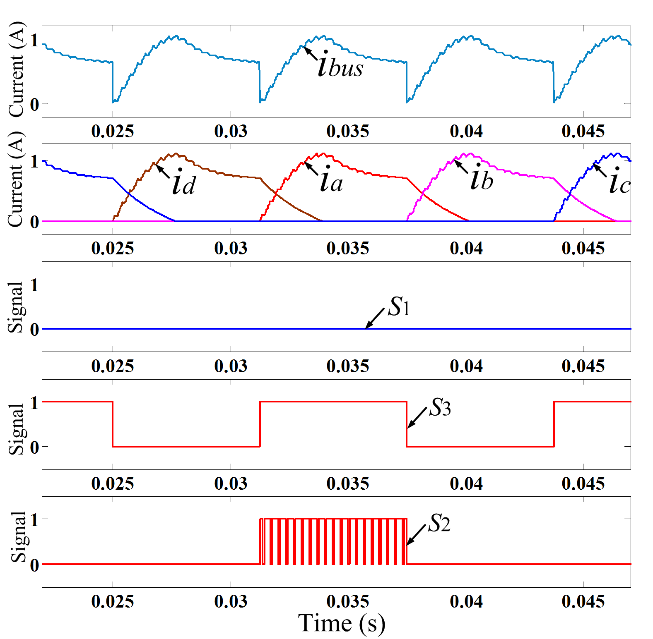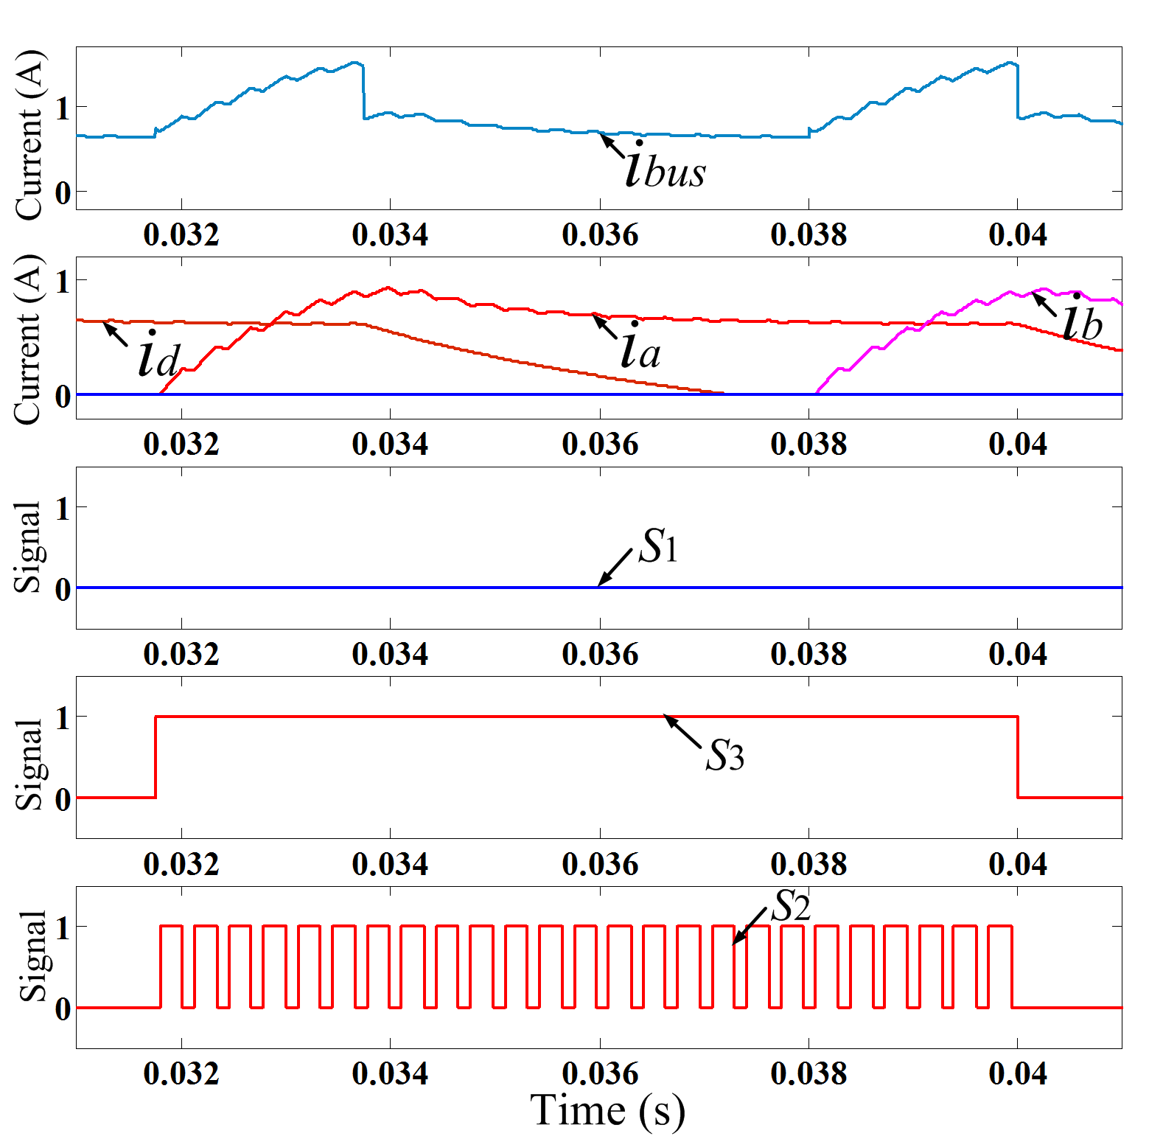
(a) (b)
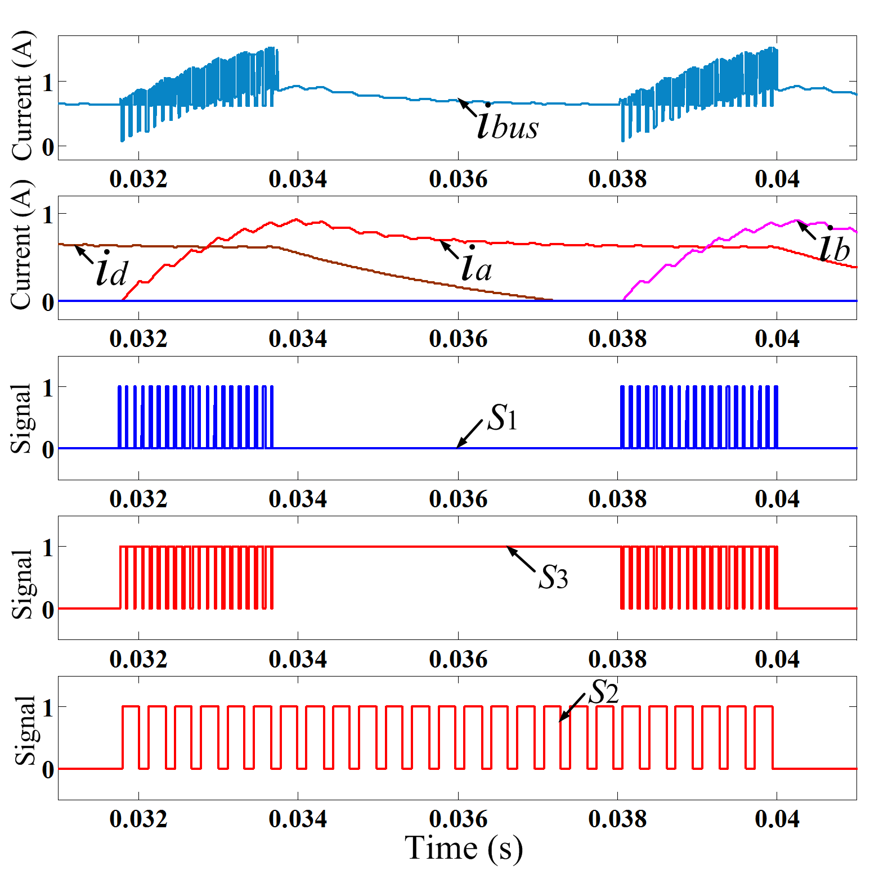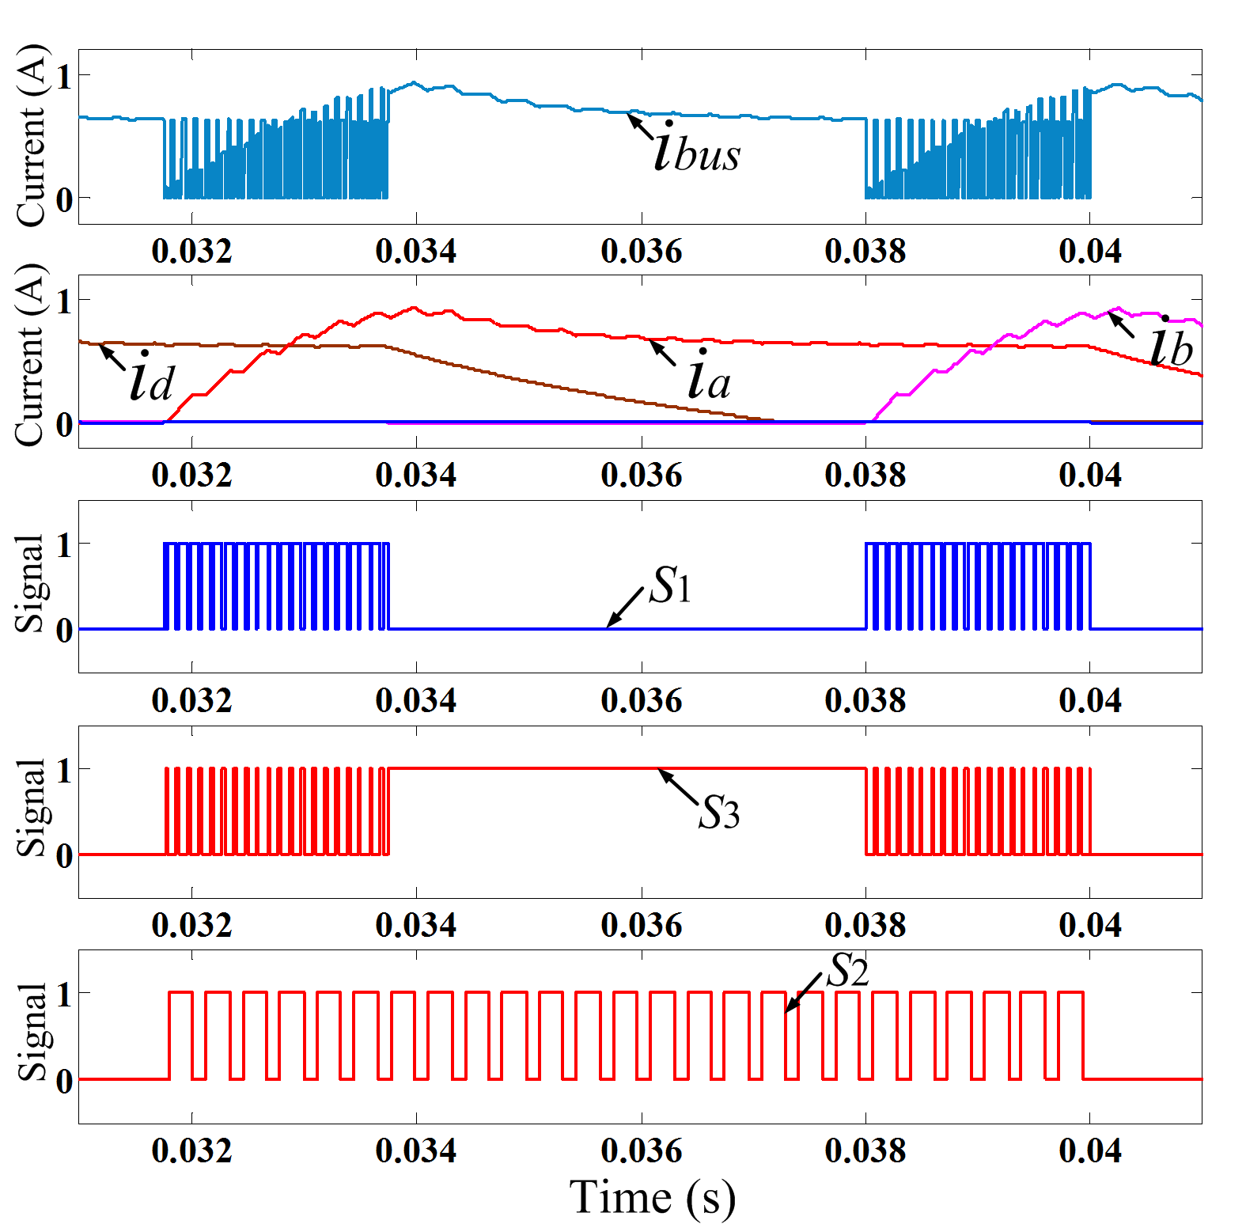
(c) (d)
Fig. 18 Phase current reconstruction scheme in the VPC-based simulation system. (a) Operation state without overlapping region. (b) Operation state with overlapping region. (c) Operation state under the duty cycle of 30%. (d) Operation state under the duty cycle of 70%.
Fig. 18 shows the relevant waveforms in the VPC-based simulation system, where the speed reference is set to 400 r/min and the PWM frequency is set to 3 KHz. The upper switch S₃ demonstrates the conduction region and the lower switch S₂ is in the chopping state according to the PWM controller. Fig. 18 (a) shows the single phase conduction mode, where the turn-on angle is set to 0° and turn-off angle is set to 15°. Fig. 18 (b) shows the operation mode with overlapping region, where the turn-on angle is set to 0° and turn-off angle is set to 21°. Fig. 18 (c) shows the waveforms when the duty cycle of S₁ and S₅ is set to 30% and Fig. 18 (d) shows the waveforms when the duty cycle of S₁ and S₅ is set to 70%. The phase current can be sampled several times from the DC-link current during each voltage-PWM cycle, which ensures the phase current can be reconstructed accurately.
Fig. 19 shows the motor speed, position of the shaft, and torque in conventional and proposed schemes, at 400 r/min and 0.5 N·m load in the CCC system. The simulation results are shown in one electric period (i.e. 60 mechanical degrees). It can be seen that the motor speed follows the speed reference well, and the torque and torque ripple are almost the same in the two schemes. Hence, the proposed method will not decrease the motor performance. The proposed phase current reconstruction scheme can be implemented successfully in APC, CCC and VPC simulation systems, which is theoretically feasible.
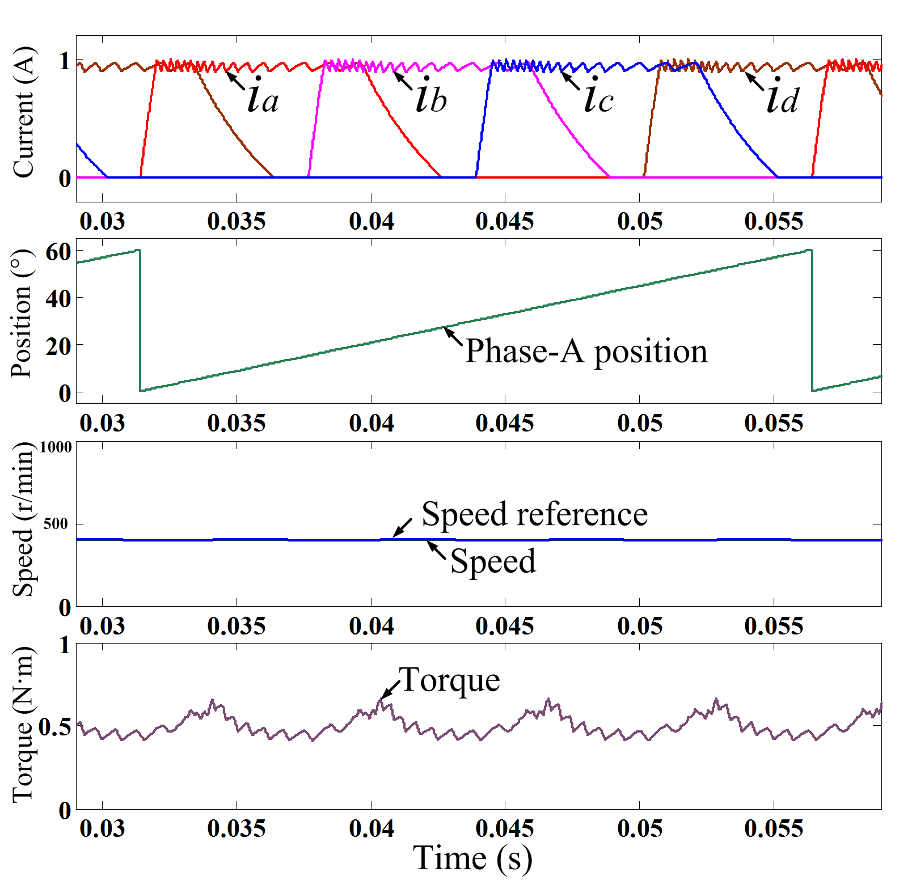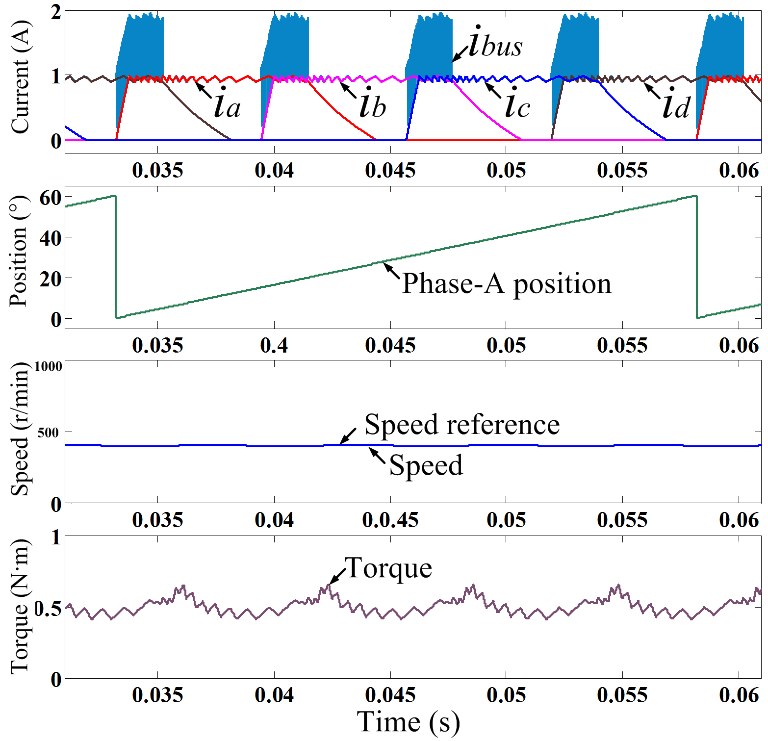
(a) (b)
Fig. 19 Simulation comparison at 400 r/min and 0.5 N·m load. (a) Conventional CCC scheme. (b) Proposed phase current reconstruction scheme.

Experiment Verification
An experimental setup is built based on a four-phase 8/6 SRM, as shown in Fig. 20, where the motor system parameters are illustrated in Table I. A dSPACE-1006 control board is utilized to realize the control algorithm, where the A/D converter measurement is set to be synchronized to a specific signal midpoint. The proportional integral (PI) controller is utilized to implement the closed-loop system of all APC, CCC and VPC. The SRM is driven by the improved converter topology. A Parker AC servomotor acts as the load. An adjustable DC power source is used to supply the power. The DC-link current and four phase currents are measured by five Hall-effect current sensors (LA55Ps), respectively. A speed sensor is used to feed back the rotor position information. The frequency of the injected switching signals is set to 10 KHz. Considering that the proposed phase current reconstruction scheme can be realized with lower requirements of the duty cycle for the injected pulse, the experiments are both carried out under the duty cycle of 30% and 70%.

TABLE I
Motor System Parameters
Parameters | Values
Phase number | 4
Number of stator/rotor poles | 8/6
Rated speed (r/min) | 1500
Rated power (W) | 150
Rated torque (N·m) | 0.95
Phase resistance (Ω) | 9.01
Minimum phase inductance (mH) | 28.65
Maximum phase inductance (mH) | 226.03
Rotor outer diameter (mm) | 54
Rotor inner diameter (mm) | 22
Stator outer diameter (mm) | 102
Stator inner diameter (mm) | 54.5
Core length (mm) | 58
Stator arc angle (deg) | 21
Rotor arc angle (deg) | 24
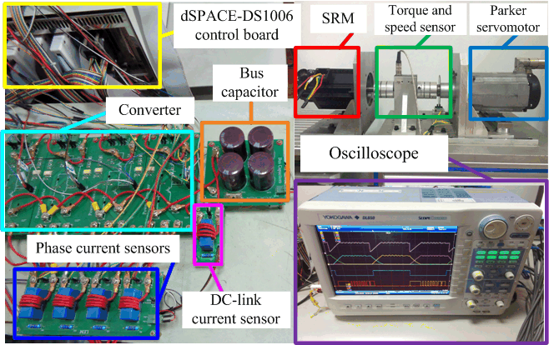
Fig. 20 Experimental setup.
Fig. 21 shows the waveforms executed in the APC system. Fig. 21 (a) shows the working mode without overlapping region, where the speed reference is set to 600 r/min. Fig. 21 (b) shows the working mode with overlapping region when the phase current reconstruction procedure is not implemented, where the speed reference is set to 800 r/min. Fig. 21 (c) shows the waveforms when the duty-cycle of S₁ and S₅ is set to 30% and Fig. 21 (d) shows the waveforms when the duty-cycle of S₁ and S₅ is set to 70%. The phase currents can be reconstructed by sampling their envelopes during the overlapping region without any voltage penalty, respectively.
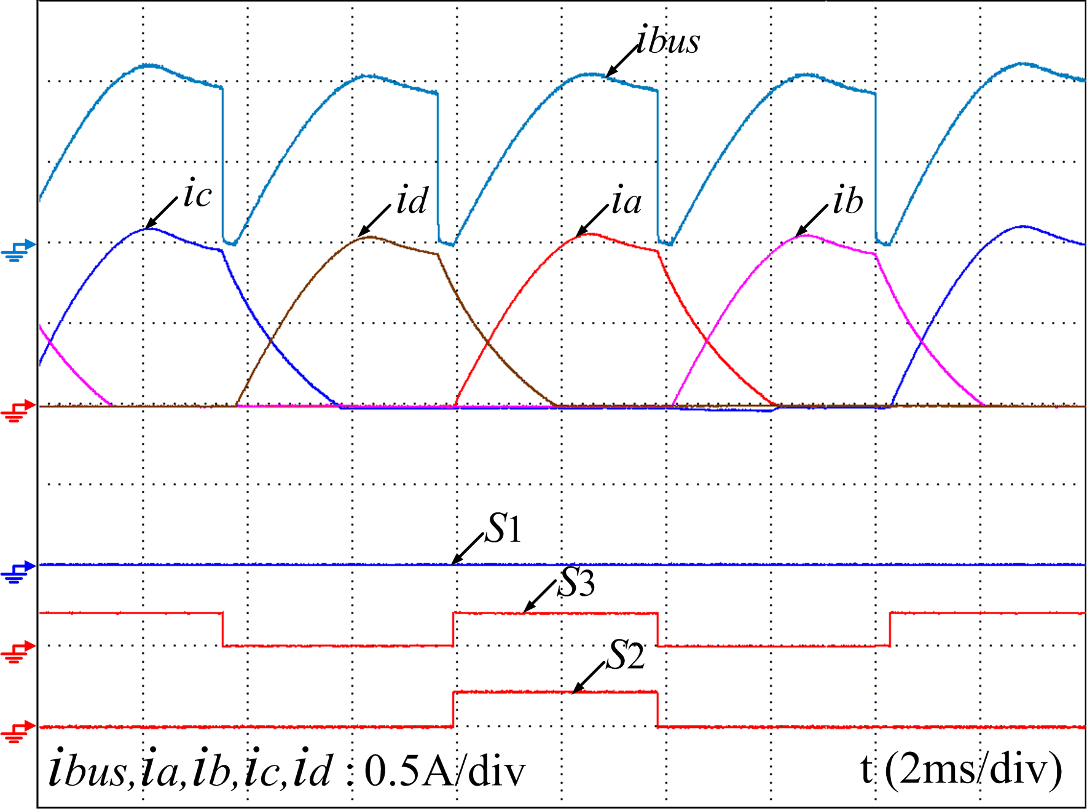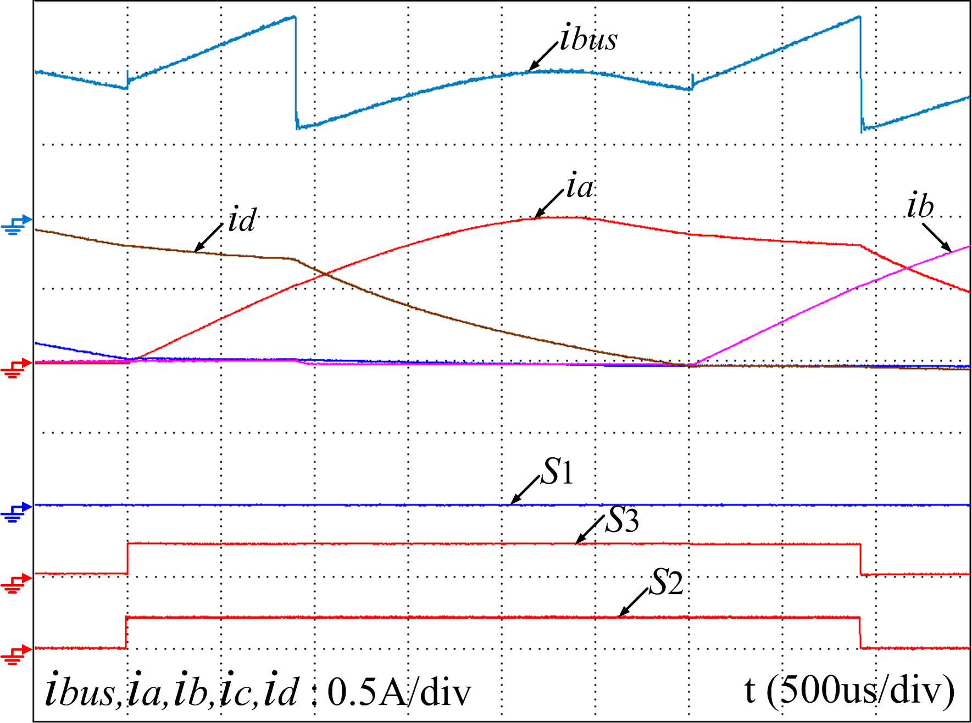
(a) (b)
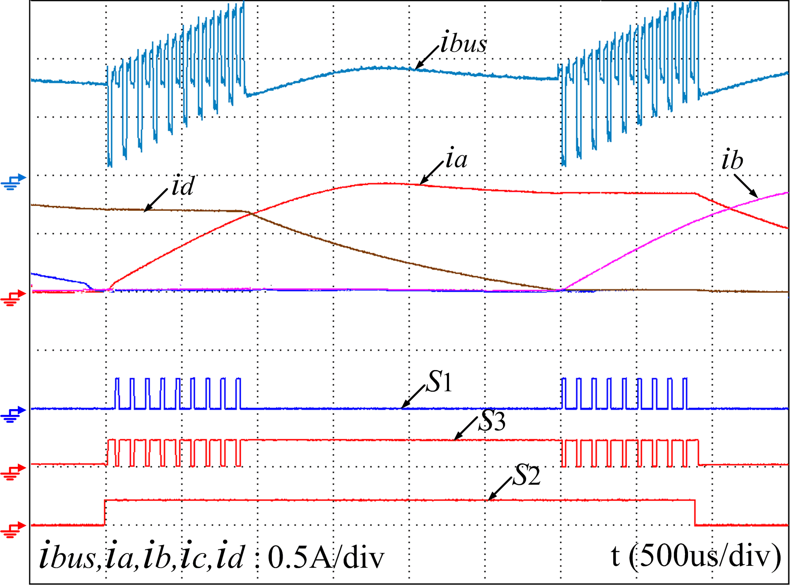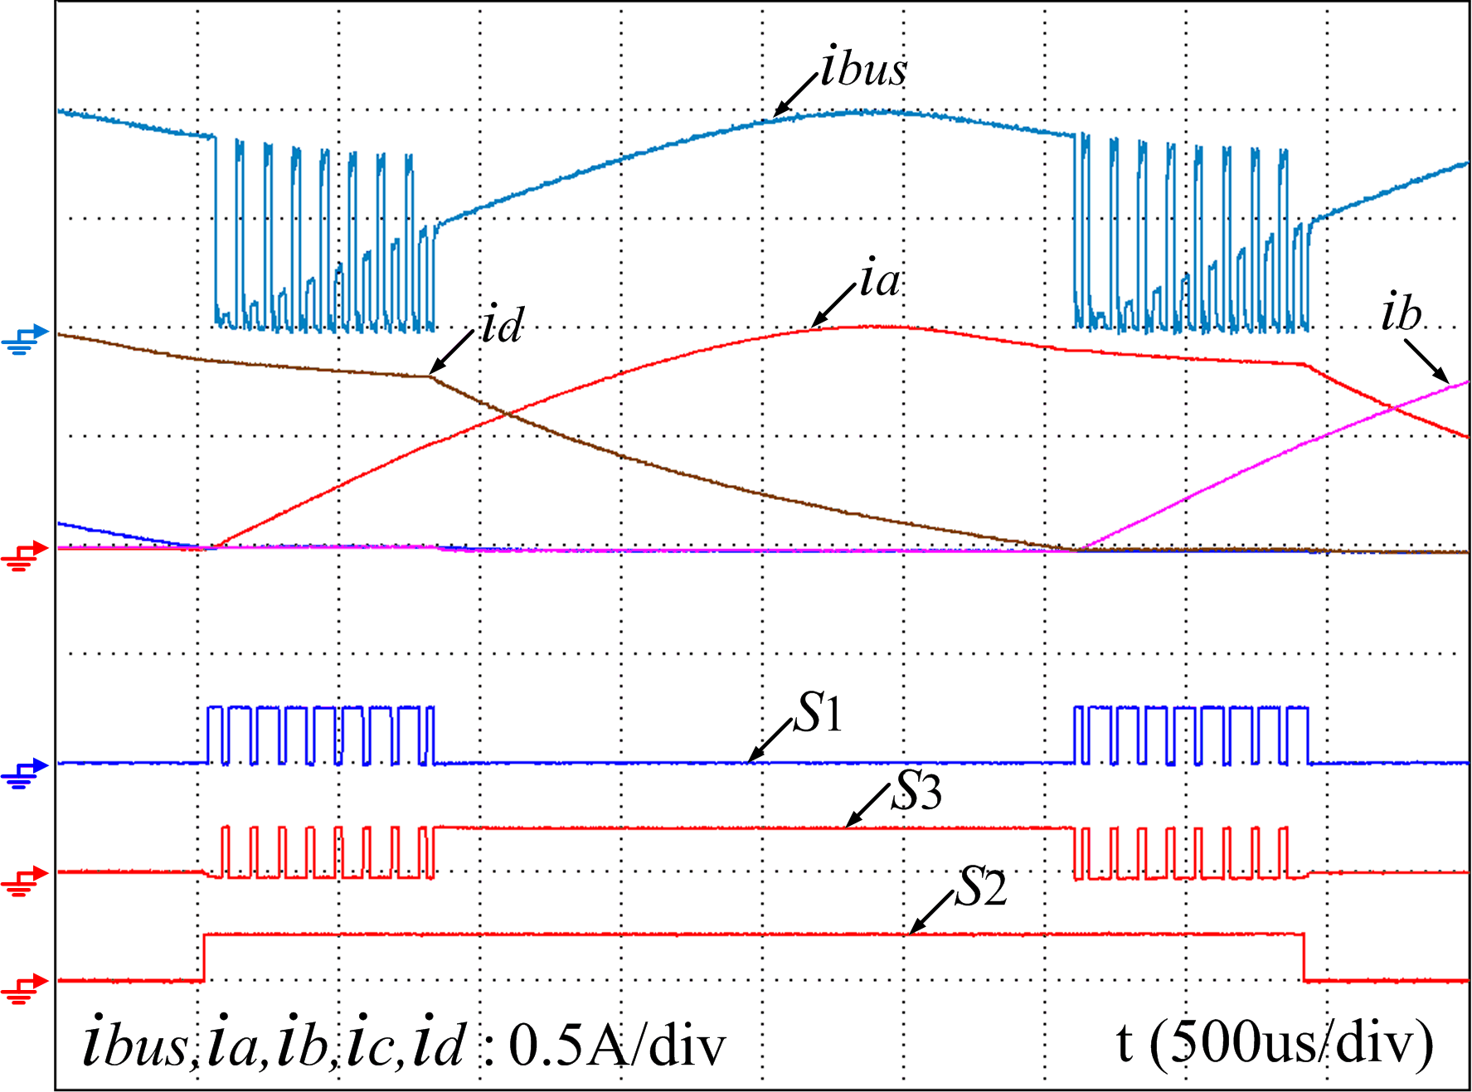
(c) (d)
Fig. 21 Phase current reconstruction scheme in the APC-based experimental system. (a) Operation state without overlapping region. (b) Operation state with overlapping region. (c) Operation state under the duty cycle of 30%. (d) Operation state under the duty cycle of 70%.
The experimental waveforms in CCC drive systems are shown in Fig. 22, where the speed reference is set to 400 r/min. In Fig. 22 (a), the operation waveforms without overlapping region are illustrated, where the turn-on and turn-off angles are set to 0° and 15°, respectively. In Fig. 22 (b), the operation waveforms with overlapping region are illustrated when the phase current reconstruction procedure is not executed, where the turn-on and turn-off angles are set to 0° and 21°, respectively. Fig. 22 (c) shows the waveforms when the duty-cycle of S₁ and S₅ is 30% and Fig. 22 (d) shows the waveforms when the duty-cycle of S₁ and S₅ 70%.
In the VPC-based experimental system, the relevant waveforms are illustrated in Fig. 23, where the PWM frequency is set to 3 KHz and the speed reference is set to 400 r/min. In Fig. 23 (a), the operation waveforms without overlapping region are illustrated, where the turn-on and turn-off angles are set to 0° and 15°, respectively. In Fig. 23 (b), the operation waveforms with overlapping region are illustrated when the phase current reconstruction procedure is not executed, where the turn-on and turn-off angles are set to 0° and 21°, respectively. Fig. 23 (c) shows the waveforms when the duty-cycle of S₁ and S₅ is set to 30% and Fig. 23 (d) shows the waveforms when the duty-cycle of S₁ and S₅ is set to 70%.
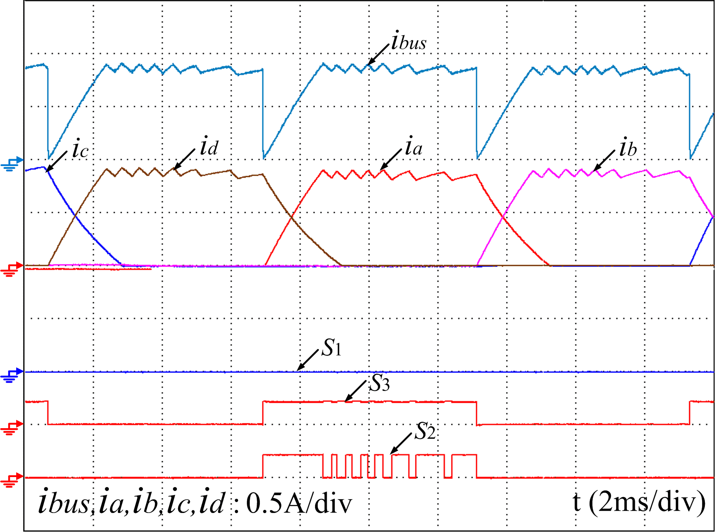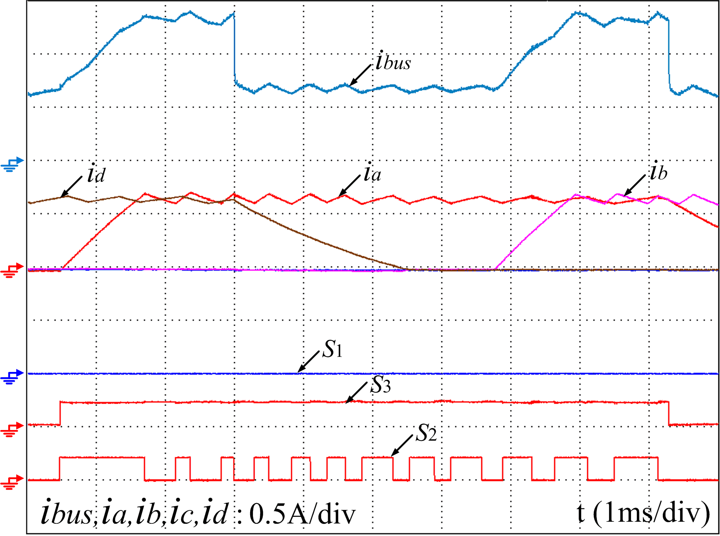
(a) (b)
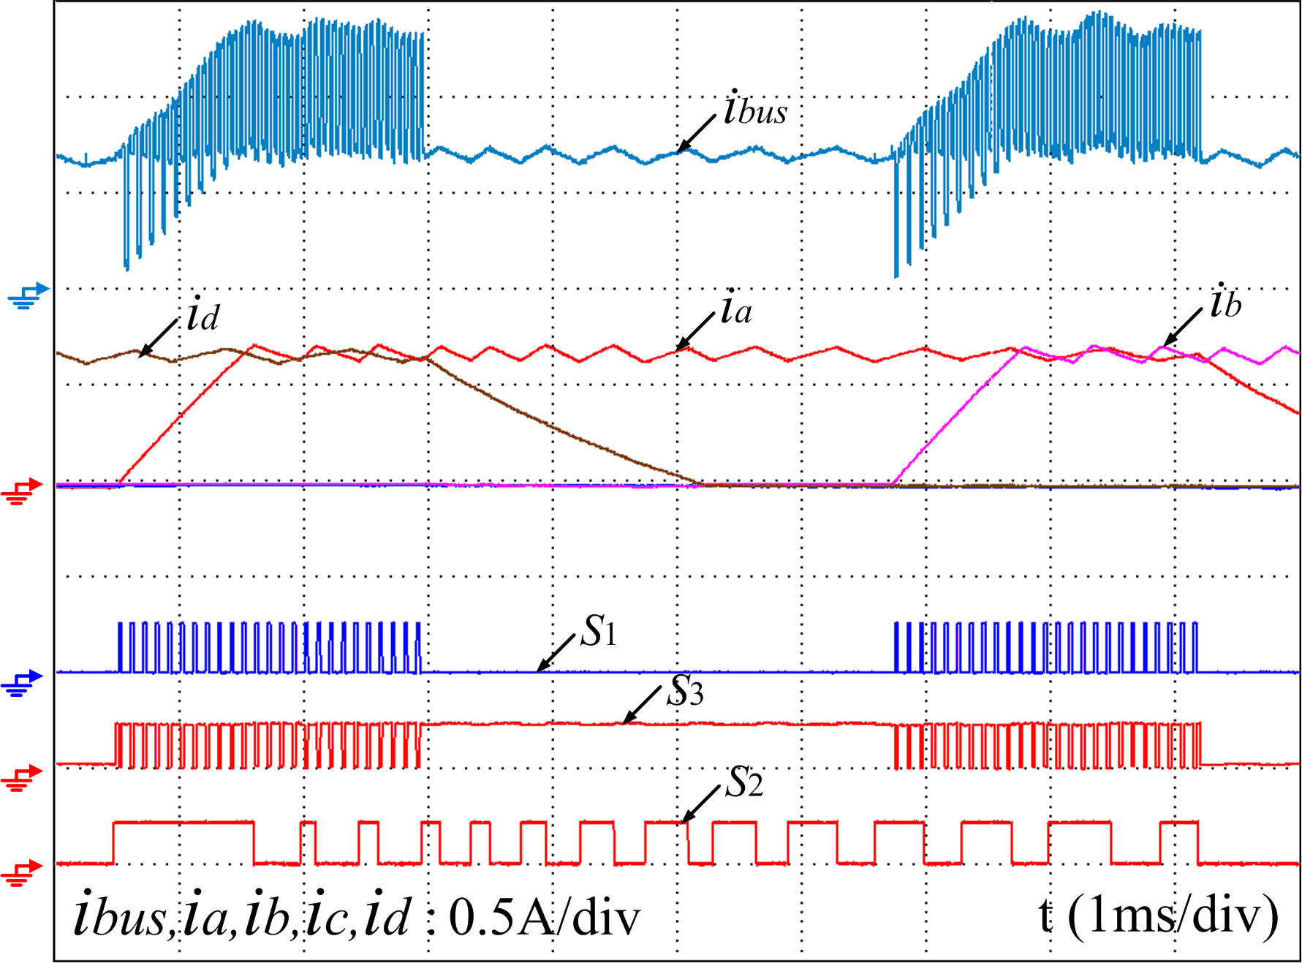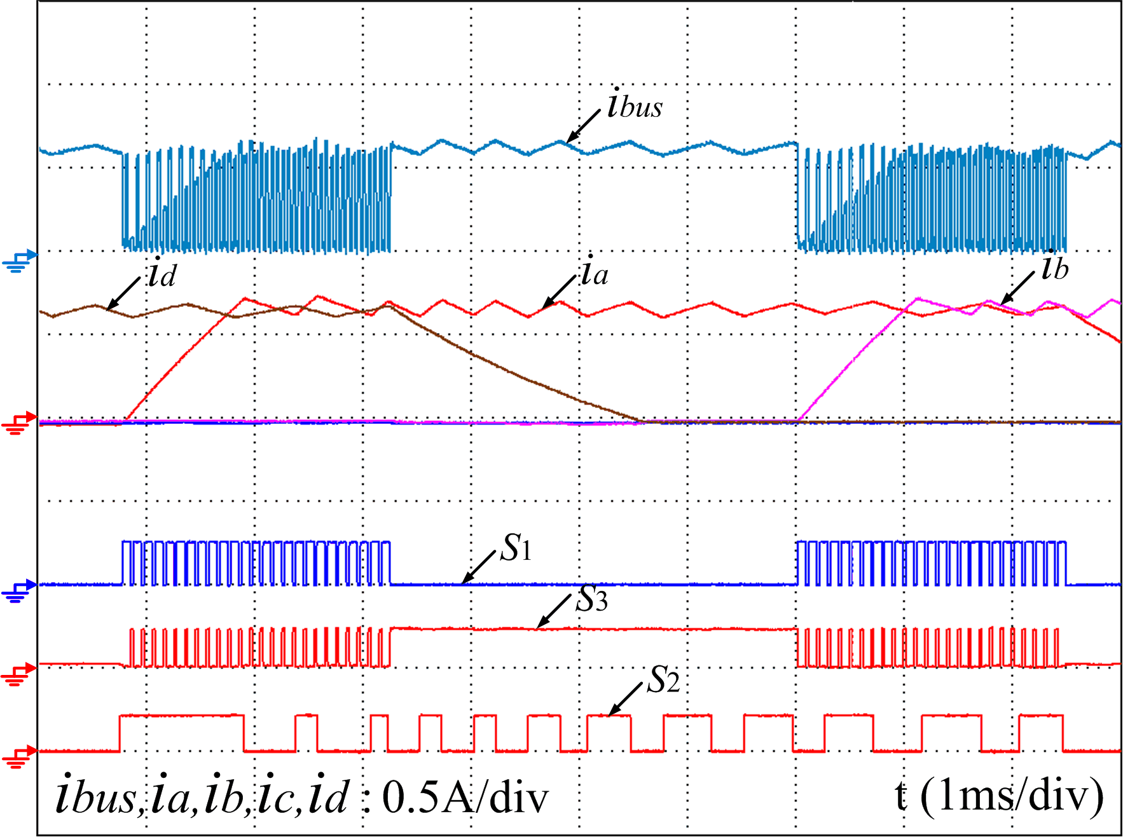
(c) (d)
Fig. 22 Phase current reconstruction scheme in the CCC-based experimental system. (a) Operation state without overlapping region. (b) Operation state with overlapping region. (c) Operation state under the duty cycle of 30%. (d) Operation state under the duty cycle of 70%.
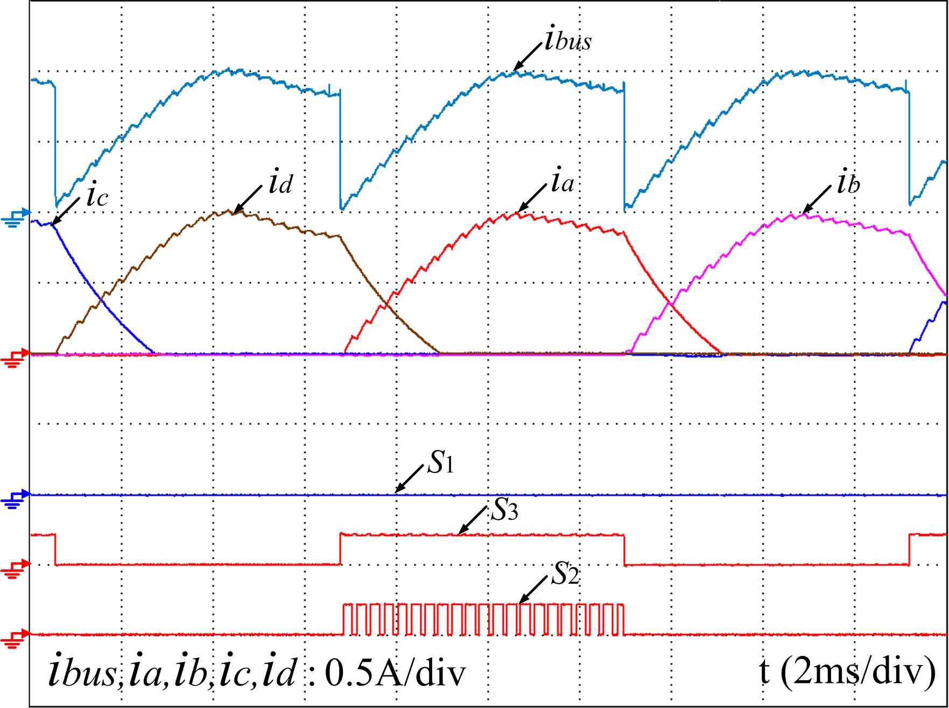 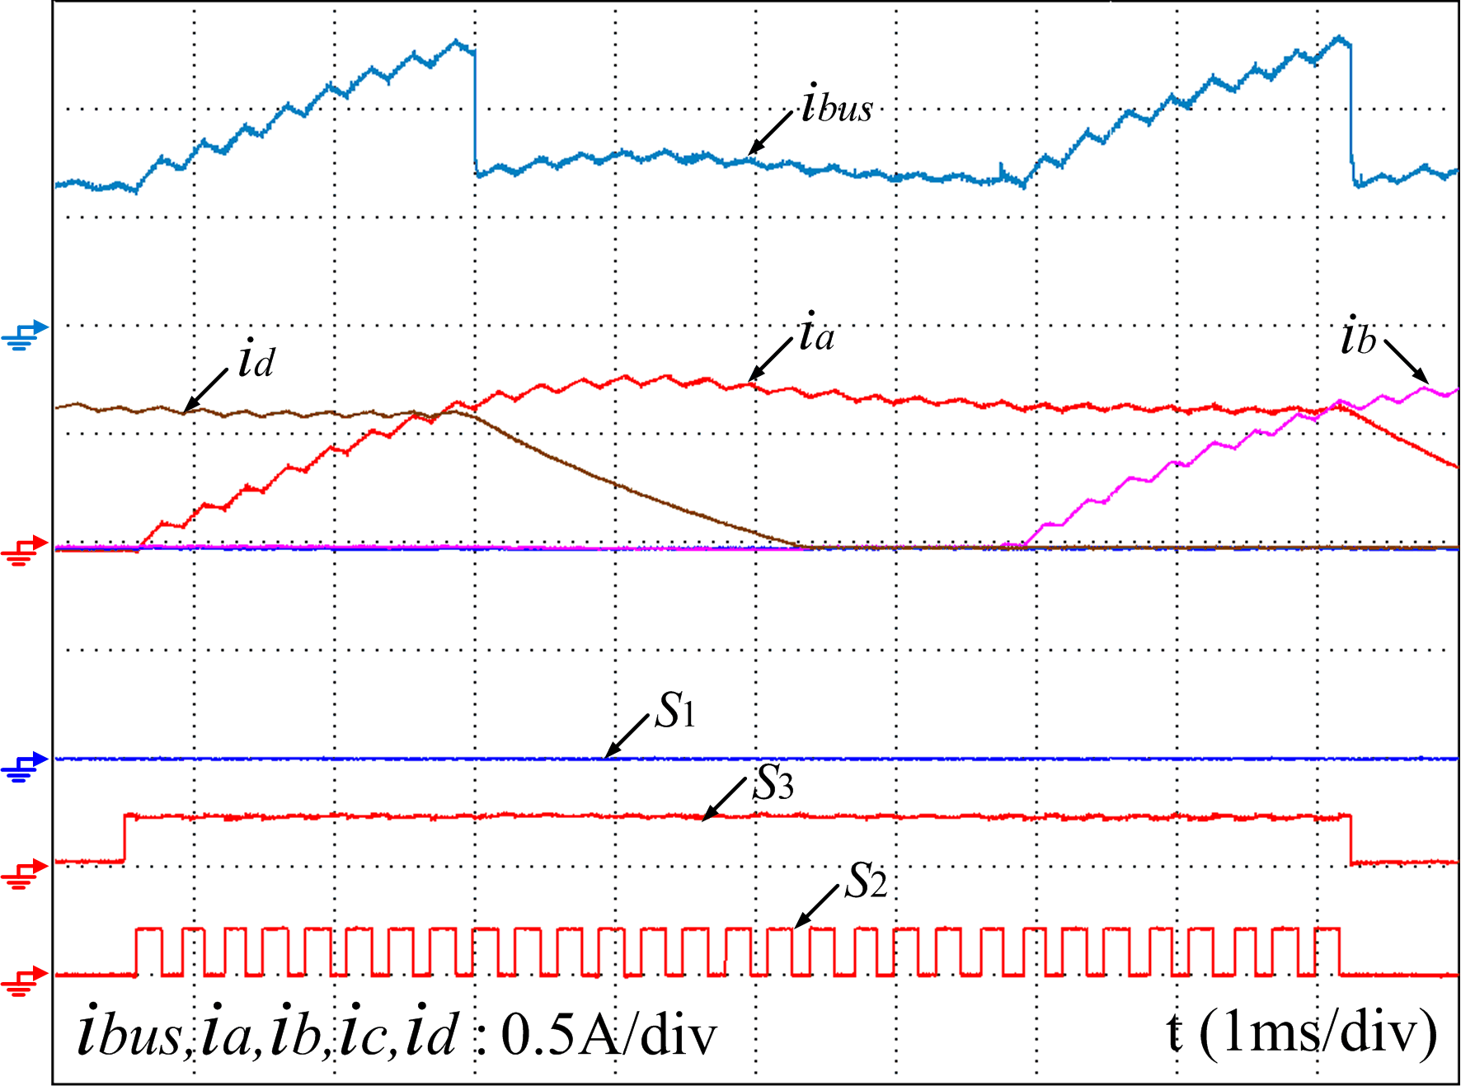 (a) (b)
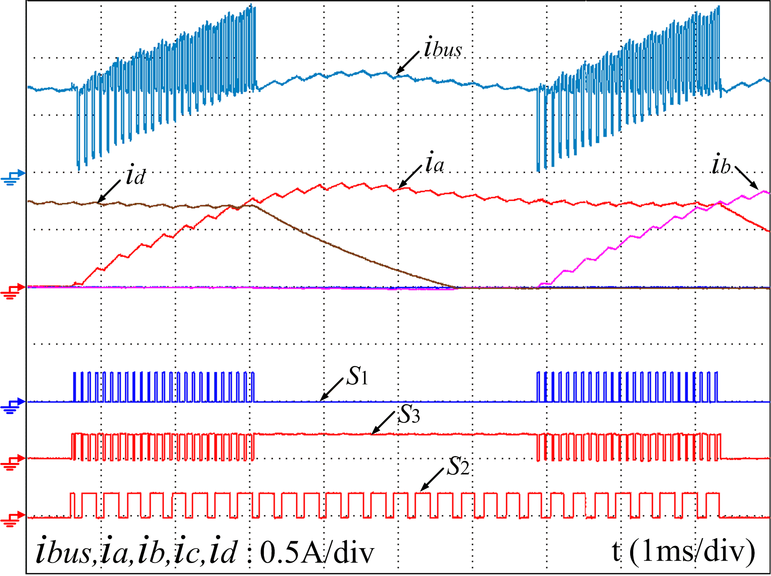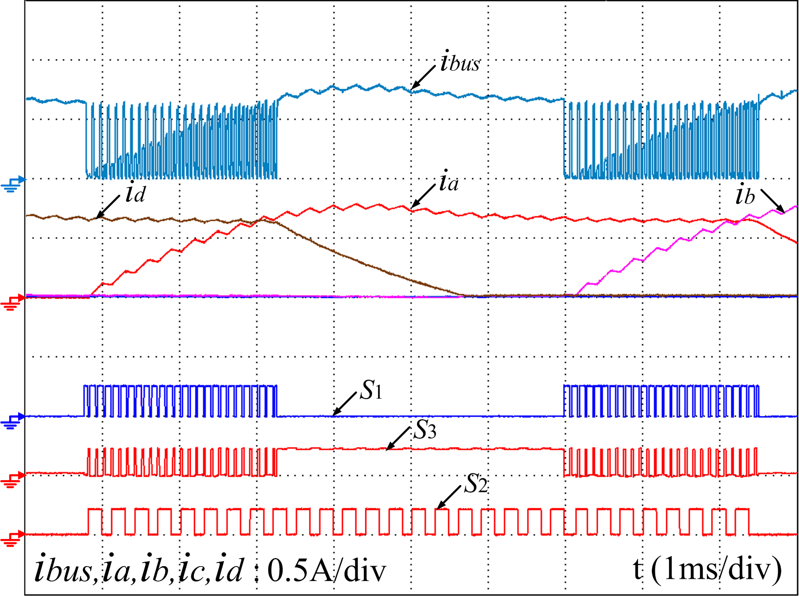
(c) (d)
Fig. 23 Phase current reconstruction scheme in the VPC-based experimental system. (a) Operation state without overlapping region. (b) Operation state with overlapping region. (c) Operation state under the duty cycle of 30%. (d) Operation state under the duty cycle of 70%.
Fig. 24 illustrates the waveforms of phase-A current, phase-A position, motor speed and torque at 400 r/min and 0.5 N·m load in both conventional and proposed schemes. Fig. 24 (a) presents the experimental results in the conventional CCC system and the results after implementing the proposed phase current reconstruction scheme is shown in Fig. 24 (b), where i_{a}´ is the reconstructed phase-A current during the turn-on region by sampling the DC-link current. Clearly, the reconstructed phase current successfully tracks the actual one, and the instantaneous speed follows the reference faithfully. The torque and torque ripple are almost the same in the two schemes.
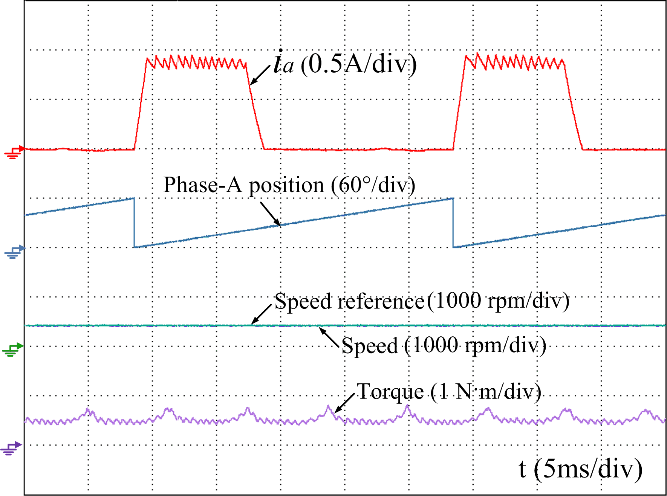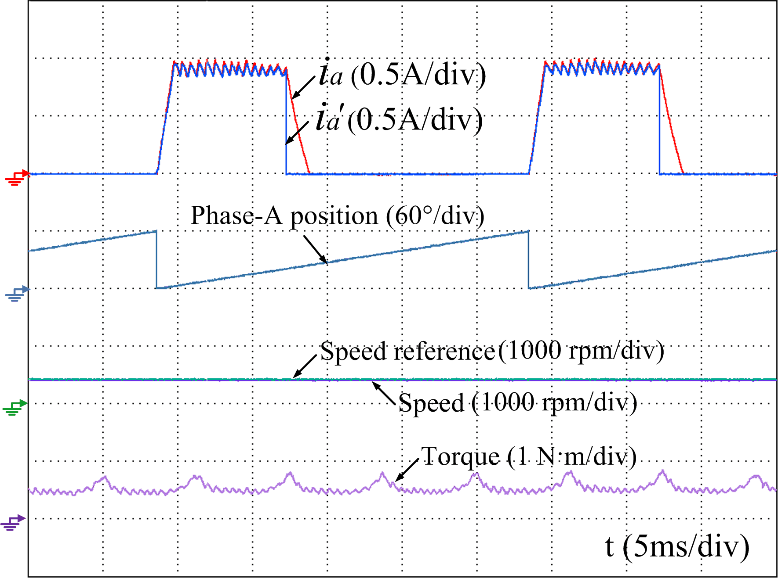
(a) (b)
Fig. 24. Experimental comparison at 400 r/min and 0.5 N·m load. (a) Conventional current control scheme. (b) Proposed phase current reconstruction scheme.
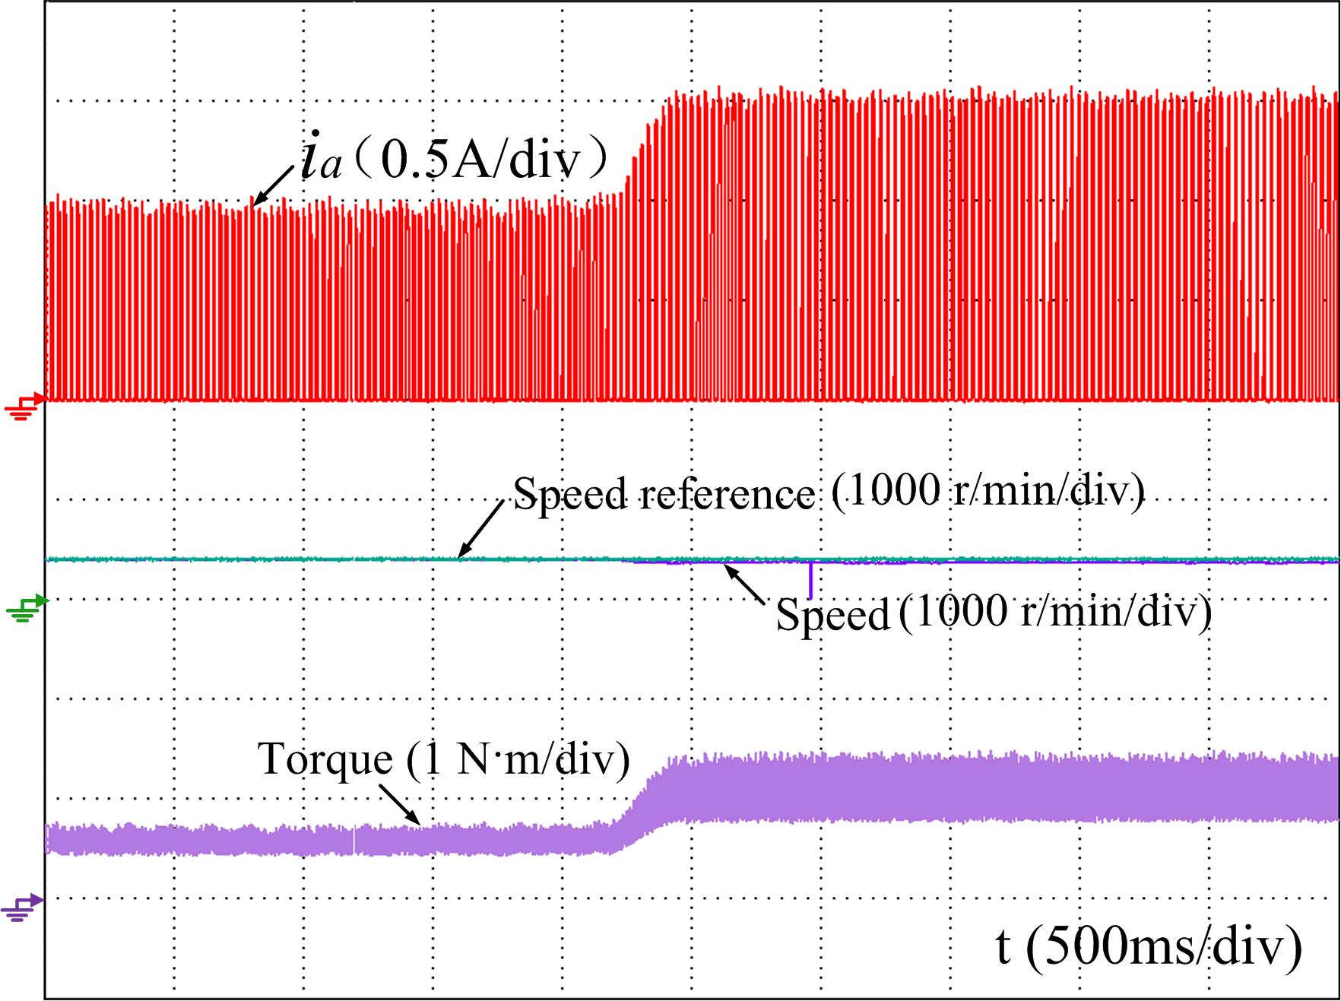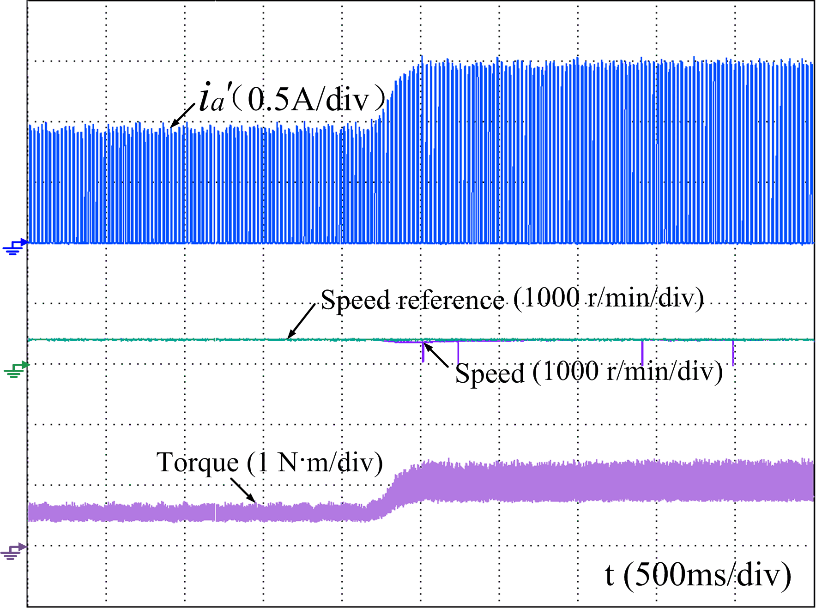
(a) (b)
Fig. 25 Experimental comparison under load change. (a) Conventional current control scheme. (b) Proposed phase current reconstruction scheme.
Figs. 25 and 26 show the dynamic performance in conventional and proposed schemes when the load and speed reference are changed. When the load increases from 0.5 to 1 N·m, the instantaneous speed follows the given values well in the proposed method, confirming a good robustness, as shown in Fig. 25. When the speed reference rises from 300 to 600 r/min and from 600 to 1000 r/min, the instantaneous speed still tracks the given value rapidly, as shown in Fig. 26. Furthermore, the torque waveforms in Figs. 25 and 26 are also the same for transient changes, confirming that the proposed phase current reconstruction scheme will not decrease the motor dynamic performance.
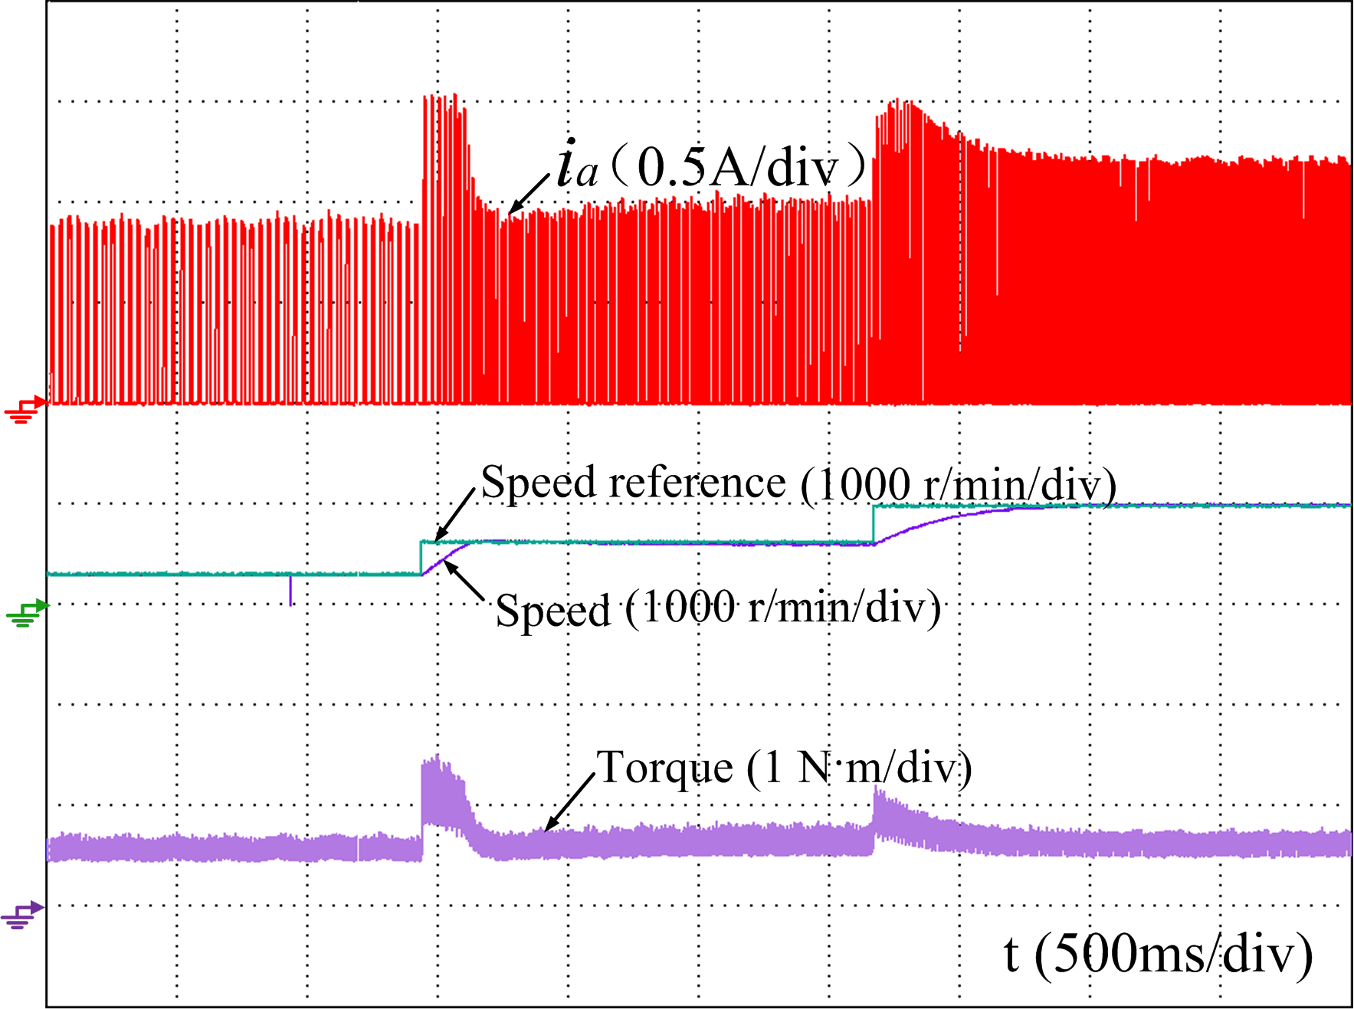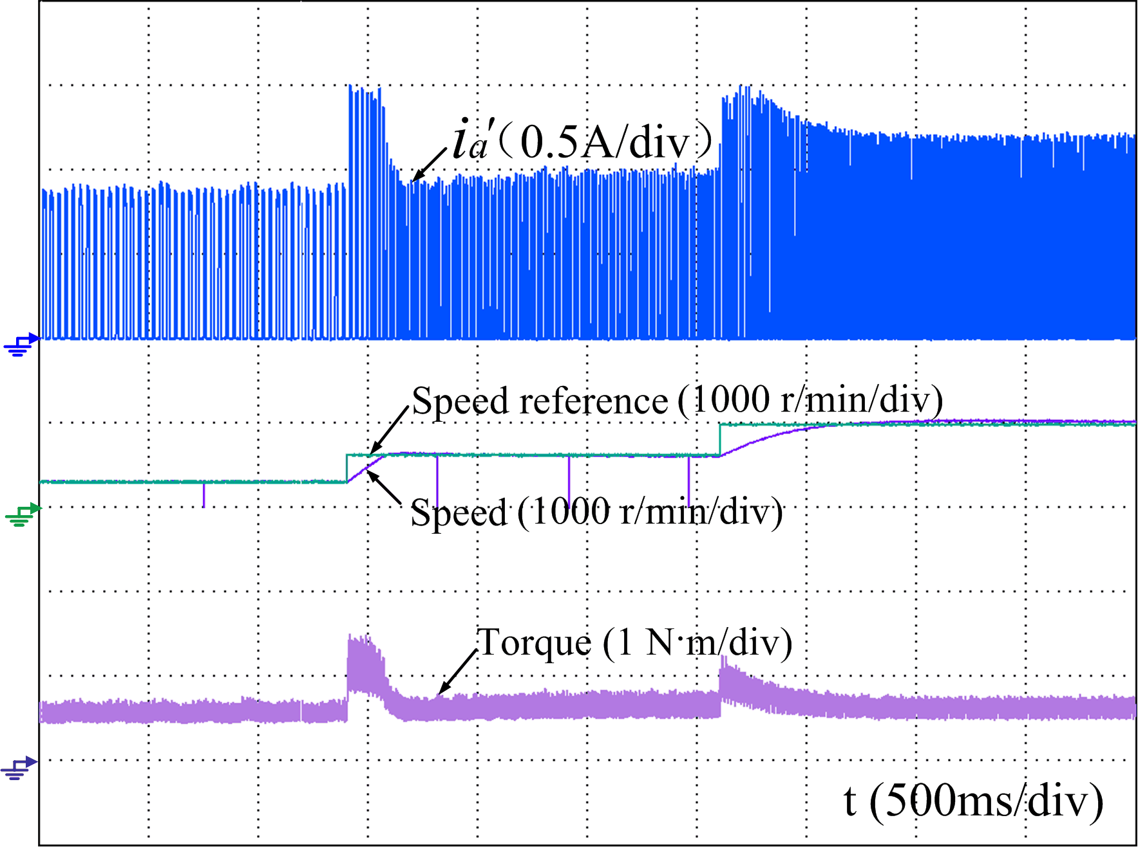
(a) (b)
Fig. 26. Experimental comparison under speed reference change. (a) Conventional current control scheme. (b) Proposed phase current reconstruction scheme.
Clearly, the experimental results match well with the simulation results above. The effectiveness of the proposed phase current reconstruction scheme is validated by the experiments. The proposed scheme is realizable and promising to reconstruct the phase currents from the DC-link current with a single current sensor.

Conclusion
In this paper, a new phase current reconstruction scheme is proposed for the four-phase SRM based on an improved asymmetrical half-bridge converter topology without any voltage penalty. The phase currents are sampled by synchronizing with the specified high level of the injected pulse signals during the overlapping regions with one single DC-link current sensor. By adopting the improved converter, the cost and volume of the drive system are both reduced with the less electronic components and compact structure. Meanwhile, the duty cycle of the injected pulses is not constrained. The difference of the duty cycle can only cause the difference of the triggered instants for the phase current sampling. The proposed scheme is a promising solution to the voltage penalty and current distortion problems caused by the forced change of switching states compared to the other existing schemes. The feasibility and effectiveness are verified in APC, CCC and VPC systems based on a 150 W four-phase 8/6 SRM in the simulation and experiments.

References
- S. G. Oh and R. Krishnan, “Two-phase SRM with flux-reversal-free stator: concept, analysis, design, and experimental verification,” IEEE Trans. Ind. Appl., vol. 43, DOI 10.1109/TIA.2007.904407, no. 5, pp. 1247-1257, Sep./Oct. 2007.
- Y. Kano, T. Kosaka, and N. Matsui, “Optimum design approach for a two-phase switched reluctance compressor drive,” IEEE Trans. Ind. Appl., vol. 46, DOI 10.1109/TIA.2010.2045212, no. 3, pp. 955-964, May/Jun. 2010.
- Z. Yang, F. Shang, I. P. Brown, and M. Krishnamurthy, “Comparative study of interior permanent magnet, induction, and switched reluctance motor drives for EV and HEV applications,” IEEE Transactions on Transportation Electrification, vol. 1, DOI 10.1109/TTE.2015.2470092, no. 3, pp. 245-254, Oct. 2015.
- Y. Hu, C. Gan, W. Cao, C. Li, and S. J. Finney, “Split converter-fed SRM drive for flexible charging in EV/HEV applications,” IEEE Trans. Ind. Electron., vol. 62, DOI 10.1109/TIE.2015.2426142, no. 10, pp. 6085-6095, Oct. 2015.
- F. Yi and W. Cai, “Modeling, control, and seamless transition of the bidirectional battery-driven switched reluctance motor/generator drive based on integrated multiport power converter for electric vehicle applications,” IEEE Trans. Power Electron., vol. 31, DOI 10.1109/TPEL.2015.2510286, no. 10, pp. 7099-7111, Oct. 2016.
- W. Ding, L. Liu, and J. Lou, “Design and control of a high-speed switched reluctance machine with conical magnetic bearings for aircraft application,” IET Electric Power Applications, vol. 7, DOI 10.1049/IET-EPA.2012.0319, no. 3, pp. 179-190, Mar. 2013.
- M. A. Prabhu, J. Y. Loh, S. C. Joshi, V. Viswanathan, S. Ramakrishna, C. J. Gajanayake, et al., “Magnetic loading of soft magnetic material selection implications for embedded machines in more electric engines,” IEEE Trans. Magn., vol. 52, DOI 10.1109/TMAG.2016.2516529, no. 5, pp. 1-6, May 2016.
- L. O. d. A. P. Henriques, L. G. B. Rolim, W. I. Suemitsu, J. A. Dente, and P. J. C. Branco, “Development and experimental tests of a simple neurofuzzy learning sensorless approach for switched reluctance motors,” IEEE Trans. Power Electron., vol. 26, DOI 10.1109/TPEL.2011.2129597, no. 11, pp. 3330-3344, Nov. 2011.
- B. Singh, A. K. Mishra, and R. Kumar, “Solar powered water pumping system employing switched reluctance motor drive,” IEEE Trans. Ind. Appl., vol. 52, DOI 10.1109/TIA.2016.2564945, no. 5, pp. 3949-3957, Sep./Oct. 2016.
- Q. Yu, B. Bilgin, and A. Emadi, “Loss and efficiency analysis of switched reluctance machines using a new calculation method,” IEEE Trans. Ind. Electron., vol. 62, DOI 10.1109/TIE.2015.2392716, no. 5, pp. 3072-3080, May. 2015.
- P. C. Desai, M. Krishnamurthy, N. Schofield, and A. Emadi, “Novel switched reluctance machine configuration with higher number of rotor poles than stator poles: concept to implementation,” IEEE Trans. Ind. Electron., vol. 57, DOI 10.1109/TIE.2009.2034678, no. 2, pp. 649-659, Feb. 2010.
- S. K. Sahoo, S. K. Panda, and J. X. Xu, “Iterative learning-based high-performance current controller for switched reluctance motors,” IEEE Energy Convers., vol. 19, DOI 10.1109/TEC.2004.832048, no. 3, pp. 491-498, Sep. 2004.
- Y. K. Choi, H. S.Yoon, and C. S. Koh, “Pole-Shape Optimization of a Switched-Reluctance Motor for Torque Ripple Reduction,” IEEE Trans. Magn., vol. 43, DOI 10.1109/TMAG.2006.892292, no. 4, pp. 1797-1800, Apr. 2007.
- N. K. Sheth and K. R. Rajagopal, “Optimum pole arcs for a switched reluctance motor for higher torque with reduced ripple,” IEEE Trans. Magn., vol. 39, DOI 10.1109/TMAG.2003.816151, no. 5, pp. 3214-3216, Sep. 2003.
- S. K. Sahoo, S. Dasgupta, S. K. Panda, and X. J., “A Lyapunov function-based robust direct torque controller for a switched reluctance motor drive system,” IEEE Trans. Power Electron., vol. 27, DOI 10.1109/TPEL.2011.2132740, no. 2, pp. 555-564, Feb. 2012.
- R. Mikail, I. Husain, Y. Sozer, M. S. Islam, and T. Sebastian, “A fixed switching frequency predictive current control method for switched reluctance machines,” IEEE Trans. Ind. Appl., vol. 50, DOI 10.1109/TIA.2014.2322144, no. 6, pp. 3717-3726, Nov./Dec. 2014.
- J. Ye, B. Bilgin, and A. Emadi, “An offline torque sharing function for torque ripple reduction in switched reluctance motor drives,” IEEE Trans. Energy Convers., vol. 30, DOI 10.1109/TEC.2014.2383991, no. 2, pp. 726-735, Jun. 2015.
- R. Mikail, I. Husain, M. S. Islam, Y. Sozer, and T. Sebastian, “Four-quadrant torque ripple minimization of switched reluctance machine through current profiling with mitigation of rotor eccentricity problem and sensor errors,” IEEE Trans. Ind. Appl., vol. 51, DOI 10.1109/TIA.2014.2365715, no. 3, pp. 2097-2104, May/Jun. 2015.
- C. Lin, and B. Fahimi, “Prediction of acoustic noise in switched reluctance motor drives,” IEEE Trans. Energy Convers., vol. 29, DOI 10.1109/TEC.2013.2291702, no. 1, pp. 250-258, Mar. 2014.
- S. M. Castano, B. Bilgin, E. Fairall, and A. Emadi, “Acoustic noise analysis of a high-speed high-power switched reluctance machine: Frame Effects,” IEEE Trans. Energy Convers., vol. 31, DOI 10.1109/TEC.2015.2470079, no. 1, pp. 69-77, Mar. 2016.
- C. Gan, J. Wu, M. Shen, S. Yang, Y. Hu, and W. Cao, “Investigation of skewing effects on the vibration reduction of three-phase switched reluctance motors,” IEEE Trans. Magn., vol. 51, DOI 10.1109/TMAG.2015.2441035, no. 9, Sep. 2015.
- K. Ha, C. Lee, J. Kim, R. Krishnan, and S. G. Oh, “Design and development of low-cost and high-efficiency variable-speed drive system, with switched reluctance motor,” IEEE Trans. Ind. Appl., vol. 43, DOI 10.1109/TIA.2007.895744, no. 3, pp. 703-713, May/Jun. 2007.
- J. Kim, K. Ha, and R. Krishnan, “Single-controllable-switch-based switched reluctance motor drive for low cost, variable-speed applications,” IEEE Trans. Power Electron., vol. 27, DOI 10.1109/TPEL.2011.2158239, no. 1, pp. 379-387, Jan. 2012.
- J. Ye, B. Bilgin, and A. Emadi, “Elimination of mutual flux effect on rotor position estimation of switched reluctance motor drives,” IEEE Trans. Power Electron., vol. 30, DOI 10.1109/TPEL.2014.2319238, no. 3, pp. 1499-1512, 2015.
- E. Ofori, T. Husain, Y. Sozer, and I. Husain, “A Pulse-injection-based sensorless position estimation method for a switched reluctance machine over a wide speed range,” IEEE Trans. Ind. Appl., vol. 51, DOI 10.1109/TIA.2015.2420618, no. 5, pp. 3867-3876, Sep./Oct. 2015.
- Y. Gu, F. Ni, D. Yang, and H. Liu, “Switching-state phase shift method for three-phase-current reconstruction with a single dc-link current sensor,” IEEE Trans. Ind. Electron., vol. 58, DOI 10.1109/TIE.2011.2123854, no. 11, pp. 5186-5194, Nov. 2011.
- B. Metidji, N. Taib, L. Baghli, T. Rekioua, and S. Bacha, “Phase current reconstruction using a single current sensor of three-phase AC motors fed by SVM-controlled direct matrix converters,” IEEE Trans. Ind. Electron., vol. 60, DOI 10.1109/TIE.2012.2232252, no. 12, pp. 5497-5505, Dec. 2013.
- B. Hafez, A. S. Abdel-Khalik, A. M. Massoud, S. Ahmed, and R. D. Lorenz, “Single-sensor-based three-phase permanent-magnet synchronous motor drive system with luenberger observers for motor line current reconstruction,” IEEE Trans. Ind. Appl., vol. 50, DOI 10.1109/TIA.2013.2296625, no. 4, pp. 2602-2613, Jul./Aug. 2014.
- H. Lu, X. Cheng, W. Qu, S. Sheng, Y. Li, and Z. Wang, “A three-phase current reconstruction technique using single DC current sensor based on TSPWM,” IEEE Trans. Power Electron., vol. 29, DOI 10.1109/TPEL.2013.2266408, no. 3, pp. 1542-1550, Mar. 2014.
- H. Ye and A. Emadi, “A six-phase current reconstruction scheme for dual traction inverters in hybrid electric vehicles with a single DC-link current sensor,” IEEE Trans. Veh. Technol., vol. 63, DOI 10.1109/TVT.2014.2305637, no. 7, pp. 3085-3093, Sep. 2014.
- X. Li, S. Dusmez, B. Akin, and K. Rajashekara, “A new SVPWM for the phase current reconstruction of three-phase three-level T-type converters,” IEEE Trans. Power Electron., vol. 31, DOI 10.1109/TPEL.2015.2440421, no. 3, pp. 2627-2637, Mar. 2016.
- P. C. Kjaer and G. Gallegos-Lopez, “Single-sensor current regulation in switched reluctance motor drives,” IEEE Trans. Ind. Appl., vol. 34, DOI 10.1109/28.673713, no. 3, pp. 444-451, May/Jun. 1998.
- C. Gan, J. Wu, S. Yang, and Y. Hu, “Phase current reconstruction of switched reluctance motors from DC-link current under double high-frequency pulses injection,” IEEE Trans. Ind. Electron., vol. 62, DOI 10.1109/TIE.2014.2364153, no. 5, pp. 3265-3276, May 2015.
- C. Mademlis and I. Kioskeridis, “Performance optimization in switched reluctance motor drives with online commutation angle control,” IEEE Trans. Energy Convers., vol. 18, DOI 10.1109/TEC.2003.815854, no. 3, pp. 448-457, Sep. 2003.
- R. Gobbi and K. Ramar, “Optimisation techniques for a hysteresis current controller to minimise torque ripple in switched reluctance motors,” IET Electric Power Applications, vol. 3, DOI 10.1049/IET-EPA.2008.0191, no. 5, pp. 453-460, Sep. 2009.
- H. Makino, T. Kosaka, and N. Matsui, “Digital PWM-control-based active vibration cancellation for switched reluctance motors,” IEEE Trans. Ind. Appl., vol. 51, DOI 10.1109/TIA.2015.2448065, no. 6, pp. 4521-4530, Nov/Dec. 2015.

