Quantifying noise exposure and natural ventilation performance in urban areas

M Barclay University of Wales Trinity Saint David, Swansea.
S Sharples University of Liverpool
J Kang University of Sheffield

INTRODUCTION
Natural ventilation strategies are difficult to implement for buildings in urban areas for a number of reasons, such as lower wind speeds, higher temperatures due to the urban heat island effect, pollution and noise. This paper deals with how noise and ventilation performance can be quantified.
The easiest way to achieve the least restriction of a ventilation path is to open large areas of the façade^{1,2}. This leads to the conflict between attempts to reduce noise ingress and the maximizing of natural ventilation rates.

Quantifying these sometimes competing factors with information and tools that are appropriate to building design professionals should help improve design decisions. The information and tools presented in this paper involve a number of different scales. These have the aim of integrating and comparing different environmental factors affecting natural ventilation. These scales are both spatial and temporal. Different calculation methodologies have to be used for different scales as different physical processes and relationships are important, and also the requirements for accuracy differ. The linking of these different scales is necessary and is the main contribution presented in this paper. An example of the smallest scale considered Involves the finite element model of the ventilation aperture and the largest scale deals with the mapping of noise around an urban area.
The same consideration of scales is important for the natural ventilation calculations, with different approaches being used to represent the driving forces of the weather, the air flow around a building or urban area and airflow through an opening or across a number of building zones/rooms.

This paper gives an overview of a method to quantify the relationships between noise exposure and natural ventilation performance in urban areas. The energy consequences of trading off reduced natural ventilation cooling against acceptable noise levels in buildings are also considered. The aim of the research was to determine where noise reduction technologies would have the most significant impact in terms of enhancing natural ventilation potential in urban areas. More details of this approach and more example results can be found in the thesis of one of the authors³.

Calculation method
The methods and example results presented here help weigh up the benefits and challenges for specific cases of natural ventilation and urban noise ingress. There are a number of steps in the integration of the different calculation procedures. Firstly, the sound reduction of five ventilation opening sizes was calculated; these opening were set as fully open, fully closed and three points in-between. This equated to aperture widths ranging from 40mm to 200mm, representing the 0% to 5% opening of the ventilation building model’s window area. Secondly, the noise exposures for various building forms in two urban locations were determined via noise mapping techniques. Thirdly, after the sound levels at the building façades had been determined, the concept of a “Tolerated noise level” was applied in the following way - the degree of opening for each window (within a ventilation model) was chosen such that the internal noise levels were as close as possible to the “Tolerated noise level”. Five “Tolerated noise level”s were used that split the range between a fully open and fully closed façade. Finally, a separate thermal building model was used that used openings that corresponded to each “Tolerated noise level”. The thermal building model performance results could then be plotted against “Tolerated noise level”. This quantified the relationship between acoustic considerations and natural ventilation potential for the specific building and site. The results also identified where noise reduction measures could have the greatest impact.

Ventilation opening definition
The ventilation apertures used in building energy modelling are acoustic weak points in the façade of a building. The thermal building model used in this paper had natural ventilation openings created by the operation of horizontally sliding windows, thereby creating long thin vertical slits. In order to establish the effective sound insulation of the façade the sound transmission of these slits had to be taken into account and combined with the sound insulation of the other components of the façade. Finite element models of the ventilation openings were built after the finite element model set up was validated by comparison with well-established solutions for circular apertures^{4,5}. Figure 1 shows a representation of this validation setup, which was implemented in COMSOL⁶. Figure 2 shows the good agreement between the finite element model and the Wilson-Soroka method.

Spherical wave
Incident plane wave
Infinite baffle
Finite wall thickness
Figure 1. Representation of circular aperture sound transmission in a finite thickness wall.

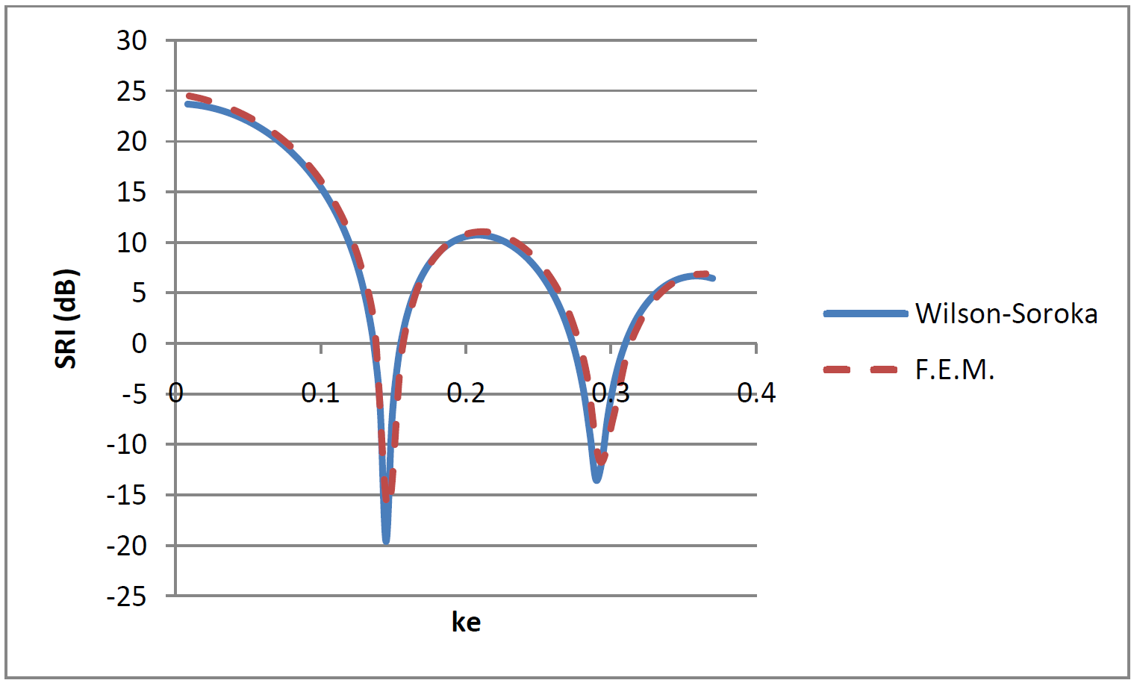
Figure 2. Comparison of Sound Reduction Index (SRI) against 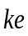 where is the wave number the circular aperture had a radius () of 11mm and depth 220mm. Two calculation methods are indicated in the legend.

The good agreement seen in the validation modelling gave confidence for using this finite element modelling approach in the modelling of ventilation apertures. The next step was to simulate apertures that matched the dimensions of the window openings in the ventilation models. The models were set up to represent a normal incident plane wave acting on an infinite area of wall with a finite thickness of 100mm and incorporating a regular aperture. A plane wave was introduced at one side of the model with its direction incident to the wall with the aperture. The wall and internal aperture surfaces were represented as fully acoustically hard. Then, areas on the source side and receiving side that represented infinity conditions were modelled with Perfectly Matched Layers (PMLs). The meshing of the model conformed to the guidance that suggested not having less than 6 elements per wavelength⁷. For some configurations, and at high frequencies, this required substantial computational resources due to the large degrees of freedom. Separate models had to be produced, with each one meshed for a specific section of the frequency domain. The results for each frequency sweep could then be joined together

The model shown in Figure 3 replicates air borne acoustic transmission through the ventilation aperture and therefore the model domain represents the air volume surrounding the building. Some of these were outside the limits of aperture dimensions for the analytical solutions^{4,8}. For numerical calculations these limits should not apply, so wider and shallower apertures can be modelled. Alternative approaches that employ other numerical or physical testing methods could also be used to give the sound transmission of the ventilation openings.

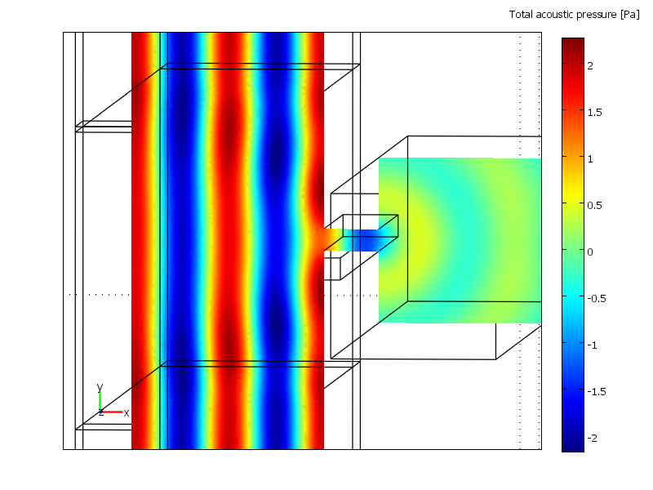
Figure 3. Finite element model set-up representing a plane wave incident on the ventilation aperture and sound transmission through it. Left hand side is source side and right hand side is receiving side.

Noise mapping
The noise mapping from this study was completed using the software CadnaA⁹. The Calculation of Road Traffic Noise (CRTN)¹⁰ method was chosen for the simulation as this has been shown to produce results that fitted well with measured noise levels at different building floor levels¹¹. The noise map of Manchester in the UK had previously been used for a study of urban morphology by one of the authors¹², and so it was convenient to use Manchester for this research. The area mapped is given in Figure 4, with the two locations A (noisy) and B (relatively less noisy). Figure 5 which show the exposure of the façades of the example buildings to road noise in the two example locations. These exposures were then used to give the ventilation opening pattern that would keep noise ingress to the tolerated levels.
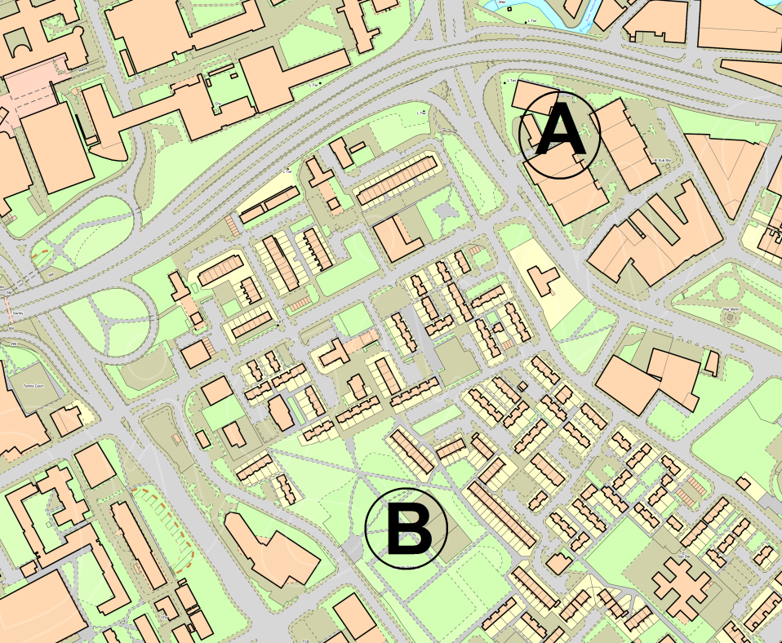
Figure 4. Area of Manchester used for noise mapping¹³. The example locations A and B are marked on the Figure.
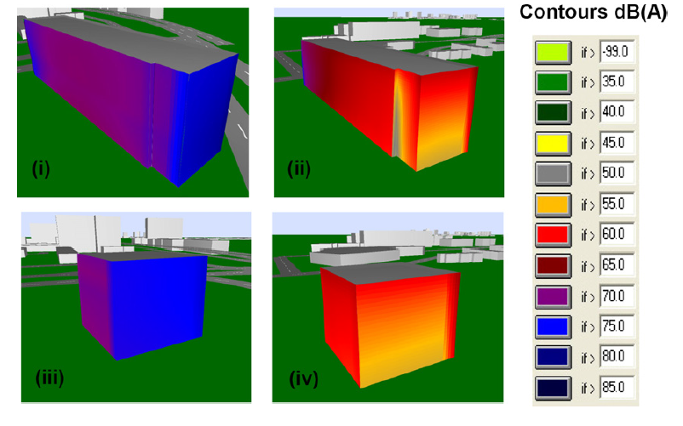
Figure 5. Contours of noise levels at building façade - (i) Building A in Location A. (ii) Building A in Location B. (iii) Building B in Location A. (iv) Building B in Location B.

Dynamic thermal modelling
The noise exposure patterns calculated previously were transposed into a thermal building model so that ventilation opening patterns are informed by noise exposure. Whole building thermal behavior is now routinely calculated with dynamic thermal building models for applications such as determining whether mechanical cooling is required or to give an early indication of the energy use and comfort consequences of building form decisions. The thermal building software EnergyPlus was used in this paper. EnergyPlus is a mature and well validated thermal modelling software tool¹⁴. EnergyPlus was used to calculate the natural ventilation performance and was supported by the use of DesignBuilder software and the EnergyPlus Sketchup plug-in, OpenStudio, for various modelling tasks. Figure 6 shows the façade and internal layout of two building types that were modelled and assessed using EnergyPlus and positioned at the two urban locations shown in Figure 4.

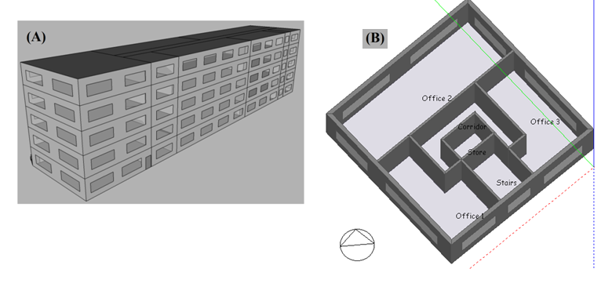
Figure 6. Representation of example buildings used in the study. Building A and Building B are shown.

The main output used in these results from the EnergyPlus modelling was the energy consumption from a mixed mode cooling system. Mixed mode cooling is where the building’s internal comfort conditions are maintained by natural ventilation as much as possible, but then supplemented with varying amounts of mechanical cooling to maintain thermal comfort when needed. This strategy has been most widely used in offices. This approach was used here since pure natural ventilation would result in unacceptable levels of overheating, particularly when the ventilation openings are restricted due to noise.

The mixed mode cooling energy presented within the results can be taken as a proxy for natural ventilation performance. If the natural ventilation performance is successful then no or little mixed mode cooling energy is needed. If it is not successful, for example when the level of external noise means that natural ventilation openings are closed, then the mixed mode cooling use is high. This high use can be seen as tending towards a fully conditioned building.

Results
The mixed mode cooling energy used for different tolerated noise levels, and therefore different ventilation opening patterns, for example building B, are shown in Figure 7. This indicates the type of output that this method can produce and more results can be found in the thesis by one of the authors³. Figure 8 shows the curve for building A with the effect of a 10 dB noise reduction measure estimated for location B. A 10dB noise reduction measure was chosen as an example as this is equivalent to a measure of medium effectiveness¹⁵. Assuming the noise reduction measure is applied uniformly for all ventilation openings then a lower level of mixed mode cooling energy is calculated for the same level of tolerated noise ingress (34 dBA). The 10 dB noise reduction measure equates to a 17 kW average chiller use for this case, resulting in an estimated 30% reduction in energy use.

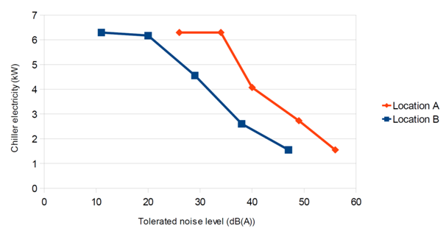Figure 7. Comparison of Building B in the different noise locations.

The differences in noise exposure between the two sites were quantified in the results by the separation of the curves. A greater tolerance of noise is needed in Location A for the same level of air conditioning used as in Location B. The distance between the curves for the buildings is related to the range of noise exposure for the two buildings in each location.

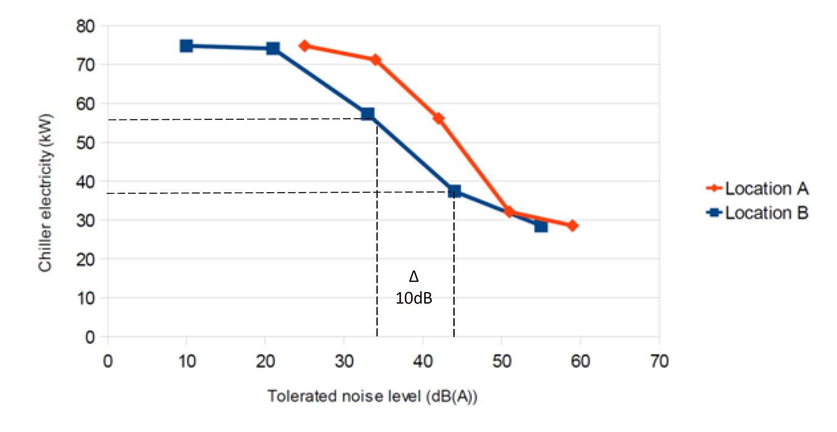
Figure 8. Illustration of how the change in chiller electricity due to a 10dB noise reduction measure is calculated for building A.

For the example buildings and locations investigated³ it was found that for the quieter noise location (site B) cooling requirements were found to decrease by 22%–45% compared to the noisier locations where natural ventilation was restricted. Site specific noise exposure patterns enabled the benefits of introducing noise reduction measures equal to 10 dB(A) to be quantified. This gave reductions in cooling energy consumption that varied from 28% to 45% of the original cooling energy consumption.

Discussion
This integrated approach could be automated within building energy calculation tools if the required information was available. This would mean that this approach could fit into the building design process providing useful information. The change in cooling energy shown in these results demonstrated the importance of this integrated approach when deciding where to adopt natural and mixed mode ventilation strategies and whether noise mitigation methods are worth adopting in specific cases. The results show that the relationship between tolerated noise and chiller use follow a pattern that is represented schematically in Figure 9. Small changes in chiller use are seen when the ventilation openings tend toward fully closed or fully open. The main gains to be made from employing noise reduction measures to the ventilation opening are seen in the middle section of this graph. The details of a graph are specific to the building and its location so automation of the process would be key to its wider adoption.

Tends towards all windows open
Main change in opening pattern
Tends towards all windows closed
Tolerated noise level
Chiller electricity
Figure 9. Representation of usual relationship between noise and mixed mode chiller use.

conclusion
This paper has given an overview of a method to integrate the noise and ventilation performance of buildings in urban buildings. The design curves that this method produced illustrate the essential relationship between noise and ventilation performance and illustrates how this method can inform the most effective use of noise reduction methods for specific sites.

Acknowledgements
The authors would like to thank the Engineering and Physical Sciences Research Council (EPSRC) for their financial support of this work (grant ref. number EP/F038100/1) and also thank the China National Science Foundation CNSF (509288) for its contribution.

References

1. De Salis, M.H.F., Oldham, D.J., Sharples, S.: Noise control strategies for naturally ventilated buildings. Build. Environ. 37, 471–484 (2002).
2. Oldham, D.J., De Salis, M.H.F., Sharples, S.: Reducing the ingress of urban noise through natural ventilation openings. Indoor Air. 14, 118–126 (2004).
3. Barclay, M.: PhD thesis - The interaction of building energy use, ventilation performance and urban noise under future climate scenarios, http://etheses.whiterose.ac.uk/4124/1/MB_Thesis_The_interaction_of_building_energy_use,_ventilation_performance_and_urban_noise_under_future_climate_scenarios.pdf, (2012).
4. Gomperts, M.C.: The “sound insulation” of circular and slit-shaped aperture. Acoustica. 14, 1–16 (1964).
5. Wilson, G.P.: Measurement of the Transmission Loss of a Finite-Depth Aperture. J. Acoust. Soc. Am. 37, 298–307 (1965).
6. Comsol Multiphysics: Acoustics Module, User’s Guide, (2008).
7. Oldham, D.J., Kang, J., Brocklesby, M.W.: Modelling the Acoustical and Airflow Performance of Simple Lined ventilation Apertures. Build. Acoust. 12, 277 – 292 (2005).
8. Wilson, G.P., Soroka, W.W.: Approximation to the Diffraction of Sound by a Circular Aperture in a Rigid Wall of Finite Thickness. J. Acoust. Soc. Am. 37, 286–297 (1965).
9. DataKustik GmbH: Cadna/A for Windows - User Manual, (2006).
10. DfT: Calculation of road traffic noise, (1988).
11. Mak, C., Leung, W., Jiang, G.: Measurement and prediction of road traffic noise at different building floor levels in Hong Kong. Build. Serv. Eng. Res. Technol. 31, 131–139 (2010).
12. Wang, B., Kang, J.: Effects of urban morphology on the traffic noise distribution through noise mapping: A comparative study between UK and China. Appl. Acoust. 72, 556–568 (2011).
13. Ordnance Survey: Roam Digimap image, http://edina.ac.uk/digimap/index.shtml, (2012).
14. Henninger, R.H., Witte, M.J.: EnergyPlus Testing with Building Thermal Envelope and Fabric Load Tests from ANSI/ASHRAE Standard 140-2007. U.S. Department of Energy, Office of Building Technologies Washington, D.C. (2009).
15. Kang, J., Brocklesby, M.W.: Feasibility of applying micro-perforated absorbers in acoustic window systems. Appl. Acoust. 66, 669–689 (2005).

