Blasts from the past: 4. The living fossil
Michelle Evans and Maggie Williams
Background
“Blasts from the past” is the section of Teaching Earth Sciences where some of the teaching ideas and activities, originally produced for early publications of ESTA and the Association of Teachers of Geology (the precursor to ESTA), are re-published. We hope that our newer members will find these teaching ideas and exercises useful.
Teaching ideas and activities have been updated and revised before re-publication in the magazine. The text of this article, web pages and copies of the images included in the article are also available on the ESTA website at: http://www.esta-uk.net/blasts/
Copies of earlier publications of ESTA and the Association of Teachers may be accessed in the archive section of the ESTA website, although PDFs of TES 26.3 onwards may be downloaded from the website.
Introduction to the living fossil activity
This activity was produced by Mary Hill (Hill, 1980). It was originally developed for use with third year pupils (13-14 year olds) in a mixed ability group. Original diagrams have been replaced by four photographs. References have been updated and a list of seven webpages added.
Reading for understanding is essential. The following activity is essentially a comprehension exercise based on an article about the coelacanth Latimeria chalumna - the so called living fossil. The information in this article was based on leaflet 10, which was available in 1980 from the British Museum of Natural History, which is now Natural History Museum, London. For this exercise, give your students a copy of the article “The living fossil” together with copies of figures 1 to 4 and ask them to answer the questions.
You may find it helpful to use sections of the video-recording of the BBC TV programme 'Invasion of the Land' (from Attenborough's 'Life on Earth' series) as an additional resource. An extension activity could be to ask students to work in groups to design a poster on the theme “The living fossil named Old Four-Legs”.
Aims of this activity are to:
- bring cutting edge Earth science into an article which students are encouraged to read;
- encourage students to think more about an aspect of geology
- allow learners to gain confidence in using scientific terms;
- help students to develop the ability to relate information derived from various sources;
- give students the opportunity to consider how science works;
- encourage students to develop a method of thinking about fossils in a more investigative manner, particularly with respect to their making and testing hypotheses about the functional morphology of the parts of fossils.
The living fossil
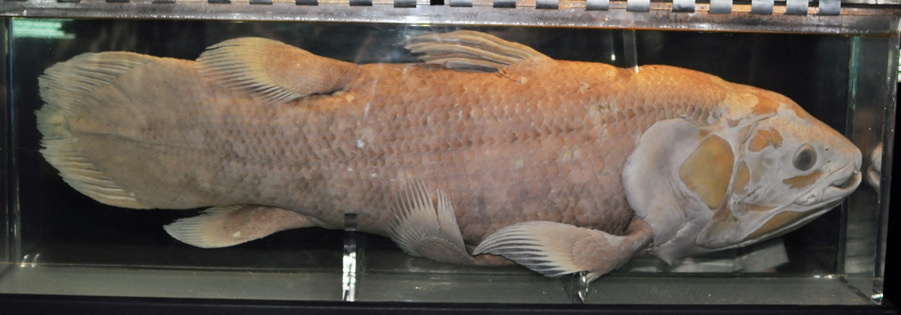
Figure 1: Coelacanth (Latimeria chalumnae) caught on 21 January 1965, next to Mutsamudu (Anjouan, Comoro Islands) Credit: Citron / CC-BY-SA-3.0
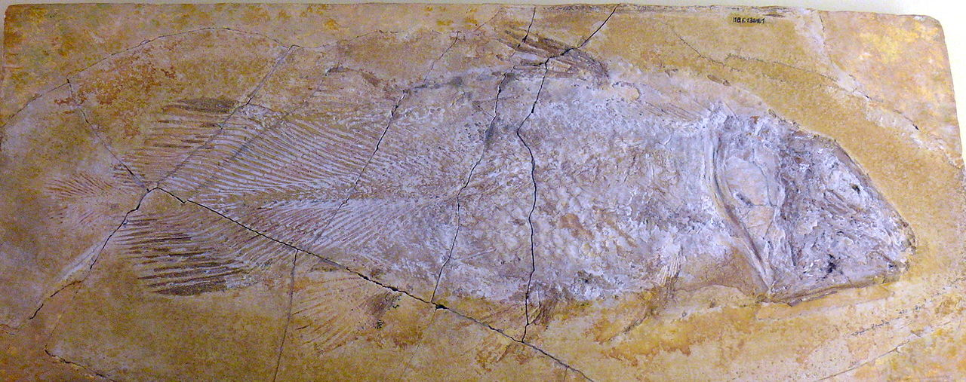
Figure 2: Coelacanth (Undina penicillata), Upper Jurassic, Germany. Credit: Alex Giltjes
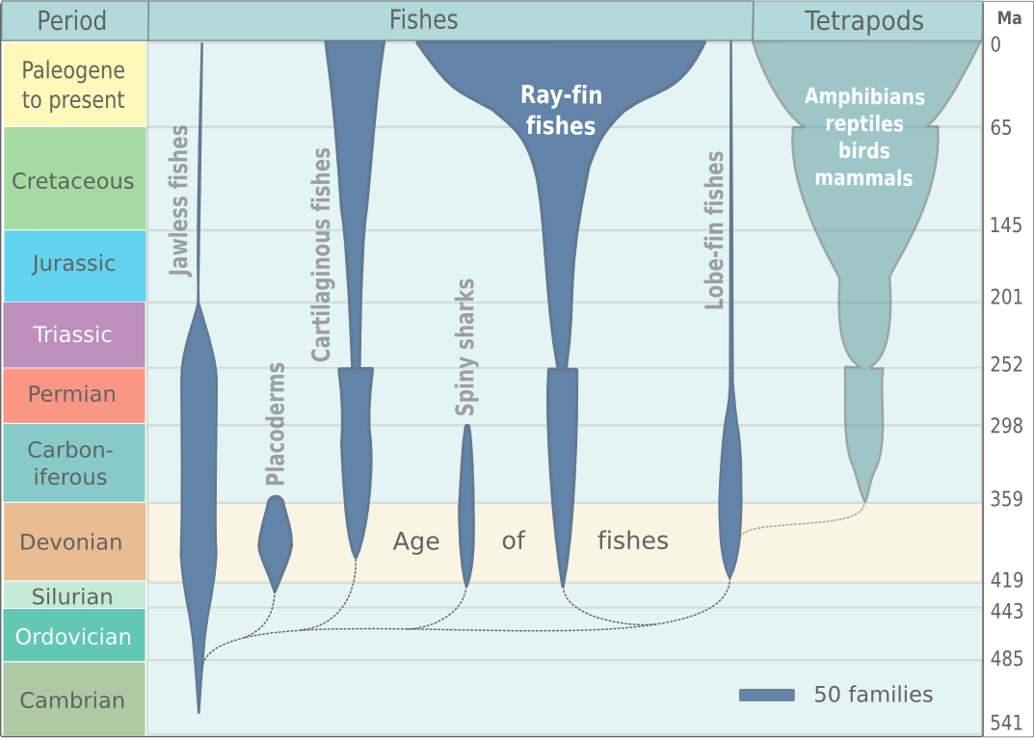
Figure 3: Fish evolution. Credit: Wikipedia
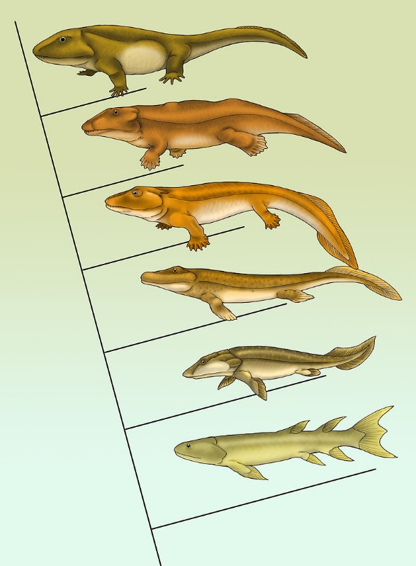
Figure 4: From fins to limbs: A cladogram of the evolution of tetrapods showing some of the best-known transitional fossils. It starts with Eusthenopteron (a fish) at the bottom to Pederpes (a tetrapod) at the top. Tiktaalik (a lobe-finned fish) is the third from the bottom. Credit: Maija Karala
The coelacanth is a fish considered a living fossil, because for years it had been thought to be extinct. Then on 22 December 1938 this fish (or at least an extremely close relative) was discovered among the catch of a local angler off the east coast of South Africa.
Ever since its dramatic discovery in 1938, the living coelacanth Latimeria has excited wide interest as a 'living fossil'. To have found a living dinosaur would scarcely have been more surprising, for the coelacanths were thought to have died out more than 70 million years ago. Moreover the living coelacanth - 'Old Four-Legs' - is of special interest as it belongs to a group of fishes closely related to the ancestors of the land vertebrates. From the living specimen much can be learned of its ancestors, whose fossil bones can now be clothed with flesh.
Palaeontologists have known about and studied the fossil remains of coelacanths for more than a century. These fishes have peculiar anatomical features that indicate their close relationship to the Rhipidistia, a group of fishes from which evolved the common ancestors of all the higher vertebrates (i.e. amphibians, reptiles, birds and mammals). The coelacanths themselves, however, are an evolutionary blind alley and were thought to have died out more than 70 million years ago.
The name Coelacanth means 'hollow spine' and refers to the spines lying above the spinal cord which in fossil specimens have a hollow centre. Coelacanths have a fossil history going back more than 400 million years, and fossil coelacanths are known from many parts of the world, including Europe, Africa and North America. Most of the fossil species were marine fishes, but a few lived in fresh-water.
During their history, coelacanths appear to have changed remarkably little in their general appearance or in the detailed organisation of the skeleton. However, since fossil remains rarely provide much information about the anatomy of a fish (apart from its skeleton), the discovery of the 'living fossil' Latimeria was of great scientific interest. In Latimeria scientists can investigate structures that either were not preserved or were difficult to interpret in the fossil coelacanths. Moreover, the living specimen provides a check on methods of reconstructing fossil animals. In fact detailed reconstructions of the skull of a Devonian coelacanth made before the 1938 discovery were found to agree almost every way with the skull of the living species.
But the interest in Latimeria goes beyond what it can tell us about fossil coelacanths. Because coelacanths are closely related to the Rhipidistia, Latimeria can throw light on these animals as well. It must, however, be stressed that, although coelacanths are related to the ancestors of the higher vertebrates, they are not themselves in the direct line of ancestry: the coelacanths gave rise only to other coelacanths.
Questions
1. Why do you think coelacanths have been nicknamed 'Old Four-Legs'?
2. Why was the discovery of the coelacanths such a surprise?
3. What use is the living coelacanth to palaeontologists?
4. “The present is the key to the past”. What do you think this statement means? Is the passage an example of this principle?
5. What does the phrase “evolutionary blind alley” mean?
6. Explain why the discovery of this living fossil was important to the development of thinking of scientists.
7. Use the webpages listed below to find out more about the nature, origin and discovery of Latimeria chalumnae.
Web pages (Accessed 02/01/2015)
Fossil facts and finds - http://www.fossils-facts-and-finds.com/devonian_period.html
The West Indian Ocean coelacanth - http://en.wikipedia.org/wiki/West_Indian_Ocean_coelacanth 81, pp. 49–54
The fish out of time - http://www.dinofish.com/
Lobe-finned fishes - http://www.bbc.co.uk/nature/life/Sarcopterygii
Introduction to the Sarcopterygii - from fins to legs http://www.ucmp.berkeley.edu/vertebrates/sarco/sarcopterygii.html
On the trail of the coelacanth, a living fossil - http://www.washingtonpost.com/wp-srv/national/horizon/nov98/fishstory.htm
Living fossils: Coelacanths and the ancestry debate - www.nhm.ac.uk/resources-rx/files/11feat_living_fossil_coelocanths-3116.pdf
References
Hill, M. (1980) The living coelacanth – a comprehension exercise for 3rd year pupils. Geology Teaching, 8 (2), pp. 68-69.
Smith, J.L.B. (1958) Old Fourlegs,The Story of the Coelacanth. London, Pan Books. 284pp.
Michelle Evans
Brunel University London

Maggie Williams
Department of Earth, Ocean and Ecological Sciences, School of Environmental Sciences, Liverpool, L69 3GP
hiatus@liv.ac.uk

