Influence of detached macroalgae on fish size and condition in nearshore habitats
Marcelo Paes Gomes¹, Cristiano Queiroz de Albuquerque², Ryan Andrades³, Agnaldo Silva Martins³, Leonie Robinson¹ and Matthew Spencer¹
1 – School of Environmental Sciences, University of Liverpool, Liverpool, L69 3GP, UK
2 - Departamento de Ciências Animais da Universidade Federal Rural do Semiárido, Presidente Costa e Silva, 59625-900, Mossoró, Rio Grande do Norte, Brazil
3 - Departamento de Oceanografia e Ecologia, Universidade Federal do Espírito Santo, Av. Fernando Ferrari, 514, 29075-910, Vitória, ES, Brazil
Corresponding author: mpgomes@liverpool.ac.uk

Abstract
Nearshore habitats are important for reproduction, feeding and growth of many fish species and are usually subject to seasonal influxes of adults from other habitats. Those areas consist mostly of small-scale sites whose environments are affected by meso- or large-scale and continental events, making it difficult to establish seasonality of habitat use. Understanding which drivers make these habitats suitable for fish species and, in particular, why this might vary seasonally is relevant to resource management. Detached macrophytes are likely to improve refuge and food for fishes and invertebrates, increasing abundance (especially juveniles) and diversity. On the southeastern Brazilian coast, detached macroalgae are carried by surface currents and swell and deposited along beaches in the winter (Dry period), but are largely absent in the summer, nutrient-enriched Rain period. This project aimed to investigate the potential importance of macroalgae to fish populations in the southeastern Brazilian coastal region. Four areas were surveyed on the southern Espírito Santo coast. The main diet of Larimus breviceps, Stellifer rastrifer and S. stellifer (Sciaenidae) was determined and some key food items were then sampled from macrophytes. Samples of fishes, food items, algae and higher plants were subject to carbon and nitrogen stable isotope analysis in order to define food chains from algae and higher plants to fish. Fish sizes were compared among Dry and Rain periods. Fish condition was addressed through linear regression models fitted with Log-transformed eviscerated weight as the response variable, and Log-transformed Standard Length, Period, Site, Species and Reproductive Class (and their first-order interactions) as the explanatory variables. Trophic positions of fish and their food items were estimated using stable isotopes signatures and macrophytes as the baseline. For most combinations of species and site, fish were shorter and lighter in the dry period than the rain period. However, fish of all three species were almost always predicted to be heavier for a given length in the Dry period, when macroalgae were present. The data suggest that detached macroalgae in the Dry period are a regional environmental driver of fish and crustacean distributions and that management of macroalgae may be important for biodiversity and fisheries conservation.

Keywords:
Sciaenidae; Food items; Macroalgae; Trophic position estimation; Condition enhancement; Environmental Driver

- Introduction
Fish populations of nearshore habitats are usually related to continental influences, mainly due to their proximity to estuaries (Abookire et al., 2000). This results in biological cycles being affected by both natural factors such as riverine nutrient discharge and anthropogenic factors such as fishing (Courrat et al., 2009). These nearshore habitats are important for reproduction, feeding and growth of many fish species (Tse et al., 2008) and are usually subject to seasonal influxes of adults from other habitats (Perera-Garcia et al., 2011), including species of commercial importance (Baisez et al. 2011). Understanding which drivers make these habitats suitable for fish species and, particularly, why this might vary seasonally is important for resource management and conservation.
Fish populations or assemblages may shift their habitat use due to changes in resource availability (Hayes et al, 1996; Dantas et al., 2012). Some processes or functions that underpin population dynamics may change over small to intermediate spatial and temporal scales (Gomes et al., 2003), including: predation (Werner et al., 1983a), habitat profitability (Werner et al., 1983b), nursery (Defeo and McLachlan, 2013) and mating/spawning grounds (Franco et al., 2006) and recruitment (Ramos et al., 2012). Seasonal changes in water temperature, salinity and other abiotic variables are known to regulate these and other biological events (Adams et al., 2006; Hajisamae et al., 2006). However, nearshore areas consist mostly of small-scale sites whose environments are affected by meso- or large-scale and continental events (Hickey and Banas, 2003), making it difficult to establish seasonality of habitat use based on temperature-salinity profiles alone.
Many attempts to address fish habitat use and the environmental factors involved have been performed in nearshore areas, and a variety of approaches have been used in order to explore the responses of fish populations to the availability of resources. Biological properties such as distribution, abundance, growth, reproduction, migration and foraging have been explored worldwide in order to relate fish populations to their ideal environmental conditions (Sanchéz et al., 1995; Prista et al., 2003; Bacon et al., 2005; Jordan et al., 2010). In addition, some biochemical approaches, such as general trace element analysis (Tulp et al., 2013) and, more specifically, stable isotope analysis (Gillanders et al., 2003) are currently used to hindcast the sites and resources individuals have come across in their lifetime or in the recent past, respectively. Indeed, stable isotopes are useful as biomarkers of organic matter incorporation into predators from food items (Ben-David and Schell, 2001). The isotopic ratio of some elements allows tracking their flux and position in a food chain (Leakley et al., 2008; Ince et al., 2007). An approach combining stable isotope analysis with relevant functional trait parameters (such as biometrics and responses of feeding rates to environmental changes) may become a powerful tool to verify the interaction of some types of resources with individual metrics, such as size-mass relationships, over a more limited timescale.
The seasonality of the southeastern Brazilian coast is characterized by a Rain period in spring and summer months, when the nearshore is commonly influenced by an estuarine nutrient enrichment, leading to higher turbidity values, and a Dry period in autumn and winter months, when detached macroalgae, mainly related to offshore rodolith beds (Amado-Filho et al., 2010), reach and accumulate on shore (Andrades et al., 2014). The transport of detached macroalgae is not well understood in this region, but in general is associated with surface currents and swell originating from intense, periodic weather changes (Colombini and Chelazzi, 2003). Riverine influence is widely expected to drive variations in fish distributions according to the strength and dispersion of estuarine runoff (Neves et al., 2016). However, this is not the only potentially important variable. It has been described how detached macrophytes provide food and shelter for terrestrial and aquatic meiofauna (Ince et al., 2007; Lercari et al., 2010) and ichthyofauna (Lenanton et al., 1982; Crawley and Hyndes, 2007), even in oligotrophic marine environments. It is therefore possible that differences in fish body condition between Dry and Rain periods are driven by differences in both estuarine nutrient enrichment and macroalgal inputs.
Andrades et al. (2014) previously observed higher fish species richness, density and biomass in response to detached macroalgae accumulation in the surf zone environment in this region, with Trachinotus falcatus and T. goodei young of the year occurrence closely related to feeding on macrophyte-associated amphipods. Thus macrophyte accumulations may have a zone of influence extending out of the immediate area of the accumulation, in addition to the influence of the river Itapemirim estuary as a known source of nutrients for lower trophic levels. Here we build on the results of Andrades et al. (2014) by investigating differences in body condition that may be associated with detached macroalgae, in three demersal Sciaenidae species (Larimus breviceps, Stellifer stellifer and S. rastrifer). These fish are widely distributed and co-occur throughout their life span in brackish and marine nearshore areas in southeastern Brazil (Menezes and Figueiredo, 1980; Pombo et al., 2013; Bessa et al., 2014). In addition, stomach contents and stable isotope analyses were used to determine diet and trophic positions. Water temperature and salinity, macroalgal volume and fish size and condition were compared between Dry and Rain periods, at sites varying in distance from the estuary, in order to evaluate whether macroalgae affects fish populations. The hypothesis we tested were: (1) the three fish species have smaller sizes and better condition in the Dry period at all non-estuarine sites and (2) the three fish species have better condition in the Rain period at river Itapemirim estuary site.
- Methods

2.1. Study area
Individuals of L. breviceps, S. stellifer and S. rastrifer were collected at three Initial Shelf (here defined as the region immediately outside the surf zone) sites on the southern coast of Espirito Santo State, in Brazil: Itaoca, north of the River Itapemirim Estuary; Barra, immediately south of the Estuary, but separated by a breakwater barrier; and Colonia, south of and most distant from the Estuary (Fig. 1). The River Itapemirim estuary was also surveyed. Those sites were chosen due to their known propensity to accumulate allochthonous macrophytes and in order to allow tests of differences in environmental influences over fish biology using the same gear. All sites were shore-delimited by reflective sandy beaches. All surveyed sites had a sand-mud-gravel soft bottom with no attached macroalgae (Teixeira et al, 2013), with Colonia the closest to the transition to a rock-patch bottom to the south.
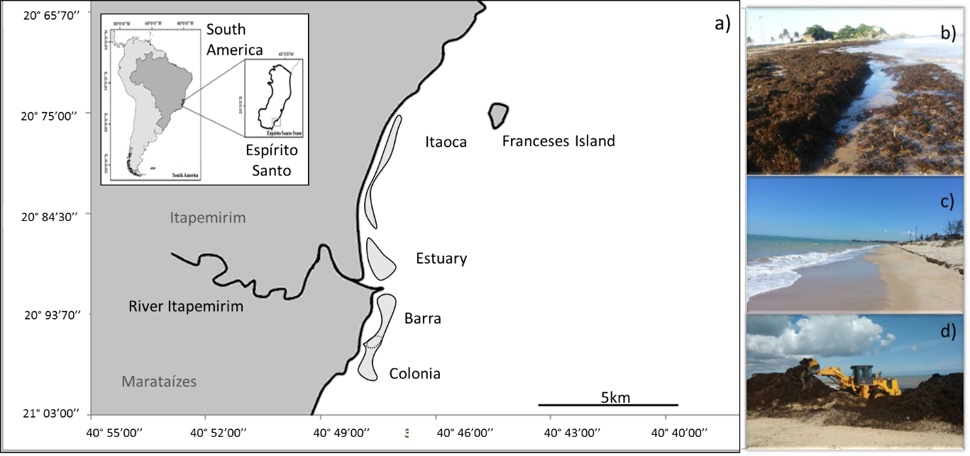
Fig. 1 – Map indicating surveyed sites on the Southern coast of Espirito Santo. Light shaded areas in (a) correspond to georeferenced trawls performed at each site. Minor traced lines indicate where trawls overlap occurred. Detached macrophytes accumulate on the shore in the Dry period (b), are buried on beaches and absent from the water column in the Rain period (c). Local authorities remove macrophytes from sandy shores for grooming using a tracked excavator (d).

The southern coast of Espirito Santo is classified as a Tropical Zone with Dry Winter (Alvarez et al., 2014). This region is strongly influenced by winds from the Northeastern quarter in the summer Rain period, leading to precipitation on the Espirito Santo coast in the summer due to retraction of the central south Atlantic high pressure centre and the presence of a low intertropical pressure zone. Due to higher precipitation in the Rain period, higher plant fragments (mainly branches and leaves, with some driftwood) are often removed from river edges and transported to coastal areas through the estuaries, also accumulating along shorelines close to estuaries. Polar fronts from the Southern quarter are stronger in winter, from April to October (Veronez-Junior et al., 2009), defined here as the Dry period. In the Dry period, swells varying from 0.5m to 1.5m high are commonly observed for weeks (even months), coinciding with the accumulation of detached macroalgae in coastal habitats such as beaches and shallow shelves (Andrades et al., 2014).

  - Data collection
At each site, three shore-parallel, along-bottom trawls in each site were performed in the Dry (July/11 and September/11) and Rain (February/12 and May/12) periods, totaling 12 trawls per site. Fish, macrophytes (both macroalgae and terrestrial Higher Plants), and their associated epifauna (mostly crustaceans, gastropods and polychaetes) were sampled using otter trawl nets (10 m long, equipped with a 5 m wide and 3.5 m high sac; mesh sizes were 20 mm in whole net and 10 mm in the sac) at all sites. In order to maintain standardized sampling, no other accessory gear was used. Trawl duration was five minutes, with an average towing speed of 2.5 km/h, giving a length of almost 300 m per trawl at depths between four and six meters, due to tidal variation. Surface and bottom water temperature (ºC) and salinity (measured using the Practical Salinity Scale) were determined prior to each trawl, using a Horiba U-52 Multiparameter Meter (Horiba Ltd., Kyoto, Japan). Due to the Barra and Colonia sites being adjacent, some trawls at Barra ended within the Colonia area, and vice-versa (Figure 1a).
The volume (liters) of macroalgae and Higher Plants was obtained from trawls. From each fish sample, the standard length (from the most anterior extreme to the end of the caudal peduncle, in millimeters) and eviscerated weight (total wet weight minus viscerae wet weight, in grams) of each individual were measured. These two metrics were chosen in order to address differences in size (both length and weight) between the Dry and the Rain periods, with little influence from chance events such as fin damage, and from transient states such as undigested large meals.
Gonad stadium was classified using the general macroscopic appearance of gonads as either: Undetermined - when the gonad is not differentiated or not developed enough to be properly dissected; Stadium I – gonad is differentiated but not well developed; Stadium II – Gonad is developed but did not show yolked oocytes (females) or full, tensioned testis (male); Stadium III – presence of yolked oocytes or full, tensioned testis; and Stadium IV – spawned, flaccid gonad. The combinations of gonad stadium and gender thus formed nine categories of Reproductive Class: Undetermined, Females I to IV and Males I to IV.
Stomachs were individually removed, fixed and stained in 10% formalin solution, and contents were identified to the lowest taxonomic level possible. Food items were dissected under a stereomicroscope and categorized into biologically relevant groups. Diet was analyzed following Amundsen et al. (1996), and the prey-specific abundance was calculated according to the Equation:
;
where “P_{i}” is the prey-specific abundance, “Si” is the stomach content (e.g. weight of the prey “i”) and “Sti” is the total stomach content in only those predators with the prey “i” in their stomach. In order to represent feeding strategies of L. breviceps, S. rastrifer and S. stellifer in the surveyed period prey-specific abundances were plotted against the frequency of occurrence of each prey item.

  - Stable isotope analysis
Ratios of δ¹³C and δ¹⁵N stable isotopes were determined for macrophytes (macroalgae and higher plants) and consumers (crustaceans and fish) through biomass samples from blades and leaves (macrophytes) and muscle (animals), respectively. Stable isotope analyses may reflect diet over a 90-day (Fry, 2006) to 105-day (Heiner et al., 2011) time period. Thus, due to the constraints on the periodicity of material available, these samples were pooled over Dry and Rain periods. In addition, because of logistical constraints, samples were pooled across the four sites. Samples were dried at 60 °C for 48h. Crustacean samples were selected to match those found as food items for the three fish species. Each sample was macerated and sub-samples (at least three) were stored in tin capsules. Each capsule contained material comprising the following components: Fish: L. breviceps, S. rastrifer and S. stellifer; Food Items: Artemesia longinaris, Xiphopenaeus kroyeri, Callinectes danae, Acetes americanus and general Amphipoda; Algae/Plants: Chlorophyta, Rhodophyta, Ochrophyta and Higher Plants.
Samples for carbon and nitrogen isotopic analysis were converted to N₂ and CO₂ with an elemental analyzer (ECS 4010, Costech Analytical, Valencia, CA) and these two gases were separated with a 3m GC column and analyzed with a continuous flow isotope ratio mass spectrometer (Delta PlusXP, Thermofinnigan, Bremen) at the Washington State University, USA. Stable isotope abundance was expressed in the traditional form :
;
where is the difference in isotopic composition between sample and standard in parts per thousand (‰) and R is the ratio between measured stable isotopes (¹³C/¹²C; ¹⁵N/¹⁴N). Standards used in this study were atmospheric air nitrogen and PeeDee Belemnite (PDB) as references for nitrogen and carbon, respectively (Fry, 2006).

  - Estimation of trophic position
Mean trophic position (TP) for all consumers was determined for each sub-sample according to Vander-Zanden and Rasmussen (2001), through the following expression:

$TP= λ+ \left(\frac{δ{}_{}^{15}{N }Consumer-δ{}_{}^{15}{N }Base}{TEF}\right)$;
where λ is the trophic level for producers (λ = 1), $δ{}_{}^{15}{N }Consumer$ is the mean ¹⁵N isotope signature of the given consumer, $δ{}_{}^{15}{N }Base$ is the mean ¹⁵N isotope signature for all producers (Chlorophytes, Ochrophytes, Rhodophytes and Higher Plants sub-samples combined). The Trophic Enrichment Factor (TEF, the average δ¹⁵N trophic enrichment per trophic level) was taken to be 3.4 (Post, 2002). Standard errors of trophic positions were calculated following
${SE}_{Consumer}= \frac{1}{3.4}\sqrt{{{SE δ{}_{}^{15}{N }Consumer }^{2}+ {SE δ{}_{}^{15}{N }Base }^{2}}_{}}$, under the assumption that measurements were independent.

  - Data analysis
Macrophyte volume and fish size (Log-transformed standard length and eviscerated weight) were compared between Dry and Rain, using three-way ANOVA with site, species and period (and all their interactions) as explanatory variables, and planned contrasts between Dry and Rain for each combination of species and period (p < 0.05). In order to address fish condition, linear regression models were fitted with log eviscerated weight as the response variable (this is an analog to Fulton’s K value determination, since the mean K value is approximately equal to the intercept of a log-log regression of weight on length, which generally has a slope close to 3), and first order interactions between Standard Length, Period, Site, Species and Reproductive Class (the combination of Gonad stadium and Gender) as the explanatory variables. Including the interaction between reproductive class and standard length allowed us to avoid confounding seasonal differences in condition with differences in length-weight relationships between juveniles and adults. Due to the small sample size of both females and males in stadia III and IV, they were aggregated into a single level in order to allow estimation of all parameters. All analyses were performed in R environment (R Studio Version 0.99.491).

- Results
Water temperature varied from 20 º C to 24.5 º C among sites and periods, and salinity varied from seven to 39 (Figure 2). The Estuary site had higher temperatures and lower salinities in June/11 (for both Surface and Bottom water, in the Dry period), February/12 and May/12 (for Surface water, in the Rain period). All the other sites showed salinities between 31 and 39. Temperature was significantly different between months (ANOVA F value = 64.75, df = 3, p < 0.0001), however there was no gradient from Dry to Rain.

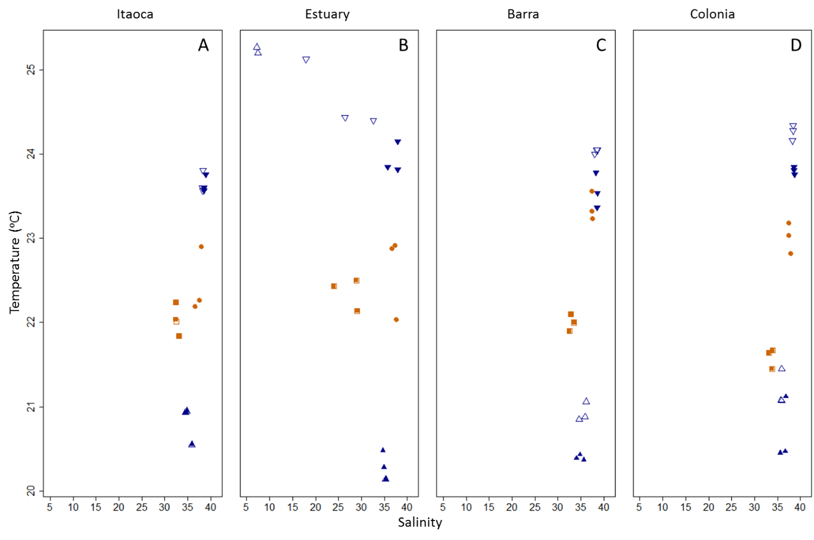
Fig. 2 –Salinity and Temperature (ºC) values of Surface (open symbols) and Bottom (filled symbols) water at Itaoca (A), Estuary (B), Barra (C) and Colonia (D) sites on June/11 (■), September/11 (●), February/12 (▲) and May/12 (▼). Orange tones represent the dry period, while blue tones represent the rain period.

There was a higher volume of detached macrophytes in the Dry period at Itaoca and Barra, while the Estuary site had a higher volume in the Rain period. All sites had macroalgae accumulations in the Dry period (Figure 3A), but higher plants were only found at the Estuary site in the Rain period (Figure 3B). For macroalgae, differences between periods were significant at Itaoca (t =6.20, df = 80, p < 0.0001) and Barra (t = 11.34, df = 80, p < 0.0001) sites, but not at Colonia (t = 0.31, df = 80, p = 0.753). There was no macroalgae at the Estuary site in the Rain period.

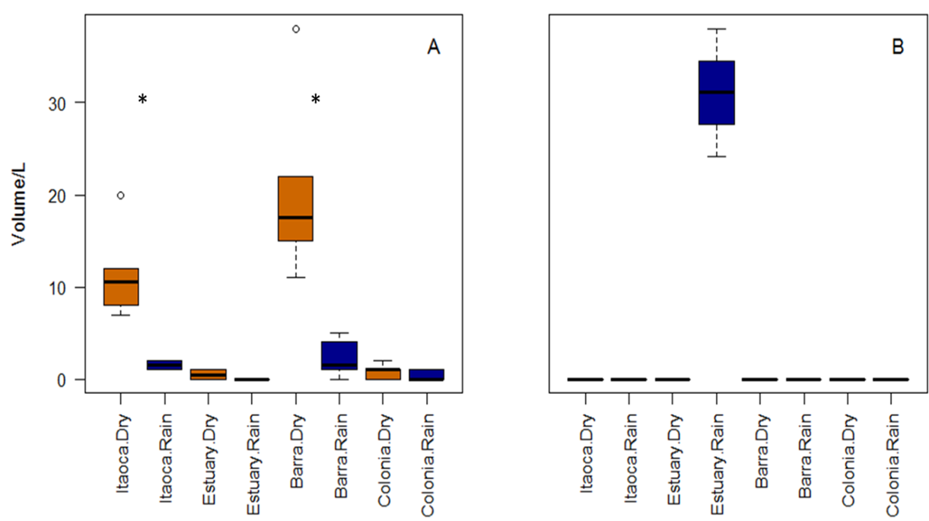
Fig. 3 –Volume of detached macrophytes at each site in the Dry (Orange) and Rain (Blue) periods (A = macroalgae; B = higher plants). Significant differences from planned contrasts (p < 0.0001) are shown by asterisks. Line = Median, box = first to third quartiles, whiskers = extend to the most extreme values no more than 1.5 times the interquartile range from the ends of the box, circles = potential outliers.

Amundsen's plots revealed generalist feeding strategies of L. breviceps, S. rastrifer and S. stellifer in both Dry and Rain periods. L. breviceps had Decapoda in high abundance in both periods, and A. americanus was a more frequent food item in the Rain period (Figure 4A). Copepoda was an especially dominant food item for S. rastrifer in the Dry period (Figure 4B), with high values (>50%) of prey-specific abundance and frequency, while other minor items (such as small parts of green algae, fish, insect, and polychaete, and also gastropod shells and cephalopod beaks) were the most abundant group of food items. S. stellifer (Figure 4C) had Decapoda parts as the most abundant (but least frequent) item in the Dry period, while Copepoda (in both periods) and A. americanus (in Dry period) had high frequencies but low abundances.

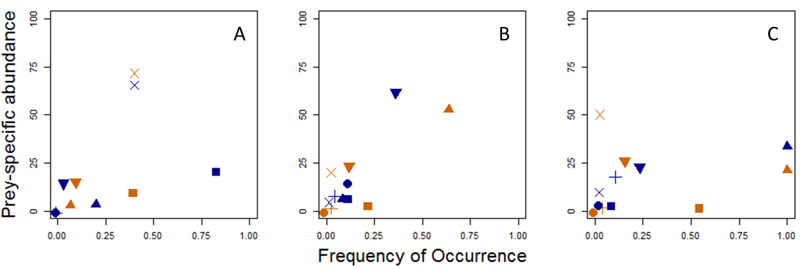
Fig. 4 – Feeding strategy of L. breviceps (A), S. rastrifer (B) and S. stellifer (C) based on the Amundsen's plot over all sites in Dry (Orange) and Rain (Blue) periods. Food items are shown by different symbols: A. americanus(■); Amphipoda – (●); Copepoda (▲); general Crustacea parts (+); general Decapoda parts (×); Other items (▼).
Stable isotope analysis revealed a food chain with the fish L. breviceps, S. rastrifer and S. stellifer as the tertiary consumers, crustaceans as the secondary consumers and Chlorophytes, Ochrophytes and Rhodophytes, as well as Higher Plants, as plausible producers, although Rhodophytes had higher Carbon signature values than the other macrophytes (Table 1). All organisms had similar δ¹³C values (increasing from -22.92 ‰ of Higher Plants to -17.54‰ of L. breviceps). δ¹⁵N values increased from producers (6.85‰) to crustacea (between 10.07‰ of Amphipoda to 13.30‰ of A. longinaris) and fish (from 14.11‰ of S. rastrifer to 14.57‰ of L. breviceps₎. Fish species were tertiary consumers, with estimated trophic positions between 3.2 and 3.3. Crustacea were secondary consumers, with trophic positions between 1.9 and 2.9, and Amphipoda were closest to the isotope signatures of producers.

Table 1 – Mean values (SE) of Carbon (δ¹³C) and Nitrogen (δ¹⁵N) signatures for producers and those consumers sampled, and estimated trophic positions for consumers.
Trophic levels | Component | δ¹³C | δ¹⁵N | Trophic position
Consumers | Larimus breviceps | -17.54 (0.11) | 14.57 (0.20) | 3.3 (0.11)
 | Stellifer stellifer | -17.67 (0.10) | 14.54 (0.07) | 3.3 (0.09)
 | Stellifer rastrifer | -18.03 (0.22) | 14.11 (0.23) | 3.2 (0.11)
 | Artemesia longinaris | -18.38 (0.07) | 13.30 (0.03) | 2.9 (0.09)
 | Xiphopenaeus kroyeri | -17.65 (0.08) | 12.72 (0.14) | 2.7 (0.11)
 | Callinectes danae | -17.46 (0.50) | 12.30 (0.55) | 2.6 (0.18)
 | Acetes americanus | -19.39 (0.07) | 10.71 (0.07) | 2.1 (0.10)
 | Amphipoda | -19.03 (0.01) | 10.07 (0.15) | 1.9 (0.10)
Producers | All producers | -20.94 (1.62) | 6.85 (0.62)
 | Higher Plants | -22.92 (2.69) | 6.07 (0.43)
 | Chlorophyta | -21.12 (0.21) | 8.23 (0.24)
 | Rhodophyta | -17.99 (0.33) | 7.19 (0.28)
 | Ocrophyta | -21.72 (0.65) | 5.91 (0.21)

Log-transformed Standard Length (SL) and Eviscerated Weight (EW) were usually lower in the Dry period at each site. L. breviceps (Figure 5A and 5D) showed lower length (df = 80, t =5.77, p < 0.0001) and weight (df = 80, t =6.15, p < 0.0001) in the Rain period at the Estuary site and in the Dry period at Colonia (SL: df = 80, t = -12.37; EW: df = 80, t = -11.00, p = 0.0001) and Itaoca (SL: df = 80, t = 2.67, p = 0.009; EW: df = 80, t = 2.39, p = 0.016), while S. rastrifer (Figure 5B and 5E) showed significantly lower length (Itaoca SL: df = 80, t = -6.25, Estuary SL: df = 80, t = -3.70, Barra SL: df = 80, t = -14.40, Colonia SL: df = 80, t = -2.61; p < 0.0001) and weight (Itaoca EW: df = 80, t = -5.22, Estuary EW: df = 80, t = -3.41, Barra EW: df = 80, t = -15.52, Colonia EW: df = 80, t = -2.78; p < 0.0001) in the Dry period at all sites. S. stellifer (Figure 5C and 5F) had significantly lower length and weight in the Dry period only at Barra (SL: df = 80, t = -8.66; EW: df = 80, t = -9.38; p < 0.0001).

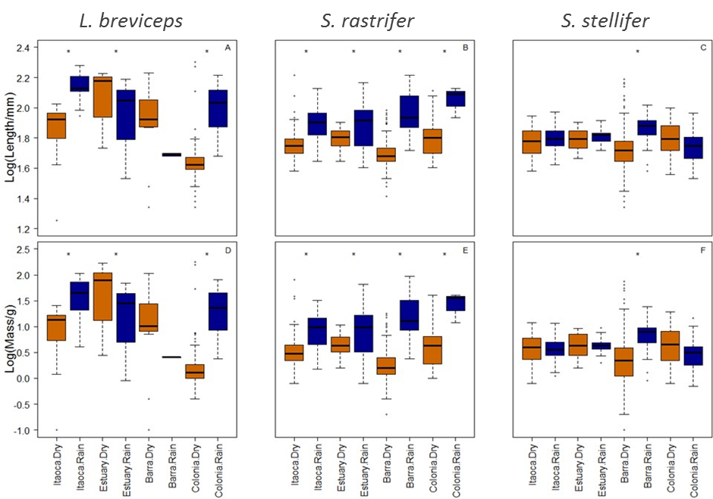
Fig. 5 – Standard Length (Log(Length/mm)) and Eviscerated Weight (Log(Mass/g)) of L. breviceps (A and D), S. rastrifer (B and E) and S. stellifer (C and F) distributions at Itaoca, Estuary, Barra and Colonia sites on the southern Espírito Santo coast in Dry (orange boxplot) and Rain (blue boxplot) periods. Significant differences from planned contrasts are shown by asterisks. Line = Median, box = first to third quartiles, whiskers = extend to the most extreme values no more than 1.5 times the interquartile range from the ends of the box, circles = potential outliers.

In the Dry period, fish tended to be shorter and lighter, and most of these small fish were juveniles with undetermined gender (Figure 6). Fish whose gender could be determined were more abundant in the Rain period. A linear regression model showed that the relationship between log eviscerated weight and log standard length depended on interactions among Period, Species, Site and Reproductive Class (Table 2).

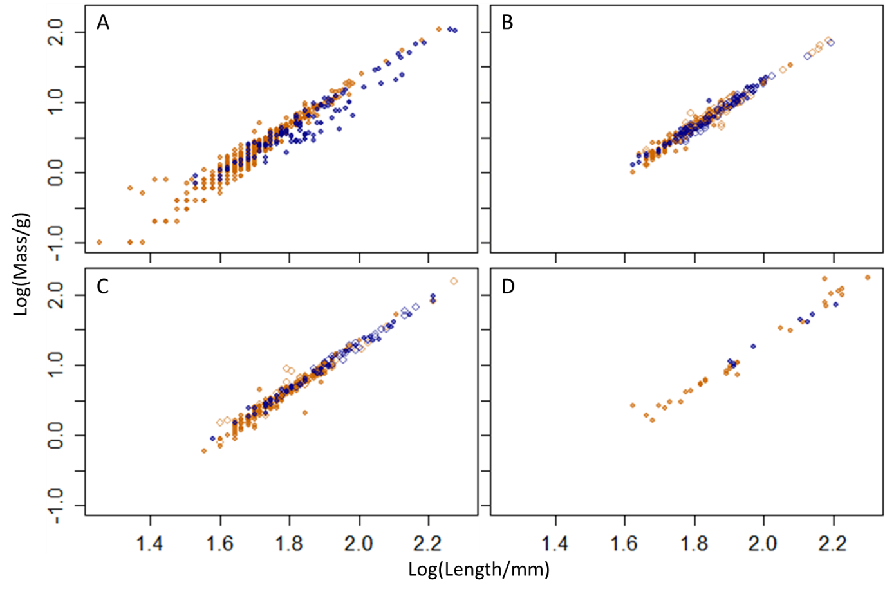
Fig. 6 – Relationships between log (eviscerated weight/g) and log (standard length/mm) for Sciaenidae in Dry (Orange) and Rain (Blue) periods pooled over sites and species: A – Undetermined; B – Female (Stadium I – filled circles; Stadium II – open circles); C – Male (Stadium I – filled circles; Stadium II – open circles) and D – Aggregated Female and Male (Stadia III and IV).

When considering individual species and sites, including reproductive class in the model, slopes of relationships between log-transformed standard length and eviscerated weight were higher for the Dry period (Figure 7, orange lines) than the Rain period (Figure 7, blue lines) at all sites. However, over the observed size ranges in this study, for which there was substantial overlap between periods (Figure 7, bold segments), fish were almost always predicted to be heavier for a given length in the Dry than in the Rain period (Figure 7, orange lines above blue lines in almost all bold segments). Model coefficients are available in Supplementary Material 1.

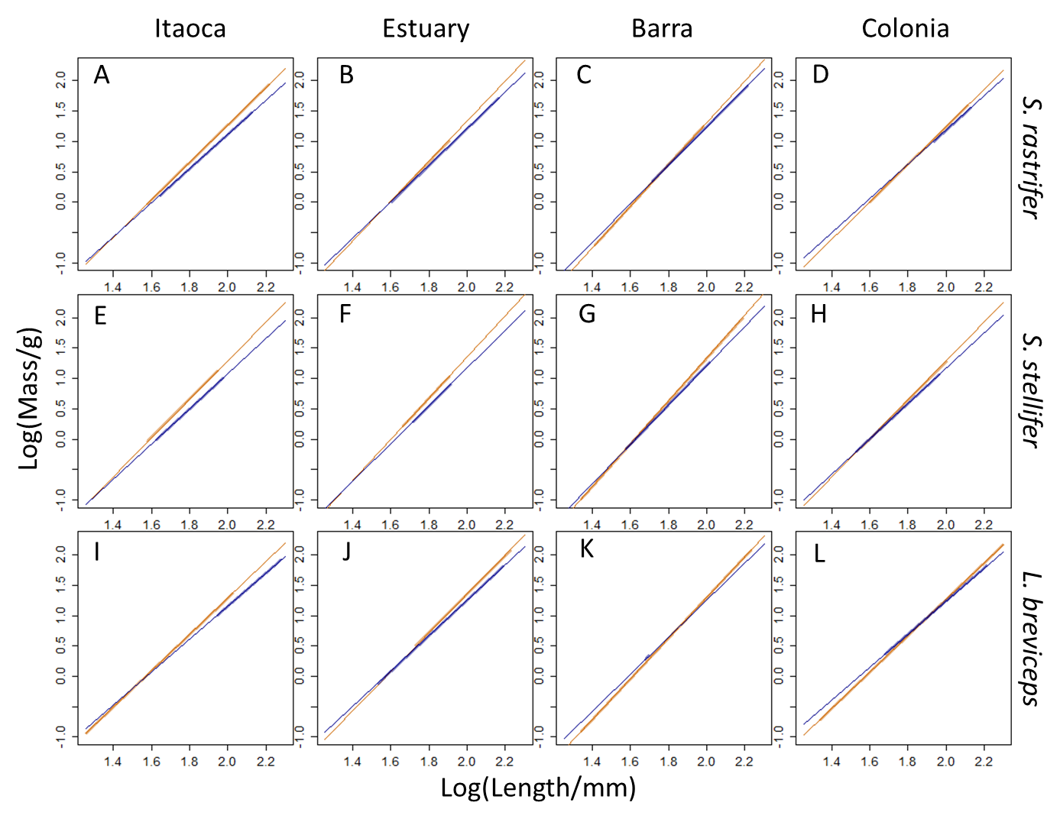
Fig. 7 – Fitted relationships between log(eviscerated weight/g) and log(standard length/mm) for S. rastrifer (A-D), S. stellifer (E-H) and L. breviceps (I-L) at Itaoca (A, E, I), Estuary (B, F, J), Barra (C, G, K) and Colonia (D, H, L) in Dry (orange) and Rain (blue) periods. Bold line segments represent observed size ranges, and thin lines are extrapolations over the entire size range in the study.

The overall regression model was significant, confirming a relationship between Eviscerated Weight and Standard Length (Table 2). All first order interactions involving Period were significant, as well as those involving Standard Length (except with Reproductive Class) and the Site x Reproductive Class interaction. The Species x Site and Species x Reproductive Class interactions were not significant. Although there were variations in the proportion of individuals in each reproductive class between periods, there is at best weak evidence that the relationship between eviscerated weight and standard length differs between reproductive classes. Thus, differences in the proportion of each reproductive class between periods do not confound the differences in length-weight relationships between periods.

Table 2 – First order interactions among explanatory variables in a linear model with log Eviscerated Weight as the response variable. F values summarize the differences in fit between the models through ANOVA and were calculated from single-term deletions (significant values are bold). *df = numerator degrees of freedom; denominator degrees of freedom were 1288 in all cases.
Model | *df | F | P
Overall model | 1289 | 31.99 | p < 0.0001
Interactions | *df | F | P
Standard Length × Period | 1 | 28.75 | p < 0.0001
Standard Length × Species | 2 | 5.05 | 0.006
Standard Length × Site | 3 | 18.26 | p < 0.0001
Standard Length × Reproductive Class | 8 | 1.86 | 0.098
Period × Species | 2 | 11.70 | p < 0.0001
Period × Site | 3 | 18.75 | p < 0.0001
Period × Reproductive Class | 5 | 20.74 | p < 0.0001
Species × Site | 6 | 0.51 | 0.80
Species × Reproductive Class | 11 | 1.38 | 0.18
Site × Reproductive Class | 17 | 2.57 | 0.001

Discussion

In this study, focused on an area of high seasonal dynamics (southern Espírito Santo, Brazil), there was a clear difference between Dry and Rain periods in the size and condition of three common, ecologically important coastal fish species. The Dry period seems to be critical to smaller, younger individuals of the three fish species studied here. Fish were shorter and lighter in the Dry period, but were heavier for a given length, particularly for the longer fish. Macroalgae reach and accumulate on the shore in the Dry period, and in two of the sites there were significantly higher volumes in this period. There was no significant variation in other potential key drivers, such as temperature and salinity. Furthermore, isotopic analysis and exploration of stomach contents suggested that macroalgae are a plausible carbon source for the food chains that support these fish in this area. The responses seen were strongly influenced by period rather than site, species or reproductive class, raising the question of whether detached macroalgae may play an important role in enhancing fish condition over a broader, regional scale.
All fish species showed condition enhancement at all sites in the Dry period, because predicted eviscerated weight for a given standard length was higher in the Dry than the Rain period over most of the observed size range at each site, leading to acceptance of hypothesis (1) but rejection of hypothesis (2). Fish that were significantly shorter and lighter, but usually heavier for a given length, were found in the Dry period at all sites for S. rastrifer, Barra site for S. stellifer and at Itaoca and Colonia sites for L. breviceps. Although there were systematic differences in weight and length between periods, there was substantial overlap, so that comparisons of length-weight relationships among periods are biologically meaningful. The length-weight relationship was allowed to differ between reproductive classes by including an interaction between standard length and reproductive class, but there was at best weak evidence that this interaction was nonzero. Thus, our conclusion is not likely to be strongly affected by differences in the proportions of each reproductive class between seasons. Fish condition in terms of fat reserves and physiological status can also be addressed by other biochemical, bioenergetic or morphometrical metrics. McPherson et al. (2011) showed a relationship between the Fulton’s K value and fat content, especially for fish with inactive gonads. In this study, fish condition was determined in a way analogous to Fulton’s K value, but allowing estimation of relationships with explanatory variables. Under the standard view that estuarine nutrient input drives seasonal variation, it would be expected that condition would be enhanced in the Rain period rather than the Dry period. This is because juvenile fish are expected to be found in higher densities in nearshore habitats in the Rain period, coinciding with higher estuarine flushes and higher turbidities (Nagelkerken et al., 2008), when more nutrients are released to the surrounding areas. For example, predominance of lower sizes of these Sciaenids were reported in Rain periods for these species in other nearshore areas in the Brazilian coastal region (Chaves and Vendel, 1997; Almeida and Branco, 1992; Bessa et al, 2014). The three species, all typically nearshore, showed the opposite pattern compared to other areas, with little evidence of an effect of freshwater nutrient enrichment, but this could be because the influence of the estuarine environment did not reach the non-estuarine sites during these years. Even small river discharge plumes may be also important for trophic subsidy of coastal benthic fisheries (Connolly et al., 2009). Also, Pombo et al. (2012) observed that variation in size of Stellifer species was related to influx of larger fish, rather than to the coexistence of different cohorts in Guaratuba Bay. Little is known for L. breviceps. Further studies may confirm whether or not this altered pattern is independent of estuarine influence.
The freshwater discharge of the Rain period showed no influence over the adjacent sites to the Estuary, and a weak potential for water mixing. The lowest well-mixed salinity values were seen at all sites in June/11 (early Dry period), suggesting swell as an agent of water mixture, as seen by Talke and Stacey (2003) in San Francisco Bay and by Lee and Birch (2012) in Sydney estuary. In the Rain period, the Estuary site showed a stratified, shallow surface plume with few contributions to the adjacent sites. At the other sites there were no differences between bottom and surface water, and all showed no gradient from Dry to Rain period in terms of water temperature and salinity. Macroalgae were seen at all sites in the Dry period, while higher plants were observed only at the Estuary site in the Rain period. These results suggest that the Itapemirim river discharge had little influence on water parameters at the other sites. Brazil has been facing a period of severe drought for at least the last five years, especially in the Northeast and North regions (Gutierrez et al., 2014; Marengo et al., 2013), and the water levels of rivers were therefore low. Rainfall in Espirito Santo tributaries is strongly influenced by the South Atlantic Convergence Zone and biased by the Amazonian water regime (Carvalho et al., 2002), where high intensity droughts have been occurring since 2005 (Lewis et al., 2011), raising some concerns about this river’s water balance deficit and how this might have affected ecosystem functioning in this study period.
Analysis of carbon isotopes suggested that in the study period, macrophytes were a plausible carbon source for fish biomass. Our results demonstrated that fish and their crustacean prey may share a common carbon source with macroalgae in nearshore areas of the Brazilian southeastern coast. Macroalgae are considered a main carbon contributor (Smit et al., 2005), with higher participation comparing to seagrass (Vizzini and Mazzola, 2003). Chlorophytes, Ochrophytes and Rhodophytes are suitable to provide carbon to a food web through herbivorous organisms (Zemke-White and Clements, 1999; Poore et al., 2012), that may transfer carbon to higher trophic levels (Nyunja et al., 2009), and increasing dissolved nutrients concentrations when decomposing (Dugan et al., 2011). Terrestrial higher plants may also make carbon contributions through more specific consumers, such as crabs (Giarrizzo et al., 2011). Trophic positions for crustaceans suggested that they were herbivores/detritivores (Christian and Luczkovich, 1999). Except for Amphipoda, the crustacean food items for the evaluated fish species are not thought to feed directly on rhodophytes, but are detritivores that favour decomposed algae or epiphyte biofilms (Boon et al., 1997). Some coastal Amphipoda are well-known herbivores on macroalgae (Kamermans et al., 2002; Adin and Riera, 2003), composed the main diet of fish in the west Australian surf zone (Crawley et al., 2006), and show preference for Ochrophytes rather than Rhodophytes (Crawley and Hyndes, 2007). In this study, Amphipoda had the lowest trophic position among consumers, closest to the macrophytes, and their carbon signatures were more distant from the Rhodophytes than other macrophytes, suggesting a pattern of detached macroalgae preference for this group. In accordance with the observation that the fish species are omnivorous in other systems (Cresson et al., 2014), any of the food items could play a part in the carbon transfer from macrophytes to fish, indicating a lower contribution of Rhodophytes. In addition, no copepods were analysed for trophic position, what must be attempted in future given its importance as a food item, especially for S. rastrifer and S. stellifer. Thus, it is plausible that there is a trophic chain from macrophytes to crustaceans to fish. However it is important to remember that our analysis was pooled across periods and sites and therefore may obscure temporal and spatial variation in the food web. In future studies, temporal and spatial variation in the proportional contributions of each macrophyte and of phytoplankton to fish biomass will be investigated using mixing models.
The role of macroalgae as shelter and biomass providers is here suggested to influence predatory fish species at higher trophic levels. The three fish species were shown to be opportunistic, generalist feeders in nearshore areas, and their identified food items (mainly decapoda shrimps) are corroborated by Bessa et al. (2014), Sabinson et al. (2015), Dantas et al. (2015) and Chaves and Vendel (1998) in other regions of the Brazilian coast. Comparing the Amundsen’s plots with Andrades et al. (2014), while Trachinotus falcatus and T, goodei got most of their diet items directly from macroalgal epifauna in the surf zone, these Sciaenids kept their opportunistic strategies in both estuary and initial shelf environments even in the presence of the detached macrophytes. Different species of the genus Stellifer develop strategies such as partitioning by water column position (Frehse et al., 2015) to share food resources along the coast, indicating that they cope with the available food resources (Pombo et al., 2013), making these fish species fitted to the overall resources that macroalgae are able to provide. The higher preference of L. breviceps for Acetes americanus, which is a pelagic shrimp (Simões et al., 2013), suggests foraging activity away from the macroalgae accumulations. Also, the only significantly lower standard length and eviscerated weight in the Rain period was observed at the Estuary site for L. breviceps, agreeing with Bessa et al. (2014) and Silva-Júnior et al. (2015). This shows the dominance of immature individuals in the Rain period of northeastern Brazilian coast, which might be related to population partitioning in the estuarine environment or to mature individuals being too large to fit into macrophyte accumulations (see Andrades et al., 2014 and Ince et al., 2007). Also, the similar carbon signatures (and trophic position) of these fish species and the crustacean consumers may make it difficult to determine whether or not these organisms compete for food resources, as previously observed by Galván et al. (2009) to be a difficulty when applying mixing models to generalist fish. Furthermore, trophic position may shift according to body size, as was observed in the lower Mekong basin for omnivorous and perciformes fish (Ou et al., 2017). First-order interactions between Standard length and Reproductive class, Species and Site, and Species and Reproductive class were not significant, suggesting that species-specific aspects of fish biology did not determine the effects on fish size, leading to a general influence of detached macroalgae in the Dry period.
In conclusion, the macroalgal contribution to other fish and crustacean populations needs to be determined in order to evaluate how the management of macroalgae (including arrival, removal or even artificial addition) can affect biodiversity and fisheries conservation in this nearshore region, which is in future likely to be subject to increasing tourism, fisheries, shipping and offshore supply activities. The addition of copepods, particulate and dissolved organic matter and sediments to this trophic model might contribute to a more complete picture, defining a major carbon source and a linking consumer to higher trophic levels. Lugendo et al. (2006) described shelter and food for fish species related to habitat connectivity through food availability and ontogenetic movements towards offshore. Hyndes et al (2014) corroborated this idea, and suggested that nearshore fish species are vectors of carbon transfer within ecosystems. In this case, the macroalgae accumulations might connect sites and perhaps habitats for nearshore fish and crustaceans in southern Espirito Santo coast. Furthermore, it is likely that these three fish species move along the coast, between the Itaoca and Estuary sites, and between the Barra and Colonia sites (there is a breakwater separating Estuary from Barra, which may be a barrier to juvenile fish), implying macroalgae accumulation may be an environmental driver for those nearshore areas on a broader, regional scale. Other landscape aspects, such as shore resilience through sediment cohesion, may also be affected by this input of organic matter (Malarkey et al., 2015). Finally, an investigation offshore from this region might indicate whether macroalgae affect fish size and condition over a broader scale.

Acknowledgements
We are grateful to two anonymous reviewers and an editor for suggestions which improved the manuscript. Kindly thanks to R. G. Santos, F. Coelho, M. S. Bolzan, G. Tenorio, V. L. A. Rodrigues, L. C. Cozer-Junior, R. Gumiero, M. L. B. Veronez, M. N. Toscano and R. J. V. Amaral for advice and co-operation. Thanks to the Hydrography Centre of Brazilian Navy for the oceanography data given. This research was conducted under SISBIO environmental authorization no. 21964-1 and funded by Fundação de Amparo à Pesquisa e Inovação do Espírito Santo (FAPES; 45439818/09). Marcelo Gomes was funded with a Full PhD grant from Science without Borders programme (234698/2014-4) by Conselho Nacional de Desenvolvimento Científico e Tecnológico (CNPq).

References
Abookire, A. A., Piatt, J. F., Robards, M. D. 2000. Nearshore fish distributions in an alaskan estuary in relation to stratification, temperature and salinity. Estuarine, Coastal and Shelf Science 51, 45–59. http://doi.org/10.1006/ecss.1999.0615
Adams, A. J., Wolfe, R. K., Kellison, G. T., Victor, B. C. 2006. Patterns of juvenile habitat use and seasonality of settlement by permit, Trachinotus falcatus. Environmental Biology of Fishes, 75(2), 209–217. http://doi.org/10.1007/s10641-006-0013-5
Adin, R., Riera, P. 2003. Preferential food source utilization among stranded macroalgae by Talitrus saltator (Amphipod, Talitridae): a stable isotopes study in the northern coast of Brittany (France). Estuarine, Coastal and Shelf Science, 56, 91-98. https://doi.org/10.1016/S0272-7714(02)00124-5
Almeida, L.R., Branco, J.O. 2002. Aspectos biológicos de Stellifer stellifer (Bloch) na pesca artesanal do camarão sete-barbas, Armação do Itapocoroy, Penha, Santa Catarina, Brasil. Revista Brasileira de Zoologia, 19(2), 601-610. https://dx.doi.org/10.1590/S0101-81752002000200016
Alvares, C.A., Stape, J.L., Sentelhas, P.C., Gonçalves, J.L. De M., Sparovek, G. 2013. Köppen’s climate classification map for Brazil. Meteorologische Zeitschrift, 22, 711‑728. DOI: 10.1127/0941‑2948/2013/0507.
Amado-Filho, G.M., Maneveldt, G.W., Pereira-Filho, G.H., Manso, R.C.C., Bahia, R.G., Barros-Barreto, M.B., Guimarães, S.M.P.B. 2010. Seaweed diversity associated with a Brazilian tropical rhodolith bed. Ciencias Marinas, 36, 371–391.
Amundsen, P.A., Gabler, H.M., Staldvik, F.J. 1996. A new approach to graphical analysis of feeding strategy from stomach contents data – modification of the Castello (1990) method. Journal of Fish Biology, 48, 607-614. DOI: 10.1111/j.1095-8649.1996.tb01455.x
Andrades, R.C., Gomes, M.P., Pereira-filho, G.H., Souza-filho, J.F., Albuquerque, C.Q., Martins, A.S. 2014. The influence of allochthonous macroalgae on the fish communities of tropical sandy beaches. Estuarine, Coastal and Shelf Science, 144, 75–81. http://dx.doi.org/10.1016/j.ecss.2014.04.014
Bacon, P.J., Gurney, W.S.C., Jones, W., Mclaren, I.S., Youngson, A.F. 2005. Seasonal growth patterns of wild juvenile fish: Partitioning variation among explanatory variables, based on individual growth trajectories of Atlantic salmon (Salmo salar) parr. Journal of Animal Ecology, 74(1), 1–11. http://doi.org/10.1111/j.1365-2656.2004.00875.x
Baisez, A., Bach, J. M., Leon, C., Parouty, T., Terrade, R., Hoffmann, M., Laffaille, P. 2011. Migration delays and mortality of adult atlantic salmon Salmo Salar en route to spawning grounds on the River Allier, France. Endangered Species Research, 15(3), 265–270. http://doi.org/10.3354/esr00384
Ben-David, M., Schell, D. 2001. Mixing models in analyses of diet using multiple stable isotopes: a response. Oecologia, 127(2), 180-184. http://www.jstor.org/stable/4222914
Bessa, E., Santos, F. B., Pombo, M., Denadai, M., Fonseca, M., Turra, A. 2014. Population ecology, life history and diet of the shorthead drum Larimus breviceps in a tropical bight in southeastern Brazil. Journal of the Marine Biological Association of the United Kingdom, 94(3), 615–622. http://doi.org/10.1017/S0025315413001690
Boon, P.I., Bird, F.L., Bunn, S.E. 1997. Diet of the intertidal callianassid shrimps Biffarius arenosus and Trypea australiensis (Decapoda: Thalassinidea) in Western Port (southern Australia), determined with multiple stable-isotope analyses. Marine and Freshwater Research, 48, 503-511.
Carvalho, L., Jones, C., Liebmann, B. 2002. Extreme precipitation events in southeastern South America and large-scale convective patterns in the South Atlantic Convergence Zone. Journal of Climate, 15, 2377–2394, doi: 10.1175/1520-0442(2002)015<2377:EPEISS>2.0.CO;2.
Chaves, P.D.T.D.C., Vendel, A. L. 1997. Reprodução de Stellifer rastrifer (Jordan) (Teleostei, Sciaenidae) na Baía de Guaratuba, Paraná, Brasil. Revista Brasileira de Zoologia, 14(1), 81–89. http://doi.org/10.1590/S0101-81751997000100008
Chaves, P.D.T.D.C., Vendel, A.L. 1998. Feeding habits of Stellifer rastrifer (Perciformes, Sciaenidae) at Guaratuba mangrove, Parana, Brazil. Brazilian Archives of Biology and Technology, 41(4), 423-428. https://dx.doi.org/10.1590/S1516-89131998000400006
Christian, R.R., Luczkovich, J.J. 1999. Organizing and understanding a winter’s seagrass foodweb network through effective trophic levels. Ecological Modelling, 117(1), 99-124. https://doi.org/10.1016/S0304-3800(99)00022-8
Colombini, I., Chelazzi, L. 2003. Influence of marine allochthonous input on sandy beach communities. Oceanogr. Mar. Biol. Annu. Rev., 41: 115–159
Connolly, R.M., Schlacher, T.A., Gaston, T.F. 2009. Stable isotope evidence for trophic subsidy of coastal benthic fisheries by river discharge plumes off small estuaries. Marine Biology Research, 5(2), 164–171. http://dx.doi.org/10.1080/17451000802266625
Courrat, A., Lobry, J., Nicolas, D., Laffargue, P., Amara, R., Lepage, M., … Le Pape, O. 2009. Anthropogenic disturbance on nursery function of estuarine areas for marine species. Estuarine, Coastal and Shelf Science 81(2), 179–190. http://doi.org/10.1016/j.ecss.2008.10.017
Crawley, K.R., Hyndes, G.A. 2007. The role of different types of detached macrophytes in the food and habitat choice of a surf-zone inhabiting amphipod. Marine Biology, 151, 1433–1443. doi:10.1007/s00227-006-0581-0
Crawley, K.R., Hyndes, G.A., Ayvazian, S.G. 2006. Influence of different volumes and types of detached macrophytes on fish community structure in surf zones of sandy beaches. Marine Ecology Progress Series, 307, 233-246
Cresson, P., Ruitton, S., Ourgaud, M., Harmelin-Vivien, M., 2014. Contrasting perception of fish trophic level from stomach content and stable isotope analyses: A Mediterranean artificial reef experience. Journal of Experimental Marine Biology and Ecology, 452, 54-62. https://doi.org/10.1016/j.jembe.2013.11.014
Dantas, D.V., Barletta, M. and Costa, M.F. 2015. Feeding ecology and seasonal diet overlap between Stellifer brasiliensis and Stellifer stellifer in a tropical estuarine ecocline. Journal of Fish Biology, 86, 707–733. doi: 10.1111/jfb.12592.
Dantas, D.V., Barletta, M., Araújo Lima, A.R. et al, 2012. Nursery Habitat Shifts in an Estuarine Ecosystem: Patterns of Use by Sympatric Catfish Species. Estuaries and Coasts, 35, 587-602. doi:10.1007/s12237-011-9452-0
Defeo, O., Mclachlan, A. 2013. Geomorphology Global patterns in sandy beach macrofauna: Species species richness, abundance, biomass and body size. Geomorphology, 199, 106–114. http://doi.org/10.1016/j.geomorph.2013.04.013
Dugan, J.E., Hubbard, D.M., Page, H.M., Schimel, J.P. 2011. Marine macrophyte wrack inputs and dissolved nutrients in beach sands. Estuaries and Coasts, 34, 839-850. doi:10.1007/s12237-011-9375-9
Franco, A., Franzoi, P., Malavasi, S., Riccato, F., Torricelli, P., Mainardi, D. 2006. Use of shallow water habitats by fish assemblages in a Mediterranean coastal lagoon. Estuarine, Coastal and Shelf Science, 66 (1–2), 67–83. http://doi.org/10.1016/j.ecss.2005.07.020
Frehse, B.F.A., Valduga, M.O., Correa, M.F.M. 2015. Feeding ecology and resource sharing patterns between Stellifer rastrifer (Jordan, 1889) and S. brasiliensis (Schultz, 1945) (Perciformes: Sciaenidae) along the coasts of Paraná and Santa Catarina, Brazil. of Parana, Journal of Applied Ichthyology, 31, 479–486. http://doi.org/10.1111/jai.12768
Fry, B. 2006. Stable Isotope Ecology. Springer-Verlag, New York. 284 pp.
Galván, D.E., Sweeting, C.J., Polunin, N.V. 2012. Methodological uncertainty in resource mixing models for generalist fishes. Oecologia, 169(4),1083-93. doi: 10.1007/s00442-012-2273-4.
Giarrizzo, T., Schwamborn, R., Saint-Paul, U. 2011. Utilization of carbon sources in a northern Brazilian mangrove ecosystem. Estuarine, Coastal and Shelf Science, 95(4), 447–457. http://doi.org/10.1016/j.ecss.2011.10.018
Gillanders, B.M., Able, K.W., Brown, J.A., Eggleston, D.B., Sheridan, P.F. 2003. Evidence of connectivity between juvenile and adult habitats for mobile marine fauna: An important component of nurseries. Marine Ecology Progress Series, 247, 281–295. http://doi.org/10.3354/meps247281
Gomes, M. P., Cunha, M. S., Zalmon, I. R. 2003. Spatial and temporal variations of diurnal ichthyofauna on surf-zone of São Francisco do Itabapoana beaches, Rio de Janeiro State, Brazil. Brazilian Archives of Biology and Technology, 46, 653–664. http://dx.doi.org/10.1590/S1516-89132003000400020.
Gutiérrez, A.P.A., Engle, N. L., Nys, E. de, Molejón, C., Sávio, E. 2014. Drought preparedness in Brazil. Weather and Climate Extremes, 3, 95–106. https://doi.org/10.1016/j.wace.2013.12.001
Hajisamae, S., Yeesin, P., Chaimongkol, S. 2006. Habitat utilization by fishes in a shallow, semi-enclosed estuarine bay in southern Gulf of Thailand. Estuarine, Coastal and Shelf Science, 68(3–4), 647–655. http://doi.org/10.1016/j.ecss.2006.03.020
Hayes, D. B., Ferreri, C. P., Taylor, W. W. 1996. Linking fish habitat to their population dynamics. Canadian Journal of Fisheries and Aquatic Science, 53(1), 383–390.
Heiner, B., Drapela, T., Frank, T., Zaller, J.G. 2011. Stable isotope ¹⁵N and ¹³C labelling of different functional groups of earthworms and their casts: A tool for studying trophic links. Pedobiologia, 54(3), 169–175. http://doi.org/10.1016/j.pedobi.2011.02.002
Hickey, B. M., Banas, N. S. 2003. Oceanography of the U.S. Pacific Northwest Coastal Ocean and estuaries with application to coastal ecology. Estuaries, 26(4), 1010–1031. http://doi.org/10.1007/BF02803360
Hyndes, G.A., Nagelkerken, I., Mcleod, R.J., Connolly, R.M., Lavery, P.S., Vanderklift, M.A. 2014. Mechanisms and ecological role of carbon transfer within coastal seascapes. Biological Reviews, 89(1), 232–254. http://doi.org/10.1111/brv.12055
Ince, R.; Hyndes, G.A.; Lavery, P.S. Vanderklift M.A. 2007. Marine macrophytes directly enhance abundances of sandy beach fauna through provision of food and habitat. Estuarine Coast. al and Shelf. Science, 74, 77–86. https://doi.org/10.1016/j.ecss.2007.03.029
Jordan, S.J., Lewis, M.A., Harwell, L.M., Goodman, L.R. 2010. Summer fish communities in northern Gulf of Mexico estuaries: indices of ecological condition. Ecological Indicators, 10(2), 504–515. http://doi.org/DOI 10.1016/j.ecolind.2009.09.003
Kamermans, P., Malta, E.J., Verschuure, J.M., Schrijvers, L., Lentz, L.F., Lien, A.T.A. 2002. Effect of grazing by isopods and amphipods on growth of Ulva spp. (Chlorophyta). Aquatic Ecology, 36(3), 425–433. http://doi.org/10.1023/A:1016551911754
Leakey, C.D.B., Attrill, M.J., Jennings, S., Fitzsimons, M.F. 2008. Stable isotopes in juvenile marine fishes and their invertebrate prey from the Thames Estuary, UK, and adjacent coastal regions. Estuarine and Coastal Shelf Science, 77(3), 513-522. doi:10.1016/j.ecss.2007.10.007
Lee, S.B., Birch., G.F., 2012. Utilising monitoring and modelling of estuarine environments to investigate catchment conditions responsible for stratification events in a typically well-mixed urbanised estuary. Journal of Estuarine and Coastal Shelf Science, 111, 1-16. http://dx.doi.org/10.1016/j.ecss.2012.05.034
Lenanton, R.C.J., Robertson, A.I. Hansen, J.A. 1982. Nearshore accumulations of detached macrophytes as nursery areas for fish. Marine Ecology Progress Series, 9, 51-57.
Lercari, D., Bergamino, L., Defeo, O. 2010. Trophic models in sandy beaches with contrasting morphodynamics: comparing ecosystem structure and biomass flow. Ecological Modelling, 221(23), 2751–2759. doi:10.1016/j.ecolmodel.2010.08.027
Lewis, S.L., Brando, P.M., Phillips, O.L., van der Heijden, G.M.F., Nepstad, D. 2011. The 2010 Amazon drought. Science, 331, 554. http://doi.org/10.1126/science.1200807
Lugendo, B.R., Nagelkerken, I., Van Der Velde, G., Mgaya, Y.D. 2006. The importance of mangroves, mud and sand flats, and seagrass beds as feeding areas for juvenile fishes in Chwaka Bay, Zanzibar: Gut content and stable isotope analyses. Journal of Fish Biology, 69(6), 1639–1661. http://doi.org/10.1111/j.1095-8649.2006.01231.x
McPherson, L.R., Slotte, A., Kvamme, C., Meier, S. and Marshall, C.T. 2011. Inconsistencies in measurement of ﬁsh condition: a comparison of four indi-ces of fat reserves for Atlantic herring (Clupea harengus). ICES Journal of Marine Science, 68,52–60. doi:10.1016/j.icesjms.2003.09.001
Malarkey, J., Baas, J.H., Hope, J.A., Aspden, R.J., Parsons, D R., Peakall, J., …Thorne, P.D. 2015. The pervasive role of biological cohesion in bedform development. Nature Communications, 6, 6257. http://doi.org/10.1038/ncomms7257
Marengo, J.A., Alves, L.M., Soares, W.R., Rodriquez, D.A. 2013. Two contrasting severe seasonal extremes in tropical South America in 2012: flood in Amazonia and drought in Northeast Brazil. J. Climate, 26, 9137-9154. DOI: 10.1175/JCLI-D-12-00642.1
Menezes, N. A., Figueiredo, J. L. 1980. Manual dos Peixes Marinhos do Sudeste do Brasil. IV. Teleostei (3). Museu de Zoologia, Universidade de São Paulo, SP. 96 pp.
Nagelkerken, I., Blaber, S. J. M., Bouillon, S., Green, P., Haywood, M., Kirton, L. G., …Somerfield, P. J. 2008. The habitat function of mangroves for terrestrial and marine fauna: A review. Aquatic Botany, 89, 155–185. http://doi.org/10.1016/j.aquabot.2007.12.007
Neves, L.M., Teixeira-Neves, T.P., Pereira-Filho, G.H., Araújo, F.G. 2016. The farther the better: effects of multiple environmental variables on reef fish assemblages along a distance gradient from river influences. Plos One, 11(12), e0166679. http://doi.org/10.1371/journal.pone.0166679
Nyunja, J., Ntiba, M., Onyari, J., Mavuti, K., Soetaert, K., Bouillon, S. 2009. Carbon sources supporting a diverse fish community in a tropical coastal ecosystem (Gazi Bay, Kenya). Estuarine, Coastal and Shelf Science, 83(3), 333–341. http://doi.org/10.1016/j.ecss.2009.01.009
Ou, C., Montaña, C.G., Winemiller, K.O. 2017. Body size–trophic position relationships among fishes of the lower Mekong basin. R. Soc. open sci., 4, 160645. http://dx.doi.org/10.1098/rsos.160645
Perera-García, M. A., Mendoza-Carranza, M., Contreras-Sánchez, W. M., Huerta-Ortíz, M., Pérez-Sánchez, E. 2011. Reproductive biology of common snook Centropomus undecimalis (Perciformes: Centropomidae) in two tropical habitats. Revista de Biologia Tropical, 59(2), 669–681.
Pombo, M., Denadai, M.R., Turra, A. 2012. Population biology of Stellifer rastrifer, S. brasiliensis and S. stellifer in Caraguatatuba Bay, northern coast of São Paulo, Brazil. Brazilian Journal of Oceanography 60: 271–282 http://dx.doi.org/10.1590/S1679-87592012000300001
Pombo, M., Denadai, M. R., Turra, A. 2013. Seasonality, dietary overlap and the role of taxonomic resolution in the study of the diet of three congeneric fishes from a tropical bay. PLoS ONE, 8(2), e56107. doi:10.1371/journal.pone.0056107
Poore, A.G.B., Campbell, A.H., Coleman, R.A., Edgar, G.J., Jormalainen, V., Reynolds, P.L., Sotka, E.E., Stachowicz, J.J., Taylor, R.B., Vanderklift, M.A., Emmett Duffy, J. 2012 Global patterns in the impact of marine herbivores on benthic primary producers. Ecology Letters, 15, 912–922. doi:10.1111/j.1461-0248.2012.01804.x
Post, D.M. 2002. Using stable isotopes to estimate trophic position: models, methods, and assumptions. Ecology, 83(3), 703-718. DOI: 10.1890/0012-9658(2002)083[0703:USITET]2.0.CO;2
Prista, N., Vasconcelos, R. P., Costa, M. J., Cabral, H. 2003. The demersal fish assemblage of the coastal area adjacent to the Tagus estuary (Portugal): relationships with environmental conditions. Oceanologica Acta, 26(5–6), 525–536. http://doi.org/10.1016/S0399-1784(03)00047-1
Ramos, S., Amorim, E., Elliott, M., Cabral, H., Bordalo, A. A. 2012. Early life stages of fishes as indicators of estuarine ecosystem health. Ecological Indicators, 19, 172–183. http://doi.org/10.1016/j.ecolind.2011.08.024
Sabinson, L., Rodrigues-Filho, J., Peret, A., Branco, J.O., Verani, J. 2015. Feeding habits of the congeneric species Stellifer rastrifer and Stellifer brasiliensis (Acanthopterygii: Sciaenidae) co-occurring in the coast of the state of Santa Catarina, Brazil. Brazilian Journal of Biology, 75(2), 423–430. http://doi.org/10.1590/1519-6984.15813
Sánchez, R. P., Remeslo, A., Madirolas, A., Ciechomski, J. D. de. 1995. Distribution and abundance of post-larvae and juveniles of the Patagonian sprat, Sprattus fuegensis, and related hydrographic conditions. Fisheries Research, 23(94), 47–81. http://doi.org/10.1016/0165-7836(94)00339-X
Silva-Júnior, C.A.B., Viana, A.P., Frédou, F.L., Frédou, T. 2015. Aspects of the reproductive biology and characterization of Sciaenidae captured as bycatch in the prawn trawling in the northeastern Brazil. Acta Scientiarum, 37(1), 1–8. http://doi.org/10.4025/actascibiolsci.v37i1.24962
Simões, S.M., Castilho, A.L., Fransozo, A., Negreiros-Fransozo, M.L., da Costa, R.C. 2013. Distribution related to temperature and salinity of the shrimps Acetes americanus and Peisos petrunkevitchi (Crustacea: Sergestoidea) in the south-eastern Brazilian littoral zone. Journal of the Marine Biological Association of the United Kingdom, 93(3), 753–759. http://doi.org/10.1017/s0025315412000902
Smit, A.J., Brearley, A., Hyndes, G.A., Lavery, P.S., Walker, D.I. 2005. Carbon and nitrogen stable isotope analysis of an Amphibolis griffithii seagrass bed. Estuarine, Coastal and Shelf Science, 65(3), 545-556. http://doi.org/10.1016/j.ecss.2005.07.002
Talke, S. A., Stacey, M. T. 2003. The influence of oceanic swell on flows over an estuarine intertidal mudflat in San Francisco Bay. Estuarine, Coastal and Shelf Science, 58(3), 541–554. http://doi.org/10.1016/S0272-7714(03)00132-X
Teixeira, J.B., Martins, A.S., Pinheiro, H.T,, Secchin, N.A., Moura, R.L., Bastos, A.C. 2013. Traditional Ecological Knowledge and the mapping of benthic marine habitats. Journal of Environmental Management, 115, 241-250. https://doi.org/10.1016/j.jenvman.2012.11.020
Tse, P., Nip, T. H. M., Wong, C. K. 2008. Nursery function of mangrove: A comparison with mudflat in terms of fish species composition and fish diet. Estuarine, Coastal and Shelf Science, 80(2), 235–242. http://doi.org/10.1016/j.ecss.2008.08.002
Tulp, I., Keller, M., Navez, J., Winter, H.V., de Graaf, M., Baeyens, W. 2013. Connectivity between migrating and landlocked populations of a diadromous fish species investigated using otolith microchemistry. PLoS ONE, 8(7), 2–9. http://doi.org/10.1371/journal.pone.0069796
Vander Zanden, M.J., Rasmussen, J.B. 2001. Variation in delta N-15 and delta C-13 trophic fractionation: implications for aquatic food web studies. Limnology and Oceanography, 46, 2061–2066.
Veronez-Junior, P., Bastos, A.C., Quaresma, V.S. 2009. Morfologia e distribuição sedimentar em um sistema estuarino tropical: Baía de Vitória, ES. Revista Brasileira de Geofísica, 27(4), 609-624. https://dx.doi.org/10.1590/S0102-261X2009000400006
Vizzini, S., Mazzola, A. 2003. Seasonal variations in the stable carbon and nitrogen isotope ratios (¹³C/¹²C and ¹⁵N/¹⁴N) of primary producers and consumers in a western Mediterranean coastal lagoon. Marine Biology, 142, 1009–1018. http://doi.org/10.1007/s00227-003-1027-6
aWerner, E.E., Gilliam, J.F., Hall, D.J., Mittelbach, G.G. 1983. An experimental test of the effects of predation risk on habitat use in fish. Ecology, 64(6), 1540–1548.
bWerner, E., Mittelbach, G., Hall, D., Gilliam, J. 1983. Experimental tests of optimal habitat use in fish: the role of relative habitat profitability. Ecology, 64(6), 1525-1539. doi:10.2307/1937507
Zemke-White, W.L. and Clements, K D.C. 1999. Chlorophyte and rhodophyte starches as factors in diet choice by marine herbivorous fish. Journal of Experimental Marine Biology and Ecology, 240(1), 137–149. http://doi.org/10.1016/S0022-0981(99)00056-8

