Dengue burden in India: Recent trends and importance of climatic parameters

Srinivasa Rao Mutheneni^{1,2*}, Andrew P Morse^{2,3}, Cyril Caminade^{3,4}, Suryanaryana Murty Upadhyayula^{1,5}.

¹Biology Division, CSIR-Indian Institute of Chemical Technology, Tarnaka, Hyderabad, Telangana, India.
²Department of Geography and Planning, School of Environmental Sciences, University of Liverpool, Liverpool, UK.
³ NIHR Health Protection Research Unit in Emerging and Zoonotic Infections, Liverpool, UK
⁴Department of Epidemiology and Population Health, Institute of Infection and Global Health, University of Liverpool, UK.
⁵National Institute of Pharmaceutical Education and Research, Guwahati, India.

Running title: Impact of Climate on Dengue

*Corresponding Author
Dr.SrinivasaRao Mutheneni
Scientist, Biology Division,
CSIR-Indian Institute of Chemical Technology
Tarnaka, Hyderabad – 500 007, Telangana, India
Phone: +91-040-27191379 (Office)/+91-040-27193227 (Fax)
Email: msrinivas@iict.res.in
Abstract:
For the past ten years the number of dengue cases has gradually increased in India. Dengue is mainly driven by complex interactions between host, vector and virus that are influenced by climatic factors. In the present study we focus on the extrinsic incubation period (EIP) and its variability in different climatic zones of India. EIP was calculated using daily and monthly mean temperature for States of Punjab, Haryana, Gujarat, Rajasthan and Kerala. Among the studied states, faster/low EIP was observed in Kerala (8-15 days at 30.8°C and 23.4ºC) and generally slower/high EIP in Punjab (5.6-96.5) days at 35ºC and 0ºC) was simulated with daily temperatures.EIP was calculated for different seasons and it was found that Kerala showed the lowest EIP during the monsoon period. Besides these, significant association between dengue cases and precipitation was also observed. The results suggest the importance of temperature for virus development in different climatic regions and in helping to understand spatio-temporal variation in dengue risk. Climate based disease forecasting models in India will have to be refined and tailored for different climatic zones rather than providing a standard and unique model.

Keywords: Dengue, India, Extrinsic incubation period (EIP), Temperature, Rainfall.
Introduction
Dengue is a vector borne disease that is a major public health threat globally. It is caused by the dengue virus (DENV-1 to 4serotypes), it is one of the most important arbovirus in tropical and subtropical regions.^{1,2} Other prevalent arboviral diseases are present in India including Japanese encephalitis, West Nile virus, chikungunya fever, Crimean-Congo haemorrhagic fever and Kyasanur forest disease virus. Since the mid-1990s, epidemics of dengue in India have become more frequent especially in urban zones and they quickly spread to new regions such as Orissa, Arunachal Pradesh and Mizoram where dengue was historically non-existent.³ The epidemiology of dengue in India was first reported in Madras (now Chennai) in 1780 and the first outbreak occurred in Calcutta (now Kolkata)in 1963; later subsequent outbreaks have been reported from different parts of India.^{4,5} Since 1956, four serotypes (1 to 4) of dengue virus have been reported from various parts of the country.⁶ Since 2001, the total number of dengue cases has significantly increased in India. In the early 2000s, dengue was endemic in a few southern (Maharashtra, Karnataka, Tamil Nadu and Pondicherry) and northern states (Delhi, Rajasthan, Haryana, Punjab and Chandigarh). It recently spread to many states including the Union Territories.³ Not only has the number of cases and severity of disease increased; there has also been a major shift in the geographical range of the disease. Dengue was restricted to urban areas but it has now spread to rural regions.⁷ The expansion of dengue in India has been related to unplanned urbanization, changes of environmental factors, host-pathogen interactions and population immunological factors. Inadequate vector control measures have also created favourable conditions for dengue virus transmission and its mosquito vectors. Both Aedes aegypti and Aedes albopictus are the main competent vectors for dengue virus in India.⁸ The number of dengue cases has increased 30-fold globally for the last five decades.⁹ Dengue is endemic in more than 100 countries and causes an estimated 50 million infections annually.¹⁰ Nearly3.97 billion people from 128 countries are potentially living at risk ofinfection.^{11,12} Dengue has a wide spectrum of clinical symptoms ranging from asymptomatic cases to severe clinical manifestations such as dengue shock syndrome.¹³ The WHO regions of South East Asia (SEA) and the Western Pacific represent about 75% of the current global burden of dengue.¹⁴ A dengue vaccine, Dengvaxia(R), has been registered in several countries. Dengvaxia(R) is a live attenuated tetravalent vaccine and is currently under evaluation in phase 3 clinical trials in Asia (Indonesia, Malaysia, Philippines, Thailand, and Viet Nam) and Latin America (Brazil, Colombia, Honduras, Mexico, and Puerto Rico).¹⁵ The protective efficacy of Dengvaxia(R)against virologically confirmed dengue in the respective individual trials was estimated to range between 50.2 and 76.6% for different ages and serotypes.¹⁶ Dengvaxia(R) is not yet approved by the Ministry of Health and Family Welfare, Government of India because it was estimated to require more clinical trials in India.¹⁷ Similarly, Indian pharmaceutical companies are developing an indigenous dengue vaccine candidate that protects from all four strains in clinical stages.¹⁸

Dengue outbreaks in Southeast Asia (SEA) were recorded as early as the late 1940s and they have continued to the present time with larger disease burden. Dengue has been hyper endemic for decades in SEA with the highest reported incidence¹⁹ and it is one of the most important epicentres with series of epidemics occurring every three to five years.²⁰ Some 87% of the total population in SEA region is at risk of dengue.²¹ Compared to other Asian countries, dengue has not been greatly recognised in India before the 1990s.

Many studies have reported changing spatial patterns for dengue transmission. The reasons for such changes are related to several factors, ranging from the globalization of travel and trade, which favours the propagation of pathogen and vectors, to climatic changes or modified human behaviour.²²⁻²⁴ In 2007, the Intergovernmental Panel on Climate Change(IPCC) warned that between 1.5 to 3.5 billion people worldwide will face the risk of dengue fever infection during the 2080's due to climate change.²⁵ Temperature and precipitation are important climatic factors for mosquito population and disease transmission dynamics.²⁶ Temperature influences development rates, mortality and reproductive behaviour of mosquitoes. Precipitation provides water availability that serve as larvae and pupae habitats.^{26,27}According to the IPCC, the global average temperature has increased by about 0.6ºC and variation in precipitation has increased over the past 35 years.²⁸ Warm temperatures and high humidity favour longevity of the adult mosquitoes and shorten the virus incubation period within the vector and its blood-feeding intervals, leading to faster virus replication and thus increased transmission intensity.²⁹ The association between weather and dengue varies with geographical location and socio-environmental strata.^{30,31}

Precipitation is often required to create and maintain breeding sites and consequently has a strong influence on vector distributions. Dengue is endemic in Thailand and Latin American countries whereas positive association between dengue prevalence and rainfall was shown.^{32,33}Aguiar et al. (2015) showed that the risk of dengue infection in Brazil is highly seasonal and increases mainly during the rainy season when vector infestation reaches its peak.¹⁴ Similarly, studies also reported that in wetter conditions mosquitoes expand their spatial range compared with drier conditions, leading to increased risk of dengue infection.³⁴ Conversely, dry conditions can also lead to epidemics in an urban setting, as vulnerable people with little access to water resources tend to store water in unprotected reservoirs within the vicinity of their household. This water attracts Ae. aegypti which is anthropophilic, thus further increasing the risk of transmission.^{35,36} Over south American countries, several studies showed a significant relationship between the warm phase of El Niño Southern Oscillation (ENSO) and dengue outbreaks.^{37,38}
The climate of South Asia is largely dominated by the Asian monsoon. India receives 75% of rainfall during the southwest monsoon period from June to September.³⁹TheIndian monsoon rainfall provides ample breeding habitats for Ae. aegypti, leading to high vector density.³⁶ For tropical zones including India, dengue is highly seasonal and very limited research has been conducted to estimate the influence of climatic factors on the burden of dengue.

The extrinsic incubation period (EIP) is the viral incubation period between the time when a mosquito draws a viremic blood meal and the time when that mosquito becomes infectious. Since the1900s, EIP has been recognized as an important factor for dengue transmission dynamics.⁴⁰ Vector competence and horizontal transmission of dengue highly depends on the EIP.⁴¹ Many studies have revealed that temperature influences the EIP; at higher temperatures in a viable survival temperature range for the vector, DENV replicates faster, the EIP shortens and increases the chance of high proportion of mosquitoes becoming infective in their life span.^{42,43} EIP is an important determinant of the temporal dynamics of DENV transmission.⁴⁴

The EIP plays an important role in modulating the occurrence of dengue cases/outbreak in a given region. Decreasing the incubation period by five days can lead to a threefold higher transmission rate of dengue, and that raising the temperature from 17ºC to 30ºC increases dengue transmission fourfold.⁴⁵ Higher temperatures may increase the amount of feeding within the gonotrophic cycle, given the smaller body size and enhanced metabolism with increasing temperature.⁴⁶ Rohani et al. (2009) reported that EIP decreases when the extrinsic incubation temperature increases from 9 days at 26ºC to 5 days at 30ºC. Most of the researchers examined the EIP of dengue virus type 2, whereas Rohani et al., (2004) also examined EIP for dengue virus type 4.⁴⁷
The EIP is generally assumed to range between 8 and12 days.^{9,48,49} Most of dengue models use fixed values for the duration of the EIP and very minimal experimental studies have been carried out in this direction. ⁵⁰⁻⁵²

Climatologically the Indian climate is distinct in nature where the country has six climatic zones. To understand EIP in these different climatic zones, five dengue endemic states (Punjab, Haryana, Rajasthan, Gujarat and Kerala) have been selected to characterize EIP changes using daily and monthly mean temperature. Similarly, the study also further assesses the impact of rainfall on dengue burden.

MATERIAL AND METHODS
Epidemiological data:
The dengue surveillance system in India is a passive surveillance system, where dengue cases are diagnosed by the public health care professionals at different levels e.g. in sub centres (at the village level), primary health centres (intermediate structures) and community health centres (which have more than 30 beds). These health centres report the number of confirmed laboratory dengue cases to the district medical officer who then forward it to the state government. Disease surveillance system is carryout by the state government and National Vector Borne Disease Control Program (NVBDCP). NVBDCP reviews the dengue situation in different states of India and maintains the case data systematically. Periodic reviews and field visits are made by the concerned health officials to review the dengue situation and record the data every day. NVBDCP, Government of India reviews these data and provides technical assistance, funding, and commodities to the endemic states and Union Territories. In addition to NVBDCP, an integrated disease surveillance program (IDSP) was also established by the Government of India in 1999 which covers 600 districts of India.⁵³
For effective control of disease outbreaks, a rapid and precise diagnosis of dengue is of paramount importance. In India, dengue is mainly diagnosed using clinical manifestations (like high fever, headache, retro-orbital pain, myalgia, arthralgia, rash, haemorrhagic manifestations) and laboratory diagnosis.⁵⁴Dengue cases are confirmed in laboratory by the MAC ELISA method based on the detection of IgM antibodies.

EIP model:
The country level EIP was calculated using monthly mean temperature for 1998-2014 using the NCEP2 reanalysis temperature data. Similarly, daily EIP was calculated for each day of the year using the daily mean NCEP2 temperature data; and seasonal EIP was also calculated using daily mean temperature. We calculated EIP at different temporal scales to obtain EIP ranges for different climatic zones of India.

To investigate the impact of temperature on the extrinsic incubation period of dengue virus in India we employed the Mclean et al.(1974) model. This model relates EIP with temperature as a covariate.⁴² The EIP (n in days) was estimated for each state based on temperature (T in ºC) using the following equation:
n(T) = 97.177e^{−.0795*T}
Climate data:
Temperature data was derived using the NCEP-DOE 2 reanalysis dataset.⁵⁵ This reanalysis dataset is using a state of the art analysis/forecast system to perform data assimilation using past observed data. This dataset is available on a T62 global Gaussian grid (about 1.8º x 1.8º) from 1979 to present at daily time step. Rainfall was derived from the Tropical Rainfall Measuring Mission (TRMM) dataset. The TRMM dataset is a satellite product which uses ground rainfall station for calibration. TRMM is available on a 0.25º x 0.25º spatial grid covering the Tropics from 1998 to present at daily time step. TRMM was originally designed to improve observations of rainfall over the tropics.⁵⁶ The annual means for rainfall, maximum, minimum and mean temperature in India are shown in Figure-1. The average temperatures and rainfall for the five states of Haryana, Punjab, Rajasthan, Gujarat and Kerala are shown in Table-1.

Statistical analysis:
A bivariate Pearson correlation coefficient test was used to detect correlation between annual dengue cases and rainfall of Punjab, Haryana, Rajasthan, Gujarat and Kerala. The level of significance was considered as 0.05. The correlation analysis was calculated by using the SPPS statistical software (version 22).

Results
Epidemiological context of dengue in India:
Since the1990s, epidemics of dengue have become more frequent in many parts of India. 82,327 dengue cases (Incidence:6.34 per million population)have been reported over the period 1998-2009. During the recent period (2010-2014)213,607 cases (Incidence:34.81 per million population)of dengue fever have been observed. Thus the number of dengue cases during the last five years has increased tremendously, by about a factor 2.6,with respect to the 1998–2009 period (Figure-2).

The 1996 dengue epidemic that occurred around Delhi and in Lucknow, Uttar Pradesh then spread to all over the country causing 16,000 cases and 545 deaths. Dengue incidence sharply increased from 1998 to 2002 from 0.72 to 3.21 per million population. In 2003, 2005, 2006, 2008 and 2009dengue incidence exceeded 10 per million population. Since 2010,dengue incidence higher than 15 per million have been reported annually (Figure-2). From 2010 onwards the states of Assam, Bihar, Jharkhand, Orissa, Uttarakhand and some union territories including Andaman and Nicobar Islands, Dadra and Nagar Haveli and Daman and Diu have become endemic for dengue. India has experienced the highest dengue incidence in 2012 (about41 per million population), 2013 (61 per million population) and 2014 (32 per million population).

From 1998 to 2014, the largest dengue incidence was reported for Puducherry (372.92), followed by Dadra Nagar Haveli (176.31) and Delhi (102.15). Similarly, large dengue incidence ranging between 21 and 50 per million was reported for the states of Punjab, Gujarat, Karnataka, Kerala, Tamilnadu and Orissa (Figure-3).

Mean climatic conditions in India:
The Indian monsoon which usually starts in June and ends in September-October brings rainfall from the Indian Ocean to the land. Maximum precipitation occurs over the western coasts of India (states of Maharashtra, Goa, Karnataka, Kerala ) and the far eastern states (Arunachal Pradesh, Assam, Manipur, Mizoram, Tripura, Meghalaya). More moderate rainfall is observed over the south-eastern coasts (Tamil Nadu, Pondicherry), the eastern states and over the northern states bordering the Himalayas (Figure-1). Mean annual temperatures generally lie within the 20-30ºC range for most Indian states (Figure-1), excepting for the northern mountain states (Jammu & Kashmir, Himachal Pradesh, Uttaranchal) where more extreme cold winter conditions prevail.

Temperature influence on dengue virus development within the mosquito vector:
In order to understand the role of temperature on the development of dengue virus five states of India were selected: Punjab, Haryana, Rajasthan, Gujarat and Kerala. These states were selected because they are very different in nature, both geographically and climatologically. The Punjab and Haryana are humid sub-tropical states and they are located in the northern part of India. Rajasthan and Gujarat states encompass an arid zone and are located in the western part of India. The southern Kerala state is located in a tropical wet and warm region. Mean annual temperatures for these five states, from the warmest to the coldest were 27.3ºC (Kerala), 21ºC (Gujarat), 16.6ºC (Rajasthan), 14.8ºC (Haryana) and 10.1ºC (Punjab). Among these five states, the average dengue incidence from 1998 to 2014 was reported for the state of Kerala (49.27 per million population) followed by Punjab (44.89), Gujarat (21.04), Haryana (16.54) and Rajasthan (15.38). The state and year wise dengue cases for these five states are further shown in Figure-4.

EIP estimated using daily mean temperature data for each studied state is shown in Figure-4. For the humid sub-tropical Punjab state, the virus development period was predicted to range between 5.6 (at 35ºC) to 96.4 days (at 0ºC, see Figure-5). These simulated EIP were compared with another sub-tropical and humid state, Haryana. EIP in Haryana based on daily mean temperatures range between 4 (at 39.8ºC) to 80.7 (at 2.3ºC) days (Figure-5). These two states show long EIP due to low temperatures reported following the monsoon period. The semi-arid Rajasthan state shows EIP values ranging from 3.6 (at 41.4ºC) to 85.3 (at 1.6ºC) days (Figure-5). Similarly, in Gujarat the EIP based on daily temperature is ranging from 5 (36.8ºC) to 38.8 (11.5ºC) days (Figure-5). The wettest and warmest state of Kerala shows a narrow range of EIP values extending from 8.3 (at 30.8ºC) to 15 (at 23.4ºC) days (Figure-5).
Mean annual EIP estimated using monthly mean temperatures for India is shown on Figure-6. The eastern and western coasts of India show the lowest EIP values whereas the central, northern and northeastern parts show longer EIP values. The northern and northeastern parts of India are highland areas and are located in the foothill of the Himalayas where low temperatures are generally reported leading to large EIP values. The lowest EIP values are mainly shown over the coastal states of India (Figure-6), and this is relatively consistent with the dengue hotspots observed on Figure-3.

Seasonal EIP prediction:
In India the climate is generally divided in four seasons: a) the pre-monsoon season/summer period (March-May), b) the monsoon period (June-August), c) the post-monsoon period (September-November) and d) winter (December-February). The temperature varies a lot across seasons impacting EIP dynamics. The EIP was thus calculated for different seasons using daily temperatures. The EIP for the studied states during different seasons are shown in Table-2 and Supplementary Figure S1. Among all states Kerala shows the lowest EIP (8-12.5 days) during the pre-monsoon period, followed by a similar range of EIP observed in winter, monsoon and post-monsoon periods (9-14.9 days). Gujarat shows low EIP (5-13.5 days) during the monsoon period and again nearly similar for pre-monsoon and post-monsoon EIP (5.83-25.4, see Fig. S1).

In Punjab the mean (±95% CI) EIP estimated through daily temperature was 24.48±0.24 days at 19.4ºC, Haryana:16.98±0.17 days at 23.9ºC, Rajasthan:14.28±0.15 days at 26.3ºC and Kerala:11.07±0.01 days at 27.3ºC. Similarly the mean (±95% CI) EIP for different seasons predicted from daily temperature are highlighted in Table-2. This shows that the risk of dengue is particularly favoured during the monsoon period, as the EIP appears to be minimum for most states.

The correlation coefficients between annual dengue incidence and annual EIP at the state level show low values (see Supplementary Table-1). This indicates poor model performance in reproducing the observed annual dengue burden from year to year. This can be due to many reasons (e.g. change in surveillance across different states, virus still not introduced in a given state). Conversely, the spatial correlation between mean dengue incidence and simulated EIP show significant negative correlations (r= -0.33; P= 0.94). This indicates that the EIP model only relying on temperature is able to discriminate states with low/high dengue burden.

Precipitation and dengue cases:
To understand the role of rainfall on dengue transmission, annual rainfall data was extracted for the dengue endemic states of Punjab, Haryana, Rajasthan, Gujarat, and Kerala. Pearson correlation analysis shows that, there is a moderate to strong positive association between total precipitation, rainy days greater than 1 mm and greater than10 mm with dengue cases. The states of Punjab, Haryana, Rajasthan and Kerala show significant association with annual rainfall, rainy days greater than1mm and greater than10mm with dengue cases whereas the arid state of Gujarat did not shown any significant association between rainfall and dengue cases (Table-3).

Discussion
Dengue is a major public health problem in India. Some studies reported that an epidemiological shift of dengue viruses and climate change might be responsible for the observed increase in dengue burden over India.^{57,58} Studies have been carried out on several epidemiological and entomological aspects of dengue and to a lesser extent to understand the relationship with climatic factors but none of has been carried out on the extrinsic incubation period of dengue virus within the mosquito vector. This is the first study which estimates the extrinsic incubation period using temperature data for different states of India. The EIP plays a major role in dengue endemic regions where the vectors ingest the virus through a blood meal, the virus escapes midgut and pass through mosquito body to finally reach the salivary glands in order to transmit the virus to another susceptible host. Most modelling studies consider static EIP values rather than dynamical EIP estimates for a particular region.⁵⁹ In this study, instead of using fixed values, we have estimated EIP using daily mean temperatures for endemic Indian states and looked at the association with the overall dengue burden at country level and for five endemic states in India. This study also investigated EIP for different seasons to understand dengue virus transmission dynamics effectively.

The Indian climate is controlled by the Indian monsoon system. During the boreal summer, south westerly winds bring moisture from the Indian Ocean to the land resulting in heavy rains across India during the south-west monsoon period. This is followed by the north-east monsoon. Recent studies show that seasonal mean temperature in India has increased significantly over the past 100 years; with an increase of 0.9ºC during the post-monsoon period and 1.1ºC during winter.⁶⁰ Slight increases in temperature can increase dengue risk by increasing mosquito development rate and shortens the virus incubation time thereby increasing the rate of transmission. In India temperature varies in different climatic zones at both temporal and spatial scales. These variations influence the EIP. This influence is very pronounced over Punjab, Haryana, and Rajasthan where EIP generally exceeds the average life span (45 to 49 days) of both Ae.aegypti and Ae.albopictus mosquitoes even during intense dengue transmission periods (Punjab only).^{61,62}

Few studies have reported that daily temperature variation could play a major role for dengue virus transmission and vector-pathogen interactions.^{63,64} Similarly, it also improves our understanding of ectotherm ecology and this provides novel ideas on how to quantify the impact of anthropogenic climate change on pest and disease risk.^{65,66} The general EIP for dengue ranges between 8 and12 days.⁹Chan & Johansson (2012) calculated the mean EIP for a village in Taiwan and they show EIP values of15 days at 25ºC and 6.5 days at 30ºC, whereas, our study predicted 13 days at 25ºC and 9 days at 30ºC.⁴⁴ Most study states show low EIP values during the monsoon period, whereas other seasons had large spatial variation in EIP (Table-2). The northwestern parts of India usually exhibit low temperature conditions during the late post-monsoon or winter periods due to cold conditions. In cool temperature setting the DENV cannot reproduce in mosquitoes and transmission does not occur. An experimental study also shows that below 18ºC the virus could not be found in the vector’s salivary glandswhereas at 21ºC the viral antigen was detected in Ae. albopictus.⁶⁷ Similarly, above 20ºC dengue incidence gradually increases and reaches its peak around 32ºC, before declining at higher temperatures.⁶⁸

The EIP for dengue viruses was found to decrease when temperature increased from 26ºC to 30ºC and this is similar with our findings.⁴⁷ For tropical countries including India these temperatures are generally experienced during monsoon or early post monsoon periods. Amongst the five states under study, Kerala experiences the highest number of dengue cases. This might be due to the availability of breeding grounds, higher percentage of infected mosquitoes, suitable temperature ranges (23.5-30ºC) and subsequent short incubation periods in all seasons (9-14 days) and during the rainy season. These temperature ranges are mostly suitable for mosquito development and virus transmission. Similar studies also reported that high prevalence of dengue was observed in Mexico during the rainy season when temperatures typically range between 17 and 30ºC.⁴⁵

Temperature in the lower range of its distribution (around 17-18ºC) limits disease transmission through its impact on the EIP. High temperatures (around 35°C, depending on the vector species) tend to decrease disease risk as they can limit mosquito survival. Consequently, future climate change might further affect dengue and other vector borne disease burden in India. In cooler areas, where temperature is a limiting factor, a slight increase in temperature might lead to disease transmission. As an example, dengue virus and its vectors rapidly expanded their range in Himalayan countries such as Nepal, Bhutan as well as the northern states of India such as Darjeeling over the last ten years.⁶⁹

A recent study compiled all dengue outbreaks in India.³ They show that most dengue outbreaks occurred in Punjab, Haryana, Rajasthan, Gujarat and Kerala states during the monsoon or post monsoon period. This indicates that all study states are influenced by strong seasonality denoting the role of both rainfall and ambient temperature on the potential transmission of dengue virus during monsoon and post monsoon periods. Further studies are required towards the development of seasonal forecasting of dengue incidence in India.

For the past few decades Aedes vectors have expanded their geographical range. Apart from dengue, Aedes vectors can also transmit other arboviruses such as Chikungunya and Zika virus.⁷⁰ Chikungunya is already wide spread in many countries including India whereas Zika virus now is an emerging arbovirus and it has similar epidemiology and transmission cycle of dengue virus in the tropical world.⁷¹ The study had some limitations including the need to understand the incubation period by serotype and by mosquito species. Our study highlights the association between weather and EIP for different states of India and we show that it is very difficult to develop a unique model for the whole country. Hence future studies should focus on the development of forecasting models by climatic zone and season. Other important parameters like socioeconomic, demographic factors like population density and migration should be included in future risk assessment studies in order to further understand this complex and fast growing disease.
References:
- Halstead SB. Dengue. The Lancet 2007; 370:1644–1652.

- Mustafa MS, Rasotgi V, Jain S, Gupta V. Discovery of fifth serotype of dengue virus (DENV-5): A new public health dilemma in dengue control. Med J Armed Forces India 2015; 71: 67-70.

- Chakravarti A, Arora R, Luxemburger C. Fifty years of dengue in India. Transactions of the Royal Society of Tropical Medicine and Hygiene 2012; 106: 273– 282.

- Ramakrishnan SP, Geljand HM, Bose PN, Sehgal PN. The epidemic of acute haemorrhagic fever, Calcutta, 1963; epidemiological inquiry. Indian J Med Res 1964; 52: 633–50.

- Chaturvedi UC, Nagar R. Dengue and dengue haemorrhagic fever: Indian perspective. J Biosci 2008; 33: 429–441.

- PandyaG. Prevalence of Dengue Infections in India. Def Sci J 1982; 4: 359-370.

- Arunachalam N, Murty US, Kabilan L, Balasubramanian A, Thenmozhi V, Narahari D, Ravi A, Satyanarayana K. Studies on dengue in rural areas of Kurnool District, Andhra Pradesh, India. J Am Mosq Control Assoc 2004;20: 87–90.

- Gubler DJ. Dengue and dengue hemorrhagic fever. Clin Microbiol Rev1998;11:480–496.
- World Health Organization, 2009. Dengue: Guidelines for Diagnosis, Treatment, Prevention and Control: New Edition. Geneva: World Health Organization.

- Lam SK, Burke D, Gubler D, Mendez-Galvan J, Thomas L. Call for a World Dengue Day. The Lancet 2012; 379:411–412.

- Bhatt S et al. The global distribution and burden of dengue. Nature 2013;496: 504–507.

- Brady OJ et al. Refining the global spatial limits of dengue virus transmission by evidence-based consensus. PLoS Negl Trop Dis 2012; 6: e1760.

- World Health Organization, 2014. Dengue and severe dengue. Available at http://www.who.int/mediacentre/factsheets/fs117/en/.

- Aguiar M, Rocha F, Pessanha JEM, MateusL,StollenwerkN. Carnival or football, is there a real risk for acquiring dengue fever in Brazil during holidays seasons? Sci Rep 2015; 5: 8462.

- Dengue vaccine: WHO position. Weekly Epidemiological Record 2016; 30: 349–364.

- Villar L, et al. Efficacy of a tetravalent dengue vaccine in children in Latin America. N Engl J Med 2015;372:113–123.

- http://www.newindianexpress.com/nation/2016/oct/06/sanofi-awaits-govt-approval-to-launch-dengue-vaccine-in-india-1525666.html?pm=210. Accessed on 22.10.2016.
- http://www.hindustantimes.com/india-news/first-made-in-india-dengue-vaccine-candidate-protects-against-all-4-strains/story-xK7Yo63JYWpREIxCJu4I4O.html. Accessed on 22.10.2016.

- Shepard DS, Undurraga EA, Halasa YA. Economic and Disease Burden of Dengue in Southeast Asia. PLoS Negl Trop Dis 2013; 7: e2055.

- Ooi EE, Gubler DJ. Dengue in Southeast Asia: Epidemiological characteristics and strategic challenges in disease prevention. Cad SaudePublica 2008; 25: S115–124.

- World Health Organization, 2007. Situation of Dengue/Dengue Haemorrhagic Fever in South-East Asia Region. [Cited 2012 March 20]. Available from: http://209.61.208.233/ en/Section10/Section332_1098.htm.

- Fischer D, Thomas SM, Beierkuhnlein C. Temperature-derived potential for the establishment of phlebotomines and flies and visceral leishmaniasis in Germany. Geospatial Health 2010; 5: 59–69.

- Pfeffer M, Dobler G. What comes after bluetongue – Europe as target for exotic arboviruses. Berl. Munch. Tierarztl. Wochenschr 2009; 12: 458–466.

- Randolph SE, and Rogers DJ. The arrival, establishment and spread of exotic diseases: patterns and predictions. Nature Reviews Microbiology 2010; 8: 361–371.

- IPCC 2007. IPCC Fourth Assessment Report: Climate Change 2007. http://www.ipcc.ch/publications_and_data.

- Patz JA, Martens WJ, FocksDA, JettenTH. Dengue fever epidemic potential as projected by general circulation models of global climate change. Environ Health Perspect 1998; 106: 147–153.

- Hopp MJ and Foley JA. Global-scale relationships between climate and the dengue fever vector, Aedesaegypti. Clim Chang 2001;48:441–463.

- Stocker, T.F., Qin, D., Plattner, G.K., Tignor, M., Allen, S.K., Boschung, J., Nauels A., Xia, Y., Bex,V., Midgley,P.M. (eds.): Climate Change 2013: The Physical Science Basis. Contribution of Working Group I to the Fifth Assessment Report of the Intergovernmental Panel on Climate Change (Cambridge University Press, 2013).

- Tseng, Wei-Chun. Estimating the economic impacts of climate change on infectious diseases: a case study on dengue fever in Taiwan. Climatic Change 2008; 92: 123-140.

- Arcari P, Tapper N, Pfueller S. Regional variability in relationships between climate and dengue/DHF in Indonesia. Singapore. J Trop Geo 2007; 28: 251–72.

- Thammapalo S, Chongsuvivatong V, Geater A, Dueravee M. Environmental factors and incidence of dengue fever and dengue haemorrhagic fever in an urban area, Southern Thailand. Epidemiol Infect 2007; 136: 135–43.

- IndaratnaK et al. Application of geographical information systems to co-analysis of disease and economic resources: dengue and malaria in Thailand. Southeast Asian J. Trop. Med. Pub Hlth 1998;29: 669–84.

- GoncalvesNeto VS, Rebelo JM. Epidemiological characteristics of dengue in the Municipality of Sao Luis, Maranhao, Brazil 1997–2002. Cad SaudePublica 2004; 20: 1424–31.

- Kolivras KN. Changes in dengue risk potential in Hawaii, USA, due to climate variability and change. Climate Res. 2010; 42: 1–11.

- Beebe NW, Cooper RD, Mottram P, Sweeney AW. Australia’s dengue risk driven by human adaptation to climate change. PLoS Negl Trop Dis 2009; 3: e429.

- Angel B, and Joshi V. Distribution and seasonality of vertically transmitted dengue viruses in Aedes mosquitoes in arid and semi-arid areas of Rajasthan, India. J Vector Borne Dis 2008; 45: 56–59.

- Poveda G, Graham NE, Epstein PR, Rojas W, Quiñones ML, Velez ID, Martens WJ. Climate and ENSO variability associated with vector-borne diseases in Colombia. In: Henry F. Diaz, Vera Markgraf (ed.) El Niño and the southern oscillation, Multi scale variability and global and regional impacts. Cambridge University Press, 2000: 183-204.

- Herrera-Martinez &Rodriguez-Morales (2010) Potential influence of climate variability on dengue incidence registered in a western pediatric hospital of Venezuela. Tropical BioMedecine 2010; 27: 280-286.

- Guhathakurta P, Rajeevan M, Sikka DR, Tyagi A. Observed changes in southwest monsoon rainfall over India during 1901–2011. Int J Climatol 2015; 35: 1881–1898.

- Bancroft T. On the etilology of dengue fever. Aust Med Gaz 1906; 25: 17–18.

- Anderson JF, Main AJ, Delroux K, Fikrig E. Extrinsic incubation periods for horizontal and vertical transmission of West Nile virus by Culex pipienspipiens (Diptera: Culicidae). J Med Entomol 2008;45: 445–451.

- McLean DM et al. Vector capability of Aedes aegypti mosquitoes for California encephalitis and dengue viruses at various temperatures. Can J Microbiol 1974; 20: 255–262.

- Watts DM, Burke DS, Harrison BA, Whitmire RE, Nisalak A. Effect of temperature on the vector efficiency of Aedes aegypti for dengue 2 virus. Am J Trop Med Hyg 1987; 36: 143–152.

- Chan M, Johansson MA. The Incubation Periods of Dengue Viruses. PLoS ONE 2012; 7: e50972.

- Koopman JS et al. Determinants and predictors of dengue infection in Mexico. Am J Epidemiol 1991; 133:1168–1178

- Macdonald G 1957. The Epidemiology and Control of Malaria, Oxford University Press, London, 201 pp.

- Rohani A, Wong YC, Zamre I, Lee HL, Zurainee MN. The effect of extrinsic incubation temperature on development of dengue serotype 2 and 4 viruses in Aedesaegypti (L.). Southeast Asian J Trop Med Public Health 2009; 40: 942-50.

- Siler JF, Hall MW, Hitchens AP. Dengue: Its history, epidemiology, mechanism of transmission, etiology, clinical manifestations, immunity, and prevention. Philipp J Sci 1926; 29: 1–304.

- Schule PA. Dengue fever: Transmission by Aedes aegypti. Am J Trop Med 1928; 8: 203–213.

- Dietz K. The estimation of the basic reproduction number for infectious diseases. Stat Methods Med Res1993; 2: 23–41.

- Luz PM, Codeco CT, Massad E, Struchiner CJ. Uncertainties regarding dengue modeling in Rio de Janeiro, Brazil. Mem Inst Oswaldo Cruz 2003;98: 871–878.

- Christofferson RC, Mores CN. Estimating the magnitude and direction of altered arbovirus transmission due to viral phenotype. PLoS ONE 2011; 6: e16298. doi:10.1371/journal.pone.0016298.

- Beatty ME et al. Best practices in dengue surveillance: a report from the Asia-Pacific and Americas Dengue Prevention Boards. PLoS Neg Trop Dis 2010; 4:e890.

- Deen JL et al. The WHO dengue classification and case definitions: time for a reassessment. Lancet 2006; 368:170–173.

- Kanamitsu M et al. NCEP–DOE AMIP-II Reanalysis (R-2). Bull Amer Meteor Soc 2002; 83: 1631–1643.

- Huffman GJ et al. The TRMM multi-satellite precipitation analysis: Quasi-global, multi-year, combined-sensor precipitation estimates at fine scale. J Hydrometeorol 2007; 8: 38–55.

- Halasa YA et al. Overcoming data limitations: design of a multi component study for estimating the economic burden of dengue in India. Dengue Bull2011;35: 1–14.

- Dhiman RC, Pahwa S, Dhillon GP, Dash AP. Climate change and threat of vector-borne diseases in India: are we prepared? Parasitol Res 2010; 106: 763–773.

- Luz PM, Codeço CT, Massad E, Struchiner CJ. Uncertainties Regarding Dengue Modeling in Rio de Janeiro, Brazil. Mem Inst Oswaldo Cruz 2003;98: 871-878.
- Arora M, Goel NK, Singh P. Evaluation of temperature trends over India. Hydrological Sciences Journal 2005; 50: 81-93.

- Manorenjitha MS, Zairi J. The Adaptation of Field Collected Aedes aegypti (L.) and Aedes albopictus (Skuse) in Laboratory Condition. International Journal of Life Science and Medical Research 2015;5: 25-30.

- Patil PB et al. Mating competitiveness and life-table comparisons between transgenic and Indian wild-type Aedes aegypti L. Pest Management Science 2015;71: 957–965.

- Chan TC, Hu TH, Hwang JS. Daily forecast of dengue fever incidents for urban villages in a city. Int J Health Geogr 2015; 14: 9.

- Lambrechts L et al. Impact of daily temperature fluctuations on dengue virus transmission by Aedes aegypti. Proceedings of National Academy of Sciences, 2011; 108: 7460-7465.

- Rohr JR et al. Frontiers in climate change-disease research. Trends Ecol Evo 2011; 26: 270–277.

- Dangles O, Carpio C, Barragan AR, Zeddam JL, Silvain JF. Temperature as a key driver of ecological sorting among invasive pest species in the tropical Andes. Ecol. Appl.2008; 18: 1795–1809.

- Xiao FZ et al. The effect of temperature on the extrinsic incubation period and infection rate of dengue virus serotype 2 infection in Aedes albopictus. Arch Virol 2014; 159: 3053-7.

- Colo´n-Gonza´lez FJ, Fezzi C, Lake IR, Hunter PR. The Effects of Weather and Climate Change on Dengue. PLoS Negl Trop Dis 2013; 7: e2503.

- Dhimal M, AhrensB, Kuch U.Climate Change and Spatiotemporal Distributions of Vector-Borne Diseases in Nepal - A Systematic Synthesis of Literature.Plos One 2015; 10(6): e0129869.

- Kraemer MU et al. The global distribution of the arbovirus vectors Aedesaegypti and Ae. albopictus. Elife 2015;4:e08347. doi: 10.7554/eLife.08347.

- Musso D, NillesEJ, Cao-LormeauVM. Rapid spread of emerging zika virus in the pacific area. Clinical Microbiology and Infection 2014; 20: 595-596.

Acknowledgements
The authors SRM and SMU are grateful to Director, CSIR-Indian Institute of Chemical Technology for his encouragement and support. SRM acknowledges University of Liverpool for providing opportunity to carry this work under University of Liverpool-India fellowship program. SMU and SRM also acknowledge CSIR funding the project GENESIS (Genomics and Informatics Solutions for Integrating Biology). The research was partly funded by the National Institute for Health Research Health Protection Research Unit (NIHR HPRU) in Emerging and Zoonotic Infections at the University of Liverpool in partnership with Public Health England (PHE) and Liverpool School of Tropical Medicine (LSTM). The views expressed are those of the author(s) and not necessarily those of the NHS, the NIHR, the Department of Health or Public Health England.CC also acknowledges support by the Farr Institute for Health Informatics Research (MRC grant: MR/M0501633/1).

Author contributions
SRM, APM, CC and SMU conceived the study. Analysis, model development and integrations were performed by SRM, CC and APM, SRM, CC, APM, SMU wrote the manuscript. All authors read and approved the final manuscript.

Competing financial interests: The authors declare no competing financial interests.

Name of the state | Dengue incidence (per million population) | Mean Minimum temperature (ºC) | Mean Maximum temperature (ºC) | Average annual Rainfall (mm)
Haryana | 16.544 | 13.8 | 33.4 | 635
Punjab | 44.894 | 12.9 | 33.6 | 663
Rajasthan | 15.380 | 15.5 | 33.3 | 478
Gujarat | 21.045 | 19.6 | 32.1 | 688
Kerala | 49.278 | 25.0 | 28.3 | 2375

Table-1:Average dengue incidence rate (per million population) during 1998-2014, average temperature (minimum & maximum) and rainfall calculated for the period 1961-1990 for five Indian states.

States | Winter | Pre-monsoon | Monsoon | Post-monsoon
Punjab | 25.72-74.63  (44.38 ±0.33) | 7.09-84.42  (20.18 ±0.31) | 5.80-22.76  (11.32 ±0.09) | 9.03-96.48  (22.43 ±0.29)
Haryana | 14.34-80.75  (30.52 ±0.23) | 5.05-48.12  (12.89 ±0.19) | 4.08-14.68  (8.38 ±0.07) | 7.02-40.50  (16.39 ±0.2)
Rajasthan | 10.63-85.37  (26.76 ±0.24) | 4.33-40.66  (9.97 ±0.15) | 3.61-12.61  (7.29 ±0.06) | 5.32-33.33  (13.33 ±0.18)
Gujarat | 10.34-38.80  (18.58±0.12) | 5.83-25.44  (9.66 ±0.08) | 5.17-13.52  (9.44 ±0.05) | 6.44-23.12  (11.33 ±0.08)
Kerala | 9.61-14.26  (11.65 ±0.02) | 8.61-12.50  (9.87 ±0.02) | 9.16-14.92  (11.49 ±0.03) | 9.61-14.20  (11.27 ±0.02)

Table-2:EIP range and mean EIP with ±95% CI for different seasons predicted using daily temperature data for the period 1979-2014.

 | Dengue cases
Climate factors | Punjab | Haryana | Rajasthan | Gujarat | Kerala
Dengue Cases | 1 | 1 | 1 | 1 | 1
Rain days TRMM >1 mm | 0.618** | 0.546* | 0.670** | 0.458 | 0.352**
Rain days TRMM >10 mm | 0.735** | 0.551* | 0.620** | 0.327 | 0.397**
Annual rainfall TRMM | 0.775** | 0.532* | 0.604* | 0.260 | 0.409**

**and* denote correlation significant at the 0.01and 0.05 significance level.
Table-3:Pearson Correlation analysis between annual dengue cases and annual rainfall.

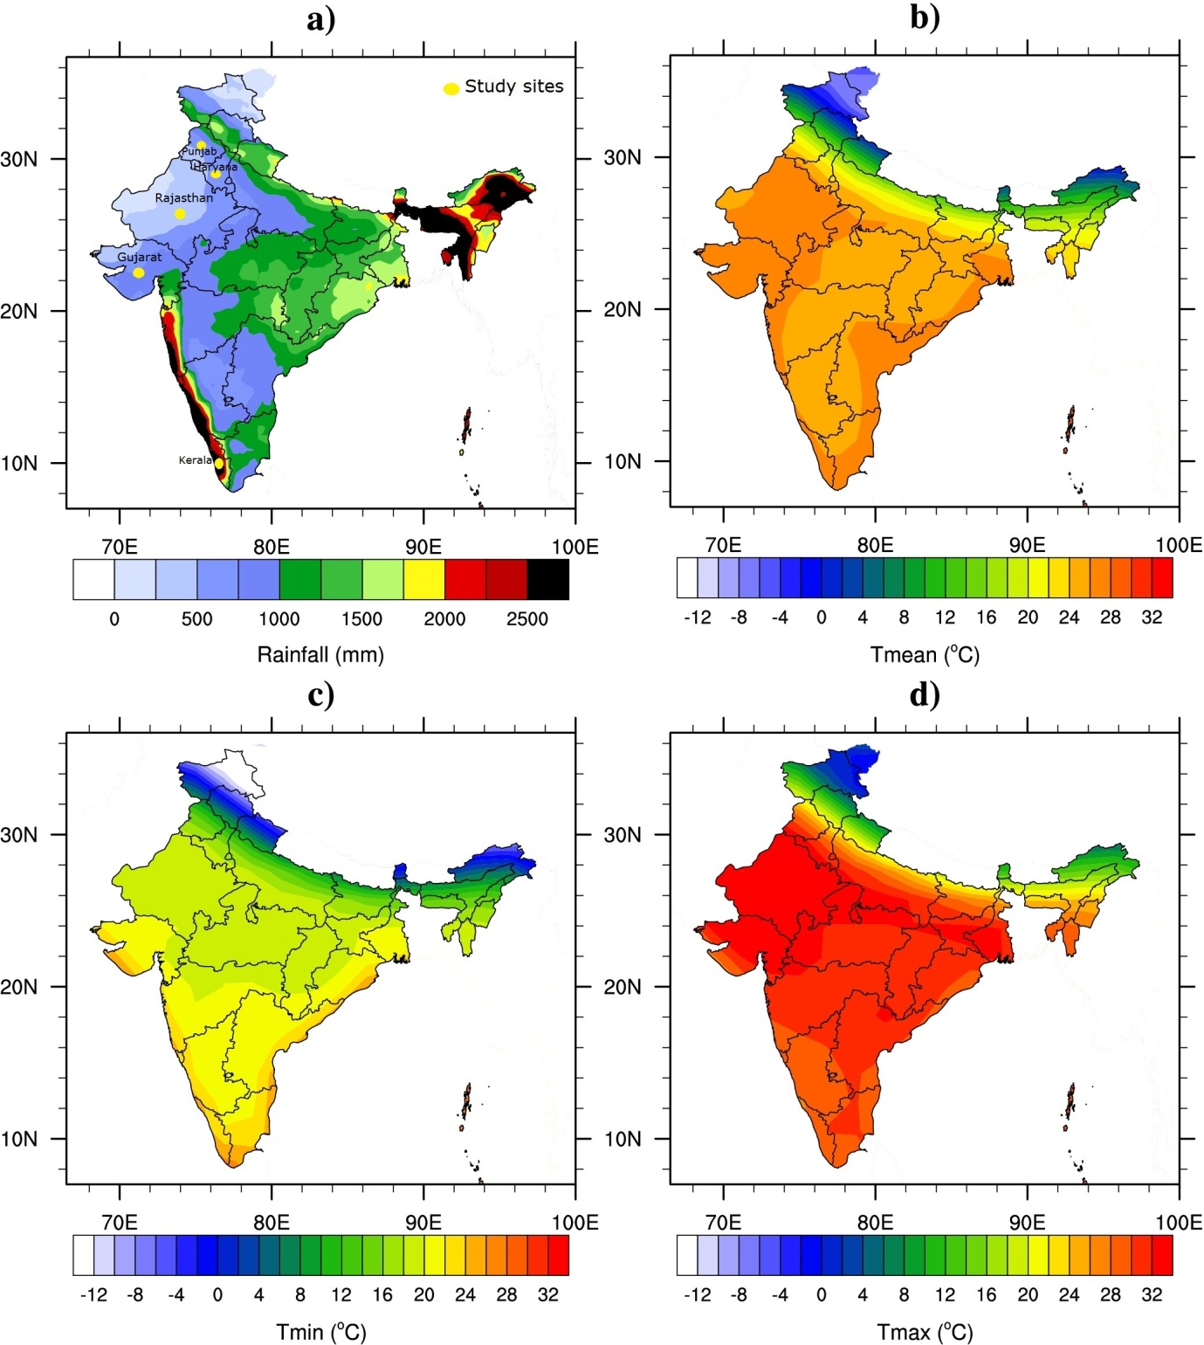
Figure-1: Mean annual a) rainfall (mm) based on the TRMM satellite data, b) mean c) minimum and d) maximum temperature (ºC) based on the NCEP2 reanalysis dataset. The annual mean is calculated for the 1998-2014 period. This figure was created using the National Centre for Atmospheric Research (NCAR) Command Language (NCL) version 6.1.2 (http://www.ncl.ucar.edu/).

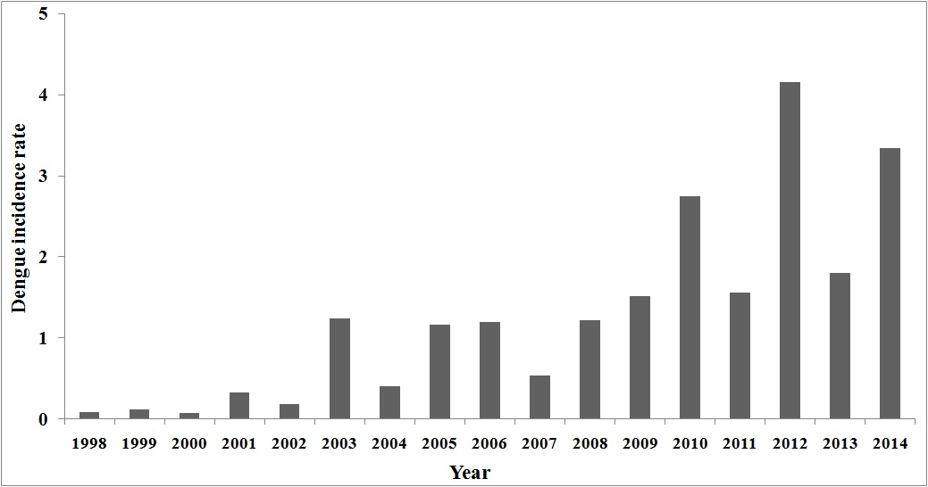
Figure-2:Dengue incidence rates (per million population)in India from 1998 to 2014.
(Data source: NVBDCP, Govt. of India)

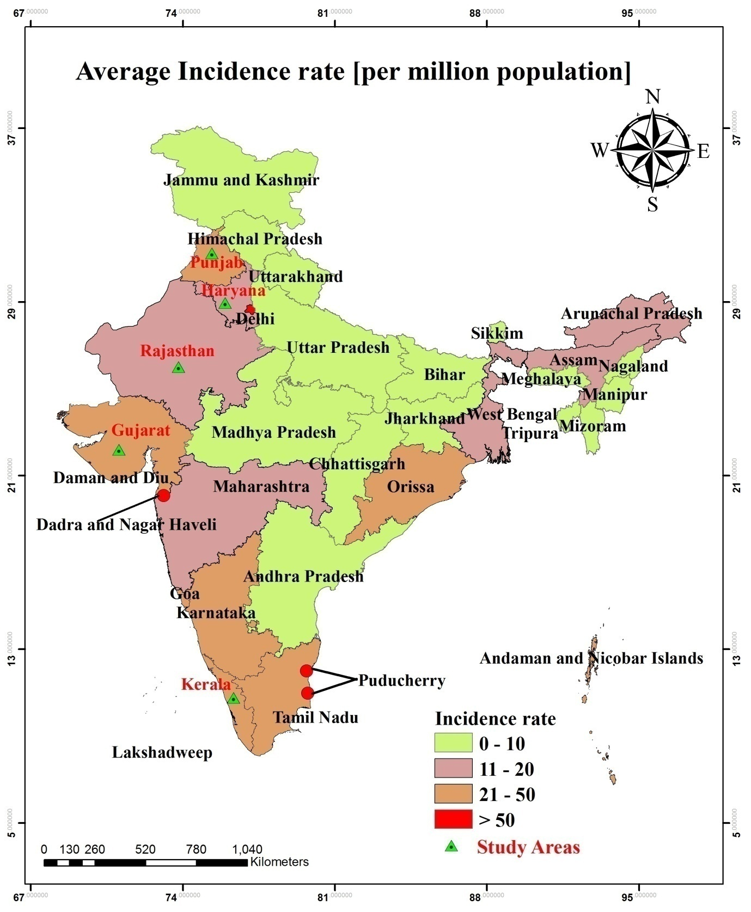
Figure-3:Average dengue incidence rates (per million population) by statesin India from 1998-2014. The map was generated with ArcGIS-10.2.1 software (http://www.esri.in) from dengue case data.

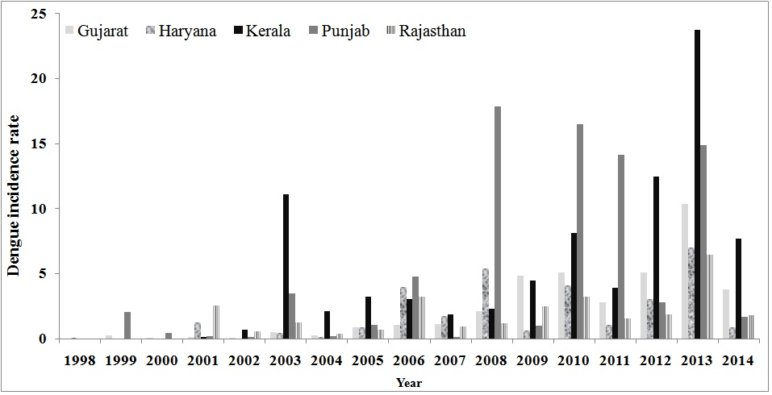
Figure-4:State and year wise dengue incidence rates for different states of India.
(Data source: NVBDCP, Govt. of India).

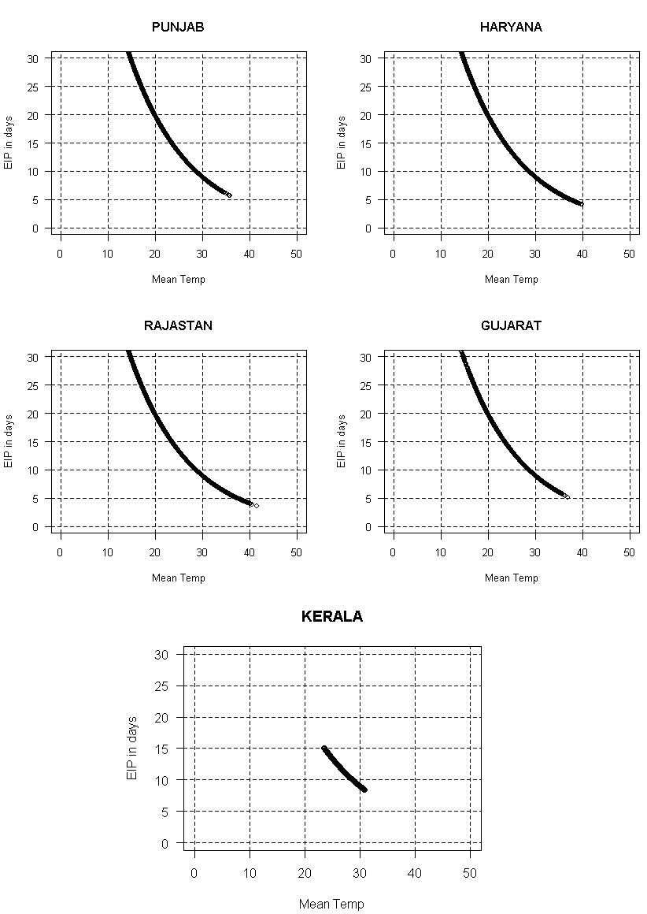
Figure-5:EIP (days) for DENV estimated from daily temperature data (from 1979 to 2014) for five states of India. The horizontal line (EIP = 30days) depicts a theoretical threshold where EIP exceeds the maximum longevity of the mosquito vector.

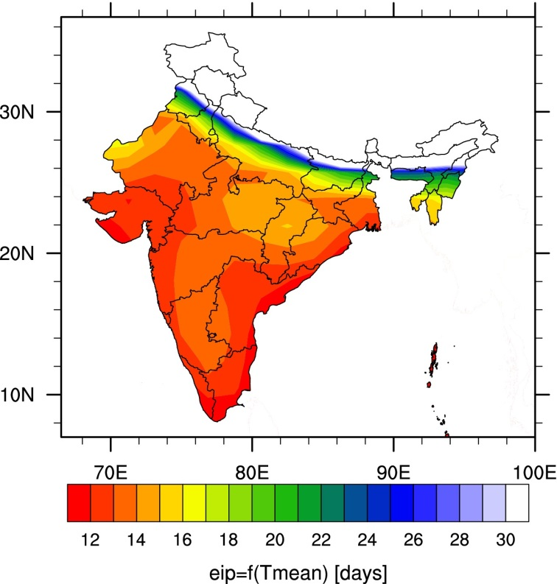
Figure-6: Mean annual EIP (in days) based on NCEP2 monthly mean temperatures calculated for the period 1998-2014. This figure was created using the NCAR Command Language (NCL) version 6.1.2 (http://www.ncl.ucar.edu/).

