Using Q as a triangulation research tool

The aim of this paper is to explore a relatively little known mixed methods research design that has an excellent historical pedigree and encourage its’ application for its robust triangulation methods.

Q methodology (hereafter Q) provides a means to study the subjectivity involved in any situation and a framework for researchers interested in accessing complexity of the individual lived experience by extracting subjective opinion through a person’s self-reference. This produces a data set and represents an attempt “to analyse subjectivity, in all its forms, in a structured and interpretable form” (Barry and Proops, 1999). Stenner and Stainton Rogers, 2004 argue that Q is positioned as a pragmatist methodology. It combines eloquently mixed methods and offers an excellent alternative research paradigm with robust triangulation. This may encourage both soft quantitative and hard qualitative researchers to engage with the methodology, as an opportunity to combine qualitative methods with a combined strand of quantitative logic and the associated hypothetico-deductive methods.

Q owes its heritage to the British physicist and psychologist William Stephenson (1902-1989). Stephenson’s interest was in subjectivity: revealing mathematically the way study participants classify themselves, not according to the definitions laid down by the researcher. Q has an established history in social and health science (Brown, 1997; Eden et al., 2005), there are few studies in Management.

An overview of the Q research process will be provided as well as addressing some ontological and epistemological issues.

Q uses methods of impression (as opposed to objective methods of expression) to discover the subjective meaning or significance, items have for respondents; using the internal frame of reference from each respondents perception of individual test stimuli. The results produce an in-depth portrayal of the patterns of subjective perspectives that prevail in a given situation (Steelman and Maguire, 1999). The subjective experience of the people taking part is where the power and integrity in Q prevails and not the generalizability. As Barker (2008, p. 919) contends, it is this ability to access ‘significance to me’ or individual’s subjectivity that mirrors Q’s departure from positivist inquiry. By inference if researchers are exploring common held beliefs and options or perspectives, Q is ideally positioned to offer a statistical basis with qualified data.

In essence the method employs a by-person factor analysis (FA) in order to identify groups of participants who make sense of (and who hence Q ‘sort’) a pool of items in comparable ways. Nothing more complicated is at issue. Although Q deploys FA, the mathematics of which is complex, it is a remarkably “user-friendly” method and requires limited knowledge of mathematics to interpret the dataset obtained.

As its name implies, Q is not simply a research ‘method’. Its epistemological foundations centre of gravity is strongly qualitative even though as a method it relies upon a statistical techniques to identify relationships within the data (Brown 1996; Dryzek, 1994).

Theoretical principles of Q

The methodological approaches in business research are customarily divided into broad categories of qualitative and quantitative strategies (Bryman, 2004). Since the 1990’s, the application of qualitative methods has gained momentum; as the need to understand complex adaptive systems, in recognition of the individuals contribution and impact and behaviours of groups and teams evolve and organisational culture and behaviour come to the forefront of progress and evolution.

When qualitative and quantitative approaches are compared, there is a propensity to reduce and simplify the approaches to one being inductive and dealing with words, and the other being hypothetic–deductive and dealing with numbers (Brannen, 2005). The truth is more nuanced than this and it is fair to say that the two research traditions have different goals. Often researchers, when looking for reasons that drive behaviour deal with issues that do not lend themselves easily to quantification. This can be as a result of the multi-layered complexity that arise in the field, this nub of complex adaptive behaviour is often difficult to access, though is an excellent position for Q to gain entry and make traction.

Integration of quantitative and qualitative approaches in mixed methods research (adapted from Creswell et al., 2007)
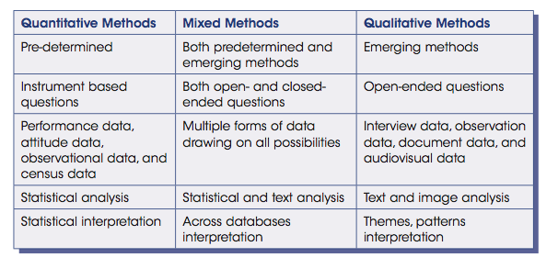
Pragmatism is viewed as the philosophical partner for the mixed methods approach. Individual researchers have a freedom of choice. In this way, researchers are free to choose the methods, techniques and procedures of research that best meet their needs and purposes (Creswell, 2007; Morgan, 2007). Pragmatism is based on a set of assumptions about knowledge and enquiry need, in order to access knowledge through a combination of philosophies, thus will combine qualitative and quantitative research designs (Creswell, 2007; Johnson and Onwuegbuzie, 2004; Maxcy, 2003; Rallis and Rossman, 2003). The pragmatist researcher looks to the ‘what’ and ‘how’, based on the intended impact and purposes (Creswell, 2007; Morgan 2007). Pragmatism is sometimes treated as a new orthodoxy built on the belief that it is allowable and desirable to mix methods from different paradigms of research (Creswell et al., 2007). Further, the triangulation of Q will offer a sense making opportunity missed when purely applying one or the other approaches. Johnson and Onwuegbuzie (2004, p. 14) argue that mixed methods research is a ‘research paradigm whose time has come’. Cameron and Miller (2007) use the metaphor of the phoenix to illustrate the emergence of mixed methods as the third methodological movement, arising from the ashes of the paradigm wars. Cameron (2008) takes this analogy further by asking whether the phoenix has landed.

Adaption of Q Paradigm continuum (Tashakkori and Teddile, 2009; Ramela and Newman, 2012)
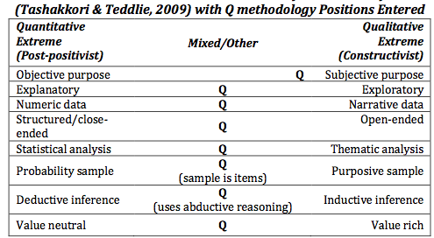
Q’s position on most of the continuums is at the centre as seen above, clearly positioning it as a mixed method. The exception is Q’s position towards the qualitative side of the continuum related to the research purpose. The purpose of Q studies is to measure subjectivity although it does so objectively, because subjectivity is made operant through factor structure (Stephenson, 1953).
To properly appreciate Q methodology, we need instead to recognize that it is essentially a gestalt procedure (Good, 2000). This gestalt emphasis means it can never ‘break-up’ its subject matter into a series of constituent themes (which immediately distinguishes Q from various forms of discursive or interpretative phenomenological analyses). What it can do, however, is show us the primary ways in which these themes are being interconnected or otherwise related by a group of participants. It can show us the particular combinations or configurations of themes that are preferred by the participant group.

Stephenson (1953: 561) was interested in the lived experience, so Q engages the attention of the qualitative researcher interested in more than just life measured by the pound, to life interpreted by each and every one within the framed experience that is the subject of the research. The underlying analytic principles in Q differ markedly from traditional correlational matrix analysis, ‘whereby tests are applied to a sample of people’, and instead applies ‘persons (to) a ‘‘sample’’ of statements. In Q it will be the ‘‘persons’’, or, more accurately, their action upon a sampling of elements, which will be correlated and subsequently factored’ (Stainton Rogers, 1995: 179). Studies include complex issues surrounding participant subjectivity and quantifiable behaviour.

Q’s quantitative features render it a highly unusual integrated mixed methods research method (Curt, 1994; Watts and Stenner, 2003a). Stenner and Stainton Rogers, (2004) argue the method is qualiquantological, whilst Ramlo et al (2015) argue its evolution into a cohesive and usable integrated mixed method; this has been analysed using at adaptation of Creswell et al., 2007 mixed methods analysis (see figure 1) supporting the argument that the integrated triangulation of Q offers creditability and insight into entangled situations that are inaccessible to other research methods. Whether acknowledged or unrecognized, such preferences may manifest as affinities for particular MMR designs or contribute to non- integration of qualitative and quantitative data through methodological favouritism (Bryman, 2007). Q using is quasi integrated mixed method supports the researcher by the expectation that triangulation needs to occur to make sense of the integrated data set.
This fact alone may encourage some soft quantitative and qualitative researchers to engage with Q, as many will have the opportunity to combine qualitative methods with a combined strand of quantitative logic and the associated hypothetico-deductive methods.

It is easy to avoid Q in the disbelief that it offers nothing that one of a number of forms of textual analysis cannot do better and in a more straightforwardly ‘qualitative’ fashion (Willig, 2001). Discourse analysis (Potter and Wetherell, 1987), narrative analysis (Crossley, 2000) and interpretative phenomenological analysis (Smith, 1996), for example, may seem to offer more palatable alternatives in this regard. Tashakkori and Teddie (2009) developed an argument for a third method of quasi-qualiquantological methodologies that bridges the divide of both extreme forms of research, supporting the notion of a realist perspective that is valid and rigorous whilst pragmatic in its application and triangulation as seen in figure 2.

It would nonetheless be unfortunate were any qualitative researcher to reject Q for either of these reasons. Harre (2004) argues that to avoid all forms of mathematical and quantitative representation (or to develop a knee- jerk aversion to science) simply because they have often been poorly employed. Qualitative methodologists have rightly challenged the currently extant ‘scientific’ or hypothetico-deductive approach in business management, but (and despite its quantitative content) it is important to recognize that Stephenson’s Q was actually performing a similar function long before any significant qualitative tradition had been established in many disciplines (Stephenson, 1935).

Rather, Q was designed for the very purpose of challenging the dated, Newtonian logic of ‘testing’ that continues to predominate in psychology. It also offered an early critique of the cognitive assertion that people can properly be divided into a series of psychological ‘parts’. This same critique has, of course, subsequently become a typical feature of ‘constructionist’ approaches (Harre 1999). Q is a typical qualitative approach with the added advantage of holding a critical stance through the embrace (rather than the rejection) of many natural scientific assumptions.

Qualitative research methods have been criticized for being influenced by researchers’ prior understandings and views and so too impressionistic and subjective (Bryman, 2004; Polit & Beck, 2004). Q provides a technique to study systematically, qualitative aspects of human subjectivity so reducing the interference of the researcher’s preconceptions. Subjectivity of the participants lived experience’ is of specific interest in Q, to gain access to otherwise inaccessible information from a statistical stance. In Q, the participant’s subjective viewpoint is known as his or her self-reference on a topic, a key aim is to ensure that this self- reference is preserved rather than compromised by the researchers’ reference concerning the research issue (McKeown & Thomas, 1988).
The Q-sort itself should not be represented as a passive ‘response dimension’ (McGarty and Haslam, 2003: 364) upon which ‘statements’ are simply ranked into piles. In practice the ranking is a dynamic medium through which subjectivity can be actively expressed (Stephenson, 1953). The researcher usually concludes the sort process with a short semi-structured interview to elicit how this dynamic process was experienced and what insights and reflections have been elicited. Participants may reflect on the decision making process of the selection and the connectivity between other q-set statements. Participants will often reflect on the difficulty this phase poses. This integrated reflective interview after the sort accesses the rich narrative gleaned from this process which gains further insight into the dynamic nature of the subject under investigation. This can then be used to triangulate the analysed data and distil sense making of phenomenon. In addition their individual narrative of this dynamic process can be pivotal in research findings.

It ordinarily adopts a multiple-participant format (data set size is usual of 40-60 participants) and is deployed in order to explore (and to make sense of) highly complex and socially contested concepts. Alternatively Q explores subject matters from the point of view of the group of participants involved (Stainton Rogers, 1995; Watts and Stenner, 2003a). It does not do this in a thematic fashion, nor does it focus on the viewpoints of specific individuals. Unsurprisingly, this typical form of Q disappoints when themes and/or individuals are the primary research targets (Ramela and Newman, 2012).

A critical summary of Q
Firstly, it does not deal with participants’ own discourse, but invites participants to engage in the unusual task of relating (in a complex and in-depth way) with a set of prepared items. This ‘unusual task’ evidently violates the principle of ‘naturalism’. In contrast the idea of ‘naturally occurring discourse’ is highly problematic (Potter, 1997) though there is not a substantiated reason to assume that unfamiliar activities cannot yield useful insights. Qualitative researchers should never underestimate the impact of research context on findings. Neither should they ‘leap’ from findings to unwarranted knowledge claims.

Secondly, Q is not well suited to dealing with the unfolding temporality of narratives. Narrative analysis actively pursues this temporality and then examines the resultant stories in terms of their temporal structure (e.g., beginning, middle, end) and function. Q pursues a ‘snap shot’ or temporally frozen image of a connected series of subject positions (or ‘view-points’). It then examines these (methodologically frozen) positions in terms of their overall structure, function and implications.

Thirdly, Q does not focuses on the narrative of specific individuals, Q typically focuses on the range of viewpoints that are favoured (or which are otherwise ‘shared’) by specific groups of participants. In other words, the typical Q methodological study very deliberately pursues constructions and representations of a social kind (Moscovici, 1981).

To conclude, these differences allow Q methodology to offer a unique form of qualitative analysis, indeed, in accenting the group and their shared viewpoints, this form of analysis provides an ideal (and noticeably more macroscopic) complement to qualitative approaches which highlight the ‘theme’ and/or ‘the individual’. Therefore persons become the variables of interest in an inverted (or ‘Q’) study. Such studies actively explore ‘correlations between persons or whole aspects of persons’ (Stephenson, 1936b: 345). As a consequence of these changes, it is also persons (not tests, traits or other types of variables) that load onto the emergent factors of an inverted factor analytic study.

This qualiquantological triangulation methodology has encouraging credentials, offers a solution to accessing complexity and manages to navigate through dynamic environments. It offers a melding of positions to soft quantitative researchers and gives more structure to qualitative researchers to engage with research. The researcher can straddle both terrains and bring them together in a unique approach that has been proven in a multi-disciplinary environments introducing new insights to market research, supporting consumer behaviour and keeping the individual at the centre of the research foci.

Exploring the modus operandi of HPTs with Q

The case study used to illuminate Q was High Performance NHS Teams within High Performance NHS trusts. Given the continuing challenges of funding for public sector organisations and institutions it is asserted that the future of services delivered by the NHS would be bleak if it were not for the prospect of Multi-Disciplinary Teams (MDTs) being able to deliver innovative services to patients. A review of the literature (Plamping et al, 2009; Grint, 2011; Flessig et al.’ 2006) reveals that without MDT’s, the needed innovation and change in NHS services provision at a local level would not be attainable or sustainable; and the collaboration and reconfiguration of services across partnering organisations would be severely challenged. A summation of the past research (Grint, 2011; Bevan & Hood, 2006; Chan et al, 2006) suggests that within the NHS, organisational leaders must put in place appropriate systems and procedures, and emphasise values that make it clear that high performance teams are a top priority. This new environment and way of working creates a climate in which the culture for innovation and high performing teams should develop and prosper; as a result research on which, why, what, when and how MDT’s operate will have more focus and insight.

Work by Plamping et al, 2009; Grint, 2011; Flessig et al. 2006) indicate that a qualitative social phenomena perspective needs to be used to explore MDT’s modus operandi in their phenomenon of complexity, uncertainty, volatility and often ambiguous forms. The approach needs to recognise issues related to keeping the individual whole within the team (individual self-reference), whilst considering the complexities of environment, structure, process and the community of practitioners, identity, governance and power.

The decision to use Q was arrived at following the evaluation of other approaches such as narrative analysis, thematic analysis and action research. Q is well established in many social science disciplines and it is an unusual qualitative research method that gives quantitative measures to qualitative questions. Stenner and Stainton Rogers (2004) label Q as being qualiquantological in nature as it combines qualitative methods to collect data with a strand of quantitative logic to interpret the data and the associated hypothetico-deductive methods.

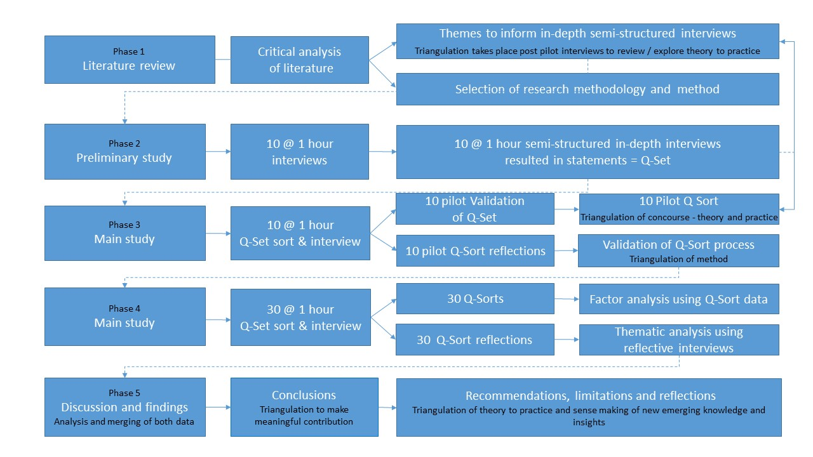

The model above depicts the approach taken to the deployment of Q in the context explained. Q has been broken into 5 phases for the purposes of this writing to envisage and scrutinise the process that is undertaken and the iteration and triangulation that takes place adding credibility and validity to the findings of the study undertaken.

Phase 1 Developing the theoretical framework for the study
An extensive thematic literature review informed the preliminary one-hour interviews (P-set n=10). A pictorial representation of the theoretical model helped inform the semi-structured interview without over whelming them. The individual participants (P-set) where asked their perceptions of each theoretical element. These interviews then formed the global concourse sample and provided structure and consistency in the semi structured interviews.

Phase 2 Concourse (Q-set) piloted by the Participants (P-set)
In this phase of Q, a concourse, which is defined as the participant’s voice on HPTs is captured. These data (a comprehensive list of items compiled about HPTs using the participants’ terms, capturing the broad range of representations) can be informed by many sources including the research participants, published literature and any other knowledge or other stimuli, for example, pictures, music or video clips. Brown (1993, p. 94) suggests a concourse should incorporate ‘virtually all manifestations of human life, as expressed in the lingua franca of shared culture’.

The concourse in this study was representative of the P-set who are nationally / internationally recognised highest performing NHS teams. The NHS Trusts the P-set reside in, was itself one of the highest performing Trusts over a period of 5 years which demonstrated prolonged high performance and so capacity and resilience.

A comprehensive concourse from participants’ perceptions of the lived experience as a member of the HPTs was collected, and audio recordings and transcriptions were made. This transcript data from the 10 one hour interviews were analysed using the principles of the thematic analysis as according to Clarke et al. (2005). Abductive reasoning was applied to the thematic analysis and involves logical inference that leads to an exploratory hypothesis and the ensuing representative statements known as the Q-Set was developed. The goal of the Q-Set is to provide a condensed version of the concourse (between 40 and 80 short statements is usual) without losing any of the comprehension in terms of content and representativeness (Van Excel and de Graaf, 2005).

Phase 3 Pilot testing the theory and practice
The Q-set was piloted for accuracy and applicability on the original pilot p-set to establish validity. This is the first sifting by the participants and is an engaging process. Replicas and errors are removed and any gaps articulated to refine the Q-set to be a representative data set. This approach provides triangulation to enhance the aspects of validity (Robson, 2002). In this case study following the preliminary interviews, Q-set statement design considerations (adapted from Watts and Stenner, 2012) helped reduce the number of statements to ensure only one key proposition, in order to improve clarity, balance the wording, and remove stereotyping and include statements, which gives a representation of the theoretical concepts and components emerging of team, engagement, performance and HPTs. The majority of the components were validated as seen below diagram with thumbs up. This theoretical triangulation ensured the discourse was both comprehensive, representative and judicious.
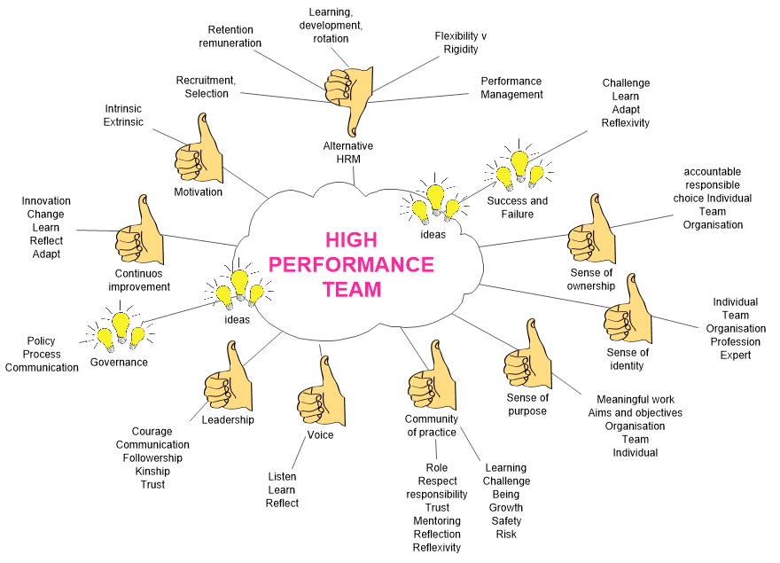
There was three anomaly items amended in this iteration / triangulation phase. When element was refuted, which was the theoretical component of alternative HRM practices, although was retained in the concourse to test theory to practice as the literature suggests it is pertinent for success in high performing organisations HPT reside within. Two components were added (see light bulb) to the literature pictorial representation which was the role and perception of governance and the HPT’s attitude and understating of perceived failure. An iterative literature review was conducted to explore how and why these new concepts operationalised HPTs and incorporated this wider understanding of practice, again this is a positive methodological triangulation of Q questioning theory to practice. The result led to an aggregation of concepts with multiple components, this is the third triangulation iteration of this method.

After conducting their Q-sort the participants who gave feedback indicated that the Q-Set helped them see the bigger picture, which they considered was thought-provoking and more complex than perhaps previously considered. The participatory sorting process encouraged them to ponder all these aspects in relation to each other carefully. In addition, participants said they found it gratifying to see the result of their effort in front of them after finishing the Q sort, and most participants were interested in the overall results of the study and suggested they would discuss the emerging viewpoints within their teams. The majority of participants found the experience intensive and tiring, and commented on how the process was getting them to ‘think’ and gave them ‘time to reflect’ on what they take as ‘the norm’.

The Q sort created a helpful ‘space’ to reflect on the team context and dynamic. One participant, who disclosed the fact that they were leaving the organisation, found this process very difficult to work through. They said the sort process had crystallised the reasons as to why they were leaving the organisation and that it had helped them come to terms with their decision. They implied that this process had reduced their own frustration and anger with the organisation and their team. Whilst this was a challenging interview, and they did not complete their sort, they said they would like the interview discourse to be included within the study to add richness to the framework and the process.

Phase 4 Q-Sort the Q-set to produce a data set
-6 |  | -5 |  | -4 |  | -3 |  | -2 |  | -1 |  | 0 |  | +1 |  | +2 |  | +3 |  | +4 |  | +5 |  | +6
Q-Sort Grid distribution grid
Least Important Most Important

The sorting process of the Q-set by the identified P-set using a Q-sort distribution grid (see above) is an engaging physical activity the participants undergo. The participants in this study without exception thanked the research for this reflective critically analytical space. The completed grids are translated to develop the data set. It is acknowledged that the Q-Set ‘can never really be complete, as there is always something else that might be potentially said’ (Watts and Stenner, 2005, p. 76). The Q-Set statements are not considered to be absolute ‘facts’ and, prior to the sorting process, are deemed to be equal in value; hence, they are ascribed meaning by the participants, and given value and significance depending upon their subjective experience, understanding and interpretation of the statements (Watts and Stenner, 2005b). The Q-Set comprises qualitative data, yet, as Stephenson (1953) states, the sorting provides quantitative data. This Q-Set sort procedure is described as: ‘the technical means whereby data are obtained for factoring’ (Brown, 1980, p. 17).

Individual participants rank (sort) their statements by placing them on a grid. As such, a completed Q-Sort registers a participant’s subjective viewpoint. The grid design usually reflects a quasi-normal distribution, but not exclusively so (Brown, 1993). The design of the grid is specific to each project and can have an unbalanced or balanced design, such as those in accordance with the experimental design principles developed by Fisher (Fisher, 1935, cited in Brown, 2010; Stephenson, 1953). The actual structure is of limited importance (Stephenson, 1953; Brown, 2010). The grid designed for this research project above illustrates the compulsory fixed distribution grid, where only one statement can be placed in each cell. The horizontal scales are only described in words from greatest to least (left to right), whereas these are assigned numerical values for the factor analysis (FA).

The process of sorting the numbered statements (or other stimuli) can be considered an active, dynamic activity (Watts and Stenner, 2005a) and, as such, the reading, handling and placing of the cards is seen to be an innovative methodology (McKenzie, et al., 2011). Q, therefore, is seen to bring clarity, coherence and structure to complex and socially contested arenas (Stainton Rogers, 1995), including research in subject areas that could be considered controversial or sensitive (Ellingsen, et al., 2011). Examples of this sensitivity relate to the power dynamic between the participant and researcher, which is potentially reduced in this process because the participants make sense of their own experience by reflecting on their finished grid. To achieve this, each participant was given an opportunity to further reflect on and review their sort, which gave them complete control over the final configuration. Interviewees, who were surprised to be interviewed and felt marginalised (e.g. the award-winning hygiene-specialist HPT members), were encouraged to voice their views autonomously throughout this process. This is the initial triangulation of the individuals self-reference (perception), which is quantified in the sort and qualified in the semi-structured interview.

Phase 5 Triangulation of both data sets
Lastly, Q could be considered to be a unique methodology in that it is able to support data that are representative of both individual and shared viewpoints, which Watts and Stenner (2013) describe as accommodating both the ‘constructivist’ (individual self-reference) and ‘constructionist’ (social bodies-of-knowledge) approaches. Participants in Q studies are in control of the classification process. A factor cannot emerge unless participants sort items to enable its emergence (Kitzinger, 1999, p. 267). The analysis process can be viewed as a gestalt procedure, with the data interpreted as a whole to assist in establishing the links between the individual Q-Sorts and the extent to which they represent the emerging factors (Watts and Stenner, 2005a). If alternative research paradigms are used, the research aims would be difficult, if not impossible, to achieve. The Q methodology brings independence in that participants sort the statements themselves, without the need for researcher input. Hence, it offers an innovative approach to qualitative analysis through a ‘quantification of patterned subjectivities’ (Shemmings, 2006, p. 147). Q uses factor analysis, which needs an acceptable level of mathematical complexity and understanding to ensure that data architecture is correct and the researcher can interpret the findings; however, the operation of the methodology does not require any in-depth mathematical knowledge in order to develop interpretations of the data obtained through the Q-Sort.

In order to measure internal consistency, that is, how closely related a set of q-sort statements are as a group, Cronbach's alpha (α) coefficient was employed. Cronbach’s α reliability coefficient normally ranges between zero and one. The general rule is that the closer Cronbach’s α coefficient is to one, the better the internal consistency of the items in the scale (George and Mallery, 2003).
Cronbach's coefficient: rule of thumb
α > 0.9 | Excellent
α > 0.8 | Good
α > 0.7 | Acceptable
α > 0.6 | Questionable
α > 0.5 | Poor
α < 0.5 | Unacceptable

The findings indicate that Cronbach's α coefficient was found to be 0.753, which is considered acceptable. Thus, the statements used in the Q-Set can be considered reliable for achieving internal consistency.

The overall approach taken to analyse the data was to use the dedicated software package PQMethod, as suggested by Schmolck and Atkinson (2002). Within the data analysis process, Q involves three methodological transitions (Watts and Stenner, 2012). The first of these is the transition (T1) from Q sorts to by-person factors; the second transition (T2) is from factor to factor arrays; the final transition (T3) is from factor arrays to factor interpretation.

Factor Analysis (FA) is the associated analysis approach (Watts and Stenner, 2012), and it will show similarities and dissimilarities between participants’ sorting of the statements, which is also known as by-person FA. FA considers the holistic picture of the way in which the statements were ranked. It is this complete sorting of statements that is analysed, resulting in factors being assigned eigenvalues. Participants with similar rankings of statements load significantly on the same factor as each other, revealing a pattern of statements that express their subjective views (Plummer, 2012). The FA process revealed the number of participants who reflect the sorting of statements that are common to each factor. In simple terms, if several people have similar views (having placed their statements in similar positions on the Q-grid) then they will all load on the same factor array. Factor arrays prepare the data to reveal their structure in readiness for qualitative factor interpretation (Brown, 1991).

Transition 1(T1) is achieved by using the Q-grid design, a numerical value was ascribed from -6 to +6 to each statement. Each completed Q sort is then inter-correlated, through the process of by-person (or by Q sort) FA, to determine the level of agreement or disagreement between the placement of each card on the sort (Q sort one with two, one with three, one with four etc., to produce a correlation matrix). This is possible because the variables within the by-person FA consist of the individual Q sorts. This inter-correlation is conducted at a statistical level, to correlate the way in which individual Q sorts cluster together within a sort, and so can be seen to belong to a similar family or factor (i.e., a similar viewpoint). The by-person FA prior to any rotation identifies the underlying factor structure of the Q sorts.
Initial eigenvalues and total variance explained before rotation
Total Factor Variance Explained
Factor | Initial Eigenvalues
 | Total | Variance  % | Cumulative  %
1 | 6.4 | 14.7 | 14.7
2 | 4.4 | 10.2 | 24.9
3 | 3.5 | 8.0 | 32.9
4 | 3.2 | 7.2 | 40.2
5 | 2.8 | 6.3 | 46.6
6 | 2.5 | 5.7 | 52.5
7 | 2.1 | 4.9 | 57.3
8 | 2.1 | 4.8 | 62.1
9 | 1.9 | 4.4 | 66.6
10 | 1.7 | 4.0 | 70.6
11 | 1.7 | 3.8 | 74.5
12 | 1.4 | 3.1 | 77.7
13 | 1.3 | 2.9 | 80.6
14 | 1.1 | 2.5 | 83.1
15 | 1.0 | 2.2 | 85.4

Eigenvalues (λs) indicate the amount of variance explained by each factor, and can be seen in the above table. It is accepted practice to only retain factors with λs values higher than one (Watts and Stenner, 2012; Tabachnick and Fidell, 2012). Every sort process represents a potentially unique and meaningful viewpoint that might legitimately be adopted by an individual Q sort. The extracted eigenvalues defined have represented the more distinguished combination of viewpoints.

Watts and Stenner (2012) assert that the second transition (T2) within data analysis is from by-person factor to factor arrays. This process involves the production of a factor array, in which the program provides a weighted average of all the factors that correlate (or load) highly with that factor. A factor array, therefore, portrays a Q sort that exemplifies, as a best fit, the positions of the statements within that factor. Centroid Factor Analysis (CFA) was used for factor extraction and rotation, as opposed to the alternative Principal Components Analysis (PCA), because this method is considered the favoured choice of Q (Stainton Rogers, 1995). Factor extraction refers to the way in which factors emerge from the correlation matrix (the patterns of similarity or difference between each Q sort with every other Q sort). The choice of how many segments (or factors) to extract and interpret, is usually dependent upon certain statistical and theoretical guidelines; namely, factors should only be retained with an eigenvalue greater than 1.00 (Brown, 1980). In addition, factors should capture as much of the study variance (range and variability of viewpoints) as possible, with a combined variance of over 40% across factors considered to be a sound solution (Watts and Stenner, 2005a). Through this process a number of factors were extracted.

Eigenvalues and total variance explained after the rotation
Total Variance Explained
Factor | Rotation Sums of Squared Loadings
 | Total | Variance  % | Cumulative  %
1 | 4.6 | 10.5 | 10.5
2 | 2.8 | 6.3 | 16.9
3 | 2.7 | 6.3 | 23.2
4 | 2.7 | 6.2 | 29.5
5 | 2.7 | 6.1 | 35.6
6 | 2.5 | 5.8 | 41.5
7 | 2.5 | 5.8 | 47.3
8 | 2.5 | 5.7 | 53.1
9 | 2.3 | 5.2 | 58.4
10 | 2.2 | 5.1 | 63.5
11 | 2.0 | 4.7 | 68.3
12 | 2.0 | 4.7 | 73.0
13 | 2.0 | 4.6 | 77.6
14 | 1.7 | 3.9 | 81.6
15 | 1.7 | 3.9 | 85.5

From the initial analysis, a total of 15 factors were retained (see table above) that had an eigenvalue of one or higher. These 15 factors accounted for 85% of the total cumulative variability. Prior to the rotation of factors, it is normal to keep factors that are representative of approximately 70% of the study (Watts and Stenner, 2012). Correspondingly, prior to the rotation, the first factor or component accounted for 14.7% of total variance; the second for 10.2%; and the third for 8.0%, up to the fifteenth for 2.3%. However, after the rotation, factor one accounted for 10.5% of total variance, which is a reduction from the pre-rotation eigenvalue of 14.7%. The second factor accounted for 6.3%, the third for 6.3% and the fifteenth for 3.9%. These findings show that, on average, the factors have relatively similar and uniform percentages of total variance before and after the rotation. Dominant factors normally occur only for the first one or two factors, which explains the relatively large amounts of variance (especially factor one), whereas subsequent factors (third, fourth, etc.) explain only small amounts of variance. Hence, in terms of λ magnitude, this finding produces relatively uniform λs of successive factors, in which after factor one the λs do not drop off drastically as indicated by the Scree Plot (Figure 3.2). It is noticeable again that factor one is clearly dominant, with 10.5% variance, and the following seven factors (in almost equal measure) including factor one, account for 53.1% of the cumulative variance (with only 0.6% variance difference between factors two and eight).
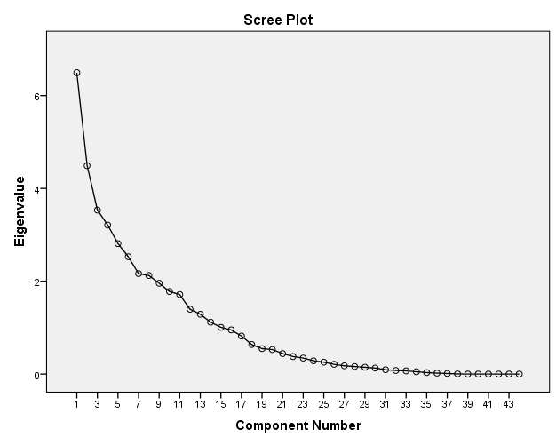
The scree plot was described in the literature (Child, 2006) as a useful way of establishing how many factors should be retained in an analysis. On closer examination, it reveals that the interpretation is somewhat difficult, since the plot does not curvature significantly. According to guidance by Watts and Stenner (2005a), over 40% across factors is considered to be a sound solution. Accordingly, using this guidance, eight factors were empirically retained, accounting for a total cumulative variance of 53%. Factors six, seven and eight all had the same eigenvalue of 2.55, and had they been excluded, the first five factors would have accounted for a total cumulative variance of 35.7% which does not meet the guidance of 40% (Watts and Stenner, 2005a).

The eight significant factors carry underlying clusters (or communalities) as indicated by their shared variances and summarised in the below table. For example, factor one groups Q-Set statement numbers 26, 18, 7, 2, 39, 33, 16 and 19, while factor two clusters Q-Set statements 42, 29, 9, 41, 38 and 17, and so forth. These clusters (or communalities) are used to explore factor interpretation. The findings reveal that factor one underlying statement numbers 26, 18, 7, 2, 39, 33, 16 and 19 measure a common phenomenon or shared perception clustered jointly. A similar analogy can inductively explain other factors, which is summarised in the next section. Factor One can be clustered jointly as ‘supportive team learning’. Factor Two as ‘shared community’, Factor Three as ‘supportive learning systems’, Factor Four as ‘team synergy’, Factor Five as ‘employment relationship synergy’, Factor Six as ‘courageous followership’, Factor Seven as ‘getting better together’, and Factor Eight as ‘team learning and shapers’.
Underlying structures of factor 1 to 8
Factors | Statement clusters  (or communalities)
1 | 26, 18, 7, 2, 39, 33, 16 and 19
2 | 42, 29, 9, 41, 38 and 17
3 | 8, 13, 43, 36 and 44
4 | 6, 12, 27, 11, 25 and 4
5 | 11, 25, 4, 31 and 40
6 | 28, 32 and 24
7 | 2, 35, 22 and 30
8 | 23, 15, 30 and 17

Valuing the whole – holistic interconnections
To properly appreciate Q, it needs to be recognized that it is essentially a gestalt procedure (Good, 2000). This gestalt emphasis means it can never ‘break-up’ its subject matter into a series of constituent themes (which immediately distinguishes Q from various forms of discursive or interpretative phenomenological analyses). What it can do, however, is show us the primary ways in which these themes are being interconnected or otherwise related by a group of participants. It can show us the particular combinations or configurations of themes which are preferred by the participant group. This openly holistic approach suggests that Q is most closely related to, but is not the same as Crossley’s (2000) ‘narrative analysis’.

The findings in this case reveal emergent factors for the development of HPTs, which have rarely been discussed comprehensively in existent literature. All Factors from One to Eight can be clustered jointly as ‘supportive team learning’, ‘shared community’, ‘supportive learning systems’, ‘team synergy’, ‘employment relationship synergy’, ‘courageous followership’, ‘getting better together’, and ‘team learning and shapers’. These factors can be used to go back to the interview data and sense make what is the individuals lived experience and qualify it with narrative. In essence the researcher triangulates theory, practice and the research method to generate new insights and understanding of entangled situations otherwise very difficult to access. In this case the strategic implication of the research is to focus on the eight dimensions that facilitate HPTs. This research can be applied to other areas such as management, marketing, and other team dependent disciplines. Further research should be also undertaken in other relevant areas with a larger sample size to ascertain the generalisability of the emerging factors.

In summary, Q uses the participant’s subjective viewpoint which is known as his or her self-reference on a topic which Q aims to preserve. Q quantitatively uses by-person factor analyses (FA); on a completed Q-Sort to determine the extent to which individual Q-Sorts correlate highly with one another and therefore can be considered to have a ‘family resemblance’ (Brown, 1993), known as a ‘factor’. Q typically focuses on the range of viewpoints that are favoured (or which are otherwise ‘shared’) by specific groups of participants. In other words, the typical Q methodological study very deliberately pursues constructions and representations of a social kind (Moscovici, 1981).

It does not deal with participants’ own discourse, rather it invites participants to engage in the unusual task of relating (in a complex and in-depth way) with a set of prepared items. This ‘unusual task’ evidently violates the principle of ‘naturalism’. In contrast the idea of ‘naturally occurring discourse’ is highly problematic (Potter, 1997) though there is not a substantiated reason to assume that unfamiliar activities cannot yield useful insights. Qualitative researchers should never underestimate the impact of research context on findings, nor ‘leap’ from findings to unwarranted knowledge claims.

Q’s strength is in the pursuance of a ‘snap shot’ or temporally frozen image of a connected series of subject positions (or ‘view-points’). It then examines these (methodologically frozen) positions in terms of their overall structure, function and implications. Secondly, Q is not well suited to dealing with the unfolding temporality of narratives. Narrative analysis actively pursues this temporality and then examines the resultant stories in terms of their temporal structure (e.g., beginning, middle, end) and function. These differences allow Q to offer a unique form of qualitative analysis. By focusing on the team and their shared viewpoints, this form of analysis provides an ideal (and noticeably more macroscopic) complement to other qualitative approaches which highlight the ‘theme’ and/or ‘the individual’. Therefore persons become the variables of interest in an inverted (or ‘Q’) study. Such studies actively explore ‘correlations between persons or whole aspects of persons’ (Stephenson, 1936b: 345). As a consequence of these changes, it is also persons (not tests, traits or other types of variables) that load onto the emergent factors of an inverted factor analytic study.

To conclusion, triangulation within the qualitative tradition generally involves using multiple methods (e.g., interviews, observations) or diverse analytic perspectives (e.g., Patton, 2002). Seeking complementary information or synthesizing divergent views to overcome strengths, weaknesses, and associated biases of a particular approach are consistent with this perspective (Bergman, 2008). Whilst Q favours the qualitative origins of triangulation, that being the reinforcement of completeness and cohesiveness over confirmation (Greene, 2007) it is more closely aligned within the more comprehensive explanatory or holistic frameworks (Howe, 2012; Jick, 1979). Q is a dynamic interactive tool that aids participant interaction and reflection as well as researcher iteration with the subject matter and reflection. By exploring subjective attitudes and opinion new insights and understanding is generated, whilst keeping the person whole and the lived experience at the centre of the study. It achieves through a combination of qualitative and quantitative methods, a powerful exploration and explanation of patterns in complex and adaptive systems.

References
Barker, J. (2008). Q-methodology: An alternative approach to research in nurse education. Nurse Education Today, 28, 917–925.
Barry, J., & Proops, J. (1999). Seeking sustainability discourses with Q methodology. Ecological Economics, 28, 337–345.
Bergman, M. (2008). Advances in mixed methods research: Theories and applications. Thousand Oaks, CA: Sage.
Bevan, G. and Hood, C. (2006). What's measured is what matters: targets and gaming in the English public health care system. Public Administration, 84 (3). pp. 517-538.

Brannen, J. (2005). Mixing methods: The entry of qualitative and quantitative approaches into the research process. International Journal of Social Research Methodology, 8(3), 173–184.
Brouwer M. (1993). Q is accounting for tastes. Journal of Advertising Research 39(2), 35-39
Brown, S.R. (1980). Political subjectivity: Applications of Q methodology in political science. New Haven, CT: Yale University Press.
Brown, S.R. (1986). Q technique and method: Principles and procedures. In W.D. Berry & M.S. Lewis-Beck (Eds.), New tools for social scientists: Advances and applications in research methods (pp. 57–76). Beverly Hills, CA: Sage.
Brown, S. R. (1993). A primer of Q methodology. Operant Subjectivity, 16, 91–138.
Brown, S.R. (1996). Q methodology and qualitative research. Qualitative Health Research, 6, 561–567.
Brown, S.R. (1997). The history and principles of Q methodology in psychology and the social sciences. Kent, OH: Department of Political Science, Kent State University.
Brown, S.R., Durning, D.W., & Selden, S.C. (2007). Q-methodology. In K. Yang & G.J. Miller (Eds.), Handbook of research methods in public administration (2nd ed., pp. 721–764). Boca Raton, FL: CRC Press.
Bryman, A. (2007). Barriers to integrating quantitative and qualitative research. Journal of Mixed Methods Research, 1(1), 8-22.

Chan WF, Cheung PSY, Epstein RJ, Mak J. (2006). Multidisciplinary approach to the management of breast cancer in Hong Kong. World Journal of Surgery 2006; 30:2095–2100.

Curt, B. 1994: Textuality and tectonics: troubling social and psychological science. Buckingham: Open University Press.
Dryzek, J.S. 1994: Australian discourses of de- mocracy. Australian Journal of Political Science 29, 221-239.
Eden, S., Donaldson, A., & Walker, G. (2005). Structuring subjectivities? Using Q methodology in human geography. Area, 37(4), 413–422.
Edwards, J. R. (2001). Multidimensional constructs in organizational behavior research: An integrative analytical framework. Organizational Research Methods, 4(2), 144-192

Fleissig A, Jenkins V, Catt S, Fallowfield L (2006). Multidisciplinary teams in cancer care: are they effective in the UK? Lancet Oncology, 7, 935-943

Greene, J. (2007). Mixed methods in social inquiry. San Francisco, CA: Wiley.

Good, J.M.M. (2000). William Stephenson, Cyril Burt and the demise of the London school. Paper presented at the History and Philosophy of Psychology section of the British Psychological Society, Annual conference, University of Ripon and York St John, UK April.
Grint, K. (2011). ‘The cuckoo clock syndrome: addicted to command, allergic to leadership’. European Management Journal, 28: 306–313.

Harre ́, R. 1999: The singular self: an introduction to the psychology of personhood. London: Sage.
Harre, R. 2004: Staking our claim for qualitative psychology as science. Qualitative Research in Psychology 1, 3-14.
Haslam, S. A., & McGarty, C. (2003). Research methods and statistics in psychology. London: Sage.
Howe, K. (2012). Mixed methods, triangulation, and causal explanation. Journal of Mixed Methods Research, 6(2), 89-96.

Jick, T. (1979). Mixing qualitative and quantitative methods: Triangulation in action. Administrative Science Quarterly, 24, 602-611.

McKeown, B.F., & Thomas, D.B. (1988). Q Methodology. Newbury Park, CA: Sage.

Molina-Azorin, J. (2012). Mixed methods research in strategic management: Impact and applications. Organizational Research Methods, 15(1), 33.

Moscovici, S. 1981: On social representations. In Forgas, J.P., editor, Social cognition: perspectives on everyday life. London: Academic Press.
Newman, D. A., Harrison, D. A., Carpenter, N. C., & Rariden, S. M. (2016). Construct mixology: Forming new management constructs by combining old ones. The Academy of Management Annals, 10(1), 943-995.

Patton, M. (2002). Qualitative research and evaluation methods (3rd ed.). Thousand Oaks, CA: Sage.

Plamping, D., Gordon, P., Pratt, J. (2009) Innovation and Public Services: Insights from Evolution, Centre for Innovation in Health Management, Leeds University Business School

Polit, D., & Beck, C.T. (2004). Nursing research: Principles and methods (7th ed.). Philadelphia, PA: Lippincott Williams & Wilkins.
Polkinghorne, D.E. 1995: Narrative configuration in qualitative analysis. International Journal of Qualitative Studies in Education 8, 8-25.
Potter, J. 1997: Discourse analysis as a way of analysing naturally occurring talk. In Silverman, D., editor, Qualitative analysis: issues of theory and method. London: Sage.
Potter, J. and Wetherell, M. (1987). Discourse and social psychology: beyond attitudes and behaviour. London: Sage.
Risdon, A., Eccleston, C., Crombez, G., McCracken. K. (2003). How can we learn to live with pain? A Q- methodological analysis of the diverse understandings of acceptance of chronic pain. Social Science & Medicine 56: 375-386
Smith, N.W. 2001: Current systems in psychology: history, theory, research, and applications. London: Wadsworth.
Sorrel, M. A., Olea, J., Abad, F. J., de, l. T., Aguado, D., & Lievens, F. (2016). Validity and reliability of situational judgement test scores: A new approach based on cognitive diagnosis models. Organizational Research Methods, 19(3), 506. Stainton Rogers, R. (1995). Q methodology. In J.A. Smith, R. Harre, & L. Van Langenhove (Eds.), Rethinking methods in psychology (pp. 178–192). London: Sage.
Steelman, T.A., & Maguire, L.A. (1999). Understanding participant perspectives: Q-methodology in national forest management. Journal of Policy Analysis and Management, 18, 361–388.
Stenner, P. and Stainton Rogers, R. (2004). Q methodology and qualiquantology: the example of discriminating between emotions. In Tod, Z., Nerlich, B., Mckeown, S. and Clark, D., editors, Mixing methods in psychology. London: Routledge.
Stephenson, W. (1935). Correlating persons instead of tests. Character and Personality, 4, 17–24.
Stephenson, W. (1936a). The foundations of psychometry: four factor systems. Psychometrika 1, 195-209.
Stephenson, W. (1936b). The inverted factor technique. British Journal of Psychology 26, 344-361.
Stephenson, W. (1953). The study of behavior: Q-technique and its methodology. Chicago: University of Chicago Press.
Stephenson, W. (1988/89). The quantumization of psychological events. Operant Subjectivity 12, 1-23.
Watts, S. and Stenner, P. (2003a). Q methodology, quantum theory and psychology. Operant Subjectivity 26, 155-173.
Watts, S. and Stenner, P. (2005). Doing Q methodology: theory, method and interpretation. Qualitative Research in Psychology 2, 67-91.
Willig, C. 2001: Introducing qualitative research in psychology: adventures in theory and method. Buckingham: Open University Press.

