Impact of electrode geometry on an atmospheric pressure surface barrier discharge

M I Hasan, Y Morabit, A Dickenson and J L Walsh*
Centre for Plasma Microbiology, Department of Electrical Engineering and Electronics, the University of Liverpool, Brownlow Hill, Liverpool, L69 3GJ, U.K.

Abstract: Several of the key characteristics of an atmospheric pressure surface barrier discharge are heavily dependent on the geometrical configuration of the plasma generating electrodes. This letter reveals that increasing the surface area of an SBD device by reducing the gaps between the electrodes can have major and unforeseen consequence on the discharge properties. It is experimentally demonstrated that a critical limit exists when reducing the electrode gap below 5 mm, beyond which the required breakdown voltage increases exponentially and the power deposited in to the discharge is impeded. Using a numerical model, it is shown that a reduced electrode gap diameter yields a decrease in the voltage difference between the electrode and dielectric surface thus lowering the maximum electric field. This study indicates a link between the electrode geometry and the nature of the reactive chemistry produced in the plasma, findings which have wide-reaching implications for many applications where multiple closely packed surface barrier discharges are employed to achieve uniform and large area plasma processing.

In recent years, Surface Barrier Discharges (SBD’s) have been the focus of an intense research effort; originally developed for ozone generation and flow actuation [1-3], they have seen a resurgence in interest for a much broader range of applications including microbial decontamination [4,5], wound therapy and high-value materials processing [6,7,8]. Typically, a SBD consists of two metallic electrodes adhered to opposing sides of a dielectric material. A high-voltage, time-varying power source energizes one electrode while the opposing electrode is grounded. On application of a sufficiently high voltage, plasma is generated around the edges of both electrodes in the form of a collection of stochastic filamentary discharges [9, 10].
Many applications of the SBD require a large area discharge that simultaneously offers a high degree of uniformity, a considerable discharge volume and a geometrically optimised structure to promote the transport of short-lived chemical species such as OH and NO [11, 12]. To achieve these characteristics, many researchers have developed arrays of SBDs employing linear [13], circular [14], or hexagonal electrode patterns [15]. To ensure a high degree of discharge uniformity, which is essential for the uniform processing of a downstream surface, these SBD arrays typically comprise of many small discharges packed closely together. While the use of SBD arrays has proven to be highly effective, efforts to increase both the plasma uniformity and volume by the further minimization of the individual discharges in the array cannot continue indefinitely as the underpinning physical processes become strongly influenced by the electrode geometry.
In this letter we report on a combined experimental and numerical investigation to uncover the impact of reducing the electrode gap diameter on the underpinning physical processes in a circular SBD configuration.
Experimental measurements were made using ten individual circular SBDs with gap diameters ranging from 10 to 1 mm. Each SBD was fabricated on a 1.6 mm thick copper clad FR4 dielectric board. In all cases, one electrode was machined to produce a circular discharge gap of the desired diameter. Silicone sealant was used to insulate all electrode edges other than those forming the circular discharge gap; optical imaging was used to confirm that breakdown only occurred within the circular electrode gap. To reach the breakdown voltage a custom-made sinusoidal power source operating at 15 kHz was employed [13]. The output of the power source was connected to the machined electrode via current and voltage probes, Pearson 115617 and Tektronix P6015A respectively. To determine the breakdown voltage, the amplitude of the applied sinusoidal voltage was gradually increased whilst monitoring the discharge current. Typically in an SBD, the discharge current is in the form of short and intense spikes occurring on timescales ranging from 10 – 100 ns. In this scenario each current spike represents a discharge event and typically has a magnitude several times larger than the underlying sinusoidal displacement current, as shown in figure 1. A Tektronix DPO 5054 oscilloscope operating in single-shot mode was used to detect the first current spike occurring as the applied voltage was increased at a rate of approximately 50 V.s⁻¹. To reduce the statistical variance of the process, the procedure was repeated six times for each SBD and an average value calculated.
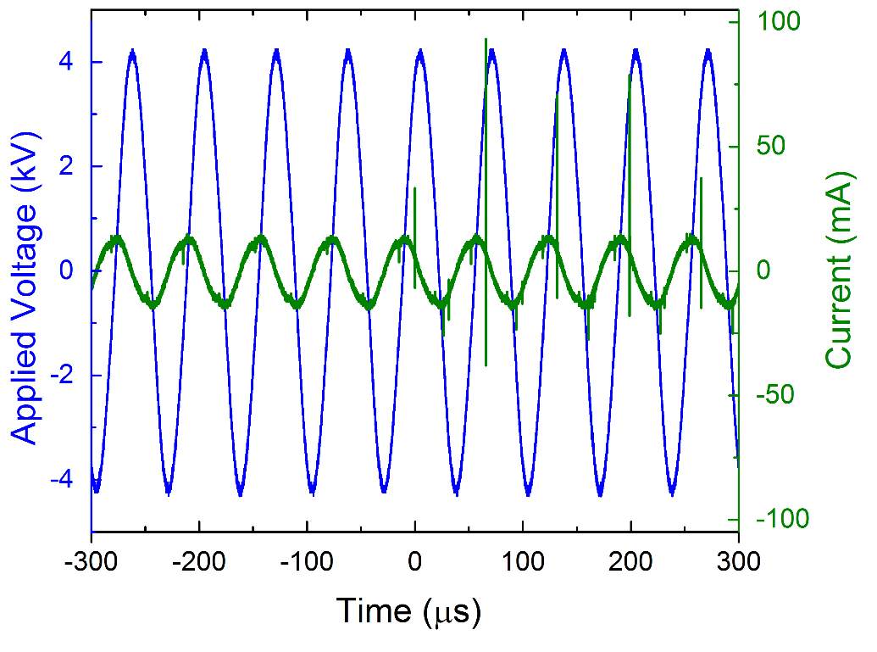
Figure 1: Applied voltage and current waveforms at the breakdown voltage for an electrode gap diameter of 4 mm.
To shed light on the experimental measurements, a numerical axisymmetric plasma model was developed to solve the conservation equations for the electrons, , , , the electron energy density, and the electric potential which is solved in both parts of the computational domain shown in figure 2, while all other variables are solved in the air domain only. A Direchlet type boundary condition for the electric potential was imposed on the driven electrode, fixing the applied potential to a desired value. On the boundary between the air domain and the dielectric domain, the model followed the surface charge density which evolved as a result of the charged species fluxes to the surface. On all other boundaries, a symmetry condition was imposed, setting the normal derivative of all solved variables to zero. The key parameters of the model (e.g. dimensions, dielectric constant, applied potential and frequency) were set to match those in the experimental configuration. The computational model was implemented using COMSOL version 5.2a.
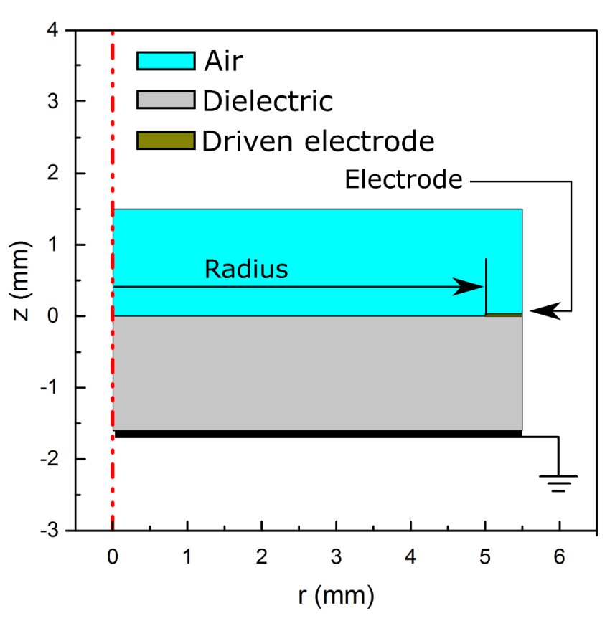
Figure 2: Schematic showing the axisymmetric computational domain, red dashed line denotes axis of symmetry.
In the numerical model, the breakdown event is characterised by a spike in the power deposited in the discharge. The deposited power in the computational domain (defined as the ohmic heating,, where J is the current density and E is the electric field) was spatially integrated in the air domain and plotted as a function of time. To determine the breakdown voltage from the calculated power, the simulation was run multiple times with the applied voltage systematically increased each time. Below the breakdown voltage, no power spike could be detected at any point over the applied voltage waveform. When a power spike was observed to occur at the peak of the applied voltage waveform, this value was assumed to be equal to the breakdown voltage. This procedure was repeated for all electrode gap diameters.
The variation of the measured breakdown voltage as a function of electrode gap diameter is shown in figure 3. It can be seen that an applied potential of 3.5 kV on the driven electrode was sufficiently high to generate an electric field exceeding or equal to the necessary breakdown electric field when the diameter of the electrode gap was greater than or equal to 5 mm. Minor variations in the measured breakdown voltages in gap diameters above 5 mm are a likely consequence of surface imprecations on the electrode edge arising during the machining process. At electrode gap diameters below 5 mm, the breakdown voltage increases rapidly with reducing dimeter despite the inter-electrode distance (i.e. the distance between the anode and cathode) remaining a constant determined by the thickness of the dielectric material. Also shown in figure 3 is the breakdown voltage predicated by the numerical model, a clear trend of increased breakdown voltage with reduced discharge gap diameter is observed, agreeing well with the experimental data.
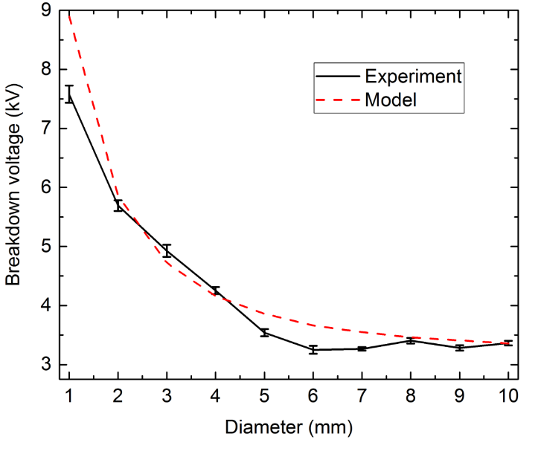
Figure 3: Breakdown voltage as a function of discharge gap diameter. Solid line shows experimental data, dashed line shown numerical data.

To explain these observations, the numerical model was run using a constant potential for each gap diameter without a plasma to isolate the plasma effects from the geometrical effects. Such an assumption mimics the discharge conditions prior to breakdown and is achieved by solving the Laplace equation instead of the entire system of equations described previously. The solution of the Laplace equation shows that as the gap diameter is reduced, the potential drop in the gap is decreased as shown in figure 4. The data shown in figure 4 implies that in large diameter electrode gaps (i.e. those greater than 5 mm), the potential at the centre of the gap is essentially uninfluenced by the potential applied to the driven electrode. The difference in potential between the centre of the gap and the electrode remains constant regardless of the diameter of the gap, meaning the breakdown voltage will essentially remain constant regardless of how large the electrode gap is made. These observations also explain the dependence of the breakdown voltage when the gap diameter is reduced. As the diameter is reduced below 5 mm, the potential across the entire discharge gap is elevated by that applied to the driven electrode. This phenomenon causes a reduction in the potential difference across the electrode gap thus weakening the electric field at any given applied voltage.
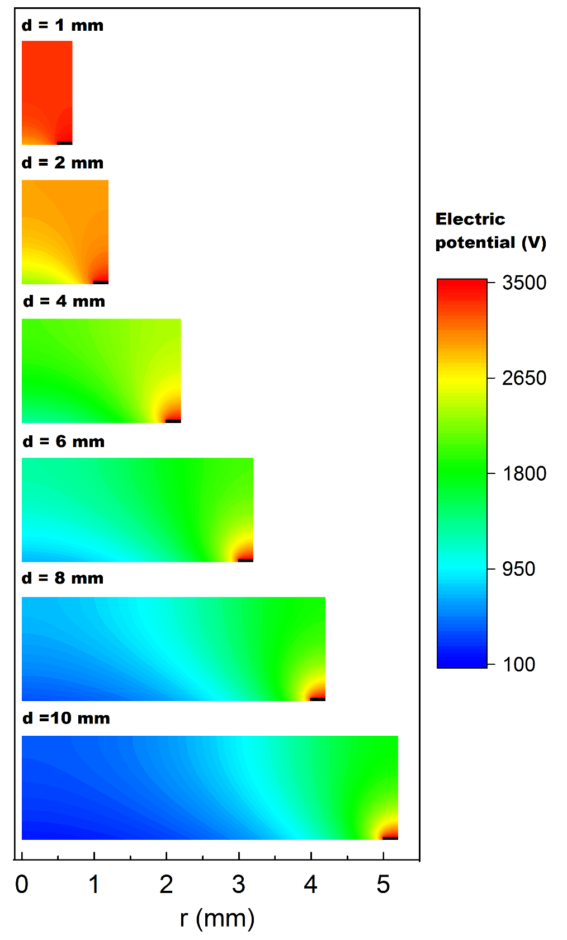
Figure 4: Electric potential for various gap diameters at a constant applied voltage of 3.5 kV, all the panels have the same legend. Electrodes are shown as black boxes.

Beyond the breakdown voltage, a critical parameter that strongly impacts both the composition and density of plasma generated reactive species is the power deposited in the discharge. To evaluate the impact of the electrode gap diameter on the deposited power, the plasma model was run for gap diameters of 4, 6, 8 and 10 mm at a constant peak applied potential of 7 kV; a voltage chosen to ensure breakdown in all investigated cases. For each gap diameter, the power deposited in the computational domain was integrated in the air domain then averaged in time over the duration of a single cycle (assuming a 15 kHz driving frequency), then normalized by the surface area of the gap. The deposited power density as a function of the gap diameter is given in table 1.
Diameter (mm) | Power density (W cm⁻²)
10 | 0.2
8 | 0.16
6 | 0.11
4 | 0.1
Table 1: Deposited power density at a constant applied potential of 7 kV as function of electrode gap diameter.

The trend shown in table 1 indicates that a reduced electrode gap leads to deceased power deposition at a given voltage. This is critical, as it has been widely demonstrated that SBD operation under high dissipated power conditions (> 0.2 W. cm⁻²) favours the production of Reactive Nitrogen Species (RNS) such as NO, N₂O and NO₂ [10]. RNS dominated chemistries are known to be highly effective for several healthcare related applications, including biofilm decontamination and wound therapy [16, 17]. Any factor that reduces power deposition in the discharge makes it increasingly difficult to access RNS dominated regimes and is extremely disadvantageous.
In conclusion, this letter highlights that the geometrical configuration of the electrodes in a SBD can have a significant impact on several key plasma parameters. Both the breakdown voltage and deposited power in the discharge are strongly affected by changes in the electrode gap diameter below a critical value. In this study, a critical dimeter of 5 mm was determined for circular discharge gaps fabricated on FR4 dielectric sheets. Below the critical diameter the breakdown voltage was observed to increase rapidly and the power deposited within the discharge reduce compared to plasmas generated in larger electrode gaps.
These findings were attributed to the potential in the circular discharge gap becoming increasingly uniform as the gap diameter is reduced, leading to a reduction in the electric field and a subsequent increase in breakdown voltage and reduction in deposited power. Given that power deposition directly influences the production of reactive chemical species, these findings have significant implications for the future development of large area and uniform SBD arrays. Essentially, a compromise must be made between the discharge area of individual SBD’s and the applied voltage required to achieve a desired discharge chemistry. While the results in this study have been obtained for circular electrode geometries in atmospheric pressure air, it is highly likely that the underpinning physical processes apply equally to all SBD systems, including those employing other electrode geometries (e.g. strips or hexagons) and other widely used gases such as Oxygen, Carbon Dioxide, Argon and Helium.

Acknowledgments
The authors are grateful for the support of the UK Engineering and Physical Sciences Research Council (Project EP/N021347/1) and InnovateUK (Project 50769-377232).

Data Availability
Figure source data can be found at: https://livrepository.liverpool.ac.uk/

References
[1] B. Eliasson, M. Hirth and U. Kogelschatz J. Phys. D: Appl. Phys. 20, 1421 (1987)
[2] V. I. Gibalov and G. J. Pietsch J. Phys. D: Appl. Phys. 33, 2618 (2000)
[3] S. Roy and K. P. Singh Appl. Phys. Lett. 88, 121501 (2006)
[4] N. N. Misra, T. Moiseev,S. Patil, S. K. Pankaj, P. Bourke, J. P. Mosnier, K. M. Keener, and P. J. Cullen Food Bioprocess Technol. 7, 3045 (2014)
[5] N.N. Misra , C. Sullivan, S.K. Pankaj , L. Alvarez-Jubete , R. Cama , F. Jacoby , and P.J. Cullen. Innov. Food Sci. & Emerg. Technol. 26, 456 (2014)
[6] D. Pavliňák, O. Galmiz, M. Zemánek, A. Brablec, J. Čech, and M. Černák Appl. Phys. Lett. 105, 154102 (2014)
[7] R. Matthes, C. Bender, R. Schlüter, I. Koban, R. Bussiahn, S. Reuter, J. Lademann, K-D Weltmann, and A Kramer PLoS ONE 8(7): e70462 (2013)
[8] C. Smet, E. Noriega, F. Rosier, J. L. Walsh, V. P. Valdramidis and J. F. Van Impe Innov. Food Sci. & Emerg. Technol., 38, 393-406 (2016).
[9] W. H. Tay, S. S. Kausik, C. S. Wong, S. L. Yap, and S. V. Muniandy Phys. Plasmas 21, 113502 (2014)
[10] Y. Sakiyama, D. B. Graves, H-W Chang, T. Shimizu and G. E. Morfill J. Phys. D: Appl. Phys. 45, 425201 (2012)
[11] M. I. Hasan and J. L. Walsh Appl. Phys. Lett. 110, 134102 (2017)
[12] M. I. Hasan and J. L. Walsh J. Appl. Phys. 119, 203302 (2016)
[13] Y. Ni, M. J. Lynch, M. Modic, R. D. Whalley and J. L. Walsh J. Phys. D: Appl. Phys. 49 355203 (2016)
[14] J-J Wang, K-S Choi, L-H Feng, T. N. Jukes and R. D. Whalley ‎Prog. Aerosp. Sci 62, 52 (2013)
[15] D. X. Liu, Z. C. Liu, C. Chen, A. J. Yang, D. Li, M. Z. Rong, H. L. Chen, and M. G. Kong Sci. Rep. 6, 23737 (2016).
[16] M. Modic, N. P. McLeod, J. M. Sutton and J. L. Walsh Int. J. Antimicrob. Agents 49, 375 (2017)
[17] M. G. Kong, G. Kroesen, G. Morfill, T. Nosenko, T. Shimizu, J. van Dijk and J. L. Zimmermann ‎New J. Phys 11 115012 (2009)

Figure Captions
Figure 1: Applied voltage and current waveforms at the breakdown voltage for an electrode gap diameter of 3 mm.
Figure 2: Schematic showing the axisymmetric computational domain, red dashed line denotes axis of symmetry.
Figure 3: Breakdown voltage as a function of discharge gap diameter. Solid line shows experimental data, dashed line shown numerical data.
Figure 4: Electric potential for various gap diameters at a constant applied voltage of 3.5 kV, all the panels have the same legend. Electrodes are shown as black boxes.

