**Title Page:**

**Management of Proliferative Verrucous Leukoplakia: Justification for a Conservative Approach.**

**Author List:**

Scott C Borgna FRACDS(OMS)3 ,

Peter T Clarke MFDS4,

Andrew G Schache PhD1,5,

Derek Lowe CStat5,

Michael W Ho FRCS1,6,

Caroline E McCarthy BDS1,2,

Stephen Adair MFDS2

E Anne Field DDSc2,

John K Field PhD1,2,

Deborah Holt PhD2,

Janet M Risk PhD1,

Bijay P Rajlawat FDS2,

Asterios Triantafyllou PhD7,

Richard J Shaw MD1,2,5*

1. MHNORG (Mersey Head & Neck Oncology Research Group), Department of Molecular & Clinical Cancer Medicine, Institute of Translational Medicine, University of Liverpool, Liverpool.

2. Dept of Oral Medicine, Liverpool University Dental Hospital, Liverpool.

3. Royal Brisbane and Women's Hospital Metro North Hospital and Health Service, Oral & Maxillofacial Surgery, Brisbane, QLD, AUS

4. Department of Restortive Dentistry, Central Manchester Foundation Trust.

5. Division of Oral & Maxillofacial Surgery, Aintree University Hospitals NHS Foundation Trust, Liverpool.

6. Leeds Teaching Hospitals NHS Trust, Oral and Maxillofacial Surgery

Leeds Dental Institute, Leeds.

7. Pathology Department, Liverpool Clinical Laboratories & School of Dentistry, University of Liverpool, Liverpool, United Kingdom

*Corresponding Author:

Professor Richard Shaw

Mersey Head & Neck Oncology Research Group, Department of Molecular & Clinical Cancer Medicine, University of Liverpool & Hon Consultant in OMFS, Aintree University NHS Foundation Trust. The University of Liverpool Cancer Research Centre, Roy Castle Building, 200 London Road, Liverpool, L3 9TA

[rjshaw@liv.ac.uk](mailto:rjshaw@liv.ac.uk)

0151 794 8832, fax 0151 529 5288

Running title: Management of PVL

Key words: Proliferative Verrucous Leukoplakia, management, malignant

**Abstract**

**Background**

Proliferative verrucous leukoplakia (PVL) is a progressive, multifocal, exophytic form of leukoplakia with high rates of malignant transformation. The aim of this study is to evaluate a cohort of PVL in a single tertiary referral clinic.

**Method**

Cases meeting accepted diagnostic criteria were reviewed with regard to their pathology, demographic characteristics, management & outcomes. HPV testing was undertaken on a subset.

**Results**

Almost half of the 48 patients with PVL (48%, n=23) underwent malignant transformation after a median 23.4 months. The characteristics of this cohort were similar to those previously described, but management was notably more conservative. Conservative management of PVL was used in 92% of our patients, but the clinical outcomes appear comparable to previously described cohorts where PVL was predominantly treated by surgical excision. All HPV testing was negative.

**Conclusions**

Aggressive surgical intervention in the premalignant phase of PVL may not influence the rate of malignant transformation.**Introduction.**

Proliferative verrucous leukoplakia (PVL) refers to a distinct but rare subset of oral leukoplakia. It is characterized by progressive, multifocal, exophytic lesions that are persistent, irreversible and more common in elderly women without risk factors(1-3). Although only characterized in 1985(2), considerable attention has been paid to PVL because of high rates of recurrence, malignant transformation and mortality(1-3). However, controversy persists regarding diagnosis, aetiology and appropriate management.

The diagnosis of PVL cannot be established on histopathological findings alone and requires correlation with a characteristic clinical appearance of progressive demarcated florid white lesions(4). Major and minor diagnostic criteria based on both clinical and histopathological features have been suggested(5) and variously endorsed(6). In their original account, Hansen et al(2) described a 10-point histological grading from 0 (normal) to 10 (frankly invasive squamous cell carcinoma), although a simplified scheme with 4 histopathological sub-types(4) has been published. It is accepted that some temporal progression in the clinical and pathological features is required before a diagnosis of PVL, implying, therefore, the need for retrospective review(7). The differential diagnosis from other conditions has been described(8).

The aetiology of PVL remains obscure, with no recognized risk factors other than advanced age and female gender. Although some early reports suggested a link between oncogenic viruses and PVL(3, 9), recent reports have not demonstrated an association with either high risk Human Papillomavirus (HPV) sub-types or Epstein-Barr Virus(10-12).

Owing to its progressive clinical course and tendency for malignant transformation, PVL has generally been aggressively managed. In a recent systematic review of 126 cases in which management was reported, surgery was used in 80%, radiotherapy in 24%, laser excision or ablation in 23% and other treatment methods in a further 12%(7). Most patients received multiple modalities and only 1.6% received no treatment, while 2.1% were managed conservatively with regular monitoring and multiple biopsies. The aim of the present study is to undertake a retrospective evaluation of patients diagnosed with PVL in a multi-disciplinary oral dysplasia clinic serving as a tertiary regional referral centre. The clinical team serving this clinic were struck that management decisions seemed notably conservative compared with the published literature, and therefore wished to establish if this was the case, and the implications for outcomes. The demographic, clinical, histopathological characteristics, management and clinical outcomes of PVL are compared with previous published cohorts. The HPV status was also established on a sub-set of this cohort.

**Materials & Methods**

An evaluation of patients diagnosed with PVL in a regional referral centre for the period 1990-2015 was undertaken. Protocols for accepting new referrals, review and management of premalignant lesions in this centre have become increasingly formalised over the period(13-15). Diagnostic criteria for and classification of PVL closely adhered to Hansen et al(2). The histopathology for all cases was re-examined, with grades 3-5 usually considered to meet the histological requirement for an initial diagnosis of PVL. Cases where there was uncertainty about the diagnosis of PVL, either from pathology, clinical course or appearance, were excluded from analysis.

After defining the index lesion and date of diagnosis, ongoing (and, sometimes, prior) management including biopsy, treatment, malignant transformation and death were recorded and assessed using Kaplan Meier (KM) analysis, and Mann-Whitney or Fisher’s exact testing. In some cases the confident diagnosis of PVL revealed a number of prior lesions or biopsies, which were then included in retrospect. Tobacco and alcohol exposure were recorded in keeping with our previous reports of premalignant lesions(15), whereby smoking status was dichotomized as greater than 5 pack years, and alcohol user was greater than 5 units per week long term use. The site of PVL lesions was classified, and for those cases with two or more lesions in different sites, they were classed as multifocal.

Determination of HPV status was undertaken for a subset of PVL cases for which formalin-fixed paraffin-embedded (FFPE) tissue blocks were retrieved. Data and tissue were collected under ethical approval (South Sefton Research Ethics Committee; EC47.01 and North West 5 Research Ethics Committee; 09/H1010/54). Tissue microarrays (TMAs) consisting of triplicate cores of representative PVL tissue from corresponding FFPE tumour donor blocks were constructed according to standard protocols. HPV detection was based on combined assessment of p16 immunohistochemistry (IHC) and high risk HPV DNA in situ hybridization (HR HPV DNA ISH). A sample testing positive for both would confirm evidence of presence of HPV DNA and the downstream effects of viral oncogene expression (p16 overexpression). Both p16 IHC and HR-HPV DNA ISH analysis was conducted using proprietary kits (CINtec Histology, mtm laboratories AG, Heidelberg, Germany; Inform HPV III Family 16 Probe B, Ventana Medical Systems Inc., Tucson, AZ, USA) on a Ventana Benchmark Autostainer (Ventana Medical Systems Inc., ) as previously described(16). Scoring of p16 IHC status was assessed using the widely-used threshold of strong and diffuse nuclear and cytoplasmic staining in greater than 70% of the tumour cells. HR HPV DNA ISH was scored using a binary classification (positive or negative) reflecting detection of chromogen in any of the tumor cells, as previously described(17).

**Results**

Following assessment of clinical and histopathological characteristics, 48 patients were diagnosed with PVL. The characteristics of histopathology at the first available biopsy are shown in Table 1. A typical illustrative case showing many of the major and minor criteria for diagnosis of PVL is shown in figures 1,2,3 & 4.

77% (n=37) of patients presented with Hansen grades 3-5 on initial biopsy; 23%(n=11) of the cohort at both ends of the grading spectrum did not show features in keeping with the histopathology of conventional PVL at presentation. All patients were reviewed with a median follow up of 3.4 years (interquartile range (IQR) 1.2-6.0 years) since diagnosis. The grading at the most recent available biopsy is also shown in Table 1.

The demographic characteristics of patients and lesions were compared to the Bagan and Silverman cohorts(1, 3) and are shown in Table 2, although some of the comparisons were limited by differing methodology e.g. history of tobacco and alcohol exposure was reported differently in the 3 cohorts.

In the current cohort, the site of lesions was pan-oral or multiple oral sites in 42% (20), gingivae in 33% (16), tongue only 13% (6), buccal only 8% (4) and other 4% (2). Half (24) of patients were male. The largest total area of leukoplakia was measured for 46 patients at: >=1000mm2 (20%, 9 patients), >=500-999mm2 (30%, 14 patients), >=250-499mm2 (20%, 9 patients) and <250mm2 (30%, 14 patients).

Active surveillance and repeat biopsy in the event of clinical change in appearance, were the most common method of management, used in 29 (60%) cases. Surgical excision of premalignant lesions (Hansen Grade 3-5) was performed in only 4 (8%) of patients, with 2 of those patients requiring marginal mandibular (‘rim’) resections and significant accompanying loss of dentition.

Almost half of the patients (23, 48%) underwent malignant transformation and the median follow up in those transformed was 8.2 years (IQR 4.6-14.5) and in those not transformed 3.5 years (IQR 1.2-9.7) (Figure 5). Adjusting for variable follow-up using Kaplan-Meier survival (Figure 2) the 5-year estimate of transformation was 4% (SE 4%) and the 10-year estimate was 22% (SE 12%). The median time to transformation (time from PVL on initial biopsy to eventual, frankly invasive histology) was 23.4 months (IQR 0.4-55.0), n=23, and these patients had a median of 1 (IQR 1-3, range1-9) total number of diagnosed malignancies during their follow-up. A total of 6 (13%) patients died as a result of oral malignancy evolving from PVL.

Comparing the 23 patients who underwent malignant transformation with the 25 who did not; neither age, gender, smoking status, or alcohol consumption were statistically different between the groups (Table 3). The larger lesions of PVL and pan-oral sites were statistically more likely to undergo malignant transformation. Gingival only lesions were statistically more likely not to progress to malignancy. There was a confounding association with pan-oral PVL patients having larger lesions (14/20 with ≥500mm2) than single site lesions, such as gingival only (9/16 with <250mm2). Patients who underwent malignant transformation received significantly more biopsies than those who did not (median of 5 versus 1). 83% (19/23) of transformed patients, all with multiple biopsies, showed a histological progression in grading.

15 of 48 had adequate tissue for HPV testing. All 15 patients tested for HPV were negative in all tests.

**Discussion**

A notable finding of this retrospective study was that in our largely conservatively managed (92%) cohort of patients with PVL there were similar malignant transformation rates (48%) and fewer disease related deaths (12.5%), when compared to the literature(1, 3, 7) (Table 2). Large (>500mm2), pan-oral lesions, present for a long duration of time (>8 years) were more likely to transform. It is also evident that the clinical progress of these lesions to malignancy appears slow and inexorable, therefore the true impact of the disease is only apparent after prolonged longitudinal follow-up.

The inclusion criteria applied here, allowed only patients treated within a specialist tertiary referral clinic, with clinical and histopathological features of PVL, to enter the study. The weaknesses of our data, in common with other published cohorts, lies in modest size and retrospective nature. Compared with the other cohorts in the published literature (1 , 3), ours has shorter follow-up (Table 2). This might partly explain why the rate of malignant transformation is broadly similar in our cohort, the mortality is significantly lower. In addition, our cohort included rather similar numbers of lesions graded Hansen 6, 7 (broadly corresponding to the less aggressive verrucous carcinoma) and Hansen 8, 9 (broadly corresponding to the more aggressive conventional squamous cell carcinoma (10, and 12 cases, respectively; Table 1). Despite systematic attempts to precisely define PVL (6,8), it is acknowledged that there remains some controversy around diagnostic criteria, particularly for less typical cases.

The demographics of our cohort are comparable to the literature, i.e. PVL mainly affecting elderly patients and apparently with little contribution from environmental carcinogens such tobacco or alcohol. Our findings also support the lack of an aetiologiocal association between PVL and oncogenic HPV(10, 12). We observed an equal representation of both males and females, which contrasts with the commonly reported female predominance (7), and found no association between gender and malignant transformation or death. Gingivae are regarded as the most common site of PVL (7), but our findings indicate multifocal disease (42% of patients) is more prominent than single site presentation. Our cohort shows overall similar transformation rate and histological progression of PVL as previously described(1-3).

We re-emphasize the lack of evidence to support the routine excision of the non-invasive phase of PVL (Hansen grades 3-5) in an attempt to prevent future malignant transformation. Our conservatively managed cohort is thus unique, and our data questions the inference from other published series, i.e. that empirical excision of PVL on presentation influences malignant transformation or survival. We would stress the need for careful and lifelong surveillance of patients with PVL in the context of a dedicated multidisciplinary team. Our aim is to diagnose emergent malignancies as early as possible and offer standard therapy based on the clinical staging of the emergent squamous cell carcinoma. The certainty behind any recommendation is currently weak, and we acknowledge the paucity of high quality data to inform treatment decisions for PVL. However, the morbidity of surgical manipulations of PVL is sometimes considerable, particularly the accumulated effects of repeat surgery. If this is carried out without sufficient evidence of benefit, it might reasonably be open to question. We have experienced that adequate excision of widespread gingival lesions often requires loss of alveolar process and many or all teeth. Bearing in mind that this group of patients have the lowest risk of malignant transformation of all PVL sites, we find it particularly difficult to recommend this intervention.

There is a need for greater awareness in the medical and dental communities of the existence of PVL and the importance of specialist management. Histopathological grading on first biopsy cannot be used in isolation to safely direct management, and clinical factors such as the appearance of the lesion and temporal trends are also crucial. In view of the relative rarity of PVL, multi-centre collaborative studies are desirable to better evaluate diagnosis and management, and establish more meaningful diagnostic and treatment guidelines for clinicians. Furthermore, the high transformation rates of PVL in conjunction with the lack of an obvious effect of smoking status and alcohol consumption, suggest a role of as yet uncharacterized molecular aberrations. With the aid of modern genomic platforms, it may be now be possible to identify the critical aetiological events that underlie the pathogenesis of this clinicopathologically challenging condition.

References

1. Bagan JV, Jimenez-Soriano Y, Diaz-Fernandez JM, et al. Malignant transformation of proliferative verrucous leukoplakia to oral squamous cell carcinoma: a series of 55 cases. Oral Oncol 2011;47(8):732-5.

2. Hansen LS, Olson JA, Silverman S, Jr. Proliferative verrucous leukoplakia. A long-term study of thirty patients. Oral Surg Oral Med Oral Pathol 1985;60(3):285-98.

3. Silverman S, Jr., Gorsky M. Proliferative verrucous leukoplakia: a follow-up study of 54 cases. Oral Surg Oral Med Oral Pathol Oral Radiol Endod 1997;84(2):154-7.

4. Batsakis JG, Suarez P, el-Naggar AK. Proliferative verrucous leukoplakia and its related lesions. Oral Oncol 1999;35(4):354-9.

5. Cerero-Lapiedra R, Balade-Martinez D, Moreno-Lopez LA, Esparza-Gomez G, Bagan JV. Proliferative verrucous leukoplakia: a proposal for diagnostic criteria. Med Oral Patol Oral Cir Bucal 2010;15(6):e839-45.

6. Carrard VC, Brouns ER, van der Waal I. Proliferative verrucous leukoplakia; a critical appraisal of the diagnostic criteria. Med Oral Patol Oral Cir Bucal 2013;18(3):e411-3.

7. Abadie WM, Partington EJ, Fowler CB, Schmalbach CE. Optimal Management of Proliferative Verrucous Leukoplakia: A Systematic Review of the Literature. Otolaryngol Head Neck Surg 2015;153(4):504-11.

8. Gillenwater AM, Vigneswaran N, Fatani H, Saintigny P, El-Naggar AK. Proliferative verrucous leukoplakia (PVL): a review of an elusive pathologic entity! Adv Anat Pathol 2013;20(6):416-23.

9. Palefsky JM, Silverman S, Jr., Abdel-Salaam M, Daniels TE, Greenspan JS. Association between proliferative verrucous leukoplakia and infection with human papillomavirus type 16. J Oral Pathol Med 1995;24(5):193-7.

10. Bagan JV, Jimenez Y, Murillo J, et al. Lack of association between proliferative verrucous leukoplakia and human papillomavirus infection. J Oral Maxillofac Surg 2007;65(1):46-9.

11. Bagan JV, Jimenez Y, Murillo J, et al. Epstein-Barr virus in oral proliferative verrucous leukoplakia and squamous cell carcinoma: A preliminary study. Med Oral Patol Oral Cir Bucal 2008;13(2):E110-3.

12. Campisi G, Giovannelli L, Ammatuna P, et al. Proliferative verrucous vs conventional leukoplakia: no significantly increased risk of HPV infection. Oral Oncol 2004;40(8):835-40.

13. Field EA, McCarthy CE, Ho MW, et al. The management of oral epithelial dysplasia: The Liverpool algorithm. Oral Oncol 2015;51(10):883-7.

14. Ho MW, Field EA, Field JK, et al. Outcomes of oral squamous cell carcinoma arising from oral epithelial dysplasia: rationale for monitoring premalignant oral lesions in a multidisciplinary clinic. Br J Oral Maxillofac Surg 2013;51(7):594-9.

15. Ho MW, Risk JM, Woolgar JA, et al. The clinical determinants of malignant transformation in oral epithelial dysplasia. Oral Oncol 2012;48(10):969-76.

16. Schache AG, Liloglou T, Risk JM, et al. Evaluation of human papilloma virus diagnostic testing in oropharyngeal squamous cell carcinoma: sensitivity, specificity, and prognostic discrimination. Clin Cancer Res 2011;17(19):6262-71.

17. Singhi AD, Westra WH. Comparison of human papillomavirus in situ hybridization and p16 immunohistochemistry in the detection of human papillomavirus-associated head and neck cancer based on a prospective clinical experience. Cancer 2010;116(9):2166-73.

FIGURE 1: Illustrative case of PVL. 79-year-old female patient with longstanding history of PVL subject to two previous resections over 15 years for verrucous carcinoma (PVL grade 8). Presents with pan-oral lesions involving the mandibular gingivae, with limited involvement of maxilla.

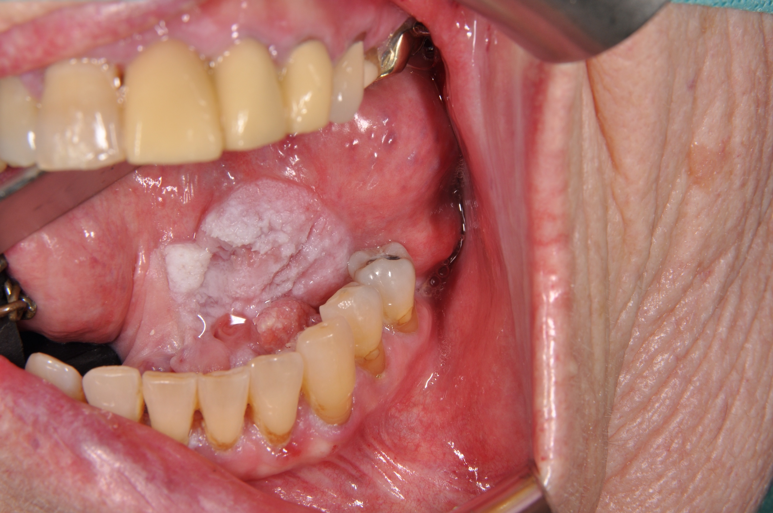

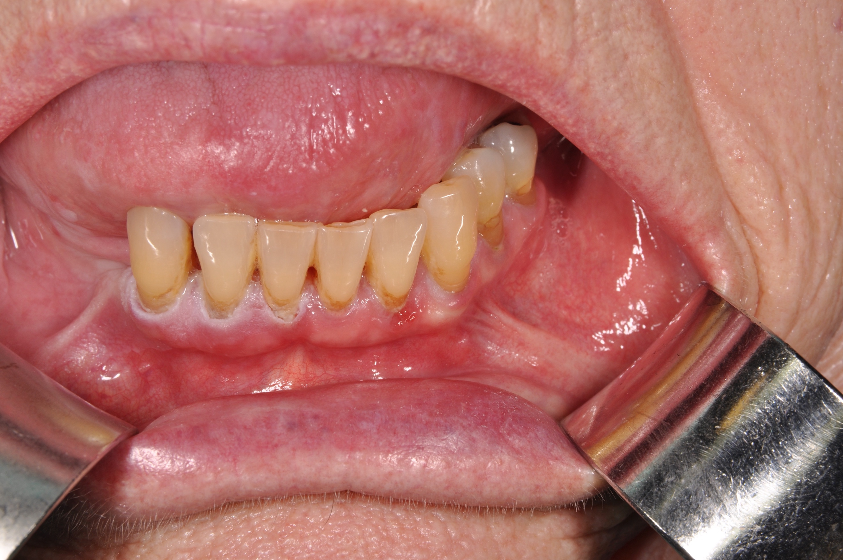

FIGURE 2: A more significant lesion involves the floor of mouth and ventral tongue. Excision of this revealed verrucous carcinoma resected with narrow margins; the patient remains under close clinical review.

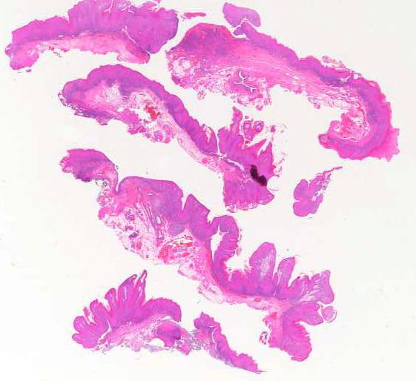

FIGURE 3 Scanned histological sections of the excised lesion shown in Figure 2, stained with hematoxylin and eosin. The limited extent of the excision can be appreciated.

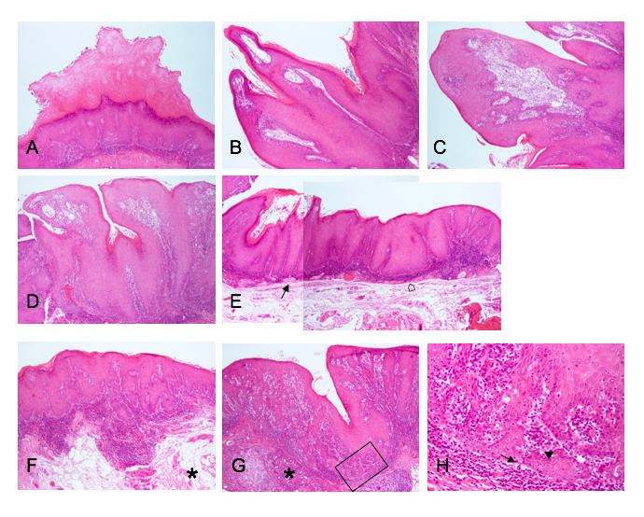

FIGURE 4 Areas of the sections shown in Figure 2 are magnified to illustrate the varying surface and front of PVL. (Unless otherwise specified, the photomicrographs were taken at a ×2 objective magnification.) (A) Compact, verrucous hyperorthokeratosis on the surface. (B) Finger-like exophytic papillary projections capped by hyperorthokeratosis, with ‘shouldering’ at the base. (C) Exophytic mammillated projection with inconspicuous keratinisation on the surface. (D) Focally infolded / invaginated surface. (E) Composite photomicrograph showing columns (arrow) and elephant feet-like arrangements (open arrow) of proliferative keratinocytes, which advance at more or less the same level; variable ‘lichenoid’ inflammatory reaction is sub-adjacent to the advancing front. (F) Gently mammillated surface, and front advancing at different levels, though not extending to submucosal fat (asterisk); inflammation is present between PVL and fat. (G) Invaginated surface, and front advancing at different levels and approaching salivary lobules (asterisk); the rectangled area is magnified in (H) to allow appreciation of cytology. (H) The proliferative keratinocytes are often differentiated, but mitoses (arrow), densely stained nuclei (arrowhead) and perturbed stratification with absence of basal layer can be seen (objective magnification ×10).



FIGURE 5

Kaplan Meier Cumulative malignant transformation rate__

|  |  |  |
| --- | --- | --- |
| Biopsy Grade | Number of Patients | |
| Initial | Most Recent* |
| 1 | - | - |
| 2 | 2 | - |
| 3 | 14 | 5 |
| 4 | 14 | 12 |
| 5 | 9 | 9 |
| 6 | 5 | 9 |
| 7 | - | 1 |
| 8 | 1 | 3 |
| 9 | 3 | 9 |
| 10 | - | - |

TABLE 1

Hansen Histopathological grade of lesions for cohort, on initial and most recent biopsy

Clinical characteristics and outcomes of PVL patients

|  |  |  |  |
| --- | --- | --- | --- |
|  | **Silverman(1) N=54** | **Bagan(2) N=55** | **Liverpool N=48** |
| Age | 62 (22-89)  (Mean/Range) | 62+/-12 (Mean +/- SD) | 70+/-13  (Mean +/- SD) |
| Followup  (Years) | 11.6 (1-39)  (Mean/Range) | 7.5+/-4.2  (Mean +/- SD) | 4.3+/-3.7  (Mean +/- SD) |
| Male:Female ratio | 1:4 | 1:2 | 1:1 |
| Tobacco Users | 31% | 36% | 69% (33/48) |
| Alcohol Users | Not reported | Not Reported | 56% (27/48) |
| Surgical removal | 79%(42/53) | 100% (55/55) | 8% (4/48) |
| Malignant transformation | 70% (38/54) | 49% (27/55) | 48% (23/48) |
| Died of disease | 40% (21/53) | Not reported | 13% (6/48) |

Table 2

**Table 3.** Transformed vs Non- transformed patients.

|  |  |  |  |  |  |
| --- | --- | --- | --- | --- | --- |
|  | | | Transformed Group (T)  N=23 | Not Transformed Group (NT)  N=25 | Mann-Whitney Test |
| Age at time of PVL diagnosis (Years), median (IQR) | | | 65 (57-73) | 68 (56-75) | P=0.46 |
| Gender | | male | 52% (12) | 48% (12) | P=0.99* |
| Smoking Status (Pack years), median (IQR) | | | 15 (0-31) | 6 (0-38) | P=0.99 |
| Alcohol Consumption (Units/Week) | | | 4 (0-8) | 1 (0-16) | P=0.97 |
| Subsite | Multifocal** | | 61% (14) | 24% (6) | P=0.02** |
| Gingiva | | 17% (4) | 48% (12) | P=0.005*** |
| Tongue | | 13% (3) | 12% (3) |  |
| Buccal | | 9% (2) | 8% (2) |  |
| Other | | 0% | 8% (2) |  |
| Number of biopsies | median (IQR) | | 5 (4-10) | 1 (1-3) | P<0.001 |
| 1 | | 0%(0) | 56% (14) |  |
| 2-5 | | 47% (11) | 44% (11) |
| 6-10 | | 34% (8) | 0% (0) |
| 11-30 | | 15% (3) | 0% (0) |
| Size of lesion. Median (IQR) | | | 750mm2  (425-1500) | 225mm2  (100-575) | P=0.001 |

*Fishers Exact Test

**Fishers Exact Test: multifocal Vs rest

***Fishers Exact Test: gingiva Vs rest