From ‘NEET’ to ‘Unknown’: Who is responsible for young people not in education, employment or training?

Situating his discussion in its recent historical context, Liam Wrigley examines how young people labelled as ‘NEET’ have now become ‘unknown’ or ‘lost’, arguing that this is due to a lack of clear strategy concerning actors that have been responsibilised in responding to the employment, training and welfare needs of young people.

Introduction: What is ‘NEET’?
The number of young people (between 16-24 years of age) who experience being Not in Education, Employment or Training (NEET) has been of grave concern, with the rates of young people labelled as not in education, employment or training remaining high (Simmons et al, 2014). In the UK alone, the number of young people who are NEET has fluctuated between 15% in 2002 to 11.5% in 2016 (DfE, 2017). The label NEET has been successively adopted throughout Europe and internationally (Simmons et al, 2014), although there has been great variation in how this policy label has been defined globally (i.e. some countries count unemployed young people who are graduates or in precarious work situations or ‘zero hour’ contracts). The label reflects a growing trend in recognizing young people that have fallen outside the labour market or education. Throughout Europe, the rate of NEET young people remains high, with countries such as Spain, Ireland and Italy recording more than 17% of young people as out of education, employment or training (Eurofund, 2016).
In the UK, It should be noted that the production of young people into fixed policy categories like NEET is nothing new. Changes to the labour market from 1979-1997 marked a period where young people found themselves being placed on various employment initiatives (such as the ‘Youth Opportunities Program’, ‘Youth Training Scheme’ and ‘Restart Program’) that were designed to address the problem of youth unemployment and education/ training (Furlong and Cartmel, 2007). All of these policy responses have been critiqued due to their highly neoliberal nature, where disadvantaged young people increasingly fell foul of precarious and unstable labour market conditions. Neoliberalism for the purpose of this article can be best described by Harvey (2005: 2-3) as:
“A theory of political economic practices that proposes that human well-being can best be advanced by liberating individual entrepreneurial freedoms and skills within an institutional framework characterized by strong private property rights, free markets, and free trade. The role of the state is to create and preserve an institutional framework appropriate to such practices […] deregulation, privatization, and withdrawal of the state from many areas of social provision have been all too common”.
In light of this, these policy responses can be summarized by the following negative attributes: low wage, lacking a tangible education outcome, lack of investment by the private companies that provided the training contracts, and lack of long term stability in employment and education for young people (Hollands, 1990; Allatt and Yeandle, 1992). The policy shift in cuts to unemployment benefit in 1988 for 16-18 year olds resulted in a noticeable change to how young people were responded to from government and policy makers.
Istance et al (1994) and colleagues had first embraced the label ‘statusZero’ in a study of young unemployed 16-19 year olds in South Glamorgan. In this study, the first reference to NEET was made by a research observation that highlighted the lack of mainstream support for young people that had fallen outside the labour market or further education and training. This was due to various factors such as: problems with schooling, issues with the local labour market, and lack of support from family and services such as the Job Centre (ibid).

The responses to NEET
The label NEET was utilised by the New Labour government in 1997 to describe the growing numbers of young people age 16-24 years of age that were at risk or had failed to transition into further education or the labour market (Furlong and Cartmel, 2007). The New Labour government set up the Social Exclusion Unit in order to tackle the problem of NEET (ibid). Tony Blair declared that:
“The best defence against social exclusion is to have a job […] the best way to get a job is to have a good education, with the right training […] The young people involved are disproportionately from poor backgrounds in deprived areas […] social exclusion in later life is disproportionately the result, They [NEETs] are much more likely to be unemployed, dependent on benefits, to live in unstable family structures and to be depressed about their lives”
– (Social Exclusion Unit, 1999:6-8)
The particular set of circumstances leading to an individual meeting the criteria of NEET are varied, and research in this area has brought to attention that young people who experience being NEET are far from being a homogenous group, despite the New Labour Government maligning responsibility onto young people to have ‘good education’ (ibid), irrespective of the great difficulty that would be faced in achieving such. Much of the research surrounding NEET policy has focused on failed or disbanded interventions strategies such as ‘Connexions’ that was introduced under the Social Exclusion Unit (Yates and Payne, 2006). The Connexions strategy attempted to deal with the complexities of NEET, but ultimately became a ‘firefighting approach’ (Nudzor, 2010: 18) which evidence suggests attempted to tackle multiple sources of social exclusion, such as addiction, exclusion from education, issues with family, and homelessness. (Yates and Payne, 2006). 2011 onwards was marked by radical change towards young people’s services under the Coalition government, with the policy label ‘NEET’ remaining still favourable under ‘new’ strategies including the Big Society (Hancock et al, 2012), the Youth Contract (Roberts, 2013) and the National Citizen Service (NCS) (de St Croix, 2017).
In particular, a speech given in 2015 by former PM David Cameron drew attention to utilizing the NCS as part of a tripartite system, along with the voluntary sector and the market in addressing young people’s social problems:
“I want National Citizen Service to become a rite of passage for all 16 and 17 year olds, changing attitudes by bringing together young people from every community and giving them the skills they need to get on in life and work […] And it’s also why I want us to continue pioneering world-leading social interventions – like our social impact bonds, so that private and voluntary sector organisations which succeed in helping the hardest to reach get into work can be rewarded with some of the savings they deliver to the taxpayer”
– (Cameron, 2015: Online)
This speech echoes the favoured anti-social democratic solution to being NEET, which ultimately prefers the free market being in control and young people having to be drivers of their own individual success stories, accompanied by the support of voluntary or private sector actors. The free market rule can be attributed towards the success of neoliberalism that the UK has experienced since 1979.
Much like the previous responses to the problem of youth unemployment, strategies such as the NCS have faced widespread criticism for being top-down, a neoliberal target culture that focuses on ‘outcomes’ and success. This profit motivation and success of the free market, evidently diverts the overall attention away from vulnerable young people in their transitions out of NEET (Roberts, 2013; de St Croix, 2011). The neoliberal policy approach has also been widely criticised due to the responsibilisation of communities and voluntary sector actors to deal with the issue of ‘at risk’ young people’s employment, education and training trajectories, which operate on minimal funding and absolve government of accountability and responsibility (Hancock et al, 2012).
Having established the definition of NEET in the UK and past policy developments relating to the reduction of numbers of NEET, the second part of this paper will turn attention towards what is currently happening to NEET young people since the collapse of New Labour initiated intervention strategies.

Why are ‘NEETs’ now ‘Unknown’ or ‘Hidden’?
Since the collapse of the Social Exclusion Unit in 2010, there has been a marked increase in debate and policy attention on ‘who’ is now responsible for the education, employment and training transitions of NEET young people. In spite of NEET becoming a bolt-on to strategies such as NCS and the Youth Contract, evidence from grey literature has centred on young people’s destinations out of NEET becoming obscured, with recent arguments suggesting that NEET to EET transitions are increasingly ‘unknown’ or ‘hidden’ (GM Talent Match, 2017; Brooks, 2014). This is principally due to the Education and Training Participation Age being increased to 18 in the UK (Furlong, 2016), which has effectively masked the NEET rate of 16-18 year olds in official statistics. As of 2017, there has been a lack of clear government initiative that effectively records the NEET rate across the country who are utilising such private or voluntary sector actors in arriving at ‘EET’ destinations (Hutchinson et al, 2016). Hence, in a Fabian Society Review ‘Out of sight: How we lost track of thousands of NEETs’, Ed Balls (2014, cited in Brooks: ix) suggested:
“Since the Connexions service was cut we have lost track of over 50,000 young people who are NEET. No single organisation or individual controls all the levers necessary to bring down the numbers of NEET in a sustained way […] businesses and third sector organisations all have their part to play”
It would be unrealistic to attempt to give a holistic analysis of NEET destinations for this article, since a devolved strategy has been employed by government in tackling young people’s problems with education, training and the labour market. The ‘devolved’ strategy differs drastically across each region in England and Wales, with each local authority having control of the service provision for NEET young people. (Dixon et al, 2011). However, the fact that the number of young people who qualify under ‘NEET’ status has become ‘lost’ clearly marks a discrepancy in the Coalition/ Conservative strategy targeting NEET to EET outcomes. As official data shows (figure 1), in areas such as the North West of England, a larger proportion (7.8%) of young people ending up in ‘unknown’ destinations than those designated as NEET.
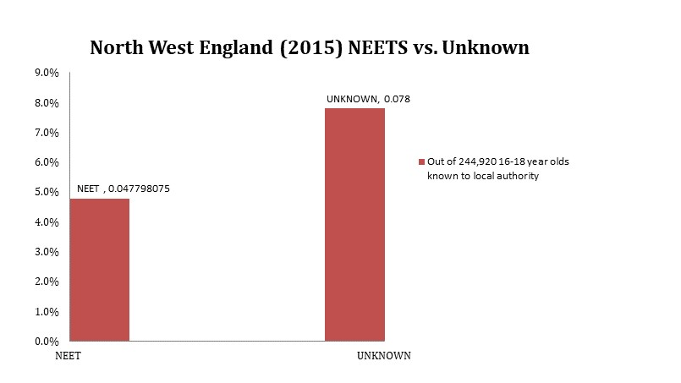
Figure 1: Number of 16-18 year old NEETs in the North West in comparison to those who activities/ destinations are currently unknown, 2015. (Adapted from: DfE, 2016)
This highlights an underlying issue as to who is now responsible for the transition of NEET young people into EET destinations. In the North West of England alone, limited evidence has emerged that various voluntary sector organisations are assisting NEET young people into education, employment and training propped up by various European Social Fund initiatives that strongly encourage an ‘outcome’ culture (Dixon et al, 2011; Furlong, 2016). Such outcomes do not necessarily have to be tangible in getting young people back into education, employment or training long term. Often, ‘Payment by Results’ models (see Dixon et al, 2011) are being operated in creating such quick-fix outcomes, which, again, are top-down neo-liberal approaches (de St Croix, 2011), that do not engage young people into further education and training. As figure 2 demonstrates (below), in a wide selection of high NEET population Borough Councils in the North West of England, increasing numbers of young people’s destinations have become ‘Unknown’ in comparison to officially recorded NEET status.
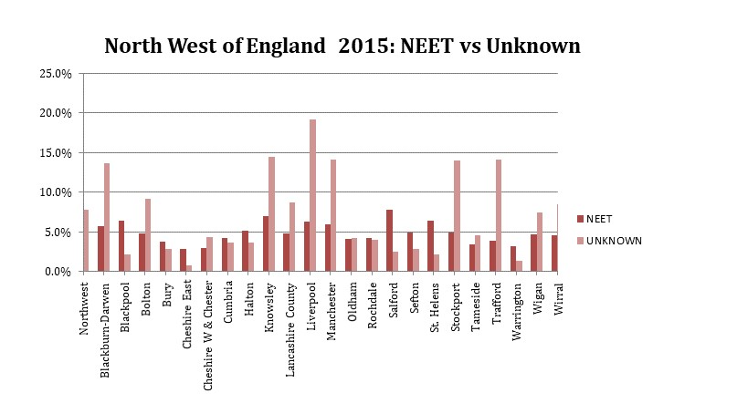
Figure 2: Breakdown by Borough Council of 16-18 year old NEETs in the North West, in comparison to those who activities / destinations are currently unknown, 2015. (Adapted from: DfE, 2016)

Hutchinson et al (2016) argues that the lack of resources and clear policy direction under the Coalition and later Conservative government, has only exacerbated the problem of ‘NEET’ with more disadvantaged and ‘at risk’ young people becoming ‘hidden’ in cycles of poverty. For instance, in large metropolitan boroughs such as Liverpool and Manchester, the rate of ‘unknown’ destinations has skyrocketed in contrast to being ‘NEET’. In a review by Greater Manchester Talent Match (2017), some of the recurring reasons given to remaining ‘hidden’ or ‘unknown’ in comparison to ‘NEET’ included a lack of capacity within Job Centre Plus at dealing with the complexities of being NEET (such as sanctioning processes), and disengagement with Job Centre Plus and partner organisations due to the lack of contextual knowledge locally about services that are designed to work with NEET young people. The points illustrated above are a clear indication of the failings of the current neoliberal arrangements / policies.
The top down approach of utilising Job Centre Plus, partner organisations and the rolling back of state intervention for NEET young people onto communities and voluntary organisations, have created a state where thousands of would-be ‘NEET’ young people have gone missing in the system. Limited attempts have been made in trying to trace ‘new’ actors that facilitate transition towards ‘EET’ destinations. Dixon et al (2011) offers a critical explanation of how the voluntary sector’s capacity needs to be increased. Part of the ‘capacity building process’ is to enable successful bidding on behalf of the Voluntary Sector for services that are ‘profitable’, but also address NEET to EET outcomes. While these schemes have been enacted successfully at a local level, this piecemeal approach has yet to be acknowledged and trailed / implemented on a national level.
This article has not intended to critique the work of the voluntary sector that has historically offered aid and assistance to thousands as an alternative to the state. However, this raises the question as to whether the role of charity organisations should be delivering services that have a young person-centric approach, rather than focusing on profit and payment by result motivations.

Destination Unknown: A time to rethink or abandon NEET policy?
This article has argued that rising numbers of would be NEET young people are ending up in unknown or highly precarious education, employment or training situations. Holistically, this only problematises the actors such as the voluntary sector, Job Centre Plus and local communities that have been expected to facilitate transitions towards EET in recent times. Although it has not been the focus of this article to critique the agencies that have accommodated difficult youth transitions, the neoliberal policy responses that have arisen from recent NEET policy have only created more issues for young people and practitioners. In the interim these Coalition / Conservative policies have produced a myriad of inefficient schemes in comparison to the streamlined New Labour strategy for NEET young people. As the Coalition / Conservative responses have subsequently collapsed and been replaced it can be concluded that a shift in NEET policy thinking is in order. This could include abandonment of the NEET term, or replacement of current policies by a social democratic approach that puts young people central rather than peripheral to such policy thinking with youth practitioners in shaping EET outcomes.
Acknowledgements:
Thank-you to the University of Liverpool for funding this research and the department of Sociology, Social Policy and Criminology. In particular Dr Andrew Kirton and Dr Susan Pickard. Liam would also like to thank the In Defence of Youth Work seminar that convened in Manchester (June 2017). The supportive environment and safe space to share ideas and knowledge was greatly appreciated. A personal thank-you to Dr Tania de St Croix, Dr Lisa Russell and Dr Danielle White.
In memory of Cassandra Jayne Dulson (1992-2016), NEET TV, Merseyside.
References:
Allatt, P. & Yeandle, S. (1992). Youth unemployment and the family: Voices of disordered times. London: Routledge.
Brooks, R. (2014). Out of Sight: How We Lost Track of Thousands of NEETs, and how We Can Transform Their Prospects. London: Fabian Society.
Cameron, D. (2015). PM Speech on Opportunity. 22 June 2015. [Online] 10/06/2017. URL. https:// www. gov. uk/ government/ speeches/ pm-speech-on-opportunity
de St Croix, T. (2011). Struggles and silences: Policy, youth work and the national citizen service. Youth and Policy, 106(4).
de St Croix, T. (2017). Time to say goodbye to the National Citizen Service? Youth and Policy. [online] URL: http://www.youthandpolicy.org/articles/time-to-say-goodbye-ncs/
DfE (Department for Education) (2016) ‘NEET data by local authority’. DfE: London. [Online] 11/06/2017.URL:https://www.gov.uk/government/publications/neet-data-by-local-authority-2012-16-to-18-year-olds-not-in-education-employment-or-training#history
DfE (Department for Education) (2017) ‘Young people not in education, employment or training (NEET), UK Statistical bulletins’. Statistical First Release. ONS: London. [Online] 11/06/2017. URL:https://www.ons.gov.uk/employmentandlabourmarket/peoplenotinwork/unemployment/bulletins/youngpeoplenotineducationemploymentortrainingneet/previousReleases
Dixon, L., Jones, E. & Southwood, S. (2011). Boosting capacity of third sector organisations to work with young people who are not in education, employment or training (NEET). London: Department of Business Innovation and Skills.
Eurofound (2016). Exploring the diversity of NEETs. Luxembourg: Publications Office of the European Union.
Furlong, A. (eds). ‘The changing landscape of youth and young adulthood’ in Furlong, A. (2016) Routledge Handbook of Youth and Young Adulthood. Second Edition. London: Routledge.
Furlong, A., & Cartmel, F. (2007). Young people and social change: new perspectives. Maidenhead: Open University Press.
GM Talent Match (2017) ‘Who are ‘hidden’ young people and why are they not engaging with welfare support?’ Manchester: GM Talent Match Reports. 10/06/2017 [Online].URL: https://gmtalentmatch.org.uk/sites/default/files/Hidden%20Research%20Report.pdf
Hancock, L., Mooney, G., & Neal, S. (2012). Crisis social policy and the resilience of the concept of community. Critical Social Policy, 32(3), 343-364.
Harvey, D. (2005). Neoliberalism: A brief history. Oxford: Oxford University Press.
Hollands, R. G. (1990). The Long Transition: class, culture and youth training. London: Macmillan Education.
Hutchinson, J., Beck, V., & Hooley, T. (2016). Delivering NEET policy packages? A decade of NEET policy in England. Journal of Education and Work, 29(6), 707-727.
Istance, D. Rees, G. and Williamson, H. (1994) Young People Not In Education, Training or Employment in South Glamorgan. Cardiff: South Glamorgan Training and Enterprise Council.
Nudzor, H. (2010). Depicting young people by what they are not: conceptualisation and usage of NEET as a deficit label. Educational futures, 2(2), 12-25.
Roberts, K. (2013). Career guidance in England today: reform, accidental injury or attempted murder?. British journal of guidance & counselling, 41(3), 240-253.
Simmons, R., Thompson, R., & Russell, L. (2014). Education, work and social change: Young people and marginalization in post-industrial Britain. Palgrave MacMillan: Hampshire.
Social Exclusion Unit (1999) Bridging the gap: New opportunities for 16-18 year olds not in education, employment or training. London: TSO.
Yates, S., & Payne, M. (2006). Not so NEET? A critique of the use of ‘NEET’in setting targets for interventions with young people. Journal of Youth Studies, 9(3), 329-344.
Biography:
Liam Wrigley is a second year PhD student and Graduate Teaching Assistant in the department of Sociology, Social Policy and Criminology at the University of Liverpool. His research interests focus on young people, difficult youth transitions and the voluntary sector.

