Electronic Supplementary Information (ESI†).

In situ Investigations of Halide Incorporation into Perovskite Solar Cells

Jeffery A. Aguiar^{a,b}*, Nooraldeen R. Alkurd^{c,d}, Sarah Wozny^{c}, Maulik K. Patel^{e}, Mengjin Yangª, Weilie Zhou^{c}, Mowafak. Al-Jassimª, Terry G. Holesinger^{f}, Kai Zhuª, and Joseph Berryª *
* Fuel Design and Development Directorate, Idaho National Laboratory, Idaho Falls, ID, 83401 USA. E-mail: Jeffery.Aguiar@inl.gov
ª Materials Science and Technology Directorate, National Renewable Energy Laboratory, Golden, CO, 80401 USA.
^{b} Materials Science and Engineering, University of Utah, Salt Lake City, UT, 84122 USA.
^{c} Advanced Materials Institute, University of New Orleans, New Orleans, LA, 70122 USA.
^{d} Department of Materials Science and Engineering, Colorado School of Mines, Golden, CO, 80401 USA.
^{e} Department of Material Science and Engineering, University of Tennessee Knoxville, Knoxville, TN, 37996 USA.
^{f} Materials Physics and Applications Division, Los Alamos National Laboratory, Los Alamos, NM, 87544 USA.

Performance of Mixed Halide Perovskite Solar Cell

Figure S1. Champion photocurrent density−voltage (J–V) characteristics of a planar perovskite FAPbI_{3-x}Cl_{x} solar cell prepared in a dry environment. Measurements were done under 100 mW/cm² AM 1.5 irradiation. Note forward and reverse bias scans are provided showing device hysteresis.

Structure of PbI₂ and PbCl₂ Precursor Solutions
Note the films are heavily textured and do not share the same theoretical structure factors.
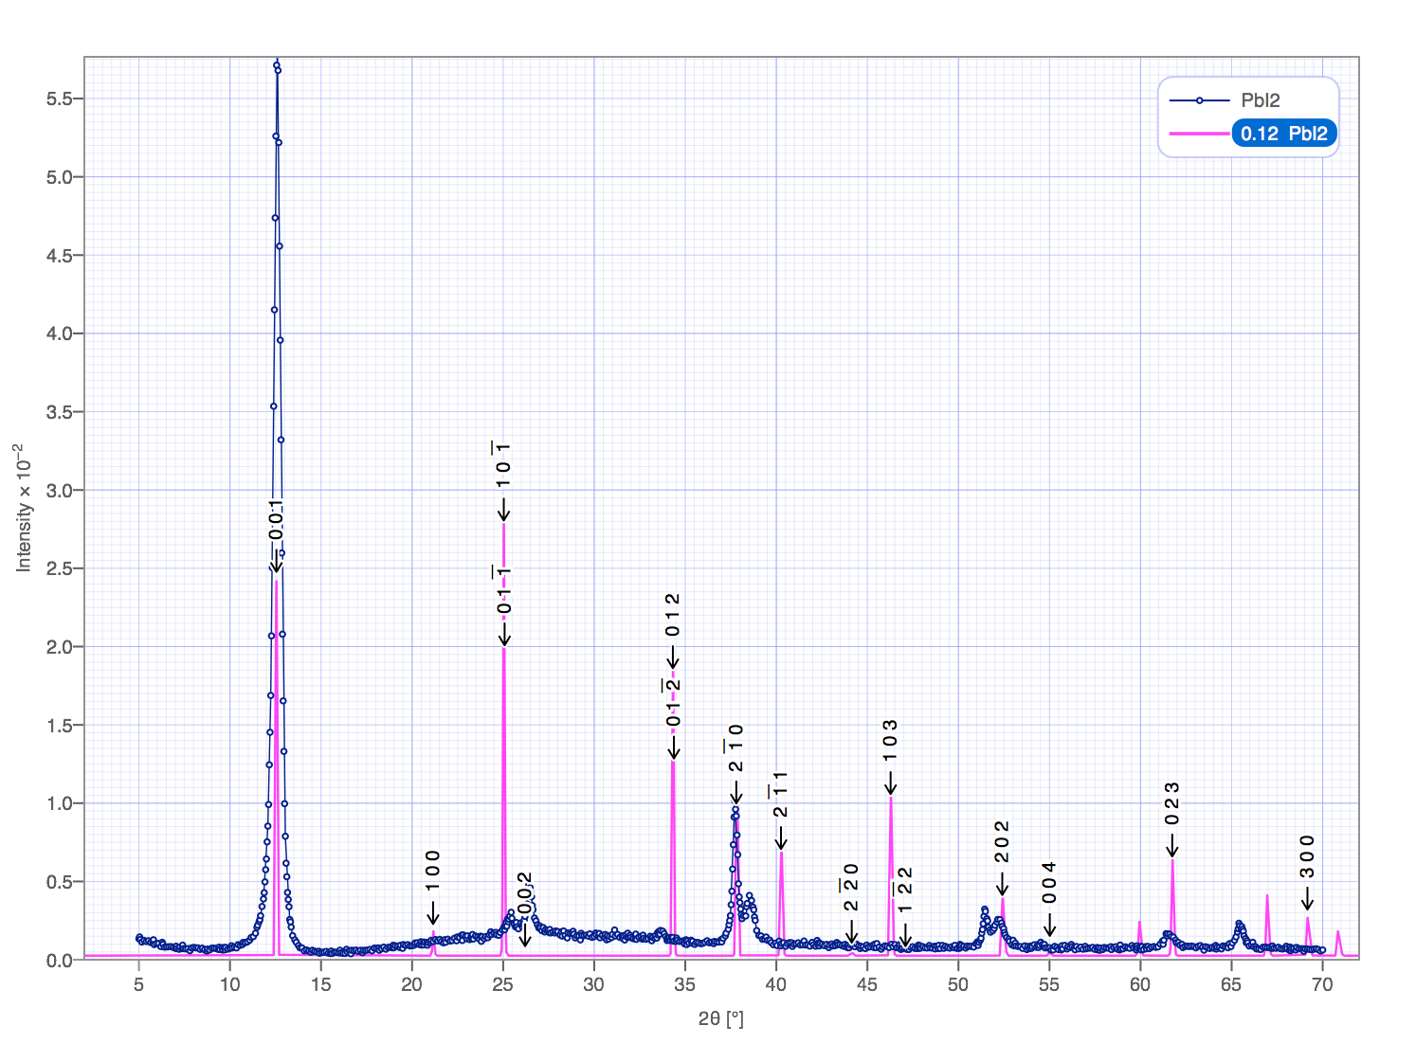
Figure S2. X-ray diffraction profile performed on the PbI₂ precursor material.

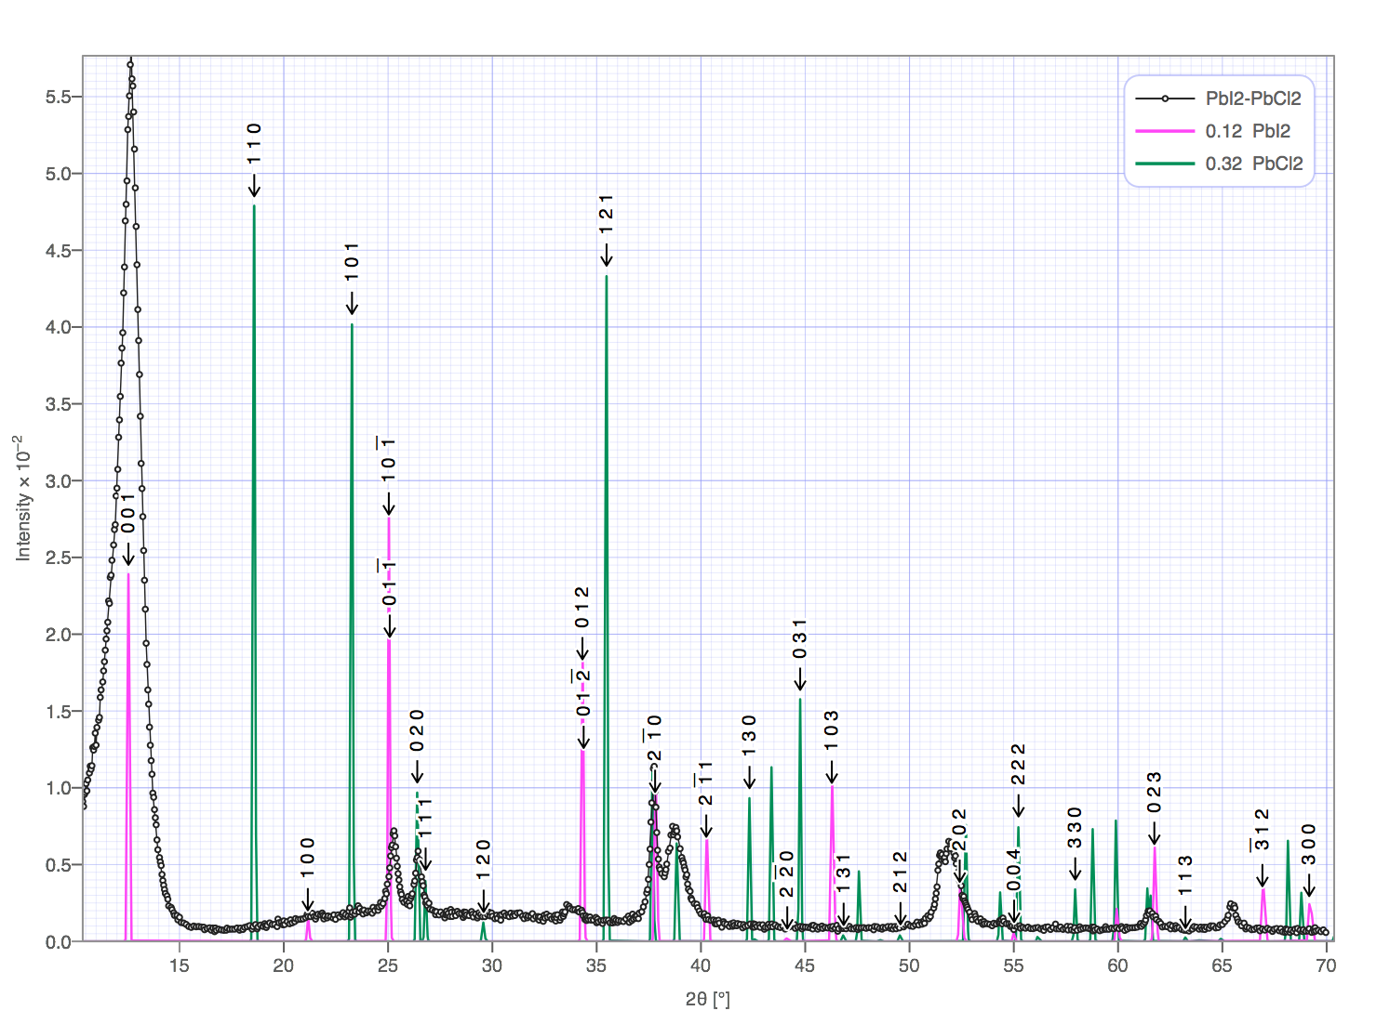
Figure S3. X-ray diffraction profile performed on the PbI₂ and PbCl₂ mixed salt solution precursor material.

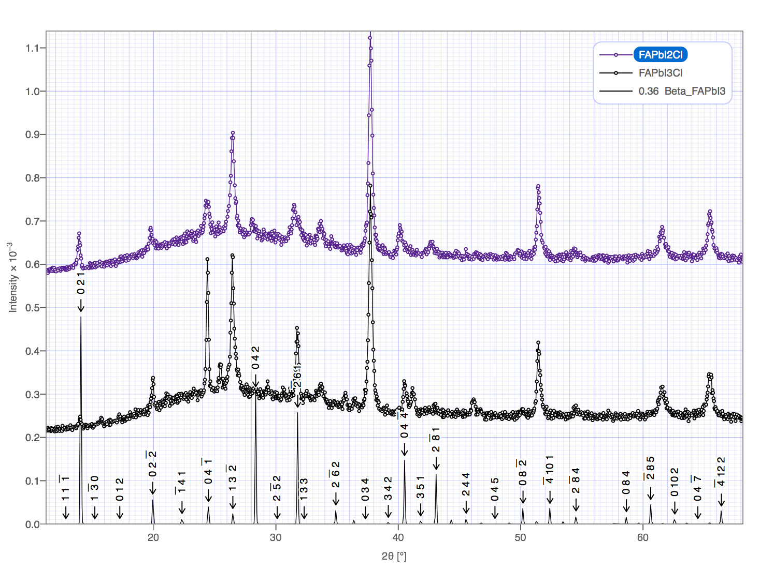
Figure S4. X-ray diffraction profiles performed on the FAPbI_{2-x}Cl_{x} and FAPbI_{3-x}Cl_{x}, compared against predicted perovskite crystal structure.

Figure S5. In situ STEM gas cell setup.

Device Fabrication and Performance

J_{sc} | 19.49 ± 0.74
V_{oc} | 0.86 ± 0.05
FF | 0.63 ± 0.03
η | 10.05 ± 0.80
Table S1 shows the device average and associated standard deviation over 10 devices. We note that the devices reported could be optimized further for higher efficiencies; however, this is out of the scope of this materials focused work.

