Abstract—A non-autonomous second-order memristive chaotic circuit is considered in this paper, which is comparatively simple, only consisting of a memristor, a capacitor, a resistor, and a sinusoidal voltage source. Based on the descriptive equation of the memristive circuit, the dynamical behaviors are investigated by theoretical analyses and numerical simulations. It is noted that the number of AC equilibrium points changes with the evolution of the time and the circuit exhibits striking dynamical features including period, chaos, forward period-doubling, reverse period-doubling, tangent bifurcation and crisis scenarios. Furthermore, a hardware circuit is set up by off-the-shelf discrete components, where hardware experiments are performed to verify the numerical results. The most significant feature of the proposed memristive circuit is the inductor-free realization with simplified topology, which makes the circuit much simpler and more intuitive in physical realization.
Non-Autonomous Second-Order Memristive Chaotic Circuit
Quan Xu, Qinling Zhang, Bocheng Bao, and Yihua Hu, Senior Member, IEEE

Index Terms—Memristive circuit, non-autonomous, chaos

INTRODUCTION
AS the fourth basic circuit element, memristor, described by flux and charge [1], brings completely new development space in various interdisciplinary areas. Specially, many researchers started to exploit memristor based application circuits due to the unique feature of memristor in the past few years [2]–[16]. Summarily, memristors with versatile nonlinearities are conveniently integrated into some existing linear or nonlinear electronic circuits to build various novel memristive chaotic circuits [17]. Some rich dynamics, such as chaotic and hyperchaotic behaviors [3], [4], hyperchaotic multi-wing attractors [2], [5], coexisting multiple attractors [6], [7], hidden attractors [8], complex transient chaotic and hyperchaotic behaviors [9]–[11], chaotic and hyperchaotic beats [10], [12], to mention a few, have been revealed from

these memristive chaotic circuits and analyzed by numerical simulations and hardware experiments. However, due to technical drawbacks and high cost in fabricating nanoscale devices, most of the memristors in those application circuits are equivalently realized by operational amplifiers and analog multipliers [7], [8], [13], [14], as well as memristive diode bridges cascaded with RC, LC or RLC filters [6], [15], [16].
Nonlinear electronic circuits have attracted appreciable attention because they can provide powerful experimental and analytical platforms for people to understand dynamical behaviors in physics [18], engineering [19], [20], electronic [21] and neurology [22]. Considering that a simple nonlinear electronic circuit can serve as a paradigm for better understanding of bifurcation and chaos, it is a significant research topic to simplify chaotic circuits by minimizing the number of dynamic elements and physical components [23]–[27]. Statistically speaking, non-autonomous circuits, one of the main forms of chaotic circuits, contain fewer dynamic elements than autonomous chaotic circuits since externally driven signals can replace a dynamic element or an oscillating unit in autonomous chaotic circuits [25]–[26]. Just like many autonomous chaotic circuits, non-autonomous nonlinear circuits can also exhibit many interesting dynamical phenomena [10]–[12].
However, in relevant literatures, most of those memristive chaotic circuits are at least fourth-order autonomous [15] or third-order non-autonomous [10], [12]. Additionally, when inductor-free realization without manually winding inductor is presented, the circuit can be regarded as a gadget, which is more suitable for IC design [27]–[29]. Motivated by those considerations, by replacing the passive LC filter with a standard sinusoidal voltage source in the existing memristive Chua’s circuit [7], the simplest second-order non-autonomous inductor-free memristive circuit is proposed in this paper. Dynamical behaviors of limit cycles and strange attractors are fortunately obtained by numerical simulations and hardware experiments. The aim of the present work is to reveal the unknown features in the proposed memristive chaotic circuit.

Non-autonomous memristive circuit
The schematic diagram of a new non-autonomous second- order memristive circuit and a memristor equivalent realization circuit are shown in Fig. 1. The proposed circuit is physically realizable and only consists of a capacitor C₁, a resistor R, a sinusoidal voltage source v_{s}, and a voltage-controlled W. Compared with the non-autonomous memristive circuits in
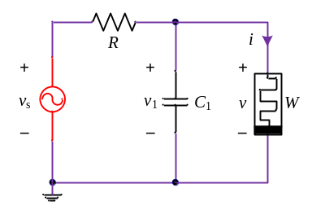
(a)
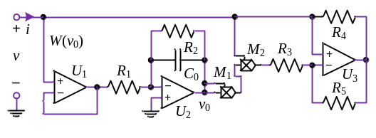
(b)
Fig. 1. Second-order non-autonomous inductor-free memristive chaotic circuit. (a) Circuit schematic diagram. (b) Equivalent circuit of memristor.
[10]–[12], the newly proposed circuit is second-order and inductor-free realization with a simplified topological structure outstandingly. Also, the comparisons of some non-autonomous memrisitve chaotic circuits are given in Tab.1.
Memristor is a nonlinear circuit element, which can be used to realize nonlinearity of the circuit in Fig. 1(a). According to [7], the equivalent realization circuit of the memristor is depicted in Fig. 1(b), which is mathematically modeled as
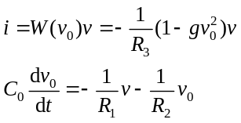 (1)
where v and i are the voltage and current at the input terminal of the memristor with memductance W(v₀), respectively. v₀ is the voltage across the integral capacitor C₀, and g is the total gain of the two multipliers M₁ and M₂.
The proposed circuit in Fig. 1(a) only has two dynamic elements, which are the capacitor C₁ and the active voltage- controlled memristor with memductance W(v₀), corresponding to two state variables of v₁ and v₀, respectively. Thus, the proposed circuit in Fig. 1(a) can be modeled as
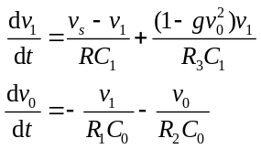 (2)
where v_{s} = Asin(2πft), and A is the amplitude and f indicates the frequency.
Taking advantage of the state equations modeled by (2), theoretical analyses and numerical simulations can be performed for the proposed non-autonomous memristive circuit. The typical circuit parameters in Fig. 1 are given as R₁ =
8 kΩ, R₂ = 4 kΩ, R₃ = 1.4 kΩ, R₄ = R₅ = 2 kΩ, C₀ = 4.7 nF, and g = 0.1 V^{–2}, R = 2.6 kΩ, C₁ = 6.8 nF, A = 2 V, and f = 7 kHz.

Tab. 1 Comparison of non-autonomous memristive chaotic circuits.
Items | Ref. [10] | Ref. [11] | Ref. [12] | Proposed circuit
Linear element | 1 capacitor  1 resistor  1 inductor | 2 capacitor  1 resistor  1 inductor | 2 capacitor  2 resistor  1 inductor | 1 capacitor  1 resistor
Memductance function | Piecewise linear | Absolute value | Piecewise linear | Quadratic
Complexity of emulator | Complex | Simple | Complex | Simple
Inductor-free | No | No | No | Yes
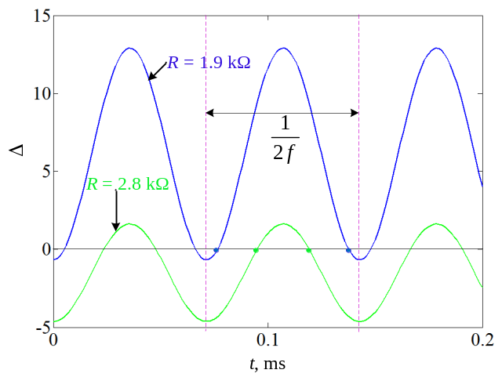
(a)
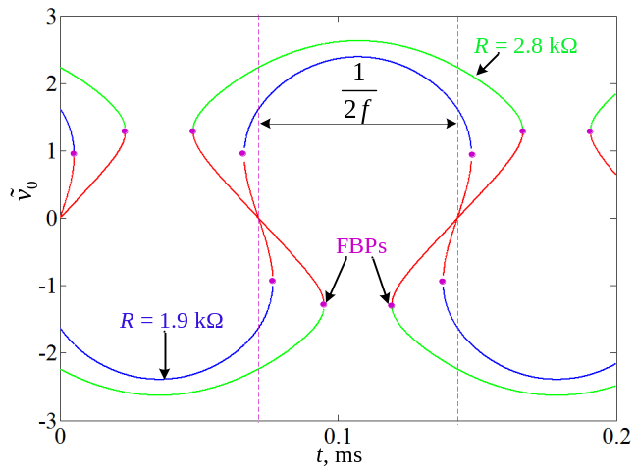
(b)
Fig. 2. Cradan discriminant and equilibrium points vary with the evolution of the time under different resisters of R. (a) Cradan discriminant. (b) Number and values of equilibrium points.

Equilibrium points and their stabilities
By setting the left-hand side of model (2) to zero, an AC equilibrium point is easily obtained as 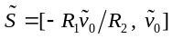, in which can be numerically solved by
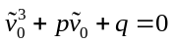 (3)
where 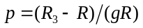 and 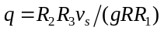. The roots of (3) can be derived as
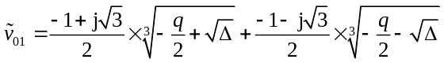 (4)
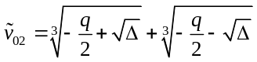 (5)
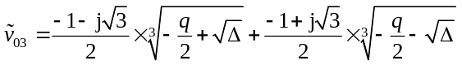 (6)
where 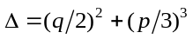.
According to Cardan discriminant [30], when Δ > 0, there exists a real root and two complex roots. Since the equilibrium point cannot be complex number, one equilibrium point is obtained from (5). However, when Δ = 0, the two complex roots in (4) and (6) evolve to one real root, leading to the fact that two real roots appear in (3). Therefore, the proposed circuit has two equilibrium points. Similarly, when Δ < 0, there are three real roots in (3), which manifests that the proposed circuit has three equilibrium points and can be obtained from (4) – (6). For the specified circuit parameters, when R varies from 1.9 kΩ to 2.8 kΩ, Cardan discriminant Δ and the number of equilibrium points with the evolution of the time are presented in Fig. 2. It can be seen from Fig. 2(a) that Δ is a periodic function of the time, and the sign of Cardan discriminant varies with the evolution of the time for each R, leading to the situation that the number of the equilibrium points changes from three to two, to one, to two and then to three in a half period of v_{s} between the two dotted lines, as shown in Fig. 2(b).
By linearizing (2) around AC equilibrium points, the Jacobian matrix is given by
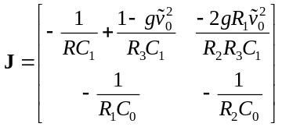 (7)
The characteristic equation associated with (7) is
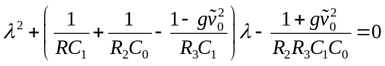 (8)
Depending on the eigenvalues at the AC equilibrium points, the stabilities are determined by the sign of Δ.

(i) When Δ < 0, there are two pairs of complex conjugate roots with negative real parts and two real roots with opposite signs for the three equilibrium points.
(ii) When Δ = 0, there are a pair of complex conjugate roots with negative real parts for one equilibrium point, and one zero root and one negative real root for the other.
(iii) When Δ > 0, there is a pair of complex conjugate roots with negative real parts for the unique equilibrium point.
It can be summarized that two stable foci and one unstable saddle point exist for Δ < 0, one stable focus and a fold bifurcation point (FBP) appear for Δ = 0, and one stable focus remains for Δ > 0. The red line denotes the unstable saddle point and the dots colored in cyan are FBPs in Fig. 2(b) specially. Note that the characteristic equation for FBP has one zero root and one negative real root.
In particular, when v_{s} = 0, the circuit in Fig. 1(a) is degraded into a second-order autonomous circuit. Thus, three DC equilibrium points for R > R₃ are yielded as
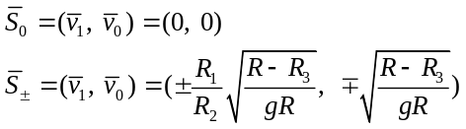 (9)
The stability of each DC equilibrium point is derived by solving the characteristic equation of (7) with . For the above given circuit parameters, the eigenvalues that characterize the stability of the DC equilibrium points are calculated as
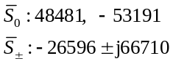 (10)
which indicate that 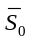 is an unstable saddle point and 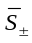 are two stable foci.

Numerically simulated dynamics
In our next work, typical circuit parameters given in Sec. II are employed and the initial states are taken as v₁(0) = 0 V and v₀(0) = 0 V. Furthermore, MATLAB ODE45 algorithm with time step 10⁻⁶ is utilized to draw bifurcation diagrams and phase portraits, and Wolf’s method proposed in [31] is used to calculate Lyapunov exponents.

Dynamics Depending On Parameter R
With R increasing from 1.9 kΩ to 2.8 kΩ, single-parameter bifurcation diagram of the state variable v₁ and Lyapunov exponent spectra are presented, as shown in Fig. 3, from which the striking dynamical features including period, chaos, forward period doubling bifurcation (FPDB), reverse period doubling bifurcation (RPDB), tangent bifurcation (TB), and crisis scenarios (CSs) are observed. In the considered parameter range of R, the dynamics starts from period-1, to period-2, to period-4, and then enters into chaos via the forward period doubling bifurcation route. Finally, the dynamics settles into period-1 via the reverse period doubling bifurcation. In the chaotic region, some periodic windows with different periodicities occur. When 1.9 kΩ ≤ R ≤ 1.98 kΩ, 2.19 kΩ ≤ R ≤ 2.46 kΩ, 2.51 kΩ ≤ R ≤ 2.58 kΩ or 2.69 kΩ ≤ R ≤ 2.8 kΩ, the circuit shows various periodic behaviors with the first Lyapunov exponent less than zero. However, when 1.98 kΩ < R < 2.19 kΩ, 2.46 kΩ < R < 2.51 kΩ or 2.58 kΩ < R < 2.69 kΩ, the first Lyapunov exponent is mainly positive, but it is less than zero in some narrow parameter ranges, which indicates the occurrence of chaotic behaviors with periodic windows. Note that the crisis scenarios happen at R = 2.19 kΩ and R = 2.58 kΩ with sudden appearance or disappearance of the chaotic behaviors, and the tangent bifurcation occurs in a periodic window with the chaotic state suddenly turning into period-5 at R = 2.51 kΩ.
For the arbitrary values of R and same initial states used in bifurcation diagrams, the trajectories of (2) on the v₁ − v₀ plane are numerically simulated, as shown in Fig. 4, respectively. The line colored in red denotes the trajectory of the unstable AC equilibrium point, and the lines colored in cyan denote the trajectories of stable AC equilibrium points. These numerical results just emulate the striking dynamical features of period
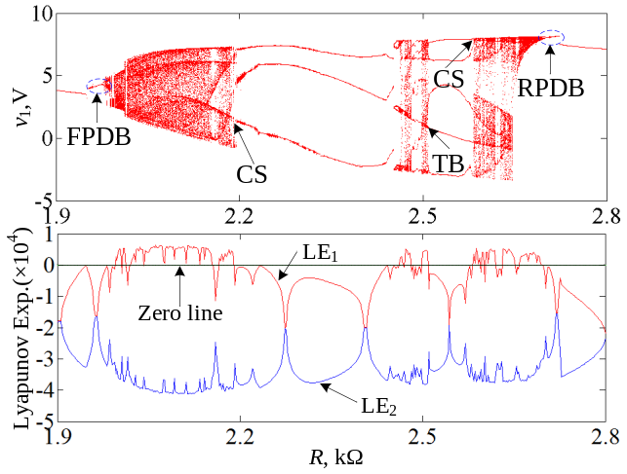
Fig. 3. Single-parameter bifurcation diagram of v₁ and Lyapunov exponent spectrum with R increasing.
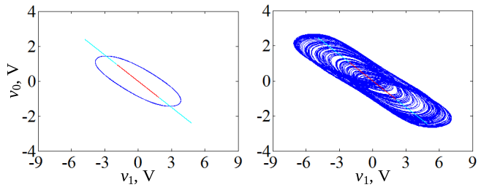
(a) (b)
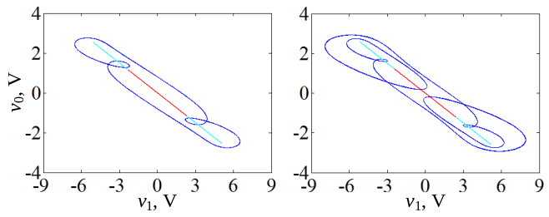
(c) (d)
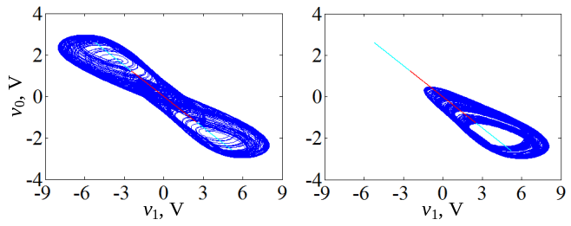
(e) (f)
Fig. 4. Numerical trajectories under different values of R on the v₁ – v₀ plane. (a) Period-1 limit cycle at R = 1.9 kΩ. (b) Chaotic attractor at R = 2.1 kΩ. (c) Period-3 limit cycle at R = 2.4 kΩ. (d) Period-5 limit cycle at R = 2.55 kΩ. (e) Double-scroll chaotic attractor (R = 2.6 kΩ). (f) Chaotic spiral attractor (R = 2.66 kΩ).
and chaos emerging from the proposed circuit. From Fig. 4, it is found that the proposed circuit in Fig. 1 can generate chaotic attractors with three different topological structures, which implies that the proposed circuit is chaotic genuinely.

Bifurcation Behaviors Depending On Sinusoidal Source

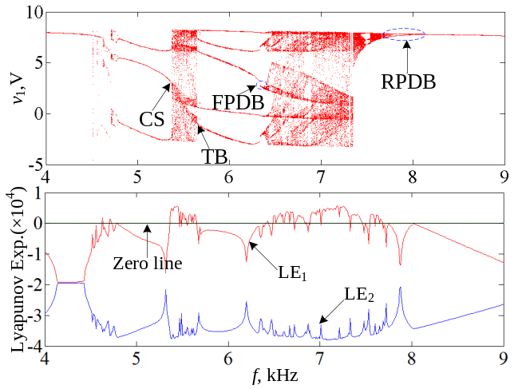
Fig. 5. Single-parameter bifurcation diagram of v₁ and Lyapunov exponent spectrum with f increasing.
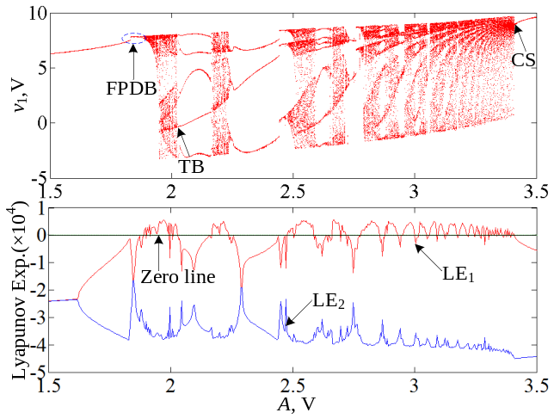
Fig. 6. Single-parameter bifurcation diagram of v₁ and Lyapunov exponent spectrum with A increasing.
With f increasing from 4 kHz to 9 kHz and A increasing from 1.5 V to 3.5 V, single-parameter bifurcation diagrams and Lyapunov exponent spectra are depicted in Figs. 5 and 6, respectively, which clearly indicate that the dynamical behaviors exist in the proposed circuit, including period, chaos, periodic window, forward period doubling bifurcation (FPDB), reverse period doubling bifurcation (RPDB), tangent bifurcation (TB), crisis scenario (CS), and so on.
In Fig. 5, there are periodic behaviors with the first exponent less than zero and chaotic behaviors with positive first Lyapunov exponent in the considered parameter range of the frequency f. The crisis scenario happens when f = 5.37 kHz and the tangent bifurcation occurs when f = 5.65 kHz. Nevertheless, when the amplitude is selected as a variable, the tangent bifurcation happens when A = 2.02 V and the crisis scenario occurs when A = 3.41 V, as shown in Fig. (6). It is interested that when 2.79 V ≤ A ≤ 3.41 V, the first Lyapunov exponent crosses the zero line alternately, which indicates that dynamical behaviors vary between periodic cycles and chaos as A increases.
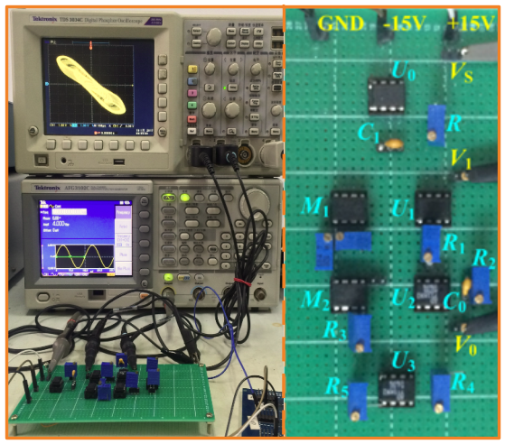
Fig. 7. The experimental circuit of the proposed circuit, the left is a overviewed graph and the right is an enlargement of circuit breadboard.
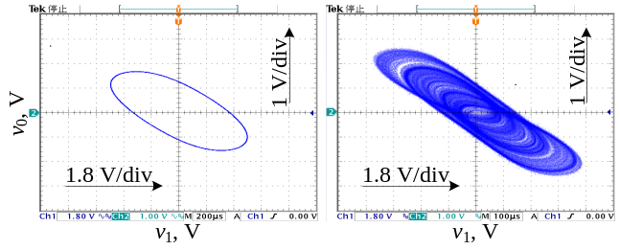
(a) (b)
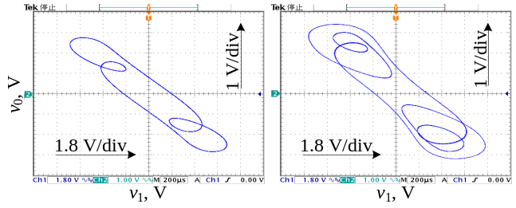
(c) (d)
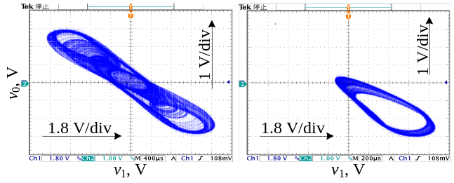
(e) (f)
Fig. 8. Attractors observed by digital oscilloscope under different values of R in the v₁ – v₀ plane. (a) Period-1 limit cycle at R = 1.9 kΩ. (b) Chaotic attractor at R = 2.1 kΩ. (c) Period-3 limit cycle at R = 2.4 kΩ. (d) Period-5 limit cycle at R = 2.55 kΩ. (e) Double-scroll chaotic attractor (R = 2.6 kΩ). (f) Chaotic spiral attractor (R = 2.66 kΩ).

Hardware experiments and captured attractors

With the circuit schematic in Fig. 1, an analogue electronic circuit is practically set up by some commercially available components, as shown in Fig. 7, where potentiometers and monolithic capacitors as well as operational amplifiers AD711KN and multipliers AD633JN with bipolar ±15 V supply are adopted. The circuit parameters used during numerical simulations are employed in hardware experiments and Tektronix AFG 3102C is taken as the sinusoidal voltage source. All of the resistors in our hardware experiments are replaced by precision potentiometers and their values are measured by Tonghui TH2816A Precision LCR Meter. Additionally, the experimental results are captured by a Tektronix TDS 3034C digital oscilloscope in XY mode with 1.8 V/ div in X direction and 1 V/div in Y direction. Note that one auxiliary voltage follower circuit realized by an operation amplifier AD711KN U₀ is hired in experimental measurements to isolate the applied sinusoidal voltage source.
A precision potentiometer is utilized for the adjustable R and its resistance is gradually tuned. For different values of R used in numerical simulations, the attractors observed by the digital oscilloscope in the v₁ – v₀ plane are shown in Fig. 8. Remark that ignoring the minor deviations caused by parasitic circuit parameters and active device non-idealities, the experimental results shown in Fig. 8 are well consistent with the numerical results in Fig. 4, which illustrates the existence of striking dynamics in the second-order non-autonomous inductor-free memristive chaotic circuit.

Conclusion
By driving a parallel memristor and capacitor filter with a sinusoidal voltage source, a simple second-order non- autonomous inductor-free memristive chaotic circuit is presented in this paper. Numerical simulations and the corresponding hardware experiments are performed, which indicate that the simple circuit has dynamical behaviors of limit cycles with different periodicities and chaotic attractors with three different topological structures. It is notable that the dynamical behaviors must be induced by the time-evolutional equilibrium points. Specially, compared with the pioneering works of non-autonomous chaotic circuits, the significant features of the proposed memristive circuit are that the circuit only contains two dynamic elements and is an inductor-free realization with hardware gadget, which is suitable for IC design.
References
- L. O. Chua, “The fourth element,” Proc. IEEE, vol. 100, no. 6, pp. 1920–1927, Jun. 2012.
- J. Ma, Z. Q. Chen, Z. L. Wang, and Q. Zhang, “A four-wing hyper-chaotic attractor generated from a 4-D memristive system with a line equilibrium,” Nonlinear Dyn., vol. 81, no. 3, pp. 1275–1288, Aug. 2015.
- I. Petráš, “Fractional-order memristor-based Chua’s circuit,” IEEE Trans. Circuits Syst. II Express Briefs, vol. 57, no. 12, pp. 975–979, Dec. 2010.
- A. L. Fitch, D. Yu, H. H. Iu, and V. Sreeram, “Hyperchaos in a memristor based modified canonical Chua’s circuit. Int. J. Bifurc. Chaos, vol. 22, no. 6, 1250133-1–1250133-8, Dec. 2012.
- L. Zhou, C. H. Wang, and L. L. Zhou, “Generating hyperchaotic multi-wing attractor in a 4D memristive circuit,” Nonlinear Dyn., vol. 85, no. 4, pp. 2653–2663, Aug. 2016.
- J. Kengne, Z. N. Tabekoueng, V. K. Tamba, and A. N. Negou, “Periodicity, chaos, and multiple attractors in a memristor-based Shinriki’s circuit,” Chaos, vol. 25, no. 10, 103126-1–103126-10, Oct. 2015.
- Q. Xu, Y. Lin, B. C. Bao, and M. Chen, “Multiple attractors in a non-ideal active voltage-controlled memristor based Chua’s circuit,” Chaos Solit.
Fractals, vol. 83, pp. 186–200, Feb. 2016.
- P. Saha, D. C. Saha, A. Ray, and A. R. Chowdhury, “Memristive non-linear system and hidden attractor,” Eur. Physs. J. Spec. Top., vol. 224, no. 8, pp. 1563–1574, Jul. 2015.
- B. C. Bao, Z. H. Ma, J. P. Xu, Z. Liu, and Q. Xu, “A simple memristor chaotic circuit with complex dynamics,” Int. J. Bifurc. Chaos, vol. 21, no. 9, pp. 2629–2645, Sep. 2011.
- A. I. Ahamed, and M. Lakshmanan, “Nonsmooth bifurcations, transient hyperchaos and hyperchaotic beats in a memristive Murali-Lakshmanan- Chua circuit,” Int. J. Bifurc. Chaos, vol. 23, no. 6, 1350098-1– 1350098-28, Jun. 2013.
- B. C. Bao, P. Jiang, H. G. Wu, and F. W. Hu, “Complex transient dynamics in periodically forced memristive Chua’s circuit,” Nonlinear Dyn., vol. 79, no. 4, pp. 2333–2343, Mar. 2015.
- A. I. Ahamed, K. Srinivasan, K. Murali, and M. Lakshmanan, “Observation of chaotic beats in a driven memristive Chuaʼs circuit,” Int. J. Bifurc. Chaos, vol. 21, no. 3, pp. 737–757, Mar. 2011.
- D. S. Yu, C. Y. Zheng, H. H. C. Iu, T. Fernando, and L. O. Chua, “A new circuit for emulating memristors using inductive coupling,” IEEE Access, vol. 5, pp. 1284–1295, Jan. 2017.
- H. H. C. Iu, D. S. Yu, A. L. Fitch, V. Sreeram, and H. Chen, “Controlling chaos in a memristor based circuit using a twin-T notch filter,” IEEE Trans. Circuits Syst. I, Reg. Papers, vol. 58, no. 6, pp. 1337–1344, Jun. 2011.
- H. G. Wu, B. C. Bao, Z. Liu, Q. Xu, and P. Jiang, “Chaotic and periodic bursting phenomena in a memristive Wien-bridge oscillator,” Nonlinear Dyn., vol. 83, no. 1, pp. 893–903, Jan. 2016.
- F. Corinto and A. Ascoli, “Memristive diode bridge with LCR filter,” Electron. Lett., vol. 48, no. 14, pp. 824–825, Jun. 2012.
- B. C. Bao, T. Jiang, Q. Xu, M. Chen, H. G. Wu, and Y. H. Hu, “Coexisting infinitely many attractors in active band-pass filter-based memristive circuit,” Nonlinear Dyn., vol. 86, no. 3, pp. 1711–1723, Aug. 2016.
- A. P. Kuznetsov, S. P. Kuznetsov, E. Mosekilde, and N. V. Stankevich, “Co-existing hidden attractors in a radio- physical system,” J. Phys. A: Math. Theor., vol. 48, no. 12, 125101-1–125101-18, Mar. 2015.
- J. S. Pei, P. W. Joseph, D. T. Michael, F. M. Sami, and G. B. Francois, “Understanding memristors and memcapacitors in engineering mechanics applications,” Nonlinear Dyn., vol. 80, no. 1, pp. 457–489, Apr. 2015.
- S. K. Duan, X. F. Hu, L. D. Wang, S. Y. Gao, and C. D. Li, “Hybrid memristor/RTD structure-based cellular neural networks with applications in image processing,” Neural Comput. Appl., vol. 25, no. 2, pp. 291–296, Aug. 2014.
- J. X. Zha, H. Huang, and Y. J. Liu, “A novel window function for memristor model with application in programming analog circuits,” IEEE Trans. Circuits Syst. II Express Briefs, vol. 63, no. 5, pp. 423–427, Mar. 2016.
- B. Arindam, “Small-signal neural models and their applications,” IEEE Trans. Biomedical Circuits Syst., vol. 6, no. 1, pp. 64–75, Feb. 2012.
- R. P. Jessica, and J. C. Sprott, “Simple autonomous chaotic circuit,” IEEE Trans. Circuits Syst. II Express Briefs, vol. 57, no. 9, pp. 730–734, Sep. 2010.
- M. Gotz, U. Feldmann, and W. Schwarz, “Synthesis of higher dimensional Chua circuit,” IEEE Trans. Circuits Syst. I, Fundam. Theory Appl., vol. 40, no. 11, pp. 854–860, Nov. 1993.
- D. Premraj, K. Suresh, T. Banerjee, and K. Thamilmaran, “An experimental study of slow passage through Hopf and pitchfork bifurcations in a parametrically driven nonlinear oscillator,” Commun. Nonlinear Sci. Numer. Similat., vol. 37, pp. 212–221, May. 2016.
- A. Arulgnanam, K. Thamilmaran, and M. Daniel, “Chaotic dynamics with high complexity in a simplified new nonautonomous nonlinear electronic circuit,” Chaos Solit. Fractals, vol. 42, no. 4, pp. 2246–2253, Nov. 2009.
- T. Banerjee, “Single amplifier biquad based inductor-free Chua’s circuit,” Nonlinear Dyn., vol. 68, no. 4, pp. 565–573, Jun. 2012.
- B. C. Bao, N. Wang, M. Chen, Q. Xu, and J. Wang, “Inductor-free simplified Chua’s circuit only using two-op-amps-based realization,” Nonlinear Dyn., vol. 84, no. 2, pp. 511–525, Apr. 2016.
- B. C. Bao, N. Wang, Q. Xu, H. G. Wu, and Y. H. Hu, “A simple third-order memristive band pass filter chaotic circuit,” IEEE Trans. Circuits Syst. II, DOI: 10.1109/TCSII.2016.2641008, Dec. 2016.
- C. Y. Han, S. M. Yu, and G. Y. Wang, “A sinusoidally driven Loren system and circuit implementation,” Math. Probl. Eng., vol. 2015, no. 3, pp. 706902-1–706902-11, May 2015.
- A. Wolf, J. B. Swift, H. L. Swinney, and J. A. Vastano, “Determining Lyapunov exponents from a time series,” Physica D, vol. 16, no. 3, pp. 285–317, Jul. 1985.

 Manuscript received May **, 2017; revised ****, 2017; accepted ****, 2017. Date of publication ****, 2017; date of current version****, 2017. This work was supported by the National Natural Science Foundation of China under Grant Nos. 61601062, and 51607013, and the Natural Science Foundations of Jiangsu Province, China under Grant No. BK20160282. Q. Xu, Q. Zhang and B. Bao are with the School of Information Science and Engineering, Changzhou University, Changzhou 213164, China (e-mail: xuquan@cczu.edu.cn, zhangqinling81@163.com, mervinbao@126.com). Y. Hu is with the Department of Electrical Engineering and Electronics, University of Liverpool, Brownlow Hill, Liverpool L69 3GJ, UK (e-mail: y.hu35@liverpool.ac.uk).

