Prediction of sound transmission in long spaces using ray tracing and experimental statistical energy analysis

Hyoseon Jang and Carl Hopkins
Applied Acoustics 2017;130:15-33

Prediction of sound transmission in long spaces using ray tracing and experimental statistical energy analysis

Hyoseon Jang and Carl Hopkins*
Acoustics Research Unit, School of Architecture, University of Liverpool, Liverpool, L69 7ZN, UK

*Corresponding author
Tel: +44 1517944938
E-mail: carl.hopkins@liverpool.ac.uk

Keywords: corridor; aircraft cabin; train carriage; long space

Abstract
Long spaces such as corridors, train carriages and aircraft cabins often have a significant decrease in sound pressure level along their length when a sound source is positioned at one end. However, the more common situation for noise control involves multiple sound sources positioned along their length. In order to use Statistical Energy Analysis (SEA) to predict spatial-average sound pressure levels along a long space when it is subdivided into a series of adjacent subsystems with one or more point sources, this paper combines ray tracing and a general form of experimental SEA (GESEA) to determine the loss factors. Predictive SEA that includes only direct coupling between subsystems (based on the open area) tends to over- or under-predict the decrease in SPL that is determined from ray tracing. This occurs when there is a point source at one end of an elongated cuboid that is either empty, has staggered barriers, or symmetrically-placed barriers. However, SEA using all Coupling Loss Factors (CLFs) determined from GESEA which incorporates indirect coupling and any negative CLFs shows almost exact agreement with ray tracing. This agreement is maintained when the point source is positioned in other subsystems, or point sources are positioned in multiple subsystems. This provides evidence of the importance of indirect coupling in long spaces, as has previously been identified with structure-borne sound transmission along a series of in-line coupled subsystems.

Introduction
For the purpose of noise control or the assessment of human perception, it is necessary to predict sound transmission along long spaces such as a corridor, train carriage or an aircraft cabin (see Fig. 1). These long spaces can be categorised into two generic types: (1) empty (see Fig. 1a), or (2) an unobstructed narrow corridor with either full-height barriers that run from floor to ceiling, partial-height barriers that are formed by seating, or a combination of full- and partial-height barriers (see Figs. 1b and 1c). When the sound source is at one end of the space, there can be a significant decrease in the Sound Pressure Level (SPL) along the length of the space. In addition, there can be zones along the space that have significantly different levels due to different noise sources injecting power at different positions along its length. Hence, subdividing a long space into several coupled volumes potentially allows prediction of sound transmission along a corridor into and out of rooms that are connected via doors, as well as the noise levels near seating positions in trains and aircraft due to mechanical and aerodynamic sources of noise.

Review of previous studies on sound transmission in long spaces
Corridors in buildings often show a decrease in the SPL over a distance, d. Early work by Yamamoto [] developed the following theoretical equation to calculate the decrease in SPL along an infinitely long corridor, ΔL_{inf}, assuming a semi-diffuse sound field in each cross-section:
where U is the perimeter of the corridor cross-section (U=2w+2h for a rectangular cross-section of width, w, and height, h), S=wh, α is the average absorption coefficient of the boundaries that form the corridor cross-section (i.e. side walls, floor, ceiling) and d is the distance travelled along the corridor. In Yamamoto’s equation, the constant, C=2.17. However, this appears to be incorrect and caused by use of 20log₁₀ rather than 10log₁₀ when calculating the decrease in SPL in decibels. Use of 10log₁₀ would have resulted in C=1.09. Yamamoto showed close agreement between his image source approach and measurements in a real corridor, but the theoretical model overestimated the measured decrease in SPL by a factor of two and this is attributed to the use of 20log₁₀.

Davies [] used a modal approach to predict sound fields along a corridor with consideration of open doors along the corridor, and branches off the corridor. Unfortunately the experimental validation was limited to one corridor at one frequency (2 kHz) with estimated values for all absorption coefficients. Redmore and Flockton [] developed theory using a similar approach to Yamamoto but their equation used C=10π/(8ln10)=1.71 which gave reasonable agreement with measurements from three different corridors. Redmore [] subsequently developed ray image models for corridors which gave close agreement for hard-walled corridors but tended to overestimate levels in corridors containing absorbent surfaces.

To avoid problems estimating absorption coefficients in real corridors, Redmore [] built scale model corridors where the absorption and cross-section could be altered. Linear regression was used to give an empirical version of Eq. (1) where C=1.4. It was noted that regression with measured data from real corridors gave C=1.7 and this slightly higher value was attributed to a lack of knowledge of the actual absorption coefficients. Hopkins [] subsequently showed that Redmore’s empirical equation could be derived theoretically by considering two-dimensional sound fields in cross-sections along the corridor to give the constant C=10/(4ln10)=1.38; hence in this paper it is referred to as a ‘propagating 2D model’. Kang [] notes that Redmore’s empirical equation is likely to be limited to corridors because when used for long enclosures up to 120 m in underground stations, the errors are significant. In corridors, the maximum distance between consecutive sets of fire doors to satisfy building regulations on fire safety [] is approximately 40 m. In reviewing the different prediction models for sound attenuation in long enclosures, Kang [7] concluded that “…it is still necessary to develop a more practical prediction method”. Whilst this also considered long enclosures such as underground tunnels and street canyons with line sources, these are not considered in the current paper. Picaut et al [] developed a theoretical model incorporating a diffusion coefficient to predict sound propagation along long spaces with diffusely reflecting boundaries. As real corridors rarely have diffusely reflecting boundaries over the entire building acoustics frequency range, this diffusion coefficient was determined from calculations of the mean free path.

The use of Statistical Energy Analysis (SEA) to predict sound transmission in corridors, train carriages, aircraft cabins and car cabins often involves subdivision of a space into coupled cavity subsystems. Long spaces can potentially be represented by a series of in-line, coupled cavity subsystems linked by large open areas. With reference to car cabins, Fahy [] noted that subdivision of a space had been criticized because the SEA assumption of ‘weak coupling’ would not apply to two coupled cavity subsystems without any impedance mismatch at the open boundary between them. No numerical or theoretical analysis was carried out by Fahy, but the qualitative discussion concluded that subdivision could be justified for a cabin when the sound field approximated a diffuse field, although the use of coupled cavities for long spaces might be more problematic.

To model a corridor in SEA, Craik [] proposed incorporating the Redmore and Flockton equation describing attenuation with distance. This approach essentially ‘forces’ the Coupling Loss Factor (CLF) to be a function of the Internal Loss Factor (ILF). An advantage of this approach is that it is possible to choose any model that has been validated for the space, such as the Redmore and Flockton equation, the propagating 2D model, or Picaut et al’s model.

For a train carriage, Forssén et al [] used an SEA model to predict sound transmission along its length (≈22 m) by subdividing it into five coupled cavity subsystems. The predicted energy for each subsystem was distributed along the subsystem length using the Redmore and Flockton equation to account for the decrease in SPL. Measurement of the spatial-average SPL in each cavity subsystem used microphones arranged in a straight line along the aisle at a height of 1.2 m (approximately corresponding to head height when seated). Comparison of measurements from a detailed scale model with ray tracing and SEA showed differences of up to ≈8 dB at 125 Hz but these reduced with increasing frequency to only ≈3 dB at 4 kHz. Differences between SEA and measurements could be attributed to the sole use of sampling positions along the aisle at a fixed height, rather than a random distribution of sampling positions in each subsystem to give a spatial-average SPL representing the entire cavity. Yang and Cheng [] used a two-subsystem SEA model to determine the sound energy in a long cavity subsystem and, in a similar way to Forssen et al, the energy was distributed along the length of the cavity subsystems using two different approaches. The first approach incorporated the Picaut et al model. The second approach was the same as Forssén et al which incorporated the Redmore and Flockton equation. Comparison of both approaches with scale model measurements approach showed agreement within ≈2 dB, except at positions near end walls. The inherent assumption in the approach used by Forssén et al and Yang and Cheng, is that net power transferred between coupled subsystems remains proportional to the difference in their modal energies, even when there is a large decrease in energy across the subsystem. Whilst this might be reasonable for rain-on-the-roof excitation (i.e. random phase, broadband sound sources with the same power output that are distributed throughout the elongated subsystem), it may not always be reasonable for a point source at one end of an elongated subsystem where the decrease in sound pressure level along its length is more than 10 dB.

Sadri et al [] considered an SEA model for vibroacoustic analysis of a train carriage which was updated using a Bayesian approach. The model had 142 subsystems of which 12 were coupled cavity subsystems representing the carriage volume (≈19 m length). Although the model included all the structural subsystems, power was only injected by one airborne source at a position in the aisle that was approximately in the middle of the carriage. Measurements were taken in a real carriage to determine the spatial-average SPL from an array of microphones arranged symmetrically in a set of three microphones across the cross section of the carriage. Two different microphone heights were used which approximately corresponded to head height for (a) the seat positions, and (b) standing in the aisle. As SEA predicts the reverberant SPL, the direct field was added to the predicted cavity energies. However, the only direct line of sight seemed to occur between the source and the microphones in the aisle because of the seats forming barriers. Hence if the direct field was significant, the model updating process might inadvertently manipulate the loss factors to compensate for inaccurate prediction of the direct field. Measurements and predictions with classical SEA showed reasonable agreement considering that (a) there was only one loudspeaker position (which was in direct line with the aisle microphones) and (b) symmetrically-placed, height-specific microphone positions were used in the cavity subsystems. The updated SEA model based on the measurements tended to show close agreement with those same measurements. However, the updating approach primarily altered the loss factors to gain agreement with the spatial-average SPL from the chosen set of microphone positions, rather than a spatial-average representing the entire cavity volume. In contrast, this paper considers the spatial-average representing the entire volume for each cavity as this is a more practical value for engineering design with SEA.

For an aircraft cabin, interior noise can vary significantly along its length depending on the proximity to various noise sources. For this reason, SEA subsystems tend to be defined by the internal layout of the cabin (e.g. business class, economy) and the galleys that demarcate the different cabin zones, or the structural subsystems (e.g. floor panels) that radiate into them. Cordioli et al [] used SEA to predict interior noise inside a narrow body executive jet (engines at the rear of the aircraft) due to the turbulent boundary layer, and engine noise and vibration. The cabin length (≈20 m) was subdivided into seven coupled cavity subsystems. An example was shown for one cavity subsystem near the front of the cabin indicating the main power inputs: at low-frequencies these were from the fuselage, floor and adjacent cavity subsystem towards the rear of the cabin; at mid-frequencies, these were the windows and the same adjacent cavity subsystem; and at high-frequencies they were the floor and galleys. This indicates the importance of correctly predicting the coupling between adjacent cavity subsystems when several sources of excitation are distributed along the long space; hence, multiple sources are considered in this paper. Wang and Maxon [] also modelled an executive aircraft using SEA by considering three main types of excitation: turbulent boundary layer, environmental control system and engine noise. Reasonable agreement was shown between the predicted and measured spatial-average SPL in the main cabin when divided into three sections (forward, mid and aft) which had large open areas between them. However, no details were given on the spatial sampling strategy used for measurements.

This paper pursues the development of SEA models for long spaces through the use of Experimental SEA (ESEA) to determine the loss factors. The “experimental” aspect refers to the use of either physical experiments on an existing long space, or numerical experiments using a ray tracing model; note that the use of numerical experiments to provide input data for ESEA is more common in the field of structure-borne sound than room acoustics (e.g. []). Woodhouse [] emphasized two points regarding ESEA. Firstly, it is useful in verifying that SEA is suitable to analyse a system before using it to predict the effect of any changes. Secondly, ESEA is crucial in determining CLFs when they are not easily calculated. Hodges et al [] investigated the optimisation of matrix-fitting routines to increase the chances of determining a loss factor matrix that could form the basis of an SEA model. However, Lalor [] noted that the ability to significantly alter CLFs implied that they might not be reliable and proposed an alternative ESEA matrix formulation to overcome the problem of ill-conditioned matrices. Hopkins [] showed that by creating an ensemble of similar systems, ESEA could be used to determine CLFs for bending wave transmission across junctions of coupled plates at low-frequencies where there were low mode counts and low modal overlap. This indicates the potential to use ESEA on systems where the response is primarily determined by the global modes of the system, such as a long space subdivided into subsystems with an open area between them. This differs from the situation in long factories and industrial spaces where there are many machines at ground level which scatter and absorb sound. Ribeiro and Smith [] subdivided a long industrial space into three subsystems and used ESEA to determine the CLFs. However, the Internal Loss Factors (ILFs) were calculated from estimates of the absorption coefficients for the room surfaces. The direct field was added to the SEA predictions but the results were found to be sensitive to the estimated ILFs with errors up to 8 dB.

In a long reverberant space, the response will primarily be determined by its global modes when the direct field is negligible. For such a space that is split into subsystems, the indirect coupling between non-adjacent subsystems is unlikely to be negligible [,]. Mace [22] describes SEA models incorporating indirect coupling as "quasi-SEA models" where an indirect coupling loss factor does not imply that energy flows between two subsystems which are not physically coupled, but that net power transfer between physically coupled subsystems also depends on the energy of a non-physically coupled subsystem. However, none of the literature reviewed above on SEA with corridors, train carriages or aircraft cabins has included, or considered, indirect coupling; hence this is considered in this paper.

Advanced SEA (ASEA) [] provides an alternative approach to predictive SEA using loss factors from ESEA. It was developed to incorporate indirect coupling (i.e. tunnelling mechanisms between indirectly connected subsystems) by using ray theory to track power flow and using SEA to account for any residual power. Heron [24] illustrated the importance of tunnelling with six coupled rods (in-line with each other) with longitudinal wave motion excited at one end of the rods (i.e. one-dimensional wave motion). However, a series of in-line SEA cavity subsystems forming a long space typically supports one-, two- and three-dimensional wave motion over the audio frequency range. For two-dimensional vibration fields, Yin and Hopkins [] used ASEA to investigate tunnelling for bending wave transmission across an L-junction comprising a periodic ribbed plate with symmetric ribs and an isotropic homogeneous plate. Indirect coupling was shown to be significant at high frequencies where each bay on the ribbed plate could be modelled as an individual subsystem. With excitation of the isotropic homogeneous plate, classical SEA significantly underestimated the energy of the bays due to the absence of indirect coupling in the model. Wilson and Hopkins [] used ASEA to model bending wave transmission across plates forming a linear box-like structure (i.e. an elongated cuboid subdivided by plates to form a row of rooms). This showed that spatial filtering of the two-dimensional vibration field across successive junctions led to non-diffuse fields on more distant plates but that ASEA could account for this by incorporating indirect coupling. There are potential parallels with two- and three-dimensional sound fields in long spaces where the direct field can be important, and angle-dependent absorption of the surrounding surfaces and symmetrical barrier layouts could introduce spatial-filtering and indirect coupling. In this paper, ray tracing is used to illustrate the potential importance of indirect coupling for a series of in-line cavity subsystems and to justify the calculation of indirect coupling loss factors with ESEA.

Aims
The main aim of this paper is to investigate SEA models for the prediction of sound transmission in long spaces where the loss factors are determined from ESEA by using ray tracing to provide input data for the ESEA calculations. Previous experimental findings from corridors, train carriages, and aircraft cabins have been tied to specific spaces where (a) the absorption coefficients of the boundaries and their reflective properties (specular or diffuse) were not known or quantified, and (b) there was limited spatial sampling of the sound field. For this reason, numerical experiments with ray tracing are used to model the sound fields so that all these properties can be prescribed. In these experiments, point sources are used in an elongated cuboid which has similar dimensions to a corridor.

To investigate the importance of the direct field and the validity of the Redmore and Flockton, and Picaut et al equations, the decrease in SPL along this empty space is determined from ray tracing assuming either specular or diffuse reflections. Ray tracing is then compared with (a) predictive SEA where the direct coupling between subsystems is based on the open area, with the direct field and forward propagating paths incorporated from ray tracing, and (b) SEA using loss factors from ESEA. This is used to assess the importance of indirect coupling and negative CLFs. A real empty corridor is used for experimental validation of ray tracing and assessment of the SEA models. SEA models using loss factors from ESEA are then assessed using the same elongated cuboid but with staggered barriers so that the influence of the direct field is removed. Experimental validation uses the same real corridor after the inclusion of partial-height barriers. The final stage is to use ray tracing to assess the elongated cuboid with symmetrically-placed barriers that form a central aisle which is more representative of a train carriage or an aircraft cabin.

Theory

Predictive SEA
To implement predictive SEA for a system that is comprised of N subsystems, the power balance equations are expressed using the following generalized matrix solution to determine the energy vector from
where η_{ij} is the CLF from subsystem i to j, η_{ii} is the ILF for subsystem i, E is the energy in subsystem i and W_{in,i} is the power injected into subsystem i.

The CLF from a three-dimensional diffuse sound field in subsystem i to subsystem j via a coupling area, S, with a non-resonant transmission coefficient, τ_{NR}, can be calculated from
where c₀ is the speed of sound (m/s), ω is angular frequency (rad·s⁻¹), V_{i} is the volume of subsystem i, and τ_{NR}=1 is assumed for an open area.

The ILF is given by
where U is the perimeter of the cross-section of the elongated cuboid, U=2L_{y}+2L_{z.}

Experimental SEA
Two formulations of ESEA are used to determine the loss factors: General ESEA (GESEA) and Alternative ESEA (AESEA). Both forms of ESEA use the Power Injection Method (PIM) in which one subsystem is excited at a time and the energy is measured in all subsystems; the process is then repeated by exciting each subsystem in turn. When using numerical experiments to carry out ESEA on structures it is common to use rain-on-the-roof excitation, e.g. unity magnitude, random phase forces applied over the surface of a plate subsystem [20]. However, physical experiments almost always use single point excitation; hence for the subsystems forming the long spaces in this paper, point sources are used for both numerical and physical experiments.

General form of ESEA
GESEA allows the existence of direct and indirect coupling loss factors using the following matrix formulation (e.g. see [20]) to determine the loss factor matrix:
where E_{ij} is the energy of subsystem i with power input into subsystem j.

As the number of subsystems increases, the energy matrix is prone to becoming ill-conditioned and inversion can lead to a loss factor matrix with negative CLFs or ILFs in some frequency bands []. If the system has been partitioned into suitable subsystems this might be caused by uncertainty in the energy terms. This can occur if these terms represent spatial-average energies that have been calculated from only a few positions in the subsystem. However, any negative loss factors cannot be attributed to uncertainty in the energy when ray tracing is used with a large number of grid points to accurately determine the spatial-average energy. In fact, Mace [22] notes that quasi-SEA models which rely on indirect CLFs can include negative CLFs. Hence failure of the matrix inversion to produce positive loss factors does not mean that the system is not suited to modelling with SEA. One possibility to try and avoid negative loss factors is to use matrix-fitting [18] although Lalor [19] noted that if the CLF could be significantly altered then any optimised values might not be reliable.

In this paper, two approaches are assessed with GESEA. The first approach uses all the CLFs including any that are negative. The second approach uses a modified set of CLFs that are determined using the following four rules to remove negative CLFs:

Rule No.1: If η_{ij} and η_{ji} are zero or positive then accept these values.
Rule No.2: If η_{ij} is negative then use the consistency relationship in Eq. to estimate it from η_{ji},
where n_{i} is the modal density of subsystem i.
Rule No.3: If η_{ij} and η_{ji} are negative then set them both to zero.
Rule No.4: If the Total Loss Factor (TLF) of a subsystem is lower than the sum of its CLFs then the TLF is replaced with the sum of CLFs that have been modified according to Rule Nos. 1, 2 and 3.

Note that for some SEA systems, it is not feasible to implement Rule No.2 if the modal density of subsystems i and j are unknown. However, the statistical modal density can be used as an approximation. Fortunately, most long spaces are subdivided into subsystems with equal volumes for practical reasons; hence only the ratio of modal densities is required, which can then be assumed to be unity.

Alternative form of ESEA
AESEA was proposed by Lalor [19] to avoid the problem of ill-conditioned matrices which is partly achieved by only considering direct coupling between subsystems. AESEA treats the calculation of ILFs and CLFs separately to reduce the problems caused by large ill-conditioned matrices. The CLFs are calculated using
and the ILFs are calculated using

Ray tracing
ODEON software (v14.01) is used to carry out ray tracing based on a combination of ray tracing and the mirror image source method [] with a transition order of two. All models use 320,000 rays and an impulse response length of 80% of the Sabine reverberation time. Air absorption was not included in the model.

A point source is used with SPLs predicted on a rectangular grid. This grid has 0.25 m spacing in the x- and y-directions, and 0.62 m (idealised cuboids) or 0.5 m (real corridors) in the z-direction. The spatial-average SPL over each subsystem volume was calculated using grid points that were ≥0.5 m from the boundaries.

The boundaries are modelled using a scattering coefficient, s, where s=0 represents specular reflections, and s=1 represents diffuse reflections. The effect of diffraction by barriers on sound transmission in the corridor models was found to be negligible by comparing models with and without diffraction; hence, it was not included.

Sound propagation from the reverberant source subsystem
The importance of the direct field is expected to increase with increasing values of the absorption coefficient used for the boundaries. Classical SEA only models reverberant fields; hence it is necessary to predict the direct field from the source into the receiving subsystems. To gain insights into the indirect field, ray tracing is used to calculate three types of propagation from the point source to receiver points along the cuboid. The direct field (referred to as a Type 1 sound field) is considered alongside Type 2 and 3 sound fields involving reflections from corridor surfaces as indicated in Fig. 2. The Type 1, 2 and 3 sound fields are added to the reverberant energy predicted from SEA for each subsystem. This is carried out by using ray tracing to calculate the SPL at grid points when the actual absorption coefficient of specific boundaries is changed to be anechoic (i.e. α=1) as indicated in Fig. 2. The average SPL for Types 1, 2 and 3 in each of the N subsystems in the SEA model is energetically added to the predicted SPL from SEA.

Type 1 describes rays that propagate directly from the point source to grid points in a subsystem when all the boundaries are anechoic (i.e. the direct field).

Type 2 describes rays which are only reflected from boundaries in the source subsystem (i.e. subsystem 1) before reaching grid points in each of the other subsystems. All the boundaries are made anechoic except those in the source subsystem which have the actual absorption coefficient. The SPL is then determined at all grid points in subsystems 2 to N (i.e. all subsystems except source subsystem 1).

Type 3 describes rays which are reflected at least once outside the source subsystem (i.e. subsystem 1) before reaching the grid points in the receiving subsystems. Hence to determine the SPL at all grid points in receiving subsystem n, all the boundaries in subsystems 1 to n-1 have the actual absorption coefficient and all the boundaries of subsystems n to N are anechoic.

For Types 2 and 3, the energy in subsystems further down the corridor is always higher with specular reflections compared to diffuse reflections. This is because specular reflections are biased towards forward propagation away from the source along the long space, whereas the probability of diffuse reflections resulting in purely forward propagation decreases with increasing number of reflections. In addition, diffuse reflections tend to have longer path lengths than specular reflections; hence more energy is lost due to larger distances being travelled and more reflections from absorbent boundaries.

Idealized cuboids used to assess theoretical models
The idealised cuboid used for numerical modelling has dimensions of 30 m × 1.5 m × 2.5 m and is considered with the following three models that are shown in Fig. 3: (1) empty, (2) with full-height, staggered barriers, and (3) with full-height, symmetrically-placed barriers. In each case the corridor is arbitrarily subdivided into six subsystems. Note that the open area between subsystems is the same for both staggered and symmetrically-placed barriers. For models (2) and (3), the barriers are positioned at the interface between adjacent subsystems.

To determine the decrease in SPL the point source is positioned at (0.25 m, 0.25 m, 0.25 m). The boundaries of the space and surfaces of the barriers are all given the same absorption coefficients of either 0.1, 0.3 or 0.6.

Models describing the decrease in SPL with distance

Propagating 2D model
After travelling a distance, d, down a long space where the end surface (positioned at x=D) has a reflection coefficient, R, the decrease in SPL, ΔL, is [3]
where ΔL_{inf} is given by Eq. (1) where C=10/(4ln10)=1.38 [6].

For a long space with staggered barriers as indicated in Fig. 3(b), a modified propagating 2D model is required to account for the transmission past each barrier by adding the term 10log₁₀(S_{open}/S_{total}) where S_{open} is the open area and S_{total} is the complete cross-sectional area of the long space.

Model for diffusely reflecting boundaries from Picaut et al
Picaut et al [9] used the diffuse equation to predict the decrease in SPL along the length of a long space by considering two parameters, the diffusion coefficient depending on the mean free path and an exchange coefficient related with wall absorption. For a long space with dimensions (l_{x},l_{y},l_{z}) and a point source near one end, the energy density of the diffuse field is given by
where
in which the exchange coefficient, h, is defined as
where α₁ and α₂ are the absorption coefficients of the end surfaces at x=0 and x=l_{x} respectively, α is the absorption coefficient of the other surfaces, and the diffusion coefficient, D, is calculated from the mean free path, λ, using
Picaut et al noted that the mean free path for a three-dimensional space (i.e. λ=4V/S_{T} where V is the volume and S_{T} is the total surface area) only gave reasonable estimates of the decrease in SPL along rooms with large cross section; hence the following mean free path was used in Eq. from []

3. Experimental work

Corridor details
Measurements are undertaken on a real corridor (54.5 m × 2.1 m × 2.3 m) when (a) empty as shown in Fig. 4, and (b) with partial-height, staggered barriers as shown in Fig. 5.

The corridor surfaces are plasterboard on the walls and ceiling, and linoleum on the concrete floor. On both sides of the walls there are some windows. Absorption coefficients were taken from the ODEON database [28] as indicated in Tables 1 and 2. The values for windows were taken directly from the database, whereas the absorption coefficient for the walls, floor and ceiling was an average value based on plasterboard on studs, and linoleum on the concrete floor. For the walls and ceiling it was not possible to identify the exact plasterboard construction and the thickness of the air cavity; it was assumed that this uncertainty would primarily affect the low-frequency range below the 250 Hz octave band. For this reason, ODEON models are only used at and above the 250 Hz octave band.

Five partial-height, staggered barriers (standard office partitions) are located every six metres along the 36 m length of the corridor. Each barrier cross-section is 1.5 m × 1.8 m. The absorption coefficient of these barriers was measured in a reverberation chamber with a volume of 122 m³. Although the measurement procedure was carried out in accordance with ISO 354 [], the room volume was smaller than the minimum of 150 m³ and the recommended volume of 200 m³. As the accuracy of absorption measurements in small volumes is known to be problematic [], the measured absorption coefficients for each barrier surface are given in Table 3 for which it was assumed that valid estimates were only obtained in and above the 250 Hz octave band.

Measurement set-up
A reference sound source (B&K Type 4204) which had a relatively flat spectrum over the frequency range of interest was positioned at one end of the corridor.

A sound level meter (NTi AUDIO XL2-TA) was used to measure sound pressure levels in terms of L_{eq,30s} in one-third octave frequency bands between 200 Hz and 10 kHz. These bands were combined to give octave bands between 250 Hz and 8 kHz. Background noise was measured to ensure that the sound level was at least 10 dB above background. A windscreen was used on the microphone to minimise any effect of airflow from the centrifugal fan of the sound source.

In the empty corridor, measurements were taken to give a spatial-average sound pressure level over the corridor cross-section in 1 m steps down the corridor to give a total of 54 spatial-average values. Each spatial-average was calculated from three random microphone positions in each cross-section using positions that were ≥0.5 m from the boundaries – see Fig. 6.

In the corridor with the staggered barriers, six random microphone positions were chosen (≥0.5 m from the boundaries) in each subsystem as indicated in Fig. 7. To carry out the PIM for ESEA, measurements were taken with the source in each of the six subsystems in turn.

Results and analysis

Empty, elongated cuboid

Idealized model
Ray tracing for the idealized, empty, elongated cuboid is used to calculate the decrease in SPL along its length when the point source is at one end. The SPL is averaged over each cross-section along the length of the cuboid at 0.25 m intervals. The decrease in SPL is referenced to the cross-sectional plane containing the point source at a distance of 0.25 m from one end, referred to as 0 m on the figures.

For absorption coefficients of α=0.1, 0.3 and 0.6, Fig. 8 compares the direct field with ray tracing using specular or diffuse reflections. For specular reflections, the results show that the reverberant field is more important than the direct field when α=0.1, but that the direct field becomes increasingly important when α=0.3 and α=0.6. In contrast, diffuse reflections increase the relative importance of the direct field compared to the reverberant field when α=0.3 and α=0.6. As noted by others [,] these results indicate that the decrease in SPL is larger with diffuse reflections rather than specular reflections. In practice, relatively few long spaces will have α≥0.6 on all surfaces and diffusely reflecting surfaces. For this reason, it is not possible to predict the sound field by considering only the direct field, and it is necessary to consider the combination of the direct and reverberant fields.

The proposed subdivision of the cuboid into six subsystems of 5 m length is justified because the largest decrease in SPL within a subsystem is only 5.3 dB (this occurs in subsystem 2 when α=0.6).

The applicability of the SEA-based approaches proposed by Craik [11], Forssén et al [12] and Yang and Cheng [13] relies on the validity of models which give the decrease in SPL along the long space. This is likely to depend on the level of absorption and whether it is reasonable to assume that all surfaces result in either specular or diffuse reflections. This provides the incentive to investigate the validity of the propagating 2D model and Picaut et al model for the same idealized cuboid. Hence, Fig. 9 compares ray tracing against both these equations with and without the direct field. This shows that the choice of specular or diffuse reflections in ray tracing gives predictions that differ by up to 15 dB when α=0.1, but are <7 dB when α=0.3 or 0.6.

When the direct field is added to the propagating 2D model and the Picaut et al model, the SPL in the plane containing the point source at a distance of 0.25 m from one end is significantly increased. This causes the decrease in SPL for the propagating 2D model and the Picaut et al model with the direct field to be higher than without the direct field. Comparing the propagating 2D model (with or without the direct field) to ray tracing (specular or diffuse reflections) shows that the propagating 2D model underestimates the decrease in SPL along the entire length of the cuboid when α=0.1, but is similar when α=0.3 and overestimates when α=0.6. Comparison of the Picaut et al model (with or without the direct field) to ray tracing (specular or diffuse reflections) indicates that they are similar when α=0.1 and α=0.3, but the Picaut et al model overestimates when α=0.6. When α=0.1 both the propagating 2D model and the Picaut et al model (with or without the direct field) show closer agreement with ray tracing assuming specular rather than diffuse reflections. This indicates that with specular reflections the reverberant field dominates over the direct field as indicated previously on Fig. 8(a). With high levels of damping, such as α=0.6, inclusion of the direct field into the propagating 2D model and the Picaut et al model is essential to give a reasonable estimate of the decrease in SPL.

Neither the propagating 2D model nor the Picaut et al model is suited to all possible absorption coefficients, or the assumption that all surfaces provide either specular or diffuse reflections (and in practice, different surfaces may provide specular or diffuse reflections). Hence whilst these models are useful indicators they are not sufficiently versatile to embed in SEA models. This provides the motivation to investigate the use of SEA and ESEA with ray tracing where the scattering coefficient can be different for each surface.

The next step is to compare ray tracing with SEA, which requires subdivision of the cuboid into six subsystems (5 m in length) and the spatial-average SPL in each subsystem – see Fig. 10. By considering spatial-average values, it is now seen that ray tracing assuming specular and diffuse reflections give increasingly similar results as the absorption coefficient is increased from 0.1 to 0.6. When α=0.1 there is reasonable agreement between SEA and ray tracing assuming diffuse reflections but not with α=0.3 and 0.6. This may be due to the highly reverberant three-dimensional sound field that is built up in subsystem 1 when α=0.1 which satisfies the assumption used to calculate the CLF using Eq.

Ray tracing is now used to calculate the direct field in the SEA subsystems as well as the sound field attributed to Type 2 and 3 sound fields that were defined in Section 2.3.1. Previously in Fig. 8 it was seen that the direct field was not important when α=0.1. Hence the cuboid with α=0.3 is considered for which Fig. 11 plots SEA with and without Type 1, 2 and 3 sound fields for comparison with ray tracing. This confirms that it is not sufficient to include only Type 1 (direct field) and that inclusion of Type 2 and 3 sound fields are needed to give reasonable estimates with SEA. Note that Types 1, 2 and 3 are equally important to improve the accuracy of SEA for specular reflections, but for diffuse reflections the inclusion of Type 3 is less important. The accuracy of SEA with and without sound propagation tends to decrease with increasing distance from the source.

In contrast to SEA incorporating Type 1, 2 and 3 sound fields, SEA using all CLFs from GESEA shows almost exact agreement with ray tracing in Fig. 11. The direct CLFs determined using GESEA differed from the values predicted using Eq. for specular and diffuse reflections. There were no instances of direct CLFs that were negative with GESEA but there were indirect CLFs that were negative; these were η₃₁, η₄₂, η₅₁, η₅₃, η₆₂, and η₆₄. SEA using modified CLFs from GESEA replaced these negative CLFs using Rule No.2 (see section 2.2.1 and the four TLFs that were lower than the sum of the CLFs (η₃, η₄, η₅, and η₆) were replaced by the sum of the CLFs to ensure that the SEA matrix was diagonally dominant. The resulting SEA prediction using the modified CLFs from GESEA is similar to SEA with Type 1, 2 and 3 sound fields, but in the more distant subsystems the agreement with ray tracing is not as close to SEA using all CLFs from GESEA.

Note that when α=1 for all the corridor surfaces, and the concept of stored modal energy is no longer valid, GESEA still gives a set of CLFs from which SEA using all CLFs from GESEA will predict the exact SPLs in the six volumes (NB They are described as volumes because, strictly speaking, they can no longer be described as subsystems). If the source positions used for PIM is exactly at the mid-point of these volumes then GESEA gives indirect CLFs but they are not negative. However, if the source positions used for PIM are as indicated in Fig. 11 (i.e. off-centre in each volume) then GESEA gives some indirect CLFs that are negative and these are essential to predict the exact SPLs in the six volumes. The implication is that indirect CLFs (positive and/or negative) from GESEA can account for the specificities of the direct field as well as the response determined by global modes (described in [22]).

Experimental validation
Fig. 12 allows comparison of measurements, ray tracing and different SEA models in octave bands for the real corridor. Results for specular reflections are shown between 250 Hz and 8 kHz because all the corridor surfaces are relatively smooth. However, at high frequencies it is appropriate to consider results assuming diffuse reflections from all surfaces; hence these results are shown between 2 kHz and 8 kHz. In general, measurements showed close agreement with ray tracing assuming specular reflections between 500 Hz and 4 kHz, and with ray tracing assuming diffuse reflections at 8 kHz. The lack of agreement between measurements and ray tracing at 250 Hz is attributed to an inaccurate estimate of the absorption coefficient used in the ray tracing, rather than measurement uncertainty because the standard deviation for the spatial variation of SPL in each subsystem was <1 dB. For this reason, the 250 Hz data is not considered further when assessing the different SEA models.

Predictions using SEA with and without Type 1, 2 and 3 sound fields are within 5 dB of each other between 500 Hz and 8 kHz. This is attributed to the average absorption coefficients being <0.1 which means that the Type 1, 2 and 3 sound fields do not significantly influence the overall SPL compared to the reverberant field. In general, predictive SEA overestimates the decrease in SPL compared to measurements and ray tracing assuming specular reflections. In contrast, SEA using all CLFs from GESEA shows almost exact agreement with ray tracing assuming specular reflections. SEA using modified CLFs from GESEA based on ray tracing assuming specular reflections shows closer agreement with measurements than SEA with or without Type 1, 2 and 3 sound fields between 500 Hz and 4 kHz. GESEA gave six negative indirect CLFs (out of the 24 indirect CLFs) when using ray tracing assuming specular reflections and the rules in section 2.2.1 were used to modify them.

At 8 kHz, measurements tend to show closest agreement with SEA with or without Type 1, 2 and 3 sound fields. Comparison of Fig. 12(f) and (i) indicates that at 8 kHz the measurements show closest agreement with ray tracing assuming diffuse rather than specular reflections. For this particular corridor, this suggests that modelling the boundaries with diffuse rather than specular reflections is a reasonable approach at 8 kHz. SEA using all CLFs from GESEA shows almost exact agreement with ray tracing assuming diffuse reflections whereas SEA using modified CLFs from GESEA only shows close agreement for the first few subsystems.

Elongated cuboid with staggered barriers

Idealized model
For the idealized, elongated cuboid with full-height, staggered barriers there is no direct line of sight from the point source in subsystem 1 into subsystems 3, 4, 5 and 6 (and only into a small region near the aperture between subsystems 1 and 2). For comparison with the empty cuboid (Fig. 11), the cuboid with staggered barriers also assumes α=0.3 for all surfaces including the barriers. Fig. 13 allows comparison of ray tracing with specular and diffuse reflections, SEA, and SEA using CLFs from GESEA. From the ray tracing, the decrease in SPL with distance is higher with diffuse rather than specular reflections due to additional energy losses by the increased likelihood of rays travelling longer distances.

In contrast to the empty cuboid there are different possibilities to position the source for the PIM; hence two different configurations of source positions, No.1 and No.2, were used to carry out GESEA in subsystems 2 to 6 (i.e. always keeping the same source position in subsystem 1 that is used to assess the decrease in SPL). Fig. 13 shows that SEA using all CLFs from GESEA is in almost exact agreement with ray tracing assuming specular reflections with both configurations of source positions. However, when diffuse reflections are assumed in ray tracing, there is exact agreement when negative CLFs are included, but when they are excluded the agreement depends on the configuration of source positions. For specular reflections, configuration No.1 shows closer agreement with ray tracing than No.2. In addition, it is notable that the standard deviation of the direct CLFs from configuration No.1 is only 0.4 dB compared to a standard deviation of 1.2 dB with configuration No.2. As it is logical for all the direct CLFs between nominally identical subsystems to be the same, this provides evidence that the standard deviation is a useful indicator of the most suitable source configuration for the PIM with GESEA.

The direct CLFs determined using GESEA differed from the values predicted using Eq. for specular and diffuse reflections. With GESEA, there were no negative direct CLFs but there were negative indirect CLFs. When assuming specular reflections, these were η₂₄, η₃₅, η₄₆, which were replaced using Rule No.2 (see section 2.2.1).

For the empty cuboid it was shown that by including Type 1, 2 and 3 sound fields into SEA it was possible to predict the ray tracing result using specular reflections within 3 dB. Hence this is now considered for the cuboid with staggered barriers. For specular reflections, Fig. 14(a) shows that SEA with Type 1, 2 and 3 sound fields improves the prediction compared to SEA but that there is a large difference compared to ray tracing of 9 dB in subsystem 6. Hence for the cuboid with staggered barriers it is not possible to gain robust insights into indirect coupling by decomposition of the sound field into Type 1, 2 and 3. Note that when there are diffuse reflections, the inclusion of Type 1, 2 and 3 sound fields into SEA is of no benefit for the cuboid with staggered barriers because SEA and SEA using modified CLFs from GESEA underestimates the decrease in SPL (see Fig. 13(b)).

For the cuboid with staggered barriers and diffuse reflections it was noted above that SEA using modified CLFs from GESEA (Configuration No.1 for PIM positions) underestimated the decrease in SPL from ray tracing. To assess whether this is due to GESEA incorrectly determining the direct CLFs (perhaps due to it allowing the existence of indirect CLFs), Fig. 14(b) allows comparison of SEA using modified CLFs from GESEA and SEA using CLFs from AESEA (using Eq. ). As these are similar it seems that they are not incorrectly determined but that the difference compared to SEA using all CLFs from GESEA can be attributed to an underestimation of the TLFs.

It is now appropriate to consider the potential errors for the SEA model with CLFs from GESEA when used with single or multiple sources in different subsystems. Fig. 15 shows the difference in SPL between ray tracing and SEA using CLFs from GESEA with a single source in either subsystem 1, 2 or 3. The results show that the differences are negligible between SEA using all CLFs from GESEA and ray tracing (specular or diffuse reflections). For SEA using modified CLFs from GESEA there are differences of up to 4 dB for specular reflections and up to 9 dB for diffuse reflections.

Fig. 16 shows examples for multiple sources with no more than a single source in one subsystem. The arbitrarily chosen power in Watts for each source is indicated on the diagrams. The differences are negligible between SEA using all CLFs from GESEA and ray tracing using specular or diffuse reflections. For SEA using modified CLFs from GESEA the differences are negligible when there is a source in each subsystem, but when there are some subsystems without sources the differences can be up to 1 dB for specular and up to 6 dB for diffuse reflections.

Experimental validation
Fig. 17 allows comparison of measurements, ray tracing, SEA, and SEA using CLFs from GESEA in octave bands. Based on the findings from the empty corridor, results for specular reflections are shown between 500 Hz and 4 kHz (Note that the absorption coefficient of the boundaries was found to be uncertain at 250 Hz in section 4.1.2 so these results are not included here) and for diffuse reflections at 8 kHz. For specular reflections, measurements generally showed close agreement with ray tracing between 500 Hz and 4 kHz with differences up to 5 dB. At 8 kHz the difference between measurements and ray tracing is up to 9 dB for both specular and diffuse reflections. As with the validation for the empty corridor, ray tracing with diffuse reflections at 8 kHz tends to overestimate the measured decrease in SPL and for engineering purposes the use of specular reflections would tend to err on the side of caution.

Fig. 17 also shows the modified propagating 2D model using the same absorption coefficients as in the ray tracing model. These two models are in close agreement between 500 Hz and 2 kHz with reasonable agreement at 4 kHz. The lowest frequency tangential mode within the cross-section of the corridor occurs at 102 Hz; hence the assumption of a two-dimensional diffuse field is reasonable above 250 Hz.

Predictive SEA fails to accurately predict sound transmission along the corridor. This is attributed to it only containing direct CLFs. However, between 500 Hz and 8 kHz, SEA using all CLFs from GESEA derived from measurements and ray tracing show exact agreement with measurements and ray tracing respectively because they include indirect CLFs. Out of the 24 indirect CLFs determined from GESEA with measured data there were up to eight negative indirect CLFs between 500 Hz and 8 kHz. When the rules in section 2.2.1 were used to modify them, SEA using the modified CLFs from GESEA show similar agreement to SEA using all CLFs from GESEA. As with the empty corridor at 8 kHz, measurements tend to show closer agreement with predictive SEA and ray tracing assuming diffuse reflections.

Idealized elongated cuboid with symmetrically-placed barriers
To assess the potential for SEA using CLFs from GESEA with long spaces such as train carriages (and potentially aircraft cabins with widely spaced seats), an idealized cuboid is considered with full-height, symmetrically-placed barriers. To allow comparison with the empty cuboid and the cuboid with staggered barriers, α=0.3 is used for all surfaces including the barriers. Fig. 18 shows the results for ray tracing, SEA and SEA using CLFs from GESEA. Predictive SEA significantly overestimates the decrease in SPL from ray tracing (specular and diffuse reflections results are nominally identical). In contrast, SEA using all CLFs from GESEA and SEA using modified CLFs from GESEA show close agreement with ray tracing. Fig. 18 shows SEA with Type 1 and 2 sound fields as well as Type 1, 2 and 3 sound fields. Type 1 is less significant because of the barriers; hence the agreement between ray tracing and SEA with Type 1 and 2 sound fields can mainly be attributed to Type 2. Note that for specular reflections, Types 1, 2 and 3 were equally important for the empty cuboid; hence they are all considered for the symmetrically-placed barrier model. However, Type 3 is not significant for the symmetrically-placed barrier model; hence it is not included.

Fig. 19 shows that for a single source in any one of the first three subsystems, SEA using all CLFs from GESEA gives negligible errors in all subsystems, but SEA using modified CLFs from GESEA can give errors up to 4 dB in one or two subsystems that are more distant from the source subsystem.

Fig. 20 shows that with multiple sources (i.e. one source in more than one subsystem) the errors are negligible when there is a source in each subsystem. However, when there are only a few subsystems containing a source, the errors in subsystems that do not contain a source can be up to 4 dB.

Conclusions
For an empty, elongated cuboid with a point source at one end, ray tracing shows that diffuse reflections from the boundaries tend to increase the importance of the direct field at the opposite end compared to specular reflections. Neither the propagating 2D model nor the Picaut et al model (with or without direct field) was found to be suitable for predicting this reverberant field for all possible absorption coefficients with the assumption that all surfaces have either specular or diffuse reflections. Validation of ray tracing models with measurements in an empty corridor showed that up to the 4 kHz octave band it is reasonable to assume specular reflections, with diffuse reflections only being appropriate in the 8 kHz octave band. In most long spaces there will be a combination of specular and diffuse reflections from different surfaces, and this will vary over the frequency range of interest. Hence, there are potential advantages in using ray tracing for a complex long space to provide data from which an SEA model could be built by subdividing this space into a series of adjacent subsystems.

Predictive SEA that includes only direct coupling between subsystems (based on the open area) tends to over- or under-predict the decrease in SPL that is determined from ray tracing. This occurs when there is a point source at one end of an elongated cuboid that is either empty, or has staggered barriers, or symmetrically-placed barriers. In contrast, SEA using all CLFs from GESEA which incorporates indirect coupling and any negative CLFs shows almost exact agreement with ray tracing, although there is less agreement when the negative CLFs are removed using a prescribed set of rules. The close agreement achieved with SEA using all CLFs from GESEA is maintained when the point source is positioned in other subsystems, or point sources are positioned in multiple subsystems. This provides evidence that indirect coupling is needed in an SEA model to predict sound transmission in long spaces, as previously identified with structure-borne sound transmission along a series of in-line coupled subsystems. For the long spaces in this paper, the only negative CLFs are indirect CLFs (i.e. no negative direct CLFs). Whilst it would have been difficult to ascribe any physical meaning to direct CLFs that are negative, the existence of indirect CLFs that are negative can be viewed as making a correction to power transfer between two non-physically coupled subsystems (i.e. two non-adjacent subsystems in a long space) where this transfer also depends on the energy of another subsystem. It is also found that indirect CLFs (positive and/or negative) from GESEA can account for the specificities of the direct field as well as the response determined by global modes.

If an SEA model is built where indirect coupling is allowed but negative CLFs are removed using the prescribed set of rules then the results depend on the choice of source position that is used for power injection with GESEA. This was exemplified with the cuboid that had staggered barriers. Fortunately, long spaces that are subdivided into a series of nominally identical subsystems should have the same direct CLFs between nominally identical subsystems. The numerical experiments suggest that if different configurations of source positions are used, then the most suitable configuration is the one that results in the lowest standard deviation of all the direct CLFs that are expected to be nominally identical. However, this paper provides evidence to suggest that any negative CLFs should always be included, and it is not advisable to remove them.

It is concluded that there is significant potential in using a combination of ray tracing and GESEA to build an SEA model at the design stage that can predict sound transmission in corridors, train carriages or aircraft cabins where there are often multiple sources positioned along their length. These sources could be airborne sources, or sound radiated by the structure which could be modelled by extending the SEA model to include other subsystems.

REFERENCES

Figures

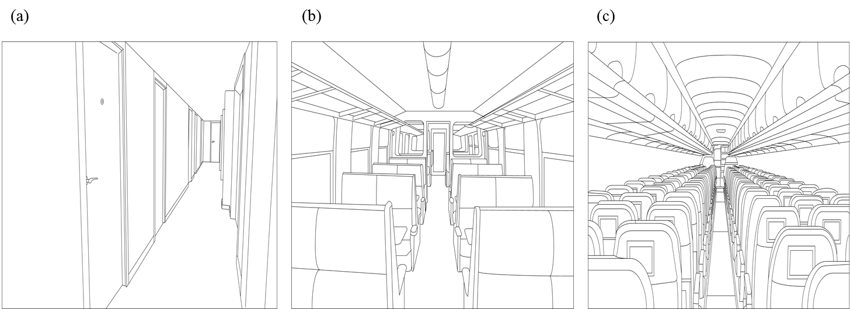

Figure 1. Illustrations of long spaces: (a) corridor, (b) train carriage and (c) aircraft cabin.

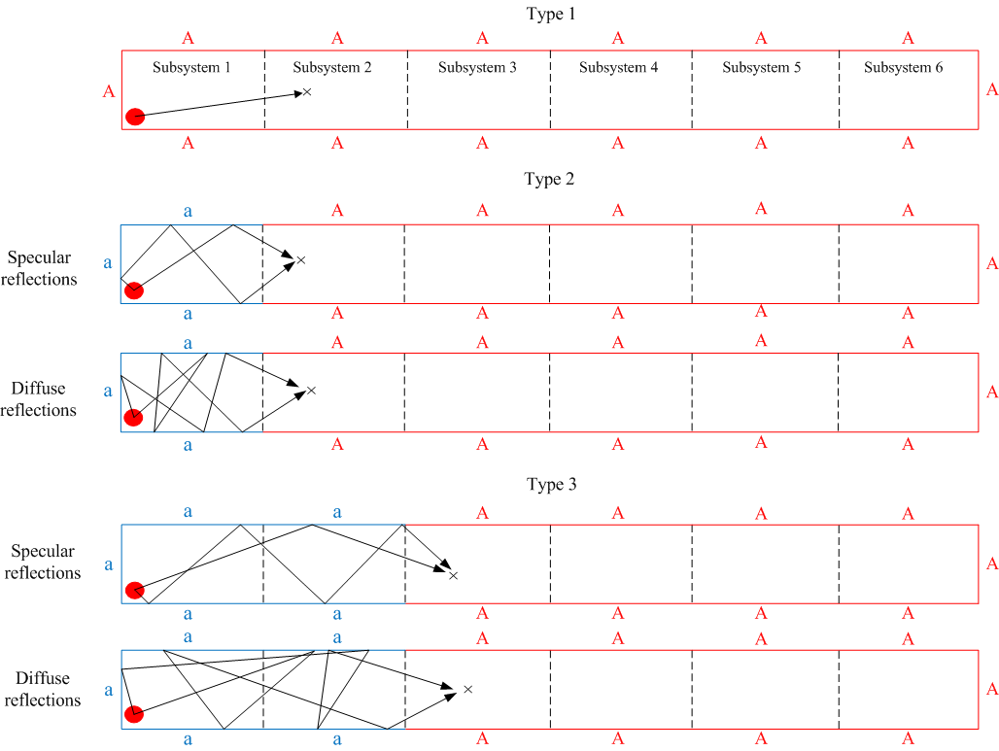

Figure 2. Type 1, 2 and 3 sound fields. Key: ‘a’ indicates boundaries with the actual absorption coefficient, ‘A’ indicates anechoic boundaries where α=1, ‘×’ indicates an example grid point in the receiving subsystem.

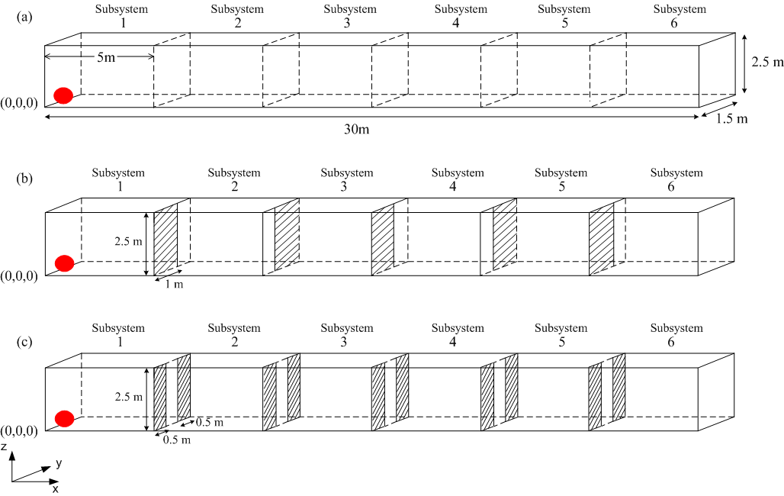
Figure 3. Idealised cuboids used for numerical modelling: (a) empty (b) with full-height, staggered barriers (c) with full-height, symmetrically-placed barriers. Point source is indicated by the shaded red circle.

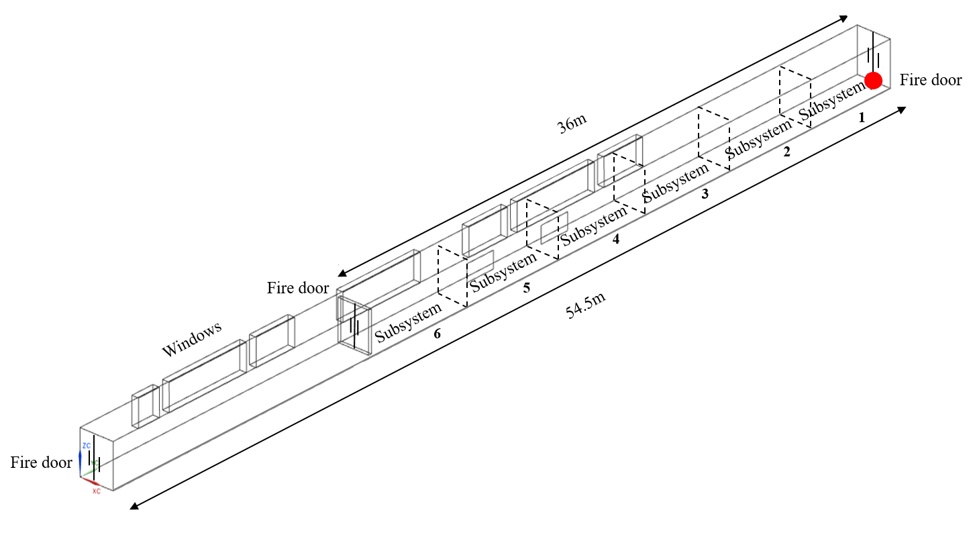
Figure 4. Diagram of the real corridor (empty) used for measurements with dashed lines indicating the open area between each subsystem.

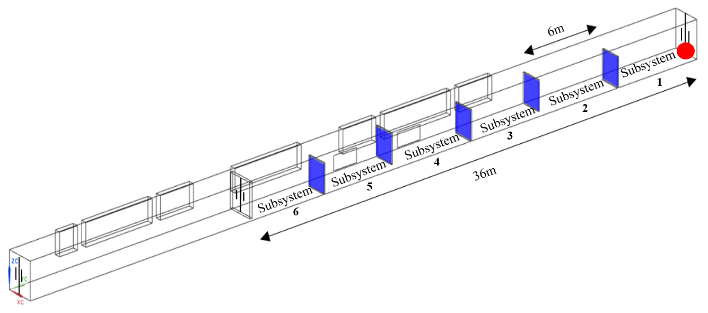
Figure 5. Diagram of the real corridor with partial-height, staggered barriers used for measurements.

Figure 6. Real corridor (empty): Three random microphone positions in each cross-section.

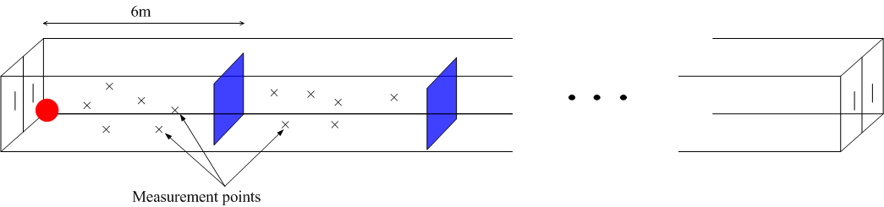
Figure 7. Real corridor with partial-height, staggered barriers: Six random microphone positions in each volume inbetween the barriers.

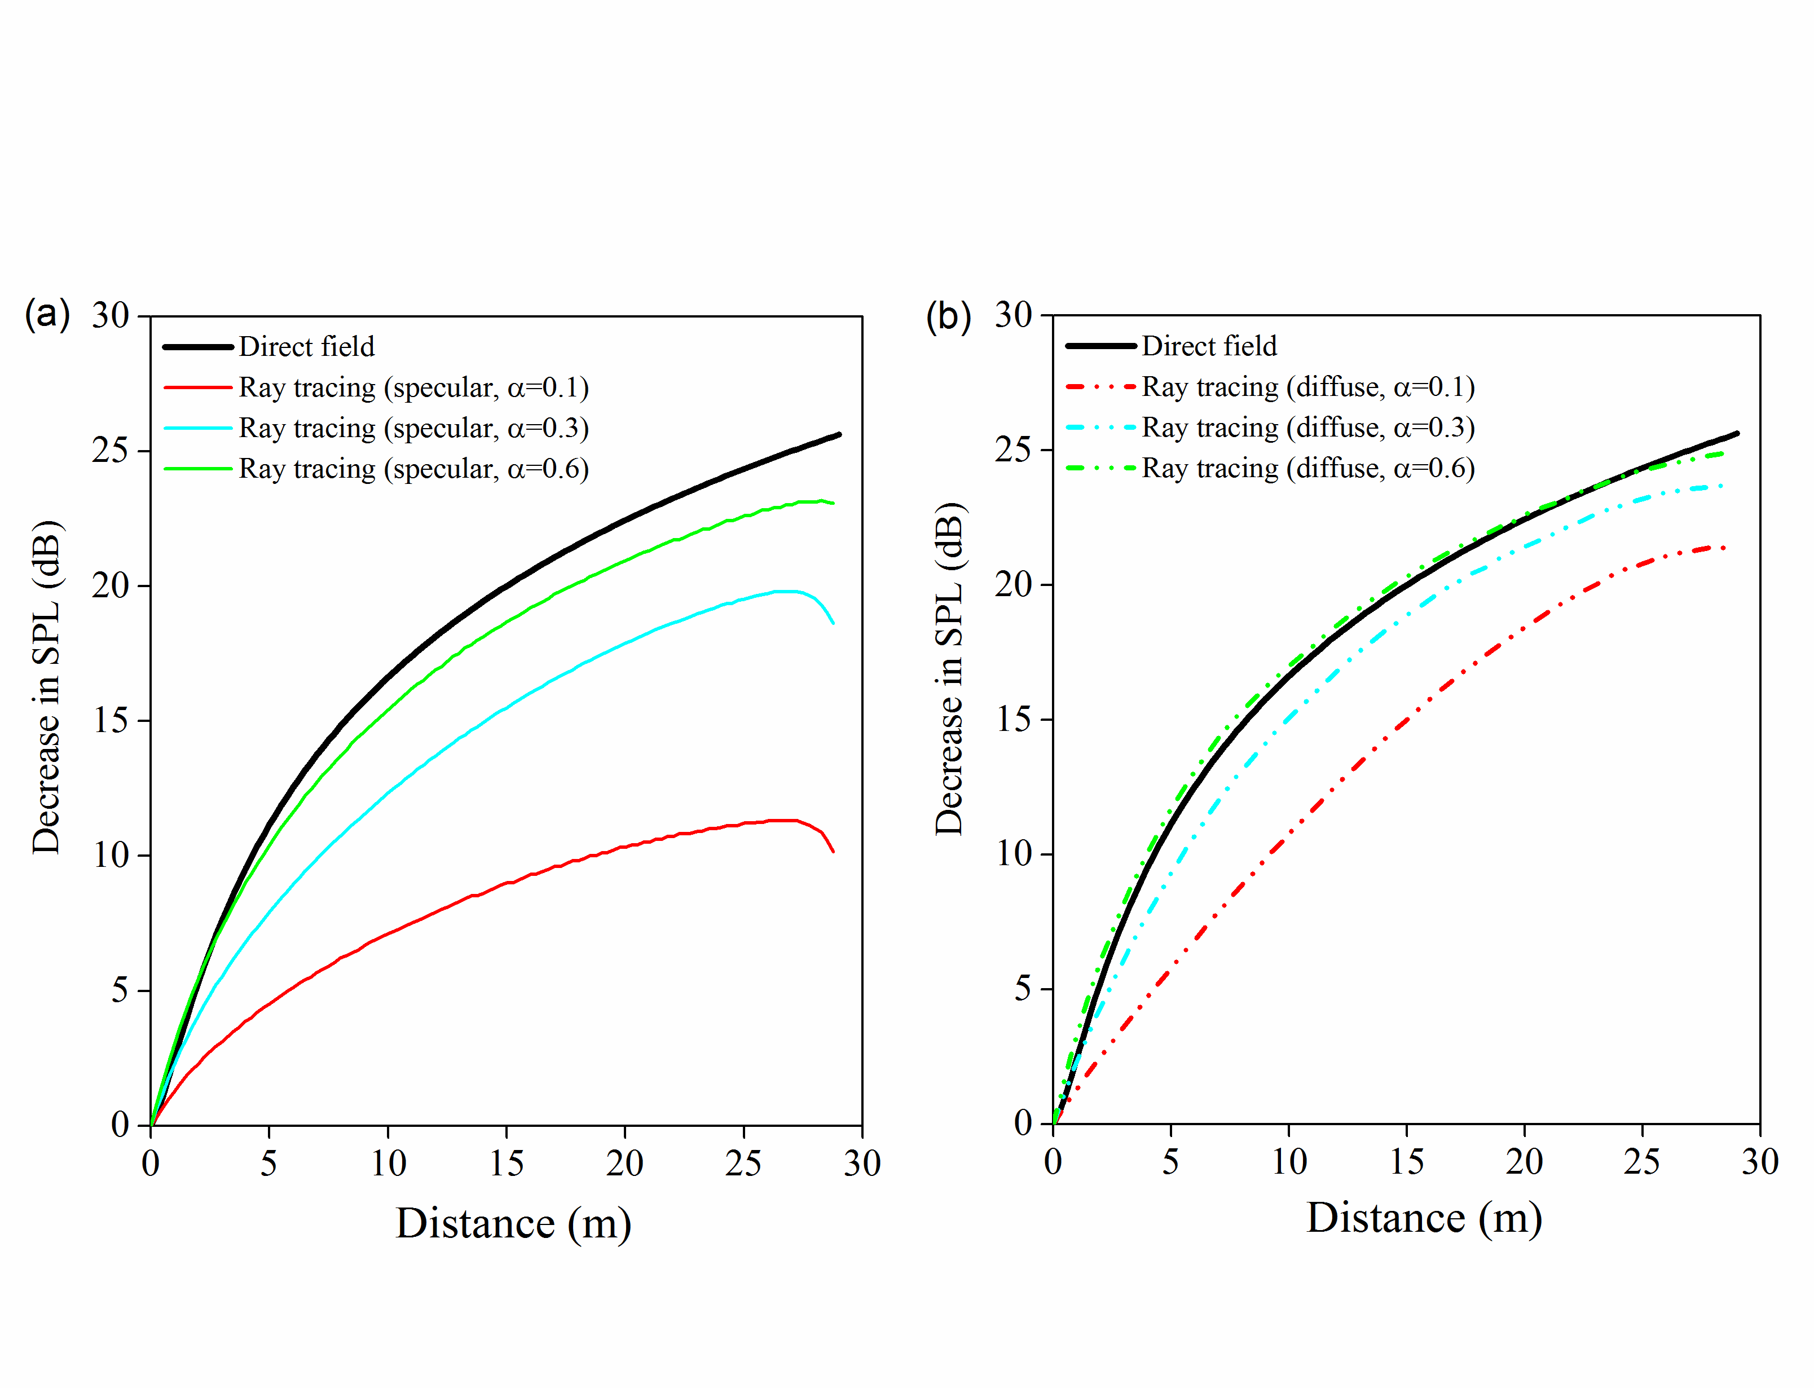
Figure 8. Idealized, empty cuboid – comparison of direct field and ray tracing for (a) specular reflections and (b) diffuse reflections. Sound absorption: α=0.1, 0.3 or 0.6.

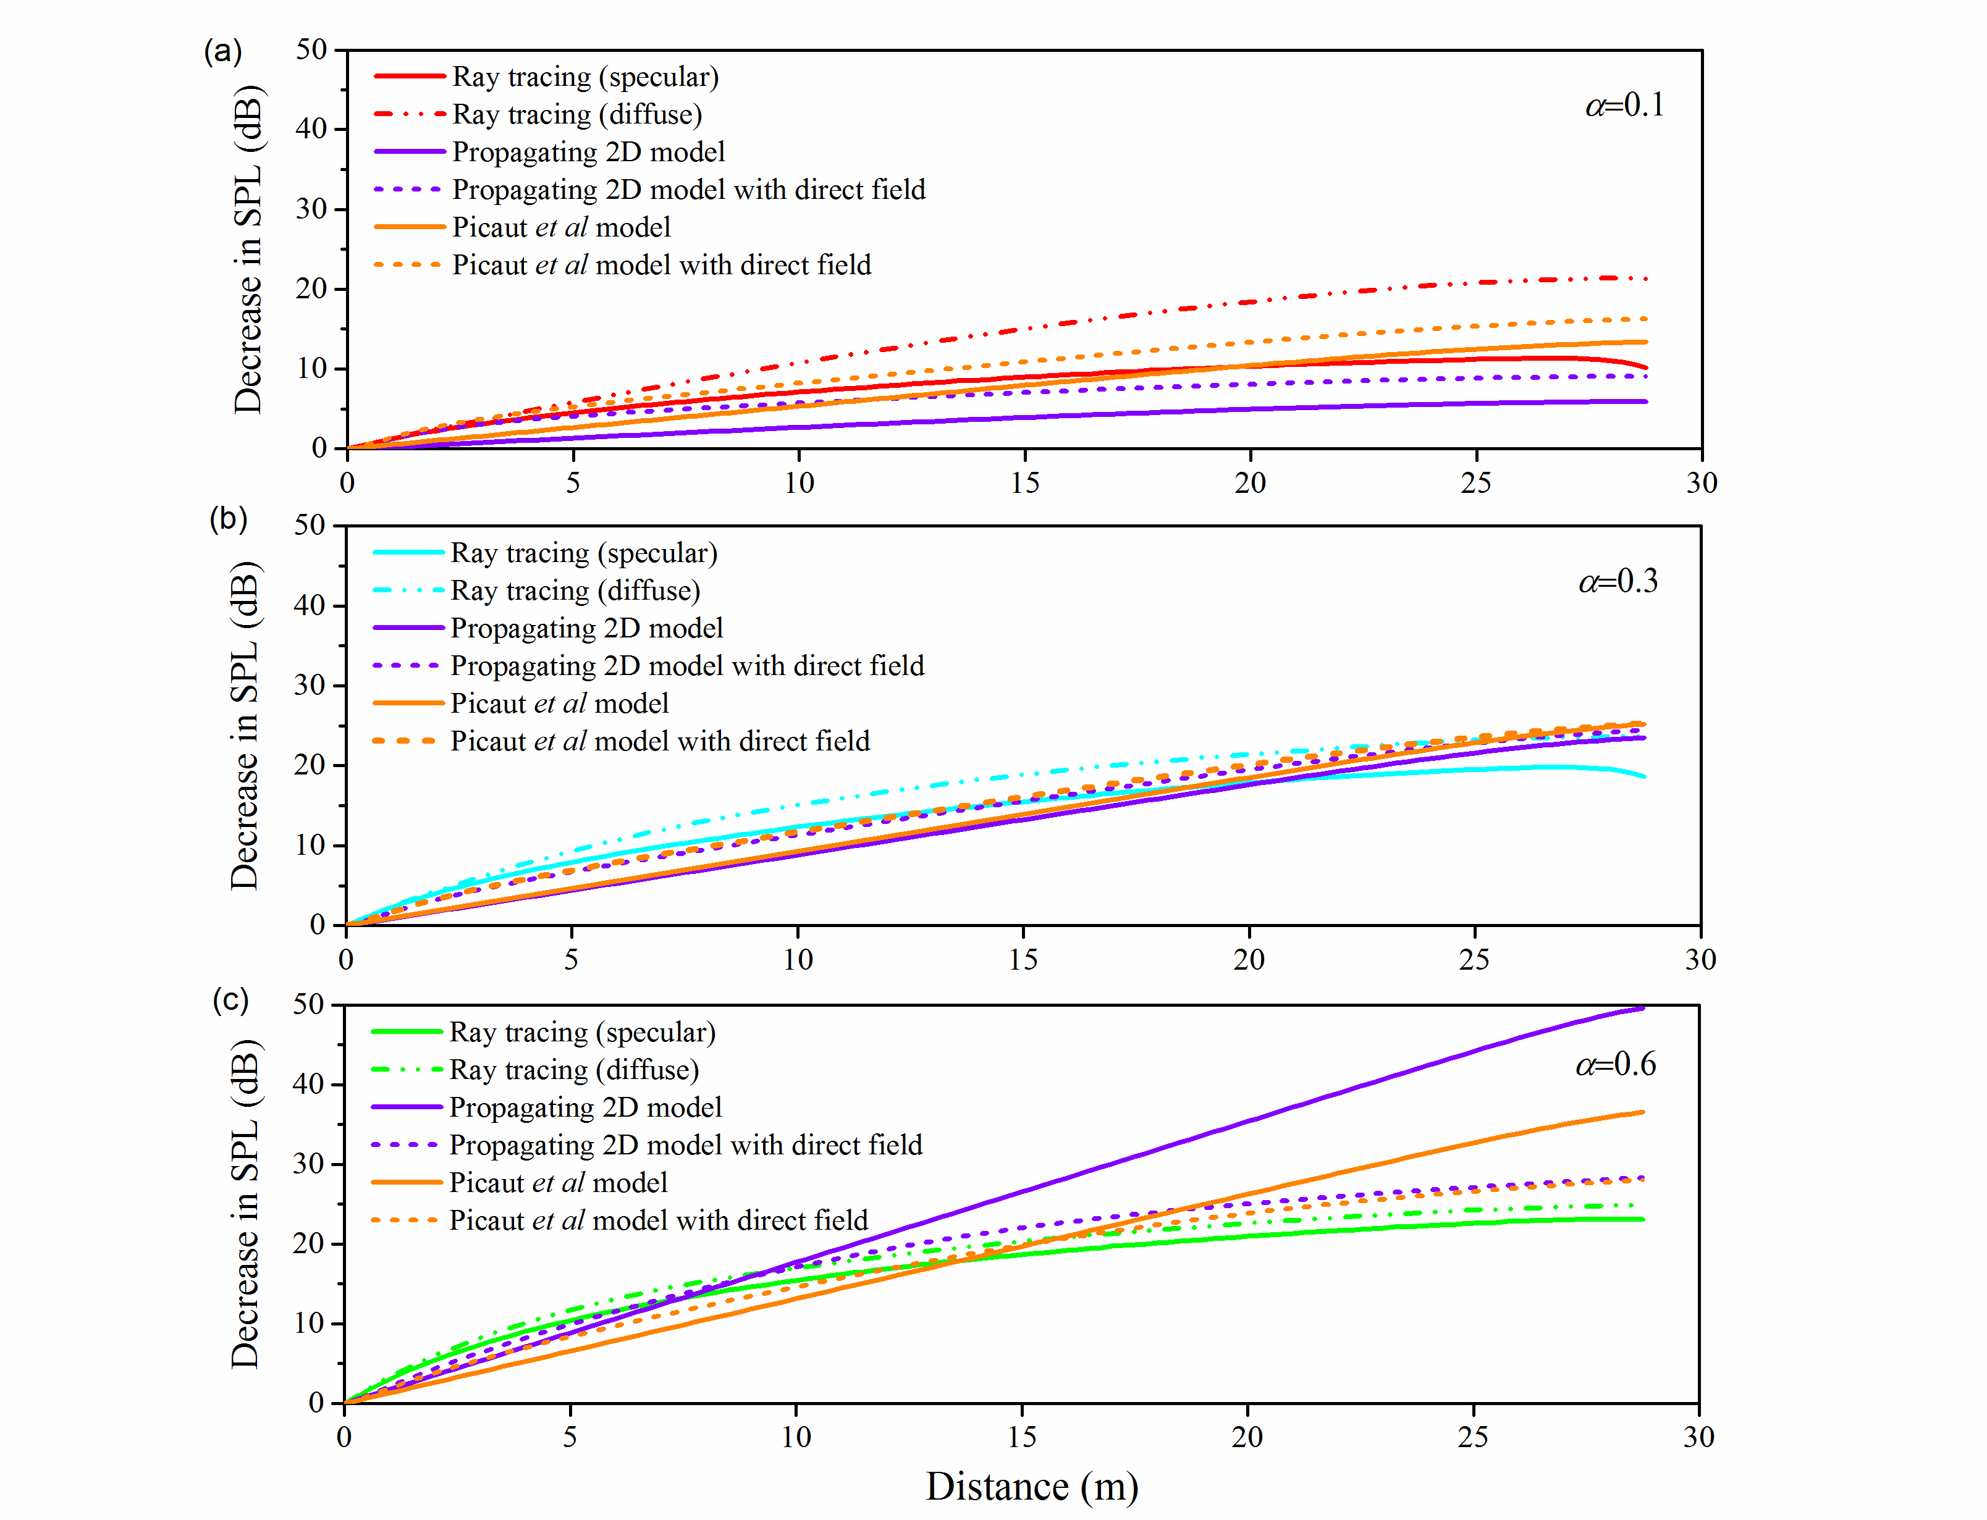
Figure 9. Idealized, empty cuboid – comparison of the propagating 2D model, the Picaut et al model and ray tracing. Sound absorption: (a) α=0.1, (b) α=0.3, (c) α=0.6.

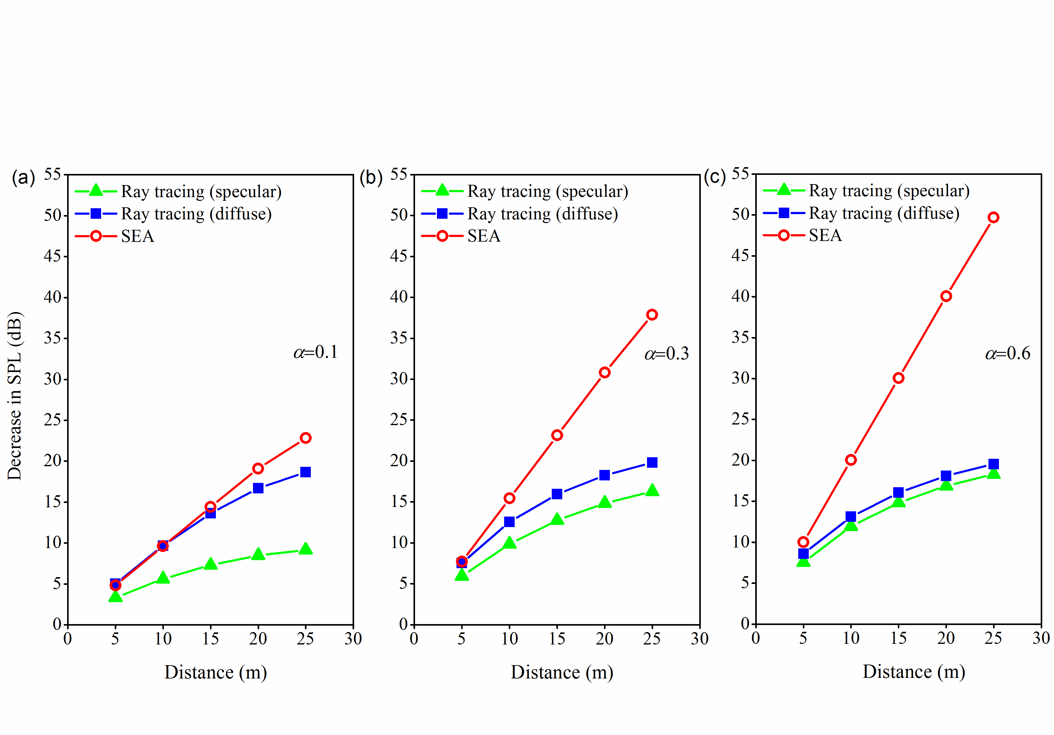
Figure 10. Idealized, empty cuboid – comparison of SEA and ray tracing (specular and diffuse reflections). Sound absorption: (a) α=0.1, (b) α=0.3, (c) α=0.6.

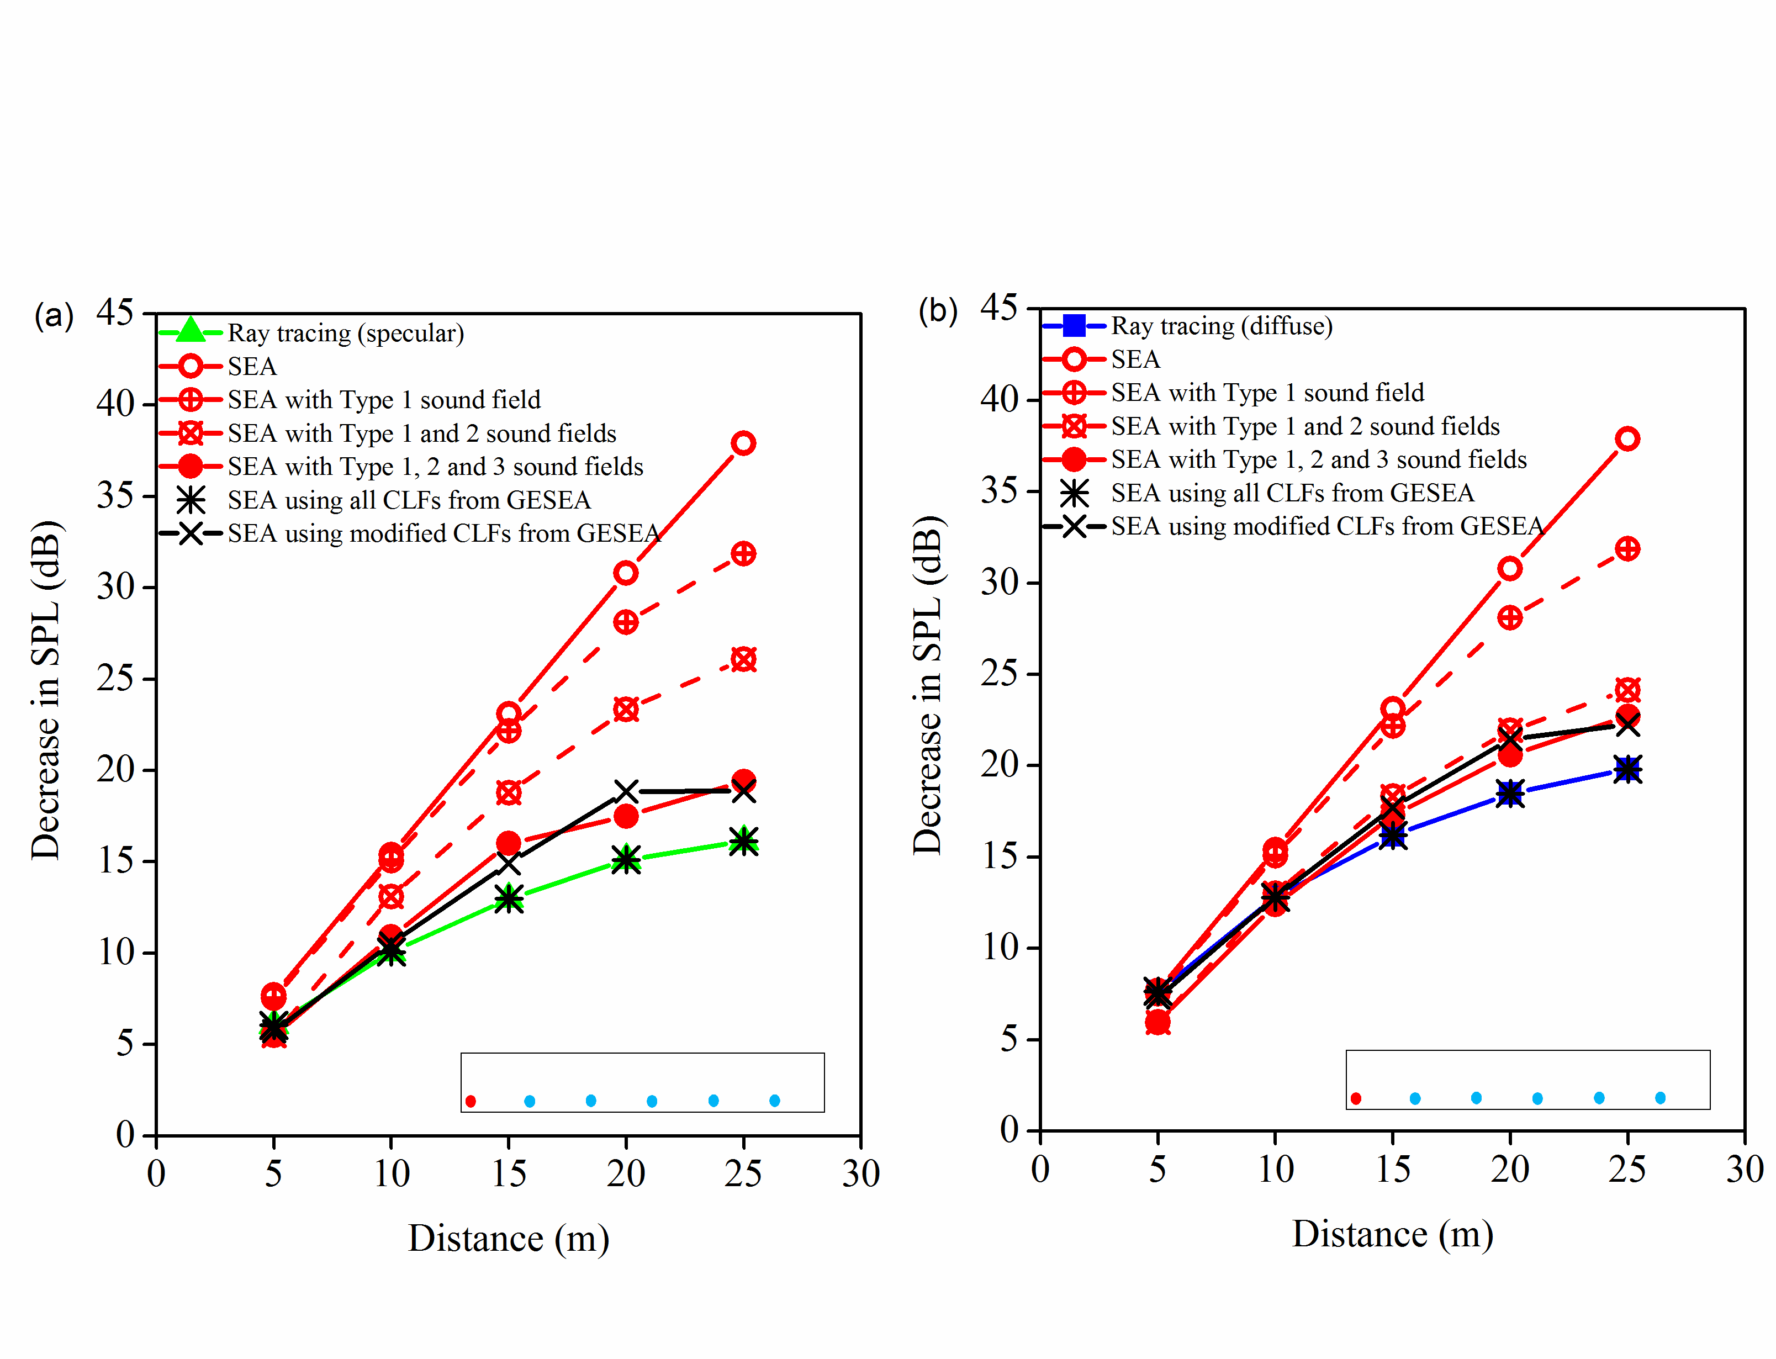
Figure 11. Idealized, empty cuboid – comparison of SEA and ray tracing. Sound absorption: α=0.3. Shaded red circle indicates the source position used to determine the decrease in SPL as well as for the PIM. Shaded blue circles indicate the additional source positions used for the PIM.

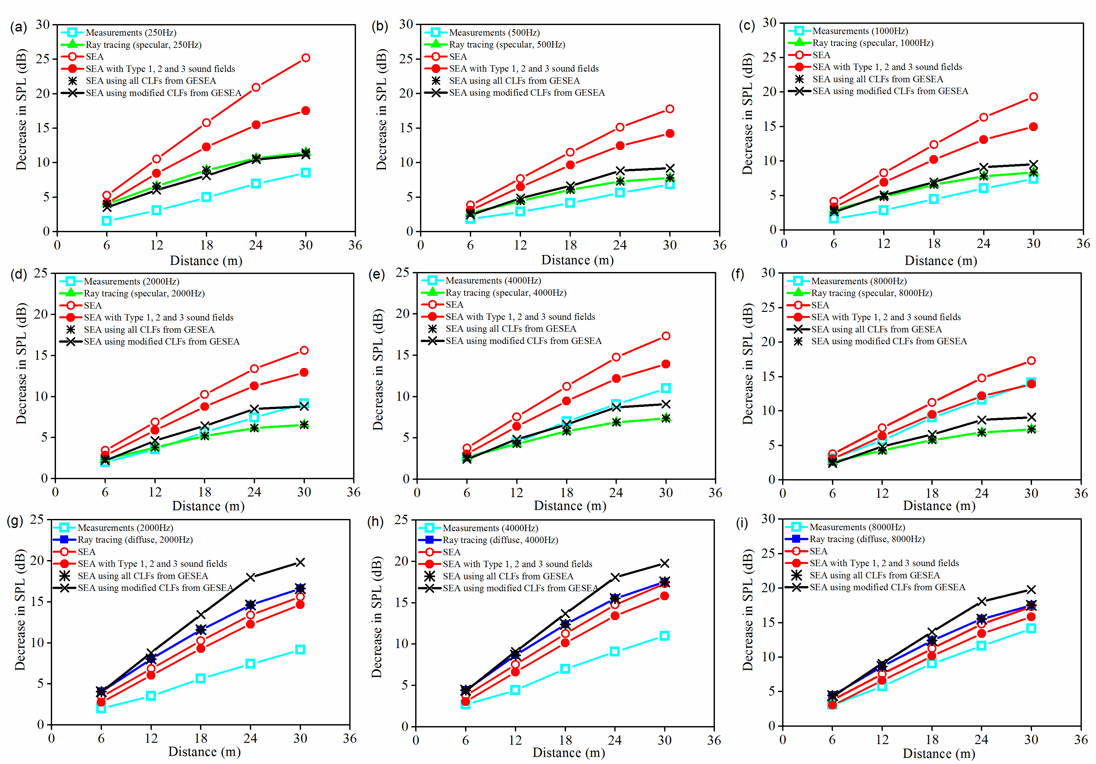
Figure 12. Real corridor (empty) – comparison of measurements, ray tracing and SEA in octave bands. Ray tracing using specular reflections: (a) 250 Hz, (b) 500 Hz, (c) 1 kHz, (d) 2 kHz, (e) 4 kHz, (f) 8 kHz. Ray tracing using diffuse reflections: (g) 2 kHz, (h) 4 kHz, (i) 8 kHz.

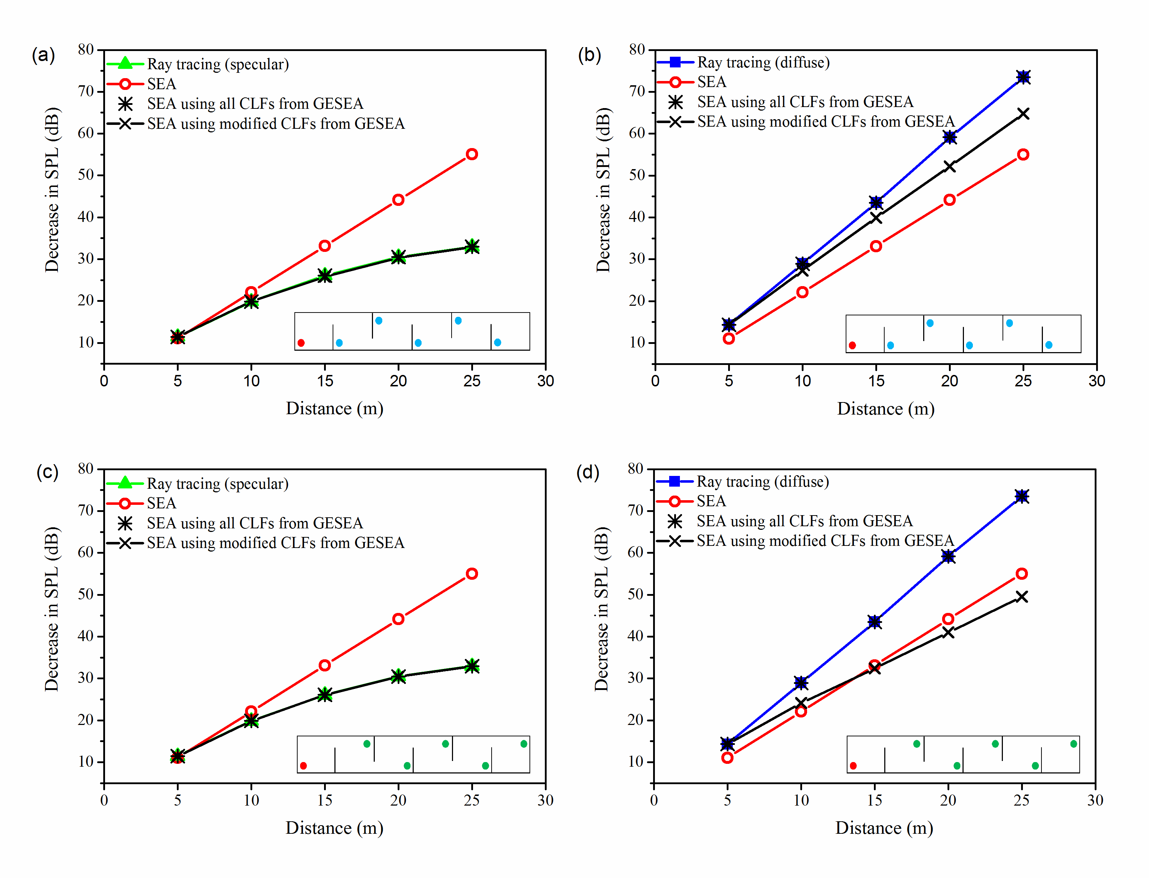

Figure 13. Idealized cuboid with full-height, staggered barriers – comparison of SEA and ray tracing. Sound absorption: α=0.3. Ray tracing uses specular reflections in (a) and (c). Ray tracing uses diffuse reflections in (b) and (d). Shaded red circle indicates the source position used to determine the decrease in SPL as well as for the PIM. Shaded blue or green circles indicate the additional source positions used for the PIM. Note that for the source positions, (a) and (b) use Configuration No.1 and (c) and (d) use Configuration No.2.

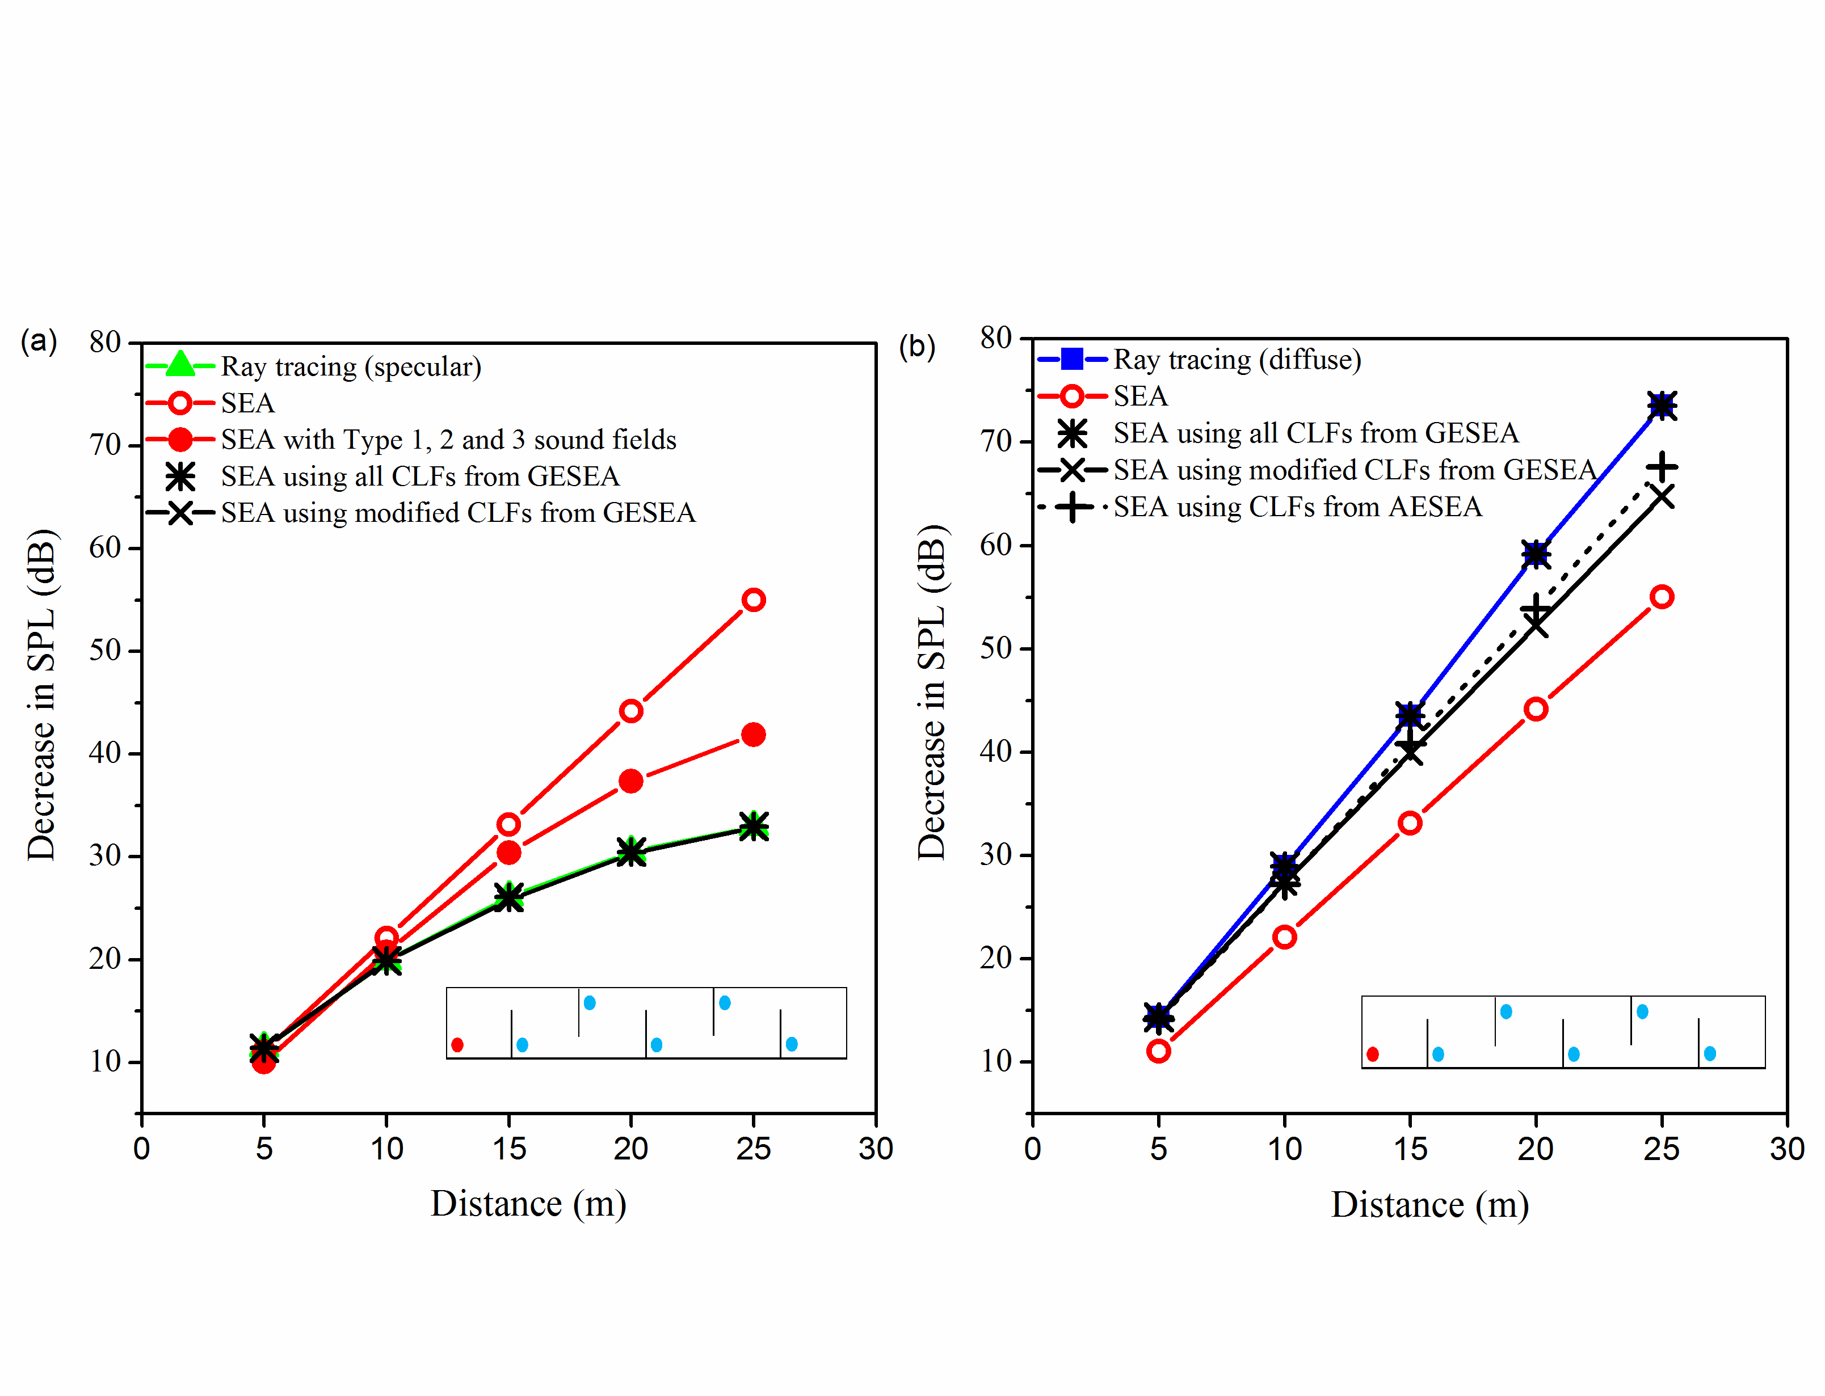
Figure 14. Idealized cuboid with full-height, staggered barriers – comparison of SEA and ray tracing. Sound absorption: α=0.3. Shaded red circle indicates the source position used to determine the decrease in SPL as well as for the PIM. Shaded blue circles indicate the additional source positions used for the PIM.

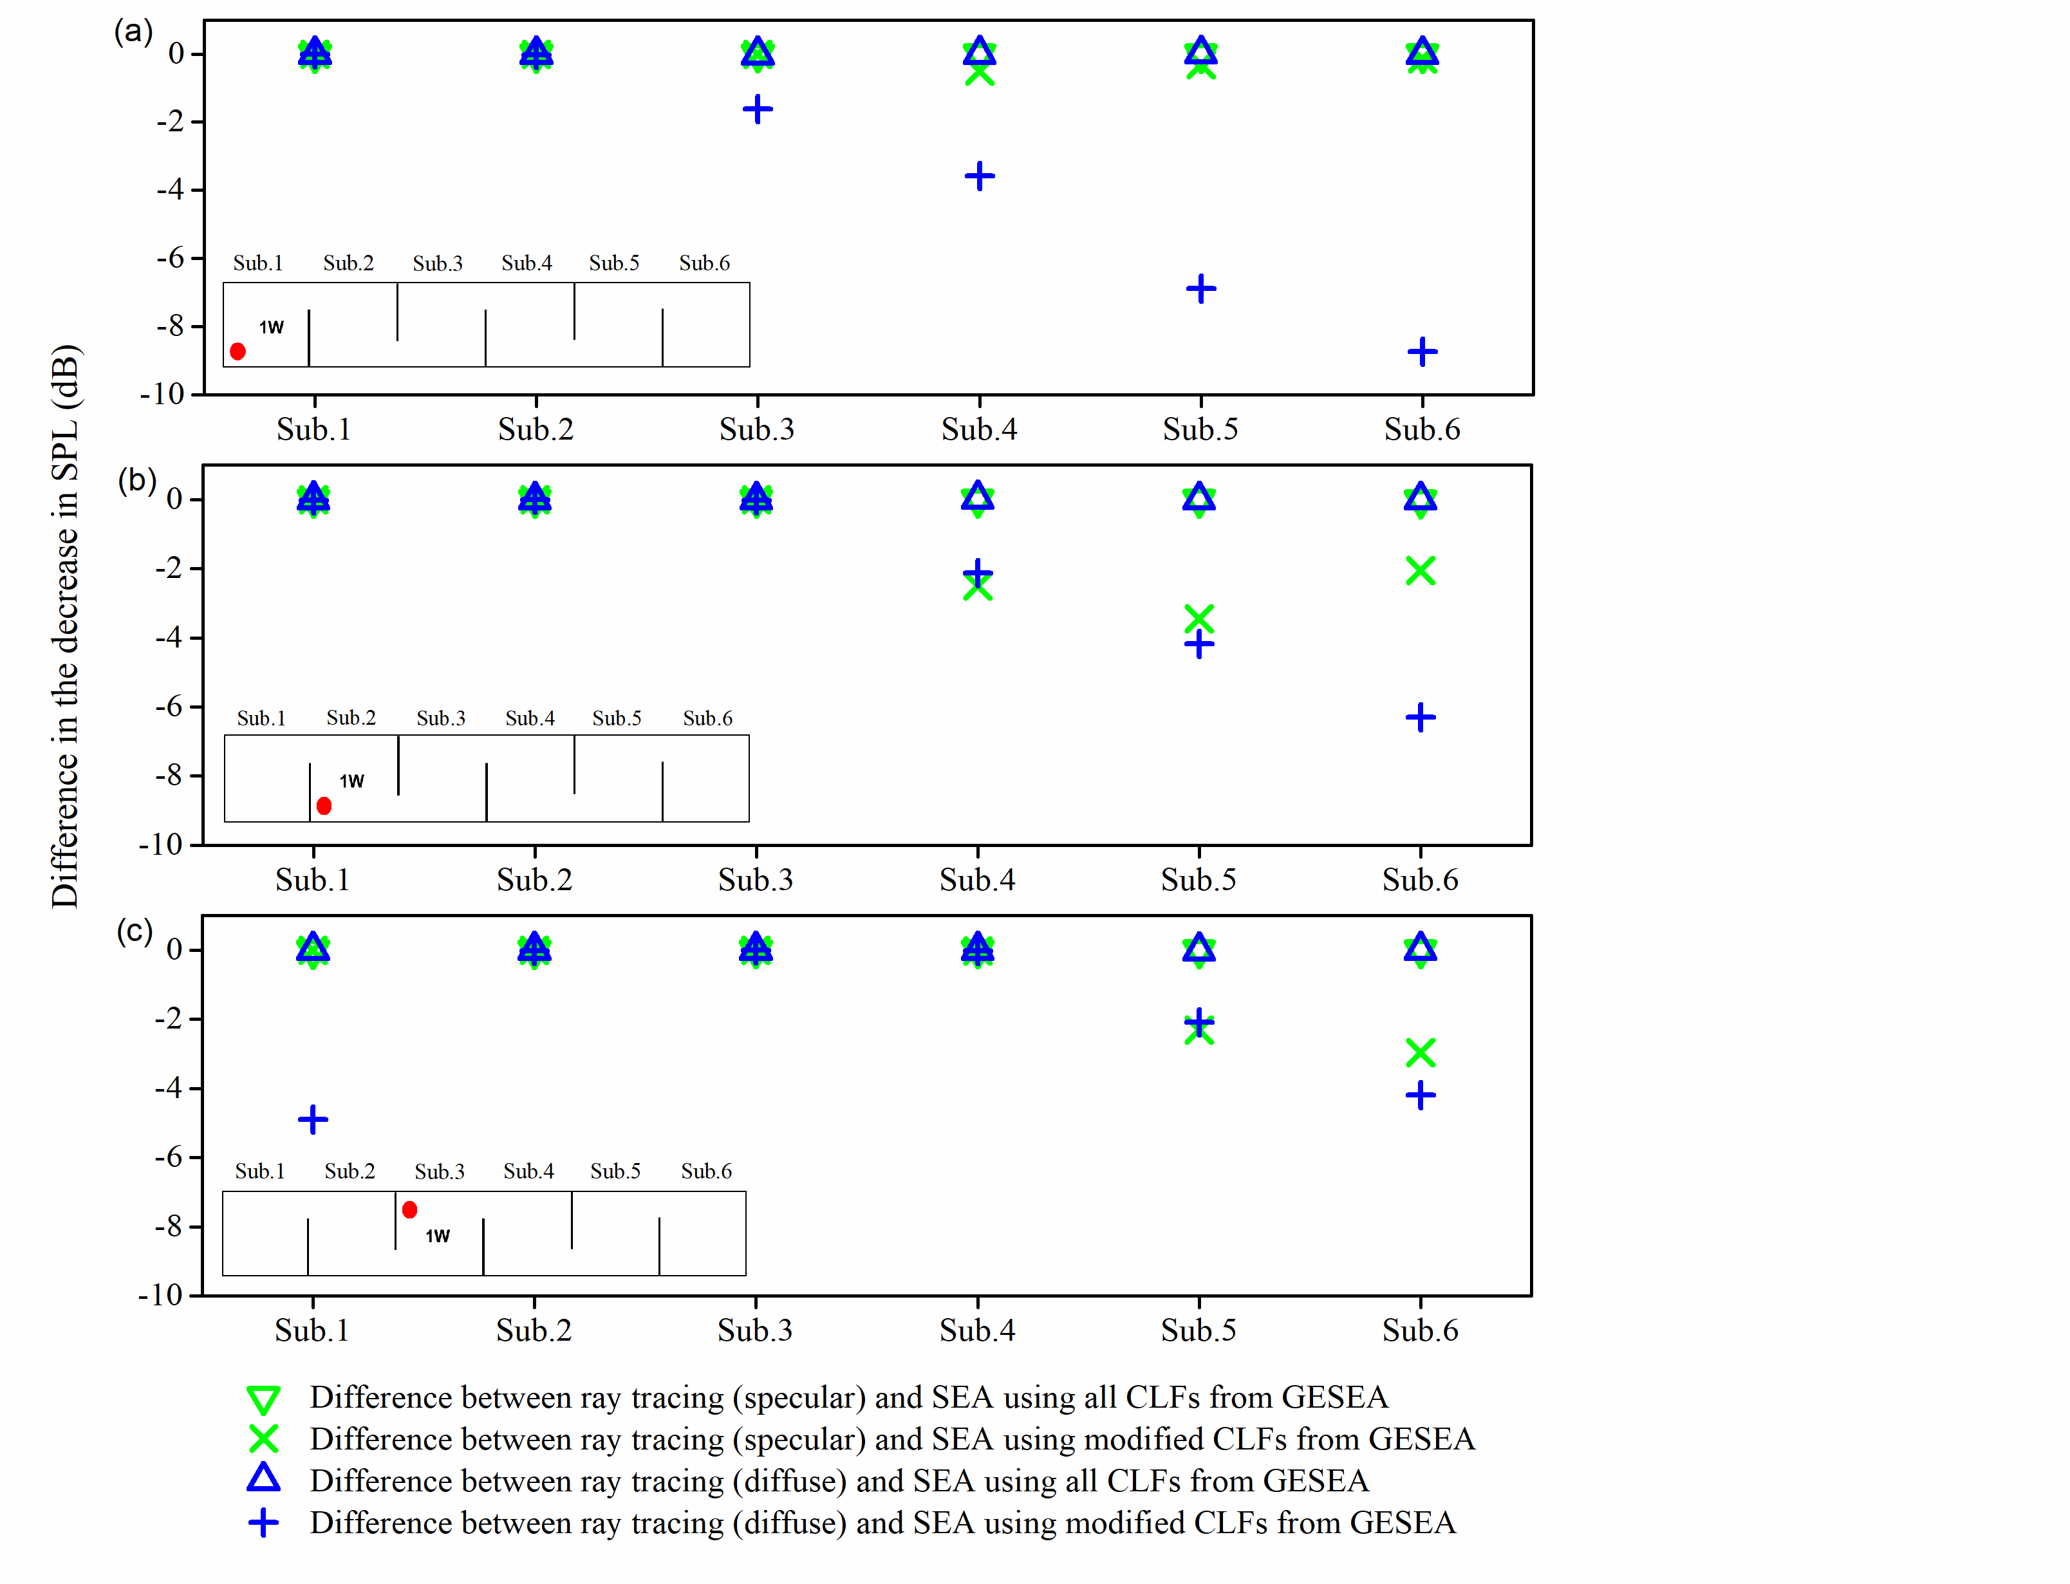
Figure 15. Idealized cuboid with full-height, staggered barriers – difference between ray tracing and SEA using CLFs from GESEA with a single source in different subsystems (shaded red circle). Sound absorption: α=0.3.

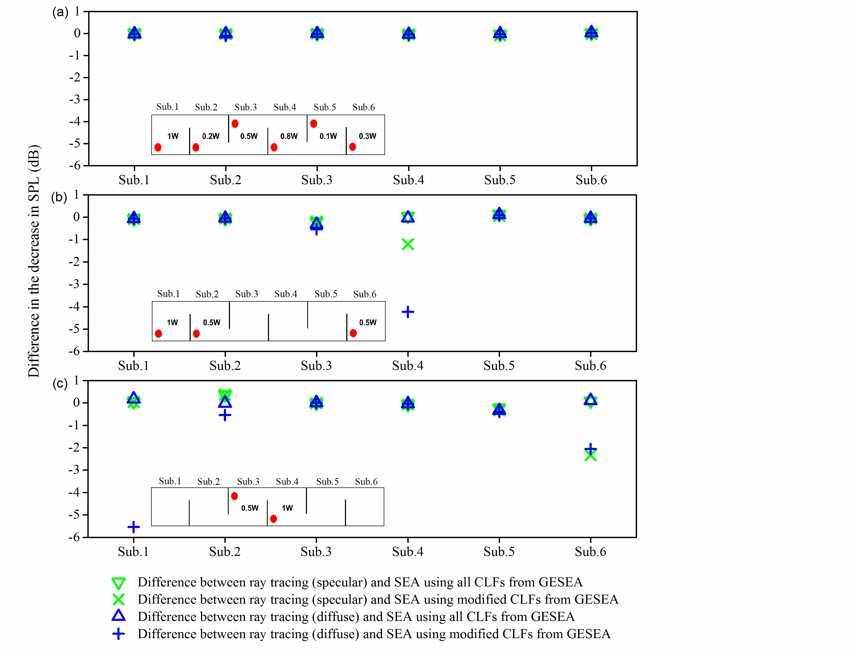

Figure 16. Idealized cuboid with full-height, staggered barriers – difference between ray tracing and SEA using CLFs from GESEA with different combinations of multiple sources (shaded red circles). Sound absorption: α=0.3.

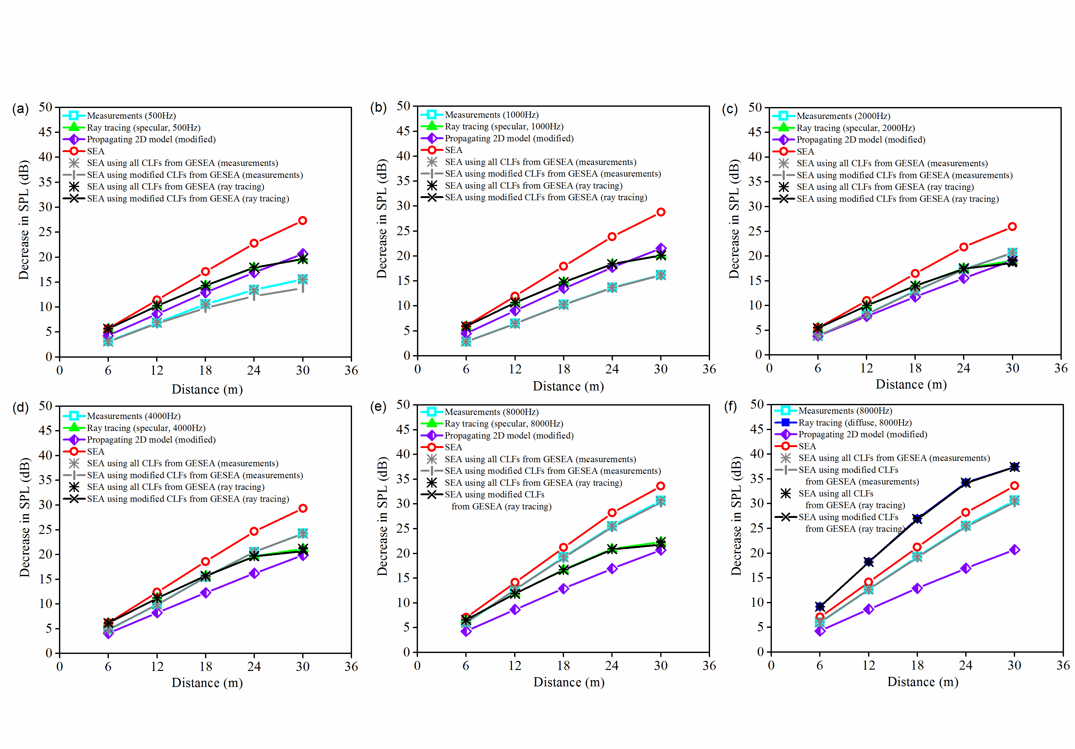
Figure 17. Real corridor with partial-height, staggered barriers – comparison of measurements, ray tracing and SEA in octave bands. Ray tracing using specular reflections: (a) 500 Hz, (b) 1 kHz, (c) 2 kHz, (d) 4 kHz, (e) 8 kHz. Ray tracing using diffuse reflections: (f) 8 kHz.

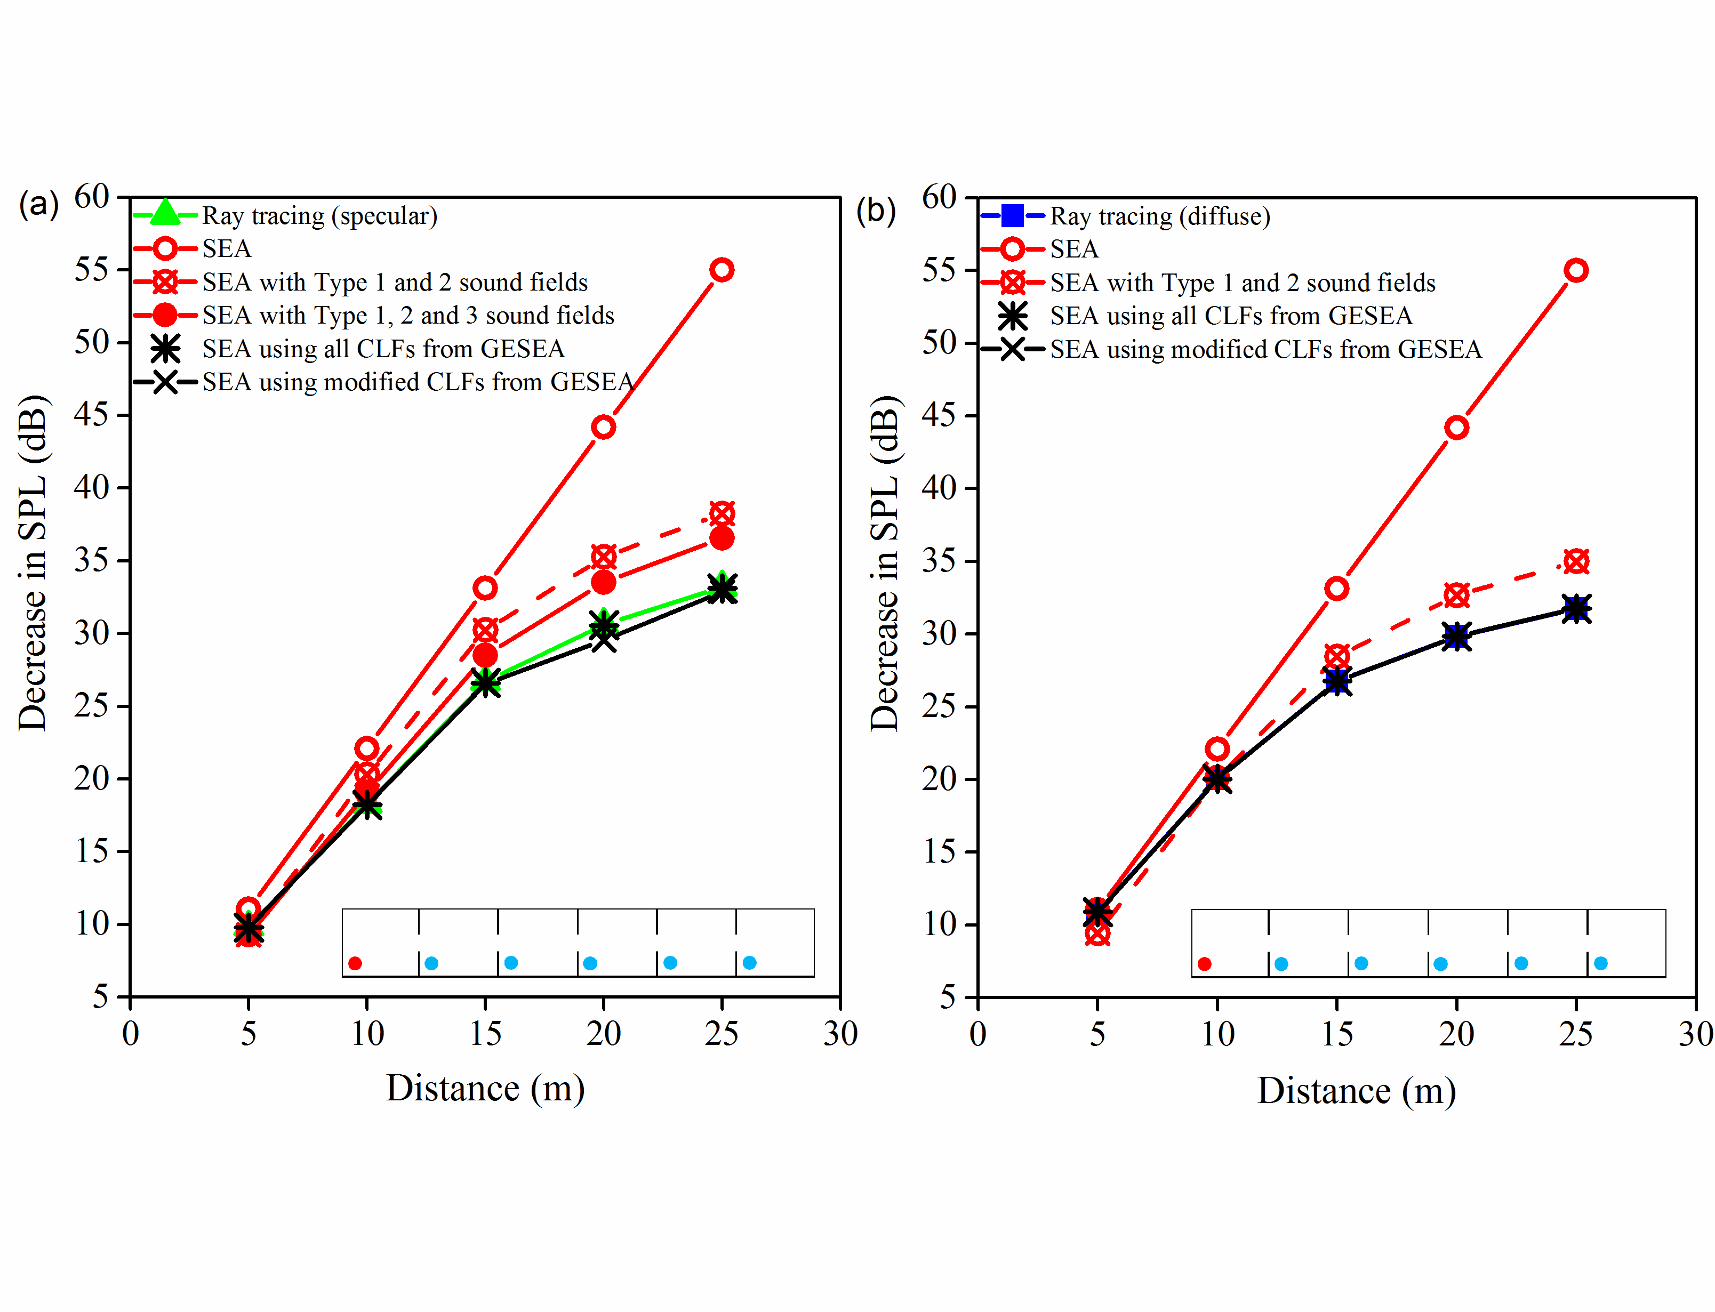
Figure 18. Idealized cuboid with full-height, symmetrically-placed barriers – comparison of ray tracing and SEA. Sound absorption: α=0.3. Shaded red circle indicates the source position used to determine the decrease in SPL as well as for the PIM. Shaded blue circles indicate the additional source positions used for the PIM.

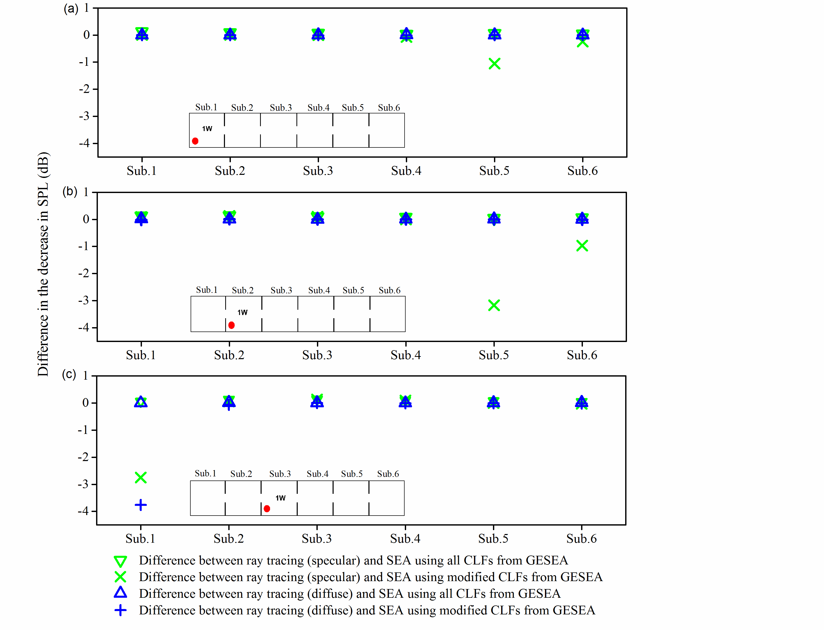
Figure 19. Idealized cuboid with full-height, symmetrically-placed barriers – difference between ray tracing and SEA using GESEA with a single source in different subsystems (shaded red circle). Sound absorption: α=0.3.

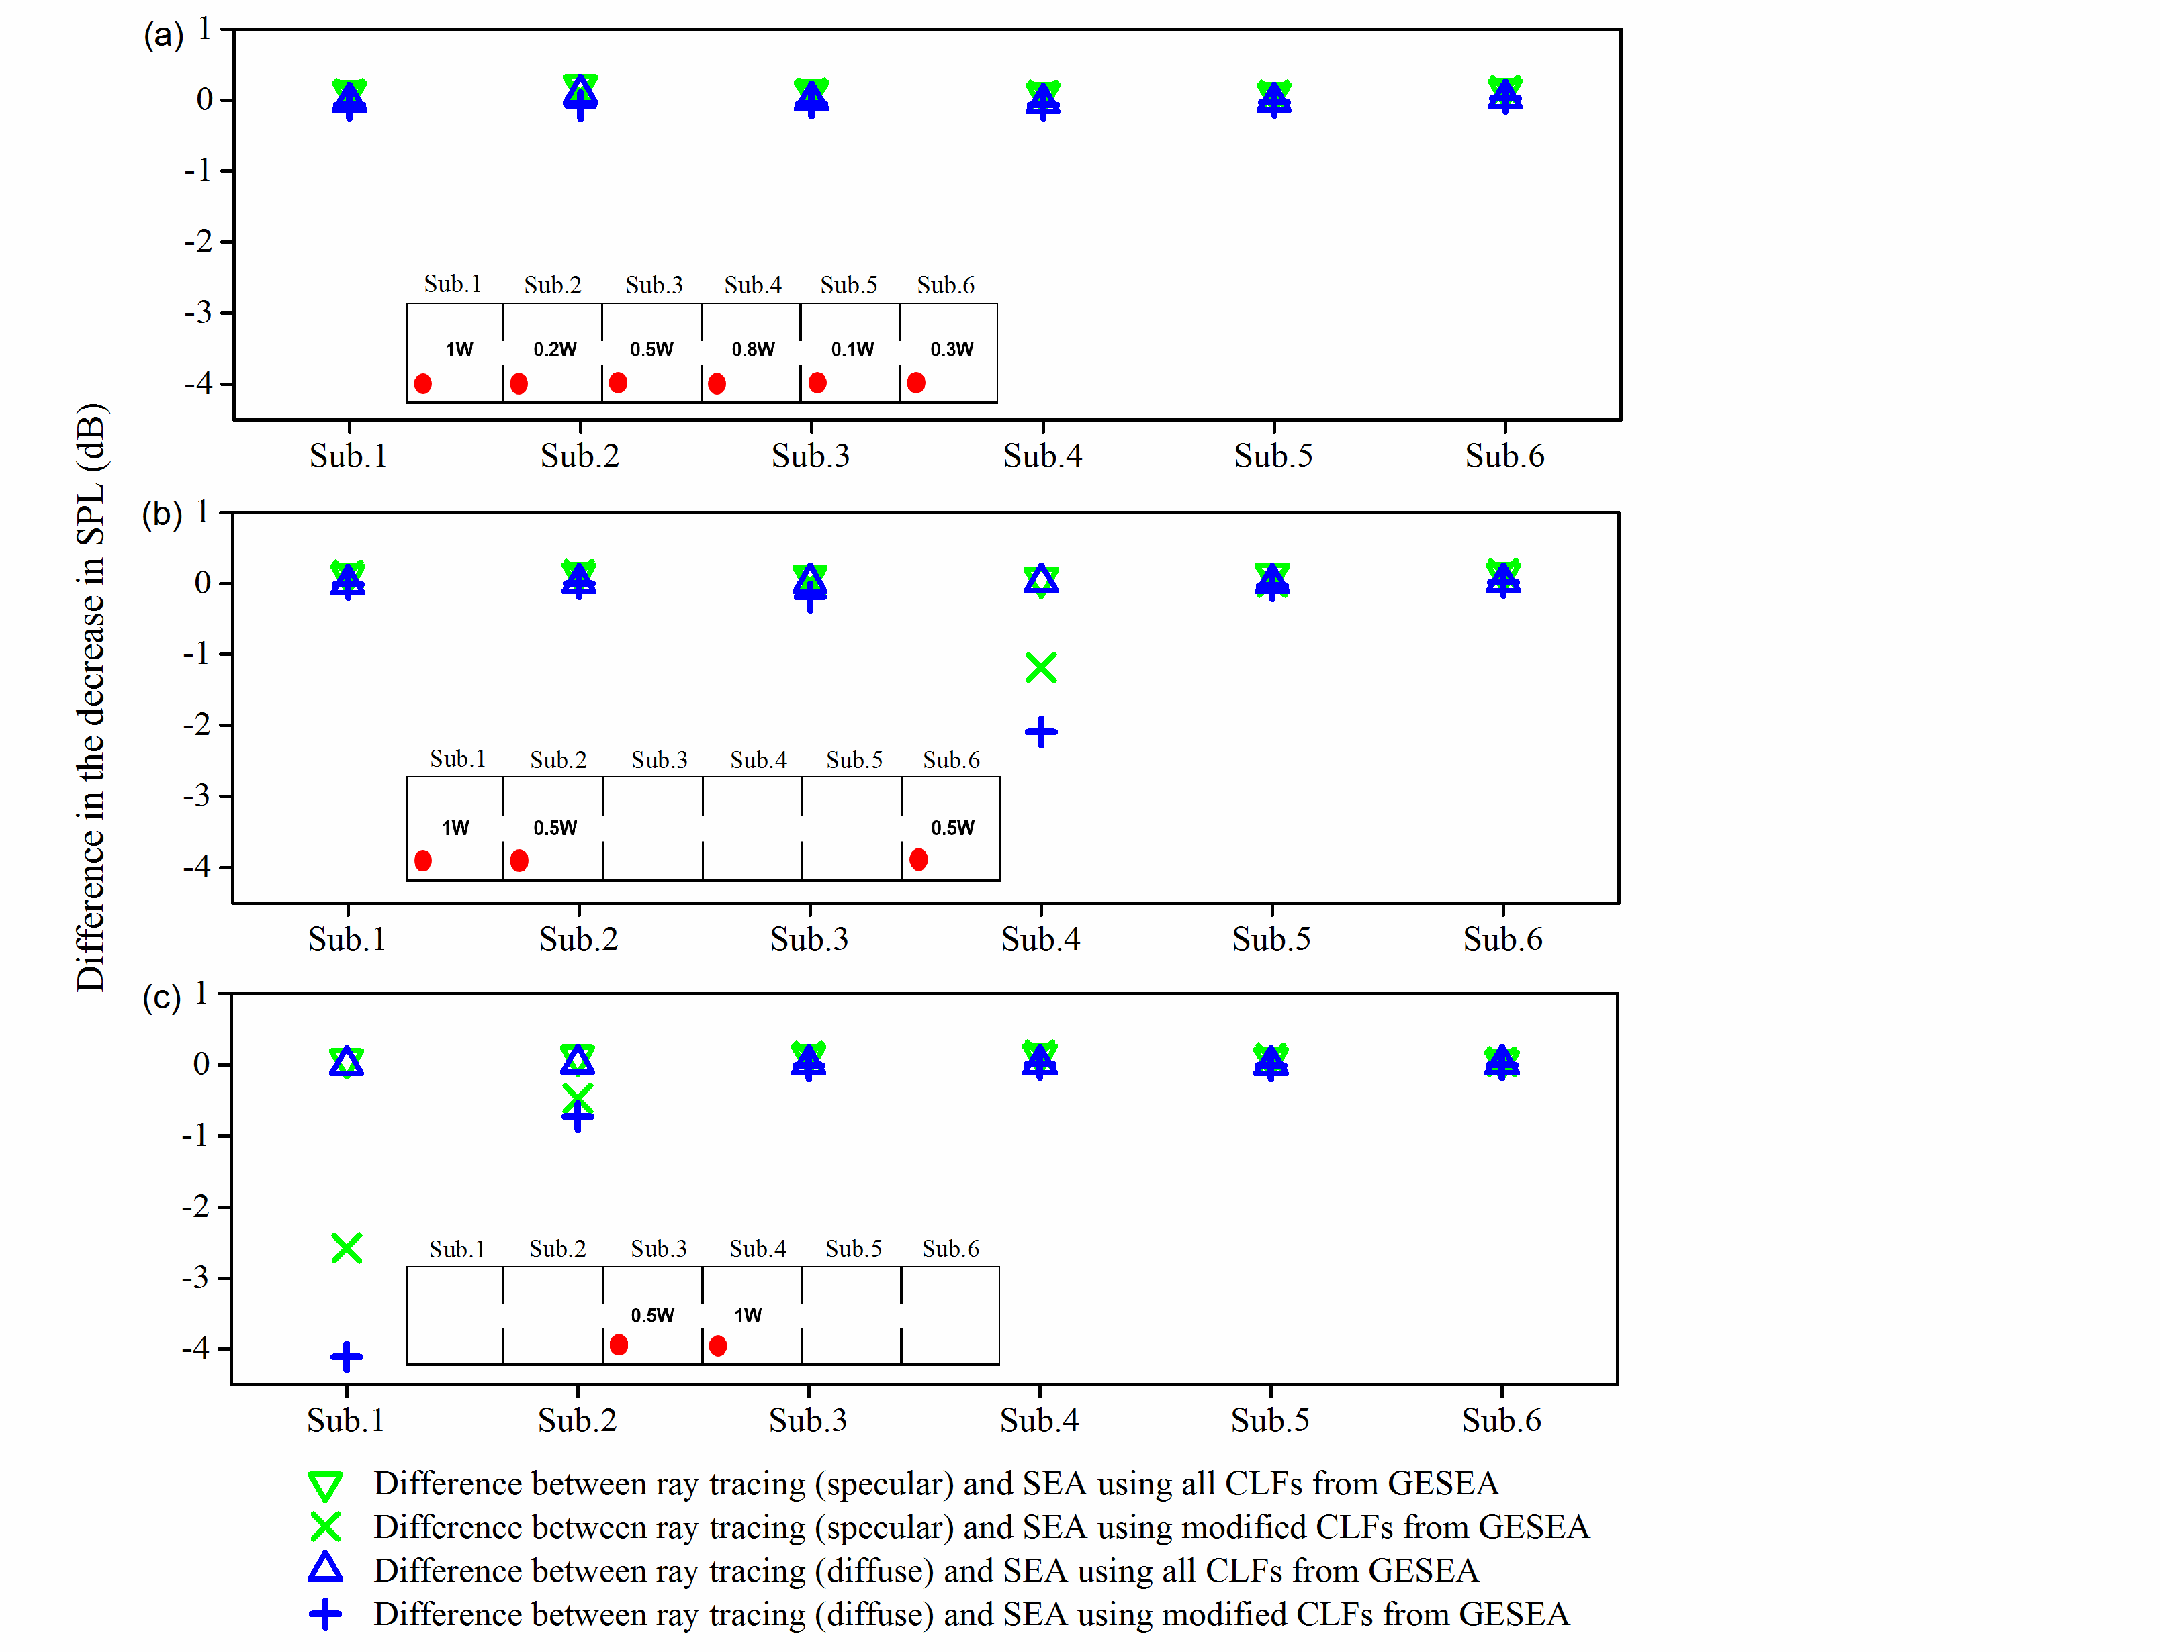
Figure 20. Idealized cuboid with full-height, symmetrically-placed barriers – difference between ray tracing and SEA using GESEA with different combinations of multiple sources (shaded red circles). Sound absorption: α=0.3.

Tables
Table 1. Absorption coefficients for the wall, floor and ceiling surfaces in the real corridor. Source: ODEON database.
Octave band centre frequency (Hz) | 250 | 500 | 1k | 2k | 4k | 8k
Absorption coefficient (-) | 0.12 | 0.06 | 0.07 | 0.05 | 0.06 | 0.06

Table 2. Absorption coefficients for the windows in the real corridor. Source: ODEON database.
Octave band centre frequency (Hz) | 250 | 500 | 1k | 2k | 4k | 8k
Absorption coefficient (-) | 0.07 | 0.05 | 0.03 | 0.02 | 0.02 | 0.02

Table 3. Measured absorption coefficients for the barrier surface in octave bands.
Octave band centre frequency (Hz) | 250 | 500 | 1k | 2k | 4k | 8k
Absorption coefficient (-) | 0.16 | 0.2 | 0.19 | 0.28 | 0.46 | 0.75

[] Yamamoto T. On the distribution of sound energy along a corridor. J Acoust Soc Jpn 1961;17:286-292.
[] Davies HG. Noise propagation in corridors. J Acoust Soc Am 1973;53(5):1253-1262.
[] Redmore TL and Flockton SJ. A design formula for predicting the attenuation of sound along a long corridor. Acoust Lett 1977;1:21-24.
[] Redmore TL. A theoretical analysis and experimental study of the behaviour of sound in corridors. Appl Acoust 1982;15(3):161-170.
[] Redmore TL. A method to predict the transmission of sound through corridors. Appl Acoust 1982;15(2):133-146.
[] Hopkins C. Sound insulation. Routledge; 2012. ISBN 978-0-7506-6526-1.
[] Kang J. Sound attenuation in long enclosures. Building and Environment 1996;31(3):245-253.
[] The Building Regulations 2000. Approved Document B. Fire safety.
[] Picaut J, Simon L, Polack JD. Sound field in long rooms with diffusely reflecting boundaries. Appl Acoust 1999;56(4):217-240.
[] Fahy FJ. A note on the subdivision of a volume of air in a vehicle enclosure into SEA subsystems. J Sound Vib 2004;271(3):1170-1174.
[] Craik RJM. Sound transmission through buildings using statistical energy analysis. Gower Publishing Company; 1996. ISBN 0566075725.
[] Forssén J, Tober S, Corakci AC, Frid A, Kropp W. Modelling the interior sound field of a railway vehicle using statistical energy analysis. Appl Acoust 2012;73(4):307-311.
[] Yang C and Cheng L. Prediction of noise inside an acoustic cavity of elongated shape using statistical energy analyses with spatial decay consideration. Appl Acoust 2016;113:34-38.
[] Sadri M, Brunskog J, Younesian D. Application of a Bayesian algorithm for the Statistical Energy model updating of a railway coach. Appl Acoust 2016;112:84-107.
[] Cordioli JA, Gerges SN, Pererira AK, Carmo M, Grandi C. Vibro-acoustic modeling of aircrafts using Statistical Energy Analysis (No. 2004-01-3337). SAE Technical Paper, 2004.
[] Wang T and Maxon J. Application of statistical energy analysis and optimization in the design of Gulfstream large-cabin aircraft interior thermal/acoustic package. In INTER-NOISE and NOISE-CON Congress and Conference Proceedings 2008;7:2073-2084. Institute of Noise Control Engineering.
[] Hopkins C. Experimental statistical energy analysis of coupled plates with wave conversion at the junction. J Sound Vib 2009;322(1):155-166.
[] Woodhouse J. An introduction to statistical energy analysis of structural vibration. Appl Acoust 1981;14(6):455-469.
[] Hodges CH, Nash P and Woodhouse J. Measurement of coupling loss factors by matrix fitting: An investigation of numerical procedures. Appl Acoust 1987;22(1):47-69.
[] Lalor N. Practical considerations for the measurement of internal and coupling loss factors on complex structures. ISVR Technical Report No.182. June 1990
[] Hopkins C. Statistical energy analysis of coupled plate systems with low modal density and low modal overlap. J Sound Vib 2002;251(2):193-214.
[] Ribeiro R and Smith M. Use of SEA to model the sound field in large acoustic spaces. Proc. Forum Acusticum 2005.
[] Mace BR. Statistical energy analysis, energy distribution models and system modes. J Sound Vib 2003;264(2):391-409.
[] Mace BR. Statistical energy analysis: coupling loss factors, indirect coupling and system modes. J Sound Vibration 2005;279:141-170.
[] Heron KH. Advanced statistical energy analysis. Philosophical Transactions of the Royal Society of London 1994;A346:501-510.
[] Yin J and Hopkins C. Prediction of high-frequency vibration transmission across coupled, periodic ribbed plates by incorporating tunneling mechanisms. J Acoust Soc Am 2013;133:2069–2081.
[] Wilson D and Hopkins C. Analysis of bending wave transmission using beam tracing with advanced statistical energy analysis for periodic box-like structures affected by spatial filtering. J Sound Vib 2015;341:138-161.
[] Sheng MP, Wang MQ, Sun JC. Effective internal loss factors and coupling loss factors for non-conservatively coupled systems. J Sound Vib 1998;209(4):685-694.
[] ODEON 14.01 Room Acoustic Software User Manual. The Department of Acoustic Technology, Technical University of Denmark 2017.
[] Pujolle J. Les différentes définitions du libre parcours moyen du son dans une sale. Revue d'Acoustique 1976;36: 44-50.
[] ISO 354:2003 Acoustics – Measurement of sound absorption in a reverberation room. International Organisation for Standardization.
[] Davern WA. Measurement of low frequency absorption. Appl Acoust 1987;21(1):1-11.
[] Kang J. Acoustics of long spaces: theory and design guidance. Thomas Telford; 2002. ISBN 0-7277-3013-4
[] Kuttruff H. Stationäre Schallausbreitung in Langräumen. Acustica 1989;69:53-62.

