Liminality, heterotopic sites, and the linguistic landscape: The case of Venice.

Stefania Tufi
University of Liverpool

This paper is an investigation into the construction of Venice as a heterotopia – another place - characterised by a liminal linguistic landscape (LL) against a background of mass tourism seen as the enactment of different tourist subjectivities converging onto a peculiarly transnational space. The first part of the study contextualises mass tourism and outlines the concepts of liminality, deterritorialisation and heterotopia. The second part presents and discusses the data, which lay the basis for a linguistic and semiotic reading of Venice’s public space. The conclusion proposes an interpretation of Venice’s LL as a deterritorialised, heterotopic and liminal space, and, importantly, highlights that LL studies have much to contribute to an understanding of late modernity.

Keywords: Venice, heterotopia, liminality, deterritorialisation, tourist, pilgrim

Venice has been painted and described many thousands of times, and of all the cities in the world it is the easiest to visit without going there. (Henry James, Portraits of Places, 1884, p. 1).

1. Introduction

The intensification of mass tourism has profoundly affected Venice as a visited space and a lived space. Sources have gone as far as saying that Venice is ‘not just visited but actually inhabited by tourists: on average, there are no fewer than 89 foreigners in the city at any given time for every one hundred Venetians who live there: the highest tourist-to-resident ratio in Europe’ (Davis & Marvin, 2004, p. 4). Recent estimates put the resident population of the historic centre of Venice at 55,589 (Comune di Venezia, 2016). This is paralleled by approximately 49,474 tourists circulating on Venetian soil at any given time. However, the general perception is that tourists outnumber residents because of the high degree of visibility of visitors compared to the local inhabitants, who tend to spend the majority of their time in indoor occupations. In the time spent observing Venice’s public areas (May 2011), the city underwent a significant transformation during the day. In the city centre, groups of people constantly moved along routes leading to the main attractions and gravitated around the principal tourist spots.
Available statistics show that more than 80% of visitors stay less than a day (Provincia di Venezia, 2016), so although each individual tourist occupies the city’s space only for a short time, to the observer they appear to be permanently there in a solid mass. Statistics on tourism in relation to the time of the survey (2011) show an increase in the number of tourists visiting Venice and therefore the situation described in Davies and Marvin (2004) had become even more noticeable by then. In addition, about 85% of tourists were not Italian (Comune di Venezia, 2012, p. 21); the main countries tourists arrived from were the US, France, the UK, Germany, Spain, Australia, Japan, Brazil, China, and Russia. Tourists from China had been increasing steadily since 2009 and visitors from Russia had increased by 50% in the same period.
With respect to the heterogeneity of the travel experience and of tourist subjectivities, a topic which will be contextualised below, it is important to reflect upon the role of the researcher in this study. In sociolinguistics taking into account the positionality of the researcher is not new and dates back to the early acknowledgement of the observer’s paradox of Labovian memory (Labov, 1972, p. 209). As a result, scholars engaged in the field are used to explaining methodologies and limitations of their data and findings in so far as the embodied scientist interacts with people, either directly or indirectly, and this in turn necessarily impacts the object of the investigation. Increasingly, self-awareness and auto-ethnography are aspects that researchers in the social sciences have discussed explicitly in a move to acknowledge and participate in reflexive modernity (England, 1994; Merriam et al., 2001; Rose, 1997). It is not our intention to engage in what can be termed autobiographical ethnographic writing because, while it is of value in other contexts, it would not add to the findings of this particular study. However, it is important to reflect upon the fact that, during the period of the fieldwork, the researcher was an integral part of the social world that she was observing and shared many aspects of the tourists’ multisensory experience of Venice. This experience involved all the senses, and triggered different emotional responses (Stroud & Mpendukana, 2009), because landscapes are not only visual, they are also touchscapes, soundscapes and smellscapes (Porteous, 1990; Basso and Feld, 1996; Pennycook and Otsuji, 2015). If, on the one hand, Venice represents the ultimate ‘dreamscape of visual consumption’ (Zukin, 1992, p. 221), on the other hand its inherent sensorial multiplicity is perceivable when one is immersed in the materiality of the city. Venice can appear highly polished and glowing when looking at the splendour of its monuments and in many of its picturesque corners when basking in sunlight in the middle of a spring day, but damp and malodorous from the flaking and peeling of buildings and from stagnant canal water when walking by a canal at dusk. All visitors need to do is take a turn into a side alleyway and claustrophobia could envelop their senses in a city which is built up to the point of excess and where a labyrinthine web of buildings, bridges and relatively isolated passageways (with no orienting signs) can give a sense of vertigo, anxiety and frustration. From this perspective we highlight the relevance of previous scholarly work (such as Pennycook and Otsuji, 2015) in their underscoring that smells and other sensory and unintentional aspects are crucial for an understanding of relational and associational constructions of space and place. From a philosophical perspective, this stance embeds a critique of the linguisticality of experience as formulated in Gadamer’s hermeneutics (2004) (see DeLanda, 2006). This interpretive framework highlights that all the senses participate in the understanding and interpretation of place, and that experience can be mediated unlinguistically. For Venice, this is integral to the liminal experience (discussed below) and enhanced by the peculiar morphology of the city. The lack of vehicular traffic which characterises other urban environments, the constant crossing of (over water) bridges, and the dead ends of the vast majority of calli (Venetian streets which usually become outlets into the canals without any warning or barriers) contribute to disorienting the tourist, and the particular significance of different sets of city mappings will be illustrated within the data section.
On many occasions the researcher participated in the walkscape regimes enacted by constant flows of visitors as part of the human stream, took photographs among crowds of photograph-takers, joined queues to access sites of interest, and bought souvenirs. The latter play a special role in Venice for reasons that will become apparent in the course of the study. Acknowledging the researcher as a tourist among tourists is important in that the researcher contributes to the social world that they experience and, in the given context, their agency also contributes to the constructions of liminal spaces via the discourses that activate them into existence.
In what follows, this study will contextualise mass tourism and tourist subjectivities before moving to an outline of the key concepts of liminality and heterotopic sites. The context will also foreground ideas such as the tourist as the modern pilgrim, a view which accommodates the configuration of the main tourist landmarks as sacralised places and objects of visual consumption (or contemplation) along the beaten path of numerous day trippers. Thus, the first part of the paper will provide a framework for the analysis of LL data, which is carried out in the second part, and lay the basis for a linguistic and semiotic reading of Venice’s public space as heterotopic, deterritorialised and liminal.

2. Contextualising mass tourism: the tourist as a modern pilgrim

It is worth considering briefly recent discussions around ideas of mass tourism and how it has been discursively constructed in research carried out within tourism studies. As proposed in Vainikka (2013, p. 270), it is possible to identify both a constructionist discourse and a flexible discourse about mass tourism, and the two different discourses are equally hegemonic, in the sense that they have exerted a significant influence upon the social understanding and use of the concept. Although there is no agreed definition of what constitutes mass tourism, constructionist discourses tend to be dismissive of tourists’ engagement with a multifaceted and potentially transformative experience and to highlight that package holidays (identified as typical of mass tourism) are impersonal, standardised and passive. The emphasis is on mass tourism seen as a result of mass consumption in late modernity and as a homogenous and static entity (Boorstin, 1964; Cohen, 1972; Poon, 1993; L. Turner and Ash, 1975). In addition, the places where mass tourism occurs have been judged as inferior and artificially manipulated to accommodate undemanding and fleeting visitors. Such discourses have been appropriated by the general public and consolidated in public discourse in the performance of difference and taste (Bourdieu, 1986; Thurlow and Jaworski, 2010; Urry, 1990). Conversely, the flexible discourse about mass tourism is being configured as a result of observations about the dynamic nature of the phenomenon. Even though re-formulations of mass tourism often involve both discourses, these observations highlight that all tourism is mass tourism to a certain extent, given the global scale of the category ‘leisure’ in the 21st century (Aramberri, 2010). The flexible discourse emphasises the fluid nature of a demarcation between mass and non-mass tourism and travel, and the fact that all types of tourism share certain features. In addition, tourists are viewed as individual agents, producers and performers of their touristic experience (Rakić and Chambers, 2012), and mass tourism destinations are re-evaluated in so far as they produce social meaning in a bidirectional process involving the visitor and the visited, and where familiar, everyday and embodied aspects of consumption are shared and shaped by both (Obrador, 2012). This perspective considers mass tourism as a heterogeneous, contextualised and situated phenomenon where interactions are complex and outcomes fluid and differentiated, and where actors are guided by a variety of motives, aspirations and projected wishes and fantasies.
Interpretations of the globalised tourist as the modern pilgrim can be considered to be a by-product of the constructionist discourse on mass tourism. These are rooted in sociological and anthropological literature on tourism which described the modern tourist as a contemporary pilgrim (MacCannell, 1973; 1976), carrying guidebooks as devotional texts (Horne, 1984).
Badone and Roseman (2004) analyse the origins and developments of this dichotomy, showing that in the era of postmodern travel a separation between pilgrimage and tourism is not tenable. Following Geertz’s (1973) conceptualisation of religion as a quest for meaning, the authors posit that ‘touristic travel in search of authenticity or self-renewal falls under the rubric of the sacred, collapsing the distinction between secular voyaging and pilgrimage’ (Ibid., p. 2). Conversely, if one reflects upon the modality of travel for highly organised mass pilgrimages, and for the motives underlying such activities, distinctions become even less meaningful. In addition, it might be the case that the pilgrim’s (or the tourist’s) experience is not transformative at all, but all that is needed is the individual’s perception that this is the main objective of the journey. This contributes to the centrality of liminality as the essence of travelling.
L. Turner (1974) and V. Turner and E. Turner (1978) represent the first systematic theorisation of the anthropological dimension of pilgrimage. Central to the analysis are the notions of liminality and communitas. The state of in-betweenness describes that of the ritualistic exiting of one world on the part of the pilgrim without entering a new one, so that the individual is situated over a threshold (limen in Latin) or between two social dimensions. Communitas is the result of liminality in so far as it creates comradeship via unmediated communication of a relational nature (V. Turner and E. Turner, 1978, p. 250). Such a framework, however, reveals an essentialisation of universal aspects of pilgrimage which is difficult to prove in the face of diverse individual experiences. Categories of pilgrims (like categories of tourists) contribute to the articulation of competing discourses with respect to understandings of the pilgrimage journey and the interpretation of the destination as a sacred site (Cohen, 1996). Eade and Sallnow (1991, p. 9, quoted in Badone and Roseman, 2004, p. 5), argue that an essentialist approach is inadequate and highlight the importance of three elements associated with pilgrimage: person, place, and text. A sacred place can be such with respect to a holy person, to a given location/building, or to a sacred text. Coleman and Elsner (1995, p. 206) add a fourth element which is constitutive of the pilgrim’s experience, i.e. movement. We argue that in Venice place-as-text (and object-as-text) is central to the experience of the visitor as language agent and is inextricably intertwined with both constructions of Venice and direct experiences of it. The Venetian walkscapes afford the visitor the ability to have physical, unmediated contact with a space which is inherently only walkable on its dry surfaces, thereby creating the premises for communitas. In addition, movement tends to be constrained by walkscapes regimes which are in turn inscribed in space. The analysis of the data will reveal the central role of tourists in the construction of such regimes.

3. Heterotopic sites, liminality and deterritorialisation

As Henry James pointed out in 1884, images and ideas of Venice have become sedimented in the collective imagination to an extent that it is not necessary to go there to be able to see the city. The appropriation of the city, in fact, is not a recent phenomenon, but one that is historically stratified. For example, the idea that Venice does not belong to Venetians or Italians was introduced by the late Victorians (Davis and Marvin, 2004, p. 292). The juxtaposition of imagined Venices is also a result of intersecting and contradicting discourses around a place which has been narrated in multiple manners and is extremely mediatised.
In this sense it could be argued that Venice is not real and has been constructed as a heterotopia, or a number of heterotopias, meaning ‘other places’, alongside or within real spaces (Foucault, 1984). In Foucault’s terms, heterotopias incorporate spaces, places and experiences of both in a dimension which is parallel to that of the real world. Heterotopias are closely related to heterochronies (other times) in a complex web of interdependencies. For example, the heterotopias of time are exemplified both by the museum, integrating in one place items from all times and styles, and by the fair/festival, which captures time in its most flowing, transitory aspect and encapsulates temporal discontinuity. In addition, heterotopias are not open to all and entry is subjected to rites and purifications. Foucault also identifies heterotopias of compensation, i.e. alternative places that are devoid of all the imperfections and chaos of ordinary living and resemble utopias. Venice as another place shares some of the characteristics of heterotopias. For example, in Venice the heterotopia of its eternity as an open-air museum and that of the Carnival as a transitory event marking temporal discontinuity coexist. The heterotopia of the Carnival as a transitory event also coexists with the idea of Venice as a permanent site of the carnivalesque and associated transgressive behaviour which is, again, historically stratified. Venice as the place where everything is allowed is deep-rooted and dates back to the time of Venetian decline (starting in the late 1600s), when the main associations were with vice – prostitution, gambling and all sorts of other illicit and amoral endeavours (Martin and Romano, 2003).
The inherent multiplicity/duplicity of material Venice, existing alongside represented and imagined Venice, is in fact the result of centuries-old discourses rooted both in socio-political developments and in artistic representations. The myth of a rich, powerful and law-abiding Venice, for instance, was compromised by Pope Clement V’s excommunication of the city following Venice’s occupation of Ferrara in 1309. The parallel and opposed myth of Venice as mean, decadent, corrupt and insatiable therefore took root after this event and was consolidated via narratives articulated by pro-Medici Florentine exponents who promoted an anti-Venice stance (Chiarini and Mengaldo, 1970). This stance was subsequently re-visited and internalised via cultural experiences such as the Grand Tour (a heterotopia in itself and precursor of forms of modern tourism), when Venice came to acquire additional mythical connotations as a set piece of Italian decadence, hedonism and dissipation (Eglin, 2001).
This ambiguous, ever-changing and elusive status was somewhat perpetuated by pictorial representations such as those by Jacopo Tintoretto, which highlighted the immaterial, evanescent and tremulous aspects of Venice (Hahn, 2008), and by numberless artistic representations which transmit the difficulty of capturing the contours and physicality of a city built on water. In this respect, and as early as in the 14th century, the city was perceived as ‘another world’, or mundus alter in Petrarch’s words (Epistolae Familiares, XXIII, 16, 3). A world characterised by its continual shifting between reality and artifice and where the solidity of the city’s appearance loses its substance and stability as it is reflected on the water that surrounds and traverses it. What the external gaze is often left with is the city’s tenuous mirror image reflected in the canals. In Foucaultian terms, the function of the mirror is that it makes the place occupied at the time of the reflection ‘at once absolutely real, connected with all the space that surrounds it, and absolutely unreal’ (Foucault, 1984, p. 4) - a ‘placeless place’, but also an actual site that displaces objects. As a result, the space occupied is simultaneously real and unreal, forming a dislocation of place.
The linguistic characterisation of Foucault’s heterotopias is particularly interesting for the purposes of this paper in that it accounts for the extraordinary scarcity of inscribed spaces in Venice’s most visited areas. Heterotopias are ‘disturbing’, they ‘undermine language’, ‘they desiccate speech, stop words in their tracks, contest the very possibility of grammar at its source; they dissolve our myths and sterilise the lyricism of our sentences.’ (Foucault, 2002, p. xix). Language as the means of articulating perceptions, emotions, practices, and knowledge, is replaced by ineffability in the disruptive realm of heterotopias. Alternatively, where linguistic mediation is made visible in the Venetian space, this contributes to the deterritorialisation process. As discussed in Deleuze and Guattari (1988) with respect to the power relations between majority and minority languages, the latter are endowed with disruptive force and deterritorializing potential:

‘A minor usage deterritorializes language by disturbing dominant regularities and setting them in variation. In disrupting majoritarian categories, a minor usage connects the personal and the political in proliferating networks of becoming. And in activating real (albeit virtual) lines of continuous variation, a minor usage directly engages collective assemblages of enunciation, fashioning not an individual voice but the voice of a people-to-be, i.e. a people in the process of becoming other.’ (Ibid.: 106)

In the LL of Venice’s most visited areas there is evidence that Italian is undergoing a minoritisation process and, as a result, social levelling with respect to the languages ascribed to the main tourist groups. Moreover, this process seems to be integral to the progressive configuration of the urban space as liminal.
Let us now turn to the linguistic and semiotic landscape of Venice to attempt an assessment of the suitability of the above frameworks. After providing information about the rationale of the project and the methodology employed (section 4.), subsequent sections will discuss to what extent linguistic data (section 4.1), symbolic sign-posting, and semiotic artefacts (section 4.2) foreground processes of deterritorialisation and heterotopic conversion facilitated by the acquired liminal dimension of the locality.

4. Empirical evidence

The data discussed in this study are those collected from an area of the city centre which had previously been identified as regularly visited by tourists and which broadly corresponds to one of the six sestieri that make up Venice, that of San Marco, and to the route used by tourists to walk to St Mark’s Square to view the basilica. The surveys were carried out in May 2011 following a pilot investigation which uncovered the peculiar LL configuration of the given area. Upon noticing both the relative paucity and the characteristics of written signs in the public space, the working hypothesis was that the local LL was being constructed as a deterritorialised (Deleuze and Guattari, 1988) space This was due to a weakening of the ties between culture and place and underpinned by a gradual displacement of local inhabitants and their activities, resulting in what Tomlinson (2013, p. 29) defines a ‘dislodging of everyday meanings’.

In the last 60 years or so the population of Venice city has decreased from 174,000 to 55,000 (Comune di Venezia, 2016). The gradual abandonment of the city centre is mainly due to the socio-economic changes brought about by tourism, such as unaffordable property prices and the transformation of the entire urban economy into a tourist-oriented economy. This has also affected the cultural and entertainment offering, which tends to be rather limited after working hours. In the late afternoon/evening and night, both day-trippers and workers drift away from Venice’s central areas, shops close and silent spaces emerge, therefore returning the city to a state of increased aphasic spatial narrative, due to a temporary cessation of its spatial consumption.

In order to study the socio-economic characteristics of the city, Scaramuzzi (1997, quoted in Davies and Marvin, 2004, pp. 97-104) divided Venice into social zones: the tourist core (the focus of this investigation), the international zone (populated by many non-Venetians who have bought second homes in the city) and the peripheral zone (an outer fringe still mainly populated by Venetians and usually neglected by tourists). The Tourist Triangle and its Connectors (the routes leading to it) are part of the tourist core, where activities and services are almost entirely carried out for and developed around tourists. The data were gathered from the Tourist Triangle, i.e. the area formed by drawing lines between the three tourist destinations of Rialto Bridge, St. Mark’s Square and the Gallerie dell’Accademia (a major collection of Venetian paintings), and from the Connector that is identified with the main route that tourists take when walking from the railway station to Rialto Bridge (a kind of Pilgrim Way) (Figure 1).

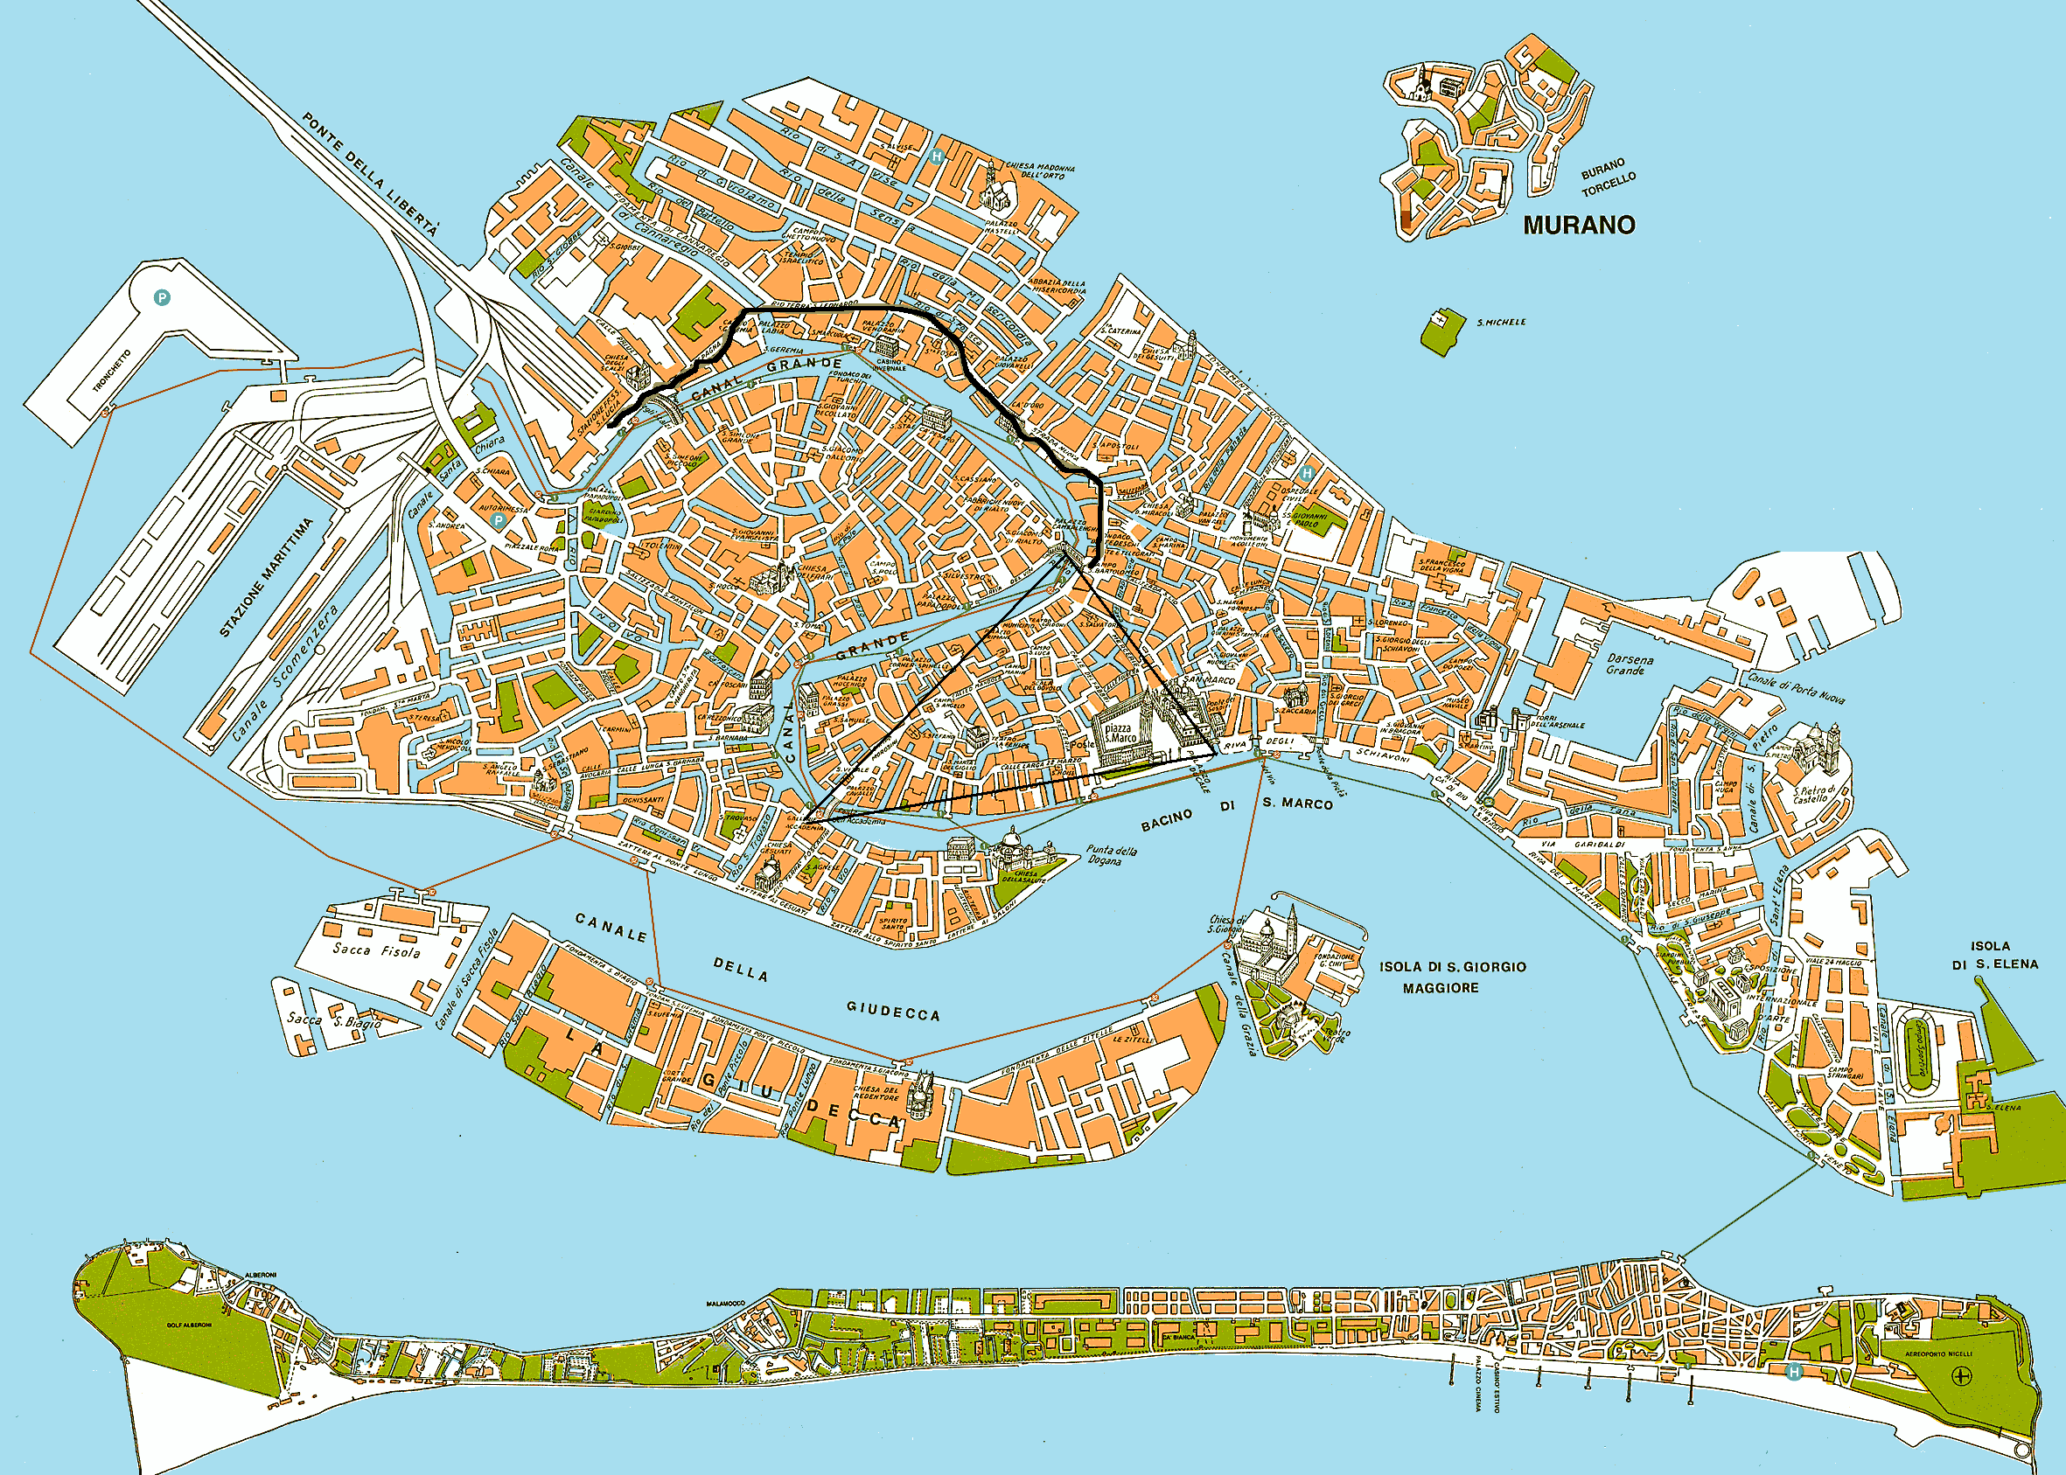
Figure 1. The Tourist Triangle and the Connector (Adapted map from Music in Venice, 2016)

The survey therefore included the whole area delimited by the Triangle, and the Connector, along a route which leads to Rialto Bridge in a relatively straightforward manner and which corresponds to the following streets: Rio Terà Lista di Spagna, Rio Terà San Leonardo, Calle del Pistor, Rio Terà della Maddalena and Strada Nova. The methodological stance adopted for this study was that all visible LL items in the relevant urban area would be recorded in order to allow a comprehensive evaluation of the Triangle and the Connector. As a result, the quantitative dimension of the analysis is directly functional to the discussion, and it is complemented by a qualitative discussion of the role of language and other semiotic elements.
For the reasons outlined above, and before discussing language displays, it is important to look at a breakdown of commercial and service establishments which were in the area (Table 1).

Table 1. Breakdown of commercial and service establishments in the surveyed area

Type of establishment | Tourist Triangle | Connector | Total
Food-related | 111 | 88 | 199
Souvenir | 174 | 106 | 280
Other shops | 190 | 111 | 301
Services | 81 | 26 | 107
Brand shops | 83 | 20 | 103
Total | 639 | 351 | 990

This information highlights to what extent these areas of Venice have been given up almost entirely to tourists as it was difficult to identify establishments that were not meant to serve tourists. Tiny calli (alleys) and larger streets were equally lined with ice-cream parlours, pizza/pasta places, coffee bars, restaurants of all descriptions and souvenir shops. In the Triangle, out of 639 establishments, only 59 (about 9%) could be classified as ‘ordinary’ shops. Along the connector, there were only 40 out of 351 (about 11%). However, coding commercial establishments such as newspaper kiosks or bookshops as ‘ordinary’ in the given context is an overstatement, because most of their customers are tourists and tourists are catered for via the sale of, amongst other goods, guidebooks, postcards and the like. Other shops such as (rather sparse) grocers’ and greengrocers’ were also used by tourists for the purchase of food and drink, and services such as pharmacies or post offices displayed signs addressing tourists as well (Figure 2).

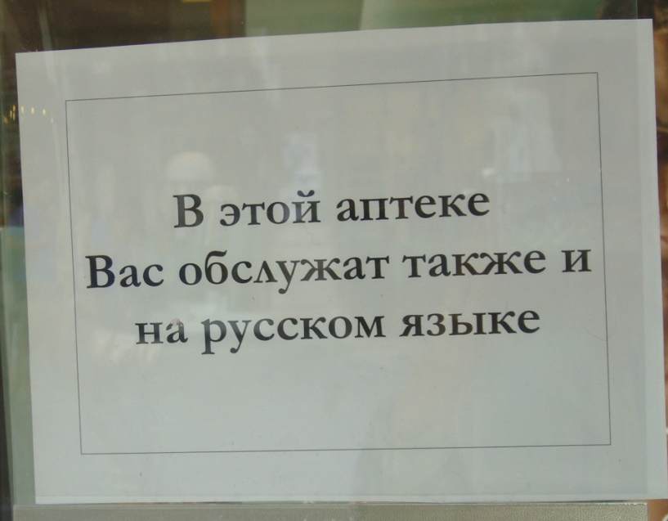

Figure 2. ‘In this pharmacy we serve you in Russian as well’

4.1 Language displays

As regards the display of languages, a breakdown is provided in Table 2.

Table 2. Languages displayed in the surveyed area (decreasing quantity of signs)

Language(s) displayed | Tourist Triangle | Connector | Total
Italian | 442 | 419 | 861
English | 216 | 129 | 345
Italian/English | 172 | 56 | 228
Italian and other languages (English/French/German/Spanish) | 92 | 54 | 146
English and other languages (French/German/Spanish) | 50 | 32 | 82
English/Italian | 54 | 24 | 78
Venetian | 6 | 5 | 11
Japanese | 2 | 0 | 2
Russian | 2 | 0 | 2
Arabic | 1 | 0 | 1
Chinese | 1 | 0 | 1
Polish | 1 | 0 | 1
Portuguese | 1 | 0 | 1
Total | 1040 | 719 | 1759

Where verbal signs were displayed, languages other than Italian (and Venetian) were visible on approximately half of the signs (887 out of 1759 tokens). The degree of visibility of languages other than Italian in the surveyed area of Venice was significantly higher than and in stark contrast to that found in other Italian urban areas, where languages other than Italian featured on an average of 15% of signs (Blackwood and Tufi, 2015, p. 207). English was used regularly, either autonomously (about 20% of the corpus) (Figure 3), or with other languages (30%), therefore featuring on 50% of the signs. Conversely, French, German and Spanish were not used autonomously (with the exception of the ubiquitous city guides, see Figure 4), but were displayed on multilingual signs such as restaurant menus or informational signs placed on monuments (13%). The use of French, German and Spanish therefore indexed undifferentiated categories of visitors whose linguistic repertoires had been simplified in the name of a perceived wide circulation of these world languages, which in turn points to deterritorialisation processes and linguistic levelling of very disparate groups of people.

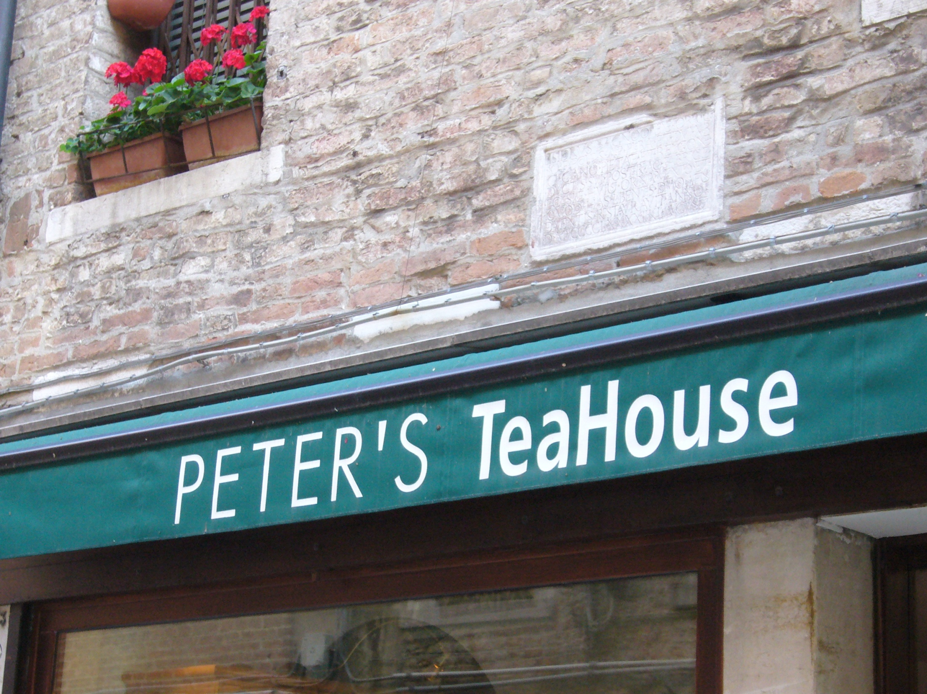

Figure 3. English used autonomously on shop sign

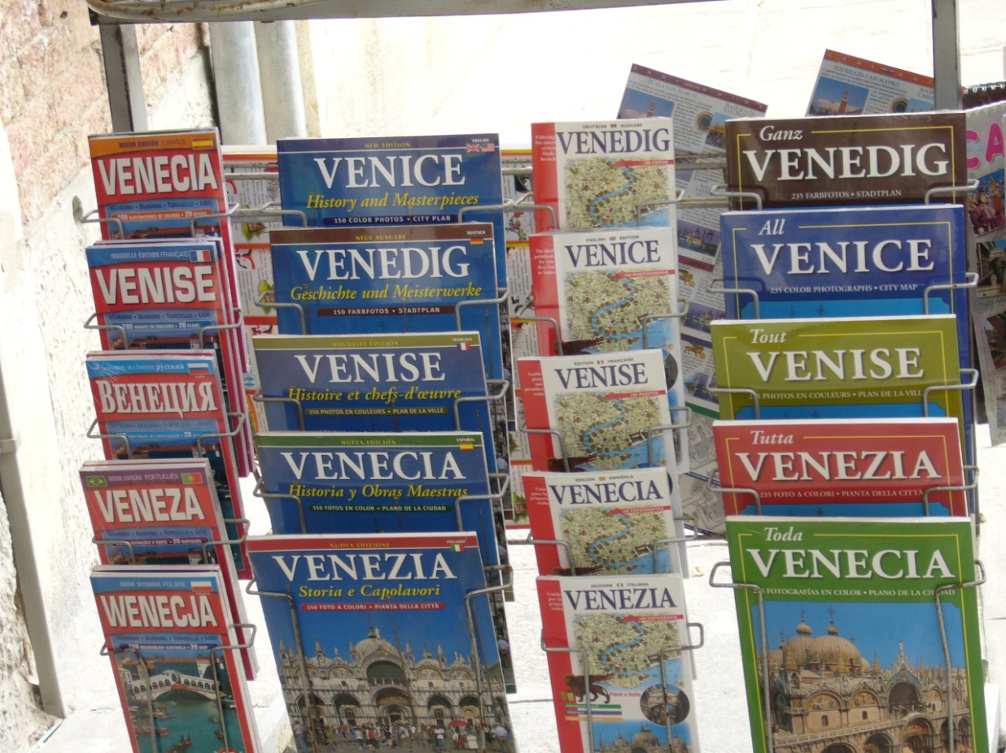

Figure 4. City guides for sale

It appears that in Venice’s tourist core there are signs of a process of deterritorialisation of the LL in the sense that the links between language as a cultural and historical product - Italian or even Venetian - and place are very weak. Non-territorial/tourist languages feature much more prominently than in other urban areas of Italy and Italian seems to index the presence of Italian tourists alongside other groups of tourists. In the linguistic market of the local tourist space not only is Italian not endowed with an enhanced symbolic status as the common language for written communication, but its functional use seems to have declined.
For example, the sign in Figure 5 was displayed on a church door and forbade visitors from entering the site during services. Italian appeared in the bottom right hand-side corner as the least prominent of the four languages (Kress and van Leeuwen, 2001; Scollon and Wong Scollon, 2003).

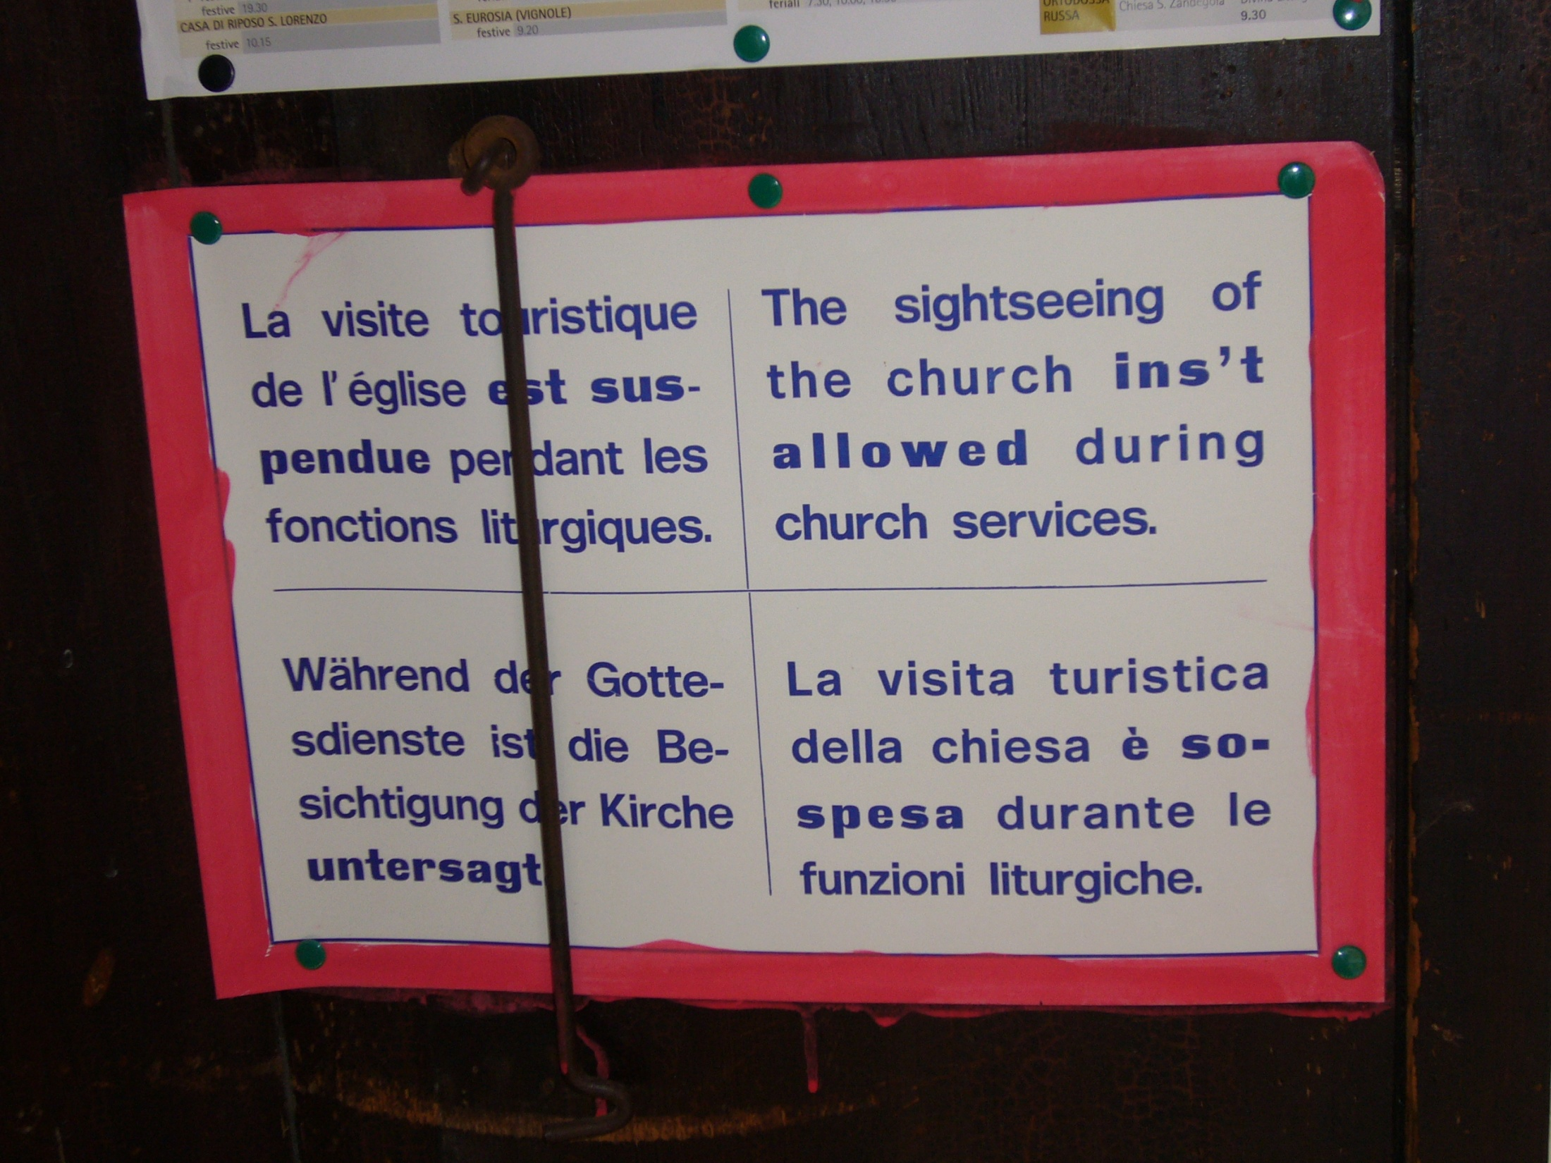

Figure 5. Sign displayed on a church door

Another instance is the sign in Figure 6 which, in indexing an establishment which serves Italian food, could be anywhere in the world.

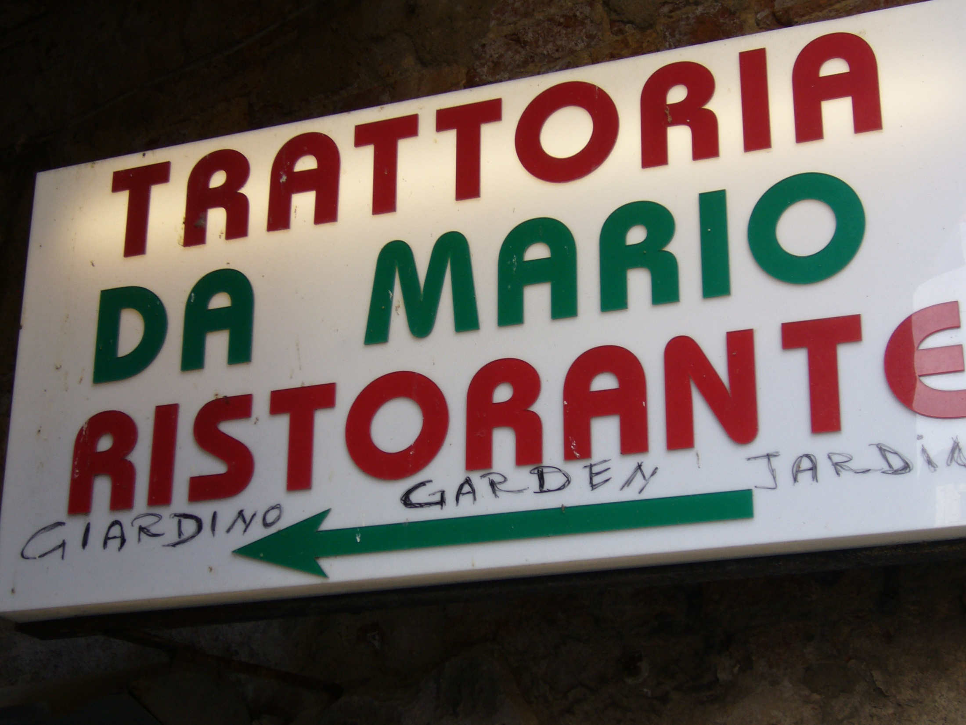
Figure 6. Trattoria sign

In Figure 6 the addition of the handwritten ‘garden’ in Italian, English and French authenticates the nature of the establishment, and not of place, with the non-standard collocation of the word ‘garden’ (here meaning ‘internal seating area’), thus reinforcing out-of-placeness. Moreover, the significant density of food-related establishments (Table 1), and of the ubiquitous pizza and/or pasta sign, in a small area of the city, paradoxically contributes to their cultural displacement – any Italian would be confident of finding pasta in any Italian restaurant and pizzerias are easily identified without large cardboard signs placed prominently outside the establishment and in proximity of outdoor seating areas, which is where tourists prefer to sit and eat, and where signs of this nature were placed. In addition, the inherent precariousness of the cardboard, hand-written signs validates the temporary nature of daytime Venice.
Even though it could be argued that the deterritorialisation of Venice has taken place over a long period of time due to the numberless representations and re-creations of Venice in other parts of the world, it is noteworthy that this process seems to have sidelined the territorial linguistic element, when it has not removed language altogether. Integrating Deleuze and Guattari’s (1988, p.106) vision with the notion of liminality, the multiplicity of voices that compose the local LL are those of ‘a people in the process of becoming other’, therefore capturing those people’s state of in-betweenness. In their discussion Deleuze and Guattari (1988) also employ the notion of assemblage. Although elusive and susceptible to interpretation, this notion posits that social entities consist of sets (assemblages) of elements which are not in a hierarchical relationship and that can be configured as parts of other assemblages. These elements are material objects, but also events (including speech events) and signs, and their assemblage is contingent and indefinite. It could be argued that the state of in-betweenness is activated by the commonality of traits in the assemblage of the tourist subjectivities, which are created and recreated via combinations of different cultural contexts. A property of this assemblage is the ability of tourist subjectivities to reterritorialise the LL by forging new articulations between the linguistic components of the public space.

4.2 Beyond language

As outlined above, in the area which mostly attracts constant flows of tourists, languages are of little relevance for the construction of Venice as ‘place’. The current linguistic configuration of the tourist core, on the contrary, points to the construction of Venice as ‘another place’, and both visual silence and non-verbal objects are dynamic contributors to the resulting heterotopia.

Table 3 provides the distribution of street signs and brand names in the surveyed area.

Table 3. Street signs and brand names

 | Tourist Triangle | Connector | Total
Street signs | 40 | 19 | 59
Brand names | 83 | 20 | 103

These signs constitute discourses which obfuscate the communicative function of language. Amongst those signs which could be coded as civic (i.e. government-controlled, as in Kallen, 2010), street signs in Venice are often misleading and/or meaningless to the tourist. Street numbering is consecutive, it covers a whole sestiere and can reach four digits (typical address: San Marco 1323), so it is likely that two distant-looking street numbers are in fact very close spatially (for instance, if San Marco 1323 is the final numbered building in the sestiere, it will be right next to San Marco 1). Toponyms are peculiar to Venice and add to spatial disorientation. For instance, there are calli (streets/roads), campi (squares) and campielli (small squares), and not (It.) vie, piazze and piazzette, to mention but a few generic terms. The word for bridge is the same (ponte), but there are about 400 in the city, a peculiarity in itself (Rizzo, 2007). Street signs are painted on buildings and maintain the original Venetian denomination, but street names are often re-used in different areas of the city. In addition, directional signs aimed at tourists point to sought-after landmarks and routes in an urban map which is superimposed onto local markings via semiotic devices, therefore backgrounding street names and foregrounding milestones and trajectories. For instance, in Figure 7 the yellow directional signs (Per Rialto, All’Accademia) stand out from a colour-code perspective, are spatially prioritised as they appear to the left of the street sign Calle de la Mandola, and are more durable than the painted street sign on the right-hand side. Attempting to reach places without tourist signs for non-Venetians usually results in walking in circles, and eventually returning to the point of departure. As a result, local street signs (and names) decorate the tourist map, on a par with other local features (architecture, canals, gondolas) that authenticate existing ideas about the city. Street signs also contribute to spatialisation practices in a dimension which could be paralleled to Lefebvre’s (1991) ‘lived space’, where le vecu is the space of human imagination existing at the intersection of perceived space and conceived space, and Soja’s (1996) ‘Thirdspace’, defined as ‘a fully lived space, a simultaneously real-and-imagined, actual-and-virtual locus of structured individuality and collective experience and agency’ (ibid.: 11). Street signs therefore contribute to the idea of Venice as painted, as artefact, but also as a physical site, although enacted as a heterotopia and as part of a liminal experience. The fact that street signs in Venice are systematically painted on buildings and do not occupy a separate or superimposed surface, as in other urban contexts, reinforces their aesthetic function.

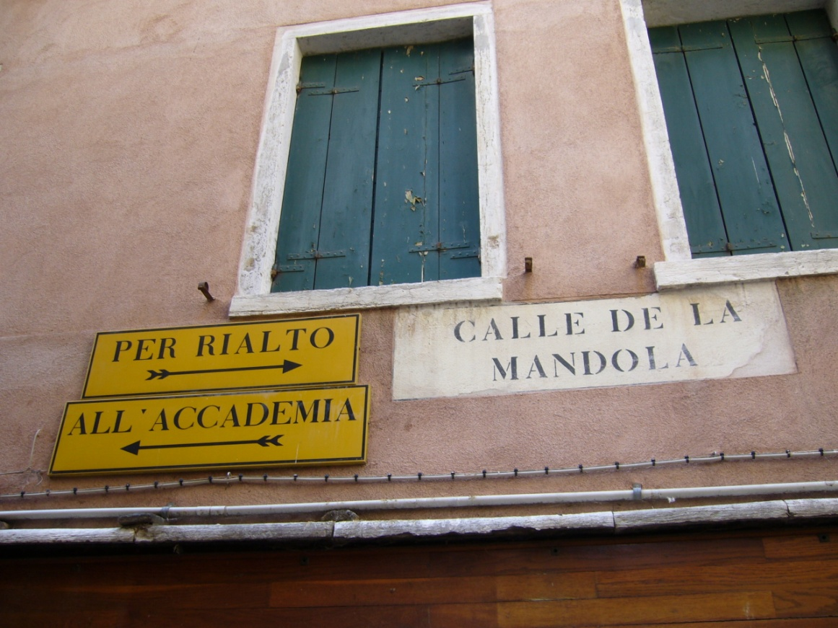

Figure 7. Two directional signs pointing to Rialto Bridge and the Gallerie dell’Accademia, and one street sign (Calle de la mandola).

With respect to brand names, we noted the presence of exclusive designer brands with shops clustered primarily around St Mark’s Square. Davis and Marvin (2004, p. 99) provide an entertaining account of the role of designer shops in Venice, arguing that the average day tourist is less than likely to spend significant sums of money on a Gucci purse or a Prada outfit. Conversely, the noteworthy presence of high-end designer shops seems to be part of a marketing ploy whereby those global brands are keen to display the city’s name (alongside that of Milan or Rome, for instance) on their shopping bags for everyone to see that they have an outlet in Venice (the ultimate ‘dreamscape of visual consumption’ (Zukin, 1992, p. 221)). From our perspective, we posit that ‘Venice’ on designer shopping bags contributes to the city’s displacement and deterritorialisation, and that, by encoding alternative spatial narratives, brand names (which account for more than 10% of all signs) are visual objects which help to configure the city as a heterotopia. In this sense brand names acquire yet another status which is complementary to both Tufi and Blackwood (2010), where the linguistic and cultural status of brand names is constantly negotiated and ascribed by different social actors in decoding processes, and Ben-Rafael (2016), where brand names are non-linguistic items in increasingly transnational urban spaces.
Conversely, the task of city branding itself seems to have been mostly delegated to commodities and practices other than language. As mentioned above, a striking aspect of Venetian public space was the limited appearance of written signs. It was not unusual for shops not to have shop signs, and even shop windows which were absolutely crammed with goods did not display any text - often not even prices.

Table 1 incorporates establishments with no visible text which were characterised by the goods on display in the shop windows. This was the case primarily in the Triangle, where about 60% of ‘souvenir shops’ and 20% of ‘other shops’ were recorded not because of observable displayed text, but as items in the semiotic landscape which represented a significant contribution to localised semiosis. Although the shopkeepers were not consulted as informants in a systematic manner, when asked they said that a shop sign was not necessary and that the shop window spoke for itself. This applied to souvenir shops as well as to other establishments in a random manner.
Souvenirs are central to discourses of Venice as another place. Souvenir shops account for about a third of all shops in the surveyed area. Their presence in the urban space is overwhelming and viewers are inundated with endless displays of Venetian glass and masks, ubiquitous signifiers potentially swamping all other signifiers. Venice is therefore appropriated again and again via the purchase of small fragments of itself. Glass and masks stand for Venice and, as its simulacrum (Baudrillard, 1994), can be taken elsewhere where the spectacle of Venice (Debord, 1994) can be recreated away from its locality.
Unlike smells, tastes and sounds, which are difficult to reactivate in different sensorial environments, souvenirs are powerful time mediators and objects of transition, of in-betweenness, of threshold (Morgan and Pritchard, 2005, p. 46). They inhabit a sphere which is outside of the everyday and between the domestic and the public. The extraordinary abundance of souvenirs in Venice materialises the in-betweenness of the urban space.

5. Conclusion

The construction of Venice as another place is deeply rooted and rests on a socio-historical basis of conflicting discourses and on the development and wide circulation of visual representations that have allowed appropriation of and familiarisation with the city and its uniqueness on the part of the global community. Mass tourism has accelerated this long-term process in recent times. However, this study engaged with both constructivist and flexible notions of tourism, and with their interconnections with ideas of the tourist as the modern pilgrim. This in turn established links with the spatial organisation of the tourist experience in Venice and foregrounded those regimes of walkscapes reproduced by tourists amidst a net of possible urban maps.
We propose that the space under investigation points to the construction of a liminal LL which characterises a heterotopic site. Venice shares some of the features of Foucault’s heterotopias, and its liminality and in-betweenness is enhanced by its physical morphology, the juxtaposition of alternative urban maps and the linguistic deterritorialisation that language agents have enacted in core tourist areas. Linguistic deterritorialisation is mostly documented by the limited role played by written Italian, when compared to other urban areas of Italy. It is likely for signs to display a number of tourist languages with or without Italian (as is the case for about 50% of the signs observed), and Italian features as non-salient in key tourist spots. Another factor contributing to liminality is the conspicuous erasure of the commercial LL and a process of metonymical substitution enacted by souvenirs. From this perspective, souvenirs are ‘objects of transition’ (Morgan and Pritchard, 2005, p. 31) and become the main discursive devices in the validation and reenactment of the tourist experience via their ability to mediate memory and place. The extreme mediatisation of Venice, and the global consumption of its multiple representations and iconography, has also led to a process of fetishisation of its material signifiers – glass and masks. The constant, regular emphasis on objects such as glass ornaments and masks as disjointed from their linguistic characterisation makes them independent social actors (Appadurai, 1988) and therefore contributes to the process of deterritorialisation and heterotopic conversion. Similarly, these material elements can be seen as components of assemblages (Deleuze and Guattari, 1988) and, as such, they participate in the creation and recreation of transitory and fluid interconnections between the material world and the reenactment of events and experience. Venice as landscape and sensescape therefore can be seen, sensed, consumed and reenacted away from locality so that, as Henry James wrote, ‘it is the easiest [city] to visit without going there’. Linguistic deterritorialisation seems to be an integral part of its displacement.
As a concluding remark, we are aware that some of the observations made in the course of the discussion apply to other popular tourist destinations. However, we contend that the linguistic and wider semiotic configuration of the public space in Venice is unique and that the analysis offered in this paper contributes to an understanding of peculiar constructions of transnational spaces as a result of late modernity. In addition, the analysis foregrounds the importance of LL studies as a means to tease out processes of meaning making which would be neglected otherwise.

Acknowledgements

I wish to acknowledge my gratitude to the British Academy for supporting the fieldwork for this study via a Small Research Grant Award (101856).

References

Aramberri, J. (2010). Modern Mass Tourism. Bingley: Emerald.
Badone, E., & Roseman, S. R. (Eds.) (2004). Intersecting Journeys: The Anthropology of Pilgrimage and Tourism. Urbana: University of Illinois Press.
Basso, K., & Feld, S. (Eds.) (1996). Senses of Place. Albuquerque, NM: University of New Mexico Press.
Blackwood, R. J., & Tufi, S. (2015). The Linguistic Landscape of the Mediterranean. French and Italian Coastal Cities. Basingstoke: Palgrave.
Baudrillard, J. (1994). Simulacra and Simulation. Ann Arbor: University of Michigan Press.
Boorstin, D. J. (1964). The Image: a Guide to Pseudo-Events in America. New York: Harper & Row.
Bourdieu, P. (1986). Distinction: A Social Critique of the Judgement of Taste. London: Routledge.
Chiarini, E., & Mengaldo, P. V. (1970). Venezia. Enciclopedia Dantesca, retrieved on 29 February 2016, from http://www.treccani.it/enciclopedia/venezia_(Enciclopedia-Dantesca)/
Cohen, E. (1972). Toward a sociology of international tourism. Social Research, 39(1), 164-189.
Cohen, E. (2006). A Phenomenology of Tourist Experience. In Y. Apostolopoulos, S. Leivadi, & A. Yiannakis (Eds.), The Sociology of Tourism: Theoretical and Empirical investigations (pp.90-114). New York: Routledge.
Coleman, S., & Elsner, J. (1995). Pilgrimage Past and Present in the World Religions. Cambridge, Mass.: Harvard University Press.
Comune di Venezia. (2012). Annuario turismo 2011. Venezia: CPM, retrieved on 22 February 2016, from http://www.comune.venezia.it/flex/cm/pages/ServeBLOB.php/L/IT/IDPagina/53175
Comune di Venezia. (2016). retrieved on 14 March 2016, from
http://www.comune.venezia.it/flex/cm/pages/ServeBLOB.php/L/IT/IDPagina/4055

Davis, R. C., & Marvin, G. R. (2004). Venice, the Tourist Maze : A Cultural Critique of the World’s Most Touristed City. Berkeley: University of California Press.
Debord, G. (1994). The society of the spectacle. New York: Zone Books.
DeLanda, M. (2006). A New Philosophy of Society: Assemblage Theory and Social Complexity. London: Continuum.
Deleuze, G., & Guattari, F. (1988) A Thousand Plateaus. Capitalism and Schizophrenia. London: Athlone Press.
Eade, J., & Sallnow, M. J. (Eds.). (1991). Contesting the Sacred. The Anthropology of Christian Pilgrimage. Urbana: University of Illinois Press.
Eglin, J. (2001). Venice Transfigured: the Myth of Venice in British Culture, 1660-1797. Basingstoke: Palgrave.
England, K. V. L. (1994). Getting personal: Reflexivity, positionality, and feminist research. The Professional Geographer, 46(1), 80-89.
Foucault, M. (1984). Of other spaces: Utopias and heterotopias. [Des Espace Autres, 1967]. Translated by Jay Miskowiec. Architecture, Mouvement, Continuité, 5, 46-49.
Foucault, M. (2002). The Order of Things. An Archaeology of the Human Sciences. London & New York: Routledge.
Gadamer, H. G. (2004). Truth and Method. London: Continuum.
Geertz, C. (1973). The Interpretation of Cultures: Selected Essays. New York: Basic Books.
Horne, D. (1984). The Great Museum: The Re-presentation of History. London: Pluto Press.
James, H. (1884). Portraits of Places. Boston: James R. Osgood and Company.
Kallen, J. L. (2010) Changing landscapes: Language, space and policy in the Dublin linguistic landscape. In A. Jaworski & C. Thurlow (Eds.), Semiotic Landscapes. Language, Image, Space (pp. 41-58). London: Continuum.
Kress, G., & van Leeuwen, T. (2001). Multimodal Discourse: the Modes and Media of Contemporary Communication. London: Arnold.
Labov, W. (1972). Sociolinguistic Patterns. Philadelphia: University of Pennsylvania Press.

Lefebvre, H. (1991). The Production of Space. Oxford: Blackwell.

Lou, J. (2007) Revitalizing Chinatown into a heterotopias. A geosemiotic analysis of shop signs in Washington, D.C.’s Chinatown. Space and Culture 10(2), 170-194.

MacCannell, D. (1973). Staged authenticity: Arrangements of social space in tourist settings.
American Journal of Sociology, 79(3), 589-603.
MacCannell, D. (1976). The Tourist: A New Theory of the Leisure Class. Berkeley: University of California Press.
Martin, J., & Romano, D. (Eds.). (2003). Venice Reconsidered: The History and Civilization of an Italian City-State 1297-1797. Baltimore: John Hopkins University Press.
Merriam, S. B., Johnson-Bailey, J., Lee, M., Kee, Y., Ntseane, Y., & Muhamad, M. (2001). Power and positionality: Negotiating insider/outsider status within and across cultures. International Journal of Lifelong Education, 20(5), 405-416.
Music in Venice. (2016). Retrieved on 2 March 2016, from http://www.musicinvenice.com/eng/infovenice.html.
Obrador, P. (2012). The place of the family in tourism research: Domesticity and thick sociality by the pool. Annals of Tourism Research, 39(1), 401–420.
Pennycook, A., & Otsuji, E. (2015). Making scents of the landscape. Linguistic Landscape, 1(3), 191-212.
Petrarch, F. Epistolae Familiares, XXIII, 16, 3.
http://www.mlat.uzh.ch/MLS/xfromcc.php?tabelle=Francesco_Petrarca_cps6&rumpfid=Francesco_Petrarca_cps6,%20Epistole%20familiares,%20%2023,%20%2016&id=Francesco_Petrarca_cps6,%20Epistole%20familiares,%20%2023,%20%2016,%20%20%20%20%2020&level=99&level9798=&satz=20&hilite_id=Francesco_Petrarca_cps6,%20Epistole%20familiares,%20%2023,%20%2016,%20%20%20%20%2020&string=EGENS&binary=&corpus=6&target=&lang=0&home=&von=suchergebnis&hide_apparatus=1&inframe=1&jumpto=20
Poon, A. (1993). Tourism, Technology and Competitive Strategies. Wallingford: CAB International.
Porteous, J. (1990). Landscapes of the Mind: Worlds of Sense and Metaphor. Toronto: University of Toronto Press.
Provincia di Venezia (2016). Turismo Venezia. Retrieved on 6 March 2016, from http://www.turismovenezia.it/-Movimentazione-Turistica-per-Tematismi-Balneare-Citt-d-Arte-Entroterra-Veneziano-2014-423675.html
Rakić, T., & Chambers, D. (2012). Rethinking the consumption of places. Annals of Tourism Research, 39(3), 1612-1633.
Ritter, A. & Wolny, M. (2016). The Russian language in the Linguistic Landscape of western European cities between migration and tourism. Examples from Nuremberg (Germany) and Venice (Italy). Paper presented at the 37TH International LAUD Symposium, Landau, 4-6 April 2016.
Rizzo, T. (2007). I ponti di Venezia. Rome: Newton Compton.
Rose, G. (1997). Situating knowledges: Positionality, reflexivities and other tactics. Progress in human geography, 21(3), 305-320.
Scollon, R. and Wong Scollon, S. (2003) Discourses in Place: Language in the Material World. London: Routledge.
Soja, E. W. (1996). Thirdspace: Journeys to Los Angeles and Other Real-and-Imagined Places. Oxford: Blackwell.
Stroud, C. and Mpendukana, S. (2009). Towards a material ethnography of linguistic landscape: Multilingualism, mobility and space in a South African township. Journal of Sociolinguistics, 13, 363-386.
Thurlow, C., & Jaworski, A. (2010). Silence is golden: The ‘anti-communicational’ linguascaping of super-elite mobility. In A. Jaworski & C. Thurlow (Eds.), Semiotic Landscapes. Language, Image, Space (pp. 187-218). London: Continuum.

Tomlinson, J. (2013). Globalisation and Culture. Oxford: Wiley.
Turner, L. and Ash, J. (1975). The ‘Golden Hordes’. International Tourism and the Pleasure Periphery. London: Constable.
Turner, L. (1974). Tourism and the Social Sciences. From Blackpool to Benidorm and Bali. Annals of Tourism Research, 1, 180-205.
Turner, V., and Turner, E. (1978). Image and Pilgrimage in Christian Culture. Anthropological perspective. Oxford: Blackwell.
Urry, J. (1990). The Tourist Gaze: Leisure and Travel in Contemporary Societies. London: Sage.
Vaikikka, V. (2013). Rethinking mass tourism. Tourist Studies, 13(3), 268-286.
Wee, L. (2016). Situating affect in linguistic landscape. Linguistic Landscape, 2(2), 105-126.

Zukin, S. (1992). Landscapes of power. Berkeley: University of California Press.

Author’s address

Stefania Tufi
Department of Modern Languages and Cultures
University of Liverpool
Cypress Building
Chatham Street
Liverpool L69 7ZR
UK

stefania.tufi@liverpool.ac.uk

In this respect Ritter & Wolny 2016 (paper presented at the 37TH International LAUD Symposium) highlight the increasing prominence of languages such as Russian, both as a tourist language and as a migrant language, in the wider municipality of Venice encompassing mainland areas and featuring migrant languages.
The discussion provided in Wee (2016) offers an interesting perspective on affective regimes of varying degrees of formalisation and inscription in the LL. In this respect the walkscapes regimes observed in Venice would intersect with the affective regime consolidated by local civic norms (e.g. the directional signs) and construct a semi-formal (Wee 2016: 121) regime characterised by a strong liminal dimension.
Lou (2007) employed Foucault’s framework for an LL analysis of Chinatown in Washington, D.C.. The construction of Chinatown as a heterotopia was the result of a locally managed mandate to have all shop signs featuring the Chinese language, regardless of the nature of the establishments. The attempt to preserve the original characteristics of Chinatown unwittingly unveiled a juxtaposition of reality and illusion and a layering of heterochronies.
I am grateful to Sandra Zdravkovich for helping me with the translation and for pointing out that the sentence reflects non-standard use of Russian.

