Formation of Hydrophobic Drug Nanoparticles via Ambient Solvent Evaporation Facilitated by Branched Diblock Copolymers

Ulrike Wais,*a,,b, c* Alexander W. Jackson,*b* Tao He*c\** and Haifei Zhang*a\**

*a* Department of Chemistry, University of Liverpool, Liverpool, L69 7ZD, UK.

*b* Institute of Chemical and Engineering Sciences, 1 Pesek Road, Jurong Island, 627833, Singapore.

*c* School of Chemistry and Chemical Engineering, Hefei University of Technology, Hefei, China.

*\** Corresponding Authors

Tao He – email: [taohe@hfut.edu.cn](mailto:taohe@hfut.edu.cn), phone: +86 551 62905158.

Haifei Zhang – email: [zhanghf@liv.ac.uk](mailto:zhanghf@liv.ac.uk), phone: +44 151 7943545

**Abstract**

Hydrophobic drug nanoparticles have been prepared by ambient solvent evaporation from ethanol at room temperature. Poly(ethylene glycol)-b-(*N*-isopropylacrylamide) (PEG-*b*-PNIPAm) branched diblock copolymers are employed to prevent drug crystallization during solvent evaporation and to stabilize the drug nanoparticles once suspended in aqueous media. After the initial solvent evaporation the dry materials obtained exhibit excellent stability during storage and can be readily dissolved in water to produce aqueous drug nanoparticles suspensions. Among the hydrophobic compounds investigated, Ketoprofen nanoparticles (*D*h ≈ 200 nm, stable up to 9 months in solution) can be produced with a drug suspension yield of 96% at a drug: polymer ratio of 0.33: 1 or a drug suspension yield of 80% at a drug: polymer ratio of 1: 1. UV-Vis spectroscopy has been used to determine the yield of drug suspended in aqueous media while cryo-TEM, dynamic light scattering (DLS) and powder x-ray diffraction (PXRD) are used to characterize the drug nanoparticles prepared.

KEYWORDS: poorly water-soluble drugs, drug nanoparticles, branched block copolymers, solvent evaporation, ketoprofen

**1. Introduction**

Despite their promising properties, there has been limited use of hydrophobic organic compounds because of their poor water-solubility. Low water solubility and poor dissolution rates can lead to clearance from the gastrointestinal (GI) tract before absorption by the intestines (Barve et. al., 2009; Liversidge and Cundy, 1995). Approaches such as salt formation, co-crystal formation and prodrugs, have been developed to increase solubility by ionization of the active molecule (Serajuddin, 2007). Chemical coupling to a carrier or antibody, and subsequent cleavage by a biochemical process has also been persued (Thakuria et. al., 2013). However, prodrugs encounter the risk of toxic by-products after cleavage (Testa, 2004) while salt formation and co-crystals require specific chemical characteristics, which might not always be available (Serajuddin, 2007). Another method to improve bioavailability is downsizing the drug to the nano-sized range (Junyaprasert and Marakul, 2015; Merisko-Liversidge and Liversidge, 2011; Wais et. al., 2016a). Nano-sizing can be accomplished via two main principals, top-down, by which micron sized particles are ground to smaller sizes via mechanical means (Canelas et. al., 2009; Van Eerdenbrugh, 2008) or bottom-up, where nanocrystals are obtained directly from solution (Chan and Kwok, 2011; Kudera and Manna, 2014; Sinha et. al., 2013).

There are various bottom-up processes such as spray drying (Broadhead et. al., 1992), solvent-antisolvent precipitation (Matteucci et. al., 2006; Viçosa et. al., 2012; Zhao et. al., 2007), supercritical fluid precipitation (Knez and Weidner, 2003; Pathak et. al., 2004; Zhang et. al., 2001) or emulsion freeze-drying (Grant and Zhang, 2011; Qian and Zhang, 2013; Wais et. al., 2016b; Zhang et. al., 2008). While they may employ milder or less invasive conditions when compared to top-down methods, they often exhibit one or more of the following draw-backs: low nanoparticle yield, extreme temperatures, particle agglomeration and potentially toxic additives (Broadhead et. al.; 1992; et. al., 2012; Matteucci et. al., 2006; Zhao et. al., 2007; Zhang et. al., 2001; Knez and Weidner, 2003; Pathak et. al, 2004; Grant and Zhang, 2011; Zhang et.al, 2008; Qian and Zhang, 2013; U.Wais et. al., 2016a).Bottom-up methods often employ small molecule surfactants as stabilizers for drug nanoparticles, unfortunately, agglomeration is still a significant issue unless the solvent is removed quickly (Gassmann et. al., 1994; Hu et. al, 2011). This key drawback introduces scalability issues with most bottom-up processes.

Thermodynamic crystallization methods generally utilize mild conditions and are energy and cost efficient. Therefore, they may be ideal for industrial production. However, crystallization methods are commonly used to obtain large single crystals, and it is desirable to obtain drug nanoparticles which are much smaller and amorphous for improved solubility (Hancock and Parks, 2000). Solvent mediated crystallization studies with Carbamazepine and different amino acids showed that the addition of certain surfactants (e.g. sodium lauryl sulphate, sodium taurochlorate) could prolong or even inhibit the transformation or growth of certain polymorphic forms (Garti and Zour, 1997; Rodriguez-Hornedo and Murphy, 2004; Weissbruch et. al., 1988). One study demonstrated that polymer additives were able to delay nucleation on the basis of hydrogen-bond formation with the active ingredient (Raghavan et. al., 2001). It was also observed that the application of polymers could prevent the formation of crystalline materials via arrest of the amorphous particles, after either evaporation by spin-coating or spray drying (Konno and Taylor, 2006; Van den Mooter et. al., 2001).

Despite these inhibitory characteristics, drug particles produced by solvent evaporation are commonly in the micron range (Rasenack and Müller, 2002; Van den Mooter et. al, 2001; Van Eerdenbrugh and Taylor, 2010; Xie et. al, 2010). Consequently, the development of thermodynamic crystallization for drug nanoparticles facilitated by surfactants or polymers could be highly beneficial. The main goal in this area is to develop a route to nano-sized drug nanoparticles which requires mild conditions and a simple/ cost-effective process. Herein, through the synthesis and application of biocompatible branched diblock copolymers, we describe the formation of hydrophobic drug nanoparticles via a simple ambient solvent evaporation approach. This process is substantially different from emulsion evaporation and evaporation-induced nanoprecipitation (Pal and Saha, 2017; Rao and Geckeler, 2011). In both processes, organic solutions and aqueous solutions are mixed, either forming an emulsion or a mixing solution. The subsequent solvent evaporation produces aqueous nanoparticle suspensions directly. In the work by Roberts and Zhang, the direct solvent evaporation of organic drug solution was performed from the solution-soaked porous polymer which was pre-fabricated by a freeze-drying process (Roberts and Zhang, 2013). The process described in this work employs the more benign organic solvent ethanol and simple open air evaporation at room temperature without use of a porous polymeric scaffold. The yields of hydrophobic Ketoprofen drug nanoparticles in the region of *D*h ≈ 200 nm can reach 96 % while the stability of the nanoparticles in solution reaches up to 9 months. The key to increasing the potential of this straightforward and robust approach is in the rational design and synthesis of branched diblock copolymers.

**2. Experimental**

*2.1. Materials*

Deionized water was prepared using an AquaMAX-Basic 321 DI water purification system. Indomethacin ≥ 99 %, Ketoprofen ≥ 98 %, Oil Red O ≥ 75 % and 1-dodecanethiol (DDT) were purchased from Sigma-Aldrich and used as received. Macro-initiator poly(ethylene glycol) azo-dimer (12 kDa) was purchased from Wako Pure Chemical Industries Ltd. (Osaka, Japan). Ethylene diacrylamide was synthesized as described elsewhere (Wais et al., 2016b). All solvents were purchased from Sigma-Aldrich and used as received.

*2.2. Synthesis of PEG-b-PNIPAm branched diblock copolymers*

The branched diblock copolymers were synthesized as described elsewhere (Wais et al., 2016b). Typically, the macro-initiator poly(ethylene glycol) azo-dimer (12 kDa, 1.2 g, 0.1 mmol, 1 eq), *N*-isopropylacrylamide (0.56 g, 5 mmol, 25 eq per PEG chain), ethylene diacrylamide (either 10.1/ 20.2/ 30.3 mg, 0.06/ 0.12/ 0.18 mmol, **0.3**/ **0.6**/ **0.9 eq** per PEG chain, respectively) and dodecanethiol (10.1 mg, 0.05 mmol, 0.25 eq per PEG chain) were transferred into a small Schlenk tube fitted with a magnetic stirrer bar and *N,N’*-dimethylformamide (7 mL) added. The reaction mixture was degassed by bubbling with N2 then placed in an oil bath at 70 °C and the polymerization quenched by rapid cooling after 16 h. The reaction mixture was diluted with THF (15 mL) and added dropwise to a large excess of ice-cold diethyl ether. The precipitation was repeated once more before the desired branched diblock copolymer was obtained as a white solid (0.94 g).

*2.3. Drug nanoparticle formation by solvent evaporation*

PEG-*b*-PNIPAm branched diblock copolymer (**0.3**, **0.6** or **0.9 eq** cross-linker) and a hydrophobic drug/ dye were added to a glass vial in drug/dye: polymer mass ratios of 1: 1, 0.5: 1 and 0.33: 1 and selected solvent (6 mL) added. The total polymer + drug/ dye concentration in solution was constant at 2 mg/mL. For example, for the drug/ dye: polymer ratio of 0.33: 1, PEG-*b*-PNIPAM (9 mg) and drug/ dye (3 mg) were dissolved in 6 ml of the selected solvent. If both materials did not fully dissolve the mixture was gently heated to 55 °C. The solution was then either left to evaporate without stirring at room temperature overnight, 50 °C or 80 °C for 2 h. Solvent evaporation was also performed under rotary evaporation at 30 °C or 50 °C until dryness. After solvent evaporation deionized water (3 mL) was added (to afford a total (drug/ dye + polymer concentration of 4 mg/mL). Any aggregates/ precipitants were removed by centrifugation and the desired drug/ dye nanoparticle suspension obtained.

*2.4. Characterisation*

Drug/ dye particle sizes were determined by dynamic laser scattering (DLS) analysis on a Malvern Zetasizer Nanoseries at 25 °C. The measurements were performed on aqueous nanoparticles suspensions with a concentration of ~ 0.2 mg/mL. Microparticles or aggregates formed during the preparation were removed by centrifugation (in order to calculate the yield of nanoparticles, detailed in the section below) with an Eppendorf Centrifuge 5415 D at 3000 rpm for 3 mins and 1 min at 3600 rpm. Cryo-transmission electron microscopy (Cryo-TEM) was carried out using a vitrification robot (FEI Vitrobot MARK IV). All samples were prepared at room temperature and 100 % humidity with blotting time of 2 and blot force of 1. The samples (5 µL) were applied onto a grid (Quantifoil, R2/2, holey carbon film, freshly glow-discharged prior to use at 20 mA for 30 sec) without dilution. Excess sample was blotted away with filter paper to leave a thin film on the grid before being vitrified in liquid ethane. Cryo-TEM measurements were performed on FEI Titan Krios equipped with automated sample loader and Field Emission Gun (FEG) operating at 300 kV. Images were recorded with Falcon II camera (4X4) with magnification of 29000 and pixel size of 2.873. Powder x-ray diffraction (PXRD) was measured in Bragg-Brentano reflection geometry on a Bruker D8 Advance powder diffractometer equipped with a Cu-Kα source, a Nickel K-β filter and a Vantec position sensitive detector. The samples were prepared on a Si-low-background sample holder (Si-single crystal polished). The obtained nano-suspensions in water were dropped onto the sample holder and left to evaporate till dry. UV/Vis analysis was performed on a Shimadzu UV-2700 in ethanol, drug/ dye concentrations were determined against a calibration curve of solutions of known concentration.

*2.5. Determination of suspended drug yield*

After solvent evaporation the solid samples obtained were dispersed into water. Microparticles and aggregates were removed by centrifugation. The yield of suspended drug/dye in water was calculated as described below:

$$Yield=\frac{m_{NP}}{m_{T}}× 100=\frac{m_{S}}{m_{S}+m_{P}}×100$$

Where *mNP* is the mass of drug/ dye suspended in water and *mT* is the total initial mass of drug/ dye. *mS* is the mass of drug/ dye in the suspension after centrifugation and *mP* is the mass of precipitated drug/ dye after centrifugation. To determine the mass in suspension, 100 µL was added to 2900 µL ethanol and measured by UV/Vis. The centrifugation precipitant was re-dissolved in 3 mL ethanol. 60 µL of this solution was then added to 2940 µL ethanol and measured by UV/Vis. Quantities of drug/ dye were determined against calibration curves of known concentrations in ethanol.

*2.6. Determination of dissolution rate*

Dissolution rates were tested using a Flow*-*Through USP IV Dissolution Apparatusby Erweka. 2.0 mg of Ketoprofen as received and 8.0 mg Ketoprofen: PEG-*b*-PNIPAm 0.33: 1 (2.0 mg Ketoprofen + 6.0 mg PEG-*b*-PNIPAm) as-prepared directly by solvent evaporation were added to glass beads and filled into the flow through cells. Membrane filters of 0.2 µm pore sizes were inserted before and after the glass beads to ensure that glass beads and larger nanoparticles/aggregates could not pass through and distort the measurement. A flow rate of 4.15% was chosen and the temperature was set to 37 °C. The set-up was set to close loop and 200 mL DI water was continuously passed through the flow cell. The beaker containing the medium was kept at 37 °C and stirred at 100 rpm. At specific time intervals 2.4 mL samples were withdrawn and 0.6 mL ethanol was added into the withdraw samples to ensure that all the Ketoprofen was completely dissolved for analysis. The UV/Vis spectroscopy was employed to determine the concentration.

**3. Results and Discussion**

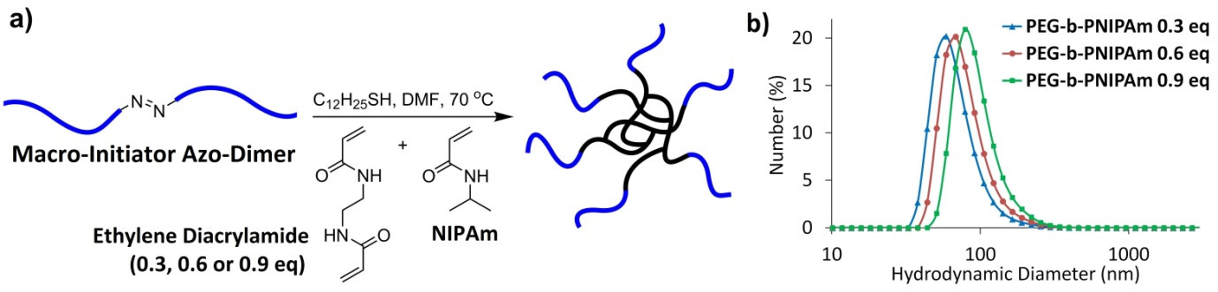

**Figure 1.** (a) Preparation of PEG-*b*-PNIPAm branched diblock copolymers via the conventional radical polymerization of *N*-isopropyl acrylamide and the cross-linker ethylene diacrylamide initiated by a poly(ethylene glycol)-based macro-initiator azo-dimer and (b) dynamic light scattering analysis of PEG-*b*-PNIPAm branched diblock copolymers prepared with varying ratios of ethylene diacrylamide cross-linker (**0.3**, **0.6** and **0.9** eq per PEG chain).

*3.1. Branched diblock copolymer synthesis and initial solvent screening*

PEG-*b*-PNIPAm branched diblock copolymers were synthesized via the conventional radical polymerization of *N*-isopropylacrylamide (NIPAm) and ethylene diacrylamide in the presence of a macro azo-dimer poly (ethylene glycol) initiator (Figure 1(a)) (Wais et. al, 2016b). Three branched diblock copolymers were prepared with varying amounts of the ethylene diacrylamide cross-linker and they formed nanoparticles when dispersed in water (Figure 1(b)). The molar equivalent of cross-linker to each PEG chain was varied at **0.3**, **0.6**, and **0.9** **eq**. The molar equivalent of cross-linker will be used to distinguish which of the three branched diblock copolymers is employed in nanoparticle formation throughout this work. The branched diblock copolymers were then screened to determine their efficiency in the formation of drug nanoparticles. Each branched diblock copolymer was dissolved in an organic solvent along with either Ketoprofen or Oil Red O. After ambient solvent evaporation water was added and the suspensions obtained analyzed. After preliminary evaluation, the branched block copolymers with **0.3** and **0.6 eq** cross-linking displayed positive results in terms of nanoparticle stability when compared to **0.9 eq**. Presumably, a cross-linking molar ratio of **0.9 eq** relative to each PEG chain results in more tightly cross-linked branched diblock copolymers which is not favourable for good polymer to drug/ dye interactions during solvent evaporation. Therefore, the **0.3** and **0.6** **eq** cross-linked branched diblock copolymers were selected for a more systematic and detailed evaluation. Dichloromethane a non-polar solvent, acetone a polar aprotic solvent and ethanol a polar protic solvent were initially screened. These solvents were chosen for their variations in vapour pressure, polarity and relatively low toxicity (ICH class 2 or 3) (The International Council for Harmonisation of Technical Requirements for Pharmaceuticals for Human Use (ICH), 2016). Oil Red O, an organic dye, was used as a model hydrophobic compound for the initial screening process in a mass ratio of 1: 1 with **0.3** and **0.6 eq** cross-linked PEG-*b*-PNIPAm. The application of Oil Red O led to easy recognition of successful nanoparticle suspension by visual observation; UV/Vis was used to determined quantitative yields of suspended dye. Initial results for the formation of Oil Red O nanoparticles with either **0.3** or **0.6 eq** cross-linked PEG-*b*-PNIPAM branched diblock copolymers by evaporation from various solvents at room temperature (around 25 oC), at a dye: polymer ratio of 1: 1 are displayed in Table 1.

|  |  |  |  |  |
| --- | --- | --- | --- | --- |
| PEG-*b*-PNIPAm  cross-linking (eq) | solvent | *D*h (nm)  Z-Average | PDI | yield (%) |
| 0.3 | Dichloromethane | 339 ± 8 | 0.41 | 76 |
| 0.3 | Acetone | 220 ± 2 | 0.26 | 27 |
| 0.3 | Ethanol | 145 ± 0 | 0.27 | 88 |
| 0.6 | Dichloromethane | 220 ± 2 | 0.26 | 12 |
| 0.6 | Acetone | 359 ± 18 | 0.17 | 1 |
| 0.6 | Ethanol | 315 ± 23 | 0.33 | 1 |

**Table 1.** Yield of suspended Oil Red O, hydrodynamic diameter (*D*h) and PDI of Oil Red O nanoparticles prepared by evaporated from various solvents in the presence of either **0.3** or **0.6 eq** cross-linked PEG-*b*-PNIPAm branched diblock copolymers and subsequent dispersion in water.

The yield of suspended Oil Red O was consistently low (1 – 12 %) when the **0.6 eq** PEG-*b*-PNIPAM was employed. It was observed that the yield of suspended dye after evaporation from acetone was under 30 % for **0.3 eq** PEG-*b*-PNIPAM. Although small particles of around *D*h = 200 nm could be achieved for **0.3 eq** cross-linker, acetone was ruled out for further study due to these consistently low yields. Dichloromethane and ethanol both gave good nanoparticle yields of 76 % and 88 % for **0.3 eq** cross-linker, respectively. Particles obtained from ethanol evaporation were less than half the size of particles obtained by evaporating dichloromethane (145 nm v 339 nm). The higher yield, small polydispersity index (PDI) of 0.27 and its lower toxicity led to the selection of ethanol as a primary solvent for further investigation. While the results for **0.6 eq** cross-linking and Oil Red O were poor with each solvent we decided to continue with both **0.3 eq** and **0.6 eq** in ethanol, to see if this trend continued with different hydrophobic actives.

*3.2. Organic dye and poorly water-soluble drug nanoparticles*

Table 2 displays the yield of suspended drug/ dye, nanoparticle sizes and PDIs for 3 different hydrophobic compounds (including 2 poorly water-soluble drugs), which were evaporated from ethanol in the presence of either **0.3** or **0.6 eq** cross-linked PEG-*b*-PNIPAm branched diblock copolymers.

|  |  |  |  |  |  |
| --- | --- | --- | --- | --- | --- |
| PEG-*b*-PNIPAm  cross-linking (eq) | drug/ dye | drug/ dye: polymer  mass ratio | *D*h (nm)  Z-Average | PDI | yield  (%) |
| 0.3 | Oil Red O | 1: 1 | 146 ± 0 | 0.26 | 75 |
| 0.3 | Indomethacin | 1: 1 | 374 ± 2 | 0.38 | 35 |
| 0.3 | Ketoprofen | 1: 1 | 203 ± 5 | 0.32 | 80 |
| 0.3 | Ketoprofen | 0.33: 1 | 208 ± 5 | 0.22 | 96 |
| 0.6 | Oil Red O | 1: 1 | 315 ± 23 | 0.33 | 1 |
| 0.6 | Indomethacin | 1: 1 | 218 ± 1 | 0.24 | 15 |
| 0.6 | Ketoprofen | 1: 1 | 209 ± 2 | 0.25 | 30 |
| 0.6 | Ketoprofen | 0.33: 1 | 209 ± 2 | 0.23 | 88 |

**Table 2.** Yield of suspended drug/ dye, hydrodynamic diameter (*D*h) and PDI of drug/ dye nanoparticles prepared by evaporated from ethanol in the presence of either **0.3** or **0.6 eq** cross-linked PEG-*b*-PNIPAm branched diblock copolymers and subsequent re-dispersion in water.

Although the **0.6 eq** PEG-*b*-PNIPAm showed low yields of suspended Oil Red O and large nanoparticle sizes when was evaporated from ethanol (Table 1) the same procedure using Ketoprofen and Indomethacin showed more promising results with nanoparticle sizes of 209 and 218 nm and nanoparticle yields of 30 and 15 %, respectively, as well as narrow PDIs. The lower yield obtained when Oil Red O was used with higher cross-linking (**0.6 eq** compared to **0.3 eq**) could be a consequence of the larger size and higher hydrophobicity of Oil Red O compared to drug molecules like Ketoprofen or Indomethacin. Our hypothesis is that good interactions between the hydrophobic active and polymer are required during solvent evaporation to allow diffusion into the branched core and increased cross-linking density could hinder these interactions when larger and more hydrophobic actives are employed. The dynamic light scattering data obtained for each drug/ dye nanoparticle facilitated by either **0.3** or **0.6 eq** cross-linked PEG-b-PNIPAm, are displayed in Figure 2(a) and (b). Photographs of the obtained nano-suspensions of Ketoprofen and Oil Red O using **0.3** and **0.6 eq** cross-linker PEG-*b*-PNIPAM are displayed in Figure 2(d) and (e). Control experiments using Ketoprofen without any polymeric material present are shown in Figure 1(f). Two control experiments were performed to confirm the necessity of branched diblock copolymer during solvent evaporation. To start with, Ketoprofen was directly added to water, the mixture stirred and left overnight, this resulted in a fine powder at the water/ air interface. Secondly, Ketoprofen was dissolved in ethanol, the solvent evaporated then water added, this afforded insoluble large crystals of Ketoprofen at the water/ air interface.

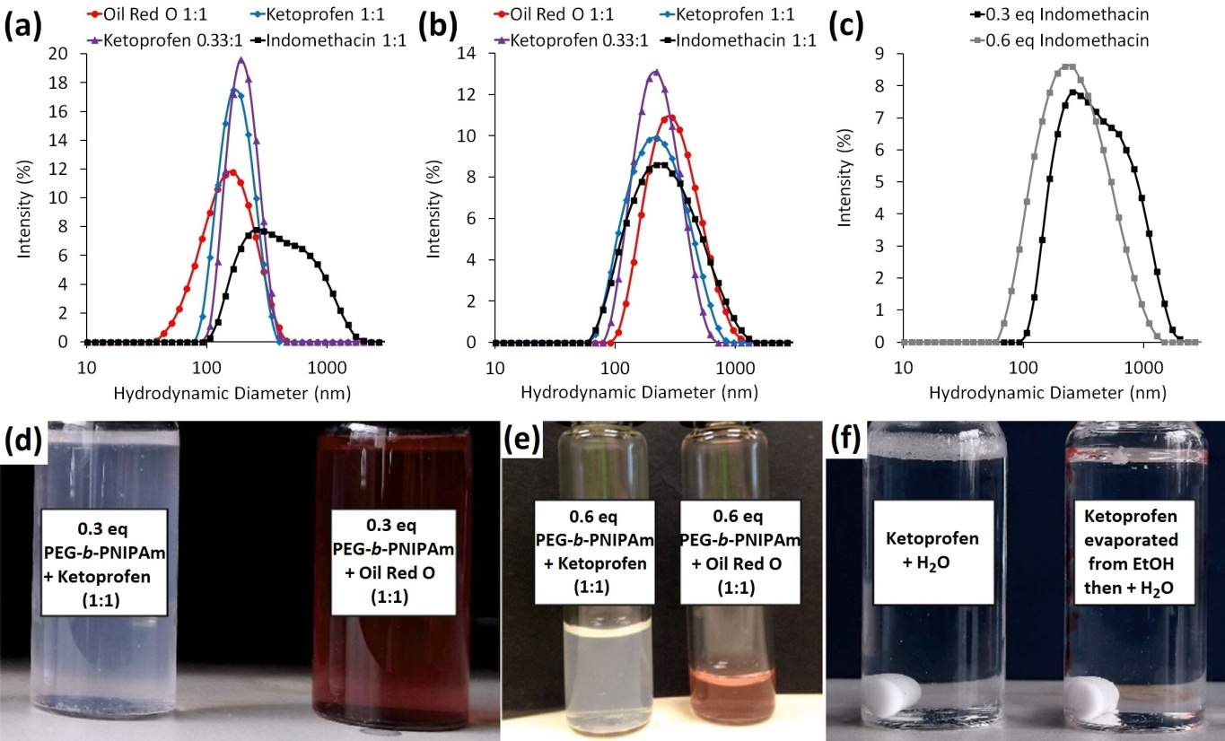

**Figure 2**. Dynamic light scattering date of different drug/ dye nanoparticles prepared with (a) **0.3 eq** or (b) **0.6 eq** cross-linked PEG-b-PNIPAm, (c) direct comparisons between **0.3** and **0.6 eq** PEG-b-PNIPAm Indomethacin drug nanoparticles. Photographs displaying nano-suspensions of Oil Red O and Ketoprofen using (d) **0.3 eq** or (e) **0.6 eq** cross-linked PEG-*b*-PNIPAm and (f) control experiments using Ketoprofen without PEG-*b*-PNIPAm branched diblock copolymer present.

We observed that lower cross-linking of **0.3 eq** resulted in greater variation in drug nanoparticle size. While higher cross-linking of **0.6 eq** proceeded with lower yields of suspended drug/ dye the resulting nanoparticles were more uniform with constant sizes and dispersities. This can be seen by directly comparing the DLS data for Indomethacin drug nanoparticles facilitated by either **0.3** or **0.6 eq** PEG-*b*-PNIPAm (Figure 2(c). Interestingly, the obtained Ketoprofen nanoparticles with sizes of about 200 nm did not vary significantly with cross-linking or with drug to polymer ratios. However, both the PDIs and nanoparticle yields did improve with a drug to polymer ratio of 0.33: 1. The percentage of Ketoprofen in suspension increased with decreasing initial drug to polymer ratio, as expected. In the case of **0.6 eq** cross-linked branched block copolymer a decrease of 58 % nanoparticle yield could be observed when the drug to polymer ratio was changed from 0.33: 1 to 1: 1. The **0.3 eq** cross-linked branched diblock copolymer only displayed a yield decrease of 16 % moving from a drug: polymer 0.33: 1 to 1: 1, as the initial yield at drug: polymer 1: 1 was already quite high (80 %). As the **0.6 eq** cross-linked branched diblock copolymer showed a greater dependence on the drug: polymer ratio this system was chosen for a more detailed investigation into the influence of drug to polymer ratio on nanoparticle size and yield of suspended drug.

*3.3. Influence of drug to polymer ratio on yield of suspended drug and nanoparticle size*

|  |  |  |  |  |
| --- | --- | --- | --- | --- |
| Ketoprofen: polymer  mass ratio | wt % Ketoprofen | *D*h (nm)  Z-Average | PDI | yield  (%) |
| 0.2: 1 | 17 | 211 ± 10 | 0.22 | 92 ± 3 |
| 0.3: 1 | 23 | 210 ± 9 | 0.25 | 92 ± 3 |
| 0.4: 1 | 29 | 222 ± 14 | 0.27 | 89 ± 6 |
| 0.5: 1 | 33 | 205 ± 23 | 0.26 | 81 ± 13 |
| 0.6: 1 | 38 | 277 ± 22 | 0.38 | 81 ± 15 |
| 0.7: 1 | 41 | 259 ± 7 | 0.21 | 81 ± 10 |
| 0.8: 1 | 44 | 263 ± 38 | 0.23 | 80 ± 13 |
| 0.9: 1 | 47 | 239 ± 32 | 0.22 | 78 ± 7 |
| 1: 1 | 50 | 273 ± 15 | 0.26 | 55 ± 10 |

**Table 3.** Yield of suspended drug, hydrodynamic diameter (*D*h) and PDI of drug nanoparticles prepared by evaporated from ethanol in the presence of **0.6 eq** cross-linked PEG-*b*-PNIPAm branched diblock copolymer and subsequent re-dispersion in water with varying mass of Ketoprofen.

To determine the optimum drug to polymer ratio with respect to highest nanoparticle yield and influence on nanoparticle size the **0.6 eq** cross-linked PEG-*b*-PNIPAm and Ketoprofen were evaporated from ethanol with varying drug to polymer ratios ranging from 0.2: 1 to 1: 1 (drug: polymer). For each experiment the ethanol volume was kept constant to ensure the same evaporation rate. Our premise was that this investigation might also elucidate the mechanism of drug nanoparticle formation. Table 3 shows the yield of suspended drug in water and resulting drug nanoparticle size and PDI. At least 3 samples have been prepared under the same conditions and measured. Figure 3(a) displays the relationship between the yield of suspended Ketoprofen with varying drug: polymer ratios from 0.2: 1 (17 wt % Ketoprofen) to 1: 1 (50 wt % Ketoprofen) and Figure 3(b) displays the relationship between the drug nanoparticle sizes after suspension in water with varying drug: polymer ratios.



**Figure 3.** Plotted DLS data of (a) initial total wt % of Ketoprofen (relative to polymer) v yield of suspended drug in solution and (b) initial total wt % of Ketoprofen (relative to polymer) v drug nanoparticle size.

The yield of Ketoprofen suspended shows a dependence on the initial ratio of drug: polymer, and a point at which this ratio is optimal. Between 17 – 29 wt % of Ketoprofen the yield of suspended drug is very high (in the region of 90 %). When the weight percentages of Ketoprofen are in the region of 33 – 48 wt%, the yields decrease slightly to the order of 80 %. The yield drops significantly when the weight percentage of Ketoprofen is ≥ 50 wt%. An approximate trend has been noticed that the yield deviations increase roughly with the increase of Ketoprofen percentage. The similar trend is also observed for the size of drug nanoparticles. This may be attributed to the less efficiency of stabilizing Ketoprofen nanoparticles when the ratio of the polymer decreases. This result suggests that there is a minimum “cut-off” of **0.6 eq** cross-linked PEG-*b*-NIPAm required to successfully stabilize the Ketoprofen drug nanoparticles during solvent evaporation and to disperse the resulting nanoparticles in water. It indicates that 70 – 85 wt % of branched diblock copolymer is required to achieve the nanoparticle yields of 90 % or above when the cross-linking density is **0.6 eq**. Figure 3(b) shows that the sizes of Ketoprofen nanoparticle are in the region of 200 – 220 nm when the wt % of Ketoprofen is 17 – 33 wt %. However, when the initial wt % of Ketoprofen increases we see significant variation in the size of drug nanoparticles (*D*h = 200 – 300 nm) which could suggest that when the initial amount of polymer is lower (relative to the hydrophobic drug) the stabilization process is much more random and less controlled.

*3.4. Cryo-TEM and PXRD characterization of Ketoprofen nanoparticles*

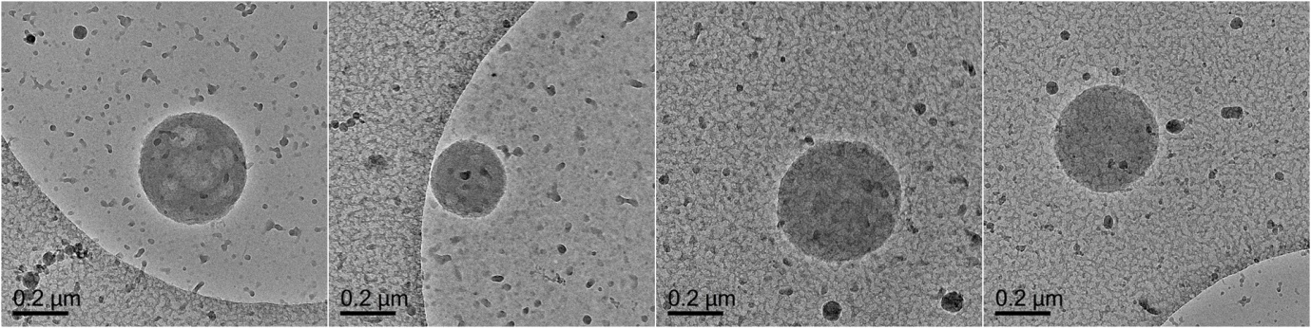

**Figure 4.** Cryo-TEM images of Ketoprofen drug nanoparticles facilitated by the **0.3 eq** cross-linked PEG-*b*-PNIPAm at a drug: polymer ratio of 0.33: 1.

Cryo-TEM analysis (Figure 4) of Ketoprofen drug nanoparticles prepared with the **0.3** **eq** cross-linked PEG-*b*-PNIPAm with a drug: polymer ratio of 0.33: 1 was performed. This sample was selected for Cryo-TEM analysis due to high yields of suspended drug after aqueous dispersion. Figure 4 show spherical Ketoprofen nanoparticles (*D*h ≈ 200 – 350 nm) obtained after evaporation from ethanol in the presence of **0.3 eq** cross-linked PEG-*b*-PNIPAm and subsequent dispersion in water. These sizes are consistent with the data obtained from dynamic light scattering. Amorphous drug particles show better dissolution behaviour than their crystalline counterparts (Hancock and Parks, 2000). As such powder x-ray diffraction (PXRD) data was measured (Figure 5) to determine if the Ketoprofen nanoparticles obtained are amorphous or crystalline in nature.



**Figure 5.** Powder x-ray diffraction data of as-prepared Ketoprofen nanoparticles (a-c) and Ketoprofen nanoparticles after 6 months in suspensions (d-f). Ketoprofen nanoparticles prepared with **0.6 eq** PEG-*b*-PNIPAm after solvent evaporation: (a) drug:polymer (1: 1); (b) drug:polymer (0.33: 1); (c) Ketoprofen evaporated without polymer present. Ketoprofen nanoparticles obtained by evaporating the water of the suspensions after 6 months: (d) drug:polymer (0.2:1); (e) drug:polymer (0.9:1); (f) polymer only.

After ethanol evaporation the solid material obtained showed amorphous character when the **0.6 eq** cross-linked PEG-*b*-PNIPAm is employed. This amorphous character was demonstrated by the lack of diffraction peaks on the PXRD patterns from the samples with drug: polymer ratios of 1: 1 (Figure 5(a)) and 0.33: 1 (Figure 5(b)). The lack of diffraction by PXRD measurement usually results from the low percentage of crystalline materials in a matrix or the low crystallinity of the materials. Due to the high content of Ketoprofen in the measured samples, it can be reasonably concluded that Ketoprofen nanoparticles are amorphous. Polarised light microscope (PLM) may be additionally used to qualitatively identify the crystalline phase based on birefringence, by dispersing the samples in paraffin oil and subsequent imaging (Kumar et al., 2014; Brough et al., 2016). However, as PLM is mainly effective for micron particles (Carlton, 2011), it may be difficult to obtain convincing images for the nanoparticles in this study. Ketoprofen nanoparticles prepared with **0.3 eq** cross-linked PEG-*b*-PNIPAm also displayed amorphous character. When the evaporation is performed without any polymer present the solid Ketoprofen obtained display crystalline character (Figure 5(c)). This data confirms that the application of branched diblock copolymers during solvent evaporation prevents the undesirable formation of crystalline Ketoprofen. From the obtained dynamic light scattering, Cryo-TEM and powder x-ray diffraction data the following mechanism (Figure 6) is proposed for the formation of drug nanoparticles. Initially, PEG-*b*-PNIPAm is fully solvated in ethanol and the drug compounds is dissolved at the molecular level. As the ethanol slowly evaporates the drug molecules diffuse into the branched diblock copolymer cores due to increasing drug concentration in solution, which prevents significant drug crystallization. After ethanol evaporation the drug molecules are intimately distributed among the polymeric material, presumably small amounts of drug crystals or agglomerates will be present (during this stage cross-linking density plays a key role on the possible diffusion of drug molecules into branched diblock copolymers). PEG-PNIPAM is amphiphilic and presents as core-shell nanoparticles with the crosslinked PNIPAM core and the hydrophilic PEG corona (Wais et al., 2016b). Thus, when adding the Ketoprofen/PEG-b-PNIPAM solid after ethanol evaporation in water, the hydrophilic chains of PEG can help break up the solid and result in the formation of aqueous nanoparticle suspension. The nanoparticles may be present as Ketoprofen-containing PEG-b-PNIPAM nanoparticles or aggregation of a few such particles. While the PEG-b-PNIPAM nanoparticles are spherical, the nanoparticles formed by aggregation of such spherical nanoparticles may not be spherical (Figure 6).

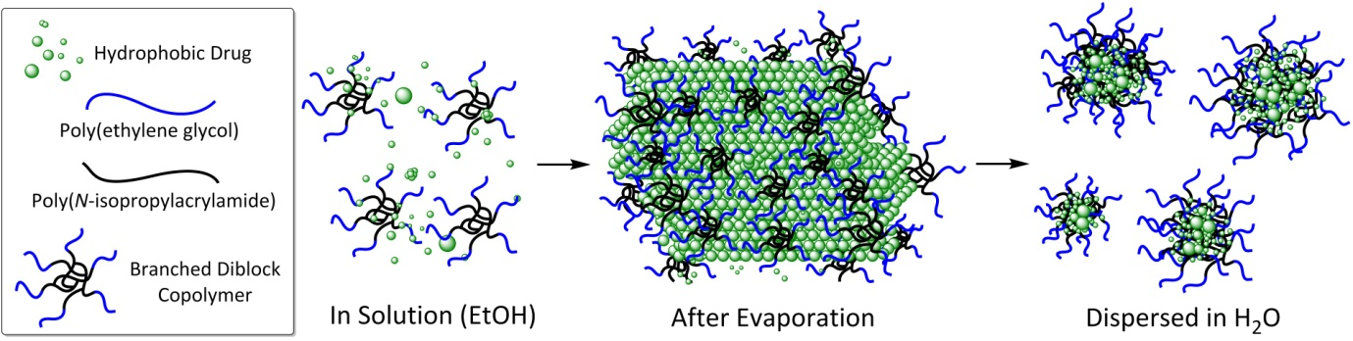

**Figure 6.** Formation of drug nanoparticles facilitated by branched diblock copolymers via solvent evaporation.

*3.5. Dissolution rates of ketoprofen nanoparticles*

According to the Noyes-Whitney equation a decrease in size and subsequent increase in surface area is the reason why drug nanoparticles show an increase in dissolution rate compared to non-processed drugs (Noyes and Whitney, 1897). Dissolution rates were measured for Ketoprofen (control experiment) and the sample Ketoprofen: **0.3 eq** PEG-*b*-PNIPAm (0.33: 1) which was used as-prepared by solvent evaporation and had a nanoparticle yield of > 90%. The measurements were done using a USP IV flow through apparatus so it could be assured that the nanoparticles were not able to leave the cell and only dissolved Ketoprofen is measured. As small amounts of Ketoprofen were measured to remain under sink conditions a closed loop set-up was chosen to minimize the measurement errors. Figure 7 shows the dissolution rates measured in the first 60 mins (crucial time scale in drug solubilization). The percentage of Ketoprofen dissolved only reached around 20 %. Increasing the dissolution time did not improve the dissolution percentage much. We attributed this to a significant amount of the material (Ketoprofen (control) as well as Ketoprofen drug nanoparticles) being ‘stuck’ to the cell wall as well as to the glass beads. The glass beads were needed to ensure laminar flow and keep turbulences to a minimum. Furthermore, it has been shown for the USP IV that at a low velocity the experimental dissolution was inhibited (D’Arcy et. al., 2010), however low velocity flow rates more closely resemble the situation that may be encountered in the intestines where inhomogeneous fluid ‘pockets’ of almost static flow rates can be found (Schiller et. al., 2005). The commonly available devices measuring dissolution are usually for larger amount of samples. Characterization of dissolution rate of drug nanoparticles has been a significant challenge (Anhalt et al., 2012). For example, our own efforts by using the light scattering approach (Anhalt et al., 2012) did not produce meaningful data. Although not completely convincing (because of low percentage dissolved), the data shown in Figure 7 are clearly indicative of the fast dissolution by Ketoprofen nanoparticles, compared to non-processed Ketoprofen (control). The Ketoprofen present in the drug nanoparticles was dissolved at a level of 22 % after 15 mins while at the same time only 8 % of Ketoprofen could be dissolved from the control experiment.

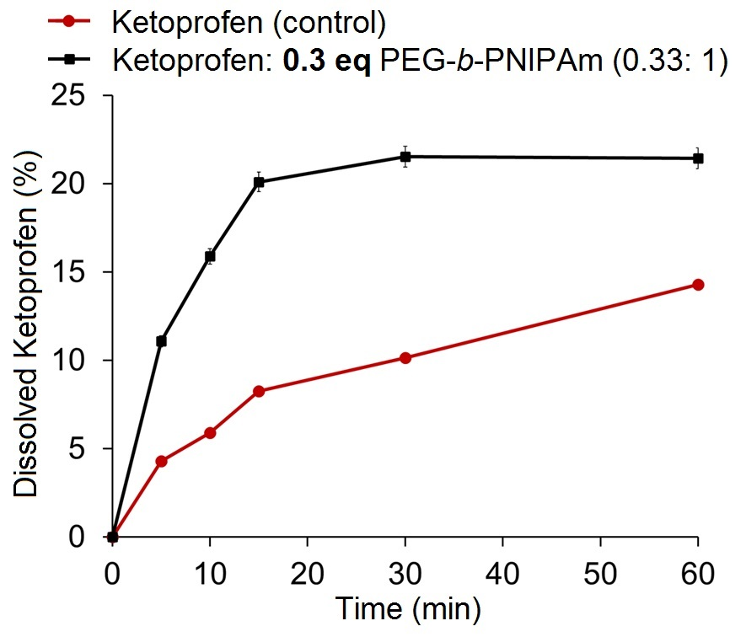

**Figure 7.** Dissolution rate of Ketoprofen v Ketoprofen: **0.3 eq** PEG-*b*-PNIPAm (0.33: 1) nanoparticles in H2O.

*3.6. Influence of temperature and pressure during evaporation*

|  |  |  |  |  |  |  |
| --- | --- | --- | --- | --- | --- | --- |
|  |  |  | time = 0 months | | time = 3 months | |
| sample | method | temp  (°C) | *D*h (nm)  Z-Average | PDI | *D*h (nm)  Z-Average | PDI |
| 1 | evaporation | r.t. | 208 ± 5 | 0.22 | 210 ± 4 | 0.22 |
| 2 | evaporation | 50 | 193 ± 2 | 0.21 | 303 ± 10 | 0.37 |
| 3 | evaporation | 80 | 213 ± 2 | 0.12 | 249 ± 3 | 0.21 |
| 4 | rotary evaporated | 30 | 288 ± 4 | 0.27 | 219 ± 1 | 0.19 |
| 5 | rotary evaporated | 50 | 204 ± 2 | 0.08 | 280 ± 4 | 0.35 |

**Table 4**. The size and PDI of Ketoprofen nanoparticles facilitated by **0.3 eq** cross-linked PEG-b-PNIPAm in a drug: polymer ratio of 0.33: 1 evaporated from ethanol at different temperatures by open air evaporation and rotary evaporation (at different temperature) followed by dispersion in water. The data displayed was obtained directly after evaporation and dispersion in water (time = 0 months) or stored as a dry solid in a desiccator for 3 months before dispersal in water (time = 3 months).

The influence of variations in evaporation conditions on the resulting Ketoprofen nanoparticles in the presence of **0.3 eq** PEG-*b*-PNIPAm formed with a drug: polymer ratio of 0.33: 1 was further investigated. This branched diblock copolymer and drug: polymer ratio was selected due to its high yield of suspended drug after dispersion in water. The influence of evaporation temperatures (room temperature, 50 °C and 80 °C) and pressure (air evaporation and rotary evaporation at 30 °C or 50 °C) were studied. This is because the rate of solvent evaporation is thought to influence the size of the nanoparticles (Rao and Geckeler, 2011) and the changes of temperature and the use of reduced pressure can change the evaporation rate. All of the obtained solid samples after solvent evaporation could be dissolved completely in water to produce stable drug nanoparticle dispersions without any precipitates. A total of five samples (**1** – **5**) were prepared under various conditions, each sample was dispersed in water directly after solvent evaporation (time = 0 months) these dynamic light scattering profiles are displayed in Figure 8(a). To investigate stability during storage each sample was stored as a dry solid for three months before dispersion in water (time = 3 months), the dynamic light scattering data obtained is summarized in Table 4. Samples **1** – **3** displayed drug nanoparticles with similar sizes (*D*h ≈ 200 nm) after immediate dispersion (time = 0 months). This suggests that atmospheric evaporation is not significantly affected by temperature. After 3 months storage in solid form Samples **2** (50° C) and **3** (80° C) showed a minor increase in nanoparticle size and PDI after dispersion in water. Sample **1** (room temperature) showed a very consistent size and PDI after dispersion in water after 3 months of storage in solid form. These results clearly indicate that increasing the temperature during atmospheric evaporation does not impede nor improve the evaporation process. Samples **4** and **5** also displayed very promising nanoparticle sizes and PDIs. After dry storage for 3 months the drug nanoparticles readily dispersed in water without any significant increase in size. These results suggest that the obtained drug nanoparticles are suitably stabilized against aggregation by PEG-*b*-PNIPAm branched diblock copolymers. To further investigate the long term storage potential, in solution, Sample **1** Ketoprofen nanoparticles dispersed in water after 0 days were left in water at room temperature and analysed by dynamic light scattering after 3 months (*D*h = 204 ± 4 nm, PDI = 0.20) and 9 months (*D*h = 225 ± 1 nm, PDI = 0.35) (Figure 8(b)). No aggregation could be observed after 9 months, demonstrating the long term stability of drug nanoparticles not only in solid state but also in aqueous suspension.

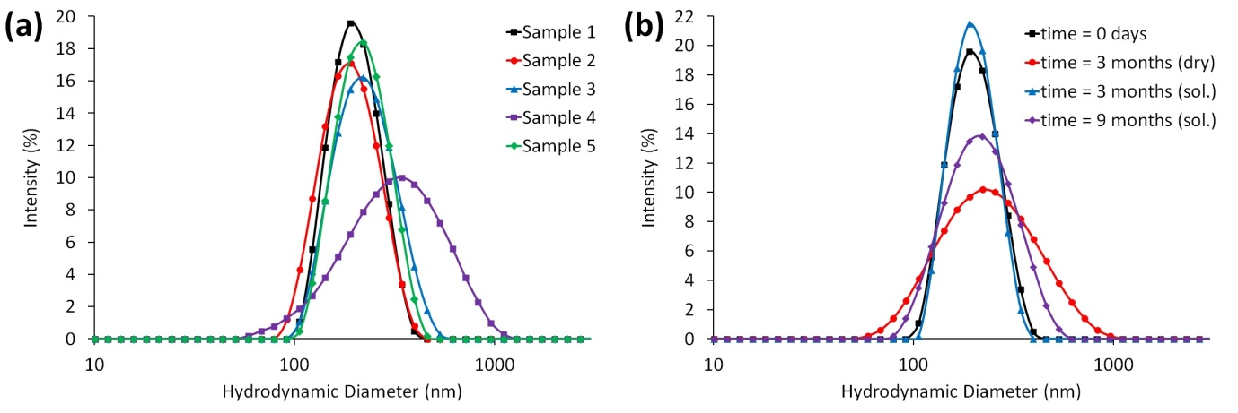

**Figure 8.** Dynamic light scattering profiles of Ketoprofen nanoparticles by solvent evaporation from ethanol facilitated by **0.3 eq** cross-linked PEG-*b*-PNIPAm at a drug: polymer ratio of 0.33:1 followed by dispersion in water. (a) Samples **1** – **5**, evaporated at different temperatures and pressures and (b) Sample **1** in solution after 0 days, in water for 3 months, in water for 9 months and stored as a solid for 3 months before suspension in water.

With regarding to the stability data shown in Figure 8, there are concerns whether the dissolution of Ketoprofen nanoparticles and the transition of amorphous to crystalline have occurred. The solubility of Ketoprofen in water at ambient temperature (22 – 24 oC) was 0.010 mg/mL or 0.253 mg/mL at 37 oC. And the solubility would change in different aqueous medium (Shohin et al., 2012). For the stability test of sample 1, 4 mg/mL of the sample was suspended in distilled water. With the drug:polymer ratio of 1:3, the concentration of Ketorofen was 1 mg/mL, which is far greater than the solubility at room temperature. Therefore, the possibility of further ketoprofen dissolution during storage is very low. In order to evaluate the possible transition of ketoprofen nanoparticles from amorphous to crystalline, the water of the nanoparticle suspensions after storage of 6 months at room temperature was evaporated and the resulting dry materials were characterized by the PXRD. As shown in Figure 5d-f, no diffraction peaks have appeared. This indicates that Ketoprofen nanoparticles in the formulations are still amorphous. There are a couple of odd peaks from the control polymer sample. This is the indication of some crystallinity in the polymer itself after evaporating from water, as have discussed in the previous work (Wais et al., 2016b).

**4. Conclusion**

A simple and robust evaporation approach from ethanol solutions of poorly water-soluble drugs with PEG-*b*-PNIPAm branched diblock copolymer at room temperature has been developed to produce stable drug nanoparticles. This method completely avoids the use of harsh conditions, toxic organic solvents and small molecule surfactants. The success of this approach relies on the application of lightly cross-linked branched diblock copolymers. We have investigated the effect of branched diblock copolymer cross-linking density, the initial drug: polymer mass ratio and influence of pressure and temperature during evaporation. Ketoprofen drug nanoparticles can be prepared with very high yields of suspended drug at drug: polymer ratios of 0.33: 1 (yield = 96 %) and 1: 1 (yield = 80 %). These Ketoprofen nanoparticles are highly stable in both solid form and aqueous suspensions, up to 9 months. Cryo-TEM and PXRD have been used to characterize the Ketoprofen nanoparticles formed and to understand the mechanism of formation. We believe that careful selection of monomer and polymeric architecture may be performed to fully optimize the formation of a range of hydrophobic drug nanoparticles. This new method may be used to produce nanoparticle tablets or aqueous drug nanoparticle suspensions that may be used for oral administration or intravenous injection, respectively. Systematic evaluations will be required to assess the passage, circulation, uptake, and fate of both drug nanoparticles and the polymeric carriers.

**5. Acknowledgment**

Ulrike Wais acknowledges the joint PhD studentship between the University of Liverpool and the A*Star Research Attachment Program (ARAP) scholarship. TH acknowledges the support from NSFC (China, 21574035). The authors would like to thank Wendy Rusli for performing cryo-TEM analysis and Martin Schreyer for performing PXRD analysis (both of A* Star, Institute of Chemical and Engineering Sciences). The authors are grateful for access to the facilities in the Centre for Materials Discover and MicroBioRefinary at the University of Liverpool.

**6. References**

Anhalt, K., Geissler, S., Harms, M., Weigandt, M., Fricker, G., 2012. Development of a new method to assess nanocrystal dissolution based on light scattering. Pharm. Res. 29, 2887-2901.

# Barve, A., Chen, C., Hebbar, V., Desiderio, J., Saw, C. L.-L., Kong, A.-N., 2009. Metabolism, oral bioavailability and pharmacokinetics of chemopreventive kaempferol in rats. Biopharm. Drug Disposition. 30, 356-365.

Broadhead, J., Edmond Rouan, S., Rhodes, C., 1992. The spray drying of pharmaceuticals. Drug. Dev. Ind. Pharm. 18, 1169-1206.

Brough, C., Miller, D.A., Keen, J.M., Kuccera, S.A., Lubda, D., Willaims III, R.O., 2016. Use of polyvinyl alcohol as a solubility-enhancing polymer for poorly water soluble drug delivery (part 1). AAPS PharmSci. Tech. 17, 167-179.

Canelas, D. A., Herlihy, K. P., DeSimone, J. M., 2009. Top‐down particle fabrication: control of size and shape for diagnostic imaging and drug delivery. Wiley Interdiscip. Rev. Nanomed. Nanobiotechnol. 1, 391-404.

Carlton, R.A., 2011. Polarized light microscopy, Chapter 2, in Pharmaceutical Microscopy, Springer Science + Business Media, LLC 2011.

Chan, H.-K., Kwok, P. C. L., 2011. Production methods for nanodrug particles using the bottom-up approach. Adv. Drug Del. Rev. 63, 406-416.

D’Arcy, D. M., Liu, B., Bradley, Healy, G. A. M., Corrigan, O. I., 2010. Hydrodynamic and species transfer simulations in the USP 4 dissolution apparatus: Considerations for dissolution in a low velocity pulsing flow. Pharm. Res. 27, 246-258.

Garti, N., Zour, H., 1997. The effect of surfactants on the crystallization and polymorphic transformation of glutamic acid. J. Cryst. Growth 172, 486-498.

Gassmann, P., List, M., Schweitzer, A., Sucker, H., 1994. Hydrosols-alternatives for the parenteral application of poorly water soluble drugs. Eur. J. Pharm. Biopharm. 40, 64-72.

Grant, N., Zhang, H., 2011. Poorly water-soluble drug nanoparticles via an emulsion-freeze-drying approach. J. Colloid Interface Sci. 356, 573-578.

Hancock, B. C., Parks, M., 2000. What is the true solubility advantage for amorphous pharmaceuticals? Pharm. Res. 17, 397-404.

Hu, J., Ng, W. K., Dong, Y., Shen, S., Tan, R. B. H., 2011. Continuous and scalable process for water-redispersible nanoformulation of poorly aqueous soluble APIs by antisolvent precipitation and spray-drying. Int. J. Pharm. 404, 198-204.

Junyaprasert, V. B., Morakul, B., 2015. Nanocrystals for enhancement of oral bioavailability of poorly water-soluble drugs. Asian J. Pharm. Sci. 10, 13-23.

Knez, Z., Weidner, E., 2003. Particles formation and particle design using supercritical fluids. Curr. Opin. Solid State Mater. Sci. 7, 353-361.

Konno, H., Taylor, L. S., 2006. Influence of different polymers on the crystallization tendency of molecularly dispersed amorphous felodipine. J. Pharm. Sci. 95, 2692-2705.

Kudera, S., Manna, L., 2014. Bottom-up synthesis of nanosized objects, in: Berti, D., Palazzo, G. (Eds), Colloidal foundations of nanoscience, ed. D. Berti and G. Palazzo, Elsevier, Amsterdam, 47-80.

Kumar, S., Shen, J., Burgess, D.J., 2014. Nano-amorphous spray dried powder to improve oral bioavailability of itraconazole. J. Control. Release 192, 95-102.

Liversidge, G. G., Cundy, K. C., 1995. Particle size reduction for improvement of oral bioavailability of hydrophobic drugs: I. Absolute oral bioavailability of nanocrystalline danazol in beagle dogs. Int. J. Pharm. 125, 91-97.

Matteucci, M. E., Hotze, M. A., Johnston, K. P., Williams, R. O., 2006. Drug nanoparticles by antisolvent precipitation: mixing energy versus surfactant stabilization. Langmuir 22, 8951-8959.

Merisko-Liversidge, E., Liversidge, G. G., 2011. Nanosizing for oral and parenteral drug delivery: a perspective on formulating poorly-water soluble compounds using wet media milling technology. Adv. Drug Del. Rev. 63, 427-440.

Noyes, A. A., Whitney, W. R., 1897. The rate of solution of solid substances in their own solutions. J. Am. Chem. Soc. 19, 930-934.

Pal, S., Saha, C., 2017. Solvent effect in the synthesis of hydrophobic drug-loaded polymer nanoparticles. IET Nanobiotechnol. 11, 443-447.

Pathak, P., Meziani, M. J., Desai, T., Sun, Y.-P., 2004. Nanosizing drug particles in supercritical fluid processing. J. Am. Chem. Soc. 126, 10842-10843.

Qian, L., Zhang, H., 2013. One-step synthesis of protein-encapsulated microspheres in a porous scaffold by freeze-drying double emulsions and tuneable protein release. Chem. Commun. 49, 8833-8835.

Raghavan, S. L., Trividic, A., Davis, A. F., Hadgraft, J., 2001. Crystallization of hydrocortisone acetate: influence of polymers. Int. J. Pharm. 212, 213-221.

Rao, J.P., Geckeler, K.E., 2011. Polymer nanoparticles: Preparation techniques and size-control

Parameters. Prog. Polym. Sci. 36, 887-913.

Rasenack, N., Müller, B. W., 2002. Properties of ibuprofen crystallized under various conditions: a comparative study. Drug Dev. Ind. Pharm. 28, 1077-1089.

Roberts, A.D., Zhang, H., 2013. Poorly water-soluble drug nanoparticles via solvent evaporation in

water-soluble porous polymers. Int. J. Pharm. 447, 241-250.

Rodríguez-Hornedo, N., Murphy, D., 2004. Surfactant-facilitated crystallization of dihydrate carbamazepine during dissolution of anhydrous polymorph. J. Pharm. Sci. 93, 449-460.

Schiller, C., Fröhlich, C. P., Giessmann, T., Siegmund, W., Mönnikes, H., Hosten, N., Weitschies, W., 2005. Intestinal fluid volumes and transit of dosage forms as assessed by magnetic resonance imaging, Aliment Pharmacol. Ther. 22, 971-979.

Serajuddin, A. T. M., 2007. [Salt formation to improve drug solubility](http://www.sciencedirect.com/science/article/pii/S0169409X07000816). Adv. Drug Del. Rev. 59, 603-616

Shohin, I.E., Kulinich, J.I., Ramenskaya, G.V., Abrahamsson, B., Kopp, S., Langguth, P., Polli, J.E., Shah, V.P., Groot, D.W., Barends, D.M., Dressman, J.B., 2012. Biowaiver Monographs for Immediate-Release Solid Oral Dosage Forms: Ketoprofen. J. Pharm. Sci. 101, 3593-3603.

Sinha, B., Müller, R. H., Möschwitzer, J. P., 2013. Bottom-up approaches for preparing drug nanocrystals: formulations and factors affecting particle size. Int. J. Pharm. 453, 126-141.

Testa, B., 2004. Prodrug research: futile or fertile? Biochem. Pharmacol. 68, 2097-2106.

Thakuria, R., Delori, A., Jones, W. M., Lipert, M. P., Roy, L., Rodríguez-Hornedo, N., 2013. Pharmaceutical cocrystals and poorly soluble drugs. Int. J. Pharm., 453, 101-125.

The International Council for Harmonisation of Technical Requirements for Pharmaceuticals for Human Use (ICH), Impurities: guideline for residual solvents Q3C (R5), http://www.ich.org/products/guidelines/quality/quality-single/article/impurities-guideline-for-residual-solvents.html, (accessed: June, 2016).

Van den Mooter, G., Wuyts, M.; Blaton, N., Busson, R., Grobet, P., Augustijns, P., Kinget, R., 2001. Physical stabilisation of amorphous ketoconazole in solid dispersions with polyvinylpyrrolidone K25. Eur. J. Pharm. Sci. 12, 261-269.

Van Eerdenbrugh, B., Taylor, L. S., 2010. Small scale screening to determine the ability of different polymers to inhibit drug crystallization upon rapid solvent evaporation. Mol. Pharm. 7, 1328-1337.

Van Eerdenbrugh, B., Van den Mooter, G., Augustijns, P., 2008. Top-down production of drug nanocrystals: nanosuspension stabilization, miniaturization and transformation into solid products. Int. J. Pharm. 364, 64-75.

Viçosa, A., Letourneau, J.-J., Espitalier, F., Inês Ré, M., 2012. An innovative antisolvent precipitation process as a promising technique to prepare ultrafine rifampicin Particles. J. Cryst. Growth 342, 80-87.

Wais, U., Jackson, A. W., He, T., Zhang, H., 2016a. Nanoformulation and encapsulation approaches for poorly water-soluble drug nanoparticles. Nanoscale 8, 1746-1769.

Wais, U., Jackson, A. W., Zuo, Y., Xiang, Y., He, T., Zhang, H., 2016b. Drug Nanoparticles by Emulsion-Freeze-Drying via the Employment of Branched Block Copolymer Nanoparticles. J Control. Release 222, 141-150.

Weissbuch, I., Addadi, L., Leiserowitz, L., Lahav, M., 1988. Total asymmetric transformations at interfaces with centrosymmetric crystals: role of hydrophobic and kinetic effects in the crystallization of the system glycine/alpha-amino acids. J. Am. Chem. Soc. 110, 561-567.

Xie, S., Poornachary, S. K., Chow, P. S., Tan, R. B. H., 2010. Direct precipitation of micron-size salbutamol sSulfate: new insights into the action of surfactants and polymeric additives. Crystal Growth & Design 10, 3363-3371.

Zhang, H., Lu, J., Han, B., 2001. Precipitation of lysozyme solubilized in reverse micelles by dissolved CO2. J. Supercrit. Fluids 20, 65-71.

Zhang, H., Wang, D., Butler, R., Campbell, N. L., Long, J., Tan, B., Duncalf, D. J., Foster, A. J., Hopkinson, A., Taylor, D., Angus, D., Cooper, A. I., Rannard, S. P., 2008. Formation and enhanced biocidal activity of water-dispersable organic nanoparticles. Nat. Nanotechnol. 3, 506-511.

Zhao, H., Wang, J.-X., Wang, Q.-A., Chen, J.-F., Yun, J., 2007. Controlled liquid antisolvent precipitation of hydrophobic pharmaceutical nanoparticles in a microchannel reactor. Ind. Eng. Chem. Res. 46, 8229-8235.