Overlap between flesh-footed shearwater Puffinus carneipes foraging areas and commercial fisheries in New Zealand waters.

Susan M. Waugh¹, Samantha C. Patrick^{2, 3}, Dominique P. Filippi⁴, Graeme A. Taylor⁵, John. P.Y. Arnould⁶

¹ Museum of New Zealand Te Papa Tongarewa, PO Box 467, Wellington, New Zealand
² University of Gloucestershire, Cheltenham GL50 4AZ, United Kingdom,
³ School of Environmental Sciences, University of Liverpool, L69 3GP, UK
Jane Herdman Building, Liverpool L69 3GP, United Kingdom.
⁴ Sextant Technology Ltd, 116 Wilton Road, Wellington, New Zealand
⁵ Department of Conservation, PO Box 10-420, Wellington, New Zealand
⁶ Deakin University, Geelong, Australia, School of Life and Environmental Sciences (Burwood Campus), 221 Burwood Highway, Burwood, VIC 3125

Keywords: fisheries interactions, oceanic, foraging, bycatch, seabird
Author for correspondence: Susan Waugh susan.waugh@tepapa.govt.nz

Abstract
Although the flesh-footed shearwater is a species with large population sizes (tens of thousands of breeding pairs) and widespread sub-tropical distribution across Australasian water-masses, it is amongst the species most threatened by longline fisheries mortality in this region. While bycatch mitigation measures have been very successful in reducing mortality in some species, bycatch of flesh-footed shearwaters is still high with captures estimated to exceed the sustainable take of 514 per year by nearly 200 birds for New Zealand fisheries alone. Management agencies aiming to reduce the impact of fisheries mortality on the populations need to understand which marine areas were being used by flesh-footed shearwaters, to better target fishery monitoring and mitigation efforts. Foraging studies of seabirds tell us about their use of resources, the way species segregate the available habitat and help to identify threats that may affect their population’s viability. Breeding shearwaters were tracked from two New Zealand colonies using GPS loggers. Individuals foraged over shelf and deep oceanic waters up to 1200 km from their nesting sites during incubation, but were mainly within 370 km during early chick-rearing. The intensity of potential interactions increased for trawl and surface longline fishing between the January and February study periods but remained at a similar level for bottom longline fishing. Following the field data collection, changes to fishery monitoring were implemented in the areas where shearwaters foraged.

Introduction

Fishing mortality is identified globally as a major threat to the conservation of Procellariform seabirds, a group which includes all shearwaters, petrels, and albatrosses (Croxall et al. 2012). Although they are very numerous and widespread (Brooke 2004), the ecology of shearwaters are poorly studied, partly due to their small size (150 – 950 g, Schreiber and Burger 2002), making remote-tracking studies difficult. Species with large populations tend to have lower conservation threat status than other seabirds, and are therefore a lower priority for research and management than threatened species. Shearwaters, like many other seabirds, benefit from fishing activity by using fisheries waste for food (Furness et al. 1988, Thompson & Riddy 1995, Garthe et al. 1996, Sullivan et al. 2006a, Thalmann et al. 2010) but they also suffer mortality through accidental capture in fishing gear (Bartle 1991, Gales et al. 1998, Scott et al. 2008, Anderson et al. 2011). The long-lived and low-productivity demographic characteristics of Procellariform seabirds result in a particular vulnerability - their populations have a low intrinsic growth rate and are especially sensitive to increases in adult mortality (Stearns 1993, Hunter et al. 2000). The death of one adult will result in the death of any nestling or egg, further impacting on a species’ productivity.
From either fishery- or seabird colony-based research perspectives, assessing the impacts of fishing mortality can be difficult (Lavers et al. 2013, Barbraud et al. 2008, 2012). When seabird bycatch is observed on vessels, it is difficult to assign provenance of captured birds to population- or species-level; birds caught may be from varying age-groups or breeding states resulting in differential population impacts. Recent research has demonstrated how using the mineral and stable isotope signatures in feathers, birds recovered from fisheries could be assigned to different ocean basins, regions or colonies (Lavers et al. 2013). Furthermore, it is costly to carry out on-board observation for non-target catch and to collate data across vessels and fleets. Recent New Zealand fishery monitoring has been undertaken at a cost of $US 375 - 410 per day (Department of Conservation 2013, 2014). Fishery management agencies aiming to gather statistically robust samples of bycatch occurrence require between 5 – 100 percent of fishing effort to be observed (Department of Conservation 2014, IATTC 2016).
Similarly, assessing the causes of population changes for seabirds observed at breeding colonies is complex: it requires long-term and detailed datasets for long-lived species, and relationships between population change, environmental and anthropogenic factors are difficult to untangle, as a combination of these factors is often operating (Blaber et al. 1998, Tasker et al. 2000, Baker et al. 2007, Rolland et al. 2009, Barbraud et al. 2012, Lavers 2015). To overcome these issues, modeling of populations and the likelihood of capture of species during encounters with fishing operations has been carried out for many seabird species (e.g. Moloney et al. 1994, Inchausti and Weimerskirch 2002, Lewison and Crowder 2003, Lewison et al. 2004, Francis and Bell 2010, Tuck et al. 2011, Richard and Abraham 2013, 2015). The causes of population changes in relation to fisheries mortality are a key focus for such studies, and their outputs can also be used to understand where to best target mitigation actions in fisheries. A key piece of information to inform these approaches is the foraging distribution of the bird species, as these can be highly variable with strong segregation of zones used between species and colonies within the same species (Ainley et al. 2004, Wakefield et al. 2015).
Seabird bycatch in New Zealand waters have been researched and managed for over 25 years (Bartle 1991, Murray et al. 1993, Ministry of Fisheries and Department of Conservation 2004, Waugh et al. 2008, Dillingham and Fletcher 2011, Abraham and Thompson 2011a and b, Ministry for Primary Industries 2013). In recent years, bycatch numbers have been reduced due to efforts by fishers, and fishery managers in both industry and government (Ministry for Primary Industries 2013). These efforts include use of mitigation such as night-setting, tori-lines, and offal reduction and more targeted mitigation efforts in areas or at times of high bycatch risk, facilitated by increased monitoring and reporting (Department of Conservation 2012, 2013, 2014, Ministry for Primary Industries 2013). Recent estimates of bycatch for the main commercial trawl and longline fisheries were ca. 3,500 birds annually between 2004/05 and 2008/09, a reduction of approximately 50% compared to the previous five-year period (Abraham and Thompson 2011a, b). For some species, however, bycatch numbers have remained high, and the flesh-footed shearwater (Puffinus carneipes) is a species for which bycatch reductions have proved difficult to achieve (Baker and Wise 2005, Abraham and Thompson 2011a, Lavers 2015).
The flesh-footed shearwater has been subject to ecological research efforts in recent years only, despite being one of the more numerous species in the Australasian region, and among the most commonly caught species in New Zealand and Australian longline fisheries (Baker and Wise 2005, Lavers 2015, Abraham et al. 2011a, Richard and Abraham 2015). It is recognized as the fourth most likely species to suffer adverse effects of fishing mortality in New Zealand commercial fisheries (Richard and Abraham 2015). The species breeds at over 60 sites in Australia and New Zealand, with one breeding site at the Île de Saint Paul in the Indian Ocean. It has a world population of c. 74,0000 pairs was estimated by Lavers (2015) following recent Australian surveys. Around 10,000 – 15,000 pairs nest annually in New Zealand (Waugh et al. 2013). Population decreases reported in the literature at the largest known colony at Lord Howe Island, Australia (c. 15,000 – 29,000 pairs) have been linked to bycatch in longline fisheries (Reid et al. 2013, Priddel et al. 2006), with ongoing research assessing the current trend for the population (N. Carlile, pers. comm.). Several populations across South Australia and South West Australia are also declining, with a range of threats including fisheries mortality, climate effects, introduced species impacts, and contamination identified as probable causes for the population changes (Lavers 2015). In New Zealand, one large northern colony at Lady Alice Island is likely to be declining, based on count data and demographic modelling, while others are stable or increasing slightly (Barbraud et al. 2012; Jamieson and Waugh 2014). For the New Zealand population, analysis of the incidental catch of this species across a broad group of commercial fisheries has created concern for the sustainability of the populations (Ministry for Primary Industries 2013). Numbers of birds estimated to potentially incur fatalities (696 , 478 – 995 95% CI, Richard and Abraham 2015) exceeded the level that is considered sustainable for the population (514, 233 – 1140 95% CI, Richard and Abraham 2015) estimated using a Potential Biological Removals approach, which assumed that all populations within a species were ‘harvested’ evenly by the fishery catch (Wade 1998, Dillingham and Fletcher 2011). Mortality from recreational fisheries in New Zealand, and Australia has been recorded but the magnitude of this catch is unknown (Abraham et al. 2010, Lavers 2015).Bycatch of New Zealand birds in commercial fisheries in Australia and the North Pacific is known to occur (Lavers et al. 2013).
Managers of protected species and fishery resources were interested to refine their understanding of where the flesh-footed shearwaters from important New Zealand populations were foraging. This would allow a programme of fishery observation and mitigation actions to be implementedthat targeted the areas where there would be most benefit in reducing pressure on the populations of New Zealand flesh-footed shearwaters. In this study, the at-sea movements of breeding flesh-footed shearwaters were documented from two New Zealand colonies to examine their foraging distribution and overlap with fisheries. The optimal areas and seasons to monitor and manage fisheries interactions were recommended, and subsequent uptake by management agencies monitoring plans is discussed.

Methods

Study sites and data collection

Flesh-footed shearwaters nest at ca. 20 localities around northern and central New Zealand (Waugh et al. 2013). This study was conducted at two of the breeding sites with larger-sized populations: Titi Island (40.95° S 174.14° E), which is important as the largest of the breeding sites in the Cook Strait area for the species; and at Ohinau Island (36.72° S 175.88° E) to represent the large breeding populations of the Bay of Plenty (approximately 50% of the New Zealand population). The sizes of each island population in the study were ca. 160 pairs at Titi Island and ca. 2100 pairs at Ohinau Island in 2012 and 2014 respectively (Jamieson and Waugh 2015). Breeding individuals were captured in their burrows and equipped with IgotU GPS loggers (Mobile Action Technology) in January 2013 at Titi Island (20 loggers), and in January and February 2014 at Ohinau Island (57 loggers). The loggers were removed from their plastic housing, programmed to record location data at 15 minute intervals and sealed in heat-shrink tubes before they were attached with waterproof adhesive tape on the back-feathers of the birds. The total mass of the attachment was 22 - 25 g, or less than 3% of the bird’s body mass, thus minimizing the risk of affecting the bird’s behavior (Phillips et al. 2003).
Median hatching date was 3 February at Ohinau Island in 2014 (n=20, range of 27 January - 18 February). Hatching of chicks at Titi Island was more sporadically checked with 4-daily inspection of nests with logger-equipped birds only – on 29 January 2013, 50% of eggs were confirmed hatched (n = 4 nests with confirmed contents); by 2 February, 80% were hatched and 20% unhatched (n=5).
Trip duration, distance travelled and maximum range are expressed as means (SE; sample size).To assess overlap with fisheries by period, we used month of the year rather than breeding stage, as calendar date is more likely to be used in fishery monitoring and management contexts.

Assessing fisheries overlap
Fine resolution GPS tracking data were used to quantify the distribution range and habitat use of the shearwaters during mid- to late-incubation in January and early chick-rearing in February.
To investigate the potential for overlap with commercial fisheries during the shearwater’s breeding season, catch per unit effort data from fisheries for the five year period 2009/10 – 2013/14 (December to May) were extracted from Ministry for Primary Industries (New Zealand) databases. This five-year dataset enabled a robust representation of vessel usage of the areas in question, whereas data from a single year could be subject to short-term changes in effort. In 2014, data were available to March only. Data for bottom longline, surface longline, and trawl (combining midwater-, bottom- and paired- trawls) fishing events were used. Date, and start-latitude and longitude were used to plot the location of events. Latitude and longitude were analyzed at a resolution of 0.1 decimal degrees. Density plots were generated using the sum of fishing effort per square of 0.1 decimal degrees for each month and fishing method.
Fisheries overlap maps were produced using a combination of ecological data from bird tracking and fishing effort data for the relevant periods and areas. Effort data were analyzed for January and February corresponding to mid- to late-incubation, and early chick-rearing parts of the shearwater breeding cycle. Bottom and surface longline effort density were expressed as hooks.day⁻¹, and trawl effort as hours·day⁻¹. Spatial overlap maps were generated by multiplying the monthly fishing effort maps with the corresponding spatially normalized seabird density maps produced by kernelling at a resolution of 0.1° x 0.1°. The spatial normalization was performed on the whole range of the species including its range outside the New Zealand Exclusive Economic Zone (NZEEZ). This created a density distribution for the range of the species during its breeding period that summed to one. This matrix was created for each month of the study. This was then clipped to the area within the NZEEZ , as fishing data were available from within the NZEEZ only. Fishery overlap indices were obtained by summing the overlap map for each month and each fishing method Data were plotted on graphics with a square-root transformation to enable high-intensity overlap areas to be more readily identifyable. These methodologies were developed and implemented for multiple species risk comparisons in Ecological Risk Assessment for New Zealand and South Pacific fisheries (Waugh et al. 2011, 2012), and differ from these examples in that the overlap metrics in this study were applied to a single bird species, and the levels of overlap between different periods for the same fishery were compared, for several fisheries. Previous studies compared several species’ overlap for one fishery only. Seabirds are known to interact with fishing vessels with variation in the intensity and outcome of interactions varying significantly between fleets, depending on factors such as the vessel discard regime, target fish species, fishing gear type, mitigation methods used, and timing of fishing in the day (Ryan and Watkins 2002, Sullivan et al. 2006b, Pierre et al. 2012). Within-fleet characteristics are most comparable, while those between fleets and fishing methods are less comparable. For this reason, comparing overlap scores between fishing methods was is not considered appropriate.

Results

GPS data were retrieved from 4 and 54 individuals from Titi Islands and Ohinau Islands, respectively. Data for each site were analysed separately to generate density distributions for the species by site, but combined when overlap with fishery was analysed (Figure 2, top row). The size of each population was taken into account when generating the overall shearwater density matrix for the overlap map, with the contribution of each tracking dataset weighted by the size of the corresponding population.
During the first-ever GPS deployment on this species in New Zealand at Titi island in 2013, many equipped birds or their partners undertook trips in excess of 10 days, which was longer than the planned period of study, leading to incomplete information for this site. Few devices were retrieved, and those that were not would be retained by the bird until the post-breeding molting period (4 months) at a maximum, or for a shorter period (e.g. 1 month) as the adhesive tape lost its’ waterproof-ness and fell off the bird. For 6 birds from Titi Island, devices were retrieved after the bird had incubated for > 9 days, and no data were recovered.
During incubation and early chick-rearing periods (Figure 3), GPS tracking showed that birds from Ohinau Island spent large amounts of time along the North Island coastline to the east of the breeding site, with regular trips to the region to the east of New Zealand over deep water. Trips averaged 3.6 days in duration (0.52; 56), with birds travelling 1223 km (202.92; 56) and with a maximum range from the breeding sites of 368.70 km (74; 56). Birds from Titi Island (average trip duration 10.9 d, 1.6; 3, note that data for one trip were incomplete) remained mainly in the waters of Cook Strait and immediately to the east and west during incubation, with some longer trips out towards the deeper waters to the north of the Chatham Rise.
The intensity of overlap of bird activity in different parts of the breeding cycle and fishing effort was calculated. The overlap metric relates to the degree of overlap between bird distribution and fishing activity and is a relative index of overlap within a fishing method. The overlap index decreased between January and February by 0.08% (from 1.68 to 1.55) for bottom longline fishing. For surface longline fishing it increased by 25% between the two months (January metric was 0.89 and February was 1.13). For trawl fishing, the increase between months was 92% (from 0.40 to 0.77).
Spatial overlap of each fishing method during different periods of the breeding season varied in relation to the concentration of fishing effort by season and area. The areas in which overlap was most intensive between flesh-footed shearwaters and all fisheries considered were a) immediately to the east of Ohinau Island and nearby continental shelf break (approximated by the 1000 m depth contour); b) from Ohinau Island to East Cape; c) around the shelf break to the south of Mahia Peninsula (Figure 3).
For bottom longline fisheries, areas of highest overlap were near to Ohinau Island, off East Cape and Mahia Peninsula (Figure 3). The zone of overlap extended in both periods between Ohinau Island and the western end of the Chatham Rise. Most overlap for bottom longline fishing was at or near the continental shelf break (in waters of approximately 200 - 1000 m of water).
For surface longline fisheries, overlap was most intense offshore from the shelf break and over deep waters across the Bay of Plenty from Ohinau Island to East Cape, with some areas of stronger interactions occurring from East Cape to Mahia Peninsula when birds were doing longer foraging trips in the incubation and late chick-rearing periods (Figure 3). This fishery operates further offshore than the other fisheries examined, so there was little overlap over the shelf waters. The main area of overlap extends from the shelf-slope and continues seaward from there. In January, areas of more intense overlap are evident near East Cape, where deep water is close to shore. In February, some intensity of overlap is apparent in the East Cape region, but it is especially intense near to Ohinau Island where deep water is closest to shore.
For trawl fisheries, the zone of overlap with flesh-footed shearwaters was over a large area, covering most continental shelf areas within the bird’s range described by the GPS tracking dataset. Overlap was more intense in February than January, and was particularly strong along the shelf-break near Ohinau Island and East Cape.

Discussion

The research describes the foraging characteristics of flesh-footed shearwaters from two important breeding populations in New Zealand, albeit with a small sample size from one site. It investigates the use of combined fishing and bird tracking data to identify which areas and times were most important for managing interactions between trawl and two longline fishing methods and the shearwaters from these colonies, during the 2-month study period. The two study populations showed a diversity of foraging movements. The shearwaters were using both shelf and pelagic waters with an average maximum distance of 370 km from their nests and an average travel distance of 1200 km per trip. Such foraging distances are not unusual for shearwaters during breeding, when they often adopt dual feeding strategies to exploit distant resources to maintain adult body condition, and feed on nearby resources to provision their chicks (Weimerskirch 1998, Granadeiro et al. 2000, Magalhães et al. 2008). There was some indication that a mix of strategies was being employed by flesh-footed shearwaters in this study, as individuals were foraging at both short and long distances.
The areas used most intensively by birds from Ohinau Island were the shelf waters around the breeding site and between that area and the eastern-most point of the New Zealand mainland (East Cape). A third hotspot of activity occurred near Mahia Peninsula on the lower east coast of the North Island of New Zealand. Throughout their range, flesh-footed shearwaters appear to be in waters at or to the north of the sub-Tropical convergence zone (Heath 1985, this study, Rayner et al. 2011). The shearwaters also used waters far to the east of the New Zealand Exclusive Economic Zone. When doing so they were far from sub-marine features such as sea-mounts. There is no convergence zone in the area in which they predominantly fed, but strong current systems have been identified running up and down the eastern side of the lower North Island (Staunton 1972, Heath 1985). Such mixing zones can be productive areas for both foraging seabirds and fisheries (Russell et al. 1992, Hyrenbach et al. 2006). Detailed data on the fisheries in these high seas areas were not available, but global catch summaries published by the FAO (2016) show the area in the NZEEZ used by birds from this study, and the high seas area immediately adjacent, to the east, yielded light to moderate catches of tunas and bill fish (between 10 tonnes and 4,000 tonnes of cumulatively over the 5 year period 2010 – 2015, per 5 degree latitude and longitude square; FAO 2016).
There is some indication of segregation of foraging areas between the colonies studied with those from Titi Island, Ohinau Island (this study), Kauwahaia Island (Rayner et al. 2011) and Lord Howe Island (Thalmann et al. 2009, Reid 2011) all using discreet foraging areas. Segregation of marine areas between colonies is reported among several families of seabirds (e.g. Ainley et al 2004, Wakefield et al. 2011, Wanless and Harris 1993, Wakefield et al. 2013, Stahl and Sagar 2000a,b). This finding has implications for managing interactions between fisheries and the shearwater populations, as the impacts of fisheries mortality in one area will not be spread evenly across the whole New Zealand breeding population of the species, but may be more intensive for some populations than others.

Overlap with fisheries

The analysis of overlap between three major fisheries and the flesh-footed shearwaters showed that each fishery had specific areas of most intense interaction, based on the Ohinau and Titi Islands tracking datasets. All methods of fishing examined had potential to overlap with shearwater foraging zones, during the two periods examined. Because of the relatively light weighting of the Titi Island birds in the analysis, due to the smaller population size at this site, the overlap of intensive fisheries from the Cook Strait area with the shearwaters is slight, except for trawl fisheries which were particularly active in this area.
Overlap increased between the two months for surface longline and trawl fishing by 25% and 92% respectively. For bottom longline, overlap decreased by 8% over the same period. During February, birds from Ohinau Island were more concentrated in their foraging activity very near to the breeding site, and curtailed their use of areas at the southern edge of their range during incubation. Similarly, the flesh-footed shearwaters from Lord Howe Island were found to overlap most with fishing vessels in the early chick-rearing period, but also showed strong overlap in the pre-breeding and early incubation period (Thalmann et al. 2009, Reid et al. 2012).
Spatially, these areas of strong overlap in early chick-rearing were in the same general area for all fishing methods – to the east of Ohinau Island and around the edge of the continental shelf. For surface longline fishing, however, the zone of most intense overlap was slightly further offshore than for other fishing methods. The increased intensity of overlap in February for the Ohinau Island population is likely to be mirrored at other breeding sites - large colonies of the species occur on islands in the Bay of Plenty and Northland areas, highlighting the need for a greater focus for bycatch monitoring and mitigation in areas within 350 km of the 8 major breeding colonies for the species (see Waugh et al. 2013).
Between-fishery differences could not be assessed in these analyses, as different overlap metrics exist for each fishery method. In effect, this analysis enables fishery and wildlife managers to examine the timing and location of overlap within a fishery, but as different fisheries attract birds (and potentially catch them) differentially; the metrics developed do not allow an indication of between-fishery performance. However, in a cross-fishery analysis of bycatch risk, Richard and Abraham (2013, 2015) concluded that on an annual basis, flesh-footed shearwaters were likely to be caught in greatest numbers in trawl, bottom and surface longline fisheries, in descending order of likelihood.
A range of factors, including mortality in non-commercial fishing (Abraham et al. 2010), introduced predators (Taylor 2000, Waugh et al. 2013) and pollution (Buxton et al. 2013) may be influencing the flesh-footed shearwater populations in the New Zealand region. A similar range of threats exist for Australian populations (Lavers 2015). The areas to the north and east of the North Island of New Zealand (e.g. Hauraki Gulf and Bay of Plenty) are subject to intense fishing effort by recreational fishers, charter fishers, and subsistence fishers, in addition to the commercial fisheries examined here. Examination of the 15 flesh-footed shearwaters found dead after thorough and repeated collection of over 1,000 birds from Bay of Plenty beaches in November 2011 showed that all had suffered injuries likely to have been caused by human interaction. Injuries resulting from fish hooks (recreational type), puncture- or crush-wounds were identified by veterinary pathologists and seabird researchers (Massey University unpublished data, Tennyson et al. 2012). Similar events have been reported for Australian recreational fisheries with flesh-footed shearwaters killed accidentally or intentionally (Lavers 2015).

Fishery management response

Following the tracking study reported here, the amount of observer effort was increased in the fisheries which had strongest potential to interact with the shearwaters. The background level of observer effort in the bottom longline fishery in east coast of the North Island was 150 d per year in 2012/13, which was increased to 600 d in 2013/14 (Department of Conservation 2012, 2013). The areas exploited by the shearwaters in this study and another at-risk procellariform seabird, the Black petrel Procellaria parkinsoni (Abraham et al. 2015) were used to refine the focus for the observing in 2014/15 and the rate of observer cover increased from 10% to 50% of fishing effort in two fisheries that had strong overlap with the flesh-footed shearwater, bottom longline fishing targeting bluenose (205 d) and inshore trawl fishing for various target fish species (600d) (Department of Conservation 2014). New work on the foraging distribution of flesh-footed shearwaters is being commissioned by the Department of Conservation (2015) to cover additional colonies and times of year than those reported here.
The information from this tracking study highlighted the exposure of shearwaters to commercial fishing effort, which was particularly intense during the early chick-rearing period compared to the incubation period, for several fishing methods examined. The results highlight the potential areas for mortalities to occur which could threaten the viability of major shearwater populations in the New Zealand area. These results were taken into account in designing observer monitoring programmes to assess whether these interactions are translated into mortalities. Such mortality may be the cause of the estimated decline in breeding numbers at Lady Alice Island (Barbraud et al. 2014, Jamieson and Waugh 2015) a site which will be subject to future shearwater studies (Department of Conservation 2015). Mortality of flesh-footed shearwaters from this site is known to occur in Australian fisheries, based on biochemical analyses of specimens recovered from this fishery (Lavers et al. 2013). Fishery observation within 350 km of the centres of population of the flesh-footed shearwater in the Bay of Plenty and Northland areas is needed to assess whether the catch of shearwaters and other seabirds is unsustainable. Concentrating on the shelf areas, and shelf-slope, and reinforcing monitoring during February and March, when birds are feeding small chicks nearby their breeding colonies would allow better quantification of the captures from these populations.
The results generated here are useful for targeting monitoring, and eventual bycatch mitigation efforts, and these have been taken up by the agencies monitoring New Zealand fisheries. The research shows however, that specific areas and times of year can be targeted to better monitor species and fishery interactions. Using foraging and fishery information together to develop more targeted management approaches will enable the costs of these activities to be moderated.

Acknowledgements

We thank the Department of Conservation, who funded this project under CSP programme POP2011-02, along with the Museum of New Zealand, Te Papa Tongarewa. We are grateful to the private owners of the field site, Ohinau Island, Ngati Hei, and particularly Joe Davis for permission to conduct the study. We thank the kaitiaki of Titi Island, Ngati Kuia for their consent to conduct field studies at that site. Thanks to the many Te Papa and Department of Conservation staff and volunteers who assisted with the programme, particularly Alison Burnett, Simon Hayward, Colin Miskelly, Sarah Jamieson, Robyn Blyth, and Jean-Claude Stahl. We thank four anonymous reviewers, and Igor Debski whose comments allowed us to improve the manuscript.

Literature Cited

Abraham ER, Berkenbusch KN, Richard Y. 2010. The capture of seabirds and marine mammals in New Zealand non-commercial fisheries. New Zealand Aquatic Environment and Biodiversity Report No. 64. Ministry of Fisheries, Wellington.

Abraham ER, Thompson FN. 2011a. Estimated capture of seabirds in New Zealand trawl and longline fisheries, 2002–03 to 2008–09. New Zealand Aquatic Environment and Biodiversity Report No. 79. Ministry of Fisheries, Wellington.

Abraham ER, Thompson FN. 2011b. Summary of the capture of seabirds, marine mammals, and turtles in New Zealand commercial fisheries, 1998–99 to 2008–09. New Zealand Aquatic Environment and Biodiversity Report No. 80. Ministry of Fisheries, Wellington.

Abraham ER, Richard Y, Bell E, Landers TJ. 2015. Overlap of the distribution of black petrel (Procellaria parkinsoni) with New Zealand trawl and longline fisheries. New Zealand Aquatic Environment and Biodiversity Report No. 161. 30 p. Ministry for Primary Industries, Wellington. https://www.dragonfly.co.nz/publications/pdf/AEBR-161-Black-petrel.pdf

ACAP 2015. Agreement on the Conservation of Albatrosses and Petrels Species assessment: White-chinned Petrel Procellaria aequinoctialis. Available from http://www.acap.aq [accessed 13 April 2015]

Ainley DG, Ribic CA, Ballard G, Heath S, Gaffney I, Karl BJ, Barton KJ, Wilson PR, Webb S. 2004. Geographic structure of Adélie penguin populations: overlap in colony-specific foraging areas. Ecol. monogr. 74: 159-178. doi:10.1890/02-4073

Anderson OR, Small CJ, Croxall JP, Dunn EK, Sullivan BJ, Yates O, Black A. 2011. Global seabird bycatch in longline fisheries. Endangered Species Research 14: 91-106

Baker GB, Wise BS. 2005. The impact of pelagic longline fishing on the flesh-footed shearwater Puffinus carneipes in Eastern Australia. Biol Conserv 126: 306-316

Baker GB, Double MC, Gales R, Tuck GN, Abbott CL, Ryan PG, Petersen SL, Robertson CJR Alderman R. 2007. A global assessment of the impact of fisheries-related mortality on shy and white-capped albatrosses: conservation implications. Biological Conservation 137: 319-333

Barbraud C, Booth A, Taylor GA Waugh SM. 2014. Survivorship in Flesh-footed shearwater Puffinus carneipes at two sites in Northern New Zealand. Marine Ornithology 42: 91–97

Barbraud C, Marteau C, Ridoux V, Delord K, Weimerskirch H. 2008. Demographic response of a population of white-chinned petrels Procellaria aequinoctialis to climate and longline fishery bycatch. J Appl Ecol 45: 1460-1467

Barbraud C, Rolland V, Jenouvrier S, Nevoux M, Delord K Weimerskirch H. 2012. Effects of climate change and fisheries bycatch on Southern Ocean seabirds: A review.
Mar Ecol Prog Ser 454:285–307

Bartle JA. 1991. Incidental capture of seabirds in the New Zealand subantarctic squid trawl fishery, 1990. Bird Conserv Int 1: 351-359

Blaber SJM, Milton DA, Farmer MJ, Smith GC. 1998. Seabird breeding populations on the far northern Great Barrier Reef, Australia: trends and influences. Emu 98: 44-57

Brooke M. 2004. Albatrosses and petrels across the world. Oxford University Press, Oxford.

Buxton RT, Currey CA, Lyver POB, Jones CJ. 2013. Incidence of plastic fragments among burrow-nesting seabird colonies on offshore islands in northern New Zealand. Mar Pollut Bull 74: 420-424

Cherel Y, Weimerskirch H, Duhamel G. 1996. Interactions between
longline vessels and seabirds in Kerguelen waters and a method to reduce seabird
mortality. Biol Conserv 75: 63-70

Department of Conservation 2014.
http://www.doc.govt.nz/Documents/conservation/marine-and-coastal/marine-conservation-services/plans/approved-csp-annual-plan-2014-15.pdf. Accessed 19 Jan 2016

Department of Conservation 2013. Conservation Services Programme Annual Plan 2013/14. Department of Conservation, Wellington. http://www.doc.govt.nz/Documents/conservation/marine-and-coastal/marine-conservation-services/approved-csp-annual-plan-2013-14.pdf

Department of Conservation 2012. Conservation Services Programme Annual Plan 2012/13. Department of Conservation, Wellington.
http://www.doc.govt.nz/Documents/conservation/marine-and-coastal/marine-conservation-services/csp-approved-annual-plan-2012-13.pdf

Department of Conservation 2015. Conservation Services Programme Annual Plan 2015/16. Department of Conservation, Wellington. http://www.doc.govt.nz/our-work/conservation-services-programme/csp-plans/csp-annual-plan-2015-16/

Croxall JP, Butchart SHM, Lascelles B, Stattersfield AJ, Sullivan B, Symes A, Taylor P. 2012. Seabird conservation status, threats and priority actions: a global assessment. Bird Conserv Int 22: 1-34

Delord K, Gasco N, Weimerskirch H, Barbraud C, Micol T. 2005. Seabird
mortality in the Patagonian toothfish longline fishery around Crozet and Kerguelen
Islands, 2001-2003. CCAMLR Science 12: 53-80

Dillingham PW, Fletcher D. 2011. Potential biological removal of albatrosses and petrels with minimal demographic information. Biol Conserv 144: 1885-1894

FAO 2016. Atlas of Tuna and Billfish Catches. http://www.fao.org/figis/geoserver/tunaatlas/# Accessed 21 Jan 2016.

Francis RICC, Bell EA. 2010. Fisheries risks to the population viability of black petrel (Procellaria parkinsoni). New Zealand Aquatic Environment and Biodiversity Report No. 51. Ministry of Primary Industries, Wellington.

Furness RW, Hudson AV, Ensor K. 1988. Interactions between scavenging seabirds and commercial fisheries around the British Isles. In Burger, J. (ed.) Seabirds and other marine vertebrates: competition, predation and other interactions. p 240-268

Gales R, Brothers N, Reid T. 1998. Seabird mortality in the Japanese tuna longline fishery around Australia, 1988–1995. Biol Conserv 86: 37-56

Garthe S, Camphuysen KCJ, Furness RW. 1996. Amounts of discards by commercial fisheries and their significance as food for seabirds in the North Sea. Mar Ecol Prog Ser 136: 1-11

Granadeiro JP, Nunes M, Silva MC, Furness RW. 1998. Flexible foraging strategy of Cory's shearwater, Calonectris diomedea, during the chick-rearing period. Anim Behav 56: 1169-1176

Harding JS, Hawke DJ, Holdaway RN, Winterbourn MJ. 2004. Incorporation of marine-derived nutrients from petrel breeding colonies into stream food webs. Freshwater Biol 49: 576 – 586

Heath RA. 1985. A review of the physical oceanography of the seas around New Zealand—1982. NZJ Mar Freshwater Res 19: 79-124

Hunter CM, Moller H, Fletcher D. 2000. Parameter uncertainty and elasticity analyses of a population model: setting research priorities for shearwaters. Ecol Modell 134: 299-324

Hyrenbach K, Veit RR, Weimerskirch H, Hunt Jr. GL. 2006. Seabird associations with mesoscale eddies: the subtropical Indian Ocean. Mar Ecol Prog Ser 324: 271-279

Inchausti P, Weimerskirch H. 2002. Dispersal and metapopulation dynamics of an oceanic seabird, the wandering albatross, and its consequences for its response to long‐line fisheries. J Anim Ecol 71: 765-770

IATTC 2016. Agreement on the International Dolphin Conservation Programme. 21st Meeting of the Parties, La Jolla, California (USA). 5 June 2009. Document MOP-21-09, Comparison of on-board observer programmes in Regional Fisheries Management Organisations. https://www.iattc.org/PDFFiles2/MOP-21-09-RFMO-observer-program-comparison.pdf. Accessed 21 Jan 2016.

Jamieson SE, Waugh SM. 2015. An assessment of recent population trends of flesh-footed shearwaters (Puffinus carneipes) breeding in New Zealand. Notornis 62: 8-13.

Lavers JL. 2015. Status and threats to Flesh-footed Shearwaters (Puffinus carneipes) in South and Western Australia. ICES Journal of Marine Science 72: 316-327. DOI:10.1093/icesjms/fsu164

Lavers, J.L., Bond, A.L., Van Wilgenburg, S.L., Hobson, K.A., 2013. Linking at-sea mortality of a pelagic shearwater to breeding colonies of origin using biogeochemical markers. Marine Ecology Progress Series 491, 265-275.

Lewison RL, Crowder LB. 2003. Estimating fishery bycatch and effects on a vulnerable seabird population. Ecol. Appl. 13: 743-753

Lewison RL, Crowder LB, Read AJ, Freeman SA. 2004. Understanding impacts of fisheries bycatch on marine megafauna. Trends Ecol Evol 19: 598-604

Magalhães MC, Santos RC, Hamer KC. 2008. Dual-foraging of Cory’s shearwaters in the Azores: feeding locations, behaviour at sea and implications for food provisioning of chicks. Mar Ecol Prog Ser 359: 283–293

Ministry of Fisheries and Department of Conservation. 2004. National Plan of Action to Reduce the Incidental Catch of Seabirds in New Zealand Fisheries. April 2004. Ministry of Fisheries, Wellington.

Ministry for Primary Industries. 2013. National Plan of Action – 2013 to reduce the incidental catch of seabirds in New Zealand Fisheries. Ministry for Primary Industries, Wellington.

Moloney CL, Cooper J, Ryan PG, Siegfried WR. 1994. Use of a population model to assess the impact of longline fishing on wandering albatross Diomedea exulans populations. Biol Conserv 70: 195-203

Murray TE, Bartle JA, Kalish SR, Taylor PR. 1993. Incidental capture of seabirds by Japanese southern bluefin tuna longline vessels in New Zealand waters, 1988-1992. Bird Conserv Int 3: 181-210

NASA 2014. http://neo.sci.gsfc.nasa.gov [Accessed 20 April 2014].

Nel DC, Ryan PG, Crawford RJM, Cooper J, Huyser OAW. 2002. Population trends of albatrosses and petrels at sub-Antarctic Marion Island. Polar Biol 25: 81-89

Patrick SC, Bearhop S, Grémillet D, Lescroël A, Grecian WJ, Bodey TW, Hamer KC, Wakefield E, Le Nuz M, Votier SC. 2014. Individual differences in searching behaviour and spatial foraging consistency in a central place marine predator. Oikos 123: 33-40

Phillips RA, Xavier JC, Croxall JP. 2003. Effects of satellite transmitters on albatrosses and petrels. The Auk 120: 1082-1090

Phillips RA, Silk JRD, Croxall JP, Afanasyev V. 2006. Year-round distribution of white-chinned petrels from South Georgia: Relationships with oceanography and fisheries. Biol Conserv 129: 336-347

Pierre JP, Abraham ER, Cleal J, Middleton DA. 2012 Reducing effects of trawl fishing on seabirds by limiting foraging opportunities provided by fishery waste. Emu 112: 244–254

Priddel D, Carlile N, Fullagar PJ, Hutton I, O’Neill L. 2006. Decline in the distribution and abundance of Flesh-footed Shearwaters (Puffinus carneipes) on Lord Howe Island, Australia. Biol Conserv 128: 412–424

Rayner MJ, Taylor GA, Thompson DR, Torres LG, Sagar PM, Shaffer SA. 2011. Migration and diving activity in three non‐breeding flesh‐footed shearwaters Puffinus carneipes. J Avian Biol 42: 266-270

Reid TA. 2011. Modelling the foraging ecology of the flesh-footed shearwater Puffinus carneipes in relation to fisheries and oceanography. PhD Thesis. University of Tasmania 2011.http://eprints.utas.edu.au/12274/1/Reid.pdf

Reid TA, Hindell MA, Wilcox C. 2012. Environmental determinants of the at-sea distribution of encounters between flesh-footed shearwaters Puffinus carniepes and fishing vessels. Mar Ecol Prog Ser 447: 231-242

Reid TA, Hindell M, Lavers JL, Wilcox C. 2013. Re-Examining Mortality Sources and Population Trends in a Declining Seabird: Using Bayesian Methods to Incorporate Existing Information and New Data. PLoS ONE 8(4): e58230. doi:10.1371/journal.pone.0058230

Richard Y, Abraham ER. 2013. Risk of commercial fisheries to New Zealand seabird populations. New Zealand Aquatic Environment and Biodiversity Report No. 109. Ministry of Fisheries, Wellington.

Richard Y, Abraham ER. 2015. Assessment of the risk of commercial fisheries to New Zealand seabirds, 2006–07 to 2012–13. New Zealand Aquatic Environment and Biodiversity Report 162. Ministry for Primary Industries, Wellington.

Rolland V, Nevoux M, Barbraud C, Weimerskirch H. 2009. Respective impact of climate and fisheries on the growth of an albatross population. Ecol App 19: 1336–1346

Russell RW, Hunt Jr. G L, Coyle KO, Cooney RT. 1992. Foraging in a fractal environment: spatial patterns in a marine predator-prey system. Landscape Ecol 7: 195-209

Ryan PG, Watkins BP. 2002. Reducing incidental mortality of seabirds with an underwater setting funnel. Biological Conservation 104: 127–131.

Schreiber EA, Burger J. 2002. Biology of Marine Birds. CRC Marine Biology Series. CRC Press, Boca Raton.

Scott D, Scofield P, Hunter C, Fletcher D. 2008. Decline of Sooty Shearwaters, Puffinus griseus, on The Snares, New Zealand. Pap. Proc. R. Soc. Tasmania 142: 185-196

Sekercioglu CH. 2006. Increasing awareness of avian ecological function. Trends Ecol Evol 21.8: 464-471

Stahl JC, Sagar, PM. 2000a. Foraging strategies of southern Buller's albatrosses Diomedea b. bulleri breeding on The Snares, New Zealand. Journal of the Royal Society of New Zealand, 30: 299-318, DOI: 10.1080/03014223.2000.9517624

Stahl JC, Sagar PM. 2000b. Foraging strategies and migration of southern Buller's albatrosses Diomedea b. bulleri breeding on the Solander Is, New Zealand. Journal of the Royal Society of New Zealand. 30:319-34. DOI:10.1080/03014223.2000.9517625

Staunton BR. 1972. Circulation along the Eastern boundary of the Tasman Sea. Oceanography of the South Pacific. New Zealand National Commission for UNESCO, Wellington.

Stearns SC. 1992. The evolution of life histories. Oxford University Press, Oxford.

Sullivan BJ, Brickle P, Reid TA, Bone DG, Middleton DAJ. 2006b. Mitigation of seabird mortality on factory trawlers: trials of three devices to reduce warp cable strike. Polar Biol 29: 745-753.

Sullivan BJ, Reid TA, Bugoni L. 2006a. Seabird mortality on factory trawlers in the Falkland Islands and beyond. Biol Conserv 131: 495-504

Tasker ML, Camphuysen CJ, Cooper J, Garthe S, Montevecchi WA, Blaber SJ. 2000. The impacts of fishing on marine birds. ICES Journal of Marine Science: Journal du Conseil 57: 531-547

Taylor GA. 2000. Action Plan for Seabird Conservation in New Zealand Part B: Non-Threatened Seabirds. Threatened species occasional publication No. 17. Department of Conservation, Wellington.

Tennyson AJD, Hunter S, Miskelly CM, Baylis S, Waugh SM, Bartle S, Gartrell B, Morgan K. 2012. Causes of seabird mortality in the Bay of Plenty, Oct–Nov 2011. Notornis 59: 191

Thalmann SJ, Baker GB, Hindell M, Tuck GN. 2009. Longline Fisheries and Foraging Distribution of Flesh-Footed Shearwaters in Eastern Australia. J Wildlife Manage 73: 399–406. doi: 10.2193/2007-461

Thalmann SJ, Lea MA, Hindell M, Priddel D, Carlile, N. 2010. Provisioning in Flesh-footed Shearwaters (Puffinus carneipes): Plastic Foraging Behavior and the Implications for Increased Fishery Interactions. The Auk 127: 140−150

Thompson KR, Riddy MD. 1995. Utilization of offal and discards from “finfish” trawlers around the Falkland Islands by the Black‐browed Albatross Diomedea melanophris. Ibis 137: 198-206

Tuck GN, Phillips RA, Small C, Thomson RB, Klaer NL, and Taylor F. 2011. An assessment of seabird–fishery interactions in the Atlantic Ocean. ICES J Mar Sci 68: 1628-163.

Wade PR. 1998. Calculating limits to the allowable human-caused mortality of cetaceans and pinnipeds. Mar Mammal Sci 14: 1–37

Wakefield ED, Phillips RA, Trathan PN, Arata J, Gales R, Huin N, Robertson G, Waugh SM, Weimerskirch H, Matthiopoulos J. 2011.Habitat preference, accessibility, and competition limit the global distribution of breeding Black-browed Albatrosses. Ecol Monogr. 81: 141-167. doi:10.1890/09-0763.1

Wakefield ED, Bodey TW, Bearhop S, Blackburn J, Colhoun K, Davies R, Dwyer RG, Green JA, Grémillet D, Jackson AL, Jessopp MJ. Kane A, Langston RHW, Lescroel A, Murray S, Le Nuz M, Patrick SC, Peron C, Soanes L, Wanless S, Votier SC, Hamer KC. 2013. Space partitioning without territoriality in gannets. Science. 341:68-70. doi: 10.1126/science.1236077

Wanless S, Harris MP. 1993. Use of mutually exclusive foraging areas by adjacent colonies of blue-eyed shags (Phalacrocorax atriceps) at south Georgia. Colon. Waterbirds 16, 176 doi:10.2307/1521435

Waugh SM, Filippi DP, Blyth R. 2011. Gillnet fisheries and interactions with non-target fisheries. Report to the United National Environment Programme. http://www.cms.int/bodies/COP/cop10/docs_and_inf_docs/inf_30_gillnet_bycatch_f.pdf

Waugh SM, Filippi DP, Kirby DS, Abraham EA, Walker N. 2012. Ecological Risk Assessment for seabird interactions in Western and Central Pacific longline fisheries. Mar Policy 36: 933–946

Waugh SM, Wilson K-J, Tennyson AJD, Taylor G. 2013. Population sizes of shearwaters (Puffinus spp.) in New Zealand with recommendations for monitoring. Tuhinga 24: 159–204

Weimerskirch H. 1998. How can a pelagic seabird provision its chick when relying on a distant food resource? Cyclic attendance at the colony, foraging decision and body condition in Sooty Shearwaters. J Anim Ecol 67: 99–109

Votier SC, Bearhop S, Witt MJ, Inger R, Thompson D, Newton J. 2010. Individual responses of seabirds to commercial fisheries revealed using GPS tracking, stable isotopes and vessel monitoring systems. J Appl Ecol 47: 487-497

FIGURES: Waugh et al. ms. Overlap between flesh-footed shearwater Puffinus carneipes foraging areas and commercial fisheries in New Zealand waters.

Figure Legends
Figure 1. Map of shearwater breeding sites around New Zealand discussed in this study (filled circles for sites where tracking studies were conducted; open circles, for sites not tracked in this study), and the locations of significant marine areas for flesh-footed shearwaters in this study. Coast – solid line, 1000 m bathymetric contour – dotted line. Inset – New Zealand landmass.
Figure 2. Data presented in the columns represent the January (left), early chick-rearing in February (right). The top row shows bird habitat use from GPS tracking; Colourbar - Normalised kernel for bird spatial usage; 2nd row – fishing effort data for bottom longline; 3rd row - effort data for surface longline; 4th row – effort data for trawl.
Figure 3 Normalised intensity of overlap between shearwater and fisheries activity overlap for January incubation period (left) and February early-chick rearing period (right). Top row - bottom longline fishing; 2nd row – Surface longline fishing; 3rd – Trawl fishing

Maps to be redrawn with the following features:

Clearer scale bar legends
Symbols for the two main study sites (open and closed circles) on each map.
NZEEZ showing on the NZ wide maps, but not the detailed FFSW locality map

To be considered –
Include all FFSW breeding sites on the first map (closed circles for the study sites, open for the rest) to show the spread of our study areas cf the whole distribution.

Deleting Fig 4 – its now only got 2 points on each graph, so doesn’t show a progression of intensity – we could state this as a % change in intensity between months in the text.

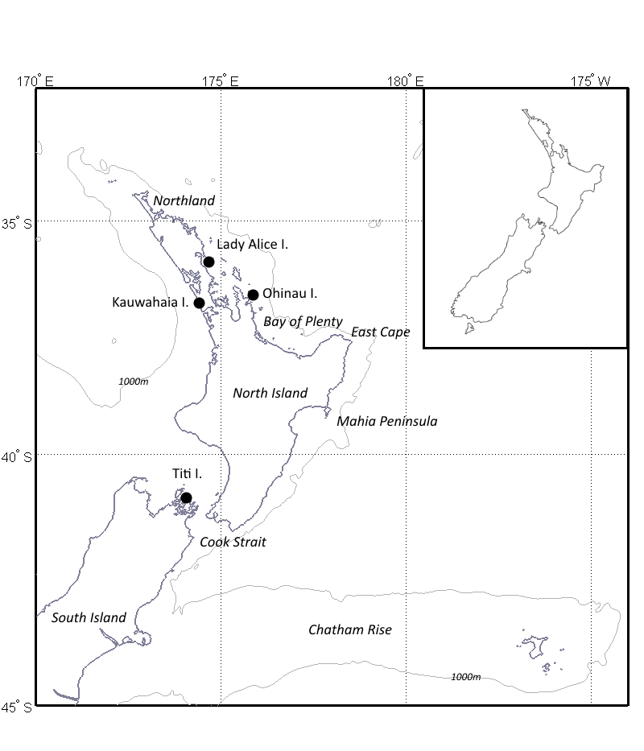
Figure 1. Change LAI and Kauwahaia I. symbol to open circles.
QUESTION TO OTHER AUTHORS, SHOULD WE ADD OPEN CIRCLES FOR THE OTHER COLONIES NOT STUDIED TO SHOW THE DISTRIBUTION OF OUR SITES COMPARED WITH THE NZ DISTRIBUTION FOR THE SPECIES.

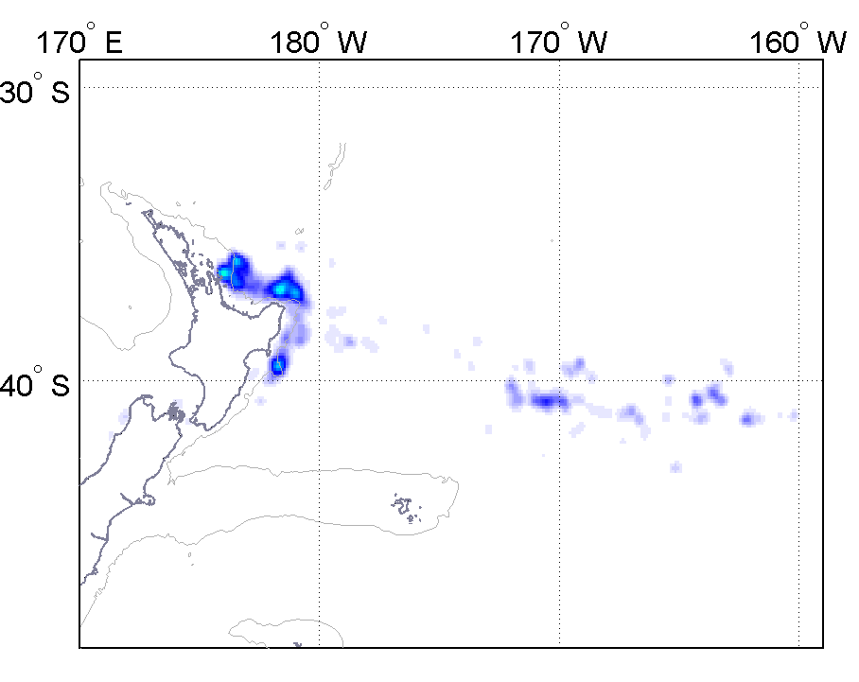 | 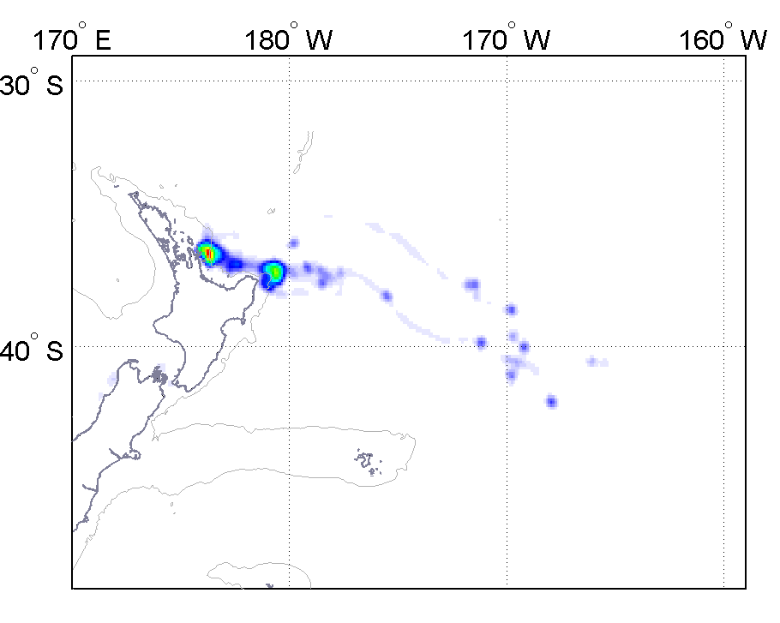
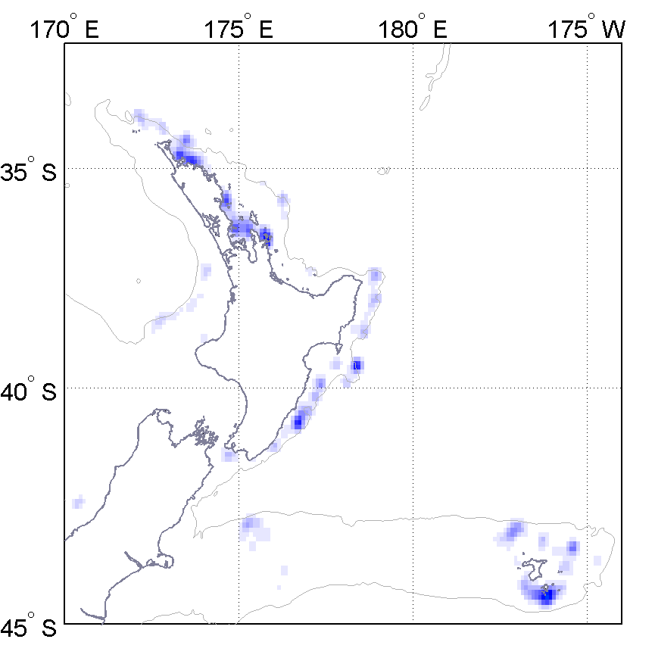 | 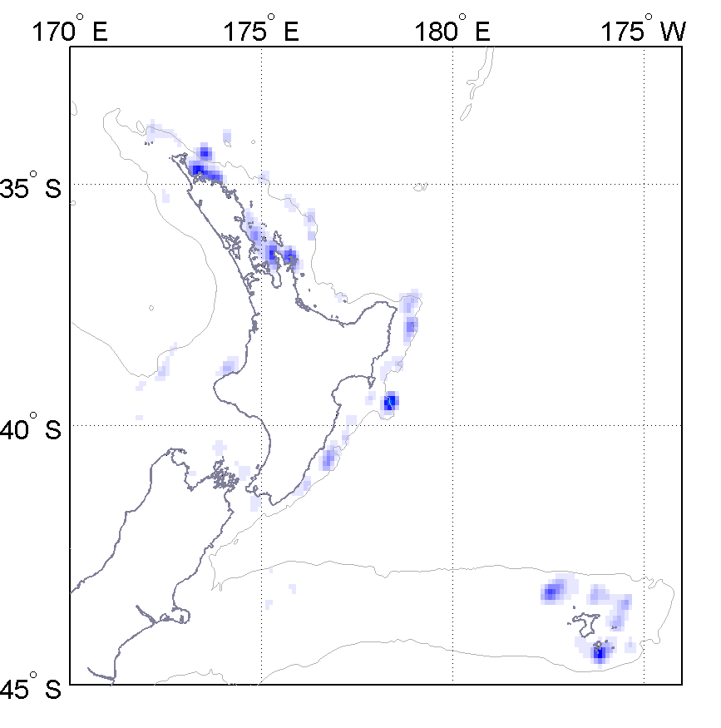
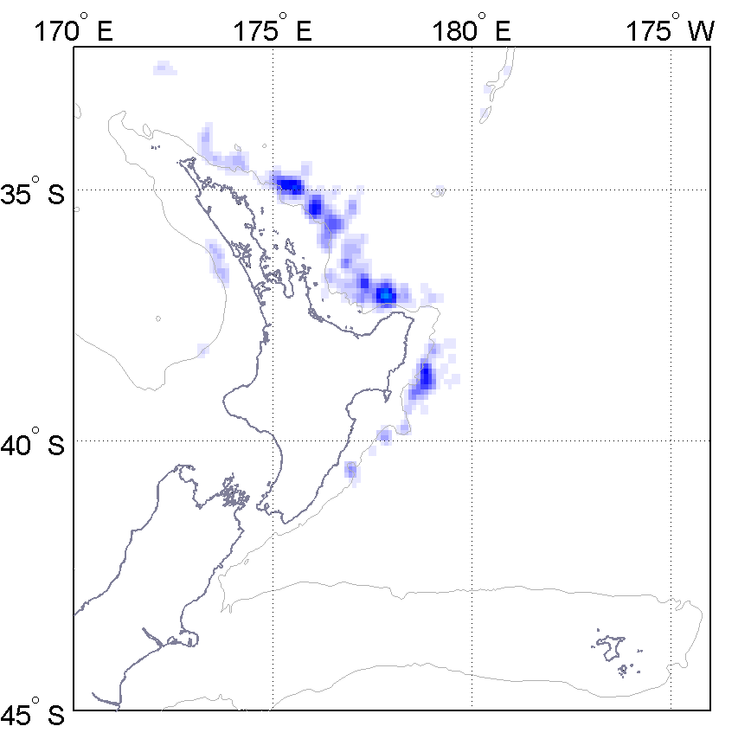 | 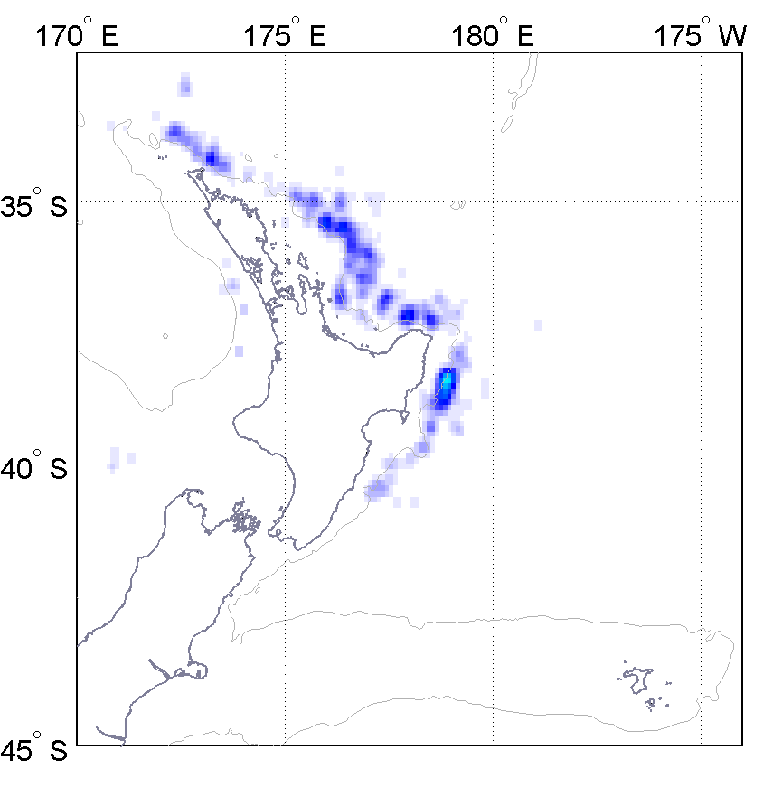
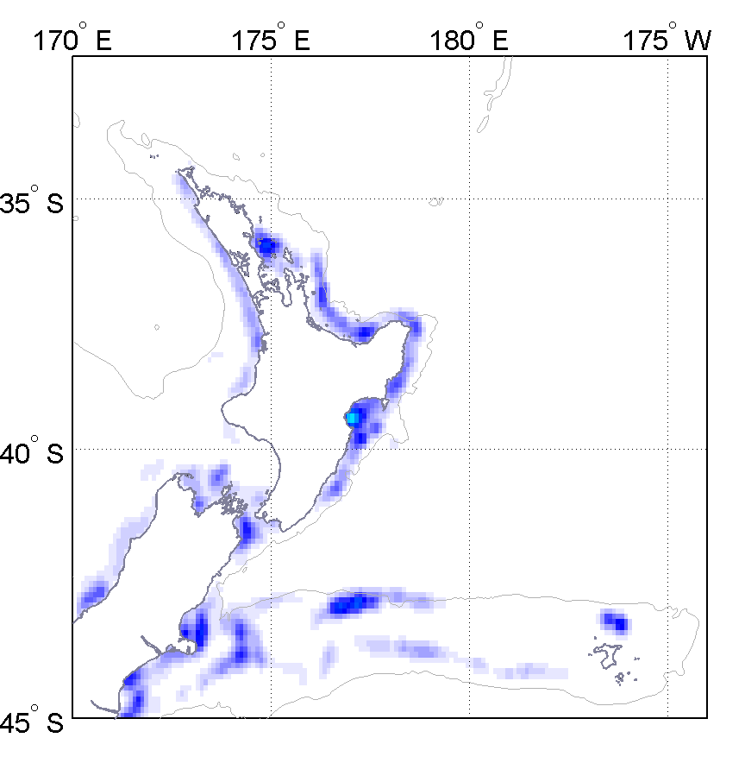 | 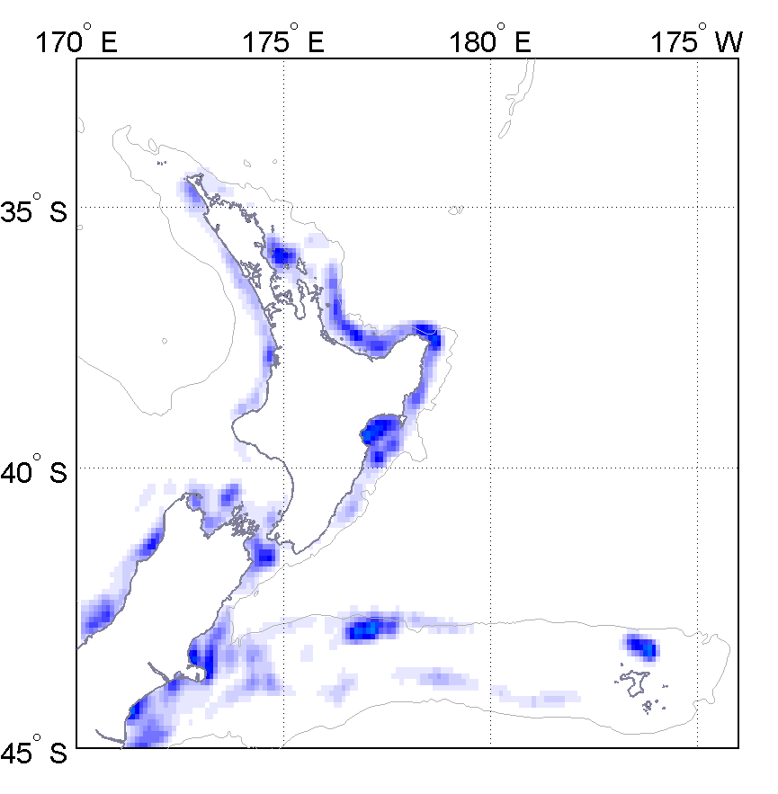
Figure 2. FIGURES NEED TO BE REDRAWN\ WITH MORE LEGIBLE CAPTION LABELS LAT/LONGS. ADD TITI ISLAND DATA TO PLOTS IN A SEPARATE COLOURWAY ON THE FIRST ROW FIGURES?

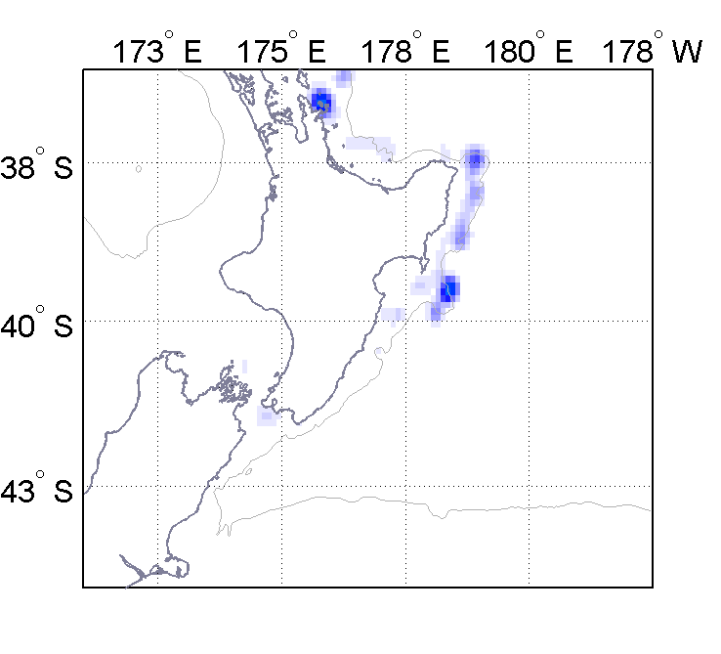 | 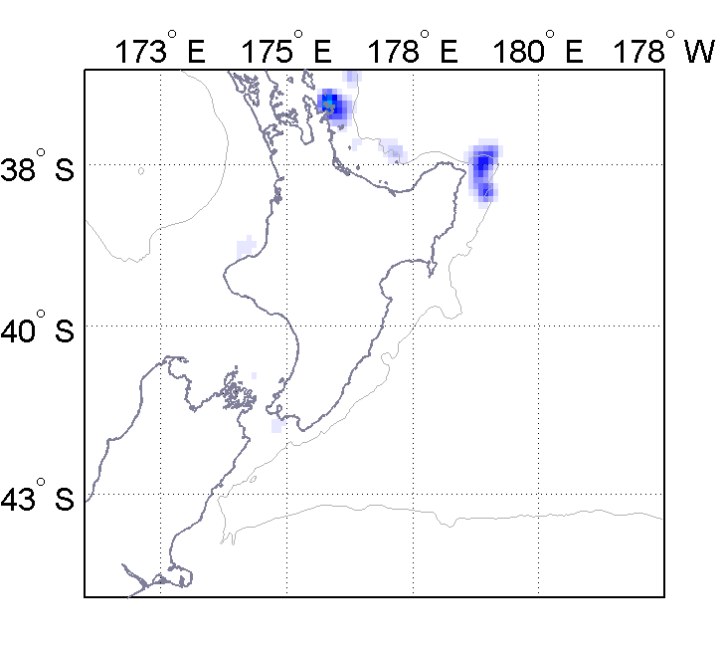
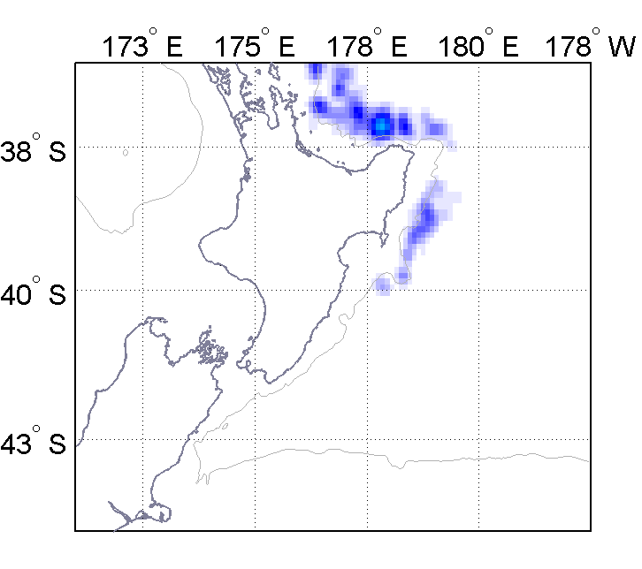 | 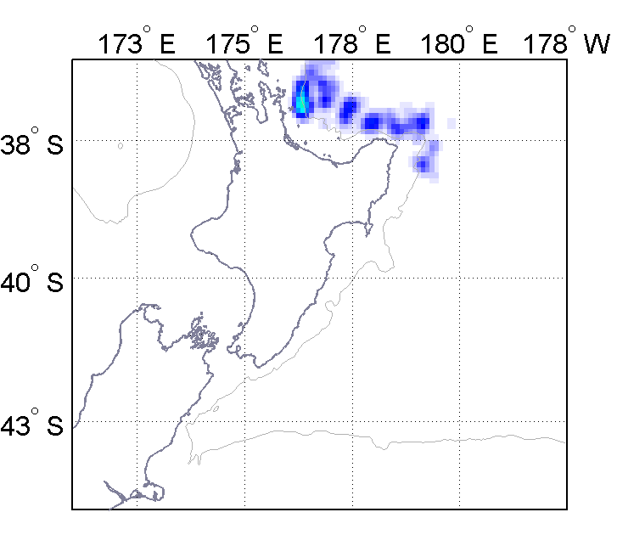
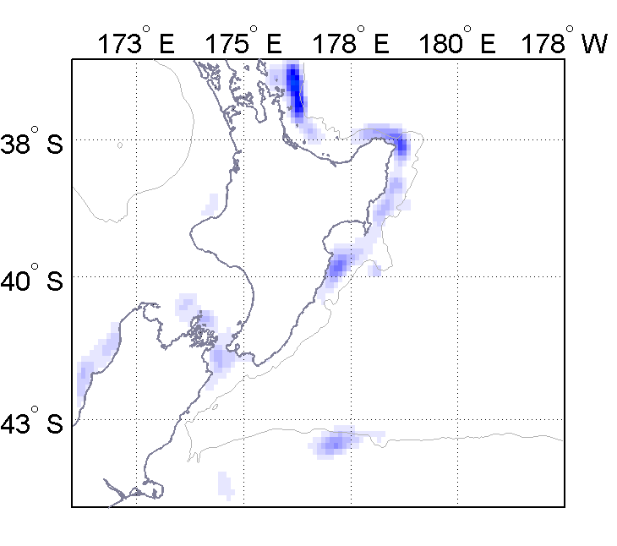 | 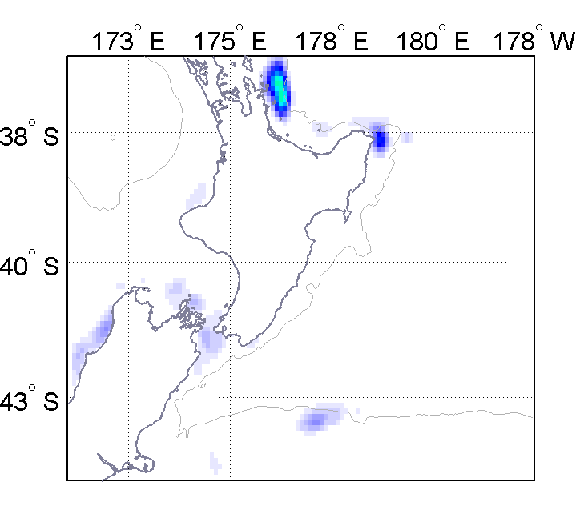
Figure 3. SCALE BAR WRITING NEEDS TO BE LARGER. ADD OHINAU AND TITI ISLAND LOCATIONS AS SYMBOLS ON THESE MAPS?

