Crystal Structure and Thermal Expansion of CsCaI₃:Eu and CsSrBr₃:Eu Scintillators
Matthew Loyd^{a,b*}, Adam Lindsey^{a,b}, Maulik Patel^{b,c}, Merry Koschanª, Charles L. Melcher^{a,b}, Mariya Zhuravleva^{a,b}
ªScintillation Materials Research Center, University of Tennessee Knoxville
^{b}Department of Materials Science and Engineering, University of Tennessee Knoxville
^{c}Department of Mechanical Materials and Aerospace, University of Liverpool, Harrison Hughes Building, Brownlow Hill, Liverpool, L69 3GH. United Kingdom

*Corresponding Author E-mail: mloyd1@vols.utk.edu
Abstract
The distorted-perovskite scintillator materials CsCaI₃:Eu and CsSrBr₃:Eu prepared as single crystals have shown promising potential for use in radiation detection applications requiring a high light yield and excellent energy resolution. We present a study using high temperature powder X-ray diffraction experiments to examine a deleterious high temperature phase transition. High temperature phases were identified through sequential diffraction pattern Rietveld refinement in GSAS II. We report the linear coefficients of thermal expansion for both high and low temperature phases of each compound. Thermal expansion for both compositions is greatest in the [001] direction. As a result, Bridgman growth utilizing a seed oriented with the [001] along the growth direction should be used to mitigate thermal stress.

Keywords: A1. X-ray Diffraction; B2. Bridgman Technique; B1 Halides; B2 Scintillator Materials
Introduction
In recent years, much research has been focused on the development of novel scintillator materials suitable for gamma ray spectroscopy for national security applications. A large part of this effort has been focused on metal halide compositions that can be grown from the melt in relatively large sizes. Compositions such as LaBr₃:Ce and SrI₂:Eu are currently the top performers, with high light yields and excellent energy resolutions [1, 2]. Many of these compositions are grown via the vertical Bridgman method, yielding single crystals up to 2 inches in diameter [3, 4]. However, there are challenges in the development of metal halide crystals; for example, the majority of the halide scintillators are hygroscopic. As a result, sealed quartz ampoules are used during growth to prevent exposure to the atmosphere. One unintended side effect is the constriction on the crystal during heating and cooling, which can lead to stresses and cracking due to thermal expansion and contraction. Rapid changes in temperature, which detectors deployed in the field will undergo, can also induce cracking in grown crystals due to thermal stress. In order to better understand these properties, the thermal expansion coefficients have been calculated for crystals such as SrI₂, CsCe₂Cl₇, and Lu₂SiO₅ [5-7] via high temperature powder X-ray diffraction (XRD).
National security applications require large crystals with uniform optical quality. Two potential compositions that have been studied at the University of Tennessee are CsCaI₃:Eu and CsSrBr₃:Eu [8, 9]. These materials show promise for gamma ray spectroscopy, with light yields of 40,000 ph/MeV and energy resolution of 4 % and 5% at 662 keV, respectively. Both compositions are distorted perovskites with cloudy appearances due to solid-to-solid phase transitions [10-12]. Previous work has shown that eliminating phase transitions yields superior crystals; for instance, substituting some of the iodine in CsCaI₃:Eu suppresses the phase transition to below room temperature, resulting in extremely transparent crystals. Both compounds crystalize into a previously unknown phase, and transform into room temperature orthorhombic Pnma phases at ~250°C [13, 14]. The goal of this work is to utilize powder diffraction at high temperatures to resolve these phases, as well as to quantify the thermal expansion in both CsCaI₃:Eu and CsSrBr₃:Eu
Experimental
Due to the hygroscopic nature of these compositions, special procedures were taken during preparation, handling, and measurement. All raw materials were purchased from APL or Sigma Aldrich in the form of anhydrous beads with purity levels of 99.99% or greater. The crystals for powder diffraction were prepared inside of a nitrogen maintained glovebox with less than 1 ppm oxygen and moisture. Starting materials of CsI, CaI₂, CsBr, SrBr₂, and EuI₂ were loaded into a quartz ampoule with a ratio of 1:0.95:0.05 for a 5% concentration of the Eu dopant relative to the divalent matrix element, Ca or Sr. The ampoules were then evacuated to a pressure of no more than 10⁻⁶ Torr and heated to 200°C to remove any trace moisture from before sealing with a hydrogen-oxygen torch.
Crystal growth for powder XRD was done in a two-zone transparent vertical Bridgman furnace with a thermal gradient of 25°C/cm at the solid-liquid interface, and a thermal insulating baffle to separate the hot and cold zones. The growth ampoules had a self-seeding capillary that resulted in single grains of unknown orientation. The crystals were translated downward at 1 mm/hr, and cooled to room temperature at 10 °C/hr after growth was complete. The grown crystals were removed from the ampoules inside a glovebox, and pieces were then powdered via mortar and pestle. The powdered samples were loaded onto an alumina sample holder and transferred to the High Temperature X-ray Diffraction (HTXRD) instrument.
The high temperature scans were measured with a Panalytical Empyrean diffractometer in the Bragg-Brentano geometry. Each sample was housed inside of an Anton-Parr HTK 1200N high temperature oven during measurement, which was evacuated to below 10⁻⁷ torr. Cu K_{α} X-rays were generated at 45kV and 40 mA. The incident beam passed through a 0.04 rad soller slit, a 0.125°divergence slit, a 0.25° anti-scatter slit, and a 10 mm beam mask. A PIXcel3D-Medipix 3 area detector operated in 1D scanning mode measured the diffracted beam, with 0.04 rad roller slits, a 5 mm fixed anti-scatter slit, and a 0.020 mm nickel beta filter. The CsCaI₃:Eu samples were scanned from 10-70° 2θ with a step size of 0.013° and total scan time of about 30 minutes, while the CsSrBr₃:Eu samples were scanned from 10-40° 2θ and similar step size. While under dynamic vacuum, diffraction patterns were acquired at temperature intervals near the respective critical temperature for each compound. A heating rate of 5 °C/min was used and the sample was allowed several minutes to reach thermal equilibrium between scans at each temperature. The stage height was adjusted during heating to account for the expansion of the alumina sample mount. All scans were plotted as intensity vs. 2θ with vertical offsets to facilitation comparison of multiple patterns.
Analyses of the powder diffraction spectra were carried out with GSAS II, an open-source software package for Rietveld refinement [15]. For the CsCaI₃:Eu low temperature phase, the published orthorhombic Pnma structure with lattice parameters: a = 8.6226 Å, b = 12.282 Å, and c = 8.555 Å was used as a starting point for refinement. The same was done with the CsSrBr₃:Eu low temperature phase (Pnma a = 8.3344 Å, b= 11.8238 Å, c= 8.2417 A). The best match for the peaks found in the high temperature phases was a tetragonal P4/mbm phase with lattice parameters a = 8.772 Å and c = 6.260 Å for CsCaI₃:Eu and a cubic P23 phase with lattice parameter 5.9441 Å for CsSrBr₃:Eu. Least Squares refinement was done sequentially, starting with the lowest measured temperature for each phase. The refined lattice parameters were used as starting values for the next temperature refinement. A LaB₆ sample was measured using the same method in order to derive instrumental parameters used for refinement of CsCaI₃:Eu and CsSrBr₃:Eu. Thermal expansion coefficients were calculated for the lattice parameters that varied linearly with temperature by dividing the change in length by the temperature range and the average length over said range.
Results and Discussion
Scans on both compounds were completed up to 400 °C, well below the melting temperatures of both compositions (686 °C CsCaI₃:Eu and 760 °C for CsSrBr₃:Eu). Figure 1 contains the patterns acquired for CsCaI₃:Eu, while Figure 2 contains those for CsSrBr₃:Eu. The low temperature patterns for both materials had similar peaks in accordance with their published structures. As seen in the region of 20-30° 2θ, both patterns lose peaks as they transform to high symmetry phases at their transition temperatures. CsSrBr₃:Eu has what appears to be an intermediate phase at 200° C, the structure for which was not resolved in this work. However, a tetragonal phase would be realistic, as it is typical for perovskites to follow an orthorhombic tetragonal cubic pattern as temperature increases [16, 17]. Lattice parameters at each temperature were determined by sequential Rietveld refinement. Figure 3 compares the calculated and the experimental patterns for both CsCaI₃:Eu and CsSrBr₃:Eu. Although care was taken to avoid moisture during sample preparation and transfer to the instrument, the CsSrBr₃:Eu room temperature pattern contained a broad peak at 29.5 ° 2θ, which can be attributed to a hydrate phase. This peak was fitted as the background, and disappeared as the sample was heated. The fits were excellent except for the intensities of (040) and (202) peaks, which may be due to a preferred orientation effect.
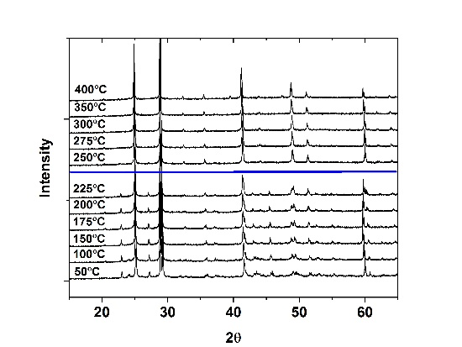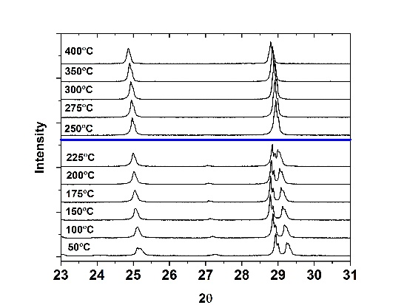
Figure 1: Powder XRD scans for CsCaI₃:Eu for the entire range (left) and a close up on a region of interest (right). The horizontal blue line separates the low temperature phase patterns from the high temperature phase.
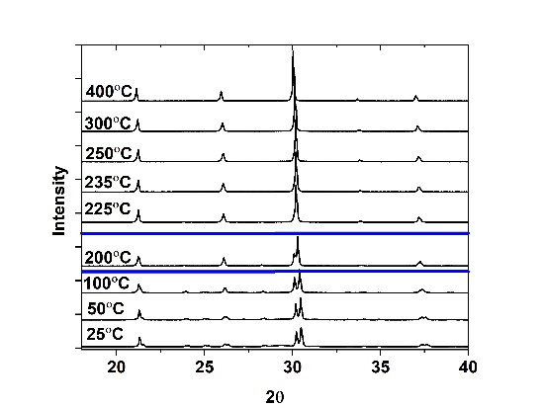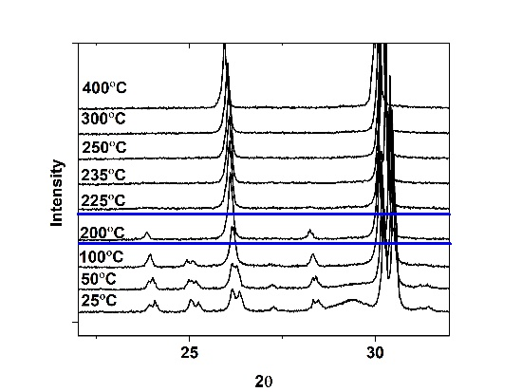
Figure 2: Powder XRD scans for CsSrBr₃:Eu for the entire range (left) and a close up on a region of interest (right). ). The horizontal blue line separates the low, intermediate, and high temperature phases.
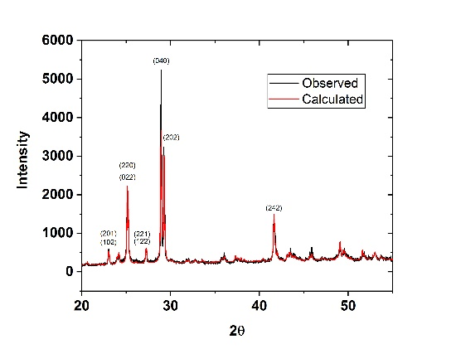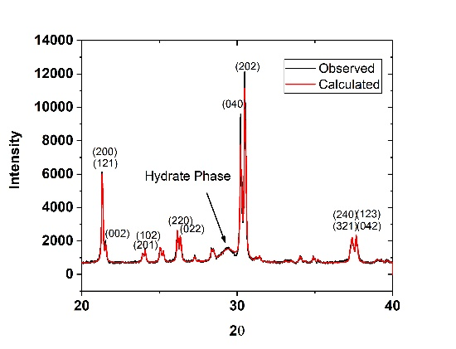
Figure 3: Observed and calculated XRD peaks for CsCaI₃:Eu (left) and CsSrBr₃:Eu (right) as measured at room temperature.
The refined lattice parameters for the low and high temperature phases of CsCaI₃:Eu are plotted in Figure 4. The b lattice parameter for the low temperature phase was found to vary nonlinearly with temperature throughout the entire low temperature region because the rising temperature causes the Ca-I octahedrons to shift from their bent orthorhombic positions into more symmetrical tetragonal positions, resulting in one of the lattice parameters decreasing as temperature increases. This can be seen in Figure 1 as the diffraction peak around 29 ° 2θ shifts to higher angle positions as temperature increases from 150 to 225 °C. This effect can also be seen in the CsSrBr₃:Eu lattice parameters that are plotted in Figure 5. However, for CsSrBr₃:Eu it is the a lattice parameter that exhibits nonlinear expansion. The intermediate phase in CsSrBr₃:Eu exists over too short of a temperature range to measure thermal expansion. However, the direction of maximum thermal expansion will likely be the same as the low temperature phase.
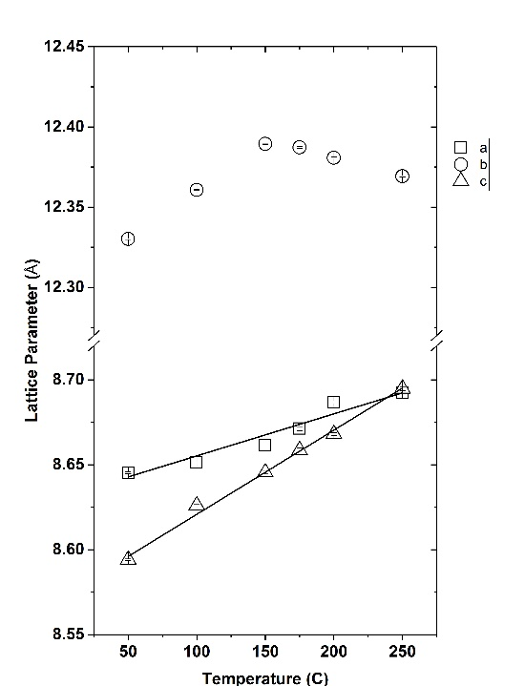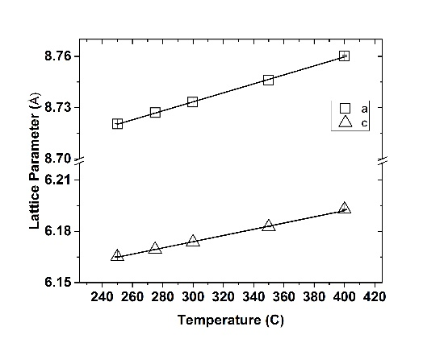
Figure 4: Lattice parameters and linear fits for the low temperature (left) and high temperature (right) phases of CsCaI₃:Eu.
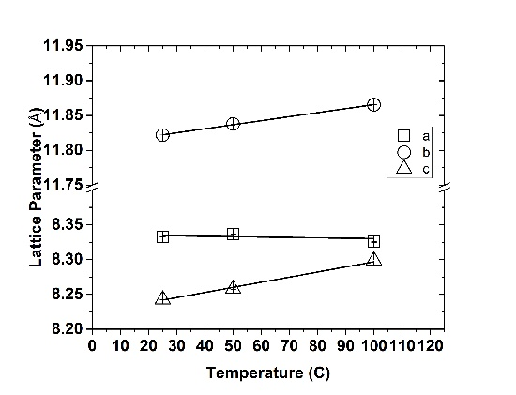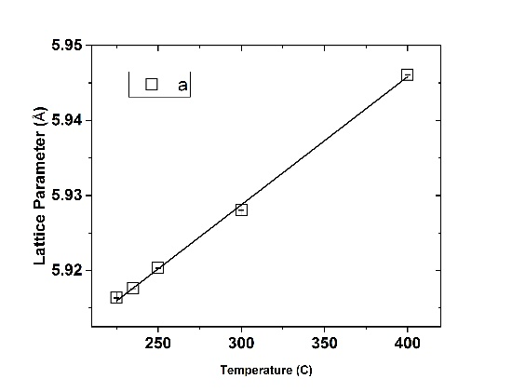
Figure 5: Lattice parameters and linear fits for the low temperature (left) and high temperature (right) phases of CsSrBr₃:Eu.
The volumetric thermal expansion was calculated for each phase using the following relationship:
$$\begin{aligned}a_{V}=α_{a}+α_{b}+α_{c}\#1\end{aligned}$$
where α_{i} corresponds to the linear thermal expansion for the i lattice parameter. The calculated values of linear thermal expansion and average volumetric expansion, as well as the ratios between the coefficents of thermal expansion (CTE) of each phase are compiled in Table 1. The low temperature phases of both materials have an anisotropic expansion with the c lattice parameter expanding twice as fast as the other. This c plane is parallel to the A-X, B-X planes in the room-temperature structure (A=Cs; B=Cs,Sr; X= I,Br). It is possible that the structure is stronger in the direction parallel to these planes, causing these structures to be less prone to thermal cracking than other compounds, such as KCaI₃:Eu, a similar metal halide perovskite scintillator [18]. Additionally, the level of anisotopy emphasize the need to grow crystals absent of multiple grains, as the anisotropy will cause separation at the grain boundary upon heating or cooling, creating cracks in the crystal. The CsSrBr₃:Eu low temperature phase has the highest CTEs of all the structures examined. The increase in symmetry during the high-temperature phase transition yielded lower values of thermal expansion for CsCaI₃:Eu and CsSrBr₃:Eu. Both compositions have more thermal expansion than LaCl₃:Ce and SrI₂:Eu, common scintillator materials. However, the ratios of the CTEs for the low temperature phases are comparable to both LaCl₃:Ce and SrI₂:Eu. This ratio measures the anisotropy of expansion, where a ratio of 1 is isotropic, and a ratio of 0.5 or 2 shows a lattice parameter that expands twice as much as another.
Table 1: Linear (a_{i}) and volumetric (a_{V)} thermal expansion coefficients for CsCaI₃:Eu and CsSrBr₃:Eu as well as SrI₂:Eu and LaBr₃:Ce
Crystal | $${\overline{α}}_{a}$$  (10⁻⁵ K⁻¹) | $${\overline{α}}_{b}$$  (10⁻⁵ K⁻¹) | $${\overline{α}}_{c}$$  (10⁻⁵ K⁻¹) | $${\overline{α}}_{V}$$  (10⁻⁵ K⁻¹) | ${\overline{α}}_{a}$/${\overline{α}}_{b}$ | ${\overline{α}}_{a}$/${\overline{α}}_{c}$ | ${\overline{α}}_{b}$/${\overline{α}}_{c}$
Low Temperature CsCaI₃:Eu Orthorhombic | 3.61 | Not linear | 6.94 | 11.2 | * | 0.52 | *
High Temperature CsCaI₃:Eu  Tetragonal | 3.02 | 3.02 | 2.95 | 9.00 | 1 | 1.02 | 1.02
Low Temperature CsSrBr₃:Eu  Orthorhombic | Not linear | 5.01 | 8.65 | 13.3 | * | * | 0.58
High Temperature CsSrBr₃:Eu  Cubic | 2.71 | 2.71 | 2.71 | 8.14 | 1 | 1 | 1
LaCl₃:Ce [19]  Hexagonal | 2.5 | 2.5 | 1.1 | 6.1 | 1 | 2.3 | 2.3
SrI₂:Eu [5]  Orthorhombic | 1.55 | 2.16 | 0.92 | 4.66 | 0.7 | 1.7 | 2.3
*Ratios could not be calculated due to the nonlinearity of one lattice parameter
Conclusion
High temperature powder X-ray diffraction patterns were collected for scintillator compounds CsCaI₃:Eu and CsSrBr₃:Eu. Both compositions undergo a reversible phase transition when heated from their orthorhombic room temperature phases to higher symmetry phases that leaves the crystals cloudy. The high-temperature phases of each composition were resolved via Rietveld refinement for the first time in this work. The lattice parameters as a function of temperature were measured using sequential refinement and the thermal expansion for both materials were calculated. CsCaI₃:Eu and CsSrBr₃:Eu exhibit anisotropic expansion. Additionally, one lattice parameter was found to vary nonlinearly with temperature. The volumetric expansion values of 11.2 x 10⁻⁵ K⁻¹ for CsCaI₃:Eu and 13.3 x 10⁻⁵ K⁻¹ for CsSrBr₃:Eu are quite large, and therefore the materials cannot sustain thermal shock, resulting in slow cooling rates. A seed crystal with known orientation could be used in the growth of these compositions to align the direction with the most expansion [001] vertically within the growth ampoule to allow for the most contraction during post-growth cooling to reduce stress in the scintillator and result in better crystal quality.
Acknowledgements
This work has been supported by the US Department of Homeland Security, Domestic Nuclear Detection Office, under competitively awarded grant #2012-DN-077-ARI067-05. This support does not constitute an express or implied endorsement on the part of the Government. The X-ray diffraction experiments were performed using the instruments procured through the general infrastructure grant of DOE-Nuclear Energy University Program #DE-NE0000693.
References
[1] E. V. D. van Loef, P. Dorenbos, C. W. E. van Eijk, K. W. Krämer, and H. U. Güdel, "Scintillation properties of LaBr3:Ce3+ crystals: fast, efficient and high-energy-resolution scintillators," Nuclear Instruments and Methods in Physics Research Section A: Accelerators, Spectrometers, Detectors and Associated Equipment, vol. 486, no. 1–2, pp. 254-258, 6/21/ 2002.
[2] N. J. Cherepy et al., "Strontium and barium iodide high light yield scintillators," Applied Physics Letters, vol. 92, no. 8, p. 083508, 2008.
[3] A. Yoshikawa et al., "Growth of 2Inch Eu-doped SrI2 single crystals for scintillator applications," Journal of Crystal Growth, vol. 452, pp. 73-80, 2016/10/15/ 2016.
[4] Y. Wu et al., "Scintillation properties of a 2-inch diameter single crystal," Nuclear Instruments and Methods in Physics Research Section A: Accelerators, Spectrometers, Detectors and Associated Equipment, vol. 866, pp. 13-17, 9/11/ 2017.
[5] N. J. Cherepy et al., "SrI2 scintillator for gamma ray spectroscopy," 2009, vol. 7449, pp. 74490F-74490F-6.
[6] M. Zhuravleva et al., "Crystal structure and thermal expansion of a CsCe2Cl7 scintillator," Journal of Solid State Chemistry, vol. 227, pp. 142-149, 7// 2015.
[7] D. Ding, L. Qin, J. Yang, G. Ren, and Y. Wu, "Thermal expansion of Lu2SiO5:Ce crystal," Thermochimica Acta, vol. 576, pp. 36-38, 1/20/ 2014.
[8] M. Zhuravleva, B. Blalock, K. Yang, M. Koschan, and C. L. Melcher, "New single crystal scintillators: CsCaCl3:Eu and CsCaI3:Eu," Journal of Crystal Growth, vol. 352, no. 1, pp. 115-119, 8/1/ 2012.
[9] V. L. Cherginets et al., "Scintillation properties of CsSrX3:Eu2+ (CsSr1−yEuyX3, X = Cl, Br; 0 ≤ y ≤ 0.05) single crystals grown by the Bridgman method," Materials Chemistry and Physics, vol. 143, no. 3, pp. 1296-1299, 2/14/ 2014.
[10] A. Lindsey, W. McAlexander, L. Stand, Y. Wu, M. Zhuravleva, and C. L. Melcher, "Crystal growth and spectroscopic performance of large crystalline boules of CsCaI3:Eu scintillator," Journal of Crystal Growth, vol. 427, pp. 42-47, 10/1/ 2015.
[11] S. S. Gokhale, L. Stand, A. Lindsey, M. Koschan, M. Zhuravleva, and C. L. Melcher, "Improvement in the optical quality and energy resolution of CsSrBr3: Eu scintillator crystals," Journal of Crystal Growth, vol. 445, pp. 1-8, 7/1/ 2016.
[12] M. Loyd, A. Lindsey, L. Stand, M. Zhuravleva, C. L. Melcher, and M. Koschan, "Tuning the structure of CsCaI3:Eu via substitution of bromine for iodine," Optical Materials, vol. 68, pp. 47-52, 2017/06/01 2017.
[13] G. Schilling and G. Meyer, "Ternäre Bromide und Iodide zweiwertiger Lanthanide und ihre Erdalkali-Analoga vom Typ AMX3 und AM2X5," Zeitschrift für anorganische und allgemeine Chemie, vol. 622, no. 5, pp. 759-765, 1996.
[14] H. J. Seifert and D. Haberhauer, "Über die Systeme Alkalimetallbromid/Calciumbromid," Zeitschrift für anorganische und allgemeine Chemie, vol. 491, no. 1, pp. 301-307, 1982.
[15] B. H. T. a. R. B. V. Dreele, "GSASII: the genesis of a modern open-source all purpose crystallography software packaged," Journal of Applied Crystallography, vol. 46, no. 2, pp. 544-549, 2013.
[16] Y. Kususe et al., "Structural phase transitions in EuNbO3 perovskite," Journal of Solid State Chemistry, vol. 239, pp. 192-199, 7// 2016.
[17] T. Baikie et al., "Synthesis and crystal chemistry of the hybrid perovskite (CH3NH3)PbI3 for solid-state sensitised solar cell applications," Journal of Materials Chemistry A, 10.1039/C3TA10518K vol. 1, no. 18, pp. 5628-5641, 2013.
[18] A. C. Lindsey et al., "Effects of increasing size and changing europium activator concentration in KCaI3 scintillator crystals," Journal of Crystal Growth, vol. 449, pp. 96-103, 9/1/ 2016.
[19] G. Meyer, "Thermal-Behavior Of Complex Halides," Eur. J. Solid State Inorg. Chem., vol. 28, no. 6, pp. 1209-43, 1991.

