Title Page
- Title: Cortical nociceptive processes are reduced by visual alpha-band entrainment in the human brain
- Running head: Visual Entrainment reduces Nociception
- Authors: Katharina Ecsy¹, Christopher A Brown², Anthony K P Jones¹.
- ¹ Human Pain Research Group, Division of Neuroscience & Experimental Psychology, University of Manchester, Manchester, United Kingdom.
² Department of Psychological Sciences, University of Liverpool, Liverpool, United Kingdom.
- Corresponding author:
Katharina Ecsy

Room C202,

Human Pain Research group,

Clinical Science Building,

Salford Royal NHS Foundation Trust,

M6 8HD

Tel 0161 206 4528

Email katharina.ecsy@manchester.ac.uk

Website http://www.bbmh.manchester.ac.uk/research/ccn/pain

- This manuscript is being submitted as an original article.
- None declared.
- There were no financial or other relationships that might lead to a conflict of interest.
- Significance: While it is known that visual stimulation can increase the brain’s oscillatory alpha rhythms, here we show for the first time that this increase in alpha power occurs alongside reduced cortical processing of nociception, as measured with EEG. This establishes an objective marker of alpha entrainment-based analgesia that may be useful in the development of neuromodulatory treatments for clinical pain.

Abstract
Background: Acute noxious stimuli induce a suppression of cortical alpha activity, yet little is known about whether increasing alpha activity affects the processing of noxious stimuli. We have previously shown that visual alpha stimulation reduces experimental pain. Here we demonstrate that increasing alpha power causes a reciprocal suppression of acute nociceptive processing.
Methods: We attempted to increase cortical alpha activity through visual entrainment at 8Hz, 10Hz and 12Hz to investigate the influence on the electrophysiological pain response. Moderately painful laser-heat stimuli were delivered following 10 minutes of visual entrainment across the alpha range.
Results: Alpha power increased significantly relative to the 1Hz control condition following 8Hz and 10Hz visual stimulation. Significant reductions in the P2 peak amplitude of the laser-evoked potential were found following visual entrainment at 10Hz; the frequency stimulation resulting in the largest reduction in pain perception. Source analysis revealed that, following the 10Hz stimulation, sources of increased alpha power and decreased nociceptive processing overlapped in precuneus and posterior cingulate cortex, with further reductions in nociceptive processing in insula cortex.
Conclusions: As far as we are aware, this is the first study to provide direct evidence that experimental induction of increased alpha power suppresses the cortical processing of acute pain.

Introduction
The lack of efficacy of available pharmacological treatments, and the growing understanding of the complexity of the physiological and psychological factors involved in pain processing, is driving the need to develop alternative interventions for the treatment of pain (Jones and Brown, 2017). Pain is an outcome of how the brain processes sensory inputs, rather than a direct result of sensory inputs. Evidence of pain being a result of supra-spinal cortical processing (Apkarian et al., 2011) strengthens the rationale for developing neuromodulatory approaches. The idea that pain can be influenced by targeting pain-related brain activity (Jensen et al., 2008) is the primary focus of various approaches aiming to contribute to the development of non-pharmacological treatments (Jensen et al., 2014).

The cortical alpha rhythm (714Hz) plays a central role in cognitive processing, specifically the top-down control of sensory information (Klimesch et al., 2007). High cortical alpha power in pain-related areas suppresses pain processing (Jensen et al., 2013; Kerr et al., 2011; Klimesch et al., 2007). Conversely, decreases in alpha power correlating with increases pain intensity have also been extensively documented (Babiloni et al., 2006; Gross et al., 2007; Peng et al., 2014). Alpha power suppression over contralateral sensorimotor and occipital cortices (Hu et al., 2013; Jensen et al., 2014; Ploner et al., 2006) may permit increased pain processing through the opening of sensory and motor system gates (Downar et al., 2000). Attempting to directly influence alpha activity in occipital and parietal areas may thus provide an effective way of altering pain perception.

Oscillatory rhythms in the 1-30Hz range, such as the alpha rhythm, can be modulated by an external stimulus. In a process known as entrainment, brainwave activity naturally adapts to the frequency of the driving stimulus, making that frequency more prominent throughout the cortex (Lakatos et al., 2008; Thut et al., 2012). Visual entrainment has the strongest resonance at 10Hz and predominantly affects the primary visual cortex (Herrmann, 2001). However, changes in cortical activity following visual alpha stimulation can be observed widely throughout the cortex (de Graaf et al., 2013). Although the function of alpha depends on the cortex, (Klimesch, 2012), alpha entrainment of the visual cortex could also engage sensorimotor regions of the parietal lobe or other areas associated with pain processing (such as the cingulate cortex and insula), and thus could prove a promising candidate for modulating nociceptive processes at the cortical level.

The aim of this study was to obtain preliminary evidence (in healthy volunteers) supporting the concept of entrainment-based analgesia, potentially contributing to the development of neuromodulatory interventions for chronic pain management.
Previously, we reported a significant reduction in acute pain ratings following visual stimulation and auditory stimulation at 8Hz, 10Hz and 12Hz (Ecsy et al., 2017). Here, we present the electrophysiological data (recorded using electroencephalography (EEG)) for the visual entrainment group. As the 10Hz flicker has the strongest resonance (Herrmann, 2001) we hypothesised that visual 10Hz entrainment would result in the most robust alpha entrainment and the largest reduction in LEP amplitude. As pain-related changes in alpha activity have been predominantly documented in the occipital and parietal lobes, and changes LEP amplitude have previously been shown to arise from the cingulate cortex (Bentley et al., 2002), we anticipate to see changes in activity in these areas.

Materials and Methods

Ethics Statement
All volunteers provided written, informed consent according to the International Conference on Harmonisation Good Clinical Practice guidelines, before participating in the study. The study received ethical approval from the NRES Committee North West – Liverpool Central (reference number 13/NW/0007).

Participants
32 healthy volunteers (17 Male, mean age 25.82 ± 8.6 SD) attended a session at Salford Royal NHS Foundation Trust after having made contact through advertisements placed throughout the Trust and on the University of Manchester website. In order to participate in the study, all volunteers needed to be right-handed, over the age of 18, and not have any of the following exclusion criteria: chronic pain, morbid psychiatric illness (e.g. major depression, schizophrenia, bipolar disorder), neurological illness, ischemic heart disease, uncontrolled high blood pressure, peripheral vascular disease, chronic skin disease (e.g. eczema, psoriasis), hypertension not controlled by medication and a history, or family history of epilepsy.

The Painful Stimulus
A CO₂ laser was applied to the dorsal surface of the participants arm to elicit a moderately painful sensation. The laser stimulus had a total duration of 150ms with a 15mm beam diameter. Following each stimulus (occurring every 10 seconds), the laser beam was relocated to a different area of the forearm to minimise sensitisation, habituation or damage to the skin. Previous studies have shown evidence of contactless activation of nociceptors related to Aδ and C fibres using brief CO₂ laser stimuli (Meyer et al., 1976). All participants were obliged to wear safety goggles whenever the laser was in use.

Psychophysics Procedure (Pre-experimental)
Prior to the start of the experiment, the CO₂ laser voltage required to reach each volunteer’s level 7 rating on a 0-10 numeric rating scale was established using a psychophysics procedure. ‘No sensation’ was marked next to level 0 on the scale, 4 was marked as the ‘pain threshold’, 7 as ‘moderately painful’ and 10 was labelled the ‘maximum tolerance level’. The psychophysics consisted of a ramping procedure with increasing stimulus intensity whereby the subjects were asked to verbally rate each pulse until their level 7 (moderately painful level) was reached. The procedure was completed a minimum of three times, until a consistent voltage for moderate pain was established. This intensity was then tested (and adjusted if necessary) by repeating a series of laser pulses across the forearm, with the participant rating each pulse. The voltage consistently eliciting a level 7 rating during the psychophysics procedure was then fixed for each subject, and not altered for the rest of the study.

Baseline Pain Ratings
Prior to the first entrainment session, all participants were asked to rate 30 pulses of laser stimuli at their ‘moderately painful’ intensity, with a 10 second resting period between each pulse. The ratings were averaged to determine each volunteer’s baseline pain rating.

Visual Entrainment
There were three different visual alpha entrainment conditions, and one control condition. Each of the four visual stimulation blocks lasted 10 minutes, and was presented in a randomised order (Figure 1). Frequency entrainment was performed at 8Hz, 10Hz, 12Hz and 1Hz (control) with a pair of flashing LED goggles. Participants were requested to keep their eyes closed whilst wearing the goggles, as entrainment is just as effective, but perceived as more pleasant with closed eyes. Following each entrainment and control stimulation volunteers were asked to rate 30 pulses of the laser stimulus (delivered at the fixed voltage established as ‘moderately painful’ by the subject during the psychophysics procedure).

Summary of Behavioural Pain Ratings
The pain ratings collected in this experiment have already been published in a previous publication by Ecsy et al (2017). Pain ratings in all three entrainment conditions (8Hz, 10Hz and 12Hz) were all significantly different to pain ratings in the 1Hz control condition (p<0.01). Additionally, pain ratings following the 10Hz stimulation were significantly lower than in the 8Hz and 12Hz conditions (p<0.01). Although the average pain ratings in the 8Hz condition were lower, they were not significantly different from the ratings in the 12Hz condition.

Acquisition of EEG Data
EEG was recorded separately for each of the four frequency-entrainment blocks, and for each of the subsequent four pain-rating blocks (but continuously throughout each of the eight blocks), using 64 Ag/AgCl surface electrodes attached to a cap according to the extended standard 10-20 system (Brain Vision Acticap and BrainAmp, Brain Products GmBH, Germany). In order to isolate eye-movement and blink artefacts, four electrodes in the set measured the horizontal and vertical electro-oculograms (EOG). The right mastoid electrode was used as a reference electrode and AFz acted as the ground electrode for all other electrodes. For all recordings a sampling rate of 500Hz was implemented and band-pass filters were set at DC – 100Hz. To minimize the amount of electrical interference in the recording, a notch filter at 50Hz was applied. Recordings were made using BrainVision Recorder 1.10 (Brain Products GmBH, Germany).

Quantitative Electrophysiological Analysis

Spectral Analysis
A spectral analysis was performed on the continuous EEG data recorded throughout each of the visual entrainment blocks, using Brain Vision Analyzer 2.0 consistent with procedures from previous work (Huneke et al., 2013). The data were initially re-referenced to the common average of all scalp electrodes. A low cut off filter at 0.05Hz (12dB/oct), and a high cut off filter at 35 Hz (48 dB/oct) were applied. In order to eliminate artefacts including eye-movement and muscle activity, a 25 component Independent Component Analysis (ICA) was performed, removing all the bad segments before reconstructing the clean data. Data were segmented into 1-second epochs (with 50% overlapping windows), with any epoch still containing artefacts being removed after manual inspection. The pre-processing for each visual entrainment (and control) block was done separately, in case of any subtle displacement of any electrodes on the scalp between the recording blocks (e.g. whilst participants were completing the questionnaires). If recording blocks are concatenated, such movements can be detrimental to successful ICA decomposition.

A Fast-Fourier Transformation with a 10% Hanning window was applied to the remaining data to calculate the average power (μV²). With a sampling rate of 500Hz, this resulted in a frequency resolution of 0.5Hz. In the present study the power in the frequency bands 8Hz ±1Hz, 10Hz ± 1Hz, 12Hz ± 1Hz was compared to the activity in the matching frequency band of the control condition.

Laser-Evoked Potentials (LEPs)
EEG analysis was completed with Brain Vision Analyzer 2.0. Data were analysed consistently using the same procedures as in previously published work (Brown et al., 2008; Huneke et al., 2013; Morton et al., 2010; Watson et al., 2009). Initially, EEG recordings obtained from each of the laser stimulation blocks were down-sampled from 500Hz to 125Hz. Segments containing the LEPs were epoched 1000ms pre-stimulus, and 1500ms post-stimulus. The laser stimulus was marked as time 0ms. A baseline correction was completed at -500ms to 0ms. A DC detrend was applied to remove linear trends from the segment. To remove horizontal eye movement and blink artefacts an ICA with classic sphering was performed with an Infomax (Gradient) Restricted Biased algorithm. Data were split into 25 components. The median number of components removed was 4 with a range of 0 to 10. Although 10 components is a high number of components to remove, it should be noted that this only occurred in one recording block of one subject (with 8 recording blocks per subject, this means one out of 256 recording blocks), and therefore is not believed to affect the quality of the overall results. The data were reconstructed with the remaining components and manually re-inspected for any remaining artefacts. Epochs were then averaged across all data sets, separately for each condition. Data were then re-referenced to the common average of electrodes. Again, the pre-possessing for each block was done separately to avoid any electrode movements between recordings negatively affecting the ICA decomposition.

In every subject and each condition LEPs were measured separately using the most negative post-stimulus point between 200ms and 300ms, identified as N2 and the largest positive peak between 350ms and 500ms after the stimulus, labelled as P2. The data from nine electrodes (CPz, Cz, FCz, CP1, CP2, C1, C2, FC2, FC1) surrounding the electrode with the largest global N2-P2 complex at baseline (the central Cz electrode) were pooled for statistical analysis for each subject and condition. Values of N2 and P2 peaks of the pooled electrodes were exported +/-10ms either side of the peak, for each subject, across all conditions. A grand average was produced to create an image of the LEPs for all conditions.

Source Localisation
Cortical sources of the N2 and P2 components of the LEP were estimated independently using low-resolution electromagnetic tomography (LORETA), using the LORETA-KEY software (Lantz et al., 1997; Pascual-Marqui et al., 2002). The LORETA software uses a three-shell spherical head model, which is registered to the Talairach anatomical brain atlas (Talairach et al., 1988). However, the coordinates used for electrodes were calculated from a co-registration between spherical and realistic head geometry thus creating the best-fitting sphere relative to cortical anatomy (Towle et al., 1993). Sources of alpha and LEPs in grey matter volume are estimated in LORETA to a 7mm³ resolution (2394 voxels) (Mazziotta et al., 2001).

The condition with the largest reduction in pain ratings was selected for LORETA analysis. The sources of the N2 and P2 peaks in the entrainment condition were compared to the control condition. Furthermore, the cortical sources of the differences in alpha activity between control and the entrainment condition with the largest analgesic effect were identified. The spatially smoothest source compatible with the electrophysiological data was estimated across all electrodes. The EEG data were plotted onto the previously mentioned map of 2394 voxels in a three-dimensional space in which each voxel represented a single potential activity zone.

Statistical Analysis
Statistical analysis was completed in SPSS version 20, with a p value of <0.05 regarded as significant. The change in alpha power averaged across all scalp electrodes was compared between the three conditions using a one-way ANOVA with a Bonferroni correction to assess the global influence of entrainment. The power in each entrainment condition band (e.g. 8Hz ±1Hz) was compared to the same frequency band in the control condition. The electrodes were then divided into 9 scalp regions: Left Anterior (AF7, F9, F7, F5, F3) Central Anterior (Fp1, Fpz, Fp2, AF3, AFz, AF4, F1, Fz, F2), Right Anterior (AF8, F4, F6, F8, F10), Left Middle (FT7, FC5, FC3, T7, C5, C3, TP7, CP5, CP3), Central Middle (FC1, FCz, FC2, C1, Cz, C2, CP1, CPz, CP2), Right Middle (FC3, FC6, FT10, C4, C6, T8, CP4, CP6, TP8), Left Posterior (P7, P5, P3, PO7), Central Posterior (P1, Pz, P2, PO3, POz, PO4, O1, Oz, O2) and Right Posterior (P4, P6, P8, PO8), averaging the electrodes’ activity in each region. For each condition, a repeated measures ANOVA was completed comparing the activity of the stimulated frequency band, to activity of the same frequency band in the control condition. For each condition the ANOVA was run with factors Left/Central/Right x Anterior/Middle/Posterior x Control/Condition. All electrodes were included in the analysis, as we were unsure which electrode scalp regions would show changes in alpha activity following exposure to the visual stimulus. A two-tailed t-test was then used to follow-up the main effects by calculating alpha power differences between the entrainment condition frequency bands and matching control condition frequency bands, separately for each scalp region (Figure 2). The ANOVA was selected due to the benefit of high statistical power and not needing to correct for multiple comparisons. Some spatial information could be determined by implementing ‘left-to-right’ and ‘anterior-to-posterior’ factors, but the importance of this was secondary to the source localisation analysis.

A mixed linear model was used to analyse the differences in N2 and P2 LEP peak amplitudes between entrainment conditions and control. The model considered the baseline peak values as a covariate and accounted for the condition (8Hz, 10Hz or 12Hz) and order of entrainment. The model output revealed amplitude of change from control for each condition, and the significance of this difference with the mentioned factors and covariate taken into account. In order to calculate the differences between conditions the mixed linear model was refitted with a Bonferroni correction using each condition as a reference category. For this analysis, data was pooled from the nine electrodes surrounding the central electrode (CPz, Cz, FCz, CP1, CP2, C1, C2, FC2, FC1) rather than analysing all sets of electrodes, to increase statistical power. As it is well established that Cz has largest global N2-P2 complex, it was logical to perform the statistical analysis only on the central electrodes of interest.

The LORETA analysis compared the control condition to the entrainment condition with the largest analgesic effect. To compare the two conditions, LORETA created statistical maps by performing voxel-wise t-tests using non-parametric randomisation. A threshold (t) was calculated to identify significant areas of activation. A LORETA analysis was completed for N2 peaks, P2 peaks and global alpha activity for the selected conditions.

Results

Alpha Activity in the Brain
For each entrainment frequency, a repeated-measures ANOVA was completed comparing the cerebral alpha power across conditions (entrainment vs. control) and across the nine scalp regions. Following the 8Hz stimulation, there was a significant main condition effect (F(1,31) = 5.6, p<0.05) with significantly higher alpha power following alpha stimulation, confirming entrainment was successful. A significant main anterior-to-posterior effect, with higher posterior alpha power was found across both control and entrainment conditions (F(2,30) = 8.71, p<0.01).

Visual entrainment at 10Hz also resulted in a significant increase in alpha power, made apparent by the main condition effect (F(1,31)= 6.0, p<0.05). Again, a significant main anterior to posterior effect was observed (F(30,2) = 5.33 p<0.01), with higher activity in the posterior regions. Following the 12Hz stimulation, no significant effect of condition was observed, suggesting no entrainment occurred in this selected frequency band. Similarly to the 8Hz and 10Hz stimulations, alpha power was significantly higher posteriorly across conditions (F(2,30) = 6.05, p<0.05) following the 12Hz stimulation (Figure 3a and 3b).

As there was no interaction between condition and anterior-to-posterior alpha power following any of the frequency stimulations, it appears that alpha power was consistently higher posteriorly irrespective of the condition. Increases in alpha power in the 8Hz and 10Hz conditions occurred globally, across multiple scalp regions. Namely, high posterior alpha power increased proportionally to other scalp regions. To verify this, follow-up two-tailed paired t-tests were completed separately over the nine scalp regions, comparing activity of the frequency entrained to the matching band in the control condition. Following the 8Hz entrainment, activity in 7/9 scalp regions was higher than in the matching control (at p <0.05; with only the Right Anterior and the Right Posterior regions not significantly different). In the 10Hz condition, all regions except for the Left Anterior were significantly higher than in the control condition (at p<0.05). No regions were significantly different to the control condition following the 12Hz stimulation, as expected by the lack of condition effect.

Laser-Evoked Potentials
The mixed linear model revealed that there were no significant differences between the N2 peaks following alpha entrainment and control (t(31) = -0.56, p=0.58; t(31) = -0.47, p=0.638; t(31) = -0.22, p = 0.823 for 8Hz, 10Hz and 12Hz respectively).
Changes in P2 were found to be significant after 10Hz entrainment (t(31) = -3.81, p<0.001), but not following 8Hz and 12Hz (t(31) = -1.35, p = 0.180 and (t(31) = -0.171, p = 0.864, respectively). The average reduction in P2 peak from control was -.89μV (SE 0.98; CI -2.84 to 1.05) following the 8Hz entrainment, -2.33μV (SE 0.99 CI; -4.29 to -0.37) following 10Hz and -0.085μV (SE 0.99; CI -2.04 to 1.87) following 12Hz stimulation (Figures 4 and 5). Refitting the model with a Bonferroni correction revealed that the average P2 peaks following 10Hz entrainment were significantly smaller than following the 8Hz (t(31) = -3.52, p<0.01) and 12Hz (t(31) = -4.5, p<0.001) entrainment sessions. Average peak amplitude following 8Hz and 12Hz did not differ significantly from one another (t(31) = -1.39, p = 1.74).

Source Analysis of Alpha Activity
Significant changes in alpha activity were found using LORETA when comparing the 10Hz alpha entrainment condition to the 1Hz control (p<0.05) (Figure 6). The source analysis showed that 10Hz entrainment resulted in a significant increase in alpha power in the posterior cingulate cortex (PCC) and the precuneus when compared to control (Table 1).

Sources of Laser-Evoked Potentials
The LORETA analysis identified 11 Brodmann areas that showed a significant difference in the P2 peak between the 10Hz and the control conditions (p<0.05). These areas are listed in Table 2. The main activity could be found in the Temporal Lobe, the Parietal Lobe, the Limbic Lobe (Posterior Cingulate), the Insula and the Occipital Lobe, with higher P2 source activity in the more painful control condition. There was no significant difference in the sources of the N2 peak between the 10Hz and the control condition (Figure 7).

Discussion
We previously reported that ten minutes of visual alpha stimulation at 8Hz, 10Hz and 12Hz significantly reduced pain ratings in healthy volunteers, with the largest effect following the 10Hz entrainment (Ecsy et al., 2017). Here, analyses of the electrophysiological results demonstrate a significant reduction of the P2 peak following 10Hz entrainment. Most electrode scalp regions showed a significant alpha power increase compared to the control condition (1Hz), following the 8Hz and 10Hz entrainment. LEP peak amplitude sources with differences in activation between the 10Hz entrainment and control condition were found over the occipital, temporal, posterior cingulate and parietal cortices. An overlap of differences in alpha power and P2 peak sources was found in the posterior cingulate cortex (PCC) and precuneus, suggesting these areas may be part of a network of brain regions mediating the effects of visual alpha stimulation on pain suppression.

Alpha Entrainment and Pain
Entrainment occurred not only in the targeted visual cortex, but increases in alpha were recorded widely across the scalp electrode regions, to the greatest extent following the 10Hz stimulation. The extent of alpha entrainment matched the elicited analgesic response (Ecsy et al., 2017), with the driving frequencies entraining the most scalp regions associated with the greatest decline in pain ratings.

Changes in LEP components
Reductions in P2 peak amplitudes matched both the entrainment and the behavioural results; with 10Hz entraining the most scalp regions, resulting in the largest reduction in pain ratings, and a significant decrease in P2 peak amplitude. Although pain ratings were significantly reduced following the 8Hz and 12Hz stimulation (Ecsy et al., 2017), P2 peak amplitudes did not display a significant reduction in these conditions. This reinforces the notion that mid-alpha frequency entrainment is the most effective at modulating nociceptive processes.

The reason for a selective effect of alpha entrainment on P2 (and not N2) peak amplitude is unclear, but it is known that N2 and P2 peaks may be influenced independently by sensory, affective and cognitive factors (Clark et al., 2008; Iannetti and Mouraux, 2010). N2 amplitude is affected by both nociceptive and non-nociceptive somatosensory stimuli (Bentley et al., 2004; Mouraux and Iannetti, 2009). Multimodal activity (i.e. activity elicited by stimuli of other sensory modalities) also influences the N2 component, but predominantly influences the P2 peak amplitude (Mouraux and Iannetti, 2009). The P2 peak can be increased independently of N2 when attending to a stimulus, and is reduced by distractions (Bentley et al., 2004; Boyle et al., 2008). Cognitive and affective components of pain, including attention, are believed to exclusively manipulate P2 peak amplitude, regardless of pain intensity (Bentley et al., 2004; Siedenberg and Treede, 1996; Zaslansky et al., 1996). High levels of alpha activity appear to be incompatible with high states of arousal. The reductions in P2 amplitude might therefore be a result of pain-attention deficiency, generated by alpha band entrainment, which did not affect the earlier N2 peak.

Source Localisation
Cortical sources showing differences in P2 peak activation between the 10Hz and the control condition were distributed over the occipital, limbic, temporal and parietal lobes. Sources showing differences in P2 peak activation were more numerous and widespread than sources displaying increased 10Hz alpha activity from neural entrainment. It was surprising to only find reductions in P2 source activity with no significant increases in alpha activity in the occipital lobe, despite this region being targeted by the 10Hz stimulus. Maximal spontaneous alpha activity is predominantly found in the occipital region (Palva and Palva, 2007) and one potential explanation may be that alpha can synchronise with the visual flicker in occipital regions without increasing alpha power.

Lower P2 amplitudes have previously been linked to decreases in insular activity (Bentley et al., 2001). In the present study, significantly lower in P2 peak source activation was observed in the insular cortex in the 10Hz condition compared to the control condition. The magnitude of pain perceived from a noxious stimulus is believed to be coded in the insular cortex (Baliki et al., 2009). As the noxious input in the present study did not vary following entrainment, but pain ratings did, it could be postulated that reduced activity in the insular cortex may have contributed to the reduction in the pain response.

Overlapping Cortical Activity
Both the P2 amplitude and alpha activity at 10Hz showed significant differences in precuneus and PCC source activation when comparing the control to the 10Hz condition. Although we expected alpha power differences in the parietal lobe, we predicted they would originate from the sensorimotor cortex, rather than the precuneus. The precuneus is involved in shifting attention to different spatial locations (Wenderoth et al., 2005). Changes in activity between the two conditions may imply that changes in attention, caused by alpha entrainment, reduce sensitivity to the spatial location of the painful stimulus. This would, in turn, would make it harder to distinguish sensory characteristics of the stimulus such as its intensity. However, as the early negative component of the LEP waveform is believed to be modulated by selectively attending to the spatial location of pain (Bentley et al., 2004; Mouraux and Iannetti, 2009), it is, perhaps, surprising no changes in N2 peak were detected.

Nociceptive activations of the PCC have been extensively documented in experimental and clinical pain literature (Bentley et al., 2002; Nielsen et al., 2005). Notably, evidence suggests it can be activated by Aδ fibres (using laser heat) via the spino-thalamic tract during thermal pain (Bromm et al., 2000; Bromm and Treede, 1987). Our results show lower activation of the PCC in the 10Hz condition in which pain and P2 amplitudes were lowest, and vice versa. Lower P2 source activation of the PCC in the 10Hz condition may hence reflect a less intense perception of the noxious heat laser stimulus.

Alpha power in the PCC was higher during the 10Hz entrainment compared to control, in which pain and P2 amplitudes were suppressed. This finding is consistent with the view of alpha oscillations being involved in the top-down inhibition of activity in sensory networks, for example in relation to changes in attention (Klimesch, 2012; Peng et al., 2014). A study on meditation styles showed that the coupling of the PCC to nodes of the Default Mode Network in the alpha band relate to attentional and cognitive control processes during meditation (Marzetti et al., 2014). These data are in-line with the role of alpha-band synchronization in the functional mechanisms for attention and consciousness.

Changes in LEP amplitude have, in addition to pain intensity, also been linked to salience and non-painful adverse events (Garcia-Larrea et al., 1997; Iannetti and Mouraux, 2010). Pertinently, the most caudal part of the PCC has also been associated with salience of experimental stimuli (Maddock, 1999). As alpha power is considered incompatible with high states of arousal, it is possible that entrainment at 10Hz reduces the attention paid to the intensity of the painful stimuli, making them seem less salient. Further research is required to test hypotheses linking alpha power to changes in salience and attention as an explanation for the analgesic effect.

Limitations and Further Research
Visual alpha entrainment affects a network of brain regions, which appear to overlap with changes in pain-related activity in the precuneus and PCC. However, further evidence is required to determine whether overlapping alpha and LEP sources mediate the reduction of pain ratings. This could theoretically be obtained, for example, by directly modulating alpha activity in the precuneus/PCC to assess if this modulates analgesia. However, such investigations are impeded as current non-invasive methods of neural stimulation, such as transcranial magnetic stimulation (TMS) and transcranial alternating current stimulation (tACS) are unlikely to be able to specifically target such deep structures.

While the present study focused exclusively on frequencies in the alpha range, other frequencies have shown promising preliminary results (Gross et al., 2007; Taesler and Rose, 2016), and should be considered for future studies. Furthermore, only the perception of acute pain was investigated. Whether our results are specific to the perception of pain, or whether changes in alpha power influence the perception of other sensory modalities calls for further investigation. Lastly, the volunteers selected for the study were healthy young adults, and our results cannot necessarily be extrapolated to clinical pain, or even acute experimental pain in an older population. Future research is required to extend the current findings to a clinical setting, investigating the efficacy of alpha entrainment as a therapy for acute or chronic clinical pain conditions.

Conclusion
Current findings extend our prior knowledge of the mechanisms of alpha power entrainment as well as providing new evidence for its impact on the electrophysiological pain response in healthy volunteers. Entrainment in the mid-alpha range (10Hz) produces the largest analgesic effect, and here we show this results in significant decreases in the electrophysiological response. The co-localisation of maximum entrainment and reductions in P2 in the precuneus and PCC suggest these regions may be part of a network of brain regions mediating the effects of alpha entrainment-induced analgesia. Although not a clinical study itself, the work presented here supports the development of new approaches to therapy, specifically those seeking to enhance top-down control mechanisms in clinical pain syndromes.

Acknowledgments:
We would like to thank Ann Lenton and Timothy Rainey, of the Human Pain Research Group, University of Manchester, for all their help with participant recruitment and technical help for this study, and Jason Taylor for his guidance on statistical models. There were no conflicts of interest.

Author Contributions
All authors have substantially contributed to the manuscript as follows:
Conceived and designed the experiments: KE CAB AKPJ.
Performed the experiments: KE
Analyzed the data: KE
Contributed materials/analysis tools: KE CAB
Discussed the results and commented on the manuscript: KE CAB AKPJ
Wrote the manuscript: KE CAB AKPJ

References

Apkarian, A.V., Hashmi, J.A., and Baliki, M.N. (2011). Pain and the brain: specificity and plasticity of the brain in clinical chronic pain. Pain 152, S49-64.
Babiloni, C., Brancucci, A., Del Percio, C., Capotosto, P., Arendt-Nielsen, L., Chen, A.C.N., and Rossini, P.M. (2006). Anticipatory electroencephalography alpha rhythm predicts subjective perception of pain intensity. Journal of Pain 7, 709-717.
Baliki, M.N., Geha, P.Y., and Apkarian, A.V. (2009). Parsing Pain Perception Between Nociceptive Representation and Magnitude Estimation. Journal of Neurophysiology 101, 875-887.
Bentley, D.E., Watson, A., Treede, R.D., Barrett, G., Youell, P.D., Kulkarni, B., and Jones, A.K. (2004). Differential effects on the laser evoked potential of selectively attending to pain localisation versus pain unpleasantness. Clin Neurophysiol 115, 1846-1856.
Bentley, D.E., Youell, P.D., Crossman, A.R., and Jones, A.K. (2001). Source localisation of 62-electrode human laser pain evoked potential data using a realistic head model. International journal of psychophysiology : official journal of the International Organization of Psychophysiology 41, 187-193.
Bentley, D.E., Youell, P.D., and Jones, A.K. (2002). Anatomical localization and intra-subject reproducibility of laser evoked potential source in cingulate cortex, using a realistic head model. Clin Neurophysiol 113, 1351-1356.
Boyle, Y., El-Deredy, W., Martínez Montes, E., Bentley, D.E., and Jones, A.K.P. (2008). Selective modulation of nociceptive processing due to noise distraction. Pain 138, 630-640.
Bromm, B., Scharein, E., and Vahle-Hinz, C. (2000). Cortex areas involved in the processing of normal and altered pain. Prog Brain Res 129, 289-302.
Bromm, B., and Treede, R.D. (1987). Pain related cerebral potentials: late and ultralate components. Int J Neurosci 33, 15-23.
Brown, C.A., Seymour, B., Boyle, Y., El-Deredy, W., and Jones, A.K. (2008). Modulation of pain ratings by expectation and uncertainty: Behavioral characteristics and anticipatory neural correlates. Pain 135, 240-250.
Clark, J.A., Brown, C.A., Jones, A.K., and El-Deredy, W. (2008). Dissociating nociceptive modulation by the duration of pain anticipation from unpredictability in the timing of pain. Clin Neurophysiol 119, 2870-2878.
de Graaf, T.A., Gross, J., Paterson, G., Rusch, T., Sack, A.T., and Thut, G. (2013). Alpha-band rhythms in visual task performance: phase-locking by rhythmic sensory stimulation. PloS one 8, e60035.
Downar, J., Crawley, A.P., Mikulis, D.J., and Davis, K.D. (2000). A multimodal cortical network for the detection of changes in the sensory environment. Nat Neurosci 3, 277-283.
Ecsy, K., Jones, A.K., and Brown, C.A. (2017). Alpha-range visual and auditory stimulation reduces the perception of pain. European journal of pain 21, 562-572.
Garcia-Larrea, L., Peyron, R., Laurent, B., and Mauguiere, F. (1997). Association and dissociation between laser-evoked potentials and pain perception. Neuroreport 8, 3785-3789.
Gross, J., Schnitzler, A., Timmermann, L., and Ploner, M. (2007). Gamma oscillations in human primary somatosensory cortex reflect pain perception. PLoS Biol 5, e133.
Herrmann, C.S. (2001). Human EEG responses to 1-100 Hz flicker: resonance phenomena in visual cortex and their potential correlation to cognitive phenomena. Experimental Brain Research 137, 346-353.
Hu, L., Peng, W.W., Valentini, E., Zhang, Z.G., and Hu, Y. (2013). Functional Features of Nociceptive-Induced Suppression of Alpha Band Electroencephalographic Oscillations. Journal of Pain 14, 89-99.
Huneke, N.T.M., Brown, C.A., Burford, E., Watson, A., Trujillo-Barreto, N.J., El-Deredy, W., and Jones, A.K.P. (2013). Experimental Placebo Analgesia Changes Resting-State Alpha Oscillations. Plos One 8, 11.
Iannetti, G.D., and Mouraux, A. (2010). From the neuromatrix to the pain matrix (and back). Experimental Brain Research 205, 1-12.
Jensen, M.P., Day, M.A., and Miro, J. (2014). Neuromodulatory treatments for chronic pain: efficacy and mechanisms. Nature reviews Neurology 10, 167-178.
Jensen, M.P., Gertz, K.J., Kupper, A.E., Braden, A.L., Howe, J.D., Hakimian, S., and Sherlin, L.H. (2013). Steps Toward Developing an EEG Biofeedback Treatment for Chronic Pain. Applied Psychophysiology and Biofeedback 38, 101-108.
Jensen, M.P., Hakimian, S., Sherlin, L.H., and Fregni, F. (2008). New insights into neuromodulatory approaches for the treatment of pain. The journal of pain : official journal of the American Pain Society 9, 193-199.
Jones, A.K.P., and Brown, C.A. (2017). Predictive mechanisms linking brain opioids to chronic pain vulnerability and resilience. British Journal of Pharmacology, n/a-n/a.
Kerr, C.E., Jones, S.R., Wan, Q., Pritchett, D.L., Wasserman, R.H., Wexler, A., Villanueva, J.J., Shaw, J.R., Lazar, S.W., Kaptchuk, T.J., et al. (2011). Effects of mindfulness meditation training on anticipatory alpha modulation in primary somatosensory cortex. Brain Res Bull 85, 96-103.
Klimesch, W. (2012). alpha-band oscillations, attention, and controlled access to stored information. Trends in cognitive sciences 16, 606-617.
Klimesch, W., Sauseng, P., and Hanslmayr, S. (2007). EEG alpha oscillations: the inhibition-timing hypothesis. Brain Res Rev 53, 63-88.
Lakatos, P., Karmos, G., Mehta, A.D., Ulbert, I., and Schroeder, C.E. (2008). Entrainment of neuronal oscillations as a mechanism of attentional selection. Science (New York, NY) 320, 110-113.
Lantz, G., Michel, C.M., Pascual-Marqui, R.D., Spinelli, L., Seeck, M., Seri, S., Landis, T., and Rosen, I. (1997). Extracranial localization of intracranial interictal epileptiform activity using LORETA (low resolution electromagnetic tomography). Electroencephalogr Clin Neurophysiol 102, 414-422.
Maddock, R.J. (1999). The retrosplenial cortex and emotion: new insights from functional neuroimaging of the human brain. Trends in Neurosciences 22, 310-316.
Marzetti, L., Di Lanzo, C., Zappasodi, F., Chella, F., Raffone, A., and Pizzella, V. (2014). Magnetoencephalographic alpha band connectivity reveals differential default mode network interactions during focused attention and open monitoring meditation. Frontiers in Human Neuroscience 8.
Mazziotta, J., Toga, A., Evans, A., Fox, P., Lancaster, J., Zilles, K., Woods, R., Paus, T., Simpson, G., Pike, B., et al. (2001). A probabilistic atlas and reference system for the human brain: International Consortium for Brain Mapping (ICBM). Philos Trans R Soc Lond B Biol Sci 356, 1293-1322.
Meyer, R.A., Walker, R.E., and Mountcastle, V.B., Jr. (1976). A laser stimulator for the study of cutaneous thermal and pain sensations. IEEE Trans Biomed Eng 23, 54-60.
Morton, D.L., Brown, C.A., Watson, A., El-Deredy, W., and Jones, A.K. (2010). Cognitive changes as a result of a single exposure to placebo. Neuropsychologia 48, 1958-1964.
Mouraux, A., and Iannetti, G.D. (2009). Nociceptive laser-evoked brain potentials do not reflect nociceptive-specific neural activity. J Neurophysiol 101, 3258-3269.
Nielsen, F.A., Balslev, D., and Hansen, L.K. (2005). Mining the posterior cingulate: segregation between memory and pain components. NeuroImage 27, 520-532.
Palva, S., and Palva, J.M. (2007). New vistas for alpha-frequency band oscillations. Trends in Neurosciences 30, 150-158.
Pascual-Marqui, R.D., Esslen, M., Kochi, K., and Lehmann, D. (2002). Functional imaging with low-resolution brain electromagnetic tomography (LORETA): a review. Methods Find Exp Clin Pharmacol 24 Suppl C, 91-95.
Peng, W., Hu, L., Zhang, Z., and Hu, Y. (2014). Changes of spontaneous oscillatory activity to tonic heat pain. PLoS One 9, e91052.
Ploner, M., Gross, J., Timmermann, L., Pollok, B., and Schnitzler, A. (2006). Pain suppresses spontaneous brain rhythms. Cerebral Cortex 16, 537-540
Siedenberg, R., and Treede, R.D. (1996). Laser-evoked potentials: exogenous and endogenous components. Electroencephalogr Clin Neurophysiol 100, 240-249.
Taesler, P., and Rose, M. (2016). Prestimulus Theta Oscillations and Connectivity Modulate Pain Perception. The Journal of neuroscience : the official journal of the Society for Neuroscience 36, 5026-5033.
Talairach, J., Tournoux, P., and Musolino, A. (1988). Anatomical Stereotaxic Studies of the Frontal-Lobe in the Management of the Epilepsies. Epilepsia 29, 205-205.
Thut, G., Miniussi, C., and Gross, J. (2012). The functional importance of rhythmic activity in the brain. Current biology : CB 22, R658-663.
Towle, V.L., Bolanos, J., Suarez, D., Tan, K., Grzeszczuk, R., Levin, D.N., Cakmur, R., Frank, S.A., and Spire, J.P. (1993). The Spatial Location of Eeg Electrodes - Locating the Best-Fitting Sphere Relative to Cortical Anatomy. Electroencephalography and Clinical Neurophysiology 86, 1-6.
Watson, T.D., Petrakis, I.L., Edgecombe, J., Perrino, A., Krystal, J.H., and Mathalon, D.H. (2009). Modulation of the cortical processing of novel and target stimuli by drugs affecting glutamate and GABA neurotransmission. Int J Neuropsychopharmacol 12, 357-370.
Wenderoth, N., Debaere, F., Sunaert, S., and Swinnen, S.P. (2005). The role of anterior cingulate cortex and precuneus in the coordination of motor behaviour. The European journal of neuroscience 22, 235-246.
Zaslansky, R., Sprecher, E., Katz, Y., Rozenberg, B., Hemli, J.A., and Yarnitsky, D. (1996). Pain-evoked potentials: what do they really measure? Electroencephalogr Clin Neurophysiol 100, 384-391.
Zhang, Z.G., Hu, L., Hung, Y.S., Mouraux, A., and Iannetti, G.D. (2012). Gamma-band oscillations in the primary somatosensory cortex--a direct and obligatory correlate of subjective pain intensity. The Journal of neuroscience : the official journal of the Society for Neuroscience 32, 7429-7438.

Figures and Tables

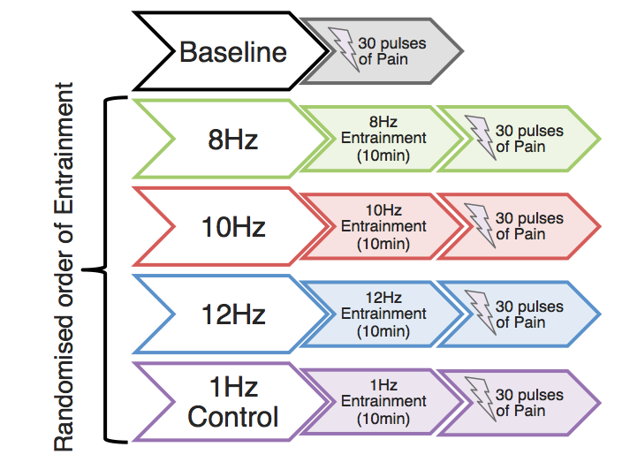
Figure 1 Experimental Procedure. After obtaining written consent, all study participants were subjected to 30 fixed-intensity pulses of their predetermined ‘level 7 pain (baseline ratings). Participants were then presented with four visual (flashing LED goggle) stimulation blocks at 8Hz, 10Hz, 12Hz and 1Hz (control), of 10-minute duration, in a randomised order. Following each visual stimulation session, participants were asked to again rate the 30 pulses of pain, fixed at the intensity previously rated as ‘level 7’.

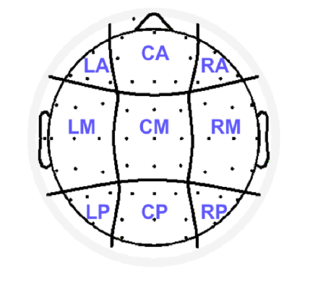
Figure 2. Map of Scalp Electrode Regions. Schematic representation of the division of electrodes into the 9 scalp regions: Left Anterior (AF7, F9, F7, F5, F3) Central Anterior (Fp1, Fpz, Fp2, AF3, AFz, AF4, F1, Fz, F2), Right Anterior (AF8, F4, F6, F8, F10), Left Medial (FT7, FC5, FC3, T7, C5, C3, TP7, CP5, CP3), Central Medial (FC1, FCz, FC2, C1, Cz, C2, CP1, CPz, CP2), Right Medial (FC3, FC6, FT10, C4, C6, T8, CP4, CP6, TP8), Left Posterior (P7, P5, P3, PO7), Central Posterior (P1, Pz, P2, PO3, POz, PO4, O1, Oz, O2) and Right Posterior (P4, P6, P8, PO8)

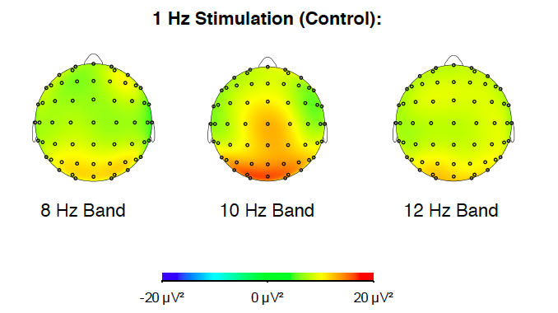
Figure 3a. Alpha Band Topographies. Topographies of alpha bands 8Hz (+/- 1Hz), 10Hz (+/- 1Hz) and 12Hz (+/- 1Hz) following 10-minutes of the visual control (1Hz) stimulation.

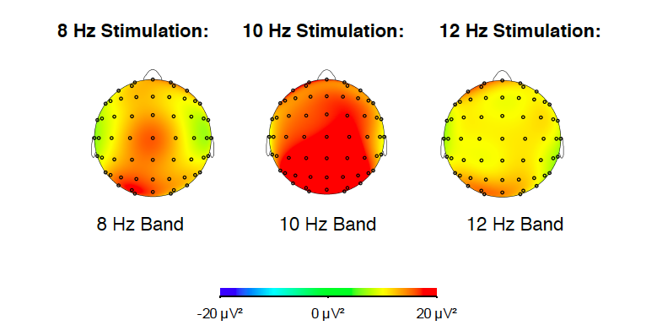
Figure 3b. Alpha Band Topographies. Topographies of alpha bands 8Hz (+/- 1Hz), 10Hz (+/- 1Hz), 12Hz (+/- 1Hz) following 10-minutes of visual alpha stimulation in their respective frequencies: 8Hz, 10Hz and 12Hz.

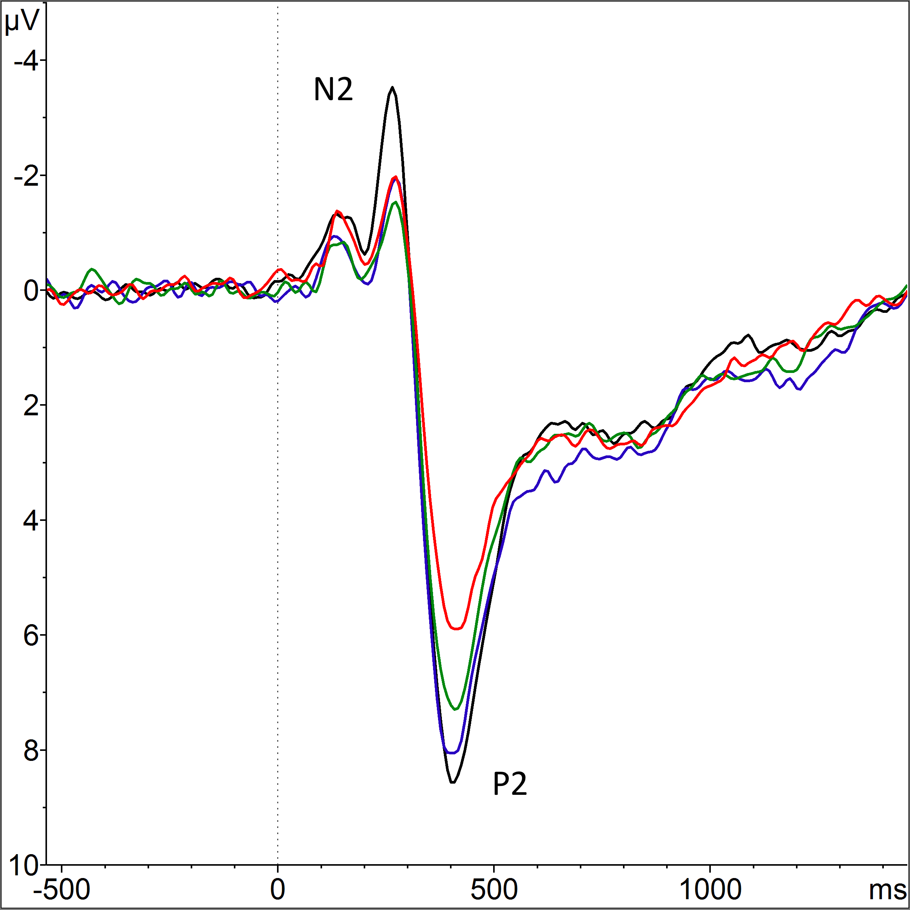
Figure 4. Laser-Evoked Potentials over Middle Central Electrodes. Graph shows the average LEP amplitude across all subjects. Nine electrodes (FC1, FCz, FC2, C1, Cz, C2, CP1, CPz, CP2) were pooled around the central Cz to produce an average N2-P2 complex. The LEP following the control stimulation is depicted in black, the LEP in the 8Hz condition is represented in green, the 10Hz condition in red and the 12Hz condition in blue. Only the P2 peak in the 10Hz condition (red) showed a significant reduction from control (p<0.001)

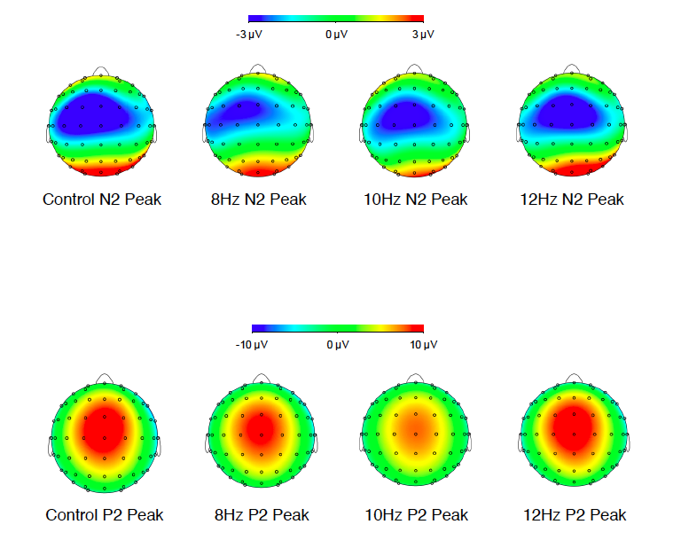
Figure 5. N2 and P2 Peak Topographies. Topographies of the negative N2 (top) and positive P2 (bottom) peaks following visual stimulation at 1Hz (Control), 8Hz, 10Hz and 12Hz. Following the 10Hz entrainment only, the P2 peak reduced significantly from control (p<0.001)

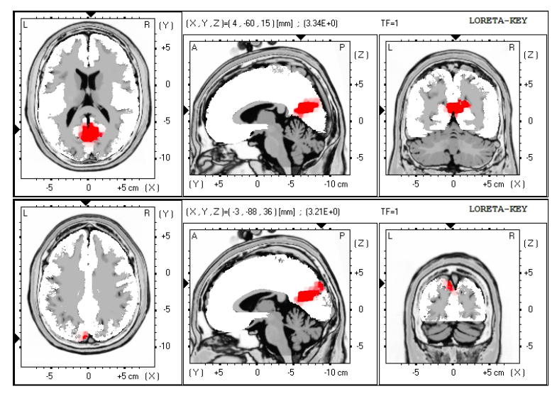
Figure 6. LORETA Alpha Power Results. Source localisation computed with LORETA displaying the measured difference in alpha power, when contrasting the control and 10 Hz condition. Areas with significantly greater alpha power in the 10Hz condition, when compared to activity in the control condition, are marked in red (p<0.05). In each row, three brain views are shown; Left view: axial, seen from above, face up; center view: saggital, seen from the left; right view: coronal, seen from the rear. Each view is sliced through the region displaying the maximum difference in activity, which is given in [X,Y,Z] Talairach coordinates, and graphically indicated by black triangles on the coordinate axes. The two regions displaying the biggest change in alpha power between the control and 10 Hz condition are Brodmann areas 23 (Posterior Cingulate [X= 4, Y= -60, Z= 15]; top row) and 19 (Precuneus [X= -3, Y= -88, Z= 36]; bottom row). Talairach coordinates: X from left (L) to right (R); Y from posterior (P) to anterior (A); Z from inferior to superior.

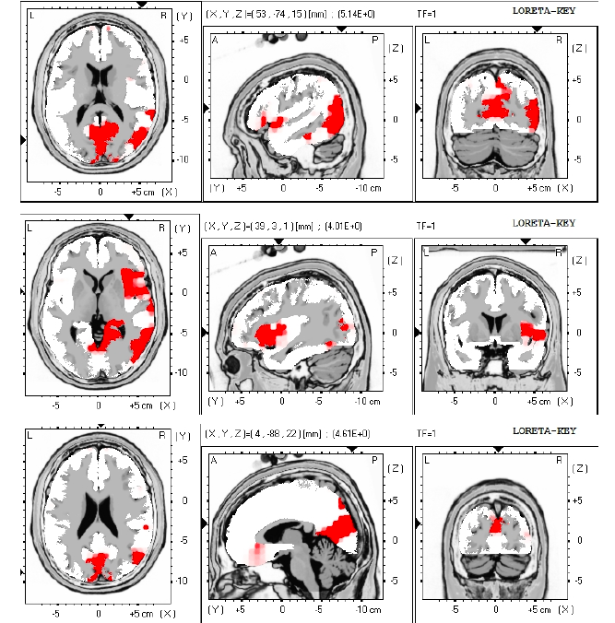
Figure 7. LORETA P2 Results. The image displays three (of eleven) selected sources neural activity, estimated using LORETA, contributing to the measured significant difference in P2 amplitude between the control and 10 Hz condition. LORETA identified 11 Brodmann areas (in the occipital, temporal, posterior cingulate and parietal cortices) with significantly greater P2 peak activity in the more painful control condition when compared to the 10Hz condition. A selection of three of these Brodmann areas is displayed here, with significant differences between the conditions marked in red (p<0.05), and maximum differences in activity given in [X,Y,Z] Talairach coordinates (graphically indicated by black triangles on the coordinate axes). Talairach coordinates: X from left (L) to right (R); Y from posterior (P) to anterior (A); Z from inferior to superior. The top row of images displays the maximum difference in Brodmann area 39 (Middle Temporal Gyrus [X= 53, Y= -74, Z= 15]), the middle row in Brodmann area 13 (Insula [X= 39, Y= 3, Z= 1]), and the bottom row in Brodmann area 18 (Cuneus [X= 4, Y= -88, Z= 22]). In each row, three brain views are shown; Left view: axial, seen from above, face up; center view: sagittal, seen from the left; right view: coronal, seen from the rear. The remaining eight Brodmann areas (and Talairach coordinates of maximum differences in activity) can be found in Table 2.

Table 1 LORETA Alpha Power Results
Brodmann Area | Coordinates (X,Y,Z) | Area
Brodmann area 23 | X= 4 , Y= -60 , Z= 15 | Posterior Cingulate, Limbic Lobe
Brodmann area 19 | X= -3 , Y= -88 , Z= 36 | Precuneus, Parietal Lobe

Table 1 LORETA Alpha Power Results. Sources showing cortical differences in alpha power activity when comparing the 10Hz entrainment and the 1Hz control condition, quoted in Talairach coordinates. For all results, t(p<0.05) = 3.08 for single voxels. Negative X coordinates signify left hemisphere activation.

Table 2 LORETA P2 Results
Brodmann Area | Coordinates | Area
39 | X= 53 , Y= -74 , Z= 15 | Middle Temporal Gyrus, Temporal Lobe
30 | X= 25 , Y= -67 , Z= 8 | Posterior Cingulate, Limbic Lobe
18 | X= 4 , Y= -88 , Z= 22 | Cuneus, Occipital Lobe
31 | X= 4 , Y= -74 , Z= 22 | Precuneus, Parietal Lobe
20 | X= 53 , Y= -32 , Z= -20 | Fusiform Gyrus, Temporal Lobe
22 | X= 67 , Y= -46 , Z= 8 | Superior Temporal Gyrus, Temporal Lobe
37 | X= 60 , Y= -60 , Z= -6 | Middle Temporal Gyrus, Temporal Lobe
13 | X= 39 , Y= 3 , Z= 1 | Insula
13 | X= 32 , Y= 24 , Z= 1 | Insula
22 | X= 53 , Y= 10 , Z= -6 | Superior Temporal Gyrus, Temporal Lobe
22 | X= 67 , Y= -18 , Z= 1 | Superior Temporal Gyrus
7 | X= -31 , Y= -60 , Z= 43 | Inferior Parietal Lobule, Parietal Lobe
7 | X= 4 , Y= -74 , Z= 50 | Precuneus, Parietal Lobe
7 | X= 18 , Y= -67 , Z= 29 | Precuneus, Parietal Lobe
37 | X= -45 , Y= -46 , Z= -27 | Inferior Temporal Gyrus, Temporal Lobe
37 | X= -52 , Y= -46 , Z= -27 | Fusiform Gyrus, Temporal Lobe

Table 2 LORETA P2 Results. Regions displaying cortical differences in P2 peak source activity when comparing the 10Hz entrainment and the 1Hz control conditions, quoted in Talairach coordinates. For all results, t(p<0.05) = 3.54 for single voxels. Negative X coordinates signify left hemisphere activation.

