Abstract: Weight stigma results from the mediatisation of ‘obesity’; conceptually, a medicalised problem resulting from personal bodily irresponsibility. We undertake a frame analysis of 1452 comments on a thematically-related online news article published via The Guardian, about the status of ‘obesity’ as a disability in EU employment law. We identify three themes: weight as a lifestyle choice or disability; weight as an irresponsible choice, and weight as a simple or complex issue. We contend that the design of the commenting platform prevents counter-narratives from challenging the dominant (‘obesity’) framing for three reasons: content is driven by comments appearing earlier in the corpus; the commenting system primarily supports argument between polarised rhetorical positions, and the platform design discourages users from developing alternative terminologies for producing counter-narratives. In this way, we explore how weight stigma is propagated through online media, and how users’ comments intersect with the affordances of the platform itself.
Keywords: weight stigma; obesity; fatness; online news commentary; socio-political discourse.

Doing Stigma: Online Commenting Around Weight-Related News Media
Phillip Brooker, Julie Barnett, John Vines, Shaun Lawson, Tom Feltwell and Kiel Long
Online news articles and their associated commentaries are public spaces where conflicting socio-political ideas meet (Glenn, Champion and Spence, 2012; Holton, Lee and Coleman, 2014; Hughey and Daniels, 2013; Koteyko, Jaspal and Nehrlich, 2013; Stroud, Muddiman and Scacco, forthcoming; Weber, 2014). Topics include the public health issue of ‘obesity’, increasingly understood by academics as a by-product of a media-facilitated neoliberal discourse which negatively impacts health and well-being (Brewis, 2014; Heuer, McClure and Puhl, 2011; Rich, 2011; Saguy, 2013; Sikorski et al, 2015; So et al, 2015; Tomiyama, 2014). Reflecting a growing interest in how digitally-mediated communication intersects with potentially stigmatising healthcare issues (eg Duguay, 2016; Didziokaite et al, forthcoming; Ems and Gonzales, 2016; Haas et al, 2011; Power et al, 2013; Salter, 2016; Tucker and Goodings, forthcoming) we demonstrate how weight stigma features in the comments section of an online news article, and how commenters’ rhetorical practices are intertwined and shaped by the technical infrastructure and affordances of the commenting system. Using frame analysis, we examine 1452 comments on an article in The Guardian reporting a European Union employment law ruling that may establish a precedent for defining obesity as a disability. We characterise the competing framings evident in the comments, observing how, despite the existence of critical counter-frames, the platform reproduces the dominant neoliberal framing of fatness, and how weight might be otherwise constructed through these platforms.
LITERATURE REVIEW
To do this, we assemble several literatures relevant to how ‘obesity’ as a cultural issue is shaped by the media through which it is presented. Given the essentially iterative nature of qualitative digital social science (Brooker, Barnett & Cribbin, 2016), the following review traces as linear a path as possible through disparate-though-pertinent literatures, and situates our study at the end-point of that path. We first discuss weight as a framed phenomenon, outlining the culturally-dominant notion of weight as a medicalised issue of public concern which may, in principle, be constructed differently. These issues are more deeply explored in regard to the neo-liberal politics of health and weight, which describe how weight features in contemporary society more generally. Then, considering social studies of weight stigma, we acknowledge a body of work that critically reacts to the dominant obesity discourse, showing how this discourse itself carries negative health effects. Finally, we explore how these political and social issues surrounding weight are made visible specifically through digital news media and online commenting, as a significant contemporary medium.
Our preference for the term ‘fatness’, and our scepticism of the term ‘obese’ as a useful descriptor of individuals, reflects our alignment with critical research on weight stigma (eg Heuer, McClure and Puhl, 2011; Major et al, 2014; Saguy, Frederick and Gruys, 2014; Sikorski et al, 2015; Thibodeau, Perko and Flusberg, 2015). Such research moves to recast ostensibly negative terms like ‘fatness’ as more neutral descriptors of bodily properties, in response to the politicisation of weight as ‘obesity’ and the stigma generated therein. Such work also acknowledges that the use of 'obesity' as a descriptor is contestable, reacting to its commonplace usage as an objective category (i.e. the widespread characterisation of 'obesity' as a mathematical formula of Bodily Mass Index; weight in kilograms divided by the square of height in metres). Further detail is given below on how 'obesity' as a term can (and should) be contested, and our scepticism around its deployment as a fixed objective category is denoted by the scare quotes we place around it throughout.
Weight as a Framed Phenomenon
Much research is organised around the idea of weight as a mediatised phenomenon, wherein cultural ideas of weight are understood as being transmitted and shaped by media (eg Dickins et al, 2016; Heuer, McClure and Puhl, 2011; Rich, 2011; Saguy, 2013; Saguy, Frederick and Gruys, 2014; So et al, 2016; Warin, 2011). Saguy (2013) notes that news media operate via ‘frames’ (Goffman, 1986); contextual filters through which we organise cultural ideas around fatness. Such frames are mutable and discursive, rather than fixed and objective. This understanding stands in opposition to prevailing cultural opinions of obesity, which adopt a singularly medical framing of ‘obesity’ as a public health concern:
‘A medical frame implies that fat bodies are pathological. It has become so pervasive and taken-for-granted...that most people do not even realize that it is a frame and that there are alternative ways of understanding fatness as, for instance, beautiful, sexy, healthy, or a positive form of human diversity.’ (Saguy, 2013: 5)
This medical framing of obesity carries ideas about what the ‘problem’ is (ie weight that exceeds a certain BMI value), what it might result in (ie increased risk of illnesses such as diabetes), and ‘who or what is to blame and what, if anything, should be done’ (Saguy, 2013: 68). Hence, ‘obesity’ is a now-normalised and stigmatised framing which depicts fatness as a societal problem to be treated with medical interventions or making fat people ‘more responsible’ for their bodies. As Aphramor and Gingras claim, ‘There is no such thing as obesity’ (2011: 192); the medicalisation of obesity is just one (particularly pervasive) way of framing the discourse – the reasons as to why it pervades are explored in our later section on the neoliberal politics of weight. Whilst alternative frames co-exist alongside the medicalised frame of obesity, these researchers explore the reasons why one frame dominates and the implications of its doing so.
The Neo-Liberal Politics of Health and Weight
To deepen our understanding of how the medicalisation of obesity emerges as the dominant framing discourse around weight, we explore other bodies of research which cast obesity as an extension of contemporary neoliberal culture (eg: Berlant, 2010; Farrell et al, 2016; Guthman, 2009; Halse, 2009; LeBesco, 2010, 2011; Warin, 2011). Such researchers note it is not just thinness that serves as a signifier of compliance with neoliberal values; these values are also demonstrated through the acceptance and enactment of the stigmatisation (of ourselves and of others) by the bodily property of weight. Hence, for countries affluent enough to be concerned with an ‘obesity epidemic’, a neoliberal political climate affects how weight is understood culturally. This suggests explanations for why a medicalised obesity frame proves so compelling:
‘“health” is a term replete with value judgments, hierarchies, and blind assumptions that speak as much about power and privilege as they do about well-being. Health is a desired state but it is also a prescribed state and an ideological position. We realize this dichotomy…when we encounter someone whose body size we deem excessive and reflexively say, “obesity is bad for your health,” when what we mean is not that this person might have some medical problem, but that they are lazy or weak of will’ (Metzl, 2010: 1-2)
Since fatness serves as a visible marker of morality, the dominant obesity frame legitimises surveillance and stigmatisation of ourselves and others. Jutel notes this ‘is a marketer’s ploy made in heaven. Here we have a self-diagnosable condition that engenders a population-wide preoccupation with self-surveillance, treatment, prevention and cure’ (2009: 74) – moreover, self-surveillance, as we shall see, influences how individuals fat or thin respond to ‘obesity’ as an issue. As Metzl (2010) notes, a preoccupation with surveillance ensures that affirming one’s own morality also involves stigmatising transgressors; we build notions of ourselves by positing our own health (and its associations of responsibility, morality, deservingness, etc) as superior to that of others (cf Goffman, 1990).
Social Studies of Weight Stigma
Given the pervasiveness of ‘obesity’ as a frame, researchers have explored the negative consequences of weight stigma and considered how to instigate different discourses around weight. Campos (2011) argues that medical-statistical data are often used to justify four interlocking assumptions of the obesity debate:
‘(1) A strong correlation exists between weight and health risk. (2) This correlation reflects a direct causal relationship. People within the narrow range of ‘ideal’ weight are healthier than people who are not... (3) Significant long-term weight loss is a practical goal, and will improve health. (4) The cost-benefit ratio involved in trying to make people thinner justifies using scarce public health funding to pursue this outcome’ (Campos, 2011: 36).
However, Campos (2011) holds that these assumptions fall short of being singularly-interpretable as objective facts and different - more positive and less stigmatising - interpretations can result from the same data. Building on such work, Aphramor and Gingras evidence a counter-claim that amongst countries who claim to be in the midst of an ‘obesity epidemic’ (eg the US, Canada, the UK), ‘fatness and/or heavy bodyweight (taken as indicating overweight or obesity) do/does not...reliably indicate a person’s metabolic risk, except at extremes of the weight spectrum’ (2011: 192). Indeed, Flegal et al (2005) suggest that the same figures that are used to vilify fatness also indicate that the longest lives are lived by those in the ‘overweight’ BMI category.
These studies exemplify a research movement organised around ‘fighting back’ in the ‘war on fat’ (eg Heuer, McClure and Puhl, 2011; Major et al, 2014; Saguy, Frederick and Gruys, 2014; Sikorski et al, 2015; Thibodeau, Perko and Flusberg, 2015), providing alternative discourses suggesting that the medicalisation of fatness itself has significant negative health implications. Activists such as Regan Chastain argue that the dominant obesity frame is premised on forcibly removing obese people from society by transforming them into thin people via medical intervention, or shaming them into diet and exercise regimes regardless of the physical or mental health implications of doing so (see https://danceswithfat.wordpress.com/2013/06/20/the-war-on-obesity-is-a-war-on-fat-people/, last accessed: 29 November 2016). As Tomiyama suggests, weight stigma – a by-product of waging war on fatness – reinforces a feedback loop ‘wherein weight stigma begets weight gain through increased eating and other behavioral mechanisms’ (2014: 8). Additionally, stigma generated through the dominant obesity frame has a negative impact on health and longevity via increasing feelings of social isolation in obese individuals. Cooper further notes, ‘The dominant discourse provides a basis for inappropriate [medical] interventions that can deplete our quality of life and embolden stakeholders to prescribe more problematic treatments’ (2011: 167). The ineffectiveness of prescribed treatments and frustrations arising from attempting to implement impossible treatments can be as detrimental to health as the condition they are intended to treat (Rich and Evans, 2005). This leaves fat individuals to find some means of coping socially in a ‘culture of thinness’ (Rich and Evans, 2005: 347) to avoid more tangible negative health outcomes than are caused by the health conditions often associated with ‘obesity’.
Digital News Media and Online Commenting
The essentially discursive nature of ‘obesity’ has ensured that digital news media have become particularly relevant as arenas where neoliberal surveillance and stigma play out, and accordingly, where alternative commentaries might intervene in these processes. Such systems facilitate users’ contributions to a digital ‘public sphere’ (Habermas, 1991; Pappachrissi, 2002; Shurki, 2011; Weber, 2014) of socio-political discussion around cultural issues such as fatness (So et al, 2016). Evidence suggests that commenting spaces contain stigmatising discourse independent of the material covered in news articles. Glenn, Champion and Spence (2012) identify discrepancies in frames between content produced by journalists and commenters. Across 19 articles presenting (supposedly) positive research-oriented depictions of bariatric surgeries, commenters primarily ‘held a negative, unsupportive and even aggressive or discriminatory tone towards obese/overweight individuals…[they] appeared to have their own agenda that was divergent from that of the news media source to which they were responding’ (Glenn, Champion and Spence, 2012: 128). Moreover, though journalists may be responding to increasing calls from public health officials to depict fatness with greater emphasis on social (rather than personal) causes and treatments, this is not reflected in readers’ comments (Holton, Lee and Coleman, 2014).
Though the above studies observe commenting-in-action, they attend to the linguistic content of comments only. It is, however, important to consider the role of the system in affording particular communicative/rhetorical practices through which linguistic content is expressed (Koteyko, Jaspal and Nerlich, 2013). Stroud, Muddiman and Scacco (forthcoming) demonstrate the possibilities of alternative system designs in driving different political opinions, noting that users engage differently with information if presented with differently-labelled buttons for expressing support (eg through distinguishing the different affordances of ‘like’, ‘recommend’ or ‘respect’ buttons). Following this, our study explores connections between linguistic content and computer-mediated form by tracing how the dominant obesity discourse emerges through the comment corpus.
METHOD
The Guardian Comments Platform
This study engages with an online news article and its’ associated commentary, working towards a discussion of how the rhetorical content and practices captured in the comments are shaped by the technical infrastructure of the commenting system itself. The research process we apply in this study aligns with Brooker, Barnett and Cribbin’s (2016) notion of the digital research process as essentially exploratory and iterative. In this sense, the points we raise in our methods, findings and discussion sections do not fall neatly into those categories, but rather overlap and call-back to one another in various ways. Hence, the paper is structured from here on in such a way as to first deal with the practicalities of the study (including outlining the news article and comment corpus in question as well as the tools with which we investigate them) and our usage of frame analysis as a way to orient to those materials and the commenters who produce them. This is followed by a presentation of findings concerning the semantic/thematic content of the comments in our corpus, and a discussion of the ways in which that content intersects with the technical affordances of the commenting system.
The article, titled ‘Obesity Can Be a Disability, EU Court Rules’, was published in The Guardian (a leading UK newspaper) on 18 December 2014 (http://www.theguardian.com/society/2014/dec/18/obesity-can-be-disability-eu-court-rules, last accessed: 28 November 2016). The article covers a legal case involving a Danish childminder – Karlsten Karltoft – who was made redundant because his fatness was deemed as having a negative impact on his capacity to work. To appeal the decision, Karltoft opened the case in the European Court of Justice, who ruled that Karltoft's weight falls within the definition of a disability in employment law. As such, Karltoft was able to claim compensation for unfair dismissal. The article leverages the court case to discuss the precedent it sets across the European Union (EU) for employers, and also captures multiple related topics of potential interest to the newspaper’s readership, including the rationality of EU bureaucracy, the morality of fatness, and ‘obesity’ as a drain on social welfare funding. Within the article, numerous ‘obesity tropes’ are evident – for instance, the ‘headless fat man’ picture beneath the headline, the use of a person’s weight as an identifying detail, and a commitment to a clinical definition of fatness as ‘obesity’. As such, the article itself accords with what Saguy (2013) notes are typical stigmatising media framings and cultural conventions around fatness (i.e. as a medicalised issue pertaining to personal responsibility, and a physical and moral deviation from a thin norm). However, rather than article itself we concentrate on the comment corpus generated by users in response to this article, as the comparatively underexplored counterpart to the ‘top-down’ analysis of institutional media publications (eg Dickins et al, 2016; Heuer, McClure and Puhl, 2011; Rich, 2011; Saguy, 2013; Saguy, Frederick and Gruys, 2014; So et al, 2016; Warin, 2011). Though Dickins (2013) undertakes a similar investigatory approach to an online user-generated comment corpus, our interest is motivated around both the thematic content of comments and their relationship with the original article as well as the ways in which that thematic content is driven and shaped by the affordances of the medium within which it is generated (i.e. The Guardian’s comment platform). The commentary following the article comprises 1452 comments posted by 611 unique users over a period from 11:38 on 18 December 2014 to 13:07 on 19 December 2014 (at which point commenting was closed by The Guardian).
Our research site reflects a wider interest in online media as part of an increasingly mediatised cultural world (eg Coleman, Thorson and Wilkins, 2011; Dickins et al, 2016; Glenn, Champion and Spence, 2012; Heuer, McClure and Puhl, 2011; Holton, Lee and Coleman, 2014; Hughey and Daniels, 2013; Koteyko, Jaspal and Nerlich, 2013; McCluskey and Hmielowski, 2011; Rich, 2011; Schwitzer et al, 2005; So et al, 2016; Weber, 2014). Articles published on news websites are often complemented with a comment space where readers are encouraged to express opinions on an article. The infrastructure of The Guardian's news website features functionalities to facilitate commentary. These include the capacity for commenters to leave original comments, as well as three other interactions. First, users could ‘reply’ to other users’ comments in ‘threads’ – this is complemented by a function for quoting other users’ comments. Second, users could ‘upvote’ comments they agree with or like, enabling an associated functionality for reorganising comments according to their popularity (see Gilbert, 2013). Third, users could ‘report’ content that they may have thought was inappropriate or offensive to The Guardian’s moderators for review and possible removal. Our dataset comprises the publically-available moderated comment corpus. Though this data does not indicate why a comment has been ‘moderated out’, comments which were removed remain part of the dataset: some salient metadata surrounding the comments (ie usernames of posters, usernames of who the comment is addressed to, the date and time of posting, and its sequential position within the corpus) is retained but the content of the comment is replaced with stock text (‘This comment was removed by a moderator because it didn't abide by our community standards. Replies may also be deleted. For more detail see our FAQs.’). Our research aims to identify the ways in which user discourses connect to the affordances of the commenting platform in discussions around weight stigma.
Research Approach
We took a qualitative frame-analytic approach to analysing the comment corpus, drawing on computational techniques for handling text data from digital sources. Our dataset comprises 1452 comments on the news article taken from the Guardian's public webpage. These data were scraped via the ‘Beautiful Soup’ Python library (https://www.crummy.com/software/BeautifulSoup/, last accessed: 28 November 2016), capturing various data fields per comment – comment ID number; parent ID number (if the comment was posted in reply to an earlier comment); author ID number identifying unique comment posters; timestamp detailing the time and date the comment was posted; number of times individual comments were upvoted, and; comment text. Using just the textual data of (un-moderated) comments, we ran the corpus through Textometrica (see http://textometrica.humlab.umu.se/, last accessed: 28 November 2016, and Lindgren and Palm (2011)); a tool for exploring co-occurrences of words in short text entries. We built a Textometrica model of the corpus, retaining all words between 1 and 25 characters in length and removing common words uninteresting to the analysis, eg ‘and’, ‘the’, and so on (see the aforementioned Textometrica website for the full ‘stop words’ list). Textometrica determined 104 ‘key’ word collocations (ie collocations occurring with a high frequency relative to other collocations in the dataset). From this list we selected all words for inclusion in the visual model, excepting the highest frequency term ‘people’ which featured in 405 comments – this term was deemed too general to be of analytic importance. With the remaining words, we built a model based on normalised co-occurrence values between words, ie, how relatively frequent the remaining 103 selected terms occurred with one another in individual comments. Selecting the strongest links by normalised co-occurrence resulted in 86 keyword pairs on which to build the visualisation shown in Figure 1, again retaining Textometrica's suggested default parameters for selecting co-occurrences for inclusion (ie those with frequencies between 3 and 76). Textometrica thus facilitated our understanding of key topics expressed by commenters, showing the volume of talk around groups of connected keywords and allowing us to filter our reading of the original dataset around those words. The resulting visualisation provided a broadest possible overview of the data, allowing us to explore the salient topics of talk throughout the entire dataset and use them as a springboard to conduct a deeper qualitative analysis of the original dataset from a frame analytic perspective. This approach also allowed us to connect the linguistic content of comments to other associated metadata (chiefly, relative position within the threads of the comment corpus, and upvotes received by individual comments) to develop insights.
Frame analysis has proliferated throughout various disciplines engaging with politics and media, though its diversity serves to provide no clear replicable guidelines (Hertog and McLeod, 2001). Goffman's (1974) original work emphasises the ways in which people make sense of their life experiences through categorising, organising and interpreting them, furnishing experiences with meaning derived from their placement within wider cultural ideas (ie ‘frames’). Hence, when analysing media documents, frame analysis is attuned to exploring the biases and ideologies that inform how those documents contribute to the production and/or reinforcement of frames. To elicit such insights from a data corpus, it is critical to question what emphases might be present in the data, how specific information helps construct accounts, and what information is excluded from those accounts. Such an exploration operates by searching for indicators of the presence and content of frames, which can include: repeated patterns, common metaphors, catchphrases, stereotypes, presentations of parties as good or bad, the type and tone of language used, and how different points of view are handled in accounts (Hertog and McLeod, 2001).
Our usage of Textometrica was as an automated means of grouping data in relation to the terms and phrases Guardian commenters used frequently; in effect using commonly-co-occurring terms as the scaffolding for an interpretive frame analysis. The co-occurrences gave us insight into the dominant frames for commenting about weight across the data corpus, with the resultant visualisation (Figure 1) mapping connections between terms. Though the Textometrica models and the resulting visualisation could have been constructed differently (i.e. by thematically grouping the data according to categories of interest), we have chosen to construct the model on the basis of word-co-occurrences rather than fit words to pre-specified categories. This was done for two reasons: firstly, to maintain an inductive approach to the data and remain sensitive to how commenters deployed these terms in their discourse (as opposed to starting with conceptual categories established before an exploration of the data), and secondly, to accord with a 'visual analytic' approach to the data and visualisations whereby they are treated not as end-results in themselves but as 'jumping-off points' from which a deep qualitative analysis can emerge (Brooker, Barnett & Cribbin, 2016). With this usage of the visualisation in mind, the 86 most significant connections between terms were explored through qualitative readings of original comments. For example, though Saguy (2013) notes a range of frames for discussing weight, within this dataset the word ‘responsibility’ shows a strong association with the word ‘personal’ rather than other terms (eg ‘social’ or ‘corporate’). Insights such as this draw us to closer qualitative readings of comments where the terms ‘personal’ and ‘responsibility’ feature together.
Figure 1: Full co-occurrence map showing strongest connections between keywords.
RESULTS
Overview of the data
Based on our exploration of the co-occurrence map we identified three interrelated themes. Each of these themes are advanced and subsequently drawn on to demonstrate, in the discussion section that follows, how the content of comments and the medium of the commentary platform intersect (i.e. how content is driven by the technical infrastructure of the commentary platform). Firstly, commenters took up a discussion of a theme of the original newspaper article pertaining to the contested status of weight as a ‘lifestyle choice’ or ‘illness/disability’. The contestation around weight as ‘lifestyle choice’ or ‘illness/disability’ is the single most discussed topic in the data (cf. Hughey and Daniels, 2013). This separation between topics is shown in Figure 2 below, where the visual model demarcates each topic as being supported by different sets of words surrounding the key identifying terms (ie ‘lifestyle’/’choices’/’choice’ and ‘obesity’/ ‘obese’/’disability’).
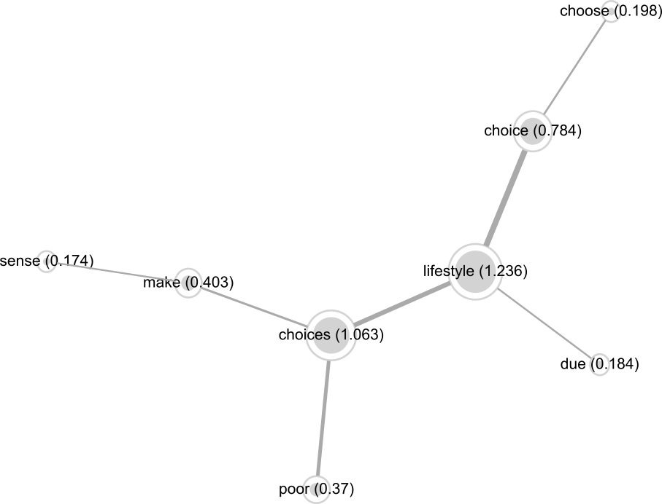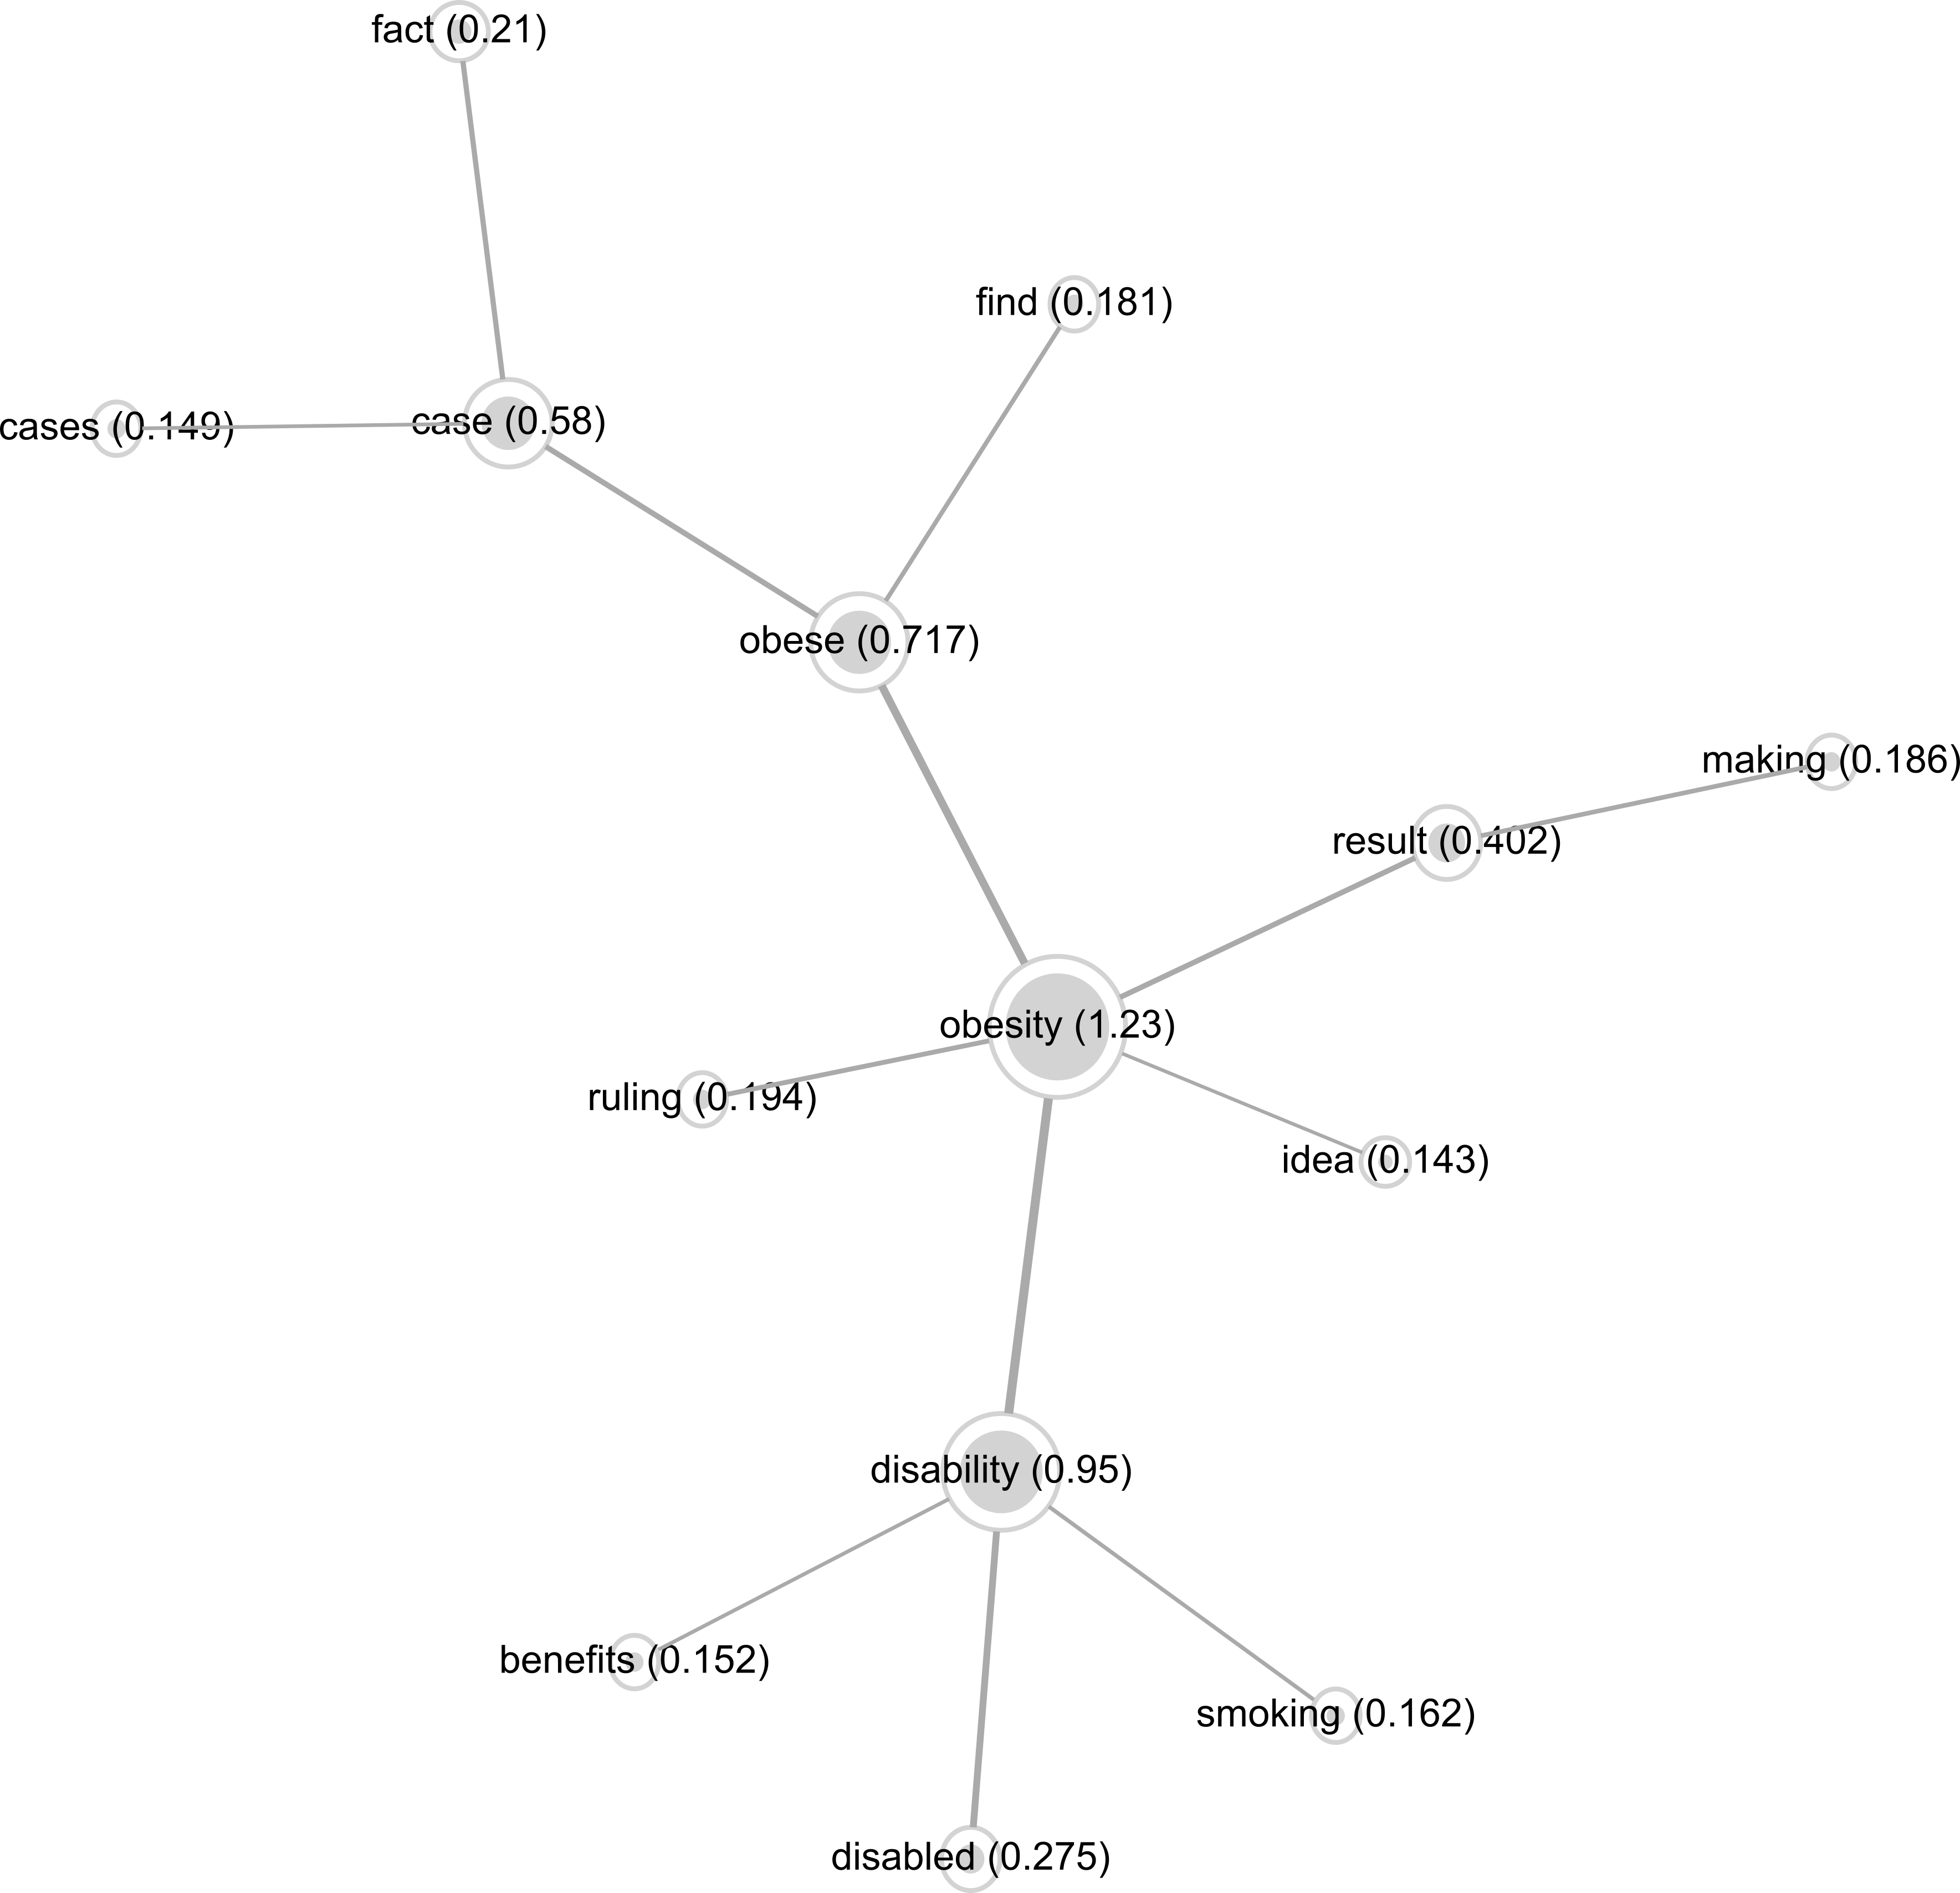
Figure 2: Co-occurrence maps for two distinct topics; ‘lifestyle’/’choices’/’choice’ (top) and ‘obesity’/ ‘obese’/’disability’ (bottom).
Secondly, commenters discussed the idea of fatness as a deficiency of self-discipline and an irresponsible choice. This is demonstrated in Figure 3 by the strength of connection between two key terms; ‘personal’/’responsibility’.
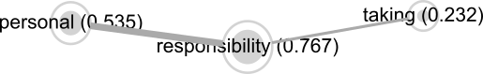
Figure 3: Co-occurrence map showing the connection between two key terms; ‘personal’/’responsibility’.
Thirdly, comments were distinguishable by their portraying of weight as a simple or complex issue. This theme concentrates on the diversity of ways in which people discuss general relevant terms (ie ‘weight’ and ‘food’/’eat’, demonstrated in Figure 4).
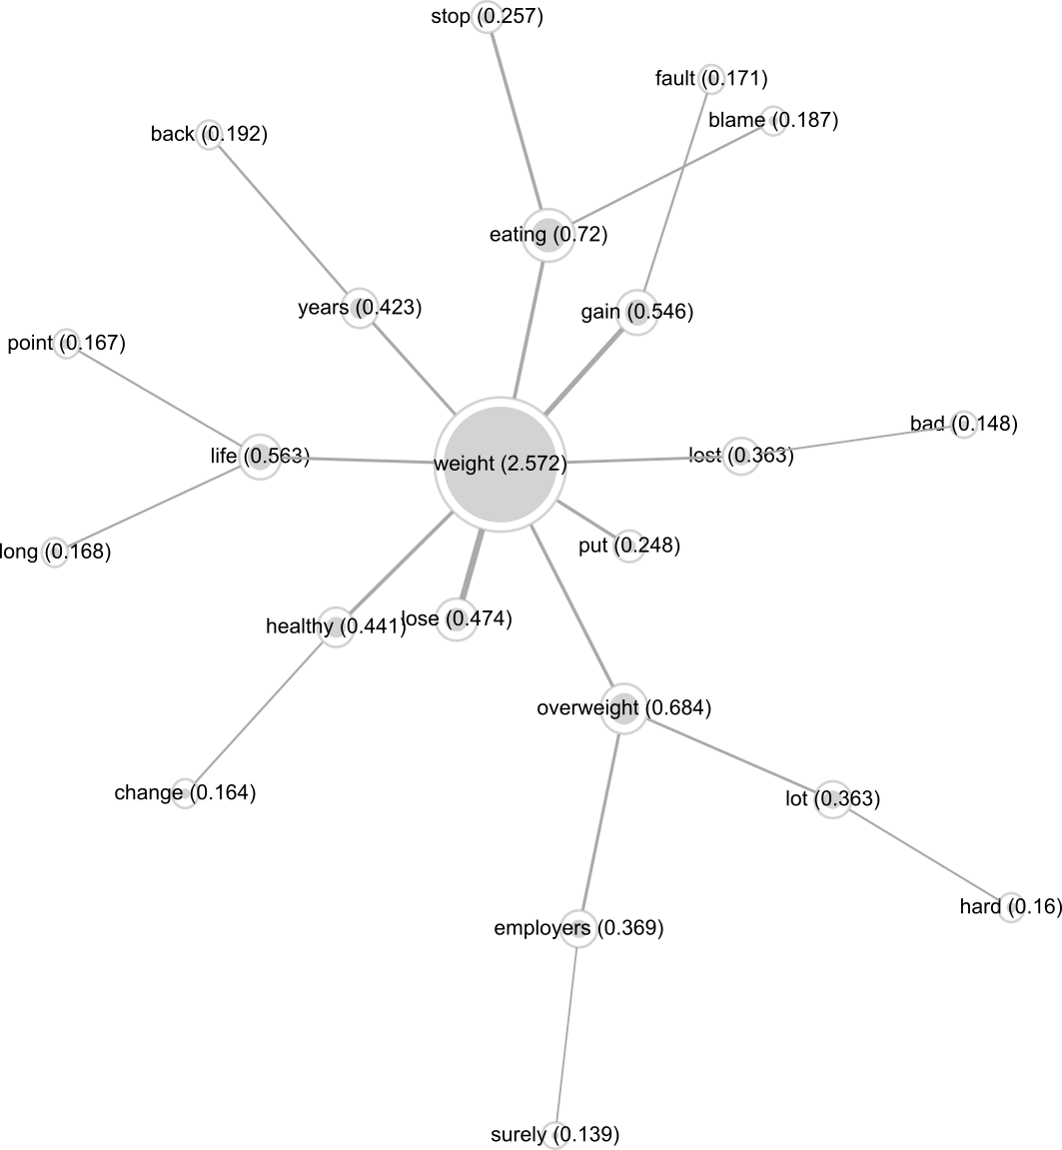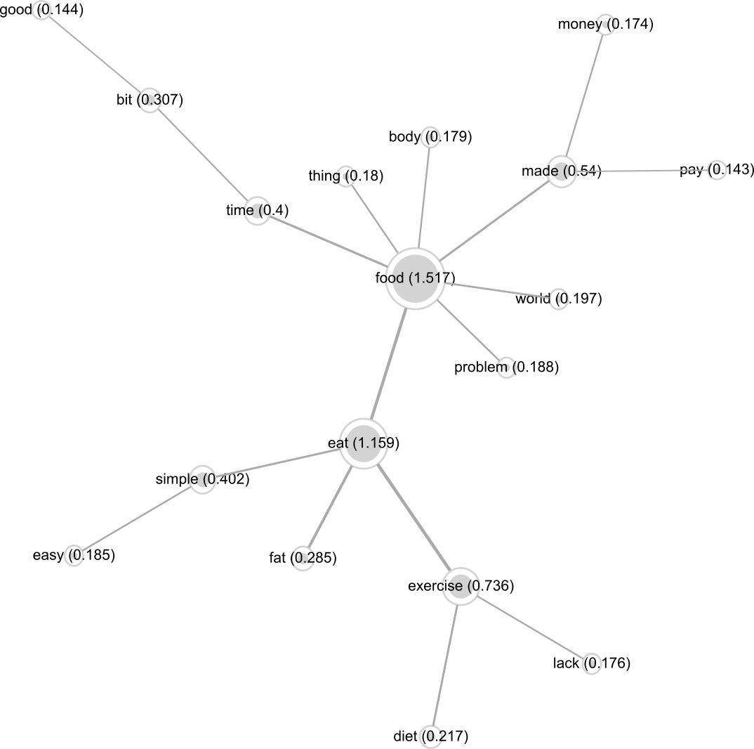
Figure 4: Co-occurrence maps for two distinct topics; ‘weight’ (top) and ‘food’/ ‘eat’ (bottom).

We drew on topics visible within the overall co-occurrence map (Figure 1) to identify sets of words (including, though not limited to, those depicted in Figures 2, 3 and 4) and consequently explore comments containing those words. We contextualised these analyses by connecting them to the affordances of The Guardian’s comment platform, chiefly around the placement of comments within threads (Figure 5 below).

Figure 5: Graph to show upvotes and replies associated with the first comments of each thread in the comment corpus. Data labels indicate timestamp of Thread Nos. 1, 100, 200, 300 and 400.
Figure 5 shows that users' engagements with the commenting system (and other commenters) were primarily concentrated around earlier threads. As such, in leveraging Textometrica to orient to the most frequently used collocations of words, our resultant analysis is attuned primarily towards the comments that are most immediately available on the article’s webpage (which by default displays the oldest comments first). The comment platform allowed users to reorganise how comments are presented to them – by oldest, newest or most recommended; with reply threads extended, collapsed or removed. However, comments concentrated in the earlier sections of the comment corpus receive by far the most replies and upvotes, and this creates a linkage between the content of users' comments and the affordances of the platform itself - though such a linkage is evidenced here, we unpick the implications in more detail in the discussion below.
Weight as Lifestyle Choice, Illness or Disability
Key to the discussion is a debate around the status of lifestyle choices as ‘self-inflicted’, and disabilities as conditions over which sufferers have less control. Commenters debated excessive weight and sporting injuries (or disabilities caused by sporting activities) in terms of whether they could result in disabilities in the same way. A key issue noted by commenters was the intentionality perceived behind either act:
‘They [those disabled by sports injury] didn't do it on purpose and they can't do anything about being disabled now. Whenever and whatever you decide to eat, that’s a choice.’ – EddieBurton; 6 Upvotes; Thread 1.¹
‘Er, you could say exactly the same for people who are made disabled in a road traffic accident; they “chose” to go outside that day. But that’s not a choice like over-eating to the extent that you damage your own health.’ – maria34; 6 Upvotes; Thread 1.
Comments such as these belie a conception of weight as a mutable property of bodies which requires only willpower to change, and demonstrates a personal responsibility framing of fatness (cf. also Dickins, 2013). Commenters portrayed weight as a binary issue – as either ‘lifestyle choice’ or ‘illness/disability’. Grey areas were explained in terms of special circumstances without upsetting the overall classification system. As one commenter notes:
‘My first thoughts were that of course it is a “lifestyle choice”, but thinking about it more deeply I think we’re on the same page. There comes a point where you have to admit that even if there’s no physical reason for a particular person to have an obese body, there may be underlying mental issues that are causing the obesity.’ – BrokenTeen; 7 Upvotes; Thread 1.
However, alongside working out the implications of self-infliction, commenters also disputed the idea of illness as a universal phenomenon or a social issue. Such comments were embedded in the personal responsibility frame in such a way as to suggest that ‘excessive’ weight could not be straightforwardly an illness, since illnesses are objective immutable phenomena:
‘we didn’t hear about people getting this “illness” fifty years ago...why is that??’ – calmmind; 56 Upvotes; Thread 1.
‘If it’s an illness at all, it’s one caused by consuming more calories than you’re burning. I wonder how many calories this Danish guy is having a day?’ – Sebastian Dawes; 12 Upvotes; Thread 1.
In these cases, illnesses are framed as a medicalised phenomenon that both have a standardised effect on human bodies (eg an effect which does not change across different generations), and can be countered with standardised metrics and techniques (eg reducing calorific intake and exercising more). However, other commenters explored the idea of illnesses as culturally affected phenomena intersecting with a wider range of issues:
‘If you’re poor or part of an ethnic minority, you’re going to be stressed and susceptible to mental health issues which might then lead to poorer lifestyle choices...some people have more choice than others due to the situations they live in.’ – Danny Barlow; 1 Upvote; Thread 11.
‘When you watch some of these documentaries you start to see that there's so much crap in our food and you recognise that a lot of people don’t have much control over their extreme eating habits...In my opinion, food manufacturers have to take most of the responsibility here.’ – Zeitgeist; 52 Upvotes; Thread 1.
These comments work to demonstrate the connectedness of illness with other factors such as social equality, historical shifts in food production and consumption, or medical conditions which may impact the capacity or motivation to diet and/or exercise. Though these comments portray an understanding of the complex intersecting factors which may conceivably affect weight gain, they nonetheless do not completely break with the personal responsibility framing of fatness. Such factors are considered to excuse and explain weight gain rather than question ‘obesity discourse’ more fundamentally. In this regard, these comments argue that the extent to which personal responsibility is an effective way to understand fatness may be variable, but in such a way that thinness (operating as an ‘unmarked category’ (Saguy, 2013: 36)) remains the norm against which reports of ‘obesity’ are to be evaluated.
Weight as an Irresponsible Choice
Commenters also explicitly discussed fatness as equating to irresponsible behaviour:
‘Any addict has a choice, whether it’s smoking, drugs, gambling, whatever. I’m not saying it’s easy to stop, but it’s possible. I’ve got addiction issues myself, but I just have to grit my teeth and fight it. So I just can’t get on board with obesity being called a disability – it’s a lifestyle choice that needs to be addressed rather than pandered to.’ – essexboots; 9 Upvotes; Thread 9.
‘If you choose to be greedy and not look after your health, you’re the only one you can blame... The whole idea of freedom relies on personal responsibility...I guess that’s why lots of people are scared of it!’ – FreebirdTeresa; 12 Upvotes; Thread 145.
However, other commenters considered a more complex relationship between personal responsibility and weight:
‘If being obese was about choice, then why do so many people choose it and why can’t they choose something else?’ – Danny Barlow; 10 Upvotes; Thread 15.
‘A degree of this is to do with individual responsibility for sure, but Westminster need to get more involved in giving out knowledge and assistance to a society that is getting increasingly out of control with medication to solve every problem and cramming crisps and sweets down their throats.’ – Marvin3487; 2 Upvotes; Thread 285.
Though the comments denote disagreement amongst commenters as to who is to blame, this framing of the issue of responsibility (personal or otherwise) for fatness precludes discussion around whether or not it is an issue for which someone needs to take responsibility at all. There is a complete absence of counter-narratives connecting with this theme in the data, where the idea of fatness as a choice might be portrayed more positively (for instance, as a celebration of free will or through justifying reasons as to why higher weights might in fact be healthier than thinness). Whilst comments grouped under this theme uniformly represent fatness as a choice, they also report it as a bad choice that fat people should resist and apologise for. Seemingly, portraying fatness uniformly as a matter of choice serves to normalise the extension of that idea into talk of bad or irresponsible choices. However, researchers who argue for the benefits of different discursive content around fatness (eg Brewis, 2014; Dickins, 2013; Heuer, McClure andPuhl, 2011; Rich, 2011; Saguy, 2013; Sikorski et al, 2015; So et al, 2015; Tomiyama, 2014) may argue the value of generating discussion around fatness without it being framed in terms of choice at all.
Weight as a Simple or Complex Issue
Throughout the dataset, comments were set against a background of competing ideas around whether or not weight was a simple or complex problem requiring a simple or complex solution. For instance, some commenters thought of fatness as having a directly causal relationship with failure to eat less and exercise more:
‘Here are some facts: obesity happens when you don’t exercise, when you drink too much booze, when you eat too much food... I’m fat, but I know why, and I don’t blame anybody else. None of this is difficult to understand.’ – ameliadupois; 5 Upvotes; Thread 1.
However, others reported different experiences and different understandings of weight loss, elaborating on the difficulties of losing weight alongside other lifestyle issues:
‘I’ve been up and down a number of times, my appetite gets worse the more weight I shed. And exercise doesn’t help. When my skinny friends talk about the “runner’s high” or whatever I can’t relate to it at all, even though I’ve put the hours in at the gym same as them. The only thing I notice is that the more I exercise, the more prone I get to viruses, while my health is supposed to be getting better!’ – Ginnalim; 18 Upvotes; Thread 1.
Here, fatness is portrayed by some as a simple issue that people make complex to absolve them of personal responsibility, and by others as a complex issue which is worsened by oversimplifications that make complex problems seem, wrongly, easily solved. Notably, both sides accept elements of the dominant obesity discourse. However, some commenters probed the possibility of a different understanding of fatness, highlighting weight as a bad measure of general health, and of human bodies demonstrating more difference than standardised medical treatments can provide for:
‘I don’t agree that everyone who is obese is greedy and idle. Might be true for some, but my Nan is in her 60s, she eats super healthy – small servings, 5 fruit and veg a day, watches her calories, etc. She is always out walking, swimming, and playing badminton... She’s got an enormous belly though, and she’s never been able to figure out why.’ – Roxy632; 3 Upvotes; Thread 302.
‘It seems like an easy option to enforce treatments on people to make them exercise more and eat healthy, especially if you can convince people that they have a societal obligation to do so. If the formula of “eat less, move more” was right, then this would work and everybody would be thin. But it’s not that easy.’ – JakeSnake; 0 Upvotes; Thread 380.
Comments such as these critically probe the underlying assumptions of the dominant obesity discourse. However, such comments are absent in the earlier threads of the dataset and accordingly are not readily available ‘upfront’ on the Guardian's comment pages, which may affect the extent to which they are upvoted, replied to or indeed even read at all.
DISCUSSION
Having explored the content comprising the comment corpus, we turn to reflect on the socio-technical role of the commenting system in driving the content of comments. As such, we work to deepen our depiction of these insights by reference to the communicative practices they embody, and how those practices (which primarily serve to stigmatise fat people) emerge through the affordances of The Guardian’s commenting system.
The importance of being first
When considering the linguistic aspects of the analysis alongside users' commenting practices as represented in Figure 5 above, it is clear that not only the content of comments that drives the practices of upvoting and replying, but also their proximity to ‘firstness’ and the design of The Guardian’s commentary system which defaults to this order when presenting comments to readers². As outlined above, these early comments were primarily stigmatising depictions of fat people in ways which accord with a dominant ‘obesity’ framing. However, rather than a model where users respond to perceived rhetorical value or usefulness, it may be that it is the topics that are commented on immediately upon publication of the article that influence the content of further comments. This interpretation may help explain the relative absence of narratives that counter the dominant obesity frame and provide an alternative and non-stigmatising take on the debate in early comment threads. This is corroborated by Gilbert (2013) who explores the social voting side Reddit, arguing that users are less motivated to explore and vote for/against new content than they are to read older content. This may not be because it has already been judged by others to be good and worthy of upvotes, but simply because it appears first. Hence, whilst it may be that the relative paucity of non-stigmatising counter-narratives is motivated by external cultural pressures that influence how people think about (and subsequently comment on) issues pertaining to fatness, our argument is that this is also in part driven by the systems through which those comments are organised online. In this corpus, the default comment system serves to give primacy to a stigmatising and already-dominant discourse and its primacy is afforded by the ways in which the system serves to intensify these early ideas, potentially at the expense of other more critical and non-stigmatising content.
Reducing issues to dichotomies
Within the data, comments were typically posited as representing one side of a two-sided argument; for example, ‘obesity is a disability’ vs. ‘obesity is a lifestyle choice’. Even where arguments were not so neatly bracketed into two distinct sides, discussions did not break out of this binary model. For instance, where commenters self-identify as fat and we might reasonably expect a more nuanced or more personal (and non-stigmatising) account of fatness, we are most often presented with an uncritical, stigmatising and overly-simplified version of fatness as a deficiency to be addressed with causally-related, and often medical, solutions. It is conceivable that even within a dominant obesity discourse there might be discussion around what kind of problem ‘obesity’ is, whether or not ‘obesity’ is a problem at all, or whether it in fact even exists. Yet those narratives are not readily available in the comment corpus we analyse here. Such (non-stigmatising) narratives might be facilitated by alternative methods of navigating around the comment corpus (Semaan et al, 2015), if commenters were supported in such a way as to encourage the identification and critique of different discursive themes. Such functionality was only provided on The Guardian’s comment platform in a very limited way (ie through allowing users to re-order the comment corpus according in ways other than from earliest-to-latest-comments, or by most upvoted). Coupled with insights drawn in the previous section, we contend that the upvoting mechanism cannot sufficiently reorganise the comment corpus to facilitate a more critical and potentially less-stigmatising engagement with it, and will tend towards presenting the more negative comments which were posted relatively early on. A different view emerges from our own investigations, which have utilised software tools to explore comments differently (ie as a ‘data corpus’) than could be experienced by commenters. Hence, in drawing on weight stigma research and the affordances of Textometrica as a tool for navigating around the comment corpus, we – the authors of the paper – are able to generate a different understanding of the comment corpus which arguably leads towards a more critical viewing of the data. Certainly, research suggests that supporting users of information systems in engaging with functionalities for reorganising and navigating differently around such information as news articles facilitates more critical understandings of that material (cf. Semaan et al, 2015). This is partly led by the affordances of the software and partly by the questions and motivations we bring to the research in the first instance. Hence, though it may require careful consideration in terms of how to undertake such work, doing more to make the analytic materials that we are privileged to access as researchers available to commenters may help provoke increasingly positive critical readings of ‘datasets’ of commentary.
Specific examples and general frames
Interspersed through the dataset are comments describing specific examples of personal experiences, often produced by someone who self-identifies as fat (or which pertain to someone known to them who is identifiable as fat). As noted above even these personal reports, which might feasibly provide less stigmatising examples of fatness-in-society, often align with the dominant obesity frame and accede to the negative generalisations perpetuated by that frame (cf Jutel (2009) on how the neoliberal mode of self-surveillance results in the self-stigmatisation of fat people). This may be in part due to the prevalence of words and phrases commonly associated with the expression of the (more general and ubiquitous) obesity frame, which provides a shared set of stigma-bearing terms for speaking about fatness (ie ‘personal responsibility’, ‘lifestyle choice’, ‘obesity’) and delineates appropriate ways to deploy that terminology (ie to talk about ‘obesity’ as a standardised medical issue). We do not find alternative ways of framing responsibility being discussed to the same extent, even where comments provide specific examples. Saguy (2013) notes that within social science research, a ‘social responsibility’ frame of fatness sits counter to the dominant ‘personal responsibility’ frame. However, there are no usages of the collocated terms ‘social responsibility’ within the captured data – commenters do share our social science terminology of ‘personal responsibility’ (albeit perhaps deployed with different motivations than social scientists) but unlike researchers, they do not have a singular cohesive notion of ‘social responsibility’ as an issue. This is not to say that the ‘social responsibility’ frame is not captured in commenter’s posts, but that the topic is not easily located in the comment corpus due to a lack of a standardised phraseology for expressing those ideas. For these specific examples to contribute to the unfolding discussion, the tendency is to reproduce stigmatising terms associated with the dominant obesity frame. Hence, terms prevalent within the dominant discourse serve to shape the conversation as it unfolds, whilst no comparably-ready phraseology exists for expressing alternative and less negative discourses. If the ‘information space’ of the comment corpus were to be made more navigable along the lines of prior discussion points above, it would be wise to consider ways of implementing this with metrics which start at points other than frequency of word use. Though word frequency is a standard starting-point for lexical analysis (including that facilitated by Textometrica), our analyses point towards the value in looking beyond ‘keywords’, inasmuch as non-stigmatising counter-narratives are not easily located within or represented by those keywords. Encouraging commenters to navigate around the whole ‘information space’ of the comment corpus in different ways may thereby serve to foster more critical understandings of fatness in ways that break out of the dominant stigmatising framing of the issue.
CONCLUSION
We have shown in this paper how a messy confluence of cultural ideas and digitally-mediated communication currently features in the perpetuation of weight stigma, and have unpicked the ways in which weight stigma emerges as a socio-technical phenomenon wherein the dominant neoliberal framing of fatness interacts with the affordances of the technical infrastructure of an online news commenting system. More specifically, this paper highlights how commenting systems are designed in such a way that they reinforce negative discourses, even when such systems are seemingly motivated to provide more informed and balanced discussion around issues. Though the neutrality of news media is something that has been contested in innumerable studies, we hope to have demonstrated that the absence of neutrality is also contingent on the technical affordances of those media; the algorithms which govern how information is represented and which demarcate the boundaries around what everyday discourse is about. In the case of user’s comments on the article investigated here, the linguistic content and technical affordances of the comment platform combine to amplify and legitimise an already-dominant, medicalised, choice-based, reductive, and stigmatising frame of fatness. Based on these insights, further work might be undertaken to design alternative news commentary platforms that produce less stigmatising content; this may constitute one step towards addressing weight stigma and the negative health outcomes it carries in its wake.

ENDNOTES
1. All comments have been paraphrased and usernames have been changes so as to preserve the anonymity of commenters.
2. This reflects Schuth, Marx and de Rijke’s (2007) exploration of commenting practices on Dutch news articles, where the majority of comments are shown to be made immediately (0-6 hours) after an article is published.

REFERENCES
Aphramor L and Gingras J (2011) Helping people change: Promoting politicised practice in the health care professions. In: Rich E, Monaghan LF and Aphramor L (eds) Debating Obesity: Critical Perspectives, Basingstoke, UK: Palgrave Macmillan, pp.192-218.
Brooker P, Barnett J and Cribbin T (2016) Doing social media analytics. Big Data & Society 3(2): 1-12.
Berlant L (2010) Risky bigness: On obesity, eating and the ambiguity of “health”. In: Metzl JM and Kirkland A (eds) Against Health: How Health Became the New Morality. London: New York University Press, pp.26-39.
Brewis AA (2014) Stigma and the perpetuation of obesity. Social Science and Medicine 118: 152-158.
Campos P (2011) Does fat kill? A critique of the epidemiological evidence. In: Rich E, Monaghan LF and Aphramor L (eds) Debating Obesity: Critical Perspectives, Basingstoke, UK: Palgrave Macmillan, pp.36-59.
Coleman R, Thorson E and Wilkins L (2011) Testing the effect of framing and sourcing in health news stories. Journal of Health Communication 16(9): 941-954.
Cooper C (2011) Fat lib: How fat activism expands the obesity debate, in Rich E, Monaghan LF and Aphramor L (eds) Debating Obesity: Critical Perspectives, Basingstoke, UK: Palgrave Macmillan, pp.164-191.
Dickins ML (2013) Weight-Related Stigma in Online Spaces: Challenges, Responses and Opportunities for Change. PhD Thesis, Monash University, Australia.
Dickins M, Browning C, Feldman S and Thomas S (2016) Social inclusion and the fatosphere: The role of an online weblogging community in fostering social inclusion’. Sociology of Health and Illness 38(5): 797-811.
Didziokaite G, Saukko P and Greiffenhagen C (forthcoming) The mundane experience of everyday calorie trackers: Beyond the metaphor of quantified self. New Media and Society.
Duguay S (2016) “He has a way gayer Facebook than I do”: Investigating sexual identity disclosure and context collapse on a social networking site. New Media and Society 18(6): 891-907.
Ems L and Gonzales AL (2016) Subculture-centered public health communication: A social media strategy. New Media and Society 18(8): 1750-1767.
Farrell LC, Warin MJ, Moore VM and Street JM (2016) Emotion in obesity discourse: Understanding public attitudes towards regulations for obesity prevention. Sociology of Health and Illness 38(4): 543-558.
Flegal KM, Graubard BI, Williamson DF and Gail MH (2005) Excess deaths associated with underweight, overweight, and obesity. Journal of the American Medical Association 293(15): 1861-1867.
Gilbert E (2013) Widespread underprovision on Reddit. In: 16th ACM Conference on Computer Supported Cooperative Work and Social Computing, San Antonion, USA, 23-27 February 2013, pp. 803-808. New York: ACM.
Glenn NM, Champion CC and Spence JC (2012) Qualitative content analysis of online news media coverage of weight loss surgery and related reader comments. Clinical Obesity 2: 125-131.
Goffman E (1974) Frame Analysis: An Essay on the Organization of Experience. New York: Harper and Row.
Goffman E (1990) Stigma: Notes on the Management of Spoiled Identity. London: Penguin.
Guthman J (2009) Teaching the politics of obesity: Insights into neoliberal embodiment and contemporary biopolitics. Antipode 41(5): 1110-1133.
Guthman J and DePuis M (2006) Embodying neoliberalism: Economy, culture, and the politics of fat. Environment and Planning D: Society and Space 24: 427-448.
Haas S, Irr ME, Jennings NA and Wagner LM (2011) Communicating thin: A grounded model of online negative enabling support groups in the pro-anorexia movement. New Media and Society 13(1): 40-57.
Habermas J (1991) The Structural Transformation of the Public Sphere. Cambridge, Massachusetts: MIT Press.
Halse C (2009) Bio-citizenship: Virtue discourses and the birth of the bio-citizen. In: Wright J and Harwood V (eds) Biopolitics and the ‘Obesity Epidemic’: Governing Bodies. London: Routledge, pp.45-59.
Hertogg JK and McLeod DM (2001) A multiperspectival approach to framing analysis: A field guide. In: Reese SD, Gandy Jr OH and Grant AE (eds) Framing Public Life: Perspectives on Media and Our Understanding of the Social World. Oxford, England: Routledge, pp.141-162.
Heuer CA, McClure KJ and Puhl R (2011) Obesity stigma in online news: A visual content analysis. Journal of Health Communication: International Perspectives 16(9): 976-987.
Holton A, Lee N and Coleman R (2014) Commenting on health: A framing analysis of user comments in response to health articles online. Journal of Health Communication 19: 825-837.
Hughey MW and Daniels J (2013) Racist comments at online news sites: A methodological dilemma for discourse analysis. Media, Culture and Society 35(3): 332-347.
Jutel A (2009) Doctor’s orders: Diagnosis, medical authority and the exploitation of the fat body. In Wright J and Harwood V (eds) Biopolitics and the ‘Obesity Epidemic’: Governing Bodies. London: Routledge, pp.60-79.
Koteyko N, Jaspal R and Nehrlich B (2013) Climate change and ‘climategate’ in online reader comments: A mixed methods study. The Geographic Journal 179(1): 74-86.
LeBesco K (2010) Fat panic and the new morality. In: Metzl JM and Kirkland A (eds) Against Health: How Health Became the New Morality. London: New York University Press, pp.72-82.
LeBesco K (2011) Neoliberalism, public health, and the moral perils of fatness. Critical Public Health 21(2): 153-164.
Lindgren S and Palm F (2011) Textometrica service package. Available at: http://textometrica.humlab.umu.se (accessed 25 October 2016)
Major B, Hunger JM, Bunyan DP and Miller CT (2014) The ironic effects of weight stigma. Journal of Experimental Psychology 51: 74-80.
McCluskey M and Hmielowski J (2011) Opinion expression during social conflict: Comparing online reader comments and letters to the editor. Journalism 13(3): 303-319.
Metzl JM (2010) Introduction: Why ‘against health’?’. In: Metzl JM and Kirkland A (eds) Against Health: How Health Became the New Morality. London: New York University Press, pp.1-11.
Pappachrissi Z (2002) The virtual sphere: The internet as a public sphere. New Media and Society 4(1): 9-27.
Power MJ, Neville P, Devereux E, Haynes A and Barnes C (2013) ‘Why bother seeing the world for real?’: Google Street View and the representation of a stigmatised neighbourhood. New Media and Society 15(7): 1022-1040.
Rich E (2011) ‘I see her being obesed!’: Public pedagogy, reality media and the obesity crisis. Health 15(1): 3-21.
Rich E and Evans J (2005) ‘Fat ethics’ – the obesity discourse and body politics. Social Theory and Health 3: 341-358.
Saguy AC (2013) What’s Wrong With Fat? Oxford: Oxford University Press.
Saguy AC, Frederick D and Gruys K (2014) Reporting risk, producing prejudice: How news reporting on obesity shapes attitudes about health risk, policy and prejudice. Social Science and Medicine 111: 125-133.
Salter M (2016) Privates in the online public: Sex(ting) and reputation on social media. New Media and Society 18(11): 2723-2739.
Schuth A, Marx M and de Rijke M (2007) Extracting the discussion structure in comments on news-articles. In: 9th ACM International Workshop on Web Information and Data Management, Lisboa, Portugal, 9 November 2007, pp. 12-14. New York: ACM.
Schwitzer G, Mudur G, Henry D, Wilson A, Goozner M, Simbra M, Sweet M and Baverstock KA (2005) What are the roles and responsibilities of the media in disseminating health information?, PLoS Medicine 2(7): e215.
Semaan B, Faucett H, Robertson SP, Maruyama M and Douglas S (2015) Designing political deliberation environments to support interactions in the public sphere. In: 33rd Annual ACM Conference on Human Factors in Computing Systems, Seoul, Korea, 18-23 April 2015, pp. 3167-3176. New York: ACM.
Shirky C (2011) Political power of social media: Technology, the public sphere, and political change. Foreign Affairs 90: 28.
Sikorski C, Luppa M, Angermeyer MC, Schomerus G, Link B and Riedel-Heller SG (2015) The association of BMI and social distance towards obese individuals is mediated by sympathy and understanding. Social Science and Medicine 128: 25-30.
So J, Prestin A, Lee L, Wang Y, Yen J and Chau W-YS (2016) What do people like to ‘share’ about obesity? A content analysis of frequent retweets about obesity on Twitter. Health Communication 31(2): 193-206.
Stroud NJ, Muddiman A and Scacco JM (forthcoming) Like, recommend, or respect? Altering political behavior in news comment sections. New Media and Society.
Thibodeau PH, Perko VL and Flusberg SJ (2015) The relationship between narrative classification of obesity and support for public policy interventions. Social Science and Medicine: 141: 27-35.
Tomiyama AJ (2014) Weight stigma is stressful: A review of evidence for the cyclic obesity/weight-based stigma model. Appetite 82: 8-15.
Tucker I and Goodings L (forthcoming) Medicated bodies: Mental distress, social media and affect, New Media and Society.
Warin M (2011) Foucault’s progeny: Jamie Oliver and the art of governing obesity. Social Theory and Health 9(1): 24-40.
Weber P (2014) Discussions in the comments section: factors influencing participation and interactivity in online newspapers’ reader comments. New Media and Society 16(6): 941-957.

