Evaluation of universal versus genotype-guided efavirenz dose reduction in pregnant women using population pharmacokinetic modeling
Adeniyi OLAGUNJU^{1,2*#}, Alessandro SCHIPANI^{2#}, Oluseye BOLAJI¹, Saye KHOO², Andrew OWEN²

¹Faculty of Pharmacy, Obafemi Awolowo University, Ile-Ife, Nigeria
²Department of Molecular and Clinical Pharmacology, University of Liverpool, 70 Pembroke Place, Liverpool, L69 3GF, United Kingdom

#Adeniyi Olagunju and Alessandro Schipani contributed equally to this manuscript.

Running title: PopPK of 400 mg efavirenz in pregnancy

*Correspondence: Adeniyi Olagunju, PhD, Faculty of Pharmacy, Obafemi Awolowo University, Ile-Ife, Nigeria. (Tel: +2348026640439. email: aeolagunju@oauife.edu.ng).
Objectives: Lack of data on the pharmacokinetics of efavirenz in pregnant women at the 400 mg reduced dose currently prevents universal roll out. Population pharmacokinetic modeling was used to explore pharmacokinetic end-points at 200, 400, and 600 mg daily doses in pregnant women stratified by CYP2B6 metabolic status.
Methods: The analysis was based on 252 plasma efavirenz concentrations from 77 pregnant women (77 sparse, 175 intensive) who received antiretroviral regimens containing 600 mg efavirenz. The model was developed using NONMEM®. The effect of genetics was investigated and concentration-time courses at steady state were simulated for individuals (n = 1000 each) classified as CYP2B6 slow, intermediate, and fast metabolisers at 200, 400, and 600 mg daily doses.
Results: At a 400 mg reduced dose, predicted mean (90% CI) mid-dose efavirenz concentration (C₁₂) was 2.24 µg/mL (0.89, 4.18) in pregnant women classified as slow metabolisers, compared with 0.87 µg/mL (0.34, 1.64) in intermediate and 0.78 µg/mL (0.30, 1.47) in fast metabolisers. C₁₂ was below the 0.47 µg/mL threshold determined within the ENCORE 1 trial in 10% at 400 mg, 4.6% at 600 mg, and 3.4% with genotype-guided dosing. The 4.0 µg/mL toxicity threshold was exceeded in 4.5% at 400 mg, 13.5% at 600 mg, and 5.2% with genotype-guided dosing.
Conclusions: These data provide context for the ongoing debate about reduction in efavirenz dose to 400mg during pregnancy, and should be interpreted alongside the lower toxicity expected with the lower dose. Additional research is required to investigate genotype-guided dose reduction in pregnant women.
The current WHO guidelines on the use of antiretroviral drugs for treating and preventing HIV infection recommend lifelong antiretroviral therapy (ART) in all adults living with HIV, including pregnant women, regardless of CD4 cell count or clinical stage of disease.¹ The benefits associated with universal lifelong ART for prevention of mother-to-child transmission (PMTCT) of HIV are believed to outweigh the risks.² Like the Option B and B+ from which it developed, this approach is expected to further reduce the risk of MTCT, improve maternal health benefits, and reduce the risk of HIV transmission to sexual partners. However, implementation of universal ART coverage, though urgent, will significantly increase the funding required for diagnosis, drugs, and personnel. This has generated interest in strategies for reducing the cost of antiretroviral drugs, including optimisation of the manufacturing process, innovative formulations, and dose reduction.³
For instance, reduced doses of indinavir/ritonavir (400/100 mg versus 800/100 mg twice daily) and atazanavir/ritonavir (200/100 versus 300/100 mg once daily) were shown to have the same efficacy and lower side effects compared with the standard doses.^{4, 5} Reduced doses of efavirenz (200 mg and/or 400 mg) were similarly reported to result in sustained virological suppression and reduced side effects despite lower plasma concentrations compared with the standard 600 mg dose.^{6, 7} The non-inferiority of the 400 mg daily reduced dose compared with the standard dose was confirmed in the ENCORE1 study,⁸ resulting in its adoption by the WHO as part of alternative first-line ART in the 2016 guideline. However, pregnant women, patients with HIV/TB co-infection and adolescents younger than 12 years old are still excluded from this recommendation because of lack of efficacy and safety data.¹ Efavirenz-based regimens are preferred as first-line ART across different populations, including pregnant women where efavirenz safety has been demonstrated.⁹
Pregnancy is known to alter the pharmacokinetics of many drugs, including certain antiretroviral (ARV) drugs.¹⁰ In a recent pharmacokinetic study, we reported significant differences in the magnitude of pregnancy-induced changes in efavirenz pharmacokinetics among HIV positive women stratified by a single nucleotide polymorphism (SNP; 516G>T; rs3745274) in efavirenz disposition gene, CYP2B6.¹¹ Pregnancy was associated with an approximately 100% increase in efavirenz apparent clearance (Cl/F) in women with the CYP2B6 516GG genotype compared with postpartum control, resulting in median (range) minimum plasma concentration (C_{min}) of 0.59 µg/ml (0.43-0.92), compared with the recommended 1.0 µg/mL.¹¹ However, the 1.0 µg/mL target was determined in patients with older regimens almost two decades ago,¹² and its validity is dubious given the lack of evidence of therapeutic failure in patients with plasma concentrations below 1.0 µg/mL in a number of studies.^{13, 14} More recently, the non-inferiority of 400 mg dose of efavirenz compared to the usual 600 mg dose was demonstrated in the ENCORE 1 trial,¹⁵ despite plasma concentrations below 1.0 µg/mL in some patients.¹⁶ Consequently, reduction of efavirenz dose to 400 mg has been suggested as a way of saving cost while maintaining efficacy and reducing adverse events.³
Although the 400 mg reduced dose of efavirenz has not been evaluated in pregnant women, observation of significantly lower plasma concentrations in pregnant women with the CYP2B6 516GG compared with other genotypes^{11, 17} suggest the need for a cautious evaluation of this dose before roll out in this population.¹⁸ An ongoing study (ClinicalTrials.gov ID: NCT02499874) will evaluate key pharmacokinetic parameters of the 400 mg reduced dose of efavirenz in a cohort of pregnant women on suppressive antiretroviral therapy (n = 25; plasma HIV-1 RNA < 50 copies/mL). However, the study is not adequately powered to explore differences between genotype groups, and complementary approaches are therefore needed to guide prospective efficacy trials towards the adoption of the 400 mg reduced efavirenz dose during pregnancy.
In the present study, we used a population pharmacokinetic modelling approach to compare plasma exposure resulting from a universal roll out of 400 mg reduced dose of efavirenz, and CYP2B6 genotype-guided dose reduction in pregnant women. The analysis is based on data from a previously published study, Clinicaltrials.gov ID: NCT02269462.¹¹

METHODS
Clinical Study Population and Design
HIV positive pregnant women were recruited from three hospitals in Benue State, Nigeria: Bishop Murray Medical Centre, Makurdi; St Monica’s Hospital, Adikpo; and St Mary’s Hospital, Okpoga. Details about study protocol have been previously reported¹¹ and available at Clinicaltrials.gov (ID: NCT02269462). In brief, the clinical study was conducted in two phases in HIV positive pregnant women receiving efavirenz in combination with two nucleoside reverse transcriptase inhibitors. Those taking other drugs or herbs with known or uncertain interaction with antiretrovirals (e.g. anti-tuberculosis drugs) were excluded. The purpose of the preliminary phase was to identify SNPs associated with efavirenz concentrations during pregnancy. In the second phase, the SNP independently associated with efavirenz plasma concentrations with the highest predictive power (CYP2B6 516G>T; rs3745274) was used to stratify patients into groups and randomly selected patients from each group were invited for the intensive pharmacokinetic phase.
Sample Collection, SNP Genotyping and Efavirenz Quantification
As previously reported,¹¹ samples were collected at a single time point after dose in the preliminary phase for DNA extraction and efavirenz quantification. Genotyping was conducted for CYP2B6 516G>T (rs3745274), CYP2B6 983T>C (rs28399499) and seven other SNPs using TaqMan® assays (Life Technologies Ltd, Paisley, Renfrewshire, UK). The influence of the genotype, was tested on efavirenz CL by dividing the patient’s population into 3 sub-groups based on combined effect of CYP2B6 516G>T and 983T>C. Individuals with two or more variant alleles (516GT plus 983TC, 516TT plus 983TT, or 516TT plus 983TC) were classified as ‘slow’ metabolisers, those with one variant allele (516GT plus 983TT, or 516GG plus 983TC) were classified as ‘intermediate’ metabolisers, and those with no variant allele (516GG plus 983TT) were classified as ‘fast metabolisers’. The current data set had only wild type and heterozygous individuals for the rare CYP2B6 983T>C. Intensive pharmacokinetic samples (7 per subject) were collected between 0.5 and 24 hours after an observed evening dose of 600 mg efavirenz. Efavirenz was quantified using a validated liquid chromatography-mass spectrometry method.¹⁹
Population Pharmacokinetic-Pharmacogenetic Model Development
The model was developed using NONMEM® (ICON, version VII 2.0). The model building strategy was as follows: one- and two- compartment models with first- or zero-order absorption without and with lag-time were fitted to the data using the first order conditional method of estimation. Proportional, additional, and combined proportional and additional error models were evaluated to describe residual variability. Inter-occasion variability was also tested. The minimal objective function value (OFV; equal to -2 log likelihood) was used as a goodness-of-fit metric with a decrease of 3.84 corresponding to a statistically significant difference between models (P = 0.05, χ² distribution, one degree of freedom). Residual plots were also examined. Exponential errors following a log-normal distribution were assumed for the description of inter-individual variability in pharmacokinetic parameters, as shown in equation 1.
θ_{i} = θ₁ *exp (η_{i}) …………………………………………………………………………………………………………………. (1)
where θ_{i} is the pharmacokinetic parameter of the ith individual; θ₁ is the population parameter estimate; and η_{i} is the inter-individual variability with a mean of zero and variance ω².
Once the appropriate structural model was established, the following covariates were explored: age, body weight, gestational age, and SNPs. An allometric weight model was applied to standardize the pharmacokinetic parameters using a standard weight (WTstd) of 70 kg. An allometric weight model for clearance parameters is given by CLwt=(WT/WTstd)^{0.75} and for volume parameters is given Vwt=(WT/WTstd)¹ where CLwt and Vwt are the weight functions for clearance parameters and volume of distribution (V) parameters, respectively, and WT is the individual weight value.^{20, 21} Continuous variables were modelled using a power model with normalized covariate:
θ_{xi} = (θ_{x} ×(COV_{i}/COV_{median}) ^{θcov})*exp (η_{xi}) ……………………………………………………………………………. (2)
where θ_{xi} is pharmacokinetic parameter “x” in the ith individual and θ_{x} is the population parameter estimate as previously. In equation 2 (for continuous covariates) COV_{i} is the value of the covariate for the ith individual, COV_{median} is the median value in the population dataset, θ_{cov} is the exponent describing the covariate effect. Graphical methods were used to explore the relationship of covariates with individual predicted pharmacokinetic parameters. Each covariate was introduced separately into the model and only retained if inclusion in the model produced a statistically significant decrease in OFV of 3.84 (P ≤ 0.05). A backwards elimination step was then carried out once all relevant covariates were incorporated and covariates were retained if their removal from the model produced a significant increase in OFV (> 6.63 points; P ≤ 0.01, χ² distribution, one degree of freedom).
To perform a visual predictive check, 1000 datasets were simulated using the parameter estimates defined by the final model with the SIMULATION SUBPROBLEMS option of NONMEM®. Datasets were simulated for efavirenz 600 mg daily standard dose. From the simulated data, 90% prediction intervals (P5–P95) were constructed and superimposed on observed data from the original dataset. At least 90% of data points within the prediction interval (5% above and below) was considered an adequate model. In addition, in order to confirm the stability and robustness of the model, a bootstrap re-sampling was used. Bootstrapping was performed with the software package Perl-speaks-NONMEM.²² The median values and 95% confidence intervals for the parameter estimates were obtained from 200 bootstrap replicates of the original data set and compared with the original population parameters.
To investigate the different dosing regimen scenarios (400 mg daily and 200 mg daily), pharmacokinetic simulations were performed and 90% prediction intervals of the simulated efavirenz concentrations for each category were plotted. For these simulations, dose-linear pharmacokinetics was assumed as has previously been demonstrated across human doses of this drug.²³

RESULTS
Data Set
The analysis was based on 252 plasma efavirenz concentrations from HIV positive pregnant women receiving regimens containing 600 mg efavirenz daily for ≥ 4 weeks. Of these, 77 were sparse pharmacokinetic samples from 77 women, and 175 were intensive pharmacokinetic samples from 25 women stratified based on their genotypes. Genotyping was successful for all 77 subjects. Patients’ demographics and genotype frequencies are shown in Table 1. This cohort and the data set on which the present analysis is based were previously described.¹¹ Concentration-time profiles for individual patients in the intensive pharmacokinetic phase are shown in Figure 1; C₁₂ was below 1.0 µg/mL in 20% (5/20) of patients and C_{min} in 44% (11/25). The median (range) efavirenz AUC₀₋₂₄, C_{max}, C₁₂, and C_{min} were 42.6 µg.h/mL (21.7-203), 3.5 µg/mL (1.3-14.4), 1.6 µg/mL (0.78-8.6), and 1.0 µg/mL (0.43-5.2), respectively.
Population Pharmacokinetic Analysis
Efavirenz pharmacokinetic was best described by a one-compartment model with first-order absorption and first-order elimination. A one-compartment model with zero-order absorption or a two-compartment model did not improve the fit. In the model, residual variability was best described by a proportional structure; the inclusion of an additive structure did not improve the model. Inter-individual random effects were described by an exponential model which was supported for CL/F, apparent volume of distribution (V/F) and absorption constant (ka). In the basic model the mean population estimates for CL/F, V/F and absorption constant were 12.7 L/h, 268 L and 0.58 h⁻¹, respectively; the inter-individual variability in CL/F, V/F and absorption rate expressed by the coefficient of variation (CV%) were 63.3, 23.5 and 88.2 respectively. The residual variability was 0.08.
A total of 5 covariates (age, body weight, gestational age, CYP2B6 516G>T and CYP2B6 983T>C) were analysed using a stepwise backward elimination. The final covariate model is detailed in Table 2. Only the genetic covariates were statistically significant. The impact of CYP2B6 genotypes on CL/F was used to categorise the population into three sub-groups based on combined effect of 516G>T and 983T>C (Table 2). The inclusion of genotypes in the final model decreased the OFV by 57 (P < 0.001, degree of freedom = 5). A summary of the final population estimates is presented in Table 2. The inclusion of the genotypes decreased the CL/F inter-individual variability by 22.2%. A 90% prediction interval was generated from 1000 simulations for efavirenz 600 mg once daily, with the covariate values of those individuals used in the building process (Figure 2). Visual predictive checks for the final model showed that predicted and observed data were in adequate agreement.
Dose Optimisation Simulations
To investigate the effect of genetics on efavirenz concentration at the end of the dosing interval (C_{trough}), we simulated pharmacokinetic data for efavirenz, stratified for CYP2B6 516G>T and 983T>C genotype. Simulated concentration-time courses at steady state were generated for the 200 mg, 600 mg and 400 mg daily doses. The simulations were carried out with a population of individuals classified as slow, intermediate, and fast metabolisers (Figure 3). For the 400 mg once daily reduced dose simulations, mean (90% CI) C₁₂ was 2.24 µg/mL (0.89, 4.18) in pregnant women classified as slow metabolisers, compared with 0.87 µg/mL (0.34, 1.64) in intermediate metabolisers and 0.78 µg/mL (0.30, 1.47) in fast metabolisers. For the standard dose of 600 mg once daily, C₁₂ was 3.37 µg/mL (1.35, 6.31) in slow, 1.31 µg/mL (0.51, 2.48) in intermediate, and 1.17 µg/mL (0.45, 2.21) in fast metabolisers (Table 3). Decreasing the daily dose to 200 mg resulted in C₁₂ of 1.14 µg/mL (0.45, 2.10) in slow, 0.44 µg/mL (0.17, 0.82) in intermediate, and 0.39 µg/mL (0.15, 0.95) in fast metabolisers.

At the 400 mg reduced dose, approximately 45% of women were predicted to have C₁₂ below the questionable 1.0 µg/mL cut-off compared with 23% at the standard 600 mg reduced dose. About 10% were predicted to have C₁₂ below 0.47 µg/mL (recommendation based on data from the ENCORE1 trial²⁴) at the 400 mg dose compared with only 3% at 600 mg, increasing to 42% when the dose was further reduced to 200 mg (Table 3). Also, the proportion of patients with predicted C₁₂ above 4.0 µg/mL decreased from 13.5% at 600 mg to 4.6% at the 400 mg reduced dose. Slow metabolisers were the most at risk with both doses (Table 3).

DISCUSSION
One of the key issues delaying the universal roll out of the 400 mg reduced dose of efavirenz is the lack of data on its pharmacokinetics, efficacy and safety in pregnant women.^{1, 18} The analysis presented here has provided an early insight into efavirenz exposure in the context of the 400 mg reduced dose in this population. Universal adoption of the 400 mg reduced dose was predicted to achieve mean (90% CI) C₁₂ of 0.87 µg/mL (0.34, 1.64) and 0.78 µg/mL (0.30, 1.47) in pregnant women classified as intermediate and fast metabolisers, respectively, compared with median (range) of 2.14 µg/mL (0.579-7.89) and 1.60 µg/mL (0.734-3.65) reported in non-pregnant adults.²⁴ This is below the 1.0 µg/mL threshold previously associated with virological suppression.¹² However, no association was found between pharmacokinetic parameters and achieving viral load below 200 copies/mL at 96 weeks in the ENCORE1 trial. In a comprehensive analysis, the sensitivity/specificity of using C₁₂ of 1.0 µg/mL for achieving plasma viral load below 200 copies/mL at 96 weeks was 97.1%/84. %, with a likelihood ratio of 6.²⁴ Using a range of potential C₁₂ cut-offs between 0.47 and 0.76 µg/mL also provided adequate sensitivity/specificity of 90% (100%/92.3% to 98.9%/ 92.3%) with a likelihood ratio of 13. The lower limits of the predictive interval for fast and intermediate metabolisers in the present study fall outside this range. In fact, a comparison of the AUC₀₋₂₄ and C₁₂ values across doses and metabolising groups between the ENCORE 1 trial (online resource 2) and the present analysis indicates about 50% reduction in pregnant women.²⁴
However, about 10% of pregnant women (16, 13 and 1.2% of fast, intermediate and slow metabolisers, respectively) were predicted to achieve plasma concentrations below 0.47 µg/mL at 400 mg, compared with 3% at the 600 mg dose (Table 3). Interestingly, data from the ENCORE1 trial showed no difference in time to virological suppression between patients in the 400 mg and 600 mg groups. Plasma HIV RNA was above 200 copies/mL at week 24 in about 10% (33/321) of patients in the 400 mg group and in 9.7% (30/309) in the 600 mg group, further reducing to 1.2% (4/321) and 2.9% (9/309), respectively, at week 36 with a mean difference of -0·02 log₁₀ copies/mL (95% CI -0·14 to 0·10; p = 0·74.⁸ Therefore, the 0.47 µg/mL C₁₂ cut-off appears reasonable for women who start ART during pregnancy for viral load below 200 copies/mL to be achieved at delivery. In fact, despite risks of C_{trough} below 1.0 µg/mL in pregnant women with CYP2B6 fast metaboliser status who received the standard 600 mg in two separate studies,^{11, 17} further analysis showed that median C₁₂ was 1.01 µg/mL (range: 0.78-1.26) in one study ¹¹, and no increased risk of MTCT was observed in the other.¹⁷

The risk of C₁₂ below 0.47 µg/mL predicted for 10% of pregnant women who received the 400 mg reduced dose raises concerns, especially when therapy is started late in pregnancy. Further research is required to validate these predictions, but a dose reduction below 400 mg is unlikely to provide adequate exposure in pregnant women. This is important because suboptimal virological suppression in HIV positive pregnant women results in detectable viral load at delivery and increases the risk of MTCT.^{25, 26} For instance, viral load above 1000 copies/mL near delivery was associated with a 12-fold increased risk of MTCT in a European Collaborative Study.²⁷ In a large multicentre US cohort study, Katz et al. reported detectable viral load at delivery in 13% of 671 women who initiated ART during pregnancy, increasing to 23.9% when started at third trimester, and identified gestational age at ART initiation, poor medication adherence, and treatment interruptions as factors increasing risk.²⁸ Among South African women who started ART before pregnancy (n = 574), 13% reportedly had viral load above 1000 copies/mL.²⁹ MTCT risks of 0.25, 2.0 and 8.5% were recently reported among women with viral load < 50, 50-1000 and > 1000 copies/mL, respectively, at delivery.³⁰ Therefore, lack of virological suppression at delivery appears to be a major contributor to residual MTCT in women receiving ART. While it is still difficult to establish a pharmacokinetic target for PMTCT, the importance of undetectable viral load at delivery for PMTCT has been demonstrated in these studies. This highlights the need for continued caution with universal roll out of the 400 mg reduced dose of efavirenz in pregnant women.

Therefore, the present analysis indicates that a confirmation of adequate virological suppression in pregnant women classified as CYP2B6 fast and intermediate metabolisers will be required before universal implementation of the 400 mg reduced dose. Meanwhile, where genotyping capacity already exists, retention of the 600 mg dose could be considered for fast and intermediate metabolisers to achieve C₁₂ of 1.31 µg/mL (0.51, 2.48) and 1.17 µg/mL (0.45, 2.21), respectively, while the 400 mg dose will achieve C₁₂ of 2.24 µg/mL (0.89, 4.18) in slow metabolisers during pregnancy. This approach will also reduce the proportion of patients (mainly slow metabolisers) at risk of early treatment discontinuation caused by CNS side effects due to plasma concentrations above 4.0 µg/mL; 5.2% with genotype-guided dosing compared to 13.5% with universal 600 mg dose, and 4.5% with universal 400 mg dose.³¹⁻³³ In addition, only 3.4% of simulated pregnant women had C₁₂ below 0.47 µg/mL with genotype-guided dosing, compared with 10% with universal 400 mg dose. Despite the difference in percentage of patients predicted to remain above this efficacy threshold, any future decision about implementation of the 400mg dose needs to consider that a) not all patients below this threshold will fail therapy, and b) these simulations do not take into account the incidence of CNS toxicity for either dose. It should be noted that CNS toxicity is more common in patients receiving 600mg,²⁴ and this may subsequently impact adherence and therefore efficacy.³⁴

Schackman et al. recently conducted cost-effectiveness analysis comparing the 600 mg standard dose with universal dose reduction to 400 mg, and genotype-guided dosing.³⁵ Assuming equal efficacy, current standard dose increases lifetime cost by $18,500 and genotype-guided dosing was found to be more cost–effective. However, universal dose reduction to 400 mg was more cost-effective than both strategies under the most plausible scenarios. These findings are consistent with the findings of an earlier observational study.³⁶ Similar cost-effectiveness analysis is now warranted to compare the current standard care with targeted genotype guided dose reduction and universal dose reduction to 400 mg in pregnant women. Such analysis should incorporate likely changes in rates of virological suppression with universal dose reduction in fast and intermediate metabolisers, as well as potential changes in available treatment options for pregnant women. Also, a value of information analysis to quantify the value of undertaking additional research to investigate the effectiveness of a genotype-guided dose reduction will help in prioritising research efforts.³⁷

Limitations in the present study include lack of data on virological suppression which precludes pharmacokinetic-pharmacodynamic analysis, the limited number of patients in the different subgroups following stratification, and lack of information on patient adherence for the sparse pharmacokinetic data. Also, the absence of the CYP2B6 983CC genotype in the cohort means ultra-slow metabolisers are not represented. In addition, differences in MTCT risks between slow, intermediate and fast metabolisers could not be assessed because data on MTCT was not available from the original study. The narrow range of body weight (48-83 kg) should be taken into account in interpreting the absence of association with efavirenz plasma concentrations in this cohort compared with previous report by Poeta et al.³⁸

Acknowledgments
We would like to thank the patients and staff at collaborating clinical sites in Benue State, Nigeria who supported the clinical research from which data for this analysis was obtained.

Funding
This study was carried out as part of our routine work.

Transparency declarations
All authors: No reported conflicts. All authors have submitted the ICMJE Form for Disclosure of Potential Conflicts of Interest. Conflicts that the editors consider relevant to the content of the manuscript have been disclosed.

References
1. WHO. Consolidated guidelines on the use of antiretroviral drugs for treating and preventing HIV infection. Geneva: World Health Organisation. 2016. Available at: http://apps.who.int/iris/bitstream/10665/208825/1/9789241549684_eng.pdf.
2. Moodley T, Moodley D, Sebitloane M et al. Improved pregnancy outcomes with increasing antiretroviral coverage in South Africa. BMC Pregnancy Childbirth 2016; 16: 35.
3. Crawford KW, Ripin DH, Levin AD et al. Optimising the manufacture, formulation, and dose of antiretroviral drugs for more cost-efficient delivery in resource-limited settings: a consensus statement. Lancet Infect Dis 2012; 12: 550-60.
4. Konopnicki D, De Wit S, Poll B et al. Indinavir/ritonavir-based therapy in HIV-1-infected antiretroviral therapy-naive patients: comparison of 800/100 mg and 400/100 mg twice daily. HIV Med 2005; 6: 1-6.
5. Avihingsanon A, van der Lugt J, Kerr SJ et al. A low dose of ritonavir-boosted atazanavir provides adequate pharmacokinetic parameters in HIV-1-infected Thai adults. Clin Pharmacol Ther 2009; 85: 402-8.
6. Avihingsanon A, Van Der Lugt J, Gorowara M. A low dose of efavirenz provides adequate efavirenz plasma concentrations in Thai HIV-1 infected adults [TUPE0079]. XVII International AIDS Conference. Mexico City, Mexico, 2008.
7. Hicks C, Haas D, Seekins D. A Phase II, double blind, placebo controlled, dose-ranging study to assess the antiretroviral activity and safety of efavirenz in combination with open-label zidovudine with lamivudine at 24 weeks (Abstract #698). 5th Conference on Retroviruses and Opportunistic Infections. Chicago, U.S.A., 1998.
8. Group ES. Efficacy and safety of efavirenz 400 mg daily versus 600 mg daily: 96-week data from the randomised, double-blind, placebo-controlled, non-inferiority ENCORE1 study. Lancet Infect Dis 2015; 15: 793-802.
9. Ford N, Mofenson L, Shubber Z et al. Safety of efavirenz in the first trimester of pregnancy: an updated systematic review and meta-analysis. AIDS 2014; 28 Suppl 2: S123-31.
10. Buckoreelall K, Cressey TR, King JR. Pharmacokinetic Optimization of Antiretroviral Therapy in Pregnancy. Clin Pharmacokinet 2012; 51: 639-59.
11. Olagunju A, Bolaji O, Amara A et al. Pharmacogenetics of pregnancy-induced changes in efavirenz pharmacokinetics. Clin Pharmacol Ther 2015; 97: 298-306.
12. Marzolini C, Telenti A, Decosterd LA et al. Efavirenz plasma levels can predict treatment failure and central nervous system side effects in HIV-1-infected patients. AIDS 2001; 15: 71-5.
13. Mutwa PR, Fillekes Q, Malgaz M et al. Middosing interval efavirenz plasma concentrations in HIV-1 infected children in Rwanda: treatment efficacy, tolerability, adherence and the influence of CYP2B6 polymorphisms. J Acquir Immune Defic Syndr 2012; 40: 400-4.
14. Borand L, Madec Y, Laureillard D et al. Plasma concentrations, efficacy and safety of efavirenz in HIV-infected adults treated for tuberculosis in Cambodia (ANRS 1295-CIPRA KH001 CAMELIA trial). PloS one 2014; 9: e90350.
15. Puls RL, Amin J, Losso M et al. Efficacy of 400 mg efavirenz versus standard 600 mg dose in HIV-infected, antiretroviral-naive adults (ENCORE1): a randomised, double-blind, placebo-controlled, non-inferiority trial. Lancet 2014; 383: 1474-82.
16. Dickinson L, Amin J, Else L et al. Pharmacokinetic and Pharmacodynamic Comparison of Once-Daily Efavirenz (400 mg vs. 600 mg) in Treatment-Naive HIV-Infected Patients: Results of the ENCORE1 Study. Clin Pharmacol Ther 2015; 98: 406-16.
17. Dooley KE, Denti P, Martinson N et al. Pharmacokinetics of efavirenz and treatment of HIV-1 among pregnant women with and without tuberculosis coinfection. J Infect Dis 2015; 211: 197-205.
18. Maartens G, Meintjes G. Lower-dose efavirenz: what is needed before implementation? Lancet Infect Dis 2015; 15: 749-5.
19. Amara AB, Else LJ, Tjia J et al. A validated method for quantification of efavirenz in dried blood spots using high-performance liquid chromatography-mass spectrometry. Ther Drug Monit 2015; 37: 220-8.
20. Holford NH. A size standard for pharmacokinetics. Clin Pharmacokinet 1996; 30: 329-32.
21. Anderson BJ, Holford NH. Mechanism-based concepts of size and maturity in pharmacokinetics. Annu Rev Pharmacol Toxicol 2008; 48: 303-32.
22. Lindbom L, Ribbing J, Jonsson EN. Perl-speaks-NONMEM (PsN) - a Perl module for NONMEM related programming. Comput Methods Programs Biomed 2004; 75: 85-94.
23. Sustiva (Efavirenz) Prescribing information. Available at: https://www.accessdata.fda.gov/drugsatfda_docs/label/2016/021360s039,020972s051lbl.pdf. 2016.
24. Dickinson L, Amin J, Else L et al. Comprehensive Pharmacokinetic, Pharmacodynamic and Pharmacogenetic Evaluation of Once-Daily Efavirenz 400 and 600 mg in Treatment-Naive HIV-Infected Patients at 96 Weeks: Results of the ENCORE1 Study. Clin Pharmacokinet 2016; 55: 861–73.
25. Garcia PM, Kalish LA, Pitt J et al. Maternal levels of plasma human immunodeficiency virus type 1 RNA and the risk of perinatal transmission. Women and Infants Transmission Study Group. N Engl J Med 1999; 341: 394-402.
26. Mofenson LM, Lambert JS, Stiehm ER et al. Risk factors for perinatal transmission of human immunodeficiency virus type 1 in women treated with zidovudine. Pediatric AIDS Clinical Trials Group Study 185 Team. N Engl J Med 1999; 341: 385-93.
27. Boer K, England K, Godfried MH et al. Mother-to-child transmission of HIV infection in the era of highly active antiretroviral therapy. Clin Infect Dis 2005; 40: 458-65.
28. Katz IT, Leister E, Kacanek D et al. Factors associated with lack of viral suppression at delivery among highly active antiretroviral therapy-naive women with HIV: a cohort study. Ann Intern Med 2015; 162: 90-9.
29. Myer L, Phillips TK, Hsiao NY et al. Plasma viraemia in HIV-positive pregnant women entering antenatal care in South Africa. J Int AIDS Soc 2015; 18: 20045.
30. Myer L, Phillips TK, McIntyre JA et al. HIV viraemia and mother-to-child transmission risk after antiretroviral therapy initiation in pregnancy in Cape Town, South Africa. HIV Med 2017; 18: 80-8.
31. Wyen C, Hendra H, Siccardi M et al. Cytochrome P450 2B6 (CYP2B6) and constitutive androstane receptor (CAR) polymorphisms are associated with early discontinuation of efavirenz-containing regimens. J Antimicrob Chemother 2011; 66: 2092-8.
32. Leger P, Chirwa S, Turner M et al. Pharmacogenetics of efavirenz discontinuation for reported central nervous system symptoms appears to differ by race. Pharmacogenet Genomics 2016; 26: 473-80.
33. Cummins NW, Neuhaus J, Chu H et al. Investigation of Efavirenz Discontinuation in Multi-ethnic Populations of HIV-positive Individuals by Genetic Analysis. EBioMedicine 2015; 2: 706-12.
34. Pedrol E, Llibre JM, Tasias M et al. Outcome of neuropsychiatric symptoms related to an antiretroviral drug following its substitution by nevirapine: the RELAX study. HIV Med 2015; 16: 628-34.
35. Schackman BR, Haas DW, Park SS et al. Cost-effectiveness of CYP2B6 genotyping to optimize efavirenz dosing in HIV clinical practice. Pharmacogenomics 2015; 16: 2007-18.
36. Martin AS, Gomez AI, Garcia-Berrocal B et al. Dose reduction of efavirenz: an observational study describing cost-effectiveness, pharmacokinetics and pharmacogenetics. Pharmacogenomics 2014; 15: 997-1006.
37. Sorich MJ, Wiese MD, Pekarsky B. Cost-effectiveness of genotyping to guide treatment. Pharmacogenomics 2014; 15: 727-9.
38. Poeta J, Linden R, Antunes MV et al. Plasma concentrations of efavirenz are associated with body weight in HIV-positive individuals. J Antimicrob Chemother 2011; 66: 2601-4.

Table 1 Patients’ demographics (median, range) and genotype frequencies.
Characteristics | Pregnancy (n = 77)
Age (years) | 27 (18-39)
Weight (kg) | 57 (48-83)
Time since diagnosis (months) | 30 (1.5-72)
Pregnancy
Gestational age (weeks) | 28 (11-36)
First trimester (%) | 5
Second trimester (%) | 25
Third trimester (%) | 70
Drug regimen and CD4 count
TDF/FTC/EFV (%) | 58
3TC/AZT/EFV (%) | 21
3TC/TDF/EFV (%) | 21
Duration on regimen (months) | 24 (0.83-45)
Baseline CD4 count (cells/mm³) | 294 (5-614)
CD4 count change from baseline (cells/mm³) | 235 (21-471)
Genotype frequenciesª
CYP2B6 516G>T (rs3745274) | GG, 0.32; GT, 0.54; TT, 0.14
CYP2B6 983T>C (rs28399499) | TT, 0.75; CT, 0.25; CC, 0.00
ªFull list of genotype frequencies is available in Clin Pharmacol Ther 2015; 97: 298-306 (Ref. 11)
Table 2 Efavirenz final parameter estimates and standard errors obtained from the final population pharmacokinetic model.
Parameter | Estimate | RSE (%) | 90% CI
CL/F_{Fast} (L/h)ª | 18 | 9 | (15-21.5)
CL/F_{Intermediate} (L/h) | 16.1 | 7 | (15.1-18)
CL/F_{Slow} (L/h) | 6.24 | 11 | (4.8-7.5)
V/F (L) | 281 | 10 | (241-320)
k_{a} (h⁻¹) | 0.61 | 23 | (0.3-0.9)
IIV CL/F (%) | 41.1 | 16 | (36-43)
IIV V/F (%) | 26.4 | 33 | (10-40)
IIV k_{a} (%) | 86.8 | 21 | (23-107)
Residual error
Proportional | 0.085 | 21 | (0.06-0.11)
ªFast, intermediate and slow metabolisers status were based on composite CYP2B6 516 and 983T>C genotype. RSE (%): relative standard error; CL/F: apparent oral clearance; V/F: apparent volume of distribution; ka: absorption rate constant; IIV: inter-individual variability; RSE defined as: (SEestimate/estimate)*100; CI: confidence interval.

Table 3 Predicted efavirenz pharmacokinetic parameters in pregnant women stratified by CYP2B6 metabolic status
Dose | 200 mg |  |  |  | 400 mg |  |  | 600 mg
Parameterª | Slow | Intermediate |  | Fast | Slow | Intermediate | Fast | Slow | Intermediate | Fast
AUC₀₋₂₄ (µg.h/mL) | 26.8 (10.7, 50.4) | 10.4 (3.99, 19.7) | 9.27 (3.52, 21.9) |  | 53.5 (21.1, 100.9) | 20.8 (8.08, 39.4) | 18.5 (7.11, 35.3) | 79.8 (31.8, 151.7) | 31.1 (12.0, 59.3) | 27.8 (10.7, 53.3)
C_{max} (µg/mL) | 1.31 (0.56, 2.46) | 0.61 (0.25, 1.16) | 0.57 (0.23, 1.23) |  | 2.67 (1.03, 4.95) | 1.22 (0.50, 2.31) | 1.13 (0.45, 2.16) | 3.88 (1.55, 7.42) | 1.83 (0.73, 3.49) | 1.71 (0.68, 3.23)
C_{trough} (µg/mL) | 0.89 (0.33, 1.82) | 0.24 (0.078, 0.51) | 0.20 (0.060, 0.52) |  | 1.78 (0.66, 3.64) | 0.47 (0.16, 1.02) | 0.39 (0.12, 0.86) | 2.68 (1.00, 5.51) | 0.71 (0.22, 1.53) | 0.59 (0.18, 1.29)
C₁₂ (µg/mL) | 1.14 (0.45, 2.10) | 0.44 (0.17, 0.82) | 0.39 (0.15, 0.95) |  | 2.24 (0.89, 4.18) | 0.87 (0.34, 1.64) | 0.78 (0.30, 1.47) | 3.37 (1.35, 6.31) | 1.31 (0.51, 2.48) | 1.17 (0.45, 2.21)
C₁₂ < 1.0 µg/mL (%)^{b} | 41 | 95 | 96 |  | 7.0 | 61 | 68 | 2.0 | 29 | 38
C₁₂ < 0.47 µg/mL (%)^{b} | 6.4 | 55 | 64 |  | 1.2 | 13 | 16 | 0 | 3.0 | 6.0
C₁₂ > 4.0 µg/mL (%) | 1.0 | 0 | 0 |  | 13 | 0.4 | 0.4 | 38 | 1.6 | 1.0
ªData are presented as mean (90% Confidence Interval); ^{b}1.0 µg/mL is the traditional C₁₂ threshold while 0.47 µg/mL is the threshold determined within the ENCORE 1 trial.

Figure legends
Figure 1. Individual plasma efavirenz concentration-time profiles in pregnant women who received 600 mg efavirenz as part of combination ART. Median C₁₂ was 1.01 µg/mL (range: 0.78-1.26). Horizontal dotted lines show 1.0 µg/mL (upper) and 0.47 µg/mL (lower) and the intersection with the vertical dotted line shows C₁₂.

Figure 2. Visual predictive check for the final pharmacokinetic model fitting. The lower, middle and upper dashed lines are the 5th, 50th and 95th percentiles of the observed data, respectively. The shaded regions represent the 90% CIs of the simulated prediction interval of the 5th, 50th, and 95th percentiles. The three sub-groups are represented with symbols: circle, fast metabolisers; triangle, intermidiate metabolisers; exe, slow metabolisers. Goodness of fit plots showing observed versus predicted plasma efavirenz concentration are presented in supplemenatry data (Figure S1).

Figure 3. Pharmacokinetic profiles at 200, 400, and 600 mg daily doses. At the 400 mg reduced dose, the mean (90% CI) C₁₂ was 2.24 µg/mL (0.89, 4.18) in pregnant women classified as slow metabolisers, compared with 0.87 µg/mL (0.34, 1.64) in intermediate and 0.78 µg/mL (0.30, 1.47) in fast metabolisers. Further reducing the daily dose to 200 mg resulted in C₁₂ of 1.14 µg/mL (0.45, 2.10), 0.44 µg/mL (0.17, 0.82) and 0.39 µg/mL (0.15, 0.95), respectively. Horizontal dotted lines show 1.0 µg/mL (upper) and 0.47 µg/mL (lower) and the intersection with the vertical dotted line shows C₁₂.
Figures

Figure 1
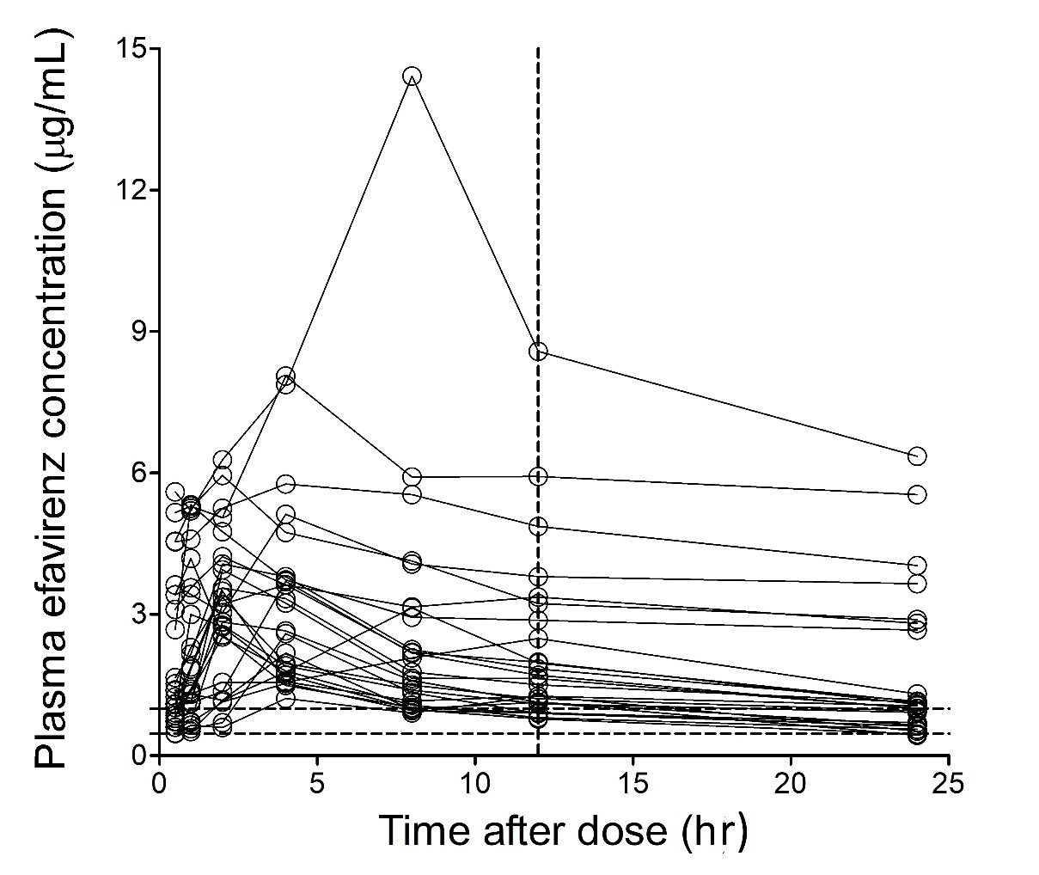

Figure 2
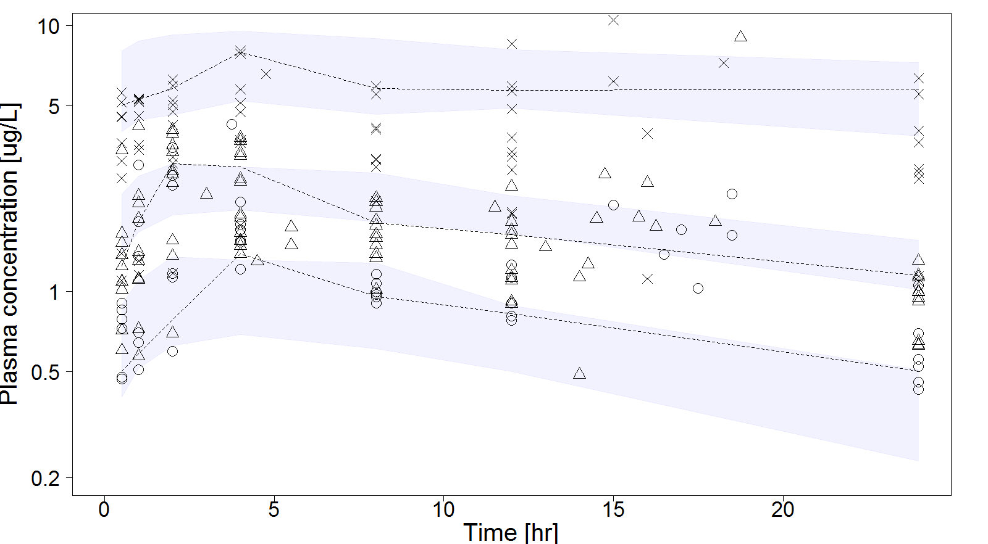

Figure 3
