Application of Smoothed Particle Hydrodynamics for modeling the wave-moored floating breakwater interaction
Bing Ren, Ming He, Yabin Li, Ping Dong
Abstract
The application of a Smoothed Particle Hydrodynamics (SPH) model to simulate the nonlinear interaction between waves and a moored floating breakwater is presented. The main aim is to predict and validate the response of the moored floating structure under the action of periodic waves. The Euler equations together with an artificial viscosity are used as the governing equations to describe the flow field. The motion of the moored floating body is described using the Newton's second law of motion. The interactions between the waves and structures are modeled by setting a series of SPH particles on the boundary of the structure. The hydrodynamic forces acting on the floating body are evaluated by summing up the interacting forces on the boundary particles from the neighboring fluid particles. The water surface elevations, the movements of the floating body and the moored forces are all calculated and compared with the available experimental data. Good agreements are obtained for the dynamic response and hydrodynamic performance of the floating body. The numerical results of different immersion depths of the floating body are compared with that of the corresponding fixed body. The effects of the relative length and the density of the structure on the performance of the floating body are analyzed.

Keywords: moored floating breakwater; mooring force; wave structure interaction; SPH

1. Introduction
Floating Breakwaters (FBs) are widely used for damping ocean waves. Compared with traditional bottom mounted breakwaters FBs have many advantages. They can be equally effectively used in offshore or coastal areas with poor foundation. They generally also have relatively less environmental impact and involve short duration of installation and potentially lower construction cost [1]. In development and application of various types of FBs, the forces acting on both the floating breakwater and its mooring lines as well as the dynamic responses of the FB system need to be determined effectively and accurately.
The performance of floating structures depends on the interaction between the incident waves and the FBs. The early established methods for predicting the performance of moored floating breakwaters often use frequency-domain analyses based on potential flow theory [2]. To better deal with the nonlinear wave-structure interaction, the time domain methods have been developed over the years. The most widely used time domain method is the Mixed Eulerian-Lagrangian (MEL) method introduced by Longuet-Higgins and Cokelet [3] based on Boundary Element Method (BEM). By this method, the instantaneous free surface is treated in the Lagrangian frame and satisfies the nonlinear boundary conditions [4, 5]. However, the potential methods neglect the fluid viscosity and are unable to account for the viscous damping which is the dominant damping mode in the pitch motion of a floating body.
With the advancement of computational fluid dynamics, a number of numerical simulations based on the NS or RANS equations are carried out to investigate the viscous or turbulent flow involved in the strong nonlinear waves-structure interaction. The NS model combined with VOF method were used to simulated the interaction between waves and inclined-moored submerged floating structures within the frame of Cartesian grid [6, 7]. In Rahman's work [7] the moving boundary of the structure was treated in the Cartesian mesh using FAVOR (Fractional Area/Volume Obstacle Representation) but this treatment suffered from the high computational cost of the mesh generation and re-meshing. Peng [6] applied the the IB (Immersed Boundary) method proposed by Peskin [8] to deal with the movable structures. However, the numerical models based on Eulerian grid methods mentioned above have difficulties in treating the structures with complex geometries or complex multi-degree freedom of motion.
When large nonlinear waves impinge on moored floating bodies, wave breaking and appreciable movements of the floating bodies are inevitable. These movements can change the reflection characteristics of the incident waves and may affect the effectiveness of the breakwater. For this reason tensioned mooring systems are often used to restrain the motion of the breakwater in earlier studies [7] as the small displacement of the FBs will only cause small motion-generated radiated waves into the protected region [9]. The experiment also reveals that appreciable movement asymmetry of the floating body may occur [10]. In order to analyze and quantify the performance of the moored floating bodies, a numerical model based on the Weakly Compressible Smoothed Particle Hydrodynamics (WCSPH) method is applied in this work. Being a meshless Lagrangian CFD method, a major advantage of SPH over Eulerian methods is its ability to treat complex interfaces including the free surface and the fluid-solid interface without involving any special tracking treatment or grid technology. Recently SPH has been applied in ocean and coastal engineering to solve a variety of nonlinear problems involving wave slamming, liquid sloshing and fluid-structure interaction [11-13]. However, most existing SPH studies were concerned with the influence of the stationary or moving solid on fluid flow, very few researches have attempted to study the problems of interactions between a floating structure and free surface waves.
In order to predict the movement of the floating body and the mooring forces accurately using SPH method, the algorithms of treating the fluid-solid interactions in the SPH frame should be properly enforced. There are generally two categories of such treatments in SPH simulations. One is to treat the floating body as deformable fluids and the motion of the floating body is calculated as the fluid with a different density. A correction procedure is then applied to the floating body particles to form the shape of the solid body satisfying the conservation of momentum. This method is not very accurate for large-amplitude motions of floating bodies [14]. The other approach [15-18] is to treat the structure as strictly solid boundary, which represents a moving wall boundary for the fluid flow with the motion of the rigid body being modeled by the Newton's law of motion. The hydrodynamic forces on the rigid body exerted by the fluid are evaluated by integrating pressures on the wetted surface of the floating body. The pressures of the boundary particles are computed by implementing the solid boundary treatment such as "mirror particle technique" [16, 19] or "dynamic particle method"[12]. The latter treatment is more straightforward in a particle approach but the noisy pressure field near the solid boundary will present some difficulties in the computation of the hydrodynamic forces. In order to reduce these pressure fluctuations, several techniques have been developed to enhance the interpolation accuracy of the pressures, such as the repulsive force approach proposed by Monaghan [20], the so-called ghost particles approach or mirror particle technique introduced by Colagrossi and Landrini [21] and developed by Adami [22] as well as the dynamic boundary particle method presented by Dalrymple and Knio [23].
In this study, an improved Weakly Compressible SPH (WCSPH) model is developed by extending the capability of the SPHysics open-source software to analyze and quantify the performance of a tensioned mooring floating breakwater. The nonlinear interactions between large waves and moored floating bodies with up to three degrees of freedom are investigated. The NS equations are used as the governing equations to describe the flow field. The motion of the moored bodies is described using the Newton's second law of motion. The mooring force is calculated using a light spring model [24]. The solid boundary is treated using the dynamic boundary particles proposed by Crespo [23]. The densities of the boundary particles are corrected by the mean densities of fluid particles in their kernel supports to reduce the spurious effects following Ren [12]. The hydrodynamic force acting on the floating body is evaluated by summing up the interacting forces on the boundary particles from the neighboring fluid particles. This established model is validated against the experimental data. The performances of the moored floating breakwater are analyzed using the calculated results of different cases.
The paper is organized as follows: after the introduction, the improved SPH model is presented in section 2 together with the equations of the motion of the rigid body and the mooring force. In section 3, the evaluation of the hydrodynamic forces on the floating body is presented. In section 4, the model is validated against the experimental data. Section 5 presents the numerical results of wave interaction with a moored floating breakwater. The effects of the immersion depth, relative length and density of the floating breakwater are discussed. Finally the conclusions of this work are drawn.

2. Methodology

2.1. SPH formulation for the fluid flow
In the present work, the motion of the fluid is governed by the mass and momentum conservation equations as:
where ρ is the density of the fluid, u is the velocity vector, p is the pressure and g is the gravitational acceleration.
In the WCSPH method, pressure is calculated using the equation of state [20]:
where; ρ₀ is a reference density, ρ₀ = 1000 kg/m³; B = c₀²ρ₀ / γ, c₀ is the speed of sound at the reference density and chosen to keep density variations within 1%.
The SPH formulation of Eqs. and can be written as:
In the above equations, subscripts i denotes the target particle; subscripts j and N denote the neighboring particles and the total number of neighboring particles within the support of particle i, respectively. W_{ij} is the SPH kernel function. In this paper, a quintic kernel suggested by Wendland [25] is used:
where,is the distance between particles i and j, h is the smoothing length.
The real viscosity of fluid is neglected and an artificial viscosity term Π_{ij} is added in the Eq. to produce a shear and bulk viscosity. Π_{ij} is given by Monaghan [26]
where,,,ϕ = 0.01h,，，c is the speed of sound.α_{Π} and β_{Π} are empirical parameters that can be adjusted as required for each problem.

2.2. Treatment of the solid boundary
In the present study the solid boundary is treated by the dynamic boundary method originally presented by Dalrymple and Knio [23] and further developed by Gómez-Gesteira [27] and Crespo [28]. The solid boundary is modeled using two layers of DBPs. The DBPs follow the same equations of continuity and state as the fluid particles, although their positions and velocities remain unchanged in time or are externally imposed. Using the dynamic boundary condition, there is no additional programming needed and it is easy to specify irregular boundaries by placing double rows of stationary particles. This condition also has the advantage of computational simplicity where the fluid-boundary interactions can be calculated inside the same loops as fluid particles with a considerable saving of computational time. However, the presence of DBPs can give rise to anomalously high density gradient near the boundary particles, which may result in a fluctuating pressure field or a spurious boundary layer near the solid boundaries. To minimize this effect, the densities of boundary particles are buffered in such a way that strong deviations from the reference density are smoothed out [27]. Here following Ren [12] the calculated densities of DBPs ρ_{i} by Eq. are corrected by the mean densities of fluid particles in the kernel supports to reduce the spurious effects as:
where ρ_{j} is the density of fluid particle j in the vicinity of DBPs, N is the number of fluid particles in the kernel support of DBPs. The correction term is added to compensate the effects of truncated compact support. β is a factor with the value between 0 and 1. The calculation results indicate that an appropriate value of β is necessary to make the pressures of boundary particles close to those of the fluid particles and ensure a smooth pressure field near the boundary. In the present simulations, generally a smaller value of β results in a higher density gradient between the fluid and boundary particles, which will lead to fluid particles separating from the wall boundary. While a small density gradient between the boundary-fluid particle pairs will result in an inadequate repulsive force and fluid particles may penetrate the wall boundary. Here β = 0.8 is adopted through a series of calibration tests.

2.3. Motion of floating body
The motion model of floating body is illustrated in Fig. 1. The floating body is taken as a rigid body. According to the Newton's law of motion, the linear and angular equations of motion are written as
where V and Ω are the linear velocity and the angular velocity of the center of mass, respectively. F_{t} is mooring force, T_{t} is torque of mooring force acting on the center of mass, f_{i} is the hydrodynamics force acting on the boundary particle i. R₀ is the position vector of the center of mass, r_{i} is the position vector of the boundary particle i. N₁ is the total number of the boundary particles on the floating body.
[Fig. 1]

2.4. Mooring force model
The mooring line system is taken as a light spring model and the gravity effect and volume of the mooring line are neglected [24]. The pre-tension of the mooring line is applied to balance the floating body in the still water. As a result, the value of mooring force is written as
where |F_{t0}| is the pretension force of the mooring line, and it equals to the diffidence between weight of the floating body and the buoyancy force acting on it when it is submerged in the water. k_{t} is the coefficient of elasticity of mooring line. l and l₀ are the transient length and initial length of the mooring line, respectively.
The torque of mooring line acting on floating body is given as follow:
where r_{t} is the position vector of the joints of the floating body and mooring line.

3. Evaluation of hydrodynamic forces
The boundary of the floating body is discretized using two layers of DBPs, whose positions change with the globe motion of the floating body. The velocity of the boundary particle i is given as follow:
The hydrodynamic force acting on the boundary particle of the floating body is evaluated from the momentum equation by means of the SPH interpolation over the neighboring fluid particles in its support area.
where subscript i denotes the boundary particle of the floating body; subscripts j and N denote the neighboring fluid particles and the total number of neighboring particles within the support of particle i, respectively. and are the corrected pressure and density of the boundary particle according to Eq. and Eq. .
The torque exerted by f_{i} on the floating body is calculated by Eq.
The total wave force and torque acting on floating body is calculated by Eqs. and

4. Validation of the SPH model
In this section the SPH model is validated by two test cases. The first one is intended to check the accuracy of wave force acting on the structure. Specifically, wave pressure on a fixed surface-piercing box is studied and compared with the analytical solution. The second test deals with wave interaction with a submerged floating breakwater and the experimental results of Peng [6] are used to validate the model.

4.1. Wave interaction with a fixed surface-piercing box
Fig. 2 shows the setup of the first test case. The rectangular box of 0.63 m wide and 0.15 m high is fixed and semi-immersed. It locates at 2.0 m away from the wavemaker at the upstream boundary of the numerical wave tank (NWT) and 0.3 m away from the sponge layer at the downstream boundary. The active absorbing wave maker and the artificial viscosity sponge layer are set in the model following Ren [29].
[Fig. 2]
The wave pressures on the fixed box are recorded using nine measuring points as listed in Table 1. The origin of coordinate system is located at the geometric center of the box, with x positive rightwards and y positive upwards. A total of 32914 particles including 1750 fixed boundary particles are used in the simulation, with an initial particle spacing of 0.01 m. To increase the computational efficiency, parallel computation based on OpenMP is implemented. The computational time for running a wave series up to 20 s is about 4 hours using an INTEL Core i7-4790 CPU@3.6GHz.
Table 1. Coordinates of the nine pressure measuring points on the surface-piercing box
No. | 1# | 2# | 3# | 4# | 5# | 6# | 7# | 8# | 9#
x-coord (m) | -0.315 | -0.315 | -0.315 | -0.158 | 0 | 0.158 | 0.315 | 0.315 | 0.315
y-coord (m) | 0 | -0.038 | -0.075 | -0.075 | -0.075 | -0.075 | -0.075 | -0.038 | 0

Fig. 3 depicts the numerical results of the hydrodynamic pressure. These results are in broad agreement with the analytical solutions of Mei and Black [30]. Some discrepancies, such as high-frequency oscillations in the time histories of the pressures of 4#~6# are observed which are caused by the small density oscillations due to the use of the equation of the state. Even with the artificial viscosity term in momentum equation, the shock wave cannot be eliminated completely. In addition, 1#, 2#, 8# and 9# show constant pressures when they encounter wave toughs and are exposed in the air.
[Fig. 3]

4.2. Wave interaction with a submerged FB
The SPH model is validated against experimental results of Peng [6] about the interactions between waves and a floating body. The experiments were carried out in a 2D wave flume at the Coastal and Ocean Engineering Laboratory, Dept. of Civil Engineering, Nagoya University, Japan. The wave tank is 30 m long, 0.7 m wide and 0.9 m deep, as shown in Fig. 4. A piston-type wave paddle is installed at one end of the wave flume to generate waves. On the other end of the wave flume, a wave absorber made of rubble mound is used to reduce the effect of reflected waves. A breakwater model is located about halfway between the wave maker and wave absorber. The floating body is homogeneous, 0.4m long, 0.68m wide and 0.15m high. The total mass and moment of inertia at its center of gravity are 28.6 kg and 0.435kg⋅m², respectively. The mooring system consists of four stainless chains which are carefully arranged to ensure a good symmetry along x and y direction and the floating breakwater is anchored to the bottom with a 60° inclination, and the immersion depth d₁ is 0.102 m. The water surface elevations near the floating body were recorded using four wave gauges. W1and W2 were installed at 1.95m and 1.2m from the seaward side of floating body, respectively. W3 and W4 were installed at 1.2m and 1.65m from the leeside of floating body, respectively. The incoming wave was regular wave with wave period T of 1.0s and wave height H of 0.046m.
[Fig. 4]
Fig. 5 shows the sketch of the numerical wave tank. The floating body with the same dimensions as that in the experiment is setup. The centroid of the body is located at x = 2.95m, y = 0.423m. The mass and moment of inertia at the center of gravity are 42 kg and 0.64 kgm². A piston-type wave maker is set at x = 0.2 m to generate propagating waves, and an artificial damping layer is arranged at the downstream boundary of the NWT to absorb the outgoing waves. The length of the damping layer is approximately equal to 1.5 times of the wavelength. To prevent the mooring line from stretching, a large value of k_{t} = 10⁶ N/m is used. A total of 48222 particles including 1925 fixed boundary particles and 212 moving boundary particles are used in the simulation, with an initial spacing of 0.01 m. The smoothing length h is 1.5 times of the initial particle spacing.
[Fig. 5]
To increase the computational efficiency, parallel computation based on OpenMP is implemented. The computational time for running a wave series up to 20 s is about 7 hours using a INTEL Core i7-4790 CPU@3.6GHz.
Before the calculation of wave-floating body interaction, the incoming waves are calibrated at the location where the structure is placed. The calibrating point is shown in Fig.5. In the calibration calculation, the wave heights at the calibrating points are made to equal to the target wave heights when no structure is placed in the wave tank so that the wave interaction with the structures can be predicted as accurately as possible even although the incoming waves away from the structure may be less accurate.
Fig. 6 shows the time series of the wave surface elevations at the measuring points W1 − W4. The results indicate that the propagating waves break over the floating body due to the shallow water. On the leeward of the breakwater, wave decomposition takes place and the higher harmonics are generated with a frequency twice that of the incident wave, which is confirmed by the results of the discrete Fourier transform. The calculated wave surface elevations of W1, W2 and W3 are almost the same with that of the experimental data except a little discrepancy. For W1 and W2 the calculated phases of the wave crest and trough deviate a little from the experimental data, which are considered to be caused by the inaccuracy of the numerical model rather than phase shift. The complex wave profile with double crests on the leeward of the breakwater is also reproduced adequately. However, the computed results under-predict the wave surface elevations of W4 by 20% − 40%. That is to say the wave heights at the measuring points W4 decay more appreciably than that at the measuring points of W1 − W3. The possible reason is that the artificial viscosity used in momentum equations can cause more decay of high-frequency waves. On the leeward of the breakwater, there are higher harmonics waves except the incident wave due to wave decomposition. Fig. 7 shows the amplitude spectrum of W3 and W4. It can be seen that there are two components in the spectrum. The first component has the same frequency with the incoming wave. The second component has the frequency of two times of the incident wave. It can also be seen from Fig. 7, compared with wave gauge #3, the wave component of the double frequency at wave gauge #4 decays more, while wave compliment of the fundamental frequency decays little.
[Fig. 6]
[Fig. 7]
Fig. 8 shows the motions of the floating body in three degrees of freedom as sway, heave and roll. A reference system o-xy is defined, with x positive right-wards and y positive upwards. The rotation here donates the roll angle which is positive in the counter clockwise direction. The floating body moves at the same frequency with the incident wave. The sway components present harmonic oscillations with a larger amplitude in the x positive direction, which is induced by the nonlinearity of the wave forces. It is the same for the roll components. As for the heave, because the elongation of the mooring line is negligible due to the large stiffness, the highest position of the centroid in the y axis is its initial balancing position. At the wave crest phase, the centroid moves towards the bottom right firstly and then it moves back to the balancing position. At the wave trough phase, the centroid moves towards the bottom left firstly, then it moves back to the balancing position. So there are two troughs of the heave component in one wave period. It can be seen from the sway and roll component, the amplitudes in the positive direction of sway are obviously larger than that in the negative direction and the amplitudes of the roll in the anti-clockwise direction are also larger than that in the clockwise direction, which induces that amplitudes of the heave at the first trough of wave crest phase are much larger than that at the second trough of wave trough phase. It can be seen from Fig. 8 that the agreements of the three movement components between SPH results and experimental data are satisfactory, except the small deviation at the trough of the heave component.
[Fig. 8]
Fig. 9 shows the time series of the mooring force, F_{s} is on the seaward side mooring line and F_{L} is the mooring force on the leeside mooring line. The variation of the mooring forces is similar to that of the movement of the heave component. The computed results agree well with the experimental results except the small deviation at the trough, which is induced by the deviations at the trough of the heave component between the computed and experimental results. For the seaward side mooring force, there exists a deviation at the second trough. For the leeside mooring force, there exists a deviation at the first trough.
[Fig. 9]
An error analysis for the differences between the model predictions and the experimental data on the time histories of surface elevations, motions of the floating body and mooring forces is carried out and shown in Table 2. The root mean squared error (RMSE) between SPH results and experimental data is calculated by:
where N = t / Δt, t is the simulated time and Δt is the sampling time interval. ξ_{SPH,i} and ξ_{Exp,i} denote the calculated results and experimental data, respectively. The results of RMSE are listed in Table 2.
Table 2. The RMSE between the numerical and experimental data
Parameters | Surface elevations |  |  |  | Motions of floating body |  |  | Mooring forces
 | 1#  (m/m) | 2#  (m/m) | 3#  (m/m) | 4#  (m/m) | Sway  (m/m) | Heave  (m/m) | Roll  (rad) | Seaward  (N/m) | Leeward  (N/m)
RMSE | 0.122 | 0.101 | 0.037 | 0.053 | 0.047 | 0.007 | 0.031 | 2.329 | 2.870

5. Numerical results and discussions
In this section, the interactions between waves and a moored floating breakwater are investigated using the validated SPH model. The numerical set up is the same as shown in Fig. 5. In order to study the hydrodynamics of the floating body, different structure configurations are modeled to analyze the reflected and transmitted waves. The ratio of the body length l_{f} and the wave length L is varied from 0.1 to 0.6, while the thickness of the body is kept as 0.15 m. The body is homogeneous and the density changes from 400 kg/m³ to 700 kg/m³. The elastic modulus of mooring line k_{t} is taken as 10⁶ N/m. The floating breakwater is anchored to the bottom with a 60° inclination. The mass and moment of inertia of different floating bodies are listed in Table 3. The water surface elevations near the floating body are determined at four locations denoted as W1 − W4. W1 and W2 are at 1.27L and 0.78L from the seaward side of floating body, respectively and W3 and W4 are at 0.78L and 1.07L from the leeside of floating body, respectively.
The reflected waves, transmitted waves and the motions of the floating body are analyzed to study the performance of the FBs. The reflected waves in front of the floating body are separated using the two-point method [31]. The fundamental frequency waves and the higher harmonic waves are separated from the transmitted waves behind the floating body using the discrete Fourier transform.
Table 3. The mass and moment of inertia of different floating bodies
Length  (m) | Width  (m) | Height  (m) | Density  (kg/m³) | Mass  (kg) | Moment of inertia  (kgm²)
0.40 | 1.0 | 0.15 | 700 | 42.00 | 0.64
0.58 | 1.0 | 0.15 | 700 | 60.90 | 1.82
0.63 | 1.0 | 0.15 | 700 | 66.15 | 2.31
0.77 | 1.0 | 0.15 | 700 | 80.85 | 4.15
0.80 | 1.0 | 0.15 | 700 | 84.00 | 4.64
0.63 | 1.0 | 0.15 | 550 | 51.98 | 1.82
0.63 | 1.0 | 0.15 | 400 | 37.80 | 1.32

5.1. The effect of the immersion depth
A series of numerical results are obtained by keeping the water depth unchanged but altering the length of the mooring line of the structure to change the immersion depth. It should be noted that for the immersion water depth being -2 cm, the structure is located above the still water level.
Fig. 10 presents the computed wave elevations for different immersion water depths. It can be seen that on the leeside of the floating body, the transmitted wave profile and water surface elevations are different for different immersion water depths. For the immersion water depth of 10cm, the wave profile is characterized with double frequency waves, while the other cases, it is single-crested. It can be seen from Fig. 7 in section 4 that the higher harmonic waves generated on the top of the floating breakwater have different amplitudes and phases, which induces the different wave profiles of different immersion water depth.
[Fig. 10]
The reflected wave heights and transmitted wave heights of different frequencies are shown in Table 4. It can be seen that for the immersion depth d₁ = 10 cm, the reflected wave height H_{r} is about 7cm and the transmitted wave height of the incident frequency H_{t,1} is very small, while for other cases, the reflected wave heights are about 4.3 − 6.5 cm and the transmitted wave heights of the fundamental frequency are about 2.3 − 4.0 cm. It seems that the higher harmonics wave height H_{t,2} are closely related to the immersion depths and increases with the increasing of the immersion water depth until it reaches the maximum value at d₁ = 10 cm.
Table 4. The reflected and transmitted wave heights (W3)
Other parameters | d₁  (cm) | H_{r}  (cm) | H_{t,1}  (cm) | H_{t,2}  (cm) | C_{t,1}  (cm/cm)
l_{f} / L= 0.41  T = 1.0 s  H = 8 cm  k_{t} = 10⁶ N/m | -2 | 5.23 | 3.18 | 0.24 | 0.40
 | 0 | 5.17 | 4.00 | 0.34 | 0.50
 | 2 | 4.31 | 3.96 | 0.52 | 0.50
 | 5 | 5.03 | 3.48 | 0.84 | 0.44
 | 10 | 7.04 | 0.34 | 1.66 | 0.04
 | 15 | 6.46 | 2.29 | 0.68 | 0.29

The wave energy flux for the different immersion depth is listed in Table 5. The incident wave energy flux is defined as 1. Others are defined as the ratios between the corresponding wave energy flux and the incident wave energy flux. Based on the conservation of wave energy, the wave energy flux of the incident waveis equal to the sum of the reflected wave energy flux, the transmitted wave energy flux, and the change of the energy flux due to the loss of the wave energy, as shown in Eq. . It should be noted that the radiation wave energy flux induced by the movement of the floating body are included in theand.
Table 5. The wave energy flux of different immersion depths
Other parameters | d₁
 | (cm) | (W) | (W) | (W) | (W)
l_{f} / L= 0.41  T = 1.0 s  H = 8 cm  k_{t} = 10⁶ N/m | -2 | 1 | 0.48 | 0.18 | 0.34
 | 0 | 1 | 0.44 | 0.26 | 0.30
 | 2 | 1 | 0.30 | 0.26 | 0.44
 | 5 | 1 | 0.41 | 0.20 | 0.38
 | 10 | 1 | 0.76 | 0.02 | 0.22
 | 15 | 1 | 0.63 | 0.08 | 0.29

It can be seen from Table 5 that the energy fluxes of the reflected waves (including the radiation waves) for the two cases of larger immersion depths (d₁ = 10 cm and 15 cm) are obviously larger than that of the other cases. Considering the motion details of the floating body (as shown in Fig. 11), for the immersion water depth of 10 cm and 15 cm, there are three features which could induce the more effective reflection of the floating body: the amplitudes in the positive direction of sway are obviously larger than that in the negative direction, the amplitudes of the roll in the anti-clockwise direction are also larger than that in the clockwise direction, and the amplitudes of the heave at the first trough are much larger than that at the second trough. Moreover, for the two cases of larger immersion depths (d₁ = 10 cm and 15 cm), all the three kinds of amplitudes including the sway in the positive direction, the roll in the anti clockwise direction and the heave at the first trough are larger than that for the other cases of smaller immersion depths. However, for the smaller immersion water depths, the amplitudes of sway and roll in the positive direction are nearly the same with that in the negative direction. Different from the fixed body, the reflection effect of the floating body is related to not only the immersion depths but also the movement of the floating body. As for the wave energy flux behind the floating body, is the smallest for the case of d₁ = 10cm. According to the conservation of wave energy flux, the losses of wave energy of the smaller immersion depths are larger. However,of smaller immersion cases is larger than that of the d₁ =15 cm and 10 cm due to its smaller reflection.
[Fig. 11]
It is well known that for a fixed horizontal structure, when the structure is located near the still water level, larger reflection happens and the transmitted wave behind the structure is smaller. As for a floating body, because of the changing position and orientation of the structure, the interaction between the waves and the moored floating body is different from that between the waves and fixed structures. Therefore the effects of the immersion depths on the transmitted waves of the fixed structure are different from that of the floating body.
To better understand the results a comparison of the reflected and transmitted wave heights between the fixed structure and the moored floating body is shown in Table 6. C_{t,1} is defined as the ratio of the H_{t,1} over the incoming wave height. It can be seen that for the fixed the structure, though the maximum reflection happens when the structure is 2 cm above the still water level, the minimum transmitted wave height occurs when the structure is exactly on the still water level. With the increasing immersion depth, the reflected wave height decreases and the transmitted wave height increases. However, for the floating body, the maximum reflected wave height occurs at d₁ = 10cm, where the transmitted wave height is the smallest.
Table 6. Comparison of the reflected and transmitted wave heights between the fixed and floating body
Other  parameters | d₁  (cm) | Fixed structure |  |  |  | Floating structure
 |  | H_{r}  (cm) | H_{t,1}  (cm) | H_{t,2}  (cm) | C_{t,1} | H_{r}  (cm) | H_{t,1}  (cm) | H_{t,2}  (cm) | C_{t,1}
l_{f} /L=0.41  H=8 cm  T=1.0 s  k_{t} = 10⁶ N/m | -2 | 6.02 | 1.46 | 0.92 | 0.18 | 5.52 | 3.77 | 0.42 | 0.47
 | 0 | 4.76 | 0.62 | 0.95 | 0.08 | 5.17 | 4.00 | 0.34 | 0.50
 | 2 | 3.50 | 1.65 | 1.40 | 0.21 | 4.31 | 3.96 | 0.52 | 0.50
 | 5 | 2.39 | 2.96 | 1.56 | 0.37 | 5.03 | 3.48 | 0.84 | 0.44
 | 10 | 1.48 | 4.30 | 1.74 | 0.54 | 7.04 | 0.34 | 1.66 | 0.04
 | 15 | 2.18 | 5.95 | 1.59 | 0.74 | 6.46 | 2.29 | 0.68 | 0.29

5.2. The effect of the relative length of the structure
Fig. 12 shows the reflected waves and the transmitted waves for different relative body lengths. It can be seen that the transmitted waves are the smallest when the relative body length is about 0.4, where the largest reflected waves are observed.
[Fig. 12]
The velocity fields at different phases of one wave period for different structure length are displayed in Fig. 13. In order to show the results more clearly, the velocity field is plotted by mapping the individual particle velocities onto a fixed grid of 0.025 m × 0.025 m in the computational domain. Wave breaking and overtopping on the top of the floating body are displayed when the waves interact with the floating body. The results show that at the wave crest stage the body firstly rotates counter clockwise and move rightwards with the incoming wave from left. Then, with the passage of the wave crest, after moving to the positive furthest point the body rotates clockwise and returns to horizontal. Under the action of wave trough, it continues to rotate clockwise and moves leftwards. After the body moves to the negative furthest point, it begins to rotate anti-clockwise, and finally, returns to the horizontal position after one wave period. Comparing the three cases, it can be seen that for the case of l_{f} / L = 0.41, there is an obvious negative horizontal flow above the structure at the instant of t = 10.56 s when the structure is at the horizontal position. The horizontal flow is caused by the phase differences of the pressures between the fluid above and below the structure, which acts with the incoming wave from the wave maker and causes a larger reflection. However for the case of l_{f} / L = 0.63, the intensity of the horizontal flow is much weaker than that of l_{f} / L = 0.41. For the case of l_{f} / L = 0.09, the structure is too small to affect the flow field.
[Fig. 13]

5.3. The effect of the density of the structure
From the above analysis we can see that the hydrodynamics of the floating body is concerned a lot with the motion of the structure. Here we compare the motion of three structures with different density and the transmitted waves behind the FB to discuss the effect of the density. The three structures have the same dimensions with different density, so they have different mass.
Fig. 14 shows the wave elevations behind the different structures. It can be seen that for the case of ρ = 700 kg/m³ the transmitted water surface elevations are characterized with double frequency waves. For the cases of ρ = 500 and 700 kg/m³, the transmitted wave profiles are characterized with obvious double crests. For the case ρ = 400 kg/m³, the transmitted wave height is much larger than other cases. It seems that the transmitted wave heights decrease with the increasing of the density of the structure and have a great relationship with the motion amplitude of the structures as shown in Fig. 15.
[Fig. 14]
[Fig. 15]
It can be seen from Fig. 15 that the motion amplitude of the case ρ = 400 kg/m³ is obviously smaller than that for the other cases. For the case ρ = 400 kg/m³, the amplitudes in the positive direction of sway are nearly equal to that in the negative direction and obviously smaller than that for the other cases; the amplitudes of the roll in the anti-clockwise direction are also almost same with that in the clockwise direction and obviously smaller than that for other cases. These two features lead to larger transmitted wave height and less effective reflection compared with other two cases. The smaller motion amplitudes of the lighter structure are induced by larger pre-tension of the mooring lines. In the calculations, the pre-tension of the mooring line is set to balance the floating body in the still water. So the pre-tension of the lighter structure is larger.
The pressure fields and particle distribution at different phases of one wave period for different density are displayed in Fig. 16. Comparing the two cases of different density, it can be seen that for the case ρ = 400 kg/m³, the floating body moves to the furthest point at t₀ + T/4 or t₀ + 3T/4, while for the case ρ = 700 kg/m³, it moves to the positive furthest point at a later time after the instant of t₀ + T/4 or t₀ + 3T/4. This difference can also be seen in Fig. 15.
[Fig. 16]
Fig. 17 shows the time series of the pressures around the structure. The positions of the six measuring points are also shown in Fig. 17. It can be seen that there are phase differences between the pressures of the measuring points above the structure, while for the three measuring points below the structure, the pressures are nearly synchronous. Because the heave motions between the two cases are different, the properties of the pressures are also different for the different density.
[Fig. 17]

6. Conclusions
This work presents a systematic investigation the nonlinear interaction between the waves and the moored floating body using a SPH model. The hydrodynamic forces acting on the floating body are calculated by summing up the interacting forces on the boundary particles from the neighboring fluid particles in the support area. The present SPH model is validated by the laboratory experimental results. Good agreements are obtained for the water surface elevations, the movement of the floating body and the mooring forces.
The numerical results of different immersion depth indicate that the energy fluxes of the reflected waves for the two cases of larger immersion depths (d₁ = 10 cm and 15 cm) are obviously larger than that of other four cases of smaller immersion depths (d₁ = -2 cm, 0, 2 cm and 5 cm). The wave energy flux behind the floating body for the case of d₁ = 10 cm is the smallest among the six calculated cases.
The performance of the floating body is different from the fixed ones. The comparisons show that for the fixed the structure, with the increasing immersion depth, the reflected wave height decreases and the transmitted wave height increases. However, for the floating body, the maximum reflected wave height occurs at d₁ = 10 cm, where the transmitted wave height is the smallest. The possible reason is that the interaction between the waves and the moored floating body is different from that between the waves and fixed structures.
The calculated results of different relative length indicate that the smallest transmitted waves are observed when the relative body length is about 0.4, where the largest reflected waves are observed and the obvious horizontal flow above the floating body may cause the large reflection. The numerical results of different density of the structure indicate that the motion amplitudes increase with the increasing of the density. The transmitted wave decreases with the increasing of the density of the structure.

Acknowledgments
We would like to thank three reviewers for their very valuable comments on the initial version of this article. This work was funded by the National Natural Science Foundation of China under Grant No. 51679032.

References
[1] McCartney BL. Floating breakwater design. Journal of Waterway, Port, Coastal, and Ocean Engineering. 1985;111 (2):304-318.
[2] Bhat S, Isaacson M. Performance of twin-pontoon floating breakwaters. Proceedings of the Eighth International Offshore and Polar Engineering Conference. Cupertino, Canada. 1998;584-589.
[3] Longuet-Higgins MS, Cokelet ED. The deformation of steep surface waves on water. I. A numerical method of computation. Proceedings of the Royal Society of London A Mathematical and Physical Sciences. 1976;350 (1660):1-26.
[4] Kashiwagi M. Non-linear simulations of wave-induced motions of a floating body by means of the mixed Eulerian-Lagrangian method. Proceedings of the Institution of Mechanical Engineers, Part C: Journal of Mechanical Engineering Science. 2000;214 (6):841-855.
[5] Koo W, Kim M-H. Freely floating-body simulation by a 2D fully nonlinear numerical wave tank. Ocean Engineering. 2004;31 (16):2011-2046.
[6] Peng W, Lee K-H, Shin S-H, Mizutani N. Numerical simulation of interactions between water waves and inclined-moored submerged floating breakwaters. Coastal Engineering. 2013;82):76-87.
[7] Rahman MA, Mizutani N, Kawasaki K. Numerical modeling of dynamic responses and mooring forces of submerged floating breakwater. Coastal Engineering. 2006;53 (10):799-815.
[8] Peskin CS. Flow patterns around heart valves: A numerical method. Journal of Computational Physics. 1972;10 (2):252-271.
[9] He F, Huang Z, Wing-Keung Law A. Hydrodynamic performance of a rectangular floating breakwater with and without pneumatic chambers: An experimental study. Ocean Engineering. 2012;51):16-27.
[10] Sannasiraj SA, Sundar V, Sundaravadivelu R. Mooring forces and motion responses of pontoon-type floating breakwaters. Ocean Engineering. 1998;25 (1):27-48.
[11] Gao R, Ren B, Wang G, Wang Y. Numerical modelling of regular wave slamming on subface of open-piled structures with the corrected SPH method. Applied Ocean Research. 2012;34):173-186.
[12] Ren B, He M, Dong P, Wen H. Nonlinear simulations of wave-induced motions of a freely floating body using WCSPH method. Applied Ocean Research. 2015;50):1-12.
[13] Shao JR, Li HQ, Liu GR, Liu MB. An improved SPH method for modeling liquid sloshing dynamics. Computers & Structures. 2012;100–101):18-26.
[14] Shao S, Gotoh H. Simulating coupled motion of progressive wave and floating curtain wall by SPH-LES model. Coastal Engineering Journal. 2004;46 (02):171-202.
[15] Albano R, Sole A, Mirauda D, Adamowski J. Modelling large floating bodies in urban area flash-floods via a Smoothed Particle Hydrodynamics model. Journal of Hydrology. 2016;541, Part A):344-358.
[16] Amicarelli A, Albano R, Mirauda D, Agate G, Sole A, Guandalini R. A Smoothed Particle Hydrodynamics model for 3D solid body transport in free surface flows. Computers & Fluids. 2015;116):205-228.
[17] Bouscasse B, Colagrossi A, Marrone S, Antuono M. Nonlinear water wave interaction with floating bodies in SPH. Journal of Fluids and Structures2013. p. 112-129.
[18] Liu X, Lin P, Shao S. An ISPH simulation of coupled structure interaction with free surface flows. Journal of Fluids and Structures. 2014;48):46-61.
[19] Antoci C, Gallati M, Sibilla S. Numerical simulation of fluid–structure interaction by SPH. Computers & Structures. 2007;85 (11–14):879-890.
[20] Monaghan JJ. Simulating free surface flows with SPH. Journal of Computational Physics. 1994;110 (2):399-406.
[21] Colagrossi A, Landrini M. Numerical simulation of interfacial flows by smoothed particle hydrodynamics. Journal of Computational Physics. 2003;191 (2):448-475.
[22] Adami S, Hu XY, Adams NA. A generalized wall boundary condition for smoothed particle hydrodynamics. Journal of Computational Physics. 2012;231 (21):7057-7075.
[23] Dalrymple RA, Knio O. SPH modelling of water waves. Coastal Dynamics '01. 2001;779-787.
[24] Hong SY, Kim JH, Cho SK, Choi YR, Kim YS. Numerical and experimental study on hydrodynamic interaction of side-by-side moored multiple vessels. Ocean Engineering. 2005;32 (7):783-801.
[25] Wendland H. Piecewise polynomial, positive definite and compactly supported radial functions of minimal degree. Advances in Computational Mathematics. 1995;4 (1):389-396.
[26] Monaghan JJ. Smoothed particle hydrodynamics. Annual Review of Astronomy and Astrophysics. 1992;30 (1):543-574.
[27] Gómez-Gesteira M, Cerqueiro D, Crespo C, Dalrymple RA. Green water overtopping analyzed with a SPH model. Ocean Engineering. 2005;32 (2):223-238.
[28] Crespo AJC, Gomez-Gesteira M, Dalrymple RA. Boundary conditions generated by dynamic particles in SPH methods. CMC-Comput Mat Contin. 2007;5 (3):173-184.
[29] Ren B, Wen H, Dong P, Wang Y. Numerical simulation of wave interaction with porous structures using an improved smoothed particle hydrodynamic method. Coastal Engineering. 2014;88):88-100.
[30] Mei CC, Black JL. Scattering of surface waves by rectangular obstacles in waters of finite depth. J Fluid Mech. 1969;38 (03):499-511.
[31] Goda Y, Suzuki T. Estimation of incident and reflected waves in random wave experiments. Coastal Engineering Proceedings. 1976 (15):828-845.

Table captions
Table 1. Coordinates of the nine pressure probes on the surface-piercing box
Table 2. The RMSE between the numerical and experimental data
Table 3. The mass and moment of inertia of different floating bodies
Table 4. The reflected and transmitted wave heights (W3)
Table 5. The wave energy flux of different immersion depths
Table 6. Comparison of the reflected and transmitted wave heights between the fixed and floating body
Figure captions
Fig. 1. Sketch of the motion model of the floating body
Fig. 2. Sketch of wave interaction with a fixed surface-piercing box
Fig. 3. Comparisons between the numerical results and the analytical solutions of the wave pressures on the section of the fixed surface-piercing box
Fig. 4. Sketch of the experimental setup of wave interaction with a submerged floating breakwater
Fig. 5. Sketch of wave interaction with a submerged floating breakwater
Fig. 6. Comparisons between the numerical and experimental results for the free surface elevations at 1#~4# wave gauges
Fig. 7. The amplitude spectra of the wave surface elevations behind the floating body
Fig. 8. Comparisons between the numerical and experimental results for the motions of the floating body in three degree of freedom
Fig. 9. Comparisons between the numerical and experimental results for the mooring forces
Fig. 10. Time series of the surface elevations for different immersion depths
Fig. 11. Time series of the motions of the floating body for different immersion depths
Fig. 12. The reflected waves and the transmitted waves for different relative body lengths
Fig. 13. Velocity fields at different phases of one wave period for different relative length (ρ = 700 kg/m³, H = 8 cm, d = 60 cm, d₁ = 10 cm)
Fig. 14. The wave elevations behind the structures of different density (unit for density symbol: kg/m³)
Fig. 15. The motion amplitude of three degrees for the different structures (unit for density symbol: kg/m³)
Fig. 16. The pressure fields and particle distribution at different phases of one wave period (Left column: ρ = 700 kg/m³, Right column: ρ = 400 kg/m³)
Fig. 17. The time series of the pressures around the structure (Left column: ρ = 700 kg/m³, Right column: ρ = 400 kg/m³)

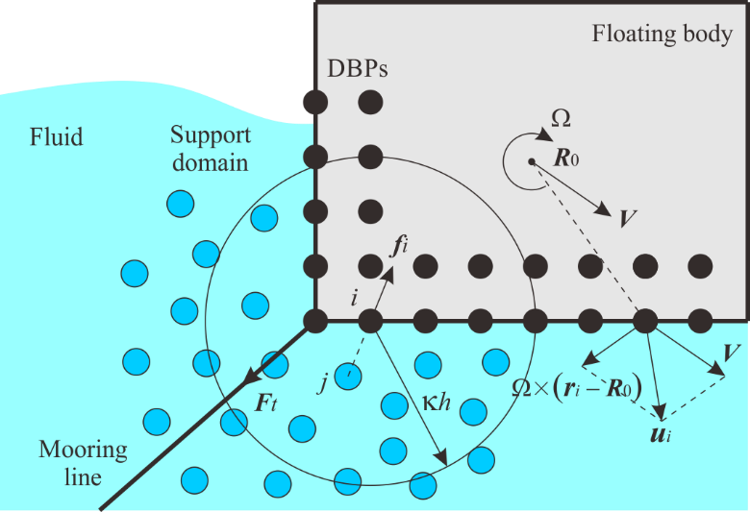

Fig. 1. Sketch of the motion model of the floating body
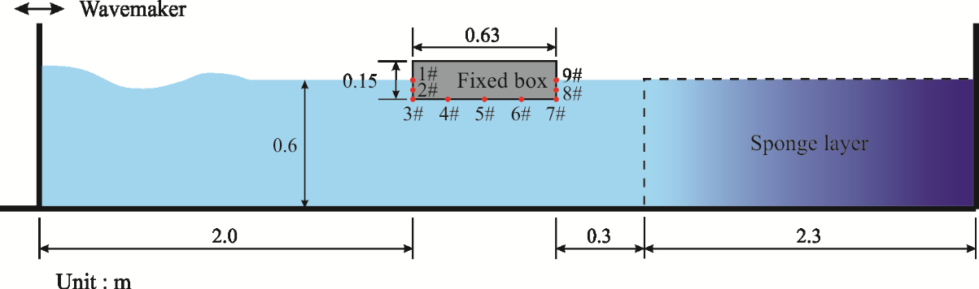

Fig. 2. Sketch of wave interaction with a fixed surface-piercing box

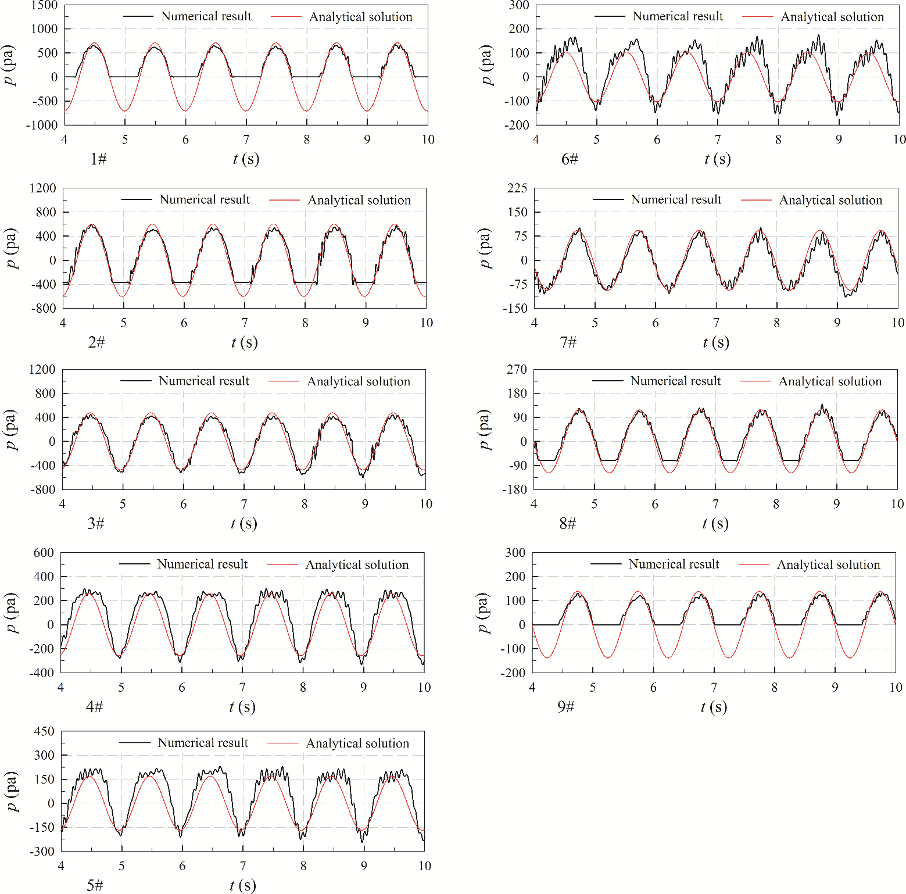

Fig. 3. Comparisons between the numerical results and the analytical solutions of the wave pressures on the section of the fixed surface-piercing box
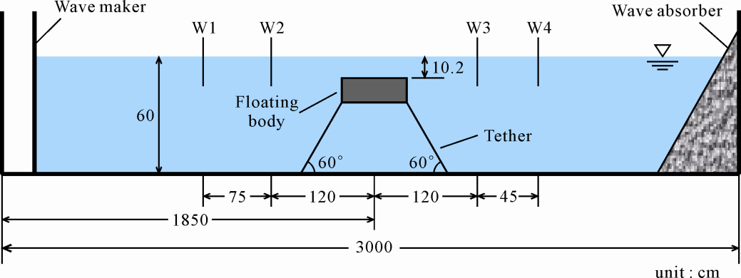
Fig. 4. Sketch of the experimental setup of wave interaction with a submerged floating breakwater

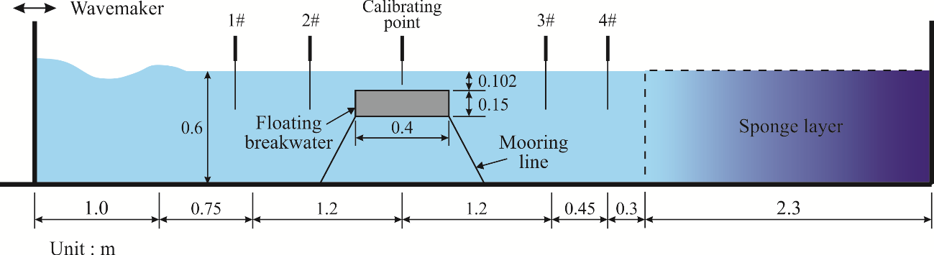

Fig. 5. Sketch of wave interaction with a submerged floating breakwater
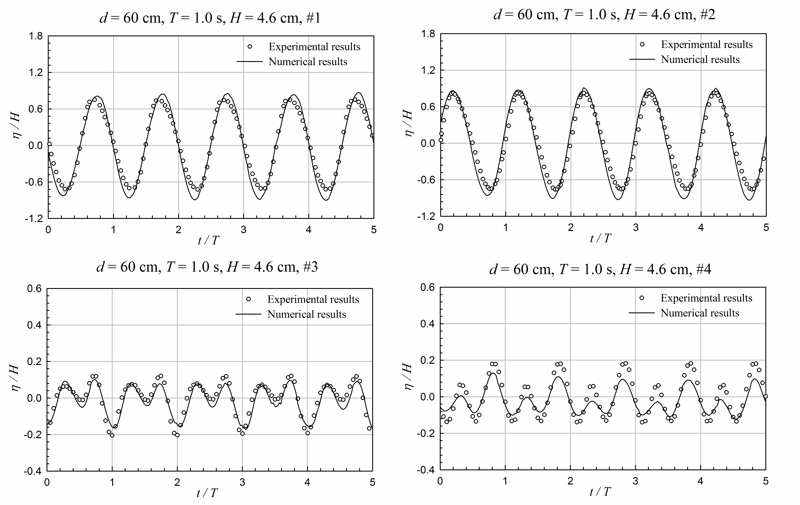

Fig. 6. Comparisons between the numerical and experimental results for the free surface elevations at 1#~4# wave gauges
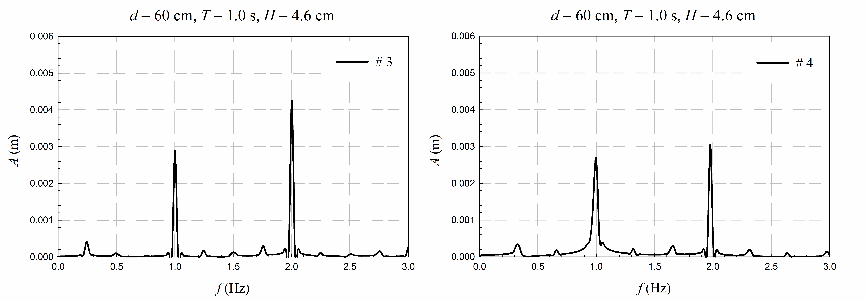

Fig. 7. The amplitude spectra of the wave surface elevations behind the floating body
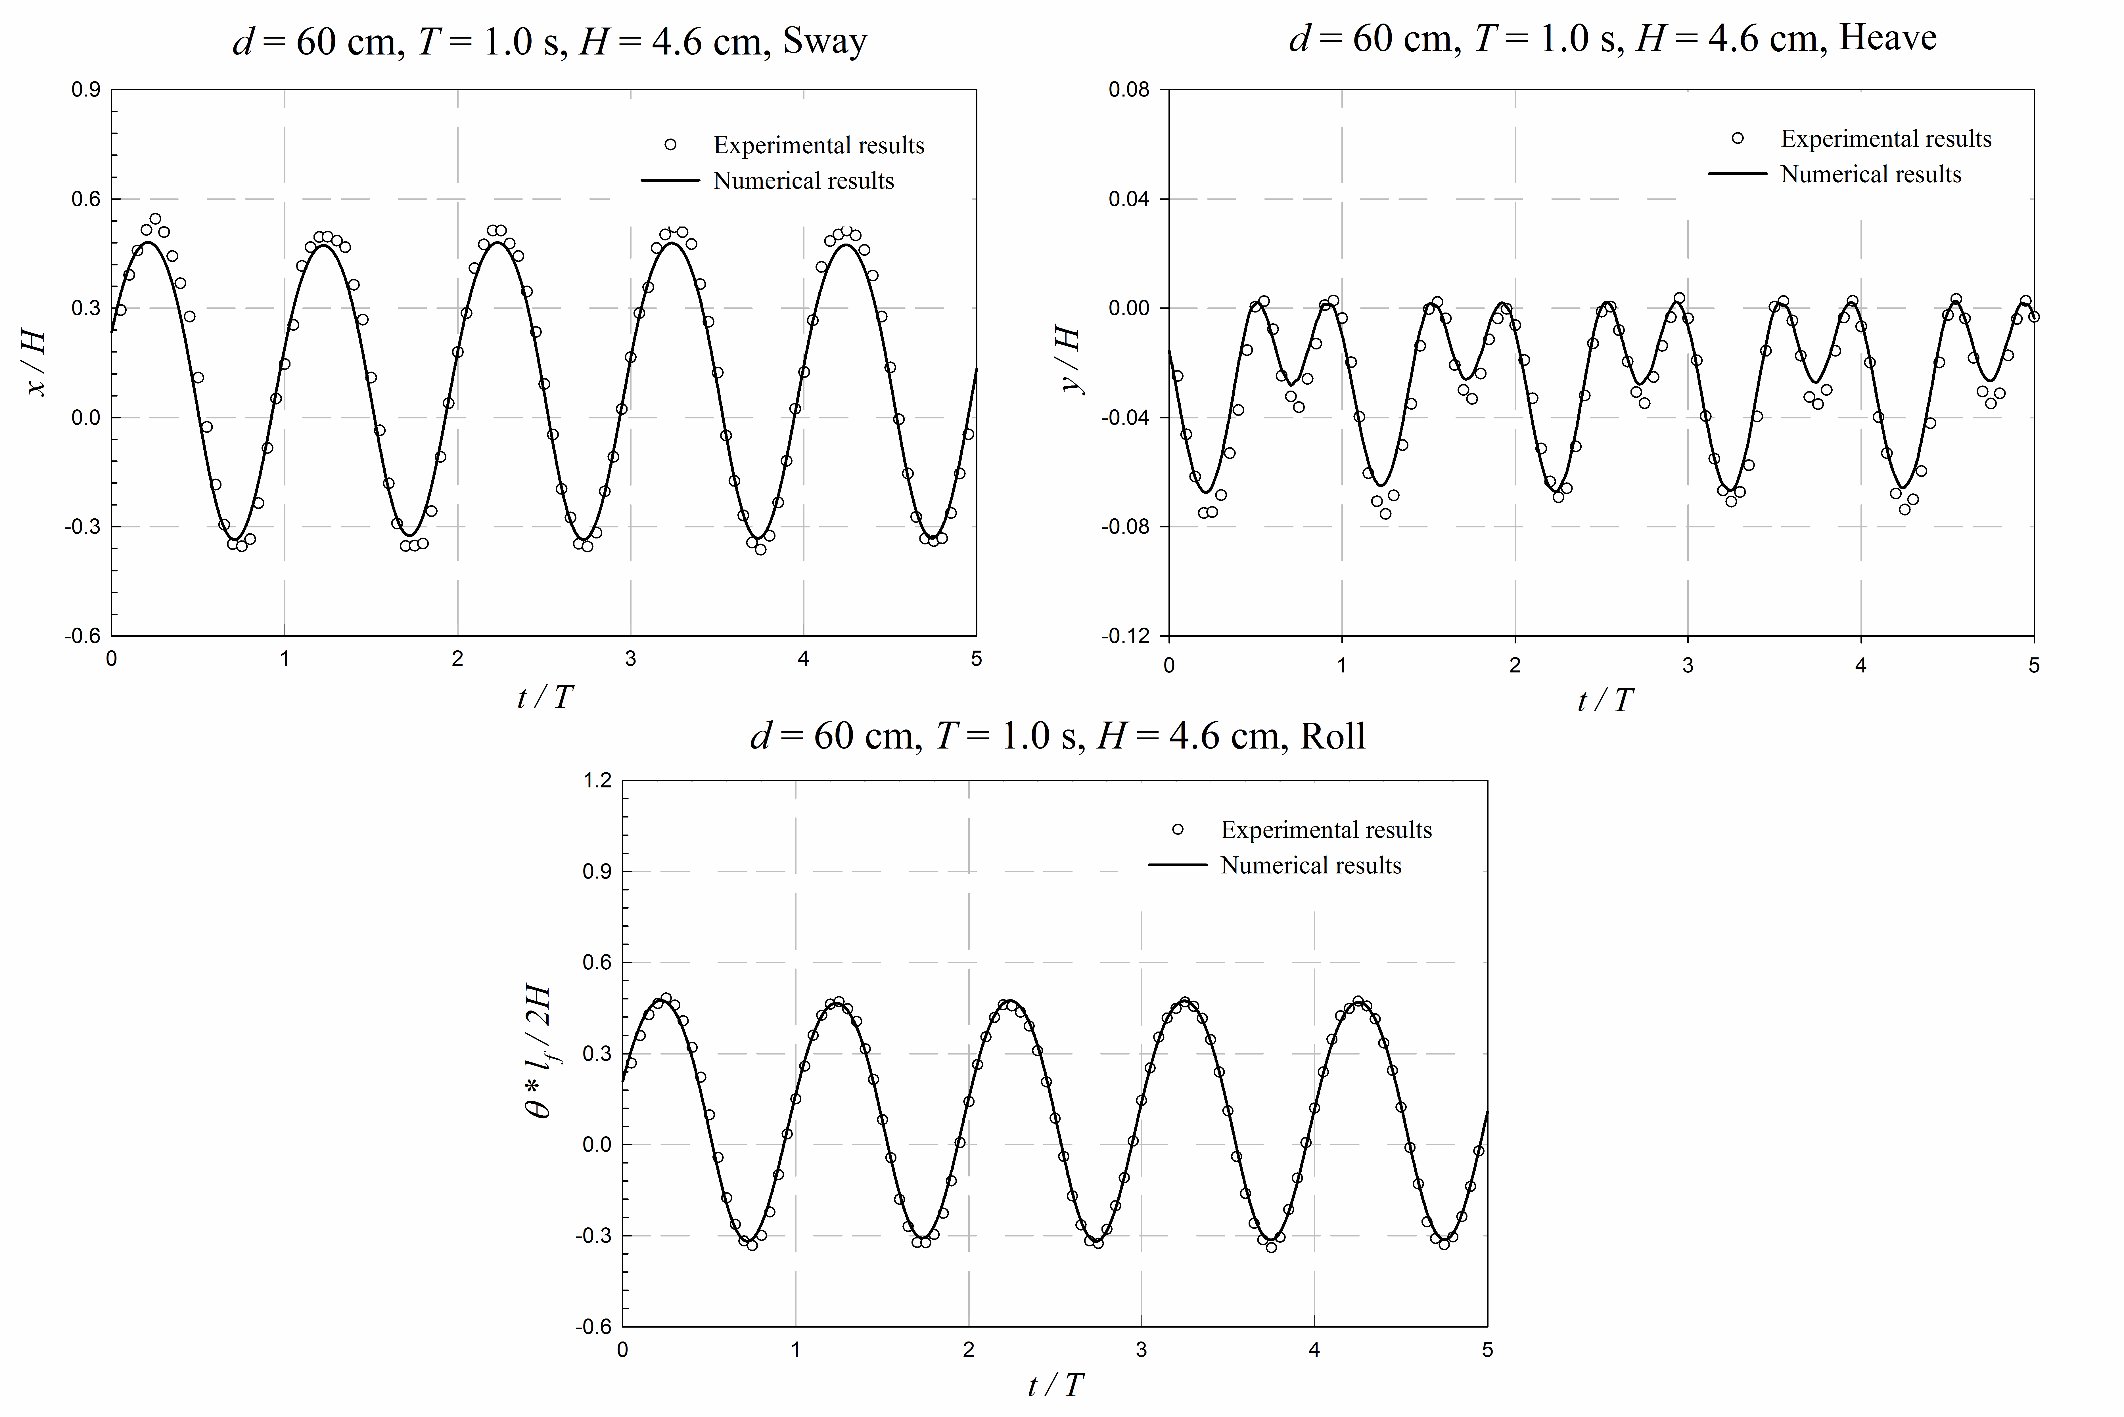

Fig. 8. Comparisons between the numerical and experimental results for the motions of the floating body in three degree of freedom
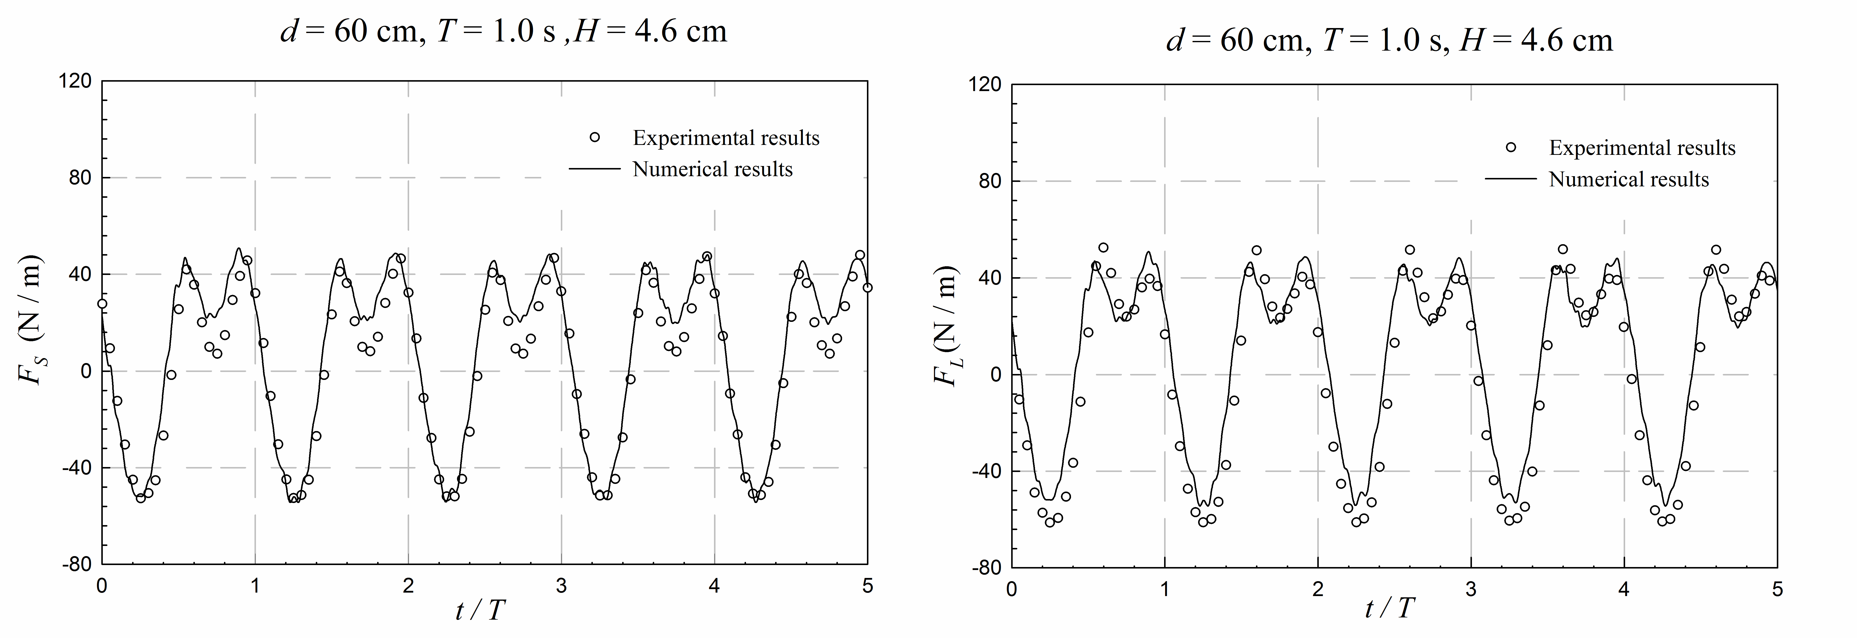

Fig. 9. Comparisons between the numerical and experimental results for the mooring forces
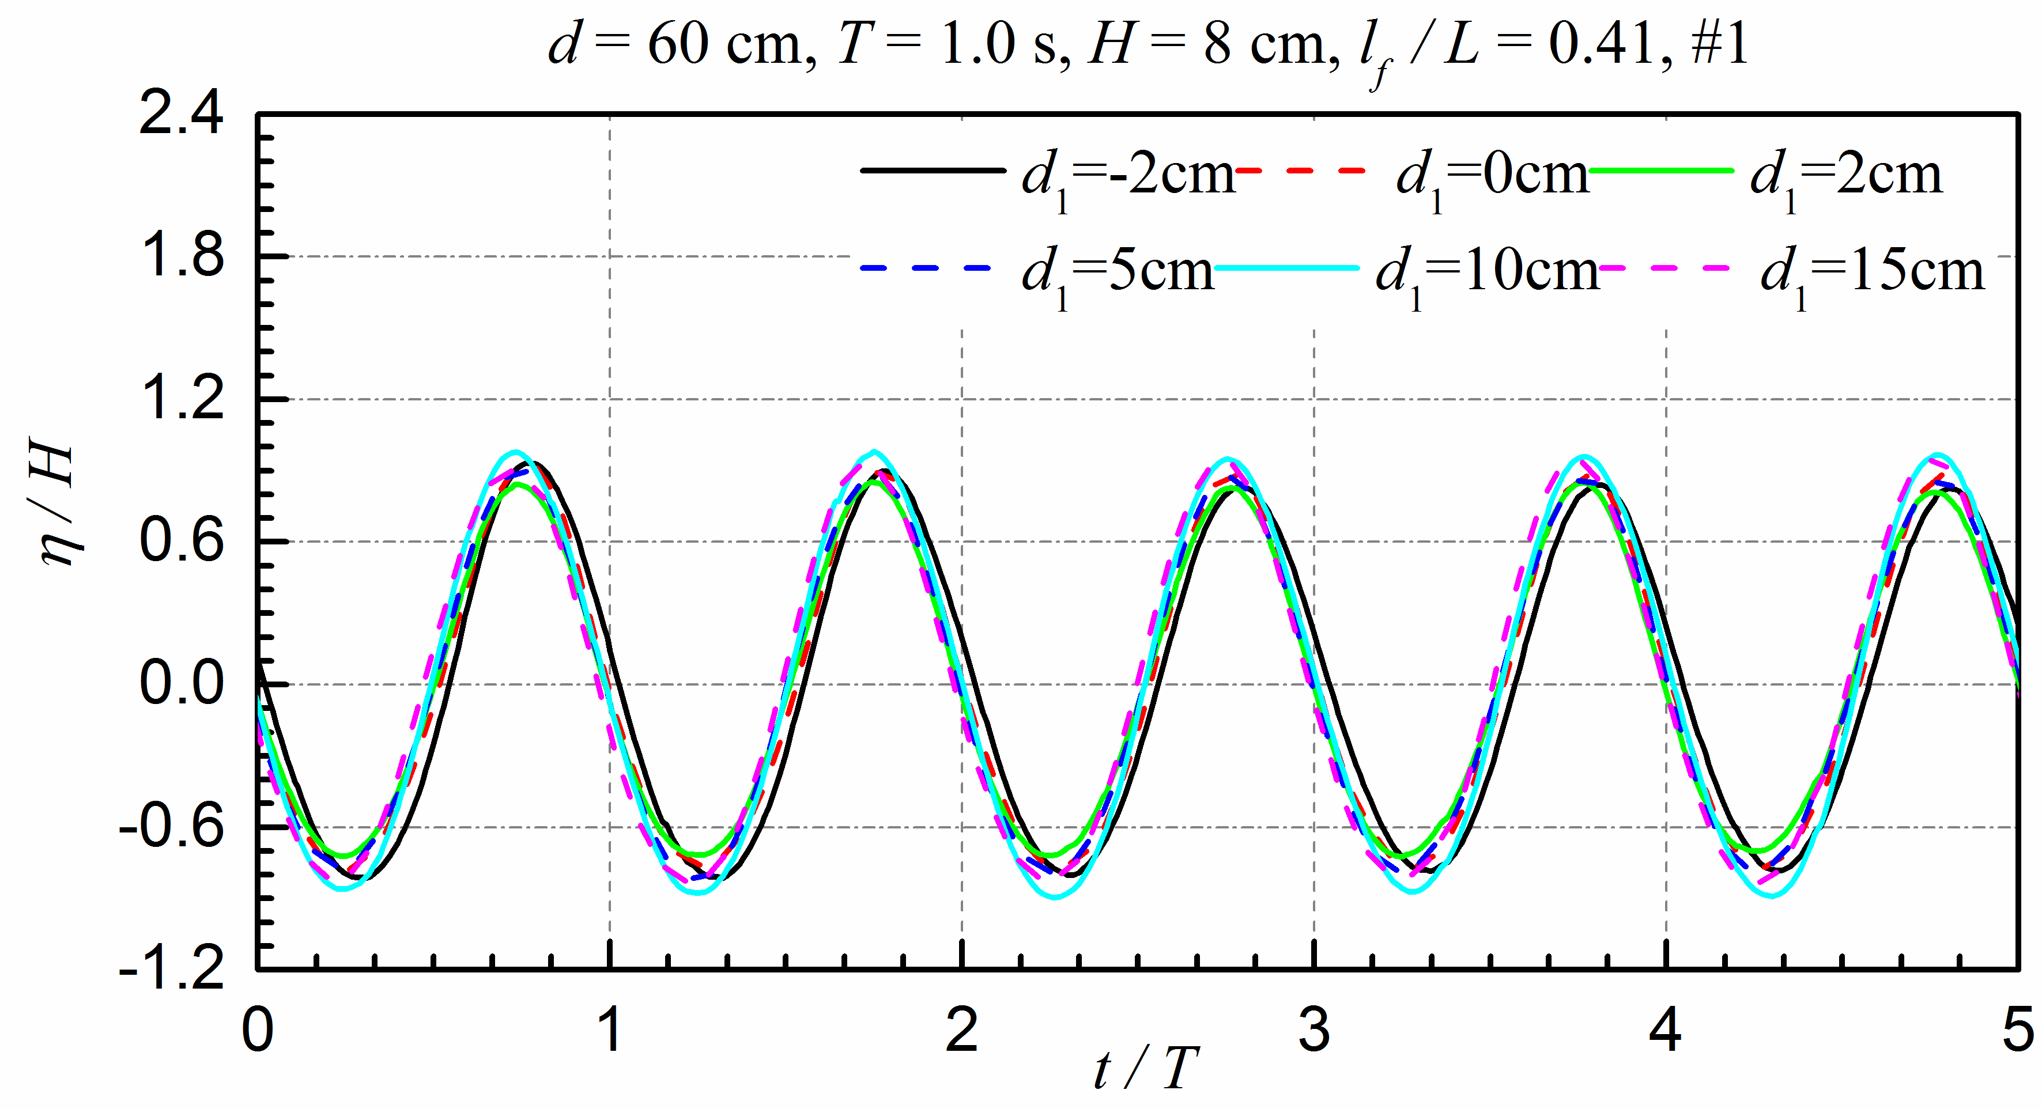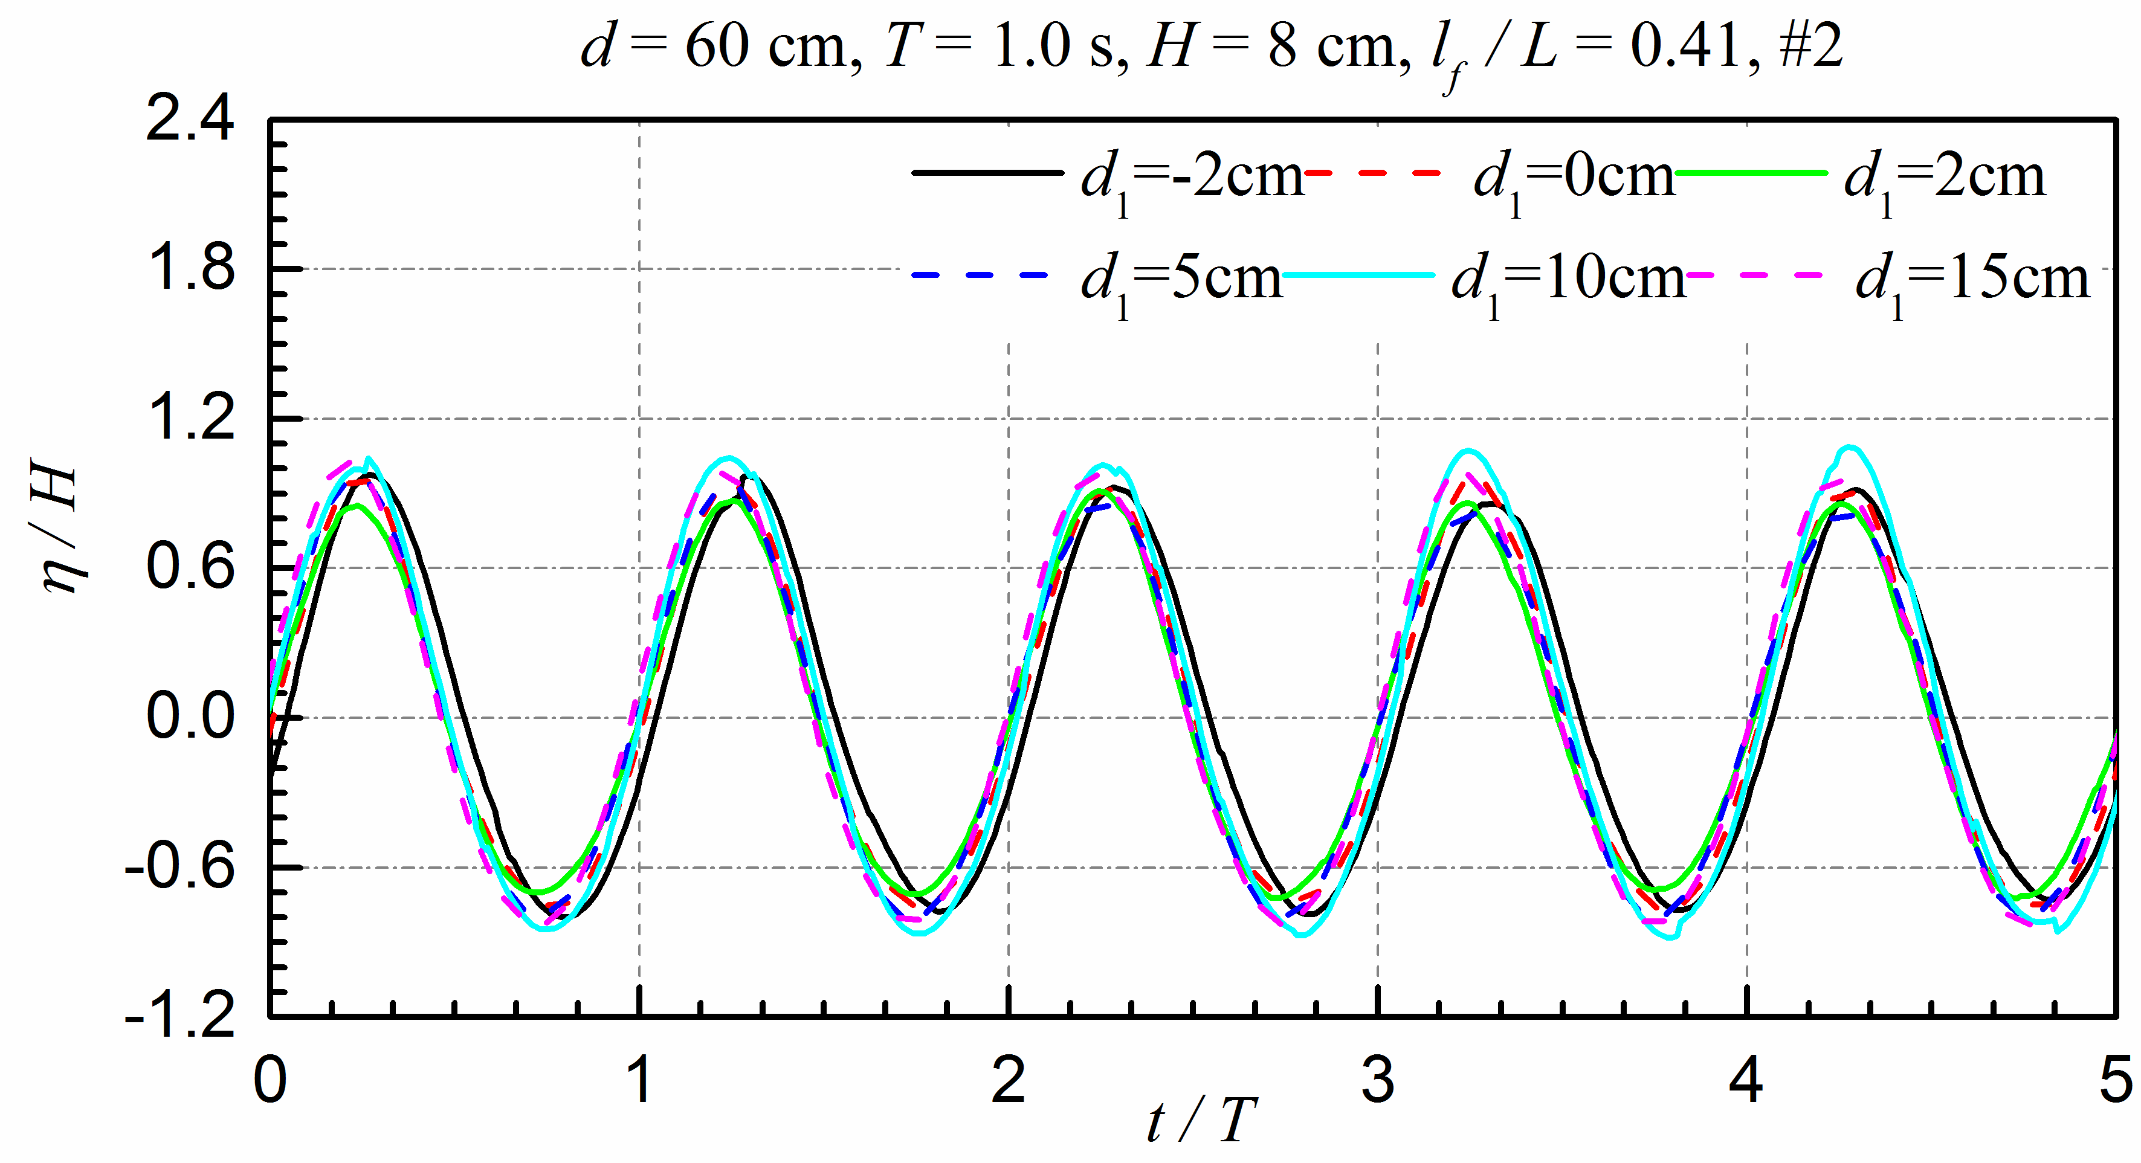
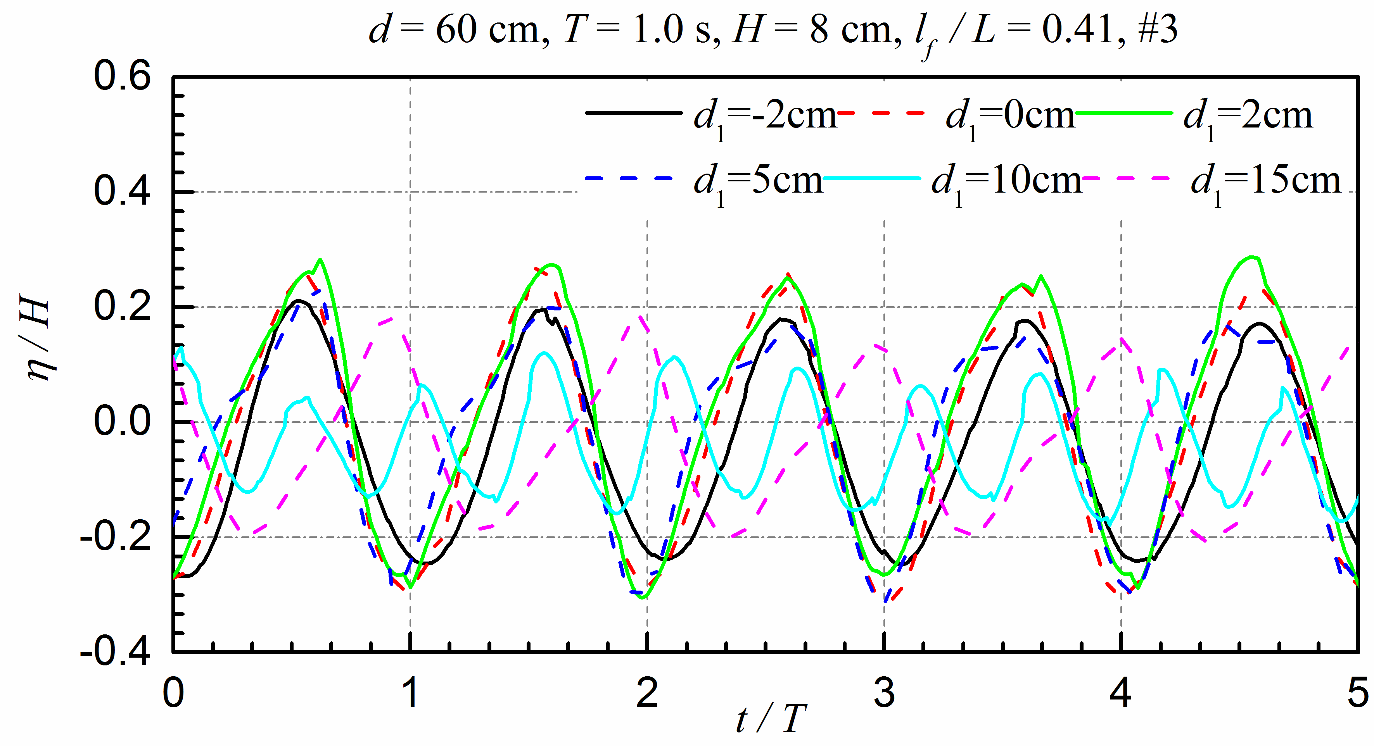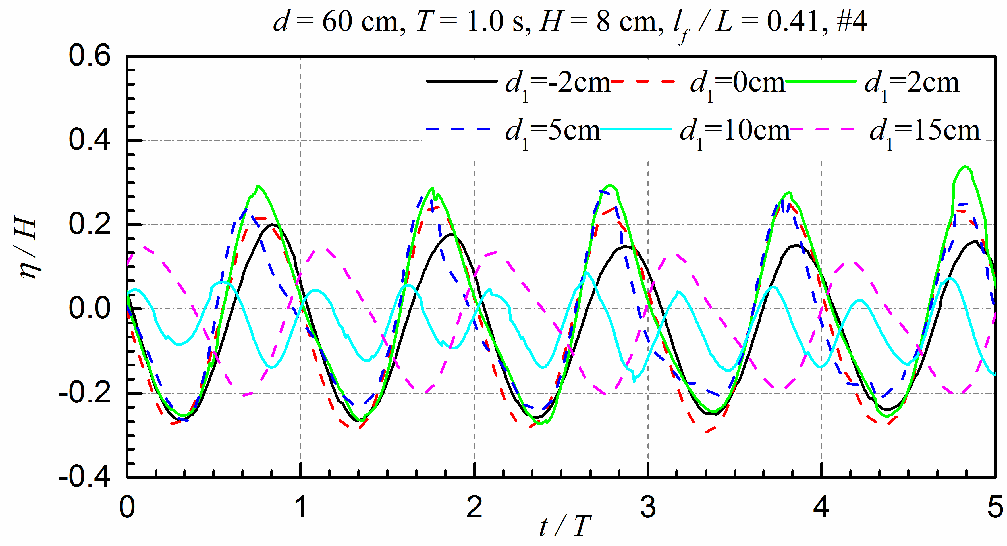

Fig. 10. Time series of the surface elevations for different immersion depths
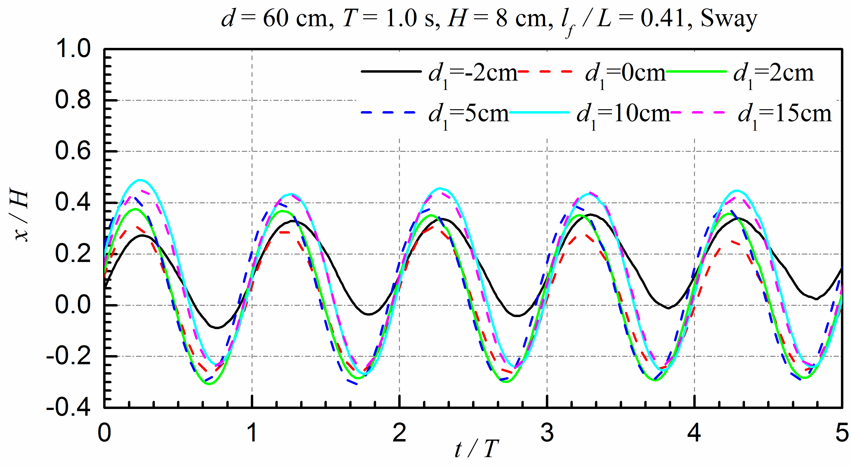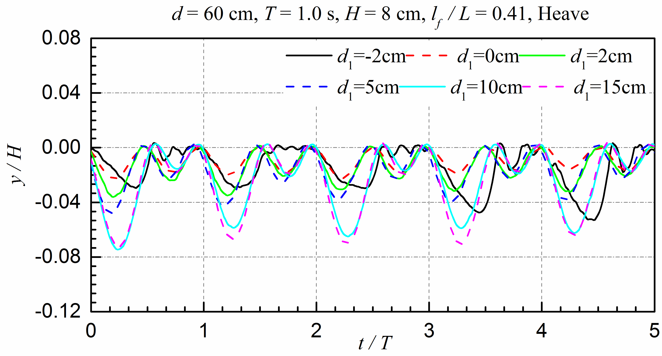
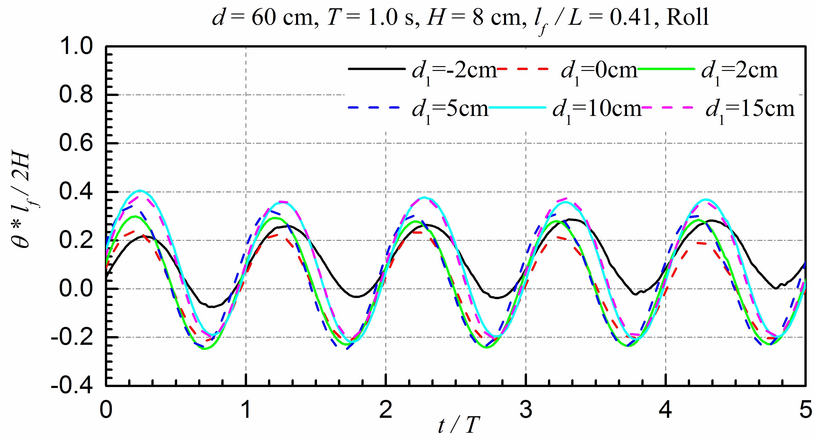

Fig. 11. Time series of the motions of the floating body for different immersion depths
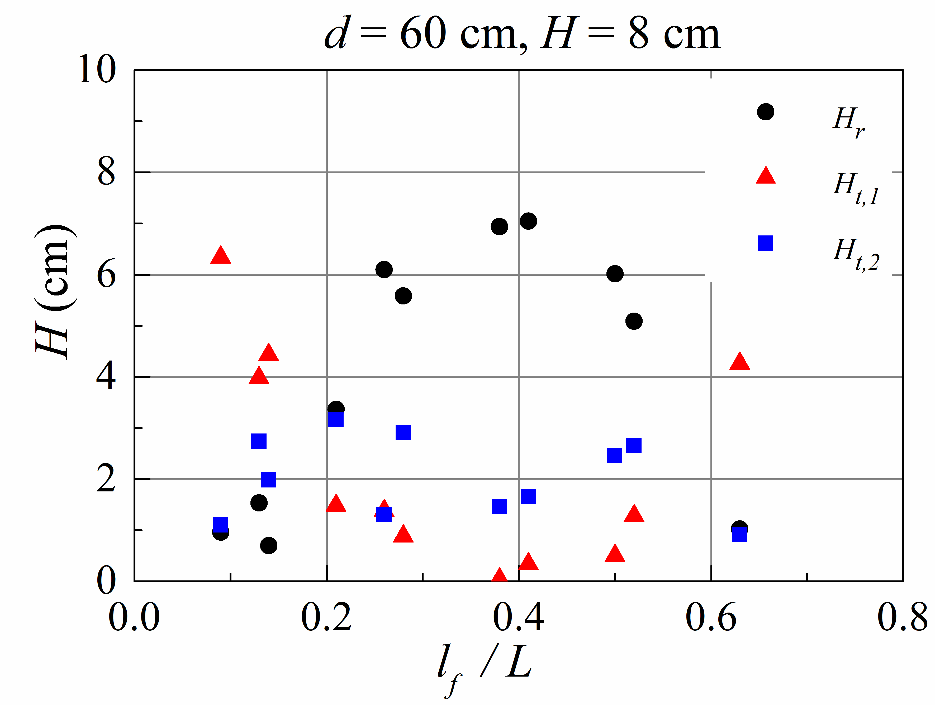

Fig. 12. The reflected waves and the transmitted waves for different relative body lengths
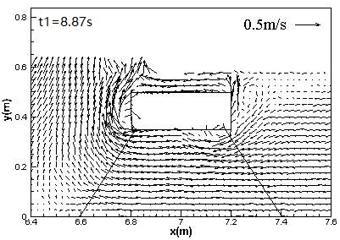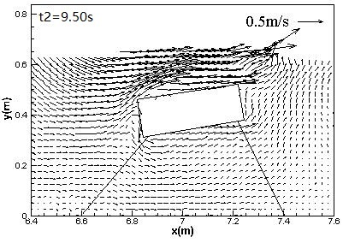
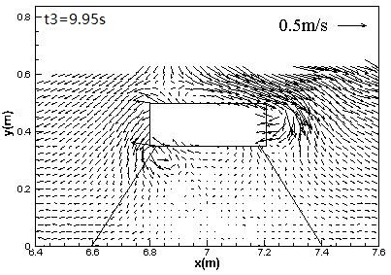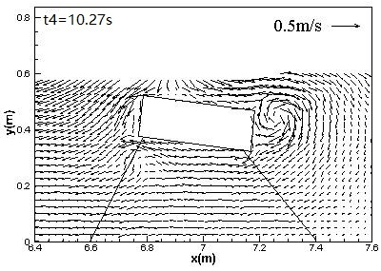
(a) l_{f} = 40 cm, T = 2.0 s, l_{f} / L = 0.09

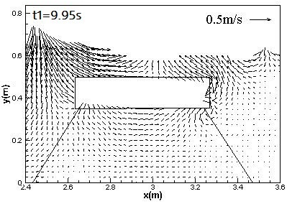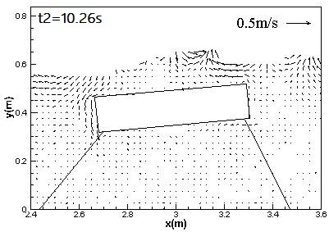
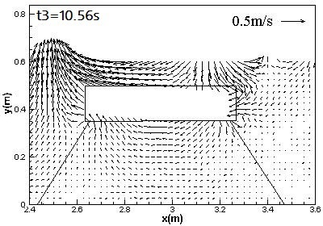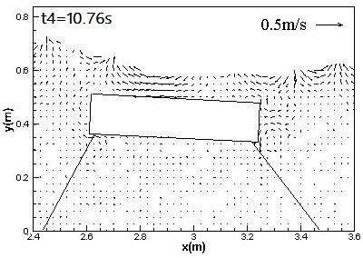
(b) l_{f} = 63 cm, T = 1.0 s, l_{f} / L = 0.41
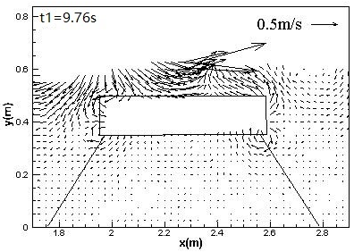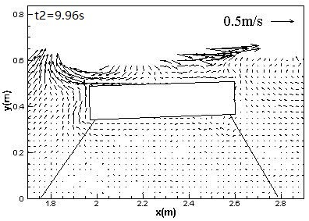
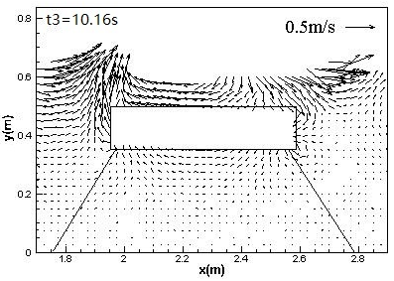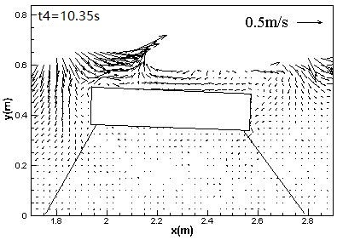
(c) l_{f} = 63 cm, T = 0.8 s, l_{f} / L = 0.63

Fig. 13. Velocity fields at different phases of one wave period for different relative length (ρ = 700 kg/m³, H = 8 cm, d = 60 cm, d₁ = 10 cm)
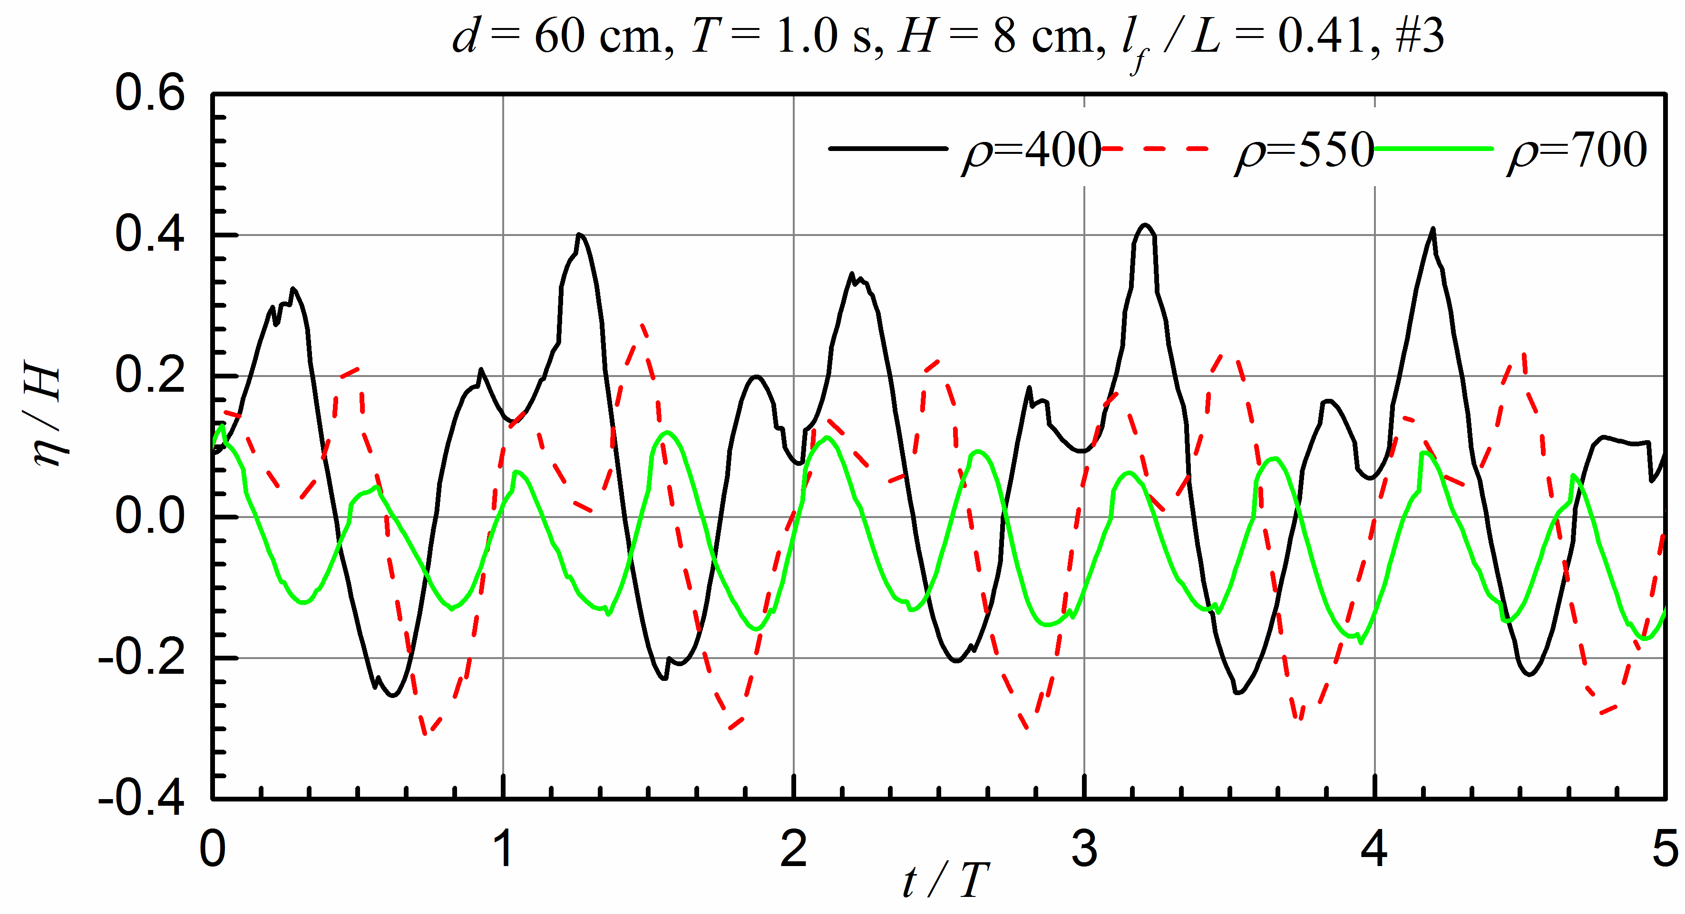

Fig. 14. The wave elevations behind the structures of different density (unit for density symbol: kg/m³)
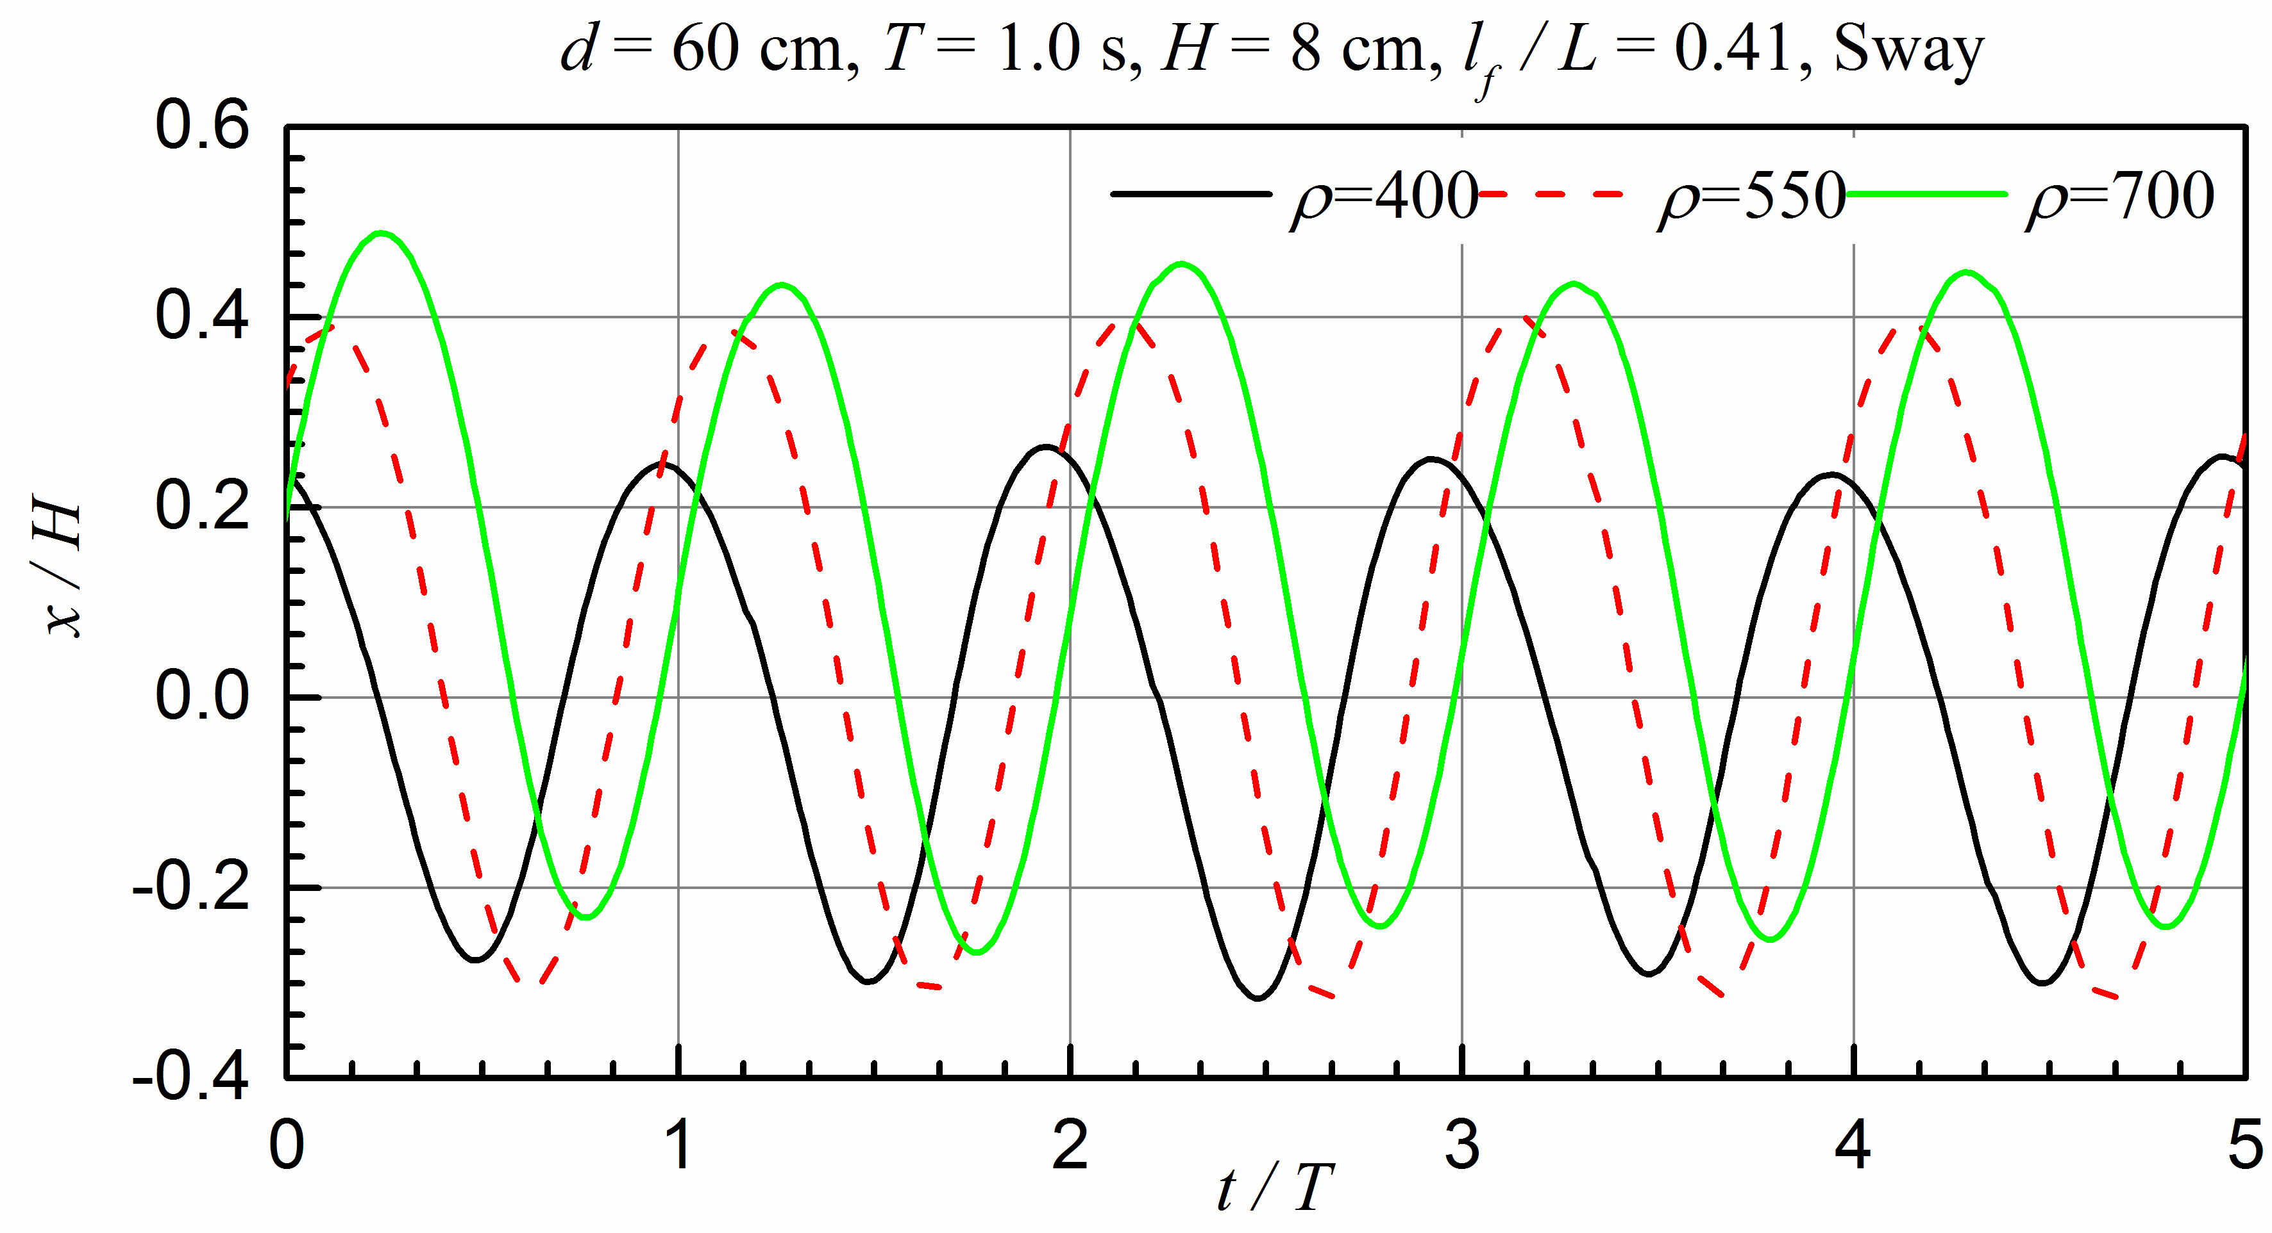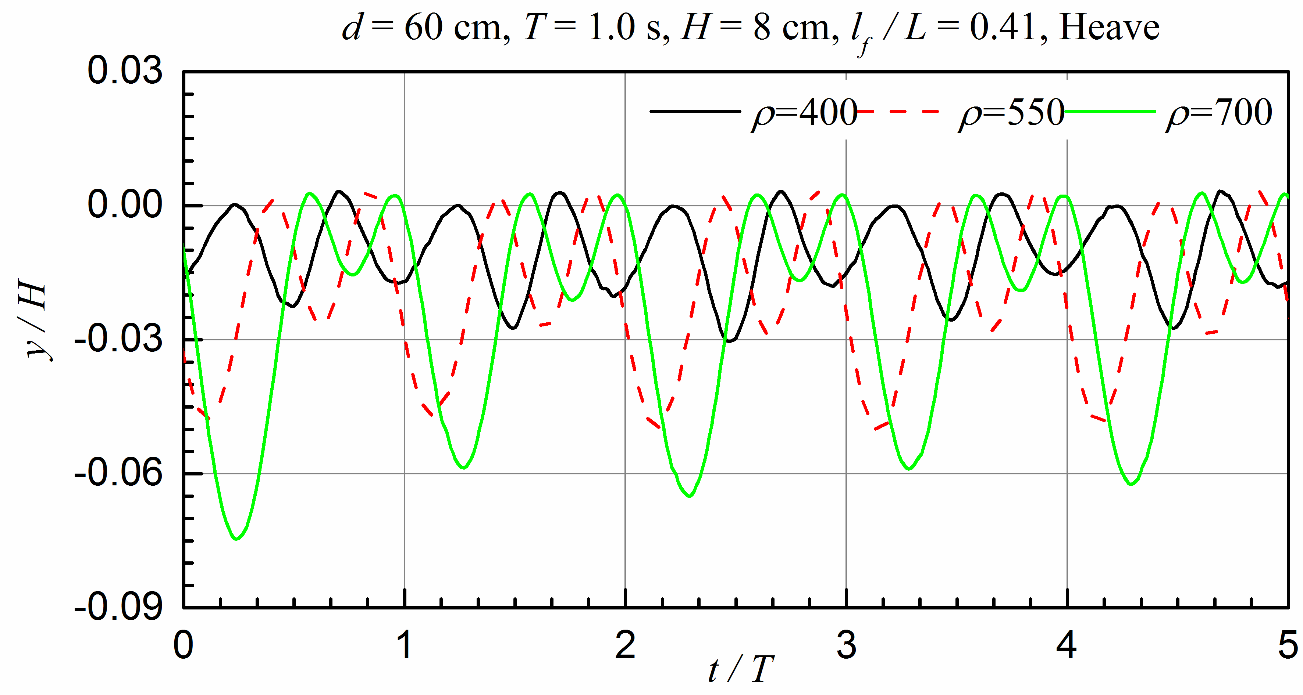
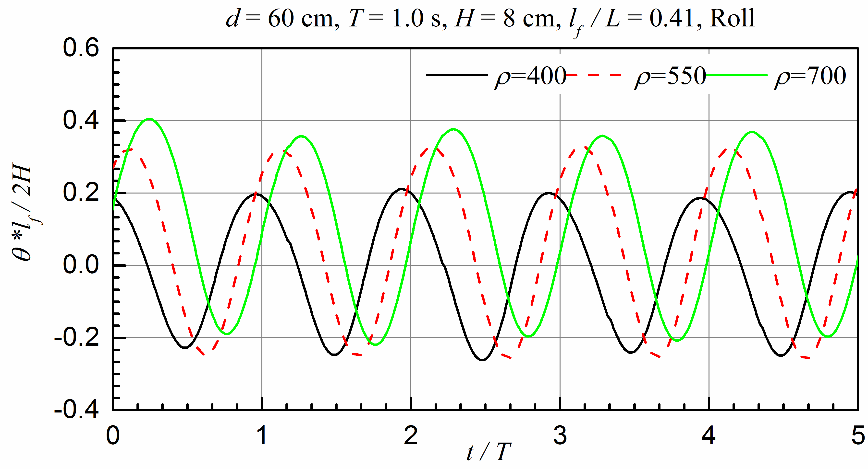

Fig. 15. The motion amplitude of three degrees for the different structures (unit for density symbol: kg/m³)
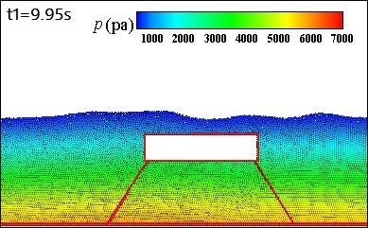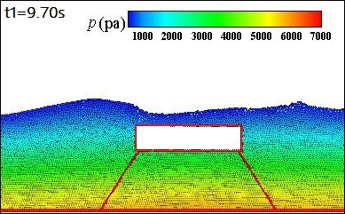
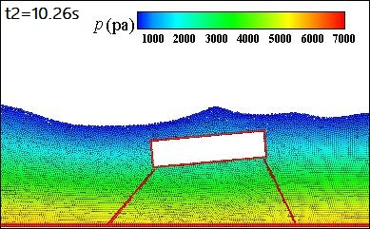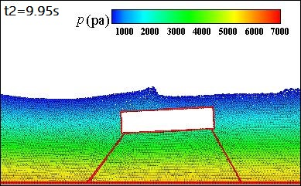
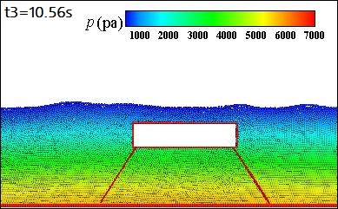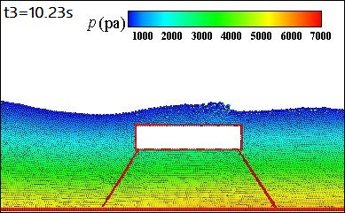
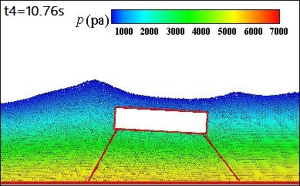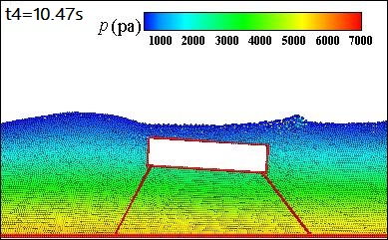
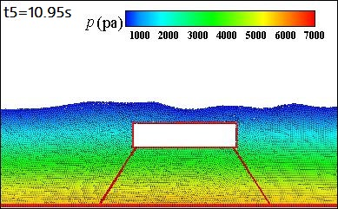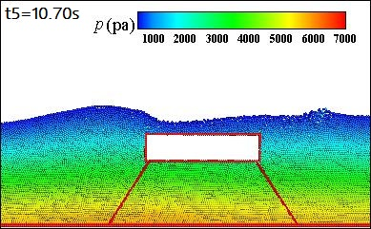

Fig. 16. The pressure fields and particle distribution at different phases of one wave period (Left column: ρ = 700 kg/m³, Right column: ρ = 400 kg/m³)
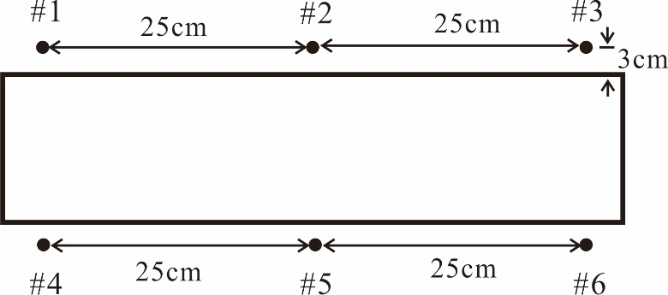

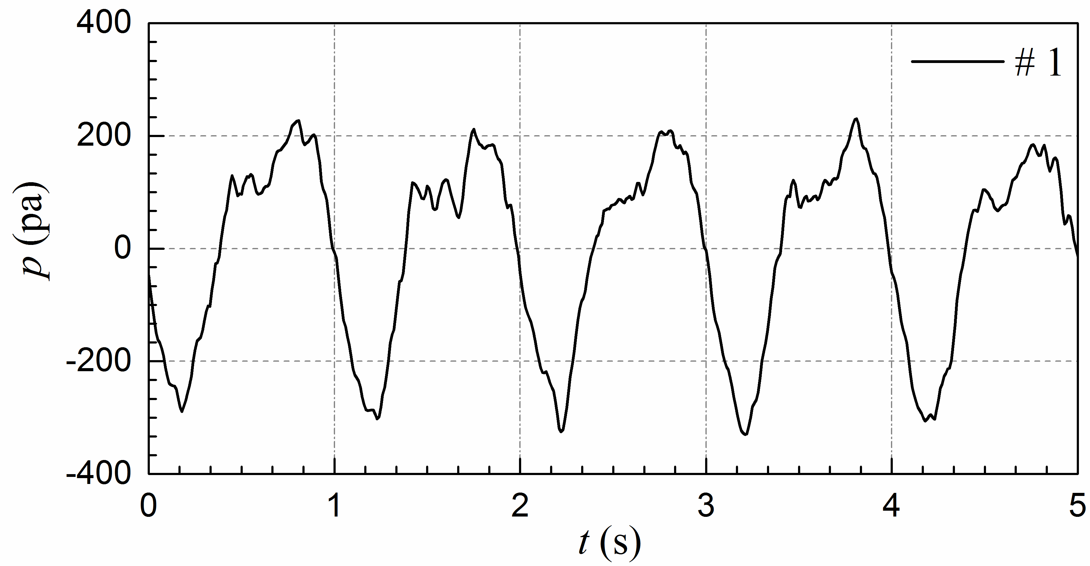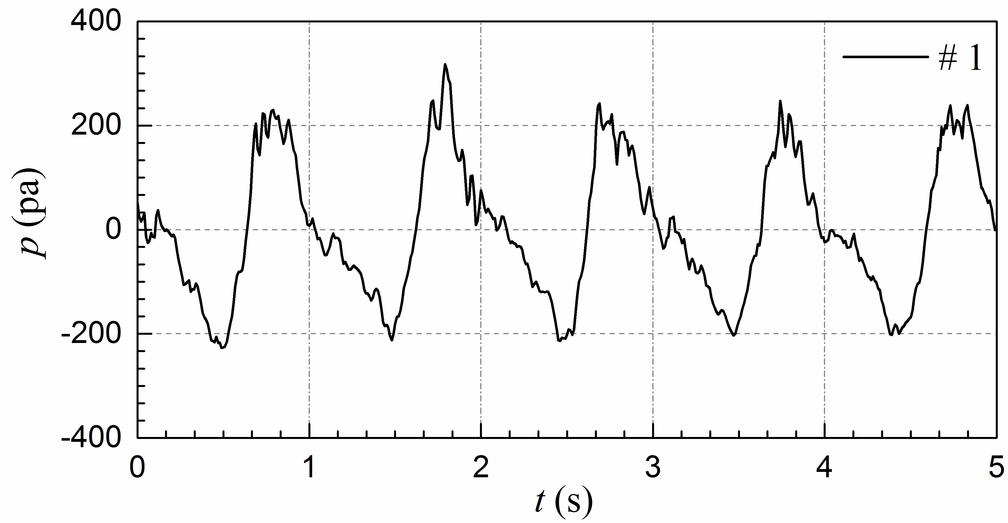
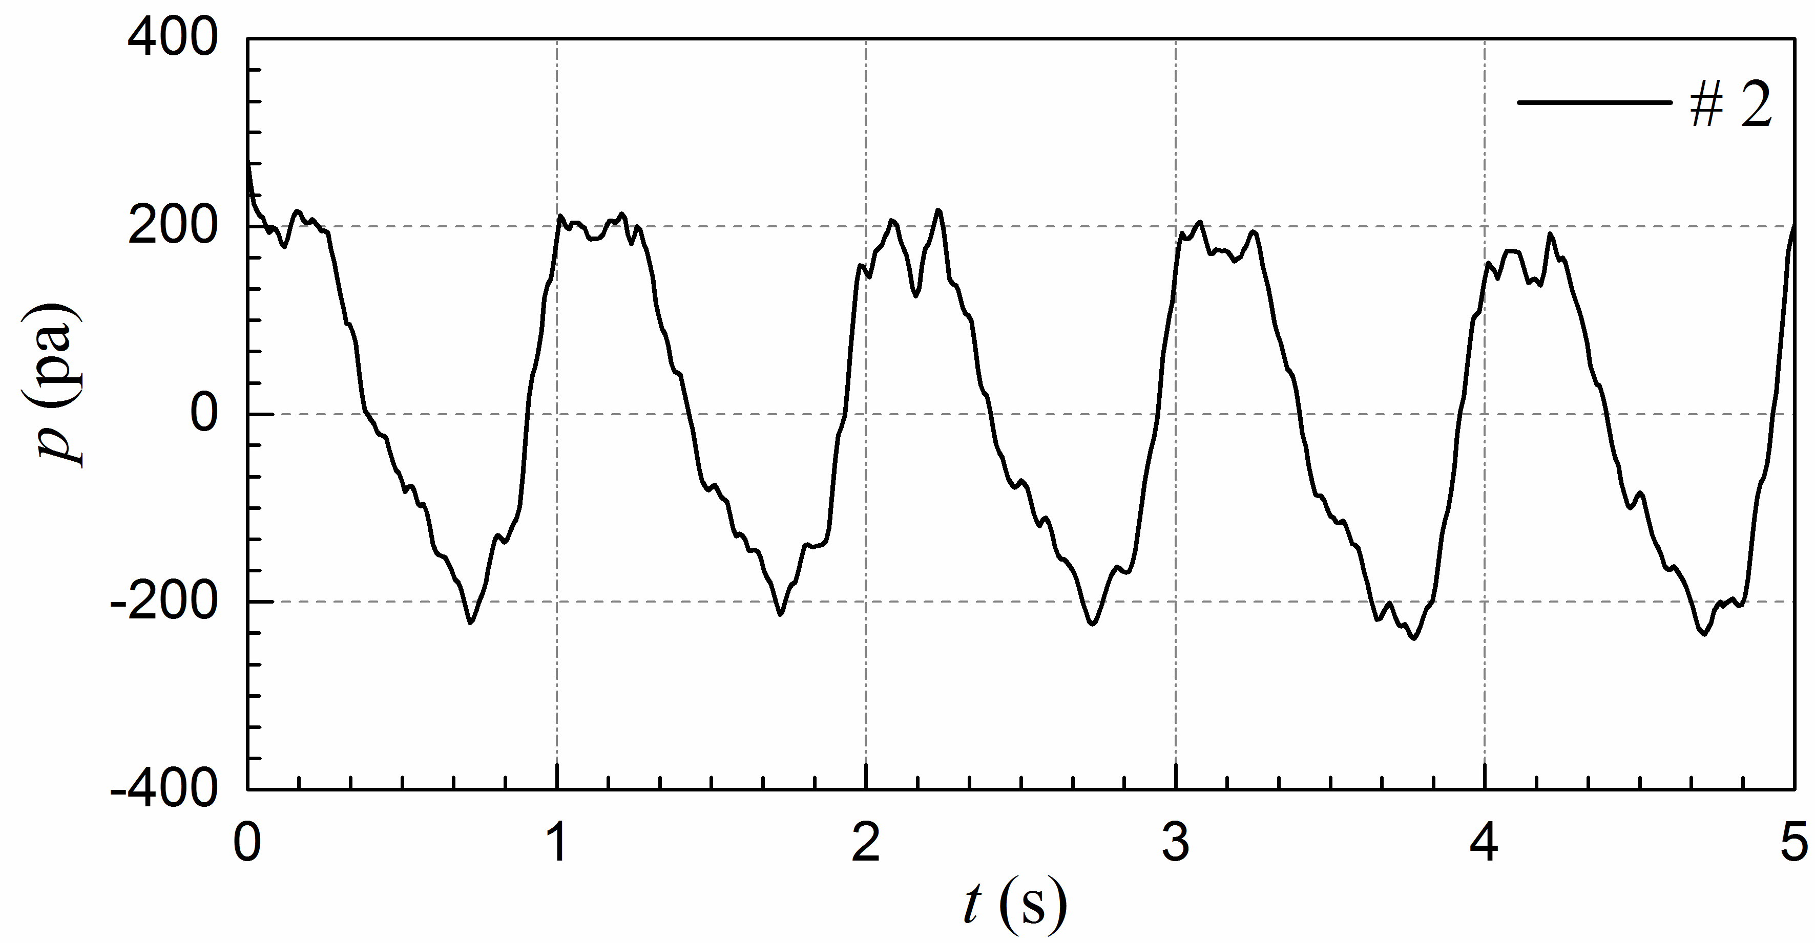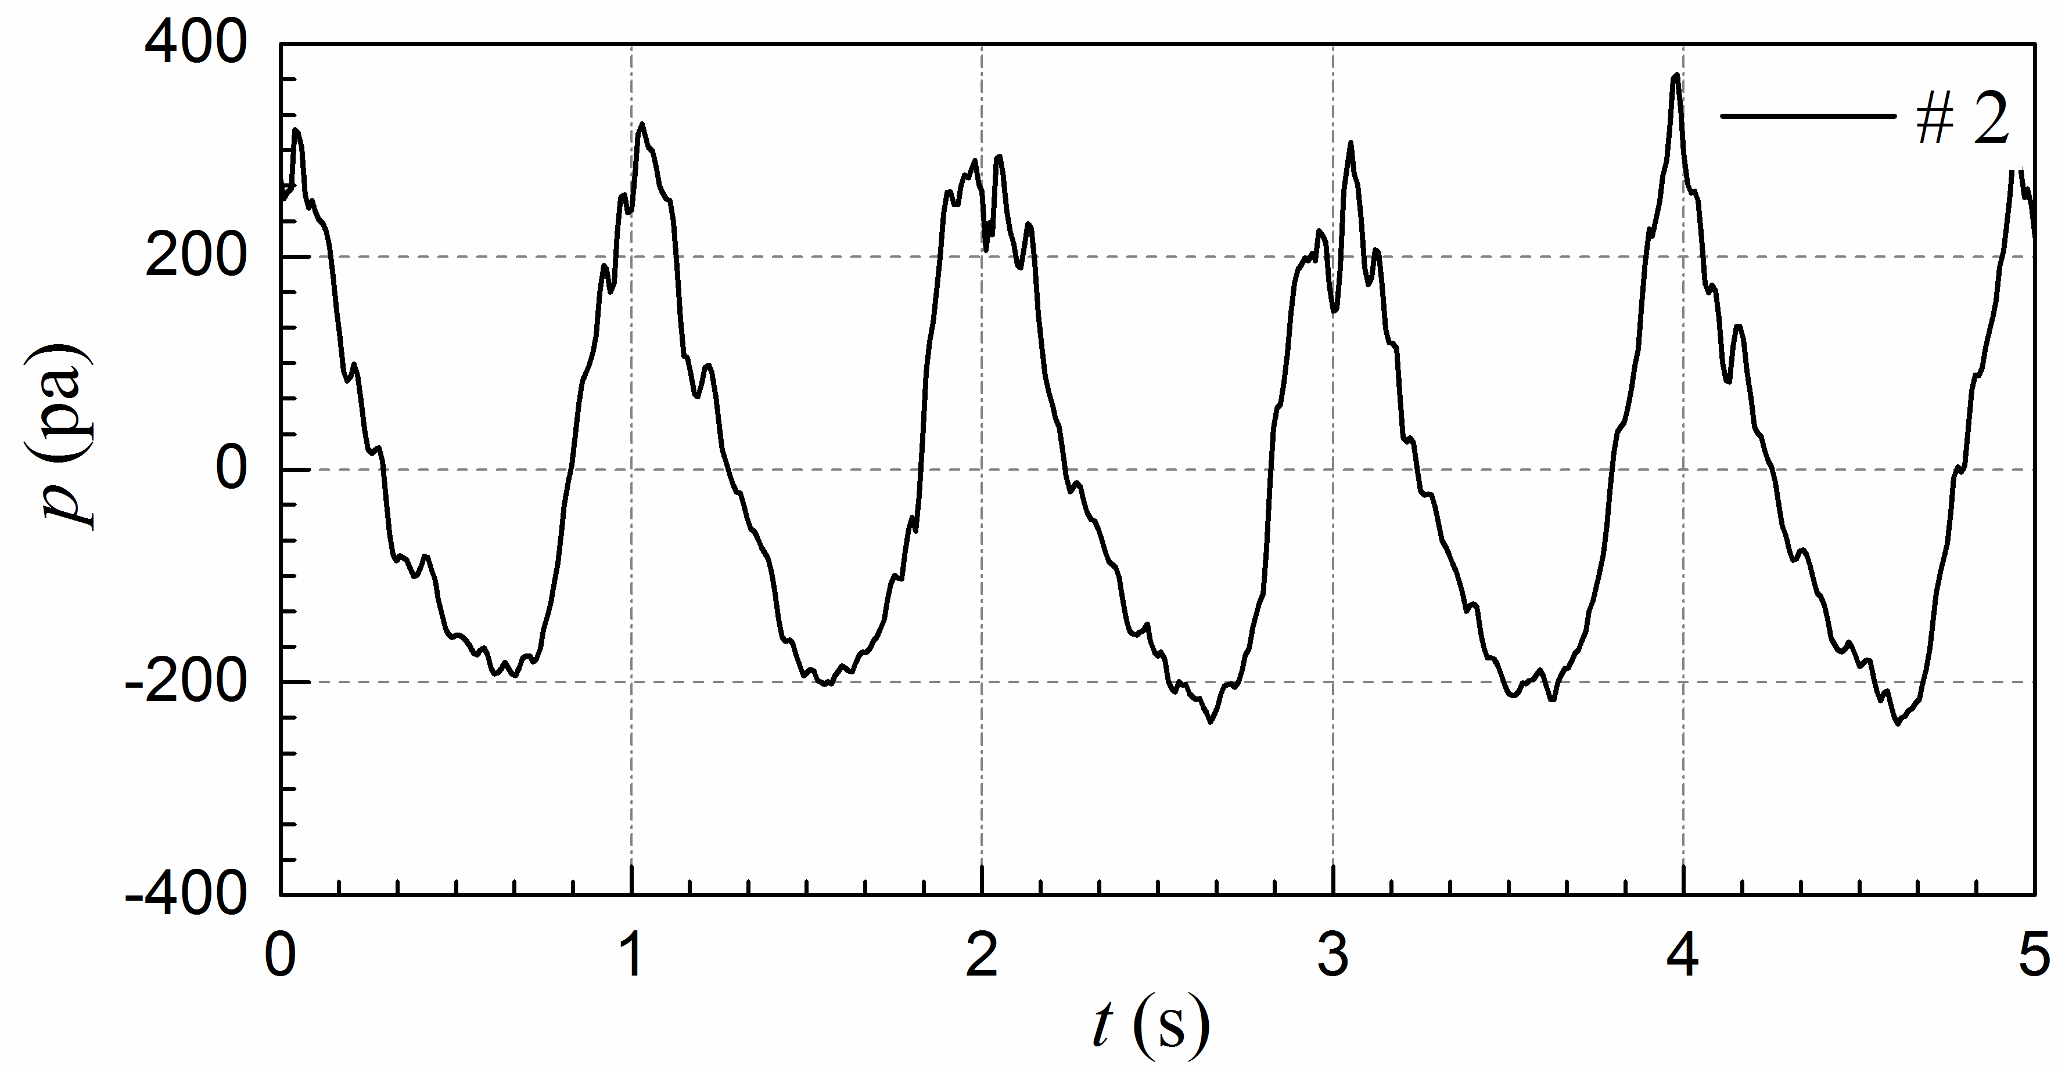
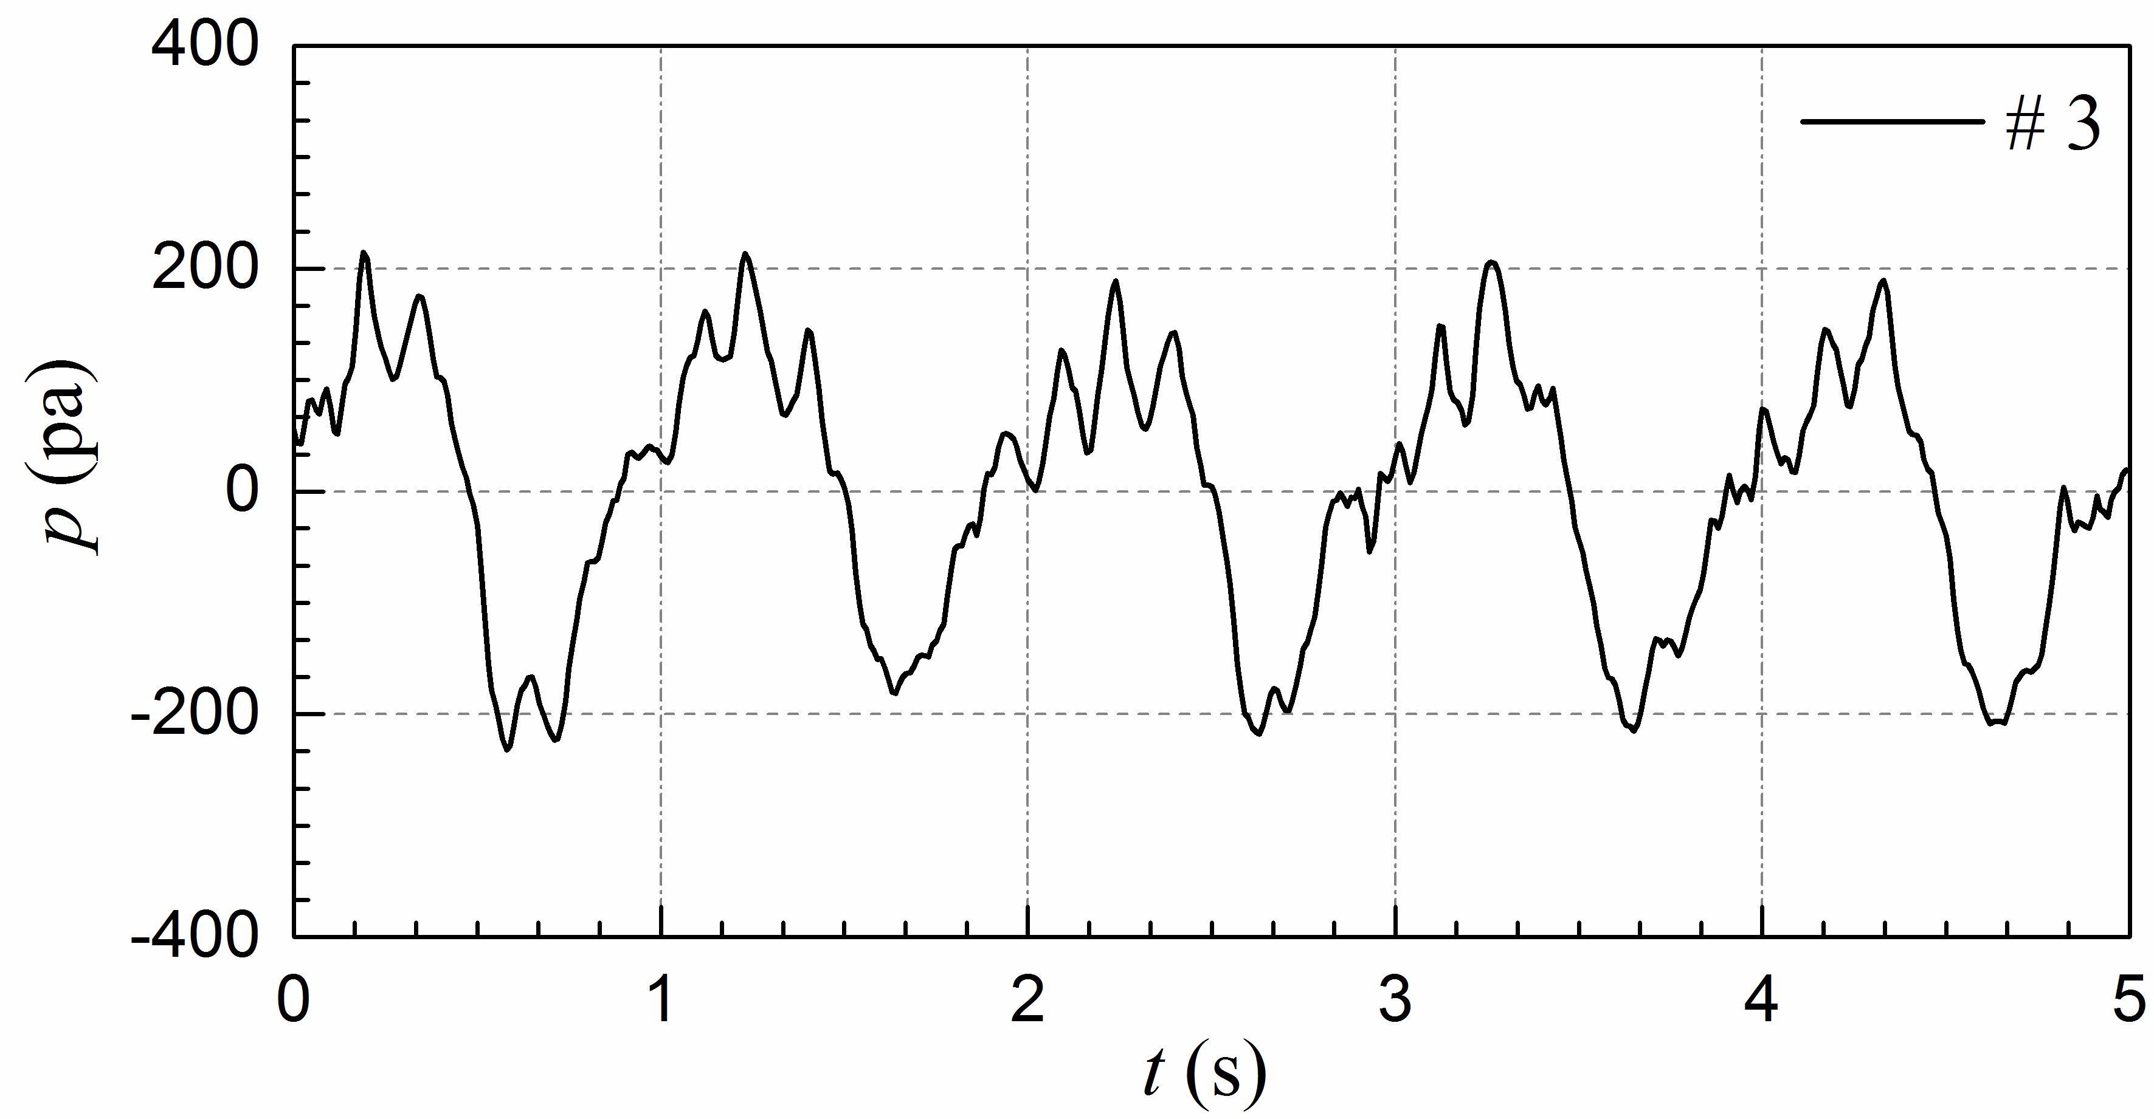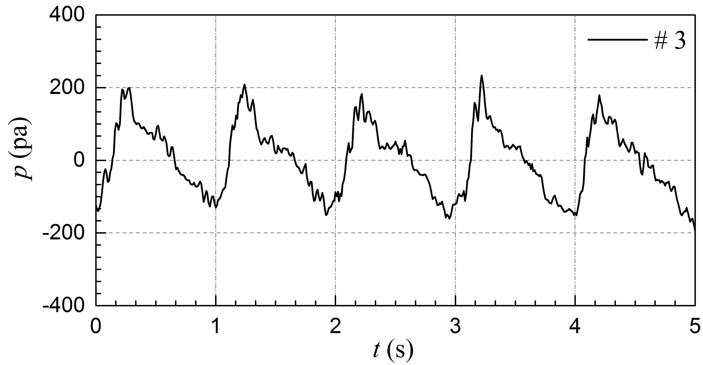
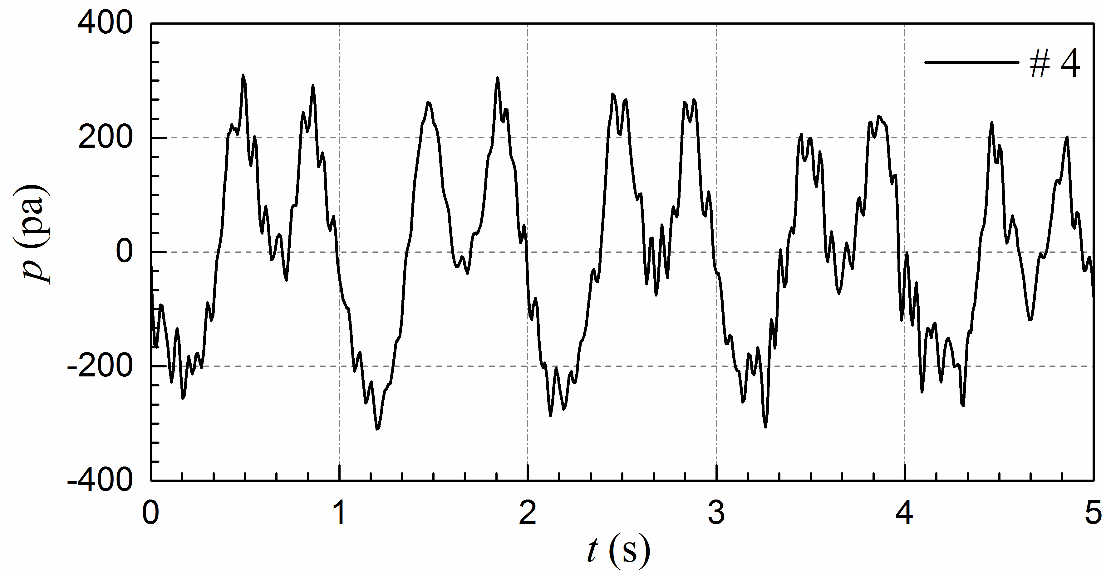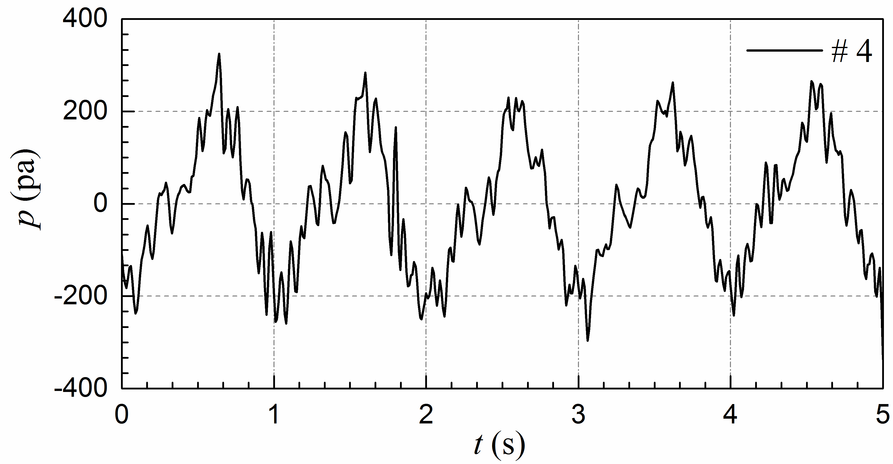
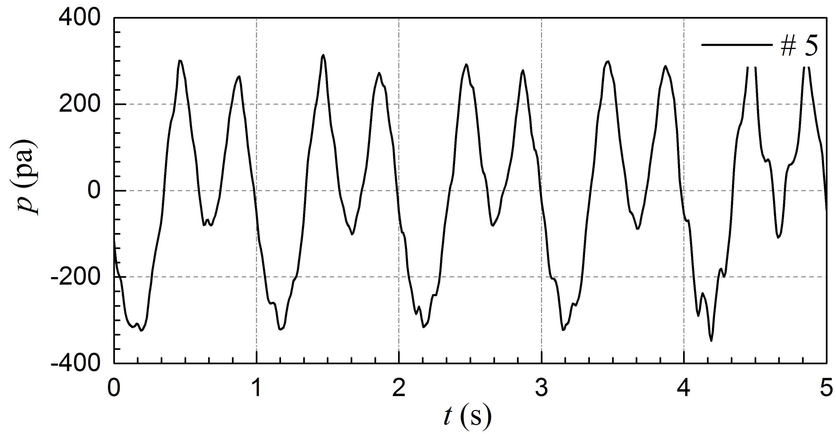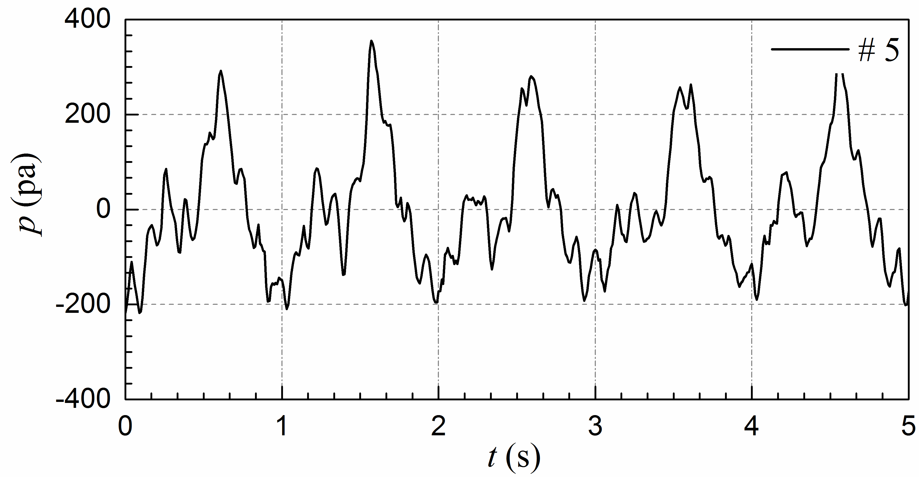
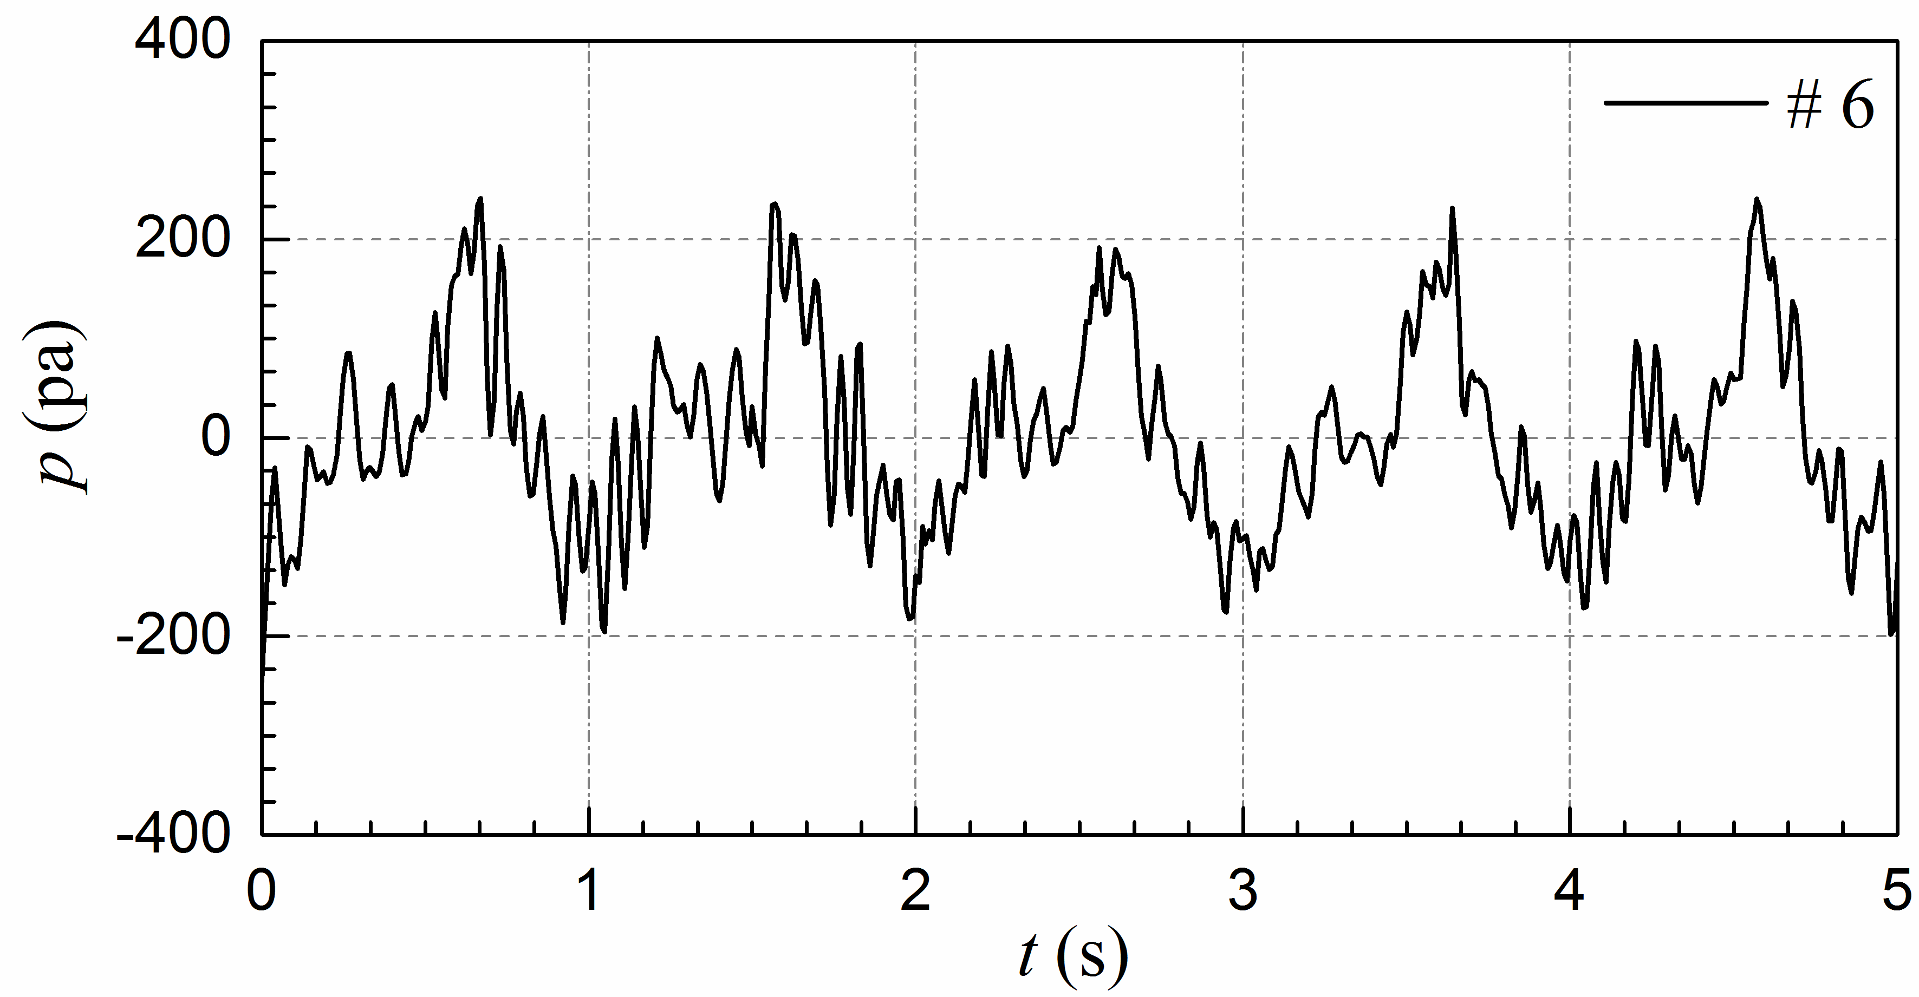

Fig. 17. The time series of the pressures around the structure (Left column: ρ = 700 kg/m³, Right column: ρ = 400 kg/m³)

Corresponding author, Professor, The State Key Laboratory of Coastal and Offshore Engineering, Dalian University of Technology, Dalian 116024, China. E-mail: bren@dlut.edu.cn. Tel.: +8641184706436
Ph.D., The State Key Laboratory of Hydraulic Engineering Simulation and Safety, Tianjin University, Tianjin 300072, China. E-mail: minghetju@163.com
Ph.D. Student, The State Key Laboratory of Coastal and Offshore Engineering, Dalian University of Technology, Dalian 116024, China. E-mail: dutlyb@163.com
Professor, School of Engineering, The Quadrangle, The University of Liverpool, Brownlow Hill, Liverpool L69 3GH, United Kingdom. E-mail: ping.dong@liverpool.ac.uk.

