Efficient SPH Simulation of Time-Domain Acoustic Wave Propagation

Y. O. Zhang a, b, T. Zhang a, c,[[1]](#footnote-1), H. Ouyang d and T. Y. Li a, c

a School of Naval Architecture and Ocean Engineering, Huazhong University of Science and Technology, Wuhan 430074, China

b Department of Mechanical and Aerospace Engineering, University of California, San Diego, La Jolla, CA 92093, USA

c Hubei Key Laboratory of Naval Architecture and Ocean Engineering Hydrodynamics, Huazhong University of Science and Technology, Wuhan 430074, China

d School of Engineering, University of Liverpool, The Quadrangle, Liverpool L69 3GH, UK

**Abstract:** As a Lagrangian meshfree method, smoothed particle hydrodynamics (SPH) can eliminate much of the difficulty in solving acoustic problems in the time domain with deformable boundaries, complex topologies, or those that consist of multiphase systems. However, the optimal value of the computational parameters used in the SPH simulation of acoustics remains unknown. In this paper, acoustic wave equations in Lagrangian form are proposed and solved with the SPH method to compute the two-dimensional sound propagation model of an ideal gas in the time domain. We then assess how the numerical error is influenced by the time step, the smoothing length, and the particle spacing by investigating the interaction effects among the three parameters using Taguchi method with orthogonal array design (OAD) and analysis of variance (ANOVA). On the basis of this assessment, appropriate values for these computational parameters are discussed separately and validated with a two-dimensional computational aeroacoustic (CAA) model. The results demonstrate that the Courant number for the meshless SPH simulation of two-dimensional acoustic waves is proposed to be under 0.4, whereas the ratio of the smoothing length to the particle spacing is between 1.0 and 2.5.

Keywords: acoustic wave equations, SPH, Taguchi method, ANOVA, time domain, meshfree method

MSC: 76M28, 65M12

# 1. Introduction

Numerical methods are widely used in sound wave propagation analysis, and computational acoustics are currently applied in industrial applications such as noise reduction of fans and manufactures, underwater detection, and room acoustics. Many classic numerical methods have been applied in spectral or temporal acoustic simulations; these methods include finite difference method (FDM) [1], finite element method (FEM) [2], boundary element method (BEM) [3], and other modified or coupled methods [4, 5]. However, all of these mesh-based methods require a good-quality mesh generated step before computation, thereby increasing computational costs and human labor.

Meshfree methods [6] have recently attracted considerable interest for modeling acoustic waves with a set of arbitrarily distributed nodes, because these methods can avoid mesh generation and handle acoustic problems with complex geometric boundaries or with large ranges of density. Several meshfree methods have been introduced in acoustic simulation, such as method of fundamental solutions (MFS) [7], multiple-scale reproducing kernel particle method (RKPM) [8], meshless Galerkin least-square (MGLS) method [9], element-free Galerkin method (EFGM) [10], and a number of hybrid methods [11, 12]. Most applications of these meshfree methods are focused on solving the Helmholtz equation, and they can provide very accurate results [13].

In view of its Lagrangian property, the SPH method not only possesses the many advantages of a meshfree method but is also suitable for solving problems with moving or deformable boundaries, multiphase systems, and object separation in the time domain, as demonstrated in recent reviews by Liu et al. [14], Liu and Liu [15], Springel [16], and Monaghan [17]. To date, this method has been successfully applied in many different fields [18-21]. By introducing this method to acoustic simulation, we can utilize its advantages for specific fields, such as combustion noise, bubble acoustics, and sound propagation in multiphase flows. However, the optimal values of computational parameters, like the time step, the smoothing length, and the particle spacing, are still unknown, because the SPH method was just applied to simulate sound waves in recent years.

The SPH method was first independently pioneered by Lucy [22], and Gingold and Monaghan [23] in 1977 to solve astrophysical problems. The method computes results using a set of particles possessing individual material properties. The first attempt at simulating sound waves was realized by solving fluid dynamic equations in 2008 [24] and then a similar work was given in 2009 [25].

However, for various acoustic waves in engineering problems, acoustic variables such as the variation in pressure, density, and velocity are generally small. On the contrary, the values of pressure, density, and velocity exist on a much larger scale than any variation in these variables, as shown in chapter 1 in [26]. Consequently, solving acoustic wave equations requires a lower computational burden compared to solving the fluid dynamic equations to simulate acoustic waves, and this approach had been widely used in modeling engineering problems [25-29]. Considering this fact, we solved the acoustic wave equations, and gave some one-dimensional tests, like the sound propagation and interference model [30, 31], the sound reflection model [32]. The SPH simulation results show good agreement with theoretical solutions. But the computational parameter values for acoustic simulation have not been discussed in any research, and only one-dimensional model was given in literatures. Therefore, this paper focuses on discussing optimal values of three computational parameters, namely the time step, the smoothing length, and the particle spacing, for SPH simulation of two-dimensional acoustic waves based on the Taguchi method with considering the interactions among different parameters.

Taguchi method [33], also known as the orthogonal array design (OAD), is applied for the evaluation of different computational parameters in the present paper. This method uses a special design of orthogonal arrays to study the entire parameter space with only a small number of experiments [34], and the analysis is always given with the analysis of variance (ANOVA) techniques. As an optimization method, Taguchi method had been used in the parameter optimization of finite element model [35], the engineering design [36], the evaluation of combined effects of different parameters [37] et al. Experiments for analysis in this paper are numerical experiments modeling with the SPH method.

The present paper is organized as follows. In Section 2, the acoustic wave equations in Lagrangian form are given and solved using the standard SPH theory. In Section 3, a two-dimensional sound propagation model is tested to validate the SPH acoustic formulations, and the significance of different computational parameters and the interactions among them are analyzed using Taguchi method and ANOVA techniques. In Section 4, suitable values of these computational parameters with significant effects are discussed based on the Taguchi result. After that, a two-dimensional computational aeroacoustic (CAA) model is computed to verify the optimized parameters in Section 5, while Section 6 summarizes the results of this work.

# 2. SPH formulations of acoustic waves

## 2.1 Basic concepts of SPH

Functions in the SPH method are represented in a particle approximation form. Some basic concepts [38] are shown in this section.

A function *f* (***r***) can be represented as

 (1)

where *f* is a function of the vector ***r***,  is the volume of the integral, *W* is the smoothing kernel, and *h* is the smoothing length. The kernel approximation operator is marked by the angle bracket <>.

The particle approximation for the function *f* (***r***) at particle *i* can be written as

 (2)

where *ri* and *rj* are positions of particles *i* and *j*, *N* is the number of particles in the computational domain, *mj* is the mass of particle *j*, , and ***r****ij* is the distance vector from particle *i* to particle *j*.

Similarly, to substitute  with , the spatial derivative  is obtained as

 (3)

where .

The cubic spline function given by Monaghan and Lattanzio [39] is used as the smoothing kernel in the present paper.

## 2.2 Acoustic wave equations in Lagrangian form

In fluid dynamics, the fluid motion is defined by using the laws of continuity, momentum and energy. The equation of continuity in Lagrangian form, as shown in Chapter 4 of [38], is

 (4)

where  is the fluid density and  is the flow velocity associated with a fluid particle at time *t*, superscript L stands for the Lagrangian variable associated with a fluid particle. The Lagrangian derivative [40] is defined by

 (5)

The simplest and most common acoustical problem occurs when body forces are not significant and the medium is characterized as inviscid and thermally nonconducting. In this case, the equation of momentum in Lagrangian form is

 (6)

where *P*L is the instantaneous pressure of a fluid particle at time *t*.

Now suppose, on one hand, the medium is lossless and at rest, so an energy equation is unnecessary; on the other hand, a small departure from quiet conditions occurs, expressed in writing

 (7)

 (8)

 (9)

where  is the quiescent density which does not vary in time and space,  is the change in density,  is the quiescent pressure,  is the sound pressure, and all these variables are associated with a fluid particle; *c*0 is the speed of sound.

In Eqs. 7-9, the inequalities at the right mean that , , and  are taken to be “small quantities of first order”. Substitute these expressions into the continuity and the momentum equations (Eq. 4 and Eq. 6):

 (10)

 (11)

The continuity and momentum equations governing sound waves are obtained

 (12)

 (13)

The state equation for ideal gas as shown in Chapter 2 of the book [41] is written in a Lagrangian form

 (14)

## 2.3 SPH formulations of acoustic waves

### 2.3.1 SPH formulation of the continuity equation

Applying the SPH particle approximation equation (Eq. 3) to the continuity equation (Eq. 12) yields

 (15)

Noting the gradient of the unity can be written as

 (16)

which can also be expressed as

 (17)

Adding the right part of Eq. 17 into Eq. 15 yields

 (18)

where ***u****ij* = ***u****i* – ***u****j*.

As noted earlier, , the particle approximation equation of the continuity of acoustic waves used in the present paper is written as

 (19)

Considering the assumptions of the lossless medium at rest (Eq. 7), another SPH formulation of the continuity equation can be obtained as

 (20)

### 2.3.2 SPH formulation of the momentum equation

Applying the SPH particle approximation equation (Eq. 3) to the momentum equation (Eq. 13), it appears as

 (21)

According to Eq. 16, the following identity can be obtained

 (22)

Adding Eq. 22 into Eq. 21 yields

 (23)

Using equations  and , SPH formulation of the momentum equation can be written as

 (24)

Considering the following equation

 (25)

and applying the particle approximation (Eq. 3) to Eq. 25 leads to

 (26)

which can be written as

 (27)

Replacing  and , particle form of the momentum equation in the SPH method is obtained

 (28)

### 2.3.3 SPH formulation of the equation of state

Particle approximation of the equation of state for ideal gas is

 (29)

## 2.4 Time integration and neighbor particle searching

The second order leap-frog integration [42] is used in the paper. In this scheme, the equation for updating velocity is

 (30)

where  is the velocity at step ,  is the size of each step,  is the acceleration at step *n*.

Eq. 30 is started with the initial velocity offset given by an Euler step

 (31)

All-pair searching approach [38], as a direct and simple algorithm, is used to realize the neighbor particle searching in the acoustic wave simulation.

# 3. Significance of different computational parameters

## 3.1 Two-dimensional sound wave model and test

In this section, a two-dimensional plane wave is simulated. The sound propagation model is shown in Fig. 1.

E:\project\Article\(JA)Taguchi method\2015.1.9submit_EABE\figures\TIFF\Fig. 1.tif

Fig. Theoretical sound pressure for two-dimensional plane wave model

Sound pressure of the plane wave is

 (32)

where *t* is the time (propagation starts when *t* = 0), *x* is the geometric position, *δp*Amp is the maximum amplitude of the plane wave which equals to 50 Pa, *w* is the circular frequency of sound wave which equals to 800 rad/s, *k* = *w*/*c*0, the sound speed *c*0 is 340 m/s, and the density of propagation medium is 1.0 kg/m3.

The sound propagates from *x* < 0 to *x* ≥ 0 and the computational domain is a square area with -0.5 m < *x* < 18.5 m and -0.5 m < *y* < 1.5 m. When *x* > 18.0 m, the particles are set free in the computation. The particles with *y* < 0 m or *y* > 1.0 m are set as the same value of particles at *y* = 0 m or *y* = 1.0 m. Simulation results at time *t* = 45 ms are used to compare with exact solutions.

A test is given to validate the SPH formulations of acoustic waves, and results are shown in Fig. 2. The particle spacing is set as 0.05 m at both *x*-axis and *y*-axis in the SPH simulation, and the time step is set as 5 × 10-7 s. Fig. 2(a) and (b) show the sound pressure solutions of SPH method and theory separately.



(a) SPH results



(b) exact solutions

Fig. Sound pressure comparison between SPH results and exact solutions (particle spacing: 0.05 m, smoothing length: 0.10 m, time step: 5.0 × 10-7 s)

It can be seen that SPH results are in good agreement with exact solutions. Positions of 6 peak values and the trend of sound pressure along the propagation direction can be computed accurately in the time domain.

## 3.2 Taguchi method

Taguchi method [33], also known as OAD, is applied for the evaluation of different computational parameters in this section. This method uses a special design of orthogonal arrays to study the entire parameter space with only a small number of experiments [34]. Experiments for analysis in our work are numerical experiments of sound propagation modeling with the SPH method.

As a meshfree method based on the kernel function, the smoothing length directly influences the accuracy of the solution. If the smoothing length is excessively large, all of the details of the particle or local properties can be smoothed out [38]; meanwhile, an excessively small smoothing length cannot support enough particles to compute forces on a given particle. Moreover, explicit numerical method can only obtain well enough results in an efficient way with a suitable time step, because a large time step increases the error and a small time step increases the computational time. Moreover, according to previous studies on the SPH simulation of fluid dynamics, the selection of both the smoothing length and the time step are related to the value of particle spacing [14, 17]. Therefore, we choose the smoothing length, the time step, and the particle spacing as three main parameters in Taguchi analysis.

An orthogonal array with three factors, including the particle spacing, the smoothing length, and the time step, is designed at three levels. Factors and levels are indicated in Table 1.

Table Computational parameters and their levels

|  |  |  |  |  |  |
| --- | --- | --- | --- | --- | --- |
| Factor symbol | Computational parameter | Unit | Level 1 | Level 2 | Level 3 |
| A | Particle spacing | m | 0.07 | 0.06 | 0.05 |
| B | Smoothing length | m | 0.06 | 0.08 | 0.10 |
| C | Time step | s | 5.0×10-5 | 5.0×10-6 | 5.0×10-7 |

Considering the interactions among three factors cannot be ignored, a *L*27(313) [43] which has 27 rows, namely 27 numerical tests, with 13 columns at three levels is used and shown in Table 2.

Table Orthogonal array *L*27(313) of Taguchi

|  |  |  |  |  |  |  |  |  |  |  |  |  |  |
| --- | --- | --- | --- | --- | --- | --- | --- | --- | --- | --- | --- | --- | --- |
| *L*27(313) | Factor No. | | | | | | | | | | | | |
| Test No. | 1 | 2 | 3 | 4 | 5 | 6 | 7 | 8 | 9 | 10 | 11 | 12 | 13 |
| 1 | 1 | 1 | 1 | 1 | 1 | 1 | 1 | 1 | 1 | 1 | 1 | 1 | 1 |
| 2 | 1 | 1 | 1 | 1 | 2 | 2 | 2 | 2 | 2 | 2 | 2 | 2 | 2 |
| 3 | 1 | 1 | 1 | 1 | 3 | 3 | 3 | 3 | 3 | 3 | 3 | 3 | 3 |
| 4 | 1 | 2 | 2 | 2 | 1 | 1 | 1 | 2 | 2 | 2 | 3 | 3 | 3 |
| 5 | 1 | 2 | 2 | 2 | 2 | 2 | 2 | 3 | 3 | 3 | 1 | 1 | 1 |
| 6 | 1 | 2 | 2 | 2 | 3 | 3 | 3 | 1 | 1 | 1 | 2 | 2 | 2 |
| 7 | 1 | 3 | 3 | 3 | 1 | 1 | 1 | 3 | 3 | 3 | 2 | 2 | 2 |
| 8 | 1 | 3 | 3 | 3 | 2 | 2 | 2 | 1 | 1 | 1 | 3 | 3 | 3 |
| 9 | 1 | 3 | 3 | 3 | 3 | 3 | 3 | 2 | 2 | 2 | 1 | 1 | 1 |
| 10 | 2 | 1 | 2 | 3 | 1 | 2 | 3 | 1 | 2 | 3 | 1 | 2 | 3 |
| 11 | 2 | 1 | 2 | 3 | 2 | 3 | 1 | 2 | 3 | 1 | 2 | 3 | 1 |
| 12 | 2 | 1 | 2 | 3 | 3 | 1 | 2 | 3 | 1 | 2 | 3 | 1 | 2 |
| 13 | 2 | 2 | 3 | 1 | 1 | 2 | 3 | 2 | 3 | 1 | 3 | 1 | 2 |
| 14 | 2 | 2 | 3 | 1 | 2 | 3 | 1 | 3 | 1 | 2 | 1 | 2 | 3 |
| 15 | 2 | 2 | 3 | 1 | 3 | 1 | 2 | 1 | 2 | 3 | 2 | 3 | 1 |
| 16 | 2 | 3 | 1 | 2 | 1 | 2 | 3 | 3 | 1 | 2 | 2 | 3 | 1 |
| 17 | 2 | 3 | 1 | 2 | 2 | 3 | 1 | 1 | 2 | 3 | 3 | 1 | 2 |
| 18 | 2 | 3 | 1 | 2 | 3 | 1 | 2 | 2 | 3 | 1 | 1 | 2 | 3 |
| 19 | 3 | 1 | 3 | 2 | 1 | 3 | 2 | 1 | 3 | 2 | 1 | 3 | 2 |
| 20 | 3 | 1 | 3 | 2 | 2 | 1 | 3 | 2 | 1 | 3 | 2 | 1 | 3 |
| 21 | 3 | 1 | 3 | 2 | 3 | 2 | 1 | 3 | 2 | 1 | 3 | 2 | 1 |
| 22 | 3 | 2 | 1 | 3 | 1 | 3 | 2 | 2 | 1 | 3 | 3 | 2 | 1 |
| 23 | 3 | 2 | 1 | 3 | 2 | 1 | 3 | 3 | 2 | 1 | 1 | 3 | 2 |
| 24 | 3 | 2 | 1 | 3 | 3 | 2 | 1 | 1 | 3 | 2 | 2 | 1 | 3 |
| 25 | 3 | 3 | 2 | 1 | 1 | 3 | 2 | 3 | 2 | 1 | 2 | 1 | 3 |
| 26 | 3 | 3 | 2 | 1 | 2 | 1 | 3 | 1 | 3 | 2 | 3 | 2 | 1 |
| 27 | 3 | 3 | 2 | 1 | 3 | 2 | 1 | 2 | 1 | 3 | 1 | 3 | 2 |

According to the relationship of different columns [43], the factor of each column is designed as shown in Table 3. The multiplication sign in the table indicates the interaction between two factors.

Table Arrangement of factors A, B, C, and the interactions among them

|  |  |  |  |
| --- | --- | --- | --- |
| Factor No. | Factor symbol | Factor No. | Factor symbol |
| 1 | A | 8 | B×C |
| 2 | B | 9 | Error |
| 3 | A×B | 10 | Error |
| 4 | A×B | 11 | B×C |
| 5 | C | 12 | Error |
| 6 | A×C | 13 | Error |
| 7 | A×C |  |  |

## 3.3 Numerical error

In order to evaluate effects of three computational parameters on the simulation accuracy, three kinds of non-dimensional numerical error (*ε*), including the error of sound pressure, particle velocity, and change in density, are used as evaluation indexes. The non-dimensional sound pressure error can be introduced as

 (33)

where *ε*pre is the non-dimensional numerical error of sound pressure, *N* is the number of particles in the computational domain,  is the sound pressure of particle *j* obtained from the SPH simulation, and  is the sound pressure obtained from the theoretical solution at the position 5 < *xj* < 10 and 0.1 < *yj* < 0.4.

In the same way, the numerical error of particle velocity and change in density are

 (34)

 (35)

where *c*0 is the speed of sound and  is the quiescent density.

After performing 27 numerical experiments, the values of *ε*pre, *ε*vel, and *ε*rho are obtained and listed in Table 4.

Table *ε*pre, *ε*vel, and *ε*rho of simulation results

|  |  |  |  |
| --- | --- | --- | --- |
| Test No. | *ε*pre (10-3) | *ε*vel (10-6) | *ε*rho (10-6) |
| 1 | 65.17 | 28.26 | 28.25 |
| 2 | 66.37 | 28.73 | 28.71 |
| 3 | 66.39 | 28.73 | 28.72 |
| 4 | 47.74 | 20.15 | 20.15 |
| 5 | 47.09 | 20.33 | 20.33 |
| 6 | 47.00 | 20.33 | 20.32 |
| 7 | 37.79 | 16.40 | 16.40 |
| 8 | 37.80 | 16.35 | 16.35 |
| 9 | 37.81 | 16.35 | 16.35 |
| 10 | 35.54 | 15.50 | 15.50 |
| 11 | 35.83 | 15.51 | 15.51 |
| 12 | 35.86 | 15.51 | 15.51 |
| 13 | 35.65 | 15.57 | 15.57 |
| 14 | 35.76 | 15.48 | 15.48 |
| 15 | 35.79 | 15.48 | 15.48 |
| 16 | 43.04 | 18.23 | 18.22 |
| 17 | 42.05 | 18.15 | 18.15 |
| 18 | 41.97 | 18.15 | 18.15 |
| 19 | 32.19 | 13.69 | 13.69 |
| 20 | 32.13 | 13.88 | 13.87 |
| 21 | 32.08 | 13.88 | 13.87 |
| 22 | 32.13 | 13.63 | 13.63 |
| 23 | 32.16 | 13.88 | 13.88 |
| 24 | 32.11 | 13.89 | 13.89 |
| 25 | 31.70 | 13.48 | 13.48 |
| 26 | 31.27 | 13.50 | 13.50 |
| 27 | 31.23 | 13.50 | 13.50 |

## 3.4 ANOVA

ANOVA is used to evaluate which computational parameter significantly affects the performance characteristic of acoustic simulation. The parameters used in ANOVA were introduced in [44, 45].

According to the arrangement of Table 3, the sum of squares for different factors are shown as follows:

, , 

, ,  (36)

, 

where the subscript E stands for error, T stands for total and

 (37)

where *k* is the factor number in Table 2, *l* is the level number, and *Kkl* is the sum of *ε*pre, *ε*vel, or *ε*rho corresponding to the level *l* and the factor *k* in Table 2. For example, assuming that the value of *ε*pre, *ε*vel, or *ε*rho of the test *m* is *Ym*, then *K*11 = *Y*1 + *Y*2 + … + *Y*9 and *K*23 = *Y*7 + *Y*8 + *Y*9 + *Y*16 + *Y*17 + *Y*18 + *Y*25 + *Y*26 + *Y*27.

The ANOVA results corresponding to three different error are shown in Table 5, Table 6, and Table 7.

Table ANOVA table for *ε*pre

|  |  |  |  |  |  |
| --- | --- | --- | --- | --- | --- |
| Source of variance | Sum of squares | Degrees of freedom | Mean square | *F*test | Contribution  (%) |
| A | 1.59×10-3 | 2 | 7.97×10-4 | 6115.46 | 66.44 |
| B | 2.87×10-4 | 2 | 1.43×10-4 | 1099.92 | 11.95 |
| C | 2.99×10-8 | 2 | 1.49×10-8 | 0.11 | 0.00 |
| A×B | 1.04×10-3 | 4 | 2.59×10-4 | 1986.03 | 21.58 |
| A×C | 1.82×10-7 | 4 | 4.55×10-8 | 0.35 | 0.00 |
| B×C | 9.81×10-7 | 4 | 2.45×10-7 | 1.88 | 0.02 |
| Error | 1.04×10-6 | 8 | 1.30×10-7 |  | 0.01 |
| Total | 2.92×10-3 | 26 |  |  | 100 |

Table ANOVA table for *ε*vel

|  |  |  |  |  |  |
| --- | --- | --- | --- | --- | --- |
| Source of variance | Sum of squares | Degrees of freedom | Mean square | *F*test | Contribution  (%) |
| A | 3.01×10-10 | 2 | 1.51×10-10 | 26141.59 | 66.44 |
| B | 5.63×10-11 | 2 | 2.81×10-11 | 4885.62 | 12.42 |
| C | 6.18×10-14 | 2 | 3.09×10-14 | 5.37 | 0.01 |
| A×B | 1.91×10-10 | 4 | 4.78×10-11 | 8308.49 | 21.12 |
| A×C | 7.06×10-14 | 4 | 1.77×10-14 | 3.07 | 0.01 |
| B×C | 6.33×10-14 | 4 | 1.58×10-14 | 2.75 | 0.01 |
| Error | 4.61×10-14 | 8 | 5.76×10-15 |  | 0.00 |
| Total | 5.49×10-10 | 26 |  |  | 100 |

Table ANOVA table for *ε*rho

|  |  |  |  |  |  |
| --- | --- | --- | --- | --- | --- |
| Source of variance | Sum of squares | Degrees of freedom | Mean square | *F*test | Contribution  (%) |
| A | 3.01×10-10 | 2 | 1.50×10-10 | 26060.06 | 66.46 |
| B | 5.61×10-11 | 2 | 2.80×10-11 | 4863.04 | 12.40 |
| C | 6.16×10-14 | 2 | 3.08×10-14 | 5.34 | 0.01 |
| A×B | 1.91×10-10 | 4 | 4.77×10-11 | 8279.25 | 21.11 |
| A×C | 7.05×10-14 | 4 | 1.76×10-14 | 3.06 | 0.01 |
| B×C | 6.32×10-14 | 4 | 1.58×10-14 | 2.74 | 0.01 |
| Error | 4.61×10-14 | 8 | 5.77×10-15 |  | 0.00 |
| Total | 5.48×10-10 | 26 |  |  | 100 |

In Table 5, Table 6, and Table 7, the degrees of freedom for a main effect are the levels of the factor minus 1, and the degrees of freedom for an interaction are the product of the degrees of freedom associated with individual components of the interaction. As factors A, B, and C each have three levels, the degrees of freedom for each factor are 2, and the degrees of freedom for the interaction between two factors are 4. Total degrees of freedom are the number of experiments minus one, which is 27 – 1 = 26. The mean square for each factor is the sum of squares divided by the degrees of freedom. The *F* value in the table for each factor is its mean square divided by the mean square of Error. The percentage contribution of each parameter in the total sum of the squared deviations *SS*T can be used to evaluate the importance of the parameter change on the performance characteristics [46].

From the analysis of variance of Table 5, Table 6, and Table 7, it can be seen that the particle spacing (A) and the smoothing length (B) are significant parameters in affecting *ε*pre, *ε*vel, and *ε*rho, with the particle spacing being the most significant. The contribution of the particle spacing and smoothing length are around 66% and 12% separately. The interaction between the particle spacing (A) and the smoothing length (B) also has statistical significance on *ε*pre, *ε*vel, and *ε*rho with about 21% contribution.

The time step (C) and interactions related do not present statistical significance on the numerical error. But it should be noted no numerical experiment is apparent distortion in all cases used in the Taguchi analysis due to the time step value.

Two ways table is recommended in [47] to select an optimum combination. Since the interaction A×B is significant, A×B two ways table is tabulated as shown in Table 8. The numerical error of the sound pressure is used in the table.

Table A×B two ways table

|  |  |  |  |
| --- | --- | --- | --- |
|  | Smoothing length (m) | | |
| Particle spacing (m) | 0.06 | 0.08 | 0.10 |
| 0.07 | *Y*1 +*Y*2 + *Y*3 =  6.60×10-2 | *Y*4 +*Y*5 + *Y*6 =  4.73×10-2 | *Y*7 +*Y*8 + *Y*9 =  3.78×10-2 |
| 0.06 | *Y*10 +*Y*11 + *Y*12 =  3.57×10-2 | *Y*13 +*Y*14 + *Y*15 =  3.57×10-2 | *Y*16 +*Y*17 + *Y*18 =  4.24×10-2 |
| 0.05 | *Y*19 +*Y*20 + *Y*21 =  3.21×10-2 | *Y*22 +*Y*23 + *Y*24 =  3.21×10-2 | *Y*25 +*Y*26 + *Y*27 =  3.14×10-2 |

As can be seen from Table 8, the optimum combination of particle spacing (A) and smoothing length (B) are 0.05 m and 0.10 m. Fig. 2 has shown a comparison of sound pressure between exact solutions and SPH results computed with optimization parameters. It can be seen from the graph that the SPH results agree well with the exact solutions.

# 4. Time step, smoothing length, and particle spacing in acoustic wave simulations

After analyzing the significance of different computational parameters and their interactions, the optimized values of two parameters are also obtained using the Taguchi method. In this section, a further discussion about the appropriate values of three computational parameters is given based on the ANOVA results in Section 3.4. Considering *ε*pre, *ε*vel, and *ε*rho have the same effect in estimating the simulation results as shown in Section 3.4, only *ε*pre is used in this section.

## 4.1 Time step

Courant-Friedrichs-Lewy (CFL) condition is widely used to represent the interaction between time step (Δ*t*) and particle spacing (Δ*x*) in the SPH simulation in other fields. So an appropriate CFL condition is analyzed in this section based on ANOVA results. The CFL condition requires Δ*t* to be expressed as

 (38)

where Δ*t* is the time step, *c*CFLis the CFL number or Courant number. Hernquist and Katz [48] set *c*CFL as 0.3 in their code for evolving three-dimensional fluids in astrophysics, and pointed out that, for SPH particles, Δ*t* for explicit schemes, such as the leapfrog integrator, is limited by *c*CFL. In the field of fluid dynamics, Skillen et al. [49] used 0.5 in their simulation for free surface flows.

In this section, *c*CFL for SPH simulation of acoustic waves is discussed by changing Δ*t* while maintaining the value of other computational parameters. In this discussion, Δ*x* is set as 0.05 m and *h* is set as 0.10 m, which have been proved in the Taguchi analysis to be reasonable values.

Fig. 3 illustrates *ε*pre of SPH simulation of acoustic waves with different Δ*t*. Each round point stands for one computation result, and a 4 points adjacent averaging line is also given. Δ*t* in the figure varies from 2.0 × 10-6 s to 1.36 × 10-4 s. A higher Δ*t* value leads to a significant distortion.



Fig. Sound pressure error graph for the SPH computation with different Courant numbers (particle spacing: 0.05 m, smoothing length: 0.10 m)

As can be seen from the figure, *ε*pre remains stable between 3.1 × 10-2 and 3.3 × 10-2 when *c*CFL is smaller than 0.4, and rises significantly when *c*CFL becomes larger. In this stable region, *ε*pre increases slightly from about 3.1 × 10-2 to 3.2 × 10-2 along with the increase of *c*CFL from around 0.01 to 0.2. Then, some fluctuations can be seen when *c*CFL is between 0.2 and 0.4. *ε*pre reaches the bottom at around 0.35 according to the averaging line. Although a low *c*CFL can also maintain a low numerical error. However, when a small *c*CFL is chosen, it would take lots of computation time. For example, when *c*CFL is set as 0.02 and 0.35, the computation time is about 220 s and 14 s separately.

Consequently, for the SPH simulation of acoustic waves, *c*CFL is better to be smaller than 0.4, and the recommended value is 0.35 for plane waves in two-dimensional acoustic models.

## 4.2 Smoothing length

The ANOVA in Section 3.4 shows that the interaction between *h* and Δ*x* has significant effects on the simulation accuracy. This result has also been found in other research fields. In Liu and Liu’s book [38], they believe the particle approximations used by the SPH method depend on having a sufficient and necessary number of particles within the support domain (which is determined by the smoothing length). Meanwhile, the number of neighbor particles is also used to analyze the stability and convergence of SPH simulation in different fields [50, 51].

Considering that *h* stays the same, the ratio of *h* to Δ*x* can be used to represent the number of neighbor particles and used to analyze the appropriate values of *h*. In the present discussion, Δ*x* and *c*CFL are set as 0.05 m and 0.35 separately. Cases with the ratio of *h* to Δ*x* varying from 0.8 to 4.8, which are 0.04 from each other, are computed. *ε*pre of these cases is shown in Fig. 4 with round point, and a 4 points adjacent averaging line is also given.



Fig. Sound pressure error graph for the SPH computation with different ratios of the smoothing length to the particle spacing (particle spacing: 0.05 m, Courant number: 0.35)

The results show that *ε*pre of cases with the ratio between 1.0 and 2.5 is less than 3.5 × 10-2, which is much smaller than other cases, and the neighbor particle number corresponding to this range is from 11 to 81 (including the particle itself). In spite of some fluctuations when the ratio is over 2.5, the error of cases increase gradually along with the increase of the ratio, and the error finally reaches over 5.5 × 10-2. When the ratio is less than 1.0, the error exceed 4.5 × 10-2 immediately. The lowest *ε*pre in all cases happens when the ratio is 1.44 corresponding to 25 neighbor particles. A similar trend can also be found in Taguchi results. In Table 8, the optimal values of *h* are 0.10 m, 0.08 m, and 0.08 m when Δ*x* are 0.07 m, 0.06 m, and 0.05 m separately.

Therefore, *h* with values from 1.0 to 2.5 times the particle spacing can maintain a low numerical error. Besides, 25 neighbor particles, corresponding to *h* is about 1.44 times the particle spacing, are proposed in two-dimensional acoustic models.

## 4.3 Particle spacing

After *c*CFL and *h* are determined, Δ*x* becomes an important factor in the SPH simulation of acoustic waves. Hence, in this section, the effects of particle spacing are discussed.

In the discussion, the ratio of *h* to Δ*x* is fixed to 1.5 and the *c*CFL is set as 0.35. Cases with Δ*x* varying from 0.015 m to 0.065 m, which are 0.005 m from each other, are used in the analysis. Fig. 5 gives the line of *ε*pre versus Δ*x*. The points in the figure stand for different cases and the straight line is a fitting curve.



Fig. Sound pressure error graph for the SPH computation with different particle spacing (smoothing length: 1.5 × ∆*x*, Courant number: 0.35)

It can be seen from the line graph that the increasing of *ε*pre caused by Δ*x* is close to linear. When Δ*x* changes from 0.015 m to 0.065 m, *ε*pre rises from 1.2 × 10-2 to 4.2 × 10-2 with little fluctuations. Although several papers [31, 52] show that, when Δ*x* is small, change of *ε*pre is minimal, this situation is not our concerns since decreasing Δ*x* increases the computational time. In conclusion, decreasing Δ*x* while maintaining constant Δ*x*/*h* can reduce the numerical error.

# 5. Two-dimensional example

## 5.1 Two-dimensional aeroacoustic model

A two-dimensional acoustic model is selected as a test example to validate the SPH computation. This model is similar to the problem given in the ICASE/LaRC workshop concerning benchmark problems in CAA [53, 54]. Let

, , ,  (39)

where *x* and *y* are the position coordinates. The initial conditions are

 (40)

 (41)

 (42)

 (43)

where *u* and *v* are the velocity of particles along the *x*-axis and *y*-axis respectively. The exact solutions for the sound waves when propagating time equals *t* are

 (44)

 (45)

 (46)

 (47)

where *J*0( ) and *J*1( ) are Bessel functions of order 0 and 1, respectively.

## 5.2 Computational results

The SPH results for the change in density at different time steps are shown in Fig. 6. During the simulation, the particle spacing is set to 0.06 m, the CFL number is selected as 0.02, and the kernel length is 1.44 times the particle spacing. All of these are optimized values, and the boundary particles around the computational domain are set free.

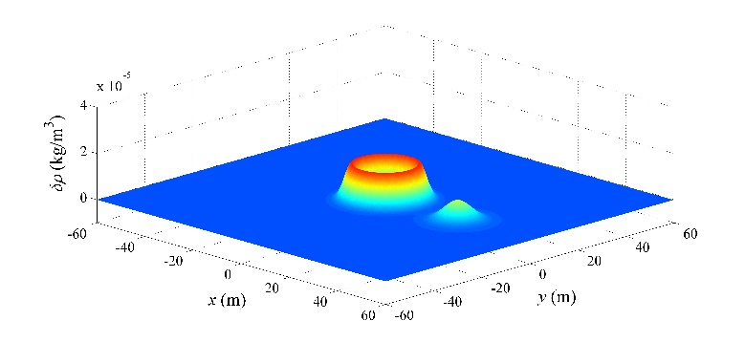

(a) 500 steps

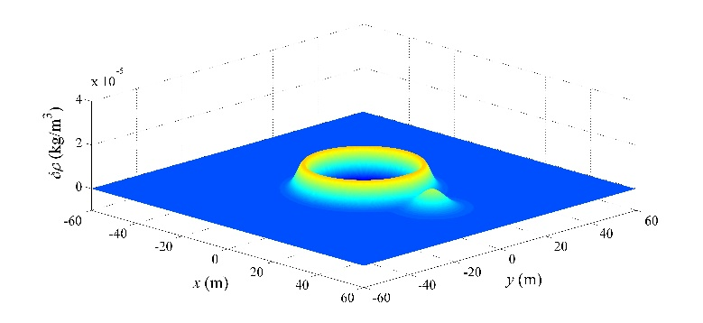

(b) 1000 steps

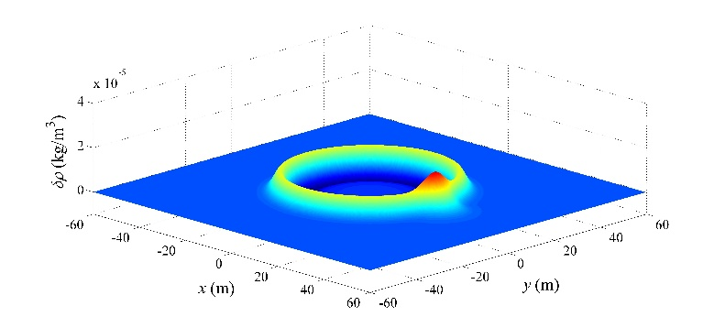

(c) 1500 steps

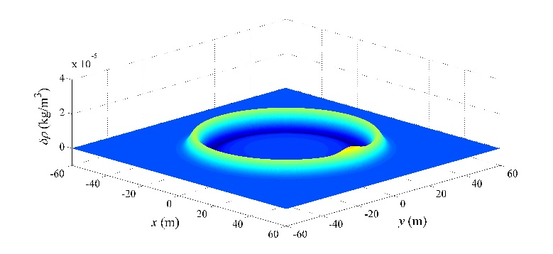

(d) 2000 steps

Fig. Contour of density change at different time steps

Fig. 6 shows that the SPH method can compute the propagation of Gaussian impulses and solve two-dimensional computational acoustic problems. The optimized parameters obtained in Section 4 can be applied in general acoustic simulation.

## 5.3 Accuracy

In order to evaluate the accuracy of the SPH method, a comparison between SPH results and exact solutions along the *x*-axis is shown in Fig. 7. The points in the figure represent the numerical values at different positions, whereas the lines denote the exact solutions. In order to clearly identify the numerical results, the points are plotted at intervals of 5. The comparison suggests that with the use of the optimized parameters, the SPH results agree well with the exact solutions.



(a)



(b)



(c)



(d)

Fig. Comparison between SPH results and exact solutions along the *x*-axis; change in density at 1000 steps (a); change in density (b), sound pressure (c), and velocity (d) at 2000 steps

In the evaluation of numerical results, the non-dimensional numerical error of the sound pressure is defined by the following:

 (48)

where  is the non-dimensional numerical error, *N* is the particle number in the computational domain,  is the numerical sound pressure of particle *i*, and  is the theoretical sound pressure at position (*xi*, *yi*) , and the FDTD method cannot compute with irregular grids.

Two types of irregular particle distributions are used to solve the problem. These distributions are built on the basis of regular particle distribution and all points are set with maximum 5% or 10% perturbations around their original positions of regular grid.

The non-dimensional sound pressure error for the SPH method and the finite-difference time-domain (FDTD) method [1] at different times are shown in Table 9. The corrective method for the SPH in Chapter 5.2 in [38] is used to improve the results. In the table, ∆*x* is the particle spacing and *t*0 and *t*1 are 0.02 s and 0.04 s separately.

Table Non-dimensional sound pressure error for the SPH method and FDTD method with regular particle distributions or irregular particle distributions (5% or 10% perturbations from original positions)

|  |  |  |  |  |  |  |  |
| --- | --- | --- | --- | --- | --- | --- | --- |
| *ε*pre (×10-6) |  | ∆*x* = 0.12 m | | | ∆*x* = 0.06 m | | |
|  |  | 0% | 5% | 10% | 0% | 5% | 10% |
| SPH | *t*0 | 15.0 | 15.7 | 16.5 | 1.9 | 4.6 | 5.7 |
| *t*1 | 20.3 | 22.6 | 23.2 | 3.4 | 10.1 | 16.2 |
| FDTD | *t*0 | 5.7 | - | - | 0.98 | - | - |
| *t*1 | 8.4 | - | - | 1.5 | - | - |

From Table 9, although the accuracy of the SPH method is less than the FDTD method with the same computational parameters, the SPH method can maintain good accuracy even with non-uniform particle distribution. Furthermore, the error increases with the increasing perturbation of irregular particle positions.

## 5.3 Convergence and computational time

The convergence of the SPH method in solving acoustic wave equations is discussed in this section. Both SPH and FDTD results are computed by using different particle spacings, and the numerical error are shown in Table 8.

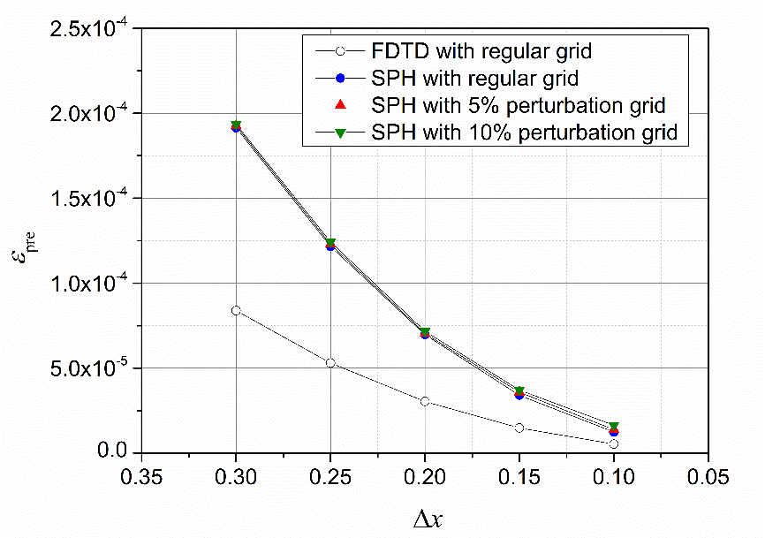

Fig. Convergence curve for the SPH method and FDTD method with regular particle distributions or irregular particle distributions (5% or 10% perturbations from original positions)

The figure shows that the numerical error decreases with decreasing particle spacing. The SPH method shows a higher order of convergence than the FDTD method and can maintain good accuracy even with irregular particle distribution.

The computational time for the SPH method and FDTD method are shown in Table 9. The performance of computation is measured on the Intel Core i7-4710 (2.5 GHz) with RAM 8.00 GB.

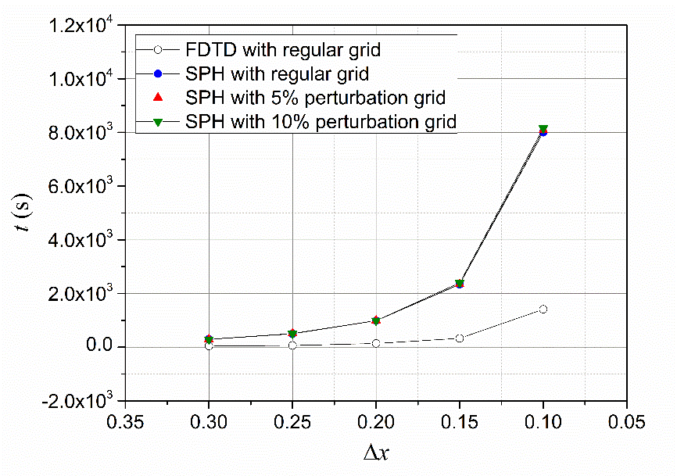

Fig. CPU time for the SPH method and FDTD method with regular particle distributions or irregular particle distributions (5% or 10% perturbations from original positions)

The graph shows that the decrease of the particle spacing not only brings accuracy improvements, but also increase the time cost on computation. Furthermore, the irregular distribution of particles has almost the same computational time comparing with the regular grid for the SPH method, and the time increase mainly spend on the particle searching. Considering many creative techniques have been proposed to improve the particle searching efficiency [14, 15, 38], spending time to maintain the Lagrangian and meshfree properties in the SPH method is still cost effective.

In general, the standard SPH method is not a high-efficiency method, but different approaches [14, 15, 38] have been attempted to modify this Lagrangian method, and these modified SPH methods can be applied in the computational acoustics following our work. The present discussion of the optimized values of computational parameters is an important foundation of the application of these modified SPH methods.

# 6. Conclusions

Acoustic wave equations in Lagrangian form are proposed in this work, and the SPH method is used to numerically simulate acoustic waves in the medium at rest. We introduce the SPH formulations for the acoustic simulation, and test the numerical method with a two-dimensional sound propagation model. In addition, the statistical significance of different computational parameters is evaluated with the Taguchi method. These parameter values are then discussed based on the ANOVA results to reduce the simulation error. We draw the following conclusions:

(1) Acoustic waves can be solved with the Lagrangian acoustic wave equations and simulated using the SPH method in the time domain. The smoothing length, the particle spacing, and the interaction between them have a statistically significant effect on the numerical error.

(2) The Courant number for the SPH simulation of two-dimensional acoustic waves is proposed to be under 0.4.

(3) The optimal smoothing length for the sound propagation simulation is found to be between 1.0 and 2.5 times the particle spacing. An optimal smoothing length is proposed to be 1.44 times the particle spacing, which is about 25 neighbor particles in the support domain.

(4) Decreasing the particle spacing while maintaining a constant ratio of the particle spacing to the smoothing length reduces simulation errors in the two-dimensional SPH simulation of acoustic waves.

# Acknowledgments

This study was supported by the Independent Innovation Foundation for National Defense of Huazhong University of Science and Technology (No. 01-18-140019). Y. O. Zhang was supported by the China Scholarship Council (201406160032).

# References

[1] Wang SZ. Finite-difference time-domain approach to underwater acoustic scattering problems. J Acoust Soc Am 1996;99(4):1924-1931.

[2] Harari I. A survey of finite element methods for time-harmonic acoustics. Comput Methods Appl Mech Eng 2006;195(13):1594-1607.

[3] Kythe PK. An introduction to boundary element methods. Vol 4, Florida; CRC Press; 1995.

[4] Warszawski A, Soares D, Mansur WJ. A FEM–BEM coupling procedure to model the propagation of interacting acoustic–acoustic/acoustic–elastic waves through axisymmetric media. Comput Methods Appl Mech Eng 2008;197(45):3828-3835.

[5] He ZC, Cheng AG, Zhang GY, Zhong ZH, Liu GR. Dispersion error reduction for acoustic problems using the edge-based smoothed finite element method (ES-FEM). Int J Numer Methods Eng 2011;86(11):1322-1338.

[6] Li SF, Liu WK. Meshfree and particle methods and their applications. Appl Mech Rev 2002;55(1):1-34.

[7] Fairweather G, Karageorghis A, Martin PA. The method of fundamental solutions for scattering and radiation problems. Eng Anal Boundary Elem 2003;27:759-769.

[8] Uras RA, Chang CT, Chen Y, Liu WK. Multiresolution reproducing kernel particle methods in acoustics. J Comput Acoust 1997;5:71-94.

[9] He Z, Li P, Zhao GY, Chen H. A meshless Galerkin least-square method for the Helmholtz equation. Eng Anal Boundary Elem 2011;35(6):868-878.

[10] Bouillard P, Suleaub S. Element-Free Galerkin solutions for Helmholtz problems: fomulation and numerical assessment of the pollution effect. Comput Methods Appl Mech Eng 1998;162:317-335.

[11] Tadeu A, Stanak P, Sladek J, Sladek V. Coupled BEM–MLPG acoustic analysis for non-homogeneous media. Eng Anal Boundary Elem 2014;44:161-169.

[12] Yao LY, Yu DJ, Cui WY, Zhou JW. A hybrid finite element-least square point interpolation method for solving acoustic problems. Noise Control Eng J 2012;60(1):97-112.

[13] Li ZJ, Li P, He Z, Liu GX. Coupled partition of unity method and improved meshless weighted least-square method for two-dimensional interior structure–acoustic problem. Eng Anal Boundary Elem 2012;36(2):154-160.

[14] Liu GR, Liu MB, Zong Z. An overview on Smoothed Particle Hydrodynamics. Int J Comput Methods 2008;5:135-188.

[15] Liu MB, Liu GR. Smoothed particle hydrodynamics (SPH): an overview and recent developments. Arch Comput Methods Eng 2010;17:25-76.

[16] Springel V. Smoothed particle hydrodynamics in astrophysics. Annu Rev Astron Astrophys 2010;48:391-430.

[17] Monaghan JJ. Smoothed particle hydrodynamics and its diverse applications. Annu Rev Fluid Mech 2012;44:323-346.

[18] Zhang GM, Batra RC. Wave propagation in functionally graded materials by modified smoothed particle hydrodynamics (MSPH) method. J Comput Phys 2007;222(1):374-390.

[19] Shao JR, Liu MB, Yang XF, Cheng L. Improved smoothed particle hydrodynamics with RANS for free-surface flow problems. Int J Comput Methods 2012;9(1):1240001.

[20] Thiyahuddin MI, Gu YT, Gover RB, Thambiratnam DP. Fluid–structure interaction analysis of full scale vehicle-barrier impact using coupled SPH–FEA. Eng Anal Boundary Elem 2014;42:26-36.

[21] Ren B, Fan HF, Bergel GL, Regueiro RA, Lai X, Li SF. A peridynamics–SPH coupling approach to simulate soil fragmentation induced by shock waves. Comput Mech 2015;55(2):287-302.

[22] Lucy LB. A numerical approach to the testing of the fission hypothesis. Astron J 1977;82:1013-1024.

[23] Gingold RA, Monaghan JJ. Smoothed particle hydrodynamics-theory and application to non-spherical stars. Mon Not R Astron Soc 1977;181:375-389.

[24] Wolfe CT, Semwal SK. Acoustic modelling of reverberation using Smoothed Particle Hydrodynamics. Proc Winter Sch Comput Graphics 2008;191-198.

[25] Hahn P, Negrut D. On the use of meshless methods in acoustic simulations. Proc ASME 2009 International Mechanical Engineering Congress and Exposition, American Society of Mechanical Engineers, 2009.

[26] Bruneau M. Fundamentals of acoustics. John Wiley and Sons; 2010.

[27] Jiang XR, Chen W, Chen CS. A fast method of fundamental solutions for solving helmholtz-type equations. Int J Comput Methods 2013;10(2):1341008.

[28] Zhang YO, Zhang T, Ouyang H, Li TY. Flow-induced noise analysis for 3D trash rack based on LES/Lighthill hybrid method. Appl Acoust 2014;79:141-152.

[29] Li E, He ZC, Xu X, Liu GR. Hybrid smoothed finite element method for acoustic problems. Comput Methods Appl Mech Eng 2015;283:664-688.

[30] Zhang YO, Zhang T, Ouyang H, Li TY. SPH simulation of sound propagation and interference. In Proceedings of the 5th International Conference on Computational Method (ICCM); 2014.

[31] Zhang YO, Zhang T, Ouyang H, Li TY. SPH simulation of acoustic waves: effects of frequency, sound pressure, and particle spacing. Math Prob Eng 2014;Article ID 348314. (In press)

[32] Zhang YO, Zhang T, Ouyang H, Li TY. Smoothed particle hydrodynamics simulation of sound reflection and transmission. J Acoust Soc Am 2014;136(4):2224-2224.

[33] Ross PJ. Taguchi techniques for quality engineering: loss function, orthogonal experiments, parameter and tolerance design. McGraw-Hill; 1988.

[34] Bagci E, Aykut Ş. A study of Taguchi optimization method for identifying optimum surface roughness in CNC face milling of cobalt-based alloy (stellite 6). Int J Adv Manuf Technol. 2006;29:940-947.

[35] Kwon KS, Lin RM. Robust finite element model updating using Taguchi method. J Sound Vib 2005;280(1):77-99.

[36] Garg N, Kumar A, Maji S. Parametric sensitivity analysis of factors affecting sound insulation of double glazing using Taguchi method. Appl Acoust 2013;74(12):1406-1413.

[37] Xiao SL, Sun WC, Du JK, Li GL. Application of CFD, Taguchi method, and ANOVA technique to optimize combustion and emissions in a light duty diesel engine. Math Prob Eng 2014;2014:Article ID 502902.

[38] Liu GR, Liu MB. Smoothed particle hydrodynamics: a meshfree particle method. World Scientific;2003.

[39] Monaghan JJ, Lattanzio JC. A refined particle method for astrophysical problems. Astron Astrophys 1985;149:135-143.

[40] Mellor GL. Introduction to physical oceanography. Springer; 1996.

[41] Blackstock DT. Fundamentals of physical acoustics. Wiley; 2000.

[42] Kelager M. Lagrangian fluid dynamics using smoothed particle hydrodynamics. University of Copenhagen; 2006.

[43] Davim JP. Design of optimisation of cutting parameters for turning metal matrix composites based on the orthogonal arrays. J Mater Process Technol 2003;132:340-344.

[44] Montgomery DC. Design and analysis of experiments. John Wiley and Sons; 1976.

[45] Mason RL, Gunst RF, Hess JL. Statistical design and analysis of experiments: with applications to engineering and science. John Wiley and Sons; 2003.

[46] Lin JL, Wang KS, Yan BH, Tarng YS. Optimization of the electrical discharge machining process based on the Taguchi method with fuzzy logics. J Mater Process Technol 2000;102(1):48-55.

[47] Park SH, Park SH. Robust design and analysis for quality engineering. Chapman and Hall London; 1996.

[48] Hernquist L, Katz N. TREESPH-A unification of SPH with the hierarchical tree method. Astrophys J Suppl Ser 1989;70:419-446.

[49] Skillen A, Lind S, Stansby PK, Rogers BD. Incompressible smoothed particle hydrodynamics (SPH) with reduced temporal noise and generalised Fickian smoothing applied to body-water slam and efficient wave-body interaction. Comput Methods Appl Mech Eng 2013;265:163-173.

[50] Swegle JW, Hicks DL, Attaway SW. Smoothed particle hydrodynamics stability analysis. J Comput Phys 1995;116:123-134.

[51] Dehnen W, Aly H. Improving convergence in smoothed particle hydrodynamics simulations without pairing instability. Mon Not R Astron Soc 2012;425:1068-1082.

[52] Quinlan NJ, Basa M, Lastiwka M, Truncation error in mesh-free particle methods. Int J Numer Methods Eng 2006;66:2064-2085.

[53] Hardin JC, Ristorcelli JR. ICASE/LaRC workshop on benchmark problems in computational aeroacoustics. National Aeronautics and Space Administration NASA CP 3300, 1997.

[54] Li K, Huang QB, Wang JL, Lin LG. An improved localized radial basis function meshless method for computational aeroacoustics. Eng Anal Boundary Elem 2011;35(1):47-55.

1. Corresponding author. Tel: +86 13995559242.

   E-mail addresses: [zhangyo1989@gmail.com](mailto:zhangyo1989@gmail.com) (Y.O. Zhang), [zhangt7666@mail.hust.edu.cn](mailto:zhangt7666@mail.hust.edu.cn) (T. Zhang), [h.ouyang@liverpool.ac.uk](mailto:h.ouyang@liverpool.ac.uk) (H. Ouyang), [ltyz801@mail.hust.edu.cn](mailto:ltyz801@mail.hust.edu.cn) (T.Y. Li). [↑](#footnote-ref-1)