Trapped in a tight spot: scaling effects occur when, according to the action-specific account, they should not, and fail to occur when they should.
Elizabeth S. Collier and Rebecca Lawson
University of Liverpool, UK

Keywords: Action, perception, perceptual scaling, demand characteristics
Running head: Action-specific account lacks predictive power

Send correspondence to:
Rebecca Lawson
Eleanor Rathbone Building
Bedford Street South
University of Liverpool
Liverpool, UK
L69 7ZA
Email: rlawson@liv.ac.uk

Acknowledgement and author note
This work was supported by a grant from the Economic and Social Research Council to the first author [ES/J500094/1].

Abstract
The action-specific account of perception claims that what we see is perceptually scaled according to our action capacity. However, it has been argued that this account has relied on an overly confirmatory research strategy – predicting the presence of, and then finding, an effect (Firestone & Scholl, 2014). A comprehensive approach should also test disconfirmatory predictions, where no effect is expected. In two experiments, we tested one such prediction based on the action-specific account, namely that scaling effects should occur only when participants intend to act (Witt et al., 2005). All participants wore asymmetric gloves, where one glove was padded with extra material so one hand was wider than the other. Participants visually estimated the width of apertures. The action-specific account predicts that apertures should be estimated as narrower for the wider hand, but only when participants intend to act. We found this scaling effect when it should not have occurred (Experiment 1, for participants who did not intend to act), and no effect when it should have occurred (Experiment 2, for participants who intended to act but who were given a cover story for the visibility and position of their hands). Thus the cover story used in Experiment 2 eliminated the scaling effect found in Experiment 1. We suggest that the scaling effect observed in Experiment 1 likely resulted from demand characteristics associated with using a salient, unexplained manipulation (e.g., telling people which hand to use to do the task). Our results suggest that the action-specific account lacks predictive power.

Introduction
Given the tight coupling between action and perception (e.g., Clark, 1999; Franchak, van der Zalm & Adolph, 2010; Gibson, 1979), the action-specific account of perception proposes that what we perceive is scaled according to our action capacity (Proffitt, 2013; Proffitt & Linkenauger, 2013; Witt, 2011, 2016; Witt, Linkenauger & Wickens, 2016). One of the earliest findings that suggested that visual perception scales according to participants’ action capacity was that participants estimated hills as steeper after vigorous exercise than before exercising (Proffitt, Bhalla, Gossweiler & Midgett, 1995, Experiment 5). Subsequently, Bhalla and Proffitt (1999) reported that hills were also estimated as steeper by participants who wore a heavy backpack, were elderly or in ill health, or had low physical fitness. Many later studies have reported effects consistent with the action-specific account (for reviews, see Proffitt, 2013; Proffitt & Linkenauger, 2013; Witt, 2011, 2016). Proffitt and Linkenauger (2013) suggested that perception can be scaled according to three components of action capacity: the bioenergetic cost of acting, performance variability and action capacity pertaining to the functional morphology of the body. For example, for bioenergetics, Witt, Proffitt and Epstein (2004) reported that distances to a target were estimated as greater after participants threw a heavy ball than a light ball. For scaling according to performance variability, Witt and Dorsch (2009) found that goalposts were estimated as higher by participants with worse kicking performance. For functional morphology, Linkenauger, Leyrer, Bülthoff and Mohler (2013) used virtual reality to alter participants’ perceived hand size. They found that objects seen near the hand were estimated as larger when the hand was rendered as smaller, and vice versa when the hand was rendered as larger. In short, the action-specific account proposes that we literally perceive the world as scaled in terms of our ability to perform actions (for reviews, see Firestone, 2013; Linkenauger, 2015; Philbeck & Witt, 2015).
However, there are a number of concerns with the action-specific account (e.g., Collier & Lawson, 2017a, 2017b; Durgin et al., 2009; Firestone, 2013). For example, Firestone and Scholl (2014; see also Firestone & Scholl, 2015) argued that this account has relied on an overly confirmatory research strategy – that is predicting, and then finding, a given effect. A comprehensive account of a phenomenon should also be able to predict the absence of an effect. Firestone and Scholl (2014) suggested employing the El Greco fallacy to test disconfirmatory predictions of the action-specific account. According to this fallacy, if perception of both the stimulus and the means of reproducing the stimulus are expected to show the same distortion following some manipulation, then the two distortions should cancel each other out and no overall distortion should be perceived. Firestone and Scholl (2014) applied this logic to the finding that apertures were estimated as narrower when participants held a horizontal rod that was wider than their body (Stefanucci & Geuss, 2009). For example, participants in Stefanucci and Geuss’ (2009) second experiment estimated the width of apertures by verbally guiding the experimenter to adjust the length of a tape measure until the length matched the width of an aperture that they were told to imagine walking through. There were four groups of participants. The hold group held a long rod horizontally in front of their body, with their arms wide apart. The hands only group positioned their arms in the same way as the hold group, but did not hold the rod. The wear group wore a backpack to which the rod was attached, so the rod was positioned as for the hold group but participants kept their arms by their sides. Finally, the control group kept their arms by their sides and had no rod. Participants in the hold and hands only groups estimated apertures as narrower than those in the wear and control groups. Stefanucci and Geuss (2009) interpreted this as evidence that participants who had their body widened in a functionally meaningful way perceived apertures as less passable, and therefore narrower. Participants in Firestone and Scholl’s (2014) replication of this study either held or did not hold a rod and verbally guided the experimenter to make adjustments to visually match the width of apertures that they imagined walking through. However, instead of a tape measure, the experimenter adjusted the width of a second aperture (the matching aperture) that was placed perpendicular to, but was otherwise identical to, the aperture that participants imagined walking through (the stimulus aperture). Firestone and Scholl (2014) found that participants who held the rod estimated apertures as wider than participants who did not hold the rod. Importantly, holding a rod should have influenced both the stimulus aperture and the matching aperture in the same way, by making it appear less passable. Thus, according to the El Greco fallacy, this should have made it impossible to detect a scaling effect and so, although the scaling effect reported by Stefanucci and Geuss (2009) was replicated by Firestone and Scholl (2014), this in fact provides evidence against, not for, action-specific scaling.
If effects consistent with the action-specific account occur when they should not, what instead explains their occurrence? Firestone and Scholl (2014) showed that the scaling effect on apertures that they observed disappeared if participants were given a convincing cover story for holding the rod. This suggests that the effect originally reported by Stefanucci and Geuss (2009) could have resulted from demand characteristics due to being asked to hold a rod without any explanation. Demand characteristics (Orne, 1962) can also explain other scaling effects that had originally been interpreted as supporting the action-specific account (Collier & Lawson, 2017b; Durgin et al., 2009). For example, in some of the first studies to provide evidence for the action-specific account, hills were estimated as steeper when observers wore a heavy backpack (Proffitt, et al., 1995; Bhalla & Proffitt, 1999). However, Durgin et al. (2009) found that if participants were provided with a cover story for wearing the backpack, their slant estimates were no different to participants who did not wear the backpack. This suggests that participants who were not given a reason for the backpack manipulation may have figured out that it was intended to influence their slant estimates and adjusted their responses accordingly. Therefore at least some scaling effects could result from demand characteristics associated with a salient, unexplained manipulation.
The reason that action-specific researchers often ask participants to imagine performing a relevant action, as in Stefanucci and Geuss (2009) and Firestone and Scholl (2014), is that scaling effects are only expected when participants intend to act (Witt, Proffitt & Epstein, 2005). The role of intention to act in the representation of space was first investigated in electrophysiological studies on monkeys by Iriki, Tanaka and Iwamura (1996). These authors identified neurons which fired when a raisin was placed within the monkey’s reach, but did not fire when the raisin was placed beyond reach. Furthermore, after the monkeys were taught to reach with a tool, these neurons adapted and now fired when raisins were placed out of arm’s reach, but still within reach using the tool. However, this adaptation did not occur when the monkeys held, but never reached with, the tool (Iriki et al., 1996). This was interpreted by Witt et al. (2005) as evidence that intention to act may be critical for changes in the representation of near space to occur.
Based on Iriki et al.’s (1996) findings, Witt et al. (2005) tested whether intention to act modulated perception of near space in humans. Witt et al. (2005) found that participants estimated the distance to targets that were out of arm's reach as shorter after reaching to them with a tool which increased maximum reach and made the targets reachable. However, this effect was only found for participants who actually reached with the tool. No effect was found for participants who held the tool, but never reached with it. The authors interpreted this as support for their claim that action-specific effects only occur when people intend to act. Intention to act has been argued as critical for finding scaling effects in a number of subsequent studies (e.g., Lessard, Linkenauger & Proffitt, 2009; Linkenauger, Witt & Proffitt, 2011; Stefanucci & Geuss, 2009; Witt & Proffitt, 2008). We therefore tested here whether scaling effects due to changes in action capacity occurred if, and only if, participants intend to act.
To summarise, a comprehensive theoretical account should be able to predict both the presence and absence of an effect. Although the action-specific account has largely relied on a confirmatory research strategy (Firestone & Scholl, 2014, 2015), this account makes the disconfirmatory prediction that scaling effects should only be found when participants intend to act. In the present studies, we tested this prediction for the task of estimating aperture width.
Experiment 1
The passability of aperture width is a good candidate for testing the claims of the action-specific account. People’s perception of whether they can walk through an aperture is dependent on their body size (Franchak, Celano & Adolph, 2012) and can rapidly be recalibrated following an increase in body girth (Franchak & Adolph, 2014). Similarly, Ishak, Adolph and Lin (2008) reported that people recalibrate whether their hand can fit through a variable-width aperture following an increase in hand width. Specifically, when participants wore a prosthesis on their hand which increased their hand width, they appropriately judged the minimum passable aperture width for that hand as wider. The results of Franchak and colleagues and of Ishak et al. (2008) demonstrate that people are sensitive to changes to their action capacity following a change in the functional morphology of their body. However, crucially, these results are not relevant to the claims of the action-specific account. This account predicts that estimates of spatial properties of action-relevant stimuli should be affected by changes in functional morphology. Specifically, here, the action-specific account predicts that people should perceive apertures that they intend to move their wider hand through as narrower, but only when they intend to act in this way (e.g., Witt et al., 2005; Linkenauger et al., 2011). No scaling effect on estimates of aperture size should be found if participants do not intend to act on the aperture.
In Experiment 1, in separate tasks, we tested both whether participants’ estimates of the narrowest aperture they could fit their hand through (action capacity task) and their estimates of aperture width (perceptual task) were affected by wearing a padded glove. The aperture apparatus, gloves, and method for measuring perceived aperture passability in the action capacity task were closely based on the methods of Ishak et al. (2008). The visual matching method used in the perceptual task was the same as that used in other work investigating the action-specific account (e.g., Collier & Lawson, 2017a, 2017b; Linkenauger et al., 2011).
Method
Participants
Thirty-six participants (23 females, mean age = 21.8 years) were recruited from the University of Liverpool. All participants self-reported as right handed and were rewarded with course credit for their participation.
Design
Participants were assigned to either the Intention-To-Act group or the No-Intention group. All participants completed two tasks: a perceptual task where they estimated the width of apertures, and an action capacity task where they judged whether they could fit their hand through apertures of different widths. These tasks are described in detail below. The Intention-To-Act group (n = 18) completed the action capacity task before the perceptual task and, on each trial of the perceptual task, they were asked whether they thought they could fit their hand through the aperture before estimating its width. This is a technique used by proponents of the action-specific account to ensure that participants intend to act in the way that the experimenter is interested in (e.g., Linkenauger et al., 2011). The No-Intention group (n = 18) completed the perceptual task before the action capacity task and they were not asked whether they thought they could fit their hand through the aperture during the perceptual task. Therefore, only the Intention-To-Act group intended to act while estimating aperture width.
Stimuli, apparatus and procedure
An aperture apparatus was created using a metal frame which held two wooden boards, see Figure 1. One board was fixed and the other could move to vary the width of a diamond-shaped aperture between 0 cm (minimum) and 30 cm (maximum). A mug was placed on a small table behind the aperture apparatus, with the handle facing the participant. A laptop was placed in front of the aperture apparatus. Two black lines were displayed on its screen. The lines began at a default distance of 1.75 cm apart. Each press of the up arrow on the laptop keyboard moved the lines 1 mm further apart and each press of the down arrow moved the lines closer together by 1 mm.
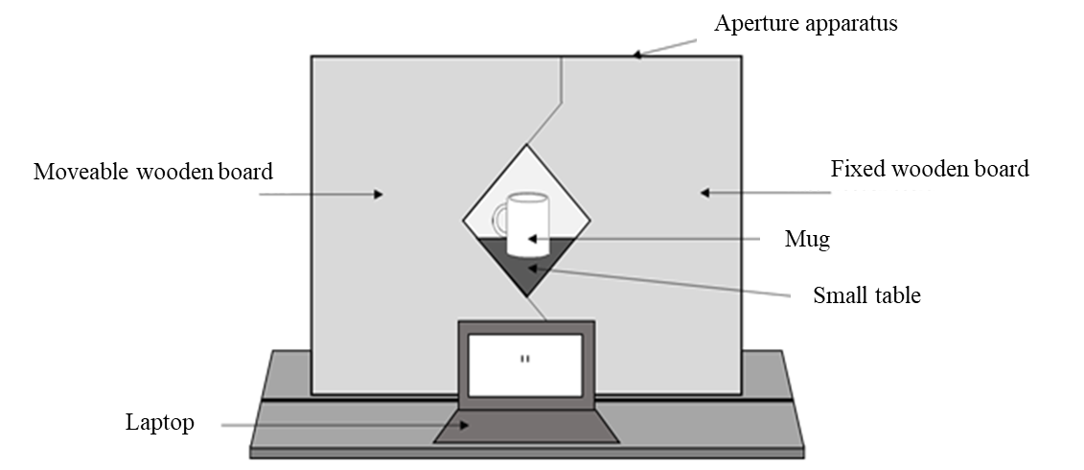
Figure 1: Diagram showing the aperture apparatus used in Experiment 1. The same apparatus was used in Experiment 2 except that the laptop was placed at 90º to the aperture.

Participants wore a pair of gloves throughout the experiment. The left (Padded) glove had additional woollen material sewn into the little finger-side of the glove. The right (Unpadded) glove had no padding. Here, we refer to the hands as Padded or Unpadded but the experimenter always referred to the “left” or “right” hand when communicating with participants, and participants were not informed about the padding.
Action capacity task
On every trial of the action capacity task, participants were asked whether they thought they could fit their hand through the aperture in order to touch the mug on the other side, see Figure 1. If, and only if, they thought they could fit their hand though the aperture did they then attempt to actually do so. If they thought they could not fit their hand through, they verbally responded “no”. They were told to judge passability based on their hand being held flat and oriented horizontally with their fingers close together and their thumb tucked under their fingers. They were told not to twist their hand, screw their fingers into a fist or bunch their fingers together. On each trial, the experimenter told them to use either their left (Padded) or right (Unpadded) hand. Responses were coded as “success” (participant could reach through the aperture), “failure” (participants attempted to reach through but their hand did not fit) or “refusal” (participants said that their hand would not fit through the aperture), see Figure 2. Aperture width ranged from 4 cm to 14 cm in 0.5 cm increments. Participants judged whether they could fit their left (Padded) or right (Unpadded) hand through each aperture width 3 times, giving 126 trials in total (2 hands × 21 aperture widths × 3 repeats) with trials presented in a different random order for each participant.
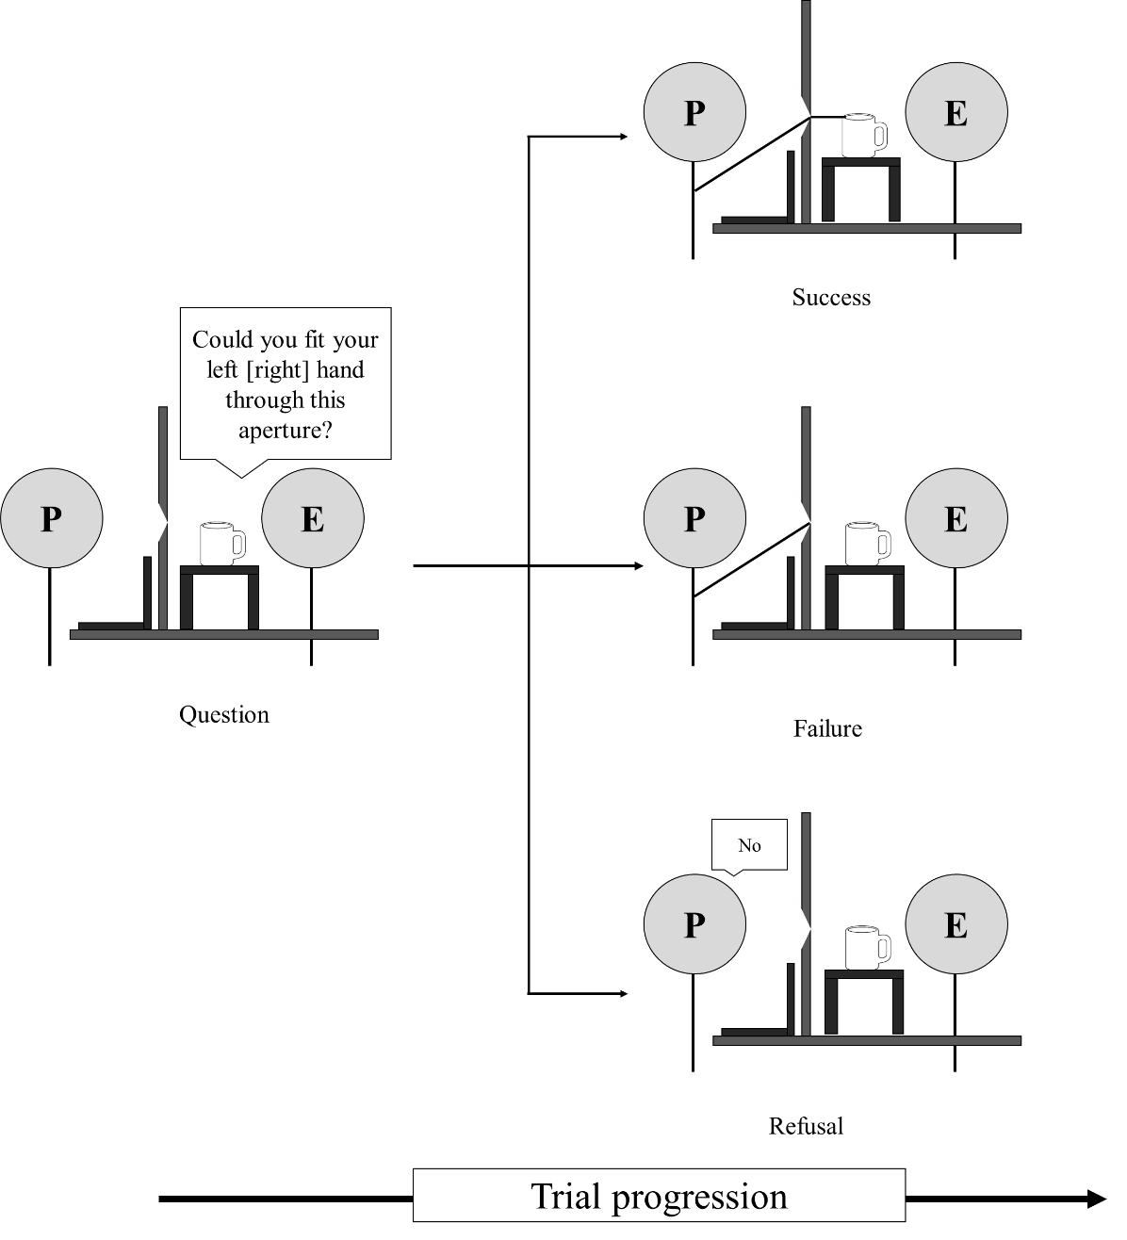
Figure 2: Diagram showing a participant completing the action capacity task in Experiment 1. The experimenter (E) first asked the participant (P) whether they could fit their hand through the aperture. The participant responded by either attempting the action (no verbal response given) or by verbally responding “no” and refusing to attempt. Responses were coded as “success” (participant successfully reached through the aperture, top), “failure” (participants attempted to reach through but their hand did not fit, middle) or “refusal” (participants said that their hand would not fit through the aperture, bottom).

Perceptual task
In this task participants were asked to use the arrow keys on the keyboard to move the lines on the screen until the distance between them matched the width of the aperture. Participants in the No-Intention Group were only told to match the width of the aperture on each trial, see Figure 3 (top). In contrast, on every trial in the perceptual task, before matching aperture width, participants in the Intention-To-Act Group were asked whether they thought they could fit one of their hands through the aperture, see Figure 3 (bottom). Unlike in the action capacity task, here participants did not actually attempt to move their hand through the aperture.
On each trial of the perceptual task, the experimenter told the participant which hand they should use to respond. For the Intention-To-Act Group, this was always the same hand that they had just judged aperture passability for. Participants were told to keep their other hand by their side so that it was out of sight. Between trials, they kept both hands by the sides of their body and closed their eyes until the experimenter had adjusted the width of the aperture. The aperture widths used were the same as in the action capacity task. Participants matched each aperture width once using each hand, giving a total of 42 trials (2 hands × 21 aperture widths) with trials presented in a different random order for each participant.
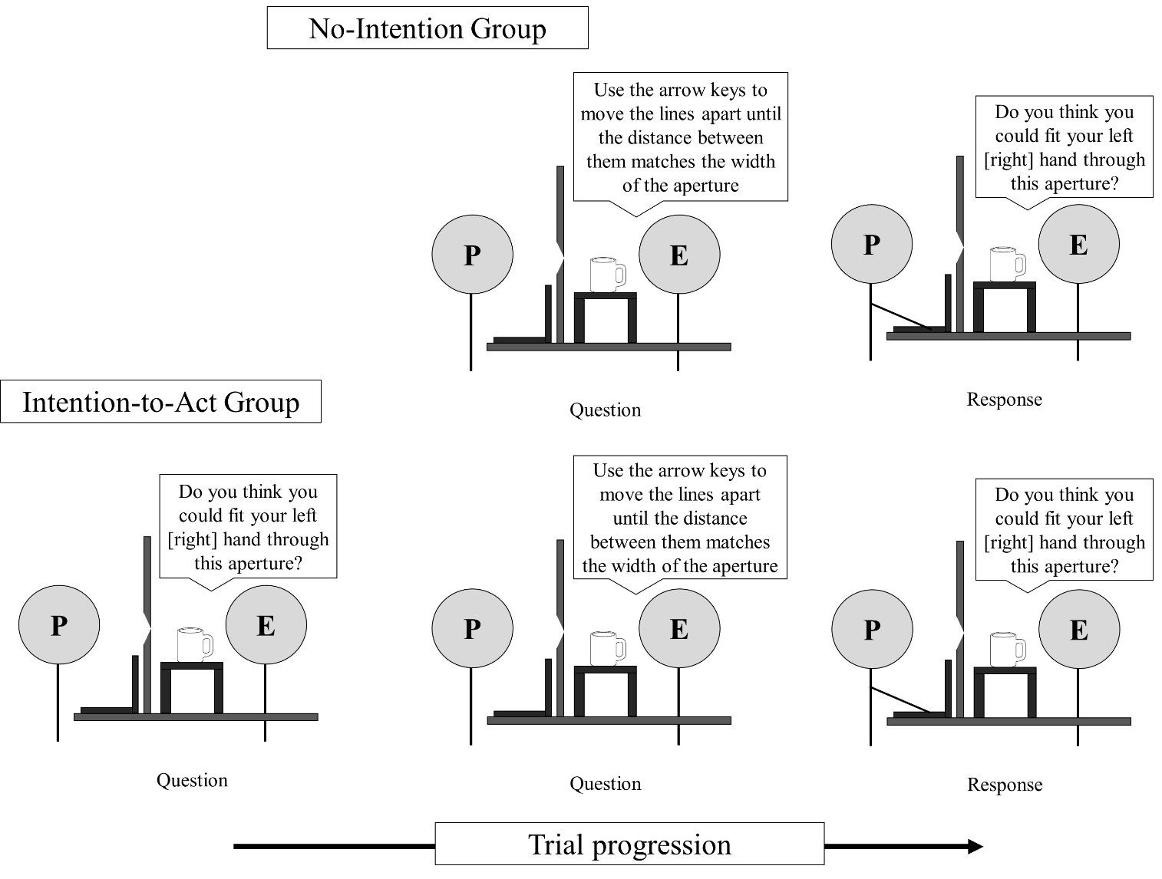
Figure 3: Diagram showing participants in the No-Intention group (top) and in the Intention-To-Act group (bottom) completing the perceptual task in Experiment 1. For both groups the experimenter asked the participant (P) to use the arrow keys to move the lines on the laptop screen to match the width of the aperture. In the Intention-To-Act group the participant was also asked whether they could fit their left (or right) hand through the aperture immediately before matching its width.

Actual aperture passability task
After participants had completed both the perceptual and action capacity tasks, the experimenter measured the actual narrowest aperture that they could fit their hands through. The experimenter opened the aperture to 15 cm and asked participants to place their hand inside it with their hand held flat and horizontally with their fingers close together and their thumb tucked under their fingers. The experimenter then closed the aperture around the participant’s hand and asked the participant to move their hand in and out of the aperture. The experimenter adjusted the aperture until it was at the narrowest width that still allowed the participant to fit their hand through without getting it trapped. Participants were only told to move their hand during this task; they were not asked about aperture passability. The minimum passable aperture was measured for each hand both with and without the gloves.
Results
Effect of wearing gloves on actual aperture passability
To check that the glove manipulation was effective, we tested whether wearing the gloves changed the actual minimum passable aperture for each hand. We conducted a mixed ANOVA where hand (Padded/Unpadded) and gloves (With/Without) were within-participants factors and group (Intention-To-Act/No-Intention) was a between-participants factor. There was a significant main effect of gloves, F(1, 34) = 38.351, p < .001, η_{p}² = .53, which was modulated by a hand × gloves interaction, F(1, 34) = 40.090, p < .001, η_{p}² = .54. Bonferroni corrected pairwise comparisons showed that, with gloves, the minimum passable aperture was greater for the Padded hand (m = 10.4 cm, se = 0.14 cm) than the Unpadded hand (m = 9.6 cm, se = 0.15 cm), whereas there was no significant difference between the Padded and Unpadded hands without gloves (m = 9.8 cm, se = 0.12 cm; m = 9.5 cm, se = 0.13 cm, respectively). There was no effect of group, F(1, 34) = 0.038, p = .8, η_{p}² = .001. There were no other significant interactions: gloves × group, F(1, 34) = 1.060, p = .3, η_{p}² = .03; hand × group, F(1, 34) = 0.708, p = .4, η_{p}² = .02; gloves × hand × group, F(1, 34) = 0.216, p = .6, η_{p}² = .01. Wearing a padded glove therefore significantly increased hand width, as we had intended.
Action capacity task: perceived aperture passability
We tested whether participants appropriately recalibrated their perception of aperture passability to reflect the asymmetry in hand width caused by wearing the gloves. For each width tested, for each hand, for each participant, we calculated the proportion of times that participants said that they could not fit their hand through that aperture in the action capacity task. Cumulative Gaussians were then fitted, from which we calculated the predicted width at which participants believed they could not fit each hand through 50% of the time (the point of subjective equality, PSE; the mean Cumulative Gaussians can be found in Appendix A). These PSEs provided an estimate of the minimum aperture width participants perceived they could fit their hand through.
PSEs were used as the dependent variable in a mixed ANOVA where hand (Padded/Unpadded) was a within-participants factor and group (Intention-To-Act/No-Intention) was a between-participants factor. Participants perceived the minimum passable aperture width for their Padded gloved hand (m = 10.6 cm, se = 0.16 cm) to be greater than that for their Unpadded gloved hand (m = 9.9 cm, se = 0.14 cm), F(1, 34) = 76.113, p < .001, η_{p}² = .70. There was no effect of group, F(1, 34) = 0.067, p = .8, η_{p}² = .002, or a hand × group interaction, F(1, 34) = 1.579, p = .2, η_{p}² = .04. Thus participants appropriately recalibrated their perception of the minimum aperture width that each gloved hand could fit through during the action capacity task by increasing their estimates for the Padded hand.
Perceptual task: estimated aperture width
Finally, we tested the critical action-specific prediction that apertures would be estimated as narrower for the Padded hand by the Intention-To-Act group but not by the No-Intention group. Ratios were calculated by dividing estimates of aperture width by actual aperture width and then averaging over all widths for a given hand of a participant. These ratios were used as the dependent variable in a mixed ANOVA where hand (Padded/Unpadded) was a within-participants factor and group (Intention-To-Act/No-Intention) was a between-participants factor. Ratios for the Padded hand (m = 0.68, se = 0.02) were significantly lower than for the Unpadded hand (m = 0.69, se = 0.02), F(1, 34) = 6.557, p = .015, η_{p}² = .16, see Figure 4. Although the effect we observed is small, this is common in the action-specific literature (see Firestone, 2013, for a discussion). There was no effect of group, F(1, 34) = 0.058, p = .8, η_{p}² = .002, or a hand × group interaction, F(1, 34) = 0.027, p = .9, η_{p}² = .001. Figure 5 shows the ratios for the Padded and Unpadded hand given by each individual participant.
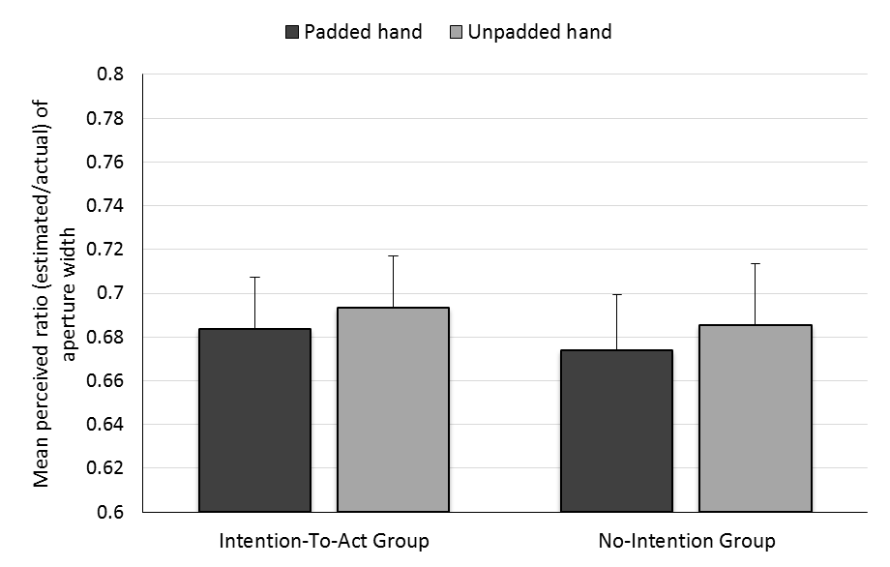
Figure 4: Results of the perceptual task in Experiment 1. Mean ratio of aperture size (estimated/actual) for each hand for each group. Error bars represent one standard error of the mean.
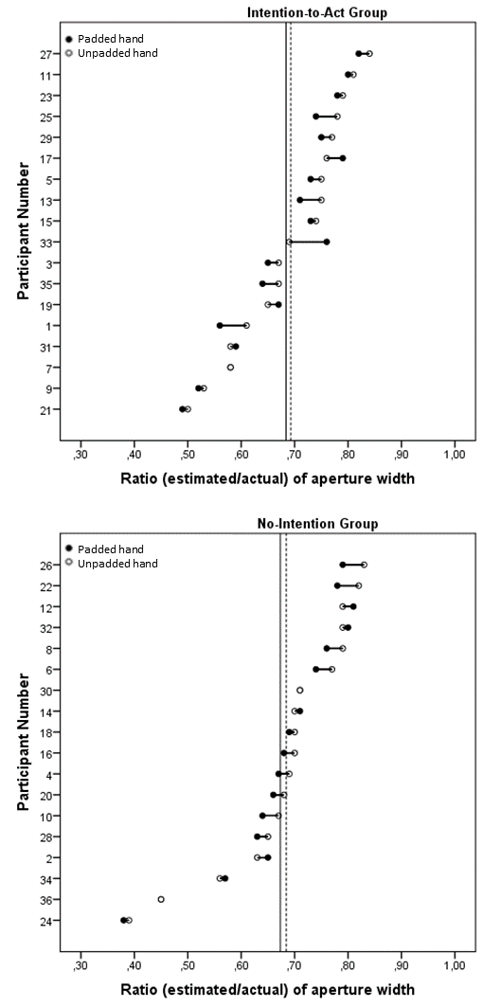
Figure 5: Individual estimates of aperture width (as a ratio of actual aperture width) for the Padded and Unpadded hands in the Intention-to-Act (top) and No-Intention (bottom) groups. The bold and dashed vertical lines show the mean ratios for the Padded and Unpadded hands respectively. Participants are ordered by increasing ratio of aperture width for the Unpadded hand. Cases where only one data point are shown indicate no difference between ratios for the Padded and Unpadded hand.

Discussion
Padding one hand increased the minimum passable aperture for that hand. Furthermore, this change was perceived by participants: in the action capacity task, participants estimated the minimum passable aperture for their Padded hand as wider than for their Unpadded hand. This latter result is consistent with previous results (Collier & Lawson, 2017a; Ishak et al., 2008), showing that participants appropriately recalibrate their perceived action capacity following a change in the functional morphology of their hands. Of most interest theoretically was the perceptual task. Participants estimated apertures as narrower when they estimated with their Padded compared to their Unpadded hand (see Figure 4) but, importantly, this was effect was not just due to estimates by the Intention-To-Act group. The action-specific account claims that intention is necessary for finding the scaling effects predicted by this account (e.g. Linkenauger et al., 2011; Stefanucci & Geuss, 2009; Witt, 2016; Witt et al., 2005). Therefore, this account cannot explain the results of the perceptual task since participants in the No-Intention group were not asked to report aperture passability, and therefore they did not intend to act.
An alternative explanation of our results is that demand characteristics could have arisen from explicitly telling participants whether to use either their left (Padded) or their right (Unpadded) hand to respond when they estimated aperture width. No explanation was provided for this manipulation, and participants may have deduced that we expected to find a hand-dependent effect. As a consequence some participants may, for example, have decided that they should use their visible hand as an anchor for estimating aperture width. Since right handers believe that their right hand is larger than their left hand (Collier & Lawson, 2017a; Linkenauger et al., 2011), this strategy could explain the results that we obtained.
Experiment 2
The action-specific account cannot explain the results of Experiment 1, since we found a scaling effect when participants did not intend to act. Instead, it is possible that this effect arose because of demand characteristics associated with telling participants whether to use the left or the right hand on each trial of the perceptual task. Previous work has suggested that demand characteristics associated with an unexplained manipulation can be reduced by using a cover story (Collier & Lawson, 2017a; Durgin et al., 2009, 2012; Firestone & Scholl, 2014). Therefore, if the effects found in Experiment 1 were the result of demand characteristics, then they might be eliminated by providing a cover story. In Experiment 2, we tested this possibility using a similar perceptual task as in Experiment 1. Participants in Experiment 2 always intended to act during the perceptual task. However, they were given a cover story for why their hand was visible near the aperture while they estimated its width. If no effect of hand padding occurs when participants are given a cover story for the presence and location of their hands, this would support the argument that the effects obtained in Experiment 1 were the result of demand characteristics.
We also made some changes to the experimental procedure in Experiment 2 to improve the design and to make it more consistent with previous studies in the action-specific literature. These changes included placing the laptop at 90º to the participant (as was done in Linkenauger et al., 2011, Experiment 2). This ensured that participants could not use landmark matching strategies while making their estimates. Also, half of the participants wore the padded glove on their left hand, while the other half wore it on their right hand. Finally, all participants were alerted to the difference in their hand width resulting from wearing the gloves. This was done by asking participants to squeeze their hand through a padded tube, which was hidden by a curtain, in order to reach the aperture on the other side. Since it is harder to squeeze wider hands through a tight space, we reasoned that haptic feedback from this task would alert participants to the fact that one of their hands was wider than the other. Completing this haptic feedback phase also served to motivate our cover story manipulation in the main perceptual task. Specifically, participants were told that, as a control measure, their hands should be in a similar position in the perceptual task as they were in the haptic feedback phase. The cover story did not explicitly mention the use of both the left and the right hands. This was because, when using a cover story to minimise demand characteristics, it is critical that the cover story used does not simply introduce a new set of demand characteristics (Proffitt, 2013) or further solidify demand characteristics that may already exist. Thus, we opted for a cover story which explained the position and location of the hands on each trial. We reasoned that this would alleviate any demand characteristics associated with specifying which hand to use in the task, without explicitly drawing attention to the fact that both hands were used.
In summary, in Experiment 2 we tested whether the results of Experiment 1 could be explained by demand characteristics. This was achieved by providing a cover story for why the participant's hand was visible near the aperture while they estimated its width in the perceptual task. At the start of the experiment, participants were told that we were interested in how well they could perform basic actions while wearing thick gloves and that they would first complete a haptic task involving moving their hands through tight spaces. Then, after the haptic feedback phase and before beginning the main perceptual task, participants were given a cover story for the presence and location of their hands. We predicted that hand padding would have no effect on estimates of aperture width in Experiment 2, because participants were given a cover story in the perceptual task which reduced demand characteristics.
Method
Participants
Thirty-six new participants (23 females, mean age = 25.9 years) were recruited from the University of Liverpool. All participants self-reported as right handed and were rewarded with course credit or a shopping voucher for their participation.
Design
Two new pairs of asymmetric gloves were made. In both pairs, the Padded glove had 1.5 cm of foam on the little finger-side and 0.5 cm of foam on the thumb-side and the Unpadded glove had 0.25 cm of foam on each side. Participants in the LHBigger group (n = 18) wore the Padded glove on their left hand and the Unpadded glove on their right hand, and vice versa for participants in the RHBigger group (n = 18).
Stimuli, apparatus and procedure
All participants completed the haptic feedback phase, then the perceptual task, then the action capacity task and finally the actual aperture passability task. The stimuli and set-up were identical to Experiment 1, except where described below.
Haptic feedback phase
For this task, a padded plastic tube (outer circumference = 26 cm, length = 30 cm) was placed in front of the aperture. The aperture and tube were hidden from the participant by a black curtain, see Figure 6. Participants sat at the table and reached under the curtain to put on the gloves. They could not see that the gloves were different sizes but we intended that participants would believe their Padded hand was wider than their Unpadded hand as it was harder to squeeze their Padded hand through the tube. On each trial, participants were told which of their hands they were to push through the tube to the aperture. They were told to place their thumb just inside one corner of the aperture and any other finger just inside the opposite corner so that they could feel the horizontal width of the aperture between their thumb and finger. They then removed their hand from the tube but kept their hands under the curtain. The experimenter then adjusted the width of the aperture for the next trial. In total, participants completed 42 trials (2 hands x 21 aperture widths). The widths were the same as those used in Experiment 1 and were presented in a random order.
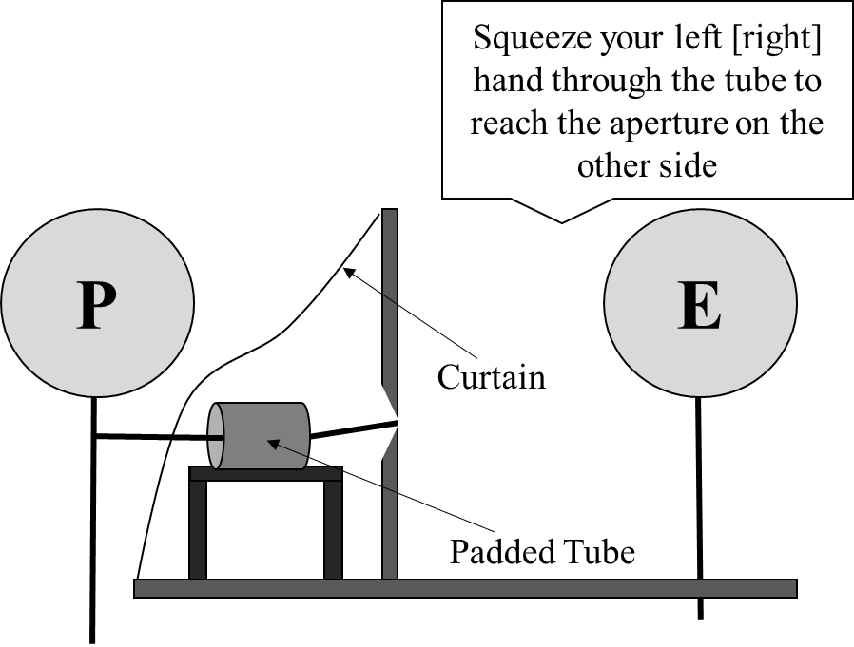
Figure 6: Diagram showing the setup and procedure of the haptic feedback phase in Experiment 2. The experimenter (E) has instructed the participant (P) to push their hand through the padded tube to reach the aperture on the other side.

Perceptual task
This task was identical to the perceptual task used in Experiment 1, except where described below. The experimenter removed the curtain and tube apparatus used in the haptic feedback phase so that the participant could see the aperture. The laptop that was used in Experiment 1 was moved so that it was at 90º to the participant. On each trial participants placed their visible hand flat on the small table in front of the aperture, see Figure 7. Critically, participants were told that placing their hand in front of the aperture was a control measure that ensured that their hands were in a similar position as in the haptic feedback phase. To ensure that they still intended to act, on every trial participants were also told to imagine moving their hand through the aperture (in the same way as in Experiment 1) as they made their width estimates. Thus although all participants intended to act (they imagined performing the action on every trial), they were given a cover story for why they were asked to place their hand near the aperture. Width estimates were made by verbally guiding the experimenter to move the lines on the laptop screen closer or further apart. The experimenter used the mouse wheel of a wireless mouse to control the distance between the lines, see Figure 7. One click of the mouse wheel moved the lines 1 mm apart. Participants were told to say ‘stop’ when they believed the distance between the lines matched the horizontal width of the aperture. To ensure estimates were as accurate as possible, participants were encouraged to request minor adjustments to the distance between the lines even after they said ‘stop’. The experimenter stood behind the aperture apparatus so they could not see the lines on the screen, see Figure 7.
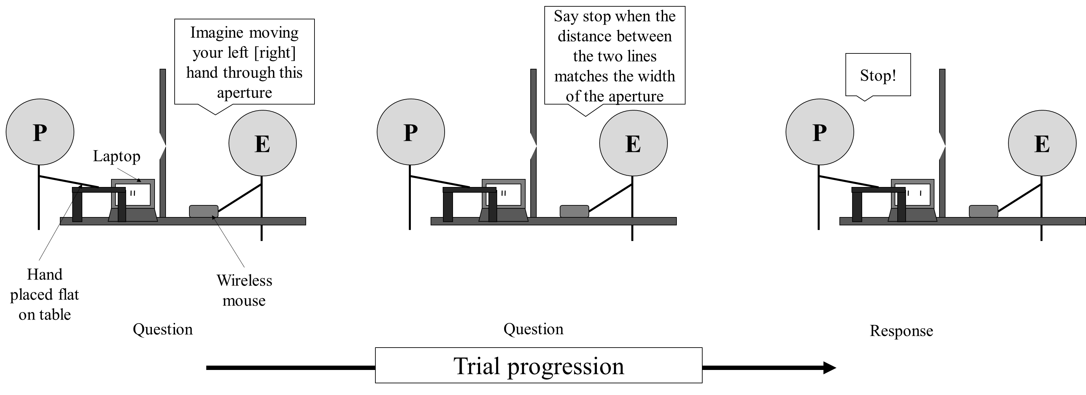
Figure 7: Diagram showing a participant completing the perceptual task in Experiment 2. The Experimenter (E) first told the participant (P) to imagine moving their left (or right) hand through the aperture. Then the participant verbally guided the experimenter to move the lines on the laptop screen closer or further apart until they thought the distance between the lines matched the width of the aperture.

Action capacity task
After completing the haptic feedback and perceptual tasks participants estimated the narrowest aperture they thought they could fit each gloved hand through. Participants were told to imagine they were going to move their left hand through the aperture in the same way as in Experiment 1. The experimenter then opened the aperture to a width of 15 cm and slowly closed the aperture. Participants were instructed to say ‘stop’ when they believed the aperture was the narrowest width they could fit their left hand through. They were not permitted to look at their hands during the task and were asked to keep them by their sides. To ensure an accurate estimate, the experimenter encouraged participants to request small adjustments even after they said ‘stop’. The task was then repeated for the right hand.
Actual aperture passability task
Finally, the actual minimum passable aperture for each hand was measured, first with then without the gloves, as in Experiment 1.
Results
Effect of wearing gloves on actual aperture passability
To check that the glove manipulation was effective, we tested whether wearing the gloves changed the actual minimum passable aperture for each hand. We conducted a mixed ANOVA where hand (Padded/Unpadded) and gloves (With/Without) were within-participants factors and group (LHBigger/RHBigger) was a between-participants factor. There was a significant main effect of gloves, F(1, 34) = 588.183, p < .001, η_{p}² = .95, which was modulated by a hand × gloves interaction, F(1, 34) = 317.151, p < .001, η_{p}² = .90. Bonferroni corrected pairwise comparisons showed that, with gloves, the minimum passable aperture was greater for the Padded hand (m = 11.5 cm, se = 0.11 cm) than the Unpadded hand (m = 10.3 cm, se = 0.09 cm) whereas there was no significant difference between the Padded and Unpadded hands without gloves (m = 9.1 cm, se = 0.12 cm; m = 9.1 cm, se = 0.11 cm, respectively). There was no effect of group, F(1, 34) = 0.004, p = .9, η_{p}² < .001. There were no other significant interactions: hand × group, F(1, 34) = 2.967, p = .09, η_{p}² = .08; gloves × group, F(1, 34) = 1.029, p = .3, η_{p}² = .03; hand × gloves × group, F(1, 34) = 0.912, p = .4, η_{p}² = .03. Wearing the padded glove therefore significantly increased hand width relative to the unpadded, gloved hand, as we had intended.
Action capacity task: perceived aperture passability
We tested whether participants appropriately recalibrated their perception of aperture passability to reflect the asymmetry in hand width caused by wearing the gloves. Perceived minimum passable aperture by the gloved hand was calculated as in Experiment 1. This was used as the dependent variable in a mixed ANOVA where hand (Padded/Unpadded) was a within-participants factor and group (LHBigger/RHBigger) was a between-participants factor. Participants perceived the minimum passable aperture for their Padded gloved hand (m = 11.1 cm, se = 0.19 cm) to be greater than that for their Unpadded gloved hand (m = 10.8 cm, sd = 0.20 cm), F(1, 34) = 9.523, p = .005, η_{p}² = .22. Also the perceived minimum passable aperture was greater for the RHBigger group (m = 11.4 cm, se = 0.26 cm) than for the LHBigger group (m = 10.5 cm, se = 0.26 cm), F(1, 34) = 5.912, p = .02, η_{p}² = .15. There was no hand × group interaction, F(1, 34) = 0.135, p = .7, η_{p}² = .004.
Perceptual task: estimated aperture width
Finally, we tested the critical action-specific prediction that apertures would be estimated as narrower for the Padded hand. Ratios were calculated as in Experiment 1 and used as the dependent variable in a mixed ANOVA where hand (Padded/Unpadded) was a within-participants factor and group (LHBigger/RHBigger) was a between-participants factor. There were no significant effects: hand, F(1, 34) = 0.690, p = .4, η_{p}² = .02; group, F(1, 34) = 0.082, p = .8, η_{p}² = .002; hand × group, F(1, 34) = 0.180, p = 0.7, η_{p}² = .01, see Figure 8. Thus, unlike Experiment 1, participants in Experiment 2 did not estimate apertures as narrower for their Padded hand than their Unpadded hand. Figure 9 shows the ratios for the Padded and Unpadded hand given by each individual participant.
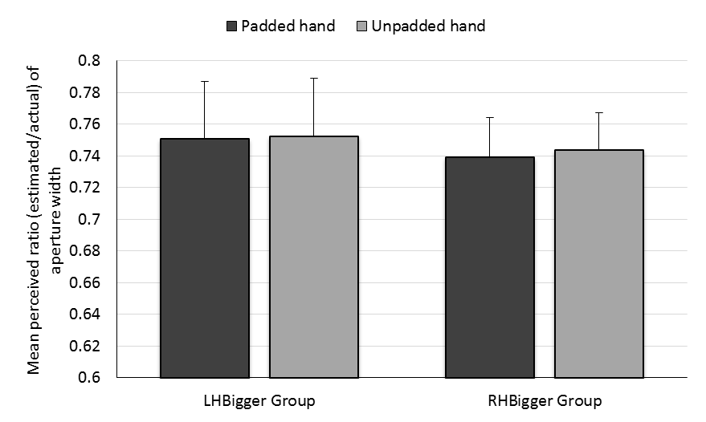
Figure 8: Results of the perceptual task in Experiment 2. Mean ratio of aperture size (estimated/actual) for each hand for each group. Error bars represent one standard error of the mean.

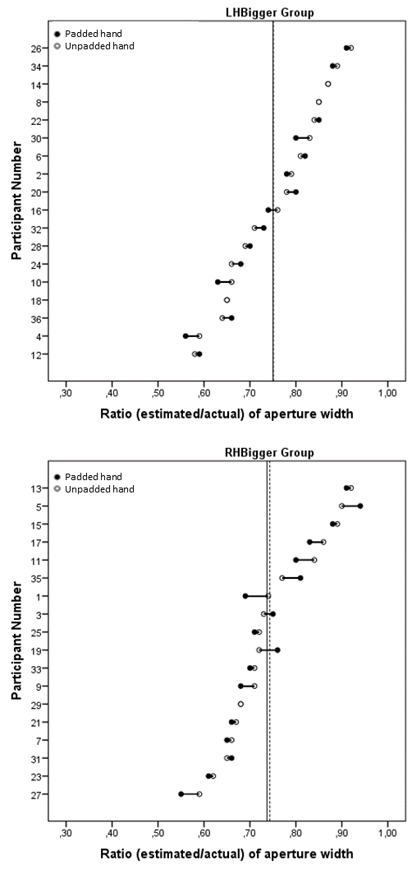
Figure 9: Individual estimates of aperture width (as a ratio of actual aperture width) for the Padded and Unpadded hands in the LHBigger (top) and RHBigger (bottom) groups. The bold and dashed vertical lines show the mean ratios for the Padded and Unpadded hands respectively. Participants are ordered by increasing ratio of aperture width for the Unpadded hand. Cases where only one data point are shown indicate no difference between ratios for the Padded and Unpadded hand.

Discussion
Replicating Experiment 1, padding one hand increased the minimum passable aperture for that hand. This change was perceived by participants: in the action capacity task, participants estimated the minimum passable aperture for their Padded hand as wider than for their Unpadded hand. Most importantly, using a cover story in the perceptual task eliminated the effect of altering action capacity on perceived aperture width which we had found in Experiment 1. Participants in Experiment 2 were told that their hands had to be placed near the aperture in the perceptual task as a control measure to ensure that their hands were in a similar position as in the haptic feedback phase. Our results are consistent with previous findings that have demonstrated that, even when participants intend to act, providing a cover story for a salient experimental manipulation can eliminate effects that appeared consistent with the action-specific account (Firestone & Scholl, 2014). Our present results suggest that the scaling effects found in Experiment 1 were not true perceptual changes, as proposed by the action-specific account, but were instead more likely due to demand characteristics (Orne, 1962).
It is important to emphasise that the action-specific account predicts a scaling effect in the perceptual task in Experiment 2 despite the use of a cover story. This is because, on every trial of the perceptual task, we asked participants to imagine whether they could fit their hand through the aperture before they made their width estimates. If action capacity directly influences what is perceived, as proposed by the action-specific account, then scaling should have occurred since we directly manipulated both actual and perceived action capacity, and participants intended to act on every trial.
General Discussion
In the present studies we were interested in biases in size perception and the role of intention to act in producing these biases. We investigated whether visual estimates of aperture width would be influenced by increases in hand size which altered action capacity. The action-specific account predicts that if a participant intends to move a wider hand through an aperture they should perceive the aperture as narrower, but that this scaling effect should not occur when participants do not intend to move their hand through the aperture (i.e. when they intend to act, Witt et al., 2005). However, we found that participants estimated apertures as narrower when the width of their hand was increased by wearing a padded glove even when they did not intend to act (Experiment 1). We then successfully eliminated this effect by providing a cover story for the presence of the hand near to the aperture, even though participants intended to act (Experiment 2). Both of these results suggest that the scaling effects that we observed were not true perceptual changes, as the action-specific account claims. Our results suggest that intention to act does not influence biases in spatial perception in the way predicted by the action-specific account. Instead our results support previous work that has shown that the action-specific account lacks predictive power (Firestone & Scholl, 2014).
Providing a cover story can reduce the demand characteristics associated with an otherwise unexplained manipulation (Collier & Lawson, 2017a; Durgin et al., 2009; Firestone & Scholl, 2014). Bhalla and Proffitt (1999; see also Proffitt et al., 1995) reported that hills were reported as steeper when observers wore a heavy backpack. However, Durgin et al. (2009) found that if participants were told that the backpack contained equipment for monitoring their ankle muscles, their slant estimates did not differ from estimates made by participants who did not wear a backpack. This finding suggests that participants who were not given a reason for wearing the backpack deduced that the backpack was supposed to influence their estimates of slant and changed their responses accordingly. Proponents of the action-specific account have rejected claims that their effects can be explained by demand characteristics (e.g. Witt & Sugovic, 2013; Linkenauger et al., 2013; Taylor-Covill & Eves, 2014). For example, Proffitt (2009; see also Proffitt & Linkenauger, 2013) argued that Durgin et al.’s (2009) study was not comparable to the original backpack studies because it used a 2 m ramp instead of a real hill and the energy required to ascend such a small ramp may not be sufficient to influence perception. However, Durgin, Klein, Spiegel, Strawster and Williams (2012) subsequently reproduced the results of Durgin et al. (2009) using a real hill, consistent with the claim that demand characteristics, rather than differences in energy requirements, produced the scaling effect on estimating hill slopes. In Experiment 1, we found an effect consistent with the action-specific account for participants who did not intend to act. Thus, our results suggest that intention to act is not critical in producing effects consistent with the action-specific account. Intention to act has been claimed as central to obtaining the scaling effects predicted by the action-specific account. For example, Witt et al. (2005) reported that increasing participants’ maximum reach by providing them with a tool (a baton) influenced distance estimates, but only for participants who intended to reach with the tool. There is, however, an alternative interpretation of Witt et al.’s (2005) results. Franchak and Adolph (2014) showed that changes to the body are not necessarily sufficient to recalibrate perceived action capacity. They reported that pregnant women were able to accurately estimate the narrowest aperture they could walk through as this increased throughout their pregnancy. In contrast, participants who were temporarily fitted with a pregnancy prosthesis were initially inaccurate in estimating the narrowest aperture they could walk through, but after attempting the task their estimates were appropriately recalibrated. Thus, short-term changes to the body may not be sufficient to change observers’ perceived action capacity, but it can be rapidly recalibrated through acting. Based on this conclusion, distance estimates by participants who held - but never reached with - a tool in Experiment 3 of Witt et al. (2005) may not have been affected by holding the tool because they had not yet recalibrated their perception of their maximum reach through acting. Thus Witt et al.’s (2005) results may not have been driven by intention to act. Instead their results may have arisen because only participants who acted with the tool recalibrated their perceived reaching capacity. Note, furthermore, that this does not mean that their perception of distances changed. Instead it may only have been their judgements of the distances that changed because they were aware that targets were easier to reach with the tool than without it (see Firestone, 2013; Firestone & Scholl, 2015, for discussions of whether action-specific effects reflect changes in visual perception or in post-perceptual judgement).
A further point is that, although intention to act is often argued to be necessary for the scaling effects predicted by the action-specific account to occur (e.g. Linkenauger et al., 2011; Witt, 2016; Witt et al., 2005), intention was not present in several studies that have been argued to support the action-specific account. For example, Bhalla and Proffitt (1999) did not mention walking up the slope to their participants, and Linkenauger et al. (2013) did not ask participants to consider or estimate the graspability of objects they estimated the size of. Therefore, even proponents of the action-specific account are not consistent about whether intention to act is needed to induce scaling effects. Given this, one possible critique of the present work is that we focused on intention to act as a test of when scaling effects should be found and when they should not. However, countering this critique, note that the action-specific account predicts an effect for the perceptual task in Experiment 2 even if participants did not intend to act. Linkenauger and colleagues (Linkenauger et al., 2010; Linkenauger, Mohler & Proffitt, 2011; Linkenauger et al., 2013) have reported that just placing the participant's hand next to an object can influence estimates of that object's size. For example, Linkenauger et al. (2013) used virtual reality to manipulate perceived hand size. Participants were not asked to imagine grasping the object in this study, yet the authors reported that objects that appeared near the apparently larger hand were estimated as smaller (because, on the action-specific account, the objects were easier to grasp), and vice versa when the hand appeared smaller.
Another possible limitation of the present work is that, by providing a cover story in Experiment 2, we may have reduced not only demand characteristics, but also reduced participants’ intention to act. However, on every trial in the perceptual task, participants were told to imagine moving their hand through the aperture while making their width estimates. This manipulation has been used in studies which have been claimed to show evidence for the action-specific account based on scaling effects (e.g. Linkenauger et al., 2011; Stefanucci & Geuss, 2009). Thus we would argue that there was no less intention to act in Experiment 2 than in other action-specific studies.
Our results suggest that intention to act is not critical in finding scaling effects. This is important because, if intention to act induces scaling effects, as the action-specific account proposes, this would suggest that visual perception is cognitively penetrable (Firestone & Scholl, 2015). This, in turn, would be inconsistent with modular theories of vision, which assume that perception cannot be influenced by higher-level cognitive factors such as intention, emotion or motivation (e.g. Pylyshyn, 1999; Firestone & Scholl, 2015). If we had found that intention to act was a driving factor in eliciting biases consistent with the action specific account, this would challenge cognitive impenetrability and it would necessitate a drastic change in our understanding of how perception works (Firestone, 2013; Firestone & Scholl, 2015). Our results instead support cognitive impenetrability.
In conclusion, the results of the present studies suggest that the action-specific account of perception lacks predictive power. We found a scaling effect consistent with the action-specific account when one should not have been found (Experiment 1, when participants did not intend to act) and we failed to find this scaling effect when it should have been present (Experiment 2, when participants did intend to act). In Experiment 2 we were able to eliminate effects found in Experiment 1 that appeared to be consistent with the action-specific account by using a cover story, suggesting that these effects were likely the result of demand characteristics rather than true perceptual changes. Our observers were sensitive to changes in their action capacity to act following changes in their hand size due to wearing padded gloves. However, changes in both their actual and perceived action capacity did not affect their visual spatial perception in the strong sense proposed by the action-specific account.

References
Bhalla, M., & Proffitt, D. R. (1999). Visual–motor recalibration in geographical slant perception. Journal of Experimental Psychology: Human Perception and Performance, 25(4), 1076-1096.
Clark, A. (1999). An embodied cognitive science? Trends in Cognitive Sciences, 3(9), 345-351.
Collier, E. S., & Lawson, R. (2017a). It’s out of my hands! Grasping capacity may not influence perceived object size. Journal of Experimental Psychology: Human Perception and Performance, 43(4), 749-769. DOI: 10.1037/xhp0000331.
Collier, E. S., & Lawson, R. (2017b). Does grasping capacity influence object size estimates? It depends on the context. Attention, Perception and Psychophysics, 79, 2117–2131. DOI 10.3758/s13414-017-1344-3..
Durgin, F. H., Baird, J. A., Greenburg, M., Russell, R., Shaughnessy, K., & Waymouth, S. (2009). Who is being deceived? The experimental demands of wearing a backpack. Psychonomic Bulletin & Review, 16(5), 964-969.
Durgin, F. H., Klein, B., Spiegel, A., Strawser, C. J., & Williams, M. (2012). The social psychology of perception experiments: Hills, backpacks, glucose, and the problem of generalizability. Journal of Experimental Psychology: Human Perception and Performance, 38(6), 1582-1595.
Firestone, C. (2013). How “paternalistic” is spatial perception? Why wearing a heavy backpack doesn’t—and couldn’t—make hills look steeper. Perspectives on Psychological Science, 8(4), 455-473.
Firestone, C., & Scholl, B. J. (2014). “Top-down” effects where none should be found the El Greco fallacy in perception research. Psychological Science, 25(1), 38-46.
Firestone, C., & Scholl, B. J. (2015). Cognition does not affect perception: Evaluating the evidence for ‘top-down’ effects. Behavioral and Brain Sciences, 1-72.
Franchak, J. M., van der Zalm, D. J., & Adolph, K. E. (2010). Learning by doing: Action performance facilitates affordance perception. Vision Research, 50(24), 2758-2765.
Franchak, J. M., Celano, E. C., & Adolph, K. E. (2012). Perception of passage through openings depends on the size of the body in motion. Experimental Brain Research, 223(2), 301-310.
Franchak, J. M., & Adolph, K. E. (2014). Gut estimates: Pregnant women adapt to changing possibilities for squeezing through doorways. Attention, Perception, & Psychophysics, 76(2), 460-472.
Gibson, J. (1979/2014). The ecological approach to human perception. Psychology Press, Hove, East Sussex, United Kingdom.
Iriki, A., Tanaka, M., & Iwamura, Y. (1996). Coding of modified body schema during tool use by macaque postcentral neurones. Neuroreport, 7(14), 2325-2330.
Ishak, S., Adolph, K. E., & Lin, G. C. (2008). Perceiving affordances for fitting through apertures. Journal of Experimental Psychology: Human Perception and Performance, 34(6), 1501-1514.
Lessard, D. A., Linkenauger, S. A., & Proffitt, D. R. (2009). Look before you leap: Jumping ability affects distance perception. Perception, 38(12), 1863-1866.
Linkenauger, S. A., Ramenzoni, V., & Proffitt, D. R. (2010). Illusory shrinkage and growth body-based rescaling affects the perception of size. Psychological Science, 21(9), 1318-1325.
Linkenauger, S. A., Witt, J. K., & Proffitt, D. R. (2011). Taking a hands-on approach: apparent grasping ability scales the perception of object size. Journal of Experimental Psychology: Human Perception and Performance, 37(5), 1432-1441.
Linkenauger, S. A., Mohler, B. J., & Proffitt, D. R. (2011). Body-based perceptual rescaling revealed through the size—weight illusion. Perception, 40(10), 1251-1253.
Linkenauger, S. A., Leyrer, M., Bülthoff, H. H., & Mohler, B. J. (2013). Welcome to wonderland: The influence of the size and shape of a virtual hand on the perceived size and shape of virtual objects. PloS one, 8(7), e68594.
Orne, M. T. (1962). On the social psychology of the psychological experiment: With particular reference to demand characteristics and their implications. American Psychologist, 17(11), 776-783.
Philbeck, J. W., & Witt, J. K. (2015). Action-specific influences on perception and postperceptual processes: Present controversies and future directions. Psychological Bulletin, 141(6), 1120-1144.
Proffitt, D. R. (2009). Affordances matter in geographical slant perception. Psychonomic Bulletin & Review, 16(5), 970-972.
Proffitt, D. R., Bhalla, M., Gossweiler, R., & Midgett, J. (1995). Perceiving geographical slant. Psychonomic Bulletin & Review, 2(4), 409-428.
Proffitt, D. R. (2013). An embodied approach to perception by what units are visual perceptions scaled? Perspectives on Psychological Science, 8(4), 474-483.
Proffitt, D. R., & Linkenauger, S. A. (2013). Perception viewed as a phenotypic expression. In Prinz, W., Beisert, M., & Herwig, A. (Eds.). Action Science: Foundations of an Emerging Discipline (pp. 171-197). Cambridge, Massachusetts: MIT Press.
Pylyshyn, Z. (1999). Is vision continuous with cognition? The case for cognitive impenetrability of visual perception. Behavioral and Brain Sciences, 22(03), 341-365.
Stefanucci, J. K., & Geuss, M. N. (2009). Big people, little world: The body influences size perception. Perception, 38(12), 1782-1795.
Taylor-Covill, G. A., & Eves, F. F. (2016). Carrying a biological “backpack”: Quasi-experimental effects of weight status and body fat change on perceived steepness. Journal of Experimental Psychology: Human Perception and Performance, 42(3), 331-338.
Witt, J. K. (2011). Action’s effect on perception. Current Directions in Psychological Science, 20(3), 201-206.
Witt, J. K. (2016). Action potential influences spatial perception: Evidence for genuine top-down effects on perception. Psychonomic Bulletin & Review, 1-23.
Witt, J. K., Proffitt, D. R., & Epstein, W. (2004). Perceiving distance: A role of effort and intent. Perception, 33(5), 577-590.
Witt, J. K., Proffitt, D. R., & Epstein, W. (2005). Tool use affects perceived distance, but only when you intend to use it. Journal of Experimental Psychology: Human Perception and Performance, 31(5), 880-888.
Witt, J. K., & Proffitt, D. R. (2008). Action-specific influences on distance perception: a role for motor simulation. Journal of Experimental Psychology: Human Perception and Performance, 34(6), 1479-1492.
Witt, J. K., & Dorsch, T. E. (2009). Kicking to bigger uprights: Field goal kicking performance influences perceived size. Perception, 38(9), 1328-1340.
Witt, J. K., & Sugovic, M. (2013). Response bias cannot explain action-specific effects: Evidence from compliant and non-compliant participants. Perception, 42(2), 138-152.
Witt, J. K., Linkenauger, S. A., & Wickens, C. (2016). Action-specific effects in perception and their potential applications. Journal of Applied Research in Memory and Cognition, 5(1), 69-76.

Appendix A
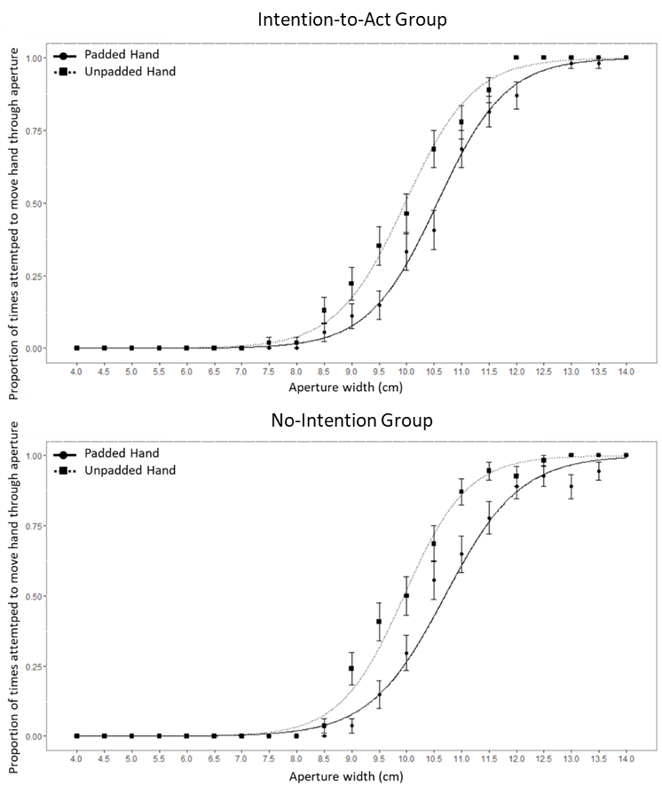
Figure 10: Mean Cumulative Gaussian curves for the Padded and Unpadded hands in the Intention-To-Act (top) and No-Intention (bottom) groups in Experiment 1. Error bars show +/- one standard error of the mean.

It is possible that at least some of the No-Intention group intended to act on the aperture given that they were seated directly in front of it. However, this group was not explicitly asked about their action capacity and they never acted on the aperture during the perceptual task. Thus few of them were likely to have explicitly considered acting by moving their hand through the aperture and any intention to act in this way in this group would likely to be weak, implicit and infrequent. In summary, an intention to put their hand through the aperture should have been stronger, explicit and universal in the Intention-To-Act group even if intention was not entirely absent in the No-Intention group.
All participants wore the Padded glove on their left hand because right handers have been shown to believe that their right hand is larger than their left hand (Collier & Lawson, 2017a; Linkenauger et al, 2011) so if participants estimated apertures as narrower while wearing the glove on their right hand, this could be because their judgements were affected by the change in hand size caused by the glove, or because of the underlying bias in perceived hand size. Having participants always wearing the Padded glove on the left hand avoided this confound. However, it introduced a second confound, namely that the same hand always wore the Padded glove, so in Experiment 2 we counterbalanced which hand wore the Padded glove.
During the haptic feedback phase participants estimated the width of the apertures they felt between their fingers. This was done in the same way as described for the main perceptual task. These results are not reported here because participants actually acted in this task but not in the perceptual task, making it difficult to compare the results of the two tasks. In addition, the action-specific account does not offer specific predictions for haptic spatial perception (though see Collier & Lawson, 2017a, and Linkenauger et al., 2011, for a discussion of the different biases that might be expected for visual and haptic perception). The main purpose of this task was to alert participants to the difference in the width of their Padded and Unpadded hands through haptic feedback, and to ensure that the cover story used in the subsequent perceptual task was persuasive.
Most participants did, though, look at their hands before the task began, while the experimenter was explaining the task.
It might be argued that our results in Experiment 1 arose from a confound. The Padded glove was always worn on the left hand and our right-handed participants might, for example, have been less confident about their ability to pass their non-dominant hand through the aperture. However, in other, similar, studies (e.g., Collier & Lawson, 2017a), we have found no evidence for a baseline difference in spatial estimates depending on whether participants intended to use their dominant versus their non-dominant hand. Furthermore, in Experiment 2 here this confound was removed and there was no effect of whether our right-handed participants wore the Padded glove on their left or their right hand. Instead, we suggest the critical difference between the design of Experiments 1 and 2 was the use of a cover story.

