#freethenipple – Digital Activism and Embodiment in the Contemporary Feminist Movement

Margaret Matich
University of Liverpool Management School
University of Liverpool, Liverpool, L69 7ZH
hsmmatic@liv.ac.uk

Rachel Ashman
University of Liverpool Management School
University of Liverpool, Liverpool, L69 7ZH
Rachel.Ashman@liv.ac.uk

Elizabeth Parsons
University of Liverpool Management School
University of Liverpool, Liverpool, L69 7ZH
Elizabeth.Parsons@liv.ac.uk

#freethenipple – Digital Activism and Embodiment in the Contemporary Feminist Movement

Abstract:

Contemporary, or so-called fourth-wave feminism has heralded an era of online activism which celebrates the potential of this space to reconfigure and reorder gender relations. In this paper we explore an example of an online campaign #freethenipple which attempts to disrupt and destabilize a highly sexualised patriarchal breast ideal.
We examine both the mechanisms of (re)inscription that feminist activists are using in the campaign and the readings and interpretations of the campaign. We find subtle slippages between these intentions and interpretations. In closing we question the ability of the campaign to revoke dominant patriarchal inscriptions of female bodies, and raise questions about the efficacy of the online environment in effecting real world change.

Keywords: Digital Activism, Social Media, Fourth Wave Feminism, Embodiment, New Materialism, Intersectionality

Introduction
Some time ago consumer researchers made a call to attend to the body in theorising around consumption and its intersections with the marketplace (Joy and Venkatesh, 1994; Catterall and Maclaran, 2001). Since this call, many consumer researchers have seriously begun to consider the body and the corporeal in their investigations (e.g. Scott, Cayla & Cova, 2017). Further, recent consumption research has theorised the resistant body in interesting and illuminating ways, drawing largely on post-structuralist theory (e.g. Evans, Riley & Shankar, 2010; Scaraboto & Fisher, 2014; Evans & Riley, 2015; Harju & Huovinen, 2015; Thompson & Ustuner, 2015). However, notwithstanding recent work on the politicised female body in magazines (Stevens and Houston, 2016) we have found little work that fully engages with the material corporeal. Here, we contribute to the growing body of literature examining digital bodies within consumer research (see Campbell, 2010, Giesler & Venkatesh, 2005; Kozinets, Patterson & Ashman, 2017). As such in this paper we foreground both material corporeal bodies and their digital counterparts through an exploration of the #freethenipple campaign.

The campaign leverages a range of women’s own imagery of their bare breasts to address the objectification and sexualisation of women in patriarchal society. The choice of the nipple is important because the breast is highly fetishized within patriarchal society; but it is also particularly disruptive to patriarchy, as it blurs the border between the normative feminine identities of mother and sex object, and because it stands to demonstrate ‘the irreducibility of sexual difference to a common measure’ (Young, 1990, p.194). As we discuss later on in the paper, disrupting patriarchy is no mean feat, particularly in a neoliberal society which reduces the political to the personal (Baer, 2016). Thus, perhaps just as important as this grand goal is the issue of individual empowerment. By posting pictures themselves, using sites such as Instagram, women are taking control over the way that their bodies are represented. As such the campaign attempts to deconstruct problematic highly sexualised and objectified representations of femininity through reclaiming and resignifying the female body.

This campaign is interesting for three key reasons. First, the campaign attempts to challenge essentialised notions of gender by referencing the very materiality of the body. In addition, the campaign’s attempts to reinscribe the female body are not confined to the virtual environment. Rather it relies on a symbiosis between online and offline activity, creating a seamless relation between online blogs, social media feeds and video material and offline events such as seminars, protests and rallies. As such we think it has something to add to feminist theorisations of the body, as well as to debates on cybernetic subjectivity which embrace new materialist thinking around the same. Second, we argue that the marketplace plays a significant role in directing and shaping these new forms of feminism. The commodification and consumption of #freethenipple serves to perpetuate specific readings of the female body. Fourth-wave feminist movements like Free The Nipple, are beginning to occupy more and more space in the theatre of consumption. Its ubiquitous, digital presence has allowed its resignifying practices and subversive activities to spill out into vast and varying marketplaces. Contemporary feminists are harnessing the pre-existing discourses, markets and arenas of consumption such as social media, and are attempting to transform these into feminist spaces of social activism and protest. Third, we think the campaign raises questions about the efficacy of the online world in creating truly utopian spaces for ‘transgressive feminist thinking’ (Welchie, 2016; Bettany, 2016). Negotiating the radical potential of women’s bodies in an intensely neoliberal, patriarchal marketplace is a thriving debate and often the source of a great deal of ideological conflict within contemporary feminist activism and discourse.

In the paper which follows, we begin by sketching the context of the #freethenipple campaign. We follow this with a discussion of feminist perspectives on the body, new materialist theory and more recent thought around virtual embodiment, as well as a discussion of contemporary digital activism. We then present our methodological approach to the study using netnography and interpretive analysis of the visuals and discourses we encountered. We order our findings to explore first the online mechanisms though which activists attempt to foreground their ‘breasted experience’ (Young, 1990) and thus free the nipple from meanings inscribed by the (patriarchal) other. Second, because we are interested in the efficacy of this form of activism, we explore the ways in which these images have been read and interpreted, in particular which cultural repertoires are invoked in these readings and with what effects. Our discussion outlines the micro, meso and macro elements of the campaign, as well as addressing the issue of intersectionality in contemporary digital bodily activism. In closing we question the ability of the campaign to revoke dominant inscriptions of female bodies. We also draw out future implications for fourth wave, contemporary feminism. Undoubtedly the reliance of the campaign on virtual or digital embodiment constitutes a key ‘re-location’ of feminist cultural practice (Braidotti, 1996, p2). But what are the limitations of this relocation? And what are the implications of digital bodies for achieving real change?

The #Freethenipple Campaign

[Figure 1 here]
[Figure 2 here]

Founded by artist and activist Lina Esco in 2013, the Free The Nipple campaign addresses the sexualisation and censorship of women’s breasts. The campaign aims to achieve the right for women to bare their chests in Western nations where going topless is largely discouraged and criminalised, unless in a ‘sexual environment’ such as a strip club. Thus, the campaign seeks to interrupt patriarchal framings of the breast as inherently sexual and the associated practices of concealment and censorship. The organisers describe the movement as ‘a mission to empower women across the world’ (Free the Nipple Website, 2016). They ‘stand against female oppression and censorship’ through their ‘real life equality movement’ in the form of public topless protests, and the viral #freethenipple campaign. According to the website, the issues they attempt to address are ‘equal rights for men and women, a more balanced system of censorship, and legal rights for all women to breastfeed in public’. They cite the fact that female toplessness is illegal in 35 US states, in some states this includes breastfeeding. They also observe that women are censored online and are often arrested for toplessness, even in countries and states where it is legal to go topless such as the United Kingdom.

Playing with the concealing and revealing of the body has long been a way for women to challenge patriarchal restrictions of women’s bodies, from freer and flapper fashions of the 1920s, which offered a challenge to the corseting of the female figure (Zeitz, 2006), to more recent sextremist methods of the 90s Riot Grrrl movement and the body politics of activist groups such as Femen and Pussy Riot, which #freethenipple should be considered alongside (Channell, 2014). Femen define sextremism as ‘female sexuality rebelling against patriarchy and embodied in the extremal political direct action events’ (Femen, 2017). Femen famously stated that ‘topless protests are the battle flags of women’s resistance’ that act as ‘a symbol of a woman’s acquisition of rights over her own body’ (Shevchenko, 2013). Further, although these fearless protestors do not receive as much exposure as their Western counter-parts, women across Africa have used topless and naked protest for decades to demonstrate ‘resistance to colonial authority and racialised Western notions of the body’ (Kazeem, 2013).

A central strand of the campaign is the circulation of women’s own images using the #freethenipple hashtag (see fig.1). The range of images shown in figure 1 capture the diversity of individual responses to the movement’s central aims – embracing both sexualised feminine identities and those of motherhood and mothering. Participants have also leveraged a range of visual strategies from presenting full body images to breast or nipple only and in some cases mere representations of the breast using other materials such as flowers and vegetables. Visual responses also draw on a range of other cultural references with some pictures heavily stylised as stills from movies and advertising campaigns. The images also make reference to the diversity of breasts in size and shape and present breasts which have been altered through tattoo, piercing or surgery. These images have been circulated widely across the globe. The Free The Nipple Instagram site has around 279 thousand followers, Twitter has 172 thousand followers and the Facebook site has 66 thousand followers. Further, in terms of individuals contributing their own content, the freethenipple hashtag has over 1 million entries on Instagram and in excess of 100,000 entries on Facebook.

Linking #freethenipple to the consumption sphere is essential in understanding the impact of activism in the neoliberal world. Free The Nipple is only one example of many others (e.g. Slutwalk, Reclaim The Night, #nomorepage3) that demonstrates how modest political action has morphed into an international feminist movement and associated consumption opportunities. These protest activities create an inescapable feedback loop, or ‘trickle up’ effect that permeates mainstream consumer culture. Most obviously, these moments of ‘commodity activism’ (Mukherjee & Banet-Weiser, 2012) feed directly into specific product avenues: you can purchase t-shirts, socks, card, necklaces etc. from large retailers to sole traders all linked with freeing the nipple (see fig. 2). In addition, these moments of activism spark entrepreneurial and market-related endeavours. Protest activities create impactful, connective effects that inject ideas, energy and new cultural aesthetics via a symbiotic relationship between offline and online networks. Through utilising these networks, individuals can gain significant cultural capital; garner attention and consequently monetise themselves as brands. This in turn can influence fellow activists to perform their own countercultural action, which collectively, in a chainlike fashion, can be impactful.

Protest activities such as Free the Nipple fundamentally oppose conformity and the free-market. They send a fresh message standing in opposition to the ‘stiff, militaristic order’ that creates ‘a meaningless plastic consumerism’ (Frank & Weiland, 1997). However, by interacting with consumerism these movements simultaneously resist and advance the free-market through their cause. This paradoxical problem has been discussed at length by Frank et al in Commodify Your Dissent (1997), The Conquest of Cool (1998) and No Future For You (2014). They would suggest that movements such as Free the Nipple embody contradiction and place feminism in an uneasy dance with capitalism (Falludi, 2014). In doing so, they perhaps undermine the cause they so desperately wish to promote (fourth-wave feminism) through perpetuating the postfeminist commodification of women’s sexuality.

Indeed these online and offline dimensions corroborate and bleed into each other in interesting ways. A feature length film has been released on Netflix, telling the story of the movement, as well as a range of merchandise. Celebrities such as Miley Cyrus, Keira Knightly, Cara Delevingne and Naomi Campbell have all publically supported the campaign. Figure 3 is a still from the trailer for the Free The Nipple movie, which features a protest in New York city where activists ran through the streets topless wearing bright pink balaclavas. The trailer and the film have been circulated widely online. This online transmission of a physical protest is characteristic of the contemporary feminist movement, and provokes a discussion of the way physical and digital bodies collide and collate in contemporary feminism. The movement as transcending boundaries between digital and physical activism is also exemplified in figure 4, an image taken from a video about Free The Nipple produced and shared by .Mic in 2015. The video was viewed and shared thousands of times, far exceeding the potential reach for a protest which takes place solely in physical space. Digital space allows the protest to continue to make an impact long after protestors go home. This is also seen in the use of the hashtag tool in the campaign, where anyone can share images and populate the thread with their own content (see fig. 1).

Towards the end of the trailer for the movie which tells the story of the campaign, one of the activists states that women’s ‘sexuality has been taken away from us and is essentially being sold back to us’ which is what the movement seeks to overturn. In this discourse, it is evident that the Free The Nipple movement aims to salvage women’s bodies from the postfeminist marketplace which facilitated the re-objectification of women’s bodies (Gill, 2007, 2008; Evans, Riley & Shankar, 2010), here referred to as the theft of women’s sexualities. This spirit of embodied resistance, and concern for the objectification of women’s bodies is evident also in Esco’s comment in a campaign video in which she questions, ‘why is it that we can sell breasts but we can’t wear them?’

In this way, as we will see, the Free The Nipple movement typifies contemporary fourth-wave feminism for a number of key reasons; firstly, through its utilisation of social media as a site for resistance and protest; secondly, through its condemnation of the postfeminist commodification of women’s sexuality; thirdly, through its appeal to a corporeal, embodied feminism and its return to the natural, material, unruly female body; and finally, through its reference to the wider aesthetics of protest.

The Body in Feminist Theory: The turn to corporeality and new materialism

In the wake of feminist poststructuralist theory, which avoided a discussion of sexual difference, feminist thinkers such as Irigaray sought to reintroduce discussions around women’s bodies and their material sexual differences from men (Hansen, 2014). Irigaray believes that sexual difference is fundamental to human experience, but states that sexual difference need not underlie gendered power structures (Irigaray, 1993). She argues that approaching ‘the other is not to [necessarily] construct it as inferior’, and that these discussions are vital if we are to truly capture women’s experiences and initiate positive advances around the treatment of women’s bodies (Hansen, 2014). Irigaray introduced the idea that women cannot truly come to know their own subjective experiences through the poststructuralist doctrines of the time, and that we must return to material sexual difference to allow women to ‘live out their own particular modalities of being in the world’ (Hansen, 2014). The poststructuralist focus on the performative and discursive construction of the gendered body neglects and excludes a discussion of the material, which forecloses attention to ‘lived material bodies and evolving corporeal practices’ (Alaimo & Hekman, 2008, p.3). As such, contemporary feminist theory has seen a return to the material and the phenomenological elements of womanhood.

In their conceptions of embodiment, these ‘corporeal feminist’ theorists investigate the ways in which the body and its fragmentations are inscribed with various meanings and significances, and how this process is mediated and thus limited by gender power relations and patriarchal schemas. These corporeal theorists explore the visceral through thorough examinations of our bodily habits and modifications (e.g. Davis, 1995, 1997; Brush, 1998) disorders (Bray & Colebrook, 1998) and appetites (Probyn, 2000). Further, and particularly relevant to the current investigation, Kristeva’s seminal work on abjection (1982), and in turn, Creed’s concept of the monstrous-feminine explore the way the feminine body is feared and abjected in contemporary patriarchal society. Creed, drawing on Kristeva, denotes that women have historically been ‘constructed as “biological freaks” whose bodies represent a fearful and threatening form of sexuality’ (2012, p.6). Thus, the patriarchal denigration of women’s bodies, Creed argues, is intimately related to the problem of material sexual difference. The motherly body is met with disgust and contempt, and as such, phallocentric patriarchy works to purify this abject entity. Analysing representations of nude women throughout art history, Ussher observes how the female is transformed from a natural being into an image of idealised feminine sexuality, with ‘all abhorrent reminders of her fecund corporeality removed – secretions, pubic hair, genitals, and disfiguring veins or blemishes all left out of the frame’ (2006, p.3).

Inspired by Irigaray, and drawing on Deleuze and Guattari’s anti-psychoanalytic notion of bodily becoming, the ‘corporeal feminists’ hold that ‘only an articulation of the body… would provide feminism with an autonomous liberation from a primarily repressive and negative masculine reason’ (Bray & Colebrook, 1998). Radically, these theorists return to the body, depicting it as a site for transformation and affirmation by observing the complex nature of embodiment and its relationship with both oppression and empowerment.

Both new materialist and poststructuralist feminist theorists have used Foucault to theorise the ways in which bodies are disciplined to conform and align with societal, patriarchal norms and ideals around beauty and femininity (Braidotti, 1986; Lennon, 2014). Further, the social meanings that are both produced by and within these disciplinary processes play a large role in the oppression, domination and subordination of women. For instance, the demand for women to be slim, white, able-bodied, sexually attractive, hairless, respectable, modest, available – all expectations which align with the heterosexual male fantasy, but that require a great deal of violent and time-consuming feminine labour (Bordo, 1993). Irigaray’s contemporaries, Braidotti most notably, rethinks her project of sexual difference as an investigation into the hitherto neglected realm of female subjectivity (Braidotti, 1994).

Elizabeth Grosz also continues Irigaray’s project, drawing also from Deleuze, Nietzsche, Merleau-Ponty, Foucault, Bergson and Darwin (Grosz, 1994, 2004).
Grosz articulates a pure material difference between the sexes (1994). She holds that neglecting the materiality of sexual difference is insufficient in characterising women’s experiences of their bodies, their oppression and their potential liberation. In her theory of inscription, she describes how cultural and patriarchal inscriptions place certain significance and value on corporeal differences, and the body comes to enact these inscriptions. Thus, within a patriarchal meaning-system, women’s bodies come to function as uncontrollable, hysterical, weak, passive, abject sex objects. Further, women actively understand themselves on these harmful terms. Acknowledging and focusing on the materiality of this process is key, Grosz thinks in breaking free from these problematic and trapping inscriptions. Grosz also formulates the body as in a ‘process of active becoming’ - forever changing and transforming (1994). Whilst attending to the materiality of the body, she references the ‘virtualities and potentialities within biological existence that enable cultural, social and historical forces to work on and transform that existence’ (Grosz, 2008, p.24). The female body ‘can no longer be regarded as a fixed, concrete substance, a pre-cultural given,’ rather, it gains its ‘determinate form only by being socially inscribed’ (Grosz, 1987, p.2). She therefore sketches the body as plastic, with potential to act as a force of transformation, as well as resistance and subversion.

Taking the discussion of the body further, feminist theory has seen a return to phenomenology. Phenomonological accounts attempt to foreground the lived experience of the body, a discussion which is often neglected in the new materialist accounts. The phenomenologists further the entanglement of nature and culture, of matter and meaning, but take this to the level of embodiment, and the way the material formulates the experience of the self and of the world. Particularly seminal in this field is Iris Marion Young, who wrote about the everyday lived experiences of women, and the way women’s bodies are often subject to strict norms around feminine bodily comportment, and how women subsequently adopt restricted and ‘inhibited intentionality’ (2005). This manifests in a pervading belief, amongst women themselves, that their bodies are things or objects which are to be ‘looked at and acted upon’ (2005, p.39).

However, Young focuses not only on inhibited bodily practices, but also leaves room for embodied engagement, and how such embodiment offers alternative possibilities for subversion, resistance and change. Alcoff offers a similar account in her conception of visible identities. She characterises the way in which material features of gendered, racially diverse bodies and the meanings they illicit become naturalised, habitualised, and deeply engrained in both those who perceive them, and those who own them (2005).

Both race and sex, Alcoff states, are ‘physical, marked on and through the body’ (2005, p.102). The significance invested upon and within these materialities becomes a key part of our immediate perceptual experience of them (Lennon, 2014). This makes them incredibly resistant to change. However, Alcoff, like Grosz and Young, remains positive about the possibility for transformation and (re)inscription, as she states ‘perceptual practices are dynamic even when congealed into habit… people are capable of change’ (2005, p.189). The means by which we may forge change through and within our bodies, in spite of the restricting inscriptions and significances of our gendered bodies, is less clear. Some theorists have looked at practices of embodied resistance and the active subversion of expected norms through body modification and other corporeal practices (Bobel & Kwan, 2011; Fahs & Swank, 2015).

In summary, new materialist feminist theory can be a more apt lens to explore the body as a site for activism. In their conceptions of embodiment, new materialist theorists investigate the ways in which the body and its fragmentations are inscribed with various meanings and significances, and how this process is mediated and thus limited by gender power relations and patriarchal schemas.

Digital Bodies

Mapping the body in digital space is an ongoing project, and feminist thinkers have come a long way in characterising virtual embodiment, in particular the relationship between our physical and virtual identities (Haraway, 1991; Hayles, 1999; Wajcman, 2010). Many theorists reject a ‘digital dualist’ position, that is, the notion that virtual bodies are entirely divorced from their physical counterparts. Hayles criticises both humanist and emergent posthumanist theory for neglecting the valuable role of embodiment in digital subjectivity (1999). She believes that the re-visioning of cybernetic subjectivity must include rather than erase a discussion of fleshy, material bodies, to produce theory which acknowledges the ways in which ‘human life is embedded in a material world of great complexity’, as well as including vital discussions about how bodies move through digital space (Hayles, 1999, p.5). Hayles argues that this is absolutely vital to explore virtual embodiment if we are to thoroughly appraise the way choice and agency can be articulated within a posthuman context. As Elund states, the digital world is based on the same codes and conventions of the ‘real’ world, and virtual bodies are subject to the same histories, conventions and politics that are faced in the physical world. Further, digital worlds do not operate outside our physical social realities, they are inextricably interwoven (Elund, 2015).

Similarly, and building on Hayles, Jurgenson argues that digital dualism is a conceptual fallacy, instead demonstrating how the digital and the physical ‘enmesh to form an augmented reality’ (2012, p.83). We do not exist online and offline independently, rather we layer our physical and digital experience to form one complex and multifaceted reality. Social media does not replace our offline reality, rather it augments and expands it (Belk, 2016). Jurgenson further demonstrates how this mutual relationship between the digital and the physical breeds dissent, activism and a ‘flammable atmosphere of augmented revolution’ (2012, p.83). This, as we have seen, is particularly evident in the feminist movement which relies heavily upon new forms of digital media for its effectiveness in creating lasting change. It is through, rather than in spite of, its interaction with embodiment that technology has the power to be such a valuable tool for activists. In this way, cyberbodies have the possibility to facilitate new forms of embodiment and ‘new ways of inscribing and interpreting the self that are central to the reconfiguration of postmodern identities’ (Elund, 2015, p.24).

The complex relationship between the physical and digital nature of contemporary protest is knotty and difficult to analyse, but here we attempt to shed some light on the complexity of this relationship in our analysis of the Free The Nipple movement in relation to the literature on digital subjectivity and embodiment presented here. We look at how contemporary feminists are taking up the project of (re)inscribing the body and making use of its proposed plasticity, and how they are attempting to do so through digital activism and virtual embodiment.

Digital Activism – Re-engineering the world?

In recent attempts to characterise the contemporary fourth wave feminist movement, many reference the movement’s migration into digital spaces (Munro, 2013; Wrye, 2009; Maclaran, 2015). This shift is reflected in the sentiment of many key feminist groups, who have expressed their concern that up until now, there has been no ‘explicit, organized effort to repurpose technologies for progressive gender political ends’ and that we must now ‘strategically deploy existing technologies to re-engineer the world’ (Laboria Cuboniks, 2015). Feminist approaches to technology avoid both technological determinism and gender essentialism, affirming that the relationship between gender and technology is ‘situated and fluid’, and thus technological change can also ‘influence gender power relations’ (Wajcman, 2010, p.143).

Technofeminist scholars have gone a long way in demonstrating how ‘the materiality of technology affords or inhibits the doing of particular gender power relations’ and the way in which ‘women’s identities, needs and priorities are configured together with digital technologies’ (Wajcman, 2010, p. 150). The overwhelming view appears to be that online spaces and platforms afford space for feminists to educate, organise and galvanise more easily than ever before, seeing a return to collective feminist activism (Baer, 2016). Underlying this optimistic outlook is a belief that feminists have digital agency and autonomy through which they can enact vital social change. Indeed, no other form of activism has had the capability to mobilise thousands within minutes, enabling those invested in social justice to ‘play their part’ through crowdfunding activity, consciousness-raising efforts and a call-out culture, by providing a platform for radical forms of education, by providing space and visibility for marginalized bodies and identities, and through the formation of online communities and knowledge sharing platforms (Martin and Valenti, 2012; Keller, 2012).

However, the idea of emancipatory digital spaces and autonomy sits in direct opposition to the ‘emphasis of social media platforms on commodified self-representation and the widespread digital dissemination of images of the material body’ that serves to ‘escalate the demands of hegemonic femininity’ (Baer, 2016, p.24). Thus, many urge caution around the internet as a tool for feminist activism (Elund, 2015). Kensinger investigates how the circulation of information in digital feminist activism is potentially problematic (2003). Citing Eisenstein, she observes that ‘getting information is not the same things as acting on it, just like virtual reality is not the same thing as bodily reality. Thinking, knowing, and acting are distinct parts of a process that require different strategies’ (2003, p.4). Conflicts often arise when information crosses borders and is consumed by many stakeholders across the globe; images and chunks of information that are widely circulated can often come to reinforce rather than subvert problematic tropes surrounding women. For example, Kensinger explores how the images of veiled women living under Taliban are employed in digital feminist activism by Afghan women’s rights groups. She observes that they often fuel problematic narratives of ‘passive women’ in need of enlightened Western feminist saviours (2003).

Digital feminist activism often orients around bite-sized, and often de-contextualised, chunks of information and images in consciousness-raising efforts. As Kensinger observes ‘mutuality, agency, context, history, and complexity are vital ingredients useful to judging the activism we find promoted on the internet, and necessary for more effective solidarity’ (2003, p.13). Thus, while the online environment can be an incredibly powerful tool in the armory of the contemporary feminist activist, once text and images have been released into digital spaces, they take on a life of their own, forging journeys we often cannot map or foresee.

Methodology

Given our aim to explore the mechanisms of (re)inscription that feminist activists are using and the contexts of their circulation and (re)interpretation, the study employed a netnographic approach (Kozinets, 2002, 2015; Rokka, 2010). Netnography is described as an adaptation of traditional ethnographic methods, which has expanded to capture the importance of the Internet and social media in contemporary social worlds, culture and communities (Kozinets, 2015). As an active user of social media, and as a young feminist activist with membership and access to a range of feminist chat rooms, discussion groups and forums, the first author’s pre-existing understanding of, and immersion in, digital feminist activism provides a key backdrop to, and inspiration for, the current study.

Having followed the Free The Nipple movement continuously for three years since its conception, she had existing insights into the online landscape of the campaign. Using this knowledge as a starting point the first author attended to ‘sites of attention rather than actual bounded sites themselves’ (Kozinets, 2015: 120-21). Search functions in social media sites (Facebook and Instagram), forums (Reddit) and news sites (Dazed Digital, The Guardian, The Telegraph, Vice) were used to retrieve entries regarding Free The Nipple. This allowed the first author to collate an extensive archive of images and posts about the movement, but also comments to capture the responses to and readings of these materials. The total amount of data collected included 255 images and approximately 89 pages of text.

An interpretivist approach (Goulding, 1999; Cova & Elliott, 2008; Langer & Beckman, 2005; Spiggle, 1994) guided the analysis of data. We explored the ways in which the campaign has been read and interpreted, in particular which cultural repertoires are invoked in these readings. All three authors identified common and recurrent themes within the discourse of the activists, and the public discussions about Free The Nipple. In analysing the data we employed a hermeneutic frame (Arnold & Fischer, 1994) in which the meanings, interpretations and experiences conveyed by the social actors were held central. There was an iterative, circular relationship between the data collected and the themes that were identified in the literature. We then brought our insights together to build a descriptive whole (Arnold & Fischer, 1994). We took a similar approach to our choice of images to analyse. The images presented below were selected as the strongest examples to illustrate the recurrent themes we identified amongst the host of images we collected (Pink, 2007; 2012; Schroeder & Borgerson, 1998). We were also concerned to explore the range of mechanisms of representation and also some of the diversity of activists and participants.

Mechanisms of disruption and (re)inscription

In this section we attempt to account for some of the key motifs and messages from the campaign, as well as representing some of its diversity. Importantly we also seek to examine some of the mechanisms of re-inscription i.e. the different representational framings feminists have employed in the campaign.

Celebrating Diversity and the Natural Body

[Figure 3 here]

[Figure 4 here]

Free the Nipple uses several strategies to resist containment and control. Most prominently the campaign deliberately demonstrates the radically unruly, complex and non-uniform nature of the breast (Young, 1990), through a diverse range of visual presentations (figure 1). These images attempt to reflect and account for the constellation of the cultural meanings of the breast. This celebration of diversity and complexity is an attempt to disrupt and destabilize the uniform patriarchal breast ideal. As Young (1990) observes, the breast blurs the line between motherhood and sexuality, and is therefore uncomfortable and inconvenient for the patriarchy, which seeks to neatly package and compartmentalise female subjectivity and women’s bodies. Many of the images included breastfeeding mothers. Images also include women who have had mastectomies (see fig. 5). The ‘diseased’ breast pushes these boundaries further, as it once again serves to collapse the notion that the breast may be neatly contained and controlled to align with heterosexual male fantasy of the homogenous, perfectly formed breast.

The celebration of the natural body is a key theme within many fourth-wave feminist campaigns (Stevens & Houston, 2016). These displays of the diverse, unruly, natural female form work to destabilise the assumption that women’s bodies hold their value solely in their capacity to be sexually inviting and aesthetically conformist to the perceived norm of sexual attractiveness, as designated by the demands of the heterosexual male fantasy. This activity can of course be viewed as a radical rejection of the abject, monstrous feminine body, and the historical policing and purification of the natural body, as the exposed nipple serves to act as a key signifier of natural secretion and motherhood. As such, the images circulated as part of the Free The Nipple movement typify the body politic at the very heart of contemporary fourth-wave feminist protest and practice.

[Figure 5 here]

The participant depicted in figure 5 demands to be perceived not only as a ‘warrior’ but also as ‘sexy’. She conceives of her post-cancerous breast as challenging patriarchal beauty norms and standards, claiming ownership, agency and authorship over her body through its radical exposure. These images serve to iterate that the breast is no one thing; it is transient, changing and plastic. Its meaning and significance is not fixed, but may be reconfigured, rewritten or reinscribed.

Resisting Containment

A second approach directly references containment. The image of the caged breast in figure 6 is undoubtedly a direct reference to the constraints placed around the breast by wider (patriarchal) society. These constraints operate figuratively through received norms of presentation i.e. when and where the breast is allowed to be displayed and seen, but also translate into the physical containment and restraint of the breast in the form of the brassiere (bra). It is perhaps no surprise that bra burning (while it turned out to be a myth perpetuated by the media) was an activity that became so heavily laden with symbolic meaning. Interestingly though, some commentators argue that ‘bra burners’ became a phrase used to trivialise the Women’s Liberation Movement of the 1960s and detract attention from the real issues of inequality. Notwithstanding this, Young argues that the bra is a tool to shape and sculpt the breast to fit its one, uniform ‘breast ideal’ – giving the breast strict parameters to allow it to seamlessly assume its status as object for visual consumption, whilst simultaneously restricting the breasts movement, fluidity and expressivity (1990, p.195).

[Figure 6 here]

Not only is the breast physically contained and bound by the bra, but the patriarchy also contains the breast figuratively by limiting and controlling the framing of the breast as highly sexualised. This is achieved in advertising, in magazines and in the wider media (consider for example the successful No More Page Three campaign) where the breast is served up for the sexual gratification of the dominantly male gaze. It also translates into the spaces and contexts where the breast is granted a presence but only in service of this gaze. The iterative and consistent reinforcement of these norms in wider culture add up over time to significantly objectify women. This view is expressed by one activist in a video featured on the official Free The Nipple website that was created for .Mic media in 2015, where they lament that topless women are often ‘relegated to sexual environments’. Discussing the online rendering of women’s naked bodies, they argue that ‘if porn is the only place where we do see topless women, no wonder how we have trouble overcoming how women are constantly being objectified’. These confinements thus serve to perpetuate the narrative written and inscribed upon the breast by the patriarchy.

Drawing Contrasts

Another means by which the activists attempt to demonstrate the plasticity of the breast is by highlighting the double standard between men and women’s nipples. The Free The Nipple activists frequently discuss how men fought the same fight in the 1930’s, when it was illegal for men to go topless on the beach. As one member of the movement states on the .Mic video, ‘now that men have had that right for decades, no-one seems disturbed by their nipples’. After fighting for the right to go topless in public, men won the battle and had the law overturned to favour their interests, and the exposure of the male chest was de-sensationalised. The Free The Nipple campaigners frequently refer to this double standard to highlight that it may be possible to carry out this kind of subversive, (re)inscriptive work with and on women’s bodies.

The activists believe that women’s breasts may undergo a vital and timely process of familiarisation and desexualisation by their overexposure, visibility and celebration. In another video about the movement featured on BTV in 2015, the campaign founder, Esco, states,

‘I really hope that this campaign will change the heart and minds of people. There is nothing wrong with the nipple… it’s the thing that nourishes us, at what point did it become, you know, an obscene’

Esco frequently attends to this idea that the female nipple has been inscribed with sexualized meanings and connotations at some point. She uses this to support the notion that through the Free The Nipple movement, it could potentially be (re)inscribed, or (de)inscribed. This notion is perfectly captured in an image shared by supermodel and celebrity Cara Delevingne (fig. 7) where she demonstrates the double standard around male and female nipple exposure. In this image, two fleshy, anatomical, material bodies are present, and a parallel is drawn between them for their material similarity. The black cross covering the female nipple, as well as it being labeled as ‘censored’, where the other is deemed ‘free’, signifies the double standard, and illustrates the way in which the female nipple is layered with unnecessary, arbitrary and oppressive inscriptions that demand censorship, modesty and shame.

[Figure 7 here]

Referencing the Wider Aesthetics of Protest

Figure 3 is a still from the trailer for the Free The Nipple movie, which features a protest staged in New York city where activists ran through the streets topless wearing bright pink balaclavas. The balaclavas are certainly a reference to the absurd criminality of the act of going topless, as well as the criminality of the protest itself. The balaclava is a motif which signals disruption and dissent, as it is used to conceal ones identity when committing a crime. Here, the activists are exhibiting dissent and attempting to disrupt societal norms and conventions around female comportment. The bright pink colour of the balaclava might be a reference to normative femininity, with its bright tone perhaps acting as a nod to the subversive, vocal nature of the protest. Hot pink and the motif of the balaclava or mask have been employed in the protest aesthetics of many feminist groups. For instance, well-known groups such as Pussy Riot, Femen and the Guerrilla Girls have long played on the politics of revealing and concealing the body, often wearing masks during their protests and performances.

The practice of feminist masking has its roots in third-wave feminist aesthetics, and has strong links to the Riot Grrrl movement (Baer, 2016). It has been said that this is to place the emphasis on the collective solidarity and message of the activists, rather than the activists themselves, as well as a ‘refutation of hegemonic femininity’ (Baer, 2016, p.27). In the context of the Free The Nipple movement, whilst being a reference to wider feminist activism, it might also be a tool to draw focus to the breast rather than the face as a mechanism of expression and as a locus of identity. Conversely, theorists have also demonstrated that the obscuring of women’s faces in images plays a key role in objectification practices in marketing and advertisements, as it removes the potential for the woman to be identified as an individual, as a human, and allows her to function purely as an object to be consumed visually (Hall & Crum 1994, Schroeder & Borgerson, 1998). The movement, and feminist masking practices more widely therefore make subversive references to the very process of objectification they are seeking to resist.

Readings and Interpretations

Following these images onto social media, we were further able to investigate the ways in which they were read and received within feminist groups, but also by general observers and commentators.

Choice, Agency and Control?

Many online users discussed the positive aspects of the campaign, often contributing to the movement themselves by tagging their social media content with #freethenipple. One user celebrated Free The Nipple as a movement which he believed would ‘benefit society’ by ‘no longer arbitrarily restricting the freedom of women’. This user demonstrates an understanding that the restrictions placed on the breast in our patriarchal society are arbitrary, unnecessary and potentially impermanent. Another user contributed to online discussion by listing various major reasons to support the movement,

- Equality
- Help normalise breasts in non-sexual contexts
- Which will help reduce their sexualisation in society
- Which will help reduce the sexualisation of women’s bodies in general…
- Breasts are not sexual organs…
- Anatomy of male and female breasts is exact same [sic]

The reasons cited in this list broadly align with the rhetoric and mechanisms employed by the activists themselves. Namely, that the movement may further the struggle for gender equality and that the breast can go through a process of normalisation and desexualisation. Further, the double standard between male and female breasts is drawn upon again to demonstrate the arbitrary nature of the restrictions on female toplessness.

An appeal to choice and agency rhetoric was also evident in the online commentary, as one user observed the movement was ‘all about people having control over their own body’, and with another Facebook user sharing the following quote:

‘I find it interesting how society doesn’t care when the media sexualises women, when men sexualise women, when school and the government sexualises women. But the second a woman is in control and sexualises herself willingly it’s wrong and disgusting’

The quote demonstrates the restriction of women’s agency and capacity for choice and authorship over their own bodies. It alludes to Young and Grosz’ notion that the patriarchy confines the breast to assume certain roles and functions, and that it is seen as ‘wrong’, ‘disgusting’ or shameful when these boundaries are breached. The user therefore characterises the Free The Nipple movement as disruptive and subversive. She shared the quote along with her own caption which read, ‘It’s time to evolve. #freethenipple’, suggesting that we are still backward in our views and treatment of the breast and demonstrating a belief in the possibility of a brighter future.

Escaping the Male Gaze?

A wide range of argumentation emerged from non-feminist online commentators but most of this rhetoric merely reproduced an essentialised view of the breast as inherently sexualised:

‘A female breast is a sexual organ. Men have to cover up their junk…women cover their nips… If we’re protesting against nip coverage, shouldn’t we protest all nudity laws?’

The breast here is equated with ‘junk’ or the penis, and toplessness is equated with nudity. As it serves no reproductive function, the breast is not in fact a sexual organ, but the many comments of this nature serve to demonstrate that the breast has been heavily sexualised and inscribed by the patriarchy, to the point that it is commonly incorrectly equated with reproductive organs. Appeals to biology were often made to explain both the male arousal response to breasts, as well as the essential sexuality of the breast:

‘Human females are the only mammal to have permanently enlarged breasts, specifically to attract male mates… It’s just stupid to think that breasts aren’t meant to be sexualized, because they only came to be so prominent due to their sexual attractiveness’

Here, mistaken and erroneous appeals to evolutionary theory are used to justify and ground the sexualisation of women’s breasts, by rooting them to some fixed biological truth or function. Such heavy handed and ignorant attempts to fix the meaning of the breast do perhaps render the movement’s hopes of re-inscription a little over ambitious. Discussions often reinforced objectification, sexualisation of the breast – viewing the campaign as no more than titillation for a male audience:

‘I love it. Because I love to see women’s nipples. I couldn’t care less about the cause. I guess it’s supposed to fight against women being sexualised. But when I saw some of those photos, all I thought about was sex’

Indeed both feminist and non-feminist commenters acknowledged that the sexualised norm of the breast may be too heavily ingrained for this kind of activism to make any difference. In fact, this was the most widely documented opinion throughout our dataset. The movement’s potency was seen to be subsumed by a culture of objectification and sexualisation, and the imagery and mechanisms of the movement were argued to in fact fuel objectification and male gaze rather than subvert it. The concern in this line of thought was not necessarily that the desexualisation of women’s breasts is impossible, but that it is not possible in the society at this time. This was particularly evident in one comment from a user in a thread about Free The Nipple on an all-female feminist discussion group;

‘I support the movement in principle, but the fine line it treads between liberation and titillation makes me really uncomfortable… I can’t help but feel like the disrespectful objectification of women’s bodies is part of a much grander system of oppression towards women and if we want to genuinely #freethenipple, first we have to #freethewoman’

It became clear that a lot of the women in the group shared this belief and regrettable concern that the movement is premature in a society in which the female body is so heavily objectified. Whilst it was agreed that objectification is a great concern for feminists, the Free The Nipple movement was not seen as effective in tackling this issue. The same user followed up her comment by embedding Figure 8, stating ‘I think this nicely sums up my issues with the movement’;

[Figure 8 here]

It is not clear whether figure 8 is a picture of a Free The Nipple protest, or if the women pictured are activists at all. The picture does however sum up concerns held by a range of users over the possibility that the Free The Nipple movement may reinforce the male gaze rather than subvert or disrupt it. Another user nuances the debate by introducing the concept of ‘male entitlement’:

‘There are many reasons why women as of now, don’t wish to free our nipples, probably [because] you haven’t even gotten to the core problem which is that men feel entitled to and find women’s bodies inherently sexual, why would you tell women to free their nipples when you know most men aren’t even close to being at the level of respect and progress in which the average women can ‘free her nipple’ without some type of harassment or unwanted attention from annoying men… women’s nipples are consistently still going to be in a sexualised format due to porn and adverts’

The user here echoes broader interpretations of the campaign as too little and too early, later on in her commentary she observes that the campaign is ‘redundant, lazy, premature’. The dominant patriarchal view, engrained historically and potentially amplified throughout the postfeminist era, seems to remain the norm. The exposure of the breast in this way was not seen as disruptive to patriarchy, nor was it viewed as an effective method of subversion. Unfortunately, despite its noble attempts to tackle objectification, Free The Nipple’s central message seems to get lost within a society which is not ready to embrace the female body in all its complexity and diversity.

Discussion

Micro, Meso and Macro Level Activism

These findings help us to discern the micro, meso and macro dimensions of the popular fourth-wave feminist #freethenipple campaign. At the micro level, the campaign has a deep impact on the individuals who participate in the campaign. This can be seen in figure 5, where one user accompanies an image of herself standing powerfully, breasts bared with a caption describing herself as a warrior. This is also seen in the movement’s desire for freedom from the patriarchal restriction of women’s bodies, and its understanding of topless protest as a means to take control back over one’s own natural body. The campaign also links social media users to other feminists, allowing them to participate in a global movement simply by posting and hashtagging their content. At the meso level, the digital campaign facilitates a participatory politics (Keller, 2012), allowing the movement to form a disparate yet powerful community of activists, who congregate in digital space around this common concern. The digital nature of the movement allows the protest to live on and grow continuously, taking up space and leaving an imprint on our timelines and social media feeds (Martin and Valenti, 2012).

At the macro level, the picture becomes more complex, as Free The Nipple attempts to utilise the weighty potential of the body (Lennon, 2014) as a site for activism. Here, and as in a great deal of contemporary feminist activity more widely, feminist work harnesses the body in an attempt to change the way people think about it, and behave towards it. In our findings, we have highlighted just three of the many ways in which women participating in the campaign are attempting to disrupt the male gaze by celebrating diversity, resisting containment and drawing contrasts. We also observed the way in which the protest element of the campaign draws on existing historical cultural and aesthetic repertoires to add potency to its meaning. However we have also found that the reception of the movement often serves to undermine its central message.

One of the key issues is the way in which the female body is already so heavily culturally inscribed, to use Foucault’s words ‘a body totally imprinted by history’ (Foucault, 1977, p.148). As Ione Gamble states in a piece published on Dazed Digital in 2016:

‘The reality is under current male-enforced circumstances it’s almost impossible to separate our breasts from sexualisation. Unfortunately, no matter how well intended, a hashtag can’t really erase decades of stereotyping that contribute to how we view the female body or deconstruct societal notions of what it means to be a woman’
Grosz alludes to the way the body writes its own meanings, and has meanings inscribed upon it (1994). She believes that it is actively engaged and involved in the process of transformation and change. It is not fixed, it is at once the mechanism by which we come to know objects, but is also an object of perception and inscription itself. We see the other and the other sees us, in a relationship of symbiosis. Grosz depicts this using the analogy of the Mobius Strip, where the corporeal schema of existence appears simultaneously internal and external, thus, the two reflect one another (1994).
However in an online world this symbiosis often fails, and in some of the online commentary, we find a slippage between how the campaigners wish to be seen, the way in which they attempt to write their own meanings; and how they are very often seen in the reception of the campaign. Intended meanings and attempts to shape those meanings are often lost in an online networked world where there is a significant disconnect of distance, intention, and context between the viewer and the viewed. As Jurgenson states, ‘no longer are protesters just shouting into the wind (made of atoms), they are also shouting into a network (made of bits); a network where there may [or may not] be an audience receptive to the message’ (2012, p.88). Further, this is not only true of digital activism – in their work on the sextremist group Femen, who favour direct action and physical corporeal protest, Khrebtan-Hörhager and Kononenk found that ‘audiences are virtually never completely ready for new meanings—old frames, representative of dominant ideologies, die hard and slowly’ (2015, p.246). However, it is difficult for any activist relying on the dissemination of images to completely predict and prohibit the myriad forms of fetishistic consumption of the body. As we have stated, to completely eradicate all forms of sexualized seeing is an incredibly difficult task. Further, as we have observed in our findings, and as has also been noted in the case of Femen (Khrebtan-Hörhager & Kononenk, 2015), images of the defiant, radical female body online or in the media are all too rapidly reconfigured to align with traditional patriarchal schemas and ‘normal sense-making devices’ (Foust, 2010, p.163). By re-sexualising these activities in this way, observers attempt to diminish the political agency of these activists, making the project of disruption and (re)inscription seemingly more difficult.

The cultural-context of these movements is key when considering how they are read and received, and also when considering their transgressive efficacy. Khrebtan-Hörhage notes the difference between the incredibly hostile and violent reception of the Femen movement in its Ukrainian home, compared to its more celebratory reception in its Western European hosts, Germany and France (2015). Khrebtan-Hörhage argues that in this Western European cultural context, where female nudity and social justice activism is more compatible with social norms, the resistant body loses some of its transformative power. However, the strong negative response in Ukraine demonstrates that Ukrainians actually confront the new framings and meanings of corporeality proposed by the Femen activists, but reject them (2015). In this way, Khrebtan-Hörhage proposes that there exists a compatibility fallacy, where sometimes a movement can be more transgressive in a setting where it is less palatable, as it can function diagnostically to bring to light hidden or unconsidered patriarchal regimes, and to at least introduce new ways of thinking the female body (2015).
Thus, macro level change appears very difficult to pinpoint and achieve. However, as change occurs at the micro and meso levels, subtle shifts may work to gradually generate greater shifts and changes, particularly through the powerful partnering of activism and technology.

Intersectionality, Corporeal Resistance and Digital Bodily Activism

The efficacy and import of corporeal activism in contemporary feminism is multifaceted and oftentimes contentious. It is, as Khrebtan-Hörhager and Kononenko state, both ‘impossible to ignore and difficult to implement’ (2015, p.246). In their analysis of the aesthetic and rhetoric of the Femen movement, Khrebtan-Hörhager and Kononenko (2015) explore the way in which the activists juxtapose the image of the aestheticized female body (the bare female breast) and floral symbolism (flower crowns) to ‘trouble the notions of masculine authority, traditional forms of privilege, and culture-specific forms of patriarchy’ as well as to ‘reframe the meaning and function of naked breasts’ (p.225), as we see also in the case of Free The Nipple. Khrebtan-Hörhager and Kononenko recognize that although ‘corporeal reframing as a mode of resistance is a complex and at times controversial communicative strategy’ (2015, p.246), it can oftentimes prove incredibly successful in gaining traction and attention due to its tangible, visual nature. This is seen as particularly effective in the case of Femen, where the activists employ shocking juxtapositions bridging seemingly incompatible symbols of normative femininity and extremist warfare to ‘contrast traditional linguistic meanings’ (2015, p.246).

Khrebtan-Hörhager and Kononenk state that in this way, through their reliance upon the corporeal, these movements and activities can serve to challenge both universal and culture-specific traditional interpretive conceptual frames, and have the power to ‘desexualize, intellectualize, politicize and give agency to what has traditionally been seen or consumed as an object of sexual pleasure or nurture-a female body’ (2015, p.246). As such, they support the rise of a more corporeal activism, reaffirming Lunceford’s claim that ‘for a social movement to gain any traction, it must mobilize bodies’ (2012, p.4).

However, in addition to reaching shared understanding with their audiences, a second key challenge for corporeal activist movements such as Free The Nipple is that of intersectionality. As O’Keefe states, ‘the body is very much a contextualised product of the relationship between capitalism, patriarchy, racism, colonialism and other systems of oppression’ and as such, ‘it is important to decipher how bodies are located in movements that resist such structures’ (2014, p.3). As a global movement, the campaign should be viewed in light of Éric Macé’s seminal work on post-patriarchy and differing global socio-cultural gender relations (2015). Macé proposes that Western civilisation is in an era of post-patriarchy, where the equality and autonomy of all individuals is commonly understood as legitimate and necessary, however gender inequality still persists. Arguably, it is this ‘inegalitarian egalitarianism’ that campaigns like Free The Nipple set about bringing to our attention. Further, this may underlie the discrepancy between the intention behind the production and the reception of images circulated as part of the movement, for the inequalities that persist in post-patriarchal Western civilisation are evident to the oppressed (women), as they remain part of our lived experience. However, in a world which pays lip service to gender equality, the oppressor may remain blind to these issues, discarding them as irrelevant and simply pertaining to the natural order of things.

Macé also crucially compares global contemporary gender relations, discussing how many societies outside Europe remain in a modernised patriarchy (distinct from his notion of traditional and modern patriarchies), where composite gender arrangements still stand to naturalise the subordination of women. He states that given the diversity of the many different societies in the world, and their different trajectories of globalisation, we must consider what forms of patriarchies or post-patriarchies operate within these societies. In a manner similar to Macé, Ortner (2014) observes that while patriarchy is certainly a global phenomenon its significance in different parts of the world varies widely. In some contexts women may not recognise patriarchal oppression at all, and some may feel that a patriarchal family and kinship system is, on balance, beneficial to them. Simply put, the project of Western feminism to challenge patriarchy may not be as relevant for women in the global south where other issues such as poverty may take precedence. She also argues that we need to recognise that patriarchy intertwines with other structures of power such as colonialism, capitalism, imperialism and racism to produce a range of complex and globally varying effects. Further nuancing the argument, Patil (2013) pushes the point that these structures of power are ‘transnational’ by nature; she encourages us to move away from a focus on nations to explore the ‘cross border dynamics’ of these processes. This is also crucial if we are to consider how the global Free The Nipple campaign may be read and received in different geo-cultural contexts, and within very different understandings of women’s bodies and ‘a woman’s place’. As is often a critique of sextremist feminist methods, the Free The Nipple campaign may only make sense under a Western understanding of [post]patriarchy, neglecting a discussion of different geo-cultural regimes of acceptance and (dis)taste.

The movement might be interpreted as merely another version of ‘selfie feminism’ which ‘claims a universal female experience located in ‘the female body’ but which neglects more nuanced understanding of women’s corporeal experiences, particularly those with deeper layers of oppression such as women of colour, disabled women, transgender women and femme-presenting women (Dean, 2016). In its neglect of intersectional marginalized identities, Dean believes that the movement ultimately constitutes white feminism:

‘The compounded male, white, and colonialist gazes that work so hard to blur Black women and femmes into oblivion have too much force behind them to leave me with enough agency both to politicize a topless mirror selfie and to believe in that politicization one-hundred percent… it is perhaps inadvisable for those of us whose subjectivities have not yet been recognized on a large scale to objectify ourselves further using the tools vetted by those who perpetuate our oppression to begin with — even in efforts toward documenting one’s life with the hope of subverting external expectations. And anyway, on the Internet, this subversion is hardly revolutionary work. In fact, the algorithm thanks you for your contribution.’

Dean’s concerns connote an open letter addressing the organisers of the SlutWalk movement published on the Black Women’s Blueprint where they state; ‘As Black women, we do not have the privilege or the space to call ourselves “slut” without validating the already historically entrenched ideology and recurring messages about what and who the Black woman is.’ (Black Women’s Blueprint, 2011).

Movements such as Free The Nipple have also been critiqued for deriving their frameworks from ‘racist, classist, capitalist “lean-in” equality-core’ predecessors, and as such, specifically black women and ‘all of us here whose bodies and selves are failed by a second-wave capitalist, classist, racist, cissexist, ableist feminism —do ourselves a disservice by considering it in the least bit viable’ (Dean, 2016). As Baer states of the similar SlutWalk protests, the practice of radical nudity offers a corporeal feminism and body politic that simply is not feasible or effective for ‘people of color, LGBT people, economically disadvantaged groups, or sex workers’ (2016, p.24). Further, in her work on SlutWalk and Femen, O’Keefe states that these groups do not subvert, but rather replicate normative, hegemonic ideals of femininity and female corporeality, and thus they serve to ‘marginalize women from diverse backgrounds’, ultimately resulting in an ‘anemic analysis of structural oppression’ (2014). Whilst acknowledging the power and potential of corporeal activism, O’Keefe claims that Femen and SlutWalk rest upon a dangerously flawed body politic. She argues that through their ‘uncritical embodiment of hegemonic, heteronormative corporealies that are unquestionably rooted within patriarchal and capitalist values’ (2014, p.5), they not only fail in their quest to disrupt and disturb patriarchal structures, but they also ‘hide the structural and intersectional nature of women’s oppression and, in their claims to be universal, are widening gender hierarchies based on body difference.’ (2014, p.15)

In step with Macé (2015) and Ortner (2014), Nagarajan, discussing the often culturally insensitive sextremist methods of the group Femen, urges us to move towards a politics of ‘international feminist solidarity that integrates a gender, race and post-colonial power analysis and takes its cue from the women affected and those who are already challenging gender inequality’ whereby we may consider a more holistic approach to understand ‘how patriarchy combines with racism, neo-colonialism and global capitalism to create a fundamentally unjust world’ (2013, n.p). Until this becomes a priority Nagarajan argues, the ideologies that underpin these sextremist methods are not inclusive, intersectional and are ultimately ineffective, as they simply perpetuate a ‘racist, colonial feminism’. This lies evident in our findings that Free The Nipple is often considered to constitute white feminism, and that it lacks inclusivity and intersectionality, two paramount considerations for contemporary feminist activists.

Digital Space and Imagery

The above critiques further question the efficacy of online spaces, and the level of agency that is afforded to marginalized subjects in digital space, a concern which was also reflected in our findings. Free The Nipple attempts to subvert and re-engineer the politics of looking. By explicitly relying upon the circulation of images and radical visibility, it does so by forcing users to look at the breast and reappraise it. However looking does not necessitate knowing, as we have seen, and the politics of looking cannot be tackled by attending only to the act of looking itself, but by simultaneously addressing the understandings and knowledges that precede looking. As Kensinger (2003) demonstrated in the case of images of veiling in feminist activism for Afghan women, the image is swept up in complex systems of looking and interpretation, and can often be inadvertently repurposed to bolster problematic understandings of womanhood. The digital image is a great tool for contemporary activists, but it is often embedded in thorny systems of looking and meaning production.

Particularly evident in this charge that the movement constitutes white feminism, and also in the discussion around the movement as fodder for the male gaze through its focus on white, slim, able, conventionally attractive bodies, is the notion that, as was the fate of third-wave choice and empowerment rhetoric, the movement has been hijacked to align with old, conventional structures around female comportment. In this way, some commentators agued that it does little revolutionary, revisionist work for women’s bodies. We should not, Dean argues, believe in the politicisation of the act of going topless, particularly not in digital spaces which were constructed and designed by those who enact our oppression. As Elund states, the digital world borrows codes from the physical world, and cyberbodies are subject to the same patriarchal schemas that physical bodies face (2015). Free The Nipple potentially yields to rather than subverts the white supremacist patriarchal preference for white, cisgender, slim, able-bodied women. As Gamble states in her 2016 piece referenced above, ‘those confident enough to participate in such a campaign are more likely women that already fall within the narrow ideals constructed by society in the first place’.

However, whilst images of young, white, slim, able-bodied, cisgender women appear to dominate the Free The Nipple movement, and whilst the emancipatory efficacy of such images is hotly contested by feminist commentators online, the fundamental aims of the movement, namely to demystify women’s breasts, and to challenge the patriarchal gaze that works tirelessly and systematically to contain and define women’s bodies as sex objects remain important and noteworthy. Many commentators did indeed find the movement to be effective in challenging patriarchal norms, and many expressed that they felt empowered through partaking in the movement and seeing it unfold. What is required, perhaps, is more space for diverse representations and depictions of the breast, and a richer, more sensitive understanding of how the breast (and the body) is configured within differing geo-cultural contexts. Hopefully, further diversification of these images as the movement evolves and persists will allow more and more women to express themselves, to author their own bodies, and to find freedom from narrow, binding norms.

Conclusions

As we see in the case of Free The Nipple, the body can be envisaged as a tool for political activism to shape and challenge the problematic ways that femininity is constructed, packaged and sold in the marketplace. Near infinite female subjectivities have been opened out through the adoption of choice feminism and postfeminism (Evans et al, 2010). However, many feminists are wary of opening out femininity in this way, and see ‘choice feminism’ as potentially damaging for the possibility for subversion and resistance within the feminist movement. The endless possibilities enabled by the multiplication of female sexuality discourses are ‘reduced through the homogenisation of the media, where representation [and visibility] is often limited to identities which conform to normative ideals of beauty’ (Evans et al. 2010, p.123). Through this process of homogenisation, transgressive acts and movement such as Free The Nipple are ‘recuperated’ and sublimated through mainstreaming, which makes the (re)inscriptive, transgressive iterations of the movement somewhat redundant and ineffectual. In fact as we have found, the ‘widespread digital dissemination of images of the material body escalates the demands of hegemonic femininity’ (Baer, 2016, p.24).

Not wanting to get carried away on the current wave social media fervour, we also have to be cognisant of the trenchant critiques of the ability of this format to support or constitute ‘real activism’. Gladwell observes that real activism that challenges the status quo and attacks deeply rooted problems is a high-risk activity that is ‘not for the faint of heart’ (2010). Taking examples from the civil rights movement in 1960s America, Gladwell discusses the central importance of deep friendship or ‘strong ties’ between participants in real or high risk activism; ties which help people to persevere in the face of danger and persecution. He also observes the importance of a targeted strategy to achieve real change, arguing that this can only be achieved through a strongly hierarchical structure. Social media then has two clear drawbacks here, being characterised by ‘weak ties’ and being networked as opposed to hierarchical in structure. Weak ties or distant connections allow us to draw from a much wider pool of knowledge and ideas but they don’t necessarily lead to high-risk activism. Networks (as opposed to hierarchical structures) are diffuse allowing little role for precision and strategy. As Gladwell (2010) observes ‘Social networks are effective at increasing participation—by lessening the level of motivation that participation requires.’ As such the social media element of #freethenipple in and of itself might not constitute ‘real activism’ to find evidence of this we have to consider its embedding within a movement which has a significant offline presence in a series of seminars, protests and rallies.

In exploring the intersections between this whole movement and a wider consumer culture in which it is embedded we might find some further possible cause for concern. There are those who have sought to harness the movement’s values and message (and indeed its broad aesthetic of resistance) for financial gain. As we mentioned earlier the movement has sparked a whole host of entrepreneurial activities from product lines to promoting associated events. Some of these activities not only stem from an economic profit motive but a building up of a certain identity and/or media celebrity capital, for some it has even made their career– it is undeniably ‘cool’ to be a chest bearing feminist. These endeavours operate as a form of ‘commodification of dissent’ (Frank & Weiland, 1997). Arguably then the marketplace is both promoting the movement (facilitating the movement of its message) while potentially simultaneously undermining that message. Indeed commentators have argued that there is a certain inevitability to countercultural resistances becoming fodder for corporate opportunities (Frank, 1998).

Despite these problems, it seems that moments of activism like ‘free the nipple’ are ultimately successful in affecting small amounts of change, which over time, in a drip-feed manner can lead to bigger shifts in perspective (Mukherjee & Banet-Weiser, 2012). Whether promoting the cause through the sale of t-shirts, the production of Instagram accounts, or the mobilization of resources through social media sites, it is undeniable that at least for some followers, movements like Free the Nipple cause waves through creating ‘networks of desire’ that ‘transmit not just information, but representations of bodies that actively contribute to all aspects of a particular consumer culture – its meanings, values, identities and rituals’ (Kozinets et al 2016, p. 679). Whether small or large, these waves ripple into the thoughts and minds of those who interact with them and in some small way, change their lives. Problematic or not, despite all the reasons discussed above, in this case, consumer behaviour is changed inch-by-inch, day by day through a protest aesthetic pushed into the network by those who have started or been highly committed to the movement, which then mobilizes others to use what Kozinets et al (2016, p. 662) call ‘culture-communicating resources, energizing and furnishing the interconnected network and the system into which it connects’. From this energy grows people power and with this more influence to dictate what is popular, successful and acceptable. Free The Nipple and other activities like it become successful by pairing values with consumption, translated through products and using technological networks. In this example, Free The Nipple is using the notion of freedom of expression to increase connective flows of desirous consumption through bodywork and intentional re-inscription.

Ultimately these moments of activism cannot be contained, but transition from one to another, shifting from the underground to the iconized celebrity realm of commercial culture, and ultimately influencing patterns of consumption. This allows those involved with the movement the development of a specific self, which makes them desirable and attractive to the network, perpetuating further passion and excitement. For the network, this perpetuates the adoption of a new aesthetic underpinned by consumption activities spanning multiple industries. With this lens, and as Gamble states in her 2016 article for Dazed Digital, ‘the empowerment of many women and a conversation around how they view their bodies is powerful in itself’. Further, in our capitalist, neoliberal society, where politics is systematically individualised and privatised, activists are charged with keeping on in-spite of these challenges. These movements may therefore contribute important groundwork for ‘re-establishing a collective feminist politics’ (Baer, 2016, p.29) in the face of neoliberal sublimation of collective feminist resistance.

To this end, we argue that despite leveraging an individualised body politic, and although it may not go as far as to reach all its political aims, Free The Nipple at the very least encourages collective activism and prompts a diagnostic conversation about hegemonic, normative and problematic ideals about women’s bodies. Free The Nipple and its loyal following have definitely provoked collective thought around the symbolic power of the female nipple; however there is still a long way to go to fully dismantle the deeply entrenched norms and restrictions that continue to inhibit and restrict women’s bodies both IRL and URL.

References:

Alaimo, S., & Hekman, S. J. Eds. 2008. Material Feminisms. Bloomington and Indianapolis: Indiana University Press.
Arnold, S. J., & Fischer, E. 1994. Hermeneutics and Consumer Research. Journal Of Consumer Research, 21(1), 55-70.
Baer, H. 2016. Redoing Feminism: Digital Activism, Body Politics, and Neoliberalism. Feminist Media Studies, 16(1), 17-34.
Belk, R. 2016. Extended Self and the Digital World. Current Opinion In Psychology, 10(Consumer Behavior), 50-54.
Bettany, S. 2016. ‘Call me Caitlyn’ vs. ‘You can’t cut your cock off and be a woman’: Modern Misogyny and Market Imperatives in Fourth-Wave Feminist Figurations. Paper presented at the 13th Conference on Gender, Marketing and Consumer Behaviour, Paris, July, 4-6.
Bobel, C. & Kwan, S. 2011. Embodied Resistance: Challenging the Norms, Breaking the Rules. Nashville: Vanderbilt University Press. Retrieved May 14, 2016, from Project MUSE database.
Bordo, S. R. 1993. Unbearable weight: feminism, Western culture, and the body. Berkeley; University of California Press, 1993.
Braidotti, R. 1986. The ethics of sexual difference: The case of Foucault and Irigaray. Australian Feminist Studies. 3: 1-13.
Braidotti, R. (1994) Nomadic Subjects: Embodiment and Sexual Difference in Feminist Theory. New York: Columbia University Press.
Braidotti, R. 1996. Cyberfeminism with a Difference. URL http://www.let.uu.nl/womens_studies/rosi/cyberfem.html Accessed October 2015.
Bray, A., & Colebrook, C. 1998. The Haunted Flesh: Corporeal Feminism and the Politics of (Dis)Embodiment. Signs: Journal of Women in Culture and Society, (1). 35.
Brunell, L. 2007. Feminism Reimagined: The Third Wave: Year In Review 2007. (2016). In Encyclopædia Britannica. Retrieved from http://www.britannica.com/topic/Feminism-Reimagined-The-Third-Wave-1376924
Brush, P. 1998. Metaphors of Inscription: Discipline, Plasticity and the Rhetoric of Choice. Feminist Review, (58). 22.
Budgeon, S. 2003. Choosing a self: Young women and the individualization of identity. Westport, Conn: Praeger.
Budgeon, S. 2015. Individualized femininity and feminist politics of choice. European Journal Of Women's Studies, 22(3), 303.
Butler, J. 2011. Bodies in Alliance and the Politics of the Street. URL http://www.eipcp.net/transversal/1011/butler/en Accessed December 2015.
Campbell, N. 2010. Future sex: Cyborg bodies and the politics of meaning. Advertising & Society Review, 11(1).
Catterall, M., & Maclaran, P. 2001. Body Talk: Questioning the Assumptions in Cognitive Age. Psychology & Marketing, 18(10), 1117–1133.
Channell, E. 2014. Is sextremism the new feminism? Perspectives from Pussy Riot and Femen. Nationalities Papers, 42(4), 611-614.
Cochrane, K. 2013. All the Rebel Women: The Rise of the Fourth Wave of Feminism, Guardian Shorts: London.
Cova, B., & Elliott, R. 2008. Everything You Always Wanted to Know about Interpretive Consumer Research but were Afraid to Ask. Qualitative Market Research: An International Journal, 11(2), 121-129.
Creed, B. 2015. The monstrous-feminine : film, feminism, psychoanalysis. London: Routledge, Taylor & Francis Group, 2015.
Davis, K. 1997. My body is my art: Cosmetic surgery as feminist utopia? European Journal of Women's Studies, 4(1), 23-37.
Davis, K. 1997. Embodied practices: feminist perspectives on the body. London; Sage, 1997.
Dean, A. 2016. Closing the Loop. The New Inquiry. URL http://thenewinquiry.com/essays/closing-the-loop/ Accessed June 2016.
Elund, J. 2015. Subversion, Sexuality and the Virtual Self. Basingstoke, Palgrave Macmillan.
Evans, A., Riley, S., & Shankar, A. 2010. Technologies of Sexiness: Theorizing Women's Engagement in the Sexualization of Culture. Feminism & Psychology, 20(1), 114-131.
Evans, A., & Riley, S. 2015. Technologies of Sexiness: Sex, Identity, and Consumer Culture. New York, NY, US: Oxford University Press.
Fahs, B., & Swank, E. 2015. Unpacking sexual embodiment and embodied resistance. In Handbook of the sociology of sexualities. Cham, Switzerland: Springer International Publishing, 149-167.
Falludi, S. 2014. Facebook Feminism, Like it or not, in “No Future for You; Salvos from The Baffler”, eds. John Summers, Chris Lehmann and Thomas Frank, pp. 199-225, The MIT Press: London, UK.
Femen. 2017. About Us. Femen official blog. URL http://femen.org/about-us/ Accessed 24/2/17
Foucault, M. 1977. Nietzsche, genealogy, history. In Language, Counter-Memory, Practice: Selected Essays and Interviews, edited by D. F. Bouchard. Ithaca: Cornell University Press, 139-164.
Foust, C. R. 2010. Transgression as a mode of resistance: Rethinking social movement in an era of corporate globalization. Lanham, MD: Lexington Books.
Frank, T. 1998. The Conquest of Cool, The University of Chicago Press: London, UK.
Frank, T., Weiland, M. 1997. Commodify your Dissent; Salvos from The Baffler, W.W. Norton & Company: London, UK.
Gamble, I. (2015) The Problems with #FreeTheNipple. Dazed Digital. URL http://www.dazeddigital.com/artsandculture/article/30554/1/the-problems-with-freethenipple Accessed 12/6/16
Giesler, M., & Venkatesh, A. 2005. Reframing the Embodied Consumer as Cyborg A Posthumanist Epistemology of Consumption. Advances In Consumer Research, 32661-669.
Gill, R. 2007. Critical Respect: The Difficulties and Dilemmas of Agency and 'Choice' for Feminism: A Reply to Duits and Van Zoonen. European Journal of Women's Studies, 14(1), 69-80.
Gill, R. 2008. Empowerment/Sexism: Figuring Female Sexual Agency in Contemporary Advertising. Feminism & Psychology, 18(1), 35-60 26p.
Gladwell, M. 2010 Small Change: Why the revolution will not be tweeted, The New Yorker Magazine, Oct 4, 2010.
http://www.newyorker.com/magazine/2010/10/04/small-change-malcolm-gladwell
Goulding, C. 1999. Consumer Research, Interpretive Paradigms and Methodological Ambiguities. European Journal of Marketing, 33(9/10), 859-873.
Grosz, E. A. 1987. Notes Towards a Corporeal Feminism. Australian Feminist Studies (5), 1-16.
Grosz, E. A. 1994. Volatile Bodies: Toward a Corporeal Feminism. Bloomington: Indiana University Press.
Grosz, E. A. 1995. Space, Time, and Perversion: Essays on the Politics of Bodies. Routledge, New York.
Grosz, E. 2004. The Nick of Time: Politics, Evolution, and the Untimely. Durham, NC: Duke UP.
Grosz, E. 2008. Darwin and Feminism: Preliminary Investigations for a Possible Alliance. In Alamo, S and Hekman, S eds., Material Feminisms, Bloomington: Indiana University Press.
Hall, C. & Crum, M. 1994. Women and 'body-isms' in television beer commercials. Sex Roles, 31(5-6), 329-337.
Hall, C., O'Sullivan, S., Phoenix, A., Storr, M., Thomas, L. & Whitehead, A. 1999. Snakes and ladders: Reviewing feminisms at century’s end. Feminist Review 61 (1999)
Hansen, J. 2014. Continental Feminism. The Stanford Encyclopedia of Philosophy (Fall 2014 Edition), Edward N. Zalta (ed.), URL = http://plato.stanford.edu/archives/fall2014/entries/femapproach-continental/
Haraway, D. J. 1991. Simians, Cyborgs and Women: The Reinvention of Nature. London: Free Association.
Harju, A. A., & Huovinen, A. 2015. Fashionably voluptuous: normative femininity and resistant performative tactics in fatshion blogs. Journal Of Marketing Management, 31(15-16), 1602-1625.
Hayles, N. K. 1999. How we Became Posthuman: Virtual Bodies in Cybernetics, Literature, and Informatics. University of Chicago Press.
Joy, A., & Venkatesh, A. 1994. Postmodernism, Feminism, and the Body: The Visible and the Invisible in Consumer Research. International Journal of Research in Marketing, 11(4), 333-357.
Jurgenson, N. 2012. When Atoms Meet Bits: Social Media, the Mobile Web and Augmented Revolution. Future Internet, (1), 83.
Kazeem, M. 2013. Bodies that Matter: The African History of Naked Protest. Okayafrica. URL http://www.okayafrica.com/news/naked-prostest-bodies-that-matter-femen-african-history/ Accessed 24/2/17
Keller, J. 2012. Virtual Feminisms: Girls' Blogging Communities, Feminist Activism, and Participatory Politics. Information Communication And Society, 15(3), 429-447.
Kensinger, L. 2003. Plugged in Praxis: Critical Reflections on U.S. Feminism, Internet Activism, and Solidarity with Women in Afghanistan. Journal of International Women's Studies, 5(1), 1-28.
Khrebtan-Hörhager, J. 2015. Je Suis FEMEN! Traveling Meanings of Corporeal Resistance. Women's Studies in Communication, 38(4), 367-373.
Khrebtan-Hörhager, J., & Kononenko, I. 2015. Of Fighters and Frames: Femen’s Corporeality between the Old, the New, the Yellow and the Blue. Journal of Intercultural Communication Research, 44(3), 224-251.
Kozinets, R. V. 2002. The Field Behind the Screen: Using Netnography for Marketing Research in Online Communities. Journal of Marketing Research, 39(1), 61–72.
Kozinets, R. V. 2015. Netnography: Redefined. Los Angeles: Sage.
Kristeva, J. 1982. Powers of horror: An essay on abjection. Trans: Leon S. Roudiez. New York: Columbia University Press.
Laboria Cuboniks. 2015. Xenofeminism: A Politics for Alienation. URL http://www.laboriacuboniks.net/qx8bq.txt Accessed December 2015.
Kozinets, R , Patterson, A & Ashman, R. 2017. Networks of Desire: How Technology Increases Our Passion to Consume. Journal of Consumer Research, 43 (5). 659 - 682.
Langer, R., & Beckman, S. C. 2005. Sensitive Research Topics: Netnography Revisited. Qualitative Market Research: An International Journal, 8(2), 189–203.
Lennon, K. 2014. Feminist Perspectives on the Body. The Stanford Encyclopedia of Philosophy (Fall 2014 Edition), Edward N. Zalta (ed.), URL = http://plato.stanford.edu/archives/fall2014/entries/feminist-body/ Accessed October 2015.
Lunceford, B. 2012. Naked politics: Nudity, political action, and the rhetoric of the body. Lanham, MD: Lexington Books.
Macé’s, É. 2015. L’Après-patriarcat [Post-patriarchy], Paris, Seuil, La couleur des idées.
Maclaran, P. 2015. Feminism’s Fourth Wave: A Research Agenda for Marketing and Consumer Research. Journal of Marketing Management, 31(15), 1732-1738.
Martin, C. and Valenti, V. 2012. #FemFuture: Online Feminism. New Feminist Solutions (Online) Volume 8. Columbia University: New York, NY
Mukherjee, R and Banet-Weiser, S. 2012. Commodity Activism: Cultural Resistance in Neoliberal Times, New York University Press: New York and London.
Munro, E. 2013. Feminism: A Fourth Wave? Political Studies Association: Political Insight. URL http://www.psa.ac.uk/insight-plus/feminism-fourth-wave. Accessed January 2016.
Nagarajan, C. 2013. Femen’s obsession with nudity feeds a racist colonial feminism. The Guardian Online. URL https://www.theguardian.com/commentisfree/2013/apr/11/femen-nudity-racist-colonial-feminism Accessed 24/2/17.
O'Keefe, T. 2014. My body is my manifesto! SlutWalk, FEMEN and femmenist protest. Feminist Review, 107(1), 1-19.
Ortner, S. B. 2014. Too soon for post-feminism: The ongoing life of patriarchy in neoliberal America. History and Anthropology, 25(4), 530-549.
Patil, V. 2013. From patriarchy to intersectionality: A transnational feminist assessment of how far we've really come. Signs, 38(4): 847-867.
Pink, S. 2007. Doing visual ethnography: images, media and representation in research. London: SAGE.
Pink, S. 2012. Advances in visual methodology. Los Angeles, California; SAGE.
Probyn, E. 2000. Carnal appetites: foodsexidentities. London ; Routledge, 2000.
Rokka, J. 2010. Netnographic Inquiry and New Translocal Sites of the Social. International Journal of Consumer Studies, 34(4), 381–387.
Scaraboto, D., & Fischer, E. 2014. Frustrated Fatshionistas: An Institutional Theory Perspective on Consumer Quests for Greater Choice in Mainstream Markets. Journal Of Consumer Research, 39(6).
Schroeder, J. E., & Borgerson, J. L. 1998. Marketing Images of Gender: A Visual Analysis. Consumption, Markets & Culture, 2(2), 161.
Scott, R., Cayla, J., & Cova, B. 2017. Selling Pain to the Saturated Self. Journal of Consumer Research, 44(1), 22-43.
Shevchenko, I. 2013. Topless Jihad! Huffington Post. URL http://www.huffingtonpost.co.uk/inna-shevchenko/femen-topless-jihad_b_2954862.html Accessed: 24/2/17
Spiggle, S. 1994. Analysis and Interpretation of Qualitative Data in Consumer Research. Journal Of Consumer Research, 21(3), 491-503.
Stevens, L. & Houston, S. 2016. Dazed Magazine, Fourth Wave Feminism, and the Return of the Politicised Female Body. Paper presented at the 13th Conference on Gender, Marketing and Consumer Behaviour, Paris, July, 4-6.
Summers, J., Lehmann, C., Frank, T. 2014. No Future for You; Salvos from The Baffler, The MIT Press: London, UK.
Thompson, C. J., & Üstuner, T. 2015. Women Skating on the Edge: Marketplace Performances as Ideological Edgework. Journal of Consumer Research, 42(2), 235-265.
Ussher, J. 2006. Managing the Monstrous Feminine: Regulating the Reproductive Body. London: Routledge, 2006.
Wajcman, J. 2010. Feminist Theories of Technology. Cambridge Journal of Economics, (1). 143.
Wechie, T. 2016. A ‘Post’ Post Feminism: The Utopian Possibilities of a Fourth Wave of Feminism and its Intersections with the Continued Dominance of a Tyrannical Consumer Capitalism. Paper presented at the 13th Conference on Gender, Marketing and Consumer Behaviour, Paris, July, 4-6.
Wrye, H. K. 2009. The Fourth Wave of Feminism: Psychoanalytic Perspectives Introductory Remarks. Studies in Gender and Sexuality, 10(4), 185-189.
Wurtzel, E. 1998. Bitch: In praise of difficult women. New York: Doubleday.
Young, I. M. 1990. Breasted Experience. In On Female Body Experience: ‘Throwing Like a Girl’ and Other Essays. New York; Oxford University Press, 2005.
Zeitz, J. 2006 Flapper: A Madcap Story of Sex, Style, Celebrity, and the Women Who Made America Modern. New York: Crown Publishers.
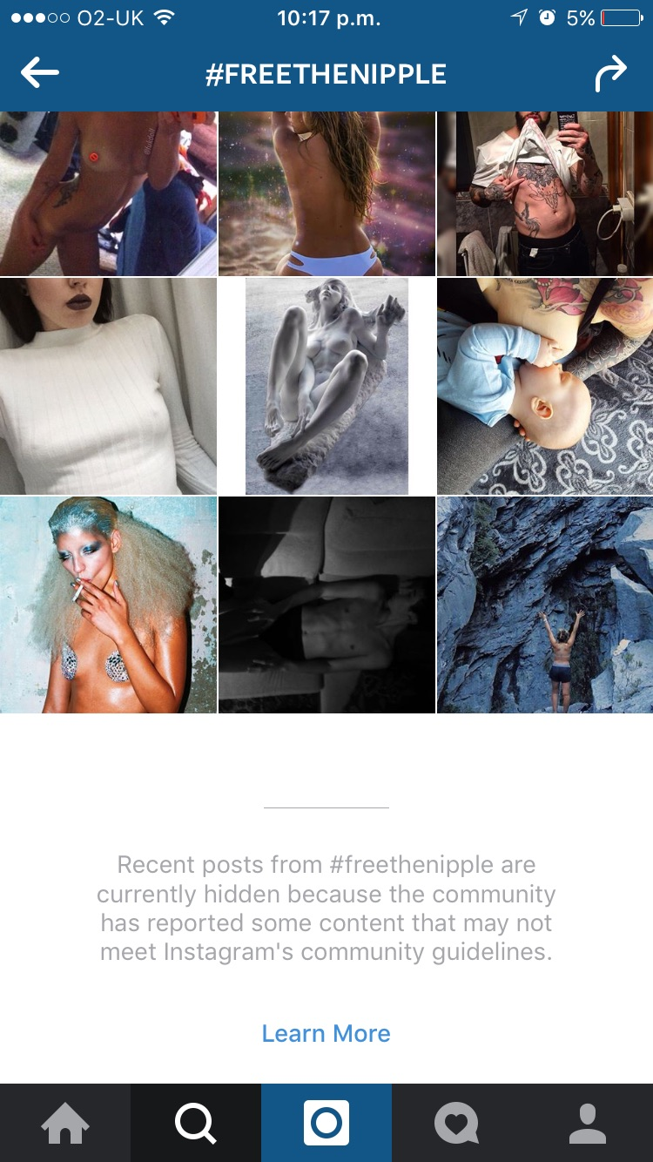


Figure 1. Screenshot of posts shared under the Free The Nipple hashtag on Instagram

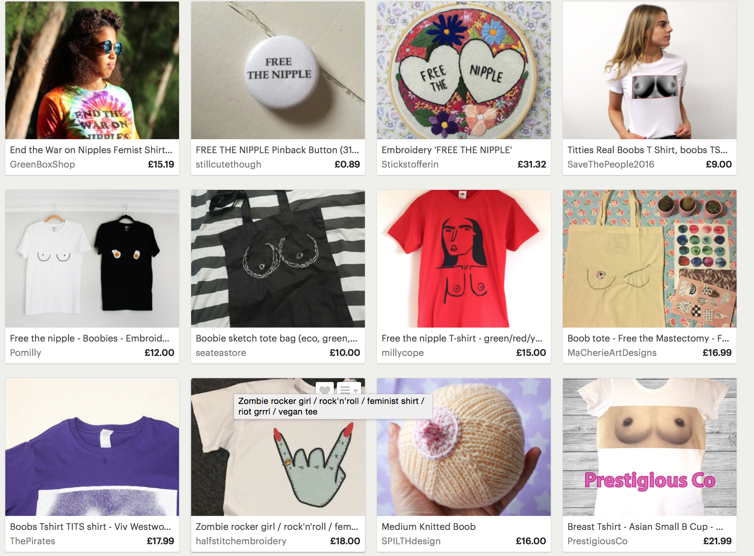
Figure 2. The Commodification of #freethenipple

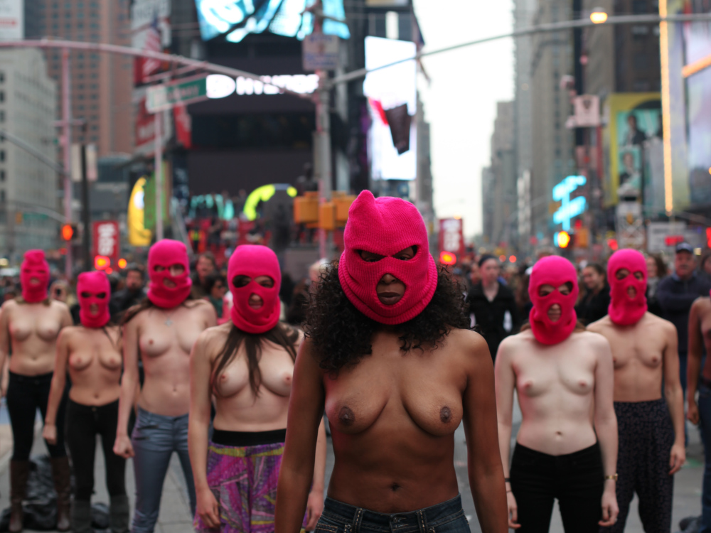

Figure 3. The topless protest that featured in the Free The Nipple movie trailer.
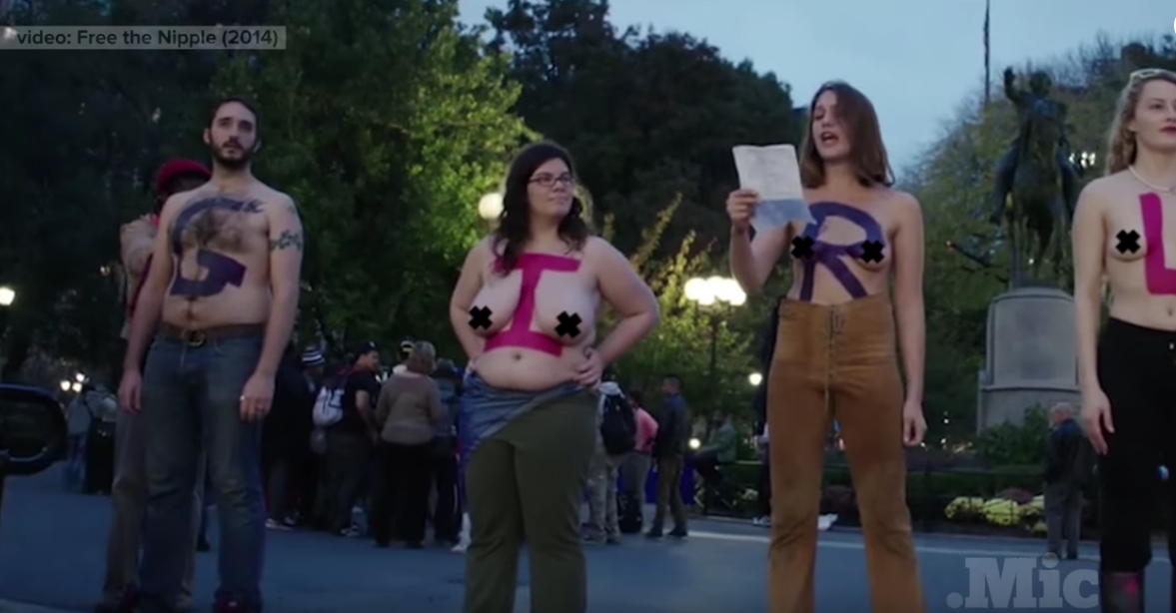

Figure 4. The Free The Nipple activists speak at a rally
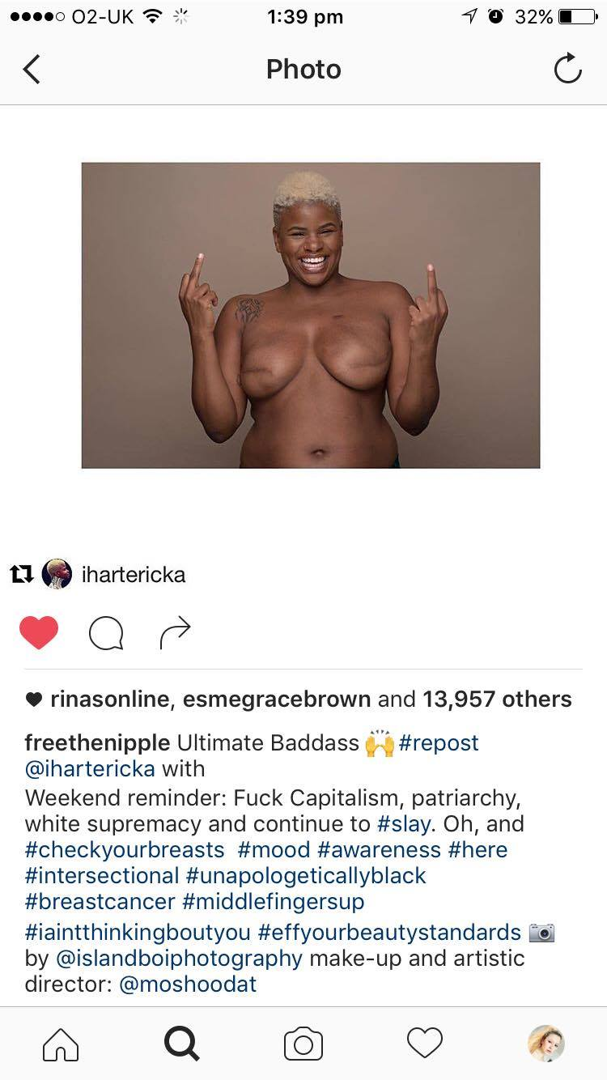
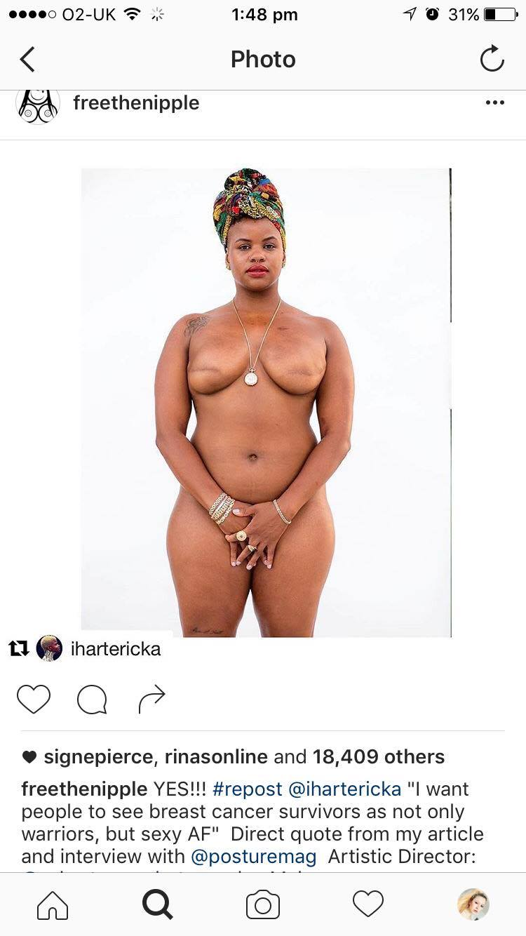

Figure 5. Two images shared on the Free The Nipple Instagram of a woman who has undergone treatment for breast cancer
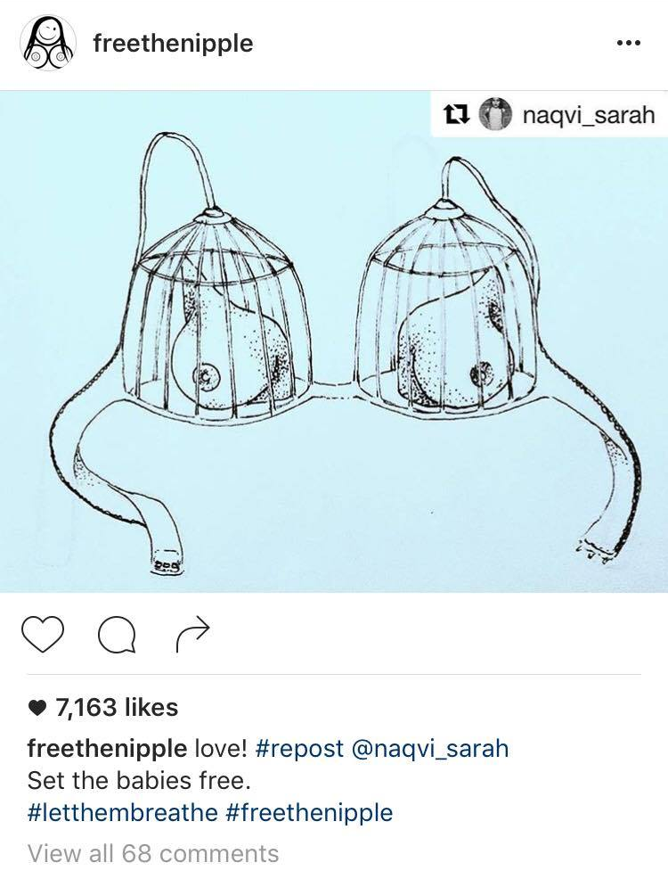

Figure 6. An image shared on the Free The Nipple Instagram
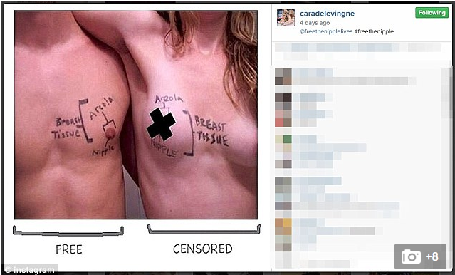

Figure 7. An image shared by model Cara Delevingne on Instagram showing support for the Free The Nipple movement, illustrating the double standard between men and women’s nipples.
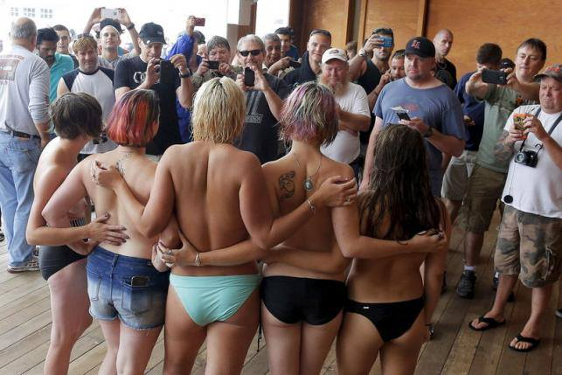

Figure 8. An image shared in discussion on a feminist Facebook discussion group.

