Bi₄O₄Cu_{1.7}Se_{2.7}Cl_{0.3}: an intergrowth of BiOCuSe and Bi₂O₂Se stabilized by the addition of a third anion
Quinn D. Gibson¹, Matthew S. Dyer¹, George F.S. Whitehead¹, Jonathan Alaria², Michael J. Pitcher¹, Holly J. Edwards², John B. Claridge¹, Marco Zanella¹, Karl Dawson³, Troy D. Manning¹,Vin R. Dhanak² and Matthew J. Rosseinsky¹
¹Department of Chemistry, University of Liverpool, Liverpool, United Kingdom L69 7ZD ²Department of Physics, University of Liverpool, Liverpool, United Kingdom L69 7ZE ³School of Engineering, University of Liverpool, Liverpool L69 3GH, United Kingdom
Supporting Information Placeholder
ABSTRACT: Layered two-anion compounds are of interest for their diverse electronic properties. The modular nature of their layered structures offers opportunities for the construction of complex stackings used to introduce or tune functionality, but the accessible layer combinations are limited by the crystal chemistries of the available anions. We present a layered three-anion material, Bi₄O₄Cu_{1.7}Se_{2.7}Cl_{0.3}, which adopts a new structure type composed of alternately stacked BiOCuSe and Bi₂O₂Se-like units. This structure is accessed by inclusion of three chemically distinct anions, which are accommodated by aliovalently substituted Bi₂O₂Se_{0.7}Cl_{0.3} blocks coupled to Cu-deficient Bi₂O₂Cu_{1.7}Se₂ blocks, producing a formal charge modulation along the stacking direction. The hypothetical parent phase Bi₄O₄Cu₂Se₃ is unstable with respect to its charge-neutral stoichiometric building blocks. The complex layer stacking confers excellent thermal properties upon Bi₄O₄Cu_{1.7}Se_{2.7}Cl_{0.3}: a room temperature thermal conductivity (κ) of 0.4(1) W/mK was measured on a pellet with preferred crystallite orientation along the stacking axis, with perpendicular measurement indicating it is also highly anisotropic. This κ value lies in the ultra-low regime and is smaller than that of both BiOCuSe and Bi₂O₂Se. Bi₄O₄Cu_{1.7}Se_{2.7}Cl_{0.3} behaves like a charge-balanced semiconductor with a narrow band gap. The chemical diversity offered by the additional anion allows the integration of two common structural units in a single phase by the simultaneous and coupled creation of charge-balancing defects in each of the units.
Layered ionic materials with multiple anions have seen a recent surge of interest, with superconductivity found in materials based on LaOFeAs¹, BaTi₂OSb₂², LaOBiS₂³ and good thermoelectric performance found in BiOCuSe⁴ and BiOCuTe⁵. The presence of two different anions drives layering in these structures, which are based on a positively charged highly ionic layer (e.g., LaO⁺) alternating with a predominantly covalent, negatively charged layer (e.g., FeAs⁻), with an ionic interaction between layers as well as a direct bonding interaction e.g., a La-As bond. The two dimensionality produced by this alternation of electronically active and inactive layers can affect the electronic properties, e.g. the maximum superconducting transition temperature of LaOFeAs is 26 K¹, while for the more two dimensional Sr₂VO₃FeAs (in which FeAs layers are widely spaced by a perovskite-type oxide layer) it is 37 K⁶. Given the structural flexibility offered by materials with two different anions, it is of interest to explore the chemistry of layered materials with three or more anions, which would allow an extra degree of freedom in structural design.
There are only a few examples of layered materials with three anions, of which some are also isoelectronic and isostructural to materials with two anions, such as (SrF)₂Ti₂OSb₂⁷ and (SrF)₂Fe₂OSe₂⁸, which have structural analogs in (SmO)₂Ti₂OSb₂⁷ and (LaO)₂Fe₂OSe₂⁹. Recently, the complex multiple anion material La₅O₄Cu₄As₄Cl₂¹⁰ has been reported, with LaO, Cl, CuAs and La layers, along with a P containing analog¹¹. However, no general design principles for these types of multiple anion materials have been proposed, and would be of interest for the design and tuning of new materials based on anion substitution.
Here we present the synthesis and properties of Bi₄O₄Cu_{1.7}Se_{2.7}Cl_{0.3} which is formed from a novel combination of Bi₂O₂Cu₂Se₂ and Bi₂O₂Se type slabs. Unlike the non-defective layered materials discussed above, the Bi₄O₄Cu_{1.7}Se_{2.7}Cl_{0.3} structure requires the introduction of Cu vacancies in the Bi₂O₂Cu₂Se₂ slab, coupled to partial Cl for Se substitution in the Bi₂O₂Se slab, in order to form. Partial substitution can occur in compounds wherein layers are electronically doped (e.g., La_{2-x}Sr_{x}CuO₄ or LaO_{1-x}F_{x}FeAs). However, in Bi₄O₄Cu_{1.7}Se_{2.7}Cl_{0.3,} this partial substitution has compensating charges on different layers and allows the combination of structural motifs that have not previously been integrated, producing a new structure type. This structural complexity reduces the lattice thermal conductivity and electronic band gap compared to the constituent structural units and offers a design principle for layered ionic materials, whereby defect-stabilized multiple anion structures can be accessed for which the unsubstituted "parent" does not form.
Single crystals of Bi₄O₄Cu_{1.7}Se_{2.7}Cl_{0.3} were isolated from a synthesis of composition Bi₂O₂CuSe:LiCl, which was heated at 800°C for 24 hours in an evacuated quartz tube. The presence of Cl in these crystals was confirmed by energy dispersive X-ray spectroscopy (Figure S6) and the structure was solved by single crystal X-ray diffraction (XRD). Bulk ceramic syntheses for compositions Bi₄O₄Cu_{1.7}Se_{2.7}Cl_{.3} was performed using Bi₂O₃, Bi, BiOCl, Cu and Se powders in stoichiometric amounts. The reaction mixtures were ground thoroughly by hand, sealed in evacuated quartz ampoules and heated for 24 hours at 800°C, followed by a second grinding and heating under the same conditions. Other compositions produced the same compound (Figures S3–S4). For Cl-free Bi₄O₄Cu₂Se₃ , the synthesis produced a mixture of BiOCuSe and Bi₂O₂Se (Figure S2), as did reactions at 700°C and 900°C, with no indications of a Bi₄O₄Cu₂Se₃ parent phase. Heating at 1000°C also failed to produce the Cl-free phase.
Bi₄O₄Cu_{1.7}Se_{2.7}Cl_{0.3} is composed of two cationic Bi₂O₂²⁺ layers (a common structural motif, especially in Aurivillius phases), separated alternately by anionic Cu_{1.7}Se₂^{2.3-} (an antifluorite-type layer formed of edge-sharing tetrahedra⁴) and Se_{0.7}Cl_{0.3}^{1.7-} layers (Figure 1). The only other reported superstructure of Bi₂O₂Cu₂Se₂ is the metallic compound Bi₂YO₄Cu₂Se₂¹². Considering these units individually, the structure can also be described as composed of alternating (Bi₂O₂Cu_{1.7}Se₂)^{0.3-} and (Bi₂O₂Se_{0.7}Cl_{0.3})^{0.3+} slabs, with each slab having a charge neutral analog in the phases BiOCuSe¹³ and Bi₂O₂Se¹⁴, respectively.
Initial single crystal X-ray refinements showed the Se2 site in the Bi₂O₂Se slab refined to partial occupancy as well as the Cu site, while the Se1 site in the BiOCuSe slab refined to full Se occupancy. When allowing for Cl mixing on the Se2 site, the composition refined such that the amount of Cl present charge-balanced the missing Cu. Furthermore, Se2, which is coordinated to 8 Bi atoms, has the same coordination environment as adopted by halides in the Sillen phases such as BiOCl^{15,16}. Thus it is reasonable that the Cl would preferentially occupy the Se2 site, with its more ionic Bi-only coordination environment, over the Se1 site.
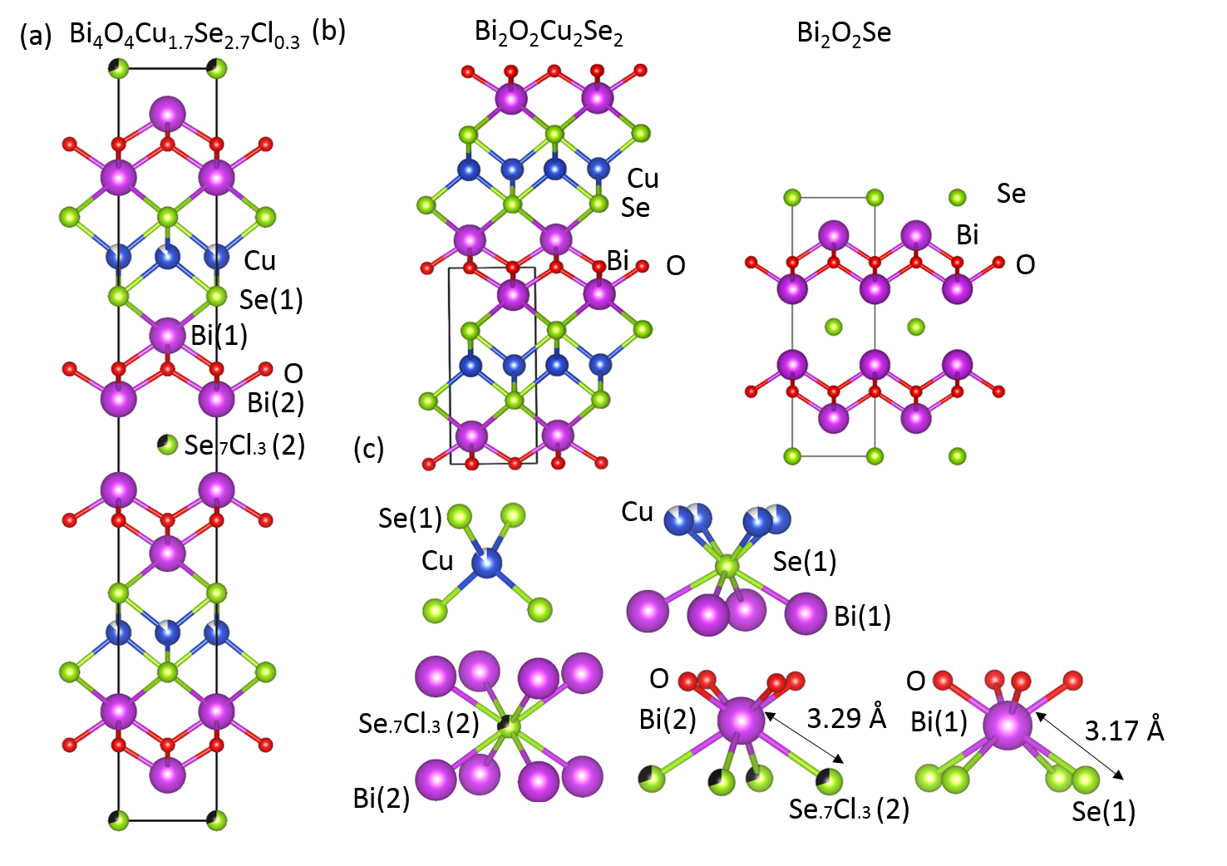Figure 1. (a) The crystal structure of Bi₄O₄Cu_{1.7}Se_{2.7}Cl_{0.3} (b) The crystal structures of the structural components BiOCuSe and Bi₂O₂Se (c) The coordination polyhedra of Cu, Se(1), Se/Cl(2), Bi(1) and Bi(2) in Bi₄O₄Cu_{1.7}Se_{2.7}Cl_{0.3} in more detail, showing the significant site differences between Se(1) and Se/Cl(2) as well as Bi(1) an Bi(2).
The single crystal refinement shows that the Se2 occupancy is 0.68(2), the Cl occupancy is 0.32(2) and Cu occupancy 0.864(12), within error of the formula Bi₄O₄Cu_{1.7}Se_{2.7}Cl_{0.3} and consistent with the composition measured by wavelength dispersive X-ray spectroscopy (Figure S5). The charge from the Cu vacancies in the BiOCuSe type slab matches, within error, that arising from the Cl for Se2 substitution in the Bi₂O₂Se type slab. As both Bi₄O₄Cu_{1.7}Se_{2.7}Cl_{0.3} and the inaccessible defect-free unsubstituted parent phase Bi₄O₄Cu₂Se₃ are charge balanced, it is initially unclear why the structure only forms with the complex composition described here. The coupled partial anion substitutions and Cu vacancies has three important effects on the formation of the compound. First, the presence of the extra anion changes the distribution of competing phases. Secondly, the in-plane lattice parameters of BiOCuSe and Bi₂O₂Se are different (3.888 Å and 3.931 Å at 300 K, respectively), producing strain (≈ 1%) when combining the two neutral units. The basal lattice parameter of Bi₄O₄Cu_{1.7}Se_{2.7}Cl_{0.3} (3.910Å) lies between those of Bi₂O₂Se and BiOCuSe - the introduction of Cu vacancies in the BiOCuSe slab allows structural relaxation that may reduce the strain. Finally the charge distribution is modulated, as instead of uniformly charged layers (two 2+ layers and two 2− layers), there are now two 2+ layers, one 1.7− layer and one 2.3− layer i.e., the distribution of charge between the anionic layers is no longer homogeneous.
Typically such high concentrations of cation vacancies in an antifluorite type layer are compensated by oxidizing other cations (e.g. CeCu_{1−x}OS^{17,18} and Sr₂MnO₂Cu_{2m−δ}S_{m+1}¹⁹), or by incorporating additional cations (e.g. K_{0.8}Fe_{1.6}Se₂²⁰). In contrast, for Bi₄O₄Cu_{1.7}Se_{2.7}Cl_{0.3} they are balanced by substitution of the anion in a separate part of the structure. The Cu vacancy content of 15% is double that accessible in BiOCuSe, which can only be made pure to the nominal composition BiOCu_{0.925}Se²¹.

The hypothetical parent Bi₄O₄Cu₂Se₃ was investigated using periodic density functional theory (DFT), in order to identify the key electronic structure features likely to be present in Bi₄O₄Cu_{1.7}Se_{2.7}Cl_{0.3}. The band structure of Bi₄O₄Cu₂Se₃ (Figure 2) shows that the electronic structure is qualitatively similar to that of BiOCuSe^{22,23.} The conduction band edge is dominated by Bi 6p states (Figure S8). The top of the valence band is dominated by Se 4p and Cu 3d states, with the O 2p states contributing more strongly towards the bottom of the valence band. The Bi 6s states lie 10eV below the Fermi energy (Figure S9). To obtain a more accurate gap for Bi₄O₄Cu₂Se₃, the hybrid HSE06 functional was used, including spin-orbit effects, with reduced k-point density and plane-wave cutoff giving an indirect gap of 0.54 eV, with a direct gap of 0.63 eV at the Γ point. The HSE06 electronic states at the band edges are modelled well by applying a rigid shift of 0.5 eV to the PBE+U+SOC states (Figure S12).
Figure 2. The electronic structure of Bi₄O₄Cu₂Se₃ computed with PBE+U+SOC level DFT. The band structure is plotted on the left along high symmetry paths in the Brillouin Zone. The radii of dots and the area of each colour represents the contribution to the electronic states of Bi₄O₄Cu₂Se from different atomic states.
The band structure of Bi₄O₄Cu₂Se₃ has multiple near-degenerate maxima at the valence band edge (Figure 2), a property which is also seen in BiOCuSe and thought to contribute to the promising thermoelectric properties²². Plotting the separate contributions to the valence and conduction band edges from the different Bi and Se ions in the structure (Figure 3) shows that the states at the top of the valence band are dominated by Se1 states, from the BiOCuSe slab (as in pure BiOCuSe), whereas the bottom of the conduction band is dominated by Bi2 6p states from the Bi₂O₂Se slab, which are 0.4 eV below the Bi1 6p states in the BiOCuSe slab. Bi₄O₄Cu₂Se₃ has a smaller gap than either parent material as it combines the valence band states of BiOCuSe with the conduction band states of Bi₂O₂Se. As the valence and conduction states come from different units in the material, the p-type properties of the material should be similar to those of BiOCuSe, whereas the n-type properties should be similar to those of Bi₂O₂Se. The calculated energy of Bi₄O₄Cu₂Se₃ is within error of 2 BiOCuSe + Bi₂O₂Se, indicating that at 0 K there is no energetic drive to form the defect free superstructure.
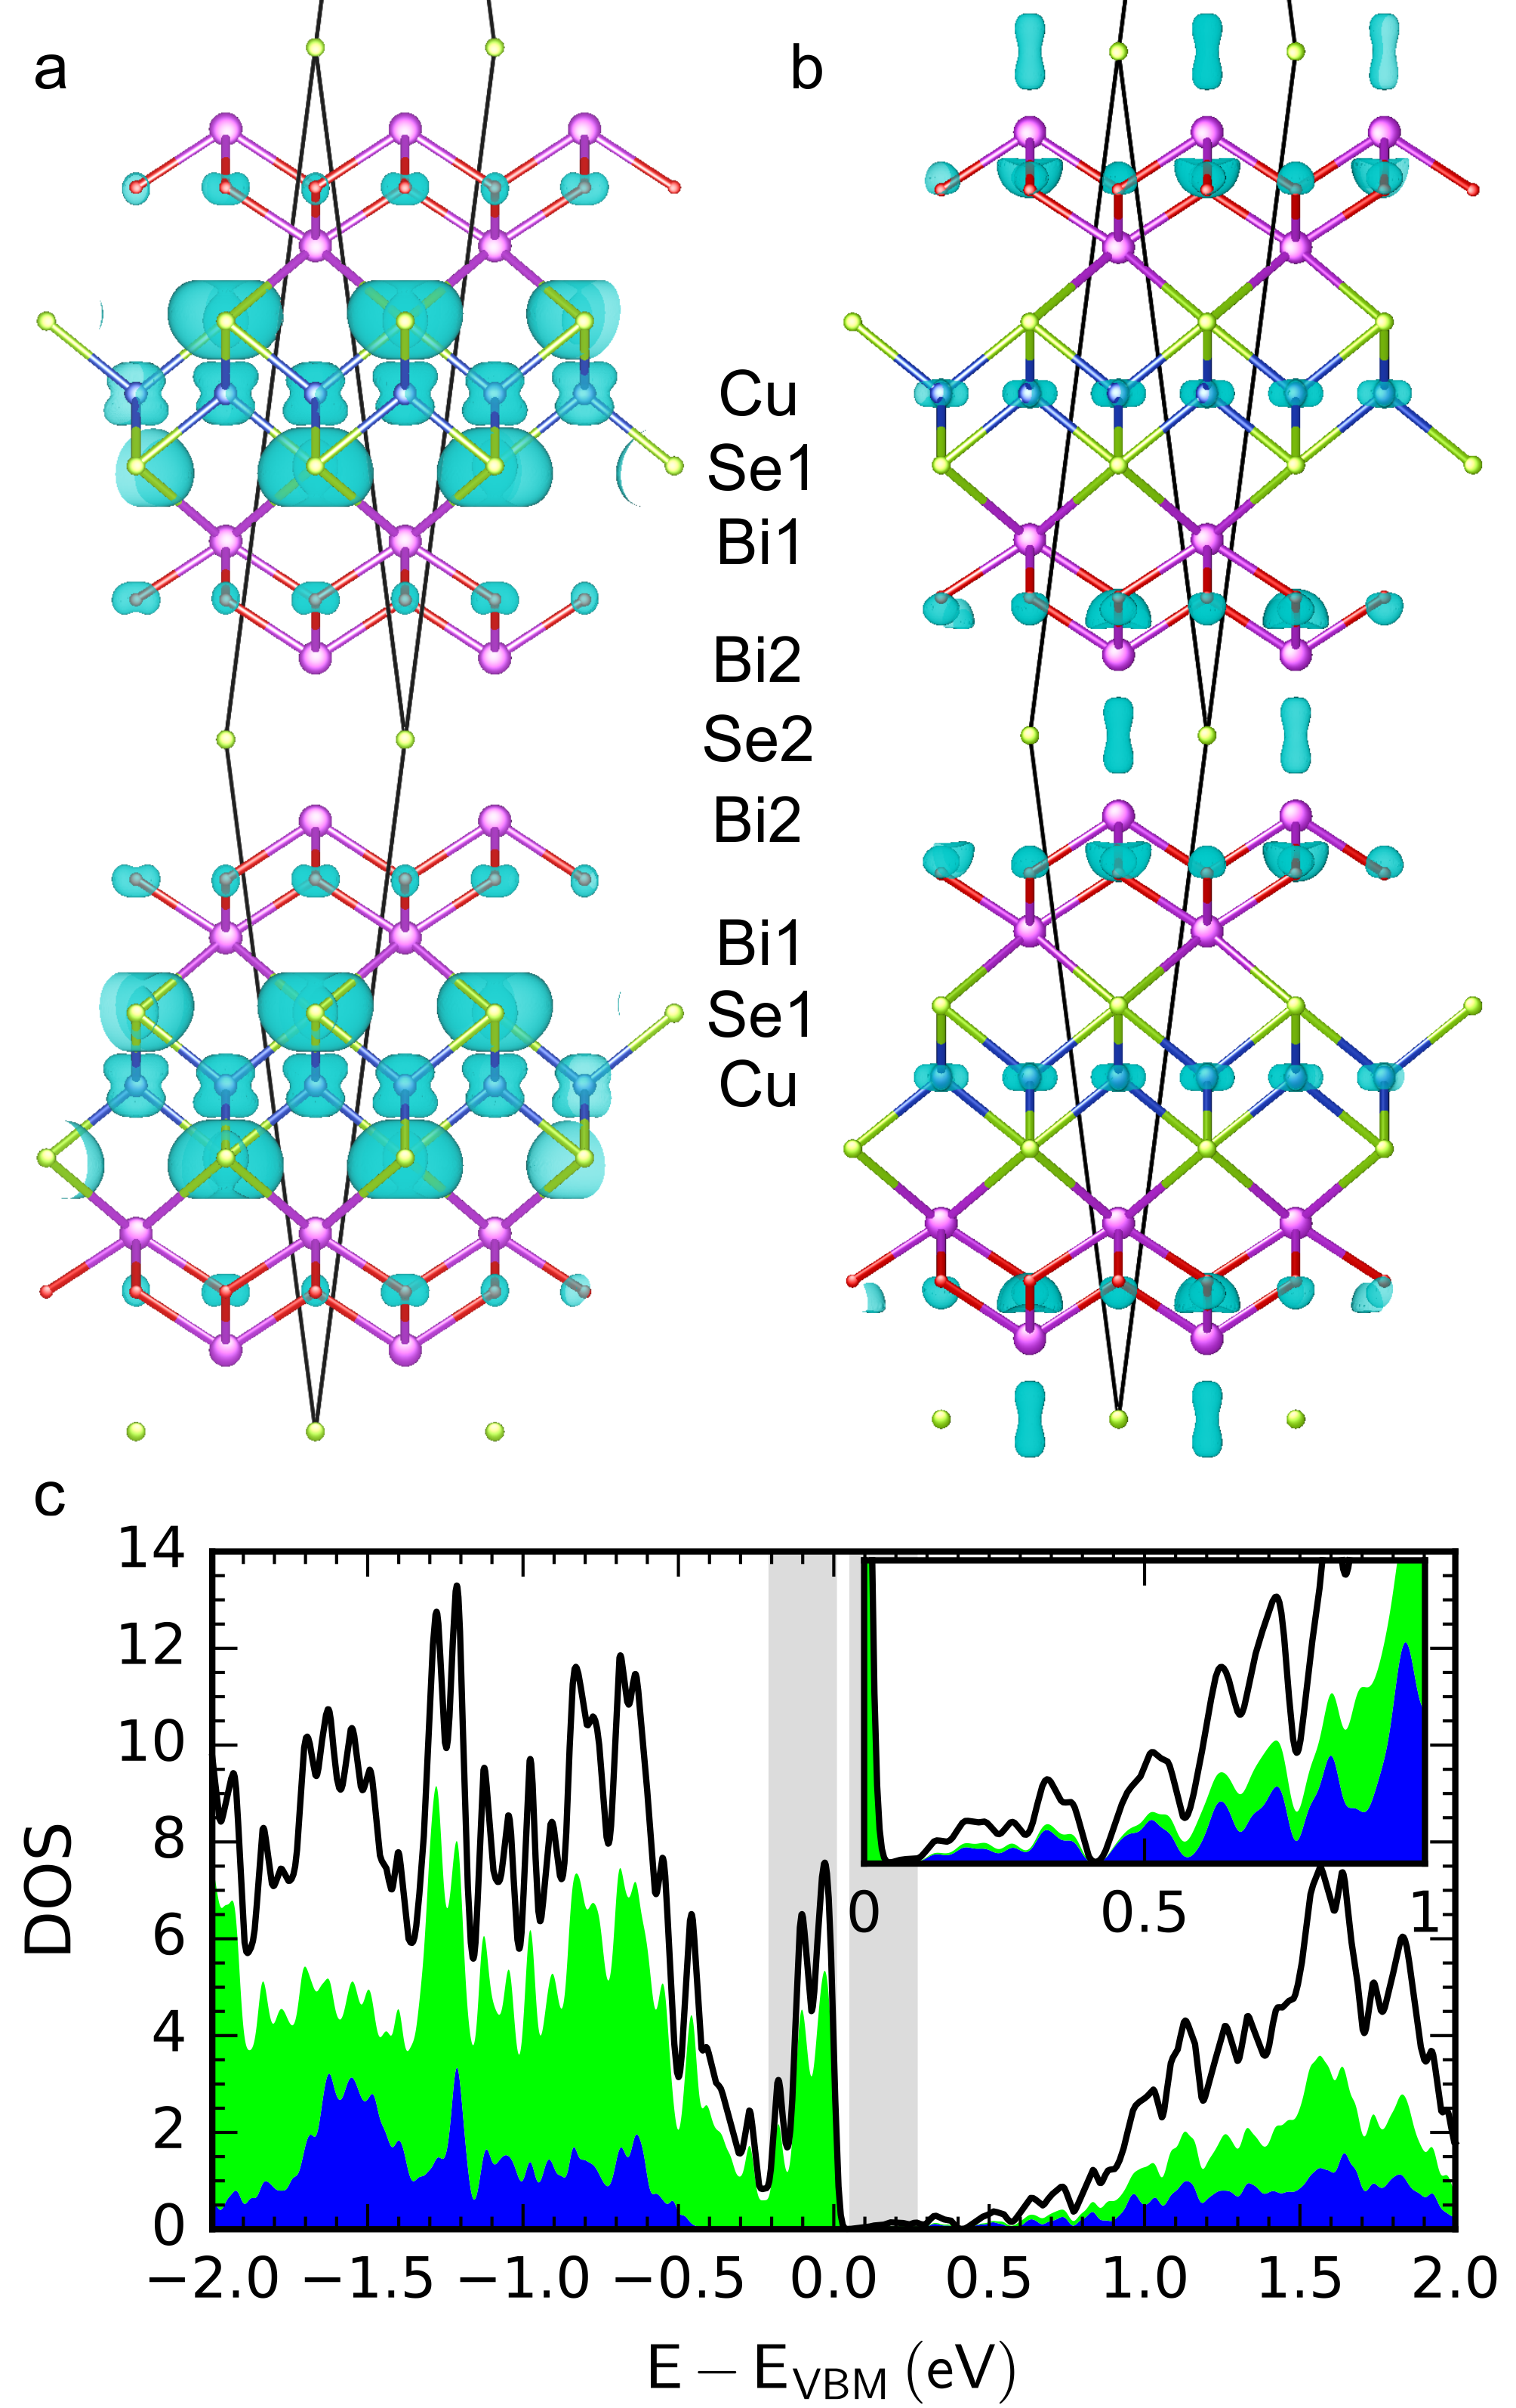
Figure 3. The electron density for the (a) valence and (b) conduction band states near E_{F.} Black lines indicate the primitive unit cell used in DFT calculations . (c) Density of states shown in a and b, with green and blue shading representing the contributions from states originating from the BiOCuSe and Bi₂O₂Se slabs, respectively. The bottom conduction band is enlarged in the inset.
A combination of valence band X-ray photoelectron spectroscopy (XPS) and inverse photoelectron spectroscopy (IPES) was used to probe the electronic structure experimentally (Figure 4d). As the conduction band tails off to a very low density of states rather than ending sharply, the 0.75(15) eV bandgap derived from these measurements is highly approximate (Figure S13). Diffuse reflectance measurements (Figure S16) show the absorption edge for Bi₄O₄Cu_{1.7}Se_{2.7}Cl_{0.3} is significantly lower in energy than that of both BiOCuSe and Bi₂O₂Se, consistent with a smaller gap. A direct transition was observed at 0.55(5) eV, along with a lower energy (<0.5 eV) indirect transition (Figures S17-S18). This value is significantly smaller than the bandgaps of BiOCuSe and Bi₂O₂Se (0.8eV and 0.87 eV, Figures S19-20), consistent with the prediction from the electronic structure calculations.
As both BiOCuSe and Bi₂O₂Se have been explored as thermoelectrics^{24,25}, the thermoelectric properties of Bi₄O₄Cu_{1.7}Se_{2.7}Cl_{0.3} were measured. The material exhibits a room temperature resistivity of 93.2(5) Ωcm and thermally activated behavior (Figure 4a). A small hysteresis is observed between the heating and cooling curves, with the two bifurcating below 220 K, as also observed in the thermopower. A logarithmic plot of the resistivity versus reciprocal temperature (Figure 4a, inset) shows two distinct regions with activation energies of 0.2 eV above 250 K and 0.025 eV below 220 K. The material becomes very resistive (>10⁵ Ωcm) below 70 K. This supports the charge balanced argument as it suggests a small extrinsic carrier density. The two activation energies are observed in both the heating and cooling curves, although the transition between them happens at different temperatures (220 K and 250 K respectively). This indicates the two activation energies and hysteresis are likely due to a subtle transition that was not observed in the X-ray diffraction. The activation energy of 0.2eV is consistent with the indirect gap of <0.5eV.
The insulating nature of the compound leads to a Seebeck coefficient of +610(10) μV/K at 300 K (Figure 4b), which is larger than the room temperature value of pristine BiOCuSe²⁵. Both Seebeck and resistivity were measured multiple times with consistent values. It is possible that the thermoelectric properties of Bi₄O₄Cu_{1.7}Se_{2.7}Cl_{0.3} could be optimized by injection of carriers by chemical doping with elements such as Ba and Pb for Bi.
Figure 4. (a) Resistivity versus temperature profile for both heating and cooling of a bar sample of Bi₄O₄Cu_{1.7}Se_{2.7}Cl_{0.3}. Inset: log of resistivity versus inverse temperature upon cooling, with two linear fits showing activation energies at high and low temperatures. (b) Thermopower versus temperature on heating and cooling, measured on a pellet. Arrows in (a) and (b) highlight where the heating and cooling curves diverge. (c) Thermal conductivity versus temperature on heating and cooling, measured on a pellet. (d) XPS/IPES measurement of the valence and conduction bands. Dashed lines indicate the fits for the bandgap estimation.
Reported room temperature thermal conductivity (κ) values for BiOCuSe and Bi₂O₂Se range from 0.6 - 1.0 W/mK^{4,21,26,27} and depend on microstructure, texture and density. A κ value of 0.4(1) W/mK was measured for Bi₄O₄Cu_{1.7}Se_{2.7}Cl_{0.3} at room temperature, which is lower than either of its component structural slabs and comparable to that of SnSe and other ultralow thermal conductivity compounds²⁸⁻³⁰. κ also decreases slightly with higher pellet density, indicating that porosity is not the source of the low thermal conductivity (Figure S22). Electron backscattered diffraction on a measured pellet revealed a preference for [001] orientation along the pressing axis (i.e., parallel to the measurement direction). Subsequent measurement of the perpendicular direction showed a κ value of 1.0(1) W/mK at room temperature (Figure S23): this anisotropy is significantly higher than that reported or predicted for BiOCuSe^{27,31}. A fit to the heat capacity gives two Debye temperatures of 112(1) K and 470(5) K (Figure S14). The lower Debye temperature is significantly lower than that of BiOCuSe, (243 K) and is associated with a low thermal conductivity⁴.
Cation substitution, often with the creation of anion vacancies, is a common tool to engineer new structures and compositions. Here we use the introduction of an extra anion species in one common structural unit to create cation vacancies in a second unit and achieve a new structure. This approach involving the synergic creation of spatially separated cationic and anionic defects offers a potentially more general route to new structures based on known units and chemistry. For Bi₄O₄Cu_{1.7}Se_{2.7}Cl_{0.3}, the resulting combination of structural motifs allows for a reduction of the thermal conductivity and band gap.
ASSOCIATED CONTENT
Crystallographic Information File, Supporting Information (1. Methods, 2. Single Crystal X-Ray Diffraction, 3. Powder Diffraction, 4. Chemical Analysis, 5. Electronic Structure Calculations, 6. Heat Capacity, 7. Photoelectron Spectroscopy 8. Diffuse Reflectance 9. Electron Backscattered Diffraction 10. Thermal Conductivity)
AUTHOR INFORMATION
Corresponding Author
m.j.rosseinsky@liverpool.ac.uk
Notes
The authors declare no competing financial interests.
ACKNOWLEDGMENT
We thank EPSRC for support (EP/N004884), Dr Clare Goodwin and Mr Charlie Patrickson (NSG Group) for use of their UV/vis/NIR spectrometer, and Dr. Jon Fellowes (University of Manchester) for WDX measurement.
REFERENCES
(1) Kamihara, Y.; Watanabe, T.; Hirano, M.; Hosono, H. J. Am. Chem. Soc. 2008, 130, 3296–3297.
(2) Yajima, T.; Nakano, K.; Takeiri, F.; Ono, T.; Hosokoshi, Y.; Matsushita, Y.; Hester, J.; Kobayashi, Y.; Kageyama, H. J. Phys. Soc. Jpn 2012, 81, 103706.
(3) Mizuguchi, Y.; Demura, S.; Deguchi, K.; Takano, Y.; Fujihisa, H.; Gotoh, Y.; Izawa, H.; Miura, O. J. Phys. Soc. Jpn. 2012, 81, 114725.
(4) Zhao, L.-D.; He, J.;Berardan, D.; Lin, Y.; Li, J.F.;Nan, C.W.; Dragoe,N. . Energy Environ. Sci. 2014, 7, 2900–2924.
(5) Vaqueiro, P.; Guélou, G.; Stec, M.; Guilmeau, E.; Powell, A. V. J. Mater. Chem. A 2013, 1, 520–523.
(6) Zhu, X.; Han, F.; Mu, G.; Cheng, P.; Shen, B.; Zeng, B.; Wen, H.-H. Phys. Rev. B. 2009, 79, 220512.
(7) Liu, R.; Song, Y.; Li, Q.; Ying, J.; Yan, Y.; He, Y.; Chen, X. Chem. Mater. 2010, 22, 1503–1508.
(8) Kabbour, H.; Janod, E.; Corraze, B.; Danot, M.; Lee, C.; Whangbo, M.H.; Cario, L. J. Am. Chem. Soc. 2008, 130, 8261–8270.
(9) Free, D. G.; Evans, J. S. Phys. Rev. B 2010, 81, 214433.
(10) Eul, M.; Johrendt, D.; Pöttgen, R. Z. Naturforsch. B 2009, 64, 1353–1359.
(11) Bartsch, T.; Benndorf, C.; Eckert, H.; Eul, M.; Pöttgen, R. Z. Naturforsch. B 2016, 71, 149–155.
(12) Chou, T.-L.; Tewari, G. C.; Chan, T.-S.; Hsu, Y.-Y.; Chen, J.-M.; Yamauchi, H.; Karppinen, M. Eur. J. Inorg. Chem. 2015, 2015, 2574–2578.
(13) Kusainova, A.; Berdonosov, P.; Akselrud, L.; Kholodkovskaya, L.; Dolgikh, V.; Popovkin, B. J. Solid State Chem. 1994, 112, 189–191.
(14) Boller, H. Monatsh. Chem. 1973, 104, 916–919..
(15) Keramidas, K.; Voutsas, G.; Rentzeperis, P. Z. Kristallog –Cryst. Mater. 1993, 205, 35–40.
(16) Dolgikh, V.; Kholodkovskaya, L. Zh. Neorg. Khim. 1992, 37, 970–985.
(17) Chan, G. H.; Deng, B.; Bertoni, M.; Ireland, J. R.; Hersam, M. C.; Mason, T. O.; Van Duyne, R. P.; Ibers, J. A. Inorg. Chem. 2006, 45, 8264–8272.
(18) Pitcher, M. J.; Smura, C. F.; Clarke, S. J. Inorg. Chem. 2009, 48, 9054–9056.
(19) Gál, Z. A.; Rutt, O. J.; Smura, C. F.; Overton, T. P.; Barrier, N.; Clarke, S. J.; Hadermann, J. J. Am. Chem. Soc. 2006, 128, 8530–8540.
(20) Basca, J.; Ganin, A.Y.; Takabayashi, Y.; Christensen, K.E.; Prassides, K.; Rosseinsky, M.J.; Claridge, J.B. Chem. Sci. 2011, 2, 1054-1058.
(21) Liu, Y.; Zhao, L. D.; Liu, Y.; Lan, J.; Xu, W.; Li, F.; Zhang, B.P.; Berardan, D.; Dragoe,N.; Lin, Y.H.; Nan, C.W. J. Am. Chem. Soc. 2011, 133(50), 20112–20115.
(22) Zou, D.; Xie, S.; Liu, Y.; Lin, J.; Li, J. J. Mater. Chem. A 2013, 1, 8888–8896.
(23) Fan, D.; Liu, H.; Cheng, L.; Zhang, J.; Jiang, P.; Wei, J.; Liang, J.; Shi, J. Phys. Chem. Chem. Phys. 2017, 19, 12913–12920.
(24) Liu, Y.; Lan, J.; Xu, W.; Liu, Y.; Pei, Y.-L.; Cheng, B.; Liu, D.-B.; Lin, Y.-H.; Zhao, L.-D. Chem. Commun. 2013, 49, 8075–8077.
(25) Ruleova, P.; Drasar, C.; Lostak, P.; Li, C-P.; Ballikaya, S.; Uher, C. Mater. Chem. Phys, 2010, 119, 299-302.
(26) Zhan, B.; Butt, S.; Liu, Y.; Lan, J.-L.; Nan, C.-W.; Lin, Y.-H. J. Electroceram. 2015, 34, 175–179.
(27) Sui, J.; Li, J.; He, J.; Pei, Y-L.; Berardan, D.; Wu, H.; Dragoe, N.; Cai, W.; Zhao, L-D. Energy Environ. Sci. 2013, 6, 2916-2920.
(28) Zhao, L.-D.; Lo, S.-H.; Zhang, Y.; Sun, H.; Tan, G.; Uher, C.; Wolverton, C.; Dravid, V. P.; Kanatzidis, M. G. Nature 2014, 508, 373–377.
(29) Tan, G.; Hao, S.; Zhao, J.; Wolverton, C.; Kanatzidis, M.G. J. Am. Chem. Soc. 2017, 139, 6467-6473.
(30) Jana, M.K.; Pal, K.; Waranakar, A.; Mandal, P.; Waghmare, U.V.; Biswas, K. J. Am. Chem. Soc. 2017, 139, 4350-4353.
(31) Saha, S.K. Phys. Rev. B 2015, 92, 041202

For Table of Contents Only

