**Health in Impact Assessments – introduction to a special issue**

*By Thomas B Fischer and Ben Cave*

Welcome to this first issue of IAPA of 2018, a special issue on ‘health in impact assessments’. Health is an increasingly important component in many *ex-ante* decision-making support impact assessment (IA) instruments. This is true at the project level and also at strategic levels, for policies, plans and programmes (PPPs). The instrument specifically dedicated to health, i.e. Health Impact Assessment (HIA), is not alone in requiring effects on human health to be considered. Human health features in both Environmental Impact Assessment (EIA) for projects and Strategic Environmental Assessment (SEA) for PPPs, together frequently referred to as Environmental Assessment (EA). Many countries formally require EIA and SEA as part of their policy- and consent process (<http://www.eia.nl/en/environmental-assessment>). The opportunity that this provides for human health has been noted (Harris et al., 2015b, Harris-Roxas et al., 2012, Winkler et al., 2013, World Health Organization Regional Office for Europe, 2014, Bond et al., 2013; Fischer et al, 2010).

At the heart of most impact assessments instruments is a desire to identify best possible outcomes with reference to consistent and compatible sets of objectives. This is to be achieved by assessing different options / alternatives within a systematic assessment procedure. The 1969 National Environmental Policy Act (NEPA), the first piece of legislation globally formulating requirements for EA, explicitly paired the environment with human health, stating that it aims at promoting ‘*efforts which will […] stimulate the health and welfare of man’, ‘assure for all Americans […] healthful surroundings’, and ‘attain the widest range of beneficial uses of the environment without degradation, risk to health or safety’* (all from § 102)*.*  However, in practice human health has remained insufficiently considered in NEPA based EA, as was first noted by Wernham (2007). In Europe, human health is an aspect to be considered in SEA based on the SEA Directive (2011/EC/42). Furthermore, the new EIA Directive (2014/52/EU), which had to be transposed in EU member states by June 2017, now also explicitly refers to human health (Fischer et al, 2016; Cave et al, 2017). The assessment of community health and safety is integral to the environmental and social safeguards of the multilateral lending institutions (see World Bank, 2017) and it is a requirement of the Equator Principles (2013). Finally, it’s important that other impact assessments, such as social impact assessment (SIA), as well as integrated and sustainability assessment should, by definition, consider health (World Health Organization Regional Office for Europe, 2014).

Whilst the importance of considering human health in IA is therefore largely undisputed, there are technical, procedural and contextual challenges in doing so (Harris et al., 2015a, Harris et al., 2014). Fischer (2014) identified five main aspects that need to be considered and understood in order to be able to design effective tailor made IAs (i.e. IAs that are able to address appropriate issues and conduct appropriate procedures) for human health inclusive IA, as follows.

1. *The specific decision tier*

Effective integration of health (and other aspects) in IA is connected with the specific decision-making tier, mainly because of existing experiences and traditions. At programme levels, in many systems traditionally different aspects have been integrated through cost-benefit analysis (CBA) and multi-criteria analysis (MCA) in the sense of forcing heterogeneous entities into a common metric. In statutory spatial planning, the purpose of impact assessment instruments has often been to highlight implications of development options in terms of specific issues, for example, the environment (usually including some health aspects), the economy and others, leaving interpretations and associated decisions on trade-offs to the plan makers. Finally, policy level assessments have tended to integrate different aspects more fully, the main reason being a more open approach to different futures of those involved at this level, which is often perceived to be more abstract and distant.

1. *Distribution of power*

Power to make decisions is not distributed equally between, for example, government, project proponents, civil society and special interest groups. In this context it has been suggested that the best thing IA can do is to create transparency with regards to who (or what) wins and / or loses. In this case, full integration of health and other assessment aspects in any specific IA instrument may just lead to hiding trade-offs and may therefore be problematic. There may either be a case for keeping different impact assessments (including HIA) separate rather than attempting either a fully inclusive EA or creating a set of strict trade-off rules.

1. *The specific administrative level*

Different administrative levels (for example national, regional and local) have different responsibilities and frequently fulfil different tasks. This can mean different options may need to be dealt with at specific administrative levels and there may be problems effectively combining different levels. For example, whereas national transport authorities are frequently responsible for planning major roads such as motorways, state or regional authorities may have responsibilities for state and regional roads and local authorities may be in charge of local transport networks. When planning a new road, e.g. a bypass, there may be problems taking the effects of the whole, multi-tier network into account effectively, as e.g. the national authority may argue that local roads cannot be considered when planning trans-local and trans-regional transport.

1. *Existence of a policy framework with compatible policy objectives*

Economic, social, environmental and health objectives of specific policy frameworks (including sustainable development strategies) have been shown to not always be fully compatible. For example, Therivel (2004) showed that there are likely to be incompatibilities in the (then) UK government’s vision on sustainable development, in particular with regards to two objectives, namely ‘prudent use of natural resources’ and ‘maintenance of high and stable levels of economic growth and employment’. If this is the case, integration of different aspects through SEA is problematic.

1. *The institutional capacity to integrate*

Even when there is a political will to integrate different substantive aspects (including health), it may be difficult to do so, because:

* in many systems, traditionally, different administrations are used (and possibly asked) to act autonomously and may find closer cooperation difficult;
* the technical or financial capacity to deal with very different aspects all at once may also be limited; on the one hand, more aspects may mean that more data need to be processed; on the other hand, the treatment of a range of aspects.

The format of effective health inclusive IA in terms of the process to follow, the methods and techniques to be applied, the substantive issues to be addressed and the scope of integration, as well as associated acting strategies are determined by these contextual factors. This is visualised in Fig. 1

***Fig.1: The format of IA as determined by contextual factors***

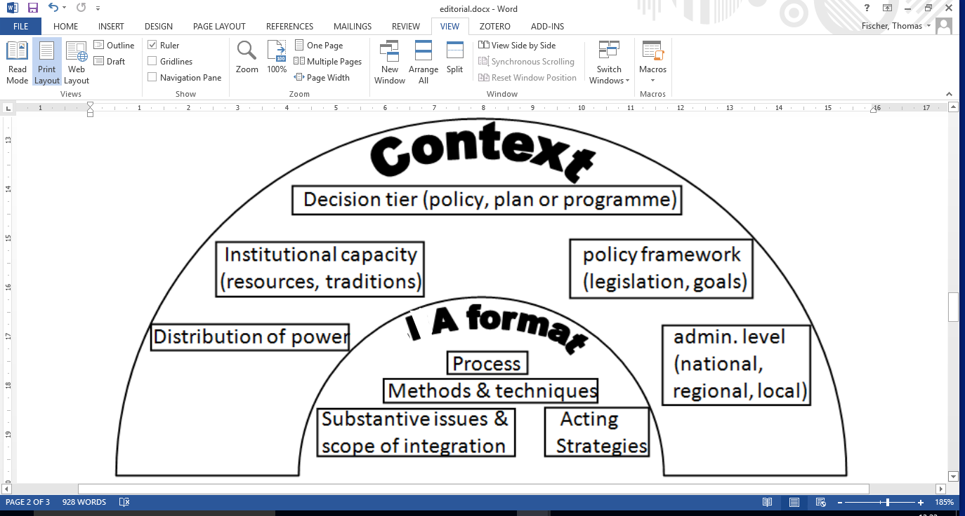

*Source: following Fischer, 2014*

In order to be able to consider human health effectively in IA, it also needs to be clear what exactly human health comprises for the purpose of assessment. In this context, the concept of different determinants of health has proven to be influential. Determinants of health were first summarized in a model by Dahlgren and Whitehead (1991) and are connected with five main attributes, as follows:

1. age, sex and constitutional factors;
2. individual lifestyle factors;
3. social and community networks;
4. living and working conditions;
5. general socioeconomic, cultural and environmental conditions.

This shows how human health is inextricably bound with the social, economic and physical environment. Whilst it is possible, in varying degrees, to exert influence over (b) to (e), the factors in (a), that is *age, sex and constitutional factors* do not change. However, it is still possible to exert an influence on associated health implications. For example, people who are predisposed to conditions such as high blood pressure or diabetes can reduce risk by modifying their behaviour, for example diet and levels of physical activity. As the built and natural environments can either encourage or discourage certain exercises (such as cycling or walking), health determinants can be influenced through policies, plans, programmes and their associated SEAs and behavioural aspects are thus important (Fischer et al, 2018). There are clear co-benefits to the environment, physical, social and economic, and to public health to be had from addressing and mitigating climate change (Patz et al., 2014; Jiricka et al, 2016).

As mentioned earlier, there can be challenges with integrating attributes, as associated objectives and actions may not always be fully compatible. In particular, there can be incompatibilities between biophysical attributes (e.g. protection of flora and fauna and low levels of noise and other emissions) with economic attributes (e.g. economic growth and jobs in industry). This is visualised by Figure 2, providing an example in the form of a conceptual model for how the integration of health determinants in SEA may be approached.

***Fig.2: Approaching the consideration of health determinants in SEA: a conceptual model***



*Source: following Fischer, 2014.*

The case for the consideration of human health is well made and the body of learning is growing. This continues to be a developing agenda which brings new actors and new perspectives into established IA systems. This can be disruptive to the established systems and challenging to the new entrants. It is within this context that a call for papers was released by the special issue editors in mid-2016, asking for papers that enhance the evidence base. It was said that suitable papers may range from conceptual to empirical papers, ranging from critical presentations of best practice cases to broad overviews of opinions.

Subsequently, the 10 papers resulting from the call are presented to you. In the first paper, Lindsay McCallum (University of Toronto, Canada), Christopher Ollson (Ollson Environmental Health Management) and Ingrid Leman Stefanovic (Simon Fraser University, Canada) report on an ‘adaptable Health Impact Assessment (HIA) framework for assessing health within Environmental Assessment (EA)’, focusing on a Canadian context, but providing for an international application. On the same topic, but focusing on Thailand, Chaunjit Chanchitpricha (Suranaree University of Technology, Thailand) and Alan Bond (University of East Anglia, UK) report on their ‘Investigation on the effectiveness of mandatory integration of health impact assessment within Environmental Impact Assessment (EIA)’. Next, Thomas B Fischer, Urmila Jha-Thakur, Peter Fawcett, Sarah Clement, Samuel Hayes (all University of Liverpool, UK) and Julia Nowacki (WHO, European Region) reflect on the ‘consideration of urban green space in impact assessments for health’, focusing on European and US American practices. In the fourth paper, Thierno Diallo (University of Geneva, Switzerland) presents the outcomes of a study on the ‘inclusion of health in impact assessments: a case study in Geneva, Switzerland’. Following on from this, and reporting on the preparation process of an associated set of guidelines, Sabine Baumgart (TU Dortmund, Germany), Joachim Hartlik Environmental Assessment and Quality Management, Germany) and Monika Machtolf (IFUA Bielefeld, Germany) provide for a German perspective on ‘improving the consideration of human health in environmental planning and decision making’. Also reflecting on the development of guidelines, in the sixth paper Anne Roué Le Gall, Nina Lemaire and Françoise Jabot (all Ecole des Hautes Etudes en Sante Publique, France) focus on the ‘lessons learned from co-constructing a guide on healthy urban planning and on integrating health issues into EIAs conducted on French urban development projects’. Moving towards an HIA focus, Kathryn Ashton, Janine Roderick, Lee Parry Williams and Liz Green (all Public Health Wales, UK) report on their experiences with developing an HIA framework for ‘managing the night-time economy in Wales’. Also focusing on HIA, Leonor Bacelar-Nicolau, Teresa Rodrigues, Elisabete Fernandes, Mariana Fernandes Lobo, Cláudia Nisa, Ianessa Azzone, Armando Teixeira-Pinto, Altamiro Costa-Pereira, Sharon-Lise T. Normand and José Pereira Miguel (all University of Lisbon, Portugal) picture Inequities for Health Impact Assessment, looking at ‘linked electronic records, mortality and regional disparities in Portugal’. In the ninth paper, Fernanda Claudio, Kim de Rijke (both University of Queensland Brisbane, Australia) and Andrew Page (Western Sydney University, Australia) provide for a ‘critical review of unconventional gas developments and best-practice health impact assessment in Queensland, Australia’. In the final and tenth contribution, Julia Haggerty, Kristin K Smith, Tara Mastel, Judith LaPan and Paul Lachapelle (all Montana State University, US) provide for an evaluation of an existing public health model by ‘assessing, monitoring and addressing boomtown impacts in the US’.

Enjoy reading!

Thomas B Fischer and Ben Cave

**References**

Bond, A., Cave, B. & Ballantyne, R. 2013. Who plans for health improvement? SEA, HIA and the separation of spatial planning and health planning. Environmental Impact Assessment Review, 42, 67-73.

Cave B,, Fothergill, J., Pyper, R., Gibson, G., Saunders, P. Health in Environmental Impact Assessment: a primer for a proportionate approach. Lincoln, England, Ben Cave Associates Ltd IEMA and the Faculty of Public Health. 2017. http://bcahealth.eu/resources/.

Dahlgren G. and Whitehead M. 1991. *Policies and Strategies to Promote Social Equity in Health.* Stockholm, Institute of Futures Studies.

Fischer, T.B. 2014. Health and Strategic Environmental Assessment, in Fehr, R.; Martuzzi, M.; Nowacki, J. and Viliani, F. Health in Impact Assessments, World Health Organization Regional Office for Europe, EUPHA and IAIA: 23-46. http://www.euro.who.int/en/health-topics/environment-and-health/health-impact-assessment/publications/2014/health-in-impact-assessments-opportunities-not-to-be-missed

Fischer, T.B.; Jha-Thakur, U.; Fawcett, P.; Nowacki, J.; Clement, S. and Hayes, S. 2018. Consideration of urban green space in impact assessment for health, Impact Assessment and Project Appraisal (this issue).

Fischer, T.B.; Therivel, R.; Bond, A.; Fothergill, J. and Marshall, R. 2016. The revised EIA Directive – possible implications for practice in England, UVP Report, 30(2): 106-112; http://www.uvp.de/de/uvp-report/jg30/jg30h2/866-uvp-report-030-19

Fischer, T. B.; Martuzzi, M. And Nowacki, J. 2010. The consideration of health in SEA, EIA review; 30(3): 200-210

Harris-Roxas, B., Viliani, F., Bond, A., et al. 2012. Health impact assessment: the state of the art. Impact Assessment and Project Appraisal, 30, 43-52.

Harris, P., Friel, S. & Wilson, A. 2015a. ‘Including health in systems responsible for urban planning’: a realist policy analysis research programme. BMJ Open, 5.

Harris, P., Sainsbury, P. & Kemp, L. 2014. The fit between health impact assessment and public policy: Practice meets theory. Social Science and Medicine, 108, 46-53.

Harris, P., Viliani, F. & Spickett, J. 2015b. Assessing Health Impacts within Environmental Impact Assessments: An Opportunity for Public Health Globally Which Must Not Remain Missed. Int J Environ.Res Public Health, 12, 1044-1049.

Jiricka, A.; Formayer, H.; Schmidt, A.; Völler, S.; Leitner, M.; Fischer, T.B.; Wachter, T. W. 2016. Consideration of climate change impacts and adaptation in EIA practice – Perspectives of actors in Austria and Germany, Environmental Impact Assessment Review, 57: 78-88; doi:10.1016/j.eiar.2015.11.010.

Patz, J. A., Frumkin, H., Holloway, T., et al. 2014. Climate change: challenges and opportunities for global health. JAMA, 312, 1565-80.

Therivel, R. 2004. Strategic Environmental Assessment in Action, Earthscan, London.

Wernham, A. 2007. Inupiat Health and Proposed Alaskan Oil Development: Results of the First Integrated Health Impact Assessment/Environmental Impact Statement for Proposed Oil Development on Alaska’s North Slope. EcoHealth, 4, 500-513.

Winkler, M. S., Krieger, G. R., Divall, M. J., et al. 2013. Untapped potential of health impact assessment. Bulletin of the World Health Organization, 91, 237-312.

World Bank Group. The Environmental and Social Framework. 2017. www.worldbank.org/en/programs/environmental-and-social-policies-for-projects/brief/the-environmental-and-social-framework-esf.

World Health Organization Regional Office for Europe, European Public Health Association and the International Association for Impact Assessment 2014. Health in impact assessments: opportunities not to be missed. In: Fehr, R., Viliani, F., Nowacki, J. & Martuzzi, M. (eds.). http://www.euro.who.int/en/health-topics/environment-and-health/health-impact-assessment/publications/2014/health-in-impact-assessments-opportunities-not-to-be-missed

The Equator Principles. 2013. <http://bit.ly/2dgVLir>.