Micro-Volume Blood Sampling of Salbutamol

Quantitation of Salbutamol using Micro-Volume Blood Sampling – Applications to Exacerbations of Paediatric Asthma

Key words: GC-MS, therapeutic drug monitoring, volumetric absorptive micro-sampling, dried blood spots, toxicity

Abstract
A novel gas chromatography-mass spectrometry (GC-MS) method has been developed to quantify salbutamol in micro-volumes (10 µL) of blood. A potential application is paediatric therapeutic dose monitoring (TDM) in acute severe asthma. At presentation, these children receive multiple doses of salbutamol (inhaled, nebulised and occasionally intravenous) but it is difficult to distinguish children who do not respond to treatment because of inadequate concentrations from those with toxicity, as symptoms are similar. A comparison was made between traditional dried blood spots (DBS) and the newly developed technique volumetric absorptive micro-sampling (VAMS), with specific investigation into the effect of drying time on analyte recovery. For both sampling techniques, the final assay demonstrated good precision and accuracy across the concentration range tested (3-100 ng/mL), including both the normal therapeutic and toxic range. The method was developed to comply with FDA guidelines with precision and accuracy <15% for all concentrations, except the limit of quantification (5 ng/mL) where they were <20%. VAMS offered advantages in sampling ease and reduced GC-MS interference. The assay was successfully applied to the quantification of blood salbutamol concentrations in three healthy volunteers dosed with 1 mg salbutamol by inhalation. This demonstrated its potential for use in paediatric TDM studies, where in the acute situation considerably higher doses of salbutamol will have been administered. This is the first time that a TDM method for salbutamol has been carried out using VAMS and offers all the advantages provided by DBS, whilst eliminating the inherent sampling volume inaccuracies of traditional DBS collection.

Introduction
Severe acute asthma (SAA) is characterized by severe breathlessness and respiratory failure and is a common and potentially life-threatening emergency. Between 2011 and 2012, just over 25,000 children were admitted to UK hospitals with a SAA exacerbation [1]. Inhaled salbutamol, a β2-adreno-receptor agonist, is the initial drug of choice for paediatric SAA [2], delivered by inhaler or nebuliser. For the most unwell children, who do not improve with inhaled therapy, intravenous therapy (IV) is required, with salbutamol selected as first line IV therapy in over 60% of cases [3]. For any child or adult presenting with SAA, it is difficult to distinguish between failure of response to treatment due to inadequate dose (for example, inhaled therapies may not be effective if little air inhaled with each breath), or toxicity (salbutamol increases blood lactate and may thereby exacerbate respiratory failure [4]).
Toxicity is a concern as, in paediatrics, unlike adult populations where doses were established based on pharmacokinetic-pharmacodynamic (PK-PD) studies, the evidence supporting current doses is minimal [5]. We know that for the most unwell children who receive IV salbutamol in addition to inhaled therapies, considerably higher doses are used than adults, risking toxicity and adverse drug reactions [6, 7]. There is therefore a pressing need to deliver clinical research to optimize doses of all therapies used in SAA, which will require studies that can accurately collect and measure salbutamol PK samples in real life conditions [8]. Obtaining blood samples from children for PK studies can be practically challenging and is often limited by ethical considerations. Historically, PK studies have required repeated measurements of drug concentration from each subject. In addition, until recently, drug assays have needed relatively large volumes (5-10 ml) of blood requiring cannulation of a large vein in the hand or arm.
Drug assays based on micro-volume blood samples can be an alternative to traditional sample assays. They are particularly useful for paediatrics, as they allow micro-volume blood samples to be obtained by a finger prick method rather than venous cannulation. Blood collection on to dried blood spots (DBS) is an established technique for collecting small volumes of blood [9, 10, 11] and offers numerous other advantages over traditional venous sampling in addition to the low blood volume required. DBS samples can also be stored and transported in ambient conditions and have a reduced risk of infectious disease transmission once dry [10, 12, 13].
Although the most widely used application of DBS is neonatal screening of inborn errors of metabolism [11, 12], DBS have also been employed successfully in a wide range of other applications [10, 12, 13]. Despite the increase in use of DBS for blood micro-sampling, there are some inherent difficulties with the technique. For example, spreading of blood over a DBS card is significantly affected by blood haematocrit and can lead to ‘over’ or ‘under’ measurements of drug blood drug concentration [14-16]. A number of solutions to these issues have been developed, including the use of pre-cut discs [17] or spotting blood into perforated circles on paper cards [18]. A further adaptation developed to this variation is the containment of a pre-cut disc in a capillary device which collects excessive blood by surface tension [19]. In this study, another alternative is investigated - the novel volumetric absorptive micro-sampling device (VAMS) [20, 21, 22]. This device absorbs a fixed volume of blood (10 μL) in a few seconds, with the variation caused by varying haematocrit from 20−70% demonstrated to be less than 5% [21].
Salbutamol has been measured using a number of analytical techniques in blood and or urine both in context of the treatment of asthma and misuse in sport. Most studies have focussed on the chromatography hyphenated mass spectrometry techniques of LC-MS [23, 24] and GC-MS [25-30] but also by using immunoassay [31]. All used traditional venous sampling to obtain samples in the milliliter range with the exception of Thomas et al [32]. Although this study measured an impressive range of compounds in 20 μL dried venous blood samples, this required extensive extraction and specialist mass spectrometry equipment.
The aim of this study was to develop a simple, high throughput, quantitative assay for measurement of salbutamol in micro-volume samples using GC-MS for concentrations in the therapeutic and toxic range. The sampling techniques of DBS and VAMS were both assessed to determine their suitability for use in the quantification of therapeutic and toxic levels of blood salbutamol. Salbutamol dosed volunteer blood samples, collected by authentic capillary sampling, were used to assess to the suitability of the VAMS method to the quantification of blood salbutamol concentrations. The aim being to then apply the validated method (using US FDA guidelines) to future studies of paediatric patients presenting with acute exacerbations of asthma who receive inhaled and or intravenous doses of salbutamol in even higher concentrations.

Materials and Methods

Chemicals and Materials
Methanol, N,O-Bis(trimethylsilyl)trifluoroacetamide (BSTFA) with 1% trimethylchlorosilane (TMCS), ethyl acetate (EA), acetonitrile (ACN) and salbutamol were purchased from Sigma Aldrich (Poole, UK). Whatman 903 Protein Saver blood cards were purchased from Fisher (Loughborough, UK). (+)-Salbutamol-d3 (3-hydroxymethyl-d2; α-d1) was purchased from Qmx Laboratories (Thaxted, UK). VAMS devices (brand name Mitra™) were kindly donated by James Rudge (Neoteryx LCC). Safety lancets were purchased from Medscope (Cirencester, UK).

Preparation of DBS/VAMS Spiked Samples
In order to prepare spiked samples for assay evaluation a stock solution of 5 mg/mL salbutamol in methanol was prepared, which was then diluted to produce solutions in the range 720 ng/mL - 24 µg/mL. 5 µl aliquots of salbutamol at appropriate concentration in methanol were added to whole blood collected in 1.2 mL K₃E-EDTA tubes (S-Monovette, Sarstedt, Leicester, UK) and agitated gently to ensure even distribution. For the production of the DBS, 10 µl blood samples were spotted onto DBS cards using an auto-pipette. VAMS samples were collected by holding the tip just below the surface of the blood in the tube and allowing the blood to wick up into the tip until the tip was completely coloured. The VAMS used for this study have a calculated average blood wicking volume of 10.1 µl as specified on the certificate of performance. A standard drying time of 2-3 hours for both DBS and VAMS was used.

Drying Time
The effect of drying time of both the VAMS and DBS spiked blood samples was assessed for three concentrations (5, 20 and 100 ng/mL) in triplicate by leaving them at room temperature (20ºC) in the dark for 2 hours and stored for up to 96 hours in polystyrene bags with desiccants before sample processing.

DBS and VAMS Extraction and Derivatization
Each fully excised DBS or detached VAMS tip was placed in a GC vial before the addition of 300 µL of solvent and sonication for 15 minutes. DBS extractions were carried out using methanol whereas the relative extraction efficiencies of methanol, ethyl acetate and acetonitrile were investigated during method development for VAMS.
The resultant solvent was placed into 300 µL insert GC vials with 180 pg d3-salbutamol internal standard (3 µL of 60 ng/mL in methanol) and dried by unheated centrifugal evaporation for 45 minutes for DBS samples and 60 minutes for VAMS samples. Samples were re-suspended in 25 µL of BSTFA/1% TMCS by vortexing shortly and 15-minute sonication before derivatization at 60ºC for 30 minutes.

Calibration and Validation
For preparation of standard solutions for calculation of recovery for both sampling methods, 10 µl salbutamol triplicate aliquots at 5, 20 and 100 ng/mL in methanol with 180 pg d3-salbutamol internal standard were placed in vials, dried then derivatized. Five repeats for each concentration were carried out.

i)DBS
For calibration, DBS cards were prepared with 10 µL of salbutamol spiked whole blood at concentrations of 5, 7.5, 10, 15, 20, 50 and 100 ng/mL and the addition of 180 pg deuterated salbutamol internal standard after extraction with methanol, and followed by evaporation to dryness and derivatization. Three repeats per concentration were produced in this manner. Two additional replicates were also carried out at 5, 20 and 100 ng/mL in order to calculate assay accuracy and precision.

ii)VAMS
For calibration, VAMS tips were prepared with 10 µL of salbutamol spiked whole blood at concentrations of 5, 7.5, 10, 15, 20, 50 and 100 ng/mL with 180 pg deuterated salbutamol internal standard added after extraction and prior to drying and derivatization. Three repeat calibration lines were produced in this manner on separate days in order to include the assessment of inter-day variation. Two additional replicate extractions were also carried out at 5, 20 and 100 ng/mL in order to calculate assay accuracy and precision.
The storage stability of the collected VAMS tips was assessed with storage at room temperature (20 ºC), in the fridge (4 ºC), freezer (-20 ºC) and oven (approx. 30 ºC) for up to 5 months. Post-preparative stability was also examined by storage of the derivatized samples for up to 72 hours at room temperature, in the fridge and freezer.

Validation Parameter Calculations
For both sampling methods precision was determined for the three validation concentrations (5, 20 and 100 ng/mL) using the relative standard deviation of the analyte peak area ratioed to the internal standard peak area, accuracy by the deviation at the measured concentration from the calibration determined true value (also internal standard ratioed), and recovery by reference of the extracted spiked blood sample to the relevant derivatized reference standard.

GC-MS
GC-MS analysis was carried out using an Agilent 7890A GC and 5975C MS with CTC-PAL autosampler (Agilent Technologies, Wokingham, UK). A DB-5MS capillary column (l = 30 m, I.D. = 0.25 mm, dF = 0.25 μm from Agilent Technologies) was used for the analysis. The GC conditions were optimised as follows: the column starting temperature was 150 ºC, which was raised to 250 ºC at 10 ºC/min, then increased at 50 ºC/min to 300 ºC where it was held for 4 minutes giving a total run time of 15 min. The inlet temperature was maintained at 280 ºC and the septum purged at 5 mL/min. The GC was operated in splitless mode with 1 mL/min column flow rate using helium as a carrier gas. 2 µl of sample was injected; a blank methanol injection was performed following each extract using a shortened runtime: the column temperature was 200 ºC which was then increased at 50 ºC /min to 300 ºC where it was held for 3 min, making the total analysis time per sample 20 minutes.
The mass spectrometer was operated in single ion monitoring mode with the following ions monitored: salbutamol m/z 369 and 86, and d3-salbutamol m/z 372, with ions indicated in bold used for quantification. A dwell time of 200 ms was used for each ion. The transfer line to the mass spectrometer was heated to 280ºC, the source temperature was maintained at 230 ºC and the quadrupole at 150 ºC.

Volunteer Sample Preparation
Three healthy adult male volunteers were administrated 1 mg of salbutamol via a 100 μg per dose inhaler and spacer device. This dose was chosen to be in the mid therapeutic range to be more representative of doses received by paediatric patients experiencing SAA. VAMS samples were collected pre-dosing in triplicate and then similarly at 5, 10, 15, 30, 45, 90 and 120 minutes post dosage. Peripheral capillary blood was collected from fingertips using a safety lancet and collected straight on to VAMS samplers. They were then left to dry for at least 2 hours before sealing in a polystyrene bag with desiccant. For analysis, 180 pg of internal standard was added after extraction with methanol, followed by evaporation to dryness and derivatization. Ethical approval was issued through the University of Leicester - Ethical Application Ref: hp28-3885.

Results and Discussions

GC-MS Analysis
GC separation was able to obtain good chromatographic resolution of salbutamol from all the other blood constituents present because of the limited sample clean-up. By reducing the sample clean-up to the bare minimum, sample throughput can be maximised but this also leads to more interfering peaks in the resultant ion chromatogram, so accurate analysis is dependent on good chromatographic separation. In order to keep the column clean and to prevent the carryover of contaminants to the next run a blank methanol injection followed each sample using a shortened 5 minute runtime a compromise which still significantly increased sample throughput.
The number and intensity of the contaminators is shown in Figure 1. It can be seen that, although they dwarf the 5 ng/mL of salbutamol present, the salbutamol peak is well separated from the majority of the noise. The profile of the VAMS samples show less interference than the DBS samples, which reduced the build-up of contaminants on the GC column. The insert shows the S/N for the chromatograms shown, the average limit of quantitation (LLOQ) in our study was determined to be 7.5 ng/mL for DBS, meeting accuracy and precision limits of <20% and S/N 10:1, whereas the limit of detection (LOD) (S/N > 5:1) was determined to be 5 ng/mL. For VAMS, the LLOQ was determined to be 5 ng/mL, meeting accuracy and precision limits of <20% and S/N 10:1, whereas the LOD (S/N > 3:1) was determined to be 3 ng/mL.

Sample Preparation
A major technical challenge in the use of DBS for quantitative analysis, and one that has stood in the way of its regulatory acceptance [12] is related to the uncertainty in the blood volume which is deposited on the card caused by varying haematocrit [14]. This phenomenon can introduce a bias in the concentrations of analytes determined from DBS samples causing exceedances of acceptable reproducibility limits in some cases.
Two potential solutions to avoid current micro-volume haematocrit sampling issues were investigated: the first was by using DBS created with a fixed volume of blood then excising the complete spot for analysis. Whereas in the laboratory fixed volume sampling is easy to carry out, it offers challenges in clinic or at home, as a higher level of training is required to produce accurate samples. Therefore, the alternative sample collection by the fixed volume VAMS was investigated as an alternative, which can be carried out with a simple set of instructions without needing a trained phlebotomist for collection.
VAMS offers improved signal to noise owing to lower interference levels, but more importantly offers a simpler and easier blood collection technique method. Optimisation of the extraction and derivatization procedure was therefore mainly focussed on VAMS as the blood collection matrix.

Optimisation of Extraction/Derivatization
The small sample volume used for DBS/VAMS offers major advantages in terms of sample collection, but also poses a serious problem in obtaining sufficient sensitivity for quantitative analysis. Efficient sample recovery and in the case of GC-MS analysis, derivatization, is therefore vital for assays. Derivatization of salbutamol is a necessary step for its analysis by GC-MS, to improve its volatility and chromatographic performance, and to obtain maximal sensitivity and specificity formation of a single derivative is preferable. Extensive investigation has been carried out previously into to the relative efficiency of salbutamol derivatization and many studies have demonstrated trimethylsilylation to be a good choice for salbutamol analysis. This is achieved using MSTFA or BSTFA often in combination with the catalyst TMCS [29, 30, 33] to produce a single analyte product with high conversion efficiency. Caban et al [24] investigated in some detail a variety of derivatization techniques for the analysis of a mixture of β-blockers and β-agonists (including salbutamol) and found that trimethylsilylation (to produce salbutamol tri-O-TMS) was the most effective for derivatizing the target compounds. For this study keeping the total derivatization volume low was crucial to obtain maximal sensitivity, so a volume of 25 μL of 99% BSTFA + 1% TMCS was used for sample re-suspension/derivatization post methanol extraction and evaporation to dryness.
Extraction solvents employed for DBS extraction are commonly organic solvents such as methanol [34] or acetonitrile [35] and have been investigated in some detail. A low volume methanol (300 µL) was therefore selected for the extraction of salbutamol from the protein saver cards. A limited number of studies, however, have looked at extracting analytes from VAMS tips so three potential solvents were investigated: methanol, acetonitrile and ethyl acetate. The most favourable recoveries were achieved using methanol as the extraction solvent in this study (data not shown) and has also been used successfully in previous studies using VAMS [21, 22] so was selected for future salbutamol extractions using a volume of 300 µl.

Drying Time
Although not often considered in the past as an important factor in DBS method validation evidence is emerging suggesting that drying time can have a significant effect on the recovery of analytes from DBS [36]. Figure 2 shows that in this study there was indeed some variability found in the recovery of salbutamol from DBS with the drying time. The recovery was stable until the 6-hour time point; after which a significant decrease in recovery was observed for 5 and 20 ng/mL. The samples spiked with 100 ng/mL however only showed a significant decrease after 12 hours. For VAMS spiked with 100 ng/mL slightly increased stability was found, with a significant decrease only occurring after 20 hours, as can be seen in Figure 3. VAMS spiked with 20 ng/mL salbutamol have a similar recovery to DBS samples but at 5 ng/mL a significant decrease in stability was seen after only 4 hours. These data demonstrate that drying time is an important factor to control in designing and implementing a DBS/VAMS assay. To ensure a constant recovery drying time should be kept constant or alternatively as recommended by Koster et al [36] exceed a minimum drying time (24 hours for the immune-suppressants tested in their study) in order to stabilise the samples and analyte recovery.

Method Validation
In order to assess the reliability of the method, precision, accuracy and recovery were tested at three salbutamol concentrations spread across the calibration range (5, 20 and 100 ng/mL) in blood. Back calculated concentrations of the calibration standards fell within acceptable accuracy limits (≤15%, or ≤20% at LLOQ), therefore the linear model shown in Figure 4 was accepted. A short assessment of the DBS method was carried out, whereas the evaluation of the VAMS device followed US FDA [37] guidelines for a more comprehensive method appraisal.

i) DBS
As can be seen in Table 1, at all three concentrations precisions and accuracies fell within 15%, except for the LLOQ which fell within 20%. The relatively simple extraction procedure gave an average extraction efficiency of 86% across the calibration range (Figure 4). A relatively wide calibration range (5-100 ng/mL) was used with 7 concentration points in order to allow for the expected high blood levels predicted for children dosed with high levels of salbutamol during an asthma attack (for example Elers et al [25] showed that 8 mg of salbutamol administered orally resulted in serum levels 18.77 ng/mL and much lower levels for the volunteer samples predicted from previous studies administering similar salbutamol doses by inhalation [25, 27].

ii) VAMS
This basic validation of the DBS method demonstrated that the reproducibility and accuracy (<15%) have the potential for the application to the reliable quantification of blood salbutamol from DBS, however, owing to the inherent advantages of the VAMS techniques this was investigated more thoroughly for potential clinical deployment.
Both inter and intra-day assessments were made of the technique along with an in-depth evaluation of stability, as shown in Table 2. Precision and accuracy were tested independently on three occasions and all fell within acceptable limits (≤15%, or ≤20% at LLOQ). The reproducibility over multiple analysis days was demonstrated with an inter-day precision of <20% at the LLOQ and below 10% for the mid and high concentrations tested.
The concentration range for validation chosen to cover sub-therapeutic levels (up to 5 ng/mL), the beginning of the therapeutic range (5-20 ng/mL), through into the toxic range which can begin as low as 30 ng/mL in adults with a putative lethal level of 160 ng/mL [4]. This would allow the potential to monitor the ranges in concentrations of salbutamol that might be expected to be observed in hospital presentations of acute exacerbations of asthma.

VAMS Stability
In order to ensure the integrity of the samples once collected on to the VAMS samplers, spiked blood samples were stored for up to 145 days in a range of temperatures from -20 ºC to 30 ºC. The baseline immediate recovery achieved for the 20 ng/mL sample used was 59% as shown in Table 2. Table 3 shows significant similar recoveries for the long-term stored samples. For all temperatures tested a similar recovery was found up to 145 days, except for the storage in the fridge where a significant decrease in recovery was observed after only 75 days. An explanation for this might be the effect of temperature changes when the fridge was opened every now and then. Post-preparative recovery was also good for the 3-day time span tested, with significant similar recoveries for the different temporarily post-preparative storage conditions tested as shown in Table 4. Storage at 4ºC showed however a significant difference for the 1-day measurement, which can be related to the non-stable 5-month sample for the long-term stability result just described as the same sample was used for evaluating post-preparative recovery.

Volunteer Samples and Application to Dose Finding Studies
Data regarding levels of salbutamol in blood following inhalation and/or oral administration in healthy subjects are relatively scarce. Two studies that have examined this in some detail are Anderson et al and [27] and Elers et al [24]. Anderson et al [27] used a GC-MS assay to quantify salbutamol from 1 mL of plasma, separated from venous sampled blood, using SPE extraction. In this study volunteers were dosed with 180 μg of salbutamol by inhalation and the mean maximum concentration (C_{max}) observed for the 10 subjects was 1.469 + 0.410 ng/mL, and the T_{max} occurring at 12.6 + 2.2 minutes. Elers et al [24] administered 0.8 mg salbutamol by inhalation or 8 mg orally and used LC-MS/MS to detect serum salbutamol concentrations from 10 mL venous blood samples. For the inhaled dosing the median serum C_{max} observed was 1.75 ng/mL and T_{max} at 1 hour.
In this work blood salbutamol concentrations were successfully measured from three healthy volunteers administered salbutamol using capillary VAMS samples. The dose used was chosen to be in the mid therapeutic range for adults so to be representative of a patient being dosed to attempt to control an acute exacerbation. The concentration profile in Figure 5 shows that T_{max} is between 10-20 minutes with a C_{max} ranging from 7.3 ng/mL to 23 ng/mL. Blood salbutamol levels up to 2 hours post dosing could be detected and quantified, with two samples being classified as above the therapeutic range but below the toxic range and all other samples within the therapeutic range or at least above LOD.
The profile of the blood salbutamol concentration observed was similar to those observed by Anderson et al [27], with a sharp initial spiking in concentration (10-15 minutes) followed by a rapid decrease which tails off leaving elevated levels several hours post dosing. The levels detected in this study for volunteer 1 were also comparable to those measured by Anderson [27] when considering that the dose administered was 1 mg, compared to 0.18 mg. The levels detected in this study for volunteer 2 and 3 were 1.5 and 2.8 times as high as measured by Anderson et al, who were using DBS instead of VAMS. The subjects in our study were male who were observed to show lower blood levels by Anderson et al, with mean C_{max} at 1.159 + 0.237 ng/mL.
In terms of application of the developed method to patient studies, the low invasiveness of the sampling technique and the very small blood volumes required the presented assay would allow it to be used for high frequency sampling. This makes the assay particularly suitable for application to monitoring the relationship between administered doses and blood concentrations of salbutamol and its metabolic removal in children of all ages.

Conclusions
This is the first time that VAMS has been used with a validated GC-MS method for the quantification of blood salbutamol levels from micro-volume blood samples of salbutamol dosed volunteers. The sensitivity of the method was sufficient to allow its application to the measurement of blood salbutamol levels in a volunteer study, for up to 2 hours post administration of 1 mg of salbutamol using 10 µL capillary sampled DBS/VAMS. Although the dose administered in the study was above the normal asthma relieving dose for children, it is low when considering the high doses of β₂ agonists administered during an acute asthmatic exacerbation. Application of this assay to preliminary volunteer experiments demonstrated that the developed method would be applicable for the monitoring of blood salbutamol concentrations in paediatric patients, where low volume, reduced invasiveness sampling is highly preferable. This method also facilitates frequent blood sampling in order to quantify salbutamol blood concentrations in high resolution for a better understanding of the action of the drug in children [27].
It can be noted that for the method development and validation venous blood was used, whereas capillary blood was used for the measurements of healthy volunteers’ blood after administration of salbutamol. Venous blood was chosen for the assay development and validation, owing to the volume of blood needed for those experiments. Previous work has demonstrated that for most analytes there is no significant difference between whole blood samples and capillary sampling [38], and it was beyond of the scope of this study to repeat the complete validation of the study with capillary blood. As salbutamol partitions 1:1 in blood to plasma similar results are expected leading to no implications for PK modelling using capillary blood [39, 40].

References
[1] AsthmaUK. Key facts and statistics, http://www.asthma.org.uk/asthma-facts-and-statistics.
[2] British Guideline on the Management of Asthma. A national clinical guideline. (Guideline 101). British Thoracic Society and Scottish Intercollegiate Guidelines Network 2012.
[3] I Morris, M D Lyttle, R O'Sullivan, N Sargant, I J M Doull, C V E Powell. Which intravenous bronchodilators are being administered to children presenting with acute severe wheeze in the UK and Ireland?, Thorax, 70, 88-91 (2015)
[4] A Tobin. Intravenous salbutamol: too much of a good thing?, Critical care and resuscitation : journal of the Australasian Academy of Critical Care Medicine, 7, 119-127 (2005).
[5] E S Starkey, H Mulla, H M Sammons, H C Pandya. Intravenous salbutamol for childhood asthma: evidence-based medicine?, Arch Dis Child, 99, 873-877 (2014).
[6] GlaxoSmithKline. ^{Pr}VENTOLIN® I.V. infusion solution, 2014 http://gsk.ca/english/docs-pdf/product-monographs/Ventolin-IV.pdf.
[7] M Cella, C Knibbe, M Danhof, O Della Pasqua. What is the right dose for children?, British journal of clinical pharmacology, 70, 597-603 (2010).
[8] DB Hawcutt, L Cooney, L Oni, M Pirmohamed. Precision Dosing in Children., Expert Review of Precision Medicine and Drug Development, 1 (1), 69 78 (2016).
[9] R Guthrie, A Susi. A simple phenylalanine method for detecting pheylketonuria in large populations of newborn infants, Pediatrics, 32, 338-343 (1963).
[10] C P Stove, A S Ingels, P M De Kesel, W E Lambert. Dried blood spots in toxicology: from the cradle to the grave?, Critical reviews in toxicology, 42, 230-243 (2012).
[11] B Wilcken, V Wiley, J Hammond, K Carpenter. Screening newborns for inborn errors of metabolism by tandem mass spectrometry, N Engl J Med, 348, 2304-2312 (2003).
[12] P A Demirev. Dried Blood Spots: Analysis and Applications, Analytical Chemistry, 85, 779-789 (2012).
[13] P M Edelbroek, J van der Heijden, L M Stolk. Dried blood spot methods in therapeutic drug monitoring: methods, assays, and pitfalls, Therapeutic drug monitoring, 31, 327-336 (2009).
[14] P Denniff, N Spooner. The effect of hematocrit on assay bias when using DBS samples for the quantitative bioanalysis of drugs, Bioanalysis, 2, 1385-1395 (2010).
[15] R de Vries, M Barfield, N van de Merbel, et al. The effect of hematocrit on bioanalysis of DBS: results from the EBF DBS-microsampling consortium, Bioanalysis, 5, 2147-2160 (2013).
[16] P M M De Kesel, N Sadones, S Capiau, W E Lambert, C P Stove. Hemato-critical issues in quantitative analysis of dried blood spots: challenges and solutions, Bioanalysis, 5, 2023-2041 (2013).
[17] N Youhnovski, A Bergeron, M Furtado, F Garofolo. Pre-cut dried blood spot (PCDBS): an alternative to dried blood spot (DBS) technique to overcome hematocrit impact, Rapid Commun Mass Spectrom, 25, 2951-2958 (2011).
[18] F Li, J Zulkoski, D Fast, S Michael. Perforated dried blood spots: a novel format for accurate microsampling, Bioanalysis, 3, 2321-2333 (2011).
[19] L Fan, J A Lee. Managing the effect of hematocrit on DBS analysis in a regulated environment, Bioanalysis, 4, 345-347 (2012).
[20] P Denniff, N Spooner. Volumetric Absorptive Microsampling: A Dried Sample Collection Technique for Quantitative Bioanalysis, Analytical Chemistry, 86, 8489-8495 (2014).
[21] N Spooner, P Denniff, L Michielsen, et al. A device for dried blood microsampling in quantitative bioanalysis: overcoming the issues associated blood hematocrit, Bioanalysis, 7, 653-659 (2014).
[22] P M M De Kesel, W E Lambert, C P Stove. Does volumetric absorptive microsampling eliminate the hematocrit bias for caffeine and paraxanthine in dried blood samples? A comparative study, Analytica Chimica Acta, 881, 65-73 (2015).
[23] W Li, F L Tse. Dried blood spot sampling in combination with LC-MS/MS for quantitative analysis of small molecules, Biomedical chromatography : BMC, 24, 49-65 (2010).
[24] J Elers, L Pedersen, J Henninge, et al. Blood and urinary concentrations of salbutamol in asthmatic subjects, Medicine and science in sports and exercise, 42, 244-249 (2010).
[25] N De Brabanter, W Van Gansbeke, L Geldof, P Van Eenoo. An improved gas chromatography screening method for doping substances using triple quadrupole mass spectrometry, with an emphasis on quality assurance, Biomedical chromatography : BMC, 26, 1416-1435 (2012).
[26] M Caban, P Stepnowski, M Kwiatkowski, N Migowska, J Kumirska. Determination of beta-blockers and beta-agonists using gas chromatography and gas chromatography-mass spectrometry--a comparative study of the derivatization step, Journal of chromatography. A, 1218, 8110-8122 (2011).
[27] P J Anderson, X Zhou, P Breen, et al. Pharmacokinetics of (R,S)-Albuterol after aerosol inhalation in healthy adult volunteers, Journal of pharmaceutical sciences, 87, 841-844 (1998).
[28] R Bergés, J Segura, R Ventura, et al. Discrimination of prohibited oral use of salbutamol from authorized inhaled asthma treatment, Clin Chem, 46, 1365-1375 (2000).
[29] G Forsdahl, G Gmeiner. Quantification and stability of salbutamol in human urine, Journal of separation science, 27, 110-114 (2004).
[30] R Ventura, J Segura, R Berges, et al. Distinction of inhaled and oral salbutamol by urine analysis using conventional screening procedures for doping control, Therapeutic drug monitoring, 22, 277-282 (2000).
[31] Y-C Lei, Y-F Tsai, Y-T Tai, et al. Development and Fast Screening of Salbutamol Residues in Swine Serum by an Enzyme-Linked Immunosorbent Assay in Taiwan, Journal of Agricultural and Food Chemistry, 56, 5494-5499 (2008).
[32] A Thomas, H Geyer, W Schänzer, et al. Sensitive determination of prohibited drugs in dried blood spots (DBS) for doping controls by means of a benchtop quadrupole/Orbitrap mass spectrometer, Anal Bioanal Chem, 403, 1279-1289 (2012).
[33] L Damasceno, R Ventura, J Ortuno, J Segura. Derivatization procedures for the detection of beta(2)-agonists by gas chromatographic/mass spectrometric analysis, Journal of mass spectrometry : JMS, 35, 1285-1294 (2000).
[34] F Versace, J Déglon, E Lauer, P Mangin, C Staub. Automated DBS Extraction Prior to Hilic/RP LC–MS/MS Target Screening of Drugs, Chromatographia, 76, 1281-1293 (2013).
[35] M Thevis, A Thomas, W Schänzer. Targeting prohibited substances in doping control blood samples by means of chromatographic–mass spectrometric methods, Anal Bioanal Chem, 405, 9655-9667 (2013).
[36] R A Koster, R Botma, B Greijdanus, et al. The influence of the dried blood spot drying time on the recoveries of six immunosuppressants, Journal of Applied Bioanalysis, 1, 116-122 (2015).
[37] Food and Drug Administration. Guidance for Industry Process Validation: General Principles and Practices, 2011.
[38] R Jantos, G Skopp. Comparison of drug analysis in whole blood and dried blood spots, Toxichem Krimtech, 78, 268-275 (2011).
[39] J Rhee, T Erickson, D G Barceloux. Clenbuterol and Salbutamol (Albuterol), Medical Toxicology of Drug Abuse. John Wiley & Sons, Inc., 295-305. (2012).
[40] D J Morgan. Pharmacokinetics of intravenous and oral salbutamol and its sulphate conjugate. British journal of clinical pharmacology, 22.5, 587-593 (1986).

Tables
Table 1 - Recovery, intra-day precision and accuracy of the GC-MS method determined for DBS created with salbutamol spiked blood
 | Intra-day
Blood Salbutamol concentration (ng/mL) | Precision  (RSD %) | Accuracy  (%) | Recovery  (%) and CV
5 | 4.5 | 118 | 78.9 (±11.1)
20 | 9.0 | 104 | 80.5 (±4.3)
100 | 4.1 | 100 | 99.8 (±6.2)

Table 2 - Recovery, intra-day and inter-day precision and accuracy of the GC-MS method determined using spiked blood samples with VAMS
 |  |  |  | Intra-day (n=5) |  |  |  | Inter-day (n=3)
Blood Salbutamol concentration (ng/mL) |  | Precision  (RSD %) |  |  |  | Accuracy  (%) |  |  |  | Precision  (RSD %) |  | Recovery  (%) and CV
5 | 6.5 |  | 2.9 | 5.5 | 106.9 |  | 114.9 | 106.2 | 19.0 |  | 62.7(±11.9)
20 | 6.8 |  | 8.5 | 9.7 | 103.7 |  | 102.8 | 87.3 | 1.2 |  | 59.4 (±0.7)
100 | 7.8 |  | 4.5 | 6.4 | 100.4 |  | 103.1 | 98.7 | 5.3 |  | 80.9 (±4.5)

Table 3 - VAMS recovery of 20 ng/mL salbutamol in blood post-extraction and after long-term pre-extraction storage.
 | Recovery % and CV for Post-Extraction Storage |  |  | Recovery % and CV for Pre-Extraction Storage
Storage conditions | 1 day | 2 days | 3 days | 30 days | 75 days | 145 days
Freezer (-20ºC) | 68.9 (±5.9) | 66.7 (±9.6) | 67.2 (±7.2) | 57.0 (±4.0) | 55.1 (±3.7) | 53.1 (±6.4)
Fridge (4ºC) | 69.4 (±6.3) | 77.3 (±10.0) | 86.6 (±5.9) | 61.1 (±4.4) | 63.5 (±2.6) | 67.2 (±6.6)
Room temperature (21ºC) | 57.0 (±7.2) | 59.5 (±2.0) | 67.5 (±4.9) | 50.3 (±0.92) | 59.7 (±8.6) | 65.1 (±6.1)
Oven (30ºC) | - | - | - | 41.5 (±0.3) | 57.7 (5.5) | 51.0 (±7.9)

Figures
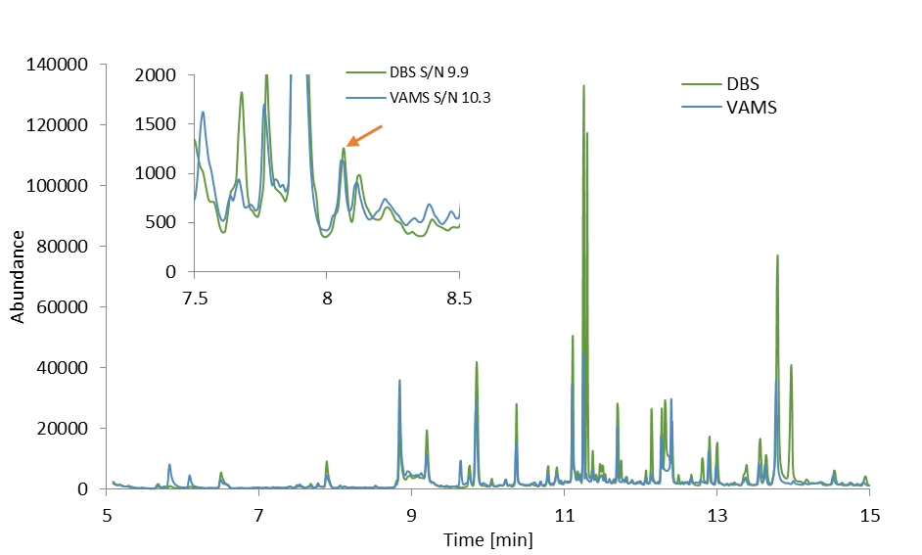
b)
a)

Fig. 1

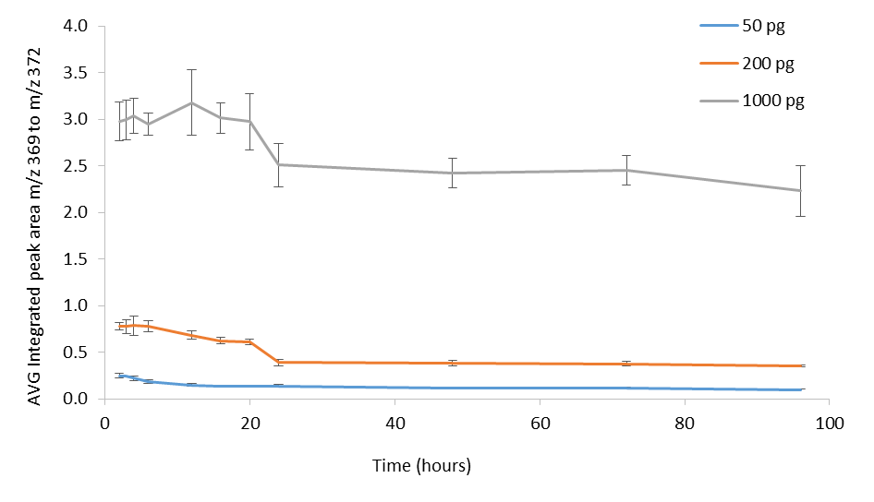

Fig. 2

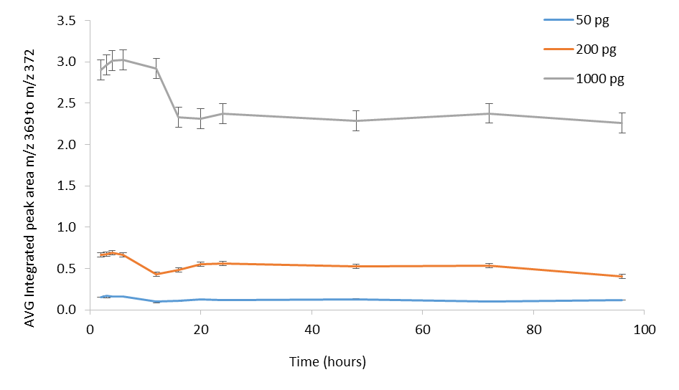

Fig. 3

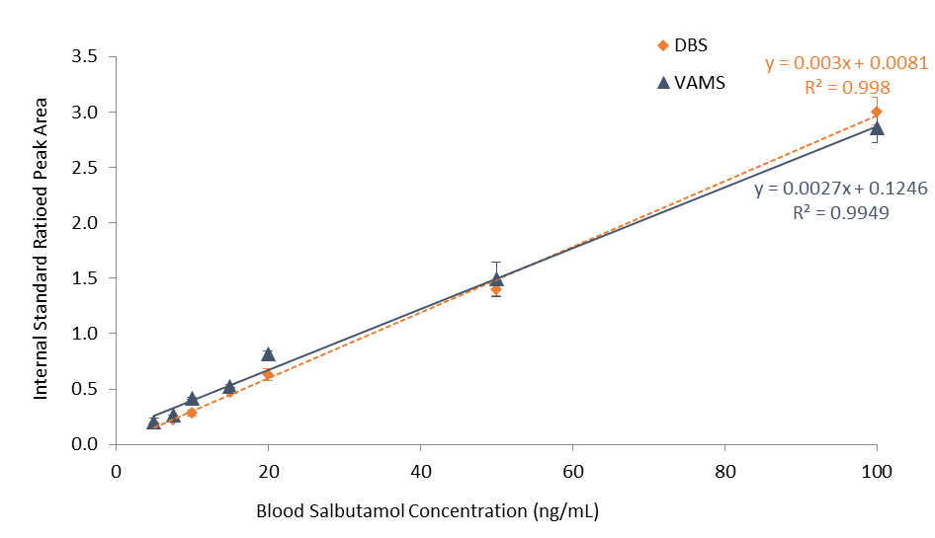

Fig. 4

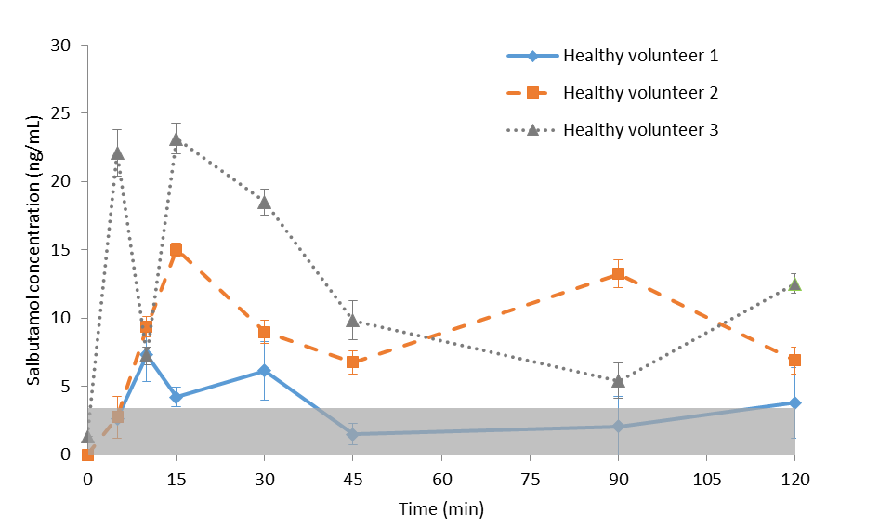
s/n 3:1

Fig. 5

Figure Legends
Fig. 1 a) GC-MS analysis of 5 ng/mL salbutamol (LOD for DBS and LLOQ for VAMS) spiked blood collected as DBS and VAMS, b) zoomed region showing the S/N ratio at the retention time of interest (8.05 minutes)

Fig. 2 Effect of drying time on recovered salbutamol internal standard ratioed peak area (mean±sd) collected as DBS (n=3)

Fig. 3 Effect of drying time on recovered salbutamol internal standard ratioed peak area (mean±sd) collected on VAMS (n=3)

Fig. 4 Sensitivity and linearity of GC-MS analysis of salbutamol spiked blood collected as DBS and VAMS (n=3, except for the concentrations used to determine accuracy, precision and recovery where n=5 was used)

Fig. 5 Analysis of capillary blood samples collected in triplicate on VAMS from three healthy male volunteers dosed with 1 mg of salbutamol by inhaling. Samples were spiked with 180 pg of internal standard then extracted with methanol, dried and derivatized

