Prescribing practices of rituximab in children: a 5-year retrospective review
  - Dr Victoria Price*^{1,2}, Dr Hanna Lythgoe*^{1,2}, Dr Louise Oni¹, Dr Daniel Hawcutt^{1,2}.
1: Department of Women’s and Children’s Health, Institute of Translational Medicine, University of Liverpool
2: NIHR Alder Hey Clinical Research Facility, Alder Hey Children’s NHS Foundation Trust, Liverpool, UK

*Both authors contributed equally to the manuscript

Keywords: Paediatrics,

Word Count: 328 (Aim 350)

Conflict of Interests: None to declare

Corresponding Author:
Dr Dan Hawcutt, Senior Lecturer in Paediatric Clinical Pharmacology,
NIHR Alder Hey Clinical Research Facility, Alder Hey Children’s NHS Foundation Trust, Eaton Road, Liverpool, L12 2AP
Email - d.hawcutt@liv.ac.uk

Aims
Rituximab, an anti-lymphocyte monoclonal antibody, is not currently licensed for use in children but is used for treatment of a variety of conditions. The purpose of this study was to (i) describe the current clinical indications being treated with rituximab in children (ii) review the doses used and (iii) investigate trends in prescribing practice.

Methods
A single-centre retrospective review of children who received rituximab during a 5-year period (October 2009 - October 2014).

Results
Eight-eight patients received rituximab with a median of four doses per patient (range 1 - 11, total 405 doses). Doses were between 375mg/m² and 750mg/m² with their frequency varying from weekly to fortnightly for up to four weeks, with clinicians deciding whether to give repeated courses at six monthly intervals. Three oncology patients had rituximab timed with their chemotherapy. The total annual dose per patient ranged from 750mg/m² to 2250mg/m². Most common clinical indications were: juvenile idiopathic arthritis JIA (n=27, 30.7%); cancer (n= 12, 13.6%); SLE (n=11, 12.5%); neuro-inflammatory disease (n= 9, 10.2%). Figure 1 summarises the clinical indications for rituximab. The number of new patients who received rituximab per year did not increase but the total number of patients and doses administered did increase due to repeat courses (total doses n=51 year 1, n=98 year 5, p<0.001).
Figure 1: The clinical indication for rituximab use in children according to the year that it was first administered during the study period

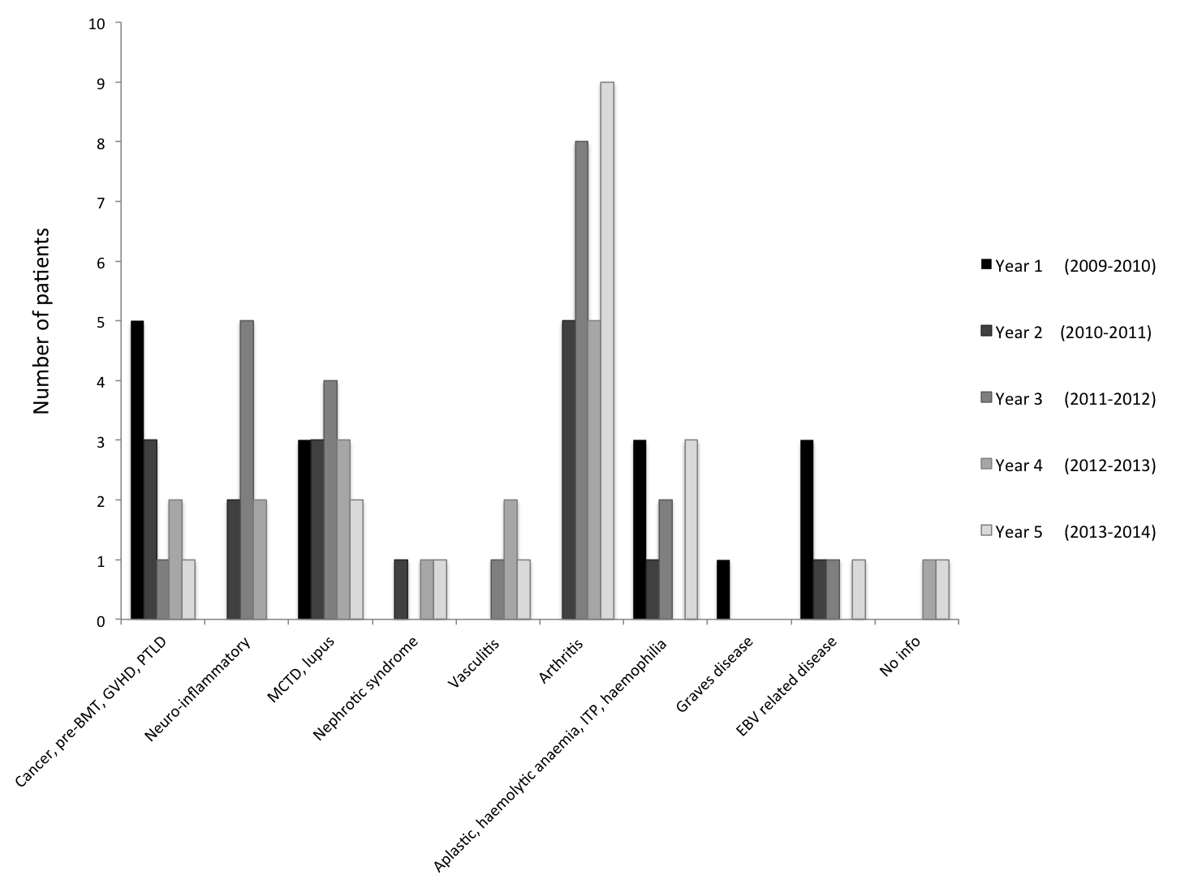

Discussion
Despite no licensed indications, rituximab prescriptions have shown a significant increase in the 5 years. While generally safe in the short term, rituximab carries the risk of rare but devastating long term adverse effects (such as progressive multifocal leukoencephalopathy) therefore determination of the optimal dose for each condition with regards to risks and benefits is required. These data provide the first characterisation of the conditions in which rituximab is being used in children, and shows the important role it has in a variety of diseases. Pharmacokinetic work is therefore required to inform safe dosing, appropriate for each indication.

Conclusion
Rituximab use is increasing due to repeat dosing of patients over time, although number of new patients remains static. Efforts to develop licencing indications for rituximab use in children are urgently needed.

References
1.
Word count 309 - including titles but not figures/diagrams/references/abstract

