Pyrene-Cored Covalent Organic Polymers by Thiophene Based Isomers, Their Gas Adsorption, and Photophysical Properties
Changfeng Li,^{1*} Peixian Li,^{1, 2} Linjiang Chen, ³ M. E. Briggs, ³ Ming, Liu,³ Kai Chen,² Xiaoxiao Shi,² Deman Han, ² Shibin Ren ^{2, 3*}
¹ School of Chemistry and materials Science, Shanxi Normal University, Lin Fen 041004, China
² School of Pharmaceutical and Chemical Engineering, Taizhou University, Taizhou 317000, China
³ Materials Innovation Factory and Department of Chemistry, University of Liverpool, Crown Street, Liverpool L69 7ZD, U.K Correspondence to: Shibin Ren (E-mail: renshibin@126.com)

((Additional Supporting Information may be found in the online version of this article.))
ABSTRACT Two new pyrene-cored covalent organic polymers (COPs), CK-COP-1 and CK-COP-2, were synthesized via the one step polymerization of two thiophene based isomers, 1,3,6,8-tetra(thiophene-2-yl) pyrene (L₁) and 1,3,6,8-tetra(thiophene-3-yl) pyrene (L₂). The resulting pyrene-cored COPs exhibit rather different surface areas of 54 m²g⁻¹ and 615 m²g⁻¹ for CK-COP-1 and CK-COP-2, respectively. The CO₂ uptake capacities of CK-COP-1 and CK-COP-2 also show different values of 2.85 and 9.73 wt% at 273 K, respectively. Furthermore, CK-COP-2 offers not only a larger CO₂ adsorption capacity but also a better CO₂/CH₄ selectivity at 273 K compared with CK-COP-1. CK-COP-1 and CK-COP-2 also exhibit considerable differences in their photophysical property. The different structure and properties of CK-COPs could be attributed to the isomer effect of their corresponding thiophene based monomers.
KEYWORDS: COPs; Thiophene Based Isomers; Gas Adsorption; Photophysical Properties

KEYWORDS: ((please insert at least five keywords))

INTRODUCTION Anthropogenic carbon dioxide (CO₂) emissions have been linked to rising global temperatures and extreme weather events. Reducing the level of these emissions by switching to green energy production combined with efficient CO₂ capture and sequestration (CCS) can lessen the negative effect on our environment. ¹ To date, only a few technologies like amine scrubbing have been commercialized for CO₂ capture and separation. However, regeneration of the amine scrubber requires significant energy expenditure while exposure to the amine solution can result in severe corrosion of equipment and pipework.^{2,3} Over the past decade, metal-organic frameworks (MOFs) have generated considerable interest as carbon capture materials due to their high specific surface area and excellent adsorption capability.⁴⁻⁸ Nevertheless, the presence of weak coordination bonds in these MOFs can lead to some severe drawbacks such as low stability and water affinity. Covalent organic polymers (COPs), constructed from strong covalent bonds have demonstrated superior thermal and chemical stability. In particular, these porous materials can reversibly adsorb and release CO₂ via physisorption as opposed to the chemisorption mechanism of the amine scrubbers, which results in a lower energy penalty for regeneration. The combination of high permanent porosity, readily functionalized pores, and well-tuned pore size distributions, mean that COPs have the potential to be CO₂ adsorbent materials of the future.⁹⁻¹¹ The incorporation of CO₂-philic functional groups into the polymers by bottom-up or post-synthesis approach allows COPs to be tailored towards specific applications.¹² The incorporation of non-classical reactive sites such as carboxyl, triazine, benzimidazole, carbazole, hydroxyl, imine, etc., into COPs has proved beneficial for CO₂ uptake. ¹³⁻¹⁹ Ionic functionality present in the polymers can also improve CO₂ capture due to the polarization of guest molecules.^{20,21} Depending on the functionality present these porous organic polymers can be classified as porous aromatic frameworks,²²⁻²³ covalent triazine polymers,¹⁴ carbazole-based microporous polymers,¹⁵ benzimidazole-linked polymers,^{16, 17} and porous imine-linked networks.¹⁹ With the exception of the COPs decorated with these polar groups, only a few non-polarizable COPs, such as PAF-1²² and a number of the PPN polymers ²³ exhibit excellent CO₂ adsorption and separation. However, the preparation of extended conjugated COPs by two isomeric thiophene substituted pyrenes has not been reported to date.
In recent years, pyrene-based porous materials have been widely used in various fields, such as photo-catalysis, photoelectric devices, chemical sensing, gas storage and separation, and degradation of nerve agent simulants due to their excellent rigidity and photophysical properties ²⁴⁻²⁸ . It has also been observed that changes in spatial configuration or conformation of isomeric ligands can have a great influence on the structures and properties of the final coordination polymers. ²⁹⁻³⁰ Motivated by all the above, we selected two isomeric monomers in which a thiophene ring is attached at either the 2- or 3- position to pyrene at its 1-, 3-, 6-, and 8- positions. Oxidative polymerization of the two thiophene containing monomers afforded porous fluorescent covalent organic polymers. The position of attachment of the thiophene to the pyrene core changes the number of reactive sites for polymerisation and will result in differences in the spatial configuration or orientation of the thiophene in the final polymers. Thiophene derivatised pyrenes can exhibit longer adsorption and emission wavelengths as well as high fluorescent quantum yields, compared with pyrene itself.³¹ The incorporation of these monomers into a network will greatly affect charge distribution within the extended conjugated frameworks. In this paper, we reported the synthesis of two pyrene-cored covalent organic polymers, CK-COP-1 and CK-COP-2, derived from 1, 3, 6, 8-tetra(thiophene-2-yl)pyrene (L₁) and 1, 3, 6, 8-tetra(thiophene-3-yl)pyrene (L₂), respectively. In addition, the gas adsorption and photophysical properties of the two isomeric polymers are also studied.
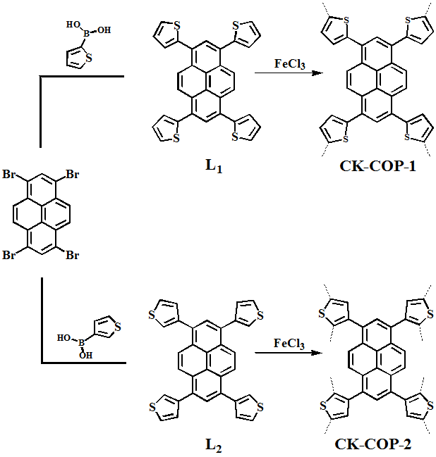
Scheme 1. The synthesis of CK-COP-1 and CK-COP-2.
EXPERIMENTAL
2.1 Materials and methods
1,3,6,8-Tetrabromopyrene was synthesized according to the literature method.³² Pyrene, 2-thienylboronic acid, and 3-thienylboronic acid were purchased from Sigma Aldrich. All other chemicals were from commercial sources and used without further purification.
¹H NMR spectra of L₁ and L₂ were tested on Bruker advance 400 MHz NMR spectrometer. Solid-state ¹³C CP/MAS NMR spectra of the polymers were measured on a Bruker Advance II WB 400 MHz NMR spectrometer using a 4 mm DVT CP/MAS probe at a MAS rate of 10 KHz. Fourier transform infrared spectroscopy (FTIR) was performed on Bruker Vector spectrophotometer using KBr pellets and measured over the range of 4000–400 cm⁻¹. Thermogravimetric analysis (TGA) was collected on TGA/SDT-Q600 under a nitrogen atmosphere at a heating rate of 10 °C min⁻¹. Power X-ray diffraction (PXRD) was carried out on Bruker D8 advance X-diffractometer with Cu-Kα radiation. Scanning electron microscopy (SEM) was performed on an S-4800 (Hitachi Ltd) field emission scanning electron microscopy. Gas adsorption-desorption isotherms were collected by volumetric method on a Micromeritics ASAP 2020 HD88 instrument. The samples were degassed at 423 K under dynamic vacuum for 12 hours. The specific surface area and pore size distribution were calculated from the N₂ adsorption at 77 K using the Brunauer-Emmett-Teller (BET) method and non-local density functional theory (NLDFT) method, respectively. CO₂ and CH₄ adsorption-desorption isotherms were tested at 273 and 298 K up to 1 bar. Photoluminescence analysis was performed on a Hitachi 850 fluorescence spectrophotometer. The solid state UV-Visible absorption were recorded on a Shimadzu UV-2550 UV-Vis spectrometer.
2.2 Synthesis of CK-COPs
2.2.1 Synthesis of 1,3,6,8-tetra(thiophene-2-yl)pyrene (L₁): In a 250 mL three-necked round-bottomed flask, the reaction mixture of tetrabromopyrene (3.12 g, 6 mmol), 2-thienylboronic acid (4.61 g, 36 mmol), palladium tetrakis(triphenylphosphine) (0.36 g, 0.30 mmol) and potassium carbonate (6.30 g, 45 mmol) were stirred in anhydrous dioxane (60 mL) under a nitrogen atmosphere for 3 days at 85 °C. After cooling to ambient temperature, the yellow reaction mixture was transferred to a solution of cold concentrated HCl solution (100mL). The precipitate was collected by filtration and then washed with 2 M HCl (3 x 40 mL). The solid was transferred to a Soxhlet and continuously extracted with CHCl₃ for 24 h. The CHCl₃ extracts were dried over MgSO₄, filtered, and evaporated under reduced pressure. The crude product L₁ was further recrystallized from hot CHCl₃ to afford L₁ as a bright yellow powder (2.11 g, 66 %). ¹H NMR (400 MHz d₆-DMSO): δ (ppm) 8.57 (s, 4H), 8.21 (s, 2H), 7.87 (dd, J=5.2, 1.2 Hz, 4H), 7.58 (dd, J=3.4, 1.0 Hz, 4H), 7.37 (dd, J=5.2, 3.6 Hz, 4H). ¹³C NMR (400 MHz CDCl₃): δ (ppm) 141.86, 131.23, 129.77, 129.12, 128.37, 127.54, 126.52, 125.88, 125.76. FT-IR (ATR 4000–400 cm⁻¹) 3418, 3086, 2927, 1800, 1603, 1495, 1462, 1430, 1385, 1272, 1236, 1207, 1076, 1044, 948, 905, 850, 830, 814, 702, 686, 597. MS (ESI): m/z for C₃₂H₁₈S₄ cacld 530.03, M⁺ 530.1.
2.2.2 Synthesis of 1,3,6,8-tetra(thiophene-3-yl)pyrene (L₂ L₂): Apart from 3-thienylboronic acid, the preparation method of L₂ was the same to that of L₁. Its yield was 1.95 g (61 %). ¹H NMR (400 MHz CDCl₃): δ (ppm) 8.31 (s, 4H), 8.09 (s, 2H), 7.55 (dd, J=2.8, 1.2 Hz, 4H), 7.53 (dd, J=4.8, 2.8 Hz, 4H), 7.47 (dd, J=4.8, 1.2 Hz, 4H). ¹³C NMR (400 MHz CDCl₃): δ (ppm) 141.39, 132.02, 130.00, 129.36, 128.47, 125.94, 125.59, 125.31, 124.12. FT-IR (ATR 4000–400 cm⁻¹) 3468, 3091, 2903, 1803, 1607, 1485, 1462, 1385, 1338, 1272, 1204, 1076, 912, 902, 886, 860, 837, 797, 781, 732, 702, 676, 647, 542. MS (ESI): m/z for C₃₂H₁₈S₄ cacld 530.03, M⁺ 530.2.
2.2.3 Synthesis of CK-COP-1: In a classical synthesized procedure, anhydrous FeCl₃ (0.81 g, 5.00 mmol) was added to a 250 mL three-necked round-bottomed flask containing 20 mL dried CHCl₃ under N₂ atmosphere. L₁ (0.13 g, 0.25 mmol) was dissolved in anhydrous CHCl₃ (20 ml) and added dropwise over 1 hour to the FeCl₃ suspension at room temperature with continuous stirring. During the addition of L₁, the reaction mixture quickly changed from dark green to black with the appearance of a precipitate. The mixture was stirred under a N₂ atmosphere for a further 24 hours. The suspension was poured into methanol (100 mL), stirred for 1 hour, filtered, and washed with methanol (3 × 20 ml) to yield an orange-red solid. The solid was added to a cold solution of concentrated hydrochloric acid (50 mL) and stirred for 2 hours. It was filtered, washed with water (3 × 20mL), methanol (3 × 20 mL), and then washed via Soxhlet extraction with THF and methanol successively for 24 hours. Finally, the purified CK-COP-1 were vacuum-dried in an oven at 100 °C for 12 hours to afford a bright orange-red solid (0.055 g, 42 %).
Synthesis of CK-COP-2: The same procedure mentioned above was followed using the precursor L₂ instead of L₁. The final product was isolated as a dark red solid with a yield of 0.049 g (38 %).
RESULTS AND DISCUSSION
The two COPs, CK-COP-1 and CK-COP-2, were prepared by oxidative polymerisation of the thiophene containing monomers, L₁ or L₂, with FeCl₃. L₁ and L₂ were synthesised via the fourfold Suzuki cross-coupling of 2-thienylboronic acid or 3-thienylboronic acid with tetrabromopyrene (Scheme 1). ³³ CK-COP-1 and CK-COP-2 were characterised by fourier transform infrared spectroscopy (FTIR), thermo-gravimetric analysis (TGA), powder X-ray diffraction (PXRD), scanning electron microscopy (SEM), and solid-state ¹³C NMR. Additionally, their porosity was investigated by the gas adsorption–desorption measurements.
The FTIR spectrum of the two monomers and their corresponding polymers is depicted in FIGURE 1. In the two monomers, three peaks at 1462, 1385, and 1207 cm⁻¹ were attributed to the stretching vibration of C=C and C–C bonds from the thiophene units. ³⁴ The vibration peaks of C–S–C bonds from the thiophene units appear at 702 cm⁻¹ for the monomer L₁ and 729 cm⁻¹ for the monomer L₂, respectively. The peaks corresponding to the C=C and C-C bonds in the two polymers were comparable to that of the monomers. However, the peak intensities at 702 and 729 cm-1, which are attributed to the aromatic C-H out-of-plane bending vibrations within thiophene structures for the two polymers decreased significantly when compared with that of L₁ and L₂.^{[35]} CK-COP-2 exhibits more obvious drop in the FT-IR intensity than CK-COP-2, which indicates that the CK-COP-2 are more completely polymerized that CK-COP-1. Solid-state ¹³C CP/MAS NMR spectrum was also used to confirm their structure of the two COPs (FIGURE 2). For CK-COP-1, the peak at ca. 141 ppm was assigned as the carbon atoms attached to the S atom in the thiophene rings and the overlapping peaks at ca. 127 ppm were assigned to the pyrene carbons and the remaining thiophene carbons.³⁶ Meanwhile, for CK-COP-2, the shoulder peak at 146 ppm was assigned to the thiophene carbon directly linked to the pyrene cores, while the broad peak from 115 to 145 ppm was assigned to the pyrene carbons and the remaining thiophene carbons. The differences between CK-COP-1 and CK-COP-2, observed by IR and solid state NMR, originate from the different connection modes between pyrene cores and thiophene units in the polymers.
The insoluble nature of both CK-COPs in common organic solvents is also indicative of the formation of well-established 3D frameworks. Thermogravimetric analysis (TGA) of the two polymers revealed obvious differences in the thermal stability. Whereas CK-COP-1 displayed little mass loss up at about 500 °C, CK-COP-2 displays a
FIGURE 1. FTIR spectra of CK-COP-1 and CK-COP-2 and their corresponding monomer L₁ and L₂.

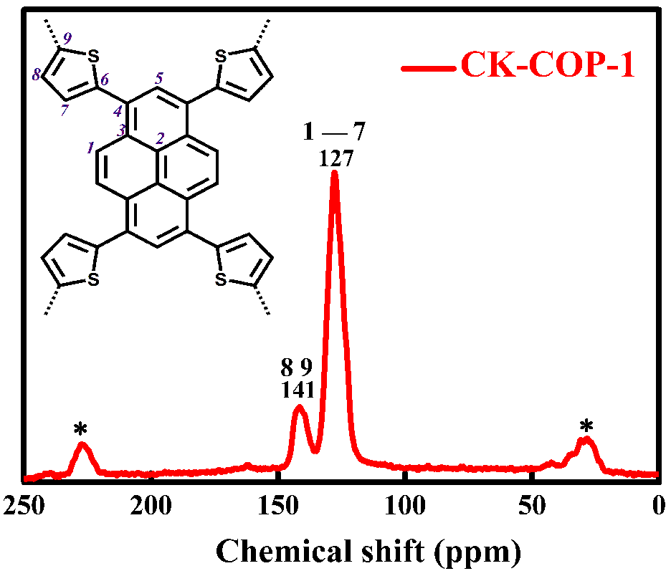
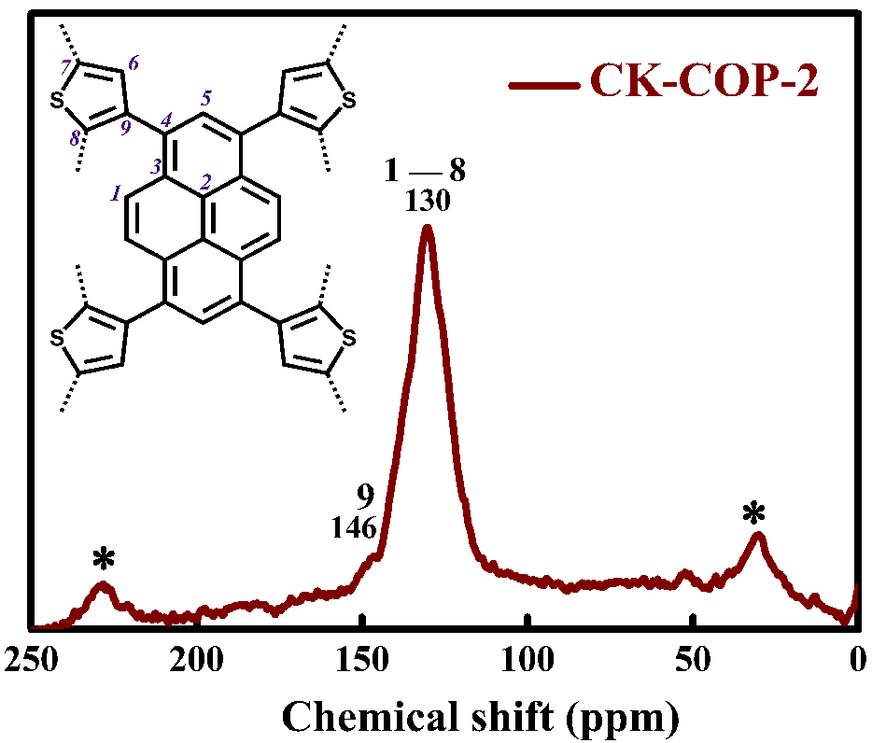
FIGURE 2. Solid-state ¹³C CP/MAS NMR spectrum of CK-COP-1 and CK-COP-2
pronounced mass loss from about 200 °C (FIGURE S1). For CK-COP-1, the SEM micrographs (FIGURE S2) showed the formation of particulate structure whereas the SEM micrographs of CK-COP-2 (Figure S3) showed a nanofiber morphology. ³⁷ There were no obvious crystallinity as suggested by their powder X-ray diffraction (PXRD) patterns (FIGURE S4), indicating the amorphous nature of the two materials.
In order to investigate the porosities of the CK-COPs, N₂ adsorption-desorption measurements at 77 K up to 1 bar pressure were performed. Prior to analysis the polymers were degassed under dynamic vacuum at 423 K for 12 hours. As shown in FIGURE 3A, CK-COP-1 displays very low N₂ adsorption across
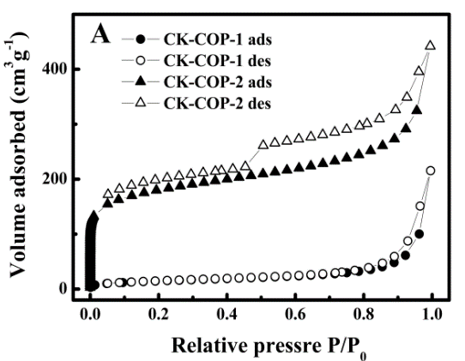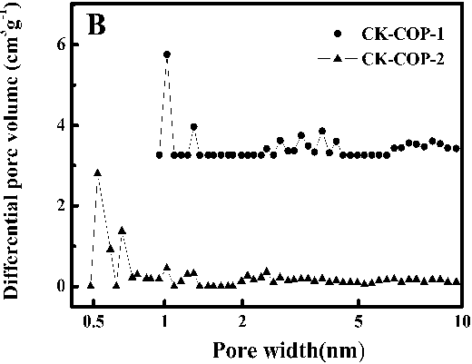
FIGURE 3. (A) N₂ adsorption/desorption isotherms at 77 K for CK-COP-1 and CK-COP-2. The filled and open symbols represent adsorption and desorption, respectively; (B) Pore size distribution of CK-COPs.
the whole pressure range. This phenomenon can be related with the tight packing structure of the prepared polymer (FIGURE S2), which blocks nitrogen gas from entering the pore channel at low temperature. However, the fully reversible isotherms of CK-COP-2 show a rapid nitrogen uptake at low pressure (P/P₀ < 0.05), indicative of a permanent microporous structure. ³⁹ The gradually increase in N₂ uptake and the minor hysteresis suggest the presence of mesopores, which may originate from the loose nanofibers structure and swelling of the polymer (FIGURE S3).³⁹ Applying the Brunauer-Emmett-Teller model within the pressure range of P/P₀ = 0.01–0.2 results in an apparent surface area (SA_{BET}) of 54 m² g⁻¹ for CK-COP-1 and 615 m² g⁻¹ for CK-COP-2. Moreover, total volumes were calculated from the single point N₂ uptake (P/P₀ = 0.99) and found to be 0.33 cm³ g⁻¹ (CK-COP-1) and 0.68 cm³ g⁻¹ (CK-COP-2). The pore size distribution of the two materials were evaluated by fitting the adsorption branches of the N₂ isotherms using the non-local density functional theory (NLDFT) and found to be centred around 1.02 nm (CK-COP-1)
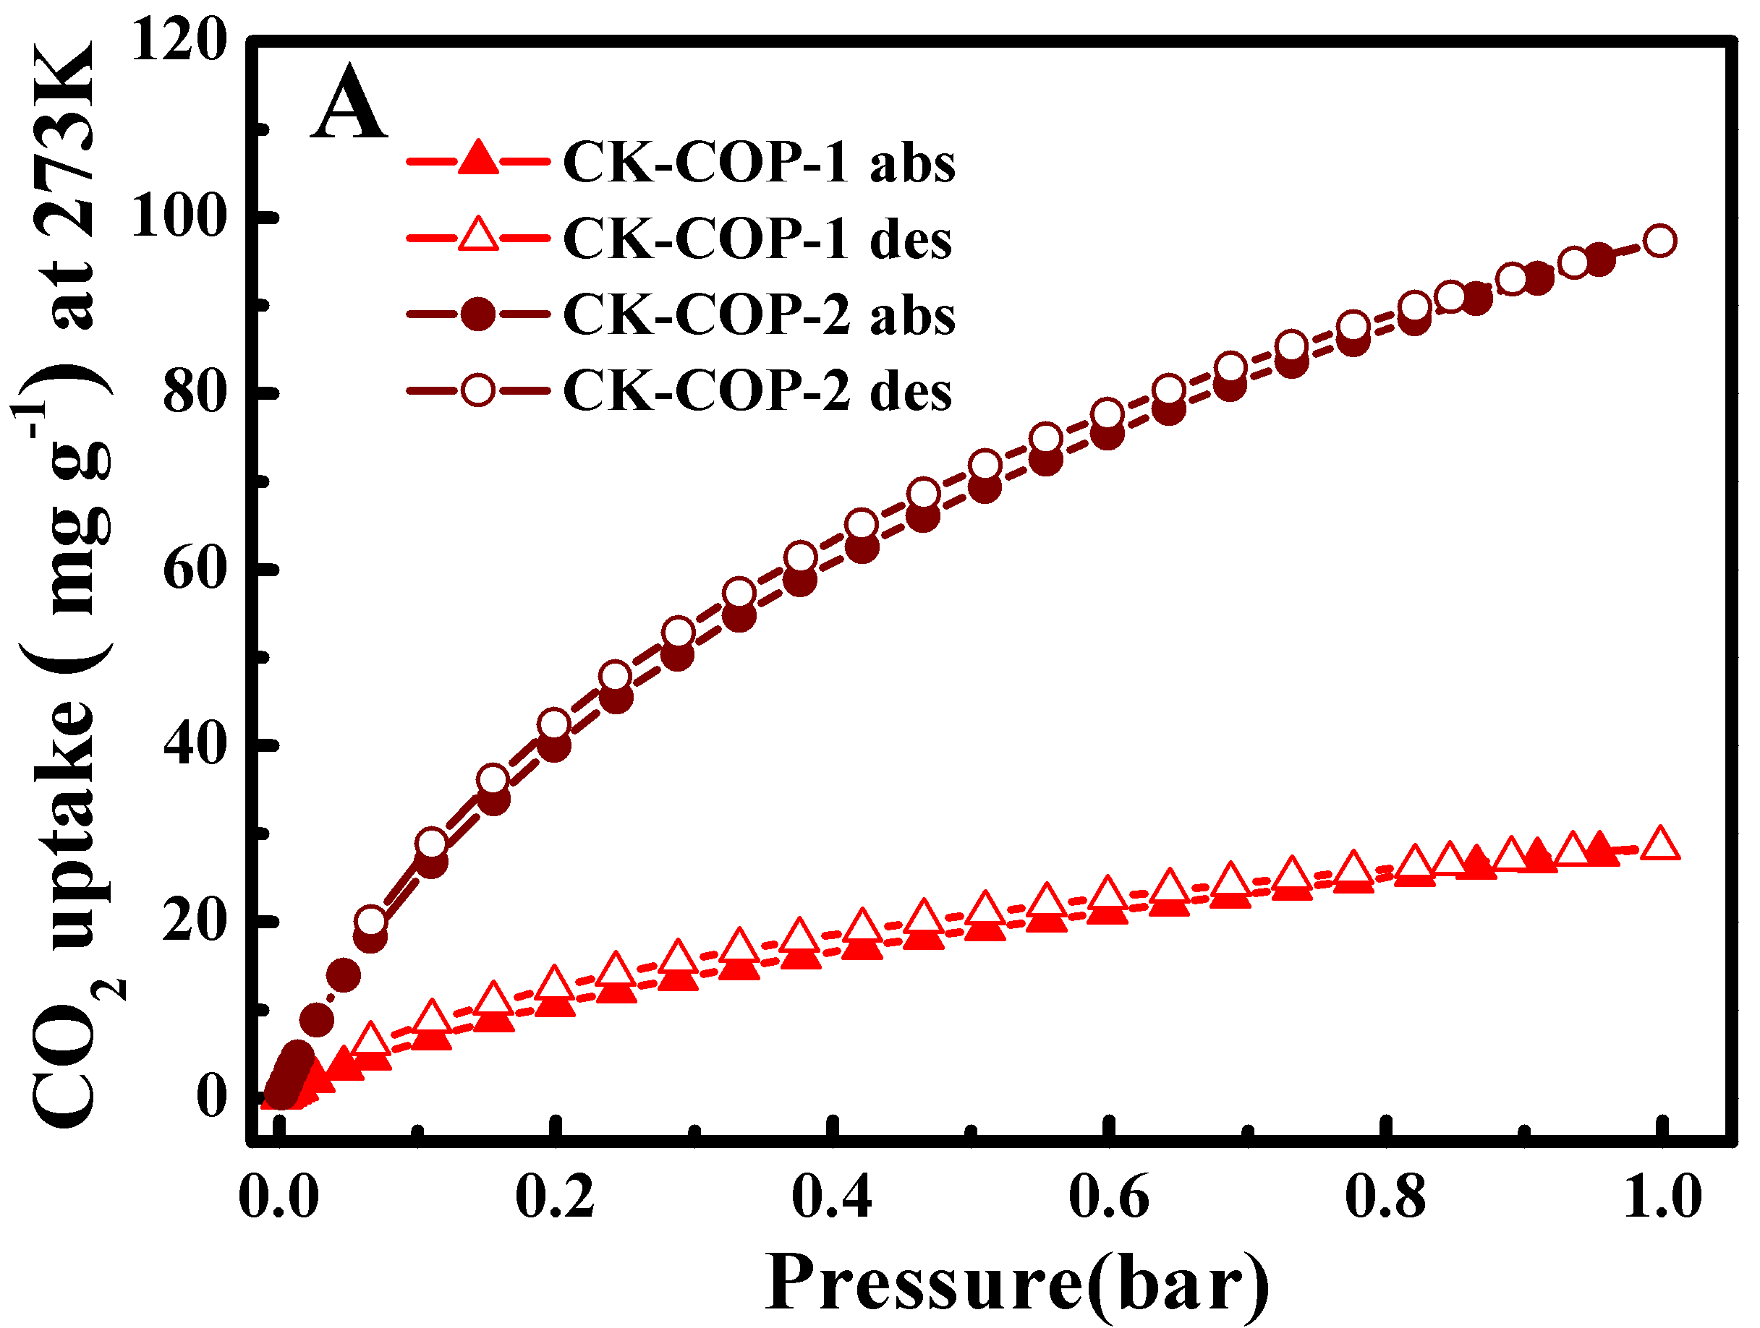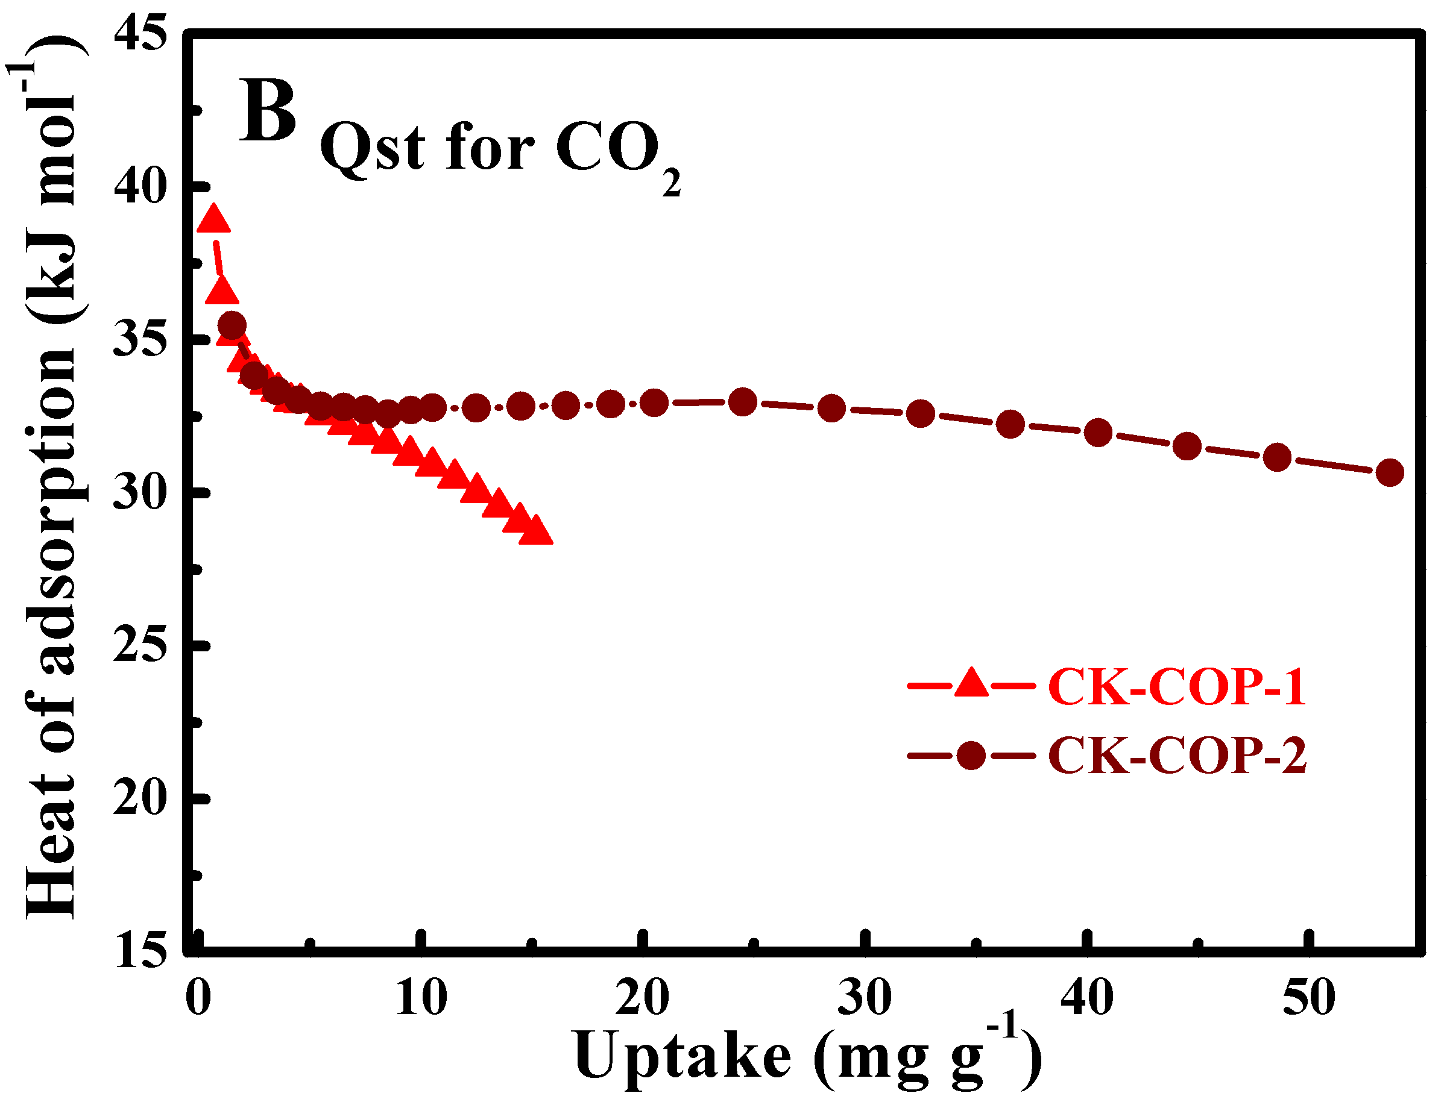
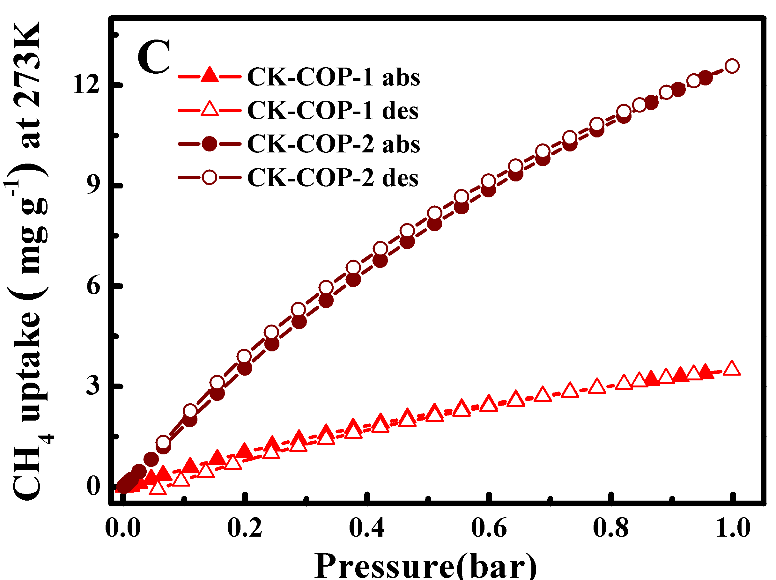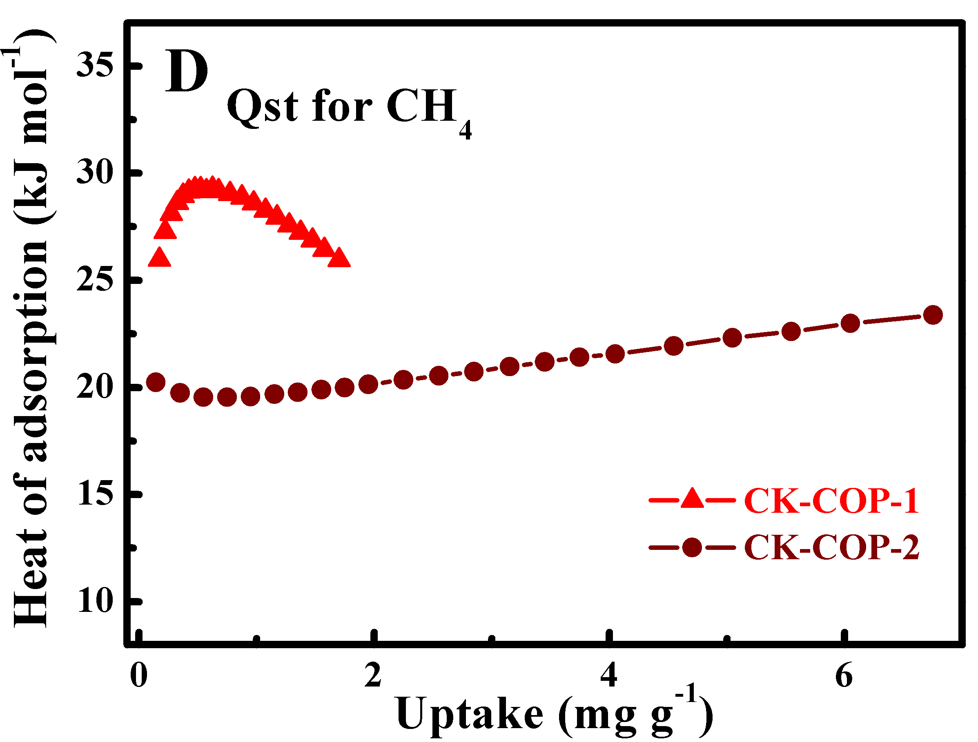
FIGURE 4. (A) CO₂ and (C) CH₄ adsorption/desorption isotherms at 273 K for CK-COP-1 and CK-COP-2. The filled and open symbols represent adsorption and desorption, respectively; Isosteric heat for (B) CO₂ and (D) CH₄ adsorption for CK-COP-1 and CK-COP-2.
and 0.52 nm (CK-COP-2) (FIGURE 3B). As depicted in table S1, the differences in the SA_{BET}, total volume, and pore size distribution between the two CK-COPs are closely associated with the different substitution patterns in the monomers. For CK-COP-1, L₁ possesses only one reactive site adjacent to the sulfur atom in the thiophene ring, which will result in a lower degree of cross-linking and result in a tightly packed structure (FIGURE S2). Whereas for CK-COP-2, L₂ possesses two reactive sites adjacent to the sulfur atom in the thiophene ring, resulting in a higher degree of cross-linking and therefore a more open structure than that observed for CK-COP-1.
In view of the fact that the CK-COPs possess different structural characteristics, the CO₂ uptake and the CO₂/CH₄ selectivity were performed. Both separations are industrially relevant for the upgrade and purification of nature gas and flue gas, respectively. The adsorption-desorption isotherms of CO₂ and CH₄ were recorded up to 1 bar at 273 and 298 K (FIGURE 4 and Figure S5). The CO₂ and CH₄ sorption isotherms of CK-COPs are shown in FIGURE 4A, 4C and FIGURE S5 at low pressure and show reversible adsorption up to 1 bar, which implies that the guest loaded CK-COPs can be cost-effectively regenerated via a pressure swing mechansim. It was observed that both CK-COPs do not reach the saturation at 1 bar. CK-COP-1 and CK-COP-2 show CO₂ uptakes of 2.85 and 9.73 wt.%, respectively, at 273 K and 1 bar. In addition, although their values are lower than those of reported porous materials, such as hydroxyl functionalized POFs (18.40 w.t%),¹⁸ imine-linked porous polymers PPF-1 (18.40 wt.%) ⁴⁰ and pyrene-derived benzimidazole-linked polymers BILP-10 (17.70 wt.%),¹⁶ the CO₂ adsorption value for CK-COP-2 (9.73 wt.%) compares favourably with that of other reported porous adsorbents such as PECONF-1 (8.2 wt.%), ⁹ CMP-1 (9.02 wt.%),¹³ ILP (8.67 wt.%), ⁴¹ TFM-1 (7.6 wt.%),⁴² and PAF-1 (9.2 wt.%).⁴³ The CH₄ sorption of CK-COPs was also assessed up to 1 bar at 273 and 298 K (FIGURE 4C). The CH₄ capacities are 0.35 and 1.25 wt.% for CK-COP-1 and CK-COP-2, respectively, at 273 K. The difference in CO₂ and CH₄ uptake capacity is consistent with the measured surface area and pore volume for the two polymers and can be attributed to differences in their structures caused by different degrees of their cross-linking.
A moderate enthalpy of CO₂ adsorption (Q_{st}) is beneficial for the development of porous adsorbents.⁹ The isosteric heat of CO₂ and CH₄ adsorption (Q_{st}) was calculated from their corresponding adsorption isotherms at 273 and 298 K, respectively, using the Clausius–Clapeyron equation. As exhibited in FIGURE 4B, at the zero coverage, the isosteric heats of CO₂ adsorption were 38.8 kJ mol⁻¹ for CK-COP-1 and 35.5 kJ mol⁻¹ for CK-COP-2. It was observed that the Q_{st} for CK-COP-1 rapidly decreased with CO₂ loading. In sharp contrast, the Q_{st} for CK-COP-2 remains consistent up to a loading of 50 mg g⁻¹. The Q_{st} for CO₂ uptake in CK-COP-1 and CK-COP-1 is within the range observed for other organic porous polymers such as PECONFs (26.0–34.0 kJ mol⁻¹),⁹ BILPs (31.2–35.8 kJ mol⁻¹),¹⁷ and PPFs (21.8–29.2 kJ mol⁻¹);⁴⁰ and are slightly below the value suggestive of chemisorption (40 kJ mol⁻¹), indicating physical adsorption of the CO₂ on to the pore wall. The co-existence of both thiophene and pyrene within the polymers leads to a highly conjugated electron rich structure, which can benefit the CO₂ adsorption via Lewis acid-Lewis base interactions. The maximum isosteric heat of CH₄ adsorption in CK-COP-1 and CK-COP-2 reach 29.2 and 20.0 kJ mol⁻¹, respectively (FIGURE 4D). To evaluate the CO₂/CH₄ separation performances of CK-COPs, the selectivity of CO₂ over CH₄ was also calculated using the ideal adsorbed solution theory (IAST), based on the experimental pure-gas isotherms at 298K and 1 bar. The adsorption selectivity for CO₂/CH₄ mixtures (15/85 molar ratio) of CK-COP-1 and CK-COP-2 as a function of pressure is shown in FIGURE S6. CK-COP-2 has better CO₂/CH₄ selectivity than CK-COP-1 at 273 K, but not such at 298 K.
In addition, the photophysical properties of L₁, L₂, and CK-COPs have also been investigated in CH₂Cl₂ at room temperature and the results are shown in FIGURE 5. The emission spectra for L₁, L₂, CK-COP-1, and CK-COP-2 exhibited maximum emission bands at 470, 432, 540, and 433 nm, respectively. The emission wavelength of CK-COP-1 is red-shifted by ~70 nm, compared with that of L₁. The red shift could be due to the enhanced planar conformation and extended π-conjugation framework for CK-COP-1. By contrast, the emission peaks of CK-COP-2 and L₂ almost overlap at 433 nm. Such a phenomenon for CK-COP-2 and L₂ is perhaps ascribed to a high degree of cross-linking and low extent of π-orbital overlap since the two reactive sites of L₂ are not equivalent.
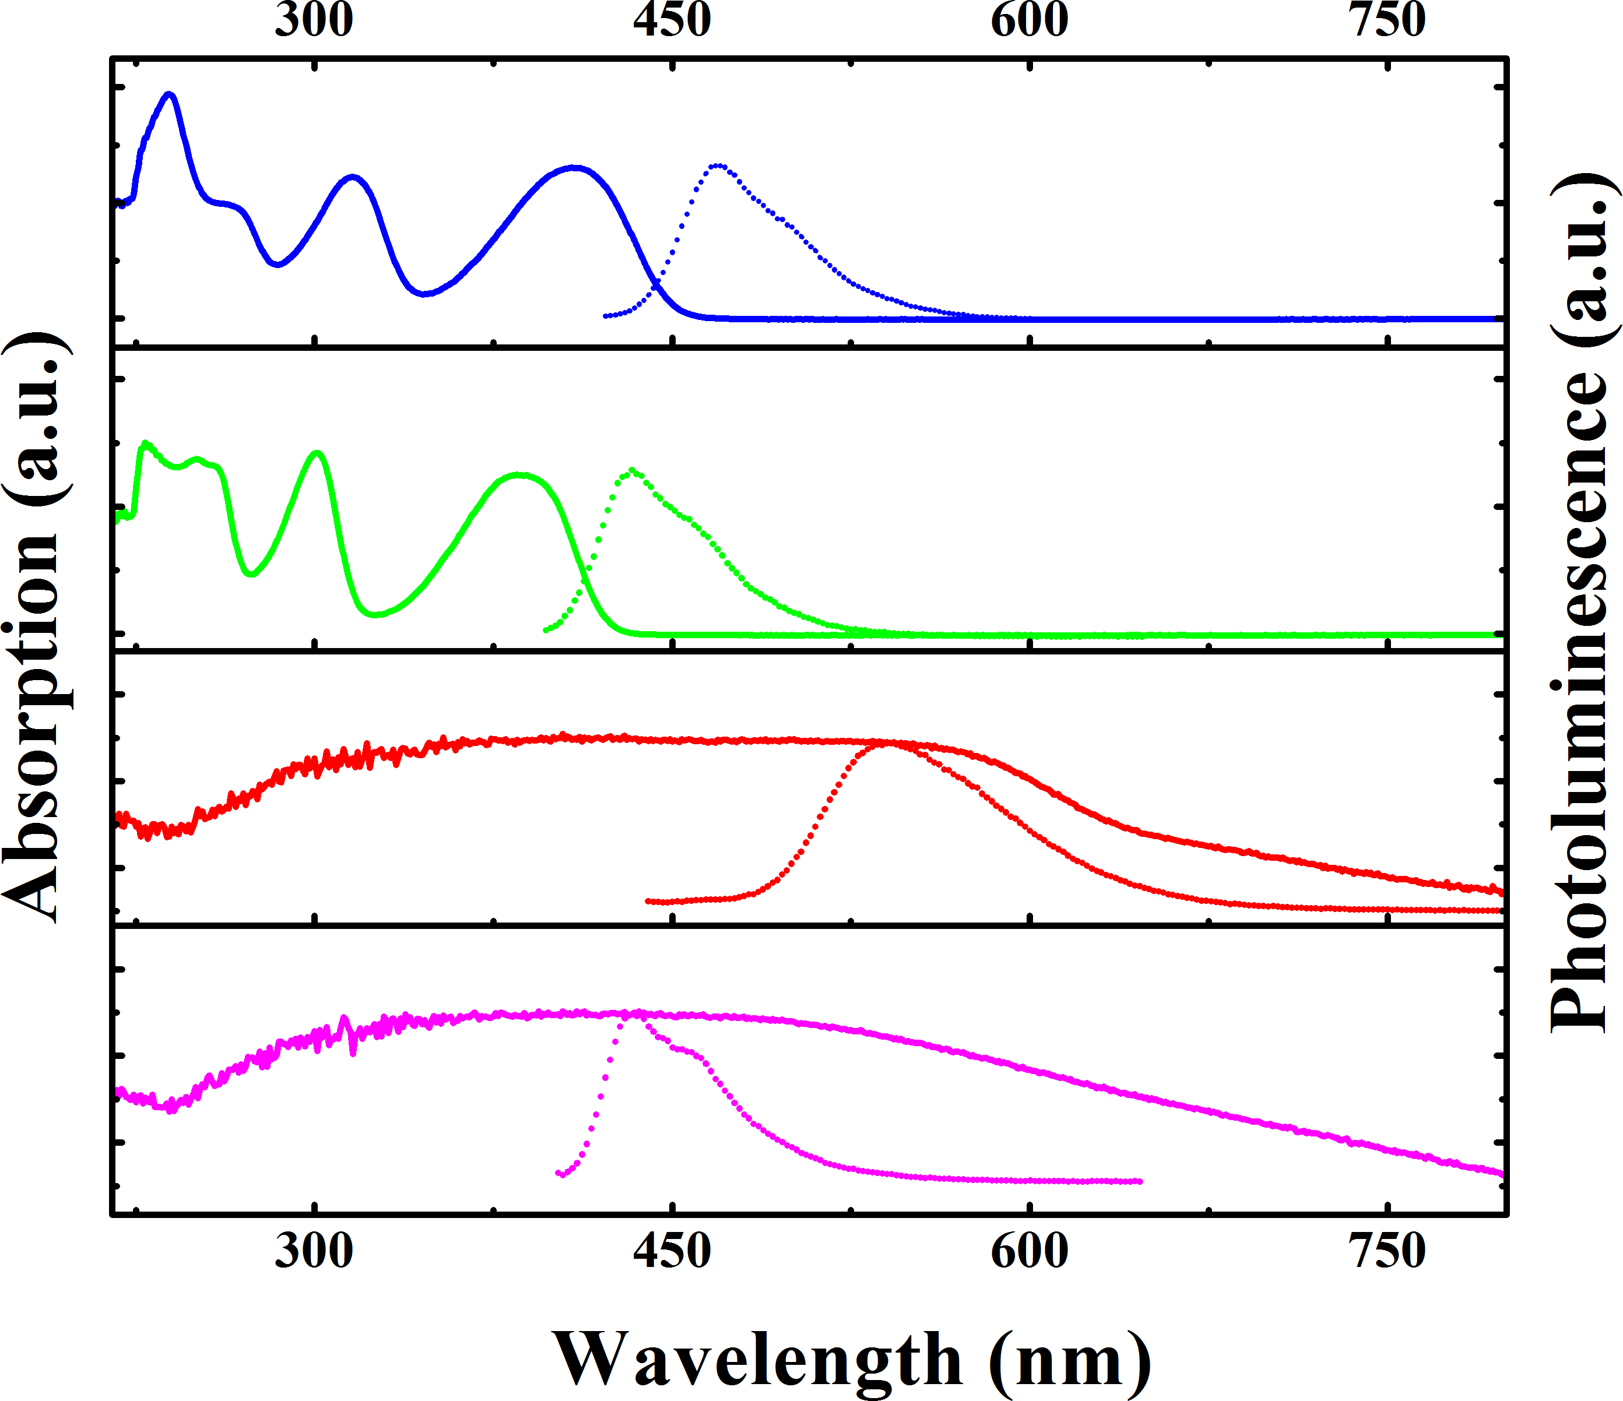
FIGURE 5. UV-Vis spectra (solid line) and Emission Spectra (dot line) of the monomers and the corresponding polymers (L₁, L₂, CK-COP-1, and CK-COP-2) upon excitation at 407 nm, 390 nm, 433 nm and 395 nm (from top to bottom).
Additionally, the emission spectra and UV-Vis spectra of L₁ and L₂ are rather similar but different in wavelength, perhaps in that L₁ can be endowed with the more planar structure and more extended π-conjugated system than L₂ even though both monomers are isomers. The position of the thiophene attached on pyrene units changes the number of reactive sites for oxidative polymerisation, which will control the orientation and distribution of thiophenes within the resulting polymers. Therefore, it is believed that all these differences in the photophysical properties of COPs could be attributable to their different structures due to the orientation and distribution of thiophenes on pyrene cores within the resulting polymers.
CONCLUSIONS
The two covalent organic polymers were successfully prepared via the oxidative polymerisation of two isomeric thiophene substituted pyrenes. Differences in the attachment of the thiophene rings to the pyrene core result in greater crosslinking in CK-COP-2 than for CK-COP-1. The high degree of crosslinking in CK-COP-2 results in a more rigid structure that results in the thiophene twisting out of plane with the pyrene. The difference in structure between the two polymers is consistent with the observed porosity, gas uptakes, and photophysical properties of the two polymers.
ACKNOWLEDGEMENTS
We are grateful for financial support from the National Natural Science Foundation of China (21471110，21575097, and 21375092).
REFERENCES AND NOTES
- Q. Wang, J. Luo, Z. Zhong and A. Borgna, Energy Environ.Sci., 2011, 4, 42–55.
- G. T. Rochelle, Science., 2009, 325, 1652 −1654.
- A. Goeppert, M. Czaun, G. K. Surya Prakash and G. A. Olah, Energy Environ. Sci., 2012, 5, 783–7853.
- A. C. Sudik, A. R. Millward, N. W. Ockwig, A. P. Côté, J. Kim, and O. M. Yaghi，J. Am. Chem. Soc., 2005, 127, 7110-7118.
- X.-S. Wang, S. Ma, D. Sun, S. Parkin, and H.-C. Zhou, J. Am. Chem. Soc., 2006, 128, 16474-16475.
- M. Xue, S. Ma, Z. Jin, R. M. Schaffino, G.-S. Zhu, E. B. Lobkovsky, S. -L. Qiu, and B. Chen, Inorg. Chem., 2008, 47, 6825-6828.
- A. Sonnauer, F. Hoffmann, M. Frba, L. Kienle, V. Duppel, M. Thommes, C. Serre, G. Férey, and N. Stock, Angew. Chem. Int. Ed., 2009, 48, 3791 –3794.
- R.-B. Lin, F. Li, S.-Y. Liu, X.-L. Qi, J.-P. Zhang, and X.-M. Chen, Angew. Chem. Int. Ed., 2013, 52, 13429 –13433.
- P. mohanty, L. D. Kull and K. Landskron. Nat. Commun., 2011, 2, 401−406.
- J.-X. Jiang, F. Su, A. Trewin, C. D. Wood, N. L. Campbell, H. Niu, C. Dickinson, A. Y. Ganin, M. J. Rosseinsky, Y. Z. Khimyak, and A. I. Cooper, Angew. Chem. Int. Ed., 2007, 46, 8574 –8578.
- Y. Xu, S. Jin, H. Xu, A. Nagai and D. Jiang, Chem. Soc. Rev., 2013, 42, 8012−8031.
- Z. Xiang, and Cao, D. J. Mater. Chem. A., 2013, 1, 2691−2718.
- R. Dawson, D. J. Adams, A. I. Cooper, Chem. Sci., 2011, 2, 1173–1177.
- A. Bhunia, V. Vasylyeva and C. Janiak, Chem. Commun., 2013, 49, 3961–3963.
- Q. Chen, M. Luo, P. Hammershøj, D. Zhou, Y. Han, B. W. Laursen, C.-G. Yan and B.-H. Han, J. Am. Chem. Soc., 2012, 134, 6084−6087.
- M. G. Rabbani, A. K. Sekizkardes, O.M. El-Kadri, B. R. Kaafarani and H. M. El-Kaderi, J. Mater. Chem., 2012, 22, 25409–25417.
- A. K. Sekizkardes, T. İslamŏglu, Z. Kahveci and H. M. El-Kaderi, J. Mater. Chem. A., 2014, 2, 12492–12500.
- A. P. Katsoulidis and M. G. Kanatzidis, Chem. Mater., 2011, 23, 1818–1824.
- N. Popp, T. Homburg, N. Stock and J. Senker, J. Mater. Chem. A., 2015, 3, 18492−18504.
- J. S. Lee, H. Luo, G. A. Baker, and S. Dai, Chem. Mater., 2009, 21, 4756–4758.
- S. Soll, Q. Zhao, J. Weber, and J. Yuan, Chem. Mater., 2013, 25, 3003−3010.
- T. Ben, H. Ren, S. Ma, D. Cao, J. Lan, X. Jing, W. Wang, J. Xu, F. Deng, J. M. Simmons, S. Qiu and G. Zhu, Angew. Chem., Int. Ed., 2009, 48, 9457–9460.
- W. Lu, D. Yuan, D. Zhao, C. I. Schilling, O. Plietzsch, T. Muller, S. Bräse, J. Guenther, J. Blümel, R. Krishna, Z. Li and H. C. Zhou, Chem. Mater., 2010, 22, 5964–5972.
- G. Lin, H. Ding, D. Yuan, B. Wang, and C. Wang, J. Am. Chem. Soc., 2016, 138, 3302−3305.
- M. G. Rabbani, A. K. Sekizkardes, Z. Kahveci, T. E. Reich, R. Ding, and H. M. El-Kaderi, Chem. Eur. J., 2013, 19, 3324–3328.
- S. Wan, J. Guo, J. Kim, H. Ihee, and D. Jiang, Angew. Chem. Int. Ed., 2009, 48, 5439–5442.
- 38 R. S. Sprick, J.-X. Jiang, B. Bonillo, S. Ren, T. Ratvijitvech, P.Guiglion, M. A. Zwijnenburg, D. J. Adams, and A. I. Cooper, J. Am. Chem. Soc., 2015, 137, 3265–3270.
- S. Dalapati, S. Jin, J. Gao, Y. Xu, A. Nagai, and D. Jiang, J. Am. Chem. Soc., 2013, 135, 17310–17313.
- S.-B. Ren, L. Zhou, J. Zhang, Y.-Z. Li, H.-B. Du, X.-Z. You, CrystEngComm, 2009, 11, 1834-1836.
- S. B. Ren, Z. J. Qiu, J. Yan, S. L. Zhao, C. L. Wu, W. P. Jia, D. M. Han, H.-D. Liang, J. Mol. Struct., 2013, 23, 15-20.
- T. M. Figueira-Duarte and K. Müllen, Chem. Rev., 2011, 111, 7260–7314.
- G. Venkataramana and S. Sankararaman, Eur. J. Org. Chem., 2005, 4162–4166.
- H. Zhang, Y. Wang, K. Shao, Y. Liu, S. Chen, W. Qiu, X. Sun, T. Qi, Y. Ma, G. Yu, Z. Su and D. Zhu, Chem. Commun., 2006, 755-757.
- C. Kvarnström, H. Neugebauer, S. Blomquist, H. J. Ahonen, J. Kankare and A. Ivaska, Electrochim. Acta., 1999, 44, 2739–2750.
- J. Wang, Electrochimica Acta, 1994, 39, 417-429.
- S. K. Kundu and A. Bhaumik, ACS Sustainable Chem. Eng., 2016, 4, 3697−3703.
- G. Cheng, T. Hasell, A. Trewin, D. J. Adams and A. I. Cooper, Angew. Chem., Int. Ed., 2012, 51, 12727–12731.
- X. Zhang, J. Lu and J. Zhang, Chem. Mater., 2014, 26, 4023–4029.
- P. M. Budd, E. S. Elabas, B. S. Chanem, S. Makhseed, N. B. Makeown, K. J. Msayib, C. E. Tattershall and D. Wang, Adv. Mater., 2004, 16, 456 – 459.
- Y. Zhu, H. Long and W. Zhang, Chem. Mater., 2013, 25, 1630–1635.
- J. Wang, I. Senkovska, M. Oschatz, M. R. Lohe, L. Borchardt, A. Heerwig, Q. Liu and S. Kaskel, ACS Appl. Mater. Interfaces., 2013, 5, 3160–3167.
- X. Zhu, C. Tian, S. M. Mahurin, S. H. Chai, C. Wang, S. Brown, G. M. Veith, H. Luo and S. Dai, J. Am. Chem. Soc., 2012, 134 , 10478–10484.
- T. Ben, C. Pei, D. Zhang, J. Xu, F. Deng, X. Jing and S. Qiu, Energy Environ. Sci., 2011, 4, 3991–3999.

