Thermal Comfort and Behaviour Control in Mixed-mode Office Buildings in Harbin, China
Ran Zhang¹, Sun Cheng¹, Steve Sharples² and Hongrui Zhang¹
¹ School of Architecture, Harbin Institute of Technology, Heilongjiang Cold Region Architectural Science Key Laboratory, Harbin, China, ranzhang_hit@163.com
1 School of Architecture, Harbin Institute of Technology, Heilongjiang Cold Region Architectural Science Key Laboratory, Harbin, China, suncheng@hit.edu.cn
2 School of Architecture, University of Liverpool, Liverpool, United Kingdom, Steve.Sharples@liverpool.ac.uk
1 School of Architecture, Harbin Institute of Technology, Heilongjiang Cold Region Architectural Science Key Laboratory, Harbin, China, zhhr_hit@163.com
Abstract: This paper presents findings from a two-week longitudinal case study of occupant thermal comfort and related behaviour control in offices in Harbin, northeast China. Long-time data were collected from on-line questionnaire surveys and data logger measurements of the thermal environment and occupant behaviour in the summer of 2017. A total of three mixed-mode buildings with four different types of office rooms and their occupants were selected. Behaviour was examined against both environmental and personal thermal comfort variables. Results indicated that thermal feelings and behaviour control differed with the type of office space. The three most commonly used methods for achieving better thermal comfort in summer were to open or close windows, switch on fans and switch on air-conditioning. The results show that the window control behaviour was always accompanied by the use of a fan or air conditioning. The results also show the influence of different variables on occupant behaviour, including environmental variables, personal factors and the geometry of the office rooms. Furthermore, the results from this study may provide a useful reference when designing and managing a better thermal environment for office buildings in northeast China.

Keywords: thermal comfort, behaviour control, office building, mixed-mode office

Introduction
Investigating the interaction between occupants and their built environment has proved to be a meaningful way of evaluating building energy consumption and the quality of indoor building environments in recent years (Valentina and Rune, 2012; Hong and Lin, 2013). For commercial and residential buildings in the USA, the impact of human behaviour can account for 37% to 54% of the energy use (U.S Department of Energy, 2011). At the same time, changes in occupant behaviour will affect factors such as indoor air temperature and air flow, thus affecting their thermal comfort (Baker and Standeven, 1997). After the importance of occupant behaviour control was established, the mechanisms of interaction between behaviour control and buildings have now started to be explored.
Window opening behaviour is one of the most important thermal comfort adaptive behaviours. Haldi and Robinson (2009) developed and compared different modelling methods of window opening predictions by investigating fourteen offices. Yun and Steemers (2009) developed a time-dependent window opening behaviour model for building simulation, taking indoor air temperature and the previous window state into consideration. Heikel et al (2008) used monitoring data from a multi-occupant office and proved a strong correlation between opening windows, outdoor air temperatures and occupancy patterns. Prays et al (2011) found that the model of Haldi and Robinson stands out among several behaviour models, due to the support of a large dataset and their broad measuring campaign. In recent years, data mining technology has been applied to the establishment of occupant behaviour models, so that the prediction of behaviour has made significant progress (Simona and Hong, 2014).
All this research has involved the collection of longitudinal data, which allows for the observation of occupant comfort and adaptive behaviour. Most of the current longitudinal surveys are only via data from loggers recording environmental physical parameters and behaviour state, but which do not track the occupants’ thermal feelings. This is mainly due to the difficulty of conducting long-term questionnaire surveys. Much of the existing research focuses on naturally ventilated buildings, and less account is taken of buildings with air conditioning (AC) equipment. The reason for this is that the researchers believe that most adaptive behaviours, especially window opening behaviour, will not be produced in air-conditioned buildings. However, in practice, mixed-mode behaviour often occurs in AC buildings, accompanied by window opening behaviour.
According to the authors’ surveys in office buildings, it was found that, regardless of whether or not the office room was natural ventilated, window opening behaviour was a very common type of adaptive behaviour. This research conducted a two-week survey of private and open space offices during a summer season in four mixed-mode office rooms in Harbin, a cold area of northern China. This research contributes findings based on this longitudinal survey of occupants’ thermal feelings, behaviour control and environment variables. This paper seeks to study factors which have not been substantively covered by previous studies as below i.e.
·to contrast and explore differences in the indoor environment, occupant thermal
feelings and adaptive behaviour of private and opening space offices rooms.
·to compare thermal sensation and adaptive behaviour in naturally ventilated and
air-conditioned office buildings, accompanied by window opening behaviour.
·to examine long-term comfort and behavioural characteristics in mixed-mode office
buildings located in the city in a hot summer period, which included naturally
ventilated and air-conditioned types of rooms.
·to assess the influencing variables of adaptive behaviour for naturally ventilated
office room in cold areas of China.
Method
The summer survey was conducted in Harbin, north-east China, in July 2017. The survey included the assessment of occupants’ sensation and behaviour using an online questionnaire survey and simultaneous measurement of indoor and outdoor environmental parameters from data loggers and a weather station. The survey was divided in to two periods; in the first week, the open plan office rooms had air conditioning (AC) switched on, and in the second week the AC was removed. Therefore, the surveyed office can be divided into three groups to make a comparison, and the details of this will be discussed in the comparison test sections. All participants had freely agreed to take part in the study

Location and buildings
The investigated office buildings are located at Harbin (125°42′-130°10′3E, 44°04′-46°40′N), which is a typical cold city in China. Harbin is in the severe cold zone of China’s building-climate zoning and experiences a medium - temperate continental monsoon climate, with four distinct seasons. The winter in Harbin is long and cold, while the summer is short and hot. The short spring and autumn are transitional seasons with a quick changing temperature. From 1986 to 2015, the average minimum temperature in January was -22.7°C, and the average maximum temperature in July was 27.9°C. Four office rooms in three mixed-mode buildings were selected and surveyed for two weeks in summer. Two of the rooms were private office rooms (one person) in building A and building B, and the other two (five persons) were open plan office rooms in building C. All the occupants in these rooms were invited as participants for the survey. The survey sites and conditions are shown in Fig.1 and Fig.2.
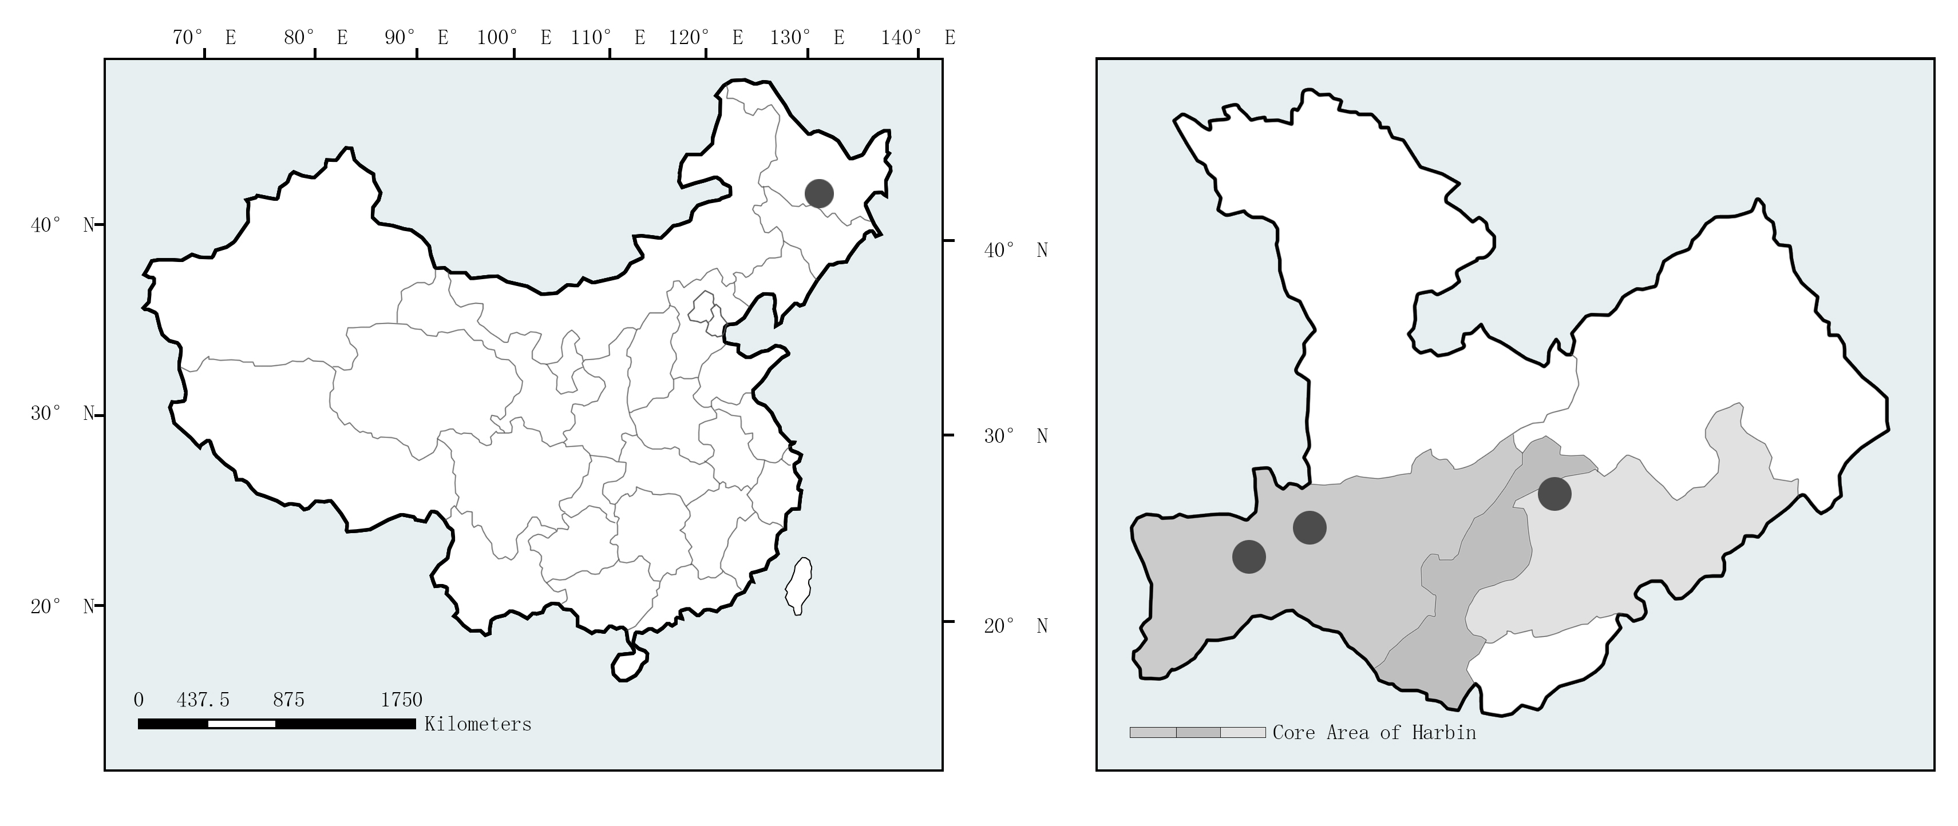
Figure 1. Location of Harbin in China (left) and geographical distribution of the surveyed offices in Harbin (right)

Following an assessment of field conditions in Harbin, the use of fans in office buildings was found to be very common during summer, but the use of AC was not, except for part of the open plan office buildings. Therefore, two types of mixed-mode buildings were considered in this research; one where one of the available behaviour controls was fan use with window opening, and the other was fan use and AC with window opening.

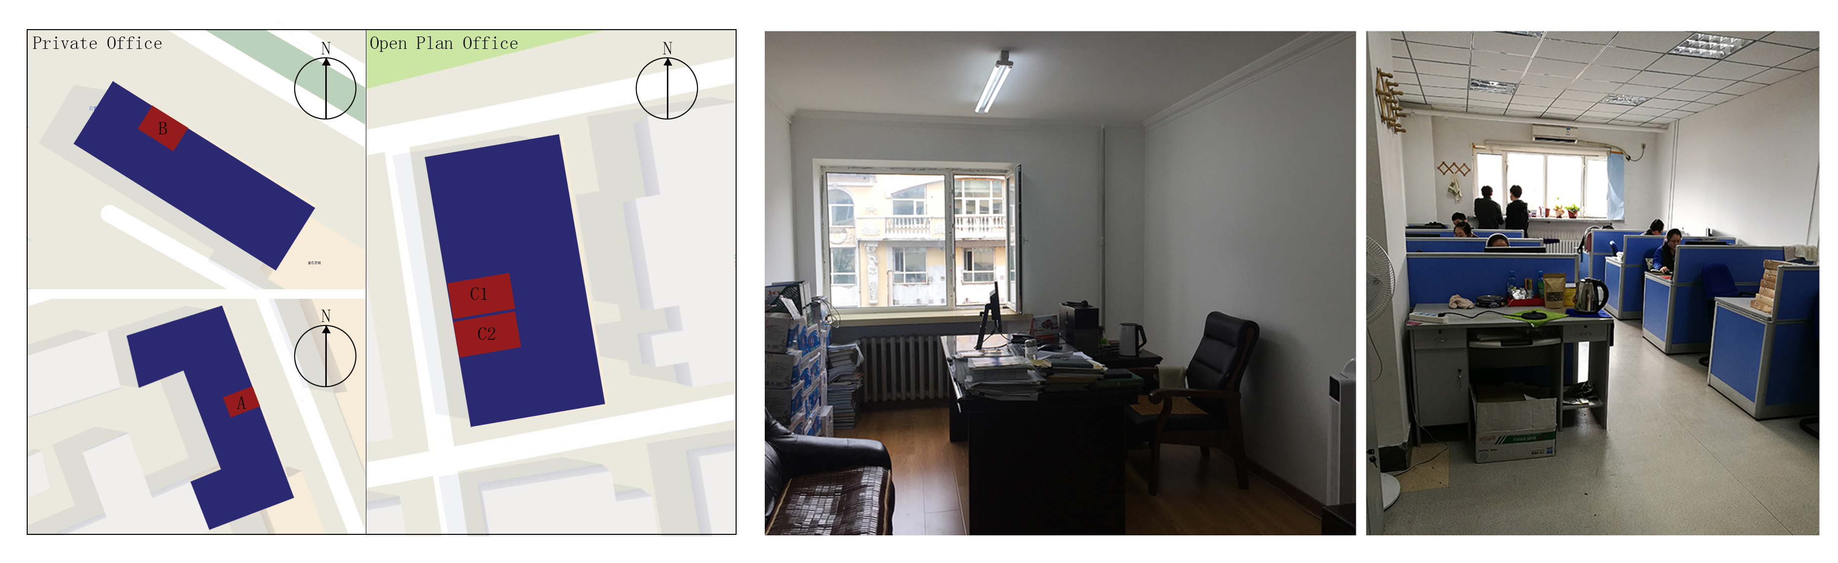
Figure 2. Offices orientation and offices types used in the survey.

Comparative Test
In the first period of the survey, building C had AC in the rooms, and during the second time the AC was removed in both rooms (i.e. switched off). The geometric parameters and orientation of the two open plan rooms of the office building were the same. Therefore, this research had three groups of comparative tests. The first two were a contrast between private and open plan rooms themselves. The third was between the two space types of naturally ventilated office rooms with fans. In this way, more physical variables changed during these two weeks and more data could be collected for analysing the behaviour controls influencing the parameters.
Longitudinal survey and filed measurements
Over the summer the subjects participated in a series of subjective and objective measurements of thermal comfort, behaviour control, and related items. These measurements were conducted by a three-part longitudinal survey as well as by environmental data loggers.
Longitudinal questionnaire survey
The questionnaire of this study was a panel survey, a kind of longitudinal survey following the same subjects during a certain period of time. The surveys were organized using the questionnaire survey software Wenjuanxing and sent through the social application Wechat twice a day for ten work days. The data of people who were not in the office or did not stay indoors for more than 20 minutes were eliminated. There were 12 people attending the survey, with 182 effective responses. Each participant was given a certain code for marking when answering the questionnaire to make it easier to match the answers with the subjects. The survey included three parts - the start survey, the daily survey and the final survey. Opening with questions about personal characteristics, the start survey was a general questionnaire that asked subjects to recall their thermal feelings in their office rooms in each season and the past three months. The daily survey focused on the subject’s feelings and the state of the window, fan and AC (open/closed/on/off) at the time they answered. The questionnaire was sent in the morning and afternoon time each day (there is a lunch break in every office in China) to give the subjects a routine of answering the questionnaire at the right time. For the final part of the survey, the main purpose was to know the occupant’s overall thermal and relative feelings over the two weeks of the survey. The final survey also included an area where participants could provide their feedback about the accessibility, time expense, and general clarity of the daily survey instruments. Before the formal research, a weekly pilot test was conducted on office occupants from similar office environment. This helped inform small revisions to the daily survey, including the accessibility, clarity and response rate of the questionnaire. Table 1 shows the type of questions of these three parts of the survey.
Field measurements
Alongside the longitudinal questionnaire data collection, continuous measurements of indoor and outdoor environmental parameters were recorded. The indoor air temperature and relative humidity were logged at 15 minutes intervals using HOBO U12-012 data loggers (accuracy: ±0.35°C, ±2.5% relative humidity). Geometric design parameters of office buildings were also measured, including office room depth, width, window height and other parameters and were used to detect any relationship with window opening behaviour. The overview of the collection and integration of various data streams are shown in Fig.3.
Data analysis
Changes of the occupants’ thermal feelings, adaptive behaviour and environmental parameters were described in terms of the time-varying distributions. Point Biserial Correlation Coefficient (r_{pq}) and Lambda/tau-y statistics were used to analyse the correlations between each factor and adaptive behaviour. r_{pq} is a correlation measure of the strength of association between a continuous-level variable (ratio or interval data) and a binary variable (a scale with only two values). The Lambda Coefficient is suitable for two variables which have either a symmetrical or a non-symmetrical relationship. Its value may range from 0.0 to 1.0. Lambda provides an indication of the strength of the relationship between independent and dependent variables (IBM SPSS 2017).

Table 1. Structure and content of the longitudinal questionnaire
 | Start Survey |  | Daily Survey (at the time of the survey) | Final Survey (for the overall two weeks survey)
Perceived Indoor Environment Parameters  (7points) | Each season | Thermal sensation;  Humidity feeling;  Air movement; | Thermal sensation;  Humidity feeling;  Air movement; Smell;  Outdoor noise;  Temperature preference;  Overall satisfaction | Thermal sensation;  Humidity feeling;  Air movement;  Smell;  Overall satisfaction
Perceived Indoor Environment Parameters  (7points) | Past 3 months | Overall satisfaction
Perceived Indoor Environment Parameters  (7points) | Variables affecting window opening behaviour
Status of the Office | - |  | Window | -
Status of the Office |  |  | Air conditioning | -
Status of the Office |  |  | Fan | -
Personal Information | Age; Gender; Time of living Harbin; Time of working in this office; Seat position |  | Clo | -
Others | - |  | Whether stayed in the office less than 20 minutes | Time expense
Others |  |  | Whether stayed in the office less than 20 minutes | Clarity of questions
Others |  |  | Whether stayed in the office less than 20 minutes | Method questionnaires distributed

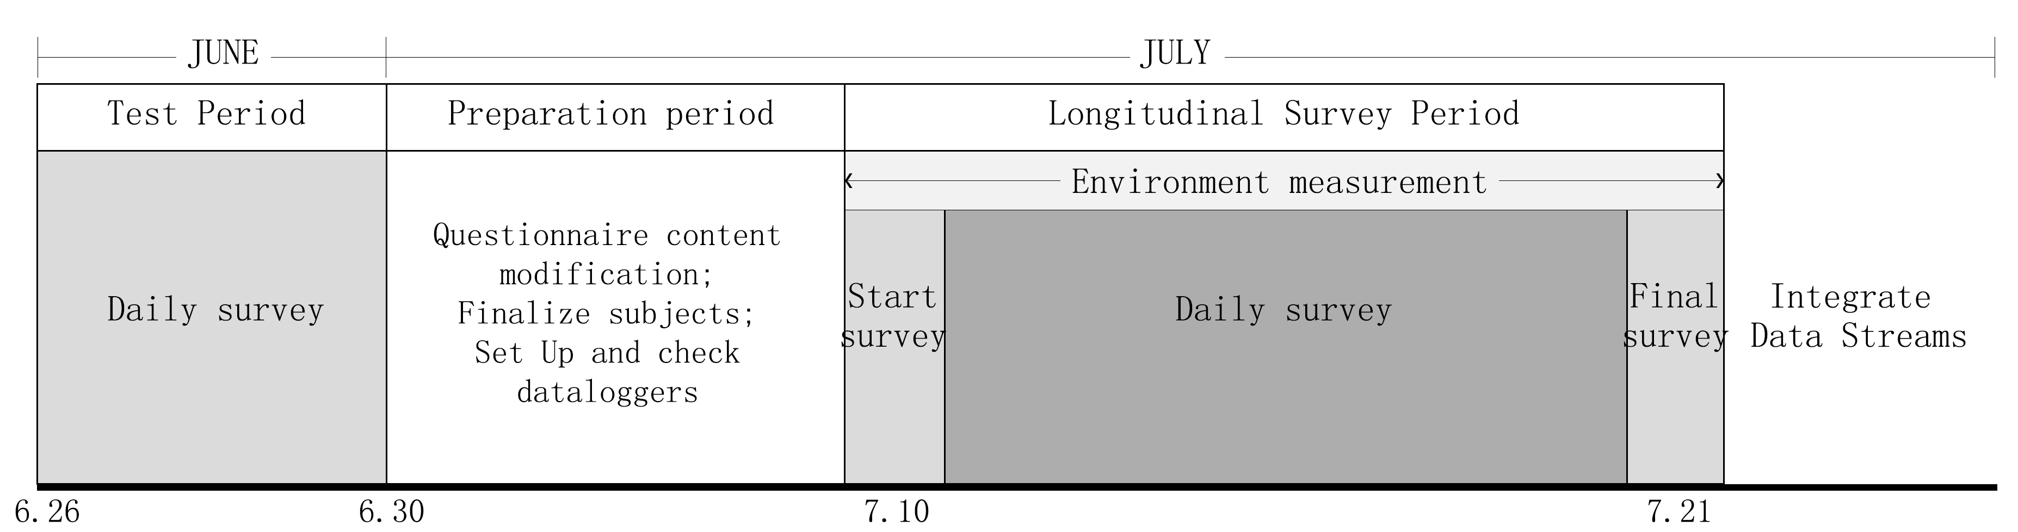
Figure 3. Collection and integration of survey, environmental data streams across two weeks.

Results and analysis
The results from the survey are shown in Table 2. The analysis is ordered as the profile of participants, the environmental variables distribution, the comparison of thermal feelings and behaviours, including the correlation between parameters, and adaptive behaviours.

Sample size and Profile of participate
Table 2 shows the sample size and the characteristics of the surveyed subjects. All the 12 occupants of the surveyed office rooms were invited to answer the questionnaire. The occupants’ number in each room type is equal. When the subjects recalled their overall indoor thermal environment in the past three months, all the people chose the neutral one. After they finished the questionnaire and then recalled the two weeks summer overall feeling, more than half of the subjects changed their answer to dissatisfied, which might indicate the thermal environment has a negative impact on the occupants.

Table2. Subjects characteristics (Total N= 12)
 | Category | N | % of final sample
Gender | Male | 7 | 58.3%
Gender | Female | 5 | 41.7%
Office type | Private | 2 | 16.7%
Office type | Opening desk | 10 | 83.3%
Recall of overall thermal satisfaction in April/May/June | = “Neutral” | 12 | 100%
General overall thermal satisfaction during the survey | ＞“Neutral” | 1 | 8.3%
General overall thermal satisfaction during the survey | = “Neutral” | 3 | 25%
General overall thermal satisfaction during the survey | ＜“Neutral” | 8 | 66.7%

The daily survey generated consistently high survey response rates (≥75.9%), yielding a total of 182 responses from the 12 subjects. The survey took just a few minutes to complete, and was positively evaluated by occupants. Table 3 summarizes key statistics regarding the performance of the daily survey during the two-week period.

Overview of Environment variables
The overview of temperature and humidity changes is shown in Fig. 4, with the distribution of mean value as the daytime series. The vertical lines in these figures represent the boundaries of temperature and environmental changes throughout the survey period. The outdoor temperature of the second week is obvious lower than the first week. The AC was switched off in the second half of the survey in building C, which means that in first half of the survey building C was a mixed-mode office with AC and fan, while in the other days they can be regarded as naturally ventilated room with fan.

Table 3. Summary of daily survey performance across the summer survey run period
 | Private Office | Opening Plan Office
No. of Response | 31 | 151
No. Link Sent | 40 | 200
Response Rate | 77.5% | 75.5%
Mean Time/Survey, Minutes | 1.39 | 1.25
Clarity of the Questionsª | 1.5 | 1.375
Accessibilityª | 2.5 | 1.25
Overall Time Expenseª | 1.5 | 1.75
Each Questionnaire Time Expenseª | 1.5 | 1.75
ª Mean response on scale, from -3 = very dissatisfied to +3 =very satisfied

During the survey period the mean indoor air temperature of each room was higher compared to the outdoor air temperature, which might be due to heat dissipation from the occupant and facilities. In the second survey stage, the outdoor temperature was lower, but the four rooms’ air temperatures remained high. For the two rooms in building C, C1 only had a short time using AC, while C2 used AC during the whole first week. The mean indoor air temperatures for C2 room were obviously lower than for the other offices (because of the AC use). The average relative humidity (RH) of each indoor environment, with values between 40% to 80%, had a lower distribution than the outdoor relative humidity. This RH range would not influence thermal comfort feelings. The relative humidity of building C showed a higher trend compared with the private rooms in the second stage of the survey.
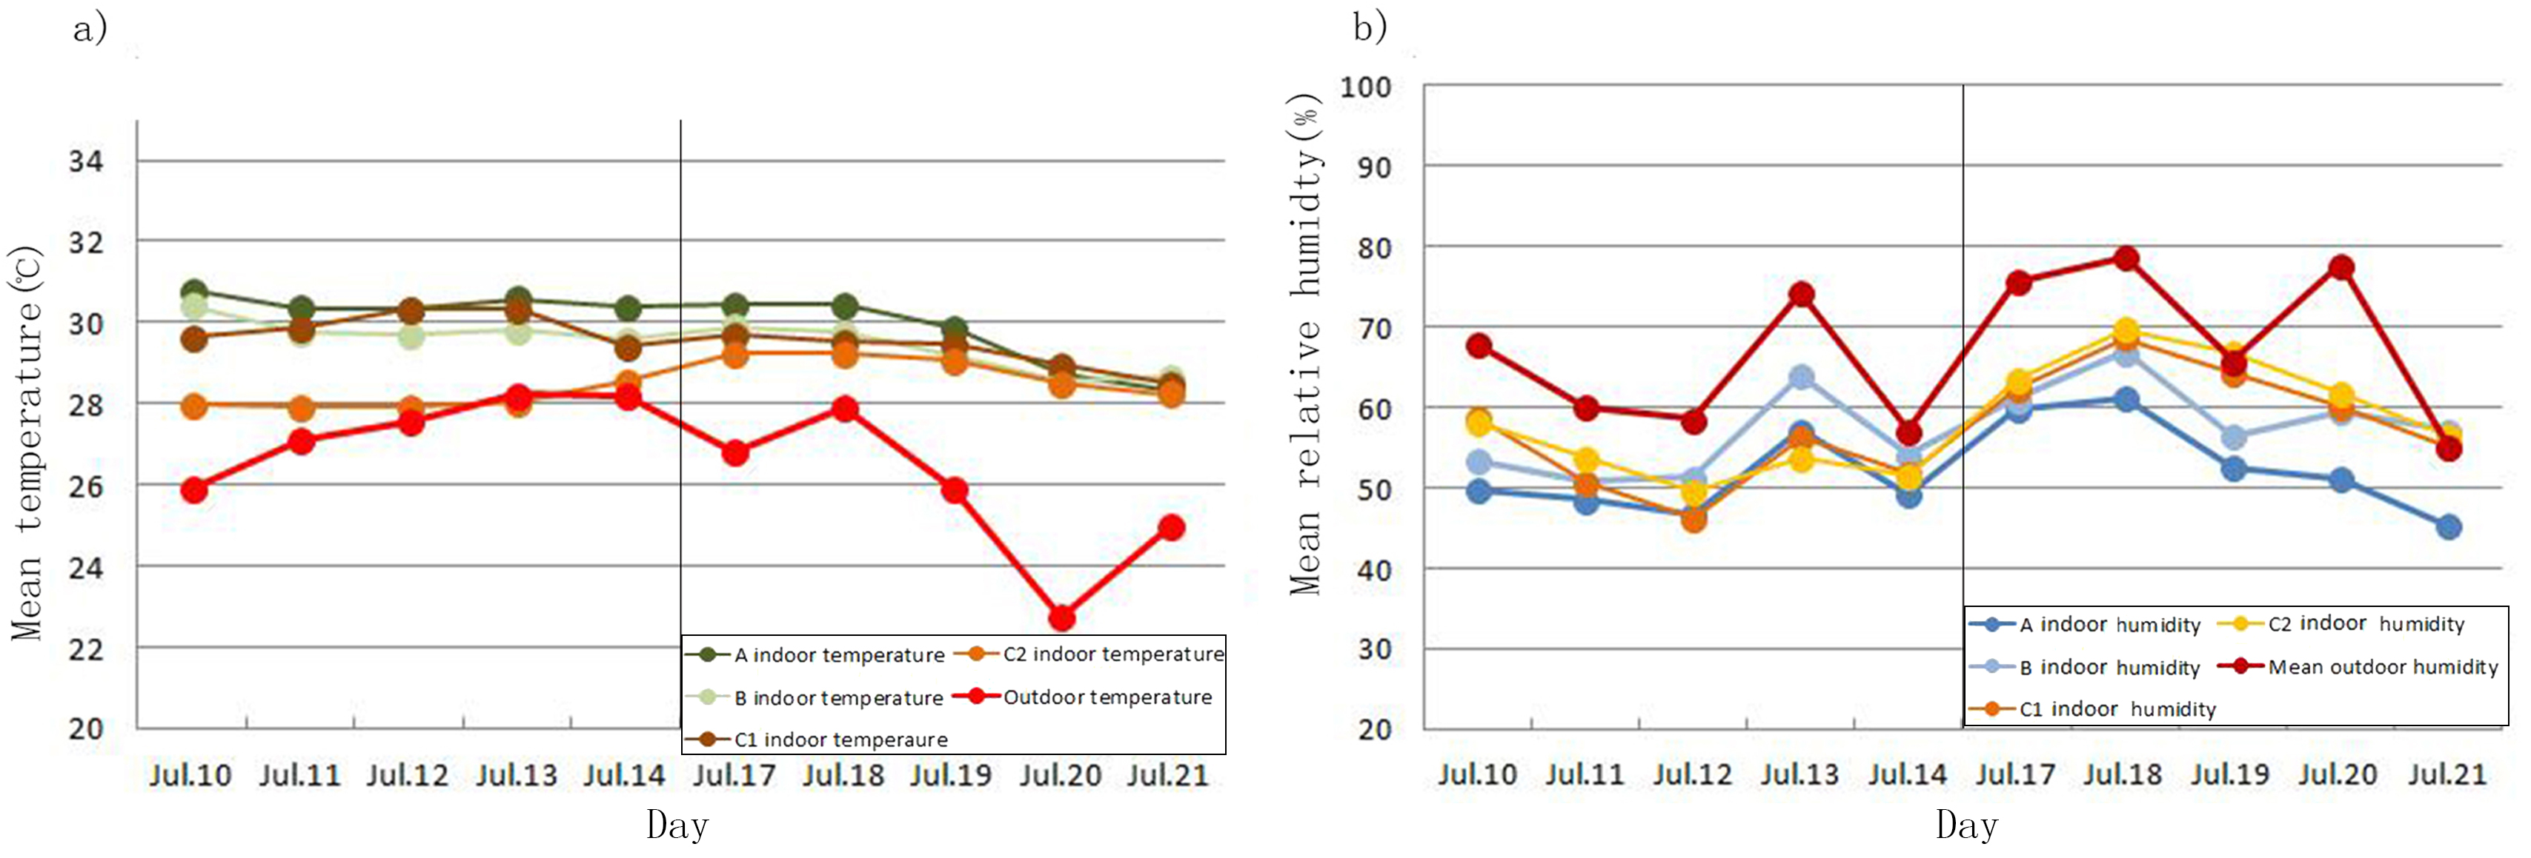
Figure 4. a) Mean daily value comparison of indoor and outdoor temperature. b) Mean daily value comparison of indoor and outdoor relative humidity.

Thermal feelings and behaviour control
The results of the occupants’ indoor thermal feelings and adaptive behaviour were carried out by three comparison groups. The first two were self-contrast analysis of the private office and the opening space one, and the third comparison was between building A, B and C.
Results of group 1
Fig. 5 compares the thermal sensation and satisfaction of two private office rooms. During the entire period, indoor air temperatures in rooms A and B maintained a stable level and kept a high value over 28°C. In the hot summer season, the fan was a necessity for a natural ventilated building. Room A used the fan, except in the morning of 13 July, while Room B used the fan across all the survey times. As can be seen from the statistics, in the summer the window opening behaviour was always accompanied by the fan being on. Both rooms kept the window open almost every day. All the parameters in the graph are the status of the indoor environment at the time the subjects were answering the questionnaire.
For thermal sensation, the occupants of the two rooms were both in a ‘hot’ state. The occupant of room B was in a stable state, while the one in room A was in a more fluctuating state. This may be because the user of room A was more sensitive to temperature and therefore did not feel hot in the morning. When the outdoor temperature was significantly reduced, although the indoor temperature was only reduced by about 2°C, the occupants' thermal sensation was significantly reduced to around the neutral value. The degree of fluctuation of the overall thermal satisfaction corresponded to the thermal sensation from slightly dissatisfied to slightly satisfied during the survey period.
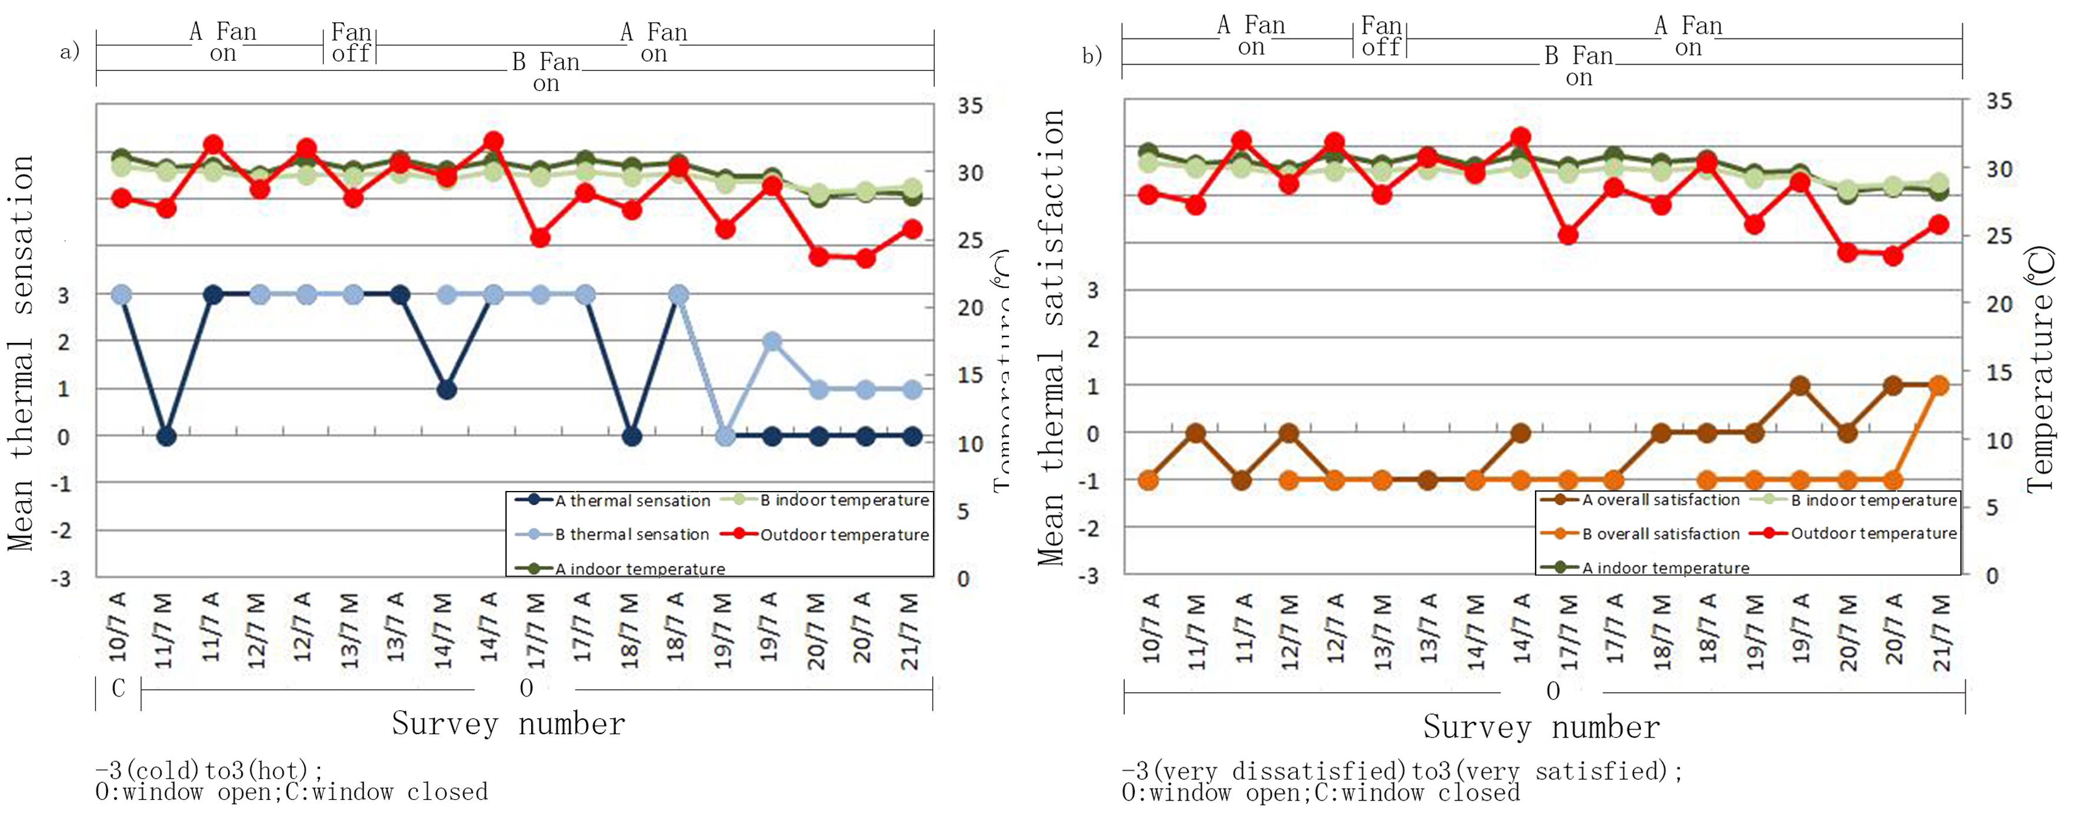
Figure 5. a) Mean value comparison of A and B thermal sensation. b) Mean value comparison of A and B thermal satisfaction.
Results of group 2
Although Harbin belongs to a cold area in China, the summer is always very hot, and the extreme air temperatures can reach 39.6°C. In most cases, part of the large space office type or multi-person office used AC in Harbin. The rooms C1 and C2 (both open plan rooms), were subjected to a comparative experiment. The test was divided into two stages; in the first stage, the C building had AC equipment; in the second stage, the AC was removed.
For stage one, at the time of answering the questionnaire, the indoor and outdoor temperature of C1 maintained a high degree of consistency (Fig.6). In this period, C2 used AC almost every day, which led to an obvious lower indoor temperature. The occupants of C1 did not use the AC. As a result, the thermal sensation of C2 is lower and satisfaction higher than in C1, which had a neutral value.
For stage two, Fig. 6 shows the indoor air temperatures of the two rooms generally presented a similar distribution and higher temperatures than outdoors. After the AC was removed, the C building changed to a naturally ventilated building with the fan device. Occupants of building C showed similar behaviour modes of using the fan at the same time with the windows open as users of building A and B. C1 maintained a routine of opening the two window every day, while C2 kept one window open almost the entire week and another open for part of the time. The thermal sensation of rooms C1 and C2 showed a hot level and the satisfaction was very low, from dissatisfied to very dissatisfied.
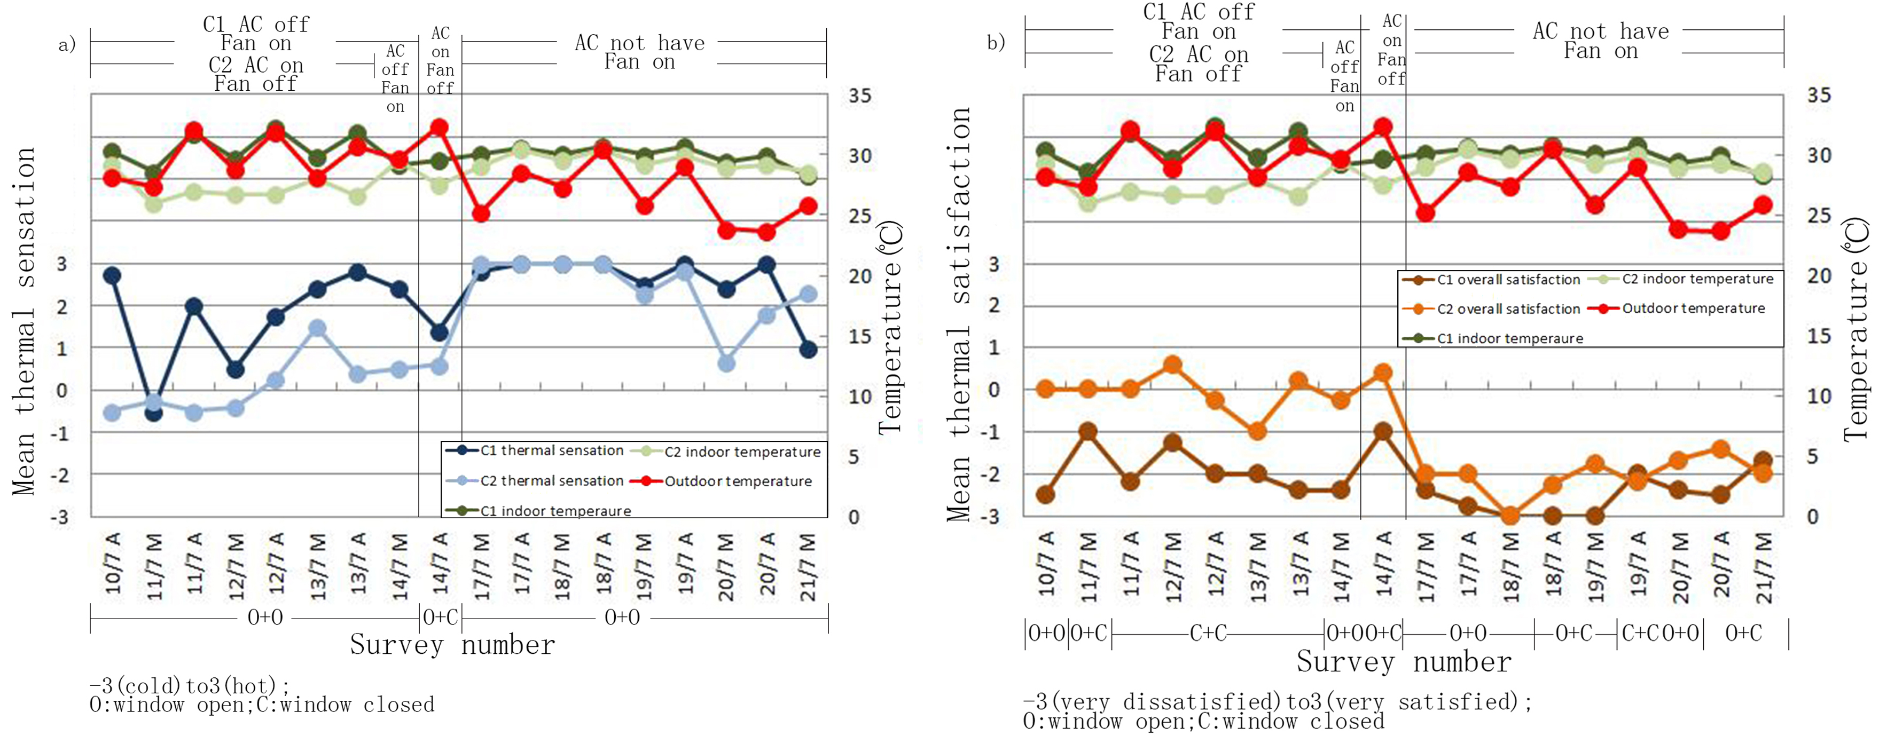
Figure 6. a) Mean value comparison of C1 and C2 thermal sensation. b) Mean value comparison of C1 and C2 thermal satisfaction.
Results of group 3
Fig. 7 shows a comparison of buildings A, B and C in the second stage of the temperature, and all the indoor temperatures show a big difference, and were higher than the outdoor temperature. After the C building switched off the air conditioning, its indoor temperature gradually increased, to a little higher value than the private office.
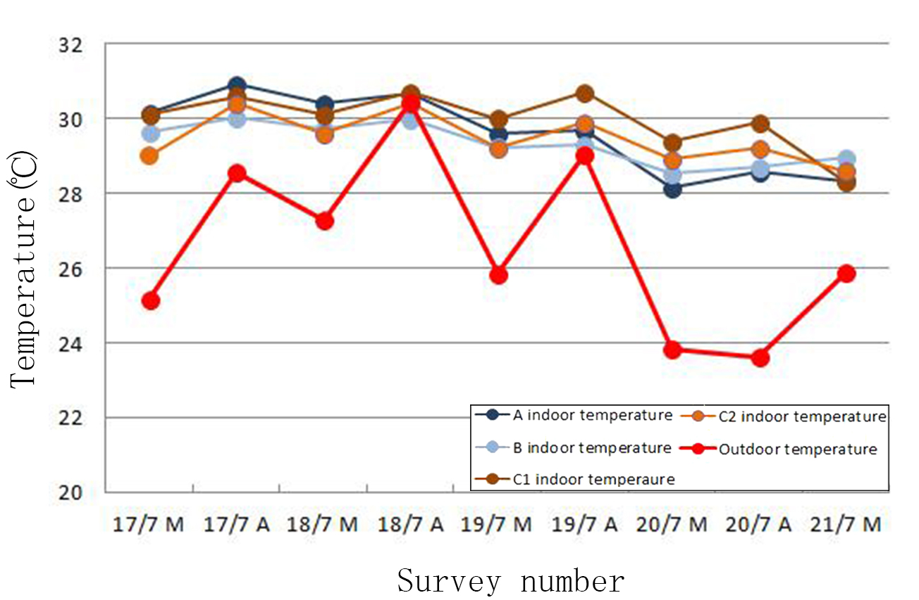
Figure 7. Comparison of indoor and outdoor temperature at the time of the questionnaire.

In this period, with the decrease of the outdoor temperature, the thermal feelings in the private office rooms showed a more substantial reduction than in the open space one, although the indoor temperature changed little. For thermal satisfaction, the data of all the research objects were all increased for the decrease of the indoor and outdoor temperatures. The overall thermal satisfaction of the private office was much higher than for the open space one.
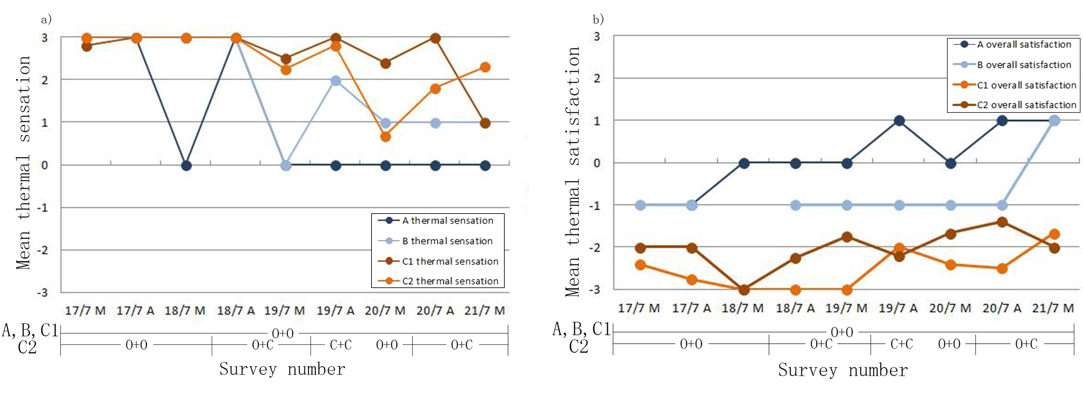
Figure 8. a) Mean value comparison of A, B and C thermal sensation. b) Mean value comparison of A, B and C thermal satisfaction.
Correlation variables and window opening behaviour
The impact variables on the use of window and fan behaviour in naturally ventilated office were examined by Point Biserial Correlation Coefficient and Lambda/tau-y Coefficient. The correlation analysis of mixed-mode office rooms with the AC device cannot be computed in this research due to the limitation of the data amount.
In the hot summer season, occupants in the naturally ventilated office, in most cases, always chose to open the window while using the fan. From the questionnaire, some subjects wrote that they thought that if the window was closed, then the indoor environment would be much stuffier and hotter. Table 4 shows the physical parameters, occupant experience parameters, and subjects’ personal characteristics had an impact on window opening behaviour. Among the physical environment parameters, only indoor humidity affected the window behaviour. This may be because, when the temperature reached a certain value, the window opening behaviour was much more related to humidity than the temperature changes. Many studies have found that the indoor and outdoor temperature are good parameters for predicting windowing behaviour. However, when only observing window opening behaviour and its influencing factors in summer in Harbin, it was found that the summer temperature fluctuation did not affect the window opening probability, while the indoor humidity and window behaviour had an obvious correlation.

Table 4. Impact variables on adaptive behaviour of naturally ventilated building
 | Window Opening |  | Fan On
Physical Parameters | Point Biserial Correlation Coefficient r_{pq} and significance level p
Physical Parameters | r_{pq} | p | r_{pq} | p
Indoor Temperature | - | NS | 0.375*** | 0.000
Outdoor Temperature | - | NS | 0.225** | 0.008
Indoor Humidity | 0.274** | 0.001 | -0.35*** | 0.000
Thermal Feeling | Point Biserial Correlation Coefficient r_{pq} and significance level p
Thermal Feeling | r_{pq} | p | r_{pq} | p
Thermal Sensation | 0.221** | 0.009 | -0.17* | 0.047
Air Movement Feeling | -0.402*** | 0.000 | 0.424*** | 0.000
Smell | -0.302*** | 0.000 | 0.47*** | 0.000
Outdoor Noise | -0.298*** | 0.000 | 0.524*** | 0.000
Temperature Preference | -0.301*** | 0.000 | 0.194* | 0.22
Thermal Satisfaction | -0.359*** | 0.000 | 0.483*** | 0.000
Building Characteristics | Point Biserial Correlation Coefficient r_{pq} and significance level p
Building Characteristics | r_{pq} | p | r_{pq} | p
N of People | 0.4*** | 0.000 | -0.395*** | 0.000
Room Width | - | NS | -0.422*** | 0.000
Room Depth | 0.348*** | 0.000 | -0.576*** | 0.000
Floor Area | 0.348*** | 0.000 | -0.676*** | 0.000
Window Size | - | NS | -0.352*** | 0.000
Other Parameters | Lambda/tau-y Coefficient
Other Parameters | Window opening(dependent) |  | Fan on (dependent)
Other Parameters | value | p | value | p
Room Number | - | NS | 0.69** | 0.001
Room Type | 0.172*** | 0.000 | 0.69** | 0.001
Time of Survey | - | NS | - | NS
Gender | 0.092*** | 0.000 | - | NS
Fan | 0.056** | 0.006 | - | NS
Window Opening | - | - | - | -
Notes: 0.01＜p＜0.05 is *,0.001 ＜p ＜0.01 is **, p＜0.001 is ***

The feelings of the indoor environment had a certain impact on the window behaviour, including thermal sensation, air movement feeling, temperature preference and thermal satisfaction. For architectural design parameters, the office type, room depth and floor area all had an influence on window opening. Gender also showed a weak but discernible impact on window opening.
Indoor relative humidity and indoor thermal feelings both affected fan use. Simultaneously, room type and geometric design parameters of the building had a significant effect on fan use. However, unlike the window opening behaviour, both the indoor and outdoor temperature had an influence on fan use. Occupants of different genders did not show much difference in terms of using a fan. It is worth noting that these mixed-mode office rooms maintained a high degree of consistency of window opening behaviour, while the use of the fan varied among these rooms. Many studies have pointed out that window opening behaviour has a greater relationship with room arrival and departure. In this study, the time parameters represent only the morning and afternoon, and different times did show a great impact on window opening and fan use behaviour.
Conclusion and discussion
This paper presents the results from a longitudinal survey to characterize occupants’ thermal feelings and adaptive behaviour in three mixed-mode buildings in Harbin, a cold area of China. The results of this research are:

·When the outdoor air temperature decreased, the occupants’ thermal sensation in the private office rooms was significantly reduced compared to the open plan office spaces. Overall thermal satisfaction of private office occupants was much higher than the open plan office occupants.
·Occupants in AC office rooms might not choose to use the AC device in case of getting cold. In the mixed-mode office buildings with AC, thermal sensation and satisfaction changed with the indoor temperature. Comparing the window opening behaviour in the mixed-mode office with AC use and naturally ventilated office with fan, the former one shows a more volatile trend and the latter tended to have a more stable state.
·In the northern part of China, due to the hot temperatures in summer, mixed-mode office rooms are the most common mode. The occupants in AC rooms occasionally opened windows at the same time as using the AC. In the naturally ventilated office buildings, fans were window are often used simultaneously.
·The occupants’ thermal feelings affected the window opening behaviour and the use of the fans. In summer, when the temperature rose to a certain value, the temperature fluctuations cannot affect the window behaviour, but influenced the use of the fan. Indoor relative humidity and architectural design parameters had correlations with adaptive behaviour.

The limitations of this study are unavoidable. The basis of this summer research of four mixed-mode office case study can only represent part of the targeted building type. More accurate results require longer survey times and a larger range of research subjects. In addition, accurate everyday monitoring of occupation and absence in the investigated rooms during the observation period is necessary for future research. Therefore, when it is subtracted from its context, the data collected and the results analysis in this research may have been over-simplified in some way.

References
Baker N, Standeven M. (1997). A behaviour approach to thermal comfort assessment. International Journal of Solar Energy, 19(1), pp.21-35.
Haldi F, Robinson D, Interactions with window opening by office occupants. Building and Environment, 2009, pp.2378-95.
Herkel S, Knapp U. Towards a model of user behaviour regarding the manual control of windows in office buildings. Building and Environment, 43(2008), pp. 588-600.
Hong T, Lin H.W. (2013). Occupant Behaviour: Impact on energy use of private offices. Berkeley, CA: Lawrence Berkeley National Laboratory
IBM SPSS (2017) https://www.ibm.com/uk-en/marketplace/spss-statistics
Parys W, Saelens D. Coupling of dynamic building simulation with stochastic modelling of occupant behaviour in offices - a review-based integrated methodology. Journal of Building Performance Simulation, 2011, pp. 1-20.
Simona D, Hong T. A data-mining approach to discover patterns of window opening andclosing behavior in offices. Building and Environment, 82(2014), pp. 726-739.
U.S Department of Energy. (2011). 2011 Table of contents. Retrieved March 31, 2014. Building Energy Data Book. http://buildingsdatabook.doe.gov
Valentina F, Rune V.A. (2012). Occupants’ window opening behaviour: A literature review of factors influencing occupant behaviour and models. Building and Environment, 58(2012), pp.188-198.
Yun F, Steemers K. Time-dependent occupant behaviour models of window control in summer. Building and Environment, (43)2009, pp. 1471-82.

