The impact of free access to leisure facilities and community outreach on inequalities in physical activity: a quasi-experimental study.

Higgerson, J., Research Fellow², Halliday, E., Senior Research Fellow¹, Ortiz-Nunez, A., Research Fellow¹ Brown, R., Leisure, Health and Wellbeing Manager³, Barr, B., Senior Clinical Lecturer²
¹Division of Health Research, Faculty of Health and Medicine, Lancaster University, Lancaster LA1 4YW, UK
²Department of Public Health and Policy, University of Liverpool, Liverpool L69 3BX, UK
³Leisure & Environment Department, Blackburn with Darwen Council, Old Town Hall, King William St, Blackburn BB1 7DY

Corresponding author: Ben Barr

Senior Clinical Lecturer in Applied Public Health Research
Department of Public Health and Policy,
Institute of Psychology, Health and Society,
University of Liverpool,
Whelan Building,
Liverpool,
L69 3GB
(0151) 794 5420
benbarr@liverpool.ac.uk

ABSTRACT

Background

There are large inequalities in levels of physical activity in the UK and this is an important determinant of health inequalities. Little is known about the effectiveness of community-wide interventions to increase physical activity and whether effects differ by socioeconomic group.
Methods
We conducted Interrupted Time Series and Difference-in-Differences analyses using local administrative data and a large national survey to investigate the impact of an intervention providing universal free access to leisure facilities alongside outreach and marketing activities in a deprived local authority area in the North West of England. Outcomes included attendances at swimming and gym sessions, and self-reported participation in gym and swim activity and any physical activity.
Results
The intervention was associated with a 64% increase in attendances at swimming and gym sessions (RR: 1.64 95%CI: 1.43 to 1.89, p<0.001) an additional 3.9% of the population participating in at least 30 minutes of moderate intensity gym or swim sessions during the previous 4 weeks (95%CI 3.6 to 4.1) and an additional 1.9% of the population participating in any sport or active recreation of at least moderate intensity for at least 30 minutes on at least 12 days out of the last 4 weeks (95%CI 1.7 to 2.1). The effect on gym and swim activity and overall levels of participation in physical activity was significantly greater for the more disadvantaged socioeconomic group.
Conclusions
The study suggests that removing user charges from leisure facilities in combination with outreach and marketing activities can increase overall population levels of physical activity whilst reducing inequalities.
Keywords: Physical activity, pricing policy, inequalities

Word count: 3340 words
BACKGROUND
Physical inactivity is linked to a wide range of physical and mental health outcomes[1] and is estimated to cost the NHS £455million a year.[1]] There is a steep socioeconomic gradient in physical activity in the UK with 76% of men in the highest income quintile achieving recommended physical activity levels compared to only 55% of men in the lowest quintile.[2] Increasing levels of physical activity in more disadvantaged groups could improve overall population health and reduce health inequalities.
Reducing the cost of participation is one potential means to increase physical activity and address these inequalities. Local government and charitable organisations in England provide a range of leisure services, including swimming, gym and other sports facilities. The provision of these facilities is generally subsidised to promote social inclusion, community wellbeing[3] and public health.[[4] Some local authorities (LA) have sought to increase levels of physical activity and promote public health by removing user charges entirely, offering free access to leisure facilities. [5–7] Evaluation of such schemes is important to ensure that they are reaching their target audience. For example, free leisure offers could inadvertently increase inequalities in participation if they are mainly used by those already active or more affluent. Analysis of uptake of the national free swimming initiative in Bristol found no relationship between area deprivation and participation.[8] Public health goals are, however, often not the main aim of pricing policies , with income generation frequently a key competing concern.[9]
Some studies comparing participation rates before and after the introduction of free offers have reported increases in participation,[10–16]] whilst another found that increased charges were associated with a small decline in participation.[17] There is some evidence that respondents in surveys do not report that entrance charges are a major barrier to participation, and that this is just one of many factors that influence their participation.[10] These studies however, provide limited evidence of the likely impact that community-based initiatives involving free access to leisure centres have on physical activity levels.
We therefore investigated the impact of the re:fresh scheme, introduced in Blackburn with Darwen, a deprived LA in the North West of England in 2008, that provided free access to activities in leisure centres (swimming pools and gyms) at most times of the day along with community outreach activities. We use quasi-experimental methods to investigate whether the scheme led to an increase in swimming and gym activities and overall levels of physical activity and whether these effects differed by socioeconomic group.

METHODS

Setting
Blackburn with Darwen is a deprived and ethnically diverse LA, in the North West of England with a population of 147,489. In 2015 Blackburn with Darwen was ranked as the 24th most deprived area out of all 326 lower tier LAs in England and 31% of the population were from a black or minority ethnic group.

The intervention
The re:fresh scheme began in July 2008, with the provision of free access to local government leisure facilities at most times of the day for people living, working or registered with a GP in Blackburn with Darwen. At the time, there were 9 leisure facilities in Blackburn with Darwen. Three of these facilities included swimming pools and gyms, one facility just had a swimming pool and five sites had gym facilities only. A map showing the distribution of these facilities in relation to area deprivation is given in Appendix 1. Several of the leisure facilities were located close to deprived neighbourhoods. Initially in July 2008 the free offer was only available to people over 50 years old, being extended to 16-24 year olds in September 2008, and finally to people aged 25-49 in April 2009. Overall during the scheme, free leisure was available for 90% of the opening hours of the 9 facilities.
The free offer was supported by outreach work delivered by health trainers and a Healthy Communities Partnership. Five Full Time Equivalent (FTE) Health Trainers were employed during the project, offering 1 to 1 and group sessions, to around 700 inactive people per year supporting behaviour change through goal setting and motivational interviewing. Two FTE community workers delivered the Healthy Communities Partnership which supported a network of volunteers who ran community events to engage people in taster sessions and increase the awareness of re:fresh, and act as buddies to accompany people to their first activity sessions.
The programme was also supported by considerable marketing and promotional activity to raise awareness of the offer and to promote participation. The scheme is ongoing, although in 2016 a flat fee of £1 was introduced for previously free activities in response to cuts in local government funding. The scheme was jointly funded by the NHS and Blackburn with Darwen Borough Council. Between 2008 and 2014 the NHS contributed a total of £6 million on top of the core funding for leisure facilities provided by the council over this period (£22 million). The outreach activities cost approximately £2 million over this time.

Datasets
Our analysis used two datasets. Firstly, we extracted data from the leisure management IT system for Blackburn with Darwen providing data on every attendance at a leisure centre from 2005 to 2014. This dataset was then used to calculate the total quarterly number of gym and swim attendances from 2005 to 2014 and the proportion of these that were free (i.e. there was no cost associated with them on the leisure management system).
Secondly, we used data from a large national annual survey of sports participation – the Active People Survey (APS). The methodology for this survey is described elsewhere.[18] This cross-sectional telephone survey is based on a random sample from each LA in England selected using Random Digit Dialing. One person aged 16 or over is randomly selected from eligible household members. Average response rates are low, ranging from 27.1% to 27.8% during the study period. We therefore applied survey weights in all our analysis. Respondents are asked to report the number of days in the past four weeks they have engaged in sports and other active recreation, including gym and swimming sessions, for at least 30 minutes and the intensity of these activities. The interviews for each survey are evenly spread across 12 months, running from October of one year to October of the next year. We used data for all surveys from APS1 (2005-2006) to APS9 (2014-2015). There was a gap from October 2006- October 2007 when no survey was completed. We pooled all data from these nine surveys giving a total pooled sample of 1,763,780 individuals aged 16 and over. Data in the sample were missing on age for 2.2%, ethnicity for 1.8% and socioeconomic status for 2.2%. A further 7.4% of the sample was excluded as their socioeconomic status was unclassifiable based on their reported occupation. Excluding these data provided a sample of 1,556,563 for the analysis, 6160 of which was within Blackburn with Darwen and 1,550,403 from the other LA areas of England.

Outcomes
Our analysis included three outcomes. Firstly, the relative change in the number of gym and swim attendances (combined) at Blackburn with Darwen leisure centres before and after the introduction of the re:fresh scheme (outcome 1). Secondly, the proportion of people reporting in the APS that they had engaged in at least 30 minutes of moderately intensive gym or swimming activity in the past 4 weeks (outcome 2). Thirdly, the proportion of people reporting in the APS they had engaged in any sport or active recreation of at least moderate intensity for at least 30 minutes on at least 12 days out of the last 4 weeks (outcome 3). Outcome 3 was designated as a national indicator in 2008 by the government for measuring the performance of LAs at promoting health and wellbeing and increasing participation in sport.

Analysis
Firstly, we used data extracted from the Leisure Management System, to conduct an interrupted time series (ITS) analysis investigating the relative change in attendances associated with the introduction of re:fresh. ITS is a quasi-experimental method using data from multiple time points before and after an intervention in order to detect whether or not the intervention had a significantly greater effect than any underlying secular trend.[19] We use data on the number of attendances for the 14 quarters (i.e., three month periods) before the intervention and 26 quarters after the intervention in a log-linear regression model with Newey-West estimators to account of autocorrelation in the data. We log transformed the data to aid interpretation of the coefficients as relative change in activity – i.e. relative risk(RR). We additionally included time trend terms for before and after the intervention and dummy variables for the four quarters of the year to adjust for seasonal changes. We used Newey and West's automatic bandwidth selection procedure[20] to estimate the maximum lags required to take into account the autocorrelation structure of the data (further details given in Appendix 2) . The effect of the re:fresh programme was estimated by including a dummy variable indicating the period after the introduction of the re:fresh scheme in the 3rd quarter of 2008 (see Appendix 2 for full model formula). To investigate whether there was a different effect on swimming compared to gym attendances we additionally replicated the ITS analysis separately for gym and swimming attendances. In sensitivity analysis, we replicated models with un-transformed count data and using a Poisson regression model rather than linear regression. (see Appendix 2).
Secondly, we used APS data to conduct a difference-in-difference [21] analysis comparing the change in outcomes within Blackburn with Darwen to the change in the rest of England, before (2005-2007) and after (2008-2014) the re:fresh intervention. This difference-in-differences approach accounts for both national trends in our outcomes and unobserved time invariant differences between Blackburn with Darwen and the rest of the country that could confound findings. The difference between the change in outcomes within Blackburn with Darwen and the change in outcomes in the rest of the country – known as the difference-in-difference parameter – provides an unbiased estimate of the intervention effect if the trends in outcomes would have been parallel in Blackburn with Darwen and in the rest of the country in the absence of the re:fresh programme.[21] We used a linear regression model including a dummy variable indicating the intervention area (Blackburn with Darwen) and a dummy variable indicating the before (2005-2007) and after (2008-2014) periods. The interaction term between these two variables is the difference-in-differences parameter. Although our outcome is binary we use linear regression as this interaction term cannot be interpreted as the programme effect in non-linear models, and linear probability models provide an unbiased estimate of the difference-in-differences parameter even with a binary outcome.[22] We additionally included variables to control for changes in the composition of the population over time – age, age squared, sex, ethnicity (white-British, White-Other, Asian, Black, Chinese, Mixed, Other) and three socioeconomic groups based on the National Statistics Socioeconomic Classification (Managerial and professional, Intermediate and Routine/Manual/Never worked/ long term unemployed). We repeated the analysis removing the ‘never worked’ category as a sensitivity analysis (see Appendix 3). We included a time trend to account for the national secular trend, and used survey weights to adjust for non-response. We estimated robust standard errors clustered at the LA level to allow for within LA correlation due to sampling design. We repeated the difference-in-differences analysis for both outcome 2 (swim and gym activity) and outcome 3 (any physical activity). To investigate whether there was a differential effect across socioeconomic groups we additionally carried out the analysis separately for each socioeconomic group. As a sensitivity test we conducted the difference-in-differences analyses using alternative comparison groups (the most deprived 20% of LAs, deprived LAs outside London, deprived LAs outside London with high Black and Ethnic Minority Populations, and other deprived LAs in the North West). We also replicated the analysis with the intervention start date set as 2009, rather than 2008 to address the inclusion of some pre-intervention data using 2008-2009 survey data (see Appendix 3). To investigate whether there was a different effect on swimming compared to gym attendances we also repeated the analysis separately for gym and swimming participation.

RESULTS
Interrupted time series analysis
Figure 1. Quarterly trend in swimming and gym attendances in Blackburn with Darwen before and after the introduction of re:fresh and the proportion of all attendances that were free. (Source: Leisure Management System)

Figure 1 shows that 11% of gym and swimming attendances were free before the intervention, this increased to 63% after the intervention. The trend in gym and swimming attendances was declining before the intervention and this trend reversed in line with the introduction of the intervention.
The ITS regression indicated that the introduction of re:fresh was associated with a 64% increase in gym and swimming activity (RR: 1.64 95%CI: 1.43 to 1.89, p<0.001). This equates to an additional 26,400 additional swim and gym attendances per quarter due to the re:fresh initiative over the 2008 to 2014 period. Additional analysis shown in Appendix 4 indicated a larger effect size when analysing the effect on gym attendances alone, models using alternative specifications showed similar results (see Appendix 4).
Difference in Differences analysis
Figure 2.Trend in the proportion of people reporting at least one moderate Gym or Swim session in previous 4 weeks, 2005-2014 in Blackburn with Darwen and the rest of England (source APS).
Figure 2 shows the trend in participation in gym and swimming activities reported in the APS for Blackburn with Darwen and England as a whole. Whilst there was a slight drop in activity between 2005 and 2007 in Blackburn with Darwen this was not significant. Following the introduction of re:fresh there was an increase in gym and swimming participation, whilst the national rate was constant before the introduction of re:fresh in 2008 and fell slightly after this point.
Figure 3. Estimates of the effect of the introduction of re:fresh from the difference-in-differences analysis on (1) % participating in gym or swim activity at least once in the past month and (2) the % participating in any sport or active recreation for a least 30 mins on at least 12 days over the last 4 weeks. Results for all socioeconomic groups in Blackburn with Darwen and separately for 3 socioeconomic groups. Effect sizes indicate the additional percentage of the population participating due to the intervention.
Figure 3 shows the estimates from the difference-in-differences analysis. The intervention was associated with an additional 3.9% of the population in Blackburn with Darwen participating in at least 30 minutes of moderate intensity gym or swim sessions during the last 4 weeks (95%CI 3.6 to 4.1). This effect was greater in the most disadvantaged socioeconomic group (4.7%, 95%CI 4.4 to 5.0), followed by managerial and professional groups and the effect was lowest in the intermediate socioeconomic group. In terms of overall participation in physical activity the intervention was associated with an additional 1.9% of the population participating in any sport or active recreation of at least moderate intensity for at least 30 minutes on at least 12 days out of the last 4 weeks (95%CI 1.7 to 2.1). This effect was much larger in the more disadvantaged routine and manual group (3.6%, 95%CI 3.3 to 3.8) and was not significant in the more advantaged socioeconomic groups. In Appendix 5 we provide participation rates by socioeconomic group before and after the intervention showing that within Blackburn with Darwen inequalities narrowed after the intervention, whilst they remained relatively unchanged nationally. In relative terms, compared to average levels of participation before the intervention this is equivalent to a 20% increase in the proportion of people participating in at least 30 minutes of moderate intensity gym or swim sessions in a month (95%CI 19% to 21%) and an 8% increase in the proportion participating in any sport or active recreation for a least 30 mins on at least 12 days over the last 4 weeks (95%CI 7% to 9%).
Sensitivity analyses given in Appendix 3 – show similar results using alternative comparator groups, when using 2009 as the intervention start date, and when removing the ‘never worked’ category from the socioeconomic classification. Replicating the analysis separately for the proportion of people reporting gym and swim sessions in the past four weeks, indicated that for swimming effect sizes were similar across socioeconomic groups whilst the effect on gym activity was significantly higher amongst people from routine and manual groups compared to professional, managerial and intermediate groups (see Appendix 3).

DISCUSSION

Main finding of this study
We found that the introduction of a scheme providing widespread free access to leisure facilities alongside outreach activities, led to an increase in swimming and gym attendances at these facilities, an increased proportion of the population participating in swimming or gym activity and increased overall physical activity levels. The increases in participation were greatest in the most disadvantaged socioeconomic group – decreasing inequalities.
In relative terms the intervention had a lower effect on overall levels of physical activity (8% increase) than on swimming and gym activity (20% increase) suggesting that there may have been some substitution of activities – i.e that some people may have shifted from other activities to gym and swimming, without necessarily increasing levels of overall physical activity.
Larger effects were seen for gym attendances at local authority facilities than swimming attendances although effects were similar for the additional number of people participating in gym activities as compared to swimming. We also found very little effect of the intervention on the numbers of people participating in gym activity from more affluent socioeconomic groups. One possible explanation is that there was some shifting from private gyms to local authority gyms when the latter became free, particularly amongst more affluent groups. This would have increased the number of gym attendances in local authority gyms whilst not increasing the numbers of people participating in any gym activities.

What is already known on this topic.
Very little is known about the effectiveness of community-wide public health programmes to improve physical activity rates.[15,24, 26] The only studies to our knowledge investigating the impact of community-based initiatives involving free access to leisure centres, have been based on simple before and after comparisons, or retrospective surveys asking respondents to recall their participation prior to the intervention or asking respondents hypothetical questions about whether they would have participated in the absence of the intervention[10–14,16,24,25]. Whilst these studies have generally found that these interventions were associated with increased participation, all of these approaches are likely to be highly susceptible to bias and provide limited evidence for the impact of the interventions. There have been a number of systematic reviews of the impact of providing financial incentives to individuals to increase physical activity– including free membership of leisure facilities. [26–28]These concluded that providing unconditional financial incentives has little effect on physical activity. Providing free access to leisure facilities across a population, however, may have a different effect from targeting free membership at particular inactive individuals.

What this study adds
This is the first study to our knowledge that uses quasi-experimental methods to investigate the impact on physical activity of a community wide scheme to offer free access to leisure facilities to the whole population alongside outreach activities. This study suggests that this approach is effective at increasing overall levels of physical activity and reducing inequalities in physical activity.

Strengths and limitations.
Our study has a number of strengths. Firstly, by using a consistent dataset of attendances at leisure centres over multiple time periods spanning a decade we were able to use interrupted time series analysis methods to estimate effects whilst accounting for any secular trends in the data. This provides a more robust analysis than a simple before and after comparison, however, it may still be subject to bias if there were other unobserved determinants of physical activity that changed around the same time as the intervention. Secondly, by using a difference in differences analysis we were able to account for any change in national trends around the same time as the intervention as well as any unobserved time invariant differences between Blackburn with Darwen and the rest of the country that could confound findings. Whilst we also controlled for observed changes in the composition of the population, some risk of confounding remains if there were other unobserved determinants of physical activity that only changed in Blackburn with Darwen around the same time as the intervention and not in other LAs. Thirdly, our analysis is strengthened by finding consistent results across multiple outcomes and datasets. These include both objective measures and those based on self-reported estimates and they ranged from outcomes more proximal to the intervention – attendance at a swimming pool or gym - to wider population measures of physical activity.
A number of limitations however remain. Measuring attendance at swimming or gym sessions using transaction data may be subject to error. People may not be captured on the system if they enter the facilities without swiping their membership card, or decide not to attend the activity initially logged on the system, or move between activities within a leisure facility. These errors could lead to bias if the level of error changed before and after the intervention. Self-report in surveys will be subject to biases in reporting and recall. Validation studies of self-reported questionnaires have shown inconsistent results when compared to more robust methods.[29]. The APS it a telephone based survey with a low response rate, which may affect the validity and reliability of the data. Although we adjusted for known correlates of non-response using survey weights, response bias could still be a problem, particularly if those most active are more likely to participate in the survey because they are engaged with the subject. To investigate this further we compared reported levels of participation in the APS to those using similar questions in the Health Survey for England, a face to face survey with a higher response rate (60%). We found very similar levels of reported activity in both surveys, suggesting that the low response in the APS is not leading to bias in estimates of overall participation (see Appendix 6). Due to the nature of our analysis, response bias would only influence our overall findings if there was a change in the groups more likely to respond over time in Blackburn with Darwen, that was not reflected in the sample from other LAs. Our use of both objective transaction data and more subjective survey data aimed to address uncertainties associated with each data type, with both indicating significant increases in participation.
As outlined above whilst the free offer was a substantial part of the intervention it also included outreach and marketing activities that were targeted at inactive groups. In our analysis we are not able to distinguish between the effects of these different components can only measure the efficacy of the scheme as a whole. We were also not able to assess the impact of the intervention on activities outside leisure facilities. It is also possible that the effectiveness of the scheme may also have been contingent on other factors in Blackburn with Darwen. Most notable of these is the relatively large number of leisure facility sites, many of which are in close proximity to deprived neighbourhoods. Whilst our analysis indicates that it was likely that the intervention had an impact on physical activity the cost effectiveness of this intervention remains uncertain.

Implications for policy.
Our study indicates that removing user charges from leisure facilities in combination with outreach and marketing activities could potentially increase overall levels of physical activity whilst reducing inequalities. Re:fresh may have achieved lower inequalities in participation due its universal nature, and availability of sessions during 90% of opening hours, therefore including people on low incomes who work full-time, who might be excluded from other more targeted schemes (such as the provision of cheaper facilities for those in receipt of state benefits) or only during off-peak hours.
With increasing cuts to local government budgets in the UK[30] many councils are considering whether to reduce the public subsidy of leisure facilities and discontinue the free leisure schemes that currently exist. There is also the potential for other funding such as local government public health grants or health service funds to be invested in subsidising leisure facilities to promote public health. Our study provides evidence that expanding free leisure schemes is likely to increase physical activity and reduce inequalities, whilst discontinuing these schemes may have the opposite effect.

Contributors
BB and EH planned the study. BB & JH conducted the analysis. JH, BB, EH, AON contributed to interpretation of data, drafting the manuscript and subsequent revision. RB supported this work providing data access, contextual information and fact-checking the final draft.
Declaration of interest
Richard Brown is employed by Blackburn with Darwen Council in their Leisure and Environment department. Richard was involved in providing information about the nature of the intervention, facilitating access to the data, and providing contextual information upon request when interpreting the results. He was not involved in study design or conducting the analysis. The remaining authors report no conflicts of interest.

Acknowledgements.

We would like to thank Ken Barnsley, Dominic Harrison, Sarah Quinn, Claire Ramwell and Ruth Young from Blackburn with Darwen Borough Council for their support in data collection and providing contextual information.

Ethics

Ethics approval was not required.

Funding
This work (Project reference: SPHR-LIL-PES-LAL) was supported and funded by the NIHR School for Public Health Research (SPHR) Public Health Practice Evaluation Scheme (PHPES). BB is supported by the National Institute for Health Research (NIHR) Collaboration for Leadership in Health Research and Care (CLAHRC NWC). The NIHR had no role in the study design, data collection and analysis, decision to publish, or preparation of the manuscript. This report is independent research arising from research supported by the National Institute for Health Research. The views expressed in this publication are those of the author(s) and not necessarily those of the NHS, the National Institute for Health Research or the Department of Health.
Exclusive license
The Corresponding Author has the right to grant on behalf of all authors and does grant on behalf of all authors, an exclusive licence (or non exclusive for government employees) on a worldwide basis to the BMJ Publishing Group Ltd and its Licensees to permit this article (if accepted) to be published in JECH editions and any other BMJPGL products to exploit all subsidiary rights, as set out in our licence.
(http://group.bmj.com/products/journals/instructions-for-authors/licence-forms/).
What is already known on the subject
Physical inactivity is a leading challenge for public health in the UK that costs the NHS an estimated £455million per year. Rates of physical activity are lowest in more deprived populations. Interventions that improve access to public facilities, such as price reductions or free offers, have the potential to increase population level physical activity levels, as well as addressing social inequalities in uptake of physical activity.
What this study adds
This study uses quasi-experimental methods to investigate the impact of the introduction of universal free access to leisure facilities alongside community outreach activities on inequalities in physical activity. Demonstrating that this can increase participation in swimming and gym activities and overall levels of physical activity, with the effects being greatest in the most disadvantaged groups.

1 Physical_inactivity_costs_to_CCGs.pdf. https://www.gov.uk/government/uploads/system/uploads/attachment_data/file/524234/Physical_inactivity_costs_to_CCGs.pdf (accessed 8 Mar 2017).
2 Health matters: getting every adult active every day - GOV.UK. https://www.gov.uk/government/publications/health-matters-getting-every-adult-active-every-day/health-matters-getting-every-adult-active-every-day#physical-activity-and-health-inequalities (accessed 8 Mar 2017).
3 Robinson L. Managing Public Sport and Leisure Services. London ; New York: : Routledge 2003.
4 Health and Social Care Act 2012. http://www.legislation.gov.uk/ukpga/2012/7/section/12/enacted (accessed 6 Mar 2017).
5 Get active with Birminghams Be Active campaign - Birmingham Adult Social Care. https://www.mycareinbirmingham.org.uk/get-active-with-birminghams-be-active-campaign.aspx (accessed 8 Mar 2017).
6 Sport England - Blackburn with Darwen’s re:fresh campaign. http://archive.sportengland.org/support__advice/local_government/in_it_for_the_long_run/case_studies/blackburn_with_darwen.aspx (accessed 31 May 2016).
7 Everyone Active » Southwark Free Swim and Gym. https://www.everyoneactive.com/southwarkfreeswimandgym/ (accessed 16 May 2017).
8 Audrey S, Wheeler BW, Mills J, et al. Health promotion and the social gradient: The free swimming initiative for children and young people in Bristol. Public Health 2012;126:976–81. doi:10.1016/j.puhe.2012.07.008
9 Halliday, E, Barr, B, Higgerson, J, et al. Using local authority entrance charges to tackle inequalities in physical activity? A qualitative study of leisure and public health perspectives. J Public Health In Press.
10 Coalter F. Entrance charges and sports participation: A review of evidence. 2002. http://www.sportdevelopment.info/index.php/subjects/55-researchsurveys/132-entrance-charges-and-sports-participation-a-review-of-evidence (accessed 7 May 2014).
11 Coalter F. Free swimming – A need for a more strategic approach - Physical Activity Health Alliance. 2006. http://www.paha.org.uk/Resource/free-swimming-a-need-for-a-more-strategic-approach#viewComments (accessed 7 May 2014).
12 Bolton N, Martin S, Anderson M, et al. Free Swimming: An Evaluation of the Welsh Assembly Government’s Initiative. Sports Council for Wales 2008. https://repository.cardiffmet.ac.uk/handle/10369/583 (accessed 30 Jan 2017).
13 Verhoef TI, Trend V, Kelly B, et al. Cost-effectiveness analysis of offering free leisure centre memberships to physically inactive members of the public receiving state benefits: a case study. BMC Public Health 2016;16. doi:10.1186/s12889-016-3300-x
14 Bullough S, Davies LE, Barrett D. The impact of a community free swimming programme for young people (under 19) in England. Sport Manag Rev 2015;18:32–44. doi:10.1016/j.smr.2014.09.001
15 PricewaterhouseCoopers LLP. Evaluation of the Impact of Free Swimming. 2010.
16 Frew EJ, Bhatti M, Win K, et al. Cost-effectiveness of a community-based physical activity programme for adults (Be Active) in the UK: an economic analysis within a natural experiment. Br J Sports Med 2014;48:207–12. doi:10.1136/bjsports-2012-091202
17 Coalter F. Sports participation: price or priorities? Leis Stud 1993;12:171–82. doi:10.1080/02614369300390171
18 Sport England. Active People Survey - Technical Report. 2014. http://doc.ukdataservice.ac.uk/doc/7369/mrdoc/pdf/7369_aps_6_technical_report.pdf
19 Biglan A, Ary D, Wagenaar AC. The Value of Interrupted Time-Series Experiments for Community Intervention Research. Prev Sci 2000;1:31–49. doi:10.1023/A:1010024016308
20 Newey WK, West K. Automatic Lag Selection in Covariance Matrix Estimation. Rev Econ Stud 1994;61:631–53.
21 Donald S, Lang K. Inference with Difference-in-Differences and Other Panel Data. Rev Econ Stat 2007;89:221–33.
22 Puhani PA. The treatment effect, the cross difference, and the interaction term in nonlinear “difference-in-differences” models. IZA Discuss Pap 2008;3478.
23 Ball, K, Carver A, Downing K, et al. Addressing the social determinants of inequities in physical activity and sedentary behaviours | Health Promotion International | Oxford Academic. https://academic.oup.com/heapro/article/30/suppl_2/ii8/641904/Addressing-the-social-determinants-of-inequities (accessed 23 Jun 2017).
24 Lyon, A., Frew, E., Pallan, M, et al. Evaluation of the Birmingham Be Active Programme.
25 PricewaterhouseCoopers LLP. Evaluation of the Impact of Free Swimming. London: : PricewaterhouseCoopers LLP 2010.
26 Barte JCM, Wendel-Vos GCW. A Systematic Review of Financial Incentives for Physical Activity: The Effects on Physical Activity and Related Outcomes. Behav Med Wash DC 2017;43:79–90. doi:10.1080/08964289.2015.1074880
27 Molema CCM, Wendel-Vos GCW, Puijk L, et al. A systematic review of financial incentives given in the healthcare setting; do they effectively improve physical activity levels? BMC Sports Sci Med Rehabil 2016;8:15. doi:10.1186/s13102-016-0041-1
28 Giles EL, Robalino S, McColl E, et al. The Effectiveness of Financial Incentives for Health Behaviour Change: Systematic Review and Meta-Analysis. PLOS ONE 2014;9:e90347. doi:10.1371/journal.pone.0090347
29 Sylvia LG, Bernstein EE, Hubbard JL, et al. A Practical Guide to Measuring Physical Activity. J Acad Nutr Diet 2014;114:199–208. doi:10.1016/j.jand.2013.09.018
30 LGA. Council leaders say these cuts simply cannot go on. 2013.http://www.theguardian.com/theobserver/2013/jun/16/letters-council-leaders-protest-cuts (accessed 12 Sep 2013).

Figures
Figure 1. Quarterly trend in swimming and gym attendances in Blackburn with Darwen before and after the introduction of re:fresh and the proportion of all attendances that were free. (Source: Leisure Management System)
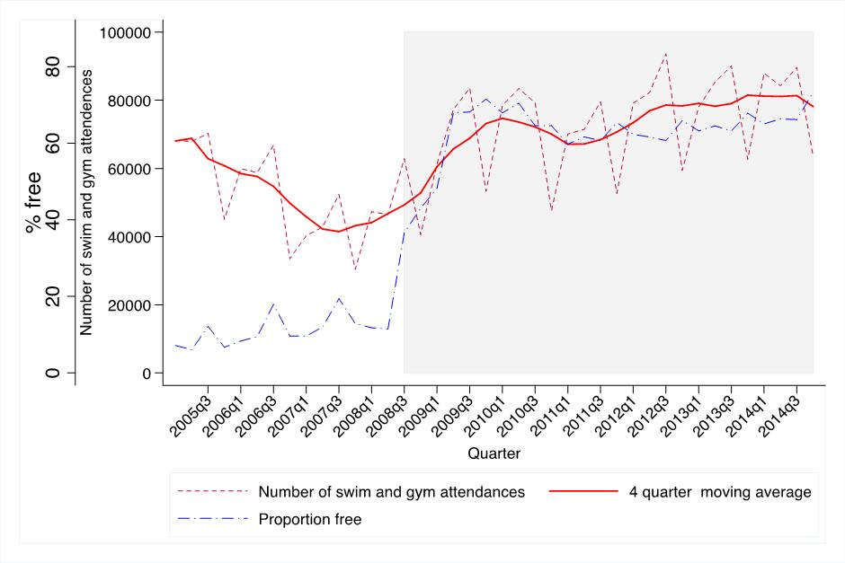

Figure 2.Trend in the proportion of people reporting at least one moderate Gym or Swim session in previous 4 weeks, 2005-2014 in Blackburn with Darwen and the rest of England (source APS).
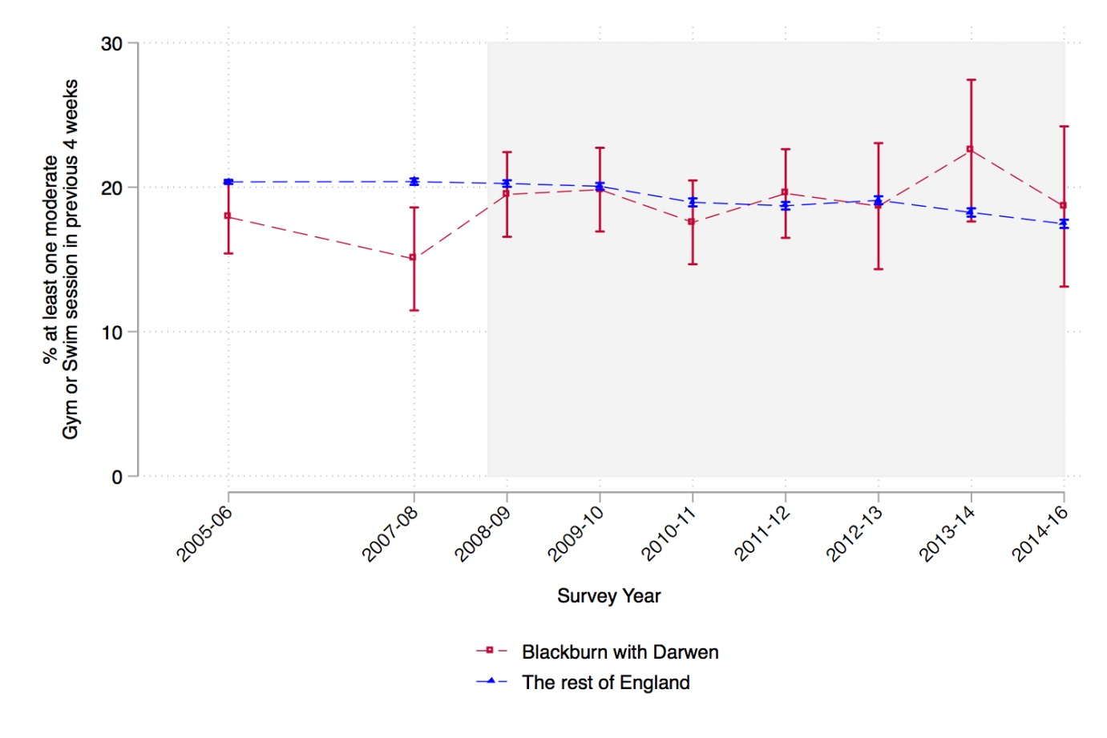

Figure 3. Estimates of the effect of the introduction of re:fresh from the difference-in-differences analysis on (1) % participating in gym or swim activity at least once in the past month and (2) the % participating in any sport or active recreation for a least 30 mins on at least 12 days over the last 4 weeks. Results for all socioeconomic groups in Blackburn with Darwen and separately for 3 socioeconomic groups. Effect sizes indicate the additional percentage of the population participating due to the intervention.

