Symmetry Effects on Attenuation Factors in Graphene-based Molecular Junctions
Qian Zhang,^{1,2} Shuhui Tao, ^{1,2} Ruowei Yi, ^{1,2} Chunhui He, ^{1,2} Cezhou Zhao,³ Weitao Su,⁴ Alexander Smogunov,⁵ Yannick J. Dappe,⁵ Richard J. Nichols,² Li Yang*^{1,2}
1. Department of Chemistry, Xi’an-Jiaotong Liverpool University, 215123, Suzhou, China.
2. Department of Chemistry, University of Liverpool, Liverpool, L69 7ZD, UK.
3. Department of Electrical and Electronic Engineering, Xi’an-Jiaotong Liverpool University, 215123, Suzhou, China
4. College of Materials and Environmental Engineering, Hangzhou Dianzi University, 310018, Hangzhou, China
5. SPEC, CEA, CNRS, Université Paris-Saclay, CEA Saclay 91191 Gif-sur-Yvette Cedex, France
AUTHOR INFORMATION
Corresponding Author
*Li Yang, Email: li.yang@xjtlu.edu.cn

ABSTRACT
The unique structural and electronic characteristics of graphene make it an attractive contact for fundamental single molecule electrical studies. With this in mind, we have probed here the electrical conductance of a molecular junction based on α,ω-diaminoalkane chains sandwiched between a gold and a graphene electrode. Using an STM based I(s) method combined with Density Functional Theory based transport calculations, we demonstrate that the resulting attenuation factor turns out to be much lower when compared to the standard molecular junction between two gold electrodes. This effect is attributed to the asymmetric coupling of the molecule through strong chemisorption at the gold electrode and weaker van der Waals contact at graphene. Moreover, this asymmetric coupling induces a higher conductance than in the same hybrid metal-graphene molecular junction using standard thiol anchoring groups.
TOC GRAPHICS
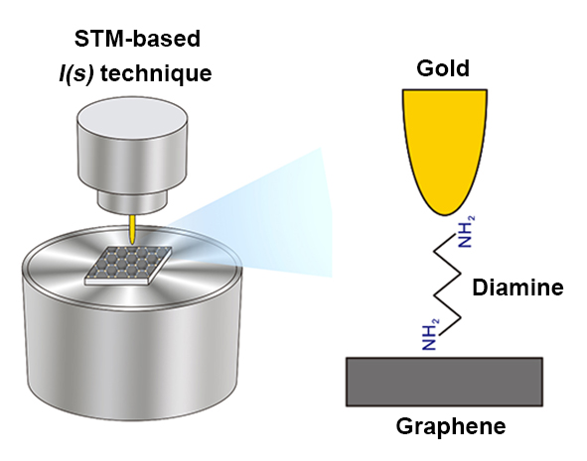
KEYWORDS
Graphene based electrode, single molecule conductance, symmetry effect, density functional theory.
Single molecule junctions (MJs) constitute elementary units in molecular electronics and understanding their electrical transport properties continues to be a leading issue in molecular electronics.¹ The transport properties of molecular junctions are related to many factors such as molecular length, contact binding properties and electronic level alignment between molecules and electrodes.^{2,3} The concerted development of techniques like mechanically controlled break junctions (MCBJ),⁴ scanning tunneling microscopy break junctions (STM-BJ),⁵ conductive probe atomic force microscopy (CP-AFM)⁶ and the I(s) technique based on STM,⁷ has given much impetus to the field of molecular electronics. A plethora of studies have been performed to examine the specific role of electrode materials and anchoring groups of molecular wires.⁸ To date, thiol has been the most widely studied anchoring group due to its strong covalent bond with gold contacts,^{9,10} although many other groups forming weaker chemisorption bonds such as pyridyl and amine have also been effective.^{5,11} In our previous works,^{12,13} we investigated the possibility of using a graphene electrode to form hybrid metal-molecule-graphene junctions. In these previous studies, we have used in particular thiol anchoring groups. We observed a reduction of the length attenuation factor of the tunneling current (the so called β-factor) of the molecular junction (by a factor of almost 2) with respect to standard gold-alkanedithiol-gold junctions.¹³ In this case, there is a stronger electronic dipole at the S-Au interface than at the SH-graphene interface which leads to an important shift of the HOMO level toward the Fermi level of the system. The lower attenuation can then be attributed among other effects to the strong molecular level alignment at the gold interface, which results in a better conductance for hybrid molecular junctions above ~1 nm molecular length, with respect to standard symmetric junctions with two gold contacts. This result offers promising perspectives for graphene contacts for molecular junctions.
Here, we investigate further these hybrid junctions by considering a different anchoring group. So far, many anchoring groups have been studied for molecular junctions employing metallic electrodes like amine (-NH₂),¹⁴ carboxylic acid (-COOH),¹⁵ isocyanide (-NC),¹⁶ dimethyl phosphine (-PMe₂),¹⁷ methyl sulphide (-SMe)¹⁸ and selenol (-SeH)¹⁹ groups. Comparisons between these different anchoring groups have also been made. In particular, Chen et al studied the effect of thiol, amine and carboxylic acid anchoring groups on single molecule conductance.²⁰ The contact resistance to gold of these anchoring groups varies in the order of thiolate (-SH), amine (-NH₂) and carboxylate (-COOH), attributed to different electronic coupling efficiencies between the molecule and electrodes. It can also be noted that the bonding patterns of these 3 anchoring groups are different: thiolate form a strong covalent bond with gold, while the binding for gold and amine-terminated alkane is significantly weaker, and carboxylic acid groups are likely to deprotonate to the carboxylate in order to coordinate to gold electrodes. Also, the symmetry of the bonding orbitals at the interface and on the molecular backbone plays an important role in the conductance properties. For example, it has been shown recently that orbital symmetry mismatching can reduce drastically the molecular conductance or even filter the spin of the current through the junction.^{21,22}
Here we show in a combined experimental and theoretical study, that the electronic conductance in a hybrid gold-graphene diamine alkane molecular junction presents a much smaller attenuation factor with respect to the standard gold-gold junction. The system has been investigated using STM-based I(s) technique and theoretical calculations based on Density Functional Theory (DFT) and a Keldysh-Green formalism. These computations reveal that the symmetry breaking induced by the graphene electrode is responsible for the low attenuation.
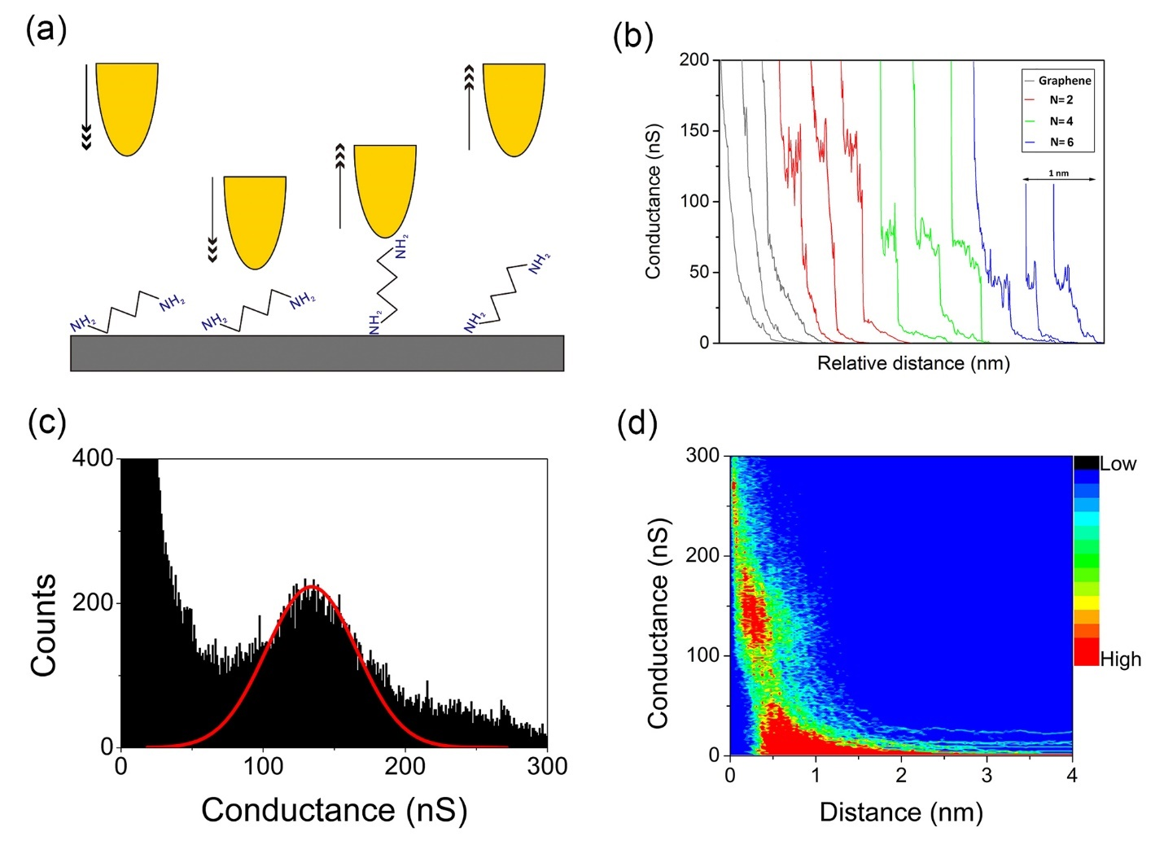
Figure 1. (a) Schematic diagram of the STM-based I(s) technique. (b) Typical I(s) curves of bare graphene (gray), gold-1,2-ethanediamine-graphene junctions (red), gold-1,4-butanediamine-graphene junctions (green), and gold-1,6-hexanediamine-graphene junctions (blue). (c) The 1D histogram of single-molecule conductance of gold−ethanediamine−graphene hybrid junctions with the Gaussian fit. (d) Corresponding 2D histogram with a sensitivity indicator of the conductance counts.
Typical conductance curves for 1,n-alkanediamine (n=2, 4, 6) are shown in Figure 1 (b). The gray curves indicate the fast exponential decay of conductance as a function of the distance between the tip and the graphene when no molecular junctions is formed. For the red (n=2), green (n=4) and blue (n=6) curves, the conductances decrease in a stepwise fashion, providing evidence for molecular junctions formation. For example, the conductance of gold-1,2-ethanediamine-graphene hybrid junctions is located at around 120-160 nS.
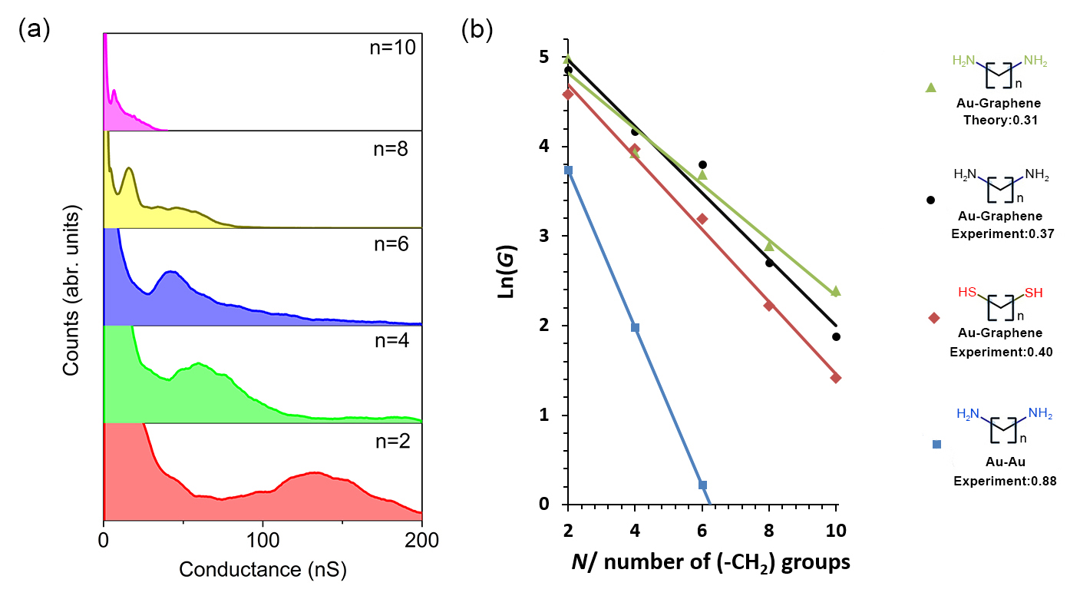
Figure 2. (a) Conductance histograms for gold−n-alkanediamine−graphene nonsymmetric junctions in which n = 2 (red), 4 (green), 6 (blue), 8 (yellow), and 10 (magenta) (b) Natural logarithmic plot of the conductance as a function of the number of CH₂ groups. The green (black) lines represent the theoretical (experimental) decay values of gold-diamine-terminated alkanes-graphene junctions. The red line is the experimental gold-dithiol-terminated alkanes-graphene junction. The blue line with a higher decay constant stands for gold-diamine-terminated alkanes-gold symmetric junction.²⁰
In Figure 1(c), a clear peak is observed in the 1D histogram for gold-1,2-ethanediamine-graphene non-symmetric junctions. Using a Gaussian fit of this peak, a conductance value of 137 nS is obtained. The corresponding 2D histogram shown in Figure 1(d) represents the data distribution of conductance values and the length of the molecular junction. A red region (high data point count) located around 120 nS to 160 nS is clearly observed in the 2D histogram which is consistent with the peak in Figure 1(c) and the plateaus shown in Figure 1(b).
To better illustrate the progression of conductance with molecular length, we plotted stacked 1D histogram of 1,n-alkanediamine (n= 2, 4, 6, 8, 10) with the same conductance and counts scale (Figure 2a). For each conductance histogram, only one single peak dominates. Detailed 1D, 2D histograms of 1,n-alkanediamine (n= 4, 6, 8, 10) are presented in supporting information (SI). The description of the experimental details including the preparation of molecular solution (diamine-terminated alkanes−methanol, 1:20, v/v) and substrate can be also found in SI. As expected, the conductance values decrease with the molecular length for each series of molecules. Table 1 summarizes the experimental and theoretical conductance values as well as the decay constant of diamine-terminated compared to dithiol-terminated-alkanes analogues for nonsymmetric gold-molecule-graphene junctions.¹³ We also list the literature conductance values (lower conductance group) of gold-gold symmetric junctions for comparison.²⁰
Table 1. Conductance values and tunneling decay value (β value) for Au-Molecule-Graphene nonsymmetric junctions and Au-molecule-Au symmetric junctions. The molecules involved are n-alkanediamine and n-alkanedithiol (n=2, 4, 6, 8, 10)
Molecular junctions | Conductance(nS) |  |  |  |  | Tunneling decay value (β_{n})
 | n=2 | n=4 | n=6 | n=8 | n=10
Gold-n-alkanediamine-Graphene | 137 | 65 | 42 | 15 | 7 | 0.37
Gold-n-alkanediamine-Graphene (theory) | 147 | 51 | 40 | 18 | 11 | 0.31
Gold-n-alkanediamine-Gold (Literature) | 42 | 7.3 | 1.2 | - | - | 0.88(LC)²⁰
Gold-n-alkanedithiol-Graphene | 98 | 53 | 24 | 9 | 4 | 0.40
Gold-n-alkanedithiol-Graphene (theory) | 152 | 46 | 25 | 18 | 6 | 0.32
Gold-n-alkanedithiol-Gold (Literature) | - | - | 28.2 | 3.9 | 0.2 | 1.08(LC)^{20,23}

For short molecular junctions, the general conductance behavior is now well described as non-resonant tunneling. This regime predicts an exponential decrease of the conductance with the molecular length, while a weaker length dependence for longer molecular lengths²⁴ is generally attributed to hopping type mechanisms. Hence, the conductance follow $G=A_{n}exp⁡(-β_{n}N)$, where G is the conductance; A is related to the nature of molecule−electrode interaction, reflecting the contact resistance; β_{n} is the decay constant, which describes the efficiency of electron transport through the molecules; N is the number of methylene groups.²⁵
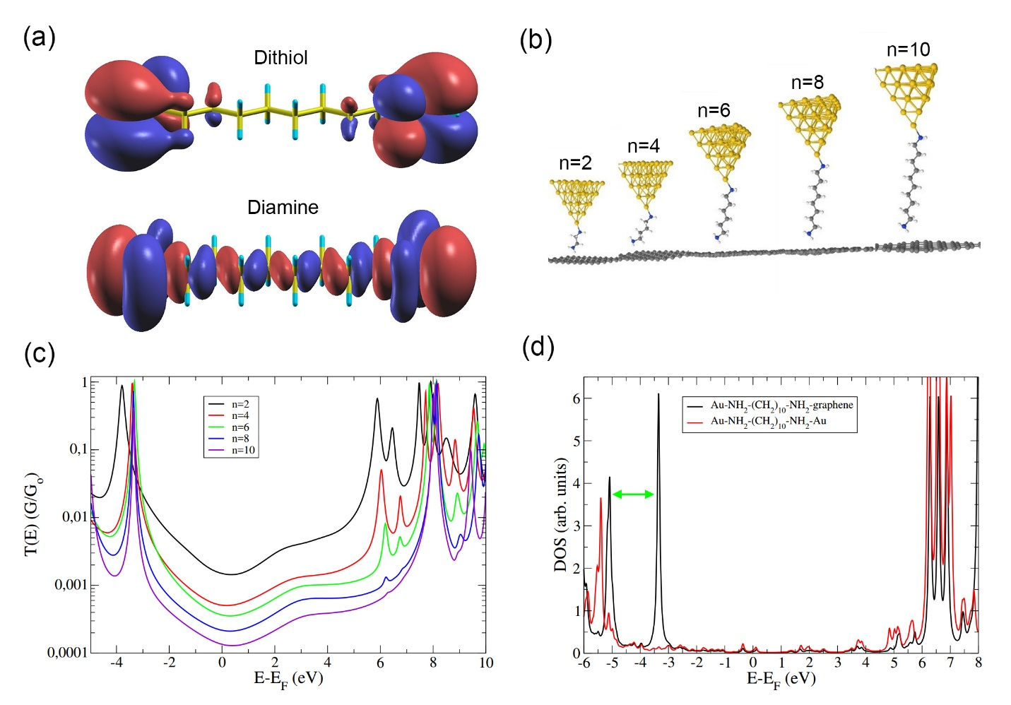
Figure 3. (a) HOMO molecular orbitals for dithiol and diamine alkane chains. Isosurfaces of positive (negative) isovalues (the same for both molecules) are shown in red (blue). (b) DFT-optimized model junctions used for the conductance calculations. (c) Calculated electronic transmissions T(E) of the molecular junctions for different lengths. (d) Comparison of the DOS of the n=10 alkane chain in a gold-gold or a gold-graphene molecular junction.
From the natural logarithmic plot of the conductance versus the number of (-CH₂) units in Figure 2(b), we found β_{n} = 0.37 for diamine-terminated alkane chains. This value is very similar to the one obtained in our previous work on alkanedithiol chains,¹³ and again much smaller than the one obtained in the case of a symmetric gold-gold molecular junction.¹¹ To understand the mechanism at the origin of this strong attenuation factor reduction, we have performed Density Functional Theory (DFT) calculations to model the system. The same procedure as the one for alkane-dithiol chains has been applied here. Figure 3(b) represents the DFT-optimized molecular junctions. Using a Keldysh-Green formalism, we have calculated the electronic transmissions represented in Figure 3(c). More details on the theoretical procedure can be found in Ref.¹³ Here the HOMO lies much closer to E_{F} implying that HOMO mediated hole tunneling would be the predicted mechanism. However, this HOMO position is markedly different for the alkane diamine compared with our previous work with on alkanedithiols. In the alkane diamine case Figure 3(b), the transmission shows that the HOMO level is much farther from the Fermi level, at -3.5 eV, than in the dithiol alkane case, where it was located at -0.4 eV. Consequently, the use of a simple barrier tunneling model here, where $β_{n}=2d_{0}\sqrt{(2mφ)/ћ}$ ,²⁶ is not sufficient to explain the low attenuation of the molecular junction. Hence, the attenuation factor is not only determined by the interface properties, but also by the electronic properties of the isolated molecule. In this respect, we present in Figure 3(a) the HOMO wave functions for the dithiol chain (top) compared to the diamine (bottom).
From Figure 3a it is clear that the (doubly degenerate) HOMO orbitals present a strong dependence on the anchoring groups. However, while for dithiol case the HOMO orbital is strongly localized on sulfur atoms, it spreads significantly into the backbone chain for the diamine case. This striking difference in HOMO spatial localizations stems from their different symmetries with respect to a mirror plane passing horizontally through the molecule. Namely, the HOMO is an odd (even) function for dithiol (diamine) chains (Figure 3(a)). Also, the lowest-decay states in a gap of alkane chains are the σ-like states of even symmetry²⁷ (originated mainly from carbon p_{z} orbitals, z being the molecular axis). These states correspond to the evanescent wavefunctions through the gap of the “free” alkane chain (without anchoring groups or connection to an electrode, i.e. the molecular backbone), and support the electronic transport through the molecular junction²⁷. In an electronic transport process, the electrons are injected into those states through the HOMO or LUMO orbitals associated to the anchoring groups of the molecular junction. That would result in a perfect symmetry matching between those states and the diamine HOMO orbital, leading to a long penetration into the molecule. The odd HOMO orbital of dithiol chain must be matched with odd evanescent states of the alkane chain which have much stronger decay rate in the gap region. Therefore, we can deduce that the conductance along the chain is much more favored in the case of the diamine molecule compared to the dithiol case. This feature has been illustrated theoretically in a recent work on methyl sulfide terminated alkane chains.²⁸ Notice that a similar reasoning can be performed on the same molecule connected to the gold and graphene electrodes. This feature is represented in Figure S2, where we have considered the isoelectronic density of states at the Fermi level. Indeed, the HOMO level strongly hybridized with the electrodes (in particular at the gold-molecule interface) makes the symmetry interpretation more complicated. Moreover, due to this strong hybridization and the resulting induced DOS in the gap, the current has to be considered at the Fermi energy. The delocalization still remains more important for the diamine case (Fig. S2), as predicted by the symmetry analysis in the isolated molecule.
Additionally, molecular conductance is often attributed to the frontier orbitals in the molecule, which corresponds to the electronic states of the “free” alkane chain, or molecular backbone. However, we have noticed in our calculations that the frontier orbitals of the molecular backbone are not modified by the anchoring groups or the electrode nature. Therefore, we can state that the current attenuation is ruled by the HOMO level of the full molecular junction (combining molecular backbone and anchoring groups), strongly dependent of the anchoring groups and its delocalization through the molecule. This has been also demonstrated through molecular complex bandstructure calculations by Sankey et al ²⁹where there is no difference observed with the anchoring groups.
From those symmetry arguments and since dithiol and diamine molecular junctions present the same attenuation factor when connected to two gold electrodes, we can expect an interplay between a higher tunneling barrier at the interface and a better molecular conductance in the diamine case. However, a theoretical determination of the tunnel barrier in this molecular junctions explaining formally the relationship between the attenuation factor, the interface barrier and the conductivity in the molecular backbone is more complicated to establish and is beyond the scope of the present work.
Now we represent in Figure 3(d) a comparison between the DOS of a diamine molecular junctions based on gold/gold or gold/graphene electrodes. The gold-alkane diamine-gold junction presents a HOMO level at around -5.5 eV from the gold Fermi level (E_{F}), which is much further from E_{F} than values found in literature for the dithiol case under the same conditions (around -2 eV). Consequently, the similar attenuation factor obtained for the dithiol and diamine junctions in the gold/gold configuration is indeed explained by the interplay between an interface barrier related to the HOMO level (which is smaller in the dithiol case) and the conductivity along the molecular chain, which is related to the HOMO level propagation along the molecule (which is larger in the diamine case). Considering the DOS of the gold/graphene junction in Figure 3(d), we can observe that the HOMO peak appears much closer (by about 2 eV closer than for Au/Au junctions) to the Fermi level, at about -3.5 eV, as indicated by a green arrow. This is a consequence of a very asymmetric coupling of the molecule to two different electrodes. On the gold side, the bonding is covalent, whereas on the graphene side, the bonding is much weaker due to van der Waals interactions. This asymmetry is at the origin of a sharp HOMO resonance (spatially distributed around the graphene-side N atom) appearing for the gold/graphene diamine chain. This significant HOMO shift presents important consequences for the molecular junction conductance. The new tunnel barrier is reduced from -5.5 to -3.5 eV which is similar to the reduction found previously for the dithiol case, from around -2 eV to -0.4 eV.²² Since the attenuation factor is the same between the two types of molecular junctions in the gold/gold case, a similar shift induced by asymmetric connection will result in much smaller attenuation factor for both molecules in the gold/graphene geometry.
Both experimental and theoretical results produce an unexpected behavior of the alkane diamine junctions compared to alkane dithiol ones. Results in literature^{20,23,30} show higher conductance for alkane-dithiol with respect to alkane-diamine molecular junctions using gold electrodes, while we find here an opposite behavior when one gold contact is substituted for a graphene one. Indeed, a systematically higher conductance for diamine chains is obtained. Moreover, the effective contact resistance can be estimated for both chains by extending the linear fits to zero methylene groups. This results in a contact resistance for the thiol compounds of 3900 kΩ, which is slightly higher than the one for diamine analogues (3700 kΩ). This small difference can be interpreted in terms of coupling to the electrode. These couplings are expected to be modified, since the gap between the gold Fermi level and the HOMO is reduced by about 2 eV in both cases, as a result of the HOMO resonance shift, while there is no change in the LUMO level energy. These couplings vary as the inverse of the gap through self-energy calculations, and are therefore increased by the gap reduction. Consequently, the conductance of the junction is strongly enhanced, which explains the slightly higher conductance of the gold | alkanediamine | graphene junction with respect to the gold | alkanedithiol | graphene junction where the gap remains unchanged with respect to the gold/gold case.
In summary, we have studied the conductance of alkanediamine molecular junctions, using an STM-based technique, with a gold electrode at one end of the junction and a graphene electrode at the other. We have obtained a similar attenuation factor to what was obtained previously in the case of alkanedithiol junctions, due to the asymmetric coupling of the diamine alkane molecular chain between gold and graphene. The weak coupling at the graphene interface is responsible for a significant HOMO molecular level shift toward the Fermi energy. This shift reduces the tunneling barrier at the interface in the same way as for the dithiol case, which provides justification for the similarity in the attenuation factors. A slightly higher conductance of the diamine hybrid junction with respect to the dithiol hybrid junction is also found. These experimental results are supported by theoretical computation and symmetry considerations for the molecular junctions. These findings lead us to expect a general reduction of the attenuation factor for hybrid gold-graphene molecular junctions with different anchoring groups, with respect to standard gold-gold junctions. This work highlights the attractive features of graphene contacts in molecular electronics which might inspire their future deployment in new device prototypes.

ASSOCIATED CONTENT
Supporting Information. The experimental methodology, the 1D and 2D histograms of gold-N-alkanediamine-graphene hybrid junctions with N=4, 6, 8, 10 respectively and the isoelectronic density of states at the Fermi energy for the alkanedithiol and the alkanediamine gold-graphene junctions.

AUTHOR INFORMATION
Corresponding Author
*Li Yang, Email: li.yang@xjtlu.edu.cn;
Notes
The authors declare no competing financial interests.
ACKNOWLEDGMENT
This work was supported by the National Natural Science Foundation of China (NSFC Grants 21503169, 2175011441), the Jiangsu Science and Technology program (BK 20140405), Suzhou Industrial Park Initiative Platform Development for Suzhou Municipal Key Lab for New Energy Technology (RR0140), Zhejiang Provincial Natural Science Foundation (LY18F040006) and the XJTLU Research Development Fund (PGRS-13-01-03 and RDF-14-02-42).

REFERENCES
(1) Cao, Y.; Dong, S.; Liu, S.; He, L.; Gan, L.; Yu, X.; Steigerwald, M. L.; Wu, X.; Liu, Z.; Guo, X. Building High-Throughput Molecular Junctions Using Indented Graphene Point Contacts. Angew. Chem. Int. Ed. 2012, 124, 12394-12398.
(2) Scullion, L. E.; Leary, E.; Higgins, S. J.; Nichols, R. J. Single-molecule Conductance Determinations on HS(CH₂)₄O(CH₂)₄SH and HS(CH₂)₂O(CH₂)₂O(CH₂)₂SH, and Comparison with Alkanedithiols of the Same Length. J. Phys.: Condens. Matter. 2012, 24, 164211.
(3) Hybertsen, M. S.; Venkataraman, L.; Klare, J. E.; Whalley, A. C.; Steigerwald, M. L.; Nuckolls, C. Amine-linked Single-molecule Circuits: Systematic Trends Across Molecular Families. J. Phys.: Condens. Matter. 2008, 20, 374115.
(4) Reed, M. A.; Zhou, C.; Muller, C. J.; Burgin, T. P.; Tour, J. M. Conductance of a Molecular Junction. Science 1997, 278, 252-254.
(5) Xu, B.; Tao, N. J. Measurement of Single-Molecule Resistance by Repeated Formation of Molecular Junctions. Science 2003, 301, 1221-1223.
(6) Cui, X. D.; Primak, A.; Zarate, X.; Tomfohr, J.; Sankey, O. F.; Moore, A. L.; Moore, T. A.; Gust, D.; Harris, G.; Lindsay, S. M. Reproducible Measurement of Single-Molecule Conductivity. Science 2001, 294, 571-574.
(7) Haiss, W.; van Zalinge, H.; Higgins, S. J.; Bethell, D.; Höbenreich, H.; Schiffrin, D. J.; Nichols, R. J. Redox State Dependence of Single Molecule Conductivity. J. Am. Chem. Soc. 2003, 125, 15294-15295.
(8) Kim, Y.; Hellmuth, T. J.; Bürkle, M.; Pauly, F.; Scheer, E. Characteristics of Amine-Ended and Thiol-Ended Alkane Single-Molecule Junctions Revealed by Inelastic Electron Tunneling Spectroscopy. ACS Nano 2011, 5, 4104-4111.
(9) Lee, S. H.; Lin, W. C.; Kuo, C. H.; Karakachian, M.; Lin, Y. C.; Yu, B. Y.; Shyue, J. J. Photooxidation of Amine-Terminated Self-Assembled Monolayers on Gold. J. Phys. Chem. C 2010, 114, 10512-10519.
(10) Kiguchi, M.; Kaneko, S. Single Molecule Bridging Between Metal Electrodes. Phys. Chem. Chem. Phys. 2013, 15, 2253-2267.
(11) Venkataraman, L.; Klare, J. E.; Tam, I. W.; Nuckolls, C.; Hybertsen, M. S.; Steigerwald, M. L. Single-Molecule Circuits with Well-Defined Molecular Conductance. Nano Lett. 2006, 6, 458-462.
(12) Liu, L.; Zhang, Q.; Tao, S.; Zhao, C.; Almutib, E.; Al-Galiby, Q.; Bailey, S. W. D.; Grace, I.; Lambert, C. J.; Du, J.; Yang, L. Charge Transport Through Dicarboxylic-acid-terminated Alkanes Bound to Graphene-gold Nanogap Electrodes. Nanoscale 2016, 8, 14507-14513.
(13) Zhang, Q.; Liu, L.; Tao, S.; Wang, C.; Zhao, C.; González, C.; Dappe, Y. J.; Nichols, R. J.; Yang, L. Graphene as a Promising Electrode for Low-Current Attenuation in Nonsymmetric Molecular Junctions. Nano Lett. 2016, 16, 6534-6540.
(14) Quek, S. Y.; Choi, H. J.; Louie, S. G.; Neaton, J. B. Length Dependence of Conductance in Aromatic Single-Molecule Junctions. Nano Lett. 2009, 9, 3949-3953.
(15) Peng, Z. L.; Chen, Z. B.; Zhou, X. Y.; Sun, Y. Y.; Liang, J. H.; Niu, Z. J.; Zhou, X. S.; Mao, B. W. Single Molecule Conductance of Carboxylic Acids Contacting Ag and Cu Electrodes. J. Phys. Chem. C 2012, 116, 21699-21705.
(16) Kiguchi, M.; Miura, S.; Hara, K.; Sawamura, M.; Murakoshi, K. Conductance of a Single Molecule Anchored by an Isocyanide Substituent to Gold Electrodes. Appl. Phys. Lett. 2006, 89, 213104.
(17) Kamenetska, M.; Koentopp, M.; Whalley, A. C.; Park, Y. S.; Steigerwald, M. L.; Nuckolls, C.; Hybertsen, M. S.; Venkataraman, L. Formation and Evolution of Single-Molecule Junctions. Phys. Rev. Lett. 2009, 102, 126803.
(18) Park, Y. S.; Whalley, A. C.; Kamenetska, M.; Steigerwald, M. L.; Hybertsen, M. S.; Nuckolls, C.; Venkataraman, L. Contact Chemistry and Single-Molecule Conductance: A Comparison of Phosphines, Methyl Sulfides, and Amines. J. Am. Chem. Soc. 2007, 129, 15768-15769.
(19) Yokota, K.; Taniguchi, M.; Tsutsui, M.; Kawai, T. Molecule−Electrode Bonding Design for High Single-Molecule Conductance. J. Am. Chem. Soc. 2010, 132, 17364-17365.
(20) Chen, F.; Li, X.; Hihath, J.; Huang, Z.; Tao, N. Effect of Anchoring Groups on Single-Molecule Conductance: Comparative Study of Thiol-, Amine-, and Carboxylic-Acid-Terminated Molecules. J. Am. Chem. Soc. 2006, 128, 15874-15881.
(21) Jasper-Tönnies, T.; Garcia-Lekue, A.; Frederiksen, T.; Ulrich, S.; Herges, R.; Berndt, R. Conductance of a Freestanding Conjugated Molecular Wire. Phys. Rev. Lett. 2017, 119, 066801.
(22) Smogunov, A.; Dappe, Y. J. Symmetry-Derived Half-Metallicity in Atomic and Molecular Junctions. Nano Lett. 2015, 15, 3552-3556.
(23) Jang, S.-Y.; Reddy, P.; Majumdar, A.; Segalman, R. A. Interpretation of Stochastic Events in Single Molecule Conductance Measurements. Nano Lett. 2006, 6, 2362-2367.
(24) Yan, H.; Bergren, A. J.; McCreery, R.; Della Rocca, M. L.; Martin, P.; Lafarge, P.; Lacroix, J. C. Activationless Charge Transport Across 4.5 to 22 nm in Molecular Electronic Junctions. Proc. Natl. Acad. Sci. U.S.A. 2013, 110, 5326-5330.
(25) Wang, Y. H.; Zhou, X. Y.; Sun, Y. Y.; Han, D.; Zheng, J. F.; Niu, Z. J.; Zhou, X. S. Conductance Measurement of Carboxylic Acids Binding to Palladium Nanoclusters by Electrochemical Jump-to-contact STM Break Junction. Electrochim. Acta 2014, 123, 205-210.
(26) Cuevas, J. C.; Scheer, E. Molecular Electronics: An Introduction to Theory and Experiment; World Scientific: Singapore, 2010.
(27) Fabien, P.; Alexander, S.; Andrea Dal, C.; Erio, T. Complex Band Structures and Decay Length in Polyethylene Chains. J. Phys.: Condens. Matter. 2003, 15, 3731.
(28) Wang, M.; Wang, Y.; Sanvito, S.; Hou, S. The Low-bias Conducting Mechanism of Single-molecule Junctions Constructed with Methylsulfide Linker Groups and Gold Electrodes. J. Chem. Phys. 2017, 147, 054702.
(29) Tomfohr, J. K.; Sankey, O. F. Complex Band Structure, Decay Lengths, and Fermi Level Alignment in Simple Molecular Electronic Systems. Phys. Rev. B 2002, 65, 245105.
(30) Quek, S. Y.; Venkataraman, L.; Choi, H. J.; Louie, S. G.; Hybertsen, M. S.; Neaton, J. B. Amine−Gold Linked Single-Molecule Circuits: Experiment and Theory. Nano Lett. 2007, 7, 3477-3482.

