Detection, characterisation and enrolment of donors of Ebola convalescent plasma in Sierra Leone.
Richard S Tedder,^{1,2,3} Dhan Samuel,⁴ Steve Dicks,^{1,2} Janet T Scott,⁵ Samreen Ijaz,¹ Catherine C Smith,⁶ Charlene Adaken,⁷ Christine Cole,⁸ Samuel Baker,⁹ Tansy Edwards¹⁰ Philip Kamara,⁹ Osman Kargbo,⁹ Saidia Niazi,¹ Davis Nwakanma,¹¹ Umberto d’Alessandro,^{11,12} Graham Burch,¹³ Heidi Doughty,^{14,15} Colin S Brown,^{16,17} Nick Andrews,¹⁸ Judith R Glynn,¹⁰ Johan van Griensven,¹⁹ Ebola CP Consortium Investigators, Georgios Pollakis,⁷ William A Paxton,⁷ and Malcolm G Semple.⁵

¹Blood Borne Virus Unit, Virus Reference Department, National Infection Service, Public Health England, London, UK; ²Transfusion Microbiology, National Health Service Blood and Transplant, Charcot Road, London, UK; ³Division of Infection and Immunity, University College London, Gower Street, London, UK; ⁴Serology Development Unit, Virus Reference Department, National Infection Service, Public Health England, London, UK; ⁵Institute of Translational Medicine and National Institute for Health Research (NIHR) Health Protection Research Unit in Emerging and Zoonotic Infections, University of Liverpool, Liverpool, UK; ⁶Travel Medicine and International Health Team, Health Protection Scotland, Glasgow, UK; ⁷Institute of Infection and Global Health, National Institute for Health Research (NIHR) Health Protection Research Unit in Emerging and Zoonotic Infections, University of Liverpool, Liverpool, UK; ⁸Clinical RM Ohio USA & Connaught Hospital, Freetown, Sierra Leone; ⁹National Safe Blood Service, Connaught Hospital, Ministry of Health and Sanitation, Freetown, Sierra Leone; ¹⁰Department of Infectious Disease Epidemiology, London School of Hygiene and Tropical Medicine, Keppel Street, London, UK; ¹¹Medical Research Council, Atlantic Boulevard, Fajara, P. O. Box 273, Banjul, The Gambia; ¹²Department of Disease Control, Faculty of Infectious and Tropical Diseases, London School of Hygiene and Tropical Medicine, Keppel Street, London, UK; ¹³DiaSorin S.p.A, Biotechnology Manufacturing, Central Road, Dartford, Kent, UK; ¹⁴National Health Service Blood and Transplant, Vincent Drive, Birmingham, UK; ¹⁵College of Medical and Dental Sciences, University of Birmingham, Birmingham, UK; ¹⁶King’s Sierra Leone Partnership, King’s Centre for Global Health, King’s Health Partners and King’s College London, UK; ¹⁷Reference Microbiology, National Infection Service, Public Health England, UK; ¹⁸Statistics, Modelling and Economics Department, Public Health England, London, UK; ¹⁹Department of Clinical Sciences, Institute of Tropical Medicine, Nationalestraat 155-2000, Antwerp, Belgium; Ebola_CP Consortium Investigators - See Appendix
Role of the funding sources The funders had no role in the collection and analysis of the samples, in the interpretation of data, in writing the report nor in the decision to submit the paper for publication.
Corresponding Author Prof Richard S Tedder, Blood Borne Virus Unit, Virus Reference Department, National Infection Service, Public Health England, 61 Colindale Avenue, Colindale, London NW95EQ, UK. Telephone 020 8327 6109; e-mail: richard.tedder@phe.gov.uk Reprints will not be available.
Funding The study “Convalescent plasma for early Ebola virus disease in Sierra Leone (ISRCTN13990511 & PACTR201602001355272) was supported by the Wellcome Trust (Award ref 106491) and Bill and Melinda Gates Foundation; Public Health England Ebola Emergency Response; and the Blood Safety Programme, National Health Service Blood and Transplant. JTS was supported by the Wellcome Trust. MS was supported by the UK National Institute for Health Research Health Protection Research Unit in Emerging and Zoonotic Infections. The study of Kerry Town survivors and community controls was supported by Save the Children internal funds and The Wellcome Trust's Enhancing Research Activity in Epidemic Situations (ERAES) programme (grant number ER1502). JvG was supported by the European Union Horizon 2020 research and innovation program (grant number 666094).
Conflict of Interest No conflicts are known.
Word Count 3029
Running title Ebola convalescent plasma qualification
Abstract
Background. Passive therapy with convalescent plasma provides an early opportunity to intervene in Ebola virus (EBOV) disease. Methods for field screening and selection of potential donors and quantifying plasma antibody are needed.
Study design and methods. Recombinant EBOV Glycoprotein (EBOV GP) was formatted into Immunoglobulin G-capture, Competitive and Double-antigen bridging enzyme-linked immunoassays. Ebola virus disease survivors in Freetown, Sierra Leone were recruited as potential plasma donors and assessed locally using sera alone and/or paired sera and oral fluids (ORF). Un-infected controls comprised unexposed Gambian and communities in Western Area, Sierra Leone. Antibody neutralisation in selected sera was measured retrospectively in a pseudotype virus assay.
Results. One hundred and fifteen potential donors were considered for enrolment, 110 plasma samples were concordantly reactive in the three EIAs; 3 were concordantly un-reactive and two reactive in two of three EIAs (98.2% agreement, 95% CI, 93.9-99.8%). In 88 donors with paired ORF and plasma, G-capture EIA reactivity correlated well in the two analytes (R²=0.795). Plasma and ORF from 44 Gambians were unreactive. ORF from 338/339 unexposed Western Area community controls were unreactive (specificity 99·7%, 95%5 CI 98·4-99·7%); ORF from 113/116 Kerry Town EVD survivors were reactive (sensitivity 97·4%, 92·5-99·5%). Strong reactivity in G-capture and/or Competitive EIAs identified donors with high plasma EBOV GP antibody levels in the Double-antigen bridging assay, correlating with high levels of neutralising antibody.
Conclusions. In-field testing can qualify convalescent donors for providing high-titre antibody. ORF testing by G-capture EIA provided a diagnostically sensitive, acceptable, non-invasive method for identifying seropositive individuals.

Key Words. Ebola virus disease; blood donors; convalescent plasma; oral fluid; neutralising antibody
INTRODUCTION
By late 2014 the outbreak of Ebola virus disease (EVD) was unchecked in Guinea, Liberia and Sierra Leone. The potential efficacy of convalescent plasma (CP) as a treatment for EVD, first described in the 1995 Kikwit outbreak,¹⁻³ led the World Health Organisation to consider development of CP therapy a priority.^{4, 5} CP has been used for other viral infections³ and we have previously shown⁶ the importance of serological confirmation of potential plasma donors rather than relying on a syndromic diagnosis alone.
The antibody response after clinical EVD appears long lived⁷ and correlates with the presence of neutralising antibody. Non-human primate studies have shown that antibody to Ebola virus envelope glycoprotein (EBOV GP) protected against disease progression. A priori, and supported by these studies in non-human primates,⁹ we decided to ensure that human CP was drawn only from donors with plasma levels of EBOV GP antibody likely also to contain high levels of neutralising antibody. In order to deliver this aspiration new serological methods for the detection and qualification of immune donors were needed.¹⁰ The development of assays was undertaken, including for non-invasive samples, to provide initial screening as well as the identification of those seropositive potential donors with higher antibody levels. In spite of previous attempts to use non-blood analytes including oral fluid (ORF) for Ebola serology being unsuccessful,¹¹ recognising the widespread use of ORF in clinical virology¹² we also elected to pursue this approach. The enzyme-linked immune assays (EIAs) had to be specific, semi-quantitative, preferably including non-invasive protocols, and sufficiently robust to be transported and used in the field in the absence of a cold chain. A series of EIA formats were constructed using the recombinant EBOV GP antigen employed by Qiu et al.⁹ The use of these EIAs, including a non-invasive test using ORF, for facilitating the identification, recruitment and qualification of convalescent blood donors as a potential source of therapeutic CP is described.

MATERIALS AND METHODS
Potential Donors The study “Convalescent plasma for early Ebola virus disease in Sierra Leone” (ISRCTN13990511 & PACTR201602001355272) was approved by the Sierra Leone Ethics and Scientific Review Committee, authorised by Pharmacy Board of Sierra Leone (PBSL/CTAN/MOHS-CST001) and sponsored by University of Liverpool. The protocol is available on request (m.g.semple@liverpool.ac.uk).
EVD survivors with certificates (issued by Ebola Treatment Centres on discharge) were recruited as potential donors through Military Hospital 34, Freetown, and the Sierra Leone Association of Ebola Survivors. Of 130 recruited and consented (Figure 1), on average 6.1 months (range1-15, mid quartiles 4-8) following discharge, 12 were referred to the Ebola Survivors’ Clinic because of possible post EVD sequelae.¹³ One hundred and eighteen well volunteers were referred to the Blood Bank in Freetown for final assessment. Three were excluded because of hepatitis B virus infection. The remaining 115 provided written consent to become qualified donors, giving 315 plasma samples and 205 ORF samples overall. In addition the first (#15/220) and the second (#15/252) WHO standards from the National Institute of Biological Standards and Controls (NIBSAC) were included as controls.
Unexposed controls, The Gambia Forty-four individuals were enrolled by the Medical Research Council (MRC) Unit, The Gambia (MRCG), into a malaria field study and serum and ORF samples archived. Approval was given to test these locally for antibody to EBOV.
Survivors and unexposed community controls, Sierra Leone As part of a separate study on transmission within households¹⁴ ORF samples were taken from 116 PCR-confirmed EBV survivors from Kerry Town Ebola Treatment Centre, and 339 healthy volunteers living in three communities in Western Area Sierra Leone which had no recorded cases of EVD. These samples were analysed in Makeni, Sierra Leone. This study was approved by the Sierra Leone Ethics and Scientific Review Committee, and by the ethics committee of the London School of Hygiene and Tropical Medicine. Written consent was sought from all participants or their parents/guardians if under 18 years.

Oral fluid sampling The Oracol (S10, Malvern Medical Developments Limited) oral fluid sampling kit was used. In Connaught blood bank the oral swabs were demonstrated by blood bank staff and then self-administered by donors. The swab was run along the upper and lower gum margins on either side of the mouth for 30 seconds each (2 minutes total) before returning it to the sampling tube. Samples were tested on receipt or stored at -20°C within a day of collection.
For the Kerry Town survivors and the community controls the oral swabs were demonstrated by the field staff and then self-administered, with adults helping children. Each swab was rubbed firmly on the gums for 90 seconds, sealed, put in a cool box, transferred daily to the laboratory, tested on receipt or stored at -20°C as above.
Sample handling Whole blood samples from potential donors were separated within 24 hours of venesection. All plasma samples received in Public Health England (PHE) Colindale were tested for EBOV RNA.¹⁵ Fresh ORFs or frozen ORFs which had been thawed at room temperature, were extracted by adding 1 ml of transport medium (TM) to the tube, agitating the swab in the TM within the tube, removing the swab with a circular motion, dispelling ORF and TM from the swab to provide the ORF extract which remained in the tube. Plasma samples and ORF extracts were stored at 4º C for up to 24 hours to allow testing before long-term storage at -20°C.
Enzyme linked immune-assays (EIAs) Three solid-phase microplate EIAs were formulated, based on the EBOV Mayinga GP antigen (rGPδTM, IBT Bioservices Inc. USA cat.0501-016). In brief, the first was an IgG-specific reverse capture assay (G-capture EIA) using horse radish peroxidase (HRPO) labelled EBOV GP. The second was a simultaneous competitive assay (Competitive EIA) using HRPO-labelled monoclonal antibody (4G7) raised against EBOV GP. The third was a double antigen bridging assay (DABA) using HRPO-EBOV GP performed qualitatively, or quantitatively to measure antibody to EBOV GP (full details of assays, critical reagents and information for use leaflets in the Supplementary Information). Both latter assays would be expected variously to detect IgM antibody, the Competitive less so because of expected antibody low-avidity in acute infection, the DABA more so because of the pentameric nature of IgM.
The positive control for the first two kits was plasma from a UK EVD survivor infected in Sierra Leone taken 1.5 months after discharge. The DABA EIA used a pool of five reactive donor plasmas attributed 1000 arbitrary units/ml (au/ml). The negative control plasma came from unexposed UK blood donors.
Normalised optical density (NOD) measures Optical densities (OD) were “normalised” as the ratio between the test sample and the cut-off. For G-capture and DABA, where a reaction is defined by a test sample giving an OD ≥ the kit cut-off, the NOD value is derived by Test sample OD/cut-off OD.
For the Competitive EIA, where a reaction is defined by a test sample giving an OD ≤ kit cut-off, the NOD value is derived by Cut-off OD / test sample OD.
Samples giving NOD of ≥ 1·0 are reactive.
Neutralising antibody The ability of a sample to neutralise the propagation of a single-cycle infectious EBOV GP pseudo-type, as previously described¹⁶, was used to investigate a selected panel of CP samples (details in Supplementary Information). In brief, the envelope-deficient HIV-1 backbone pSG3^{∆env} from the NIH AIDS reagents repository (https://www.aidsreagents.org/) was complemented with the Ebola glycoprotein expressed in pcDNA3.1 from Thermofisher. The Ebola glycoprotein is derived from the KP096421 early strain to which the coding changes appearing later in the epidemic (A81V, I317V, T229A and N551D) were introduced. All analyses were performed in triplicate and repeated. The neutralising ability of a sample was expressed as that dilution of plasma which provided a 50% reduction of virus infection (IC₅₀).
Sample Size and statistical analysis The size of the potential donor panel was determined by the need for plasma for a planned therapeutic intervention study. Within and between assay variability was assessed as the % coefficient of variation (i.e. standard deviation/mean) using paired testing of samples and from repeat testing of the positive kit control across runs. Results from different assays (DABA, G-capture, Competitive) run on the same samples as well as G-capture run on paired plasma and ORF samples were compared by calculating R² values (square of the correlation coefficient) and as percentage agreement.
RESULTS
Test performance
For the G-capture EIA, replicate testing within plates of 222 analytes (plasma or ORF) from the potential donors, gave an average coefficient of variation of 2·9%; replicate testing of ORF samples from survivors and community controls gave an average coefficient of variation of 8.0% within plates (23 samples) and 17.9% between plates (104 samples). For the Competitive EIA, replicate testing within plates of 127 plasma samples from potential donors gave an average coefficient of variation of 9·1%. For the quantitative DABA on repeat testing the average coefficient of variation was 13%, the calibration plots demonstrated a coefficient of variation of around 8%.
Control populations Forty four ORF and serum samples were tested in duplicate at MRCG. Using a cut-off of kit mean negative plus 0·1, no sample was considered reactive. The 16 serum samples with highest OD reactions were retested in the Competitive EIA, all were unreactive.
In Sierra Leone, using the same cut-off of mean negative plus 0·1 OD, ORF from 338/339 individuals with no known exposure to EBOV infection were unreactive, giving a specificity of 99·7% (95% CI 98·4-99·9%). The one reactive sample (NOD=1.4) was unreactive on further duplicate re-testing. All other samples had NOD of <0.7. Among the 116 PCR-confirmed survivors from Kerry Town Ebola Treatment Centre, 113 ORF samples were reactive on a single test, giving a sensitivity of 97·4%, (95% CI 92·5-99·5%).
Potential donors Field testing of paired plasma and ORF samples from 10 convalescent donors tested using the G-capture EIA at Connaught Blood Bank in May 2015 demonstrated a clear correlation between the reactivity of plasma and ORF (Figure 2; R² = 0·822). Tested at Connaught at the same time, 36/37 convalescent donor plasmas, were reactive in both G-capture and Competitive EIAs, with correlated reactivity levels (Figure 3a; R²= 0·625). Further initial and repeat re-testing was carried out at PHE Colindale. All 115 plasma samples were retested for EBOV RNA on receipt in the UK; all were negative. Eighty eight paired plasma and ORF samples showed good correlation in reactivity on the G-capture EIA (R² =0·795 using linear regression; Figure 3b). One ORF sample was unreactive (NOD 0·78), giving a sensitivity of ORF compared to plasma of 87/88, 98·9% (95% CI: 93·8-99·97). Two ORF samples, although reactive, had lower reactivity in the ORF G-capture test than expected from the plasma results (Figure 3b). They had a low level of IgG in the oral fluid as sampled (<3mg/L). One of these donors (ORF NOD 3·2, plasma NOD 12·0) had provided an unpaired ORF three days earlier which gave a NOD of 10·0.
Plasma samples from the 115 donors were tested in the G-capture, Competitive and DABA EIAs: 110 were concordantly positive in all three EIAs, 3 were concordantly unreactive in all three EIAs, and two samples were below the cut-off in one of the three EIAs but reactive in the other two (Table). The overall agreement between the three assays was therefore 113/115 (98·2%, 95% CI 93·9-99·8%) and the sensitivity of the assays was 111/115 (96·5%, 95% CI 91·3-99·0%) for G-capture and Competitive EIAs and 112/115 (97·4%, 95% CI 92·6-99·4%) for DABA. Reactivity correlated between Competitive and G-capture EIAs (Figure 3c).
EBOV GP antibody reactivity was measured in the quantitative DABA EIA (Figure 4). The three samples concordantly unreactive in the two screening EIAs, had undetectable EBOV GP antibody in the qualitative DABA EIA. The measurable antibody in the remaining 112 plasmas varied over 2xlog₁₀, from 50 to 3624 au/ml with a geometric mean titre (GMT) of 392 au/ml. The 29 samples with reactivity in the upper quartile of the capture EIA had GMT 745au/ml, the 29 in the upper quartile of the competitive EIA had a GMT of 838 au/ml, and the 20 in both upper quartiles had a GMT of 934 au/ml. The subset of 25 samples chosen for investigation of neutralising antibody had DABA antibody levels ranging from 200 to >4000 au/ml reflecting the range of reactivity of donor samples in this assay. There was a close correlation between DABA reactivity and IC₅₀ titres of neutralising antibody (R²=0.57, Figure 5b). A similar correlation between the level of neutralising antibody and reactivity in the G-capture EIA was also seen for the paired plasmas (Figure 5a) and ORFs from 21 of the same donor samplings where ORF data were available (R²=0.40, Figure 5c). The neutralisation IC₅₀ of both the first ( #79 NIBSC 15/220) and the second (#92 NIBSC 15/262 ) WHO standards are as shown at 162 and 192 respectively (Figure 5a and b) .

DISCUSSION
We have shown that recruitment and screening of potential CP donors to exclude seronegative individuals and to select those with higher antibody levels is possible in a resource poor setting during an EVD outbreak. Furthermore, the high sensitivity and specificity of the tests developed, and the comparable performance of the G-capture EIA assay when used on oral fluids, have implications beyond the identification of donors, as they enable large-scale non-invasive serological studies.¹⁴
Seronegative individuals were however rare among potential donors (3/115). Although all potential donors possessed certificates indicating discharge from an Ebola Treatment Unit (ETU), in the societal turmoil of an ongoing epidemic and resulting deprivation it is not surprising that certification may not be secure. Though recruitment was facilitated by certification and financial incentive it is clearly appropriate to use serology to qualify donors for therapeutic purposes. The seronegative donor of plasma 1 (Table) was diagnosed before admission to the ETU with a high viral load which became undetectable within 48 hours suggesting an erroneous first PCR. On further enquiry, no record of EBOV PCR testing could be found nationally for the seronegative donors of plasmas 2 and 3. If these three are truly seronegative as these data would infer, the G-capture EIA identified 111/112 (99·1%, 95% CI 95·1-99·98%).
ORF testing provides acceptable non-invasive sampling, used widely in clinical virology¹²and is valuable in acute outbreaks and sero-epidemiological studies. The ORF EIA also correlated with EBOV candidate vaccine response in UK volunteers.¹⁷ The negative G-capture results from a non-exposed population in The Gambia indicated good specificity. This was confirmed in the unexposed community controls from Sierra Leone (338/339 negative, specificity 99.7%) while the sensitivity of the G-capture EIA on ORF remained high (113/116 Kerry Town EVD survivors positive, sensitivity 97·4%).¹⁴ Furthermore the clear association between reactivity of ORF and plasma (Figures 2 and 3b) demonstrates that ORF is appropriate for investigating the spread of EBOV in diverse communities as well as selection of seropositive donors. Previous studies were unable to detect EBOV antibody in ORF samples¹¹ reflecting the poor sensitivity of indirect EIAs for oral fluid studies.¹⁸ This is not the case for reverse G-capture EIAs. However, the ORF sample must be taken adequately to avoid false negatives from low ORF IgG levels; it would not normally be possible in the field to check total IgG levels in the ORF.
A Competitive EIA incorporating a monoclonal antibody to a well-defined neutralising epitope⁹ confirmed the specificity of the ORF G-capture EIA, but requires a plasma sample. The use of EIAs of different format has long been considered advantageous in the terms of specificity¹⁹ and this same principle should apply to EBOV serology. Choice of the EBOV GP antigen for serology was driven by availability, by the previous selection of this glycoprotein for vaccine studies and the generation of protective murine monoclonal antibody.⁹ This however does not imply that antibody to EBOV GP is necessarily the only therapeutic component of CP.
Having an antigen-coated solid phase and a directly conjugated GP, it was a natural extension to develop a double antigen bridging EIA for antibody quantification. Measurement of the level of reactivity in a capture or competitive assay has subtly different implications. A capture assay reaction depends upon the proportion of the antibody present in the analyte that recognises the antigen and the avidity with which the antibody interaction occurs. A competitive assay depends upon the concentration of antibody present in the analyte and the avidity and specificity of that antibody. Usually a strong reaction in one EIA correlates with a strong reaction in the other EIA, but not necessarily with a direct linear relationship (Figures 3a and 3c). When antibody to EBOV GP was quantified in the DABA EIA, levels differed widely between individuals and many survivors had very low levels of measurable antibody to GP. This suggests that alternative host determinants such as the cytotoxic T-Lymphocyte response may be more important for survival and recovery than the humoral response.⁸ It also begs the question whether EVD survivors with low antibody levels are more susceptible to viral persistence or reactivation.
Both the G-capture and Competitive EIAs allowed selection of donors with high level antibody (Figure 4) quantified by DABA EIA which in turn measures total antibody to EBOV GP. This selection however reduced the number of suitable donors available, so having a non-invasive initial screening method that could be used more widely was considered particularly useful. The range of antibody levels we observed across the cohort may explain the lack of clinical benefit⁴ found with the use of unselected CP in the trial in Guinea. Quantification of antibody to EBOV GP in DABA correlated with the measurement of biologically determined neutralising antibody. Both assays also ranked the two WHO standards in the expected order of potency and the observed neutralisation IC50 titres were in agreement with published data²⁰. We believe these observations indicate that the DABA EIA was suitable for quantifying biologically-active antibody in the field. If the effect of CP depends on antibody dosing¹⁰ it will be interesting to quantify neutralising antibody in the full cohort of Sierra Leone donors.
The three different EIAs we have developed, their biological plausibility, correlation with neutralising antibody and the excellent performance of the G-capture EIA on oral fluid providing a sensitive, specific and non-invasive way of determining the EBOV serological status of individuals, provide a suitable epitaph to our much loved and sadly missed colleague Dr Dhan Samuel.

Acknowledgements We thank colleagues variously for their support and encouragement: staff in VRD Colindale for handling and clearing samples from quarantine; DiaSorin for their continuing support of test kit ancillaries; the Programme EVA Centre for AIDS reagents for supplying the pSG3∆env plasmid (Cat# 11051) donated by Drs John C Kappes and Xiaoyun Wu; the Sierra Leone Association of Ebola Survivors; Gary Kobinger for the gift of monoclonal 4G7; Sheila Maclennan NHSBT and Lisa Jarvis SNBTS for samples from UK1 and UK2; Colin Brown, NIS, PHE Colindale for analysing data bases for evidence of PCR testing of donors. Also G McCann & L Matthews (Institute of Translational Medicine and National Institute for Health Research (NIHR) Health Protection Research Unit in Emerging and Zoonotic Infections, University of Liverpool, Liverpool, UK); I Bates (Department of International Public Health, Liverpool School of Tropical Medicine, Liverpool, UK) A Kohlenberg (HIV and Neglected Tropical Diseases, Institute of Tropical Medicine, Antwerp, Belgium); WA Brooks (International Severe Acute Respiratory and Emerging infection Consortium (ISARIC), International Centre for Diarrhoeal Disease Research, Dhaka, Bangladesh, Department of International Health, Johns Hopkins University, Baltimore, USA); MP Kieney (World Health Organization Geneva, Switzerland), A Jones (Department of Biostatistics, and North West Hub for Trials Methodology Research, University of Liverpool, Liverpool, UK); C Burm & D Arango (Clinical Trials Unit, Institute of Tropical Medicine, Antwerp, Belgium); NF Walker (London School of Hygiene and Tropical Medicine); the members of the Convalescent Products and Allied Therapy Intervention Technical Committee, the Research Ethics Committee and the Pharmacy Board Committee, (all Ministry of Health and Sanitation, Republic of Sierra Leone).

Author contributions RST, DS Concept and delivery of serological development, field trial, data analysis and manuscript drafting; SD, SN, CSB Analytical processing and co-ordination of results, quality assessment; SI Data analysis, design and delivery of Figures, manuscript drafting; JTS Principal clinical lead in Sierra Leone, design and oversight of clinical standards; CC shared clinical lead and governance in Sierra Leone; CCS shared clinical lead and governance in Sierra Leone; TE Biostatistician for Ebola_CP; SB Clinical lead transfusion practice NSBS; OK, PK Principal transfusion scientists, field trial and serology in NSBS, conduct of plasmapheresis; DN, UA validation of EIAs in a low risk population, manuscript drafting; GB selection and provision of critical ancillary reagents for field kits and technical support; HAD Haemo-vigilance and support for plasmapheresis, manuscript drafting; CB Retrieval and collation of National Sierra Leone EBOV PCR data for CP donors; JvG Co-ordination with and support from parallel studies in Guinea, manuscript drafting; NA Statistical advice and analysis of numerical data; JRG PI study of Kerry Town survivors and community controls, manuscript drafting; CA, GP, WAP oversight of neutralisation testing, manuscript drafting ;MGS Consortium Lead Investigator for Ebola_CP, conceived the plasma intervention, design of serological studies, manuscript drafting.

Figure 1

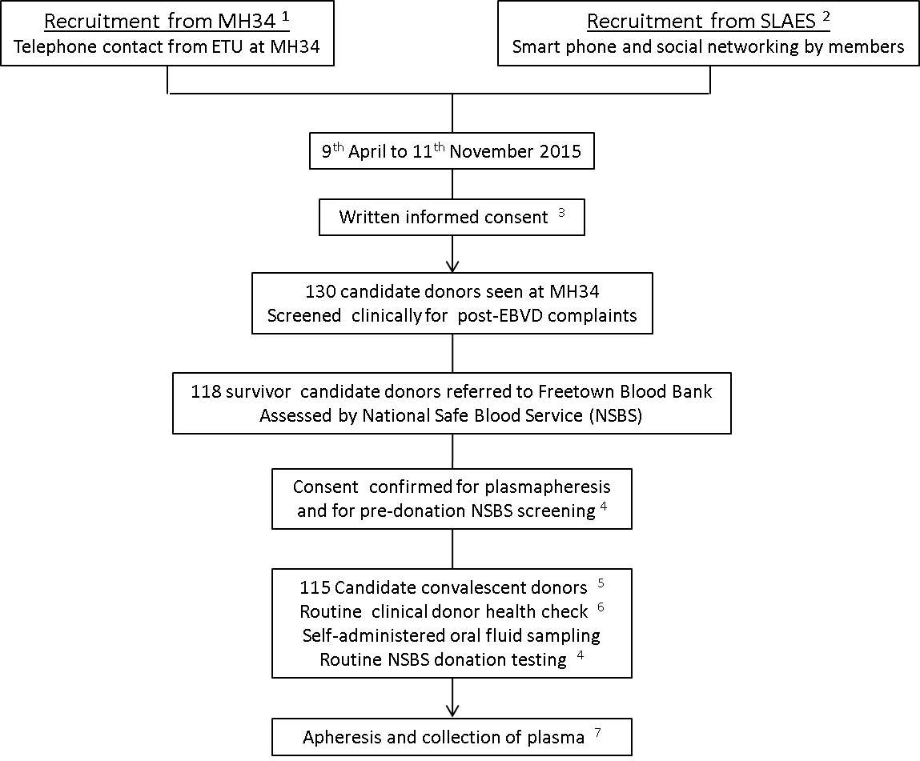

Figure 2

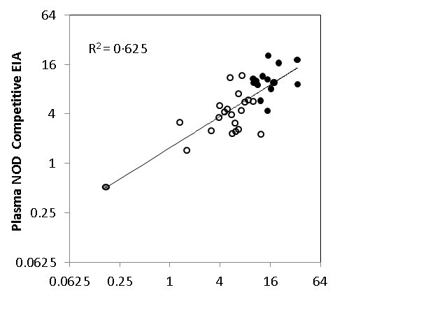
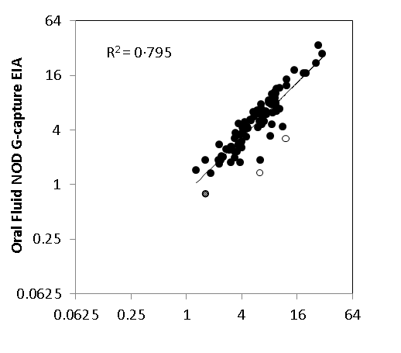
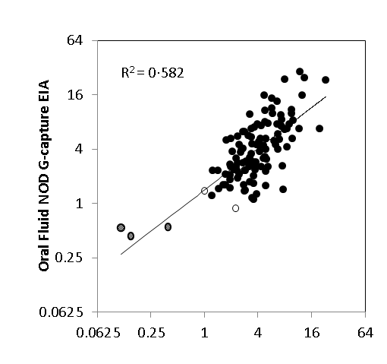
Figure 3
Plasma NOD G-capture EIA
a
ORF NOD G-capture EIA
Plasma NOD Competitive EIA
Plasma NOD Competitive EIA
c
b

Figure 4
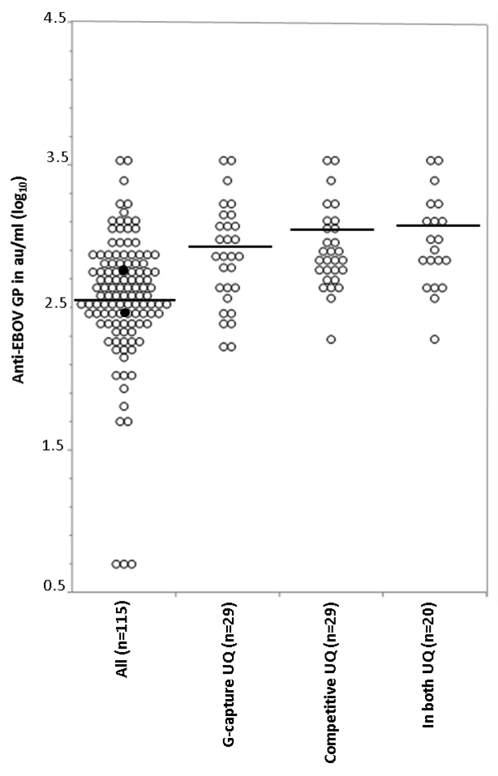

Figure 5
128
512
2048
8192
Anti-EBOV GP au/ml
b
R²=0.7633
1
2
4
8
16
32
32
64
128
256
512
Plasma NOD G-capture EIA
a
R²=0.6794
Neutralisation IC₅₀ titre
R²=0.5700
1
2
4
8
16
32
ORF NOD G-capture EIA
c

Legends for figures
Figure 1
Recruitment process for volunteer convalescent donors seen first at the 34th Regimental Military Hospital Wilberforce Freetown (MH34) before referral to the Blood Bank, National Safe Blood Service, Connaught Hospital, Freetown
- 34th Regiment Military Hospital, Wilberforce, Freetown, Sierra Leone
- Sierra Leone Association of Ebola Survivors
- Compensation for cost of attendance of 40,000 Sierra Leone Leones (SLL, $8 USD)
- Anaemia; HBsAg, anti-HCV, anti-HIV and antibody to syphilis
- HBV infection excluded three donors; compensation of 80,000SLL ($16 USD) for attendance
- Current wellbeing, vital signs including temperature, height and weight, research samples including: ORF sampling by Oracol™ device, blood drawn in tempus™ tubes, vacutainer®PPT™ tubes and EDTA tubes.
- Candidate donors returned to NSBS Blood Bank for first and subsequent apheresis and
received compensation for each apheresis of 300,000 SLL ($60 USD)
Figure 2
Correlation between paired oral fluid and plasma reactivity, expressed as raw OD (optical density), from 10 convalescent donors tested in the G-capture EIA at Connaught Blood Bank, Freetown (R²=0·822 from linear regression). Linear regression line on logged titres is shown.

Figure 3
a) Correlation of normalised optical densities (NOD) in the Competitive and the G-capture EIAs of 37 donor samples field tested in Connaught Blood Bank, Freetown (R² = 0·625 from linear regression). Samples from donors selected for further attendance are shown as solid circles. One sample is concordantly unreactive (hatched). Reactivities of the two WHO standards are shown as open squares (15/ 262 upper left; 15/220 lower right).
b) Correlation between NOD reactivity of 88 paired ORF and plasma samples in the G-capture EIA from donors taken at first attendance (R²=0·795). One ORF sample had a normalised optical density (NOD) value less than 1·0 (hatched, 0·78). Two dually-reactive ORFs with anomalously low ORF NODs are shown as open circles. Linear regression line on logged titres is shown.
c) Correlation between G-capture and Competitive EIAs, expressed as log₁₀ NOD values, of 115 first attendance plasma samples (R²=0·582). Three samples are concordantly unreactive in both EIAs (hatched). Two samples are discordantly unreactive (open circles), one is just below the cut-off in the G-capture and the other is just below cut-off in the Competitive EIA (see Table). Linear regression line on logged titres is shown.
Figure 4
Anti-EBOV glycoprotein levels in 115 seropositive convalescent donor plasmas, expressed as log₁₀ au/ml, measured in the DABA EIA. Results are shown for the entire cohort (All) superimposed with the first (15/220, lower of the two) and second(15/262, upper of the two) WHO EBOV standards (solid symbols), and for those in either of the two upper quadrants for the G-capture (Capture UQ) or for the Competitive EIA (Competitive UQ) and for those plasmas reacting in both upper quadrants of the G-capture and the Competitive EIA s (In both UQ). Horizontal bars represent geometric mean values anti-EBOV GP in au/ml.
Figure 5
Anti-EBOV glycoprotein levels in a selected panel of 25 convalescent donors. Plasma antibody measured by pseudotype neutralisation (interpolated IC₅₀ neutralisation titres) is compared with plasma reactivity in the G-capture EIA (expressed as normalised ODs, panel a, R² = 0.52), with quantified plasma reactivity in the DABA EIA (expressed in au/ml, panel b, R²= 0.57) and with paired oral fluid (21 ORF samples only) reactivity in G-capture EIA (expressed as normalised ODs, panel c, R² =0.40). IC₅₀ titres shown as open squares (Figures 5a and 5b) for first (#15/220 lower left) and the second (#15/252 upper right) WHO standards. Linear regression lines on logged titres are shown.

Table 1
Details of the five first-time donor plasma samplings where an EIA normalised OD was less than 1·0 in one or more of the three EIAs.
Sample Identity | G-capture EIA |  | Competitive EIA |  | DABA EIA au/ml | Comment
 | Raw OD* | Normalised OD* | Raw OD* | Normalised OD*
Donor 1 | 0·02 | 0·15 | 3·20 | 0·43 | <35 †, | PCR cycle threshold 20 in holding unit, undetectable at 48 and 72 hours later when retested after transfer to Ebola Treatment Unit (ETU)
Donor 2 | 0·02 | 0·11 | 2·58 | 0·54 | <35† | No record of PCR found nationally for this donor by name within 4 days of the date of reported admission to an ETU
Donor 3 | 0·07 | 0·38 | 2·53 | 0·55 | <35† | No record of PCR found nationally for this donor by name within 4 days of the date of reported admission to an ETU
Donor 4 | 0·17 | 0·99 | 1·00 | 1·38 | 112 | Recorded PCR positive (though discrepancy in gender and age in records) no address provided
Donor 5 | 0·39 | 2·24 | 1·57 | 0·88 | 64 | PCR positive cycle thresholds 34 and 37 in two tests taken a day apart
Positive control | 3·65 | 20·87 | 0·14 | 18·26 | 1000 | UK 1 plasma used for both G-capture and Competitive EIAs. A pool of highly reactive plasma ascribed to contain 1000 arbitrary units (au) used for DABA
Negative control | 0·07 | 0·41 | 2·63 | 0·53 | <35† | Pooled normal human plasma from UK blood donors
Cut-off | 0·17 | 1·00 | 1·39 | 1·00 | Not applicable | Defined for G-capture by mean OD negative controls + 0.1 OD  Defined for Competitive EIA by comparison with 50% inhibition of label binding

Plasma samples from donors 1-3 inclusive were unreactive in any of the three tests used. Plasma sample from donor 4 was unreactive in the G-capture EIA and plasma sample from donor 5 was unreactive in the Competitive EIA, both plasmas from donors 4 & 5 contained detectable antibody to EBOV glycoprotein in the DABA EIA. * optical density. † lower limit of detection in the run.
Appendix
The Ebola_CP: The Consortium Investigators for Ebola_CP (Convalescent Plasma for Early Ebola Virus Disease in Sierra Leone) are MG Semple, (Consortium Lead Investigator) & JT Scott, (both Institute of Translational Medicine & NIHR Health Protection Research Unit in Emerging and Zoonotic Infections University of Liverpool, Liverpool, UK); SM Gevao (Country Lead Investigator) F Sahr (Country Deputy Lead Investigator), CP Cole & J Russell (all College of Medicine and Allied Health Sciences, Freetown, Sierra Leone); S Baker, O Kargbo & P Kamara (all National Safe Blood Service, Connaught Hospital, Ministry of Health & Sanitation, Freetown, Sierra Leone); M Lado & CS Brown (King’s Sierra Leone Health Partnership, King’s Health Partners & King’s College London, London, UK); J van Griensven, R Ravinetto & Y Claeys (all Institute of Tropical Medicine, Antwerp, Belgium); RS Tedder, R Gopal & TJG Brooks (National Infection Service, Public Health England, London, UK); CC Smith (Health Protection Scotland, UK); HA Doughty (NHS Blood and Transplant, & College of Medical and Dental Sciences, University of Birmingham, Birmingham, UK); A Mari Saez and M Borchert (both Institute for Tropical Medicine and International Health, Charité, Berlin, Germany); AH Kelly (Department of Sociology, Philosophy and Anthropology, Exeter University, Exeter, UK); JK Baillie (The Roslin Institute, University of Edinburgh, Edinburgh, UK) N Shindo & D Pfeifer (Department of Pandemic and Epidemic Diseases, World Health Organization Geneva, Switzerland); DL Hoover (ClinicalRM Inc., Ohio, USA) WA Fischer II & DA Wohl (both Department of Medicine, University of North Carolina, Chapel Hill, USA) NM Thielman (Duke University School of Medicine, Durham, USA) PW Horby & L Merson (Nuffield Department of Medicine, University of Oxford, Oxford, UK) PG Smith & T Edwards (MRC Tropical Epidemiology Group, London School of Hygiene & Tropical Medicine, London).

References
1. Mupapa K, Massamba M, Kibadi K, et al. Treatment of Ebola hemorrhagic fever with blood transfusions from convalescent patients. International Scientific and Technical Committee. J Infect Dis. 1999;179 Suppl 1:S18-23.
2. Zeitlin L, Whaley KJ, Olinger GG, et al. Antibody therapeutics for Ebola virus disease. Curr Opin Virol. 2016;17:45-9.
3. Mair-Jenkins J, Saavedra-Campos M, Baillie JK, et al. The effectiveness of convalescent plasma and hyperimmune immunoglobulin for the treatment of severe acute respiratory infections of viral etiology: a systematic review and exploratory meta-analysis. J Infect Dis. 2015;211(1):80-90.
4. van Griensven J, Edwards T, de Lamballerie X, et al. Evaluation of Convalescent Plasma for Ebola Virus Disease in Guinea. N Engl J Med. 2016;374(1):33-42.
5. Delamou A, Haba NY, Mari-Saez A, et al. Organizing the Donation of Convalescent Plasma for a Therapeutic Clinical Trial on Ebola Virus Disease: The Experience in Guinea. Am J Trop Med Hyg. 2016; 95(3):647-53.
6. Parry RP, Tettmar KI, Hoschler K, et al. Strategies for screening blood donors to source convalescent H1N1v plasma for intervention therapy. Vox Sang. 2012;103(2):107-12.
7. Sobarzo A, Ochayon DE, Lutwama JJ, Balinandi S, Guttman O, Marks RS, et al. Persistent immune responses after Ebola virus infection. N Engl J Med. 2013;369(5):492-3.
8. Sobarzo A, Stonier SW, Herbert AS, et al. Correspondence of Neutralizing Humoral Immunity and CD4 T Cell Responses in Long Recovered Sudan Virus Survivors. Viruses. 2016;8(5).
9. Qiu X, Wong G, Audet J, et al. Reversion of advanced Ebola virus disease in nonhuman primates with ZMapp. Nature. 2014;514(7520):47-53.
10. van Griensven J ET, Baize S. Efficacy of Convalescent Plasma in Relation to Dose of Ebola Virus Antibodies. New England Journal Medicine. 2016;10.1056/NEJMc1609116.
11. Formenty P, Leroy EM, Epelboin A, et al. Detection of Ebola virus in oral fluid specimens during outbreaks of Ebola virus hemorrhagic fever in the Republic of Congo. Clin Infect Dis. 2006;42(11):1521-6.
12. Perry KR, Brown DW, Parry JV, et al. Detection of measles, mumps, and rubella antibodies in saliva using antibody capture radioimmunoassay. Journal of medical virology. 1993;40(3):235-40.
13. Scott JT, Sesay FR, Massaquoi TA, et al.Post-Ebola Syndrome, Sierra Leone. Emerg Infect Dis. 2016;22(4):641-6.
14. Glynn JR, Bower H, Johnson S, et al. Asymptomatic infection and unrecognised Ebola virus disease in Ebola-affected households in Sierra Leone: a cross-sectional study using a new non-invasive assay for antibodies to Ebola virus. Lancet Infect Dis. 2017; 17(6):645-653 16.
15. Trombley AR, Wachter L, Garrison J, et al. Comprehensive panel of real-time TaqMan polymerase chain reaction assays for detection and absolute quantification of filoviruses, arenaviruses, and New World hantaviruses. Am J Trop Med Hyg. 2010;82(5):954-60.
16. Baan E, de Ronde A, Stax M, et al. HIV-1 autologous antibody neutralization associates with mother to child transmission. PloS one. 2013;8(7):e69274.
17. Lambe T, Rampling T, Samuel D, et al. Detection of Vaccine-Induced Antibodies to Ebola Virus in Oral Fluid. Open Forum Infect Dis. 2016;3(1):ofw031.
18. Ksiazek TG, Rollin PE, Williams AJ, et al. Clinical virology of Ebola hemorrhagic fever (EHF): virus, virus antigen, and IgG and IgM antibody findings among EHF patients in Kikwit, Democratic Republic of the Congo, 1995. J Infect Dis. 1999;179 Suppl 1:S177-87.
19. Tedder RS. Reflections on testing for antibody to Human Immunodeficiency Viruses. Bull Inst Pasteur, 1986; 84: 405-413.
20. Wilkinson DE, Page M, Mattiuzzo G, et al, Comparison of platform technologies for assaying
antibody to Ebola virus. Vaccine. 2017 35(9):1347-1352.

