Experience with developing antibiotic stewardship programmes in Serbia; potential model for other Balkan countries?

Kalaba M¹, Kosutic J^{2,3}, *Godman B^{4,5,6}, Radonjic V⁷, Vujic A⁸, Jankovic S⁸, Srebro D³, Kalaba Z⁹, Stojanovic R^{3,10}, Prostran M^{3,10}

¹Primary Healthcare Centre “Zemun“, Šilerova 46, Belgrade, Serbia Email: kalabamarija2@gmail.com
²The Institute for Medical Care of Mother and Child of Serbia "Dr Vukan Cupic", Radoja Dakića, Belgrade, Serbia, Email:jovankosutic54@gmail.com
³School of Medicine University of Belgrade, Serbia. Email: srebrodragana1@gmail.com
⁴Strathclyde Institute of Pharmacy and Biomedical Sciences, Strathclyde University, Glasgow, UK. Email: brian.godman@strath.ac.uk
⁵Division of Clinical Pharmacology, Karolinska Institute, Karolinska University Hospital Huddinge, SE-141 86, Stockholm, Sweden. Email: Brian.Godman@ki.se
⁶Health Economics Centre, Liverpool University Management School, Liverpool, United Kingdom. Email: Brian.Godman@liverpool.ac.uk
⁷Medicine and Medical Device Agency of Serbia, Belgrade, Serbia. Email: vesela.radonjic@yahoo.com
⁸Clinical Center Kragujevac, Zmaj Jovina street 30, Kragujevac, Serbia. Email: anavjc97@gmail.com, slobnera@gmail.com
⁹Children Hospital for Pulmonary Diseases and Tuberculosis at University Hospital Center “Dr Dragisa Misovic”, Belgrade, Email: zlatko.kalaba1@gmail.com
¹⁰Clinical Pharmacology Unit, Clinical Center Serbia. Emails: mprostran@doctor.com, crnobelibravobravo@gmail.com

*Author for correspondence: Brian Godman, Division of Clinical Pharmacology, Karolinska Institute, Karolinska University Hospital Huddinge, SE-141 86, Stockholm, Sweden. Email: Brian.Godman@ki.se; Telephone: +46 8 58581068. Fax: +46 8 59581070 and Strathclyde Institute of Pharmacy and Biomedical Sciences, University of Strathclyde, Glasgow G4 0RE, United Kingdom. Email: brian.godman@strath.ac.uk.

(Accepted for publication in Journal of Comparative Effectiveness Research – please keep CONFIDENTIAL)

ABSTRACT

Introduction: Antimicrobial resistance (AMR) and inappropriate use of antibiotics in children are important issues. Consequently, there is a need to develop comprehensive stewardship programmes even in hospitals with limited resources starting with children’s hospitals. Method: Retrospective observational analysis of antimicrobial utilization and resistance patterns over five years in a tertiary care children’s hospital in Serbia. Results: Cumulative AMR decreased but were still high, with high cumulative resistance rates among the most widely used antibiotics in the hospital. Total antibiotic use decreased from 2010 to 2014 although there was still high prescribing of reserved antibiotics. Conclusion: Concerns with inappropriate use, and high resistance rates, among some antibiotics used in the hospital are being used to develop guidance on future antibiotic use in this hospital, building on the recently introduced antibiotic stewardship programme, as well as encourage other hospitals in Serbia to review their policies.

Key words: Serbia, antibiotic resistance, antibiotic utilisation, children, hospitals, low-resources, stewardship programmes

INTRODUCTION

There are concerns with increasing resistance to antibiotics through their inappropriate use, leading to increased morbidity, mortality and costs [1-5]. The costs of antibiotic resistance in Europe were estimated at €1.5billion in 2007, now reaching €9billion per year or higher [6, 7], with costs also increasing with the use of newer more expensive antibiotics to treat resistant organisms [2, 8]. As a result, the monitoring of antimicrobial resistance (AMR), antibacterial use and the establishment of infection control programs, including the development of antibiotic stewardship programmes in hospitals, are seen as increasingly necessary to reduce resistance development and conserve existing antibiotics [9-15]. As part of this, antibiotic prescribing in children is of primary concern to reduce future morbidity and mortality. This includes both access to antibiotics, which can be a concern in some countries, as well as appropriate use [2, 3, 7].

In Serbia, antimicrobial use policies within hospitals are principally based on administrative measures and restrictions. In 2005, the concept of reserving antibiotics was implemented within the reimbursed hospital drug list, List B. This has resulted in regulations regarding their use including countersigning by specialists, and an evaluation of the microbiological outcomes [16, 17]. Under exceptional circumstances, hospitals can use an antibiotic which is not on the positive list [18]. Currently, restricted antibiotics include the carbapenems, linezolid, vancomycin, piperacillin-tazobactam, teicoplanin, colistin and ceftriaxone. In addition in 2013, the Ministry of Health requested that every hospital in Serbia should establish an antibiotic committee to instigate AMR monitoring and reporting as well as give professional advice for the rational use of antibiotics [19]. However, there were limited resources to implement such measures.

Despite these initiatives, data regarding antibiotic use and AMR patterns among children in hospitals in Serbia is currently very limited. This is not helped by the fact that antibiotic prescriptions and microbiology test results are often recorded on separate pieces of paper by different departments. As a result, making correlations between the two data sets challenging. This will potentially compromise the implementation of activities such as surveillance of antibiotic utilization and/ or AMR patterns.

Consequently, we sought to combine these two datasets within a leading children’s hospital in Serbia to guide future empiric use as part of antimicrobial stewardship programs. Our assumption was that if we found concerns in a leading children’s hospital in Serbia, there will be a high likelihood of similar concerns among other hospitals in Serbia where children are being treated as well as more widely within Serbia.

MATERIALS AND METHODS

A retrospective drug utilisation and surveillance study was conducted among the paediatric and paediatric surgery clinics (125 beds) of a tertiary care institution in Serbia, the Clinical Centre Kragujevac hospital, which overall has 1274 beds. The number of beds available for children (patients aged 0-18 years) did not significantly change during the study period, with the number of bed days oscillating between 28576 and 36171 per year in the paediatric wards.

In the first part of the study, we undertook an analysis combining antimicrobial utilisation data with cumulative resistance in 2010 vs 2014.

Antibiotic utilisation data was measured using the ATC DDD methodology, with DDDs typically accepted for recording medicine use for comparative purposes [20-24]. We are aware that DDDs are normally assigned based on their use in adults, and for medicines approved for use in children, dose recommendations will differ based on children’s age and body weight. In addition, many medicines used in children are typically not approved for such use, and documentation regarding dosing regimens are generally unavailable. Consequently, the WHO International Working Group for Drug Statistics Methodology concluded that paediatric DDDs are impossible to assign, and prescribed daily dosages (PDDs) and indications in paediatric population should be used if available [25]. However, if this is difficult, the Working Group suggested DDDs should be used as a measuring tool for overall comparisons [25].

Antibiotic dispensing data were collected from the hospital pharmacy on all antibiotics prescribed for systemic use among children from 2010-2014. In order to concentrate on the most prescribed antibiotics, the data on their utilization was limited to those antibiotics which comprised 90% of total utilization expressed in DDDs/100 patient days [23,26,27]. At the same time, we followed the percentages of bacterial isolates resistant and susceptible to the same antibiotics that were used in the study site. Utilization and resistance rates were combined. Cumulative resistance rates were calculated for those microbes naturally susceptible to each antibiotic from those antibiotics comprising 90% of total antibiotic utilisation as a percentage of resistance, intermediate or susceptible strains from the total number of strains analysed. Resistant and intermediate strain data were subsequently combined. . This is part of ongoing antimicrobial stewardship programmes in the hospital.

We are aware that antibiotic stewardship programs do differ in their content from hospital to hospital, and from country to country, to reduce infections and colonisation with antibiotic-resistant bacteria within hospitals [15,28,29]. We are also aware that there is limited data available on their implementation and effectiveness among paediatric patients [30]. In the Clinical Center Kragujevac, antibiotic stewardship (AS) was composed of the following elements: (i) establishing a drug and therapeutics committee (DTC), (ii) issuing antibiotic prescribing policies and hospital formularies via the DTC, (iii) biannual analysis of resistance patterns among the isolates from the central Intensive Care Unit and its distribution to all clinicians, (jv) pre-authorization of reserve antibiotics dispensing by a clinical pharmacology specialist, (v) issuing local guidelines for antibiotic prophylaxis and empiric treatment and consulting clinical pharmacologists and infectious diseases specialists when prescribing antibiotics to complex patients. The AS was fully implemented in this hospital at the beginning of 2014, and is ongoing.

Data on antimicrobial resistance were obtained from hospital microbiological laboratory. This included more than 90,000 uniform Excel files from 2010 to 2014 containing information for instance regarding the clinic/ ward where the specimens were collected and in which material, e.g. sputum, blood or liquor, which bacteria were isolated, what antibiotics were used to test potential bacteria resistance and what were the results. Using Excel macros, data involving children were extracted for each year. The data were subsequently filtered to improve the understanding in tables and graphs. Duplicate samples with the same isolates from the same patients were taken into account as one sample.

We included only species with at least ≥30 isolates tested. Under certain circumstances, when we did not have ≥30 isolates, we combined the isolates form two consecutive years into the calculations [27]. All sources of potential microbes, including pus, sputum, wounds, blood, and urine, were analyzed together since we wished to represent the total volume of resistant pathogens circulating in the hospital. Microbiology reports define resistant, intermediate or sensitive strains according to Clinical and Laboratory Standard Institute standards [31]. Antimicrobial susceptibility systems employed by the microbiology department have not changed through the years.

The costs per DDD were also calculated to help with future guidance. Cost data was recorded in local currency (RSD) to avoid problems with currency conversions. This included developments in the procurement system, including centralised procurement, to help reduce costs [32].

In the second part of the study, we looked at antimicrobial resistance patterns in more detail for five consecutive years to determine specific cumulative resistance and utilisation rates for the predominant bacterial population to provide future guidance. For these microbes, cumulative resistance rates were calculated for the most used antibiotics from the antibiotic panel used in the sensitivity tests with the same methodology described above.

Data from clinical and surgical units included in the study are provided in one group as the first step of introducing a new surveillance systemin hospital settings with limited resources. This methodology can be further modified by the type of medical specialty (medical vs surgical, ICU and non-ICU) since the nature of any surveillance system is to disentangle the epidemiology of antibiotic use and define areas at risk of antibiotic misuse.

No ethical approval was sought since this study collected anonymised aggregated data. This is in line with other studies employing similar methodologies [22, 33-35], and is the current situation in Serbia.

RESULTS

Antibiotic utilisation data

Figure 1 documents the utilisation and resistance profile for antibiotics for systemic use (ATC J01) in the paediatric and paediatric surgery clinics of Clinical Center Kragujevac in 2010.

Figure 1 – Drug utilisation 90%-cumulative resistance profile in 2010
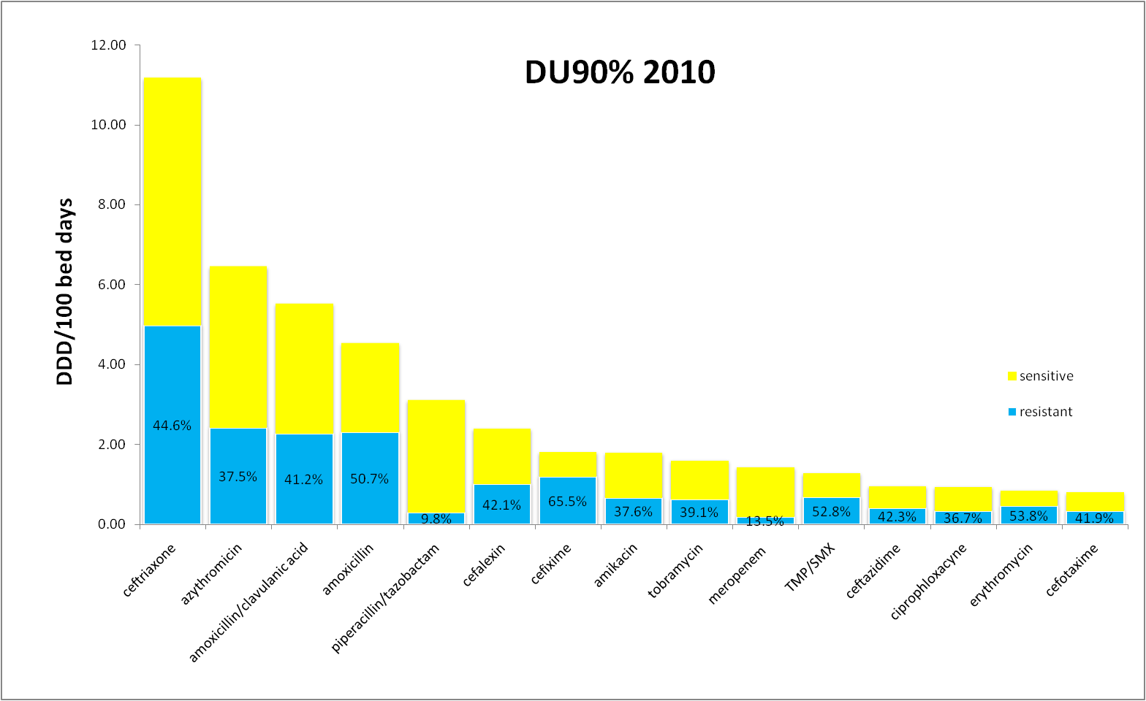
In 2010, antibiotics outside DU90% included ampicillin, benzylpenicillin, fenoximetilpenicillin, benzylpenicillin procaine, chloramphenicol, cefazolin, cefuroxime, cefprozil, cefepime, imipenem/cilastatin, clarythromycin, clindamycin, gentamicyn, vancomycin, teicoplanin, colistin and metronidazole. Table 1S (Supplementary material) documents the 15 antibiotics ranked in order of number DDDs corresponding to 90% of their use in 2010 as well as percentage resistance.

Figure 2 documents antibiotics for systemic use (ATC J01) as well as resistance profiles in paediatric and paediatric surgery clinics of Clinical Center Kragujevac in 2014.

Figure 2 – Drug utilisation 90%-cumulative resistance profile in 2014

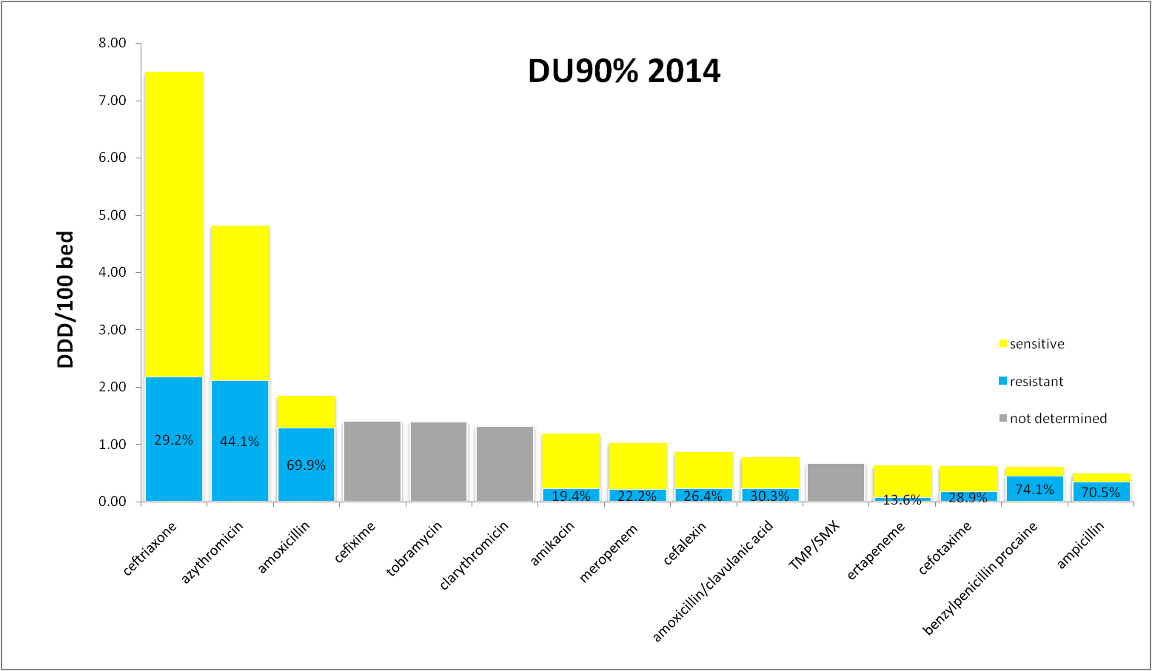

In 2014 antibiotics outside DU90% included chloramphenicol, ampicillin/sulbactam, piperacillin/tazobactam, cefazolin, cefprozil, ceftazidime, imipenem/cilastatin,erythromycin, clindamycin, gentamicyn, ofloxacyn, ciprophloxacyne, vancomycin, teicoplanin, colistin and metronidazole. Table 2S (Supplementary material) documents the 15 antibiotics ranked in order of number DDDs corresponding to 90% of the use in 2014.

From the antibiotic DU90% profile for 2010 versus 2014, total antimicrobial use among children in the hospital was 49.4 and 27.8 DDDs/100 bed days in 2010 versus 2014 (Tables 1S and 2S). There were limited changes in the patterns of antibiotic use comparing 2010 with 2014. The utilisation of reserve antibiotics from the reimbursement drug list was approximately 30% of the total consumption within the DU90% segment, with high utilisation of ceftriaxone and low utilisation of the other restricted antibiotics. Cumulative resistance rates generally decreased with a slight increase of resistance to azithromycin (37.5% to 44.1%, 2010 vs. 2014, calculated by dividing the number of resistant isolates by the total number of isolates). However, there was high cumulative resistance to benzyl penicillin, amoxicillin and ampicillin as the antibiotic panel used in sensitivity tests for S.aureus, the most common isolated bacteria, included these antibiotics and almost all S.aureus tested were 100% resistant. No data on resistance patterns were available for 4 of the 15 most commonly used antibiotics in 2014, while all were available in 2010. These were cefixime, tobramycin, clarythromicin, and TMP/SMX. Finally, the total costs per DDD typically decreased during the study period.

Specific cumulative resistance and utilisation rates for predominant bacterial population

The number of the assays performed for the paediatric and paediatric surgery clinics was comparable across the years, e.g. 4516 in 2010, 5268 in 2011, 4441 in 2012, 5217 in 2013 and 6871 in 2014.

The most identified isolated organisms in the paediatric and paediatric surgery clinics in Clinical Center Kragujevac in 2014 were Staphylococcus aureus (36 %), Streptococcus pneumoniae (20%) and Escherichia coli (13 %).

As methicillin resistance is CLSI-recommended surrogate for all beta lactams, we report just the extent of methicillin resistant S. aureus [MRSA]. This reflected a general downward trend from13.3% in 2010, to 3.8% in 2011, 0%in 2012, 6.7% in 2013, and 0.5% in 2014. Oxacillin is currently not available in Serbia, just cloxacillin. However, the antibiotic panel used in sensitivity tests for S.aures does not contain routine testing for cloxacillin. In addition, cefpodoxime is not currently tested, with cefpodoxime known to have good activity among major respiratory pathogens [36]

Figures 3 to 5 provide further details of the most common bacteria and the most common antimicrobial resistance patterns. S. pneumoniae isolates used to create the antibiogram reflected complicated and refractory infections since S. pneumoniae is not routinely cultured in uncomplicated otitis media or pneumonia (Figure 3).

Figure 3.-Antibiotic resistance patterns for Streptococcus pneumoniae from 2010 to 2014

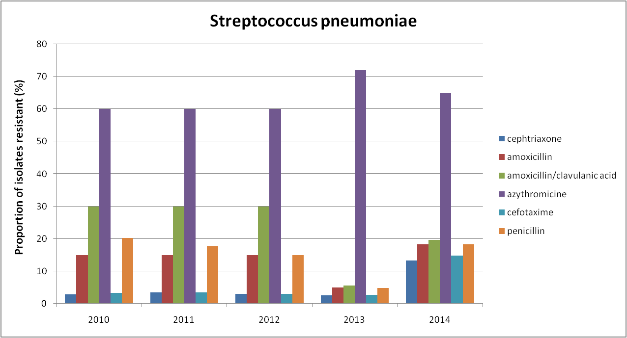

The percentage of isolates that conferred resistance to amoxicillin and amoxicillin/clavulanic acid decreased from 30% in 2010 to 20% in 2014, and for ampicillin from 17% to 15%, respectively. The percentage of isolates that conferred resistance to ceftriaxone and cefotaxime increased to 13% and 15% in 2014 from 3% in 2010, respectively (Figure 3).

Regarding the most used antimicrobials tested, the proportion of erythromycin resistance varied from 40% in 2010/2011 to 51% in 2014. Erythromycin susceptibility predicts azythromicin susceptibility to S. pneumoniae. Clindamicin resistance varied 55% in 2010/2011 to 59% in 2014. All isolates with exception of one were susceptible to vancomycin in 2014 (0.5%). Overall, 18% of S. pneumoniae at KC Kragujevac were resistant to penicillins.

According to CLSI recommended standards, CNS (central nervous system) breakpoints were used for S. pneumoniae isolated from cerebrospinal fluid. During the study period, there were three isolates and all were susceptible to ceftriaxone and one was resistant to penicillin. Resistance to azythromicin was high throughout the study period (Figure 3). However, there is no obvious association between the extent of azythromicin use and antibiotic resistance patterns for S.pneumoniae.

Figure 4 shows the trend in resistance rate of E.coli to amikacin, amoxicillin/clavulanic acid, TMP/SMX, cephtriaxone, ceftazidime, cefptaxime, cefalexin and meropenem. The results of resistance rates for other tested antimicrobials in 2014 were 66% for ampicillin, 55% for gentamicin, 52% for cefuroxime, 15% for cefepime, 7% ofloxacin, 5% nitrofurantoin and 0% for imipenem and ertapeneme.

Figure 4. Antibiotic resistance patterns for Escherishia coli from 2010 to 2014 for antibiotics in DU90% utilisation segment
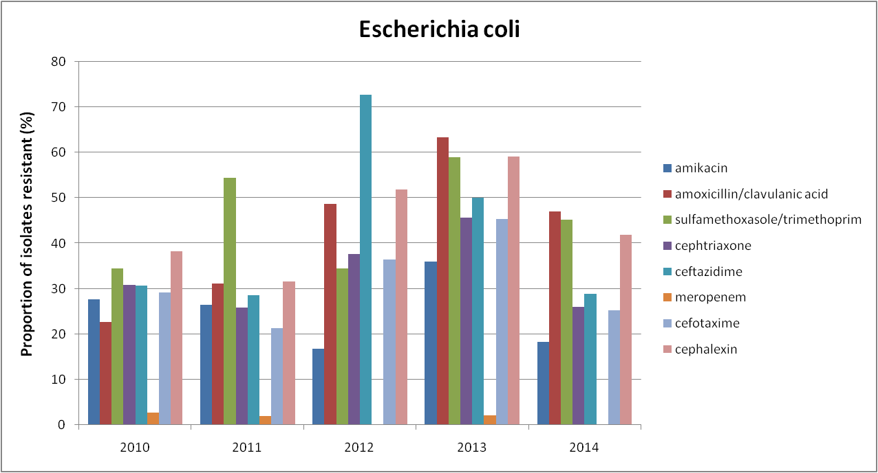

ESBL-rates were estimated based on susceptibility to third-generation cephalosporins, such as ceftazidime. The rate of ESBL-producing E.coli did not appreciably change during the study period although there appeared to be a downward trend, i.e. 30% in 2010 and 28% in 2014 respectively.

Cefazoline is a first-generation parenteral cephalosporin and an important choice for the treatment of acute UTI; however, its susceptibility is currently not routinely tested in the hospital. However even for the cephalosporins that are routinely used in susceptibility tests, it is not possible to make a straightforward decision whether their use was justified and therefore whether they contributed to the observed resistance patterns. For example, without an insight in diagnoses of the patients we could not decide about relation between ceftriaxone and resistance rate shown in the Figure 5.

Figure 5. Trend analysis of ceftriaxone utilisation and resistance pattern for E.coli
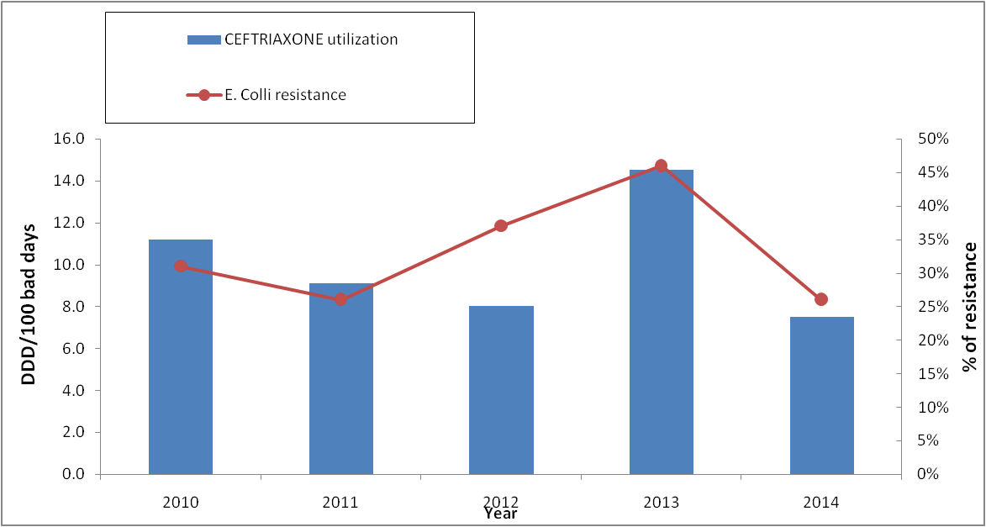

Cost data

The total costs per DDD typically decreased during the study period (Tables 1S and 2S). For example, the cost of ceftriaxone fell from 856 RSD/DDD in 2010 to 128 RSD/DDD in 2014, meropenem from 4475 in 2010 to 1970 RSD/DDD in 2014, and cefixime from 193 in 2010 to 134 RSD/DDD in 2014 (Table 1).

Table 1 – Cost/ DDD (in RSD) of antibiotics used among children in 2014.

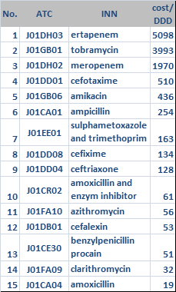

DISCUSSION

Developing effective antibiotic policies in hospitals depends on the surveillance of current resistance patterns, coupled with an understanding of current antibiotic utilization patterns, to guide empiric use whilst sensitivity analyses are being undertaken. Hence, it should become mandatory for hospitals to establish efficient surveillance systems along with monitoring current antibiotic utilization to improve their appropriate use. This can be helped by instigating measures such as the WHONET Software programme to monitor local resistance patterns; however, we believe only one hospital in Serbia is currently using this programme [37].

From the antibiotic DU90% profile in 2010 vs, 2014, we can conclude that the cumulative antimicrobial resistance is similar and relatively high (Figures 1 and 2 as well as Tables 1S and 2S), with high cumulative resistance rates among the most widely used antibiotics from 2010.

Overall, total antibiotic use decreased appreciably from 2010 to 2014 (Tables 1S and 2S); however, there was high prescribing of the reserved antibiotic ceftriaxone. In addition, sensitivity tests were not available for 4 of the 15 most commonly used antibiotics in 2014, pointing to a lack of integration between microbiology and routine clinical care in the hospital. We will now be reviewing this within the hospital to develop policies to improve future prescribing, and this will be part of future studies. This can also act as an exemplar for other hospitals in Serbia to improve future antibiotic prescribing.

One of the main findings of this study is the high resistance of S.pneumoniae to azythromicin (Figure 3). This maybe because there has been high total antibiotic consumption in Serbia versus other European countries in recent years [38]. In addition, antibiotic use among children in primary care in Serbia has been extremely high, with frequent prescribing for indications with little or no benefit from antibiotics such as upper respiratory tract infections [27]. This is important since previous antibiotic exposure in primary care is related to high antibiotic resistance in hospitals [39].

The debate continues in literature with regard to the impact of macrolide resistance on the outcome of pneumococcal pneumonia. Antibiotic resistant strains increase the severity of illness and make it more difficult to treat these infections effectively. Several cases of macrolide treatment failure have been documented in the literature [40, 41], and with high levels of macrolide resistance in this children’s hospital, we believe these antibiotics should not be routinely used as empiric therapy of S. pneumoniae whilst AMR rates remain high. Probable reasons for the increase in resistance rate of azithromycin and amoxicillin in 2014, despite a decrease in their intra-hospital use, is the extensive and unjustified prescribing of these antibiotics in primary care. On the other hand, the antibiotics used only in hospitals such as ceftriaxone had decreased both in usage and resistance rates. The main promoter of resistance to antibiotics is likely inappropriate use of these antibiotics in ambulatory care especially for wrong indications, which include potential viral infections, and this should be placed in focus in future interventions within the healthcare system in Serbia and other countries. A reasonable alternative to macrolides may be levofloxacin, which is already being used for the treatment of community acquired pneumonia (CAP) in children in clinical trials [42, 43]. Although quinolones may have adverse effects on the cartilage of great joints in children, recent studies with long-term follow-up showed that this risk was overestimated and its use in hospitalized children with such serious infection as CAP is justified [44]. Consequently, we have begun implementing this recommendation in this children’s hospital, alongside educational and other measures, to reduce inappropriate macrolide use, and will be following this up in future studies to further guide prescribing in this and other similar hospitals in Serbia.

Additionally, the Ministry of Health in Serbia is now planning to introduce in a national immunization programme - the pneumococcal conjugate vaccine - in all infants and young children. This may also be critical in reducing nasopharyngeal carriage and limit the dissemination of drug-resistant strains [45-47]. We will also be monitoring this impact in the future.

Rhamos et al. showed that the prevalence of resistance is country specific and reflects differences in the availability and consumption of antibiotics. In countries with a long tradition of surveillance programmes such as Australia, Slovakia and Sweden, there have been reductions in the prescription and use of antibiotics [48]. In our study, ESBL-rate E.coli decreased with decreased antibiotic consumption in 2010 vs. 2014; however, this was still high at 28% in 2014 . For an antibiotic to be considered as first line empirical treatment for urinary tract infections, resistance should not exceed 20% in the most likely infecting strains [49, 50]. According to these criteria, all third generation cephalosporins used in our hospital are currently above this with reported resistance rates from 25-28% (Figure 5). The use of antimicrobials for which the uropathogen has shown resistance can lead to serious consequences [51], particularly for patients with pyelonephritis. Consequently, in this situation, healthcare providers should consider empiric treatment with carbapenem or amikacin or another agent found to be consistently active on the basis of the local antibiogram. This policy has again already been introduced into our hospital, and again we will be monitoring the situation to provide guidance to others.

Encouragingly, the rate of MRSA among the pediatric population in KC Kragujevac is relatively low compared to reports from other countries [52], and it should be kept this way through the continuous monitoring of local S. aureus susceptibility patterns.

Since cloxacillin must be administered frequently (i.e. four times daily in children), and cloxacillin is sometimes associated with severe phlebitis, cefazoline is a reasonable substitute for the empiric management of bacteremia with MSSA. With such high levels of resistance in our hospital, clindamycin should only be used for infections caused by MSSA if the sensitivity of an isolate was confirmed, and the D-test for erythromycin – induced resistance was negative. Such recommendations have also now been in introduced in our hospital.

As can be seen (Section 3.3 as well as Tables 1S and 2S), the costs of antibiotics have been falling in recent years. This can be partially explained by a reform in the procurement system for hospital medicines in Serbia. Until 2013, Serbia had a system whereby each hospital procured their own medicines individually, choosing their own suppliers and brands for medicines to address particular diseases. Rather than competing on price, suppliers typically competed on the level of “rebate” offered to a hospital to increase the monies available to the hospital to purchase other goods and services. These rebates were often as much as one-third of the total purchase price. The new procurement system was introduced in 2014 to address this leading to central procurement and an appreciable drop in prices such as prices for ceftriaxone [32] (Table 1).

We acknowledge that there are typically a low number of tissue specimens analyzed in Serbian hospital, which may have influenced interpretation of the results. General limitations of DDDs are common for all aggregated data, exacerbated in the case of paediatric patients. This together with and the limitations of the aggregate microbiology data are described by Goryachkina et al. [26]. Calculations of costs and drug utilization in children based on adult DDDs can also not be used for estimates of prevalence, so the only aspects we could follow were time trends and comparisons between the groups. Despite these limitations, we believe our findings are robust and are already influencing prescribing in this hospital and wider.

CONCLUSIONS AND RECOMMENDATIONS

Overall, we believe our findings show that increased local efforts to enhance surveillance for AMR are necessary to inform treatment decisions, especially empiric use. The approach to local infection control should be multifaceted and should include microbiology and utilization assessments together with measures to improve local hygiene such as improved hand-hygiene in wards [53-56]. The development of pro-active antibiotic stewardship programs is a way forward [13-15,29,57-61] as well as consulting microbiologists and clinical pharmacologists when prescribing antibiotics for complex clinical cases [62]. Furthermore, joint efforts should be made to enhance appropriate antibiotic prescribing and dispensing in all primary, secondary and tertiary care settings in Serbia which treat children. This again will be the subject of future research projects together with increasing efforts in Serbia to reduce the illegal purchase of antibiotics in Serbia [37] as well as improve physician education surrounding antibiotic use.

Finally, we hope this original research in Serbia has implications for other central and eastern European countries struggling to enhance their appropriate use of antibiotics.

Acknowledgements.

All authors have been active participants in the research. We would like to thank Mr Radovan Kuzmanovic for IT support regarding microbial resistance data.

Funding and Conflicts of interest

There was no external funding for this research and no conflicts of interest. However, the write-up of the paper was in part supported by a grant from the Karolinska

No author has conflicts of interest to declare.

Key points
- The appropriate use of antibiotics especially in children is of growing importance given the extent of antibiotic resistance across countries including Serbia and the lack of new antibiotics
- Knowledge of current antibiotic utilisation patterns coupled with knowledge regarding current resistance rates is essential to improve the empiric use of antibiotics and reduce future AMR rates across sectors including hospitals
- Effective antibiotic guidance can be developed by combining an analysis of antibiotic utilisation and resistance patterns even in countries with limited resources, and lead to changes in the future empiric use of antibiotics and subsequent changes in resistance rates
- Reserving antibiotics through formal guidelines can help control their use, especially if prior authorisation schemes are in place in hospitals. However, this needs to be followed up with education and other initiatives to improve future use
- Appropriate use of antibiotics coupled with changes in pricing policies can appreciably reduce their costs benefitting all key stakeholder groups

REFERENCES
(* of interest, ** of considerable interest)
1. HM Government. Antimicrobial Resistance: Tackling a Crisis for the Health and Wealth of Nations. Available at URL: http://www.jpiamr.eu/wp-content/uploads/2014/12/AMR-Review-Paper-Tackling-a-crisis-for-the-health-and-wealth-of-nations_1-2.pdf.
*2. Md Rezal RS, Hassali MA, Alrasheedy AA, Saleem F, MdYusof FA, Godman B. Physicians' knowledge, perceptions and behaviour towards antibiotic prescribing: a systematic review of the literature. Expert review of anti-infective therapy. 2015;13(5):665-80.
Good review paper discussing physicians' knowledge and attitudes towards antibiotics
3. Laxminarayan R, Matsoso P, Pant S, Brower C, Rottingen JA, Klugman K, et al. Access to effective antimicrobials: a worldwide challenge. Lancet. 2016;387(10014):168-75.
4. Loeffler JM, Garbino J, Lew D, Harbarth S, Rohner P. Antibiotic consumption, bacterial resistance and their correlation in a Swiss university hospital and its adult intensive care units. Scandinavian journal of infectious diseases. 2003;35(11-12):843-50.
5. Frank U, Kleissle EM, Daschner FD, Leibovici L, Paul M, Andreassen S, et al. Multicentre study of antimicrobial resistance and antibiotic consumption among 6,780 patients with bloodstream infections. European journal of clinical microbiology & infectious diseases. 2006;25(12):815-7.
6. Gandra S, Barter DM, Laxminarayan R. Economic burden of antibiotic resistance: how much do we really know? Clinical microbiology and infection : the official publication of the European Society of Clinical Microbiology and Infectious Diseases. 2014;20(10):973-80.
7. Oxford J, Kozlov R. Antibiotic resistance--a call to arms for primary healthcare providers. International journal of clinical practice Supplement. 2013(180):1-3.
8. Laxminarayan R, Heymann DL. Challenges of drug resistance in the developing world.BMJ . 2012;344:e1567.
9. Earnshaw S, Mendez A, Monnet DL, Hicks L, Cruickshank M, Weekes L, et al. Global collaboration to encourage prudent antibiotic use. The Lancet infectious diseases. 2013;13(12):1003-4.
10. Ganguly NK, Arora NK, Chandy SJ, Fairoze MN, Gill JP, Gupta U, et al. Rationalizing antibiotic use to limit antibiotic resistance in India. The Indian journal of medical research. 2011;134:281-94.
11. Laxminarayan R, Duse A, Wattal C, Zaidi AK, Wertheim HF, Sumpradit N, et al. Antibiotic resistance-the need for global solutions. The Lancet infectious diseases. 2013;13(12):1057-98.
12. GRIPP. The Global Respiratory Infection Partnership. Available at URL:http://www.grip-initiative.org/about-the-partnership/partnerships-mission/the-grip-declaration/.
*13. Baur D, Gladstone BP, Burkert F, Carrara E, Foschi F, Döbele S, et al. Effect of antibiotic stewardship on the incidence of infection and colonisation with antibiotic-resistant bacteria and Clostridium difficile infection: a systematic review and meta-analysis. The Lancet Infectious Diseases.17(9):990-1001.
Good paper outlining the impact of a recent antibiotic stewardshop programme
*14. Hulscher M, Prins JM. Antibiotic stewardship: does it work in hospital practice? A review of the evidence base. Clinical microbiology and infection. 2017
Good paper outlining antibiotic stwardship programmes in practice in hospitals
15. Dyar OJ, Huttner B, Schouten J, Pulcini C. What is antimicrobial stewardship? Clinical Microbiology and Infection. 2017.
16 Official Gazette of the Republic of Serbia. Rulebook of the criteria, manner and procedure for listing/delisting of reimbursement medicines in/from the list of medicines prescribed and dispensed under the compulsory health insurance coverage. No: 65/15, 71/15, 104/15
17. Official Gazette of the Republic of Serbia. Rulebook of the criteria, manner and procedure for listing/delisting of reimbursement medicines in/from the list of medicines prescribed and dispensed under the compulsory health insurance coverage. Nos: 24/16, 57/16, 61/16
18. Official Gazette of the Republic Serbia, no 12/2016
19. Official Gazette of the Republic Serbia , no 101/13
20. WHO Collaborating Centre for Drug statistics Methodology. Guidelines for ATC classification and DDD assignment 2015. Available at URL: http://www.whocc.no/filearchive/publications/2015_guidelines.pdf.
21. Versporten A, Bolokhovets G, Ghazaryan L, Abilova V, Pyshnik G, Spasojevic T, et al. Antibiotic use in eastern Europe: a cross-national database study in coordination with the WHO Regional Office for Europe. The Lancet infectious diseases. 2014;14(5):381-7.
22. Furst J, Cizman M, Mrak J, Kos D, Campbell S, Coenen S, et al. The influence of a sustained multifaceted approach to improve antibiotic prescribing in Slovenia during the past decade: findings and implications. Expert review of anti-infective therapy. 2015;13(2):279-89.
23. Bergman U, Risinggard H, Vlahovic-Palcevski V, Ericsson O. Use of antibiotics at hospitals in Stockholm: a benchmarking project using internet. Pharmacoepidemiology and drug safety. 2004;13(7):465-71.
24. Vlahovic-Palcevski V, Gantumur M, Radosevic N, Palcevski G, Vander Stichele R. Coping with changes in the Defined Daily Dose in a longitudinal drug consumption database. Pharmacy world &science. 2010;32(2):125-9.
25. WHO Collaborating Centre for Drug Statistics Methodology, Guidelines for ATC classification and DDD assignment 2016. Oslo, 2016. Available at URL: https://www.whocc.no/filearchive/publications/2017_guidelines_web.pdf
**26. Goryachkina K, Babak S, Burbello A, Wettermark B, Bergman U. Quality use of medicines: A new method of combining antibiotic consumption and sensitivity data- application in a Russian hospital. Pharmacoepidemiology and drug safety. 2008; 17: 636-644.
Good paper outlining a new methodology to review utilisation patterns alongside resistance patterns to guide future care
**27. Bozic B. Use of antibiotics in paediatric primary care settings in Serbia. Arch Dis Child.2015 Oct;100(10):966-9
Landmark paper in Serbia discussing antibiotic use in this important patient population
28. Cox JA, Vlieghe E, Mendelson M, Wertheim H, Ndegwa L, Villegas MV, et al. Antibiotic stewardship in low-and middle-income countries: 'same, but different'? Clinical microbiology and infection. 2017.
29. Pulcini C. Antibiotic stewardship: update and perspectives. Clinical Microbiology and Infection. 2017.
30. Araujo da Silva AR, Albernaz de Almeida Dias DC, Marques AF, Biscaia di Biase C, Murni IK, Dramowski A, et al. The role of antimicrobial stewardship programmes in children: a systematic review. Journal of Hospital Infection. 2017
31. Clinical and Laboratory Standards Institute. Performance standards for antimicrobial disk susceptibility tests.Document M2-A9. Wayne, PA: CLSI; 20010.
32. World Bank. Serbia. Available at URL: http://www.worldbank.org/en/results/2014/02/24/centralized-procurement-of-drugs-saves-serbia-25-million-euros
33. Chitnis A, Wang R, Sun SX, Dixit S, Tawah A, Boulanger L. Impact of initiation of asenapine on patterns of utilization and cost of healthcare resources associated with the treatment of bipolar I disorder. Journal of medical economics. 2015:1-23.
34. Godman B, Petzold M, Bennett K, et al. Can authorities appreciably enhance the prescribing of oral generic risperidone to conserve resources?: Findings from across Europe and their implications. BMC Med 2014;12:98
35. Moon JC, Godman B, Petzold M, et al. Different initiatives across Europe to enhance losartan utilization post generics: impact and implications. Front Pharmacol 2014;5:219
36. Schito GC, Georgopoulos A, Prieto J. Antibacterial activity of oral antibiotics against community-acquired respiratory pathogens from three European countries. The Journal of antimicrobial chemotherapy. 2002;50 Suppl:7-11
37. WHO. WHONET Software. Available at URL: http://www.who.int/drugresistance/whonetsoftware/en/.
38. Kalaba M, Bajcetic M, Sipetic T, Godman B et al. High rate of self purchasing of oral antibiotics in Serbia: implications for future policies. PPRI Vienna 2011; 26. Available via: http://whocc.goeg.at/Downloads/Conference2011/PraesentationenPPRIKonferenz/general_PPRI%20conference%202011%20Abstract%20book.pdf
**39. Costelloe C, Metcalfe C, Lovering A, Mant D, Hay AD. Effect of antibiotic prescribing in primary care on antimicrobial resistance in individual patients: systematic review and meta-analysis. BMJ 2010;340:c2096.
Interesting paper discussing prescribing and resistance patterns in ambulatory care
40. Musher D, Dowell M et al. Emergence of macrolide resistance during treatment of pneumococcal pneumonia. New Engl J Med 2002; 346:630-1.
41. Van Kerkhoven D, Peetermans WE, Verbsit L, Verhaegen J. Breakthrough pneumococcal becteraemia in patients treated with clarithromycin or oral β-lactams. J AntimicrobChemother 2003; 51: 691-6.
42. Bradley J.S, Arguedas A, Blumer J. L, Sáez-Llorens X, Melkote R, Noel, G. J. Comparative study of levofloxacin in the treatment of children with community-acquired pneumonia. The Pediatric infectious disease journal 2007, 26(10): 868-878.
43. Kabra SK, Lodha R, Pandey RM. Antibiotics for community‐acquired pneumonia in children. Cochrane Database Syst Rev. 2010 Mar 17;(3):CD004874
44. Bradley JS, Kauffman RE, Balis DA, Duffy CM, Gerbino PG, Maldonado SD, Noel GJ. Assessment of musculoskeletal toxicity 5 years after therapy with levofloxacin. Pediatrics 2014;134(1): e146-e153.
45. Escola ,Kilpi T, Palmu A et al. Efficacy of a pneumococcal conjugate vaccine against otitis media. N Engl J Med 2001; 344: 403-9.
46. Mbelle N, Huebner RE, Wasas AD et al. Immunogenicity and impact on nasopharyngeal carriage of nonvalent pneumococcal conjugate vaccine. J Infect Dis 1999; 180: 1171-6.
47. Black S, Shinefield H, Fireman D .Efficacy, safety and immunogenocity of heptavalent pneumococcal conjugate vaccine in children. Pediatr Infect Dis J 2000; 19:187-15.
**48. Ramos NL et al. Characterisation of uropathogenic Escherichia coli from children with urinary tract infections in different countries. Eur J Clin Microbial Infect Dis. 2011; 30:1587-1593.
Landmark paper in this population to provide guidance on future care
49. Gupta K, Hooton TM, Naber KG, et al. Infectious Diseases Society of America European Society for Microbiology and Infectious Diseases. International clinical practice guidelines for the treatment of acute uncomplicated cystitis and pyelonephritis in women: A 2010 update by the Infectious Diseases Society of America and the European Society for Microbiology and Infectious Diseases. Clin Infect Dis 2011;52:e103-20.
50. Bryce A, Hay AJ, Lane I, et al. Global prevalence of antibiotic resistance in paediatric urinary tract infections caused by Escherichia coli and association with routine use of antibiotics in primary care: systematic review and meta-analysis. BMJ 2016;352:i939.
*51. Lee S, Song Y, Cho SH, Kwon KT. Impact of extended-spectrum beta-lactamase on acute pyelonephritis treated with empirical ceftriaxone. Microb Drug Resist. 2014;20:39–44
Well conducted research discussing empiric use of ceftriaxone in this patient population
52. Herigon JC, Hersh AL, Gerber JS at al. Antibiotic management of Staphylococcus aureus infections in US Children’s hospitals, 1999-2008. Pediatrics 2010 Jun; 125(6): e1294-300.
53. Freeman J, Dawson L, Jowitt D, et al. The impact of the Hand Hygiene New Zealand programme on hand hygiene practices in New Zealand's public hospitals. N Z Med J 2016;129:67-76.
54. Hansen S, Zingg W, Ahmad R, et al. Organization of infection control in European hospitals. J Hosp Infect 2015;91:338-45.
55. Storr JA, Engineer C, Allan V. Save Lives: Clean Your Hands: a WHO patient safety initiative for 2009. World Hosp Health Serv 2009;45:23-5.
56. Llor C, Bjerrum L. Antimicrobial resistance: risk associated with antibiotic overuse and initiatives to reduce the problem. Ther Adv Drug Saf 2014;5:229-41.
57. Viale P, Tumietto F, Giannella M, et al. Impact of a hospital-wide multifaceted programme for reducing carbapenem-resistant Enterobacteriaceae infections in a large teaching hospital in northern Italy. Clin Microbiol Infect 2015;21:242-7.
58. Rocha-Pereira N, Lafferty N, Nathwani D. Educating healthcare professionals in antimicrobial stewardship: can online-learning solutions help? J Antimicrob Chemother 2015;70:3175-7.
59. Zhang YZ, Singh S. Antibiotic stewardship programmes in intensive care units: Why, how, and where are they leading us. World J Crit Care Med 2015;4:13-28.
60. Pollack LA, Srinivasan A. Core elements of hospital antibiotic stewardship programs from the Centers for Disease Control and Prevention. Clin Infect Dis 2014;59 Suppl 3:S97-100.
61. Goff DA, Mendelson M. Antibiotic stewardship hits a home run for patients. The Lancet Infectious diseases. 2017;17(9):892-3
62. Jankovic SM, Milovanovic D, RuzicZecevic D, Folic M, Rosic N, Vulovic D. Consulting clinical pharmacologist about treatment of inpatients in a tertiary hospital in Serbia. Eur J Clin Pharmacol. 2016 Dec;72(12):1541-1543

