A Broadband Helical Saline Water Liquid Antenna for Wearable Systems
Gaosheng Li, Yi Huang, Gui Gao, Cheng Yang, Zhonghao Lu, and Wei Liu
Gaosheng Li, Gui Gao, Cheng Yang, Zhonghao Lu and Wei Liu are with the College of Electronic Science and Engineering, National University of Defense Technology, Changsha, 410073, China. (Gaosheng7070@vip.163.com)
Yi Huang is with the Department of Electrical Engineering and Electronics, University of Liverpool, Liverpool, L69 3GJ, United Kingdom. Gaosheng Li is a visiting scholar with the University of Liverpool during 2016-2017.
Gaosheng Li received his B.S. degree in electromagnetic field and microwave and his M.S. degree as well as his PH. D. in electronic science and technology from the National University of Defense Technology (NUDT), Changsha, China, in 2002, 2004 and 2013, respectively.
He has been with NUDT as a Teaching Assistant from 2004 to 2006, and a Lecturer from 2006 to 2011, and then as an Associate Professor since 2011. From 2014 to 2016, he was with Nanjing University of Aeronautics and Astronautics (NUAA) and Wuxi Huace Electronic Systems Co., Ltd., China as a Postdoctoral Research Fellow. From 2016 to 2017, he is a Visiting Scholar with the University of Liverpool (UoL), United Kingdom, sponsored by China Scholarship Council (CSC).
Dr. Li is the author or co-author of 6 books and 91 papers published in journals and conference proceedings. He owns 16 Chinese patents and 6 software copyrights. He won 2 national scientific prizes in 2007 and 2013, respectively. He is a Member (2008) of the IEEE AP Society and EMC Society, a Member (2016) of IET, and a Member (2011) of the Institute of Electronics, Information and Communication Engineers (IEICE), as well as a Senior Member (M’2008, SM’2014) of the Chinese Institute of Electronics (CIE).
ORCID ID: orcid.org/0000-0001-5230-1428
Total number of words: 4027
A Broadband Helical Saline Water Liquid Antenna for Wearable Systems
A broadband helical liquid antenna made of saline water is proposed. A transparent hollow support is employed to fabricate the antenna. The rotation structure is fabricated with a thin flexible tube. The saline water with a concentration of 3.5% can be injected into or be extracted out from the tube to change the quantity of the solution. Thus, the tunability of the radiation pattern could be realized by applying the fluidity of the liquid. The radiation feature of the liquid antenna is compared with that of a metal one, and fairly good agreement has been achieved. Furthermore, three statements of the radiation performance corresponding to the ratio of the diameter to the wavelength of the helical saline water antenna have been proposed. It has been found that the resonance frequency increases when the length of the feeding probe or the radius of the vertical part of the liquid decreases. The fractional bandwidth can reach over 20% with a total height of 185 mm at 1.80 GHz. The measured results indicate reasonable approximation to the simulated. The characteristics of the liquid antenna make it a good candidate for various wireless applications especially the wearable systems.
Keywords: Helical antenna, liquid antenna, tunable antenna, water antenna.

1. Introduction
Liquid antennas, especially the non-metal liquid antennas, have drawn more and more attentions in recent years due to the potential in reconfigurability and the virtue of flexibility, transparency, together with the low price, etc.
Several kinds of non-metal liquid antennas have been proposed or demonstrated. The first type is to use sea water, saline water or distilled water to build the radiation structure. For instance, to form a monopole or a dielectric resonator antenna. The second idea is to substitute some part of the conventional antenna to make a new one. The water patch microstrip antenna is one of the examples.
A wideband hybrid rectangular water antenna for DVB-H (Digital Video Broadcasting - Handheld) applications was developed. The hybrid structure combined a dielectric resonator antenna and a monopole antenna to effectively double the available bandwidth without compromising other characteristics [1]. A transparent water dielectric patch antenna fed by an L-shaped probe was proposed. In contrast to other reported water antennas, the proposed design had the operation mechanism similar to the conventional metallic patch antenna [2]. A mechanically reconfigurable frequency-tunable microstrip antenna that uses a liquid actuator as the dielectric layer to reduce the size is reported [3]. The dielectric liquid is encapsulated in the polymer to form an actuator, which can change the liquid thickness. Thus, the resonant frequency of the fabricated antenna can be changed. A sea water monopole antenna consists of a feeding probe and a sea-water cylinder held by a clear acrylic tube for maritime wireless communications was presented to demonstrate the feasibility of liquid antenna [4]. Measurement shows that the proposed sea-water antenna has high radiation performance. A Compact dual-feed water-based antenna for hand portable systems was developed, and a ground defect structure was employed to provide a decoupling path between the antenna ports [5]. A Sea-Water Half-Loop Antenna was designed for maritime wireless communications [6], which could generate a new antenna when needed with the help of a pump in the ocean environment. An antenna consisted of a cylindrical conducting monopole antenna, saline-water and a biocompatible shell was designed for Industrial, Science and Medical (ISM, 2.45 GHz) band [7]. . The miniaturization of a liquid-based DRA due to the high relative permittivity of water was demonstrated. Furthermore, a DRA-based technique was proposed for measuring liquid permittivity [8]. A hybrid antenna with solid and liquid materials was discussed [9], with the focus of the influence of the feeding locations and the distribution of the liquid.
In the area of wearable and body-centric networks, a conformal wearable antenna for medical body-area network was developed [10]. This antenna was built by placing a truncated meta-surface, consisting of a 2×2 array of I-shaped elements, underneath a planar monopole. Narrowband interference mitigation in body surface to external communication in ultra-wide-band body-area network using first order pulse has been proposed [11]. A wireless wearable surface functional electrical stimulator has been developed [12]. An all-textile logo antenna was designed [13]. The crossed LV-shaped logo composed of two longer thin arms and two shorter thick arms. The proposed antenna was fabricated from a conductive textile and a leather substrate. A CPW-Fed wearable monopole antenna using conductive nanomaterial with different conductivity for on-body applications was designed [14]. The antenna consisted of a rectangular patch with improved ground plane structures using graphene and carbon nanotubes on the flexible substrate.
Till now, some of the published liquid antennas are of fixed forms without using of the fluidity of the liquid. Others obtained primary performance of reconfigurability, but further study is still needed to improve the convenience together with the variety and the diversity of the antennas. At the same time, the requirement for new types of wearable systems become more and more intense.
Here, we will present a manually tunable broadband helical saline water antenna, the performance of which could be changed by adding or reducing the water. The influence of relative parameters on the operating frequency bands and the radiation patterns has been studied. The features of the antenna make it suitable for several application environments of wireless systems.

2. Configuration and structure
The designing of the antenna is in accordance with the elementary principle of helical antennas [15]. The general theory of the thin metal wire helical antenna also work for this one, especially for the relationship between the electrical size and the radiation pattern. A hollow cylindrical transparent hard plastic tube is used to fabricate the liquid helical antenna, and a thin flexible tube containing liquid is twined around the cylindrical one, as shown in Figure 1 (a). Here, the total height of the hard tube is 185 mm and the inner and outer radius is 8 mm and 10 mm, respectively. Furthermore, this kind of antenna can be applied to wearable systems with convenient, as shown in Figure 1 (b), where a flexible antenna is fixed on the arm of the user by himself. A digital thermometer and a syringe together with an electronic balance are helpful for the investigation, as shown in Figure 1 (c), (d) and (e). An SMA interface with a long probe sticking into the lower end of the liquid is used for the signal excitation, as shown in Figure 1 (f). A piece of single side substrate with the size of 100 mm×70 mm is used for the mounting of the feeding interface.
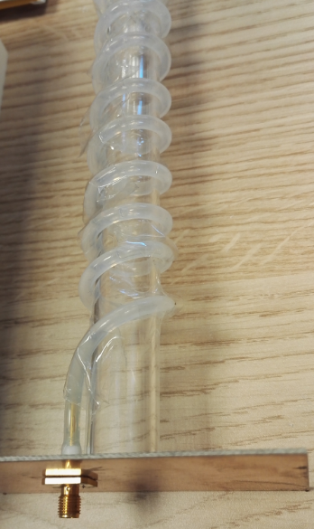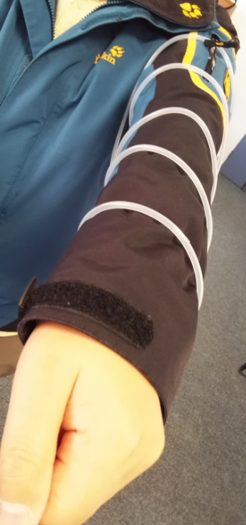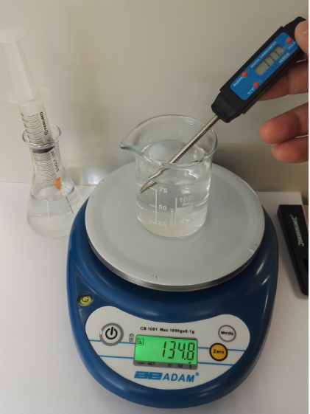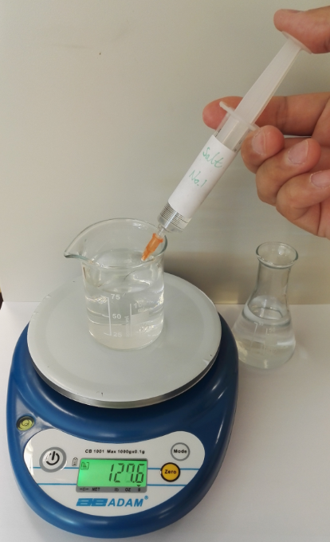
(a) (b) (c) (d)
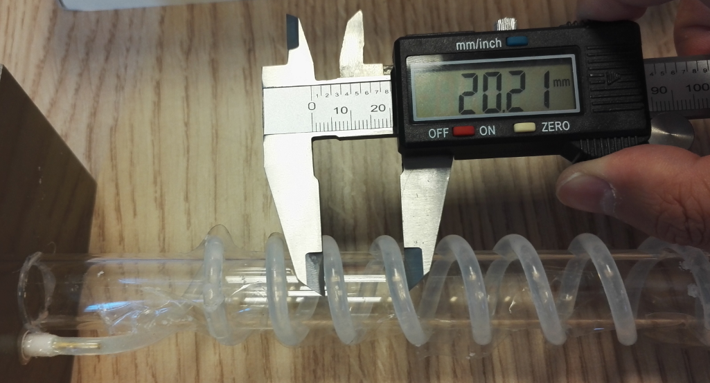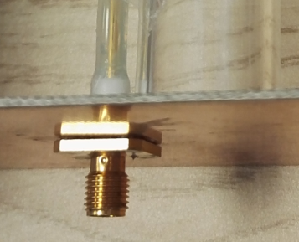
(e) (f)
Figure 1. Photographs of the helical liquid antenna. (a) Photograph of the saline water antenna, (b) A helical liquid antenna on the arm , (c) Measuring the temperature of the saline water, (d) Extracting the liquid from a beaker with a syringe, (e) Measuring the distance of the circles of the soft tube, and (f) The feeding probe of the antenna.
Sure, it is impossible for the antenna with a big substrate as shown in Figure 1(a) to operate in the scenario shown in Figure 1(b). However, we have simulated and fabricated a much smaller feeding structure that has a substrate dimensions of 2 cm×2 cm×0.1 cm, which is affordable for the user. By the way, there is really not very detailed investigations for the applications of wearable systems. The proposed application scenario is only the elementary design and we will try to optimize it. At the same time, we hope the proposed design experiences would enrich the choices of sea water antennas for the navy and others.
The solution consists of water and salt is made up and the temperature of the saline water is measured to be 21.5 ℃ at that time. The concentration of the solution is 3.5%, which is similar to that of the average value of the sea water. The model and the geometry structure of the antenna is shown in Figure 2. The dimensions of the antenna is shown in Table 1.
Table 1. The dimensions of the liquid antenna.
Parameter | Dimension (mm) | Parameter | Dimension (mm)
Hs | 185 | Lp | 8
Ds | 21 | Rto | 5
Lg | 100 | Tg | 0.035
Wg | 70 | Ts | 2.2
Hv | 17
Figure 2. The structure of the helical saline water antenna.
A flexible transparent tube with the inner diameter of 3.0 mm and the outer diameter of 5.0 mm is used to contain the saline water, and it is twined around the cylindrical support for eight circles. Since the hard tube is fixed at the center of the substrate, thus, the location of the feeding probe is 12.5 mm to the center of the substrate, considering the radius of the two tubes. As has been introduced, the total length of the transparent hard cylindrical tube is 185 mm. There is not only 8 circles around it, but also a vertical straight liquid part of 17.0 mm at the lower end. So the total length of the circles is 168 mm, and the distance between the adjacent helical circles is 21.0 mm each.
The liquid can be injected into or be sucked out from the soft tube by the syringe, thus to realize the tunability of the antenna. That is to say, we could get a rotation angle of 2,880 degrees of the maximum, while the angle could be decreased to be only 720 degrees or even less, if we get water out of the tube. By this means, the manual tunability of the antenna could be obtained. And there is no need to change the whole structure during the variations of the inner liquid.

3. Simulations and analysis

3.1. Variations of the radiation diversity according to the ratio of the diameter to the wavelength
For a metal helical antenna, it has been proved that the antenna with a certain ratio of the diameter to the operating wavelength will present three statements of radiation patterns, as shown in Figure 3 [16].
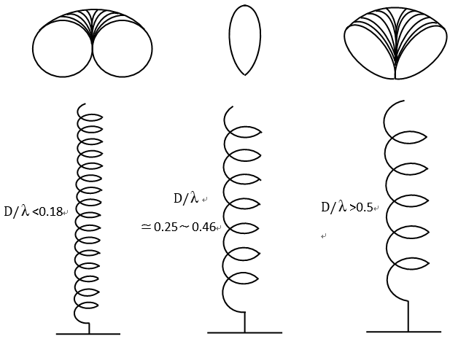
Figure 3. The variation of the radiation patterns according to the ratio of the diameter to the wavelength.
A similar conclusion as metal antennas has been achieved after our investigation on the saline water helical antenna. The directivity of three statements of the antenna, including horizontal omnidirectional, end-fire and sloping up radiation. CST Microwave Studio is used for the modelling and the simulations.
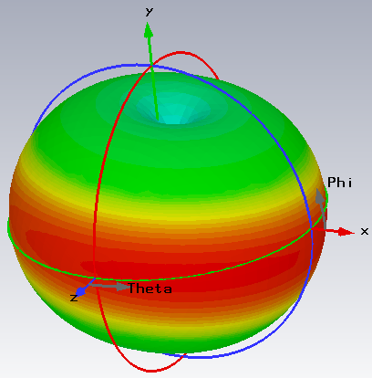
- (b)
Figure 4. Radiation patterns of the saline antenna at 0.5 GHz. (a) The 3-D radiation pattern. (b) The 2-D radiation patterns of four angles of conditions including Phi=0°, Phi=90°, Theta=0° and Theta=90° (The other varies from 0° to 360°).
Figure 4 presents the 3-D radiation pattern as well as the 2-D patterns in a polar coordinate at 0.5 GHz, including four curves, namely the slice of Phi=0°, Phi=90°, Theta=0° and Theta=90°, while the other angle varies from 0° to 360°. This is the first statement corresponding to Figure 3, namely, the horizontal omnidirectional one. It could be seen that the radiation distributes evenly in the horizontal plane.
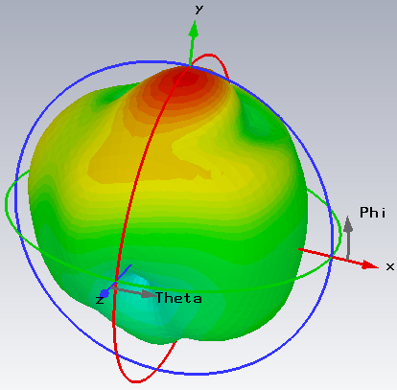
- (b)
Figure 5. Radiation patterns of the liquid antenna at 3.7 GHz. (a) 3-D radiation pattern. (b) 2-D radiation patterns of four angles of slices including Phi=0°, Phi=90°, Theta=0° and Theta=90°.
The corresponding radiation patterns at 3.7 GHz are shown in Figure 5, which belong to the situation of end-fire radiation with the main lobe at the upper axial direction.
The energy in the axial direction decreases with the rising of the frequency above 4.8 GHz. As it could be observed from Figure 6 (Take the example of 6.0 GHz for explanation), the large radiation directions move to that around the overhead area, which is similar to that of the metal helical antenna.
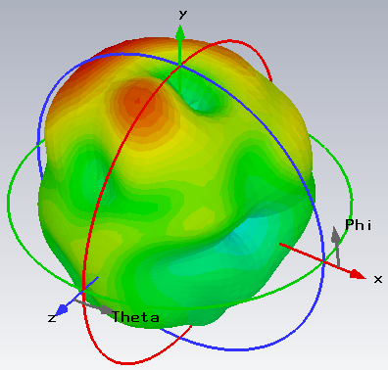
(a) (b)
Figure 6. Radiation patterns of the saline water antenna at 6.0 GHz. (a) The 3-D radiation pattern. (b) The 2-D radiation patterns of four angles of conditions including Phi=0°, Phi=90°, Theta=0° and Theta=90°.
The detailed values of the above-mentioned situations are shown in TABLE I. As it could be seen from the table, the radiation directivity turning points of the liquid antenna is 0.1 and 0.4, which are lower than the metal helical antenna (0.18 and 0.5), while the gap remains nearly the same, namely 0.30 and 0.32, respectively. Corresponding to the parameters in Table 2, it is really difficult for one antenna to operate in such a wide frequency band and cover the range from several hundred MHz to several GHz. A specifically designed feeding structure would benefit the matching performance of the antenna, and furthermore to enlarge the bandwidth.
Table 2. Radiation parameters of the antenna according to the ratio of the diameter to the wavelength.
Radiation Situation | Horizontal Omnidirectional | End- Fire | Sloping Up
Diameter (mm) | 25 | 25 | 25
Frequency Range (GHz) | < 1.2 | 1.2-4.8 | > 4.8
Wavelength Range (mm) | > 250 | 62.5-250 | < 62.5
Ratio ($D/λ$) | < 0.1 | 0.1-0.4 | > 0.4
Ratio of Metal Antenna ($D/λ$) | < 0.18 | 0.25-0.46 | > 0.5

3.2. Comparisons of saline water antenna with the metal helical antenna
The comparisons of radiation patterns of the saline water helical antenna with that of the metal one are shown in Figure 7. The 2-D patterns at 1.8 GHz and 2.0 GHz are displayed respectively. The plane of Theta=90° & Phi varies from 0° to 360° is presented, and it could be found from the figure that the gains of the metal antenna are higher than that of the liquid one.
Figure 7. Radiation patterns of the saline water helical antenna compared with that of a metal antenna (Theta=90° & Phi varies from 0° to 360°).
The gain of each configuration is shown in Table 3, where it could be found that the differences are 2.47 dBi and 1.15 dBi. The gaps are mainly the result of the obvious distinction in the conductivity, which leads to different surface current distributions, especially for the amplitudes.
Table 3. Comparison of the gain of the liquid antenna with the helical metal antenna.
Antenna Material | Saline Water | Metal
Gain at 1.8 GHz (dBi) | 3.80 | 6.27
Gain at 2.0 GHz (dBi) | 4.48 | 5.63

3.3. Reflection coefficient vs. length of the probe
Figure 8. Reflection coefficient vs. probe length.
The length of the probe has an important impact on the performance of the antenna. Figure 8 shows the reflection coefficients of four sizes, from which it could be observed that the resonance frequency increases when the length of the probe decreases from 12.0 mm to 8.0 mm, 5.0 mm and finally to 2.0 mm, as shown in Table 4. The tendency is a positive proportion that nearly linear variation between the size of the wavelength and the probe length. All the fractional bandwidths are over 20% with the maximum of 24.1%.
Table 4. The influence of the probe length on the reflection coefficients.
Probe Length (mm) | 12.0 | 8.0 | 5.0 | 2.0
Center Freq. (GHz) | 1.70 | 1.92 | 2.12 | 2.44
Min. S11 (dB) | -25.7 | -19.9 | -16.3 | -12.9
Freq. Range (GHz) | 1.54-1.90 | 1.73-2.17 | 1.90-2.42 | 2.19-2.75
Fractional Bandwidth | 20.9% | 22.6% | 24.1% | 22.7%

3.4. Reflection coefficient vs. thickness of the substrate
The thickness of the substrate would lay some influence on the matching performance of the feeding structure. Here, the material of Rogers RT5880 with a dielectric permittivity of 2.2 is chosen for the study. The resonance frequency decreases from 1.74 GHz to 1.70 GHz, 1.66 GHz and then 1.62 GHz, when the thickness of the substrate increases from 0.6 mm to 1.2 mm, 2.2 mm and 3.0 mm, as shown in Figure 9 and Table 5. The thicker the substrate gets, the lower resonance frequency it would obtain. During the variation, the fractional bandwidth remains nearly the same value of 20%.
Figure 9. Reflection coefficients according to different thicknesses of the substrate.
Table 5. The influence of the substrate thickness on the reflection coefficients.
Substrate Thickness (mm) | 0.6 | 1.2 | 2.2 | 3.0
Center Freq. (GHz) | 1.74 | 1.70 | 1.66 | 1.62
Min. S11 (dB) | -24.9 | -25.5 | -26.8 | -27.2
Freq. Range (GHz) | 1.57-1.93 | 1.54-1.89 | 1.50-1.84 | 1.47-1.80
Fractional Bandwidth | 20.1% | 20.4% | 20.3% | 20.2%

3.5. Reflection coefficient vs. material of the substrate
If we change the material of the substrate while keeping the thickness and other configurations stable, the resonance frequency will stay at the same point, with only differences in the concrete values, as shown in Figure 10. This phenomenon verifies that the resonance frequency is determined by several parameters except the dielectric permittivity of the substrate.
Figure 10. Reflection coefficient vs. dielectric permittivity.
The materials used here refer to Rogers TMM13i, Arlon ar600, FR-4 and Rogers RT 5880, with the permittivity of 12.85, 6.0, 4.3 and 2.2, respectively. An interesting phenomenon is that the matching performance will improve as the permittivity decreases.

3.6. Reflection coefficient vs. radius of the vertical liquid
The operating frequency range of the antenna could be changed by alternating the radius of the vertical part of the liquid at the lower end, as shown in Figure 11 and Table 6. Again, it is proved that the resonance frequency of the antenna has a positive proportion relationship with the size of the structure, which is the radius of the vertical cylindrical liquid here.
Figure 11. Reflection coefficient vs. radius of the vertical part of the liquid.
Table 6. The influence of the radius of the vertical liquid on the reflection coefficients.
Radius (mm) | 1.0 | 1.5 | 2.0 | 2.5
Center Freq.(GHz) | 2.02 | 1.79 | 1.73 | 1.64
Min. S11 (dB) | -21.4 | -23.5 | -17.7 | -15.8
Freq. Range (GHz) | 1.51-1.80 | 1.58-1.91 | 1.61-1.99 | 1.83-2.26
Relative Bandwidth | 17.5% | 18.9% | 21.1% | 21.0%
3.7. Tunability of the liquid antenna
As the main radiation material is liquid, there is a potential to make use of the fluidity to achieve the tunability of the antenna. The quantity of the water can be added or be reduced, which would bring forth the increasing or decrease of the rotation angle of the helical antenna. Thus the variation in the radiation would occur. We carried out some calculations for the rotation angles of 2520°, 2160°, 1800° and 1440°, which refers to the circle number of 7, 6, 5 and 4. The computational results are shown in Figure 12. Variations in the radiation pattern could be noticed, though not so large.
Figure 12. Radiation pattern vs. rotation angle of the helical liquid antenna at 1.60 GHz.

4. Measurements and results
A saline water liquid helical antenna is fabricated and measured for verification of the proposed simulations and analysis.
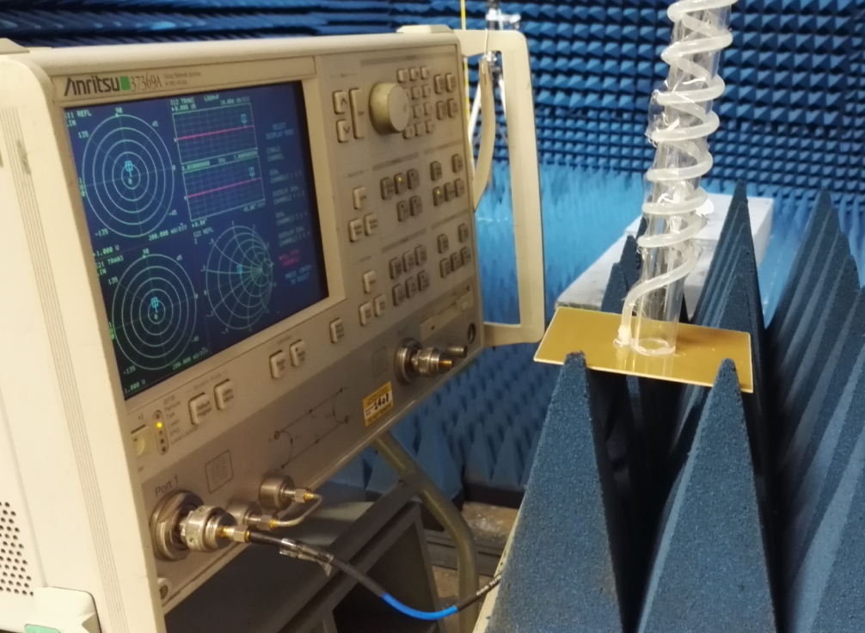
Figure 13. Measurement of the reflection coefficients of the helical liquid antenna with the vector network analyzer.
The substrate is Rogers RT5880 with the size of 99.5 mm×69.6 mm, and the thickness is 1.18 mm. An SMA connector with a probe on the head is used to make excitations. For the measurement of the reflection coefficients, a vector network analyzer (VNA), Anritsu 37369A, is used to get the S11, as shown in Figure 13.
Figure 14 presents the comparison of the simulated and the measured S11 curves from 40 MHz to 3.0 GHz. The reflection coefficients at the configuration of the probe length 8.0 mm and that of the substrate thickness of 2.2 mm are shown. Both of the two resonance frequencies are slightly lower than that of the simulated values under the two configurations while the whole shapes agree well.
Figure 14. Comparison of the simulated and the measured results of the reflection coefficients.
The radiation patterns are measured in the anechoic chamber with the help of a turntable and the VNA, as shown in Figure 15. A wideband ridged horn is used to radiate signals.
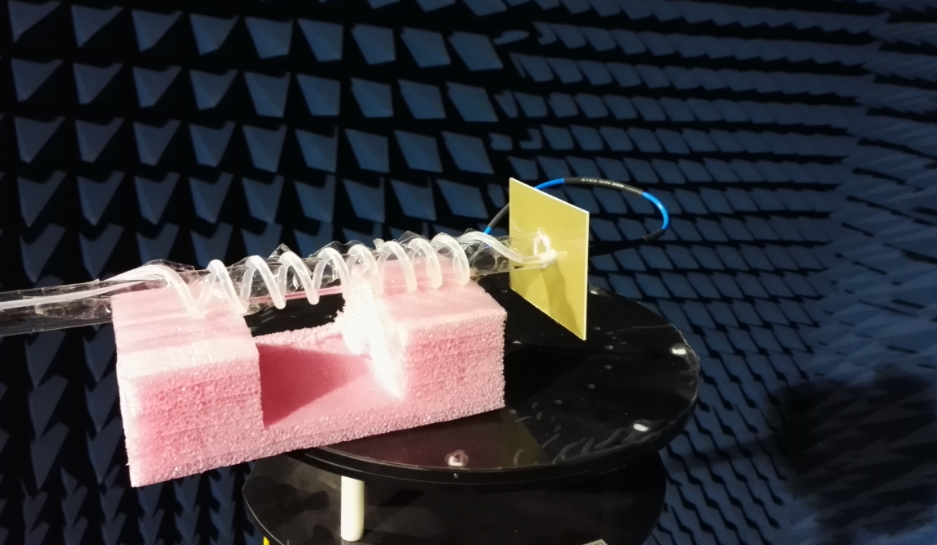
Figure 15. Measurement of the radiation patterns of the helical antenna in the anechoic chamber.
Figure 16 presents the comparison of the simulated and the measured radiation patterns of the saline water antenna at 1.90 GHz, when the rotation angle of the liquid is 2,790 degrees.
- (b)
Figure 16. Comparison of the simulated and measured radiation patterns of the helical antenna. (a) Horizontal polarization, (b) Vertical polarization.
The horizontal and vertical polarizations of the auxiliary testing antenna are used one by one. The points of view for the two slices are Theta=90° while Phi varies from 0° to 360° in Figure 16 (a), and Phi=90° while Theta varies from 0° to 360° in Figure 16 (b).
The measured shapes of the radiation patterns in the two slices are similar to those simulated. Fairly good similarities and agreements could be found especially in the locations of the valleys and zeros.

5. Conclusion
The simulations and measurements demonstrated the validation of the helical saline water liquid antenna. The flexibility and the fluidity of the liquid make it a good candidate for wireless wearable electronics systems, including body-center network, Internet of Things (IoT), wireless energy harvesting, sports and health monitoring as well as multimedia amusement systems and so forth. To change the parameters of the probe, the substrate, the diameter and the height of the vertical liquid together with the concentration of the saline water would bring the variations of the matching performance in frequency ranges of the antenna. To change the quantity of the liquid solution could lead to the changes of the radiation patterns, which is an easily realized means of low cost and complexity for tunability. The flexibility of the tube as well as the liquid enables the convenience of folding and packing up when it is not in use, which gives more freedom of the applications of the antenna.

References
- Lei Xing, Yi Huang, Qian Xu, and Saqer AlJa’ afreh, “Wideband, Hybrid Rectangular Water Antenna for DVB-H Applications,” Microwaves and Optical Technology Letters, 2015, Vol. 57, Iss. 9, pp.2160-2164.
- Yujian Li, Kwai-Man Luk, “A Water Dense Dielectric Patch Antenna,” IEEE Access, vol. 3, 2015, pp.274-280.
- Kentaro Noda, Makoto Ohkado, Binh Nguyen, Kiyoshi Matsumoto, Hisayoshi Fujikawa, and Isao Shimoyama, “Frequency-Tunable Microstrip Antenna with Liquid Actuator Using Gradually Widened Transmission Line,” IEEE Antennas and Wireless Propagation Letters, vol. 14, 2015, pp. 551–555.
- Changzhou Hua, Zhongxiang Shen, and Jian Lu, “High-Efficiency Sea-Water Monopole Antenna for Maritime Wireless Communications,” IEEE Transactions on Antennas and Propagation, vol. 62, 2014, pp. 5968-5973.
- Saqer S. Alja’afreh, Yi Huang, Lei Xing, “A Compact Dual-feed Water-based Diversity Antenna,” Proceedings of Loughborough Antennas & Propagation Conference, Loughborough, United Kingdom, November, 2013, pp.182-185.
- Changzhou Hua, Zhongxiang Shen, “Sea-Water Half-Loop Antenna for Maritime Wireless Communications,” Proceedings of IEEE 4th Asia-Pacific Conference on Antennas and Propagation, Bali, Indonesia, July, 2015, pp.231-232.
- Yunnan Jin , Jinpil Tak, Jaehoon Choi, “Broadband hybrid water antenna for ISM-band ingestible capsule endoscope systems,” Proceedings of International Workshop on Antenna Technology, pp.82-85. Cocoa Beach, FL, USA, March, 2016.
- Rongguo Zhou, Hualiang Zhang, Hao Xin, “Liquid-based Dielectric Resonator Antenna and its Application for Measuring Liquid Real Permittivities,” IET Microwaves, Antennas & Propagation, vol. 8, no. 4, pp. 255-262, 2014.
- Chenglong Lin, Gaosheng Li, Peiguo Liu, Yujian Qin and Yi Huang, “A Hybrid Antenna with Solid and Liquid Materials,” International Symposium on Antennas and Propagation, Okinawa, Japan, Oct., 2016.
- Jiangzhi Hao, Donovan E. Brocker, Peter E. Sieber, and Douglas H. Werner, “A Compact, Low-Profile Metasurface-Enabled Antenna for Wearable Medical Body-Area Network Devices,” IEEE Transactions Antennas and Propagation, vol. 62, no. 8, pp. 4021-4030, August, 2014.
- Deepak Kumar Rout, Susmita Das, “Narrowband Interference Mitigation in Body Surface to External Communication in Ultra-wide-band Body-area Network using First Order Hermite Pulse”, International Journal of Electronics, Vol. 103, No. 6, 2016, pp. 985-1001.
- Haipeng Wang, Aiwen Guo, Yuxuan Zhou, Yang Xia, etc., “A Wireless Wearable Surface Functional Electrical Stimulator”, International Journal of Electronics, Vol. 104, No. 9, 2017, pp. 1514-1526.
- Jinpil Tak, and Jaehoon Choi, “An All-Textile Louis Vuitton Logo Antenna,” IEEE Antennas and Wireless Propagation Letters, vol. 14, no. 2, pp. 1211-1214, Feb., 2015.
- M. M. Mansor, S. K. A. Rahim, and U. Hashim, “A CPW-fed 2.45 GHz Wearable Antenna Using Conductive Nanomaterials for On-Body Applications,” IEEE Region 10 Symposium, Kuala Lumpur, Malaysia, 2014, pp. 240-243.
- R. P. Singh, R. N. Singh, “Helical Antenna for Satellite Transmission”, International Journal of Electronics, Vol. 34, No. 5, 1973, pp. 601-607.
- Zaiping Nie, “Antenna Engineering Handbook”, Chengdu: Press of the University of Electronic Science and Technology of China. July, 2014, pp. 918-919.

