**A study of the relationship between microstructure and oxidation effects in nuclear graphite at very high temperatures**

I-Hsuan Loa,b, Nassia Tzelepic, Eann A Pattersonb, Tsung-Kuang Yeha,d*

a Institute of Nuclear Engineering and Science, National Tsing-Hua University, Hsinchu 30013, Taiwan.

b School of Engineering, University of Liverpool, Liverpool, The Quadrangle, Brownlow Hill L69 3GH, United Kingdom.

c National Nuclear Laboratory (NNL), Reactor Operations Support, Central Laboratory, Sellafield CA20 1PG, United Kingdom.

d Department of Engineering and System Science, National Tsing-Hua University, Hsinchu 30013, Taiwan.

*Corresponding author. Tel.：+ 886-3-5742373；fax：+ 886-3-5720724.

E-mail address：tkyeh@mx.nthu.edu.tw (T.K. Yeh).

**Abstract**

Graphite is used in the cores of gas-cooled reactors as both the neutron moderator and a structural material, and traditional and novel graphite materials are being studied worldwide for applications in Generation IV reactors. In this study, the oxidation characteristics of petroleum-based IG-110 and pitch-based IG-430 graphite pellets in helium and air environments at temperatures ranging from 700 to 1600 oC were investigated. The oxidation rates and activation energies were determined based on mass loss measurements in a series of oxidation tests. The surface morphology was characterized by scanning electron microscopy. Although the thermal oxidation mechanism was previously considered to be the same for all temperatures higher than 1000 oC, the significant increases in oxidation rate observed at very high temperatures suggest that the oxidation mechanism of the selected graphite materials at temperatures higher than 1200 oC is different. This work demonstrates that changes in surface morphology including the oxidation of the filler particles in the specimens more prominent, taking account of the dominant role in oxidation rate at temperatures above 1200 oC. Furthermore, possible oxidation mechanisms of the two graphite materials at different temperature ranges are discussed taking account of the dominant role played by temperature.

**1. Introduction**

Most nuclear reactors currently in operation are Generation II or III reactors. To improve the safety and energy conversion efficiency of nuclear reactors, intensive research efforts are being devoted to Generation IV nuclear systems. Amongst Generation IV nuclear reactor designs, the Very High-Temperature Gas-Cooled Reactors (VHTRs) are attracting significant commercial interest. VHTRs have drawn considerable attention because of their high operating temperature (900 °C) and electricity generating efficiency (>45%), improved safety and redundancy, low environmental impact and fuel consumption, less radioactive waste, more compact components and other external benefits [1].

In a VHTR, nuclear-grade graphite is used as the moderator and as a structural material and it will be exposed to a reactor grade helium environment at high temperatures ranging from 600 to 1100 °C. This helium environment is highly inert and is essential in order to prevent the oxidation of graphite and metallic structures. However, trace amounts of impurities, such as oxygen and water vapor, which are inevitably present in reactor grade helium, are expected to influence graphite oxidation during normal operations of VHTRs [2]. In addition, during a severe loss-of-coolant accident (LOCA), the fuel temperature in a VHTR is likely to reach 1600 °C [3] and atmospheric air may ingress into the reactor core. Graphite exposed to an oxygen-rich environment, is bound to immediately experience serious oxidation at high temperatures. Therefore, a comprehensive investigation of the oxidation mechanisms of graphite in various gaseous environments at elevated temperatures is essential for reliable predictions of graphite behavior under such conditions [4].

Numerous studies have shown the existence of three regimes of graphite oxidation based on temperature: Regime I chemical (<550 oC), Regime II in-pore diffusion (550–800 oC) and Regime III boundary layer or mass transport (>800 oC) [14]. In addition, oxidation kinetics and associated temperature effects for artificial graphite at temperature ranges between 600 to 2500 oC have been reviewed, mainly by Okada & Ikegawa [5] and Ong [6]. Graphite materials undergo the following three main oxidation processes [5-7]:

Graphite oxidation reaction

$$C+{aO}_{2}→bCO+c{CO}_{2} (1)$$

Boudouard reaction

$$C+{CO}_{2}→2CO (2)$$

CO combustion reaction

$$2CO+O_{2}→2{CO}_{2} (3)$$

Since transport control (Regime III) was widely accepted as the oxidation process above 800 oC, Okada and Ikegawa [5] assumed that the same number of the oxidizing agent molecules were transported to the graphite surface at all temperatures above 800 oC and suggested a transition of the type of reaction at higher temperatures [5]. Ong [6] made the assumption that the number of carbon atoms removed from the surface is changed and theoretically calculated the oxidation rate change when the main reaction product changes from CO2 to CO at high temperatures [6]. However, Ong pointed out that additional experimental data were required for more careful assignments in the temperature range 1100 to 2500 oC. Furthermore, the materials used by Okada & Ikegawa [5] and Ong [6] were semi-isotropic graphites which differ from isotropic graphite used for VHTRs, and there is no experimental evidence that the behavior or rate of oxidation of different graphite grades (isotropic and semi-isotropic) will be the same. Based on this work, several studies analyzed the gasification of nuclear graphite only by measuring the product ratio of CO and CO2 using gas chromatography [5-12]; mass loss was not measured in these studies.

The experimental results for nuclear graphite gasification [7-12] and subsequent oxidation kinetic models [7,13,14] have shown characteristics similar to those for classic oxidation kinetics of porous materials [15], i.e. three regimes for the control process of graphite oxidation depending on the temperature, for temperatures up to 800 oC.

The studies providing experimental data for graphite oxidation at temperatures higher than 1200C are not in agreement. For example, Sun *et* al. [16] found that the oxidation rate of IG-110 increases with the increase of temperature at the high temperature between 1000 and 1200 °C, while Kim *et* al. [7] showed a sharp oxidation rate increase above 1000 oC approaching a plateau at 1400 oC for IG-110. However, Fuller *et* al. [8] agreed with the three regimes of control process, showing that that the oxidation rate is saturated above 800 oC, also for IG-110. Hence, these experimental data cannot substantiate the assumed equations from Ong [6] and they also reveal the uncertainty associated with the method using gas chromatography.

It is suggested that the evaluation of reaction rate based on gasification and kinetic models takes account only of the net rate of the graphite-oxygen reaction mechanism, known as the effective reaction rate [14], and neglects the microstructural characteristics of graphite. A more representative approach would describe the oxidation mechanism at the microscale, including the structure of pores and filler particles. On the other hand, the accuracy of CO measured by gas chromatography may be substantially poorer, because the molar mass of CO is similar to that of N2.

Numerous studies on the oxidation behavior of nuclear grade graphite with measurement of mass loss are summarized in Table 1 [17-23]. However, data for isotropic graphite at very high temperatures are still limited. Temperatures of graphite components associated with the ingress of air during a LOCA accident may reach as high as 1600 oC. Past research efforts on graphite oxidation have generally focused on temperatures below 1100 oC based on the assumption that the oxidation rate would become steady and stay unchanged at 900 oC and higher [17-18, 23]. In these references [14, 24], it is claimed that mass transfer control would be the major oxidation mechanism of graphite, leading to a steady rate at temperatures higher than 900 oC.

There are studies with oxidation temperature higher than 1200 oC. Lee *et al*. carried out oxidation of the IG-110 and NBG-18 graphite at 1600 oC, but they did not report the effect of oxidation temperature on graphite oxidation rate; particularly for temperatures between 1200 and 1600 oC, the oxidation rate was not reported [19,21]. Huang *et* al. and Yang *et* al. also investigated the oxidation behavior of nuclear graphite (IG-110 and NBG-18) at elevated temperatures ranging from 700 to 1600 oC [20, 22]. They found that in atmospheric environments the oxidation rates of these two graphite materials appeared to become constant at temperatures between 900 oC and 1200 oC but started to increase rapidly again at temperatures greater than 1200 oC. The trends in graphite oxidation, reported in the literature, are quite different over the temperature range 1200 to 1600 oC. Noticeably, the oxidation mechanism, especially for the microscale of graphite with the structure of pores and filler particles, above 1200 oC has not been discussed previously.

In order to fully understand the oxidation characteristics of graphite materials at elevated temperatures up to 1600 oC in both reactor grade helium and atmospheric environments, two candidate nuclear grade graphite materials (IG-110 and IG-430) for future VHTR applications were selected and extensive oxidation tests were conducted over a wide range of temperatures. Results for mass changes of the graphite specimens and possible oxidation mechanisms based on microstructure for different temperature ranges are reported and discussed. The lowest oxidation temperature used in this study is 700 oC. Although lower oxidation temperatures are used as a reference and cross-comparison with the literature, this work focuses on the temperatures typically associated with Regime III, i.e. oxidation occurs at the exterior surface. Hence, investigation of the surface microstructure has been used to analyze the oxidation behavior at different temperatures.

**2. Experimental details**

This study investigates the oxidation behavior of two graphite materials and the corresponding changes in the microstructure in dry air and in helium environments at temperatures ranging from 700 to 1600 °C.

*2.1 Materials*

Two fine grain nuclear graphites IG-110 and IG-430 were selected for this study. IG-430 is a pitch-based graphite and IG-110 is a petroleum-based graphite. The work presented here is not intended as a comparative study of these two graphite materials. They were selected for this study because they are currently being used or being considered for VHTR applications. However, as can be seen from the manufacturer’s data for the relevant characteristics of these two materials presented in Table 2 [13,22], the differences may provide insights into their oxidation behavior. Since there is no ASTM standard for graphite oxidation at high temperatures, ASTM 7542 [25] was used for the selection of sample size, geometry and preparation method. Specifically, cylindrical specimens with a diameter of 10 mm and a length of 15 mm were prepared from the same block of graphite in a consistent manner. All graphite specimens were machined from the graphite in the same orientation and the tolerance of the machining was 0.1 mm. In order to prevent contamination during handling, the specimens were machined in lubricant-free conditions, using diamond tools, and handled with cotton gloves according to the ASTM standard D7542-15 [25].

*2.2 Oxidation system setup*

A dynamic oxidation system was constructed, as depicted in Fig.1. A high-power furnace with an alumina heating chamber of diameter 76 mm was used. The temperature in the heating chamber was measured using R-type thermocouples. The furnace operated with three heating zones and each zone had an independent control system, including one controller, one thermocouple and three heating rods. Prior to the oxidation tests, the furnace temperature was calibrated by an R-type thermocouple of length 50 cm to ensure that the specimens were appropriately placed at locations within the desired temperature range. The temperature was constant and consistent throughout the designed location. A gas-mixing chamber equipped with mass flow controllers and designed for achieving the required atmospheres and simulating air ingress conditions, was directly connected to the heating chamber inlet. Additionally, an independent mass flow controller was connected to the chamber outlet in order to prevent gas leakage.

All specimens used in this study were from the same block. For each oxidation test, only one specimen placed at designated locations inside the heating chamber was tested at the same time. The chamber was first ventilated with pure argon at a flow rate of 1 L/min and then heated to the designated temperature at a ramp rate of 3 oC/min. After the system reached a state of thermal equilibrium, the atmosphere was changed to either dry air or helium at a flow rate of 1 L/min. This was determined by the flow velocity of an air ingress accident [1] for each oxidation test, taking into account our furnace tube of diameter 76.2 mm. In the literature, it is shown that the order of oxidation reaction rate was not affected by different flow rates [14, 26-28] nor by different oxygen mole fractions of inlet gas [8, 9, 11]. In this study, additional oxidation experiments at higher flow rates showed higher oxidation rates for the graphite materials but similar oxidation trends as a function of temperature; therefore, only the data collected at 1 L/min flow rate are discussed in this paper. Although ultra-grade helium was used in this study, traces of impurities were present in the helium gas and the composition of the impurities is listed in Table 3 [21].

The specimen mass was measured before and after the oxidation test using calibrated microbalances. The oxidation test was terminated when a ~10% mass loss for a graphite specimen was attained. Because the mass measurements were made at the beginning and the end of the experiment, there was a preliminary test at each temperature for estimating the time required for the different grades of graphite to attain a ~10% mass loss. The average of the oxidation rate for each set of three specimens showed a standard deviation of no more than 5%. Once the oxidation test had achieved a ~10% mass loss in the graphite specimen, the atmosphere in the chamber was changed to pure argon again and the cooling stage started at a rate of 3 oC/min. Because the time of oxidation test was relatively shorter than the time of heating and cooling process, there was a corrected test at each temperature for the mass loss of graphite specimen under heating and cooling stages. The specimens were retrieved when the furnace thermocouple reading reached ambient temperature. The testing temperatures in this study varied from 700 to 1600 °C, and atmospheric pressure was maintained in the heating chamber throughout each test.

*2.3 Determination of oxidation rate*

The mass of each specimen was measured before and after every oxidation test, and the results taken from the six specimens were used to calculate the average mass loss and oxidation rate of the graphite material based on ASTM standard D7542-15 [25], as shown below.

$Mass Loss\left(\%\right)=\frac{\left(specimen mass before oxidation-specimen mass after oxidation\right)}{specimen mass before oxidation}×100\%$ (5) $Oxidation Rate\left(\frac{g}{m^{2}×hr}\right)=\frac{(specimen mass before oxidation-specimen mass after oxidation)}{specimen surface areaoxidation time}$ (6)

where specimen surface area is the solid cylinder area. The mass loss measured from the corrected test was reduced at each temperature. The average mass loss (g) for each set of six specimens showed a standard deviation of no more than 5% in the dry air condition. This demonstrated that the oxidation tests were well-controlled and the results were a reasonable representation of graphite oxidation for the specific graphite grade.

*2.4 Surface morphology and pore characterization*

Because the selected range of temperatures in this study was in Regime III, where oxidation occurs at the exterior surface, an investigation of the surface morphologies of the graphite samples can provide indicative values of the trend in porosity with temperature. The surface morphologies of the graphite specimens oxidised under different conditions were investigated using a Field Emission Gun Scanning Electron Microscope (FEG–SEM) activated at 15 kV. In order to avoid introducing features on the surface, the specimens were not polished. SEM images were directly used for analysing the morphological changes of the filler particles and filler-binder matrix of all graphite specimens. All six specimens at each temperature were examined using several micrographs at medium (200x) and high (500x) magnification. The SEM images at medium magnification were used to compare the general morphological changes in the graphite filler particles, binders and pores.

In order to characterize the changes in filler size, sixty filler particles, which had distinct boundaries, were selected from the SEM images for further analyses [20]. The size of each filler particle was measured using freely available software (ImageJ), and an average value was calculated for the graphite material oxidized at a specific temperature.

To quantify the surface porosity of each specimen, thirty SEM images from six individual specimens at 500X magnification were transformed into grayscale plots and intensity histograms constructed by using ImageJ [20]. The pixel size was consistent for all porosity analyses. The resolution limit on pore diameter is about 2 µm, so this study only considered the porosity changes above this limit. The two peaks near 0 and 255 in histogram were related to the pores and graphitic skeleton respectively. The total porosity on the graphite surface could be calculated as the proportion of pixels identified as pores to the total number of pixels in an image. Noticeably, the results were affected by surface roughness but this method cannot distinguish between open and closed porosity. In addition, different results were found for tortuous elongated pores and circular pores with the same areas, showing that they were influenced by the geometry of the pores for different grade nuclear graphites.

*2.5 Determination of activation energy*

In order to identify the oxidation mechanisms of the two graphite materials at various temperatures, the Arrhenius equation is generally accepted to determine alternate reaction pathway. Accordingly, Arrhenius plots based upon the experimentally-derived graphite oxidation rates and the test temperatures were prepared. The Arrhenius law, i.e.

$R_{graphite}=k_{0}exp⁡(-\frac{E_{a}}{RT})P^{n}$ (7)

where $R_{graphite}$ is oxidation rate, $T$ is temperature, $k_{o}$ is kinetic constant, $E_{a}$ is activation energy, $R$ is the universal gas constant, and $P^{n}$ is partial pressure of oxygen for reaction order $n$, was adopted to calculate the respective activation energy of each graphite material [15].

**3. Results and Discussion**

*3.1 Temperature effect on graphite oxidation*

*3.1.1 Dry air condition*

It was found that temperature had a distinct influence on the oxidation of graphite, especially at temperatures greater than 1200 oC. Fig.2 illustrates the oxidation rate of the two graphite materials in dry air at temperatures ranging from 700 to 1600 °C.

The oxidation rate of IG-430 was lower than that of IG-110 at 700 oC, but the rates for these two materials were close and increased with increasing temperature as expected for temperatures lower than 900 oC. In this temperature range the major mechanism associated with the oxidation of graphite is controlled by in-pore diffusion [15]. In this Remine II mechanism, oxidation is dominated primarily by air diffusing into the pores of the graphite and therefore, as expected, our data is closely related to the volume percentage of porosity of the graphite. As shown in Table 2, the porosity of the petroleum-based IG-110 is higher than that of the pitch-based IG-430 [20]. This is consistent with the surface porosity measurements (Table 4) in this study.

At temperatures between 900 and 1200 oC, the oxidation rates of the two materials continued to increase with increasing temperature but at a slower pace. Furthermore, the oxidation rates of IG-110 and IG-430 were almost the same in this temperature range based upon Fig.2. According to the literature [15], the control mechanism in this temperature range is mass transfer control, and prompt oxidation of graphite surfaces occurs as soon as they come into contact with air. Under this mechanism, the dominating factors influencing the oxidation rate are the exposed surface area of graphite and the oxygen concentration in the test environment. The trends in the oxidation rates of the two graphite materials observed in this study were similar to those reported in the literature [17-23] for temperatures below 1200 oC, at which most thermal oxidation tests of graphite were terminated in prior work. However, the oxidation rates of IG-430 and IG-110 started to increase rapidly again above 1200 oC in the data presented here. This phenomenon continued up to 1500 oC, beyond which the oxidation rates seemed to plateau out, but at a relatively large magnitude of about 5000 g/m2/hr. These findings differ significantly from the results predicted in the literature [15,24], in which the oxidation rate of graphite in dry air was thought to increase slowly in this temperature range.

The oxidation rate examined in our study showed an increase with increase of temperature ranging from 1200 to 1500 oC. Both of the graphite materials IG-430 and IG-110, exhibited a plateau in the oxidation rate in the temperature range between 1500 and 1600 oC. Hence, the mass transfer control mechanism alone may be responsible at temperatures higher than 1500 oC but it cannot be considered appropriate for the thermal oxidation of graphite at temperatures between 900 and 1500 oC because of the oxidation rate changes within this temperature range.

In this study, additional oxidation experiments at higher flow rates showed higher oxidation rates for the graphite materials but similar oxidation trends as a function of temperature in agreement with Chi et al. [28]; therefore, only the data collected at 1 L/min flow rate are discussed in this paper. Sun et al. [16] demonstrated the increase of the oxidation rate above 1000 oC can be found in the corresponding flow rate but would be relatively slight at the lower flow rate. This is expected as the main regime above 900 oC is close to mass transfer control and the limited amount of oxygen will lead to a constant oxidation rate with temperature at low flow rates. This probably explains explain the reason why the oxidation rate reached a plateau at different temperatures in the studies using the gasification method [7, 8, 16]. The fact that there is no increase in oxidation rate at low flow rates shows that the theory of Ong [6] cannot provide the main mechanism of the graphite oxidation above 1200 oC.

*3.1.2 Dry helium condition*

In addition to the dry air condition, the oxidation rates of the two graphite materials in a dry helium environment were also investigated in this study. These are shown in Fig.3 and the corresponding impurity levels of helium used in this study are summarized in Table 3 [21]. As expected, the graphite oxidation rates were significantly lower, by an order of magnitude, than those measured in dry air environments. As the temperature increased, the graphite oxidation rates increased as well. In particular, the oxidation rates of the two materials exhibited significant increases at temperatures greater than 1200 oC, consistent with what had been observed in the dry air environment, but at lower magnitudes. The phenomenon of a slow increase in oxidation rate at temperatures less than 1200 oC and a sharp increase at higher temperatures can be attributed to a small amount of impurities in the helium gas. When the helium temperatures were below 1200 oC, the oxidation rates of both IG-110 and IG-430 slowly increased with increasing temperature but remained at less than 30 g/m2/hr. When the helium temperature reached 1200 oC, rapid oxidation of graphite was triggered, and the rates promptly increased to more than 50 g/m2/hr. At the end of this series of tests at 1500 oC, the oxidation rates of IG-110 and IG-430 were both in the vicinity of 300 g/m2/hr, which is very high for graphite heated in an “inert” environment.

The sharp increase above 1400 oC could be attributed to the mass transfer control. The oxidation rate is dependent on the surface area of the specimens and the oxidation rate will increase with the increasing oxygen concentration in reactor grade helium. This is not the case for oxidation in dry air due to the abundance of the oxidising agent, as shown in the literature [13,14] and in this study. It is important to note that the levels of impurities in the helium gas used in this study were actually lower than those listed in the helium-gas specifications to be used in a VHTR as shown in Table 3 [21]. It is expected that the oxidation rate of a graphite component would be highly correlated to the impurities in the reactor grade helium, especially above 1200 oC.

*3.2 Surface morphologies of oxidized graphite*

The surface morphologies of both pitch-based IG-430 and petroleum-based IG‑110 were investigated after the specimens were oxidized to produce a ~10% mass loss at various temperatures.

*3.2.1 Surface characterization*

SEM images showing the surfaces of IG-430 and IG-110 specimens that were oxidized at various temperatures in dry air are shown in Fig.4 and 5, respectively. Although SEM images of the specimens oxidised at all temperature steps were taken, Figures 4 and 5 only show one image for each of the identified temperature ranges. The images shown here are representative of the surface morphology observed for all six samples in each oxidation temperature range. In the temperature range 700 to 900oC, the underlying mechanism of graphite oxidation is considered to be in-pore diffusion (Regime II) [15]. Diffusion of oxygen from the air into the bulk material through existing pores within the inter-connected filler-binder matrix of the bulk material led to an increase in the size of the pores via thermal oxidation [15]. This work focuses on the temperatures typically associated with Regime III, oxidation occurs at the exterior surface. The effects of this process can be observed in the SEM images, which show a number of island-shaped structures (or agglomerates), consisting of both filler and filler-binder matrix material, on the surfaces of the graphite specimens.

Based upon surface observations, faster oxidation in the filler-binder matrix of all graphite specimens was observed at temperatures between 900 and 1200oC (Regime II); the large filler particles seemed to be more intact and separate filler particles could be observed on the specimen surfaces, as shown in Fig.6. In particular, the integrity of the filler particles remained almost unchanged during exposure in this temperature range, based upon surface morphology examination of the SEM images. This phenomenon of selective oxidation of the filler-binder matrix was particularly evident in the specimens exposed to dry air.

At temperatures equal to and above 1200 oC in dry air, even the large filler particles started to experience severe oxidation, and the size of the filler particles decreased with increasing temperature, especially in IG-110. However, the oxidation of the large filler particles was at a lower rate than that of the filler-binder matrix, leading to more isolated filler particles. With increasing temperature, the damage of filler particles became more severe than that at temperature lower than 1200 oC. It is noted that fewer large particles could be found in the samples tested at 1400 oC and 1500 oC than in those tested at 1200 oC in Fig.4 and 5. A remarkable finding shown in Fig.7 (1000 oC, 1200 oC and 1400 oC) is that the filler particles appear as crystallite slabs (basal planes) having a high surface-to-volume ratio, which would increase their oxidation rate. This finding corroborates the rapidly increased oxidation rate observed at temperatures ranging from 1200 to 1500 oC. Hence, the oxidation of filler particles could potentially be the main mechanism for the oxidation rate increase in dry air condition. Additionally, these figures show that the removal of the binder exposed filler particles to the gas and also the gaps between basal planes. The oxidation rate of the filler-binder matrix was still higher than that of the filler particles.

At 1500 oC, the filler-binder matrix was still oxidized quickly compared to the filler particles, and the surface morphologies of the specimens showed shrunken but identifiable individual filler particles, as seen in Fig.5. On the other hand, the SEM images of both the IG-110 and IG-430 specimens showed flattened surfaces, on the specimens tested at 1600 oC, and the filler-binder matrix and the filler particles in the specimens were no longer distinguishable. According to the mechanism of mass transfer control, the oxidation occurred at the exterior surface of the graphite, which could explain the ‘flat’ oxidation surfaces observed in the macro-scale. Therefore, it has been demonstrated that the control mechanism at temperatures above 1600 oC is mass transfer control.

*3.2.2 Volume reduction of the filler particles and surface porosity*

The effect of temperature of the thermal oxidation process on the filler particle size changes was further investigated and quantified using image analysis. Fig.8 shows a few examples of the specimens selected for this calculation. The fractional percentage volume reduction due to oxidation in the filler particles of IG-110 and IG-430 at various temperatures in dry air is illustrated in Fig.9. The volume reduction rate shown in this study is the percentage width change of a filler particle relative to that in virgin material. Both the length and width of the acicular particles were measured in this study. Though the volume reduction trends indicated by both the changes in length and width are almost the same for these temperature ranges, the change in width appears to be greater than that in length. Therefore, the length of the acicular particles was used to represent their size in the virgin graphite in this study. Furthermore, the data for surface porosity in the graphite specimens at the same temperatures and 10% mass loss are listed in Table 4. Based on the experiment data in this study, Fig.10 shows the schematic of the relation between the mass loss data and surface morphology at different temperature ranges.

For IG-110, volume reduction of the filler particles exhibited a slow increase with temperature in the range from 700 to 1100 oC. A marked increase from less than 5% to well above 20% occurred at 1200 oC. A substantial and steady increase in percentage volume reduction occurred with increasing temperature between 1200 and 1500 oC, at which the percentage volume reduction in the filler particles was greater than 40%. It is particularly worth noting that the percentage of volume reduction in the filler particles of IG-110 abruptly decreases to around 8% at 1600 oC.

The trend in surface porosity of IG-110 above 1200 oC did not follow that of the oxidation rate. The surface porosity steadily increased to 30% with increasing temperature, but decreased by 5% at 1500 oC. A potential explanation for this is shown in Fig.5; it appears that the removal of the binder exposed the filler particles to the gas and also the gaps between basal planes, which usually constitute the closed porosity. Therefore, the porosity available to the gas increases suddenly and significantly increases the oxidation rate. However, large filler particles cannot be found in the surface morphology at 1500 oC. This is attributed to their removal by oxidising the binder around them which, in turn, leads to a decrease of the surface porosity at 1500 oC. Although the oxidation mechanism was dominated by mass transfer at both 1500 and 1600 oC and the oxidation rates of the graphite specimens showed no significant difference at these temperatures, the oxidation modes of the specimens were distinctly different.

For IG-430, the trend in volume reduction of the filler particles and that of surface porosity were significantly different from that of IG-110. According to the mechanism mentioned in the previous paragraph, the main factor for these changes was the average size of the filler particles. With the size of filler particles of IG-110, in reality, being around three times bigger than that of IG-430, the proportion of binder-filler matrix to each filler particle is larger in IG-430. As a result, the oxidation of the filler-binder matrix leads to a relatively large increase in the volume reduction of filler particles in the temperature range from 700 to 1100 oC for IG-430.

The smaller filler particles in IG-430 compared to IG-110 also imply a higher surface-to-volume ratio for the IG-430 filler particles. Above 1200 oC, this led to the easier detachment of the IG-430 filler particles, which made the filler particle volume reduction in IG-430 appear slower than that in IG-110. For the same reason, the surface porosity was almost unchanged above 900 oC. However, most of the filler particles on the graphite surface were detached leaving large pores at their initial locations at 1500 oC, as shown in Fig 6. Hence, the surface porosity abruptly increased and the deviation was relatively high at this temperature. Though the trend was somewhat different between IG-110 and IG-430, it is worth noting that the percentage volume reduction in the filler particles for both IG-110 and IG-430 abruptly decreases at 1600 oC, signifying the occurrence of and general oxidation of both the binder and the filler portions in the specimen.

Based on the references [5, 6], it is believed that the rapid increase in reaction rate above 1200 oC is also due to the main reaction product changing from CO2 to CO at high temperatures. However, as presented in this work, there are other factors such as microstructure that may contribute to this increase in the oxidation rate [14].

*3.3 Activation energy for graphite oxidation*

The oxidation rate data shown in Fig.2 was re-plotted in the Arrhenius plot (Fig.11). The activation energy was calculated using the Arrhenius equation, in order to support the proposed rate limitation for oxidation in graphite at temperatures above 1200oC. The activation energy data (Table 5) in a dry air environment was calculated by fitting a line between two temperatures (linear regression) at different temperature ranges. The results derived for temperatures below 1200 oC were in good agreement with those reported in the literature [17-23]. Noticeably, the transition temperature might be involved at different temperature ranges; therefore, this could only be regard as a guideline for rate limiting process [27]. The activation energy for both air and helium environment have been calculated in this study, but the experimental uncertainty of the oxidation rates in the helium environment due to the number of potential oxidising agents and the long oxidation times, made these values meaningless. Hence, we mainly focused on the values for air oxidation.

Earlier data in the literature showed that at temperatures beyond 1000oC, the forecasted activation energy for graphite oxidation would approach zero based upon the fact that the activation energy had already decreased to ca. 10 kJ/mol at 900oC [15].

However, our experimental results revealed that the activation energy for graphite oxidation actually increased again beyond 1100oC, and it varied from 9.3 to 46.3 kJ/mol. Activation energy is known to be sensitive to many factors, including oxygen content and metallic impurities within the graphite [14, 15]. The higher activation energy for the oxidation of filler particles compared to that of the filler-binder matrix is a result of the lower porosity and higher crystallinity associated with the filler particles [29,30]. The proposed explanation that the oxidation rates of the graphite specimens increased at temperatures beyond 1200oC could be mainly attributed to the significant oxidation of the filler particles occurring at these higher temperatures.Nevertheless, more assignments await additional experimental data at very high temperature.

**4. Conclusions**

This study has established the oxidation behavior of nuclear grade graphite at temperatures that might result from an air ingress accident, with a focus on pitch-based IG-430 and petroleum-based IG-110. The differences in oxidation rates between these two materials were not significant.

Faster oxidation in the filler-binder matrix at temperatures between 900 and 1200 oC was observed from examination of the surface morphology. Simultaneously, the size of filler particles remained almost unchanged in tests in this temperature range.

At temperatures above 1200 oC, the oxidation rate of IG-430 and IG-110 increased rapidly, and this phenomenon was present up to 1500 oC, beyond which the oxidation rate seemed to be constant with temperature. Marked increases in the fractional percentage volume reduction of the filler particles occurred for temperatures between 1200 and 1500 oC. SEM images showed flattened surfaces at 1600 oC, and the filler-binder matrix and the filler particles in the specimens were no longer distinguishable. This behavior has been observed in experiments for the first time and contradicts prior unvalidated predictions.

Even though the activation energies are higher than previously believed at higher temperatures, the proposed explanation of high oxidation rates above 1200 oC is attributed to the oxidation of the filler becoming more prominent.

**Acknowledgements**

I-HL received funding from the National Tsing-Hua University (NTHU) and University of Liverpool (UoL) dual PhD programme and EAP was in receipt of a Royal Society Wolfson Research Merit Award. The authors acknowledge the fruitful ideas and invaluable discussions with Dr. Mei-Ya Wang (NTHU, Taiwan) and Dr. Martin Metcalfe (NNL, UK).

**References**

1. S. Saito, T Tanaka, Y Sudo, O Baba, M Shindo, Design of High Temperature Engineering Test Reactor (HTTR), JAERI-1332, Japan Atomic Energy Research Institute, Japan, 1994.
2. C.I. Contescu, R.W. Mee, P. Wang, A.V. Romanova, T.D. Burchell, Oxidation of PCEA nuclear graphite by low water concentrations in helium, J. Nucl. Mater. 453 (2014) 225-232.
3. C.H. Oh, E.S. Kim, H.C. No, N.Z. Cho, Experimental validation of stratified flow phenomena graphite oxidation, and mitigation strategies of air ingress accident, INL/EXT-08-14840, Idaho National Lab, USA, 2008.
4. C.H. Oh, E.S. Kim, Isothermal air ingress validation experiments at Idaho National Laboratory: description and summary of data, INL/EXT-10-19727, Idaho National Lab, USA, 2010.
5. J. Okada, T. Ikegawa, Combustion Rate of Artificial Graphites from 700°C to 2000°C in Air, J. Appl. Phys. 24 (1953) 1249-1250.
6. J.N. Ong, On the kinetics of oxidation of graphite, Carbon. 2 (1964) 281-297.
7. E.S. Kim, H.C. No, Experimental study on the oxidation of nuclear graphite and development of an oxidation model, J. Nucl. Mater. 349 (2006) 182-194.
8. L. Fuller, J.M. Okoh, Kinetics and mechanisms of the reaction of air with nuclear grade graphite: IG-110, J. Nucl. Mater. 240 (1997) 241-250.
9. E.S. Kim, H.C. No, Experimental study on the reaction between nuclear graphite IG-110 and carbon dioxide, J. Nucl. Mater. 350 (2006) 96-100.
10. E.S. Kim, K.W. Lee, H.C. No, Analysis of geometrical effects on graphite oxidation through measurement of internal surface area, J. Nucl. Mater. 348 (2006) 174-180.
11. M. Takahashi, M. Kotaka, H. Sekimoto, Burn-off and production of CO and CO2 in the oxidation of nuclear reactor-grade graphites in a flow system, J. Nucl. Sci. Tech. 31 (1994) 1275-1286.
12. Z. Hu, Z. Li, D. Chen, W. Miao, Z. Zhang, CO2 corrosion of IG-110 nuclear graphite studied by gas chromatography, J. Nucl. Sci. Tech. 51 (2014) 487-492.
13. M.S. El-Genk, J.-M. Tournier, Comparison of oxidation model predictions with gasification data of IG-110, IG-430 and NBG-25 nuclear graphite, J. Nucl. Mater. 420 (2014) 141-158.
14. J.J. Kane, C.I. Contescu, R.E. Smith, G. Strydom, Understanding the reaction of nuclear graphite with molecular oxygen: Kinetics, transport, and structural evolution, J. Nucl. Mater. 493 (2017) 343-367.
15. C.I. Contescu, S. Azad, D. Miller, M.J. Lance, F.S. Baker, T.D. Burchell, Practical aspects for characterizing air oxidation of graphite, J. Nucl. Mater. 381 (2008) 15-24.
16. X. Sun, Y. Dong, Y. Zhou, Z. Li, L. Shi, Y. Sun, Z. Zhang, Effects of reaction temperature and inlet oxidizing gas flow rate on IG-110 graphite oxidation used in HTR-PM, J. Nucl. Sci. Tech. 54 (2017) 196-204.
17. S.H Chi, G.C. Kim, Comparison of the oxidation rate and degree of graphitization of selected IG and NBG nuclear graphite grades, J. Nucl. Mater. 381 (2008) 9-14.
18. X. Luo, J.C. Robin, S. Yu, Comparison of oxidation behaviour of different grades of nuclear graphite, Nucl. Sci. Eng. 151 (2005) 121-127.
19. J.J. Lee, T.K. Ghosh, S.K. Loyalka, Oxidation rate of nuclear-grade graphite IG-110 in the kinetic regime for VHTR air ingress accident scenarios, J. Nucl. Mater. 446 (2014) 38-48.
20. W.H. Huang, S.C. Tsai, C.W. Yang, J.J. Kai, The relationship between microstructure and oxidation effects of selected IG- and NBG-grade nuclear graphites, J. Nucl. Mater. 454 (2014) 149-158.
21. J.J. Lee, T.K. Ghosh, S.K. Loyalka, Oxidation rate of nuclear-grade graphite NBG-18 in the kinetic regime for VHTR air ingress accident scenarios, J. Nucl. Mater. 438 (2013) 77-87.
22. W.H. Huang, S.C. Tsai, I.C. Chiu, C.H. Chen, J.J. Kai, The oxidation effects of nuclear graphite during air-ingress accidents in HTGR, Nucl. Eng. Des. 271 (2014) 270-274.
23. C.I. Contescu, T. Guldan, P. Wang, T.D. Burchell, The effect of microstructure on air oxidation resistance of nuclear graphite, Carbon. 50 (2012) 3354-3366.
24. J. Eapen, R. Krishna, T.D. Burchell, K.L. Murty, Early damage mechanisms in nuclear grade graphite under irradiation, Mater. Res. Let. 2 (2014) 493-450.
25. ASTM Standard D7542–15, Standard Test Method for Air Oxidation of Carbon and Graphite in the Kinetic Regime, ASTM International, West Conshohocken, PA, USA, 2015.
26. M.S. El-Genk, J.-M. Tournier, C.I. Contescu, Chemical kinetics parameters and model validation for the gasification of PCEA nuclear graphite, J. Nucl. Mater. 444 (2014) 112-128.
27. M.S. El-Genk, J.-M. Tournier, Sherwood number correlation for nuclear graphite gasification at high temperature, Prog. Nucl. Energy 62 (2013) 26-36.
28. S.H. Chi, G.C. Kim, Effects of air flow rate on the oxidation of NBG-18 and NBG-25 nuclear graphite, J. Nucl. Mater. 491 (2017) 37-42.
29. R. Moormann, H.K. Hinssen, K. Kühn, Oxidation behaviour of an HTR fuel element matrix graphite in oxygen compared to a standard nuclear graphite, Nucl. Eng. Des. 227 (2004) 281-284.
30. H.K. Hinssen, K. Kühn, R. Moormann, B. Schlogl, M. Fechter, M. Mitchell, Oxidation experiments and theoretical examinations on graphite materials relevant for the PBMR, Nucl. Eng. Des. 238 (2008) 3018-3025.

Table 1 - Previous oxidation studies of nuclear graphite.



Table 2 - Major properties and characteristic of petroleum-based IG-110 and pitch-based IG-430 graphite materials [11,13].



Table 3 - The components in wppm of helium used in this study and representative reactors [10].



Table 4 - Data for surface porosity of the graphite samples.



Table 5 - Activation energies in dry air of g petroleum-based IG-110 and pitch-based IG-430 graphite materials for the temperature range 700 to 1600 oC.



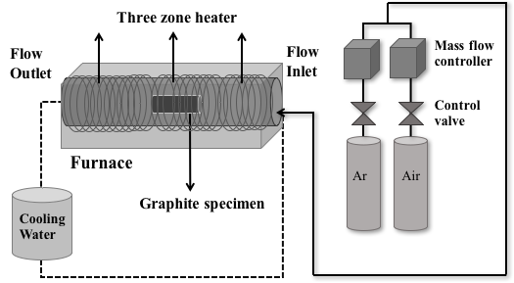

Figure 1 - Schematic of the dynamic testing system for graphite oxidation experiment.



Figure 2 - Comparison of oxidation rate for petroleum-based IG-110 and pitch-based IG-430 graphite materials in dry air at temperature ranging from 700 to 1600 oC.



Figure 3 - Comparison of oxidation rate for IG-430 and IG-110 graphite materials in dry helium at temperature ranging from 700 to 1600 oC.

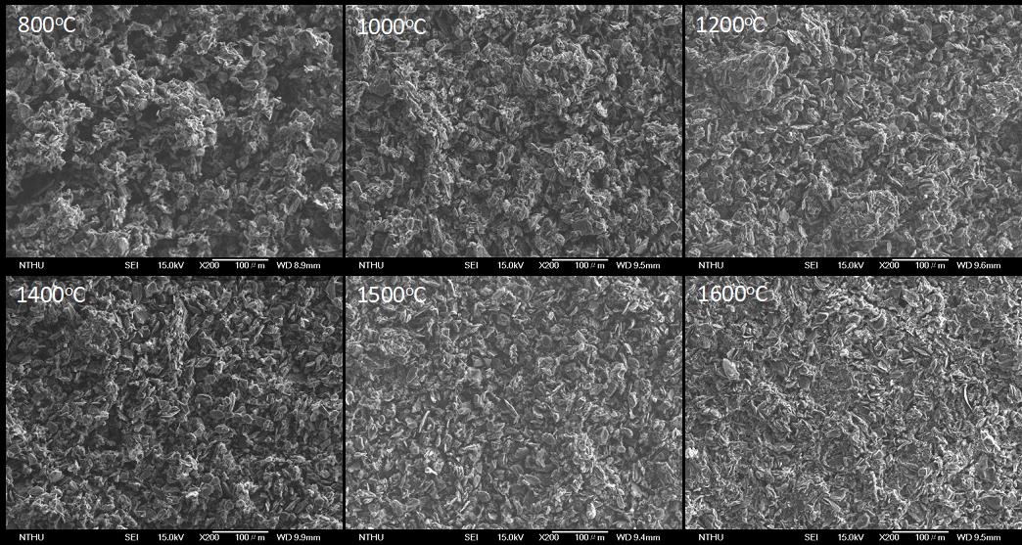

Figure 4 - SEM micrographs of the surface of pitch-based IG-430 graphite samples oxidized at various temperatures.

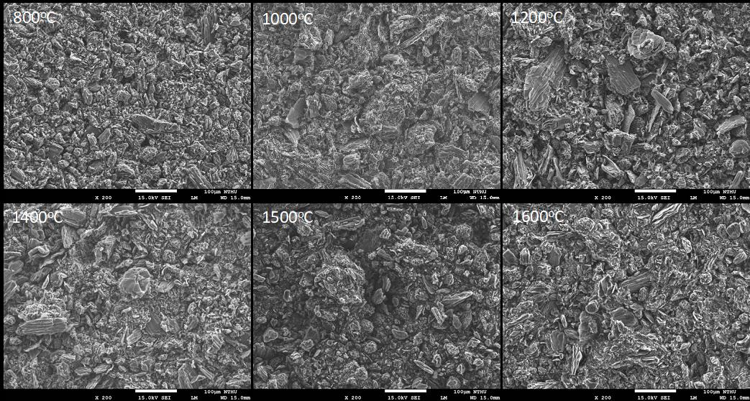

Figure 5 - SEM micrographs of the surface of petroleum-based IG-110 graphite samples oxidized at various temperatures.

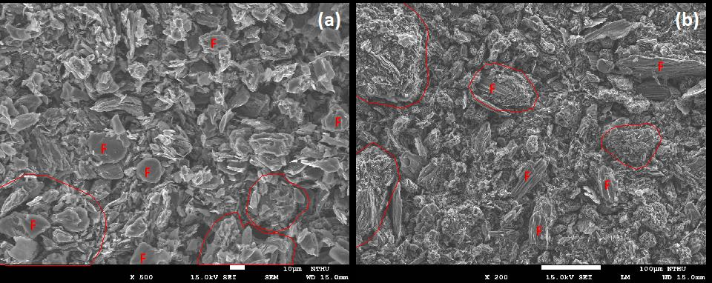

Figure 6 - Illustration of filler particle (F) and island-shaped structure (circle area) nuclear graphite at 1100 oC: (a) pitch-based IG-430, and (b) petroleum-based IG-110.

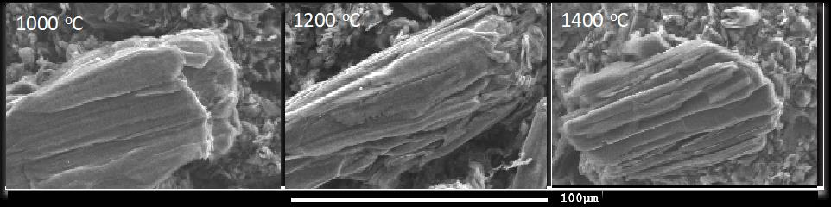

Figure 7 - The comparison of surface morphology of a filler particle for petroleum-based IG-110 nuclear graphite at 1000, 1200 and 1400 oC.

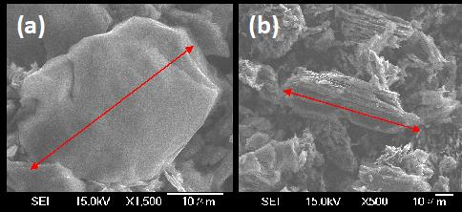

Figure 8 - The example of the samples selected for the calculation of filler particle size: (a) pitch-based IG-430, (b) petroleum-based IG-110.



Figure 9 - The fractional percentage erosion of filler particles with increasing oxidation temperature in dry air for petroleum-based IG-110 and pitch-based IG-430 graphite materials.