A Cost-Effectiveness Analysis of Contact X-ray Brachytherapy for treatment of patients with a partial response to Chemoradiotherapy for Rectal Cancer
Mr Christopher Rao MRCS PhD, Specialist Registrar in General Surgery;¹* Mr Fraser Mc Lean Smith FRCSI MD, Consultant Colorectal Surgeon;² Mr Antony Paul Martin MSc, Health Economist;³ Dr Amandeep S Dhadda FRCR MSc, Consultant Clinical Oncologist;⁴ Dr Alexandra Stewart, FRCR MD, Consultant Clinical Oncologist;⁵ Dr Simon Gollins FRCR DPhil, Consultant Clinical Oncologist;⁶ Dr Andrew Healey, Health Economist;⁷ Dr Brendan Collins PhD, Healtb Economist;⁸ Prof Thanos Athanasiou FRCS PhD, Professor of Surgery;⁹ Prof Arthur Sun Myint FRCR, Consultant Clinical Oncologist and Honorary Professor in Gastroenterology.¹⁰

Institutions: (1) Queen Elizabeth Hospital, Woolwich, London. (2) The Royal Liverpool and Broadgreen University Hospitals NHS Trust, Liverpool. (3) National Institute for Health Research, Collaborations for Leadership in Applied Health Research and Care, North West Coast (NIHR CLAHRC NWC), University of Liverpool. (4) Queen's Centre for Oncology & Haematology, Castle Hill Hospital, Hull. (5) St Luke's Cancer Centre, Royal Surrey County Hospital, Guildford. (6) North Wales Cancer Treatment Centre, Glan Clwyd Hospital, Rhyl, Denbighshire. (7) Department of Health Economics, King’s College London. (8) Department of Public Health and Policy, University of Liverpool. (9) Department of Surgery and Cancer, Imperial College London. (10) The Clatterbridge Cancer Centre, Merseyside.
*Corresponding Author Department of Surgery, Queen Elizabeth Hospital, Woolwich, London SE18 4QH. Telephone: +44 (0) 7796 954 284 E-mail: christopher.rao@nhs.net

Research Highlights

- Watch-and wait with contact brachytherapy and external beam radiotherapy (WW_{CXB}) was more effective and less costly than both watch-and wait with external beam radiotherapy alone (WW_{EBRT}), and Radical Surgery following chemoradiotherapy (RS) independent of patient cohort age and comorbidity.
- WW_{CXB} was more cost-effective with a high degree of certainty (61.9-76.5%) at a threshold of £20,000/QALY.
- Budget impact analysis suggests that an initial investment of £3.6 million would be required in order to implement a WW_{CXB} strategy in England and Wales.
- WW_{CXB} would be cost-saving by the second year following introduction compared to RS and the fourth year compared to WW_{EBRT}. This could result in a savings of over a five year period of over £8million to the NHS
- A ceiling-value of £8.7million was estimated for further research on the efficacy of WW_{CXB}.

Abstract

Background: A “watch and wait” approach (WW) may provide equivalent survival and oncological outcomes to initial Radical surgery (RS) in patients with a clinical complete response (cCR) following neoadjuvant chemoradiotherapy (CRT). However, over 80% of patients do not achieve a cCR. Contact X-ray Brachytherapy (CXB) enables high doses of radiation to be delivered directly to rectal cancers with minimal damage to adjacent tissue, and can be used in addition to external beam radiotherapy (EBRT) to increase the cCR rate. There is evidence to suggest that CXB may improve the incidence of bowel continuity. The long-term cost-effectiveness of CXB has not been evaluated. Consequently, we aim compare the cost-effectiveness of WW with CXB and EBRT (WW_{CXB}), to WW with EBRT alone (WW_{EBRT}), and RS for patients with rectal cancer treated with CRT.
Design: Decision analytical modelling and a Markov simulation were used to model long-term costs, quality-adjusted life years (QALYs), and cost-effectiveness from a third-party payer (NHS) perspective. Sensitivity analysis was used to investigate the effect of uncertainty in model parameters and patient demographics. Budget Impact Analysis and Value of Information Analysis was also performed.
Results: WW_{CXB} was more effective than both RS and WW_{EBRT} and less costly independent of patient cohort age and comorbidity. Consequently WW_{CXB} was more cost-effective with a high degree of certainty (61.9-76.5%) at a threshold of £20,000/QALY. Budget impact analysis (BIA) suggests that CXB would be cost saving by the second year following introduction compared to RS and the fourth year compared to WW_{EBRT.} This could result in a savings of over a five year period of over £8million to the NHS. Value of information analysis estimated a ceiling-value of £8.7million for further research on the efficacy of WW_{CXB}.
Conclusions: WW_{CXB} is likely to be cost-effective compared to both WW_{EBRT} alone and RS. These findings strongly support the use of CXB boost as an adjunct to a WW strategy. This is further supported by BIA which suggests that implementation of CXB will be cost-saving.

Keywords: Rectal, radiotherapy, neoadjuvant, watch and wait, complete clinical response, elderly, cost-effectiveness

Abbreviations

BIA Budget Impact Analysis
cCR Clinical Complete Response
CEAC Cost-effectiveness Acceptability Curve
CET Cost-effectiveness Threshold
cm80 80-year-old male cohort with comorbidities
cPR Clinical Partial Response
CRT Chemoradiotherapy
CXB Contact Brachytherapy
EBRT External Beam Radiotherapy
EVPI Expected Value of Perfect information
fm60 60-year-old male cohort with no comorbidities
fm80 80-year-old male cohort with no comorbidities
HES Hospital Episode Statistics
HRQoL Health-related Quality-of-life
NICE National Institute for Health and Care Excellence
ONS Office of National Statistics
pCR Pathological Complete Responses
QALY Quality-Adjusted Life Years
RS Radical Surgery
WTP Willingness-to-pay
WW Watch and Wait
WW_{CXB} Watch and Wat with EBRT and CXB Boost
WW_{EBRT} Watch and Wait with EBRT alone

Introduction

The standard of care for locally advanced rectal cancer is currently neoadjuvant chemoradiotherapy (CRT) followed by radical surgery (RS) [1, 2]. Perioperative mortality, particularly in elderly co-morbid patients following RS is significant [3]. There is also significant morbidity associated with RS. Significantly, 83% of patients had a stoma following surgical resection (either because the rectum was removed, or “temporary” defunctioning stomas). Over 50% of patients, however, still had a stoma 18 months following surgery. This unquestionably has a significant effect on patient health-related quality of life (HRQoL) [4].

Significantly, a complete pathological response (pCR), with absence of cancer cells in the resected specimen, however, has been reported in between 10-20% of patients [5, 6]. Subsequently, several studies have demonstrated the safety of adopting a “watch and wait” (WW) strategy after CRT in patients for whom a clinical complete response (cCR) has been achieved where no evidence of residual tumour can be identified [7, 8]. These approaches eliminate perioperative mortality, deliver equivalent oncological outcomes if cCR is maintained, and preserve bowel continuity in patients for whom a stoma is unsuitable or unacceptable [9]. While disease does recur in some patients, limited data suggests that should this occur, subsequent RS can be performed with equivalent oncological outcome to patients initially treated with RS [8, 10]. There is now emerging evidence to suggest that long-term survival and oncological outcomes following WW and RS may be comparable [5]. Modelled data from our group suggests that not only does WW provide equivalent survival, it is also cost-effective [11, 12].

Unfortunately, however the cCR is low with conventional external beam radiotherapy (EBRT). A recent UK series reported that 12% of patients achieved a cCR [5]. Consequently, there is an urgent need to improve and sustain cCR rates following CRT. One practical means to improve and sustain cCR is to escalate the dose of radiation delivered, however this is associated with the side-effects of radiation toxicity. Contact X-ray Brachytherapy (CXB) boost can be used to achieve this with limited collateral damage to surrounding normal tissues [13-15]. Several case series suggest that CXB may improve both the rate and sustainability of a cCR [16, 17]. There is randomised evidence to support an improved cCR following CXB [13]. The effect that this may have on long-term quality-of-life and cost-effectiveness is however uncertain.

Therefore, in this study we aim to compare both the clinical and cost-effectiveness of WW with EBRT and CXB boost (WW_{CXB}), WW with EBRT alone (WW_{EBRT}), and RS following EBRT. We will investigate and quantify the associated uncertainty. We also aim to perform alternative analyses to investigate if these results are sensitive to patient age and comorbidity. Finally, we will perform Budget Impact Analysis (BIA) to investigate the burden of CXB on the consumption of healthcare resources nationally.

Materials and Methods

Outcomes in patients with a cCR following neoadjuvant CRT treated with WW_{CXB}, WW_{EBRT}, and RS were modelled using a decision analytical model adapted from the published literature consisting of a decision tree and Markov chain simulation (Figure 1) [12]. Details of all interventions that patients undergo in each modelled state have previously been described (Figures 2 and 3) [12]. Table 1 shows clinical parameters used to populate the model. These parameters were used in previous work and represent best available estimates [11, 12]. The economic data used to populate the model is listed in Table 2. Table 3 shows perioperative mortality used to populate the model extracted from the Hospital Episodes Statistics (HES) database, and Table 4 shows baseline mortality data used to populate the model based on UK Office of National Statistics (ONS) Life Tables).

Analysis was performed from a third party-payer perspective (UK National Health Service, NHS) according to the National Institute for Health and Care Excellence guidelines on technology assessment [18]. Costs are reported in UK pound sterling (£) [19]. The effects of interventions were measured in Quality-Adjusted Life Years (QALYs), a composite measure of survival and utility. Incremental costs and effects were calculated for the lifetime of the hypothetical patient cohorts. Costs and effects were discounted at 3.5% per annum according to guidelines on cost-effectiveness analysis [18]. Probabilistic sensitivity analysis was performed to investigate and quantify associated uncertainty [20]. Decision analytical software (TreeAge-Pro, TreeAge; Williamstown, MA) was used to perform the analysis. This study was exempt from Institutional Review Board ethical approval as it is a modelling study and did not require any interface with patients.

Definition of Treatment Strategies, Modelled Patient Populations and Outcomes of Interest
In our modelled cohorts all patients underwent CRT. In the RS modelled cohort all patients underwent RS after CRT. In the WW cohort patients with a cCR according to strictly defined criteria [11, 21] were managed with WW approach. Patients without a cCR in the WW cohort underwent RS. In the WW_{CXB} patients who initially had a cCR following CRT were treated with a WW approach. Patients without a cPR and a residual tumour greater than 3cm underwent RS, patients with a residual tumour of 3cm or less were given a CXB boost. CXB was delivered as an outpatient treatment every 2 weeks using a Papillon plus machine (Ariane Medical Systems, UK). Patients received a total of 90 Gy delivered in 3 fractions over 4 weeks. We have previously described in more detail the treatment regime for CXB boost [22]. In our modelled cohort patients who had a cCR following CXB boost were managed with a WW approach. Patients without a cPR following CXB boost underwent RS.

We assumed that follow-up for patients undergoing surgery was according to national guidelines [23]. Briefly, these recommend a minimum of 2 CTs of the chest, abdomen, and pelvis in the first 3 years. In addition, a surveillance colonoscopy at 1 year is offered after initial treatment. If this is normal, a further colonoscopy is considered after 5 years. In the WW cohort follow-up was more intensive with 2 CTs per year for the first 3 years, 3 pelvic MRIs a year for the first 2 years and then 2 MRIs in the following year. Clinical examination was performed every 3 months for the first 2 years accompanied by alternating rigid and flexible sigmoidoscopy. In the third year this was performed every 6 months, and subsequently every year until 5 years following initial treatment. Finally, a surveillance colonoscopy at 1 year is offered after initial treatment. If this is normal, a further colonoscopy is considered after 5 years.

We assumed that should tumor recurrence occur in either cohort, patients underwent full oncological restaging and salvage surgery where appropriate. Patients in whom salvage surgery was not possible underwent palliative surgery and chemotherapy. Patients with distant metastasis underwent palliative chemotherapy and a proportion of patients, reflecting actual clinical practice, underwent liver resection [24]. It was assumed that patients received the maximum dose of radiotherapy and so our model did not account for further costs associated with palliative radiotherapy. As less than 1% of patients with colorectal metastasis in the lung undergo resection we did not account for this in our model (Figures 1-3) [25].

To investigate whether the results of our analysis were sensitive to patient age and comorbidities analysis was performed for a 60-year-old male (fm60) and 80-year-old male cohort with mild comorbidities (fm80) (Charlson Score<3), and an 80-year-old male cohort with significant comorbidities (cm80) (Charlson Score≥3). The Charlson Comorbidity Index is an established tool to predict mortality for a patient who may have a range of comorbid conditions [26].

Model Parameters
Post-operative mortality in the first 90 days for each demographic cohort was obtained from the HES database, a national database which describes the care provided to patients in NHS hospitals (Table 1, Table 3). HES data is widely used for NHS quality assurance, by government agencies and in the academic literature [27]. Baseline mortality estimates were extracted from UK ONS Life Tables (Table 4) [28].

Estimates of other clinical parameters used to populate the model were extracted from published literature [6, 7, 10, 11, 29-41]. The rationale for using these estimates has previously been discussed [11]. Estimates of the costs associated with treatment were based on NHS reference costs [42] or previous NICE reports in the case of palliative chemotherapy [43] (Table 2).

The cCR rate following CXB boost was estimated to be 26% based on data from a randomised study comparing CXB boost with CRT alone [13, 15]. As there was no direct comparative evidence no assumptions were made about an increased durability of cCR following CXB. This represents a conservative estimate of the efficacy of CXB as several case series have reported improved cCR rate (65-98%) and durability (local re-growth rate 8-12%) following CXB [16, 17, 22]. The cCR following CRT was derived from the UK OnCoRe study, as we felt this probably best reflected current UK practice and the populations modelled in this study [5]. It should be noted that the cCR rate is significantly less than that reported in some studies and thus must be considered a conservative estimate of the cCR rate [6, 44]. This is congruent with the findings of other studies [45]. The proportion of patients with a cPR following CRT who were suitable for CXB boost was derived from a recently published study from own centre [22], as this reflects a similar population with similar initial treatment from the same geographical area as those in the OnCoRe study [5]. Finally, the costs associated with CXB boosts were based on a primary costing study undertaken at our own institution using methodology consistent with NHS reference costs [46]. This study is summarised in the supplemental information.

Sensitivity Analysis
Deterministic sensitivity analysis was performed to investigate the sensitivity of the study to assumptions made about the value of individual model parameters. Each model parameter was varied with plausible ranges (Table 1, Table 2). In order to estimate the combined effect of uncertainty associated with all model parameters, a probabilistic sensitivity analysis was performed using a Monte Carlo simulation. Briefly, all parameters including transition probabilities were randomly sampled from assigned distributions (Table 1, Table 2). It was assumed that parameters were independent, i.e. not correlated with each other. The model was then run to simulate a “virtual” cohort of 1000 “matched” patients using these sampled probabilities for each intervention. All model parameters were then re-sampled and the model was then run again to generate data for a further virtual cohort of 1000 patients. This process was repeated until data had been generated for 1000 matched virtual cohorts of 1000 patients. This allowed QALY payoffs and costs to be estimated for both treatment strategies. Crucially however, it also allowed estimates of the uncertainty associated with these outcomes to be calculated. As cost parameters may by closely correlated, it is possible that the assumption that all model parameters are not correlated may overestimate the uncertainty.

Budget Impact Analysis
To evaluate the cost of implementation of CXB in England and Wales a Budget Impact Analysis (BIA) was performed. The incidence of rectal cancer and the proportion of patients undergoing neoadjuvant CRT prior to undergoing major resections, was extracted from the National Bowel Cancer Audit report (Table 5) [4]. Unlike in the cost-effectiveness analysis capital investment expenses such as the cost of the Papillion Plus machine were considered separately to the incremental treatment costs for each patient. The initial cost of training the team is covered by the manufacturer (Ariane Medical Systems, UK). It was conservatively assumed that the first 20 patient treatments would be undertaken by the whole team under supervision, and consequently this was also considered in the BIA. It was assumed that each centre could treat a maximum of 150 patients per year, whilst this probably represents a conservative estimate, this would ensure a reasonable geographic coverage to support local MDT, and that the distance patients would be required to travel would not be excessive. Finally the model was populated with a young, fit cohort to ensure that burden of the log-term costs associated with WW follow-up were not underestimated. As surgical costs are significantly less in this cohort (Table 2) this assumption would probably also conservatively account for cost savings associated with CXB. A time horizon of 5 years was adopted for BIA. All assumptions were tested in sensitivity analysis. All parameters used in BIA are described in Table 5.

Value of Information Analysis
Population Expected Value of Perfect Information (EVPI) was calculated to quantify the cost of the uncertainty associated with the results of the cost-effectiveness analysis and determine a hypothetical ceiling for the value of further research [20]. NICE and the Health Technology Assessment Programme have suggested that EVPI analysis is both a practical and potentially useful method of prioritizing research investment [47], and has been applied to a number of different healthcare interventions [48]. For EVPI analysis the model was populated with an elderly, comorbid cohort in which we anticipated that uncertainty and QALY payoffs would be lowest, thus conservatively estimating the value of further research. The target population was assumed to be the same as for BIA. The lifetime of the technology was conservatively estimated to be ten years. All parameters used in EVPI are described in Table 5.

Results

In all modelled patient cohorts WW_{CXB} was both less costly and more effective than RS and WW_{EBRT}, and thus could be said to be dominant. Compared to WW_{EBRT}, WW_{CXB} in the fm60 cohort was less costly by £833.96; 95%CI -£1,430.09 to £3,637.33; and more effective by 0.10QALYs; 95%CI -0.42QALYs to 0.61QALYs. In the fm80 cohort it was less costly by £531.21; 95%CI -£1,766.31 to £3,137.96; and more effective by 0.08QALYs; 95%CI -0.15QALYs to 0.33QALYs. In the cm80 cohort it was less costly by £800.29; 95%CI -£1,619.73 to £3,634.94; and more effective by 0.11QALYs; 95%CI -0.11QALYs to 0.36QALYs. Compared to RS, WW_{CXB} in the fm60 cohort WW was less costly by £2,205.5; 95%CI -£1,288.12 to £6,427.99; and more effective by 0.18QALYs; 95%CI -0.64QALYs to 1.02QALYs. In the fm80 cohort it was less costly by £1,555.01; 95%CI -£1,917.85 to £5,535.2; and more effective by 0.15QALYs; 95%CI -0.17QALYs to 0.51QALYs. In the cm80 cohort it was less costly by £2,065.1; 95%CI -£1,857.05 to £6,568.73; and more effective by 0.20QALYs; 95%CI -0.14QALYs to 0.55QALYs (Table 5).

Deterministic Sensitivity Analysis
The results of deterministic sensitivity analysis at a willingness-to-pay/ cost-effectiveness threshold (CET) of £20,000/QALY is shown in Figure 4. Each panel has the plausible ranges for a variable plotted on each axis. The boundary between the shaded areas represents the tipping point of the model at which there is equipoise. The area shaded green indicates values at which WW_{CXB} is cost-effective, the blue indicates where WW_{EBRT} is cost-effective, and the red indicates RS is cost-effective. Deterministic sensitivity analysis did not suggest that the results of the model were sensitive to individual model parameters, moreover as the bivariate sensitivity analysis in Figure 4 shows, the model remains insensitive to the effect of individual model parameters in all the demographic cohorts modelled.

Probabilistic Sensitivity Analysis
The results of probabilistic sensitivity analysis are shown Figure 5 demonstrating the effect of the combined uncertainty associated with all model parameters. At a CET of £20,000/QALY, WW_{CXB} is most cost-effective in all modelled cohorts. The cost-effectiveness acceptability curve (CEAC) is a method for summarising information on uncertainty in cost-effectiveness. The CEAC identifies the probability that the intervention is cost-effective compared to the alternative based upon the data provided for a given CET [20]. In the fm60 cohort WW_{CXB} was most cost-effective in 61.9% of model iterations, this increased to 66.7% in the fm80 cohort, and 76.5% in the cm80 cohort at a CET of £20,000/QALY (Figure 5).

Budget Impact Analysis and Value of Information Analysis
BIA suggests that a capital expenditure of £3.6 million would be required in order to implement a WW_{CXB} strategy in England and Wales. In the first year following implementation WW_{CXB} would save £2.2 million compared to RS, by the second year this will raise to £4.1 million, by the third year £6 million, by the fifth £11.7 million. Compared to WW_{EBRT} the cost savings in the first, second third, and fifth year are £0.78million, £1.6 million, £2.3million, and £4.7million respectively. Consequently after the cost of implementation is subtracted WW_{CXB} would be cost-saving compared to WW_{EBRT} and RS at year 4 and 2 respectively and cost-saving by year 5 with 58.1% certainty compared to WW_{EBRT} and 91% certainty compared to RS (Figure 6). The corresponding population EVPI was £8,698,109.97 (Figure 7) at a CET of £20,000/QALY.

Discussion

The results of the modelling presented in this study suggest with a high degree of certainty that the addition of CXB boost as an adjunct to WW management in order to optimise the proportion of patients who achieve a cCR and are thus eligible for non-operative management is cost-effective. The degree of certainty associated with these findings is in part because addition of a CXB boost for this indication is both cost-saving and effective, resulting in an increased QALY payoff, and consequently could be said to be dominant. These findings were true in all three modelled demographic cohorts (fm60, fm80, and cm80). Predictably however, as age and patient co-morbidities increase the uncertainty associated with these findings decreases. This is unsurprising as by increasing the cCR rate compared to WW_{EBRT}, WW_{CXB} can result in RS can being avoided in some patients, and the effect of avoiding RS in elderly and co-morbid patients is likely to be more marked. The reason that the incremental QALY payoff is not more marked in elderly in the fm80 and cm80 cohort is that these patients have a significantly lower life-expectancy than the fm60 cohort, and consequently the QALY payoff for each death avoided is consequently less.

Previous work that we have undertaken suggests that WW offers at least comparable clinical to RS [11]. This is supported by emerging clinical evidence [5]. We have also shown that WW is cost-effective compared to RS for patients with a cCR to CRT [12]. In view of these findings, evidence from the literature about the efficacy of CXB boost [13], and the findings of this study on the relative cost-effectiveness of WW_{EBRT} and WW_{CXB}, it is not surprising that WW_{CXB} dominates RS alone in all the modelled demographic cohorts. Whilst this may not be a surprising finding, arguably the cost-savings suggested by this comparison may be most relevant to decision makers as most UK centres which do not have a formal WW programme of any kind yet.

UK National guidelines (NICE) already suggest that CXB in conjunction with external-beam radiotherapy is safe and efficacious in patients who are unable to undergo RS [49]. NICE also suggests that whilst CXB is safe in patients who are able to undergo RS but choose not to, its effectiveness remains uncertain and consequently these patients should be enrolled in clinical audit or research programmes [49]. These guidelines are supported by our study, and as one of a plethora of studies that support the use of CXB boost specifically and WW in general it is possible that these guidelines may need to be further revised.

The cost-savings that this study suggest could be achieved with CXB, without compromising clinical outcomes are particularly relevant in view of the challenges faced in the wider UK healthcare environment. The results of our BIA analysis suggest that within a relatively short period the capital expenditure needed to implement WW_{CXB} would be offset by the healthcare costs incurred by individual patients. This further supports wider implementation of a WW_{CXB} strategy (Figure 6). In many respects our BIA is quite conservative, not only because of the conservative modelling assumptions described in the methods section, but because this BIA does not consider the role that commissioned CXB centres could have in treating patients with other cancers or rectal cancer for other indications (Palliation, Salvage and T1 polyp cancers for example)

All studies based on decision analytical modelling represent simplification of complex real-world scenarios, and consequently the results of these studies must be interpreted with caution. All models are vulnerable to uncertainty associated with model parameters, and consequently we have endeavoured to populate our model with the most relevant and robust estimates, and to fully quantify the uncertainty associated with these model parameters. We hope that the OPERA trial [50] which is currently recruiting patients will provide empirical support for these modelled findings. Interestingly, the results of the population EVPI analysis which conservatively defines a ceiling of £8,698,109.97 for further research at a CET of £20,000/QALY arguably justifies increased support to help UK centres recruit to the OPERA trial and for continuation and expansion of the UK led prospective CXB outcomes database.

Conclusions

This study strongly suggests that WW_{CXB} is cost-effective compared to both WW_{EBRT} and RS, and implementation of WW_{CXB} in England and Wales would be cost-saving. This has significant implications both for clinicians working in this field, and policy makers.

Acknowledgements

We would like to thank Helen Wong for providing additional clinical CXB data for the primary costing study. We would also like to thank Mark Davies of Ariane Medical Systems for providing information relating to purchase costs and service contracts for the Papillion Plus system.

References

[1] Sauer R, Becker H, Hohenberger W, Rodel C, Wittekind C, Fietkau R, et al. Preoperative versus postoperative chemoradiotherapy for rectal cancer. N Engl J Med. 2004;351:1731-40.
[2] Improved survival with preoperative radiotherapy in resectable rectal cancer. Swedish Rectal Cancer Trial. N Engl J Med. 1997;336:980-7.
[3] Mamidanna R, Almoudaris AM, Faiz O. Is 30-day mortality an appropriate measure of risk in elderly patients undergoing elective colorectal resection? Colorectal Dis. 2012;14:1175-82.
[4] NBOCA. National Bowel Cancer Audit Report 2016. In: (NBOCA) NBCA, editor. London: Health Quality Improvement Partnership Ltd. (HQIP). NHS Digital; 2016. p. 75.
[5] Renehan AG, Malcomson L, Emsley R, Gollins S, Maw A, Myint AS, et al. Watch-and-wait approach versus surgical resection after chemoradiotherapy for patients with rectal cancer (the OnCoRe project): a propensity-score matched cohort analysis. Lancet Oncol. 2016;17:174-83.
[6] Martin ST, Heneghan HM, Winter DC. Systematic review and meta-analysis of outcomes following pathological complete response to neoadjuvant chemoradiotherapy for rectal cancer. Br J Surg. 2012;99:918-28.
[7] Habr-Gama A, Perez RO, Nadalin W, Sabbaga J, Ribeiro U, Jr., Silva e Sousa AH, Jr., et al. Operative versus nonoperative treatment for stage 0 distal rectal cancer following chemoradiation therapy: long-term results. Ann Surg. 2004;240:711-7; discussion 7-8.
[8] Smith JD, Ruby JA, Goodman KA, Saltz LB, Guillem JG, Weiser MR, et al. Nonoperative management of rectal cancer with complete clinical response after neoadjuvant therapy. Ann Surg. 2012;256:965-72.
[9] Kennelly RP, Heeney A, White A, Fennelly D, Sheahan K, Hyland JM, et al. A prospective analysis of patient outcome following treatment of T3 rectal cancer with neo-adjuvant chemoradiotherapy and transanal excision. Int J Colorectal Dis. 2012;27:759-64.
[10] Habr-Gama A, Perez RO, Proscurshim I, Campos FG, Nadalin W, Kiss D, et al. Patterns of failure and survival for nonoperative treatment of stage c0 distal rectal cancer following neoadjuvant chemoradiation therapy. J Gastrointest Surg. 2006;10:1319-28; discussion 28-9.
[11] Smith FM, Rao C, Oliva Perez R, Bujko K, Athanasiou T, Habr-Gama A, et al. Avoiding radical surgery improves early survival in elderly patients with rectal cancer, demonstrating complete clinical response after neoadjuvant therapy: results of a decision-analytic model. Dis Colon Rectum. 2015;58:159-71.
[12] Rao C, Sun Myint A, Athanasiou T, Faiz O, Martin AP, Collins B, et al. Avoiding Radical Surgery in Elderly Patients With Rectal Cancer Is Cost-Effective. Dis Colon Rectum. 2017;60:30-42.
[13] Ortholan C, Romestaing P, Chapet O, Gerard JP. Correlation in rectal cancer between clinical tumor response after neoadjuvant radiotherapy and sphincter or organ preservation: 10-year results of the Lyon R 96-02 randomized trial. Int J Radiat Oncol Biol Phys. 2012;83:e165-71.
[14] Sun Myint A, Grieve RJ, McDonald AC, Levine EL, Ramani S, Perkins K, et al. Combined modality treatment of early rectal cancer: the UK experience. Clin Oncol (R Coll Radiol). 2007;19:674-81.
[15] Gerard JP, Chapet O, Nemoz C, Hartweig J, Romestaing P, Coquard R, et al. Improved sphincter preservation in low rectal cancer with high-dose preoperative radiotherapy: the lyon R96-02 randomized trial. J Clin Oncol. 2004;22:2404-9.
[16] Dhadda AS, Martin A, Killeen S, Hunter IA. Organ Preservation Using Contact Radiotherapy for Early Rectal Cancer: Outcomes of Patients Treated at a Single Centre in the UK. Clin Oncol (R Coll Radiol). 2017;29:198-204.
[17] Frin AC, Evesque L, Gal J, Benezery K, Francois E, Gugenheim J, et al. Organ or sphincter preservation for rectal cancer. The role of contact X-ray brachytherapy in a monocentric series of 112 patients. Eur J Cancer. 2017;72:124-36.
[18] Guide to the methods of technology appraisal 2013. In: Health Do, editor. London, United Kingdom: National Institute for Health and Care Excellence (NICE); 2013.
[19] Forex U. GBP to USD Exchange Rate. 2016.
[20] Briggs AH, Claxton K, Sculpher MJ. Decision modelling for health economic evaluation. Oxford: Oxford University Press; 2006.
[21] Habr-Gama A, Perez RO, Wynn G, Marks J, Kessler H, Gama-Rodrigues J. Complete clinical response after neoadjuvant chemoradiation therapy for distal rectal cancer: characterization of clinical and endoscopic findings for standardization. Dis Colon Rectum. 2010;53:1692-8.
[22] Myint AS, Smith FM, Gollins S, Wong H, Whitmarsh K, Rooney P, et al. Dose escalation using Contact X-ray brachytherapy for radical treatment of rectal cancer. Outcomes from a single centre experience. Int J Radiat Oncol Biol Phys. 2017:Submitted.
[23] Colorectal cancer: diagnosis and management. In: Health Do, editor. Updated 2014 ed. London, United Kingdom: National Institute for Health and Care Excellence (NICE); 2011.
[24] Meriggi F, Bertocchi P, Zaniboni A. Management of potentially resectable colorectal cancer liver metastases. World J Gastrointest Surg. 2013;5:138-45.
[25] Zisis C, Tsakiridis K, Kougioumtzi I, Zarogoulidis P, Darwiche K, Machairiotis N, et al. The management of the advanced colorectal cancer: management of the pulmonary metastases. J Thorac Dis. 2013;5 Suppl 4:S383-8.
[26] Charlson ME, Pompei P, Ales KL, MacKenzie CR. A new method of classifying prognostic comorbidity in longitudinal studies: development and validation. J Chronic Dis. 1987;40:373-83.
[27] Hospital Episode Statistics (HES). United Kingdom: Health and Social Care Information Centre (HSCIC); 2013. p. Hospital Episode Statistics (HES).
[28] National Life Tables: United Kingdom. United Kingdom: Office of National Statistics (ONS); 2013. p. National Life Tables: United Kingdom.
[29] Smith FM, Waldron D, Winter DC. Rectum-conserving surgery in the era of chemoradiotherapy. Br J Surg. 2010;97:1752-64.
[30] Neuman HB, Elkin EB, Guillem JG, Paty PB, Weiser MR, Wong WD, et al. Treatment for patients with rectal cancer and a clinical complete response to neoadjuvant therapy: a decision analysis. Dis Colon Rectum. 2009;52:863-71.
[31] Valentini V, van Stiphout RG, Lammering G, Gambacorta MA, Barba MC, Bebenek M, et al. Nomograms for predicting local recurrence, distant metastases, and overall survival for patients with locally advanced rectal cancer on the basis of European randomized clinical trials. J Clin Oncol. 2011;29:3163-72.
[32] Maas M, Nelemans PJ, Valentini V, Das P, Rodel C, Kuo LJ, et al. Long-term outcome in patients with a pathological complete response after chemoradiation for rectal cancer: a pooled analysis of individual patient data. Lancet Oncol. 2010;11:835-44.
[33] Guillem JG, Chessin DB, Cohen AM, Shia J, Mazumdar M, Enker W, et al. Long-term oncologic outcome following preoperative combined modality therapy and total mesorectal excision of locally advanced rectal cancer. Ann Surg. 2005;241:829-36; discussion 36-8.
[34] Garcia-Aguilar J, Hernandez de Anda E, Sirivongs P, Lee SH, Madoff RD, Rothenberger DA. A pathologic complete response to preoperative chemoradiation is associated with lower local recurrence and improved survival in rectal cancer patients treated by mesorectal excision. Dis Colon Rectum. 2003;46:298-304.
[35] Tepper JE, O'Connell M, Hollis D, Niedzwiecki D, Cooke E, Mayer RJ, et al. Analysis of surgical salvage after failure of primary therapy in rectal cancer: results from Intergroup Study 0114. J Clin Oncol. 2003;21:3623-8.
[36] van den Brink M, Stiggelbout AM, van den Hout WB, Kievit J, Klein Kranenbarg E, Marijnen CA, et al. Clinical nature and prognosis of locally recurrent rectal cancer after total mesorectal excision with or without preoperative radiotherapy. J Clin Oncol. 2004;22:3958-64.
[37] Hahnloser D, Nelson H, Gunderson LL, Hassan I, Haddock MG, O'Connell MJ, et al. Curative potential of multimodality therapy for locally recurrent rectal cancer. Ann Surg. 2003;237:502-8.
[38] Cassidy J, Clarke S, Diaz-Rubio E, Scheithauer W, Figer A, Wong R, et al. Randomized phase III study of capecitabine plus oxaliplatin compared with fluorouracil/folinic acid plus oxaliplatin as first-line therapy for metastatic colorectal cancer. J Clin Oncol. 2008;26:2006-12.
[39] Konski A, Watkins-Bruner D, Feigenberg S, Hanlon A, Kulkarni S, Beck JR, et al. Using decision analysis to determine the cost-effectiveness of intensity-modulated radiation therapy in the treatment of intermediate risk prostate cancer. Int J Radiat Oncol Biol Phys. 2006;66:408-15.
[40] Van Den Brink M, Van Den Hout WB, Stiggelbout AM, Klein Kranenbarg E, Marijnen CA, Van De Velde CJ, et al. Cost-utility analysis of preoperative radiotherapy in patients with rectal cancer undergoing total mesorectal excision: a study of the Dutch Colorectal Cancer Group. J Clin Oncol. 2004;22:244-53.
[41] Miller AR, Cantor SB, Peoples GE, Pearlstone DB, Skibber JM. Quality of life and cost effectiveness analysis of therapy for locally recurrent rectal cancer. Dis Colon Rectum. 2000;43:1695-701; discussion 701-3.
[42] NHS Reference Costs 2013-2014. In: Health Do, editor. London, United Kingdom: Department of health; 2014.
[43] Hoyle M, Crathorne L, Peters J, Jones-Hughes T, Cooper C, Napier M, et al. The clinical effectiveness and cost-effectiveness of cetuximab (mono- or combination chemotherapy), bevacizumab (combination with non-oxaliplatin chemotherapy) and panitumumab (monotherapy) for the treatment of metastatic colorectal cancer after first-line chemotherapy (review of technology appraisal No.150 and part review of technology appraisal No. 118): a systematic review and economic model. Health Technol Assess. 2013;17:1-237.
[44] Garcia-Aguilar J, Shi Q, Thomas CR, Jr., Chan E, Cataldo P, Marcet J, et al. A phase II trial of neoadjuvant chemoradiation and local excision for T2N0 rectal cancer: preliminary results of the ACOSOG Z6041 trial. Ann Surg Oncol. 2012;19:384-91.
[45] Jakobsen A, Ploen J, Vuong T, Appelt A, Lindebjerg J, Rafaelsen SR. Dose-effect relationship in chemoradiotherapy for locally advanced rectal cancer: a randomized trial comparing two radiation doses. Int J Radiat Oncol Biol Phys. 2012;84:949-54.
[46] Reference Costs Guidance 2014-15. In: Health Do, editor. London, United Kingdom: Department of Health; 2014.
[47] Claxton K, Ginnelly L, Sculpher M, Philips Z, Palmer S. A pilot study on the use of decision theory and value of information analysis as part of the NHS Health Technology Assessment programme. Health Technol Assess. 2004;8:1-103, iii.
[48] Yokota F, Thompson KM. Value of information literature analysis: a review of applications in health risk management. Med Decis Making. 2004;24:287-98.
[49] Low energy contact X ray brachytherapy (the Papillon technique) for early stage rectal cancer. In: Health Do, editor. London, United Kingdom: National Institute for Health and Care Excellence (NICE); 2015.
[50] Gerard JP, Benezery K, Doyen J, Francois E. Aims of combined modality therapy in rectal cancer (M0). Recent Results Cancer Res. 2014;203:153-69.

Figure and Table Legend

Table 1. Estimates of clinical parameters and utilities. cCR = complete clinical response; pCR = complete pathological response; pPR = partial pathological response. Transition probabilities were described by beta distributions based on the listed expected value and range.

Table 2. Economic parameters.

Table 3. Ninety-day mortality data after proctectomy from Hospital Episode Statistics database. Mortality was best described by beta distributions. The mean and SE are used to facilitate comparison with other literature.

Table 4. Age-specific UK baseline mortality.

Table 5. Additional parameters used in budget impact and value of information analysis

Table 6. Summary of the results of cost-effectiveness analysis

Figure 1. Schematic representation of our decision-analytic model, consisting of a decision tree and Markov chain simulation to investigate the long-term outcomes associated with the competing interventions. Decision nodes are represented by boxes in the main figure, and chance nodes are depicted by circles. The decision tree terminates either with the patients dying (in the case of patients who do not survive surgery), shown by a triangle, or a Markov chain simulation, shown by a circle with an “M” inside. The structure of the Markov simulation is depicted by the bubble diagram shown in the insert. The transition probabilities for the Markov simulation which are determined by initial treatment and whether a pCR was achieved after CRT and are described in Table 1.

Figure 2. Detailed description of the costs incurred by hypothetical patients in each Markov state following RS.

Figure 3. Detailed description of the costs incurred by hypothetical patients in each Markov state following WW.

Figure 4. Deterministic (Bivariate) sensitivity analysis at a CET of £20,000/QALY. The boundary between the shaded areas represents the tipping point of the model at which there is clinical equipoise. The area shaded green indicated values at which WW_{CXB} is most cost-effective, the red area corresponds to RS, and the blue area WW_{EBRT}. This figure shows the insensitivity of the analysis to the values of individual model parameters. The top panels show that this is the case as operative mortality varies (Figures A-E), and the bottom panel shows that this is the case as baseline mortality varies (Figures F-J), suggesting that this is the case for all demographic cohorts.

Figure 5. Willingness-to-pay curves showing the proportion of model iterations and hence the certainty with which RS, WW, or WW_{CXB} is most cost-effective for different Willingness-to-pay (Cost-effectiveness thresholds). The results of probabilistic sensitivity analysis from the fm60 cohort is shown in the top panel, the fm80 cohort in the middle panel and the cm80 cohort in the bottom panel.

Figure 6. The cost of implementing WW_{CXB} compared to WW_{EBRT} (Blue line) and RS (Red Line).

Figure 7. Results of the EVPI analysis. Population EVPI is plotted against Willingness-to-pay (Cost-effectiveness thresholds).
Table 1
Model parameter | Expected Value | Range | Distribution | α | β
% of patients where cCR = pCR after CRT[7, 11, 29, 30] | 70% | 0-100% | Beta | 4.44 | 3.40
Surgical mortality after salvage surgery for primary tumor[11, 27] | See Table 3 | 0-16.4% | Beta | - | -
Relapse if true pCR and surgery[6, 11, 30-34] | 17% | 0-30% | Beta | 9.01 | 247.50
% of recurrences that are distant if pCR and surgery[11, 30-34] | 81% | 50-100% | Beta | 18.87 | 5.64
Relapse if true pCR and observation alone[11, 30] | 17% | 0-30% | Beta | 9.01 | 247.50
% of recurrences that are distant if pCR and observation alone[11, 30] | 81% | 50-100% | Beta | 18.87 | 5.64
Relapse if pPR and surgery[11, 30-34] | 36% | 0-80% | Beta | 4.77 | 7.57
% of recurrences that are distant if pPR and surgery[11, 30-34] | 83% | 26-100% | Beta | 8.98 | 3.91
Relapse if pPR and observation alone[11, 30] | 70% | 0-80% | Beta | 6.53 | 6.53
% of recurrences that are distant if pPR and observation alone[11, 30] | 43% | 0-71% | Beta | 6.01 | 9.81
% of patients with cPR who are suitable for CXB[22] | 71% | 50-100% | Beta | 115 | 46
% of patients with cCR following CRT with EBRT alone[5] | 12% | 0-50% | Beta | 31 | 228
% of patients with cCR following CXB Boost[13] | 26% | 0-50% | Beta | 11 | 34
Salvage surgery for local recurrence if prior rectal surgery[11, 30, 35, 36] | 37% | 10-70% | Beta | 8.89 | 13.90
Salvage surgery for local recurrence if observation[10, 11, 30] | 80% | 50-90% | Beta | 31.53 | 11.47
Surgical mortality after salvage surgery for local recurrence[11, 27] | See Table 3 | - | Beta | - | -
Survival after local recurrence with surgical salvage[11, 30, 37, 38] | 50% | 20-60% | Beta | 26.27 | 130.81
Survival after local recurrence without surgical salvage[11, 30, 37, 38] | 30% | 0-50% | Beta | 7.55 | 13.18
Survival with distant metastatic disease[11, 30, 35, 38] | 20% | 0-30% | Beta | 12.18 | 17.33
Baseline Mortality (See Table 4)[28] | - | - | - | - | -
Utility of observation after radiation[30, 39] | 0.91 | 0.85-1 | Beta | 107.42 | 9.34
Utility of surgery after radiation[30, 40] | 0.86 | 0.7-1 | Beta | 41.87 | 7.20
Utility of Local recurrence with associated morbidity[30, 41] | 0.78 | 0.5-0.85 | Beta | 19.20 | 6.06
Utility of Distant recurrence with associated morbidity[30, 40] | 0.7 | 0.5-0.85 | Beta | 19.92 | 7.24

Table 2
Model parameter | Mean  (£) | Lower Quartile (£) | Upper Quartile (£) | Distribution | α | λ
Cost of Radical Surgery (Abdominoperineal resection) -Comorbidities[42] | 11,885.96 | 7,726.96 | 14,959.0 | Gamma | 4.923 | 0.00042
Cost of Radical Surgery (Abdominoperineal resection) -Without Comorbidities[42] | 9,027.26 | 6,524.94 | 10,527.21 | Gamma | 9.27 | 0.0010
Cost of Liver Resection - Comorbidities[42] | 9,243.24 | 6,396.18 | 10,329.71 | Gamma | 10.06 | 0.0011
Cost of Liver Resection – Without Comorbidities[42] | 6,870.48 | 5,328.16 | 8,133.0 | Gamma | 10.94 | 0.0016
Cost of Palliative Surgery - Comorbidities[42] | 7,014.06 | 4,918.21 | 8,427.36 | Gamma | 7.28 | 0.0010
Cost of Palliative Surgery – Without Comorbidities[42] | 5,422,16 | 4,290.19 | 6,016.5 | Gamma | 17.98 | 0.0033
Cost of Examination under Anesthesia[42] | 1,220.16 | 898.92 | 1,402.57 | Gamma | 10.70 | 0.0088
Cost of Rigid Sigmoidoscopy[42] | 179.58 | 119.88 | 215.0 | Gamma | 6.49 | 0.036
Cost of Flexible Sigmoidoscopy[42] | 197.2 | 105.73 | 244.0 | Gamma | 3.71 | 0.019
Cost of Colonoscopy[42] | 333.84 | 207.46 | 494.0 | Gamma | 2.47 | 0.0074
Cost of Magnetic Resonance Imaging of Pelvis[42] | 138.46 | 103.69 | 160.93 | Gamma | 10.67 | 0.077
Cost of Computerised Tomography of Chest, Abdomen and Pelvis[42] | 128.54 | 94.31 | 161.5 | Gamma | 6.67 | 0.052
Cost of Multi-disciplinary Discussion of Patient Management[42] | 123.17 | 72.64 | 145.36 | Gamma | 5.23 | 0.042
Cost of Outpatient Appointment[42] | 105.04 | 75.23 | 122.71 | Gamma | 8.93 | 0.085
Cost of Palliative Chemotherapy[43] | 53,000 | - | - | Gamma | 7.78 | 0.00015
Model parameter | Mode  (£) | Lower Limit (£) | Upper Limit (£) | Distribution
Cost of Contact Brachytherapy | 1,274.7 | 956.03 | 1,593.38 | Triangular | - | -

Table 3
 | 90 Day Mortality(%) Charlson<3 |  |  |  |  |  | 90 Day Mortality(%) Charlson>3
Age | 90 Day Mortality | Total Number of Patients | Representative Mean Mortality* | Representative SE* | Parameter for Beta Distribution |  | 90 Day Mortality | Total Number of patients | Representative Mean Mortality* | Representative SE* | Parameter for Beta Distribution
 |  |  |  |  | α | β |  |  |  |  | α | β
<61 | 49 | 4086 | 1.2 | 0.003 | 49 | 4037 | 47 | 1739 | 2.7 | 0.009 | 47 | 1692
61-70 | 130 | 5186 | 2.5 | 0.003 | 130 | 5056 | 133 | 2764 | 4.8 | 0.008 | 133 | 2631
71-80 | 271 | 4883 | 5.5 | 0.005 | 271 | 4612 | 242 | 2613 | 9.3 | 0.011 | 242 | 2371
>80 | 179 | 1512 | 11.8 | 0.021 | 179 | 1333 | 129 | 785 | 16.4 | 0.047 | 129 | 656

Table 4
Age | Baseline Mortality (%) | Age | Baseline Mortality (%) | Age | Baseline Mortality (%) | Age | Baseline Mortality (%)
60 | 0.9 | 70 | 2.2 | 80 | 6.3 | 90 | 15.6
61 | 0.9 | 71 | 2.4 | 81 | 7.0 | 91 | 16.7
62 | 1.0 | 72 | 2.7 | 82 | 7.7 | 92 | 18.8
63 | 1.1 | 73 | 3.0 | 83 | 8.5 | 93 | 20.9
64 | 1.3 | 74 | 3.3 | 84 | 9.6 | 94 | 22.8
65 | 1.4 | 75 | 3.7 | 85 | 10.7 | 95 | 24.9
66 | 1.5 | 76 | 4.1 | 86 | 11.8 | 96 | 26.6
67 | 1.7 | 77 | 4.5 | 87 | 12.9 | 97 | 28.7
68 | 1.9 | 78 | 5.0 | 88 | 14.1 | 98 | 30.3
69 | 2.1 | 79 | 5.6 | 89 | 14.6 | 99 | 31.4

Table 5
Model parameter
Additional Parameters for BIA and population EVPI Analysis
 | Mean | Standard Deviation |  | Distribution
Number major resections for rectal cancer annually in England and Wales (Mean over last 5 years) | 4,823 | 78.03 |  | Normal
 | Mode | Lower Limit | Upper Limit | Distribution
Proportion of patients undergoing major resections having neoadjuvant CRT | 28% | 18% | 46% | Triangular
 | Mode | Lower Limit | Upper Limit | Distribution
Number of patients that can be treated with WW_{CXB} at each centre annually in the UK | 150 | 100 | 200 | Triangular
Cost of purchase of Papillion Plus system | £355,000 | £266,250 | £443,750
Cost of learning curve (team training) for each centre – Staffing for 20 sessions | £6, 409.4 | £4,807.05 | £8,011.75 | Triangular
Alternative Parameters for BIA
 | Mode | Lower Limit | Upper Limit | Distribution
Alternative cost of CXB used in BIA excluding cost of capital investment | £961.41 | £721.06 | £1,201.76 | Triangular

Table 6
Cohort | Cost Saving (£) |  | Incremental Effectiveness (QALY) |  | Uncertainty; Percentage of model simulations intervention most cost-effective (%)
 | Mean | 95% CI | Mean | 95% CI | CET 20,000£/QALY
WW_{CXB} vs WW_{EBRT}
fm60 | 833.96 | -1,430.09 to 3,637.33 | 0.10 | -0.42 to 0.61 | WW_{CXB} - 61.9%, WW_{EBRT} – 16.1%, RS – 22%
fm80 | 531.21 | -1,766.31 to 3,137.96 | 0.08 | -0.15 to 0.33 | WW_{CXB} - 66.7%, WW_{EBRT} – 19.8%, RS – 13.5%
cm80 | 800.29 | -1,619.73 to 3,634.94 | 0.11 | -0.11 to 0.36 | WW_{CXB} - 76.5%, WW_{EBRT} – 14.3%, RS – 9.2%
WW_{CXB} vs RS
fm60 | 2,205.5 | -1,288.12 to 6,427.99 | 0.18 | -0.64 to 1.02 | WW_{CXB} - 61.9%, WW_{EBRT} – 16.1%, RS – 22%
fm80 | 1,555.01 | -1,917.85 to 5,535.2 | 0.15 | -0.17 to 0.51 | WW_{CXB} - 66.7%, WW_{EBRT} – 19.8%, RS – 13.5%
cm80 | 2,065.1 | -1,857.05 to 6,568.73 | 0.20 | -0.14 to 0.55 | WW_{CXB} – 76.5%, WW_{EBRT} – 14.3%, RS – 9.2%

Figure 1
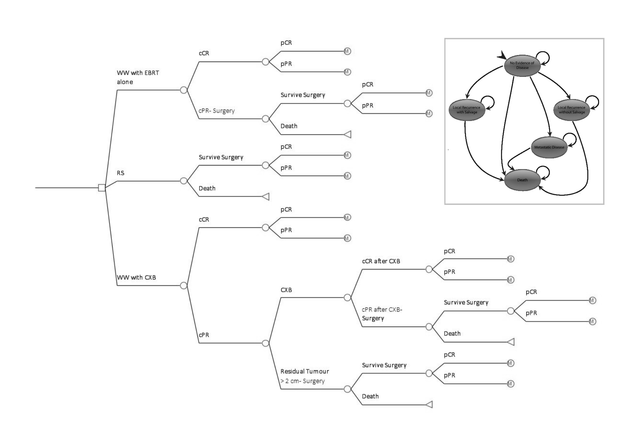

Figure 2

Figure 3

Figure 4
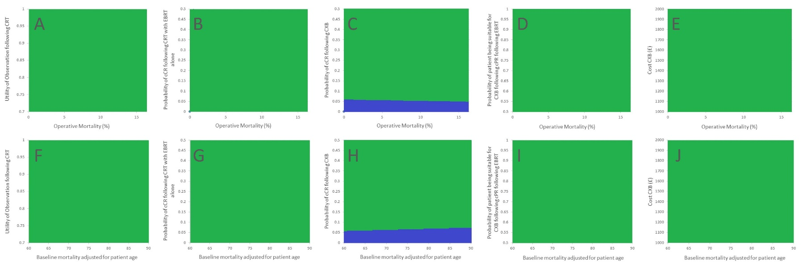
Figure 5
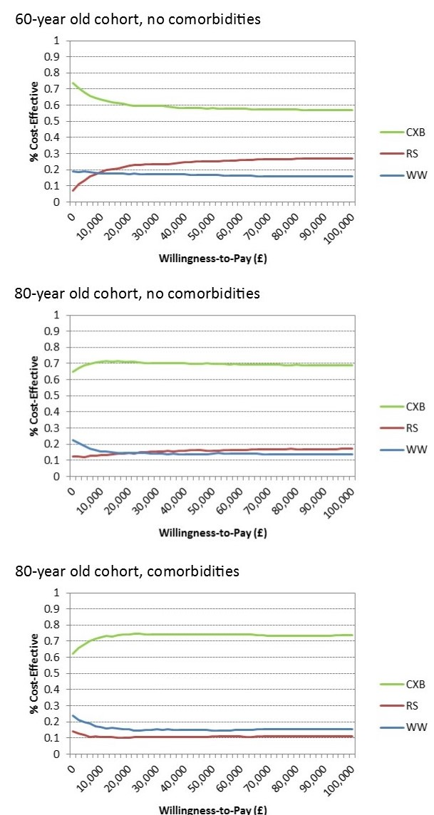
Figure 6
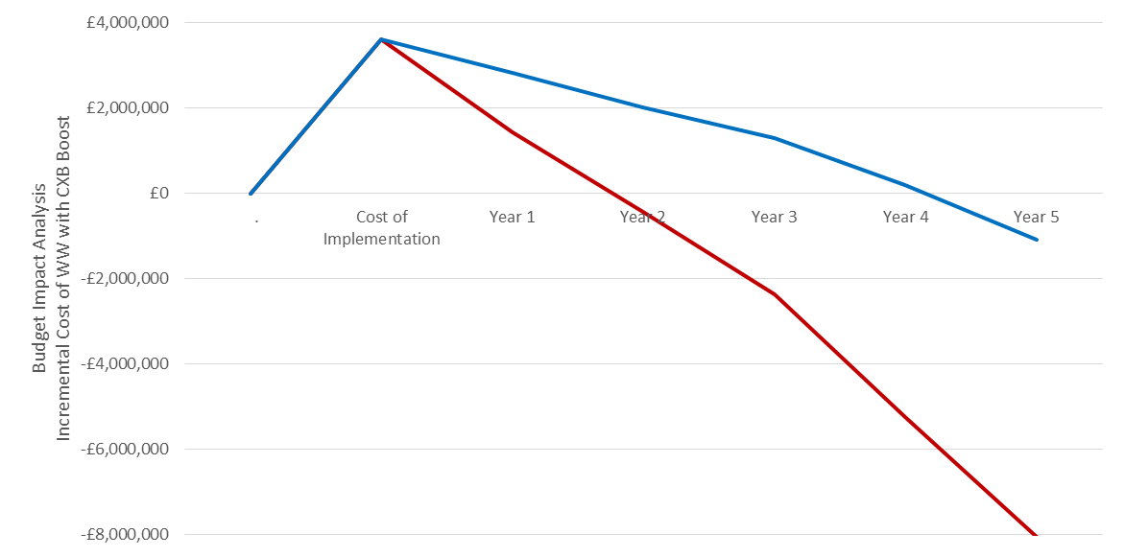

Figure 7
