Experimental study of atmospheric-pressure, micro-plasmas for

the ambient sampling of conductive materials

Zhengchao Duan1, Feng He1,*, Xinlu Si1, James W. Bradley2 and Jiting Ouyang1

1School of Physics, Beijing Institute of Technology, P.O. Box 327, Beijing 100081, China

2Department of Electrical Engineering and Electronics, The University of Liverpool, Brownlow Hill, Liverpool, L69 3GJ, UK.

(*corresponding author; Electronic mail: hefeng@bit.edu.cn)

**Abstract**

The conductive solid material sampling by micro-plasma under ambient atmosphere were studied experimentally. A high-voltage pulse generator is utilized to drive the discharge between a tungsten needle and metal samples. The effects of pulse width on discharge, micro-plasma and sampling were investigated. The electrical results show that two discharge current pulses can be formed in one voltage pulse. The duration of the first current pulse is on the order of 100 ns. The duration of the second current pulse depends on the width of the voltage pulse. The electrical results also show that arc micro-plasma was generated during both current pulses. The results of the emission spectra of different sampled materials indicate that the relative emission intensity of the elemental metal ions will increase with the pulse width. The excitation temperature and electron density of the arc micro-plasmas increase with the voltage pulse width, which contributes to the increase of relative emission intensity of metal ions. The optical images and EDS results of the sampling spots on metal surfaces indicate that the discharge with short voltage pulse can generate a small sputtering crater.

**Keywords:** micro-plasma, pulsed discharge, ambient sampling, atmospheric-pressure.

**1. Introduction**

In the last two decades, atmospheric-pressure plasmas (APPs) have attracted a amount of attention from both academic groups and companies, for the plasmas can be generated without expensive vacuum system. The low temperature, non-equilibrium plasmas obtained under atmospheric pressure contain many reactive species, and have been successfully applied in surface treatment, pollution control, bio-medicine, plasma catalysis, etc [1-6].

Besides the fields mentioned above, APPs have also been used for analytical chemistry under atmospheric pressure [7-9]. Mass spectrometry (MS) and optical emission spectroscopy (OES) are useful analytical methods in industry and research, as they can provide a lot of atomic and molecular information within a single test[10-13]. Generally, in traditional MS or OES detection, the process includes sample preparation, sampling/ionization in a low-pressure environment with radio frequency (RF) or glow discharge (GD) plasma, and then the species themselves or their light emission are analyzed by mass spectrometry or optical spectroscopy respectively[14-15]. In 2004, Dr. Takáts *et al* proposed an innovative conception about ambient sampling prior to material analysis, and analyzed a living flower directly in ambient conditions by mass spectrometry for the first time [16]. In their experiment, the sampling and ionizing of atoms/molecules were implemented using an atmospheric-pressure ion source without sample preparation. This work leads a rapid development of ambient sampling to meet the requirement of pharmaceutical analyses, environmental samples, food engineering and biological materials, etc. Different technologies based on micro-plasma have been proposed for ambient sampling, such as Plasma-assisted Desorption/Ionization (PADI) [17], Flowing Atmospheric-Pressure Afterglow (FAPA) [18], Dielectric Barrier Discharge Ionization (DBD) [19], etc. Most atmospheric-pressure plasma sources for material sampling are operated in the glow regime, and used for easy-desorption or thermal-sensitive materials. For high melting point materials, Laser ablation (LA) is a powerful sampling method for the analysis of elemental constituents [20-24]. However, the LA device of ambient sampling has been a relatively expensive system for application. Spark/arc discharge has also been proposed for analysis of alloys and metals due to the low cost [25-26]. Li *et al* used an arc micro-plasma to sample solid materials directly in a nitrogen atmosphere, and their work focused on the element analysis of samples by inductively-coupled plasma mass spectrometry (ICP-MS) [26]. However, the characteristics of discharge and arc-plasma acting on sample were not discussed in detail.

In this paper, sampling metal materials by the pulsed arc micro-plasma in the open atmosphere environment are investigated experimentally. The characteristics of the pulsed micro-discharge are analyzed. The effects of the pulse width on the sampling crater and the optical emission spectroscopy are also discussed.

**2. Experimental Setup**

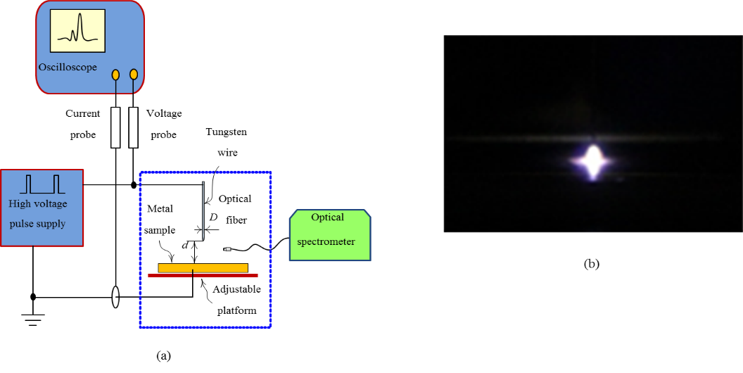

Figure 1. (a) Schematic diagram of the experimental apparatus. (b) The image of the micro plasma.

Figure 1 (a) shows a schematic diagram of the experimental apparatus. The experiments were carried out in an open environment with air as the working gas. The micro-discharge is generated in a typical needle-panel structure which consists of a tungsten wire and the conductive sample. The tungsten wire was settled in a ceramic tube and served as the discharge anode. Before the experiments, the tungsten wire was cleaned with 400 grit sandpaper followed by rinsing in alcohol, to ensure no contamination on the tip of the tungsten wire. A metal sample as the ground electrode was fixed on a platform with precision adjustment screws. The maximum distance of the platform moving toward the tungsten wire is 10 mm, and the minimum adjustable size is 5 μm, which satisfied the requirement of the adjustment of the electrode gap *d* between the tungsten wire electrode and the metal sample. In this work, the gap *d* is set to be 400 μm.

The voltage waveforms applied on the tungsten electrode were measured by digital oscilloscope (DPO 4034B, Tektronix) with a Tek P6015A voltage probe. The discharge current passing through the wire connected to the sample was detected using a current monitor (Pearson 2877, Pearson Electronics). The optical emission spectra of the discharge plasma were recorded by a fiber optic spectrometer (AvaSpec-3648, Avantes). A quartz optical fiber was mounted near the discharge gap about 10 mm to guide the emission light to the spectrometer. Therefore, the emission spectrum was spatially integrated. During pulse operation, the gate width of the spectrometer was 100 ms which was much longer than the duration of current pulse, i.e. the emission light was also necessarily time-integrated. The light emissions of the plasma were scanned from 200 nm to 1100 nm with the resolution of 0.6 nm. Each spectrum was obtained by averaging the results of 10 scans, then subtracting the background light emissions from the averaged value.

The discharge apparatus was powered by a high-voltage pulse generator. The high-voltage pulse generator consists of a DC (direct current) power supply (DW-P203-20ACF2, Dongwen), two high-voltage power MOSFETs (S1, S2), and a low voltage control circuit module, as shown in figure 2. The output currents of the DC power supply are 0 ~ 20 mA. In order to provide large transient current, a capacitor (C1) was used to store electrical energy. Two current-limiting resistors (R1, R2) were chosen for over-load current protection of DC power supply and MOSFETs. The two MOSFET devices constituted a half-bridge circuit, and were turned “ON” alternately to generate a positive high-voltage pulse with fast rising and falling edges on the load. In order to avoid the shot-through, the two MOSFETs were switched on with about 2 μs dead-time. Accordingly the voltage pulse width on the load during discharge will be 2 μs smaller than the voltage pulse width without discharge. The output of the high-voltage pulse supply can be varied from 0 ~ 3kV. The pulse frequency *f* can be operated at 0.1 ~20 kHz with adjustable duty cycle.

figure2

Figure 2. Schematic diagram of the high-voltage pulse generator.

**3. Results and discussion**

**3.1 Electrical Characteristics of the discharge**

Figure 3 shows the voltage waveforms on the tungsten wire without discharge at various duty cycles or pulse widths. It can be seen that without discharge, each voltage waveform is a standard square-wave. Both the rising and falling edges of the pulse are about 200 ns (the voltage varies from 10% to 90% of the pulse amplitude). The pulse widths of the waveforms shown in figure 3 are 2.5 μs, 2.9 μs and 3.6 μs respectively. By setting a 2 μs dead-time, the actual time of MOSFET S1 turned "ON" or the effective pulse width should be obtained by subtracting 2 μs accordingly. The effective pulse width is hereinafter denoted as *tw*,eff. In figure 3, we also provide a current waveform at *tw*,eff = 0.5 μs. It shows that the charge/discharge currents of the needle-panel structure can be negligible at the rising and falling edges, for the capacitor of the structure is quite small.

**figure3**

Fig. 3 The voltage and current waveforms without discharge at various pulse widths.

For our discharge apparatus, the initial breakdown voltage mainly depends on the electrode gap and is above 2.5 kV in most cases. After the discharge ignited, the output voltage of DC power supply was adjusted to 2.0 kV manually and the pulsed discharge can be maintained stably. Figure 4(a)-(c) provide the voltage and current waveforms during stable pulsed discharge at various *tw*,eff. The voltage waveform no longer maintains a square-wave with

figure4a

(a) *t*w,eff=0.5μs

figure4-b.emf

(b) *t*w,eff=0.9μs

figure4c

(c) *t*w,eff=1.6μs

Fig. 4 The voltage and current waveforms of the pulsed micro-discharge. The pulse frequency is 2.5 kHz.

discharge. All the voltage waveforms have a high-voltage short pulse. A low-voltage, long-duration pulse might follow the short pulse, which depends on the effective pulse width *tw*,eff. At the rising edges of voltage waveforms in figure 4, the voltage peak of stable pulse is in the range of 1.3~1.5 kV which is much lower than the initial breakdown voltage. Once consecutive pulse discharges are formed, more seed electrons can be kept in the gas gap, which causes a lower breakdown voltage, and the voltage peak decreases slightly as *tw*,eff increasing (as shown in figure 4). The current has a 50 ns lag-time compared to the voltage rising edge and then increases up to 4 A rapidly in less than 10 ns, then the voltage drops to 0 V for the current limiting resistor. This process forms a short pulse with high voltage and large current at various *tw*,eff. The duration of the first current pulse is about 100 ns. In figure 4(c), it can be found that large current of the first pulse is maintained, even at the voltage lower than 100V. From the voltage and current waveforms, it can be calculated that the average power is about 1 kW during the first current pulse. The characteristics of low voltage and large current with high discharge power indicate that the discharge is transferred to arc regime after ignited.

Following the first short pulse, the voltage will increase again if the MOSFET S1 is not turned "OFF", and a new discharge pulse will be formed, as shown in figure 4 (b) and (c). The second discharge is triggered when the voltage is increased to ~300 V. This value is lower than that of the first pulse, as many charged particles are formed by the first discharge. With *tw*,eff =0.5μs, the voltage cannot reach 100 V before the MOSFET S1 switching to "OFF" state. Hence the second discharge wasn't observed in the waveforms of short pulse width (see figure 4 (a)). At larger *tw*,eff (figure 4 (b) and (c)), a low voltage on the order of several tens volts is kept till the falling edge of the voltage pulse, while the current amplitude can reach 3 A and keeps almost unchanged during the second discharge pulse. The average power of the second pulse is also calculated and on the order of 100 watt. So the second pulse is still operated in typical arc discharge. The results show that both two discharge pulses will form arc micro-plasma in our experiment.

**3.2 Optical emission spectroscopy**

Although arc micro-plasmas were formed in all discharge pulses, the effects of the arc micro-plasma at different pulse widths on material sampling also OES are different and will be discussed in the following sections.

For comparing, the spectrum of DC discharge was recorded firstly, as shown in figure 5. The discharge was performed using the same apparatus with the DC power supply connected to the tungsten wire through a 200 kΩ ballast resistor. The purity 99.9999% of iron sample was used as the cathode. The output voltage of DC power supply was set to be 1.5 kV. The discharge current is about 6mA. Such current generally indicates the discharge operated in glow regime. Although the spectrometer integration time was increased to 200ms, the experimental results show that the light emission of the discharge plasma is quite weak. In addition, from the spectrum in figure 5, the dominant emission line spectra include 315nm, 337nm, 357nm and 380nm which come from the second positive bands of N2 (C3∏u − B3∏g) [26]. However, the emission lines of Fe atom or Fe ion were not found in the spectrum of DC discharge. This result means that it is difficult to sample the metals by the DC discharge.

figure8

Fig. 5 The emission spectrum from the DC discharge.

The emission spectra of the arc micro-plasma were measured to study the sampling effects of the arc micro-plasma. All the results of pulsed discharge were obtained at the pulse frequency *f*= 2.5 kHz. At the gate width=100ms, the emission spectra were integrated in 2500 pulses. The time of plasma acting on the samples is 2 minutes. The same output voltage of DC power supply was used for each metal sample.

Using pulsed discharge, the spectra of arc micro-plasma acting on aluminum, copper and iron sample under various *tw*,eff were obtained. Figure 6 shows the spectra of arc plasma sampling iron substrate. Comparing figure 6 with figure 5, the emission intensities of N2 spectral lines in the pulsed arc discharge are much higher than that in DC discharge. From figure 6, not only the lines of N2 but also some new emission lines can be found in all spectra of pulsed arc discharges. The new emissions lines are mainly emitted by Fe atom (FeI) or Fe ion (FeII). The spectrum of *tw*,eff= 0.5 μs shows that with only the first short pulse, the dominant emissions come from N2. Moreover, the strong emission of 248nm(FeI, 3*d*64*s*2 −3*d*6(5D)4*s*4*p*(1P)) appears in the spectrum. The spectral results further confirm that the metal material was sampled successfully. As *tw*,eff increases, the relative intensity emitted by N2 will decrease, for example 337 nm changes from 100% to 13%, and the dominant lines become the emissions of FeI and FeII. For FeI, the relative intensity of 248nm decreases slightly, while the relative intensity of 344nm (FeI, 3*d*64*s*2 − 3*d*6(5D)4*s*4*p*(3P)) and 382nm (FeI, 3*d*7(4F)4*s* − 3*d*7(4F)4*p*) increases. The relative intensities of FeII increase remarkably. 275nm line (FeII, 3*d*6(5D)4*s*−3*d*6(5D)4*p*) becomes the strongest emission in Fig.6(b) and6(c) . As shown in figures 7 and 8, the spectra of sampling aluminum and copper have similar tendencies. The results reveal that with the second discharge pulse, more sample atoms can be ionized. It is worth noting that, as the pulse width increases, the emission spectrum of manganese(MnII, 3*d*54*s*2- 3*d*5(6S)4*s*4*p*(3Po)) at *λ* = 403 nm was also obtained, which is one of the trace elements contained in the iron sample (less than 0.000003%). In other words, using long pulse voltage is of benefit to mass spectrometry analysis or optical spectrum analysis.

figure6-a.emf

Fig. 6 The emission spectra from the arc plasmas with a Fe sample at various times *tw*,eff.

figure6-b.emf

Fig. 7 The measured emission spectra from the arc plasmas with a Al sample at various times *tw*,eff.

figure6-c.emf

Fig. 8 The measured emission spectra from the arc plasmas with a Cu sample at various times *tw*,eff.

**3.3 Excitation temperature and Electron density**

The excitation temperatureis obtained using the well-known Boltzmann plot method. The equation is as follows:

$\ln{\frac{I_{ki}λ_{ki}}{g_{k}A_{ki}}}=-\frac{E_{k}}{K_{B}T}+C$ $\ln{\frac{I_{ki}λ_{ki}}{g_{k}A_{KI}}}=-\frac{E_{k}}{K_{B}T}+ln⁡({\frac{N\left(T\right)}{U\left(T\right)}})$ $\ln{\frac{I_{ki}λ_{ki}}{g_{k}A_{KI}}}=-\frac{E_{k}}{K_{B}T}+ln⁡({\frac{N\left(T\right)}{U\left(T\right)}})$ (1)

Where $I_{ki }$ is the intensity of a emission light , $g_{k }$ is the statistical weight of the upper excited level with energy *Ek*, is the transition probability of spontaneous radiation, and $C$ is a constant. Seven spectral lines of iron atom were used to estimate the electron temperature. The relevant parameters are listed in Table 1[27]. The calculated excitation temperatures at *tw*,eff =0.5 μs, 0.9 μs, 1.6 μs are 5830K , 7800K and 7300K respectively. It shows that the excitation temperature in the short pulse discharge is lower than that in long pulse discharge.

Table 1 Fe parameters of plasma emission spectroscopy

|  |  |  |  |  |
| --- | --- | --- | --- | --- |
| **Species** | $λ_{ki}$**/nm** | **Ek/cm-1** | **Aki(108s-1)** | **gk** |
| **Fe I** | 248 | 40257.311 | 4.81 | 5 |
| 382 | 33095.939 | 0.668 | 4 |
| **Fe II** | 240 | 42237.033 | 2.05 | 8 |
| 238 | 41968.046 | 3.13 | 12 |
| 260 | 39013.206 | 1.74 | 4 |
| 275 | 44232.512 | 2.1 | 10 |
| 344 | 29056.322 | 0.171 | 3 |

The electron density is an important parameter because it indicates the reaction frequency between the electrons and the sampled atoms. The electron density was estimated using Stark broadening of the spectral lines. The contribution of other mechanisms of broadening can be neglected in this high density plasma[28]. The full width at half maximum (FWHM) of the Stark-broadened lines, $λ_{\frac{1}{2}}$, being related to the electron density n*e* (cm-3) by[29-32]:

$λ_{\frac{1}{2}}=$ 2 $w\frac{n_{e}}{{10}^{16}}$ (2)

where *w* is an electron impact parameter. As shown in figure 9, the Stark width is estimated by fitting the 238nm spectral line[FeⅡ, from the triplet (*3d6(5D)4s—3d6(5D)4p*)]. The electron density is 1.0×1017 cm-3 at *tw*,eff =0.5 μs , 3.5×1017 cm-3 at *tw*,eff =0.9 μs and 3.8×1017 cm-3 at of *tw*,eff =1.6 μs. The results show that both excitation temperature and electron density will be increased if the second discharge current pulse is formed. This result also implies an increase in voltage pulse width is benefit to ionization or excitation.

 

1. (b) (c)

Fig.9 Lorentz function fitting of FeⅡ238 nm line stark broadening (a)at *tw*,eff =0.5 μs, (b) *tw*,eff =0.9 μs and (c) *tw*,eff =1.6 μs

**3.4 Sputtering Craters**

Figure 10 show the optical micrographs of the aluminum, copper and iron sample surface, respectively. All the images were obtained by an optical microscope at a magnification of ×80. From the images of different samples, it can be found that inerratic craters were formed on different sample surfaces. It means that the arc micro-plasmas of our experimental apparatus can sample high-melting-point conductive solid materials successfully in ambient atmosphere.

The shapes of the craters on different materials are very similar. The diameters of the craters increase with increasing of the effective pulse width gradually. At *tw*,eff =0.5 μs, the crater diameter is about 400μm, and few metal grains can be found in the craters, as shown in figure 10(a) 10(d) and10 (g). When the effective pulse width is 0.9 μs, the crater diameter is about 500μm, and many metal grains were found in the craters(see figure 10(b), 10(e)and 10(h).). At *tw*,eff =1.6 μs, the crater diameter is increased to 600μm, and the whole crater is almost covered by metal grains(see figure 10(c), 10(f) and 10(i)).

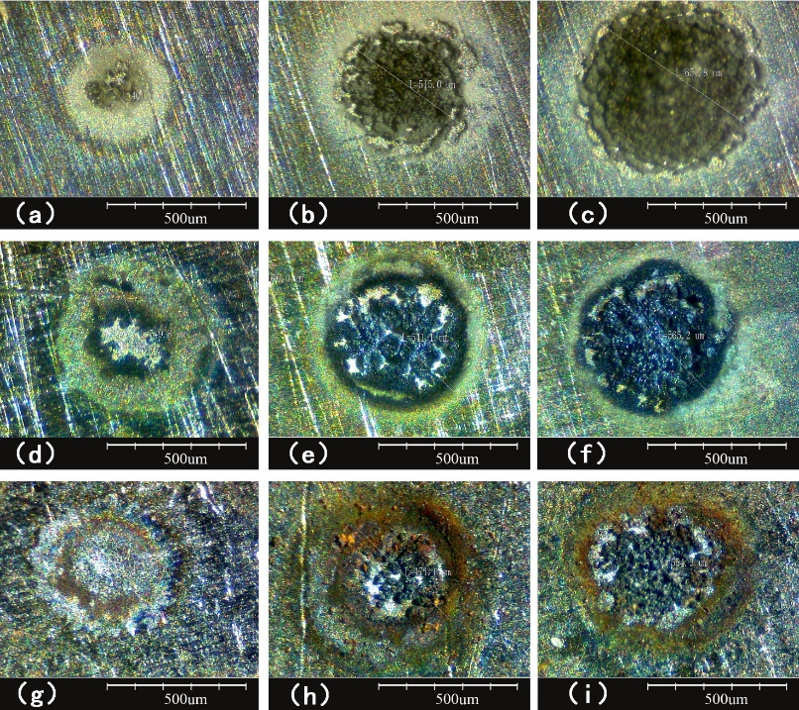

Fig. 10 The micrographs of the craters on the sample surfaces at various *tw*,eff . (a) *tw*,eff= 0.5 μs, (b) *tw*,eff = 0.9 μs, (c) *tw*,eff = 1.6 μs on Al sample. (d) *tw*,eff= 0.5 μs, (e) *tw*,eff = 0.9 μs, (f) *tw*,eff = 1.6 μs on Cu sample. (g) *tw*,eff= 0.5 μs, (h) *tw*,eff = 0.9 μs, (i) *tw*,eff = 1.6 μs on Fe sample.

Table 2 and Table 3 presents the element composition in the craters on aluminum and copper samples respectively. These results are obtained by Energy Dispersive Spectrometer (EDS). From the results, it can be found that the proportions of oxygen in the craters of aluminum and copper samples decrease evidently as the voltage pulse width changed from 1.6μs to 0.5 μs.

Table 2 Element composition of aluminum sample surface

|  |  |  |  |  |  |  |
| --- | --- | --- | --- | --- | --- | --- |
| element | tw,eff =0.5 μs | | tw,eff =0.9μs | | tw,eff =1.6μs | |
| Weight (%) | Atomic (%) | Weight(%) | Atomic(%） | Weight(%) | Atomic（%） |
| Al | 54.25 | 39.85 | 47.49 | 33.97 | 41.41 | 28.81 |
| O | 37.33 | 46.25 | 44.21 | 53.32 | 52.34 | 61.41 |
| C | 8.42 | 13.89 | 7.62 | 12.25 | 6.26 | 9.78 |
| Si | 0 | 0 | 0.67 | 0.46 | 0 | 0 |

Table 3 Element composition of copper sample surface

|  |  |  |  |  |  |  |
| --- | --- | --- | --- | --- | --- | --- |
| element | tw,eff =0.5 μs | | tw,eff =0.9μs | | tw,eff =1.6μs | |
| Weight(%) | Atomic(%) | Weight(%) | Atomic(%） | Weight(%) | Atomic(%） |
| Cu | 69.18 | 33.84 | 72.66 | 37.24 | 60.79 | 25.81 |
| O | 18.02 | 35 | 16.81 | 34.21 | 24.75 | 41.73 |
| N | 5.31 | 11.78 | 0 | 0 | 0 | 0 |
| C | 7.49 | 19.38 | 10.53 | 28.55 | 14.46 | 32.47 |

The images of sputtering crater on sample surface and the results of EDS at various *tw*,eff show that the two discharge pulses can cause different effects. From section 3.1, one can see that both of the two pulsed discharges include the processes of gas breakdown and arc discharge. The duration of arc discharge in the first pulse is very short. So the effect of the first pulse on the metal surface is mainly ion sputtering. While in the second pulse, the arc discharge lasts longer time stably, which causes a remarkable heating effect on the metal surface [33-34]. We consider that at larger *tw*,eff , the heating effect leads to more oxidation reactions of metal atom in the craters, and forming more grains. The oxidized grains will prevent the discharge ignited in same region during subsequent pulses, which causes larger crater. These results indicate that the first short voltage pulse is of benefit to sampling in small region.

**4. Conclusions**

In this paper, the sampling of high-melting-point solid metal material using a pulsed discharge under ambient atmospheric pressure was studied experimentally. The experimental results show that with a short voltage pulse, a pulse discharge about 100 ns will be triggered; and with a longer voltage pulse, a large current, low voltage discharge can be formed following the first short pulse. The electrical characteristics reveal that arc micro-plasmas are formed in both discharge pulses. The relative emission intensities of the sample elemental ions increase considerably during the second current pulse, and the emission spectrum of the trace elements in the sample was also observed. With the second current pulse in the discharge, the electron temperature and electron density increase evidently, which contributes to more ionization and excitation of the sample ions. The images of the craters on different metal materials and the EDS results show that shorter voltage pulse can form smaller sputtering crater because of less oxidation reactions on the surface. It means that short voltage pulse is of benefit to improvement of spatial resolution.

**Acknowledgement**

This work was supported by the National Science Foundation of China under Grant No. 11475019.

**References**

1. K. H. Schoenbach and K. Becker. 20 years of microplasma research: a status report. Eur. Phys. J. D. 2016, 70(2), 29
2. J. Winter and R. Brandenburg, and K. D. Weltmann. Atmospheric pressure plasma jets: an overview of devices and new directions. Plasma Sources Science Technology. 2015,24, 064001
3. R Foest and E Kindel and A Ohl and M Stieber and K-D Weltmann. Non-thermal atmospheric pressure discharges for surface modification. Plasma Physics and Controlled Fusion. 2005, 47, B525
4. María Hijosa-Valsero, Ricardo Molina, Anna Montràs, Michael Müller & Josep M. Bayona. Decontamination of waterborne chemical pollutants by using atmospheric pressure nonthermal plasma: a review. Environmental Technology Reviews. 2014, 3, 71-91
5. X. Lu, G. V. Naidis, M. Laroussi, S. Reuter, D. B. Graves, and K. Ostrikov. Reactive species in non-equilibrium atmospheric-pressure plasmas: Generation, transport, and biological effects. Physics Reports, 2016,. 630, pp. 1–84,.
6. J. C. Whitehead. Plasma catalysis: A solution for environmental problems. Pure Appl. Chem. 2010, 82(6), 1329–1336.
7. M. E. Monge, G. A. Harris, P. Dwivedi, and F. M. Fernandez. Mass spectrometry: recent advances in direct open air surface sampling/ionization. Chem Rev, 2013, 113(4), 2269
8. R. B. Cody, J. A. Laramée, and H. D. Durst. Versatile new ion source for the analysis of materials in open air under ambient conditions. Anal Chem, 2005, 77(8):2297–2302.
9. A. Bowfield, D. A. Barrett, M. R. Alexander, C. A. Ortori, F. M. Rutten, T. L. Salter, I. S. Gilmore, and J. W. Bradley. Surface analysis using a new plasma assisted desorption/ionisation source for mass spectrometry in ambient air. Rev Sci Instrum, vol. 83, no. 6, p. 063503, 2012.
10. GroßeKreul and S Hübner and S. Schneider and D Ellerweg and A von Keudell and S Matejčík and J Benedikt, Plasma Sources Sci. Technol. Mass spectrometry of atmospheric pressure plasmas, 2015, 24(4), 044008.
11. Raman Bekarevich and Iuliana Motrescu and Aliaksandr Rahachou and Masaaki Nagatsu. Mass spectrometric study of ammonia/methane surface-wave plasma applied to low-temperature growth of carbon nanomaterials. Journal of Physics D: Applied Physics. 2015, 48(4), 045201
12. G D Stancu and F Kaddouri and D A Lacoste and C O Laux. Atmospheric pressure plasma diagnostics by OES, CRDS and TALIF. Journal of Physics D: Applied Physics, 2010, 43(12), 124002
13. A F H van Gessel and B Hrycak and M Jasiński and J Mizeraczyk and J J A M van der Mullen and P J Bruggeman. Temperature and NO density measurements by LIF and OES on an atmospheric pressure plasma jet. Journal of Physics D: Applied Physics. 2013, 46(9), 095201
14. Giglio J J, Caruso J A. Evaluation of Alternative Plasma Gases for Radio-Frequency Glow Discharge Mass Spectrometry (rf GD-MS)[J]. Applied Spectroscopy, 1995, 49(7):900-906.
15. Payling R, Chapon P, Bonnot O, et al. Characterising the Radio Frequency Plasma Source for Glow Discharge Optical Emission Spectroscopy[J]. Transactions of the Iron & Steel Institute of Japan, 2007, 42(Suppl):S101-S105.
16. Z. Takáts, J. M. Wiseman, B. Gologan, and R. G. Cooks. Mass spec-trometry sampling under ambient conditions with desorption electrospray ionization. Science. 2004, 306(5695), 471–473,
17. Ratcliffe, Lucy V. and Rutten, Frank J. M. and Barrett, David A. and Whitmore, Terry and Seymour, David and Greenwood, Claire and Aranda-Gonzalvo, Yolanda and Robinson, Steven and McCoustra, Martin. Surface Analysis under Ambient Conditions Using Plasma-Assisted Desorption/Ionization Mass Spectrometry. Analytical Chemistry. 2007, 79(16), 6094-6101
18. Andrade, Francisco J. and Shelley, Jacob T. and Wetzel, William C. and Webb, Michael R. and Gamez, Gerardo and Ray, Steven J. and Hieftje, Gary M. Atmospheric Pressure Chemical Ionization Source. 1. Ionization of Compounds in the Gas Phase. Analytical Chemistry. 2008, 80(8), 2646-2653
19. N. Na, M. Zhao, S. Zhang, C. Yang, X. Zhang. Development of a dielectric barrier discharge ion source for ambient mass spectrometry. Journal of the American Society for Mass Spectrometry. 2007, 18(10), 1859-1862.
20. Yasuo Iida. Effects of atmosphere on laser vaporization and excitation processes of solid samples. Spectrochimica Acta Part B: Atomic Spectroscopy, 45(12):1353 – 1367, 1990.
21. Christopher Shiea, Yeou-Lih Huang, Sy-Chyi Cheng, Yi-Lun Chen, and Jentaie Shiea. Determination of elemental composition of metals using ambient organic mass spectrometry. Analytica Chimica Acta, 968(Supplement C):50 – 57, 2017.
22. Annemie Bogaerts, Zhaoyang Chen, Renaat Gijbels, and Akos Vertes. Laser ablation for analytical sampling: what can we learn from modeling? Spectrochimica Acta Part B: Atomic Spectroscopy, 58(11):1867 – 1893, 2003.
23. Julia Wienold, Heike Traub, Britta Lange, Thorsten Giray, Sebastian Recknagel, Heinrich Kipphardt, Ralf Matschat, and Ulrich Panne. Elemental analysis of copper and magnesium alloy samples using ir-laser ablation in comparison with spark and glow discharge methods. J. Anal. At. Spectrom., 24:1570–1574, 2009.
24. Günther D, Hattendorf B. Solid sample analysis using laser ablation inductively coupled plasma mass spectrometry. Trac Trends in Analytical Chemistry, 2005, 24(3):255-265.
25. R. Maibusch, H.-M. Kuss, A. G. Coedo, T. Dorado, and I. Padilla. Spark ablation inductively coupled plasma mass spectrometry analysis of minor and trace elements in low and high alloy steels using single calibration curves. J. Anal. At. Spectrom., 14:1155–1162, 1999.
26. Weifeng Li, Zhibin Yin, Xiaoling Cheng, Wei Hang, Jianfeng Li, and Benli Huang. Pulsed microdischarge with inductively coupled plasma mass spectrometry for elemental analysis on solid metal samples. Analytical Chemistry, 87(9):4871–4878, 2015.
27. Kramida A, Ralchenko Y, Reader J. NIST Atomic Spectra Database, National Institute of Standards and Technology, Gaithersbury, ND, 2013.
28. M Milan, J. J Laserma. Diagnostics of silicon plasmas produced by visible nanosecond laser ablation. Spectrochimica Acta Part B: Atomic Spectroscopy 56, 2001, 275-288
29. C .S .Chen , X.L. Zhou , B .Y .Man et al .Investigation of the mechanism of spectral emission and red-shifts of atomic line in laser-induced plasmas . Optik , 2009 , 120(10):473 — 478.
30. CREMERS D A, RADZIEMSKI L J．Handbook of Laser—Induced Breakdown Spectroscopy．Chichester：John Wilkey & Sons Ltd．2006．
31. Griem HR, Spectral Line Broadening by Plasma : Academic Press, New York,1974.
32. Singh JP, Thakur SN. Laser-induced breakdown spectroscopy. Amsterdam: Elsevier science BV, 2006.
33. David Z Pai, Gabi D Stancu, Deanna A Lacoste, and Christophe O Laux. Nanosecond repetitively pulsed discharges in air at atmospheric pressurethe glow regime. Plasma Sources Science and Technology, 18(4):045030, 2009.
34. D L Rusterholtz, D A Lacoste, G D Stancu, D Z Pai, and C O Laux. Ultrafast heating and oxygen dissociation in atmospheric pressure air by nanosecond repetitively pulsed discharges. Journal of Physics D: Applied Physics, 46(46):464010, 2013.