Complex DNA damage induced by high-LET α-particles and protons triggers a specific cellular DNA damage response

Rachel J. Carter*, Catherine M. Nickson*, James M. Thompson†, Andrzej Kacperek‡, Mark A. Hill†, and Jason L. Parsons*.

*Cancer Research Centre, Department of Molecular and Clinical Cancer Medicine, University of Liverpool, 200 London Road, Liverpool L3 9TA, UK
†CRUK/MRC Oxford Institute for Radiation Oncology, University of Oxford, Gray Laboratories, ORCRB Roosevelt Drive, Oxford, OX3 7DQ, UK
‡The National Eye Proton Therapy Centre, The Clatterbridge Cancer Centre NHS Foundation Trust, Clatterbridge Road, Bebington, CH63 4JY, UK

Reprint requests to: Jason L. Parsons, PhD, Cancer Research Centre, Department of Molecular and Clinical Cancer Medicine, 200 London Road, Liverpool, L3 9TA, UK. Tel: (44) 151 794 8848; Email: j.parsons@liverpool.ac.uk
Supported by grants to JLP from North West Cancer Research (CR1074) and by the Medical Research Council via a New Investigator Research Grant (MR/M000354/1). Funding from Medical Research Council Strategic Partnership Funding (MC-PC-12004) for the CRUK/MRC Oxford Institute for Radiation Oncology is also gratefully acknowledged.
Conflict of interest: none.
Supplementary material for this article can be found at www.redjournal.org.
Acknowledgement-The authors thank Prof T. Carey for providing the UMSCC cells and Prof G. Dianov for providing APE1, NTH1 and OGG1 bacterial expression plasmids. We also thank Brian Marsland, Andy Wray and Ian Taylor at the Clatterbridge Cancer Centre for technical assistance with proton irradiation of cells.

Abstract
Purpose: Complex DNA damage (CDD), where two or more DNA lesions are induced in close proximity, is a signature of ionising radiation (IR) that contributes significantly to cell killing due to the difficult nature of its repair. However the precise mechanism of recognition and processing of CDD in cellular DNA, where the DNA is wrapped around histone proteins to form chromatin, is currently unknown.
Methods and Materials: HeLa and oropharyngeal squamous cell carcinoma (UMSCC74A and UMSCC6) cells were irradiated with high linear energy transfer (LET) α-particles or protons, versus low-LET protons and x-rays. At various time points post-irradiation, site-specific histone post-translational modifications (PTMs) were analysed by quantitative Western blotting, DNA damage and repair was measured by different versions of the comet assay, and cell survival was determined using clonogenic assays.
Results: Site-specific histone PTMs following low and high LET radiation, particularly proton irradiation, were screened aiming to identify those responsive to CDD. We demonstrate that histone H2B ubiquitylated on lysine 120 (H2B_{ub}) is specifically induced several hours post-irradiation in response to high-LET α-particles and protons, but not by low-LET protons or x-rays. This is associated with increased levels of CDD and which contributes to decreased cell survival. We further discovered that modulation of H2B_{ub} is under the control of two E3 ubiquitin ligases, MSL2 and RNF20/RNF40 complex, whose depletion leads to defective processing and further persistence of CDD, and to additional decreased cell survival post-irradiation.
Conclusion: This study demonstrates that the signalling and repair of CDD, particularly induced by high-LET IR is co-ordinated through the specific induction of H2B_{ub} catalysed by MSL2 and RNF20/40, a mechanism which contributes significantly to cell survival post-irradiation.
Introduction
Ionising radiation (IR) induces a plethora of different types of DNA damage of which DNA double strand breaks (DSBs) are a relatively small proportion (<5 %) and where DNA single strand breaks (SSBs) and DNA base damage predominate. However, IR deposits energy in highly structured tracks which can lead to the formation of complex DNA damage (CDD; also termed clustered DNA damage), defined as two or more DNA lesions induced in close proximity (eg. within 1-2 helical turns of the DNA). Due to their complex nature CDD, along with DSBs, are thought to be the major contributors to IR-induced cell killing and therefore in cancer treatment by radiotherapy. This is because non-DSB CDD have been shown to be difficult to repair both in vitro using synthetic oligonucleotide substrates, but also in bacterial, yeast and mammalian cells using plasmid reporter systems (1,2). Consequently, whilst SSBs have a short lifetime (<30 min) and DSBs have an intermediate lifetime (~1-2 h), CDD can persist in cells and tissues several hours post-IR (3,4). Mathematical modelling has estimated that CDD increases from ~30 % for low linear energy transfer (LET) IR, up to 90 % for high-LET α-particles (5-8). Proton beam irradiation, which is increasingly being utilised therapeutically for cancers including head and neck cancers (9), has also been predicted to generate CDD with the proportion dependent on energy and LET. In particular, high energy (or low-LET) protons are thought to generate a DNA damage spectrum similar to that of x-rays and γ-irradiation, whereas low energy protons (with increased LET), specifically at the Bragg peak distal end, generate CDD with increasing frequency. Indirectly, this has been shown by demonstrating that increasing proton LET leads to decreased cell survival and an increase in persistent DNA DSBs (10-12). This suggests that protons at specific energies are more effective at killing cancer cells through CDD formation, and should be considered in developing optimal therapeutic strategies. Despite this, the cellular response to CDD particularly induced by high-LET α-particles and protons is currently unclear.
Nucleosomes form the basic structure of chromatin, whereby the DNA is wrapped around a histone octamer consisting of two copies each of the core histone proteins. The N-terminal tails of histones can be subject to post-translational (PTMs), including acetylation, methylation, phosphorylation and ubiquitylation which can dynamically alter chromatin structure and are important for several DNA-dependent processes, including DNA repair (13). The most well characterised modification induced by DNA damage is the phosphorylation of the histone variant H2AX on serine 139 (also known as γH2AX; (14)) at sites of DNA DSBs catalysed by ataxia telangiectasia mutated (ATM), but also ATM and Rad3 related (ATR), and DNA-dependent protein kinase (DNA-Pk). Formation of γH2AX causes the recruitment of DNA damage response proteins, such as MDC1 and 53BP1, but also stimulates localisation of chromatin modifiers to the DSB site, largely through a ubiquitylation-dependent process (15). Indeed E3 ubiquitin ligases and deubiquitylation enzymes control H2A and H2AX ubiquitylation, and in association with chromatin remodelling complexes, assist in DSB repair. However other histone modifications, including induction of H2B ubiquitylation at lysine 120 by RNF20/RNF40 (16) that may also impact on H3 methylation on lysine 4 (17), and a reduction in H3 acetylation at lysines 9 and 56 (18) are also thought to be modulated at DSB sites. Collectively this highlights the importance of histone PTMs in the cellular DNA damage response by promoting chromatin relaxation and coordinating recruitment of DNA damage repair proteins. However the site-specific histone PTMs, and the enzymes and mechanisms involved in the signalling and processing of CDD, are currently unknown and are required for improving our understanding of radiobiology.

Methods and Materials
Antibodies, proteins and siRNA
Primary/secondary antibodies, proteins and siRNA sequences are in supplementary information.

Cell culture
HeLa, UMSCC6 and UMSCC74A cells were cultured under standard conditions as previously described (19). siRNA knockdowns were performed for 48 h using Lipofectamine RNAiMAX (Life Technologies, Paisley, UK).

Irradiation sources
Cells were exposed to low-LET γ-irradiation using a caesium-137 sealed-source irradiator (GSR D1, Gamma-Service Medical GmbH, Leipzig, Germany; dose rate of 2.0 Gy/min). Cells were exposed to low-LET x-rays (100 kV) using a CellRad x-ray irradiation (Faxitron Bioptics, Tucson, USA; dose rate of 3 Gy/min). Proton irradiations were performed using a horizontal, passive-scattered beam line of 60 MeV maximal energy from the Douglas Cyclotron at Clatterbridge (20). Cells in 35 mm dishes were positioned at the iso-centre 70 mm from a brass collimator (43 mm diameter). For high energy protons, cells were irradiated directly by a ~1 keV/µm pristine beam of 58 MeV effective energy (dose rate of ~5 Gy/min). Low energy proton irradiations were performed using a modulator to generate a 27 mm spread-out Bragg peak (SOBP). A 24.4 mm Perspex absorber was used to position the cells at the distal edge of the SOBP, corresponding to a mean proton energy of 11 MeV at a dose averaged LET of 12 keV/µm (dose rate of ~5 Gy/min). Cells were irradiated with 3.26 MeV α-particles (LET of 121 keV/µm; dose rate of ~1.2 Gy/min) using a ²³⁸Pu irradiator as described previously. Cell cycle analysis was performed by fluorescence-activated cell sorting (FACS; see supplementary information).

Histone extractions and Western blotting.
Cells were irradiated with 10 Gy x-rays, α-particles, protons or treated with 150 µM H₂O₂ for 15 min and harvested by centrifugation (1500 rpm, 5 min, 4°C). To inhibit DNA transcription, cells were preincubated for 1 h with 1 μg/ml actinomycin D prior to irradiation. Histones were purified by acid extraction, as previously described (21), and analysed by quantitative Western blotting using the Odyssey image analysis system (Li-cor Biosciences, Cambridge, UK) as described in supplementary information from at least three independent experiments.

Single cell gel electrophoresis (Comet) assays.
The alkaline comet assay for measurement of SSBs and alkali labile sites and the neutral comet assay for DSBs are previously described (19,22,23). For detection of CDD, an enzyme modified neutral comet assay was used similar to that previously described (24), but with modifications, as described in the supplementary information. % Tail DNA values were calculated from at least three independent experiments and normalised against those seen immediately post-irradiation which was set to 100 %, to allow for comparative kinetics of DNA repair. However for detection and revealing CDD sites, absolute values of % tail DNA are shown.

Clonogenic assays
Following irradiation in 35 mm dishes, cells were trypsinised, counted and a defined number seeded in triplicate into 6-well plates (250/500 for HeLa and 2000/4000 for UMSCC74A/ UMSCC6 for unirradiated controls). Plating efficiencies for HeLa and UMSCC74A/UMSCC6 were ~40 % and 5 %, respectively. Note that increasing cell numbers were used for increasing IR, and double or quadruple the numbers of cells were plated following MSL2 and RNF20 siRNA, respectively to account for plating efficiencies. Colonies were allowed to grow (~7-10 days), prior to fixing and staining with 6 % glutaraldehyde, 0.5 % crystal violet for 30 min. Colonies were counted using the GelCount colony analyser (Oxford Optronics, Oxford, UK). Surviving fraction (SF) was expressed as colonies per treatment versus colonies in the untreated control from at least three independent experiments. Data were fitted to the equation ln(SF)=-αD, where D equals dose using OriginPro 9.1, and the RBE with associated errors were calculated relative to high energy protons by determining the proton doses required to give a surviving fraction of 0.5.
Results
H2B_{ub} is induced in response to IR-induced CDD
HeLa cells were irradiated with low-LET γ-irradiation (γ-IR) or high-LET α-particles (α-IR) known to generate CDD in different proportions, and histone PTMs analysed at various time-points post-treatment. Cells were also treated with hydrogen peroxide. Our focus was on identifying specific histone PTMs responsive to CDD induced by α-IR, particularly at later time-points post-IR where CDD persists. Reductions in H3S10 and H3S28 phosphorylation (mitotic markers), and in acetylation of H2B, were observed irrespective of the treatment. H2B ubiquitylation at lysine 120 (H2B_{ub}) appeared to increase at 1-4 h post-treatment following α-IR, whereas levels initially decreased and then returned to control levels following γ-IR and hydrogen peroxide (Fig. 1). Using low energy (11 MeV; relatively high-LET) and high energy (58 MeV; low-LET) protons, a reduction in H3S10 and H3S28 phosphorylation was also observed (Fig. 2). Additionally, no difference in cell cycle position following low or high-LET protons was observed (Fig. E1A and E1B). High-LET protons appeared to cause elevations in the levels of H3K56 acetylation, and H3 trimethylation. However similar to α-IR, induction of H2B_{ub} was observed at later time points post-IR where CDD persists.
Induction of H2B_{ub} was confirmed quantitatively following α-IR and high-LET protons from 1 h post-IR, versus γ-IR and low-LET protons, and this induction was maintained 3-6 h post-IR where CDD persists (Figs. 3A-3D). To exclude that this was associated with transcription, cells were preincubated with actinomycin D. Using DMSO as a control, there was still a significant accumulation of H2B_{ub} at 3-4 h post-treatment with high-LET protons versus the unirradiated control (Fig. 3E). Whilst the baseline levels of H2B_{ub} were significantly supressed following actinomycin D, by increasing signal intensity there was still a significant increase in H2B_{ub} above the unirradiated control at 3-4 h post-treatment with high-LET protons. H2B_{ub} induction by high-LET protons was also shown quantitatively in two head and neck squamous cell carcinoma cells (UMSCC74A and UMSCC6), suggesting that H2B_{ub} is an epigenetic marker of CDD sites (Figs. E2A-D).

High-LET protons directly cause persistent CDD
Using the alkaline comet assay, detecting SSBs and alkali-labile sites, HeLa cells repair the DNA damage induced by x-rays and low-LET protons within ~30-60 min post-treatment. In contrast, high-LET protons generate DNA damage that persists up to 2 h post-irradiation, suggesting CDD formation (Fig. 4A). Interestingly the repair of DSBs by the neutral comet assay was the same under all IR conditions (Fig. 4B). These data were also reproduced in UMSCC74A and UMSCC6 (Figs. 4C, 4D, E3A and E3B). The existence of CDD induced by high-LET protons was proven using the enzyme modified neutral comet assay, employing recombinant DNA repair enzymes (APE1, OGG1 and NTH1) to incise residual DNA base damage and abasic sites. Therefore whilst there was no difference in the kinetics of repair of DSBs in HeLa cells induced by low-LET or high-LET protons following mock treatment (Fig. 5A; green and blue bars), only cells irradiated with high-LET protons caused a significant elevation in strand breaks immediately post-irradiation following enzyme addition, which persisted 2-4 h post-irradiation (Fig. 5A; yellow bars). As a consequence, using clonogenic survival assays we demonstrate that HeLa cells show significantly decreased cell survival following high-LET protons versus low-LET protons (Fig. 5B; RBE=1.67±0.14). Similarly we observed the same, significant LET dependent difference in survival of UMSCC74A and UMSCC6 cells following proton irradiation (Figs. 5C and 5D; RBE=1.85±0.15 and 1.68±0.10, respectively). The α values are shown in Table E1, and fitted survival curves in Fig. E4A-C.

MSL2 and RNF20/40 catalyse H2B_{ub} that signals CDD and its repair
RNF20/40 is well known to catalyse H2B_{ub}, additionally MSL2 has been shown to catalyse histone H2B ubiquitylation, albeit on lysine 34 (25). We therefore assessed the roles of these enzymes in CDD signalling and repair. An siRNA knockdown of RNF20 (Fig. 6A) caused a significant reduction (~90 %) in unirradiated levels of H2B_{ub} in HeLa cells, but also supressed induction in H2B_{ub} 3-4 h post-irradiation with high-LET protons, versus a non-targeting control siRNA (Fig. 6B and 6C). Surprisingly, depletion of MSL2 similarly reduced (~60 %) unirradiated levels of H2B_{ub} and those in response to high-LET protons, suggesting that both RNF20/40 and MSL2 are involved in stimulating H2B_{ub} in response to CDD. An siRNA knockdown of RNF20, but not MSL2, caused a delay in the repair of DSBs induced by both high-LET and low-LET protons (Fig. E5A and E5B), consistent with its proposed role in modulating DSB repair (16,17). These data using high-LET protons were also replicated using the enzyme modified neutral comet assay following mock treatment of cells (Fig. 6D; green, blue and red green bars). However, addition of recombinant repair enzymes to measure CDD, caused an increase in strand breaks in unirradiated cells following RNF20 or MSL2 siRNA compared to non-targeting control siRNA treated cells, but also caused a significant persistence of CDD up to 4 h following high-LET protons (Fig. 6D; purple, yellow and orange bars). Furthermore, depletion of RNF20 and MSL2 significantly increased sensitivity of cells to high-LET protons versus the non-targeting control siRNA (Fig. 6E). In contrast, depletion of these enzymes did not alter radiosensitivity with low-LET protons where significantly less CDD is induced (Fig. 6F).
Discussion
CDD is a signature of IR thought to contribute significantly to cell killing due to the difficult nature of its repair, and is particularly important for cancer treatment by radiotherapy. High-LET IR, such as α-particles, are more efficient at producing CDD than low-LET x-rays or γ-irradiation and there is increasing evidence that persistent DNA damage, predictably CDD, can be generated following low energy (high-LET) protons (10-12). CDD is less efficiently repaired than isolated DNA damage, as revealed by persistence of the damage but also of DNA repair protein foci (26). Despite this, the radiobiology and the cellular response to CDD in chromatin has not previously been identified.
On screening of site-specific histone PTMs following high and low-LET IR, therefore varying the frequency of CDD produced, we discovered surprisingly that the majority of these PTMs do not change dramatically over a time course post-IR, similar to a previous study examining phleomycin to generate DSBs (18). Only a decrease in the mitotic markers, H3 phosphorylation on serine 10 and 28, at later time points post-irradiation, irrespective of the treatment, was observed. Furthermore, no significant changes in cell cycle position were observed following irradiation with high or low-LET protons. Focussing on CDD-specific PTMs, only H2B ubiquitylation at lysine 120 (H2B_{ub}) was consistently induced following both high-LET α-particles and protons at >2 h post-irradiation where CDD persists. Interestingly, high-LET protons also appeared to promote a decrease in acetylation of H3K14 and increases in trimethylation of H3K9, H3K36 and H3K79 at later time points post-IR, which require further investigation.
H2B_{ub} has previously been suggested to be induced >1 h post-treatment in response to DSBs by the radiomimetic neocarzinostatin and x-ray irradiation (16,17), although another study showed H2B_{ub} levels do not alter following neocarzinostatin (27). In agreement with the latter, we found no evidence for an elevation of H2B_{ub} in response to DSBs induced by low-LET radiation, including γ-irradiation, x-rays and low-LET protons, particularly 2 h post-IR when the majority of DSBs have been repaired. Instead, we demonstrate that H2B_{ub} is specifically induced by high-LET α-particles and protons, at ~2-6 h post-irradiation, which correlates with the slow kinetics of CDD repair, as revealed by enzyme modified neutral comet assays. We were unable to demonstrate any difference in the repair of DSBs using neutral comet assays following low- versus high-LET protons, whereas there was a persistence of SSBs/alkali-labile-sites using alkaline comet assays following high-LET protons, suggesting that CDD sites are non-DSB in nature. In support of this, levels of non-DSB associated CDD were shown to be 4 times higher than the levels of DSBs following low-LET IR (28) but predicted to be 8 times higher following high-LET (5).
Intriguingly, we discovered that H2B_{ub} induced by CDD is catalysed by two E3 ubiquitin ligases, RNF20/40 and MSL2. A role for RNF20/40 in response to DSBs has previously been reported (16,17,27), and indeed we observed a deficiency in the repair of DSB induced by both low- and high-LET protons following RNF20 depletion, but arguably that induction of H2B_{ub} is not essential for this process. We also demonstrate that deletion of RNF20 leads to almost a complete reduction in H2B_{ub}, as observed in the previous studies highlighted above, largely as this histone mark is involved in co-ordination of DNA transcription. Additionally, however, we now propose a role for RNF20/40 in the signalling and repair of CDD induced by high-LET radiation. Interestingly we discovered that CDD repair is also dependent on MSL2. MSL2 has previously been proposed to target ubiquitylation of H2B on lysine 34 for transcriptional activation (25), but that a knockdown of MSL2 causes a significant reduction in H2B_{ub} by decreasing the association of RNF20/40 with chromatin. A follow-up study demonstrated that MSL1/2 and RNF20/40 directly interact and are dependent on each other for stabilisation on chromatin in association with transcription elongation factors (29). Similarly, we observed a substantial reduction in H2B_{ub} in the absence of MSL2, and are in support of the evidence that MSL2 and RNF20/40 are mutually dependent in co-ordinating H2B_{ub}. However we now advance these findings further to describe that these enzymes are crucial for the co-ordination and efficiency of IR-induced CDD repair, and are important factors responsive to high-LET radiation.

References
1. Sage E, Harrison L. Clustered DNA lesion repair in eukaryotes: Relevance to mutagenesis and cell survival. Mutat Res 2011;711:123-33.
2. Eccles LJ, O'Neill P, Lomax ME. Delayed repair of radiation induced clustered DNA damage: Friend or foe? Mutat Res 2011;711:134-41.
3. Magnander K, Hultborn R, Claesson K, et al. Clustered DNA damage in irradiated human diploid fibroblasts: Influence of chromatin organization. Radiat Res 2010;173:272-82.
4. Gollapalle E, Wang R, Adetolu R, et al. Detection of oxidative clustered DNA lesions in x-irradiated mouse skin tissues and human mcf-7 breast cancer cells. Radiat Res 2007;167:207-16.
5. Nikjoo H, O'Neill P, Wilson WE, et al. Computational approach for determining the spectrum of DNA damage induced by ionizing radiation. Radiat Res 2001;156:577-83.
6. Nikjoo H, Bolton CE, Watanabe R, et al. Modelling of DNA damage induced by energetic electrons (100 ev to 100 kev). Radiat Prot Dosimetry 2002;99:77-80.
7. Watanabe R, Rahmanian S, Nikjoo H. Spectrum of radiation-induced clustered non-dsb damage - a monte carlo track structure modeling and calculations. Radiat Res 2015;183:525-40.
8. Stewart RD, Yu VK, Georgakilas AG, et al. Effects of radiation quality and oxygen on clustered DNA lesions and cell death. Radiat Res 2011;176:587-602.
9. Holliday EB, Frank SJ. Proton radiation therapy for head and neck cancer: A review of the clinical experience to date. Int J Radiat Oncol Biol Phys 2014;89:292-302.
10. Chaudhary P, Marshall TI, Perozziello FM, et al. Relative biological effectiveness variation along monoenergetic and modulated bragg peaks of a 62-mev therapeutic proton beam: A preclinical assessment. Int J Radiat Oncol Biol Phys 2014;90:27-35.
11. Britten RA, Nazaryan V, Davis LK, et al. Variations in the rbe for cell killing along the depth-dose profile of a modulated proton therapy beam. Radiat Res 2013;179:21-8.
12. Chaudhary P, Marshall TI, Currell FJ, et al. Variations in the processing of DNA double-strand breaks along 60-mev therapeutic proton beams. Int J Radiat Oncol Biol Phys 2015.
13. Bannister AJ, Kouzarides T. Regulation of chromatin by histone modifications. Cell Res 2011;21:381-95.
14. Rogakou EP, Pilch DR, Orr AH, et al. DNA double-stranded breaks induce histone h2ax phosphorylation on serine 139. J Biol Chem 1998;273:5858-68.
15. Schwertman P, Bekker-Jensen S, Mailand N. Regulation of DNA double-strand break repair by ubiquitin and ubiquitin-like modifiers. Nat Rev Mol Cell Biol 2016;17:379-94.
16. Moyal L, Lerenthal Y, Gana-Weisz M, et al. Requirement of atm-dependent monoubiquitylation of histone h2b for timely repair of DNA double-strand breaks. Mol Cell 2011;41:529-42.
17. Nakamura K, Kato A, Kobayashi J, et al. Regulation of homologous recombination by rnf20-dependent h2b ubiquitination. Mol Cell 2011;41:515-28.
18. Tjeertes JV, Miller KM, Jackson SP. Screen for DNA-damage-responsive histone modifications identifies h3k9ac and h3k56ac in human cells. EMBO J 2009;28:1878-89.
19. Nickson CM, Moori P, Carter RJ, et al. Misregulation of DNA damage repair pathways in hpv-positive head and neck squamous cell carcinoma contributes to cellular radiosensitivity. Oncotarget 2017.
20. Kacperek A. Protontherapy of eye tumours in the uk: A review of treatment at clatterbridge. Appl Radiat Isot 2009;67:378-86.
21. Shechter D, Dormann HL, Allis CD, et al. Extraction, purification and analysis of histones. Nat Protoc 2007;2:1445-57.
22. Nickson CM, Parsons JL. Monitoring regulation of DNA repair activities of cultured cells in-gel using the comet assay. Frontiers in genetics 2014;5:232.
23. Edmonds MJ, Carter RJ, Nickson CM, et al. Ubiquitylation-dependent regulation of neil1 by mule and trim26 is required for the cellular DNA damage response. Nucleic Acids Res 2017;45:726-738.
24. Holt SM, Georgakilas AG. Detection of complex DNA damage in gamma-irradiated acute lymphoblastic leukemia pre-b nalm-6 cells. Radiat Res 2007;168:527-34.
25. Wu L, Zee BM, Wang Y, et al. The ring finger protein msl2 in the mof complex is an e3 ubiquitin ligase for h2b k34 and is involved in crosstalk with h3 k4 and k79 methylation. Mol Cell 2011;43:132-44.
26. Sage E, Shikazono N. Radiation-induced clustered DNA lesions: Repair and mutagenesis. Free Radic Biol Med 2016.
27. Kari V, Shchebet A, Neumann H, et al. The h2b ubiquitin ligase rnf40 cooperates with supt16h to induce dynamic changes in chromatin structure during DNA double-strand break repair. Cell Cycle 2011;10:3495-504.
28. Sutherland BM, Bennett PV, Sidorkina O, et al. Clustered damages and total lesions induced in DNA by ionizing radiation: Oxidized bases and strand breaks. Biochemistry 2000;39:8026-31.
29. Wu L, Li L, Zhou B, et al. H2b ubiquitylation promotes rna pol ii processivity via paf1 and ptefb. Mol Cell 2014;54:920-31.

Figure legends
Fig. 1. Analysis of histone PTMs in response to γ-irradiation, α-particles and hydrogen peroxide. HeLa cells were untreated (designated C), irradiated with 10 Gy γ-irradiation/α-particles or 150 µM H₂O₂, harvested at the time points indicated post-treatment and purified histones analysed by immunoblotting. Red boxes indicate increased levels of histone PTMs, whereas green boxes indicate reduced levels. Shown are representative images acquired from at least two independent experiments and levels of the respective unmodified histone are shown as a loading control.

Fig. 2. Analysis of histone PTMs in response to proton irradiation. HeLa cells were untreated (designated C) or irradiated with 10 Gy protons at low- or high-LET, harvested at the time points indicated post-treatment and purified histones analysed by immunoblotting. Red boxes indicate increased levels of histone PTMs, whereas green boxes indicate reduced levels. Shown are representative images acquired from at least two independent experiments and levels of the respective unmodified histone are shown as a loading control.

Fig. 3. H2B_{ub} is induced in HeLa cells in response to CDD induced by high-LET α-particles and protons. (A-D) HeLa cells were untreated (designated C), irradiated with 10 Gy γ-irradiation, α-particles or protons at low- or high-LET, harvested at the time points indicated post-IR and purified histones analysed by immunoblotting. In (E), cells were pretreated with DMSO or actinomycin D prior to irradiation with 10 Gy high-LET protons. Red boxes indicate increased levels of H2B_{ub}. (B and D) Shown is the mean fold change±S.D. in H2B_{ub} normalised against H2B. *p<0.05, **p<0.01, ***p<0.005, ****p<0.002 as analysed by a two sample t-test.

Fig. 4. High-LET protons induce SSB and alkali-labile site-associated DNA damage which displays slow repair kinetics. (A) HeLa, (C) UMSCC74A or (D) UMSCC6 cells were irradiated with 1.5 Gy x-rays, or protons at low- or high-LET and SSBs/alkali labile sites measured at various time points post-IR by the alkaline comet assay. (B) HeLa cells were irradiated with 4 Gy IR and DSBs measured at various time points post-IR by the neutral comet assay. Shown is the % tail DNA±S.D. normalised to the levels seen immediately post-IR which was set to 100 %. *p<0.005, **p<0.002, ***p<0.001 as analysed by a one sample t-test.

Fig. 5. High-LET protons directly induce persistent CDD formation which contributes to increased radiosensitivity. (A) HeLa cells were irradiated with 4 Gy protons at low- or high-LET and CDD measured at various time points post-IR by the enzyme modified neutral comet assay in the absence or presence (indicated as modified) of APE1, NTH1 and OGG1. Shown is the % tail DNA±S.D. *p<0.02, **p<0.01, ***p<0.005, ****p<0.001 as analysed by a one sample t-test. Clonogenic survival of (B) HeLa, (C) UMSCC74A and (D) UMSCC6 cells following protons at low- or high-LET. Shown is the surviving fraction±S.E. A comparison of the surviving fraction at 2 Gy (SF2) is statistically significantly different by one-way ANOVA (p<0.02 for HeLa and UMSCC74A; p<0.01 for UMSCC6).

Fig. 6. RNF20 and MSL2 catalyse formation of H2B_{ub} in response to CDD induced by high-LET protons. (A-F) HeLa cells were treated with non-targeting control siRNA (NT), MSL2 or RNF20 siRNA. (A) Whole cell extracts were analysed by immunoblotting. (B and C) Cells were untreated (designated C) or irradiated with 10 Gy high-LET protons, harvested at the time points indicated post-treatment and purified histones analysed by immunoblotting. (C) Shown is the mean fold change±S.D. in H2B_{ub} normalised against H2B. *p<0.02, **p<0.005 as analysed by a one sample t-test of fold change in H2B_{ub} versus the unirradiated control. Red box indicates increased levels of H2B_{ub}. (D) HeLa cells were irradiated with 4 Gy protons at high-LET and CDD measured at various time points post-IR by the enzyme modified neutral comet assay following incubation in the absence or presence (as indicated by mod) of APE1, NTH1 and OGG1. Shown is the % tail DNA values±S.D. *p<0.02, **p<0.005, ***p<0.001 as analysed by a one sample t-test. (E-F) Clonogenic survival of HeLa cells was analysed following protons at (E) high-LET and (F) low-LET. Shown is the surviving fraction±S.E. A comparison of the surviving fraction at 2 Gy (SF2) following NT siRNA versus MSL2 (p<0.01) or RNF20 (p<0.05) siRNA only following high-LET protons is statistically significantly different by one-way ANOVA.

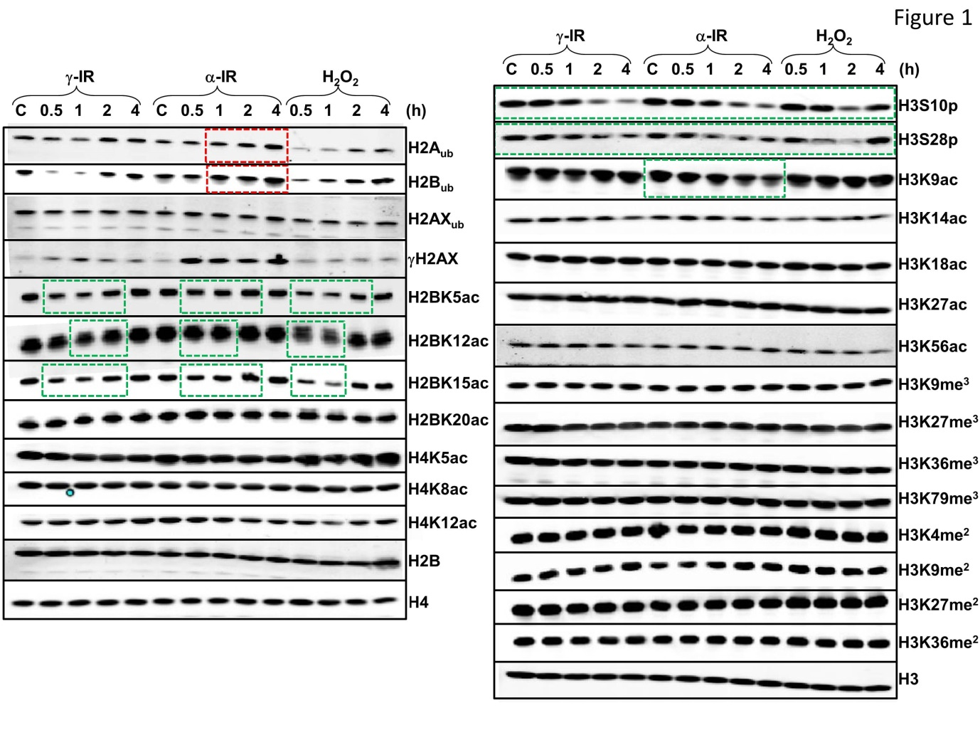

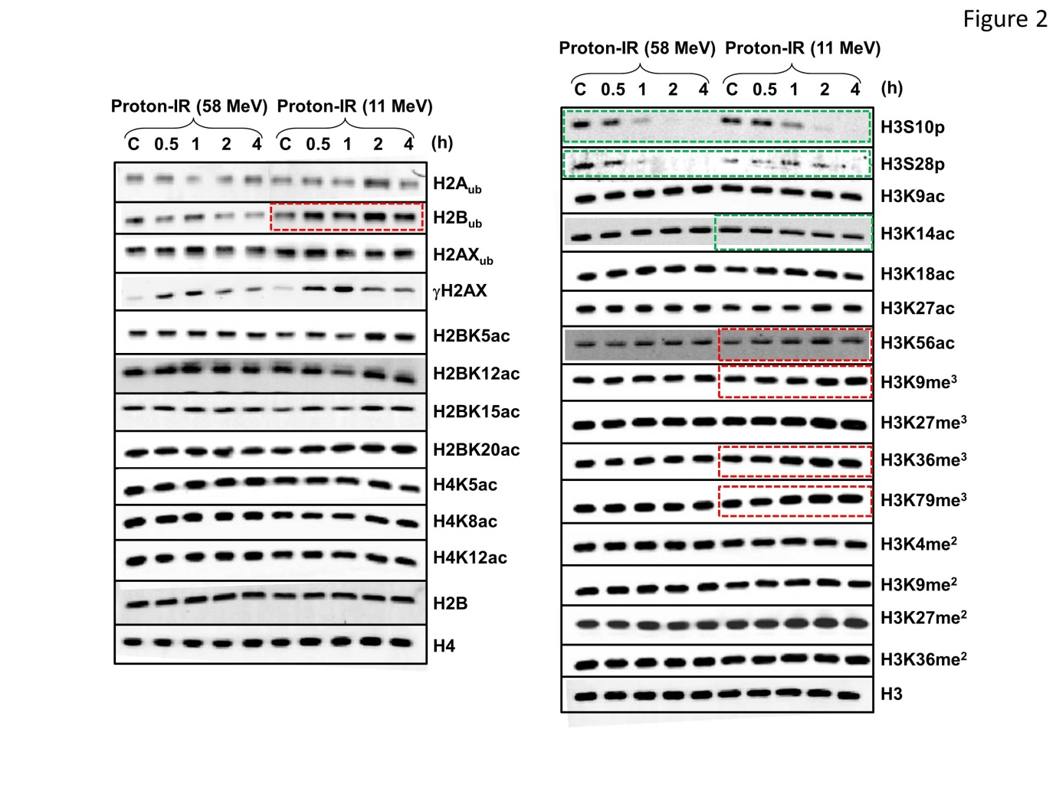

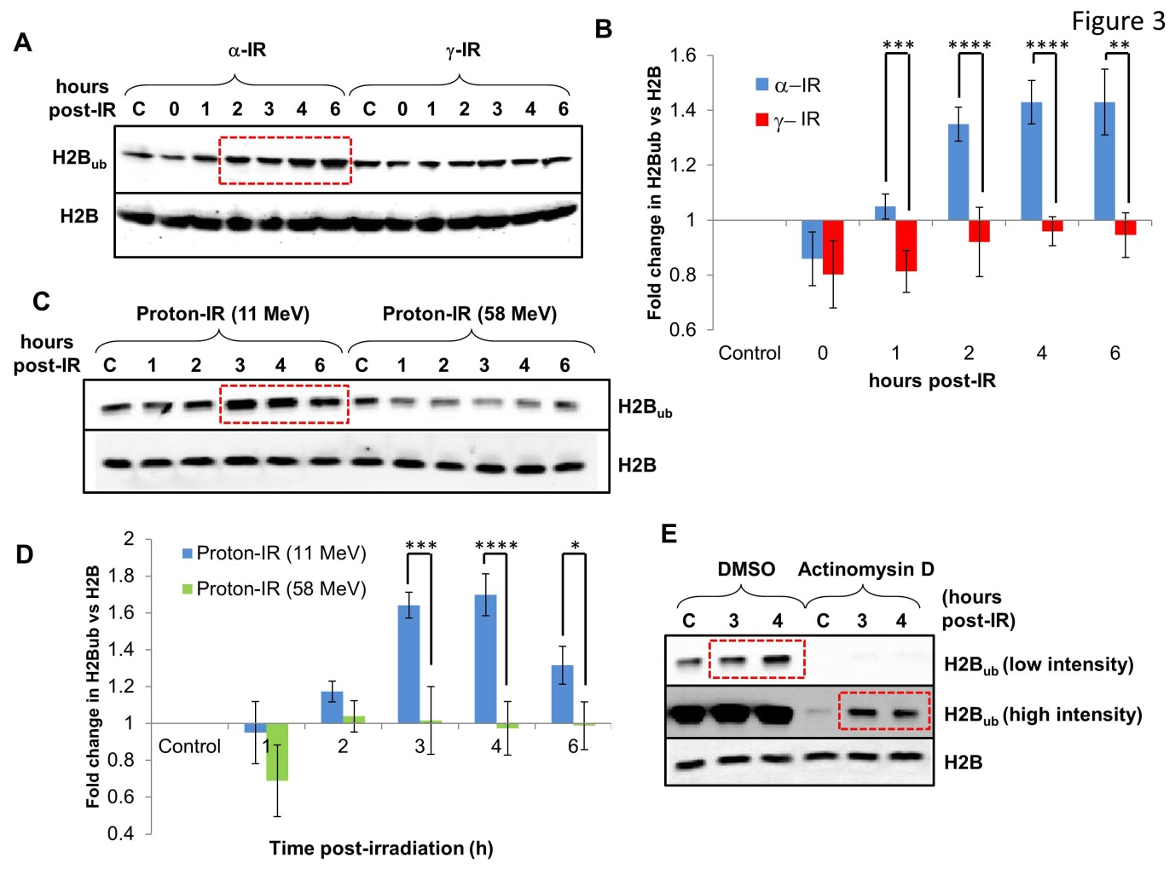

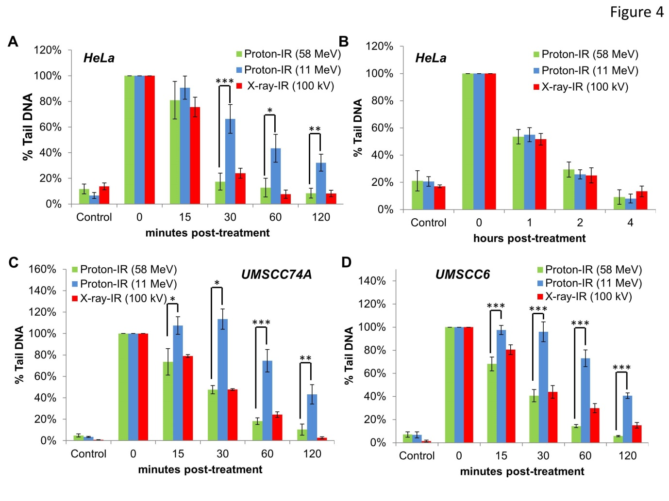

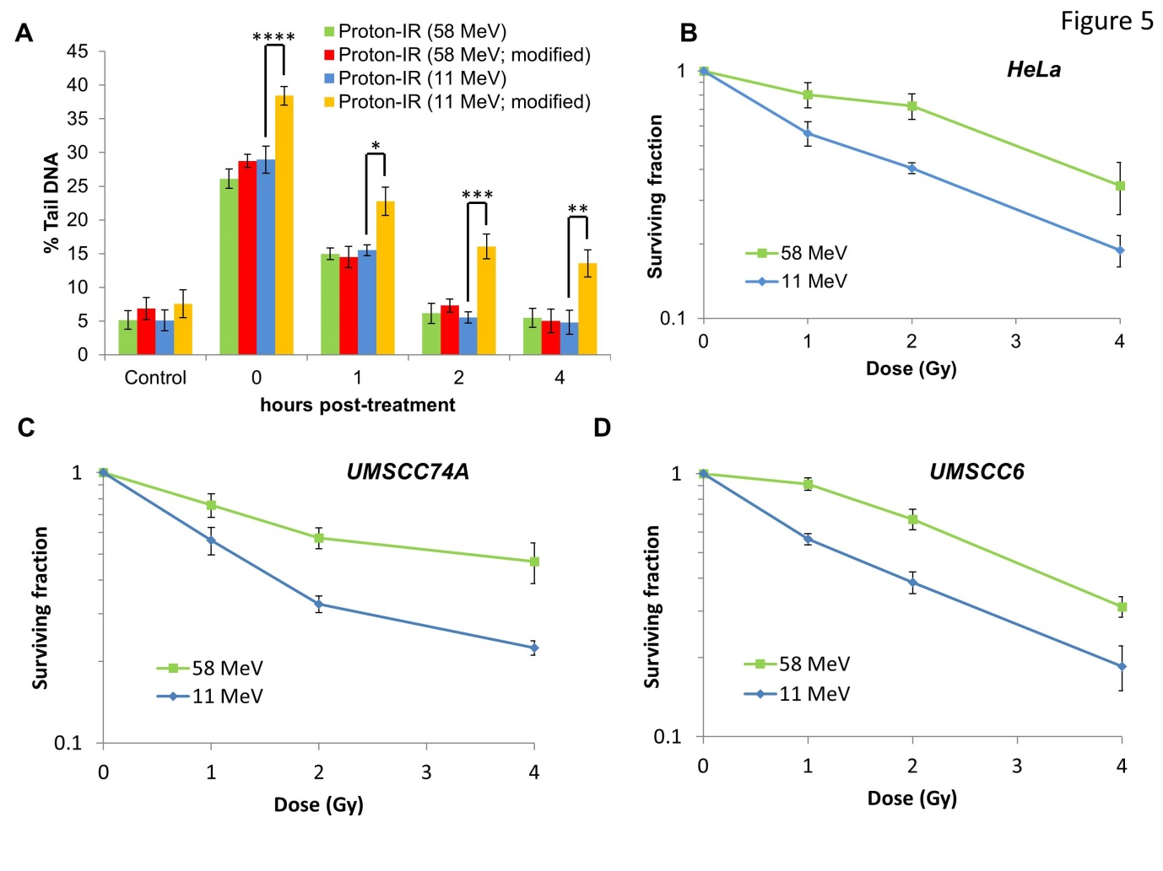

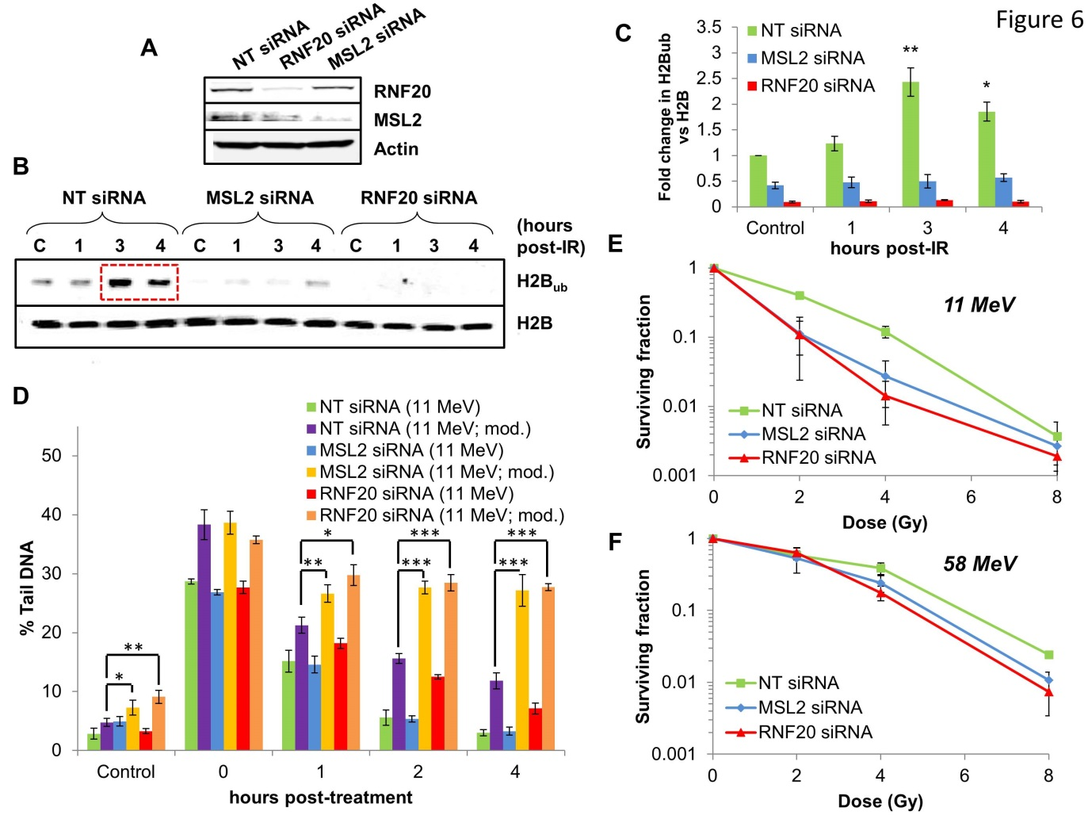

Supplementary methods
Antibodies and proteins
Details of all antibodies are included in the table below. Recombinant histagged NTH1, OGG1 and APE1 were overexpressed in Rosetta2(DE3)pLysS bacterial cells, and purified by HisTrap chromatography (GE Healthcare, Little Chalfont, UK) using a gradient elution of imidazole and an AKTA purifier FPLC system. siRNA sequences targeting RNF20 and MSL2 (both SMARTpool siGENOME; GE Healthcare, Little Chalfont, UK) are as follows: RNF20/40 (Cat No. M-007027-00) : 5'-CCAAUGAAAUCAAGUCUAA-3', 5'-UAAGGAAACUCCAGAAUAU-3', 5'-GCAAAUGUCCCAAGUGUAA-3', 5'-AGAAGAAGCUACAUGAUUU-3'; MSL2 (Cat No. M-020828-01): 5'-GCAGUUCUGUUAUCAAUGG-3', 5'-UCUCUUAGCCAUAAUGUUU-3', 5'-CCAGUACACAUGAUGAUAA-3', 5'-GAGUAUAUAACACAGACUA-3'. The non-targeting control siRNA (AllStars Negative Control siRNA, Cat No. SI02655450; Qiagen, Manchester, UK) was used although the sequence is proprietary information.

ANTIBODY | COMPANY | CATALOGUE NUMBER
Anti-ubiquityl-Histone H2A (K119) | Merck-Millipore | 05-678
Anti-ubiquityl-Histone H2AX (K119) | Merck-Millipore | AB10029
Anti-ubiquityl-Histone H2B (K120) | MediMabs | AB10029
Anti-phospho-Histone H2AX (S139) | Merck-Millipore | 05-636
Anti-acetyl-Histone H2B (K5) | Cell Signaling Technology | 2574
Anti-acetyl-Histone H2B (K12) | Cell Signaling Technology | 9861
Anti-acetyl-Histone H2B (K15) | Cell Signaling Technology | 9083
Anti-acetyl-Histone H2B (K20) | Cell Signaling Technology | 2571
Anti-acetyl-Histone H4 (K5) | Cell Signaling Technology | 8647
Anti-acetyl-Histone H4 (K8) | Cell Signaling Technology | 2594
Anti-acetyl-Histone H4 (K12) | Cell Signaling Technology | 13944
Anti-phospho-Histone H3 (S10) | Cell Signaling Technology | 3377
Anti-phospho-Histone H3 (S28) | Cell Signaling Technology | 9713
Anti-acetyl-Histone H3 (K9) | Cell Signaling Technology | 9649
Anti-acetyl-Histone H3 (K14) | Cell Signaling Technology | 4318
Anti-acetyl-Histone H3 (K18) | Cell Signaling Technology | 9675
Anti-acetyl-Histone H3 (K27) | Cell Signaling Technology | 4353
Anti-acetyl-Histone H3 (K56) | Cell Signaling Technology | 4243
Anti-trimethyl-Histone H3 (K9) | Cell Signaling Technology | 13969
Anti-trimethyl-Histone H3 (K27) | Cell Signaling Technology | 9733
Anti-trimethyl-Histone H3 (K36) | Cell Signaling Technology | 4909
Anti-trimethyl-Histone H3 (K79) | Cell Signaling Technology | 4260
Anti-dimethyl-Histone H3 (K4) | Cell Signaling Technology | 9725
Anti-dimethyl-Histone H3 (K9) | Cell Signaling Technology | 4658
Anti-dimethyl-Histone H3 (K27) | Cell Signaling Technology | 9728
Anti-dimethyl-Histone H3 (K36) | Cell Signaling Technology | 2901
Anti-Histone H3 | Cell Signaling Technology | 2935
Anti-Histone H4 | Cell Signaling Technology | 3638
Anti-Histone H2B | Santa Cruz | sc-10808
Anti-RNF20 | Bethyl Labs | A300-714
Anti-MSL2 | Aviva Systems Biology | ARP43246
IRDye 800CW goat anti-mouse IgG | Li-Cor Biosciences | 926-32210
IRDye 800CW goat anti-rabbit IgG | Li-Cor Biosciences | 926-32211
Alexa Fluor 680 goat anti-mouse IgG | Life Technologies | A-21057
Alexa Fluor 680 goat anti-rabbit IgG | Life Technologies | A-21076

Histone extractions
Cell pellets were resuspended in hypotonic buffer (10 mM Tris-HCl, pH 8.0, 1 mM KCl, 1.5 mM MgCl₂) containing 1 µg/ml pepstatin, leupeptin, chemostatin and aprotinin, 1 mM N-ethylmaleimide and 0.1 mM PMSF, and incubated for 30 min at 4°C with shaking. Nuclei were pelleted by centrifugation (), resuspended in 0.4 M sulfuric acid and incubated overnight at 4°C with shaking. Samples were centrifuged at 16,000 x g for 10 min at 4°C, the supernatant containing histones removed and precipitated with trichloroacetic acid (33 %) on ice for 30 min. Histones were pelleted (16,000 x g for 10 min at 4°C), washed twice with ice-cold acetone and air dried at room temperature. Histone pellets were redissolved in water, concentrations measured using a Nanodrop (Thermo Scientific, Warrington, UK) before adding 3x SDS-PAGE loading buffer (25 mM Tris-HCl, pH 6.8, 2.5 % β-mercaptoethanol, 1 % SDS, 10 % glycerol, 1 mM EDTA, 0.05 mg/ml bromophenol blue). Histones (~1 µg) were separated by 16 % Tris-glycine SDS-PAGE and transferred onto an Immobilon FL PVDF membrane (Millipore, Watford, UK). Membranes were blocked using Odyssey blocking buffer (Li-cor Biosciences, Cambridge, UK) and incubated with the primary antibody overnight at 4°C. Membranes were washed with PBS containing 0.1 % Tween 20, incubated with either Alexa Fluor 680 or IR Dye 800 secondary antibodies for 1 h at room temperature and further washed with PBS containing 0.1 % Tween 20. Histones were visualized and quantified using the Odyssey image analysis system (Li-cor Biosciences, Cambridge, UK).

Cell cycle analysis
Cells were trypsinised, washed twice with ice cold PBS (100 x g for 5 min at 4°C), fixed with ice cold 70 % ethanol and kept at 4°C until analysis. Fixed cells were centrifuged (200 x g for 5 min at 4°C), washed with PBS containing 0.05 % Tween-20, and then resuspended in PBS containing 0.05 % Tween-20, 10 µg/ml propidium iodide and 0.1 mg/ml RNase A for 1 h at room temperature. Cell cycle analysis was performed by fluorescence-activated cell sorting (FACS) using the Attune NxT Flow Cytometer (Life Technologies, Paisley, UK).

Single cell gel electrophoresis (Comet) assays.
The alkaline comet assay for measurement of DNA single strand breaks and alkali labile sites was performed as follows. Briefly cells were trypsinised, diluted to 1 × 10⁵ cells/ml and 250 µl aliquots of the cell suspension placed into the wells of a 24 well plate which was placed on ice. Cells were irradiated (1.5 Gy) and embedded on a microscope slide in low melting agarose (Bio-Rad, Hemel Hempstead, UK). The slides were incubated for up to 2 h at 37°C in a humidified chamber to allow for DNA repair, prior to lysis in buffer containing 2.5 M NaCl, 100 mM EDTA, 10 mM Tris-HCl pH 10.5, 1 % (v/v) DMSO and 1 % (v/v) Triton X-100 for 1 h at 4°C. The slides were then incubated in the dark for 30 min in cold electrophoresis buffer (300 mM NaOH, 1 mM EDTA, 1 % (v/v) DMSO, pH 13) to allow the DNA to unwind, prior to electrophoresis at 25 V, 300 mA for 25 min. Slides were neutralised with three 5 min washes of 0.5 M Tris-HCl (pH 8.0) and allowed to dry overnight. The neutral comet assay for measurement of DNA double strand breaks was similar to that described above, but with the following modifications. Cells were irradiated (4 Gy) and slides were incubated for up to 4 h to allow for DNA repair. Cell lysis was performed in buffer containing 2.5 M NaCl, 100 mM EDTA, 10 mM Tris-HCl pH 10.5, 1 % N-lauroylsarcosine, 1 % DMSO and 1 % (v/v) Triton X-100. Electrophoresis was performed in cold 1 × TBE buffer (pH 8.3) at 25 V, ~20 mA for 25 min. Finally slides were washed three times with 1 × PBS before allowing to dry overnight. For detection of complex DNA damage, an enzyme modified neutral comet assay was used as follows. In brief, the neutral comet assay was followed as described above but following cell lysis, slides were washed three times with enzyme reaction buffer (40 mM HEPES-KOH, 100 mM KCl, 0.5 mM EDTA and 0.2 mg/ml BSA, pH 8.0). Slides were then incubated with either buffer alone (mock treated) or with buffer containing 5 pmol OGG1, 6 pmol NTH1 and 0.6 pmol APE1 for 1 h at 37°C in a humidified chamber. These enzymes were prepared by overexpression in Rosetta2(DE3)pLysS bacterial cells using the pET28a plasmids (kindly provided by G. Dianov) and purified by HisTrap chromatography (GE Healthcare, Little Chalfont, UK) using a gradient elution of imidazole and an AKTA purifier FPLC system. Slides were washed three times with cold 1 × TBE buffer and electrophoresed in the same buffer prior to washing with 1 × PBS, as described above. Once dried, all slides from both alkaline, neutral and enzyme modified comets were subsequently rehydrated for 30 min in water (pH 8.0), stained for 30 min with SYBR Gold (Life Technologies, Paisley, UK) diluted 1:10,000 in water (pH 8.0) and again dried overnight. Cells (50 per slide, in duplicate) were analysed from the dried slides using the Komet 6.0 image analysis software (Andor Technology, Belfast, Northern Ireland) and % tail DNA values averaged from at least three independent experiments.
Supplementary Table
Table E1. Survival curve characteristics for cells following proton irradiation. Data from survival curves were fitted to the equation ln(SF)=-αD, where D equals dose and SF is surviving fraction, and α values are shown below.
Cell Line | α (Gy⁻¹) – 58 MeV | α (Gy⁻¹) – 11 MeV
HeLa | 0.26±0.03ª | 0.44±0.02
UMSCC74A | 0.22±0.03 | 0.41±0.03
UMSCC6 | 0.27±0.02 | 0.45±0.03
ªMean±SE
Supplementary figures
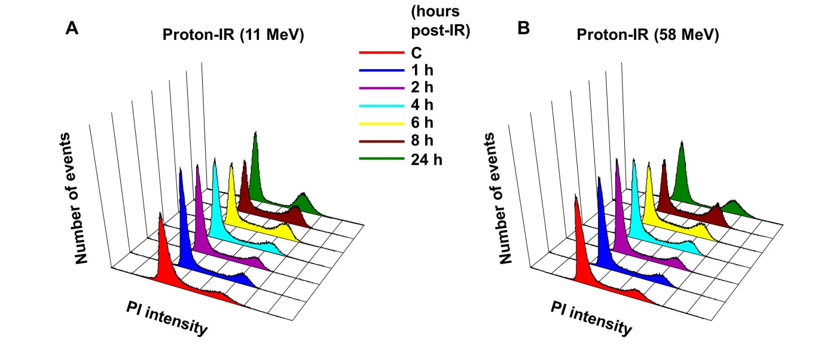
Figure E1. Cells display similar cell cycle profiles post-irradiation with either low- and high-LET protons. HeLa cells were unirradiated (designated C) or irradiated with 4 Gy protons at (A) high-LET (11 MeV) or (B) low-LET (58 MeV) and harvested at the time points indicated (1-24 h) post-treatment. Cell cycle profiles were determined by FACS analysis.
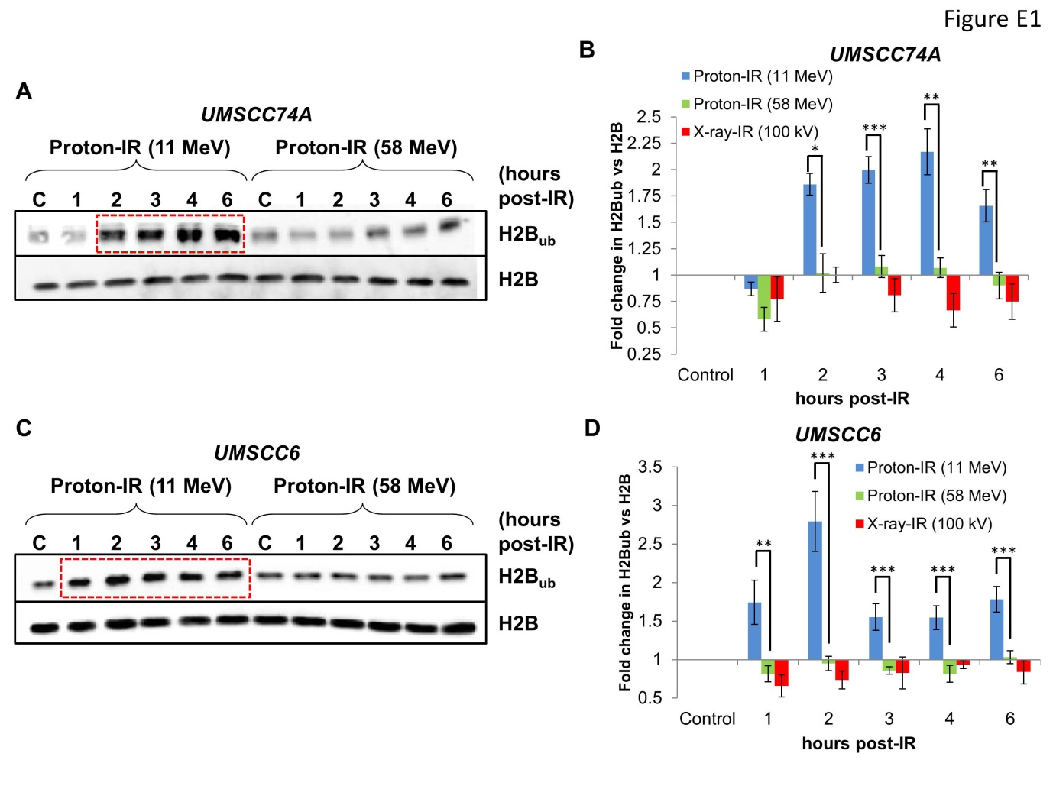
Figure E2. H2B_{ub} is induced in head and neck squamous cell carcinoma cells in response to CDD-induced by high-LET proton irradiation. (A-D) UMSCC74A and UMSCC6 cells were untreated (designated C) or irradiated with 10 Gy protons at low-LET (58 MeV) or high-LET (11 MeV) or 10 Gy x-rays (100 kV), and harvested at the time points indicated (1-6 h) post-treatment. Histones were purified by acid extraction, separated by 16 % SDS-PAGE and analysed by immunoblotting using the indicated antibodies. Red boxes indicate increased levels of H2B_{ub}. (B and D) Shown is the mean fold change in H2B_{ub} normalised against H2B, with standard deviations from at least three independent experiments. *p<0.05, **p<0.02, ***p<0.005 as analysed by a two sample t-test of fold increase in H2B_{ub} values following low-LET versus high-LET protons at each particular time point.
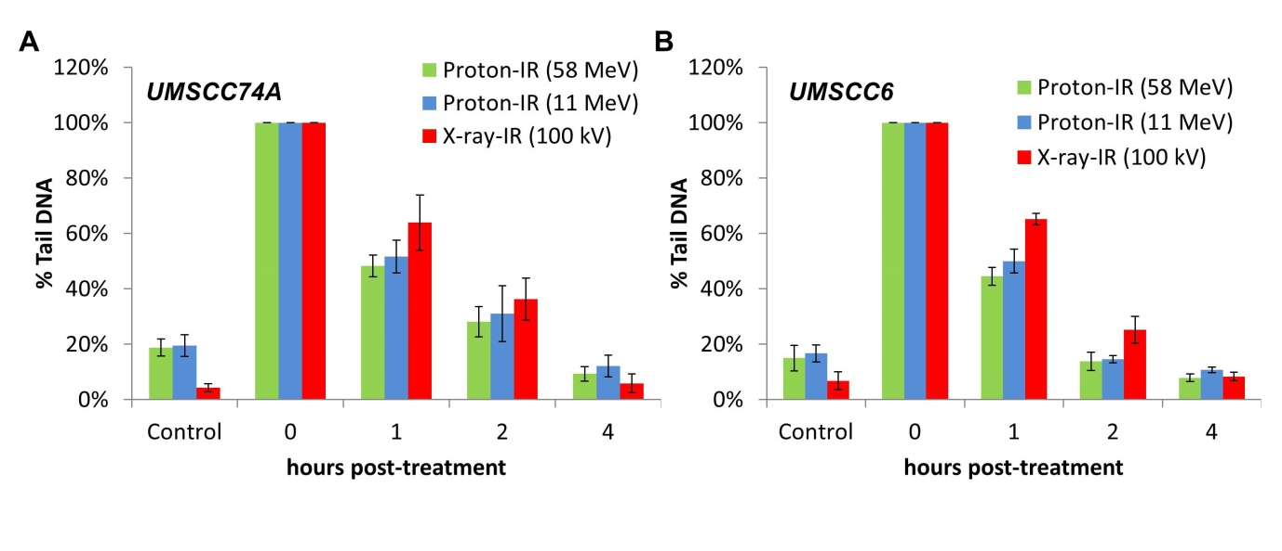
Figure E3. Low- and high-LET protons induce DSB which display similar DNA repair kinetics. (A) UMSCC74A or (B) UMSCC6 cells were irradiated with 4 Gy protons at low-LET (58 MeV) or high-LET (11 MeV) and DNA DSBs measured at various time points post-IR by the neutral comet assay. Shown is the % tail DNA with standard deviations from at least three independent experiments normalised to the levels seen immediately post-IR (0 min) which was set to 100 %.

Figure E4. High-LET protons display increased radiosensitivity compared to low-LET protons. Clonogenic survival data of (A) HeLa, (B) UMSCC74A and (C) UMSCC6 cells following protons at low-LET (58 MeV) or high-LET (11 MeV) are shown. Data were fitted to the equation ln(SF)=-αD, where D equals dose and SF is surviving fraction using OriginPro 9.1.
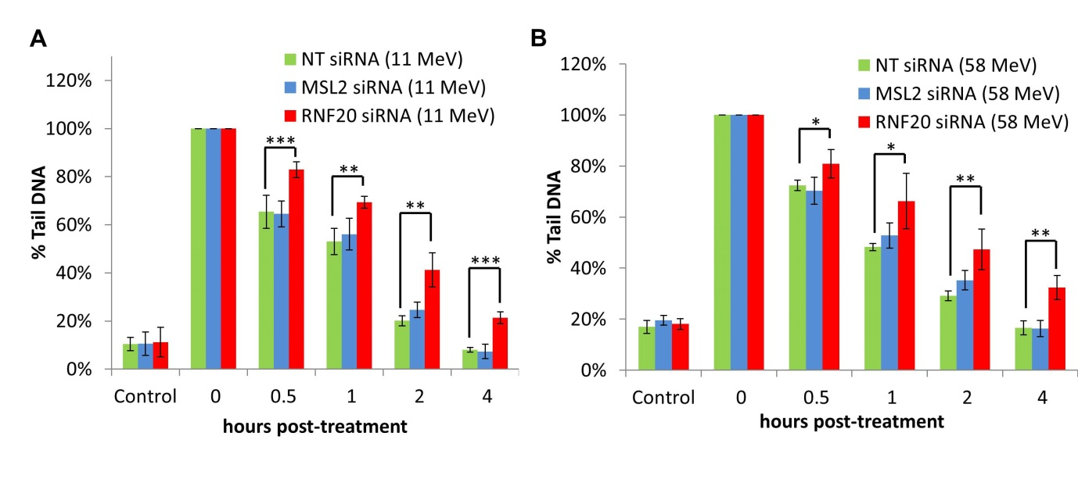
Figure E5. Depletion of RNF20/40 causes a delay in the repair of DSBs generated by either low-LET or high-LET protons. (A-B) HeLa cells were treated with non-targeting control siRNA, MSL2 or RNF20 siRNA for 48 h. Cells were irradiated with 4 Gy protons at (A) high-LET (11 MeV) or (B) low-LET (58 MeV) and DNA DSBs measured at various time points post-IR by the neutral comet assay. Shown is the % tail DNA with standard deviations from at least three independent experiments normalised to the levels seen immediately post-IR (0 min) which was set to 100 %. *p<0.05, **p<0.02, ***p<0.01 as analysed by a one sample t-test of % tail DNA following RNF20 siRNA treatment in comparison to the non-targeting control siRNA at each particular time point.

