Nature of events and alcohol-related content in marketing materials at a university freshers’ fair: a summative content analysis

Ms. A Fuller, PhD candidate¹
Dr K M Fleming, Senior Lecturer in Social Epidemiology²
Dr L Szatkowski, Associate Professor in Medical Statistics¹
Dr M Bains, Assistant Professor in Qualitative and Mixed Methods Health Research¹

¹Department of Epidemiology and Public Health, University of Nottingham, Nottingham, NG5 1PB, UK
² Department of Public Health and Policy, Institute of Psychology, Health and Society, University of Liverpool, L69 3GL, UK

Address correspondence to amy.fuller@nottingham.ac.uk

Abstract
Introduction
The transition to university is a potentially influential time upon students’ drinking behaviour. This study explored the nature of activities and alcohol-related content in marketing materials from student-led societies and local businesses provided to students, at a university freshers’ fair in the UK.

Methods
All marketing materials handed out at the fair were collected across the 5-day event in September 2015. Written and visual content was analysed using a summative qualitative content analysis.

Results
Most student-led societies promoted social events they were hosting (n=530), most of which took place in a drinking venue or referred to drinking (n=335). Only four explicitly alcohol-free events were promoted. Student-led societies also promoted activities relating to their interest e.g. sports training (n=519), a small proportion of which had references to drinking and drinking venues (n=54). Three societies provided promotional handouts from local bars or nightclubs. Local bars, pubs and nightclubs promoted events they hosted (n=81) as well as alcoholic drink promotions (n=79) and alcohol branded advertising (n=22), albeit infrequently for the latter.

Conclusions
In the first week of university, students are exposed to alcohol-related events, promotions, and advertising, which may act as an incentive to participate in drinking.

Introduction
Alcohol is major risk factor for premature death and disease in the UK (1). Average volume of alcohol consumption and heavy drinking occasions are wholly and partially attributable to many acute and chronic disease outcomes, including cancers and cardiovascular disease, and injury (2-4).

Recent data from the Alcohol Study toolkit indicates that approximately 25% of the population are higher risk drinkers (5) (classed as scoring ≥ 8 on AUDIT, or ≥ 5 on AUDIT-C tools, which measure harmful and hazardous drinking, and potential alcohol dependence (6)). A study of seven universities in the UK using AUDIT characterised 41% of students as hazardous drinkers (at increased risk of harm from drinking), 11% as harmful drinkers (resulting in consequences to physical and mental health) and 10% as probable alcohol-dependent (7), suggesting that drinking rates are higher amongst university students than the general adult population. A study in New Zealand also found that university students drank more than their non-university counterparts of the same age (8). Heavy episodic drinking (drinking five or more alcoholic drinks in one occasion) (9) is a particular risky drinking behaviour seen commonly among young adults in the UK; in the most recent Health Survey for England, drinking more than 8/6 units on a single occasion for males/females was highest amongst 16 – 24 year olds (10). A recent study found 65% of female and 75% of male students reported heavy episodic drinking at least once in the previous two weeks (11).

The first week of the university academic year, typically known as freshers’ week, is an orientation week for new students. Freshers’ week has been identified as a potentially influential time upon young adults’ drinking behaviour (12, 13) that may persist throughout university (14). Establishing a pattern of binge drinking during early adulthood can continue or develop into other patterns of harmful drinking later in adulthood (15).

During freshers’ week, many universities run a marketing event called the freshers’ fair where student-led societies and local businesses promote themselves to new students. Such businesses at these events can include bars and pubs, and are seen as an opportunity ‘to build a relationship with students’ at the start of their university careers (16). Previous qualitative work exploring the role of alcohol at university also identified student-led societies as a potential influence upon students’ alcohol consumption(17), with many leaders of these groups ranking drinking alcohol as an important part of social events they organise (18). However, little is known about how alcohol is portrayed and promoted by these groups, particularly at their first point of contact with new students. Therefore, this study explored marketing materials handed out at a freshers’ fair event to:
- Identify the nature of activities offered and promoted by student-led societies and local businesses exhibiting at the event, including how many featured or were related to alcohol.
- Quantify and characterize any other alcohol-related content.

Methods
Materials
In September 2015, a week-long freshers’ fair was attended (by AF) at a large university in the East Midlands, UK. The fair comprised four individual events across the university’s campuses; a larger five-day event at the main campus and three small afternoon events at external campuses. Since the three smaller events took place on the same day, a decision was made to attend the largest to include the majority of exhibitors in the study. Each exhibitor was visited once and all marketing materials being handed out were collected.

Analysis
We used a summative qualitative content analysis (19) to identify the frequency and describe the nature of activities offered and alcohol-related content present in the marketing materials. All materials were read several times (by A.F.) to identify and record, in NVivo 11, any written references or images related to activities or alcohol. Each occurrence was studied to explore the nature of the text or image and preliminary codes were applied inductively to them. These codes were revised following greater familiarity with the data and grouped according to similarity, resulting in distinct themes. A sample of 24 exhibitors (11%) were independently validated by author M.B. In these, there were 428 occurrences and the level of agreement between researchers was 85% (n = 364). Disagreements in coding were discussed, which led to final refinement of the themes that were then applied to all data.

The frequency of each code was recorded per exhibitor, with any repetitions (e.g. the logo of a branded alcoholic drink appearing twice on one handout) counted as one occurrence. Results are displayed according to broad categories defined by the Students’ Union as to the nature of the exhibitor (listed in Table 1).

Ethical approval
This study was approved by the Faculty of Medicine and Health Sciences Research Ethics Committee, University of Nottingham (D18062015).

Results
Of the 348 exhibitors present at the event, 217 (62%) provided at least one handout including printed leaflets, booklets, and merchandise. From these our analysis identified three themes: society-interest activities and socialising events; alcohol-related drink and event promotions; and alcohol brands and advertising of venues. There were a total of 1199 distinct occurrences in text and imagery; content related to society-interest activities and socialising events occurred throughout the categories, whereas content related to alcohol-related drink and event promotions and alcohol brands and advertising of venues was more concentrated among marketing materials from local businesses (Table 1).

Table I: Frequency of themes and sub-themes within the freshers’ fair marketing materials, by exhibitor category
 | Society-interest activities  and socialising events |  |  |  |  |  |  | Alcohol-related drink and event promotions |  |  | Alcohol brands and advertising of venues
 | Society-interest sessions |  | Socialising activities in a bar |  | Socialising activities  not in a bar |  |  | Drink offers | Event offers | Alcohol incentive | Branded drink | Venues
 | Alcohol reference | No alcohol reference | Alcohol reference | No alcohol reference | Alcohol based | Alcohol free | No alcohol reference
Course-based and career (CC), n=50 | 33 | - | 6 | 13 | 5 | 1 | 38 | 1 | - | - | - | 1
Equality, diversity and student networks (EDS), n=15 | - | - | - | 3 | - | 1 | 26 | - | - | - | - | -
Faith, thought and belief (FTB), n=12 | 20 | - | - | - | - | - | 6 | - | - | - | - | -
Hobbies, interests and lifestyle (HIL), n=56 | 100 | 16 | - | 10 | - | 1 | 21 | 4 | 2 | - | 2 | -
International and cultural (IC), n=38 | 6 | - | - | 2 | 1 | - | 29 | - | - | - | - | -
Music and dance (MD), n=25 | 25 | 2 | 4 | 176 | - | - | 9 | 1 | 3 | - | 2 | 7
Volunteering, campaigning and current affairs (VCC), n=32 | 29 | 3 | 1 | 3 | - | - | 19 | - | - | - | 1 | -
Sports, n=79 | 252 | 33 | 2 | 24 | 4 | 1 | 42 | - | - | - | - | -
Local businesses, n=40 | - | - | 11 | 70 | - | - | 1 | 79 | 9 | 8 | 22 | 8
Totalª | 54 | 465 | 24 | 299 | 10 | 4 | 191 | 85 | 14 | 8 | 27 | 16
ªTotal number of occurrences are higher than number of stalls as many exhibitors provided more than one marketing material or promoted several events/branded drinks

Society-interest activities and socialising events
Most student-led societies and local businesses promoted at least one activity or event within the marketing materials. This included ‘society interest sessions’, which were activities and events run by student-led societies that related to their interest (ranging from sports training, music rehearsals, volunteering, cultural trips and religious worship) and socialising events outside of the society’s special interest (including pub, cinema or restaurant trips, and nightclubbing).

Society-interest activities
There were 519 (49.5%) references to student-led societies interest sessions across the handouts, 54 of which (10.4%) had a reference to drinking. The majority of activities which referenced drinking were from sports (33, 62%) and HIL (16, 29.6%) societies. Activities were typically a taster session for new students or a regular society session followed by going to the Students’ Union bar, “After every film, we head off to the [bar] for post-show drinks and discussion. What better way to end the week than that?” (HIL society 8).

Socialising events
There were 530 (50.5%) references to social events that were not regular society-interest activities, organised by student-led societies and local businesses.
- Taking place in a bar, pub or nightclub
325 (61.5%) social events took place in a pub, bar or nightclub. These were promoted across all categories except FTB societies. Events run by student-led societies included bar crawls (12, 3.7%), pub quizzes (10, 3.1%), pub trips (36, 11.1%) and going to nightclubs (12, 3.7%). Some were described as the society’s “first social” of the year (sports society 22) or “the perfect way to make friends” (CC society 41), as well as regular events, “Come join us at our weekly social at [pub] on Tuesdays at 8pm!” (MD society 18). Such events offered by businesses (namely bars and nightclubs) were weekly clubbing (35, 11.0%) and live music events (229, 70.5%).

Of these, 25 (7.7%) explicitly referenced drinking or alcohol, found across MD, VCC, CC and sports societies, and local businesses. Such references included images of students with alcohol accompanying the event description, text which encouraged students to “come have a drink” (CC society 37), or alcohol branding. One sports club made it clear in the name of their fancy-dress event, “Get Shipwrecked” (sports society 31), that the purpose of the event was to get drunk. All events promoted by local businesses that referenced drinking included promotions for and advertising of alcoholic drinks available at the event (Figure 1).

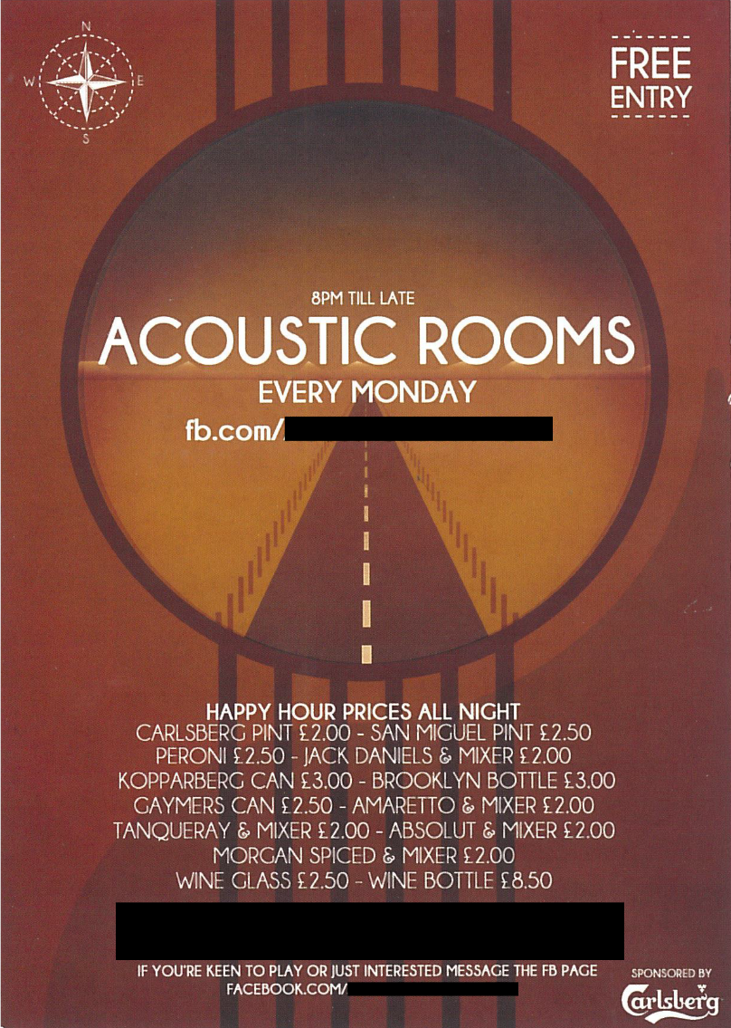
Figure 1: Handout featuring alcoholic drink promotions and alcohol brands advertising at a social event in a bar (Business 4)

- Not in a bar, pub or nightclub
There were 204 additional events categorised into three groups: those which referenced drinking or alcohol (10, 1.9%), those which were explicitly alcohol-free (4, 0.8%), and those which were not clear on whether they did or did not involve drinking alcohol (190, 35.9%).

Events explicitly referencing drinking were found in the CC, IC and sports societies. This included food and alcohol evenings, “Cocktails and Canapés” (sports society 50), and formal events such as a “River cruise party” (CC society 7) and “Science ball” (CC society 6) that were accompanied by alcohol imagery (Figure 2) or images of students with alcohol.

Four societies (from HIL, CC, EDS and sports society categories) each promoted one event that was explicitly alcohol-free (4, 0.8%). This included a “tea social” (sports society 50) and a mini-golf activity which was described as the society’s “sober social” (CC society 24).

Events that did not clearly state whether they were based on or free from alcohol included film nights, bowling, and cultural events such as Chinese New Year or Bonfire Night. Other societies simply stated they had “many socials throughout the year” (sports society 16) or listed events similarly named to those which did reference a bar, pub or nightclub, or drinking, e.g. “freshers’ social” (sports society 40) and “River cruise” (CC society 32).
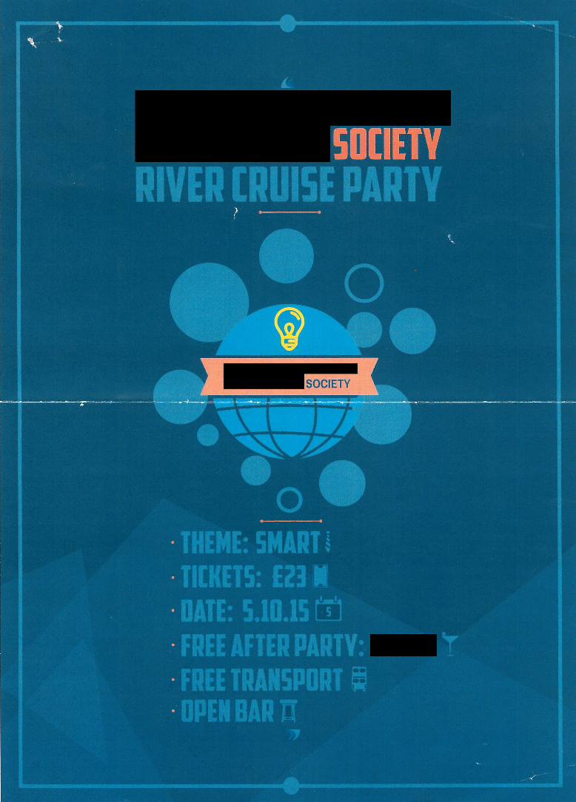
Figure 2: Handout promoting an alcohol-related event (Course-based and career society 7)

Alcohol-related drink and event promotions
Drink promotions
There were 85 drink promotions within the handouts, 80 (94%) of which were for alcoholic drinks and 5 (6%) for non-alcoholic drinks. Most promotions featured on handouts from local businesses, however, three student-led societies (MD and HIL categories) also handed out leaflets that included promotions for local bars, pubs and nightclubs; two alcohol-interest societies also offered promotions to their members. Promotions included regular offers on alcoholic drinks at bars, pubs and nightclubs e.g. happy hour (Figure 1), and vouchers for specific drinks at these venues (Figure 3). Many targeted students, “Student drinks prices ALL NIGHT on EVERYTHING” (Business 8).

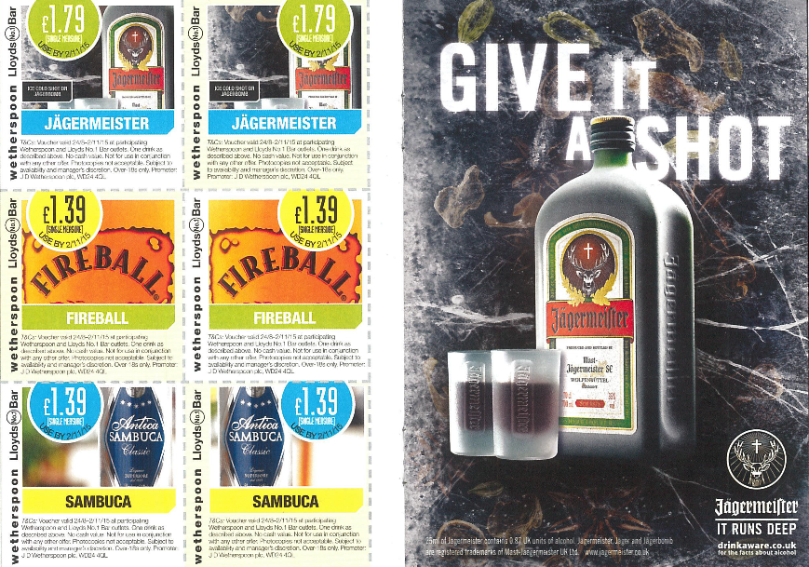
Figure 3: Handout featuring alcoholic drink promotions and alcohol brands advertising (Business 13)

Alcohol-related event promotions
There were 14 distinct references to reduced-price entry to events, which were either alcohol-based (2, 14.3%) or took place at a bar, pub or nightclub (12, 85.7%). They included vouchers and regular promotions on entry into nightclubs, often featuring alongside alcoholic drink promotions “FREE before 11pm - £2.50 cocktails all night!” (Business 4). Events at nightclubs were all described as either having great music, “All the best pop from all the best eras” (Business 4) or the place to have a good night out, “the most fun Friday night in town” (MD society 23). Other promotions included “free or reduced price entry to over 160 beer festivals” and “brewery excursions” (HIL society 34) available to student members of a beer society.

Alcohol-related incentives
In addition to this, there were eight occurrences where alcohol-related incentives were offered in exchange for engaging with an event, social media page or e-newsletter. This included receiving “drinks offers” (Business 4) by joining a nightclub’s Facebook page or signing up to their e-newsletter, winning a £1,000 bar tab when visiting a bar (Business 12) and having a “pizza & beer night” for taking part in a weekly football tournament (Business 17).

Alcohol brands and advertising of venues
An advertisement is defined as a “notice or announcement in a public medium promoting a product, service, or event” (20). We found 27 instances of advertising of branded alcoholic drinks and 16 references to advertising of bars, pubs and nightclubs within the handouts. Again, the majority appeared on handouts from local businesses (30, 70.0%), with a few on handouts from MD, VCC, CC, and HIL societies.

Alcohol brands
Advertising of branded alcoholic drinks included the logos of Jägermeister, Carlsberg and Jack Daniels brands, among others, on leaflets and merchandise promoting nightclubs. They also featured as advertisements (Figure 3) with taglines asking “Hoo's for a Hooch?” and inviting you to “GIVE IT A SHOT” (Business 13).

Advertising of venues
Advertising of bars, pubs and nightclubs across the handouts represented eight unique venues. These included written descriptions and logos of the venues on leaflets and merchandise. Venues described themselves as “unique” (Business 11), well-renowned among students, “NOW INTO IT'S 13TH YEAR AS THE OFFICIAL [UNIVERSITY] FRIDAY NIGHT” (Business 8), providing great entertainment or having an “ever-changing drinks selection” (MD society 23). One bar also promoted its drinks menu by giving away A3 posters featuring recipes and images of the cocktails on offer.

Discussion

Main findings of this study
We found that most student-led societies promoted their activities of interest within the marketing materials, a small proportion of which referred to drinking. They also promoted their social events, most of which took place in a drinking venue or referred to drinking within the event description and accompanying imagery. Only four events were explicitly alcohol-free. Local businesses promoted their club nights and live music events, some of which featured promotional offers on drinks and alcohol branding. Promotional offers on alcoholic drinks also featured on additional marketing materials from local businesses and some student-led societies. Alcohol branded advertising was found among local businesses, although infrequently.

What is already known on this topic?
The point of transition, from home to university, has been identified as a critical time where new health behaviour patterns emerge for undergraduate students (21). Previous work by Riordan et al (13) found that students in New Zealand drank more during freshers’ week than before entering university, which then uniquely contributed to higher levels of drinking during the academic year. This suggests the freshers’ week period is an important and influential time upon students’ drinking behaviour.

A number of factors have been identified to play a role in increased drinking at the point of transition to university, including changes in drinking motives (viewing alcohol as a socialisation tool and way of fitting in), perceived drinking norms (overestimating peer drinking and approval of drinking) and membership to student societies associated with heavy drinking (22). Arnett (23) also argued that drinking in emerging adulthood is used to cope with rebuilding self-identity as an adult and a social life, as well as becoming more susceptible to peer influence, which is of particular relevance to new students as they transition to a new social environment.

Peer networks are suggested to have an important influence as students become more reliant upon peers at university; peer pressure, pro-alcohol peer norms and socialising with peers who drink have been associated with alcohol misuse and binge drinking (24). Further, modelling of alcohol-use by older students can lead to new students viewing alcohol as a positive and socially acceptable experience (24). Studies have noted that increased alcohol use at university is a result of the “socially permissive norms around drinking” (25) in the university environment, which provides opportunities for heavy drinking (14).

What this study adds
Events that involved or were related to drinking were not present across all categories of student-led societies, however, those that promoted a social event typically promoted at least one that referred to drinking or took place in a drinking venue. This suggests that drinking-related socials are commonplace among student-led societies and appears to be endorsing the pro-social norms surrounding drinking at university. In addition, that local bars, pubs and nightclubs are present, being promoted and promoting and advertising alcohol at the freshers’ fair suggests that the university is a part of creating an environment that upholds the notion that drinking is considered a normal behaviour at university. That many societies did not promote any social events within the freshers’ fair materials suggests they may be promoted in other ways, such as through social media or word of mouth. Further exploration into this would help us better understand the occurrence and nature of events, including the extent to which alcohol features, across more societies and throughout the academic year.

Although many of the events taking place at a drinking venue did not refer to drinking explicitly, it has been documented that attending such venues is often accompanied by heavy drinking, in the form of ‘pre-loading’ or drinking at the venue (26, 27). Although this does not necessarily apply to everyone that attends such events, it suggests that many advertised at the fair would have involved heavy drinking. Only four events were explicitly alcohol-free and one of which described as a ‘sober social’. A previous study within another university in the UK (18) found that although student-led societies were encouraged to promote non-alcoholic social alternatives, these tended to occur less often than alcohol-based socials and were not strictly enforced. We did not find any evidence to suggest that such alternatives are promoted at other universities in the UK and so our finding is perhaps reflective of the general lack of promotion of non-alcoholic social events in this setting.

Many drinking venues provided or advertised reduced-priced alcoholic drink offers, or used alcohol as an incentive to engage with them, within their marketing materials. A recent qualitative study exploring drinking among young adults (28) found that although many self-imposed a budget on drinking nights to moderate alcohol consumption, it can be undermined by alcoholic drink offers enabling them to afford more alcohol within their budget. The presence of such offers, alongside alcohol advertising, exposure to which has also been found to increase alcohol consumption (29), may serve to encourage heavier drinking among students during this transitional period.

That many of the promotional offers, as well as alcohol-related advertising, were present in materials from local businesses, and three student-led societies promoted such venues, suggests established relationships exist between the university, student-led societies and drinking venues. This may act as an endorsement of drinking to students by the university and warrants further exploration of how such relationships form and what policies relating to alcohol are present at the university. Further, in the absence of any health promotion material on alcohol at the freshers’ fair, it could be argued that students will fail to consider the potential risks of drinking at this important transitional stage when drinking becomes more prominent. We suggest that the provision of such information at the freshers’ fair event or during this first week could be an important first step to mediate how alcohol is portrayed to new students.

Limitations of this study
Although this study included all exhibitors present at the freshers’ fair event covering student-led societies with a variety of interests, as well as local and national businesses, it was undertaken at a single university in the UK so the findings cannot be generalised to other universities. Further to this, only the handouts provided at the freshers’ fair were included in the analysis, omitting the visual stands that included further information and imagery relating to societies and businesses. Such content may have impacted upon students’ impressions on the extent to which the society involves drinking within their activities and events.

References
1. Public Health England. The Public Health Burden of Alcohol and the Effectiveness and Cost-Effectiveness of Alcohol Control Policies: An evidence review. Available at: https://www.gov.uk/government/uploads/system/uploads/attachment_data/file/583047/alcohol_public_health_burden_evidence_review.pdf (Date Accessed 15 May 2017); 2016.
2. Rehm J, Baliunas D, Borges GL, Graham K, Irving H, Kehoe T, et al. The relation between different dimensions of alcohol consumption and burden of disease: an overview. Addiction (Abingdon, England). 2010;105(5):817-43.
3. Rehm J, Mathers C, Popova S, Thavorncharoensap M, Teerawattananon Y, Patra J. Global burden of disease and injury and economic cost attributable to alcohol use and alcohol-use disorders. Lancet (London, England). 2009;373(9682):2223-33.
4. Rehm J, Gmel GE, Gmel G, Hasan OSM, Imtiaz S, Popova S, et al. The relationship between different dimensions of alcohol use and the burden of disease—an update. Addiction (Abingdon, England). 2017;112(6):968-1001.
5. de Vocht F, Brown J, Beard E, Angus C, Brennan A, Michie S, et al. Temporal patterns of alcohol consumption and attempts to reduce alcohol intake in England. BMC public health. 2016;16:917.
6. Babor T, Higgins-Biddle J, Saunders J, Monteiro M. The Alcohol Use Disorders Identification Test - Guidelines for Use in Primary Care. Geneva: World Health Organization; 2001.
7. Heather N, Partington S, Partington E, Longstaff F, Allsop S, Jankowski M, et al. Alcohol Use Disorders and Hazardous Drinking among Undergraduates at English Universities. Alcohol and Alcoholism. 2011;46(3):270-7.
8. Kypri K, Cronin M, Wright C. Do University students drink more hazardously than their non-student peers? . Addiction (Abingdon, England). 2005;100((5)):713-4.
9. Jackson KM. Heavy Episodic Drinking: Determining the Predictive Utility of Five or More Drinks. Psychology of Addictive Behaviors. 2008;22(1):68-77.
10. Health and Social Care Information Centre. Health Survey for England 2015 - Adult alcohol consumption. Available at: http://healthsurvey.hscic.gov.uk/media/37746/hse2015-adult-alc.pdf (Accessed 4 September 2017); 2016.
11. El Ansari W, Sebena R, Stock C. Socio-demographic correlates of six indicators of alcohol consumption: survey findings of students across seven universities in England, Wales and Northern Ireland. Archives of Public Health. 2013;71(1):29.
12. Gill JS. Reported levels of alcohol consumption and binge drinking within the UK undergraduate student population over the last 25 years. Alcohol and Alcoholism (Oxford, Oxfordshire). 2002;37(2):109-20.
13. Riordan BC, Scarf D, Conner TS. Is orientation week a gateway to persistent alcohol use in university students? A preliminary investigation. Journal of Studies on Alcohol and Drugs. 2015;76(2):204-11.
14. Merrill JE, Carey KB. Drinking Over the Lifespan: Focus on College Ages. Alcohol Research: Current Reviews. 2016;38(1):103-14.
15. Mathurin P, Deltenre P. Effect of binge drinking on the liver: an alarming public health issue? Gut. 2009;58(5):613-7.
16. BAM. National Freshers' Report 2014. Available from: http://www.bamuk.com/wp-content/uploads/2014/02/BAM-National-Freshers-Report.pdf (Accessed 15 May 2017); 2014.
17. Partington S, Partington E, Heather N, Gibson A, Longstaff F, Allsop S, et al. Use and Abuse of Alcohol in UK University Sport. Available from: http://alcoholresearchuk.org/downloads/finalReports/AERC_FinalReport_0074.pdf (Accessed 15 May 2017); 2010.
18. Taylor A, Nestel P. The need and opportunities to manage binge drinking among undergraduates at an English University. Education and Health. 2014;32((4)).
19. Hsieh HF, Shannon SE. Three approaches to qualitative content analysis. Qualitative Health Research. 2005;15(9):1277-88.
20. Oxford Dictionaries (Internet]. Available from https://en.oxforddictionaries.com/definition/advertisement: Oxford University Press; 2017. Advertisement [cited 15 May 2017].
21. Deforche B, Van Dyck D, Deliens T, De Bourdeaudhuij I. Changes in weight, physical activity, sedentary behaviour and dietary intake during the transition to higher education: a prospective study. International Journal of Behavioral Nutrition and Physical Activity. 2015;12(1):16.
22. Borsari B, Murphy JG, Barnett NP. Predictors of alcohol use during the first year of college: Implications for prevention. Addictive Behaviors. 2007;32(10):2062-86.
23. Arnett JJ. The developmental context of substance use in emerging adulthood. The Journal of Drug Issues. 2005;35:235-54.
24. Borsari B, Carey KB. Peer influences on college drinking: a review of the research. Journal of Substance Abuse. 2001;13(4):391-424.
25. Sudhinaraset M, Wigglesworth C, Takeuchi DT. Social and Cultural Contexts of Alcohol Use: Influences in a Social–Ecological Framework. Alcohol Research: Current Reviews. 2016;38(1):35-45.
26. Hughes K, Bellis MA. Drinking Environments. In Alcohol in the European Union: Consumption, Harm and Policy Approaches. Copenhagen, Denmark: World Health Organization Regional Office for Europe; 2012. p. 63-8.
27. Penny GN, Armstrong-Hallam S. Student Choices and Alcohol Matters (SCAM): A multi-level analysis of student alcohol (mis)use and its implications for policy and prevention strategies within universities, cognate educational establishments and the wider community. Available at: http://alcoholresearchuk.org/downloads/finalReports/AERC_FinalReport_0073.pdf (Accessed 15 May 2017); 2010.
28. Seaman P, Ikegwuonu T. Drinking to belong: Understanding young adults' alcohol use within social networks. Joseph Rowntree Foundation. Available at: https://www.jrf.org.uk/sites/default/files/jrf/migrated/files/alcohol-young-adults-full.pdf (Accessed 15 May 2017); 2010.
29. Stautz K, Brown KG, King SE, Shemilt I, Marteau TM. Immediate effects of alcohol marketing communications and media portrayals on consumption and cognition: a systematic review and meta-analysis of experimental studies. BMC Public Health. 2016;16:465.

Figures

Figure 1: Handout featuring alcoholic drink promotions and alcohol brands advertising at a social event in a bar (Business 4)
Figure 2: Handout promoting an alcohol-related event (Course-based and career society 7)
Figure 3: Handout featuring alcoholic drink promotions and alcohol brands advertising (Business 13)

