A review of the recent UK Guidelines for the Management of

Meningitis in Adults with a focus for general practitioners

Olivier Gaillemin1 and Fiona McGill2, 3, 4, 5

1. Salford Royal NHS Foundation Trust

2. Institute of Infection and Global Health, University of Liverpool; 3. National Institute for Health Research Health Protection Research Unit on Emerging and Zoonotic Infections; 4. Royal Liverpool and Broadgreen University Hospitals NHS Trust; 5. Leeds Teaching Hospitals NHS Trust

-----------------------------------------------------------------------------------------

**Introduction (2659 words, 41 references)**

Bacterial meningitis and meningococcal sepsis are rare in adults but any diagnostic delays with subsequent delay to treatment can have disastrous consequences1. In recent years there has been a reduction in the incidence of bacterial meningitis, although mainly in children. Over a similar time frame there have also been changes in diagnostics. As a result the British Infection Association in partnership with other Specialist Societies’ formed a working group to revise the previous consensus statement of 1999 on Management of Meningitis in Adults2,3. Here we review these new guidelinesand what they may mean for clinicians working in the community.

These guidelines do not consider meningitis in immunocompromised individuals, post-surgical/iatrogenic meningitis or tuberculous meningitis. The management of bacterial meningitis and sepsis in children and young people under the age of 16 is covered elsewhere4.

## Epidemiology

The welcome decline in bacterial meningitis over the past few decades has unfortunately not been accompanied by a reduction in the case fatality rate5,6 which can be as high as 20% for all causes of bacterial meningitis and 30% in pneumococcal meningitis7**.** The number of cases of invasive meningococcal disease (including meningitis and meningococcal sepsis) has also been reducing and is now half what it was some 20 years ago. The majority of cases are in young children with a second peak in adolescents and young adults8.

With the routine UK vaccination schedule including vaccines for many meningitis causing bacteria there have been significant reductions in meningitis due to *Haemophilus influenzae* type b, *Streptococcus pneumoniae* and *Neisseria meningitidis* serogroup C. *S. pneumoniae* remains the predominant cause of community acquired meningitis in adults and *N. meningitidis* serogroup B is responsible for over 80% of meningococcal disease8,9. Currently England and Wales have been experiencing an epidemic of meningococcal disease due to serogroup W10 . Most cases occur in adults and there is often an atypical presentation including many with gastrointestinal symptoms 11.

Due to the reduction in bacterial meningitis viral meningitis is playing a more predominant role. The exact incidence is unknown and probably under-diagnosed and under-reported12,13. The most common causes in the UK are the enteroviruses and the herpes viruses (predominantly HSV-2 and VZV). Other less common viruses include cytomegalovirus, Epstein Barr virus and mumps virus. Herpes simplex virus type 1 more commonly causes encephalitis than meningitis. Whilst viral meningitis is rarely fatal in immunocompetent adults and is even frequently described as self-limiting, it can cause significant morbidity and may cause underappreciated sequelae14-16.

Viral meningitis must not be confused with viral *encephalitis* – the former being infection of the meninges and the latter being infection of the brain parenchyma itself. The aetiology, pathogenesis, clinical features, treatment and most importantly prognosis are vastly different. There are recently published guidelines on the management of viral encephalitis17. Further definitions are given in table 1.

**How do adults with meningitis and meningococcal sepsis present in the community?**

**Clinical features of meningitis and meningococcal sepsis**

In a patient exhibiting the classic triad of neck stiffness, fever and altered consciousness, with perhaps accompanying headache and photophobia, vomiting and a petechial rash, diagnosis will be straight forward. However, many patients will not have these signs in combination. The classic triad for example, is present in less than 50% of patients with bacterial meningitis7,18. Given each sign may frequently occur in isolation consequent to more minor, self-limiting illness we can see they may be poor discriminators for meningitis or meningococcal sepsis19 posing challenges for the primary care physician. Furthermore, clinical presentation may be different in specific populations. For example the elderly are more likely to have an altered conscious level but not exhibit other symptoms such as neck stiffness or fever20.

Patients with viral meningitis also present with signs of meningism (headache, neck stiffness and photophobia) possibly with additional non-specific symptoms such as diarrhoea or sore throat. Whilst they will not have reduced level of consciousness (which would suggest an alternative diagnosis such as bacterial meningitis or viral encephalitis), it is clear there is overlap with the symptoms of bacterial meningitis.

Invasive meningococcal disease can be considered on a spectrum with meningococcal meningitis at one end and meningococcal sepsis at the other; meningococcal meningitis presenting with signs and symptoms of meningitis; meningococcal sepsis presenting with signs of sepsis including hypotension and classically a purpuric rash - although the rash may take on other forms, or be absent (figure 1). Patients may of course have features of both. Mortality is higher in meningococcal sepsis but neurological and other long term sequelae are more frequent in meningococcal meningitis21.

Examination should pay attention to neurological symptoms, particularly the level of consciousness (reduced GCS is a poor prognostic marker), signs of meningism and any focal neurology which may point to alternative diagnosis. Additional attention must be paid to look for signs of shock and a careful examination of the skin for evidence of a rash. Shock, coma and a rapidly progressive rash are all associated with a poor prognosis in meningococcal disease. Traditional signs such as Kernig’s and Brudzinski’s have poor sensitivity22,23and should not be relied upon to exclude, or make, a diagnosis of meningitis.

There is an overlap in symptoms and signs between viral and bacterial meningitis which often does not allow for reliable differentiation24. Hence all suspected cases of meningitis or meningococcal sepsis must be referred to hospital for further assessment and consideration of a lumbar puncture (LP)3**.**

**How should GPs assess and manage patients initially?**

The challenge for general practitioners is to distinguish the minority of patients who have a life threatening illness from those who have minor self-limiting infections. Careful assessment for clues as to the potential for invasive meningococcal disease or evidence of shock is paramount as this will help determine the urgency of hospital transfer as well as the need or not of pre-hospital antibiotics. Evidence also exists, albeit in children, that simply a high index of suspicion of meningitis from either the doctor or a relative is potentially an important indicator that disease is present25.

Additional information that should be sought specifically is travel history, any upper respiratory tract symptoms, especially otitis media and any contact with meningitis, sepsis or other infection.

***Should antibiotics be given prior to admission?***

The aim of pre-hospital antibiotics is to prevent any delay in antibiotic therapy which is known to be associated with increased mortality1,26. There are concerns of giving antibiotics in the community, including the risk of allergic reaction and decreased diagnostic yield following antibiotic administration. The majority of community patients with suspected meningitis will turn out to have viral meningitis or other viral illness with associated meningism and thus antibiotics should be reserved for those most likely to benefit from them.

Current evidence neither strongly supports nor refutes the use of pre-hospital antibiotics27,28. However, given the evidence that early antibiotics reduce mortality, antibiotics should be given to those where there is a strong suspicion of meningococcal disease (e.g. a rash is present), who have signs of sepsis or of a poor prognosis such as an altered level of consciousness or seizures. If there will be a delay to hospital admission of greater than an hour antibiotics should also be administered in the community.

Antibiotics should be given in the form of Benzylpenicillin 1200mg IM or IV or a third generation cephalosporin such as Cefotaxime (2g) or Ceftriaxone (2g) IM or IV. In the case of known anaphylaxis to penicillins or cephalosporins, antibiotics should not be given until admission to hospital. Parenteral antibiotics should not delay transfer to hospital3.

**Which patients should be referred urgently and where?**

Urgent hospital referral is mandatory in **ALL** adults in whom meningitis or other forms of invasive meningococcal disease is suspected. This will allow a rapid assessment of whether an LP is required and prompt administration of appropriate treatment. Transfer should be arranged via emergency ambulance such that patients arrive in hospital, ideally, within an hour of assessment in the community.

**How should diagnosis be confirmed?**

The value of early LP cannot be stressed enough (figure 2). This is key to establishing a definitive diagnosis, ensuring targeted treatment and minimising risks of unnecessary overtreatment.

Ideally LP should be performed before giving antibiotics (this is advocated if it can be performed within an hour of arrival to hospital) as "yield" rapidly reduces with potentially only 75% of LPs giving a positive culture 4 hours post iv antibiotics and none were positive at eight hours29. Real world logistics however mean that many patients will have had treatment started prior to LP. Therefore, if intravenous antibiotics have already been commenced, the LP should still be performed as soon as possible, and preferably within 4 hours. Advances in the availability of bacterial CSF PCR may still establish the aetiology in culture-negative cases. However this will not provide antibiotic sensitivity for the organism. A significant factor to delayed LP is the wait for neuroimaging, much of which may be unnecessary29. This has proved an area of practice resistant to change. Indications for neuroimaging prior to LP are shown in table 2. - . All other patients should have LP as soon as possible.

The CSF cell count and gram stain will be the first results available after LP and can be key to diagnosis. Typically if the CSF leukocyte count is <5 x 106 cells/L this excludes meningitis. Although approximately 1-2% of patients with bacterial meningitis may have a normal CSF white cell count. In addition to the initial cell count the CSF will also be cultured and analysed for total protein and glucose concentrations. PCR analysis for bacteria (*S. pneumoniae* and *N. meningitidis*) and viruses (HSV and VZV and Enteroviruses) may also be performed.

Other investigations will include blood cultures, meningococcal and pneumococcal PCR on blood, serum glucose to pair with CSF glucose and a swab from the nasopharynx for evidence of *N.meningitidis*. This swab is useful for surveillance incase the CSF or blood cultures are rendered sterile by prior antibiotic use.

Typical CSF findings for viral and bacterial meningitis as well as encephalitis are compared in (table 3).

**What are the evidence-based management options?**

As discussed earlier, for patients seen in the community where there is a strong suspicion of meningococcal disease such as presence of a rash or presence of poor prognostic markers such as signs of sepsis, altered mental state or seizures, or where a delay in transfer to hospital is anticipated, antibiotics should be given prior to admission.

**What treatment should be given empirically in hospital?** (Table 4)

Empirical antibiotic choice is as outlined in Box A. Certain groups will benefit from cover for Listeria (which is rarely seen in younger people) with additional ampicillin / amoxicillin. These groups include: those over 60 years of age, those patients with alcoholism, diabetes, malignancy or who are on immunosuppressive therapy30. Anti-listerial antibiotics are not routinely recommended for pre-hospital antibiotics as although Listeria monocytogenes is more common in these groups, S. pneumoniae is still by far the most frequent organism seen. Return from travel (within the last 6 months) in an area of known penicillin-resistant pneumococcus will prompt the addition of vancomycin or rifampicin. Chloramphenicol is recommended where there is a clear history of anaphylaxis to penicillins or cephalosporins.

**What definitive antimicrobial treatment should be given?**

In proven meningococcal meningitis or sepsis ceftriaxone, cefotaxime or high dose benzylpenicillin is recommended. There is mounting evidence that shorter courses of treatment for meningitis, especially meningococcal, are not associated with a poor outcome31-33. If patients are slow to respond they may be given slightly longer courses. Treatment should be discontinued after day 5 where patients have recovered. Similarly, treatment can be stopped for patients with a typical petechial/purpuric meningococcal rash but no identified organism who have recovered after day 5. Finally in patients with pneumococcal disease who have recovered, treatment can be stopped after 10 days. Treatment is normally also with ceftriaxone, cefotaxime or high dose benzylpenicillin if the organism is susceptible.

**Treatment of viral meningitis**

Whilst some physicians will treat herpes meningitis with aciclovir or valaciclovir, there is currently no evidence to support the use of antivirals in viral meningitis. Simple supportive measures and reassurance should be the mainstay of treatment.

**Prophylaxis and secondary prevention**

Meningitis is a notifiable disease and all cases must be reported. Secondary care will normally do this. The local health protection team will arrange prophylaxis for relevant contacts34. Treatment will differ dependent on aetiology.

**Meningococcal infection**

**Close contacts are those living in the same household within the previous 7 days and others such as ‘mouth kissing contacts’.**

A single dose of Ciprofloxacin is recommended for close contacts.

- 500mg for adults

- 250mg for children aged 5-12 years

- 125 mg for children aged 1month to 4 years

Rifampicin is only recommended for those unable to take Ciprofloxacin at a dose of 600mg twice daily for 2 days.

Of note, even following use of prophylaxis, close contacts remain at additional risk for at least 6 months. Therefore general practice records of all close contacts must be annotated to alert to this risk. Where contact has been with a case caused by a vaccine preventable serogroup, close contacts should be offered vaccination35.

***Haemophilus influenzae* type b infection**

Whilst *H. influenzae* meningitis is uncommon in adults, if infection is caused by a type b strain then in addition to close contacts receiving prophylaxis as above, vaccination should be given to all previously unvaccinated household contacts aged less than 10 years old. Furthermore, in households where an at risk individual resides, all household contacts should receive prophylactic Rifampicin.

**Pneumococcal infection**

Close contacts of pneumococcal meningitis are not at an increased risk and as such antibiotic prophylaxis is not required.

**How should patients be followed up?**

Most patients will fully recover. However the sequelae of bacterial meningitis and meningococcal disease can be disabling (figure 3). Problems are more likely to occur in pneumococcal meningitis than in meningococcal meningitis7,36. Problems may be as a result of direct neurological injury, or from tissue and organ damage secondary to sepsis. Headaches are frequently reported37. Both physical and psychological sequelae can have profound effects on the lives of patients’ families as well as the patient themselves and it is therefore important to both assess for and identify them such that appropriate treatment and support may be offered.

Notably careful assessment of hearing, cognition and mental health must be performed with any adverse findings addressed38,39. If this has not happened prior to discharge arrangements should be made by the GP. Specific NICE guidance exists to support management for all adults who have suffered a critical illness and may have spent time in critical care40.

All patients with bacterial meningitis should be offered a hospital follow-up appointment within 6 weeks of discharge though GPs may pick up previously missed adverse sequelae requiring earlier assessment. Patients and families must be empowered to seek support early if needed and should be provided with contact details of support and advocacy organisations such as the Meningitis Research Foundation ([www.meningitis.org](http://www.meningitis.org)) or Meningitis Now (www.meningitisnow.org).

Many patients feel well at discharge from hospital and do not realise that they may not be able to immediately return to all their normal duties and activities. Fatigue, headaches, sleep disorders and emotional difficulties are frequently reported in the weeks and months after discharge15. Support from hospital clinicians and GPs can help with this and enable patients to stage their return to work or studies on a part-time basis at first.

**Key Points**

**---------------**

* Incidence of bacterial meningitis and meningococcal disease in adults is declining but case fatality rates remain high
* All suspected cases of meningitis should be referred to hospital for assessment and consideration of lumbar puncture
* Careful assessments for signs of poor prognosis such as signs of sepsis, altered level of consciousness and evidence of rash must be made at first point of contact
* Pre-hospital antibiotics are advocated where there are poor prognostic signs or an anticipated delay in hospital admission of greater than 1 hour
* All patients should receive follow-up and be provided with contact details of support organisations

|  |  |
| --- | --- |
| Table 1. Definitions (adapted from The UK Joint Specialist societies guideline on the management of meningitis and meningococcal sepsis in immunocompetent adults3 . | |
| Meningism | Symptoms of headache, neck stiffness and photophobia often associated with meningitis |
| Meningitis | Inflammation of the meninges  Strictly a pathological diagnosis  Elevated cerebrospinal fluid white cell count and protein are normally used as indicators of inflammation  Meningeal enhancement may be seen on contrast enhanced CT scan or MRI |
| Sepsis | Presence of infection with systemic manifestations such as:   * Fever or hypothermia * Tachycardia * Tachypnoea * Altered mental state   (see the surviving sepsis guidelines for a full list of potential manifestations of sepsis (41) |
| Severe sepsis | Acute organ dysfunction secondary to documented or suspected sepsis |
| Septic shock | Severe sepsis plus hypotension not reversed with fluid resuscitation |
| Meningococcal sepsis | Evidence of sepsis with or without a characteristic petechial/ purpuric skin rash and hypoperfusion. *Neisseria meningitidis* may be identified from blood, CSF or skin lesions (culture or PCR). |
| Invasive meningococcal disease | Invasion of any normally sterile site by *Neisseria meningitidis* including meningitis and bacteraemia |
| Encephalitis | Inflammation of the brain parenchyma  Strictly a pathological diagnosis  Elevated cerebrospinal fluid white cell count and protein normally used to indicate inflammation  Parenchymal inflammation may be seen on MRI |
| Meningoencephalitis | Inflammation of the meninges and adjoining brain parenchyma |
| Aseptic Meningitis | Symptoms of meningism and raised numbers of cells in the CSF with a sterile bacterial culture/negative bacterial PCR. |
| CSF – cerebrospinal fluid; PCR – polymerase chain reaction; MRI – magnetic resonance imaging; CT – computed tomography | |

|  |
| --- |
| **Table 2.** Indications for neuroimaging before lumbar puncture (LP) in suspected meningitis* (taken from The UK Joint Specialist societies guideline on the management of meningitis and meningococcal sepsis in immunocompetent adults 3) |
| * **Focal neurological signs** * **Presence of papilloedema\*\*** * **Continuous or uncontrolled seizures** * **GCS ≤12\*\*\*** |
| *to exclude significant brain swelling and shift that may predispose to cerebral herniation post LP  **inability to view the fundus is not a contraindication to LP, especially in patients who have had a short duration of symptoms  *** LP without prior neuroimaging may be safe at levels below this |

|  |  |  |  |  |  |
| --- | --- | --- | --- | --- | --- |
| **Table 3. Classical CSF Features of the different causes of meningitis** (taken from The UK Joint Specialist societies guideline on the management of meningitis and meningococcal sepsis in immunocompetent adults3 ). | | | | |  |
|  | **Normal** | **Bacterial** | **Viral** | **Tuberculous** | **Fungal** |
| **Opening Pressure**  **(cm CSF)** | 12-20 | Raised | Normal/mildly raised | Raised | Raised |
| **Appearance** | Clear | Turbid, cloudy, purulent | Clear | Clear or cloudy | Clear or cloudy |
| **CSF WCC (cells/μL)** | <5 | Raised  (typically >100)* | Raised (typically 5-1000)* | Raised (typically 5- 500)* | Raised (typically 5-500)* |
| **Predominant cell type** | n/a | Neutrophils** | Lymphocytes# | Lymphocytes† | Lymphocytes |
| **CSF protein (g/L)** | <0.4 | Raised | Mildly raised | Markedly raised | Raised |
| **CSF glucose (mmol)** | 2.6-4.5 | Very low | Normal/slightly low | Very low | Low |
| **CSF/ plasma glucose ratio** | >0.66 | Very low | Normal/slightly low | Very low | Low |
| **CSF – cerebrospinal fluid; WCC – white cell count**  **Local laboratory ranges for biochemical tests should be consulted and may vary from these quoted here.**  **A traumatic lumbar puncture will affect the results by falsely elevating the white cells due to excessive red cells. A common correction factor used is 1:1000.**  *Occasionally the CSF WCC may be normal  ** May be lymphocytic if antibiotics given before lumbar puncture (partially treated bacterial meningitis), or with certain bacteria e.g. *Listeria monocytogenes*  *#* May be neutrophilic in enteroviral meningitis (especially early in disease)  † May be neutrophils early on in the course of disease | | | | | |

|  |  |  |
| --- | --- | --- |
| **Table 4. Empirical Antibiotic choices** (adapted from The UK Joint Specialist societies guideline on the management of meningitis and meningococcal sepsis in immunocompetent adults 3). | | |
|  | Preferred Choice | Alternative |
| Adults <60 years of age* | Cefotaxime 2g 6 hourly  OR  Ceftriaxone 2g 12 hourly | Chloramphenicol 25mg/kg 6 hourly |
| Adults ≥60 years of age* | Cefotaxime 2g 6 hourly  OR  Ceftriaxone 2g 12 hourly  AND  Amoxicillin 2g 4 hourly | Chloramphenicol 25mg/kg 6 hourly  AND  Co-trimoxazole 10-20mg/kg (of the trimethoprim component) in four divided doses |
|  | | |

Figure 1 – Meningococcal rash (provided kindly by The Meningitis Research Foundation with the consent of the patient).

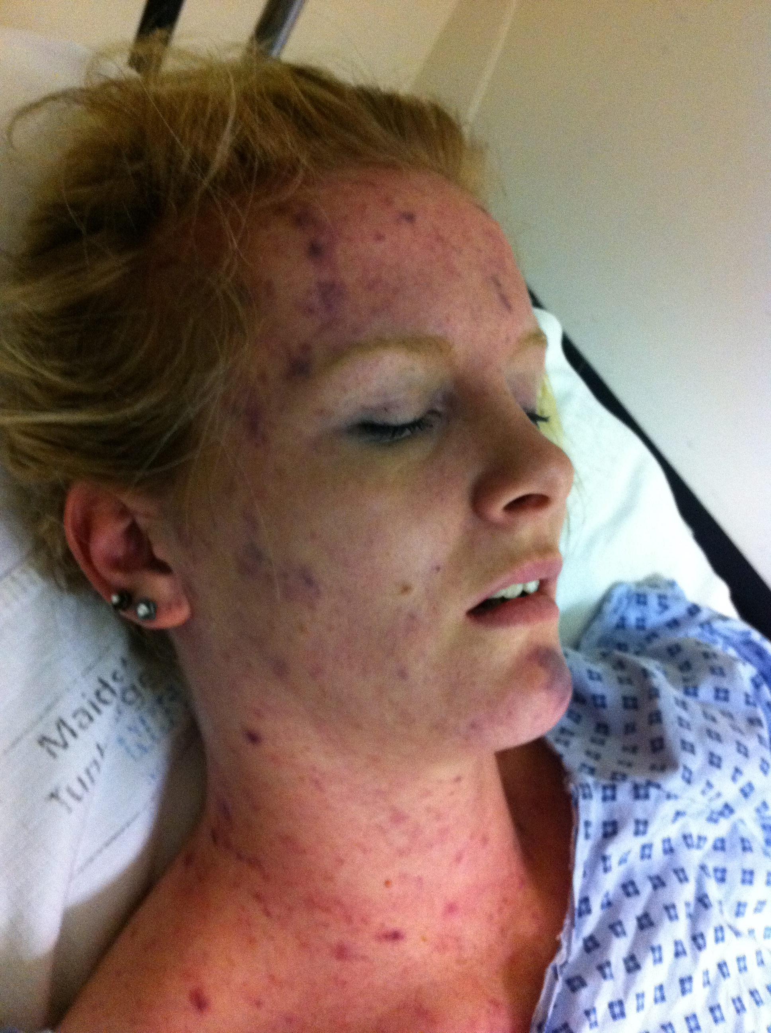

Figure 2 – LP (provided kindly by Dr Benedict Michael with the consent of the patient)

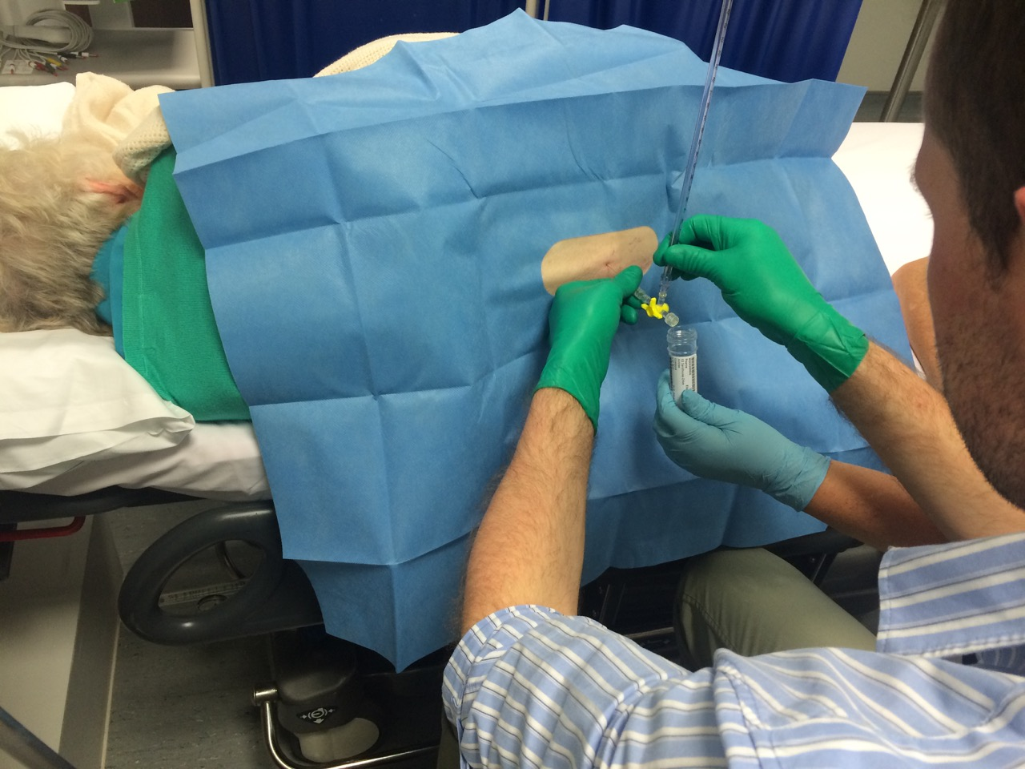

Figure 3 – Some of the disabling after effects of Meningococcal disease. Picture on the left before and on the right after meningococcal sepsis (provided kindly by The Meningitis Research Foundation with the consent of the patient).



**Acknowledgements**

FM is an NIHR doctoral research fellow. The views expressed are those of the author(s) and not necessarily those of the NHS, the NIHR, the Department of Health or Public Health England. This work was conducted independently of influence from the NIHR.

**References**

1. Proulx N, Frechette D, Toye B, Chan J, Kravcik S. Delays in the administration of antibiotics are associated with mortality from acute bacterial meningitis. *QJM* 2005; **98**: 291-8.

2. Begg N, Cartwright KAV, Cohen J, et al. Consensus Statement on Diagnosis, Investigation, Treatment and Prevention of Acute Bacterial Meningitis in Immunocompetent Adults. *J Infect* 1999; **39**: 1-15.

3. McGill F, Heyderman RS, Michael BD, et al. The UK Joint specialist societies guideline on the management of community acquired bacterial meningitis in immunocompetent adults. *Journal of Infection* 2016; **72**(4): 405-38.

4. National Institute for Health and Care Excellence. Meningitis (bacterial) and meningococcal septicaemia in under 16s: recognition, diagnosis and management. 2010.

5. Thigpen MC, Whitney CG, Messonnier NE, et al. Bacterial Meningitis in the United States, 1998-2007. *N Engl J Med* 2011; **364**: 2016-25.

6. Gjini AB, Stuart JM, Lawlor DA, et al. Changing epidemiology of bacterial meningitis among adults in England and Wales 1991-2002. *Epidemiol Infect* 2006; **134**: 567-9.

7. van de Beek D, de Gans J, Spanjaard L, Weisfelt M, Reitsma JB, Vermeulen M. Clinical Features and Prognostic Factors in Adults with Bacterial Meningitis. *N Engl J Med* 2004; **351**: 1849-59.

8. Public Health England. Meningococcal disease: laboratory confirmed cases in England and Wales. 2014. <https://www.gov.uk/government/publications/meningococcal-disease-laboratory-confirmed-cases-in-england-and-wales> (accessed 29/09/2014 2014).

9. Okike IO, Ribeiro S, Ramsay M, Heath PT, Sharland M, Ladhani SN. Trends in bacterial, mycobacterial and fungal meningitis in England and Wales 2004-11: an observational study. *Lancet Infect Dis* 2014.

10. Ladhani SN, Beebeejaun K, Lucidarme J, et al. Increase in Endemic Neisseria meningitidis Capsular Group W Sequence Type 11 Complex associated With Severe Invasive Disease in England and Wales. *Clin Infect Dis* 2015; **60**(4): 578-85.

11. Campbell H, Parikh SR, Borrow R, Kaczmarski EB, Ramsay M, Ladhani SN. Presentation with gastrointestinal symptoms and high case fatality associated with group W meningococcal disease (MenW) in teenagers, England, July 2015 to January 2016. *Euro surveillance : bulletin Europeen sur les maladies transmissibles = European communicable disease bulletin* 2016; **21**(12): pii=30175.

12. Chadwick D. Viral meningitis. *Br Med Bull* 2005; **75-76**: 1-14.

13. Kelly TA, O'Lorcain P, Moran J, et al. Underreporting of Viral Encephalitis and Viral Meningitis, Ireland, 2005-2008. *Emerg Infect Dis* 2013; **19**(9): 1428-36.

14. Schmidt H, Cohrs S, Heinemann T, et al. Sleep disorders are long-term sequelae of both bacterial and viral meningitis. *J Neurol Neurosurg Psychiatry* 2006; **77**(4): 554-8.

15. Schmidt H, Heimann B, Djukic M, et al. Neuropsychological sequelae of bacterial and viral meningitis. *Brain* 2006; **129**: 333-45.

16. Sittinger H, Muller M, Schweizer I, Merkelback S. Mild cognitive impairment after viral meningitis in adults. *J Neurol* 2002; **249**: 554-60.

17. Solomon T, Michael BD, Smith PE, et al. National ABN/BIA guideline for the management of encephalitis for adults. *J Infect* 2012; **64**(4): 347-73.

18. Attia J, Hatala R, Cook DJ, Wong JG. Does this Adult Patient Have Acute Meningitis? *JAMA* 1999; **281**(2): 175-81.

19. Granier S, Owen P, Pill R, Jacobson L. Recognising meningococcal disease in primry care: qualitative study of how general practitioners process clinical and contextual ifnormation. *BMJ* 1998; **316**: 276-9.

20. Domingo P, Pomar V, de Benito N, Coll P. The specturm of acute bacterial meningitis in elderly patients. *BMC Infect Dis* 2013; **13**(108).

21. Barquet N, Domingo P, Cayla JA, et al. Meningococcal disease in a large urban population (Barcelona, 1987-1992): predictors of dismal prognosis. Barcelona Meningococcal Disease Surveillance Group. *Arch Intern Med* 1999; **159**(19): 2329-40.

22. Thomas KE, Hasbun R, Jekel J, Quagliarello VJ. The Diagnostic Accuracy of Kernig's Sign, Brudzinski's Sign, and Nuchal Rigidity an Adults with Suspected Meningitis. *Clin Infect Dis* 2002; **35**: 46-52.

23. Brouwer MC, Thwaites G, Tunkel AR, van de Beek D. Dilemmas in the diagnosis of acute community-acquired bacterial meningitis. *Lancet Infect Dis* 2012; **380**: 1684-92.

24. Brivet FG, Ducuing S, Jacobs F, et al. Accuracy of Clinical Presentation for differentiating bacterial from viral meningitis in adults: a multivariate approach. *Intens Care Med* 2005; **31**: 1654-60.

25. Van den Bruel A, Aertgeerts B, Brutninckx R, Aerts M, Buntinx F. Signs and symptoms for diagnosis of serious infections in children: a prospective study in primary care. *Br J Gen Pract* 2007; **57**: 538-46.

26. Miner JR, Heegaard W, Mapes A, Biros M. Presentation, time to antibiotics, and mortality of patients with bacterial meningitis at an urban county medical center. *J Emerg Med* 2001; **21**(4): 387-92.

27. Sudarsanam TD, Rupali P, Tharyan P, Abraham OC, Thomas K. Pre-admission antibiotics for suspected cases of meningococcal disease. *Cochrane Database Syst Rev* 2013; **8**.

28. Hahne SJM, Charlett A, Purcell B, et al. Effectiveness of antibiotics given before admission in reducing mortality from meningococcal disease: systematic review. *BMJ* 2006; (332): 1299.

29. Michael B, Menezes B, Cunniffe J, et al. Effect of delayed lumbar punctures on the diagnosis of acute bacterial meningitis in adults. *Emerg Med J* 2010; **27**: 433-8.

30. Gerner-Smidt P, Ethelberg S, Schiellerup P, et al. Invasive listeriosis in Denmark 1994–2003: a review of 299 cases with special emphasis on risk factors for mortality. *Clinical microbiology and infection : the official publication of the European Society of Clinical Microbiology and Infectious Diseases* 2005; **11**(8): 618-24.

31. Karageorgopoulos DE, Valkimadi PE, Kapaskelis A, Rafailidis PI, Falagas ME. Short versus long duration of antibiotic therapy for bacterial meningitis: a meta analysis of randomised controlled trials in children. *Arch Dis Child* 2009; **94**: 607-14.

32. Molyneux E, Nizami SQ, Saha S, et al. 5 versus 10 days of treatment with ceftriaxone for bacterial meningitis in children: a double-blind randomised equivalence study. *Lancet* 2011; **377**(9780): 1837-45.

33. Ellis-Pegler R, Galler L, Roberts S, Thomas M, Woodhouse A. Three Days of Intravenous Benzyl Penicillin Treatment of Meningococcal Disease in Adults. *Clin Infect Dis* 2003; **37**(5): 658-62.

34. Health Protection Agency Meningococcus and Haemophilus Forum. Guidance for public health management of meningococcal disease in the UK 2012.

35. Department of Health. Immunisation against Infectious Diseases: "The Green Book". <https://wwwgovuk/government/uploads/system/uploads/attachment_data/file/147977/Green-Book-Chapter-25-v4_0pdfpdf;> 2013.

36. Jit M. The risk of sequelae due to pneumococcal meningitis in high-income countries: a systematic review and meta-analysis. *J Infect* 2010; **61**(2): 114-24.

37. Neufeld MY, Treves TA, Chistik V, Korczyn AD. Postmeningitis headache. *Headache* 1999; **39**(2): 132-4.

38. Caye-Thomasen P, Dam MS, Omland SH, Mantoni M. Cochlear ossification in patients with profound hearing loss following bacterial meningitis. *Acta oto-laryngologica* 2012; **132**(7): 720-5.

39. Merkelbach S, Sittinger H, Schweizer I, Muller M. Cognitive outcome after bacterial meningitis. *Acta Neurol Scand* 2000; **102**: 118-23.

40. National Institute of Health and Care Excellence. Rehabilitation after critical illness. 2009. <https://www.nice.org.uk/guidance/cg83/resources>.

41. Dellinger RP, Levy MM, Rhodes A, et al. Surviving Sepsis Campaign: international Guidelines for Management of Severe Sepsis and Septic Shock: 2012. *Crit Care Med* 2013; **13**(2): 580-637.