(Birmingham City University)

BACKGROUND

In this strand, we explored how professional creative citizenship and its related network can be embodied within a co-working space (the Moseley Exchange) and how it can overlap with other types of creative
citizenship (more broadly civic in character) in a particular place (Moseley in Birmingham). Our initial aims centred upon examining the role and extent of various types of media usage in the networks of entrepreneurs using the Moseley Exchange (and the networks fostered by the space itself), the role of physical interactions and these networks as both a
support and a mean of creative collaboration, and the importance of locality in the success, identity, and reach of start-up spaces. Howeve r, our research
focus expanded during the course of the project, and we began to investigate the tensions between an entrepreneurial and social/community space, as well as the complexities of reaching wider communities, taking into account the particularities of our case study. To pursue these aims we have worked closely with our community partner, the Moseley Community Development Trust (MCDT) throughout the project.

Moseley Village, located in the South East of
B i rmingham, dates from the 17th century and was
incorporated into Birmingham in 1911. In the 1950s-1970s, the area became ‘the ‘Midlands Mecca’ for many of
the youths of the counterculture and dispossessed of society” (Hewston, 2009:70) and was characterised by an important cultural boom with significant concentrations of writers, musicians, and artists. Groups such as UB40 emerged from this cultural mix and events such as the Moseley Festival (created in 1975) are still part of Moseley life. This cultural
ebullition seemed to have been related to the emergence of a strong community milieu or what Hews ton (2009: 72) calls ‘small cooperatives, workshops, makeshift temples, self-help and community support groups.’

Moseley remains characterised by numerous civic society activities (e.g. Moseley Society, Moseley Forum, Moseley in Bloom, Moseley Round table). The MCDT emerged in 2001 with the purpose of leading the ‘regeneration of the neighbourhood
through social, economic and environmental projects for Moseley’s diverse communities’ and with a vision ‘For Moseley to be a creative neighbourhood, valued and sus tained by its community.’ Based on its purpose and vision, the MCDT’s activities range from regeneration and planning , street wardens, community games, support to the voluntary sector, and the creation and operation of a co-working space – the Moseley Exchange. The Exchange, a three s torey building that was once a telephone
exchange, is owned by the MCDT. It has rentable office space and meeting rooms to support both its
economic, environmental and social activities, and the ground floor contains the Moseley Exchange, focused mainly on entrepreneurship. The Moseley
Exchange idea and marketing had based itself on the idea that Moseley was a creative village, with a perceived higher than average (for the area) percentage of people employed within the creative industries. This space, the firs t of its kind in Birmingham, was set up to offer desk space for people starting new businesses, remote workers, or freelancers who would normally have worked from home. Moreover, it is a means of
income generation for the MCDT.

The co-working ethos is that of creative collaboration and flexible support, and the MCDT was the first in Birmingham to connect to the global co-working movement begun in the USA at the start of 2000. Overall, ‘co-working consists in renting a desktop in an open space for a very flexible period of time’ (Leforestier, 2011) though a set of principles and
values are associated to this: “C o-working is a
self-directed, collaborative and flexible work style that is based on mutual trust and the sharing of common core objectives and values between
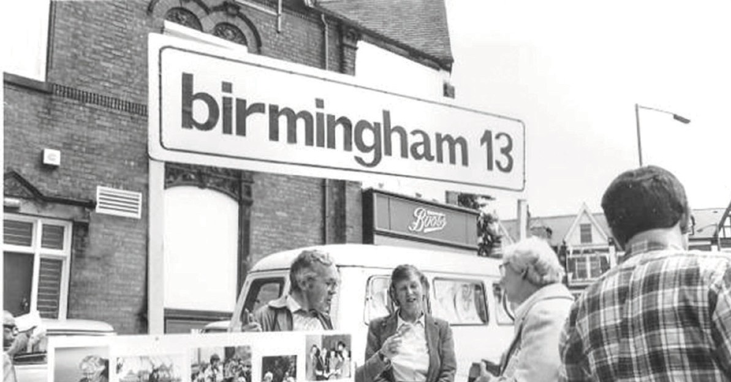members.” (Deskmag , 2012:3).

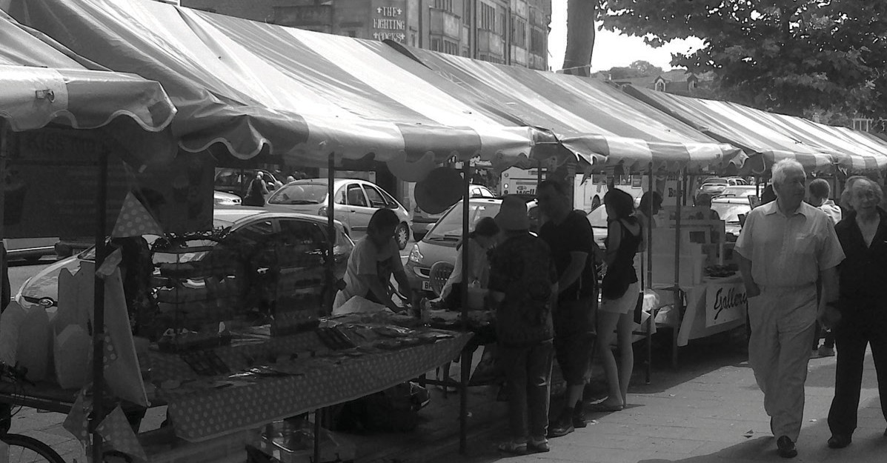Figure 4. Moseley Festival Stalls, 1970s and today.

METHODS

Making visible the diversity, possibility and complexity of creative citizenship: Our case study, the MCDT and the Moseley Exchange co-working space embody various aspects of actual and potential creative
citizenship - from entrepreneurial activities and formal and informal collaborations through to civic interventions and citizen led social and cultural projects. However, these are diverse in both nature and impetus. For example, the main objectives and goals of the MCDT are not necessarily the same as those operating within the co-working space. Our research methods therefore needed to take into account the at times both complementary and contesting voices, practices and purposes of those operating within the locality.

Our methods encompassed in depth interviews with members of the MCDT and with co-workers, participant observation within the Moseley Exchange space, media and asset mapping workshops to ascertain the existing level of media usage and to develop a media co- creation, and the media co-creation itself; a digital
s torytelling project entitled ‘Exchange Stories’. This media co-creation involved several other methods such as s tory elicitation via a stand at the annual Street Fair, one to one recordings and photography, trainingworkshops, and the undertaking of related questionnaires to assess its response and impact. In addition to these, we also conducted secondary data analysis and undertook interviews in other co- working spaces in the UK.

The interviews enabled us to gain insights into several key themes: the various expressions of creative
citizenship within Moseley and the MCDT and their relationship, the role and impact of a co-working space for its users, the role of new and social media and physical interactions in creating and fostering
networks, and the importance of the physical locality,
Moseley, in these dynamics. The participant observation further provided us with a valuable
insight into how people interacted within the space. The workshops, held with representatives from the MCDT, Exchange staff and coworkers, explored the existing and future goals of the MCDT and the Moseley Exchange in particular, and how a media
resource might help them to accomplish these.
From these workshops it became clear that groups linked to the MCDT i.e. co-workers and people involved in other social activities may work within the same space but did not hear about what each
other was doing or understand how these activities might impact upon the local and wider communities. This limited the understanding and the reach of the diverse activities within the building (and thea
resultant wider networks).
Another key concern was increasing the visibility of the building and the co-working space -as with many other co-working spaces, it operates very much on word of mouth and existing network connections. Digital storytelling emerged as a means through which these voices could not only be captured and heard, but also shared and reflected upon. The s tories
(from local people, MCDT members, Exchange staff, co-workers) were housed on a dedicated website, complete with specially commissioned artwork
which opened up the physical Moseley Exchange building whilst and situated it within the stories of Moseley from the wider community.

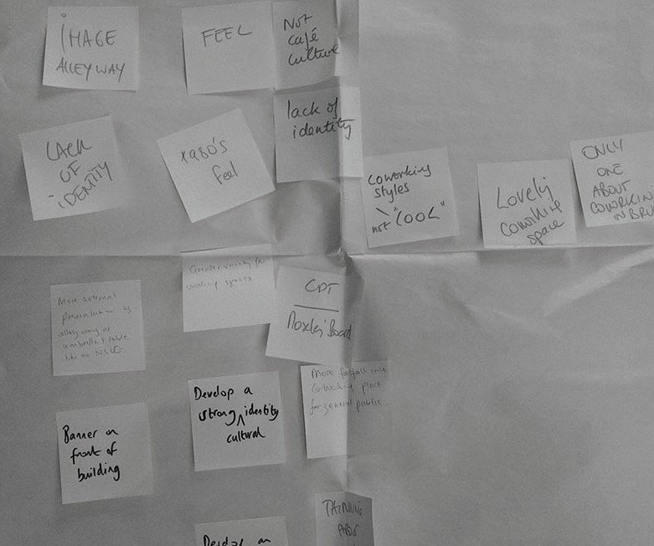

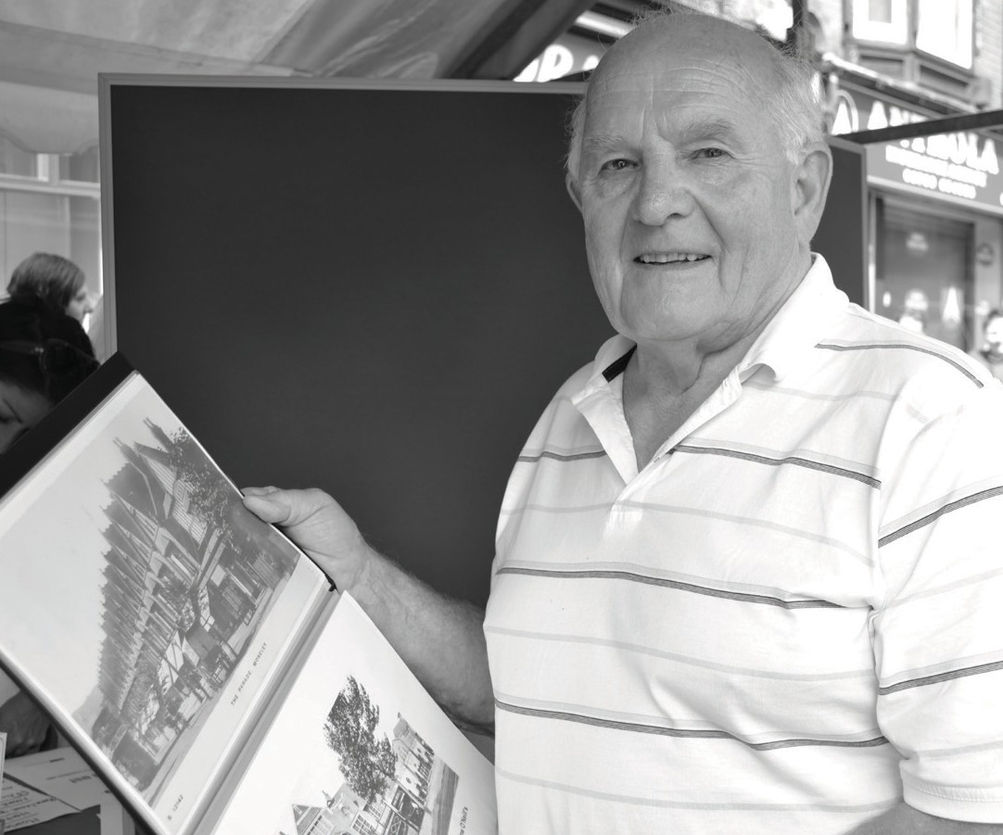

Figure 5.
Asset mapping notes and one method in action.

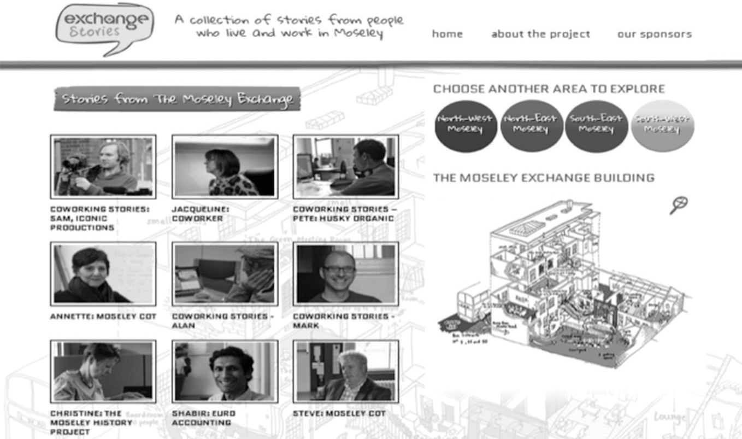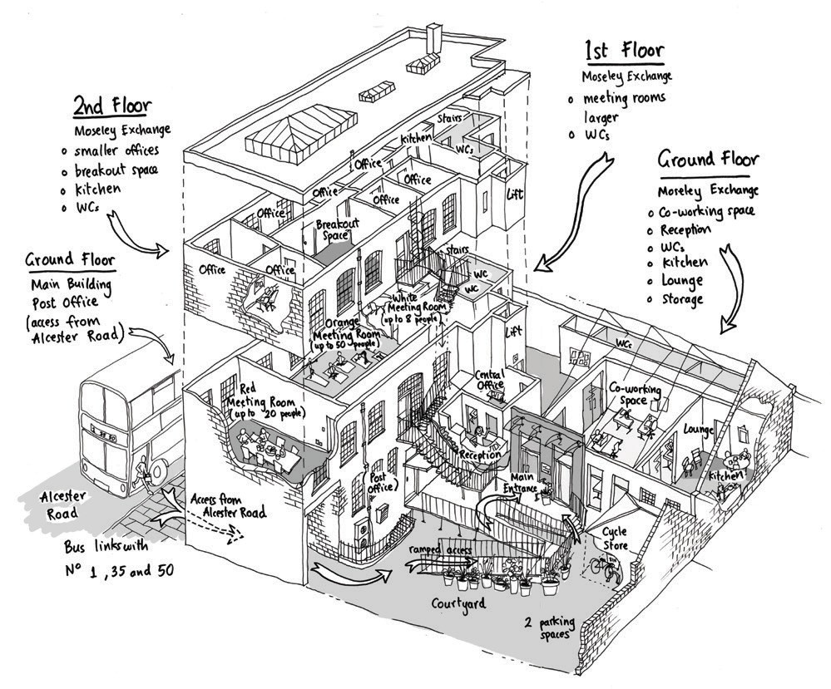

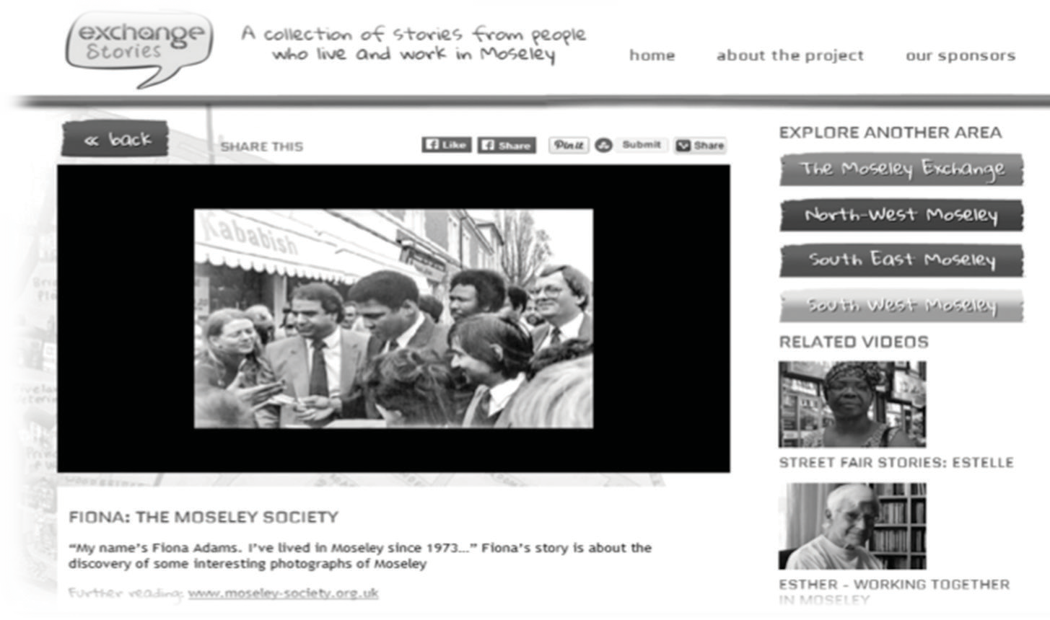

Figure 6.
Stories on our Exchange Stories website.

FINDINGS

Our preliminary findings have centred around two key areas - firstly, the complexities of how creative citizenship and its diverse values are defined, and secondly, the role and affordances (and limitations) of new media and how these can support creative citizenship.

- Tension/Cohesion: Separate Spheres and Overlapping Circles of Creative Citizenship

Our research with the MCDT highlighted that enactments of creativity and citizenship (professional/economic, civic) are diverse in terms of both motivation and type (and arguably should be, see for example Stevenson 2010a and 2010b) and cannot be explored or classed as an uncontested unified body. Indeed, there exist tensions between the MCDT’s social and environmental objectives expressed through its civic activities and its financial sus tainability and en trepreneurial objectives embodied through its co-working space.

The perspectives of the people involved in the co-working space and those involved in the wider
remit of the MCDT differed not only in terms of the objectives of the space and its impact on the community, but also through differing views and perceptions of Moseley itself.

This was outlined in the MCDT interviews where
several participants commented on the problematic resulting from the MCDT’s different aims.
One interviewee for example commented: “we’re
torn between different agenda and different sets of priorities and different sets of networks actually”
Some of these participants may also have a very partial understanding of what the activities of the co-working space involve, being less interested in its entrepreneurial remit.

In contrast, most co-workers do not necessarily know about the social and environmental activities of the MCDT. This was then expanded by the perspectives of the coworkers, several of whom supported the notion of the people within the co-working space having a more autonomous role in the running of
the space; a stance with the potential to generate tensions with other aspects of the organisation’s wider remit.

Howeve r, all interviewees shared, without exception, an enthusiasm for the possibilities (financial, social, collaborative) afforded by the space, even if from
differing viewpoints. Moseley as a location served as a uniting theme; all felt it to be a place that
afforded, supported or drove forward their creative, entrepreneurial and social activities.

Who then are our Creative Citizens and what can
they tell us about the possibilities and limitations of the interconnected physical environment which they share?

The social and the economic values which they create are often interlinked, but they can also easily collide or clash. For the co-workers, their professional endeavour can be seen and to an extent experienced from the point of view of the individual, quite distinct from the wider social concerns of the MCDT; yet it
is clear that the MCDT’s wider footprint impacts directly on the reach (and success) of the
co-working space.

Professional activity enables the coworkers to forge networks and interactions directly from the Moseley Exchange outwards on levels far beyond the local. The space itself fosters vital informal and formal collaboration and intera ctions on many levels,
from professional ne tworks, creative a dvice or
inspiration through to everyday support. It provides an innovative and timely solution for those seeking to begin or build up new enterprises. We could
say that creative citizenship here belongs to the professional sphere. However, there are overlapping circles between the activities of the coworkers, the aims of the MCDT and the communities of Moseley.

The co-workers, many of whom are locals, are
embedded with their wider local communities on an everyday basis. In addition, the MCDT needs to
generate an income, to market and grow the space, and engage with the wider entrepreneurial/creative scene to support its non-economic objectives and
thereby create a positive impact in the wider community. Our other creative citizens are of course the various residents and people connecting to the Exchange
and to Moseley and involved in wider cultural,
social activities and the general wellbeing of the neighbourhood.They create a milieu and identity integral to all of the engagements and activities within and surrounding it. This is not seamless, nor
is it uncontested, and arguably it should never be. Creative citizenship is here defined by the variety of its components and enriched by its differing perspectives, diverse voices, and real and imagined possibilities.

- Online/Offline Interactions and Creative Citizenship

Another important component of our research is to understand how Web 2.0 can support and enhance creative citizenship. The role of Web 2.0 in the
practices taking place in the MCDT/Moseley Exchange challenged our research expectations. The co-workers relied heavily on ICT to undertake their activities, and could in theory work from anywhere, but chose the Exchange due to the (physical) support network it offered them. This included the possibilities for networking and collaboration, but also the informal support and sense of community it afforded them.

C osts were also a factor - the Exchange provided start-up companies and freelancers with an affordable space to conduct their entrepreneurial activities.
Here the offline and local interactions within the Exchange are a counterbalance to their often
individualised, computer/online based daily lives.
We found that most of the co-workers tended to
interact less with the social media networks within and between the Exchange (that is not to say that they don’t listen/receive information via them,
see Crawford (2009).

In terms of professional social media usage, most
expressed an underlying assumption that they should be using social media tools, but many reported that
they did not do so directly. For example some participants said they used them because they had
to: “I don’t like it and I don’t like spending time on it. But it’s a modern marketing means of communication. So therefore get over that and get good at it”. Others differentiated between types of media : “Not Facebook. I have a Facebook account but I keep it at arm’s length really. There is no particular reason, I just do not engage with it very much.
But I use Twitter”. Most were responsive in their viewpoint – if their clients used it, they did or would (see also the different perspectives in
existing literature on the values, relevance and drawbacks of Web 2.0 business usage and also levels and definitions of participation, e.g. Cammaerts, B (2008) van Dijck, J and Nieborg , D (2009),
Hausmann, A. (2012), Uricchio, W. (2004), Wu Song ,
F. (2010)). Interviews with other users of the MCDT reveal similar findings with age, unclear economic benefits in comparison to perceived time required to populate these media and publicness of these media expressed as barriers to social media usage.
Online and offline activities are of course not binaries, as existing literature on online/offline interactions and communities suggests (see for example Erikson (2010) Mesch and Talmud (2010), Valentine and
Holloway (2002)) and the social media interactions of the Exchange itself supported this, predominately drawing upon pre-existing place based communities.
Whilst the Exchange has a wide reach of social media followers, it overtly interacts mostly within local discussions and events, very much linking in to the wider local and regional networks.

These initial findings were nevertheless, slightly counterbalanced by the reaction to the digital
storytelling platform created as part of our research.
Workshops, questionnaires and interviews suggest that initial reception of and interactions with our
digital storytelling project were extremely positive. Here the possibilities of new media interaction build upon existing traditional media and on the capacities and effectiveness of sharing personal narratives,
enabling the creation and dissemination of short, shareable media that can be as elegantly simple or as technically or creatively complex as the creator/ participant wants them to be.

Whilst there are limitations (levels of participation, access, editing issues, representation) there are also, as C ouldry (2008) suggests, possibilities of
democratic contribution to the public sphere (2008:387). From our co-creation we found people from differing areas (of place, perspective) engaged well with the
concept, were keen to contribute, and reacted positively to a screening of the stories. For example, one co- worker felt that the medium suitably showcased his entrepreneurial activities, whilst MCDT members
felt it effectively showcased the role of the MCDT and also Moseley itself.

Howeve r, the key aim of the intervention is
sustainability and visibility. Staff members at the Exchange are trained not only to record s tories but to help others to record their own, and the Exchange now has the relevant resources (from voice recorders to a dedicated website) to keep the project going.

REFERENCES

Cammaerts, B (2008) ‘Critiques on the participatory potentials of Web 2.0’ in Communication, Culture
& Critique 1(4) 358-377

Couldry, N. (2008) Mediatization or mediation?
Alternative understandings of the mergent space of digital storytelling New Media & Society 10, 373-
391

Crawford, K. (2009) ‘Following you: Disciplines of listening in social media’ Continuum:Journal of Media and Cultural Studies 23(4) 525-535

Deskmag (2012) The 2nd annual global coworking survey. Available online at: www.deskmag.com
[Accessed on 20th June 2013]

Erikson, I. (2010) ‘Geography and Community:
New Forms of Interaction Among People and Places’

American Behavioural Scientist 53(8), 1194-1207
Hausmann, A. (2012) ‘Creating ‘buzz’: opportunities and limitations of social media for Arts institutions and their viral marketing’ International Journal of
Nonprofit and Voluntary Sector Marketing 17, 173-182

Hewston N. (2009) A history of Moseley Village. Vol. 1. Stroud: Amberley Publishing Leforestier A. (2009), The coworking space concept. CINE term project. Available online at: http://www.iimahd.
ernet.in/users/anilg/files/Articles/Co-working%20 space.pdf [accessed 10th December 2013]
Mesch, G.S and Talmud, I. (2010) ‘Internet Community, Community Participation,
and Place Attachment: A Longitudinal Study’
American Behaviourial Scientist 53(8) 1095- 1110

Stephenson, N (2010a) Education, neoliberalism
and cultural citizenship: living in ‘X factor’ Britain
European Journal of Cultural Studies. 13(3), 341-358

Stephenson, N. (2010b) Cultural citizenship,
education and democracy: redefining the good society, Citizenship Studies, 14:3, 275-291
Valentine, G. and Holloway, S. (2002) ‘Cyberkids?

Exploring Children’s Identities and Social Networks in On-lIne and Off-Line Worlds’ Annals of the
Association of American Geographers 92(2) 302-319

van Dijck, J and Nieborg , D (2009) ‘Wikinomics and its discontents:
a critical analysis of Web 2.0 business manifestos’ New Media and Society 11(5) 855-874

Wu Song , F. (2010) ‘Theorizing Web 2.0’
Information, Culture & Society 13(2) 249-275

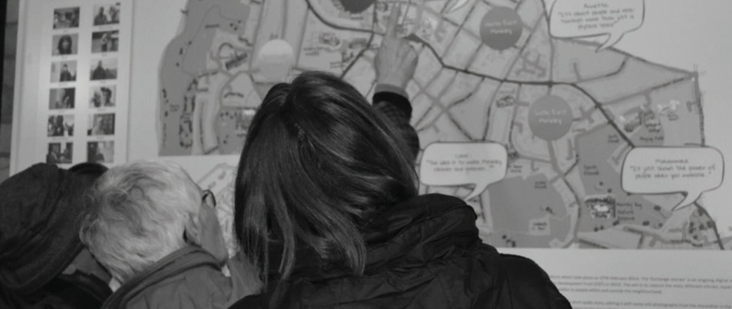

Figure 7. Moseley residents reacting to the Exchange Stories’s mural.

